Computer Architecture and Operating Systems

  - Digital Degree Apprenticeship Computing
  - Afonso Surgy Pereira Da Silva (1800654)

Contents
Introduction 2
General Operating Systems 3
Windows OS CLI Commands 7
Linux OS CLI Commands 11
Windows OS Scripts 13
Linux OS Script 18
References 18
Appendix 2 18

Introduction
This report is written to document some uses of scripting languages in Windows and Linux operating systems. The languages used are Batch and PowerShell for Windows environments, and Bash for Linux. The report shall also include a brief demonstration of some functions and monitoring capabilities of an example General Operating System.

General Operating Systems
General Operating Systems are characterized as Operating Systems intended to operate on a broad range of hardware, and with broad application to a variety of specified needs. Key functions for such systems include but are not limited to: Memory Management, Process Management, Peripheral Management and File Management. [1]
The most popular General OS, and second most popular OS overall, is Windows with 72.52% of the PC market and 27.48% of the overall OS market. [2]
For a General Operating System, Memory Management refers to the Operating System’s control and tracking of Main Memory. With this function an Operating System keeps track of what Memory units are free or allocated; allocates units to processes as required; and frees up units as possible and required. [3]
For Windows specifically, it uses a technique called Virtual Memory, where the Memory available is made up of Memory Addresses as a base unit, grouped in Pages which are mapped onto physical Memory. Not all addresses are always loaded in and instead when an address is referred to, the Operating System will attempt to access that address, and if the data is not on Memory at that time the Operating System will load the data in and re-execute the instruction needed. [4]
Monitoring the Memory in Windows can be done in various ways. Performance Monitor allows to view in real time various parameters related to system performance metrics, including relating to Memory with parameters like Page Writes/sec, Page Reads/sec, Page Faults/sec, Available Kbytes, etc. [5] [6]
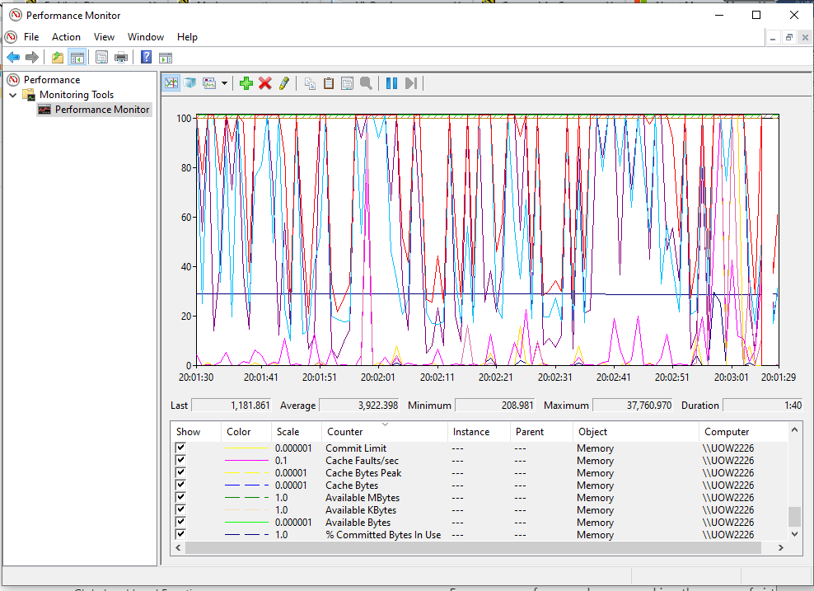Performance Monitor displaying all available metrics on Memory.
Process Management involves the Operating System allocating resources to processes, enable cross-process interaction, and prevent processes to interfere with each other. The Operating System initiates the processes, puts the processes to the resources needed (Processor time, Memory, etc.), terminates processes, and keeps track of processes and their states. [7]
In Windows, process can be monitored with the Task Manager. Task Manager lists processes, allocated resources, and lists the status of the process e.g.: whether the process is Running, Suspended, Not Responding. It also allows for terminating and starting processes, and for setting priority, which core should run the process, which processes the process analysed is waiting on, etc. [8]
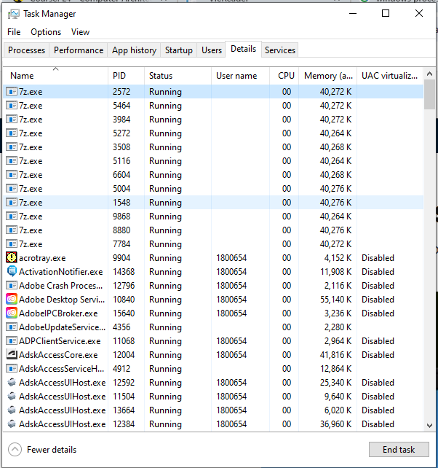
Task Manager in the Details Tab showing detailed metrics on Processes.

As a key function, the Operating System interfaces between the User and Hardware, including Peripherals. Device Drivers are the programs that determine much of the work of this function. When the Operating System sends a command to a peripheral, it looks to the Device Driver of the device to translate the Operating System’s command to one that the Peripheral will understand.
Peripheral Interrupts are also implemented by the Operating System. The Operating System is responsible for allocating the needed system resources to the peripherals and can prioritize the input from a peripheral so that the User’s actions are not ignored. [9]
In Windows, Peripherals can be managed partially through the Settings, in the Devices tab. It allows the User to view some devices, and alter their settings.
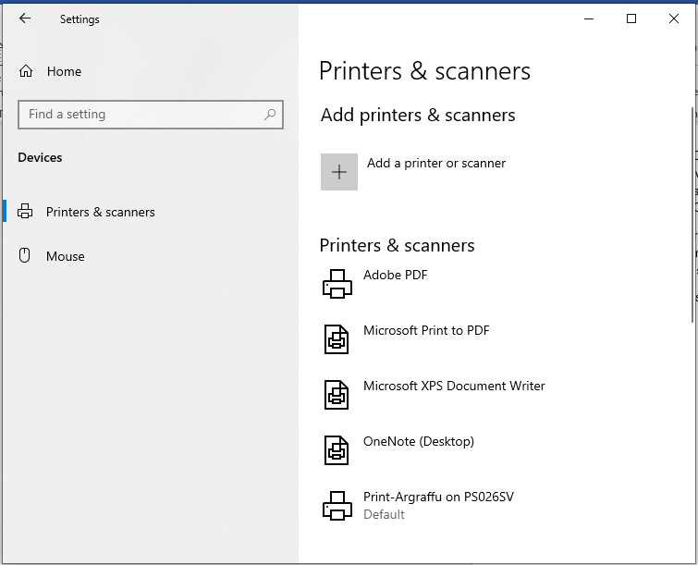
Windows Settings Device tab.
Device Manager allows a more complete and extensive view and greater control over Peripherals and Device Drivers.
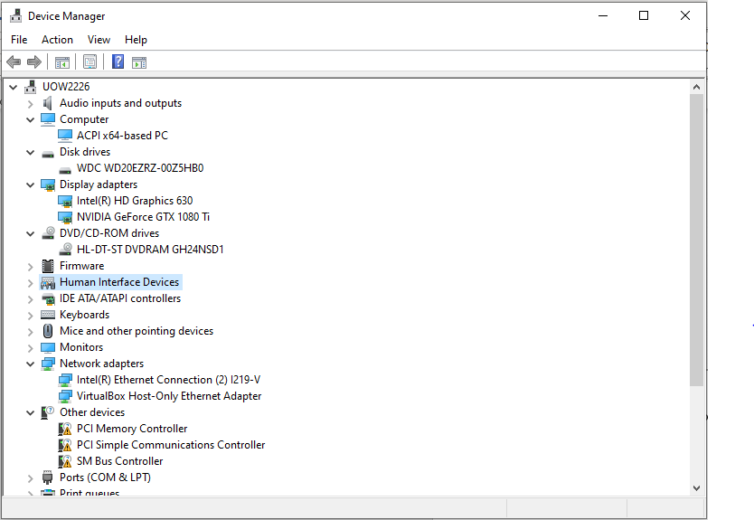
Finally, with File Management, Operating Systems fulfil several functions, some of which are: Creation, Encryption and Compression, Organization, Deletion, Backup and Recovery, and Permissions. [10]
File management is most easily done in Windows through the File Explorer, which allows for creation, deletion, search, compression, organization, etc. of files.
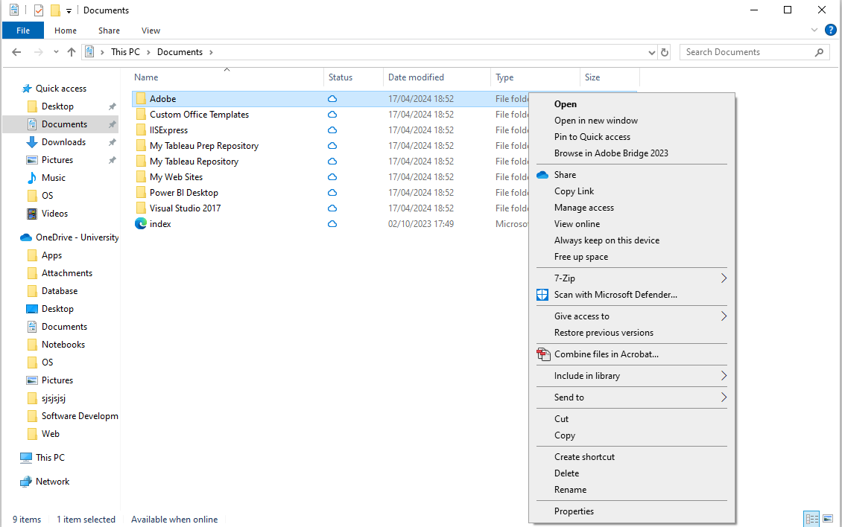

Windows OS CLI Commands
- SET Command:
The SET command allows the user to set variables in the CLI. There are two switches for this, /p which accepts user input, and /A which evaluates a mathematical expression. [11]
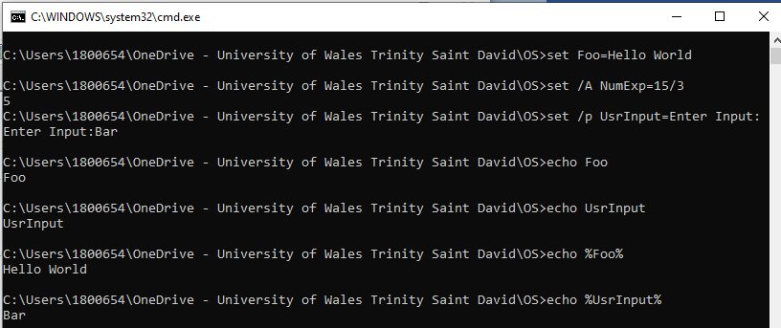
- PAUSE Command:
The PAUSE command pauses the CLI until a key is presses. It gives opportunity for the user to terminate the script with CTRL+C and Y, and allows the user some time to consider data the CLI may be displaying before the script moves on. [12]
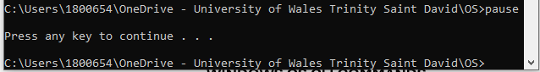
- IF Command:
The IF command evaluates a statement, and if true executes the command following the statement. This allows to check for the existence of critical files before executing commands, to check for values in variables, etc. [13]
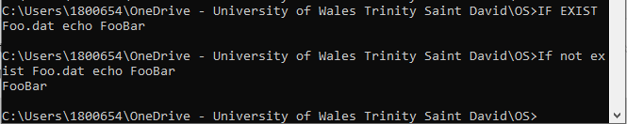
- GOTO Command:
The GOTO Command skips straight to a label set in the script, and the program will execute as normal from that point. This allows to skip sections of script that should no longer be processed, for example by checking or User Input which is meant to end the program, which jumps to a label at the end of the program. [14]
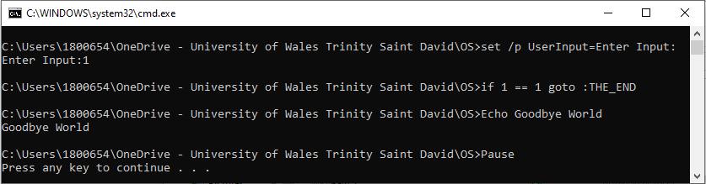
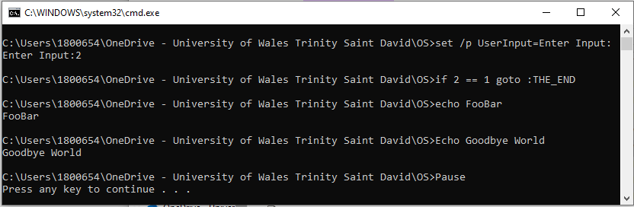
Above displayed a conditional where, if 1 is the input, the GOTO command is processed, otherwise the program continues as normal.
- MKDIR Command:
The MKDIR command creates a new directory at the root the CLI is set to. Subdirectories can be created at the same time, by writing each folder name separated by \. [15]
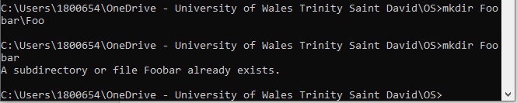
- RMDIR Command:
The RMDIR removes directories specified. There are two switches, /s which deletes the directory specified and any subsequent subdirectories, and /q which supresses the customary confirmation request when deleting the directory tree. [16]
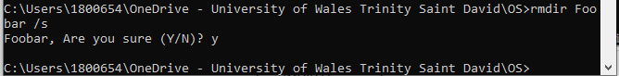
- COPY Command:
The COPY command copies files in a specified directory to a specified destination. There are several switches for this command: /d allows encrypted files to be save as decrypted, /v verifies that new files are written correctly, /n uses when available a shorter name/extension if name is longer than 8 and extension is longer than 3 characters, etc. [17]
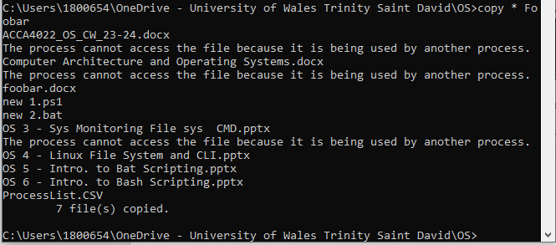
- DEL Command:
The DEL command deletes specified files. It has some switches: /p prompts confirmation before deleting, /f forces deletion of read only files, /q suppresses deletion confirmation, etc. [18]
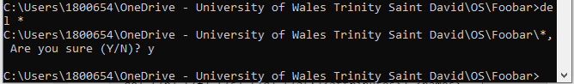
- CD Command:
The CD command sets the CLI’s operating directory. .. and ../.. can be used to go up to the parent directory or the parent’s parent respectively. CD can also be used to display the current operating directory if no new directory is specified. [19]
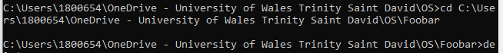
- HELP Command:
The HELP command displays a list of all commands with a brief description. If used before another command, the HELP command displays detailed information on the specified command. [20]
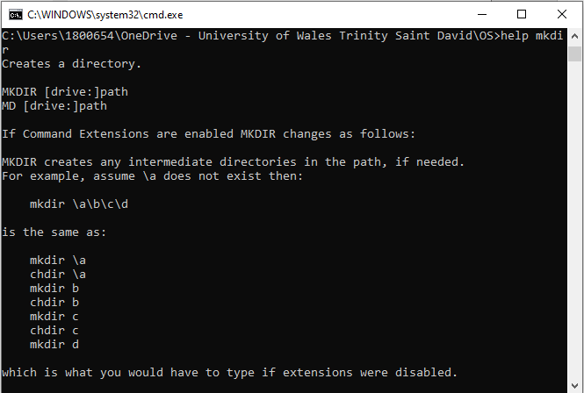

Linux OS CLI Commands
- PWD Command:
- LS Command:
Lists the contents of a directory. [21]
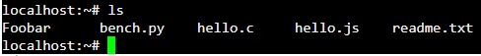
- HISTORY Command:
The History command lists previously entered commands in the terminal. If a number is specified, it will display up to that number of the latest commands. With the -c parameter at the end, the command clears the history. [22]
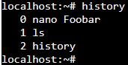
- RM Command:
Removes specified directory or file. Directories can be deleted with the -r flag. Multiple files can be deleted multiple files in a row by listing files one after another following the rm command. [23]
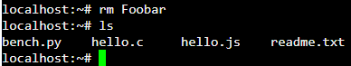
- MKDIR Command:
Creates new directories. Multiple can be created by listing new directories one after another. Permissions for the directories can be specified for the command, and with the -p flag a directory tree can be created. [24].
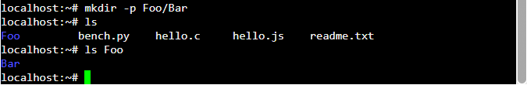
- MV Command:
The MV command can rename and move files/directories. If a file is specified, then another file is specified, it will rename the first to the second. Any number of files and directories to the destination directory. The -b flag creates backups of the files that may otherwise be deleted. [25]
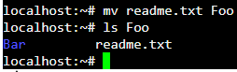
- CAT Command:
The CAT command is used to read the contents of files. It can also be used to concatenate the contents of files to a new file, and to create a new file. [26]
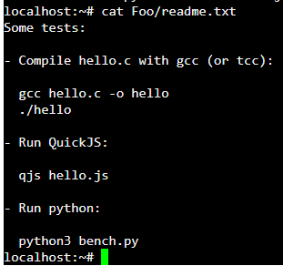
- DU Command:
This command shows the disk usage of files/directories. Importantly, the size will be an approximation. -h can be used to show the output in Gigabyts, Megabytes, and Kilobytes to be more easily readable. By default, it displays in Kilobytes. [27]
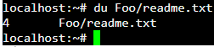
- NETSTAT Command:
This will list some statistics regarding network connections being made. It can be used to diagnose some network issues, and for simple regular monitoring. [28]
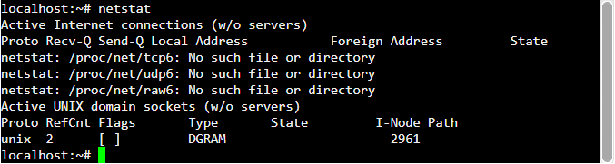
- ARP Command:
The ARP Command calls to the ARP cache, which records the IP addresses and corresponding MAC addresses of devices on the network. -a can be used to view every entry in the cache and -d to delete a host. [29]

Windows OS Scripts
Part of a script, which sets a variable value and displays it.
Script now checking for specific input to output select message.
Script now with Goto conditional which allows User to go back to the start.
Script demonstrating repeated commands.
Script demonstrating array assignment and display.
Script now using a Function to pass in number, multiply it by itself and display the value.

Linux OS Script
Script creates variable and takes in User Input.
Script outputs specific message conditional on User Input.
Arrays can also be declared with the declare keyword.
Script demonstrating for loop displaying a list of things.
Script demonstrating a case statement, which matches variable value to value in the case statement.
Script now with function which raises inputted number to the power of 2, and is called depending on User Input.

References

[1] | GeeksforGeeks, “Functions Of Operating System - GeeksforGeeks,” GeeksforGeeks, 19 January 2024. [Online]. Available: https://www.geeksforgeeks.org/functions-of-operating-system/. [Accessed 15 04 2024].
[2] | StatCounter, “Operating System Market Share Worldwide | Statcounter Global Stats,” StatCounter, [Online]. Available: https://gs.statcounter.com/os-market-share. [Accessed 17 04 2024].
[3] | TutorialsPoint, “Operating System - Memory Management,” TutorialsPoint, [Online]. Available: https://www.tutorialspoint.com/operating_system/os_memory_management.htm. [Accessed 17 04 2024].
[4] | A. S. Tanenbaum and H. Bos, “Modern Operating Systems: Global Edition,” Amsterdam, Pearson, 2014, p. 194.
[5] | Microsoft, “Memory Performance Information - Win32 apps | Microsoft Learn,” Microsoft, 01 07 2021. [Online]. Available: https://learn.microsoft.com/en-us/windows/win32/memory/memory-performance-information. [Accessed 17 04 2024].
[6] | Microsoft, “Performance Counters Tools - Win32 apps | Microsoft Learn,” Microsoft, 01 07 2021. [Online]. Available: https://learn.microsoft.com/en-us/windows/win32/perfctrs/performance-counters-tools. [Accessed 17 04 2024].
[7] | A. S. Tanenbaum and H. Bos, “Modern Operating Systems: Global Edition,” Amsterdam, Pearson, 2014.
[8] | C. Hoffman and H.-t. Geek, “Windows Task Manager: The Complete Guide,” How-to Geek, 14 10 2023. [Online]. Available: https://www.howtogeek.com/405806/windows-task-manager-the-complete-guide/#managing-processes-with-the-task-manager. [Accessed 17 04 2024].
[9] | Alfie and TutorChase, “How do operating systems manage peripheral devices? | TutorChase,” TutorChase, [Online]. Available: https://www.tutorchase.com/answers/ib/computer-science/how-do-operating-systems-manage-peripheral-devices. [Accessed 17 04 2024].
[10] | M. Dham, “File Management in Operating System,” PrepBytes, 20 06 2023. [Online]. Available: https://www.prepbytes.com/blog/operating-system/file-management-in-operating-system/. [Accessed 17 04 2024].
[11] | Microsoft, “set | Microsoft Learn,” 09 06 2023. [Online]. Available: https://learn.microsoft.com/en-us/windows-server/administration/windows-commands/set_1. [Accessed 18 04 2024].
[12] | Microsoft, “pause | Microsoft Learning,” 02 03 2023. [Online]. Available: https://learn.microsoft.com/en-us/windows-server/administration/windows-commands/pause. [Accessed 18 04 2024].
[13] | Microsoft, “if | Microsoft Learn,” 02 03 2023. [Online]. Available: https://learn.microsoft.com/en-us/windows-server/administration/windows-commands/if. [Accessed 18 04 2024].
[14] | Microsoft, “goto | Microsoft Learn,” 02 03 2023. [Online]. Available: https://learn.microsoft.com/en-us/windows-server/administration/windows-commands/goto. [Accessed 18 04 2024].
[15] | Microsft, “mkdir | Microsoft Learn,” 02 03 2023. [Online]. Available: https://learn.microsoft.com/en-us/windows-server/administration/windows-commands/mkdir. [Accessed 18 04 2024].
[16] | Microsoft, “rmdir | Microsoft Learn,” 02 03 2023. [Online]. Available: https://learn.microsoft.com/en-us/windows-server/administration/windows-commands/rmdir. [Accessed 18 04 2024].
[17] | Microsoft, “copy | Micosoft Learn,” 02 03 2023. [Online]. Available: https://learn.microsoft.com/en-us/windows-server/administration/windows-commands/copy. [Accessed 18 04 2024].
[18] | Microsoft, “del | Microsoft Learn,” 02 03 2023. [Online]. Available: https://learn.microsoft.com/en-us/windows-server/administration/windows-commands/del. [Accessed 18 04 2024].
[19] | Microsoft, “cd | Microsoft Learn,” 02 03 2023. [Online]. Available: https://learn.microsoft.com/en-us/windows-server/administration/windows-commands/cd. [Accessed 18 04 2024].
[20] | Microsoft, “help | Microsoft Learn,” 02 03 2023. [Online]. Available: https://learn.microsoft.com/en-us/windows-server/administration/windows-commands/help. [Accessed 18 04 2024].
[21] | javaTpoint, “50 Linux Commands List with Examples - javatpoint,” [Online]. Available: https://www.javatpoint.com/linux-commands. [Accessed 18 04 2024].
[22] | D. McKay and H.-t. Geek, “How to Use the history Command on Linux,” 23 01 2024. [Online]. Available: https://www.howtogeek.com/465243/how-to-use-the-history-command-on-linux/#the-history-command. [Accessed 18 04 2024].
[23] | The Linux Information Project, “How to use the rm command, by The Linux Information Project,” 11 01 2006. [Online]. Available: https://www.linfo.org/rm.html. [Accessed 18 04 2024].
[24] | The Linux Information Project, “The mkdir Command,” 22 08 2005. [Online]. Available: https://www.linfo.org/mkdir.html. [Accessed 18 04 2024].
[25] | The Linux Information Project, “The mv command, by The Linux Information Project (LINFO),” 04 05 2006. [Online]. Available: https://www.linfo.org/mv.html. [Accessed 18 04 2024].
[26] | The Linux Information Project, “The cat Command,” 15 06 2004. [Online]. Available: https://www.linfo.org/cat.html. [Accessed 18 04 2024].
[27] | The Linux Information Project, “How to use the du command -- by The Linux Information Project (LINFO),” 21 08 2004. [Online]. Available: https://www.linfo.org/du.html. [Accessed 18 04 2024].
[28] | GeeksforGeeks, “Netstat command in Linux - GeeksforGeeks,” 01 02 2024. [Online]. Available: https://www.geeksforgeeks.org/netstat-command-linux/. [Accessed 18 04 2024].
[29] | W. Al Assad, “The “arp” Command in Linux [7 Practical Examples],” 18 01 2024. [Online]. Available: https://linuxsimply.com/arp-command-in-linux/. [Accessed 18 04 2024].
[30] | IEEE, IEEE Reference Guide, Piscataway: IEEE Periodicals, 2018.
[31] | Free Software Foundation, Inc., “Bash Reference Manual,” 19 09 2022. [Online]. Available: https://www.gnu.org/software/bash/manual/bash.html. [Accessed 18 04 2024].

Appendix 2
For Course Engagement, the Microsoft Introduction to PowerShell was selected. [Microsoft, Inc., “Introduction to PowerShell,”. [Online]. Available: https://learn.microsoft.com/en-us/training/modules/introduction-to-powershell/. [Accessed 18/04/2024]]

