
Intercultural Competence Report
Foreign Languages and Cultural Awareness

February 28, 2024
Tutor name

Word count:

Student name:

Mihai Alexandru Crisan

Student number:

2217500

Module code:

BMIH5003

Contents
Executive Summary: 2
Introduction: 2
Cultural Differences Between England and Italy 3
Comparison Using the Globe Project 5
Challenges of Intercultural Leadership in Hospitality 6
Recommendations to Overcome Challenges: 8
Conclusion: 8
References: 9

Executive Summary:

As the newly appointed assistant manager for the 5-star Inclusivity Hotel and Spa in London, I have conducted an analysis comparing the cultural differences between England and Italy, utilizing insights from prominent scholars such as Geert Hofstede, Fons Trompenaars, and Robert J. House. This report critically discusses the challenges of intercultural leadership in the hospitality industry, providing concrete examples, and offers three realistic recommendations to overcome these challenges.
This report aims to explore the cultural disparities between England and Italy, focusing on their impact on leadership and organizational practices within the hospitality industry. Drawing upon the Globe Project's insights, the report also evaluates the challenges faced by intercultural leaders in managing diverse teams.

Introduction:
In an era of globalization, the hospitality industry serves as a microcosm of diverse cultures, necessitating adept management of cultural differences for operational excellence (Globe Project, 2004.). As the assistant manager of the esteemed 5-star Inclusivity Hotel and Spa in London, understanding and navigating these disparities are paramount. This report leverages the cultural dimensions identified by renowned scholars to illuminate the challenges encountered by intercultural leaders in the hospitality sector.
In an increasingly globalized world, the hospitality industry serves as a melting pot of cultures, with diverse teams working together to provide exceptional service to guests. As the assistant manager of the esteemed 5-star Inclusivity Hotel and Spa in London, understanding and effectively managing cultural differences is paramount to ensuring the success of the hotel's operations (Morrison, 2013). This report delves into the contrasting cultural landscapes of England and Italy, two nations that boast rich histories and distinct societal norms. By leveraging insights from the Globe Project, which examines cultural dimensions and their impact on leadership and organizational practices, this report aims to shed light on the challenges faced by intercultural leaders in the hospitality industry (Globe Project, 2004.).

Cultural Differences Between England and Italy
England, known for its individualistic ethos, values punctuality, independence, and direct communication. In contrast, Italy, with its collectivistic culture, emphasizes relationships, harmony, and indirect communication. These cultural disparities extend to various facets of life, including business practices, leadership styles, and workplace dynamics. The Globe Project's comprehensive analysis of cultural dimensions such as power distance, uncertainty avoidance, masculinity/femininity, and long-term orientation provides a framework for understanding the nuances of cultural differences between England and Italy (Globe Project, 2004).
This report concludes with practical recommendations aimed at equipping intercultural leaders with the tools and strategies needed to navigate these challenges successfully. By fostering a culture of understanding, inclusivity, and continuous learning (Morrison, 2013), the Inclusivity Hotel and Spa can harness the richness of cultural diversity to deliver unparalleled guest experiences and drive organizational success in the competitive hospitality landscape.
1. Communication Styles:
England: English communication tends to be more direct and straightforward, emphasizing clarity and efficiency in conveying information. In the hotel industry, this may translate to clear instructions given to staff and guests, ensuring smooth operations (Hofstede, 1980).
Italy: Italian communication often involves more indirect and nuanced expressions, with an emphasis on building relationships and rapport. In hotels, this could manifest as staff engaging in extensive conversations with guests to establish a personal connection and provide a warm welcome (Hofstede & Hofstede, 2005).
2. Customer Service Approach:
England: English hotels often prioritize efficiency and professionalism in customer service, focusing on meeting guests' needs promptly and effectively. Staff members are trained to adhere to standardized service protocols to ensure consistency (Morrison, 2013).
Italy: Italian hospitality places a strong emphasis on personalized service and building long-term relationships with guests. Staff members may go above and beyond to make guests feel welcome, offering personalized recommendations and catering to individual preferences (Kusluvan et al., 2010).
3. Work Ethic and Punctuality:
England: British work culture values punctuality, with employees expected to arrive on time for shifts and meetings. This emphasis on timeliness contributes to the smooth functioning of hotel operations and guest satisfaction (Tung & Chang, 2016).
Italy: In Italy, there is often a more relaxed approach to time management, with greater flexibility in work schedules. While this can foster a laid-back atmosphere, it may also lead to challenges in maintaining efficiency and meeting deadlines in the hotel industry (Trompenaars & Hampden-Turner, 1997).
4. Hierarchical Structures:
England: English organizations, including hotels, tend to have relatively flat hierarchical structures, with clear lines of authority and responsibilities. This allows for efficient decision-making and clear communication channels (Schneider et al., 2017).
Italy: Italian workplaces may exhibit more hierarchical structures, with respect for authority and seniority playing a significant role in decision-making processes. In hotels, this hierarchical culture may influence how staff interact with supervisors and collaborate with colleagues (House et al., 2004).
5. Cultural Customs and Etiquette:
England: English hotels often adhere to international standards of etiquette and decorum, with an emphasis on professionalism and adherence to rules and regulations. However, they also value inclusivity and respect for diverse cultural customs (House et al., n.d.).
Italy: Italian hospitality embraces cultural customs and traditions, with an emphasis on warmth, hospitality, and generosity. Hotels may incorporate local customs into their service offerings, such as serving traditional Italian dishes or celebrating local festivals with guests (House et al., n.d.).
Comparison Using the Globe Project:
Power distance, uncertainty avoidance, masculinity/femininity, long-term orientation. The Globe Project identifies key cultural dimensions, including power distance, uncertainty avoidance, masculinity/femininity, and long-term orientation. England tends to have lower power distance, higher uncertainty avoidance, and a more masculine orientation compared to Italy. These differences shape leadership behaviours and organizational practices in each country (Globe Project, 2004).

.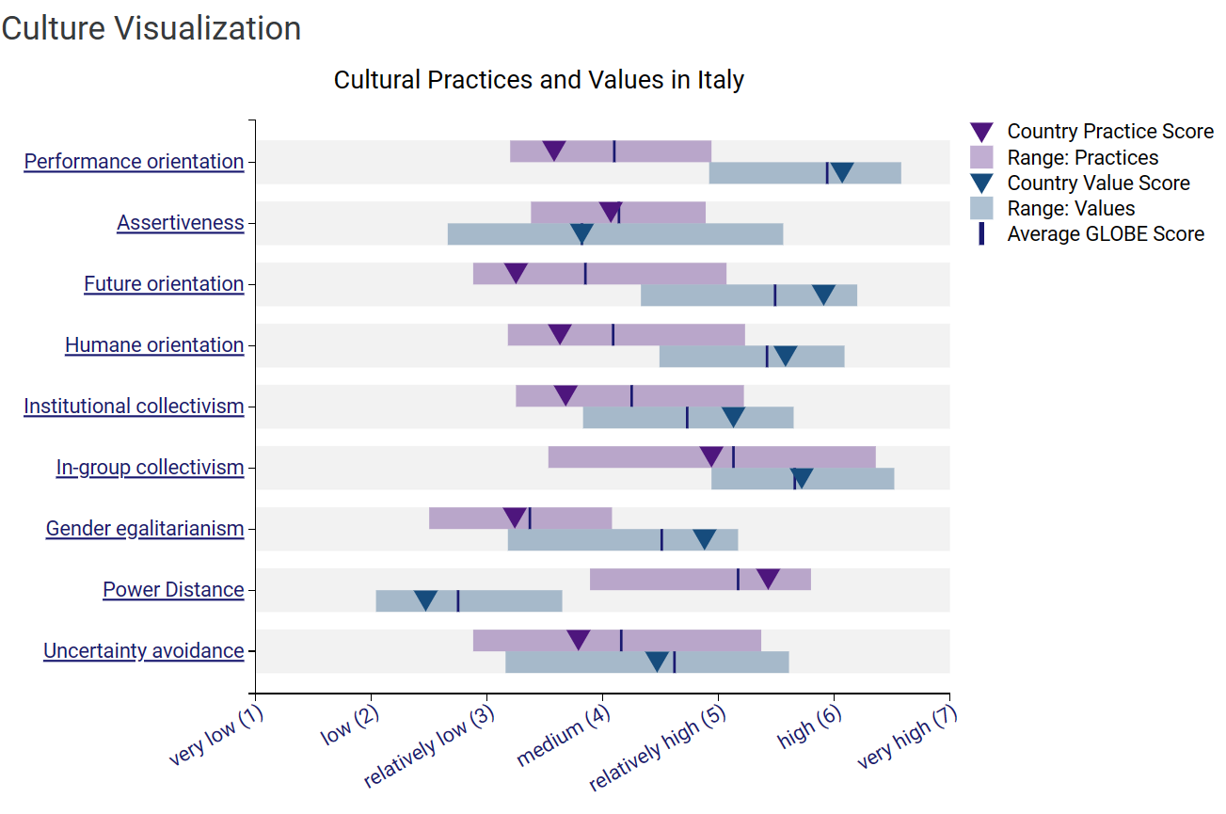
Fig. 1 Globe Project. (2004). Cultural Practices and Values in Italy. Retrieved from https://globeproject.com/about?page_id=intro.html#globe2020_intro (21 February 2024)
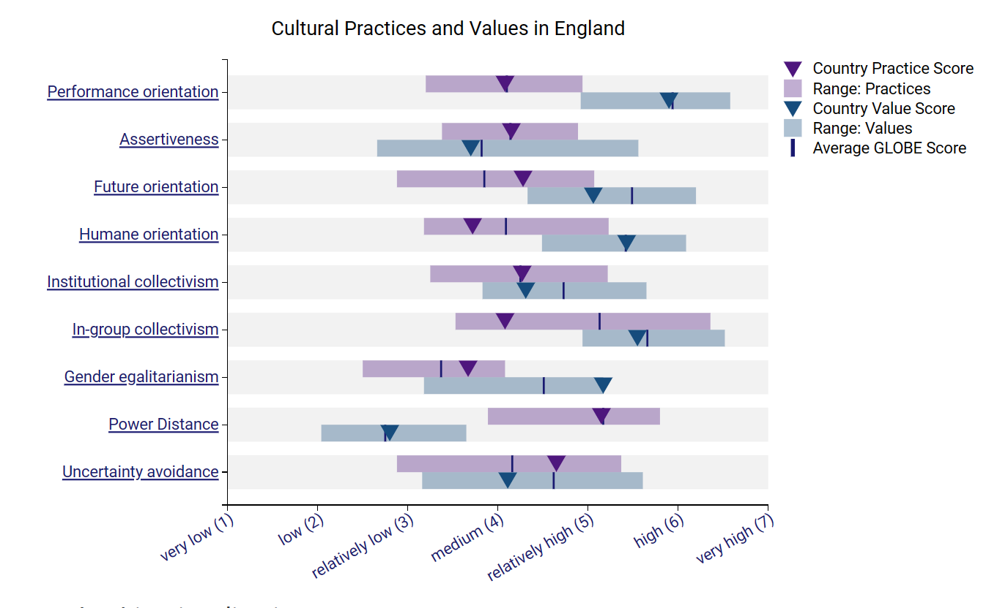
Fig. 1 Globe Project. (2004). Cultural Practices and Values in England. Retrieved from https://globeproject.com/about?page_id=intro.html#globe2020_intro (21 February 2024)

Challenges of Intercultural Leadership in Hospitality

Intercultural leadership in the hospitality industry poses several challenges, such as miscommunication, cultural misunderstandings, and difficulty in building trust and cohesion among diverse teams. For instance, a British manager's direct communication style may be perceived as rude by Italian employees, leading to tensions and decreased morale (Globe Project, 2004).
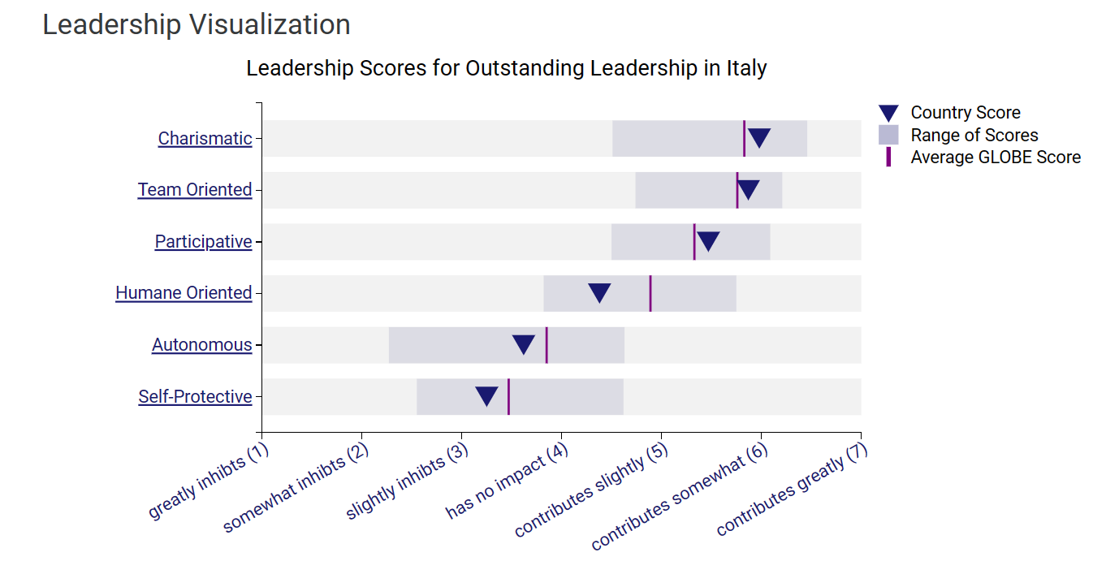
Fig. 3 Globe Project. (2004). Leadership Scores for Outstanding Leadership in Italy . Retrieved from https://globeproject.com/about?page_id=intro.html#globe2020_intro (Accessed 21 February 2024)
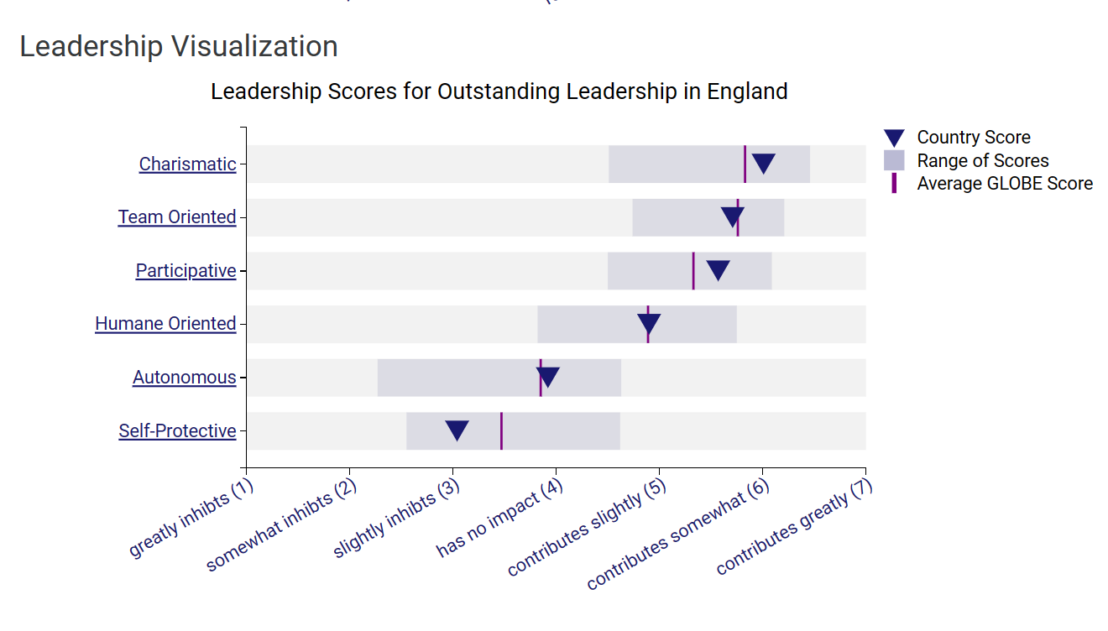
Fig. 3 Globe Project. (2004). Leadership Scores for Outstanding Leadership in England . Retrieved from https://globeproject.com/about?page_id=intro.html#globe2020_intro (Accessed 21 February 2024)

Recommendations to Overcome Challenges:
a. Cross-Cultural Training: Implement mandatory cross-cultural training programs for all employees, focusing on cultural awareness, communication styles, and conflict resolution strategies. This will help foster mutual understanding and respect among team members.
b. Cultural Sensitivity Workshops: Conduct regular workshops and seminars to raise awareness about cultural differences and promote empathy and inclusivity within the workplace. Encourage open dialogue and exchange of perspectives to bridge cultural gaps.
c. Leadership Development Programs: Offer leadership development programs tailored to intercultural competency development. Provide managers with tools and strategies to adapt their leadership styles according to the cultural backgrounds of their team members. Encourage active listening, empathy, and flexibility in leadership approaches.

Conclusion:

In conclusion, this report emphasizes the crucial role of understanding and managing cultural differences in the hospitality industry. Drawing on insights from scholars like Hofstede (1980), House et al. (2004), Kusluvan et al. (2010), and others, we've explored how cultural dimensions shape leadership, organizational practices, and workforce dynamics. Through the Globe Project (Globe Project, 2004), we've identified significant cultural disparities, particularly between nations like England and Italy, impacting communication styles, customer service approaches, and hierarchical structures. Despite challenges like miscommunication and trust-building issues, strategies such as cross-cultural training and leadership development programs offer pathways for leveraging cultural diversity. By fostering a culture of understanding and inclusivity, organizations can deliver exceptional guest experiences and thrive in the competitive hospitality landscape.

References:

- Globe Project. (2004). Introduction to Globe 2020. Retrieved from https://globeproject.com/about?page_id=intro.html#globe2020_intro (Accessed on 19 February).
- Hofstede, G. (1980). Culture's consequences: International differences in work-related values. Sage.
- Hofstede, G., & Hofstede, G. J. (2005). Cultures and organizations: Software of the mind. McGraw-Hill.
- House, R. J., Hanges, P. J., Javidan, M., Dorfman, P. W., & Gupta, V. (2004). Culture, leadership, and organizations: The GLOBE study of 62 societies. Sage Publications.
- House, R. J., Hanges, P. J., Javidan, M., Dorfman, P. W., & Gupta, V. (n.d.). Global Leadership and Organizational Behavior Effectiveness (GLOBE) Project. Retrieved from https://globeproject.com/results/countries/GBR%3Fmenu=list.html [24 February 2024]
- Kusluvan, S., Kusluvan, Z., Ilhan, I., & Buyruk, L. (2010). The human dimension: A review of human resources management issues in the tourism and hospitality industry. Cornell Hospitality Quarterly, 51(2), 171-214.
- Morrison, A. M. (2013). Marketing and managing tourism destinations. Routledge.
- Schneider, B., González-Romá, V., Ostroff, C., & West, M. A. (2017). Organisational climate and culture: Reflections on the history of the constructs in the Journal of Applied Psychology. Journal of Applied Psychology, 102 (3), 468-482.
- Trompenaars, F., & Hampden-Turner, C. (1997). Riding the waves of culture: Understanding diversity in global business. Nicholas Brealey Publishing.
- Tung, A. Y. L., & Chang, Y. Y. (2016). The effects of work engagement on hotel employees’ job performance: The mediating role of affective commitment. Journal of Hospitality and Tourism Management, 29, 10-18.

