2204938
Module code: BMOE6005

Perspectives On Outdoor Education

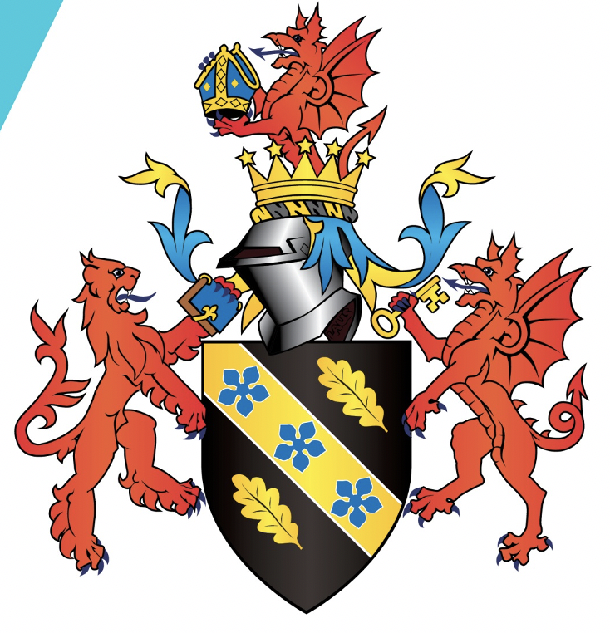

Assessment: Report

Module lead: Maria Trevino Gonzalez

This report will cover an introduction to our project, what, how and why we did what we did. It will give a brief background on the population we decided to work with and justification for why the project was suggested. The practicalities of the project will be detailed in terms of activities completed, locations and some next steps of how the project could work in the future. Next a critical analysis of the project will be completed, including barriers and challenges faced during the project but also identifying ways in which the project succeeded.

Our project aimed to provide short accessible outdoor activities to an adult population. In order to access this population we chose to partner with the Stroke Association (SA) in Carmarthenshire. Outdoor activities were something that had been requested by those accessing the service. Because of the potential support and accessibility needs of stroke survivors, it was identified during planning that we would need to ensure any activities could be done inside, sitting down and that non-participation in activities was an option if necessary. The project advertised parallel support groups, so stroke survivors and their carers could come and take part. The Stroke association communicated with us that carers often were unable to attend support groups aimed at just carers because of the 24-hour care stroke survivors commonly need, if the carers went to a support group the people, they are caring for would have no-one to support them. Opening our activities to carers and survivors means that carers can access support as well as being near those they are caring for.
The main aims of the project were to:
- Increase self-confidence in participants
- Provide space for mindfulness
- Strengthening links between the Stroke association and Cynefin
- Create an opportunity for participants to socialise with others with similar experiences

To achieve these aims it was important for the project to be well thought through and for us as facilitators to be consulting our contact at the SA. This meant planning activities that were open to adjustment, and which required some effort but not so much that participants felt exhausted afterwards. We also chose activities that could be done by everyone which meant that no matter what a person was physically capable of they would leave having completed something, even if for them the hardest thing was turning up. Another thing this achieves is that participants are not completely focused on the activity and can have that chance to chat and relate to other stroke survivors or carers at the project. For us as facilitators representing the university it also should be recognised that this project has the potential to be reproduced by future students at Cynefin. So, that means we as representatives of the university had a responsibility to behave in a professional manner, by communicating effectively, being timely and organised and doing our best to create a project that delivers what is advertised.

The activities offered were making bird feeders, cooking on the firepit, willow weaving and some short walks around the sight. What was offered on the day was adjusted based on what participants came and the weather. The crafting activities helped to increase engagement with participants as they could be completely autonomous over how much or little they did, without ever being distanced from the rest of the group. Having the firepit and opportunity for walking around meant that participants who were more capable could explore and push themselves, instead of being held back. This mixture aimed to achieve those aims of increasing self-confidence and mindfulness and giving space for socialising but it also aimed to contribute to a relaxed atmosphere within which participants who are likely to be experiencing some anxiousness can feel safe and comfortable leading to more opportunity for growth.

This project can be related back to a range of themes that have been explored as part of the wider module.
Considering our target audience can be considered an underserved community as a result of their disability, it is important to look to wider literature as to how projects like this work and the effect they have. An important thing to note for when we were creating our plans was specifically to understand barriers for stroke survivors in accessing more physical activities like this. Morris et al (2021) found that the biggest barriers stroke survivors faced in being physically active were “negative emotional responses to PA”, anxiety and embarrassment as well as thinking physical activity was unhelpful meant that stroke survivors were not seeking it out. The study also highlighted ways in which they overcame those barriers and reduce any negative experiences within the project (Morris et al, 2021). For facilitators it was about engaging soft skills like empathy, understanding (Sempik and Bragg, 2016) and recognising the person as a whole, their past experiences and understanding how they will impact their perceptions (Morris et al, 2021). The concept of physical activity for stroke survivors can be daunting which can lead to a lack of motivation to participate (Morris et al, 2021), however participating in a gardening scheme for stroke survivors has been shown to increase self-efficacy and provide a sense of achievement which led to an increase in motivation (Seale et al, 2014). This is an important factor as if stroke survivors are more motivated to be active, they are less likely to experience further physical and mental health problems (Lee et al, 2018), they also experience lower stress levels (Lee et al, 2018; Stinear et al, 2020).
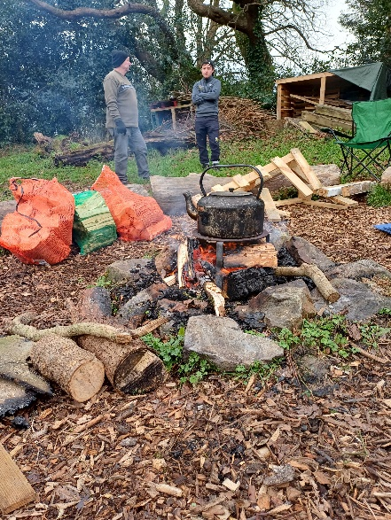
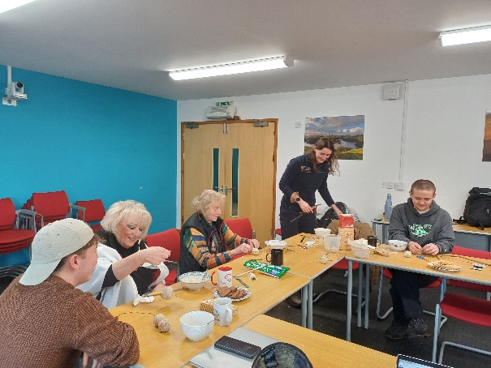
Through consulting with the Stroke Association, we decided to offer three activity sessions where survivors and carers could attend and considered accessibility requirements to ensure that all participants were able to engage. Our sessions were advertised as three hours long and we chose to put them on in the morning, as it was identified that a lot of stroke survivors generally have more energy in the morning and therefore be more likely to attend. The first session consisted of some short introductions with tea and coffee in the classroom to get participants introduced to the project and give them an idea of what to expect, which it was hoped would reduce anxieties. We then allowed them to have a walk around the site, encouraging them to open their senses and immerse themselves in the natural environment. It was planned that we would then do an activity up in the yurt however participants were complaining about the cold, so we decided to go back into the classroom. Inside we then did the next activity, which was making birdfeeders.
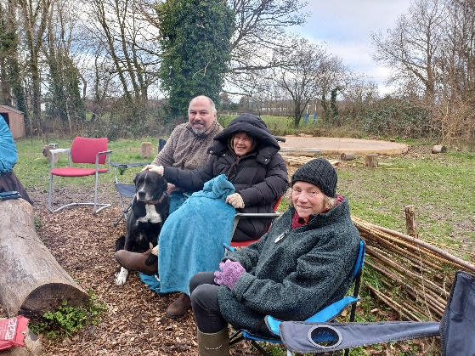
A little over a week later we had the next session, we started with a similar structure, introducing ourselves and the site to some who had not come to the first session then moving onto the activities. This session we had a Coed Lleol group there at the same time, so we made our participants aware of this and joined on with their activities. This day was slightly warmer, so participants were comfortable spending more time outside, this meant we spent most of the session outside around the campfire. The first activity we did was weaving willows to create wreaths. This involved weaving the willow and foraging for decorations for the wreaths. Participants then got to spend some time talking to each other around the campfire and relating their experiences.

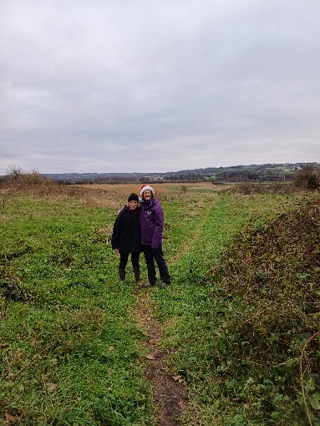
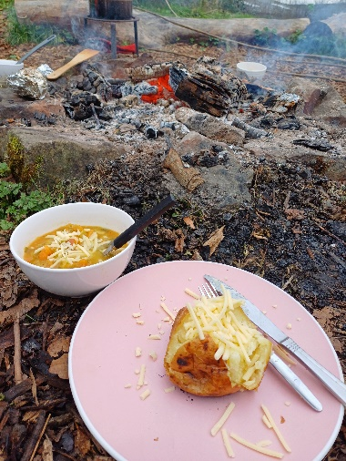
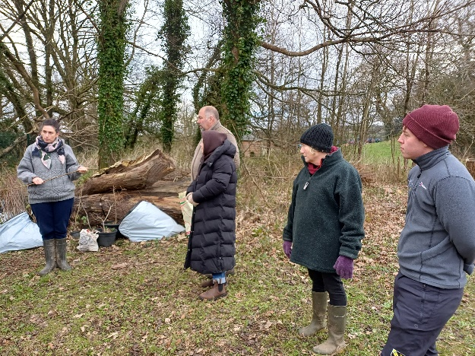
The last session again the weather was comfortable and dry so we planned to make a campfire and as a group cook some baked potatoes, soup and bread. The participants who attended this session were particularly capable, so we decided to take them on a short walk through the wetlands to take in the unique environment and wildlife. We then came back and while eating had a short discussion about what participants enjoyed and what they would like from future sessions. This can help us and the Stroke association if in future we or someone else are asked to recreate the project, as participants have identified the things they want to do more or less of. Participants said they enjoyed the inclusiveness of activities, so they felt there was a place for them even if they were not doing a specific activity. One participant said they would like planting activities specifically. It was also highlighted that the relaxed style of facilitation and planning was helpful in making participants feel comfortable and confident to engage in the sessions. This relaxed style was deliberate; however, I think it helped that as people, me and my co-facilitators have a calm temperament, and we were mentally prepared for plans changing. I would say in future this is something I would continue to prioritise as I think how we behaved as facilitators rubbed off on participants and because we were professional and friendly it put participants who may have been anxious or feeling negative emotions at ease which set the tone for the session and resulted in higher engagement.

By looking critically at the project, we can identify barriers and challenges which will aid in improving the effectiveness of future projects.
Barriers identified were low participant uptake and accessibility of the environment. Because the timing of this project was very specific and had to be done at short notice gaining the number of participants we wanted was difficult. Being students was also a factor in this scenario as we have unregular schedules meaning the sessions could not be on the same days each week. This created a problem for participants as they would come but be unable to return because they would have other things on other days. This was a predictable barrier however in future I think this would become less and less of a problem as it was fed back that a want for more sessions was expressed by stroke survivors and carers who had heard about the sessions through word of mouth. The second barrier identified was the accessibility of the environment, if recreating this project it should be a priority to offer better solutions. For example, it may be important to have a store of suitable footwear like wellingtons because the site does not have any designated concrete paths this would increase the area participants can explore. More advertising of the site could also improve the accessability in terms of reducing anxiety and increasing confidence in potential participants.
The challenges of this project were;
- Understanding participant needs
- Reliability of us as facilitators
Through conversations with participants and group reflections the outcomes of the project would be identified as; time at Cynefin gave participants; some distraction from their symptoms/caring commitments, opportunity to speak to others who have a similar experience, these things both brought a sense of mindfulness and although it was not a long project participants still said it was impactful to be able to do something physical and outdoors as those are the things often hard after experiencing a stroke. This is shown by
There were also outcomes for us as facilitators. The project allowed growth for facilitators, as someone who had never worked with disabled people before it gave insight into the lived experiences of this group which can in future inform how I work with them in future.
In recreating the project, it is important to consider alternative routes that still achieve the aims.
The first gap to consider are inconsistencies in participation; by having a consistent day and time for the group participants, they communicated they were more likely to return. A regular group gives the opportunity for stronger relationships within the group which has the potential to make participants even more engaged, building higher self confidence in the environment and themselves. This change is unlikely to make any of the aims less likely to be achieved.

In future it may be valuable to provide more options for activities, the way the project ran with fewer than expected participants was effective, however, with more participants it is likely there will be bigger gaps in ability. This has the potential to create problems in the inclusiveness of activities. A solution that would combat this would be to provide more levels to the activities provided, our project did not do this, but this never became a problem because we had a low uptake in participants. If we were to recreate this project, more options and levels of difficulty would mean wider levels of ability can be catered for within the sessions.
For differing populations this project could be altered, the nature of stroke survivors means that a calm and relaxed atmosphere was highly important, this could be applied to other populations with similar needs for example, people struggling with depression, anxiety or loneliness.
The project demonstrated how important diversity and inclusion within outdoor education is. The project came about because of the stroke association asking for it, there is a clear lack of projects in the area with these sorts of activities that are accessible for disabled people. As it has been said, creating accessible activities required the most planning in this project, however, the response highlighted why this was so necessary. Participants spoke of how since experiencing a stroke the opportunity to just be outside was not there, the project supported participants in connecting with nature in a way that had been taken away from them with some saying how they will prioritise time outside more because they had forgotten how good it made them feel.

This project provided the opportunity for stroke survivors to relate to others of a similar experience, as well as participate in inclusive activities in a natural environment. It aimed to improve self-confidence and provide space for mindfulness in the participants and for facilitators it aimed to improve competence and confidence in us as facilitators by reflecting on how we performed as facilitators and ways in which we could have improved the experience for participants. The project met these aims, as seen by the verbal feedback from participants who all enjoyed the sessions and expressed a desire for more. In recreating this project, a more regular time frame would be beneficial as well as more options for activities to allow for a range of abilities to take part. The biggest learning as a facilitator personally was how vital an atmosphere can be when working with vulnerable adults, my inexperience as an outdoor educator became less important because of the friendly and welcoming space that we created. Hard skills are important but from reflecting on this project I believe, when working with the aims of supporting a person emotionally, soft skills are irreplaceable and can make a huge difference in the experiences of participants.

References
Lee A., Park S., Park H., Son K. (2018). ‘Determining the effects of a horticultural therapy program for improving the upper limb function and balance ability of stroke patients’, HortScience, 53(1), pp. 110–119. https://doi.org/10.21273/HORTSCI12639-17
Morris J.H., Irvine, L.A., Dombrowski, S.U. (2022) ‘We Walk: a person-centred, dyadic behaviour change intervention to promote physical activity through outdoor walking after stroke—an intervention development study’, BMJ Open, 12(6). doi: 10.1136/bmjopen-2021-058563
Seale, B., Davis, A,, Lawson, J., Smith, L., Watson, J., Henderson-Wilson, C. (2014) ‘Nature-Based Design in Stroke Rehabilitation Environments: A Scoping Review’, HERD: Health Environments Research & Design Journal, 17(4), pp. 86-211. doi:10.1177/1937586724125183
Sempik, J., & Bragg, R. (2016). Green care. In Green exercise: linking nature, health and well-being (pp. 100-113). London: Routledge.
Stinear, C.M., Lang, C.E., Zeiler, S., Byblow, W.D. (2020). ‘Advances and Challenges in Stroke Rehabilitation’, Lancet Nueral, 19(4), pp. 348-360. DOI: 10.1016/S1474-4422(19)30415-6

AI was not used in the creation of this project.

