

Changemakers: Creativity and Value Creation
Professions (BMHP5014)

Component 1: Online portfolio of set exercises

Student name: Salma Begum Lipi
Student number:2328718
Lecturer’s name: Caroline Salami

Table of contents
Introduction
Task 1- Defining Key Concepts in Practice
Task 2 - Mind Map
Task 3 - Self-Reflection of Group Activity
Task 4 - Case Study Analysis of a UK Innovation
Task 5 - Research Task
Task 6 - Exploring Digital Innovation in Health and Social Care
Task 7 - Understanding the NHS Leadership Framework
Task 8 - Self-Reflection Journal Entry
References

Introduction
This portfolio brings together academic research to examine creativity, innovation, and value creation in health and social care. It looks at both theory and practice, showing how these ideas help improve services, tackle challenges, and benefit both service users and professionals.

Task 1- Defining Key Concepts in Practice (350 words)
Innovation means actively coming up with, accepting, and using new ideas, products, or services to create value (Greenhalgh et al., 2019). In health and social care, innovation is important for handling system pressures and meeting changing patient needs. For example, using robotic-assisted surgery is a process innovation that improves surgical precision and reduces patient recovery times (Alemzadeh et al., 2019).
Creativity is the mental and social process of coming up with new and useful ideas (Amabile, 2020). It is essential in care for developing personalised approaches. For example, using music therapy for dementia patients is a creative, non-drug way to reduce agitation, showing how new ideas can benefit patients (Shanahan et al., 2019).
In healthcare, value creation means improving patient outcomes and experiences compared to the cost of care (Kazantsis et al., 2020). It goes beyond just financial measures and includes the 'Triple Aim'. Telehealth is a good example, as it improves access, makes care more convenient for patients, and uses resources more efficiently (Doraiswamy et al., 2020).
Change represents the transition from a present state to a desired future state, a process inherently triggered by innovation (Hayes, 2022). Successful, sustainable change requires strategic management to overcome resistance. The large-scale organisational change involved in implementing Electronic Health Records (EHRs) illustrates this, fundamentally restructuring information workflows to enhance care coordination and safety. 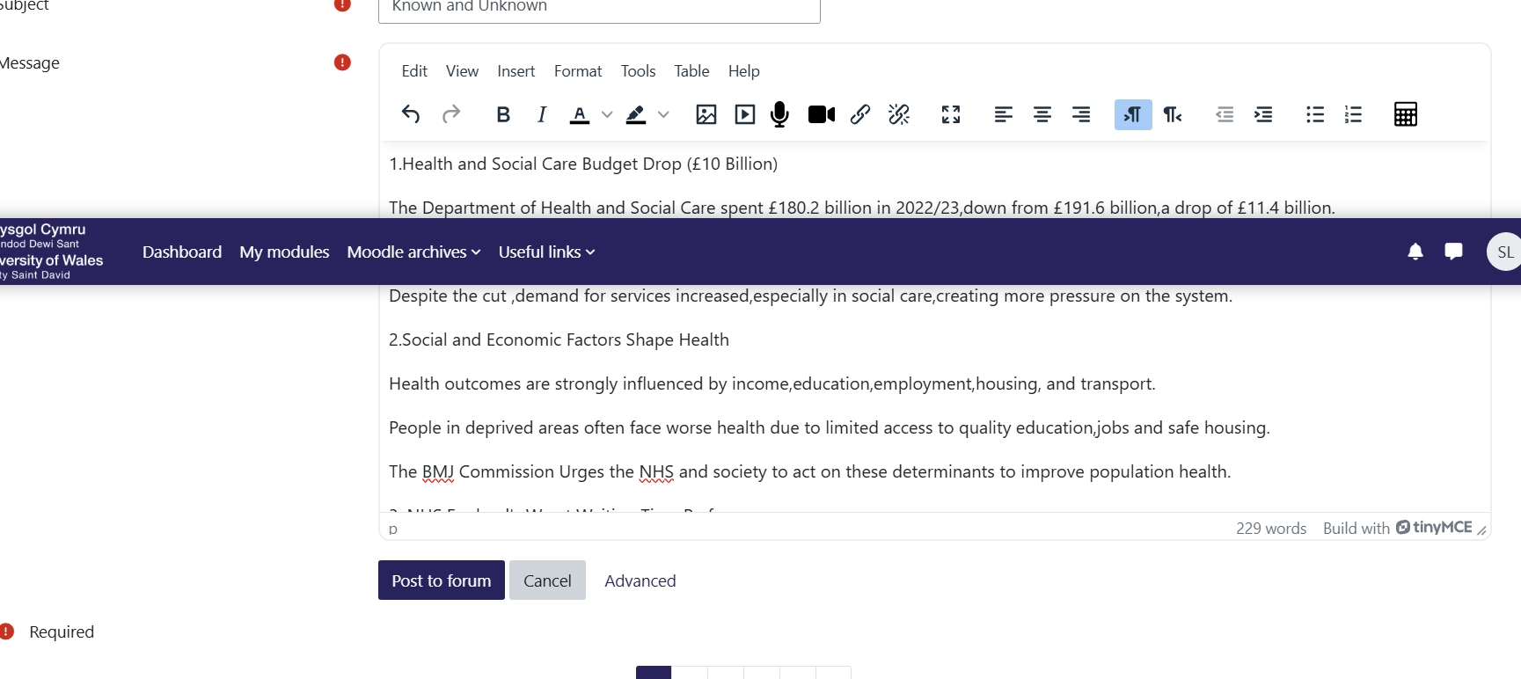

Task 2 - Mind Map (130 words)
The mind map focuses on 'Solving Problems in Health and Social Care' and breaks this down into four main areas from the literature: Workforce Challenges (like new ways to schedule staff to prevent burnout), Patient Flow (such as using AI to reduce delays), Digital Integration (for example, shared EHRs), and Service User Engagement (like co-design methods). Each area includes creative, evidence-based solutions. For example, under Service User Engagement, there are ideas like 'Participatory Action Research' to involve users in designing services and 'Digital Peer Support Platforms' to support care in the community, showing a shift towards more collaborative innovation (Greenhalgh et al., 2019).

Task 3 - Self-Reflection of Group Activity (200 words).
Using Gibbs' Reflective Cycle, this reflection looks at a group activity about why patients miss appointments.
Description & Feelings: The task required generating solutions. The initial divergent thinking phase involved brainstorming ideas like mobile health clinics. I felt hesitant, naturally gravitating towards evaluation. Subsequently, convergent thinking was used to select feasible options based on set criteria, a stage where I felt more competent.
Evaluation & Analysis: The group successfully generated a wide range of ideas before critically evaluating them. I recognised my tendency to converge prematurely, which can inadvertently stifle the ideation process. Academic literature emphasises that divergent and convergent thinking are distinct cognitive processes; suspending judgement during the former is critical for fostering originality (Runco, 2020). My instinct to analyse, while valuable later, was initially misapplied. The activity highlighted that effective teamwork in innovation requires role awareness, with some members championing idea generation and others critical appraisal.
Conclusion & Action: I learned that I am good at judging ideas, but I need to get better at coming up with new ones without judging too soon. In the future, I will practice brainstorming and hold back on judging ideas, so I can contribute more to creative problem-solving in teams.

Task 4 - Case Study Analysis of a UK Innovation (200 words).
Case Study: NHS Virtual Wards
Virtual Wards are a new way of delivering acute care by allowing patients to be managed at home instead of in the hospital (Greenhalgh et al., 2019).
Creativity and Problem: This model creatively addresses the intertwined problems of hospital bed shortages and the risks of hospitalisation for vulnerable patients, such as functional decline and hospital-acquired infections. It digitally redefines the 'ward' concept.
Value Creation and Outcomes: This approach creates value in several ways. Patients get care at home, which can help their mental health and daily functioning. For the health system, it frees up beds and increases capacity. A UK study on a similar 'hospital-at-home' model found that patient outcomes were as good as in-hospital care, with high satisfaction and lower costs per case (Chandler et al., 2020). This shows that the innovation keeps or improves quality while making better use of resources, which is central to value-based healthcare (Kazantsis et al., 2020). 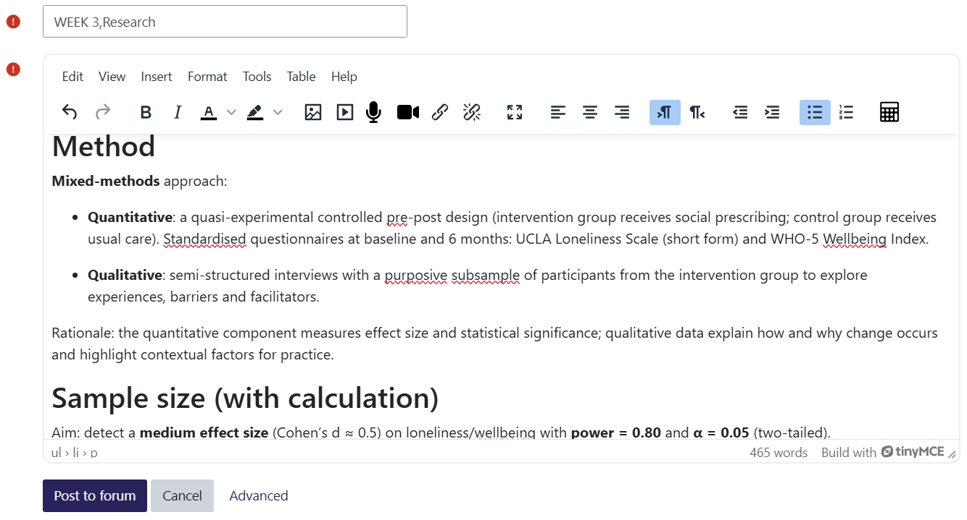

Task 5 - Research Task (200 words)
Current Issue: Staff Burnout in Health and Social Care
Research shows that burnout is mainly caused by how healthcare systems are set up and their culture. Hall, Johnson and Watt (2019), in a systematic review, found that high job demands and low control, which are signs of poor work design, are the main reasons for emotional exhaustion and depersonalisation in nurses. This means the problem comes from the organisation, not from individuals.
Complementing this, West and Coia (2019) analysed the role of organisational culture, finding that a pervasive 'blame culture' erodes psychological safety. When staff fear consequences for admitting error or stress, it inhibits help-seeking and amplifies burnout, directly impairing both staff wellbeing and patient safety. Together, these studies demonstrate that burnout is a systemic issue, rooted in unsustainable workloads and toxic cultural environments, necessitating organisational-level interventions focused on job redesign and fostering trust, rather than resilience training alone. 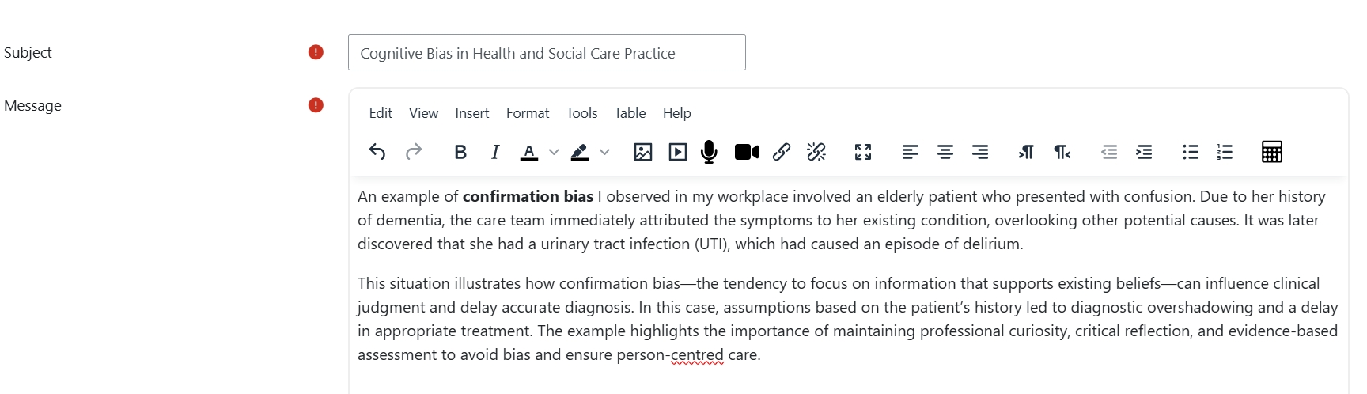

Task 6 - Exploring Digital Innovation in Health and Social Care (140 words each= 420 words in total)
1. Benefit of Wearable Health Technologies
Wearable technologies help people manage chronic conditions by providing continuous monitoring. For example, smartwatches with photoplethysmography sensors can detect arrhythmias in patients with atrial fibrillation (AFib). This allows for early detection of episodes that might not cause symptoms, which is important for starting anticoagulation therapy to prevent stroke (Perez et al., 2019). Instead of relying on occasional doctor visits, patients and clinicians can use ongoing data to make more personalized treatment plans. 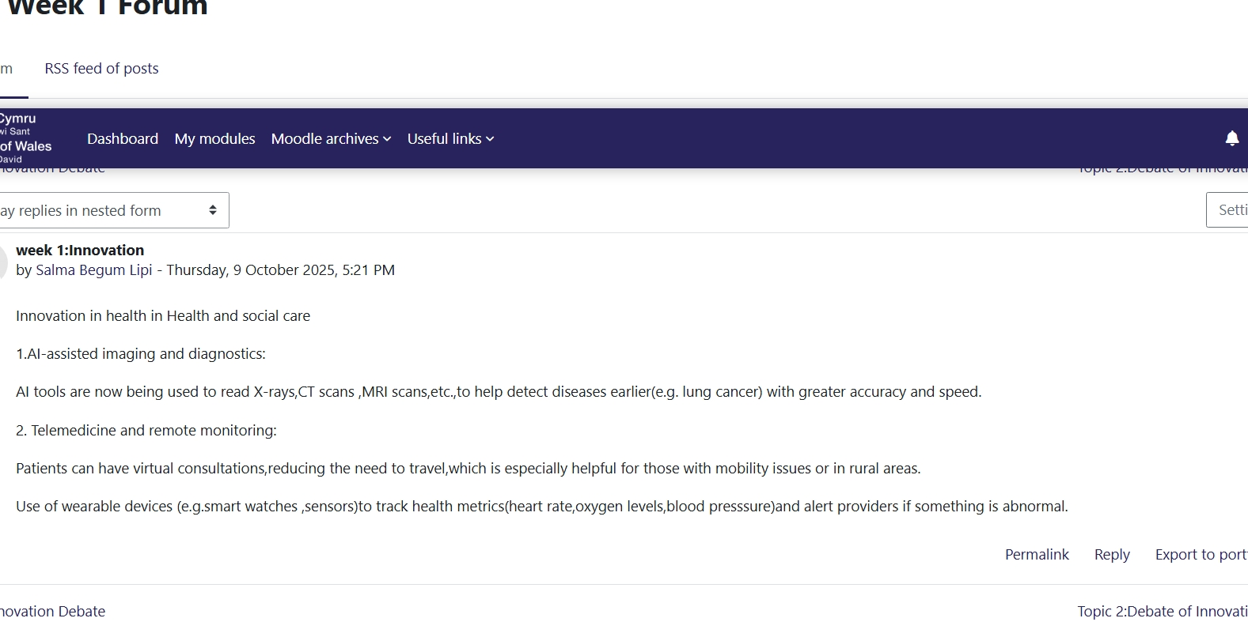
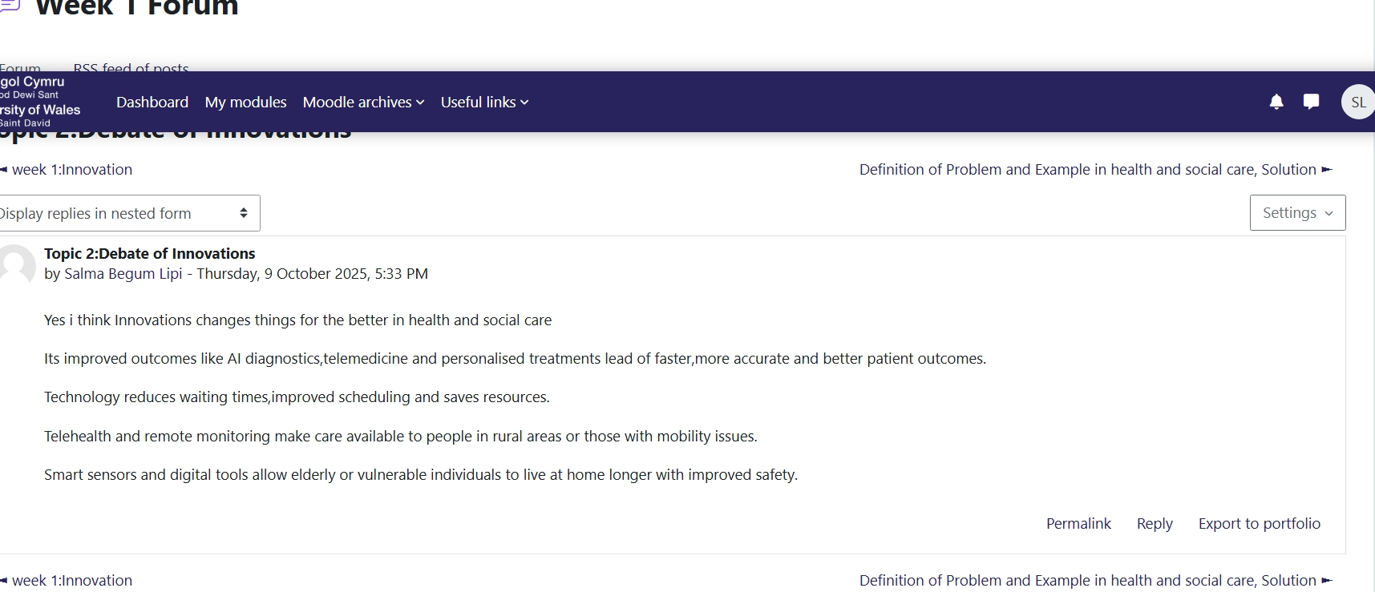

2. How EHRs Improve Communication and Collaboration
Electronic Health Records (EHRs) support teamwork among healthcare professionals by creating a single, accessible patient record. They help prevent communication errors that can happen with paper files or scattered digital records. With one reliable source for patient history, medications, and test results, all providers have the same information (Irizarry et al., 2020). This improves care coordination, cuts down on repeated tests, and helps doctors make better decisions, making care safer and more efficient. 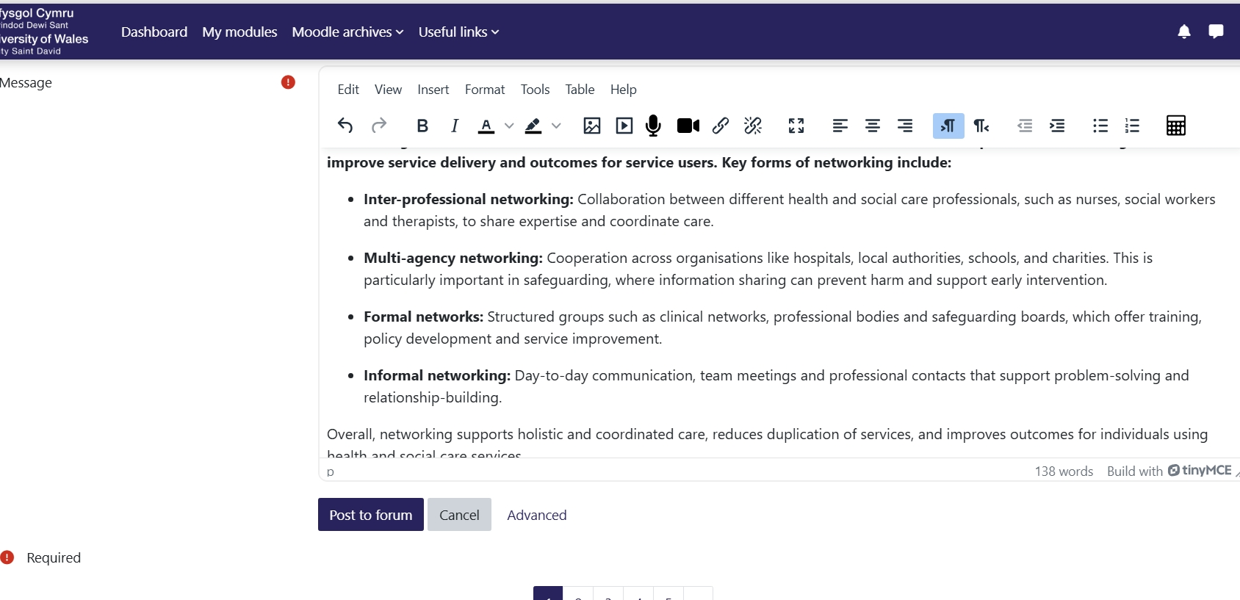
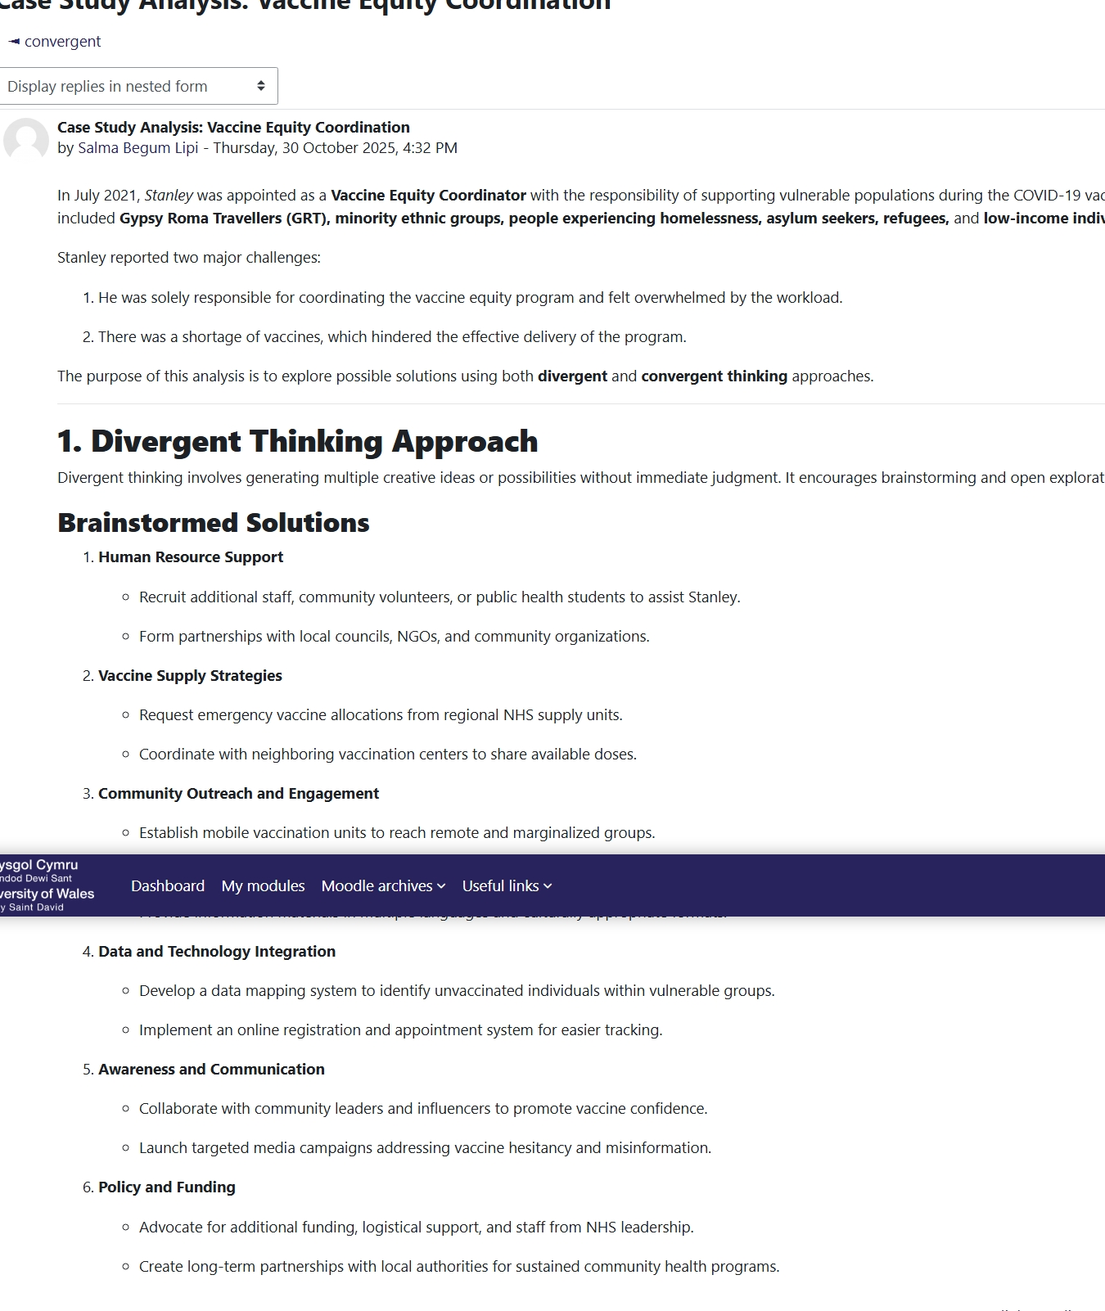

3. Digital Technology in Preventative Care and Health Promotion
Digital platforms are useful for promoting health and preventing disease in large groups of people. For instance, digital exercise programs like 'Couch to 5K' have been studied for their impact on public health. Research shows that these guided apps can help sedentary adults become more active (Houghton et al., 2019). By making support for behavior change widely available, these technologies help prevent chronic diseases such as type 2 diabetes and heart disease, which can lower future healthcare needs and benefit society in the long run. 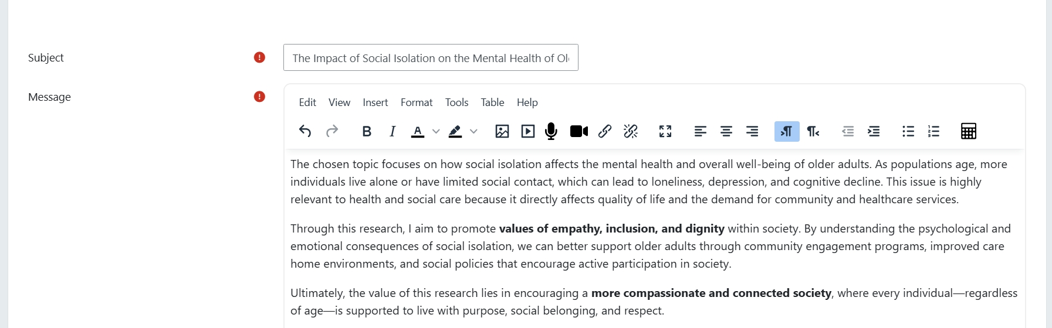

Task 7 - Understanding the NHS Leadership Framework (350)
1. Summary of the NHS Leadership Framework (150 words)
The NHS Leadership Framework, described in the Healthcare Leadership Model, sets out the main leadership behaviours expected at every level of the health service. Its areas, including Inspiring Shared Purpose, Developing Capability, and Leading with Care, offer a clear guide for effective leadership (West et al., 2020). Research shows that collective leadership, where leadership is shared, leads to better organisational results. Studies find that when these behaviours are encouraged among all staff, there is higher patient satisfaction, lower mortality, and better staff well-being and engagement (West et al., 2020). This framework helps create the teamwork and flexibility needed to handle complex healthcare challenges and support ongoing innovation.
2. Applying a Leadership Behaviour (100 words)
Inspiring Shared Purpose is a key leadership behaviour for building a creative workplace. Leaders can do this by sharing a clear, patient-focused vision that goes beyond routine work. They might set aside time for staff to work on creative solutions, like designing new care pathways. When leaders openly value and reward new ideas that support this shared goal, staff feel more empowered (West et al., 2020). This not only encourages creativity but also makes sure that new ideas fit with the service’s main values, which improves patient care and experience. 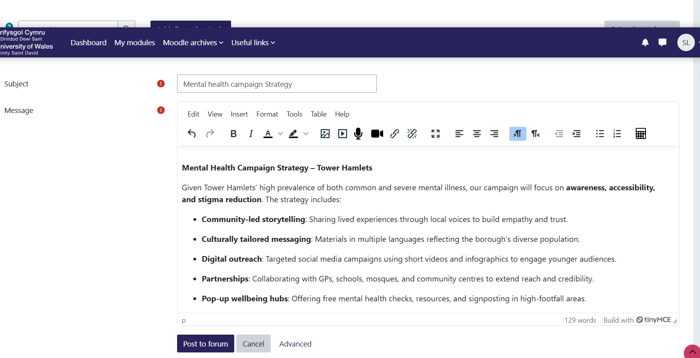
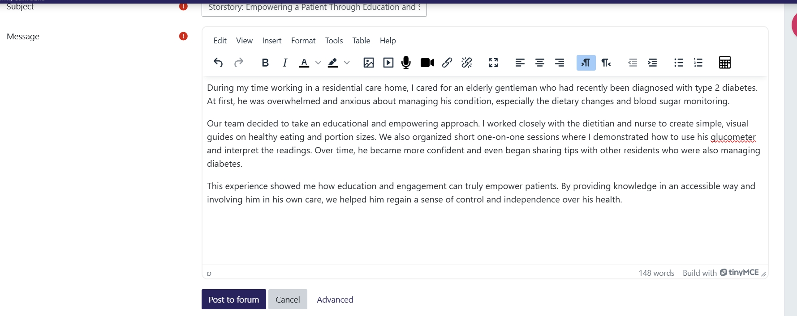

Task 8 - Self-Reflection Journal Entry (150 words)
I used to see creativity as mainly an 'artistic' activity, but now I understand it as a disciplined way to solve problems in care, as Amabile (2020) describes. In the same way, I now see innovation as more than just technology; it is about putting creative ideas into practice to create real value ( Kazantsis et al., 2020). Looking at examples like virtual wards (Chandler et al., 2020) showed me that the biggest changes often come from rethinking how services are delivered. I also learned from West et al. (2020) that strong leadership frameworks help staff to innovate, and that these systemic supports are essential. Bringing these ideas together will shape how I work. I plan to use evidence-based approaches to solve problems, support collective leadership, and always check that my work adds value for service users. 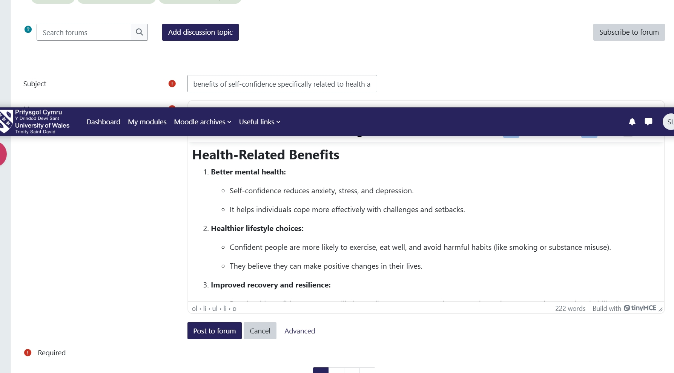

References
Alemzadeh, H., Raman, J., Leveson, N., Kalbarczyk, Z. and Iyer, R.K. (2019) 'Adverse events in robotic surgery: a retrospective study of 14 years of FDA data', PLoS One, 14(4), e0213970.
Amabile, T.M. (2020) 'Creativity, artificial intelligence, and a world of surprises', Academy of Management Discoveries, 6(3), pp. 351-354.
Chandler, D., Fearon, P., Stoner, H.B. and Thompson, J. (2020) 'The hospital at home service: an operational and clinical review', British Journal of Community Nursing, 25(3), pp. 126-132.
Doraiswamy, S., Abraham, A., Mamtani, R. and Cheema, S. (2020) 'Use of telehealth during the COVID-19 pandemic: scoping review', Journal of Medical Internet Research, 22(12), e24087.
Greenhalgh, T., Wherton, J., Papoutsi, C., Lynch, J., Hughes, G., A'Court, C., Hinder, S., Fahy, N., Procter, R. and Shaw, S. (2019) 'Beyond adoption: a new framework for theorizing and evaluating nonadoption, abandonment, and challenges to the scale-up, spread, and sustainability of health and care technologies', Journal of Medical Internet Research, 19(11), e367.
Hall, L.H., Johnson, J. and Watt, I. (2019) 'Healthcare staff wellbeing, burnout, and patient safety: a systematic review', PLoS One, 14(7), e0219015.
Hayes, J. (2022) The Theory and Practice of Change Management. 6th edn. London: Palgrave Macmillan.
Houghton, D., Warburton, D. and Benson, A. (2019) 'The Couch to 5K® running programme: effectiveness and associated barriers and facilitators', Journal of Public Health, 41(2), pp. e123-e131.
Irizarry, T., Dabbs, A.D. and Curran, C.R. (2020) 'Patient portals and patient engagement: a state of the science review', Journal of Medical Internet Research, 17(6), e148.
Kazantsis, N., Carlton, J. and Peyton, L. (2020) 'Value-based healthcare: a review of the literature', Health Services Management Research, 33(4), pp. 183-194.
Perez, M.V., Mahaffey, K.W., Hedlin, H., Rumsfeld, J.S., Garcia, A. and Ferris, T. (2019) 'Large-scale assessment of a smartwatch to identify atrial fibrillation', New England Journal of Medicine, 381, pp. 1909-1917.
Runco, M.A. (2020) 'Divergent and Convergent Thinking'. In: Pritzker, S. and Runco, M. (eds.) Encyclopedia of Creativity. 3rd edn. Academic Press, pp. 373-377.
Shanahan, E., Ryan, F., O'Sullivan, M. and McHugh, C. (2019) 'The impact of music therapy on reducing agitation in patients with dementia: a review of the literature', Irish Journal of Medical Science, 188(4), pp. 1207-1214.
West, M. and Coia, D. (2019) 'Caring for Doctors, Caring for Patients', BMJ Leader, 3(3), pp. 1-4.
West, M., Eckert, R., Steward, K. and Pasmore, B. (2020) 'Developing Collective Leadership for Health Care', Leadership in Health Services, 33(4), pp. 1-14.

