Module Code: BMHP5021
Module Name: Protecting and Supporting Families in Health and Care
Topic: An examination and analysis of how the ‘Early Help’ system is signposted to UK families by their local authority website.
Name: Charlotte Mikano
Lecturer: Amanda Jones

Contents
Introduction 3
Early Help System 3
Multi-agency work 4
Evaluation of three local authority websites 4
A comparative analysis of the main strengths and weaknesses of how the local authority websites communicate the Early Help and other support services available to families 7
Conclusion with recommendations for areas for improvement 8
References 9

Introduction
Early Help provides a preventative and voluntary framework which is designed to support the children and their families by accessing and referring them to contact local council’s children’s service team or sought for guidance from the National Society for the Prevention of Cruelty to Children (NSPCC) platform (Department for Education, 2022). The aim of this report is to develop an understanding of the Early Help System with multi-agency work along with comparative evaluation of the local authority websites of Leeds, Tower Hamlets and Norfolk. This will be done to determine the way each of the websites communicate the Early Help system and related family support services.

Early Help System
The Early Help system in the UK is considered to be a preventive approach in which the needs of the children, young people and their family members are identified and addressed using statutory intervention to prevent escalation. The aim of the Early Help System is to ensure that timely and coordinated support and intervention are received by the service users and that improved outcomes in areas of health, education, parenting, housing, emotional wellbeing and financial stability is achieved (UK Government, 2022). The Early Help System works using a multi-agency partnership model in which the gap between the universal services including schools and GP surgeries and acute statutory social care are bridged. The primary goal of the system is to address the emerging needs and problems faced by the children and families including domestic abuse, special educational needs, parental mental health and prevent the issues from escalating into crises otherwise this would require child protection interventions (Frost, 2021). Further, the key services offered under the Early Help System are parenting programmes and behavioural support, emotional health and wellbeing counseling, support for young carers or children with Special Educational Needs and Disabilities (SEND), housing, debt and financial advice (Young Minds, 2019).

Multi-agency work
Multi-agency working is a significant principle of the Early Help system in the UK which ensures that the children, young people and families are able to receive coordinated support from diverse professionals from different fields so as to prevent escalation. Instead of a single agency working towards addressing the complex needs of the families, Early Help fundamentally advocates for multi-agency working by bringing together different organisations including local authorities, schools, general practitioners, health services, mental health services, voluntary and community organisations, police and housing providers (Walker, 2018). Each of the agencies are expected and responsible for contributing for identifying the needs of the children and families while assess the risk and provide appropriate line of interventions. One of the key feature of the multi-agency working is information sharing in which the family’s consent is crucial and must develop comprehensive understanding about the circumstances (Purcell, Baginsky and Steils, 2025). In terms of the Early Help Assessment, professionals work in collaboration to identifying the needs of the service users by creating a single support plan with defined responsibilities and shared outcomes. The coordinated approaches led by a Lead Professional is significant in facilitating communication, monitoring progress, acting as the main point of contact for the family and arranging for review meetings (Lucas and John Archard, 2021). This multi-agency working approach proved to be effective in reducing duplication of services, ensuring that emerging needs and concerns are identified and addressed promptly and consistently. The statutory guidance Working Together to Safeguard Children (2023) focused on effective safeguarding foster through shared accountability, strong collaboration and timely information sharing (UK government, 2026). With the combination of professional knowledge and resources, multi-agency working is significant to strengthen early intervention and thereby improve children’s health, education and wellbeing and enhance family resilience.

Evaluation of three local authority websites
The first local authority websites evaluated is for the Norfolk County Council where the council website has a string strategic commitment to the preventative services for the residents. This also included a strategic commitment to the Early Help System and its effectiveness in whether the user is a professional or a family seeking support (Norfolk County Council, 2026a). In this regard, the Early Help webpage of Norfolk Council is located within the council’s Strategies and Policies section instead of a dedicated family support section.

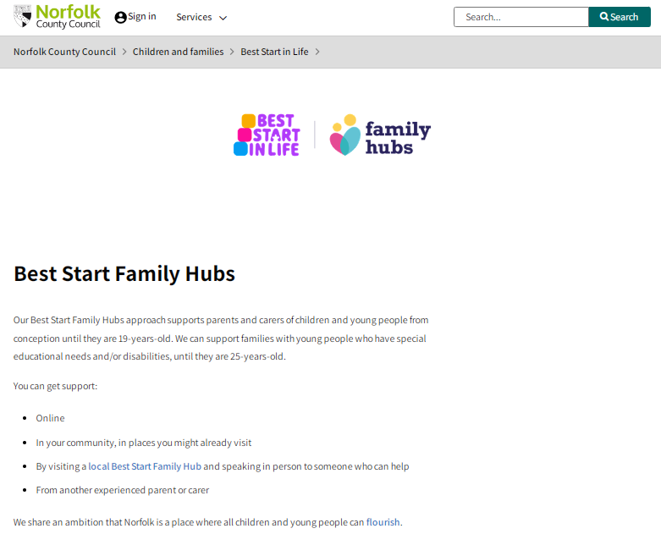
Source: (NCC, 2026)
This proved to be crucial for setting the primary purpose of communicating the policy to the viewer’s rather than just focusing on the direct public guidance. One of the crucial aspects of the webpage is transparency over the information about the health and social services including an unrestricted access to the comprehensive Prevention and Early Help Strategy (2026-2030). This strategy is navigated to a downloadable format file with 24 pages of strategy that clearly explained the vision, strategic objectives, governance arrangements, partnership approach and commitment to ensure that children receiving ‘the right support at the right time’ (Norfolk County Council , 2026b).
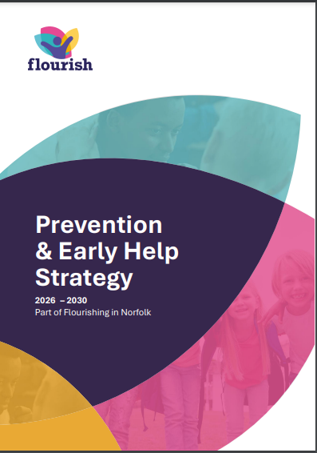

Source: (Norfolk County Council, 2026b)

This strategy has been crucial in collaborative working for early intervention and then demonstrating accountability on the way services are evaluated and improved. Conversely from a family perspective, the local authority website of Norfolk is treated and considered as less effective. Although there is a brief overview of Early Help webpage, the navigation of the website is challenging for the users as the actual strategy is a 24-page long document which is downloaded and stored by the users. However, there is a lack of practical information about the Early Help especially in terms of determining who is eligible, how families can sort for support and self-referral options and what services are available (Jongmans et al., 2022). Norfolk’s Early Help Information has spread across multiple websites including the Norfolk Safeguarding Children Partnership including family support resources rather than developing an integrated one. Overall the website is significant in communicating strategic vision and partnership approach to early Help but requires practical service orientation and more informative page for the professionals (Jongmans et al., 2022).
The second local authority website is of Tower Hamlets which has provided a well-organised Early Help Section which is located through the Children and Family Care pages. The homepage of the website has adopted the family centred approach based on which the Early Help has been explained in the webpage including who it is for and how to support them or receive any support (Tower Hamlets, 2026). Instead of solely
focusing on referrals like other council websites, Tower Hamlets provided wider Early Help offer which includes Best Start Family Hubs, Children and Family Centres targeted services and guidance that aims to create a holistic understanding about the support available. One of the significant aspects of the Early Help webpage is that there is clear explanation of the Multi-Agency Support Team (MAST) which is the single point of contact for Early Help (Tower Hamlets, 2025).
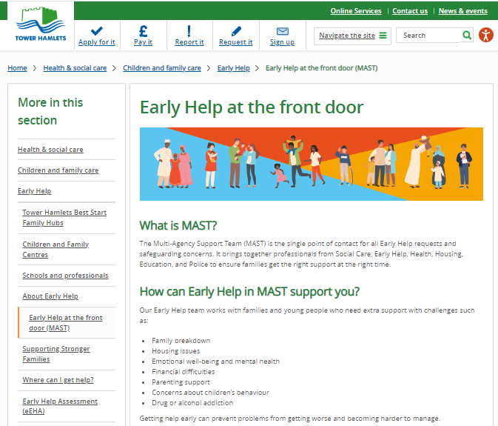

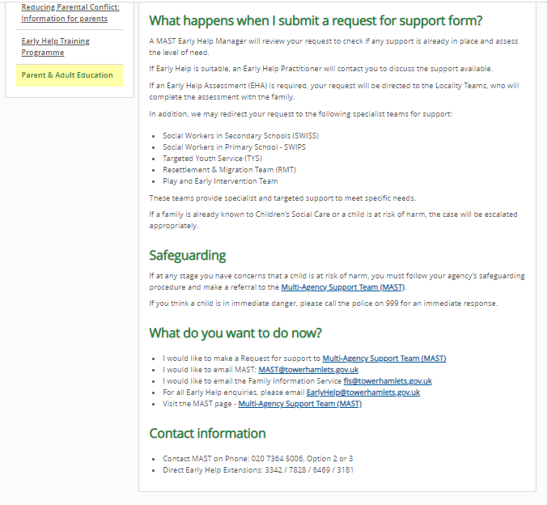
Source: (Tower Hamlets, 2025)
The webpage also outlines the step-by-step referral process with range of difficulties identified which the Early Help system can address using multiple contact methods including telephone numbers, online referral forms and email addresses. However, the website has been embedded with too many and extensive information while the terminologies used in website that makes it unfamiliar to many places and even parents. The information on the webpage is text-heavy and limited use of visual aids and info graphics that showcased the improvement in accessibility for users with lower literacy levels or learning needs (Traboco et al., 2022). Overall, the Tower Hamlets’ website is effective in communicating the Early Help system effectively with near clear navigation, detailed information and accessible referral routines to emphasis on simple language and inclusive communication (Tower Hamlets, 2026).
The Leeds City Council is the third local council website which has been accessed to provide a well-structured and comprehensive source of information for Early Help schedule. The website offered a library of One Minute Guides which engages the users to access concise information on the different aspects of children’s services and safeguarding. This structure also includes the One Minute Guides for Early Help which offered a well-integrated approach and easy to find local relevant guidance (Leeds City Council, 2023).
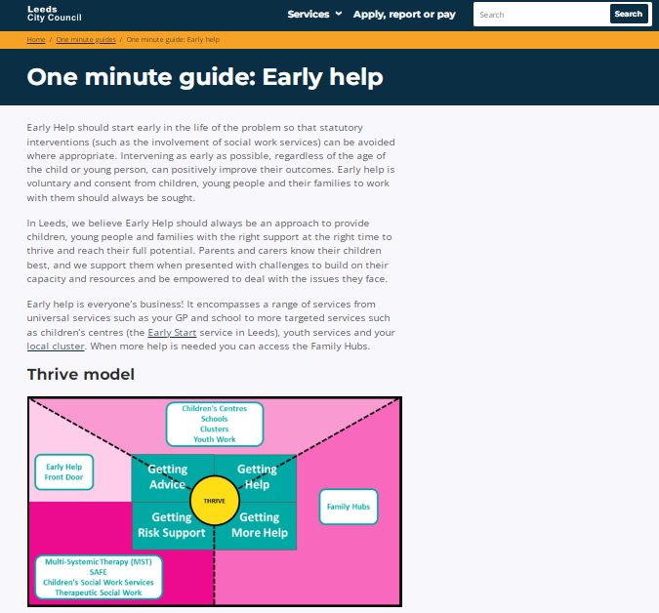

The Early Help Webpage has clear communication of the purpose of the strategy including emphasis on prevention, early intervention and partnership working with families. The website also contained a graduated ‘Thrive Model’ to effectively engage the families to move from universal services to targeted and specialist support for the diverse children needs (Leeds City Council, 2023).
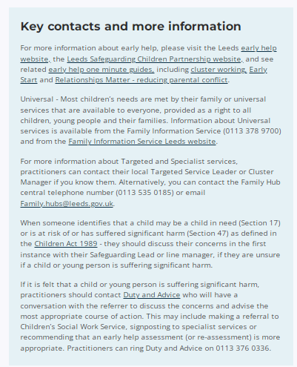

Source: Leeds City Council (2023)
The webpage also reflected the current national guidance including the Working Together to Safeguard Children (2023) suggesting that the information has been regularly updated. The website integrated the family hubs and Early Help Front Door that send out clear pathway for accessing support while also including telephone numbers, safeguarding procedures and email and contact details improved the accessibility to practitioners and families for seeking advice and support (Leeds City Council, 2023). Although the Early Help webpage provided comprehensive content on the strategy, the Leeds website has been primarily designed for professionals and is therefore not friendly with the public. This webpage also contained technical terminology including cluster working, restorative practices etc. which are difficult for the parents and carers to comprehend (Dunlap and Lowenthal, 2016). Further, the webpage also was presented as lengthy paragraphs of key contacts and more information about early help supported by contact details and backed by legislations but with limited visual aids which reduced the readability of the page seeking quick guidance.

A comparative analysis of the main strengths and weaknesses of how the local authority websites communicate the Early Help and other support services available to families
A comparative analysis of the three local authority websites are crucial in understanding the way each of the councils shared their commitment towards promoting Early Help using early intervention, family centred support and multi-agency collaboration. However, there are considerable differences in the way information is communicated to the users.
The strengths of Tower Hamlets’ website communicating Early Help and other family support services lay in the family centred approach which ensured that clear and simple explanations of Early Help is provided that abides by the eligibility criteria and available services and referral pathways through MAST which is significant for the families to make the website accessible and informative (Tower Hamlets, 2026).
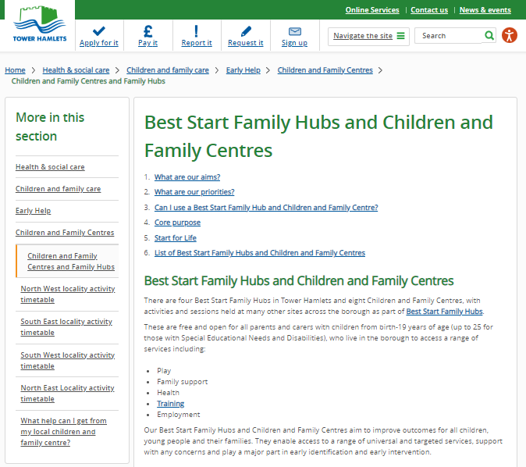

Comprehensive operational guidance is also a key strength of the Leeds website which demonstrated a comprehensive guide in the form of One Minute Guides and Thrive Model that gradated the pathway from universal to targeted specialist services on Early Help Support with current national safeguarding guidance (Leeds City Council, 2023). Comparing the strengths of the websites of Leeds and Tower Hamlets, the Norfolk’s principal strength lay in the transparent strategic commitment toward providing detailed policy documents which offers a clear and detailed guidance over partnership working and long-term priorities for Early Help. However, each of the websites involve and present notable weaknesses (Norfolk County Council, 2026b). While Norfolk has a dedicated document on Early Help, the strategy lacked practical information for the families which required the user to navigate the lengthy strategy document and different webpages to determine the available support (Norfolk County Council , 2026b). On the other hand, Leeds’ weakness in its website for Early Help support has extensive professional terminology along with lengthy text which eventually reduced the readability and accessibility of information about Early Help and family support services for parents and carers. Similarly, Tower Hamlets website is user friendly comparatively bit the webpages are txt heavy with limited use of visual resources and interactive tools for facilitating the use of Early Help information resources (Traboco et al., 2022). Overall the three websites have complementary strengths but also weaknesses which could be addressed to improve public understand and greater accessibility to early Help services.

Conclusion with recommendations for areas for improvement
Thus, the three local authority websites have depicted their commitment towards communicating and promoting early Help using early intervention, partnership working an family support. However, there lays differences in the effectiveness of communicating and publishing key information about the Early Help System on the websites. Norfolk has provided a comprehensive strategic guidance document while Tower Hamlets offered accessible family focused information and Leeds delivered operational guidance for professionals. The accessibility of all the three websites could have been improved with the recommendation of using more if simplified professional terminology free from medical jargons, reducing the heavy content text from the web page and recommended use of more visual aids including videos, infographics and clear self-referral pathways. These recommendations would enhance user experience and also boost public understanding and confidence over accessing Early Help services more efficiently.

References
Department for Education (2022) Early help system guide a toolkit to assist local strategic partnerships responsible for their early help system. Available at: https://assets.publishing.service.gov.uk/media/628de13be90e071f5f7e1bd2/Early_Help_System_Guide.pdf (Accessed: July 23, 2026).
Dunlap, J.C. and Lowenthal, P.R. (2016) “Getting graphic about infographics: Design lessons learned from popular infographics,” Journal of Visual literacy, 35(1), pp. 42–59. Available at: https://doi.org/10.1080/1051144x.2016.1205832.
Frost, N. (2021) Safeguarding children and young people. SAGE.
Jongmans, E., Jeannot, F., Liang, L. and Dampérat, M. (2022) “Impact of website visual design on user experience and website evaluation: The sequential mediating roles of usability and pleasure,” Journal of Marketing management, 38(17–18), pp. 1–36. Available at: https://doi.org/10.1080/0267257x.2022.2085315.
Leeds City Council (2023) One minute guide: Early help | leeds.gov.uk, Leeds.gov.uk. Available at: https://www.leeds.gov.uk/one-minute-guides/early-help (Accessed: July 22, 2026).
Lucas, S. and John Archard, P. (2021) “Early help and children’s services: Exploring provision and practice across english local authorities,” Journal of Children’s services, 16(1), pp. 74–86. Available at: https://doi.org/10.1108/jcs-03-2020-0006.
Norfolk County Council (2026a) Prevention and Early Help Strategy , Norfolk County Council . Available at: https://www.norfolk.gov.uk/article/73743/Prevention-and-early-help-strategy (Accessed: July 23, 2026).
Norfolk County Council (2026b) Prevention and Early Help Strategy (2026-2030). Available at: https://www.norfolk.gov.uk/media/21073/Prevention-and-Early-Help-Strategy/pdf/doNorfolk_Prevention___Early_Help_Strategy_202630_.pdf?m=1769077653453 (Accessed: July 23, 2026).
Purcell, C., Baginsky, M. and Steils, N. (2025) “No quick fixes: Multi-agency working to improve information-sharing on men and keep children safe,” The british journal of Social work, 56(4), pp. 1610–1630. Available at: https://doi.org/10.1093/bjsw/bcaf249.
Tower Hamlets (2025) Multi-Agency support team (MAST), Towerhamlets.gov.uk. Available at: https://www.towerhamlets.gov.uk/lgnl/health__social_care/children_and_family_care/Multi-Agency-Support-Team-MAST.aspx (Accessed: July 23, 2026).
Tower Hamlets (2026) Early help hub, www.towerhamlets.gov.uk. Available at: https://www.towerhamlets.gov.uk/lgnl/health__social_care/children_and_family_care/Early_Help/Early_Help_Hub.aspx (Accessed: July 23, 2026).
Traboco, L., Pandian, H., Nikiphorou, E. and Gupta, L. (2022) “Designing infographics: Visual representations for Enhancing education, communication, and scientific research,” Journal of Korean medical science, 37(27). Available at: https://doi.org/10.3346/jkms.2022.37.e214.
UK Government (2022) Supporting families: Early help system guide, GOV.UK. Available at: https://www.gov.uk/government/publications/supporting-families-early-help-system-guide (Accessed: July 23, 2026).
UK government (2026) Working together to Safeguard children 2026. Available at: https://assets.publishing.service.gov.uk/media/69fb1c28d0e316a40f269a5b/Working_together_to_safeguard_children_2026_a_guide_to_multi_agency_working.pdf (Accessed: July 23, 2026).
Walker, G. (2018) Working together for children - a critical introduction to multi-agency wor. 2nd edn. Bloomsbury Publishing Plc.
Young Minds (2019) Guide to early help and early intervention services, Young minds. Available at: https://www.youngminds.org.uk/parent/parents-a-z-mental-health-guide/early-help-and-early-intervention-services/ (Accessed: July 22, 2026).

