Transient Response Modelling of a Vehicle
Yujian Liu
Abstract: This paper examines the development of vehicle models from simple spring-mass-damped (SMD) models to complex seven-degree-of-freedom (7DOF) models. The research outlines the theoretical foundations and practical applications of each model, from the basic spring-damped model used to simulate vehicle suspension systems to a full 7DOF model incorporating longitudinal, lateral, vertical, pitch, roll and yaw motions, including one degree of freedom for each wheel. The research includes dynamic response testing, correlation of the model with simulator data, and critical evaluation and further investigation of the model's accuracy, limitations and potential for improvement through parameter changes. The paper makes extensive use of mathematical formulas to describe the system dynamics, simulations using Simulink, and suggestions for modifications to improve model accuracy and vehicle response.
Introduction
During driving, vehicles often experience significant vibrations due to uneven road surfaces, changes in speed, and directional shifts. These vibrations not only have a significant negative impact on vehicle performance, including reduced fuel efficiency, poor handling, reduced stability, and reduced passenger comfort, but can also cause wear and tear on vehicle components and cargo, which can shorten the life of the vehicle[1][2]. Therefore, the design of suspension systems is particularly important to mitigate these vibrations, emphasising the need for careful selection of suspension parameters to enhance vehicle dynamic characteristics and overall performance.

In order to fully analyse the behaviour of a vehicle suspension system, one of three models is commonly used: the quarter vehicle model[3], [4]the half vehicle model and the full vehicle model[5][6]. The quarter-vehicle model focuses on one corner of the vehicle and is mainly used to study the dynamic response of individual tyres and suspension systems. The half-vehicle model considers one half of the vehicle and is able to simulate the behaviour of the vehicle in both longitudinal and lateral movements, including roll and pitch. The full vehicle model, on the other hand, provides the most comprehensive view, which involves all four tyres and suspension systems of the vehicle, as well as the dynamic response of the body[7][8].

In this study, a full vehicle model was used to examine in detail the performance of the suspension system of a heavy vehicle. The model is a linear system with seven degrees of freedom, which includes a spring mass and four unsprung masses. The spring mass, i.e. the body, is connected to the unsprung masses via the suspension system, which consists of four suspension units and tyres at each corner of the vehicle. The sprung mass has three degrees of freedom, representing the body's bouncing, rolling and pitching movements, which are key factors in assessing the vehicle's handling stability and passenger comfort. The unsprung mass, on the other hand, has four degrees of freedom and focuses on vertical motion, which is critical to understanding how the tyres interact with the road surface and how they are adjusted by the suspension to absorb shocks and reduce vibration.

By studying the full vehicle model in detail, the design of the suspension system can be better understood and optimised to improve vehicle performance in all driving conditions, ensure passenger comfort and extend the life of the vehicle. This analytical approach provides valuable insight for engineers when designing and tuning suspension systems, enabling them to more accurately predict vehicle behaviour and therefore develop suspension system solutions that enhance performance while ensuring safety and comfort.
1.Developing the SMD Model from 1DOF to 7DOF for vehicle
1.1 Simple spring-mass-damper model
The spring damping model is a classical physical model widely used in engineering and science to describe the vibrational behaviour of a system under external forces. Using the spring damping model to simulate a vehicle suspension system, the dynamic response of the system can be ptimized by adjusting the spring stiffness and damping coefficient to achieve the purpose of vibration damping and vibration control.
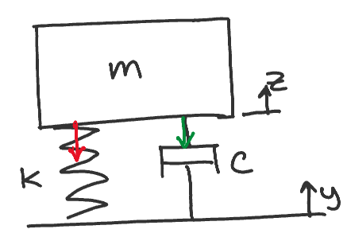
The model is consisted of mass block, spring and damper. The spring represents the restoring force of the system, i.e., the force generated when the system deviates from the equilibrium position and tries to pull the system back to the equilibrium position. The force of the spring is proportional to the displacement and follows Hooke’s law:
$F_{s}=k\left(z-y\right)$ (1)
Dampers represent the damping force applied to the system, proportional to the velocity of the system, always in the direction opposite to the direction of motion, with the expression:
$F_{d}=C\left(\dot{z}-\dot{y}\right)$ (2)
Combining the spring and the damper, the dynamic equations of the spring-damped model are obtained
$-ma=F_{s}+F_{d}$ (3)
$-m\ddot{z}=k\left(z-y\right)+C\left(\dot{z}-\dot{y}\right)$ (4)

Where :
$z$ is the displacement;
$y$ is the Road Incentives;
$m$ is the mass of the system;
$\ddot{z}$ is the acceleration.
We use the Simulink model of matlab to simulation. The model is shown below.
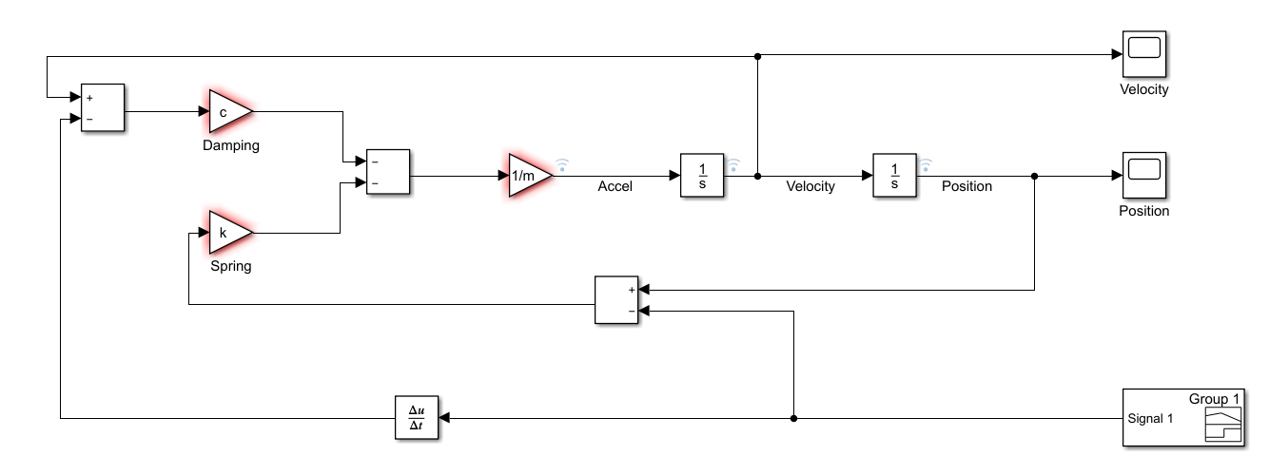
1.2 1/4 vehicle model
The single-wheel vehicle model is a fundamental tool in the field of vehicle dynamics and is primarily used to assess ride quality and the efficacy of suspension systems. By abstracting the vehicle as a single mass connected to the road through only one wheel, the model intentionally sets aside complex issues such as pitch and roll dynamics and the interaction between multiple axles and their respective wheels. With this simplified approach, it is easier to analyse how the suspension system responds to irregularities in the road surface, providing engineers with a focused view of the contribution of suspension components to the overall smoothness of the vehicle ride.
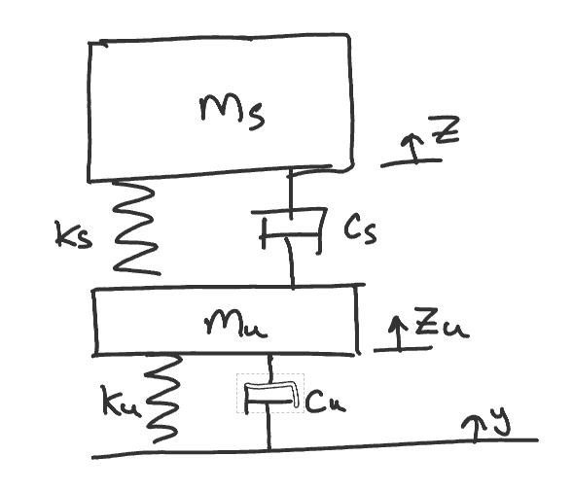
According to the Newton’s second law to the model, establish the following differential equation.
$$-m_{s}\ddot{z}=k_{s}\left(z-z_{u}\right)+C_{s}\left(z-z_{u}\right)$$
$$-m_{u}\ddot{z}=k_{u}\left(z_{u}-y\right)+C_{u}\left({\dot{z}}_{u}-\dot{y}\right)-k_{s}\left(z-z_{u}\right)-c_{s}(\dot{z}-{\dot{z}}_{u})$$
Where :
$z$ is the displacement;
$y$ is the Road Incentives;
$m_{s}$ is the mass of vehicle;
$m_{u}$ is the mass of tyre;
$\ddot{z}$ is the acceleration.
Simulink model is shown in below figure.
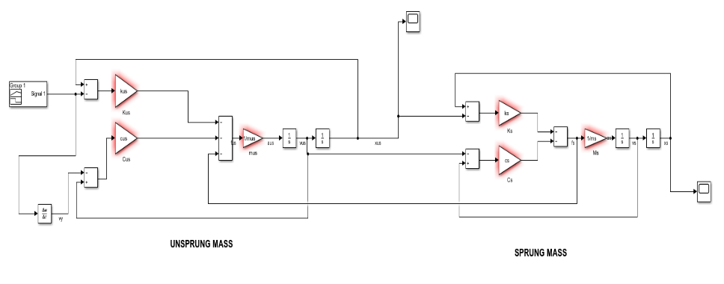
1.3 1/2 vehicle model
The half-vehicle model is an important concept in the analysis of vehicle dynamics, providing a more sophisticated and closer analysis of actual vehicle behaviour than the single-wheel model, while at the same time being more simplified than the full-vehicle model. A half-vehicle model usually includes one half of the vehicle, assuming symmetry of the vehicle, in order to study the dynamic response of the vehicle in the vertical direction, especially the vibration characteristics when facing an uneven road surface. This model is able to take into account both pitch (back and forth oscillation) and bump (up and down vibration) motions of the vehicle in order to analyse the performance of the suspension system and the ride comfort. Simplified model is shown as follows.
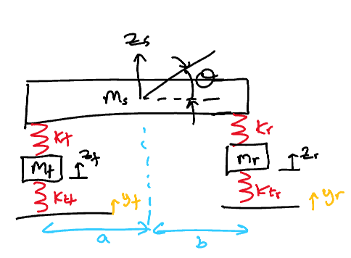
Firstly, we analysing the front and rear tyres. Tyres received two forces of spring.
$$-m_{f}{\ddot{z}}_{f}=k_{tf}\left(z_{f}-y_{f}\right)-k_{f}\left(z_{s}-z_{f}-aθ\right)$$
$$-m_{r}{\ddot{z}}_{r}=k_{tr}\left(z_{r}-y_{r}\right)-k_{r}\left(z_{s}-z_{r}+bθ\right)$$
The body is subjected not only to the spring force, but also to the torque generated by the pitching. According to the law of rotation and Newton's second law, we can obtain two equations.
$$-m_{s}{\ddot{z}}_{s}=k_{f}\left(z_{s}-z_{f}-aθ\right)+k_{r}\left(z_{s}-z_{r}+bθ\right)$$
$$-I\ddot{θ}=bk_{r}\left(z_{s}-z_{r}+bθ\right)-ak_{f}\left(z_{s}-z_{f}-aθ\right)$$
Where :
$z_{s}$ is the displacement;
$θ$ is the pitch angle;
$\ddot{θ}$ is the pitch angle acceleration
Simulink model is shown in below figure.
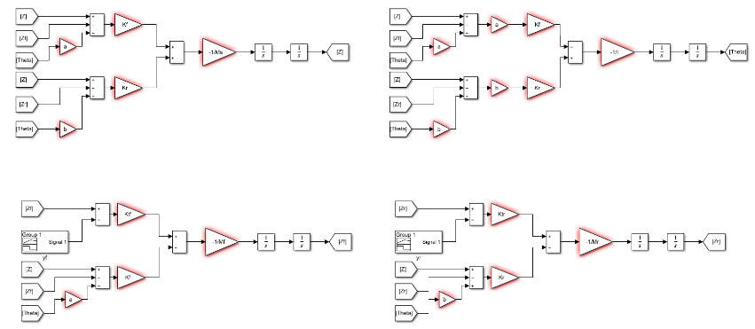
1.4 7DOF vehicle model
The comprehensive vehicle model captures a multi-faceted view of vehicle dynamics by including seven degrees of freedom, which accounts for each wheel's independent movement and the vehicle body's motion in three-dimensional space. This advanced model encompasses the entire vehicle's response to various driving conditions and maneuvers. It factors in key vehicle geometric properties, such as the wheelbase and track width, which are fundamental to understanding stability and handling. The spring rates and damping coefficients are integral to the model as they dictate the suspension system's reaction to road irregularities, contributing to ride comfort and control. Additionally, the roll center heights are crucial for assessing the vehicle's propensity to roll in turns, influencing the dynamic load transfer and overall lateral dynamics. This detailed modeling approach provides a robust framework for simulating real-world vehicle behavior with high fidelity.
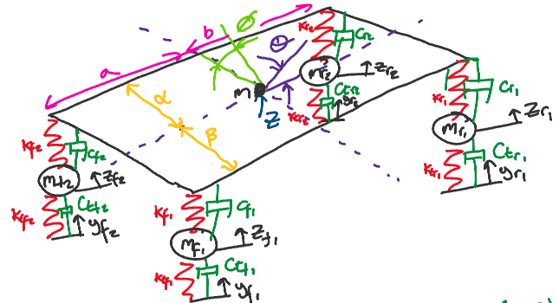

Equations of motion for the centre of mass of the body:
$$-m\ddot{z}=k_{f1}\left(z-z_{f1}-aθ-β∅\right)+C_{f1}\left(\dot{z}-\dot{z_{f1}}-a\dot{θ}-β\dot{∅}\right)$$
$${+k}_{f2}\left(z-z_{f2}-aθ+α∅\right)+C_{f2}\left(\dot{z}-\dot{z_{f2}}-a\dot{θ}+α\dot{∅}\right)$$
$$+k_{r1}\left(z-z_{r1}+bθ-β∅\right)+C_{r1}\left(\dot{z}-\dot{z_{r1}}+b\dot{θ}-β\dot{∅}\right)$$
$$+k_{r2}\left(z-z_{r2}+bθ+α∅\right)+C_{r2}\left(\dot{z}-\dot{z_{r2}}+b\dot{θ}+α\dot{∅}\right)$$
Equations of motion for body pitch:
$$-Ixx\ddot{θ}={bk}_{r1}\left(z-z_{r1}+bθ-β∅\right)+{bC}_{r1}\left(\dot{z}-\dot{z_{r1}}+b\dot{θ}-β\dot{∅}\right) +{bk}_{r2}\left(z-z_{r2}+bθ+α∅\right)+bC_{r2}\left(\dot{z}-\dot{z_{r2}}+b\dot{θ}+α\dot{∅}\right)-{ak}_{f1}\left(z-z_{f1}-aθ-β∅\right)-aC_{f1}\left(\dot{z}-\dot{z_{f1}}-a\dot{θ}-β\dot{∅}\right)-ak_{f2}\left(z-z_{f2}-aθ+α∅\right)-aC_{f2}\left(\dot{z}-\dot{z_{f2}}-a\dot{θ}+α\dot{∅}\right)$$
Equations of motion for body roll:
$$-Iyy\ddot{∅}={αk}_{f2}\left(z-z_{f2}-aθ+α∅\right)+{αC}_{f2}\left(\dot{z}-\dot{z_{f2}}-a\dot{θ}+α\dot{∅}\right)$$
$$+{αk}_{r2}\left(z-z_{r2}+bθ+α∅\right)+{αC}_{r2}\left(\dot{z}-\dot{z_{r2}}+b\dot{θ}+α\dot{∅}\right)$$
$$-{βk}_{f1}\left(z-z_{f1}-aθ-β∅\right)-βC_{f1}\left(\dot{z}-\dot{z_{f1}}-a\dot{θ}-β\dot{∅}\right)$$
$$-βk_{r1}\left(z-z_{r1}+bθ-β∅\right)-{βC}_{r1}\left(\dot{z}-\dot{z_{r1}}+b\dot{θ}-β\dot{∅}\right)$$
Four equations of tyres:
$${-m}_{f1}\ddot{z_{f1}}={k_{tf1}\left(z_{f1}-y_{f1}\right)-k}_{f1}\left(z-z_{f1}-aθ-β∅\right)$$
$$-C_{f1}\left(\dot{z}-\dot{z_{f1}}-a\dot{θ}-β\dot{∅}\right)+C_{tf1}\left(\dot{z_{f1}}-\dot{y_{f1}}\right)$$
$${-m}_{f2}\ddot{z_{f2}}=k_{tf2}\left(z_{f2}-y_{f2}\right)- k_{f2}\left(z-z_{f2}-aθ+α∅\right)$$
$$-C_{f_{2}}\left(\dot{z}-\dot{z_{f2}}-a\dot{θ}+α\dot{∅}\right)+C_{tf2}\left(\dot{z_{f2}}-\dot{y_{f2}}\right)$$
$${-m}_{r1}\ddot{z_{r1}}={k_{tr1}\left(z_{r1}-y_{r1}\right)-k}_{r1}\left(z-z_{r1}+bθ-β∅\right)$$
$$-C_{r1}\left(\dot{z}-\dot{z_{r1}}+b\dot{θ}-β\dot{∅}\right)+C_{tr1}\left(\dot{z_{r1}}-\dot{y_{r1}}\right)$$
$${-m}_{r2}\ddot{z_{r2}}={k_{tr2}\left(z_{r2}-y_{r2}\right)-k}_{r2}\left(z-z_{r2}+bθ+α∅\right)$$
$$-C_{r2}\left(\dot{z}-\dot{z_{r2}}+b\dot{θ}+α\dot{∅}\right)+C_{tr2}\left(\dot{z_{r2}}-\dot{y_{r2}}\right)$$

The following table shows the main parameters of the seven-degree-of-freedom vehicle model. Assuming that the vehicle is subjected to a displacement input of 0.05m from the ground.

Vehicle Mass (kg) | M_{T} | 514
Front Corner Unsprung Mass (kg) | M_{usf} | 22
Rear Corner Unsprung Mass (kg) | M_{usr} | 22
Vehicle Sprung Mass (kg) | M_{s} | 426
Centre of Gravity Height (m) | CoG | 0.277
Weight Split F:R (%) | - | 45:55
Wheelbase (m) | W | 2.443
Front Track (m) | T_{f} | 1.62
Rear Track (m) | T_{r} | 1.57
Front Tyre Rolling Radius (m) | r_{f} | 0.2667
Rear Tyre Rolling Radius (m) | r_{r} | 0.2794
Front Motion Ratio | M_{Rf} | 1
Rear Motion Ratio | M_{Rr} | 1
Front Default Spring Rate (N/mm) | K_{sf} | 18
Rear Default Spring Rate (N/mm) | K_{sr} | 16
Front Roll Centre Height (mm) | h_{f} | 0.9
Rear Roll Centre Height (mm) | h_{r} | 59
The simulation model of the whole vehicle are as follows:
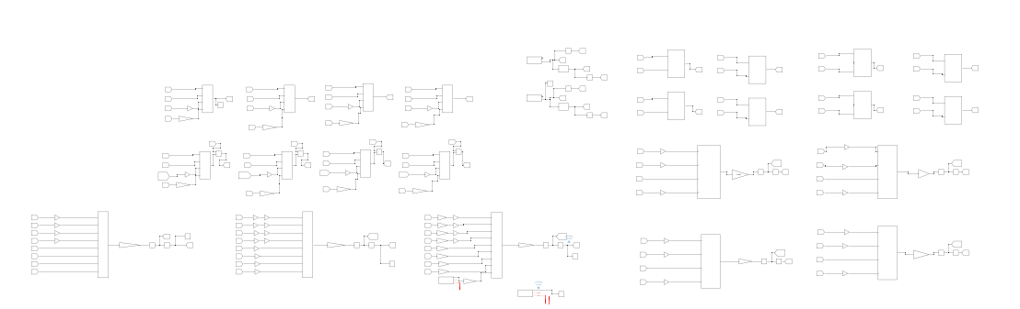

2. Dynamic Response Testing and Correlation with Simulator Data
2.1 The dynamic response of the 7DOF system in pitch and roll
The detailed examination of the dynamic response of a vehicle subjected to a road surface excitation of 0.05m reveals several critical aspects of its behavior, particularly in terms of vertical displacement, pitch angle, and lateral inclination.
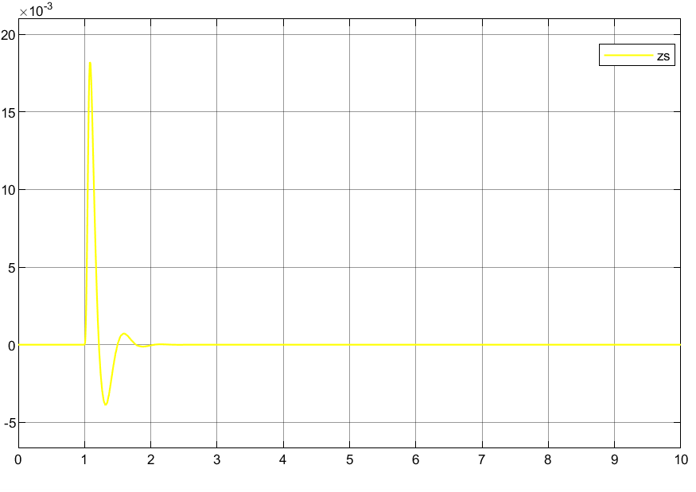
Firstly, the vertical displacement of the vehicle body, highlighted in yellow, demonstrates a significant response to the road excitation, peaking at a maximum amplitude of 0.01822 meters. This peak amplitude is a vital indicator of the vehicle's vertical dynamic behavior under the given road conditions. After reaching its maximum, the displacement shows a stabilization trend, settling down after approximately 2.4 seconds. This pattern suggests that the vehicle's suspension system efficiently absorbs and dissipates the energy from the road excitation, returning to a steady state within a relatively short duration.
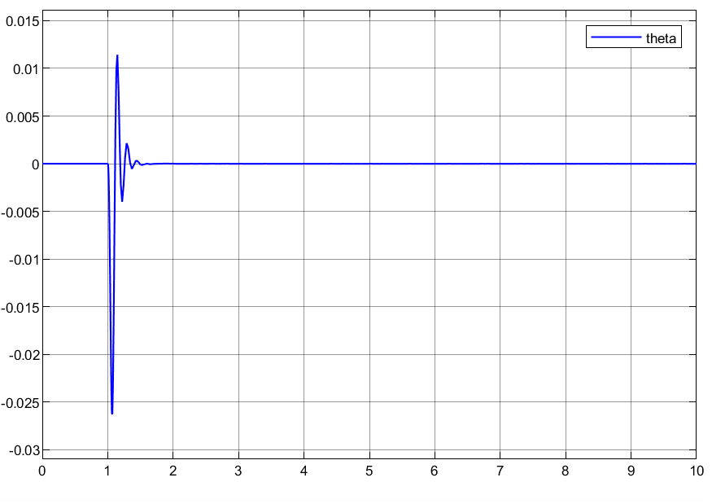
Secondly, the pitch angle of the vehicle body, denoted in blue, exhibits oscillations around the 0-degree mark. It achieves a maximum deviation of -0.02627 degrees from this neutral position. The fluctuation of the pitch angle is an important measure of the vehicle's longitudinal dynamic stability. The fact that it stabilizes after 1.9 seconds indicates the effectiveness of the vehicle's suspension system in managing longitudinal oscillations and maintaining the vehicle's orientation relative to the driving direction.
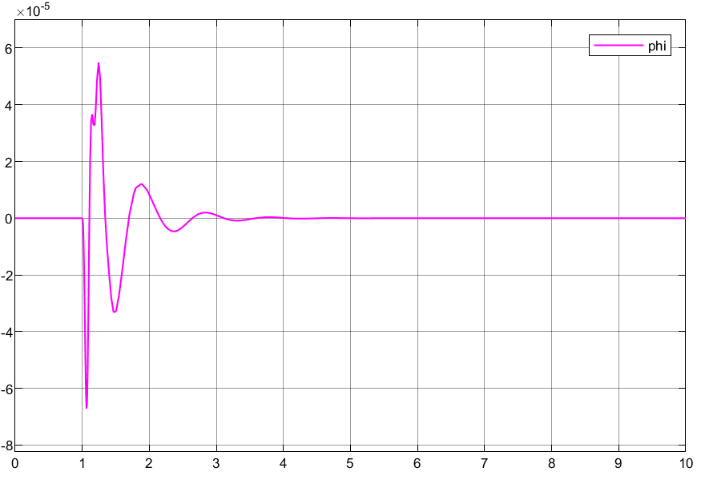
Lastly, the lateral inclination angle of the vehicle body remains negligible throughout the observation period, indicating an almost non-existent lateral tilting movement. This observation is crucial, as lateral stability is paramount for vehicle safety, especially in maneuvers such as turning or when subjected to side winds. The absence of significant lateral inclination under the specified road excitation is attributed to the symmetrical design of the vehicle's suspension system. The equal stiffness and damping coefficients of the left and right suspensions, along with the uniform stiffness of the left and right tires, ensure that the vehicle remains balanced and stable laterally. This symmetry prevents differential responses on either side of the vehicle, thus maintaining a level orientation without inducing lateral tilt.
2.2 Correlating Model to Simulator Data
In order to implement the lane shift test operation of the simulink model, lateral acceleration (ax) is introduced and used as an input to the SDM in matlab/simulink. At this point the body roll equation is:
$$-Iyy\ddot{∅}={αk}_{f2}\left(z-z_{f2}-aθ+α∅\right)+{αC}_{f2}\left(\dot{z}-\dot{z_{f2}}-a\dot{θ}+α\dot{∅}\right)$$
$$+{αk}_{r2}\left(z-z_{r2}+bθ+α∅\right)+{αC}_{r2}\left(\dot{z}-\dot{z_{r2}}+b\dot{θ}+α\dot{∅}\right)$$
$$-{βk}_{f1}\left(z-z_{f1}-aθ-β∅\right)-βC_{f1}\left(\dot{z}-\dot{z_{f1}}-a\dot{θ}-β\dot{∅}\right)$$
$$-βk_{r1}\left(z-z_{r1}+bθ-β∅\right)-{βC}_{r1}\left(\dot{z}-\dot{z_{r1}}+b\dot{θ}-β\dot{∅}\right)$$
$$+ma_{x}h$$
Where:
$m$ is the mass of vehicle
$a_{x}$ is the transversal acceleration
$h$ refers to the COG height above the pitch centre
In order to better match the real vehicle conditions and to have a better response and adjustment of the suspension system after receiving the excitation, the model was changed to a variable damping system. The judgement condition is the state of the damper, i.e. damper compression/stretching and the relative speed of the body and tyre. The damper is divided into four states: Slow Bump, Fast Bump, Slow Rebound and Fast Reboud, and the specific damping coefficients are shown in the table below:
Front Slow Bump | N/m/s | 1660
Front Fast Bump | N/m/s | 511
Front Slow Rebound | N/m/s | 1915
Front Fast Rebound | N/m/s | 511
Rear Slow Bump | N/m/s | 1477
Rear Fast Bump | N/m/s | 537
Rear Slow Rebound | N/m/s | 1612
Rear Fast Rebound | N/m/s | 537
In the actual simulation, the vehicle speed and tyre speed are very small, and it can be judged that the dampers are in the state of slow motion.
Joint motec and simulink simulation is performed. Different spring stiffnesses are set to evaluate the different dynamic responses of the vehicle, especially the lateral camber. The details are shown in the table below:
Springs Investigation |  | Setup 1 | Setup 2 | Setup 3
Front Spring Rate (N/mm) | Ksf | 14 | 18 | 23
Rear Spring Rate (N/mm) | Ksr | 20 | 16 | 20
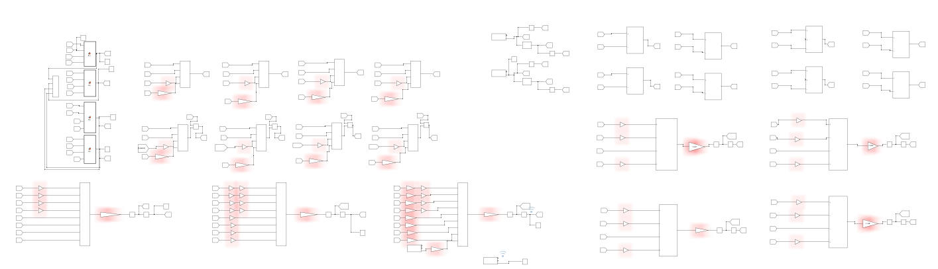
Set up1
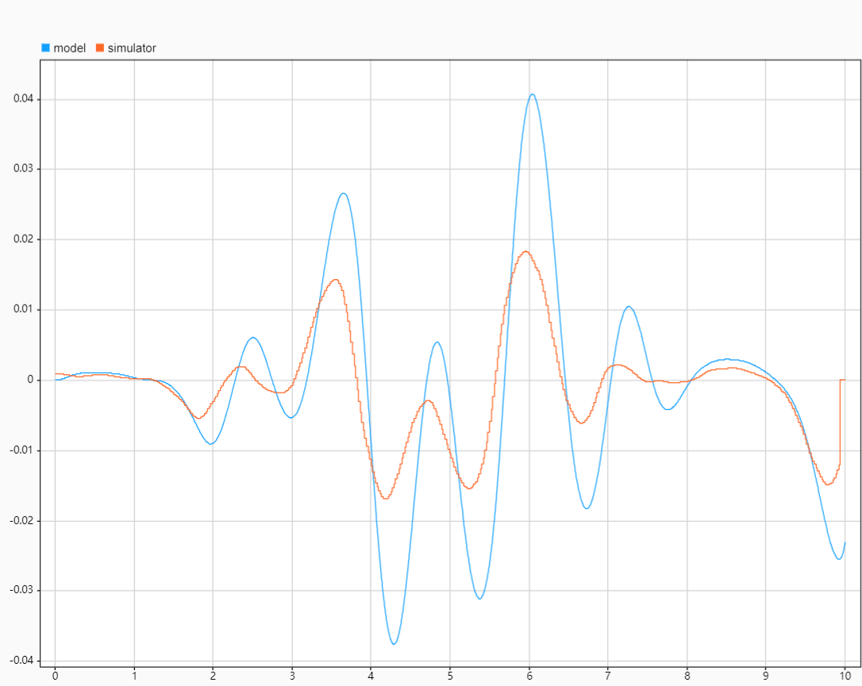
From the above figure, it can be seen that under the setup conditions of setup1, the simulation results of simulink have similar trends with the simulator data, but there is some error in the amplitude. simulink's simulation results have a large amplitude, with the largest value of 0.041. This is probably due to the setting of the tyre parameter as well as the setting of the damping coefficient of the suspension system. From a practical point of view, a larger lateral camber is not conducive to the comfort and stability of passenger cars.
Set up2
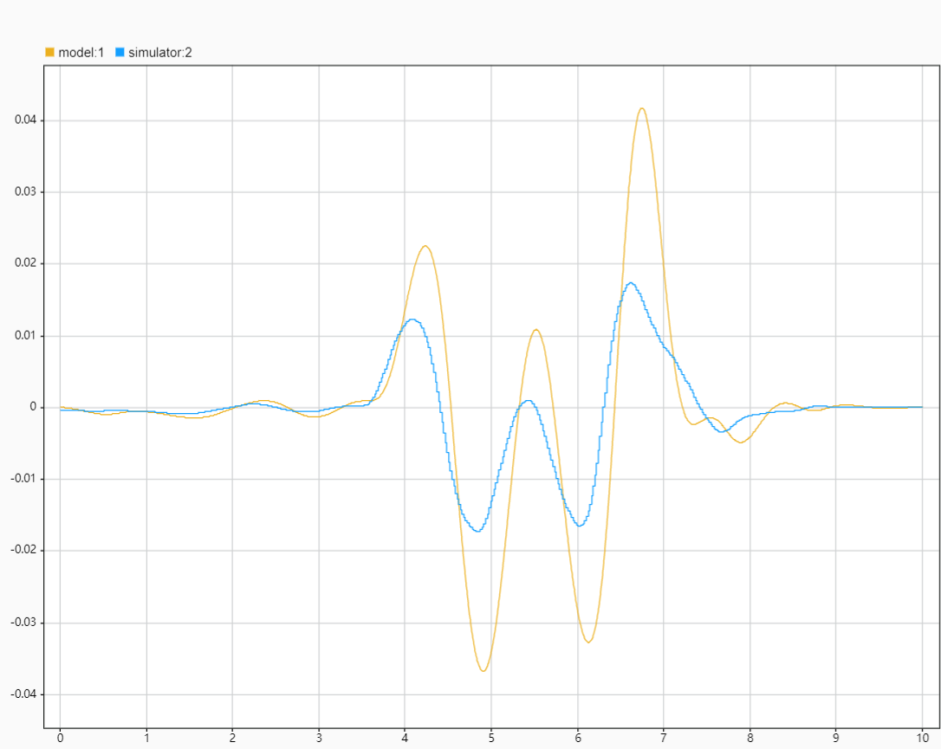
From the above figure, it can be seen that under the setup2 condition: the simulink simulation results have similar trend with the simulator data, and there is also a situation that the simulink simulation results have large amplitude. However, in the range of the first 4s and the last 2s, the simulation results fit well with the simulator data, which is due to the rapid response of the suspension system by changing the spring stiffness, which is conducive to improving the handling stability.
Set up3
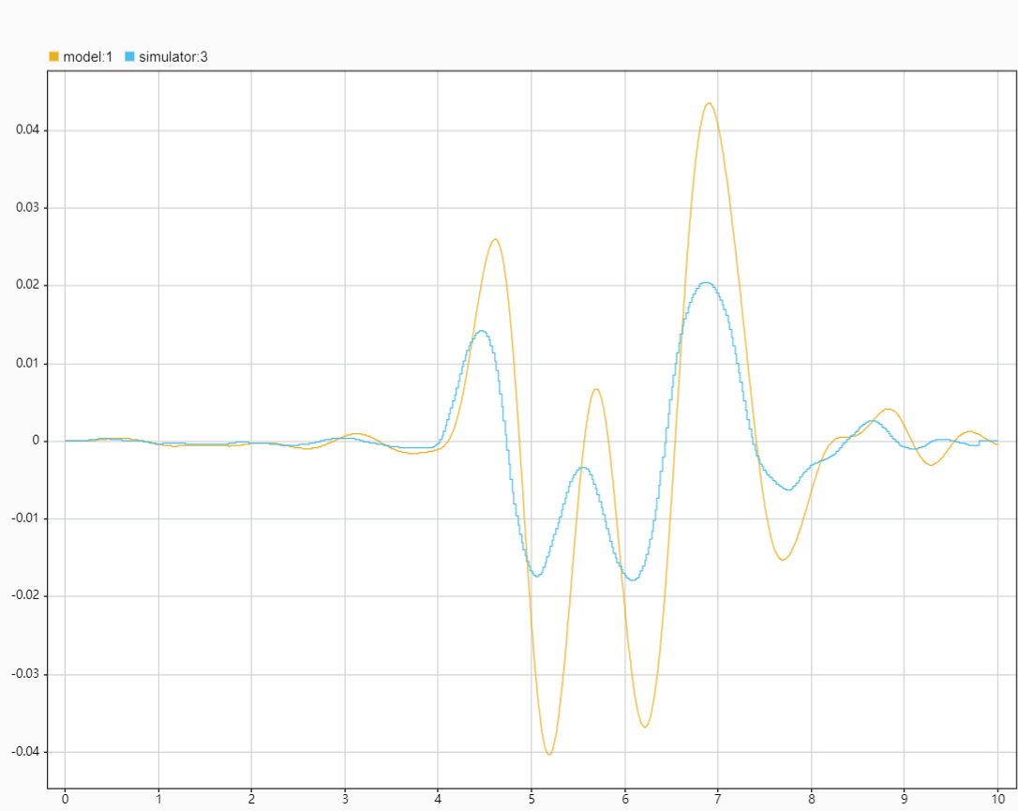
In the provided figure, setup 3's simulation results closely mimic the pattern observed in simulator data, showcasing an effective simulation within the initial 4-second interval. Beyond this, between 4 to 8 seconds, although the trend remains consistent with the simulator's output, the simulation's amplitude appears notably larger—approximately double. This suggests that the model may be overestimating the vehicle's response to certain dynamic inputs during this phase. The final interval from 8 to 10 seconds shows improved alignment, indicating that the initial discrepancies were temporary and that the model re-establishes fidelity towards the end of the simulation period. This behavior warrants a closer examination of the model's parameters and the physical phenomena being simulated during the middle phase to enhance accuracy throughout the entire timeframe.
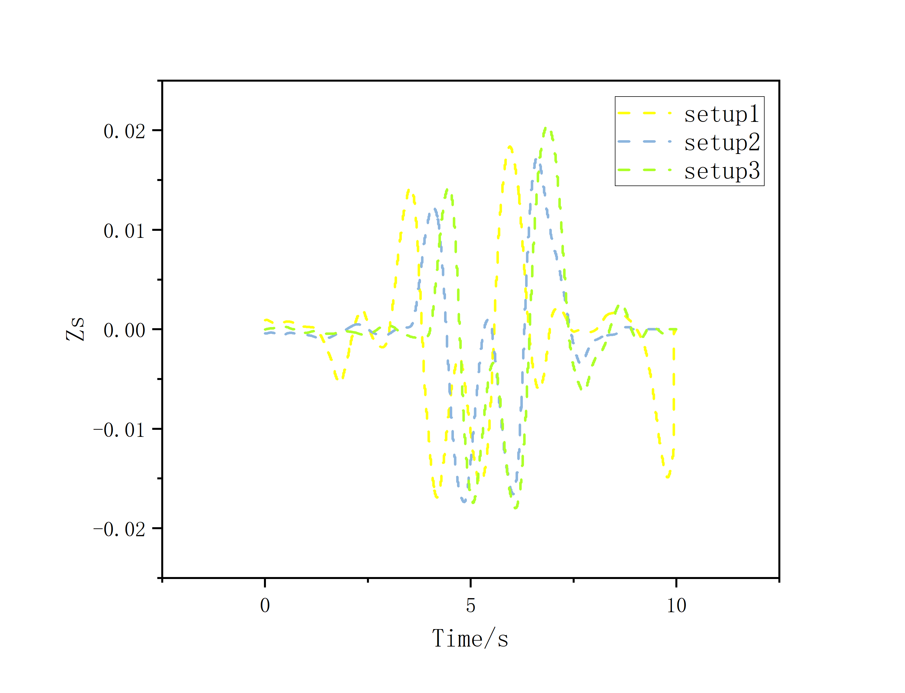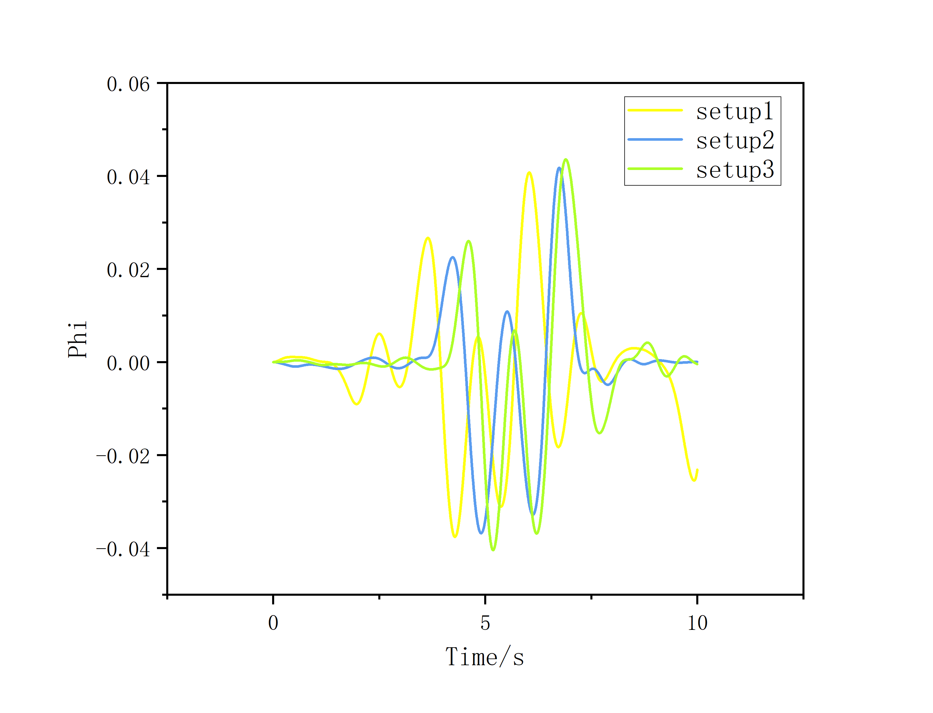
The graph depicts the vehicle's longitudinal displacement (Zs) over time for three different suspension setups. Remarkably, all scenarios maintain minimal longitudinal displacement, suggesting an absence of significant vertical vibrations. This stability in the vertical axis is crucial for maintaining vehicle control during lane changes, where lateral forces are at play. Moreover, analyzing the Phi-Time graph reveals that lateral tilt (Phi) for all setups stays within a ±0.04 radian range, indicating that while there is some lateral tilt during cornering, it remains within controlled limits. The extent of this tilt, however, may influence the vehicle's cornering stability and occupant comfort, implying a need for further fine-tuning of the suspension settings to optimize these aspects. This tilt is a result of complex interactions between vehicle speed, suspension stiffness, and the forces exerted during cornering maneuvers.
3 Critical Appraisal and Further Investigations
3.1 Model Accuracy and Limitations
The Simulink model, while accurately reflecting general trends observed in simulator data, exhibits notable discrepancies in precision, particularly with exaggerated amplitude responses. This deviation might be rooted in the linear assumptions underlying the 7DOF SMD model, which simplifies the complex, often non-linear behavior of actual vehicle components under varying operational stresses. The model's fidelity is also critically dependent on the precision of input parameters like spring rates and damping coefficients, which in real-world conditions, are subject to change due to factors like wear or environmental influences. Moreover, despite offering a broad perspective on vehicle dynamics, the 7DOF model's simplified approach may overlook intricate interactions, such as tire-road contact dynamics, aerodynamic influences, and the vehicle's structural flexibility. This calls for an enhancement of the model's complexity to include non-linear dynamics for a more accurate representation of real-world vehicle behavior, alongside continuous updates and validation against empirical data to ensure reliability and relevance in simulations.
3.2 Altering Parameters and Discussing Vehicle Response
The suspension system parameters have been refined based on the insights from Setup 2, which showed better alignment with the desired performance outcomes. This optimization process involves adjusting the spring coefficients while maintaining all other variables constant, to fine-tune the vehicle's dynamic response. The focus on spring coefficients is pivotal for achieving a delicate balance between ride quality and handling performance, ensuring that the vehicle can respond adequately to various driving conditions without compromising comfort. This iterative approach to suspension tuning highlights the critical role of targeted parameter adjustments in vehicle dynamics optimization. The spring coefficients are set as shown below.
 | 1 | 2 | 3
Front spring rate(N/m) | 18000 | 38000 | 58000
Rear spring rate(N/m) | 16000 | 36000 | 56000
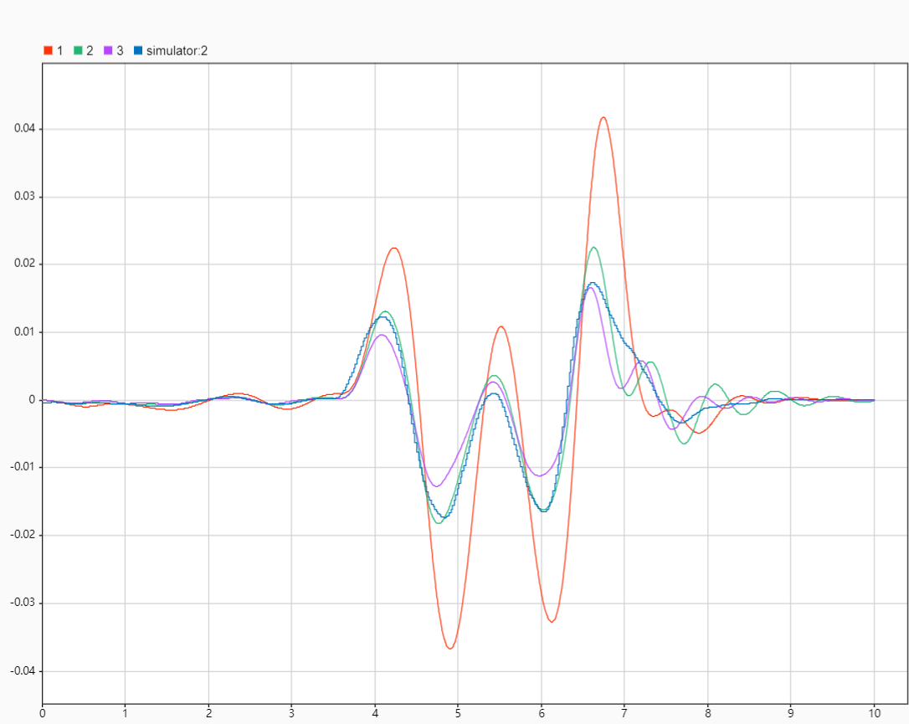
The optimisation results marked by the green line are highly correlated with the actual data, emphasising the importance of spring stiffness in the vehicle suspension system. As the spring stiffness increases, the roll stiffness of the body increases, thus improving the stability of the vehicle during sudden manoeuvres such as sharp turns and evasive manoeuvres. This increased stability is critical to maintaining control and safety in emergency situations. However, it also comes at the expense of ride comfort, as a stiffer suspension system transmits more road surface irregularities and vibrations to the occupants. Striking a balance between these two aspects of stability and comfort requires careful calibration of the suspension parameters.
Keeping other parameters unchanged, the damper coefficients are set as shown below.
 | 1 | 2 | 3
Front slow Bump (N/m/s) | 1915 | 5915 | 9915
Front slow Rebound (N/m/s) | 1660 | 5660 | 9660
Rear slow Bump (N/m/s) | 1612 | 5612 | 9612
Rear slow Rebound (N/m/s) | 1477 | 5477 | 9477
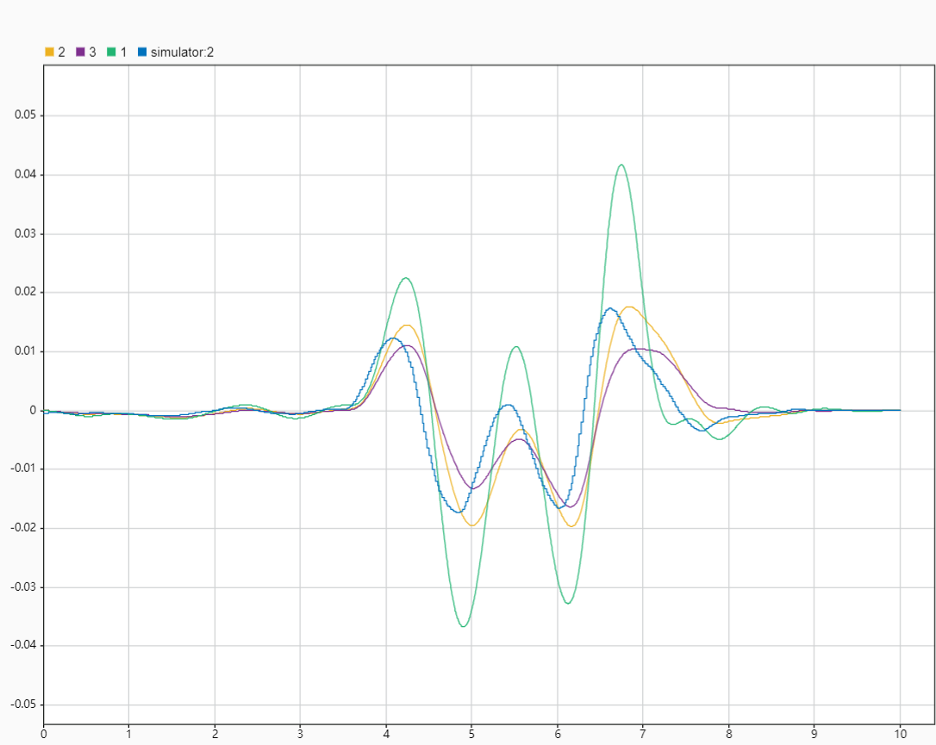

The detailed optimization results, represented by the yellow line closely matching real-world data, highlight the nuanced impact of adjusting damping coefficients on the vehicle's dynamic behavior. With the specified settings for front slow bump and rebound, alongside rear adjustments, we observe a reduction in vibration amplitude and frequency. This improvement is attributed to the enhanced damping ratio, directly influenced by the adjusted damping coefficients. However, a noticeable time delay in response, or hysteresis, suggests an imbalance between damper settings and spring stiffness. This mismatch might cause delays in the suspension's response to road irregularities, indicating a complex interplay between suspension components that requires further tuning to achieve both optimal comfort and dynamic performance. This analysis underscores the importance of a carefully calibrated suspension system, where precise adjustments can significantly improve vehicle stability and ride quality while minimizing undesirable vibrations.
Upon achieving the optimized settings for the vehicle model—specifically, the front spring rate at 38,000 N/m, rear spring rate at 36,000 N/m, along with the damping coefficients for slow bump and slow rebound actions—the simulation data closely aligns with the empirical data collected from real-world testing. This optimal configuration showcases a significant improvement in the vehicle's dynamic response to various driving conditions, enhancing both the stability and comfort of the ride. The adjustments made to the spring rates and damping coefficients demonstrate a delicate balance between handling and ride comfort, suggesting a nuanced approach to suspension system design. Through meticulous testing and adjustments, this model optimization offers valuable insights into the interplay between different vehicle dynamics parameters and their collective impact on vehicle performance.
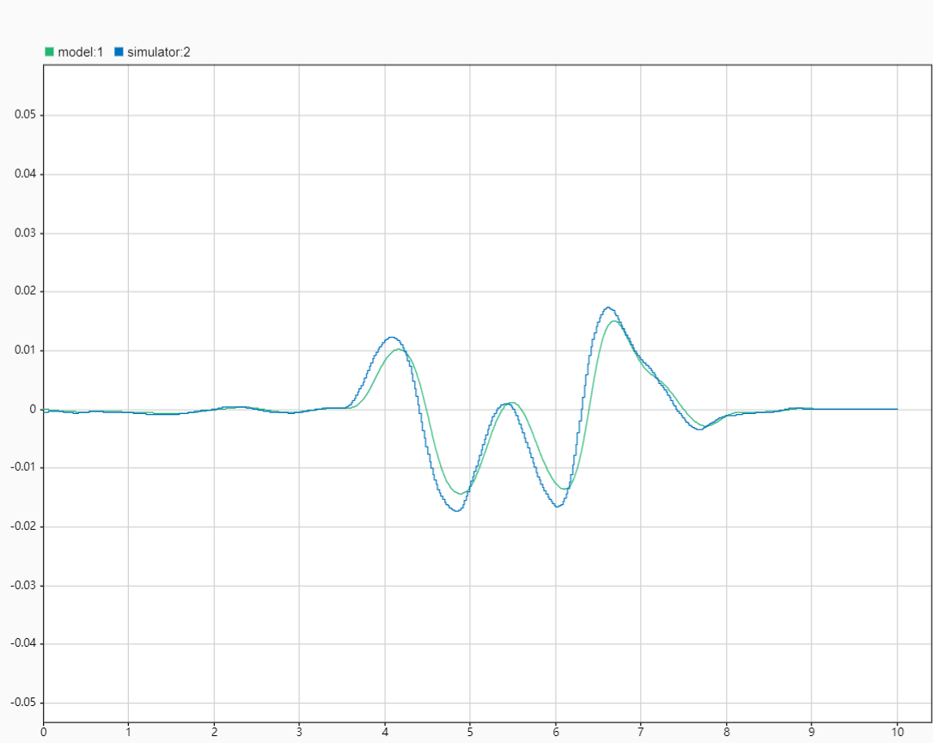
Conclusion
The document details the progression from a 1DOF Spring-Mass-Damper (SMD) model to a comprehensive 7DOF vehicle model, emphasizing the crucial role of suspension system design in managing vehicle dynamics. Initial sections introduce basic concepts, progressing to complex models that incorporate longitudinal, lateral, vertical, pitch, roll, and yaw motions. Simulation results, validated against real-world data, demonstrate the impact of suspension parameters on vehicle performance, including stability and comfort. The study underscores the balance between ride comfort and handling, advocating for optimized suspension settings to enhance overall vehicle dynamics. Critical analysis reveals model limitations and the importance of accurate parameterization, suggesting further research for refinement.
References
- K. Hudha, H. Jamaluddin, P.M. Samin, "Disturbance Rejection Control of a Light Armored Vehicle Using Stability Augmentation Based Active Suspension System," International Journal Heavy Vehicle Systems, vol. 15, pp. 152-169, 2008
- D.J.M Sampson, G. McKevitt, D. Cebon, "The Development of an Active Roll Control System for Heavy Vehicles," Proc. 16th IAVSD Symposium on the Dynamics of Vehicles on Roads and Tracks, Pretoria, South Africa, 30 Aug. – 3 Sept. 1999, pp. 704-715.
- A. W. Burton, A. J. Truscott and P. E. Wellstead, "Analysis, Modeling and Control of An Advanced Automotive Self-Leveling Suspension System," IEEE Proc. on Control Theory Appl., vol. 142, No. 2, pp. 129139, 1995.
- W. Can, W. Weirui, "Chaotic Behaviors of Half Car Model Excited by the Road Surface Profile," Information Science and Engineering (ICISE), 2009 1st International Conference, pp.3752-3755, Nanjing, China, 18-20 Dec. 2009.
- C.Y. Tang, G.Y. Zhao, H. Li, S.W. Zhou, "Research on Suspension System Based on Genetic Algorithm and Neural Network Control," Intelligent Computation Technology and Automation, 2009. ICICTA '09. Second International Conference, pp.468-471, vol.1, Zhangjiajie, China, 10-11 Oct. 2009.
- C.P. Cheng, C.H. Chao, T.H Li, "Design of Observer-Based Fuzzy Sliding-Mode Control for An Active Suspension System With Full-Car Model," Systems Man and Cybernetics (SMC), 2010 IEEE International Conference, pp.1939-1944, 10-13 Oct. 2010.
- P.S.A. Singh, I.Z.M. Darus, "Enhancement of SUV Roll Dynamics Using Fuzzy Logic Control," Informatics and Computational Intelligence (ICI), 2011 First International Conference, pp.106-111, Bandung, Indonesia, 12-14 Dec. 2011.
- R. Darus, Y.M. Sam, "Modeling and Control Active Suspension System for A Full Car Model," Signal Processing & Its Applications, 2009. CSPA 2009. 5th International Colloquium, pp.13 -18, Kuala Lumpur, Malaysia, 6-8 March 2009.

