  - Introduction to Web and Database Concepts

Assignment: HTML & CSS Web Development
Jacob Hopkins
2003836
BSc Computing (Computer Networks and Cybersecurity)
Submission Deadline: Monday April 26th

Contents
Introduction 3
Requirements 3
Design 3
Implementation 7
Validation 9
Evaluation 11
a. 11
Usability 11
Accessibility 11
Search Engine Optimisation 11
b. 12
Usefulness 12
Search Engine Optimisation 12
Accessibility 14
References 17
Appendices 18
Home (Index) Page HTML 18
New In Page HTML 21
Products Page HTML 25
About Page HTML 29
Contact Page HTML 32
Main CSS 35

Introduction
Throughout this report, I will demonstrate an understanding and implementation of the fundamental principles, technologies, and standards needed to design and develop functional and validated web pages. Evaluating the importance of different website processes such as search engine optimisation (SEO) and accessibility and cover how they affect the visibility of a website, both on the internet and for an individual.

Requirements
Blush & Ivy is small private business that was created by close friend Lara Berni in 2020. The small start-up both creates and sells handmade accessories such as jewellery online, using the popular and ever-growing online website ‘etsy.com’ as her primary marketplace for her goods. The purpose behind the Blush & Ivy website is to create an online space where Lara can inform and update her followers/customers on many different topics such as new product releases, updates in stock, or potential changes to the businesses, etc. It also allows for followers and customers to privately contact her through the use of an online form, available on the website, with any queries they may have. In addition to the social activity, the website can act as a hub that can connect the businesses other social profiles together, including the Esty store page and public Instagram account, which in turn can help increase interactions and traffic to said social accounts. While it cannot quite be called an e-commerce website due to its inability and lack of EPOS (electronic point of sale), the content and intentions of the website could label it as a homepage, blog, or even an online portfolio.
With regards to the websites target audience, the content primarily will be directed towards a larger female audience as the products created and sold by the business are both intended and labelled for women. There is no specific age group targeted for the site with its products designed for all ages, its intuitive and user-friendly design helps even the least experienced with the internet to easily navigate its pages and explore the sites’ content.
All images used across the website were captured and edited by me in collaboration with Lara and Blush & Ivy.

Design
Before creating the webpages, it is always sensible to plan and create initial designs to base your website around. Not only does it help with ensuring you are pleased with the layout and setup of your webpages, but also it can help identify any potential problems your webpages may pose, such as inconsistent design or lack of consideration for accessibility. To help with planning webpages, many web designers use wireframes. These are basic illustrations that layout the structure of each page to a website, often used while consulting with clients on their desired webpage design.

Index Page Wireframe
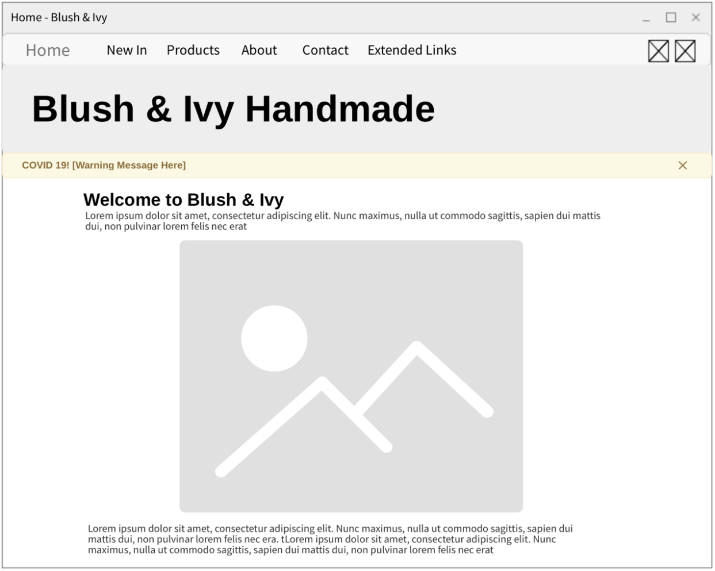
New In Page Wireframe
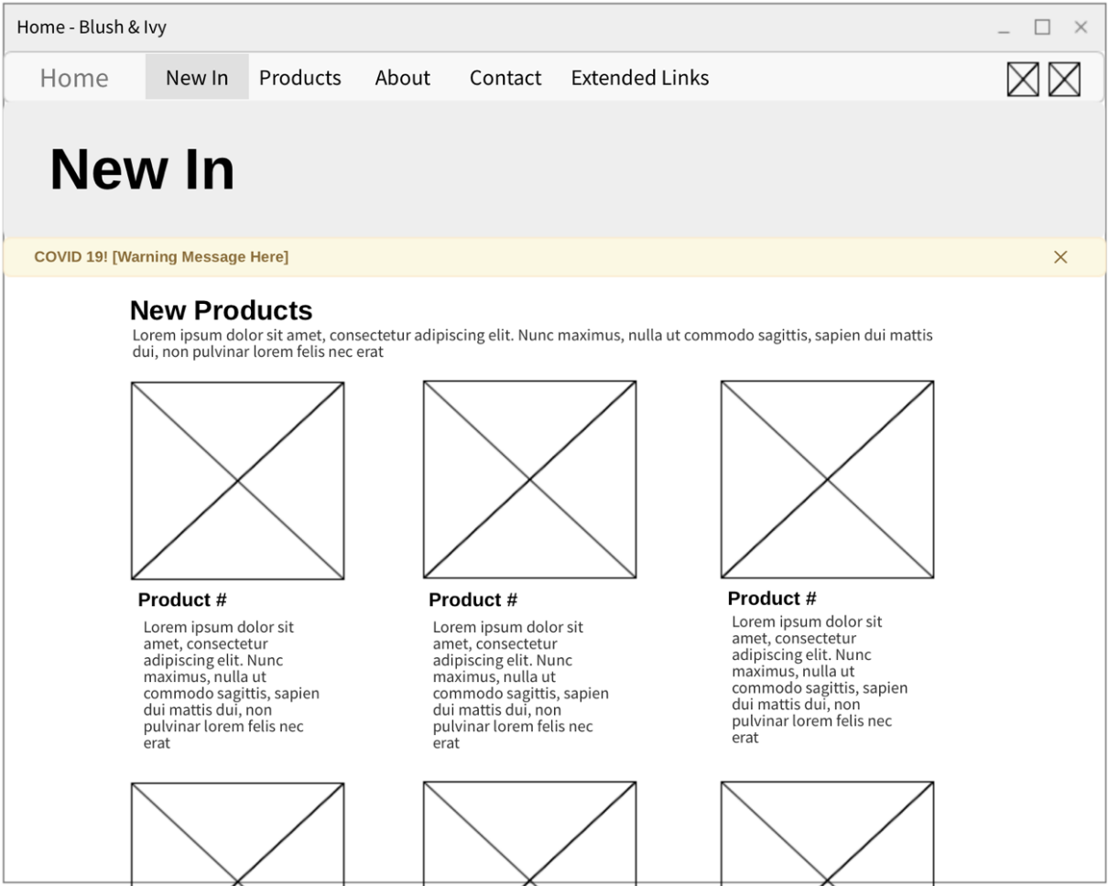
Products Page Wireframe
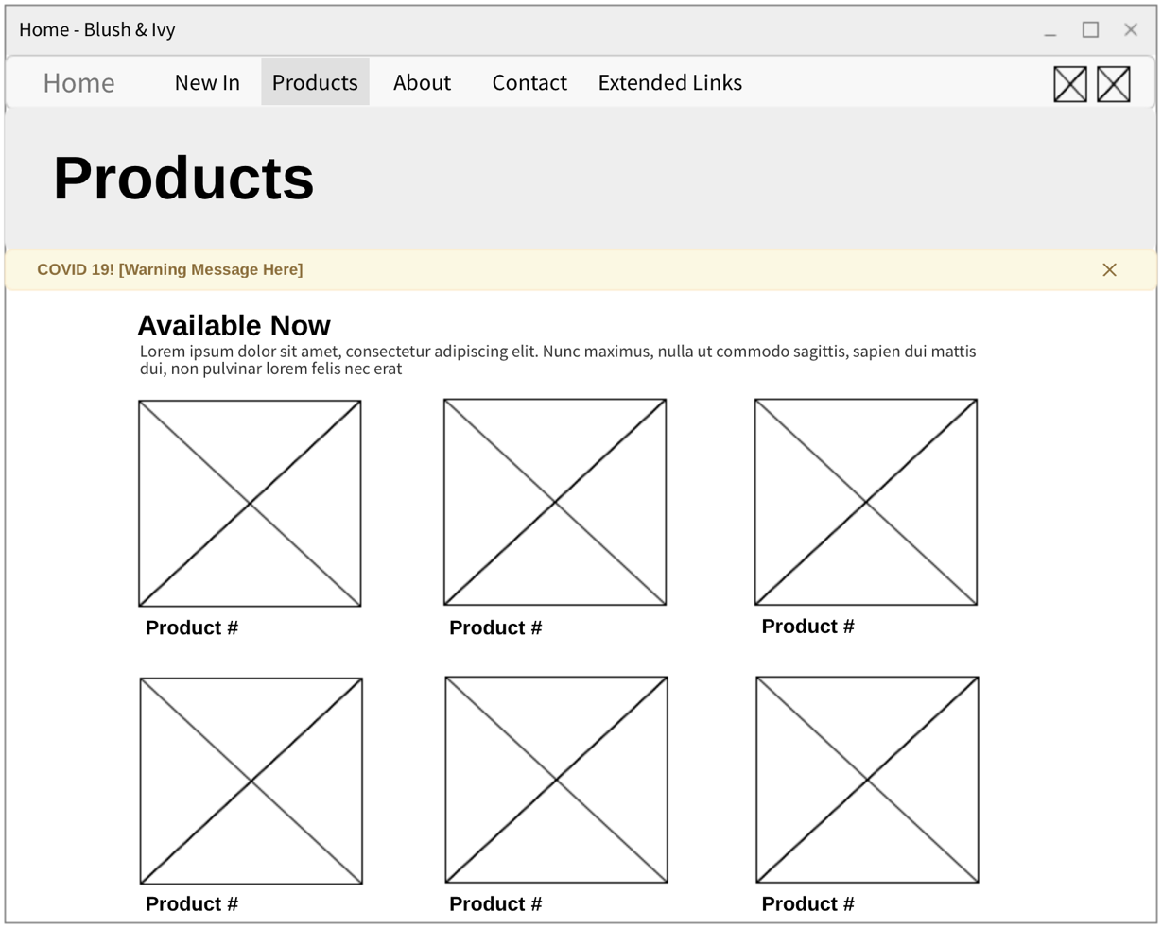
About Page Wireframe
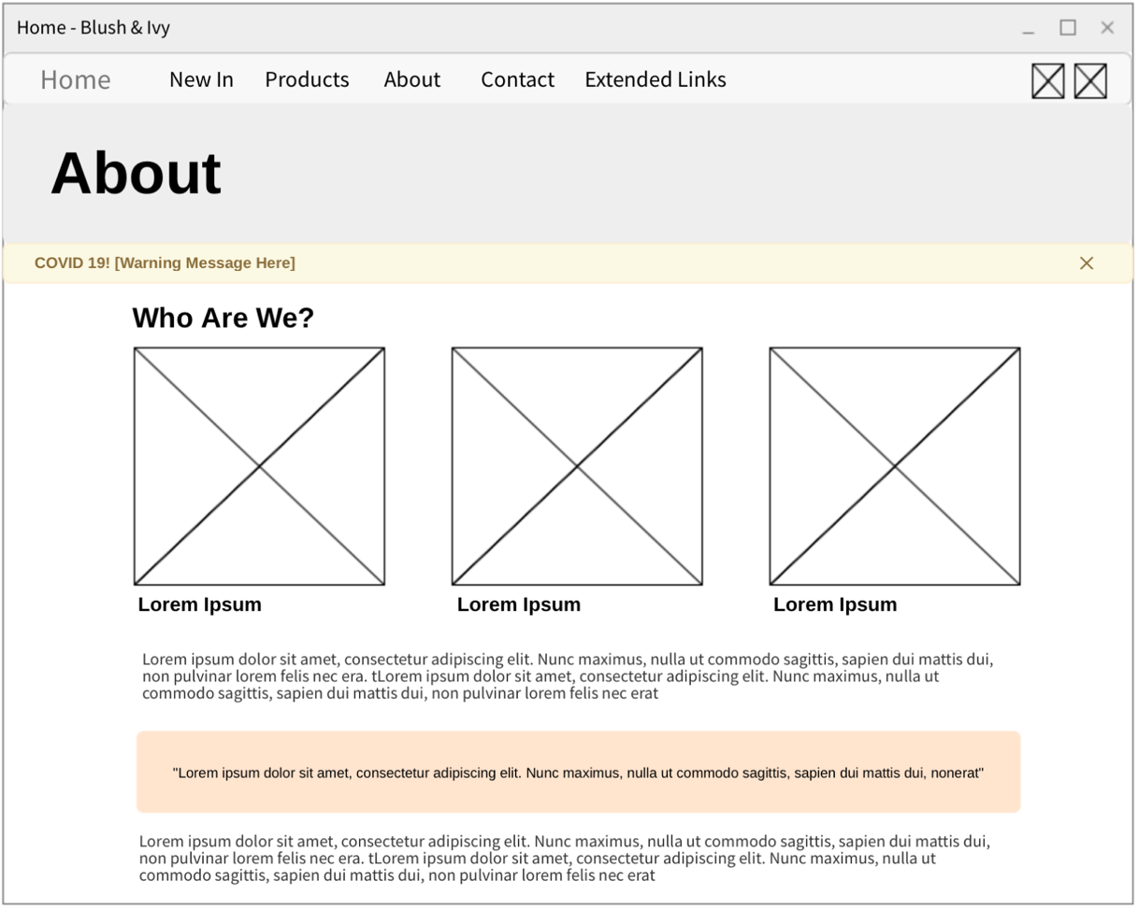
Contact Page Wireframe
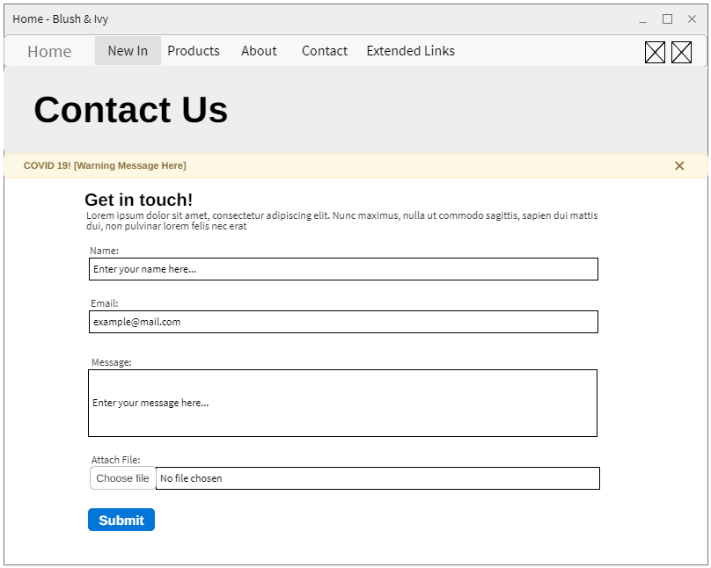

Implementation
Home Page
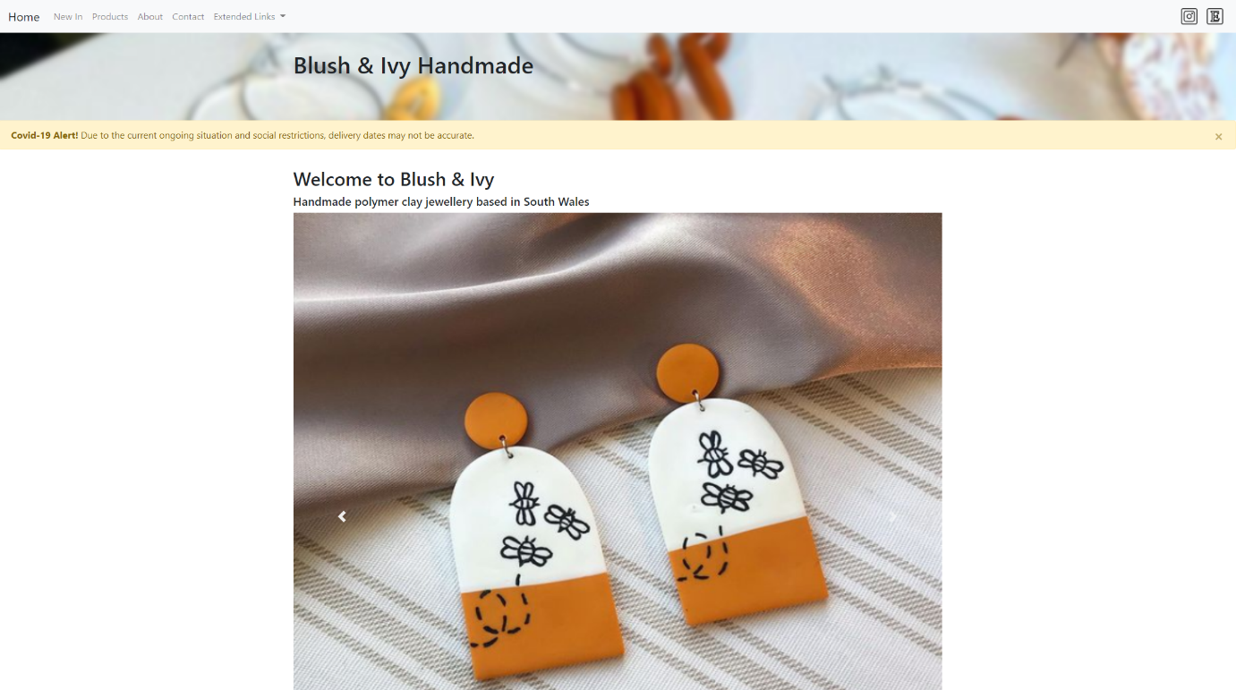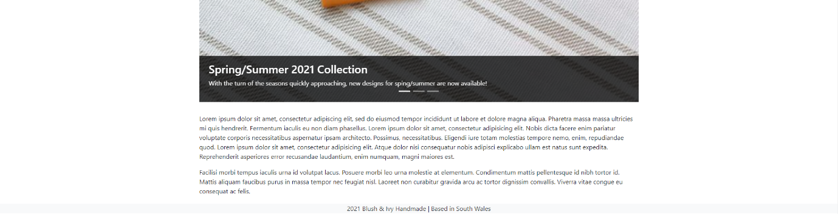
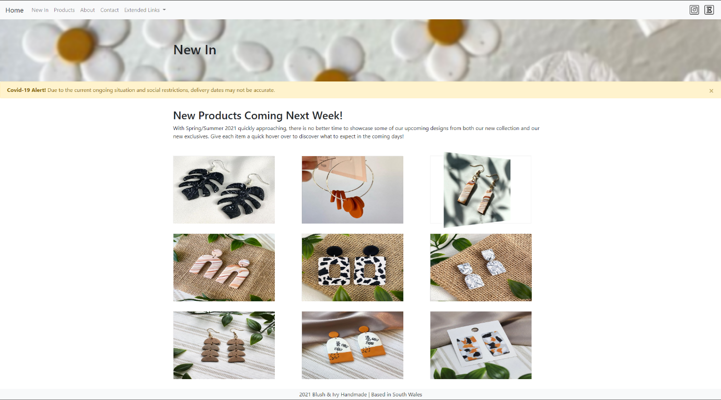
New In Page
Image spins on hover!

Products Page
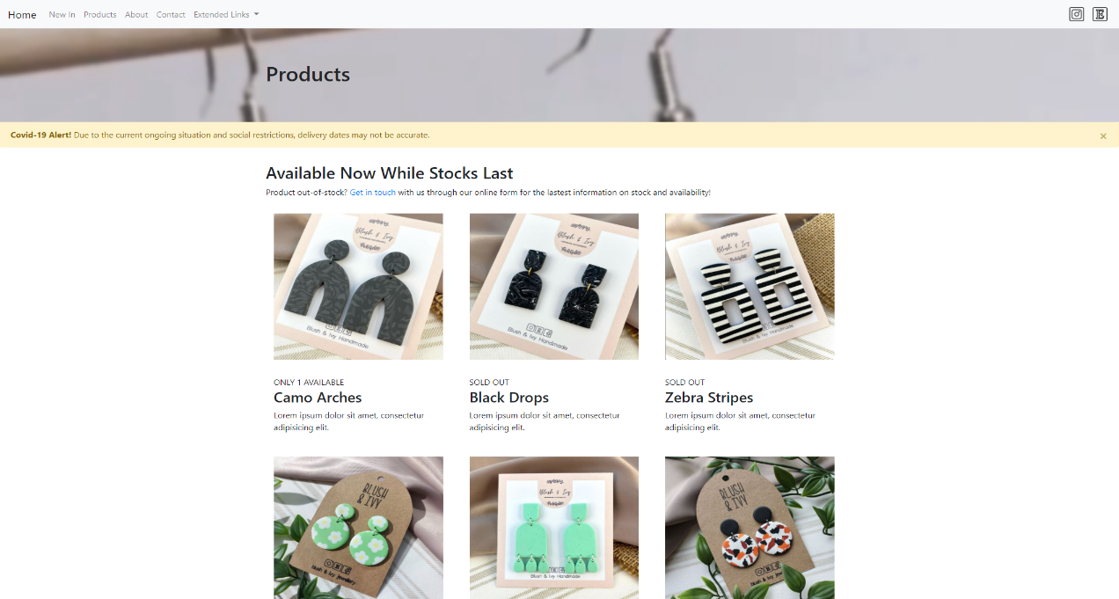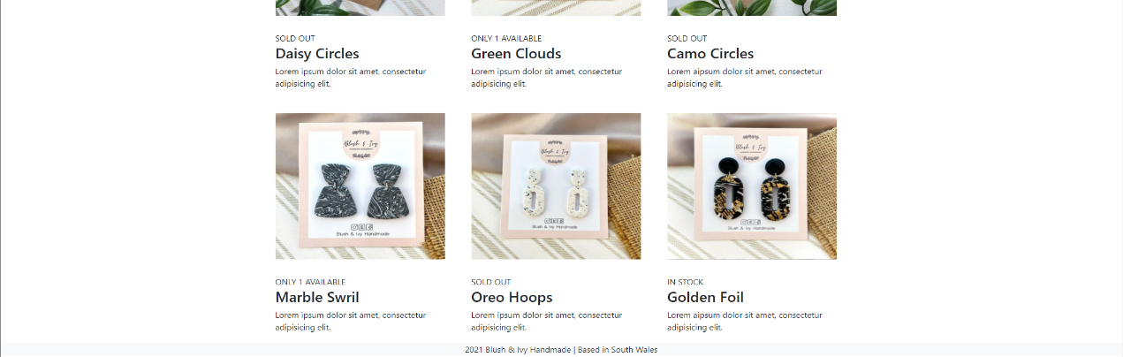
About Page
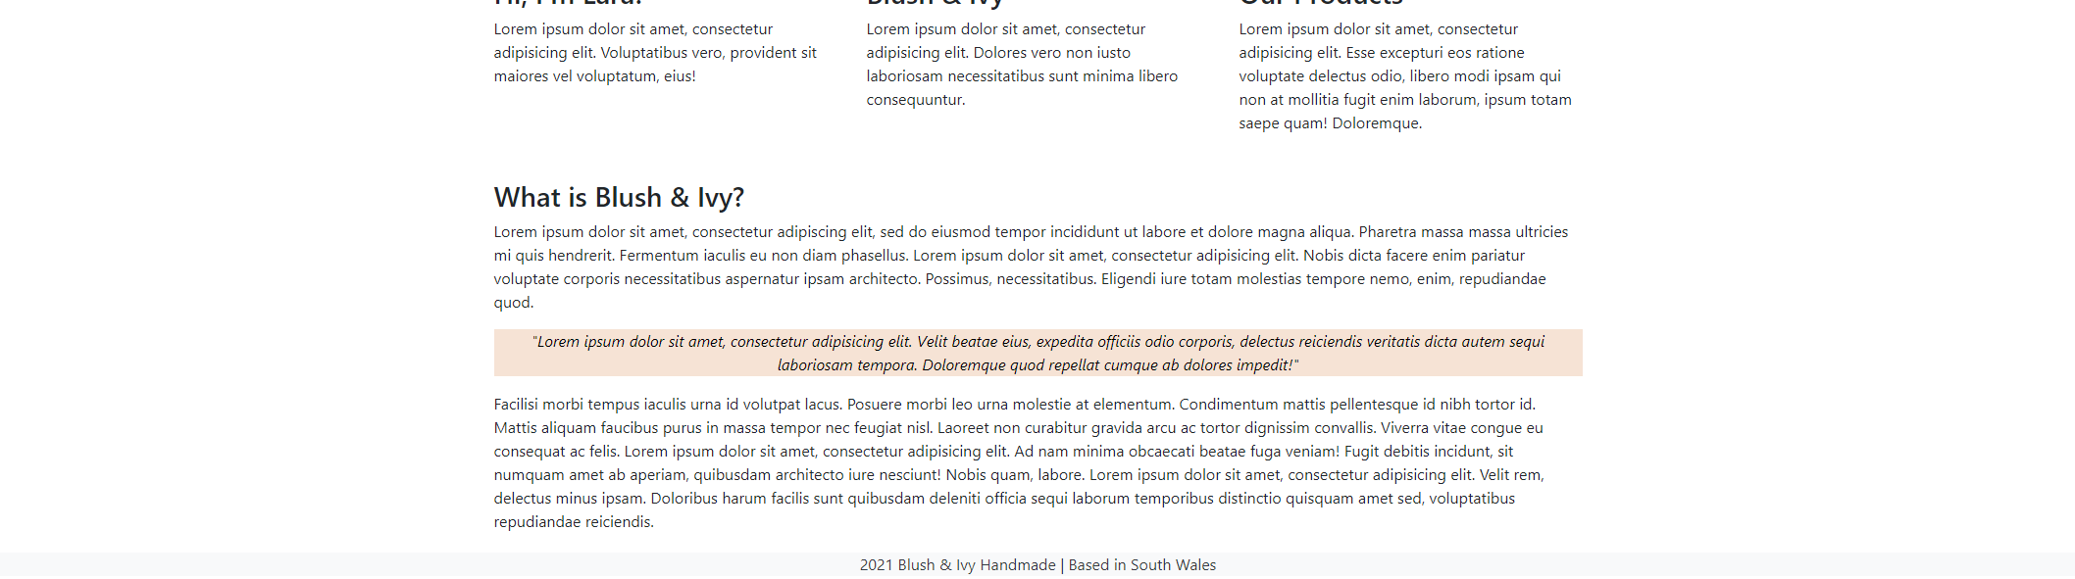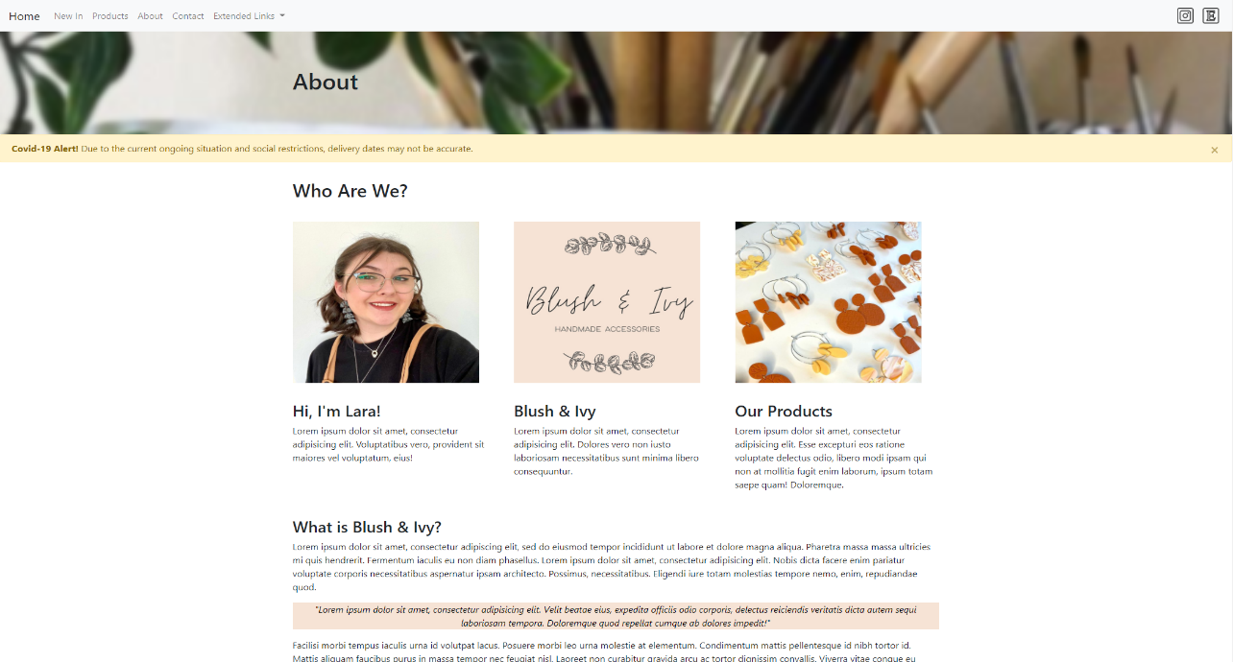
Contact Page
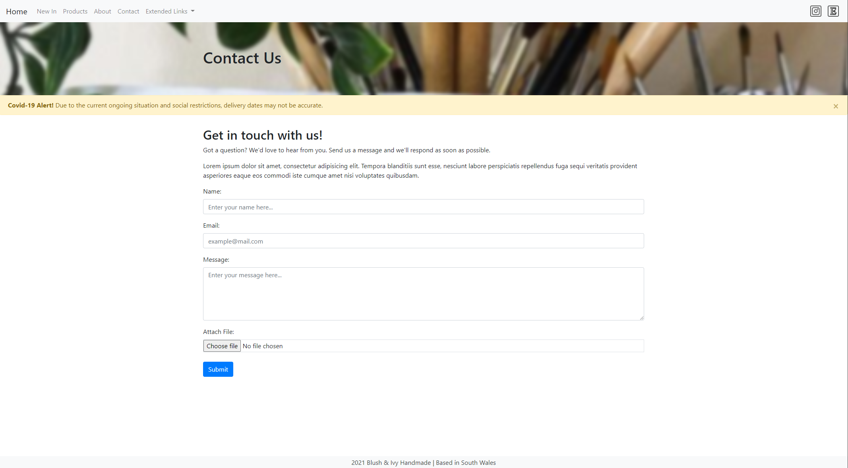

Validation
Although a website might seem to be functioning properly, there can often be some invalid code hidden within the HTML or CSS that does not comply with the W3C’s web standards. To help prevent this, the World Wide Web Consortium (W3C) provide an online markup validation service ^{[1]} free of charge for web developers to test their code. The validator compares the provided code with the W3C standards and highlights any issues found, adding guidance on ways the code could be altered to resolve the problem.
HTML Validation – Home Page
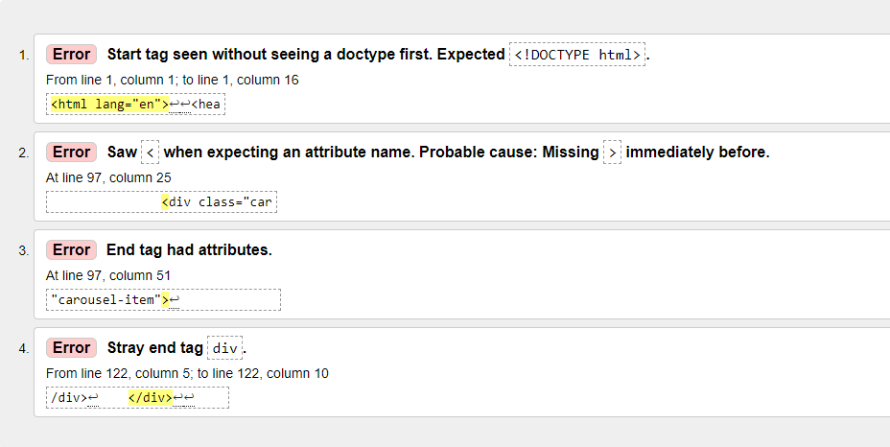
Upon validating the HTML code of my websites Home Page, a handful of invalid code was identified. This included an essential missing ‘doctype’, an unclosed ‘div’ element, and a stray end tag ‘div’ caused by the unclosed ‘div’. Additionally, there was also an error within the code, highlighting an unconverted ‘&’ special character. Because of its use of declaring an entity reference, it is required to type an ‘&’ as ‘&amp;’ to use within text.
Resolving these issues, I included an important HTML doctype at the beginning of my code, “<!DOCTYPE html>”. I then identified the unclosed element and made sure the “<div>” was appropriately typed; this alteration also resolved the stray end tag error. Finally, I altered my use of the ‘&’ symbol and corrected it to “&amp;” to comply with the W3C standard.
The alterations proved effective, with the validator returning the following message upon re-uploading my HTML code:
CSS Validation
Just like the validation of HTML code, CSS also is required to comply with W3Cs published standards. Using a CSS variant of the same online validator from W3C, I was able to validate my CSS code for my website and identify any errors there might be.
Thankfully, the online validator returned no errors within my code, stating it complied with the W3C standards.
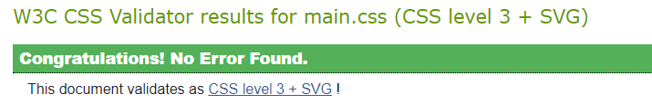

Evaluation

Usability
The usability of a website, described quite generally, is “how well and how easily a user, without formal training, can interact with an information system of a website” ^{[2]}. Said to be “one of the salient features of any website” ^{[3]}, usability not only plays a significant role in the designing of webpages but can also greatly affect things such as webpage traffic. There are numerous factors that can have an effect on a websites’ usability such as its readability. This could include the amount of white space, positioning or formatting of text, and placement of different user elements; each of which, if not managed appropriately, could distract users from the intended content of the webpage, or even potentially cause users to abandon the site ^{[4]}. Additional factors include the colours and contrast of content used throughout the sites webpages, and even navigation. The use of inconsiderate colours that are difficult to distinguish from one-another, or complex and unintuitive navigation techniques such as horizontal scrolling can lead to poor user experience and in turn negatively affect website traffic.

Accessibility
As described by the World Wide Web Consortium, web accessibility “means that websites, tools, and technologies are designed and developed so that people with disabilities can use them” ^{[12]}, aiding in perceiving, understanding, navigating, and interacting with a website. Disabilities such as vision, mobility, auditory, or cognitive impairments can each have an affect on how individuals interact with the web, therefore by providing a range of accessibility tools you can help improve usability and broaden the number of potential users of your site, while also improving their quality of life. It is noted by W3C that, “accessibility overlaps with other best practices” ^{[13]} and that “case studies show that accessible websites have better search results, reduced maintenance costs, and increased audience reach, among other benefits.” ^{[13]}. There are many different examples of web accessibility including, ‘alt text’ for images which are useful for those with visual impairments and make use of screen readers. Keyboard input for those unable to use a mouse, this could include those with limited fine motor control/functions. And even transcripts for audio, providing those with hearing impairments the ability to use audio files such as podcasts or voice recordings.

Search Engine Optimisation
Search engine optimisation, or SEO, as described in Oxford Reference’s Dictionary of the Internet is “the process of structuring a website and employing content that ensures that whenever a search engine retrieves pages in response to a search, the site is one of the first to be retrieved” ^{[5]}. How well a website is optimised for search engines can greatly affect areas such as web traffic, with a lower SEO ranking resulting in webpages appearing further down the results lists of search engines. As a result of this, it is important to consider SEO before building/publishing a website. We are told by SEO consultants that “you should incorporate your SEO strategy into the site planning process long before your site goes live” ^{[6]} and that a strategy surrounding your website and its SEO “should be well outlined” ^{[6]} before the most basic of decisions surrounding a website. Following these conventions, we are able to include more features within our website that can help boost our SEO, helping increase web traffic. Some factors that can increase a websites SEO include ensuring relevant content and an effective use of keywords are found throughout a site. ‘Michigan Tech’ claim that “quality content is the number one driver of your search engine rankings” ^{[7]} and using web tools such as heading tags can help emphasise and “highlight” keywords to search engines. Additional factors such as the use of ‘alt tags’ and keeping content regularly updated also increase SEO, helping “search engines to locate your page” ^{[7]}, while also making the content more accessible. However, it is too be known that excessive or forceful attempts to improve a websites SEO such as using link farms, or keyword stuffing, can negatively affect a website. “Search engines look for sites that employ these techniques [link farms, keyword stuffing, etc.] in order to remove them from their indices” ^{[8]}.

Usefulness
The Blush & Ivy website is designed as a platform for Lara to broadcast information surrounding the business to both customers and followers in an efficient and effective way. By separating each distinctive topic into their own webpages, the website is able to best present and deliver the relevant content to its audience while still offering consistent and functional surroundings. The use of supporting imagery and alternating styles (e.g. headings, fonts, etc.) build comprehensible and coherent digital environments that help guide user across the site. Paired with direct feedback from well labelled and responsive navigation, such as that found within the navigation bar, help ensure an intuitive and user-friendly experience.
In future cases, I would ensure a greater amount of content is available to view across numerous other webpages, expanding on both current features of the site while also introducing new features for better site interaction. Additionally, developing and implementing a larger palette of colours for the site to better match the Blush & Ivy brand would help present a more professional and inviting look.

Search Engine Optimisation
There are several on-page SEO techniques used throughout the Blush & Ivy website. These include:
- Headings/Content Formatting
Headings and different content formats are widely used across the sites numerous webpages to help break up and portray hierarchy within content. The use of the ‘h1’, ‘h2’, and ‘h3’ heading tags, as well as the important ‘title’ tag can help properly format a webpage and its content. When used appropriately, headings can help boost SEO.
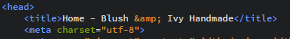
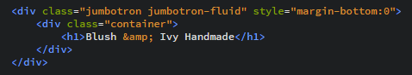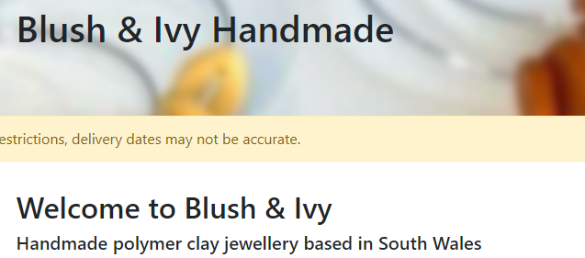

- Images/Other Multimedia Elements
Helping improve both the presentation and depth of the content across the site, various original images can be found amongst other information helping improve SEO. These images each hold their own ‘alt tags’ helping describe the content of the image not only to those who are visually impaired, but also to search engines. With both small file sizes and descriptive filenames, these images are ideal for use on a website. Below is an image taken from the products page on the Blush & Ivy website.
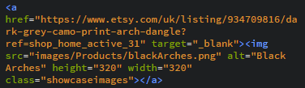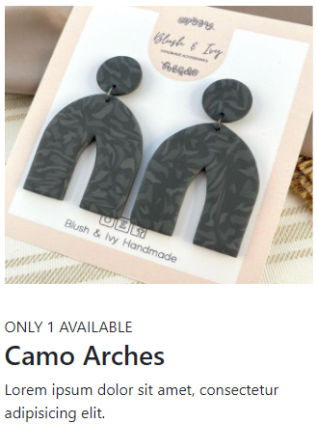
- Internal Links
Primarily used for navigation, internal links are a great way to increase SEO as they help allow search engines to quickly find extended parts of your website to assess. In addition to this, they are also help “increase both the time spend on your website, number of pages per visit, and decrease the bounce rate” ^{[9]}. Below is an internal link to another page on the Blush & Ivy website.
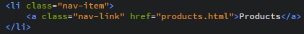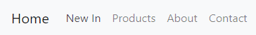
- External Links
Using external links, search engines are able to determine the topic of a website based off the content found on the linked website. As long as external links relate to the content of your site, they are a great way of improving your SEO relevant to your website. Below are some external links to webpages related to the content of Blush & Ivy.
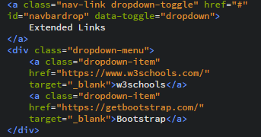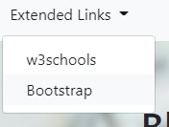
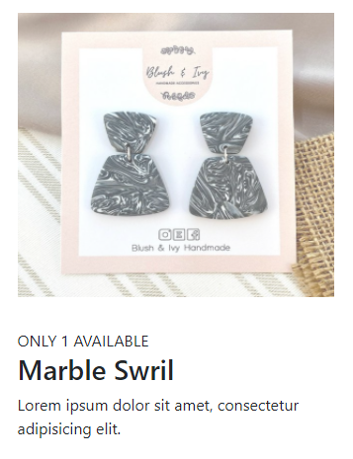
- Page Loading Speeds
In a recent study conducted by Google, it was found that “over 50% of mobile users abandoning sites that take longer than three seconds to load” ^{[10]}. By optimising both my images and code, I was able to reduce the webpage loading times significantly.
- Mobile Friendliness
Bootstrap helps deliver an effortless and effective method of website mobile optimisation. Through automated techniques, the website is able to push mobile friendly versions of itself to millions of devices. Google offer a useful tool that helps check whether a webpage is mobile friendly or not ^{[11]}.
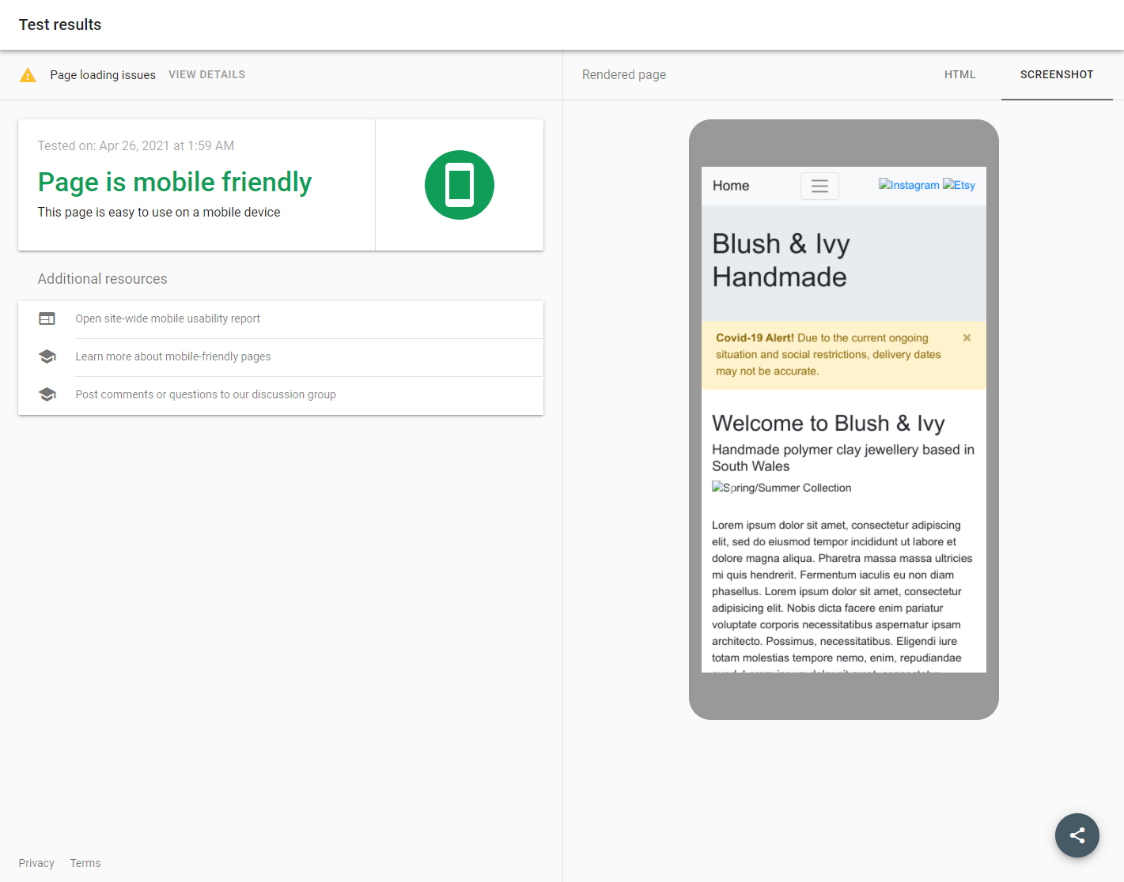

Accessibility
As a way of providing web developers with guidance on how to implement and manage accessibility on their sites, the W3C created the ‘Web Content Accessibility Guidelines’, otherwise known as WCAG, with their latest release 2.1 published in June 2018. Covering a wide range of recommendations for web accessibility, these guidelines help accommodate those with ranging impairments to help make online content more accessible and interactive. Broken down into four main principles, perceivable, operable, understandable, and robust. The guidelines cover an extensive and detailed list of potential situations that could impact of accessibility. While you are able to manually cover the content of the guidelines to identify any potential accessibility issues within your site, there are helpful tools online that can automate this process and highlight parts of webpages that could pose a problem for those suffering from disabilities. These checkers are able to compare against different acceptance levels set out by the W3C, ranging from level A minimal compliance, level AA acceptable compliance, and level AAA optimal compliance. For this example, I will be using AChecker ^{[14]}, a web accessibility checker that accepts file uploads for evaluation, following the level AA WCAG guidelines.

Home/Index Page
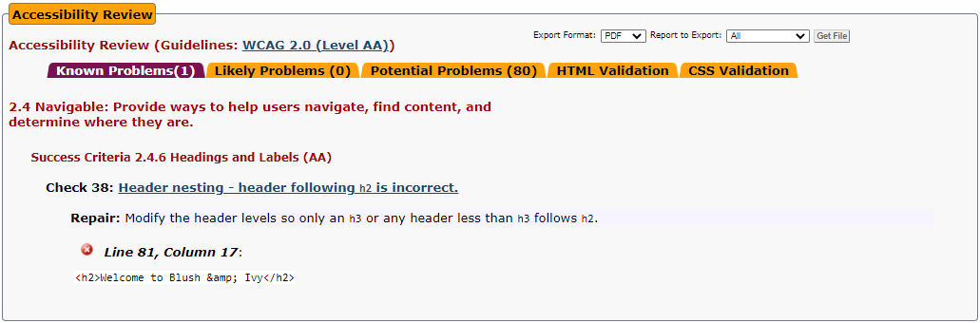

New In Page
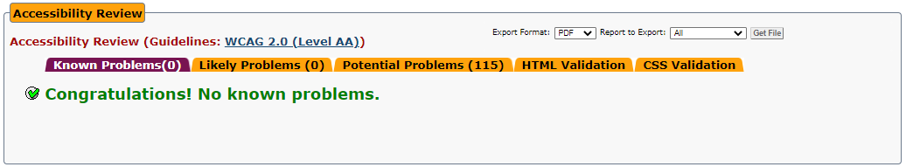

Products Page
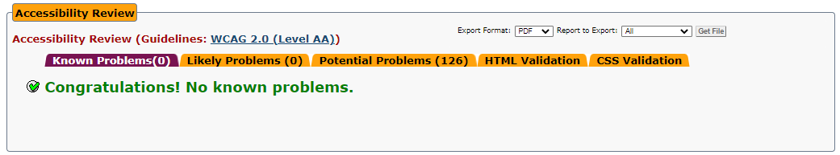

About Page
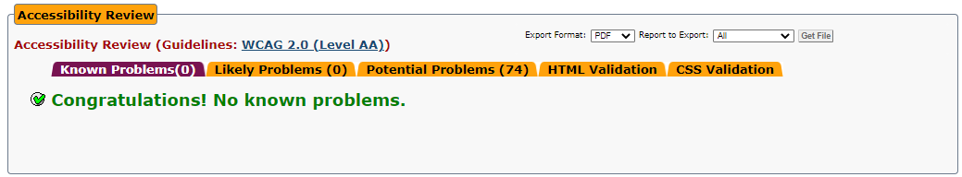

Contact Page
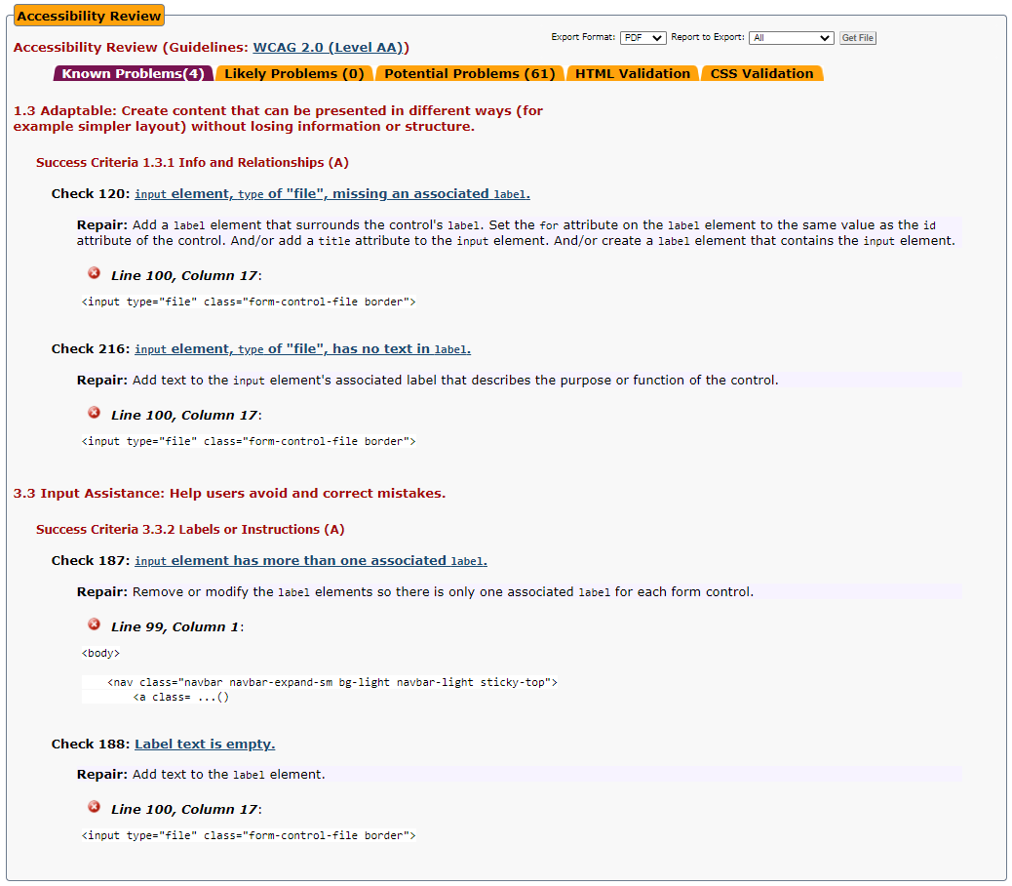
Affecting the operable aspect of our website, an instance on the index.html page fails to comply with rule 2.4 of the WCAG. An incorrect use of headings has led to a potentially more difficult experience for those with disabilities to navigate or locate content across the webpage. To resolve this, modifying the stated header levels will allow for accessibility tools to more accurately guide those who are impaired through the site.
The contact.html page also suffers from a couple failed compliances of the WCAG, affecting the perception and robustness of the webpage. Challenging both 1.3 adaptable for not providing appropriate information and relationships for elements, and 3.3 input assistance poor labelling and instructions. Alterations to labels, including both adding and removing labels from multiple elements can help resolve these issues presented by AChecker.
In all, the Blush & Ivy website provides an intuitive and user-friendly environment for content sharing. The site achieves its intended purpose of creating an online platform for Blush & Ivy to share their content and connect with both customers and followers. Through the use of numerous thought-out techniques, such as the use of appropriate formatting, images, internal/external links, and mobile friendly content, it is well optimised for search engines. And helping deliver its content to those living with disabilities, it minimises potential problems found across websites with useful accessibility tools for an improved experience.

References
[1] World Wide Web Consortium, “Markup Validation Service”, W3C. [Online] Available: http://validator.w3.org/ [Accessed Apr. 23, 2021]
[2] R. Benbunan-Fich, “Using protocol analysis to evaluate the usability of a commercial web site,” vol. 39, no. 2, pp. 152, 2001, doi: https://doi-org.ezproxy.uwtsd.ac.uk/10.1016/S0378-7206(01)00085-4 [Online] Available: https://www-sciencedirect-com.ezproxy.uwtsd.ac.uk/science/article/pii/S0378720601000854 [Accessed Apr. 24, 2021]
[3] A. Abdul Ganiyu, A. Mishra, J. Elijah, and U. M Gana, “The Importance of Usability of a Website,” ICFAI journal of information technology, vol. 13, no. 3, pp. 27, 2017.
[4] H. Raoult, “5 Quick Ways to Improve Your Website’s Usability”, Usability Geek. [Online] Available: https://usabilitygeek.com/5-quick-ways-to-improve-your-websites-usability/ [Accessed Apr. 24, 2021]
[5] Oxford References, “A Dictionary of the Internet”, Oxford References. [Online] Available: https://www.oxfordreference.com/view/10.1093/acref/9780191884276.001.0001/acref-9780191884276-e-4349?rskey=EdoYh6&result=2203 [Accessed Apr. 25, 2021]
[6] E. Enge, “The art of SEO”, 2nd ed. 2012, ch. 4, pp. 99. [E-book]
[7] Michigan Tech, “Five Ways to Improve your Site’s Ranking (SEO)”, Michigan Tech. [Online] Available: https://www.mtu.edu/umc/services/websites/seo/ [Accessed Apr. 25, 2021]
[8] w3schools, “WEB - SEO”, w3schools. [Online] Available: https://www.mtu.edu/umc/services/websites/seo/ [Accessed Apr. 25, 2021]
[9] A. Chris, “On-Page SEO Techniques That’ll Boost Your Rankings”, Reliablesoft. [Online] Available: https://www.reliablesoft.net/on-page-seo/#definition [Accessed Apr. 25, 2021]
[10] D. Kirkpatrik, “Google: 53% of mobile users abandon sites that take over 3 seconds to load”, Marketing Dive, Sep. 12, 2016. [Online] Available: https://www.marketingdive.com/news/google-53-of-mobile-users-abandon-sites-that-take-over-3-seconds-to-load/426070/#:~:text=Over%2050%25%20of%20mobile%20users,lies%20with%20ads%20on%20mobile [Accessed Apr. 25, 2021]
[11] Google, “Mobile-Friendly Test”, Google. [Online] Available: https://search.google.com/test/mobile-friendly [Accessed Apr. 25, 2021]
[12] World Wide Web Consortium, “Introduction to Web Accessibility”, W3C. [Online] Available: https://www.w3.org/WAI/fundamentals/accessibility-intro/#what [Accessed Apr. 25, 2021]
[13] World Wide Web Consortium, as cited Usability.gov, “Accessibility Basics”, usability.gov. [Online] Available: https://www.usability.gov/what-and-why/accessibility.html#:~:text=By%20making%20your%20website%20accessible,the%20site%20for%20all%20users [Accessed Apr. 25, 2021]
[14] https://achecker.ca/checker/ [Accessed Apr. 25, 2021]

Appendices

Home (Index) Page HTML
<!DOCTYPE html>
<html lang="en">
<head>
<title>Home - Blush &amp; Ivy Handmade</title>
<meta charset="utf-8">
<meta name="viewport" content="width=device-width, initial-scale=1">
<link rel="shortcut icon" type="image/png" href="images/UWTSD-logo.ico">
<link rel="stylesheet" href="https://maxcdn.bootstrapcdn.com/bootstrap/4.3.1/css/bootstrap.min.css">
<script src="https://ajax.googleapis.com/ajax/libs/jquery/3.3.1/jquery.min.js"></script>
<script src="https://cdnjs.cloudflare.com/ajax/libs/popper.js/1.14.7/umd/popper.min.js"></script>
<script src="https://maxcdn.bootstrapcdn.com/bootstrap/4.3.1/js/bootstrap.min.js"></script>
<style>
.fakeimg {
height: 200px;
background: #aaa;
}
.jumbotron {
background-image: url("images/jumbotronImageBlur.png");
background-size: cover;
}
</style>
<link rel="stylesheet" href="css/main.css">
</head>
<body>
<nav class="navbar navbar-expand-sm bg-light navbar-light sticky-top">
<a class="navbar-brand" href="index.html">Home</a>
<button class="navbar-toggler" type="button" data-toggle="collapse" data-target="#collapsibleNavbar">
<span class="navbar-toggler-icon"></span>
</button>
<div class="collapse navbar-collapse" id="collapsibleNavbar">
<ul class="navbar-nav">
<li class="nav-item">
<a class="nav-link" href="newin.html">New In</a>
</li>
<li class="nav-item">
<a class="nav-link" href="products.html">Products</a>
</li>
<li class="nav-item">
<a class="nav-link" href="aboutus.html">About</a>
</li>
<li class="nav-item">
<a class="nav-link" href="contactus.html">Contact</a>
</li>
<!-- Dropdown -->
<li class="nav-item dropdown">
<a class="nav-link dropdown-toggle" href="#" id="navbardrop" data-toggle="dropdown">
Extended Links
</a>
<div class="dropdown-menu">
<a class="dropdown-item" href="https://www.w3schools.com/" target="_blank">w3schools</a>
<a class="dropdown-item" href="https://getbootstrap.com/" target="_blank">Bootstrap</a>
</div>
</li>
</ul>
</div>
<div class="text-right">
<a href="https://www.instagram.com/blushandivy.handmade/" target="_blank"> <img src="images/insta_logo.png" alt="Instagram" class="icon"> </a>
<a href="https://www.etsy.com/uk/shop/BlushAndIvyHandmade" target="_blank"> <img src="images/etsy_logo.png" alt="Etsy" class="icon"> </a>
</div>
</nav>
<div class="jumbotron jumbotron-fluid" style="margin-bottom:0">
<div class="container">
<h1>Blush &amp; Ivy Handmade</h1>
</div>
</div>
<div class="alert alert-warning alert-dismissible fade show">
<button type="button" class="close" data-dismiss="alert">&times;</button>
<strong>Covid-19 Alert!</strong> Due to the current ongoing situation and social restrictions, delivery dates may not be accurate.
</div>
<div class="container" style="margin-top:30px">
<div class="row">
<div class="col-sm-12">
<h2>Welcome to Blush &amp; Ivy</h2>
<h5>Handmade polymer clay jewellery based in South Wales</h5>
<div id="demo" class="carousel slide" data-ride="carousel">
<ul class="carousel-indicators">
<li data-target="#demo" data-slide-to="0" class="active"></li>
<li data-target="#demo" data-slide-to="1"></li>
<li data-target="#demo" data-slide-to="2"></li>
</ul>
<div class="carousel-inner">
<div class="carousel-item active">
<img src="images/summerSpringCarousel.png" alt="Spring/Summer Collection" width="1100" height="500">
<div class="carousel-caption">
<h3>Spring/Summer 2021 Collection</h3>
<p>With the turn of the seasons quickly approaching, new designs for sping/summer are now available!</p>
</div>
</div>
<div class="carousel-item">
<img src="images/blackAndWhiteCarousel.png" alt="Black & White Jewellery" width="1100" height="500">
<div class="carousel-caption">
<h3>Black &amp; White are Back!</h3>
<p>By popular demand, the return of the <a href="products.html">black and white collection</a> is available now!</p>
</div>
</div>
<div class="carousel-item">
<img src="images/mosaicMadnessCarousel.png" alt="Mosaic Designs" width="1100" height="500">
<div class="carousel-caption">
<h3>Mosaic Madness</h3>
<p>Here's a sneak peak at some of the new designs being worked on! These mosaic patterns are works of art!</p>
</div>
</div>
</div>
<a class="carousel-control-prev" href="#demo" data-slide="prev">
<span class="carousel-control-prev-icon"></span>
</a>
<a class="carousel-control-next" href="#demo" data-slide="next">
<span class="carousel-control-next-icon"></span>
</a>
</div>
</div>
</div>
</div>
<div class="container" style="margin-top:30px">
<div class="row">
<div class="col-sm-12">
<p>Lorem ipsum dolor sit amet, consectetur adipiscing elit, sed do eiusmod tempor incididunt ut labore et dolore magna aliqua. Pharetra massa massa ultricies mi quis hendrerit. Fermentum iaculis eu non diam phasellus. Lorem ipsum dolor sit amet, consectetur adipisicing elit. Nobis dicta facere enim pariatur voluptate corporis necessitatibus aspernatur ipsam architecto. Possimus, necessitatibus. Eligendi iure totam molestias tempore nemo, enim, repudiandae quod. Lorem ipsum dolor sit amet, consectetur adipisicing elit. Atque dolor nisi consequatur nobis adipisci explicabo ullam est natus sunt expedita. Reprehenderit asperiores error recusandae laudantium, enim numquam, magni maiores est.</p>
<p>Facilisi morbi tempus iaculis urna id volutpat lacus. Posuere morbi leo urna molestie at elementum. Condimentum mattis pellentesque id nibh tortor id. Mattis aliquam faucibus purus in massa tempor nec feugiat nisl. Laoreet non curabitur gravida arcu ac tortor dignissim convallis. Viverra vitae congue eu consequat ac felis.</p>
</div>
</div>
</div>
<footer class="container-fluid bg-light">
<p class="text-center text-dark my-1">2021 Blush &amp; Ivy Handmade | Based in South Wales</p>
</footer>
</body>
</html>

New In Page HTML
<!DOCTYPE html>
<html lang="en">
<head>
<title>New In - Blush &amp; Ivy Handmade</title>
<meta charset="utf-8">
<meta name="viewport" content="width=device-width, initial-scale=1">
<link rel="shortcut icon" type="image/png" href="images/UWTSD-logo.ico">
<link rel="stylesheet" href="https://maxcdn.bootstrapcdn.com/bootstrap/4.3.1/css/bootstrap.min.css">
<script src="https://ajax.googleapis.com/ajax/libs/jquery/3.3.1/jquery.min.js"></script>
<script src="https://cdnjs.cloudflare.com/ajax/libs/popper.js/1.14.7/umd/popper.min.js"></script>
<script src="https://maxcdn.bootstrapcdn.com/bootstrap/4.3.1/js/bootstrap.min.js"></script>
<style>
.fakeimg {
height: 200px;
background: #aaa;
}
.jumbotron {
background-image: url("images/jumbotronNewInBlur_.png");
background-size: cover;
}
</style>
<link rel="stylesheet" href="css/main.css">
</head>
<body>
<nav class="navbar navbar-expand-sm bg-light navbar-light sticky-top">
<a class="navbar-brand" href="index.html">Home</a>
<button class="navbar-toggler" type="button" data-toggle="collapse" data-target="#collapsibleNavbar">
<span class="navbar-toggler-icon"></span>
</button>
<div class="collapse navbar-collapse" id="collapsibleNavbar">
<ul class="navbar-nav">
<li class="nav-item">
<a class="nav-link" href="newin.html">New In</a>
</li>
<li class="nav-item">
<a class="nav-link" href="products.html">Products</a>
</li>
<li class="nav-item">
<a class="nav-link" href="aboutus.html">About</a>
</li>
<li class="nav-item">
<a class="nav-link" href="contactus.html">Contact</a>
</li>
<!-- Dropdown -->
<li class="nav-item dropdown">
<a class="nav-link dropdown-toggle" href="#" id="navbardrop" data-toggle="dropdown">
Extended Links
</a>
<div class="dropdown-menu">
<a class="dropdown-item" href="https://www.w3schools.com/" target="_blank">w3schools</a>
<a class="dropdown-item" href="https://getbootstrap.com/" target="_blank">Bootstrap</a>
</div>
</li>
</ul>
</div>
<div class="text-right">
<a href="https://www.instagram.com/blushandivy.handmade/" target="_blank"> <img src="images/insta_logo.png" alt="Instagram" class="icon"> </a>
<a href="https://www.etsy.com/uk/shop/BlushAndIvyHandmade" target="_blank"> <img src="images/etsy_logo.png" alt="Etsy" class="icon"> </a>
</div>
</nav>
<div class="jumbotron jumbotron-fluid" style="margin-bottom:0">
<div class="container">
<h1>New In</h1>
</div>
</div>
<div class="alert alert-warning alert-dismissible fade show">
<button type="button" class="close" data-dismiss="alert">&times;</button>
<strong>Covid-19 Alert!</strong> Due to the current ongoing situation and social restrictions, delivery dates may not be accurate.
</div>
<div class="container" style="margin-top:30px">
<div class="row">
<div class="col-sm-12">
<h2>New Products Coming Next Week!</h2>
<p>With Spring/Summer 2021 quickly approaching, there is no better time to showcase some of our upcoming designs from both our new collection and our new exclusives. Give each item a quick hover over to discover what to expect in the coming days!</p>
</div>
</div>
</div>
<div class="container" style="margin-top:30px">
<div class="row">
<div class="col-sm-4">
<div class="flip-card">
<div class="flip-card-inner">
<div class="flip-card-front">
<img src="images/blackAndWhiteNewInpng.png" alt="Dark Forest" style="width:300px;height:200px;">
</div>
<div class="flip-card-back">
<h2>Dark Forest</h2>
<p>Black &amp; While Collection</p>
<p>Lorem ipsum dolor sit amet, consectetur adipisicing elit. Rem praesentium a sed saepe delectus.</p>
</div>
</div>
</div>
</div>
<div class="col-sm-4">
<div class="flip-card">
<div class="flip-card-inner">
<div class="flip-card-front">
<img src="images/orangeDropsNewIn.png" alt="Orange Drops" style="width:300px;height:200px;">
</div>
<div class="flip-card-back">
<h2>Orange Drops</h2>
<p>Spring/Summer 2021 Collection</p>
<p>Lorem ipsum dolor sit amet, consectetur adipisicing elit. Voluptate numquam mollitia, cum.</p>
</div>
</div>
</div>
</div>
<div class="col-sm-4">
<div class="flip-card">
<div class="flip-card-inner">
<div class="flip-card-front">
<img src="images/longDuneNewIn.png" alt="Long Dunes" style="width:300px;height:200px;">
</div>
<div class="flip-card-back">
<h2>Long Dunes</h2>
<p>World Collection</p>
<p>Lorem ipsum dolor sit amet, consectetur adipisicing elit. Nesciunt aliquid rerum repellendus saepe, est tenetur suscipit!</p>
</div>
</div>
</div>
</div>
</div>
</div>
<div class="container" style="margin-top:30px">
<div class="row">
<div class="col-sm-4">
<div class="flip-card">
<div class="flip-card-inner">
<div class="flip-card-front">
<img src="images/duneNewIn.png" alt="Sand Dunes" style="width:300px;height:200px;">
</div>
<div class="flip-card-back">
<h2>Sand Dunes</h2>
<p>World Collection</p>
<p>Lorem ipsum dolor sit amet, consectetur adipisicing elit. Rem praesentium a sed saepe delectus.</p>
</div>
</div>
</div>
</div>
<div class="col-sm-4">
<div class="flip-card">
<div class="flip-card-inner">
<div class="flip-card-front">
<img src="images/cowPatchNewIn.png" alt="Cow Patch" style="width:300px;height:200px;">
</div>
<div class="flip-card-back">
<h2>Cow Patch</h2>
<p>Animal Collection</p>
<p>Lorem ipsum dolor sit amet, consectetur adipisicing elit. Voluptate numquam mollitia, cum.</p>
</div>
</div>
</div>
</div>
<div class="col-sm-4">
<div class="flip-card">
<div class="flip-card-inner">
<div class="flip-card-front">
<img src="images/marbleNewIn.png" alt="Marble Drops" style="width:300px;height:200px;">
</div>
<div class="flip-card-back">
<h2>Marble Drops</h2>
<p>World Collection</p>
<p>Lorem ipsum dolor sit amet, consectetur adipisicing elit. Nesciunt aliquid rerum repellendus saepe, est tenetur suscipit!</p>
</div>
</div>
</div>
</div>
</div>
</div>
<div class="container" style="margin-top:30px">
<div class="row">
<div class="col-sm-4">
<div class="flip-card">
<div class="flip-card-inner">
<div class="flip-card-front">
<img src="images/ovalDrops.png" alt="Oval Drops" style="width:300px;height:200px;">
</div>
<div class="flip-card-back">
<h2>Oval Drops</h2>
<p>Standard Collection</p>
<p>Lorem ipsum dolor sit amet, consectetur adipisicing elit. Rem praesentium a sed saepe delectus.</p>
</div>
</div>
</div>
</div>
<div class="col-sm-4">
<div class="flip-card">
<div class="flip-card-inner">
<div class="flip-card-front">
<img src="images/beeHivesNewIn.png" alt="Bee Hives" style="width:300px;height:200px;">
</div>
<div class="flip-card-back">
<h2>Bee Hives</h2>
<p>Spring/Summer 2021 Collection</p>
<p>Lorem ipsum dolor sit amet, consectetur adipisicing elit. Voluptate numquam mollitia, cum.</p>
</div>
</div>
</div>
</div>
<div class="col-sm-4">
<div class="flip-card">
<div class="flip-card-inner">
<div class="flip-card-front">
<img src="images/camoNewIn.png" alt="Camo" style="width:300px;height:200px;">
</div>
<div class="flip-card-back">
<h2>Camo</h2>
<p>Standard Collection</p>
<p>Lorem ipsum dolor sit amet, consectetur adipisicing elit. Nesciunt aliquid rerum repellendus saepe, est tenetur suscipit!</p>
</div>
</div>
</div>
</div>
</div>
</div>
<footer class="container-fluid bg-light fixed-bottom">
<p class="text-center text-dark my-1">2021 Blush &amp; Ivy Handmade | Based in South Wales</p>
</footer>
</body>

</html>

Products Page HTML
<!DOCTYPE html>
<html lang="en">

<head>
<title>Products - Blush &amp; Ivy Handmade</title>
<meta charset="utf-8">
<meta name="viewport" content="width=device-width, initial-scale=1">
<link rel="shortcut icon" type="image/png" href="images/UWTSD-logo.ico">
<link rel="stylesheet" href="https://maxcdn.bootstrapcdn.com/bootstrap/4.3.1/css/bootstrap.min.css">
<script src="https://ajax.googleapis.com/ajax/libs/jquery/3.3.1/jquery.min.js"></script>
<script src="https://cdnjs.cloudflare.com/ajax/libs/popper.js/1.14.7/umd/popper.min.js"></script>
<script src="https://maxcdn.bootstrapcdn.com/bootstrap/4.3.1/js/bootstrap.min.js"></script>
<style>
.fakeimg {
height: 200px;
background: #aaa;
}

.jumbotron {
background-image: url("images/jumbotronProductsBlur.png");
background-size: cover;
}
</style>
<link rel="stylesheet" href="css/main.css">
</head>

<body>

<nav class="navbar navbar-expand-sm bg-light navbar-light sticky-top">
<a class="navbar-brand" href="index.html">Home</a>
<button class="navbar-toggler" type="button" data-toggle="collapse" data-target="#collapsibleNavbar">
<span class="navbar-toggler-icon"></span>
</button>
<div class="collapse navbar-collapse" id="collapsibleNavbar">
<ul class="navbar-nav">
<li class="nav-item">
<a class="nav-link" href="newin.html">New In</a>
</li>
<li class="nav-item">
<a class="nav-link" href="products.html">Products</a>
</li>
<li class="nav-item">
<a class="nav-link" href="aboutus.html">About</a>
</li>
<li class="nav-item">
<a class="nav-link" href="contactus.html">Contact</a>
</li>
<!-- Dropdown -->
<li class="nav-item dropdown">
<a class="nav-link dropdown-toggle" href="#" id="navbardrop" data-toggle="dropdown">
Extended Links
</a>
<div class="dropdown-menu">
<a class="dropdown-item" href="https://www.w3schools.com/" target="_blank">w3schools</a>
<a class="dropdown-item" href="https://getbootstrap.com/" target="_blank">Bootstrap</a>
</div>
</li>
</ul>
</div>
<div class="text-right">
<a href="https://www.instagram.com/blushandivy.handmade/" target="_blank"> <img src="images/insta_logo.png" alt="Instagram" class="icon"> </a>
<a href="https://www.etsy.com/uk/shop/BlushAndIvyHandmade" target="_blank"> <img src="images/etsy_logo.png" alt="Etsy" class="icon"> </a>
</div>
</nav>

<div class="jumbotron jumbotron-fluid" style="margin-bottom:0">
<div class="container">
<h1>Products</h1>
</div>
</div>

<div class="alert alert-warning alert-dismissible fade show">
<button type="button" class="close" data-dismiss="alert">&times;</button>
<strong>Covid-19 Alert!</strong> Due to the current ongoing situation and social restrictions, delivery dates may not be accurate.
</div>

<div class="container" style="margin-top:30px">
<div class="row">
<div class="col-sm-12">

<h2>Available Now While Stocks Last</h2>
<p>Product out-of-stock? <a href="contactus.html">Get in touch</a> with us through our online form for the lastest information on stock and availability!</p>

<div class="container" style="margin-top:30px">
<div class="row">
<div class="col-sm-4">
<a href="https://www.etsy.com/uk/listing/934709816/dark-grey-camo-print-arch-dangle?ref=shop_home_active_31" target="_blank"><img src="images/Products/blackArches.png" alt="Camo Arches" height="320" width="320" class="showcaseimages"></a>
<div>ONLY 1 AVAILABLE</div>
<h3>Camo Arches</h3>
<p>Lorem ipsum dolor sit amet, consectetur adipisicing elit.</p>
</div>

<div class="col-sm-4">
<a href="https://www.etsy.com/uk/shop/BlushAndIvyHandmade" target="_blank"><img src="images/Products/blackDrops.png" alt="Black Drops" height="320" width="320" class="showcaseimages"></a>
<div>SOLD OUT</div>
<h3>Black Drops</h3>
<p>Lorem ipsum dolor sit amet, consectetur adipisicing elit.</p>
</div>

<div class="col-sm-4">
<a href="https://www.etsy.com/uk/listing/939194879/polymer-clay-handmade-jewellery-black?ref=shop_home_active_50" target="_blank"><img src="images/Products/zebraHoops.png" alt="Zebra Stripes" height="320" width="320" class="showcaseimages"></a>
<div>SOLD OUT</div>
<h3>Zebra Stripes</h3>
<p>Lorem ipsum dolor sit amet, consectetur adipisicing elit.</p>
</div>

</div>
</div>

<div class="container" style="margin-top:30px">
<div class="row">
<div class="col-sm-4">
<a href="https://www.etsy.com/uk/shop/BlushAndIvyHandmade" target="_blank"><img src="images/Products/daisyCircles.png" alt="Daisy Circles" height="320" width="320" class="showcaseimages"></a>
<div>SOLD OUT</div>
<h3>Daisy Circles</h3>
<p>Lorem ipsum dolor sit amet, consectetur adipisicing elit.</p>
</div>

<div class="col-sm-4">
<a href="https://www.etsy.com/uk/listing/934274696/speckled-mint-green-stud-dangle-earrings?ref=shop_home_active_37" target="_blank"><img src="images/Products/greenClouds.png" alt="Green Clouds" height="320" width="320" class="showcaseimages"></a>
<div>ONLY 1 AVAILABLE</div>
<h3>Green Clouds</h3>
<p>Lorem ipsum dolor sit amet, consectetur adipisicing elit.</p>
</div>

<div class="col-sm-4">
<a href="https://www.etsy.com/uk/shop/BlushAndIvyHandmade" target="_blank"><img src="images/Products/camoCircles.png" alt="Camo Circles" height="320" width="320" class="showcaseimages"></a>
<div>SOLD OUT</div>
<h3>Camo Circles</h3>
<p>Lorem aipsum dolor sit amet, consectetur adipisicing elit.</p>
</div>

</div>
</div>

<div class="container" style="margin-top:30px">
<div class="row">
<div class="col-sm-4">
<a href="https://www.etsy.com/uk/listing/939262819/polymer-clay-handmade-jewellery-charcoal?ref=shop_home_active_47" target="_blank"><img src="images/Products/marblePicks.png" alt="Marble Swril" height="320" width="320" class="showcaseimages"></a>
<div>ONLY 1 AVAILABLE</div>
<h3>Marble Swril</h3>
<p>Lorem ipsum dolor sit amet, consectetur adipisicing elit.</p>
</div>

<div class="col-sm-4">
<a href="https://www.etsy.com/uk/shop/BlushAndIvyHandmade" target="_blank"><img src="images/Products/oreoHoops.png" alt="Oreo Hoops" height="320" width="320" class="showcaseimages"></a>
<div>SOLD OUT</div>
<h3>Oreo Hoops</h3>
<p>Lorem ipsum dolor sit amet, consectetur adipisicing elit.</p>
</div>

<div class="col-sm-4">
<a href="https://www.etsy.com/uk/listing/939146097/polymer-clay-handmade-jewellery-black?ref=shop_home_active_42" target="_blank"><img src="images/Products/goldenFoil.png" alt="Golden Foil" height="320" width="320" class="showcaseimages"></a>
<div>IN STOCK</div>
<h3>Golden Foil</h3>
<p>Lorem aipsum dolor sit amet, consectetur adipisicing elit.</p>
</div>

</div>
</div>

</div>
</div>
</div>

<footer class="container-fluid bg-light">
<p class="text-center text-dark my-1">2021 Blush &amp; Ivy Handmade | Based in South Wales</p>
</footer>

</body>

</html>

About Page HTML
<!DOCTYPE html>
<html lang="en">

<head>
<title>About - Blush &amp; Ivy Handmade</title>
<meta charset="utf-8">
<meta name="viewport" content="width=device-width, initial-scale=1">
<link rel="shortcut icon" type="image/png" href="images/UWTSD-logo.ico">
<link rel="stylesheet" href="https://maxcdn.bootstrapcdn.com/bootstrap/4.3.1/css/bootstrap.min.css">
<script src="https://ajax.googleapis.com/ajax/libs/jquery/3.3.1/jquery.min.js"></script>
<script src="https://cdnjs.cloudflare.com/ajax/libs/popper.js/1.14.7/umd/popper.min.js"></script>
<script src="https://maxcdn.bootstrapcdn.com/bootstrap/4.3.1/js/bootstrap.min.js"></script>
<style>
.fakeimg {
height: 200px;
background: #aaa;
}

.jumbotron {
background-image: url("images/jumbotronAboutBlur.png");
background-size: cover;
}
</style>
<link rel="stylesheet" href="css/main.css">
</head>

<body>

<nav class="navbar navbar-expand-sm bg-light navbar-light sticky-top">
<a class="navbar-brand" href="index.html">Home</a>
<button class="navbar-toggler" type="button" data-toggle="collapse" data-target="#collapsibleNavbar">
<span class="navbar-toggler-icon"></span>
</button>
<div class="collapse navbar-collapse" id="collapsibleNavbar">
<ul class="navbar-nav">
<li class="nav-item">
<a class="nav-link" href="newin.html">New In</a>
</li>
<li class="nav-item">
<a class="nav-link" href="products.html">Products</a>
</li>
<li class="nav-item">
<a class="nav-link" href="aboutus.html">About</a>
</li>
<li class="nav-item">
<a class="nav-link" href="contactus.html">Contact</a>
</li>
<!-- Dropdown -->
<li class="nav-item dropdown">
<a class="nav-link dropdown-toggle" href="#" id="navbardrop" data-toggle="dropdown">
Extended Links
</a>
<div class="dropdown-menu">
<a class="dropdown-item" href="https://www.w3schools.com/" target="_blank">w3schools</a>
<a class="dropdown-item" href="https://getbootstrap.com/" target="_blank">Bootstrap</a>
</div>
</li>
</ul>
</div>
<div class="text-right">
<a href="https://www.instagram.com/blushandivy.handmade/" target="_blank"> <img src="images/insta_logo.png" alt="Instagram" class="icon"> </a>
<a href="https://www.etsy.com/uk/shop/BlushAndIvyHandmade" target="_blank"> <img src="images/etsy_logo.png" alt="Etsy" class="icon"> </a>
</div>
</nav>

<div class="jumbotron jumbotron-fluid" style="margin-bottom:0">
<div class="container">
<h1>About</h1>
</div>
</div>

<div class="alert alert-warning alert-dismissible fade show">
<button type="button" class="close" data-dismiss="alert">&times;</button>
<strong>Covid-19 Alert!</strong> Due to the current ongoing situation and social restrictions, delivery dates may not be accurate.
</div>

<div class="container" style="margin-top:30px">
<div class="row">
<div class="col-sm-12">

<h2>Who Are We?</h2>

</div>
</div>
</div>

<div class="container" style="margin-top:30px">
<div class="row">
<div class="col-sm-4">
<img src="images/portrait.png" alt="Portrait" height="320" width="320" class="aboutusimages">
<h3>Hi, I'm Lara!</h3>
<p>Lorem ipsum dolor sit amet, consectetur adipisicing elit. Voluptatibus vero, provident sit maiores vel voluptatum, eius!</p>
</div>

<div class="col-sm-4">
<img src="images/b&i_logo.png" alt="Logo" height="320" width="320" class="aboutusimages">
<h3>Blush &amp; Ivy</h3>
<p>Lorem ipsum dolor sit amet, consectetur adipisicing elit. Dolores vero non iusto laboriosam necessitatibus sunt minima libero consequuntur.</p>
</div>

<div class="col-sm-4">
<img src="images/aboutImage.png" alt="Products" height="320" width="320" class="aboutusimages">
<h3>Our Products</h3>
<p>Lorem ipsum dolor sit amet, consectetur adipisicing elit. Esse excepturi eos ratione voluptate delectus odio, libero modi ipsam qui non at mollitia fugit enim laborum, ipsum totam saepe quam! Doloremque.</p>
</div>

</div>
</div>

<div class="container" style="margin-top:30px">
<div class="row">
<div class="col-sm-12">
<h3>What is Blush &amp; Ivy?</h3>
<p>Lorem ipsum dolor sit amet, consectetur adipiscing elit, sed do eiusmod tempor incididunt ut labore et dolore magna aliqua. Pharetra massa massa ultricies mi quis hendrerit. Fermentum iaculis eu non diam phasellus. Lorem ipsum dolor sit amet, consectetur adipisicing elit. Nobis dicta facere enim pariatur voluptate corporis necessitatibus aspernatur ipsam architecto. Possimus, necessitatibus. Eligendi iure totam molestias tempore nemo, enim, repudiandae quod.</p>

<p class="aboutusquote">
"Lorem ipsum dolor sit amet, consectetur adipisicing elit. Velit beatae eius, expedita officiis odio corporis, delectus reiciendis veritatis dicta autem sequi laboriosam tempora. Doloremque quod repellat cumque ab dolores impedit!"
</p>

<p>Facilisi morbi tempus iaculis urna id volutpat lacus. Posuere morbi leo urna molestie at elementum. Condimentum mattis pellentesque id nibh tortor id. Mattis aliquam faucibus purus in massa tempor nec feugiat nisl. Laoreet non curabitur gravida arcu ac tortor dignissim convallis. Viverra vitae congue eu consequat ac felis. Lorem ipsum dolor sit amet, consectetur adipisicing elit. Ad nam minima obcaecati beatae fuga veniam! Fugit debitis incidunt, sit numquam amet ab aperiam, quibusdam architecto iure nesciunt! Nobis quam, labore. Lorem ipsum dolor sit amet, consectetur adipisicing elit. Velit rem, delectus minus ipsam. Doloribus harum facilis sunt quibusdam deleniti officia sequi laborum temporibus distinctio quisquam amet sed, voluptatibus repudiandae reiciendis.</p>
</div>

</div>
</div>

<footer class="container-fluid bg-light">
<p class="text-center text-dark my-1">2021 Blush &amp; Ivy Handmade | Based in South Wales</p>
</footer>

</body>

</html>

Contact Page HTML
<!DOCTYPE html>
<html lang="en">

<head>
<title>Contact - Blush &amp; Ivy Handmade</title>
<meta charset="utf-8">
<meta name="viewport" content="width=device-width, initial-scale=1">
<link rel="shortcut icon" type="image/png" href="images/UWTSD-logo.ico">
<link rel="stylesheet" href="https://maxcdn.bootstrapcdn.com/bootstrap/4.3.1/css/bootstrap.min.css">
<script src="https://ajax.googleapis.com/ajax/libs/jquery/3.3.1/jquery.min.js"></script>
<script src="https://cdnjs.cloudflare.com/ajax/libs/popper.js/1.14.7/umd/popper.min.js"></script>
<script src="https://maxcdn.bootstrapcdn.com/bootstrap/4.3.1/js/bootstrap.min.js"></script>
<style>
.fakeimg {
height: 200px;
background: #aaa;
}

.jumbotron {
background-image: url("images/jumbotronAboutBlur.png");
background-size: cover;
}
</style>
<link rel="stylesheet" href="css/main.css">
</head>

<body>

<nav class="navbar navbar-expand-sm bg-light navbar-light sticky-top">
<a class="navbar-brand" href="index.html">Home</a>
<button class="navbar-toggler" type="button" data-toggle="collapse" data-target="#collapsibleNavbar">
<span class="navbar-toggler-icon"></span>
</button>
<div class="collapse navbar-collapse" id="collapsibleNavbar">
<ul class="navbar-nav">
<li class="nav-item">
<a class="nav-link" href="newin.html">New In</a>
</li>
<li class="nav-item">
<a class="nav-link" href="products.html">Products</a>
</li>
<li class="nav-item">
<a class="nav-link" href="aboutus.html">About</a>
</li>
<li class="nav-item">
<a class="nav-link" href="contactus.html">Contact</a>
</li>
<!-- Dropdown -->
<li class="nav-item dropdown">
<a class="nav-link dropdown-toggle" href="#" id="navbardrop" data-toggle="dropdown">
Extended Links
</a>
<div class="dropdown-menu">
<a class="dropdown-item" href="https://www.w3schools.com/" target="_blank">w3schools</a>
<a class="dropdown-item" href="https://getbootstrap.com/" target="_blank">Bootstrap</a>
</div>
</li>
</ul>
</div>
<div class="text-right">
<a href="https://www.instagram.com/blushandivy.handmade/" target="_blank"> <img src="images/insta_logo.png" alt="Instagram" class="icon"> </a>
<a href="https://www.etsy.com/uk/shop/BlushAndIvyHandmade" target="_blank"> <img src="images/etsy_logo.png" alt="Etsy" class="icon"> </a>
</div>
</nav>

<div class="jumbotron jumbotron-fluid" style="margin-bottom:0">
<div class="container">
<h1>Contact Us</h1>
</div>
</div>

<div class="alert alert-warning alert-dismissible fade show">
<button type="button" class="close" data-dismiss="alert">&times;</button>
<strong>Covid-19 Alert!</strong> Due to the current ongoing situation and social restrictions, delivery dates may not be accurate.
</div>

<div class="container" style="margin-top:30px">
<div class="row">
<div class="col-sm-12">

<h2>Get in touch with us!</h2>
<p>Got a question? We'd love to hear from you. Send us a message and we'll respond as soon as possible.</p>
<p>Lorem ipsum dolor sit amet, consectetur adipisicing elit. Tempora blanditiis sunt esse, nesciunt labore perspiciatis repellendus fuga sequi veritatis provident asperiores eaque eos commodi iste cumque amet nisi voluptates quibusdam.</p>

<div class="form-group">
<label for="name">Name:</label>
<input type="text" class="form-control" id="name" placeholder="Enter your name here...">
</div>
<div class="form-group">
<label for="email">Email:</label>
<input type="email" class="form-control" id="email" placeholder="example@mail.com">
</div>

<div class="form-group">
<label for="comment">Message:</label>
<textarea class="form-control" rows="5" id="comment" placeholder="Enter your message here..."></textarea>
</div>

<label for="comment">Attach File:</label>
<input type="file" class="form-control-file border">

<br>

<button type="submit" class="btn btn-primary">Submit</button>

</div>
</div>
</div>

<footer class="container-fluid bg-light fixed-bottom">
<p class="text-center text-dark my-1">2021 Blush &amp; Ivy Handmade | Based in South Wales</p>
</footer>

</body>

</html>

Main CSS
.carousel-caption {
position: absolute;
right: 0;
bottom: 0;
left: 0;
z-index: 10;
padding: 1em 1.5em 2em;
padding-bottom: 20px;
color: #fff;
background-color: rgb(0, 0, 0, 0.75);
text-align: left;
}

.carousel-inner img {
width: 100%;
height: 100%;
}

.icon {
width: 40px;
height: 40px;
}

.icon:hover {
opacity: 0.7;
}

.aboutusimages {
padding-bottom: 2em;
}

.showcaseimages {
padding-bottom: 2em;
}

.showcaseimages:hover {
padding-bottom: 2em;
opacity: 0.7;
}

.aboutusquote {
text-align: center;
color: black;
font-style: italic;
background-color: #F6E3D5;
}

.carousel-item {
height: 88vh;
min-height: 350px;
background: no-repeat center center scroll;
-webkit-background-size: cover;
-moz-background-size: cover;
-o-background-size: cover;
background-size: cover;
}

.flip-card {
background-color: transparent;
width: 300px;
height: 200px;
border: 1px solid #f1f1f1;
perspective: 1000px;
}

.flip-card-inner {
position: relative;
width: 100%;
height: 100%;
text-align: center;
transition: transform 0.8s;
transform-style: preserve-3d;
}

.flip-card:hover .flip-card-inner {
transform: rotateY(180deg);
}

.flip-card-front, .flip-card-back {
position: absolute;
width: 100%;
height: 100%;
backface-visibility: hidden;
}

.flip-card-front {
background-color: #bbb;
color: black;
}

.flip-card-back {
background-color: white;
color: black;
transform: rotateY(180deg);
}

