CHILDREN YOUNG PEOPLE AND FAMILIES
Student Name: Liliana Turbatu
Student ID: 1919066
Course Name: Children Young People and Families
Course Code: BMHP 5004
Lecturer name: Bianca Sanfilippo
Table of Contents
Introduction 3
Discussion 3
Conclusion 9
References 10

Introduction
The social construction of childhood is explained to be the ideas that are carried forward about childhood and are carved by society rather than being determined by the biological age factors of a child. Thus, social construction is defined as the factor that is understood as hope the school and their childhood knowledge is being created including the purpose of the knowledge that would serve the society (Low, 2022, p. 150). Moreover, the social construction of childhood is referred to be grounded within various concepts that include cultures, society, and also different periods in the history of evaluating childhood. Therefore, this study is going to explain the social factors and the importance of knowledge for a child, with the involvement of their families.

Discussion
Definition of childhood
As per sociology, the definition of childhood has been explained as the construction that is meant to be developing with the help of the ideas which are being created by the society around the child. The characteristics of childhood have three major parts which are dependency, vulnerability, and resilience (Joaquin and Biana, 2022, p. 12). These are the opposite of adulthood as childhood is seen as the requirement of protection and the rights that are not to work and to be dependent on adults. Therefore, childhood is considered to be an age of status that is not fixed or universal. During the childhood stage, they have a lot of experience that refers to society's period and also, they differ within the different age groups. Children are also considered an influential factor in social character and personality towards society. Moreover, this stage requires devotion from family and parents so that the child knows fundamental values, emissions, love, and behaviour, and respects others. These are the factors that affect children's mental and physical health and strength. Thus, this states that childhood is not a natural or inevitable period within a person's life but is also acknowledged as a socially constructed episode of life.
Discuss the main element of family life and childhood
As per the Anthropologists, families are classified and organised as Matrifocal (a mother and her children); patrilocal; (a father, and his children); conjugal (a wife, her husband, and their children, it is also known as a nuclear family); avuncular (a grandparent, a brother, his sister, and her children). Within a family, two types of kin are living together, one brother and sisters and grandparents who are constituted within the blood as wife or wife belonging to marital kin (Wang, 2022, p. 312). A family is also known as a universal Institution and the creation that fulfils some of the basic requirements of mankind. Every family life has a pattern that is according to the social and physical environment and historicity. The primitiveness of a family provides a surety that they can bear all the universal elements within their family with surrounding challenges within it. On the other hand, there are 5 elements of childhood which are psycho education, problem-solving, insight building, social skills training, and communication skills. These are known as the prominent and effective adolescent Universal programming (Compton-Lilly et al., 2022). It has also been that some of the important ways of sending the possibility within childhood are through different relationships they are acquiring. This is a very powerful modifier for releasing the toxic stress that they go through within their childhood period. Does stimulation and healthy habits are referred to as important elements within a child's development.
Provide an understanding of the developments involved in the social construction of childhood
The idea that social construction carries is the understanding that childhood is a natural process and it and the notion that cannot be seen to be isolated. Thus, the social construction of childhood explains to be different thoughts in society that are provided on the nature of the behaviour of the children. As per the notion, social construction is arguing that humans are the creation and assistants with all the social phenomena through their existence within social practices (Power, 2022, p. 20). In exploring the knowledge game within childhood as a social construction it has been attempted to express all the certainties which are involved in the conceptions at the heart of the social studies of children and childhood. It has also been stated that social construction at the purse of giving that end was developmentalism within the discourse of children who are constructed as not yet adults. These are also the processes that become rather than a person within their rights. Social construction is also believed to be what other people’s perceive to be true or the way that is to be done independently within a provided time. Within this contemporary society, it has been believed that our day to day lives of children are distinct from those of their adults. These are the differences that are manufactured in several ways from the closing to the leisure activities that are legally permitted them to do. However, there is a clear difference between a child and an adult in which their workflows vary.

Changes in lives of the children and their families from historical to present times
This is an argument that is conflicting from the history of childhood to the present life of the children. Moreover, according to some historians, it has been claimed that the notion of childhood is a distant phase of an individual’s life, where development did not happen until the 16th century. It is also not easy to forget that they are some of the notions and norms of childhood which have changed radically over the years both positively and negatively (Howard et al., 2022, p. 21). By a Russian psychologist, it has been understood that they are developing to process as a Universal and natural within the life and changing life within the children. It has also been explained that social relationships are dependent upon the social and cultural context that follows with the understanding and the knowledge a child is gaining over the years. Therefore, the modern concepts over childhood are the result of the whole great project of education and institutionalisation being constructed to ensure that children are grown up as useful and well educated and regulated adults. These are also the emphasis that is involved within the construction and implications of law which are stress over children within their only education and to acquire required skills.
Provide the factors, policy, and legislation that have influenced the social construction of childhood and families
Personal growth helps the child to develop their identity and their potential to get development through proper social and educational facilities. Self-esteem brings concentration over recognition of a child's development and accomplishments and feelings of respect from other persons (Hilal and Brayne, 2022). Love and belonging are the child opportunities that are mentioned to be maintained within the family connections and in having self-belongingness within the society. This also helps the child to learn about their understanding of others who are involved in the same situation. Safety and well-being are the physical care that is esteemed towards having a peaceful development of a child within the society (Schmitt-Egenolf and Birrell, 2022). It also explains acquiring proper educational facilities without any inequalities within the way. The basic needs of a child and his or her family are education, employment, and timely meals for their child. This marks highlighting the child to have a safe and secure future.
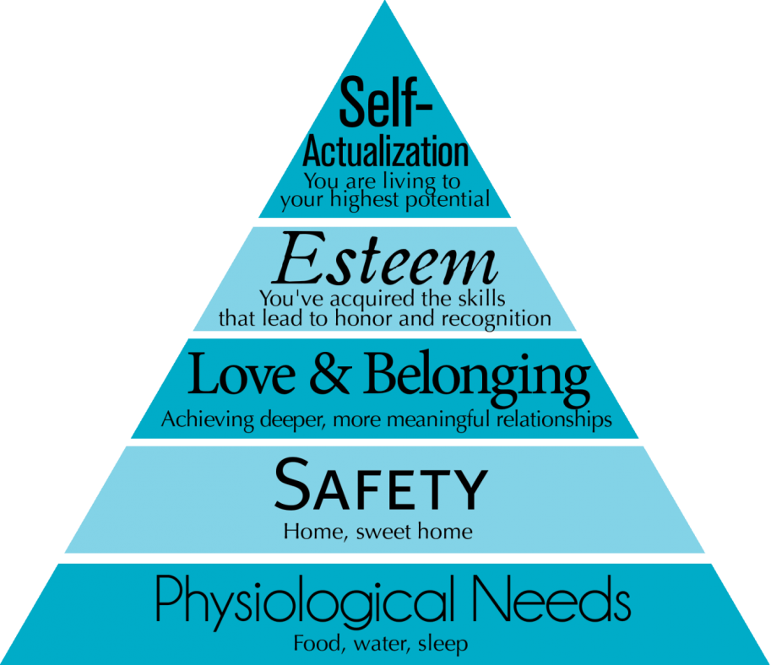
Figure 1: Maslow’s Hierarchy of Needs Theory
(Source: Education Library. 2022)
Elementary Education Act 1870 has ensured that every individual living should have access to basic educational facilities. Thus, this has improved the educational requirements for a girl child. It also claimed that every child in the age group 5-13 years is required to attend school, and this also helps in removing the issues of unemployment and social dilemmas. Child Support Act 1991 UK is considered as the introduction to enforce the public with the requirements which are imposed over all the parents who are considered not to be liable for paying for their child support to their partner are required to do so.
Factors to improve the lives of a child, young people, and families in the reduction of inequalities within health and social care
Economic factors are considered to be providing a huge impact on the development of a child's life. It has also been seen the children’s costs are high, as they require housing food, clothing, toys, and other activities. Family income is the major factor affecting the growth and the fulfilment of the requirements of the child (Halfon et al., 2022, p. 37). These are also the opportunities that influence the children could have. A stable economic factor would help in removing the existence of inequalities within the society as it has been said that money is the main factor through which everything is judged. Basic stable incomes help in providing children with good education facilities or provide just a basic education. The economic factor also supports factors of community and society and supports the social life of a family and their children.
The health factor that influences in having proper growth within an individual and acquiring knowledge is heredity. This is because heredity is considered the transformation which consists of the physical characteristics that are taken from their parents through genes (Hjort and Agergaard, 2022, p. 1235). In addition, this environment is playing an important role in the development of a child's knowledge, and this is represented to be the total of physical and psychological stimulation that is carried forward by the child.
Family is one of the main factors and basic structure of the foundation of knowledge and development of a child (Jacoby et al., 2022). This is because the child gets love, acres, and nurture that are provided with the opportunities for a child in bringing up a better lifestyle. Community or society is considered to be the second most important factor within the development of a child as society affects the growth of defining the relationship within the society. This processes a sense of identity within the learning and acquiring of active support and participation within the world.
Education is the basic need for the development of a child’s life. This also brings discipline and a sense of responsibility and an understanding of teamwork to the child. This is also considered to prevent the child from feeling social insecurity. Education helps in constructing the knowledge and assuming roles that are in front of others and metacognition and improving inter-institutional communication factors of an individual.
Range of approaches and interventions that are involved in support of vulnerable children, young people, and families
Education is considered to have a great amount of potential that is responsible for changing the world. Thus, lack of education is the cause of unemployment, exploitation, and gender inequality within families and communities.
Unemployment rates are high and steady as these are the major negative impacts that are imposed on an individual for a long run of economic growth. Unemployment is considered a waste of resources and is generated through re-distributed pressures and distortions.
Poverty also has numerous kinds of negative impacts on child health, social considerations, emotional stability, cognitive development, and educational positive and negative outcomes (Poirier et al., 2022, p. 1150). The children experiencing poverty are most likely to have a white range of issues in their health that involve poor nutrition, chronic diseases, and mental health issues.
Social environmental factors are the basic influences that cause both positive and negative relationships within the society and which child is being developed. Living in a good social environment increases the likelihood that a child is required to experience and also have a traditional conception of skills which would develop its inner behaviour.
Present an evaluation of effectiveness within the reduction of inequalities
Proper education would bring benefits to the poverty and unemployment level. The main key to all the issues which a child faces during inequality with others is proper education and educational facilities both at school and at home (Vrabic et al., 2022). It has been demonstrated by scholars and educationists that education influences an increase in propensity for processing better employment facilities in his or her future. It has also been provided by the opportunities that not only education creates a smart population but also boosts economic growth are the basic advances within the increase of the GDP of a country. It has also been understood by the polls that are living a healthy lifestyle with the quality and high standards. Thus, education also resolves the social dilemmas that are caused within a society. Poverty is also a factor that would be resolved when the family head or the family members are better educated and are employed. Good and stable employment is dependent upon basic and good educational facilities.
Recommendations
The family members who are lacking in providing good education facilities to their child, as they are not economically stabilised, are recommended to at least provide their child with better social constructive education facilities so that they would be able to resolve all the money related issues the family would be facing. It has also been stated by the constitutional rights that every individual should at least acquire basic education in their life. For this reason, the government has opened schools where education is free. Unemployment can also be resolved with the implementation of better educational facilities for the students, and also changes within the policies that are regarded towards individuals (McGorry et al., 2022, p. 70). The families and the child is required to build their ethnicity wisely and are recommended not to believe in caste, gender race, and discrimination within families. It is necessary to be involved within a better society and positive social factors that help in growing in life and not discourage one.
Potential impact
To bring development within a child's life and family culture, it is required to improve their potential and bring positive impact as education is seen to be one of the basic requirements in an individual life that would improve the family welfare and sustain them from being in the poverty line (Gillespie et al., 2022, p. 17). The family and the child are required to be settled within a positive environment so that they can develop their mental conditions and try their best to improve their economic state. Moreover, it is also required that education is the only key that would help an individual to acquire better employment options and opportunities to develop in their own life.

Conclusion
In the above study, it has been explained the importance of social construction within childhood and the elements that would influence the family life of the child. Some of the children's acts are demonstrated within which it has been highlighted that all have been done for the improvement of childhood life and family culture. The importance of education has also been defined as being the main key to the issues which a child and family face today.

References
Compton-Lilly, C., Shedrow, S., Hagerman, D., Hamman-Ortiz, L., Chi, Y.K., Kim, J., Lee, S.Y., Papoi, K., Quast, E., Taira, B.W. and Zheng, B., 2022. Children in Immigrant Families Becoming Literate: A Window into Identity Construction, Transnationality, and Schooling. Routledge. https://books.google.com/books?hl=en&lr=&id=M2JkEAAAQBAJ&oi=fnd&pg=PT8&dq=Social+construction+of+children&ots=Io1JNZIQPH&sig=KbfvvWPLqAhlzpj3bmWMrr-Q1ig
Education Library. 2022. Maslow's Hierarchy of Needs in Education - Education Library. [online] Available at: <https://educationlibrary.org/maslows-hierarchy-of-needs-in-education/> [Accessed 30 March 2022].
Gillespie, S., Banegas, J., Maxwell, J., Chan, A.C., Darawshy, N.A.S., Wasil, A.R., Marsalis, S. and Gewirtz, A., 2022. Parenting Interventions for Refugees and Forcibly Displaced Families: A Systematic Review. Clinical child and family psychology review, pp.1-18. https://www.researchgate.net/profile/Neveen-Ali-Saleh-Darawsha/publication/357715615_Parenting_Interventions_for_Refugees_and_Forcibly_Displaced_Families_A_Systematic_Review/links/61e2da405779d35951adc360/Parenting-Interventions-for-Refugees-and-Forcibly-Displaced-Families-A-Systematic-Review.pdf?_sg%5B0%5D=started_experiment_milestone&_sg%5B1%5D=started_experiment_milestone&origin=journalDetail
Halfon, N., Russ, S.A. and Kahn, R.S., 2022. Inequality and child health: dynamic population health interventions. Current opinion in pediatrics, 34(1), pp.33-38. https://journals.lww.com/co-pediatrics/Fulltext/2022/02000/Inequality_and_child_health__dynamic_population.8.aspx
Hilal, S. and Brayne, C., 2022. Epidemiologic Trends, Social Determinants, and Brain Health: The Role of Life Course Inequalities. Stroke, pp.STROKEAHA-121. https://www.ahajournals.org/doi/abs/10.1161/STROKEAHA.121.032609’
Hjort, R.L.N. and Agergaard, S., 2022. Sustaining Equality and Equity. A Scoping Review of Interventions Directed towards Promoting Access to Leisure Time Physical Activity for Children and Youth. International Journal of Environmental Research and Public Health, 19(3), p.1235. https://www.mdpi.com/1660-4601/19/3/1235/pdf
Howard, S., Houghton, C.M.G., White, R., Fallon, V. and Slade, P., 2022. The feasibility and acceptability of a single-session Acceptance and Commitment Therapy (ACT) intervention to support women self-reporting fear of childbirth in a first pregnancy. Psychology & Health, pp.1-22. https://www.tandfonline.com/doi/pdf/10.1080/08870446.2021.2024190
Jacoby, P., Williams, K., Reddihough, D., Leonard, H., Whitehouse, A. and Downs, J., 2022. Modelling quality of life in children with intellectual disability using regression trees. Developmental Medicine & Child Neurology. https://onlinelibrary.wiley.com/doi/pdf/10.1111/dmcn.15206
Joaquin, J.J.B. and Biana, H.T., 2022. From Social Construction to Social Critique: An Interview with Sally Haslanger. Hypatia, pp.1-13. https://www.cambridge.org/core/journals/hypatia/article/from-social-construction-to-social-critique-an-interview-with-sally-haslanger/0E798BB63F9EA9EC4194E511A952864D
Low, S.M., 2022. Spatializing culture. The social production and social construction of public space. In On the Plaza (pp. 127-153). University of Texas Press. https://www.degruyter.com/document/doi/10.7560/747135-009/html
McGorry, P.D., Mei, C., Chanen, A., Hodges, C., Alvarez‐Jimenez, M. and Killackey, E., 2022. Designing and scaling up integrated youth mental health care. World Psychiatry, 21(1), pp.61-76. https://onlinelibrary.wiley.com/doi/pdfdirect/10.1002/wps.20938
Poirier, B.F., Hedges, J., Smithers, L.G., Moskos, M. and Jamieson, L.M., 2022. Child-, Family-, and Community-Level Facilitators for Promoting Oral Health Practices among Indigenous Children. International Journal of Environmental Research and Public Health, 19(3), p.1150. https://www.mdpi.com/1660-4601/19/3/1150/pdf
Power, K., 2022. The influence of changing discourses of childhood on 1860s educational policy. History of Education, 51(1), pp.1-21. https://www.tandfonline.com/doi/pdf/10.1080/0046760X.2021.1953158
Schmitt-Egenolf, M. and Birrell, F., 2022. Diverse research designs are needed for population health: Lessons from Maslow. Lifestyle Medicine. https://www.diva-portal.org/smash/get/diva2:1627020/FULLTEXT01.pdf
Vrabic, S.C., Herbers, J.E., Davis, M. and Thomas, C., 2022. Perceptions of Support in Shelter Environments for Caregivers and Young Children Experiencing Family Homelessness. Child: Care, Health and Development. https://onlinelibrary.wiley.com/doi/abs/10.1111/cch.12963
Wang, J., 2022, January. Racial Ideology Development in Children: A Cause, Implication and Strategy Study. In 2021 International Conference on Social Development and Media Communication (SDMC 2021) (pp. 312-316). Atlantis Press. https://www.atlantis-press.com/article/125968670.pdf

