Taylor Hodges (2008862)
2008862@student.uwtsd.ac.uk
BSc Computing (Software Engineering)
Lecturer: Nitheesh K
Due: 29/4/22
NETWORK OPERATING SYSTEMS AND SERVICES (ACCA5023)
Manage and maintain network resources, and its services applying suitable policies and drafting security and redundancy practices.

Contents
Table of Figures 1
Objectives 2
Task 1 – NTFS and Share Permissions 2
1.1. NTFS 2
1.2. Share permissions 5
1.3. Accessing file share over network 6
2. Policy management 7
Task 2 - Fail cluster 11
2. FTP Server 11
3. remote access 16
4. IP Packet Filtering 23
Filter 1: Stopping anyone on private net 1 from pinging the router. 23
Filter 2: Restrict access to FTP service 25
Filter 3: Only allow client 2 to access to FTP server 26
Task 3 - Observations 27
i. Sound Password Principals 27
ii. Failover Clustering 28
A. High Availability (HA) and Continuous Availability (CA) 28
B. Failover Cluster 29
iii. Network Policy 31
Bibliography 33

Table of Figures
Figure 1: [4] Information security triangle depicts how confidentiality, integrity, and availability (CIA) works together to create security solutions for information. 28
Figure 2: [11] On the Domain Controller (DC), the failover clustering feature is selected and installed. 29
Figure 3: [11] Node 1 and Node 2 already on the domain is connected as failover machines. 30
Figure 4: Network layout. 31

Objectives
- Configure and understand NTFS and share permissions
- Install FTP server
- Configure file and storage server
- Set up group policy
- Install routing and remote access
- Installed routing protocols (RIPv2)
- Implement IP packet filtering

Task 1 – NTFS and Share Permissions

NTFS
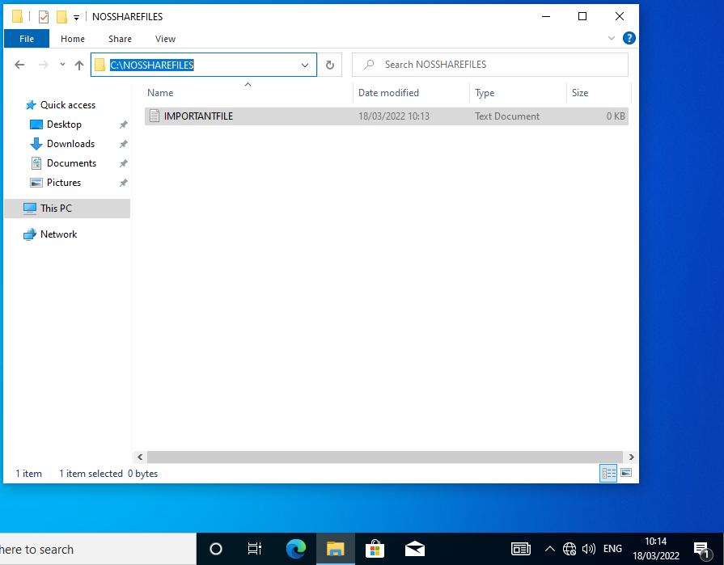
A new file was created on the C drive of Client 1. An important file text document is located inside.
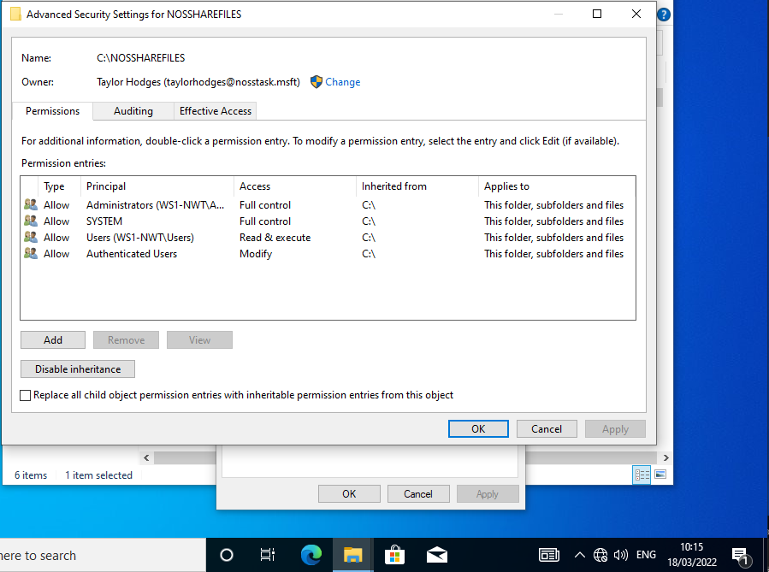
File permissions, before. Permissions will now be cleared and reselected manually.
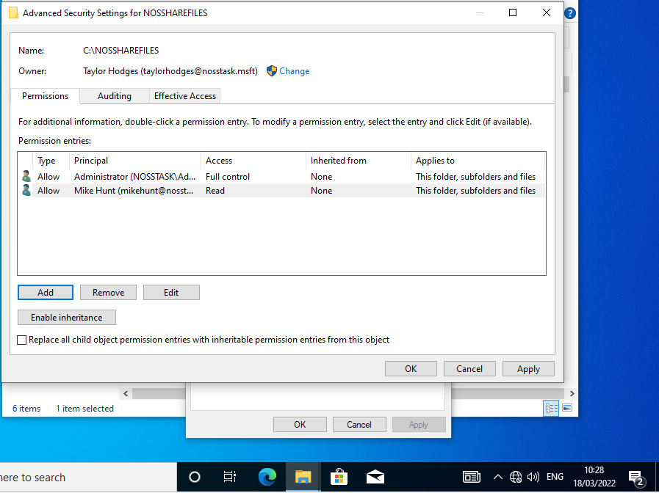
File permissions, after. Administrator has full access. Non-admin account, Mike, only has read permissions.
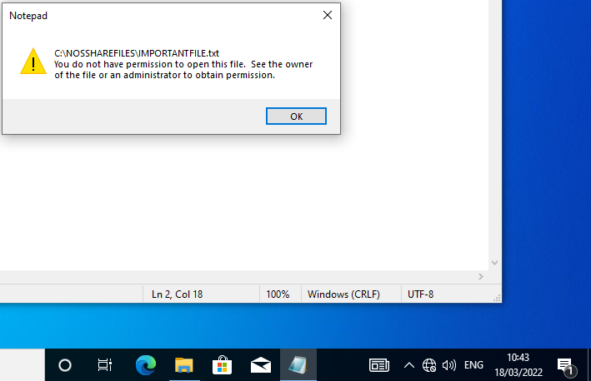
User with read only permissions is unable to make changes to files in shared area due to reads only permissions.

Share permissions
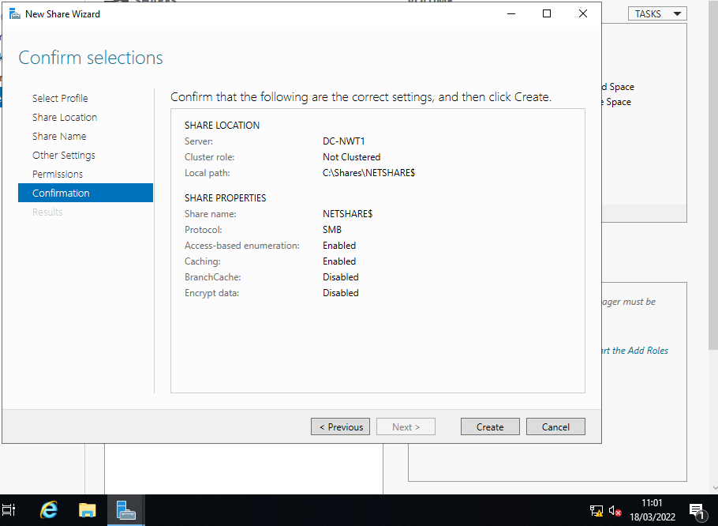
A new share folder was created on the C drive of Server 1. With access-based enumerations and caching both enabled. Access-based enumerations means only authorised users will be able to see this file. Caching means users with access can still see these files offline.
The same access is granted as previously; the two users with access rights are administrator with full access, and non-admin, Mike, with read only authorisation.

Accessing file share over network
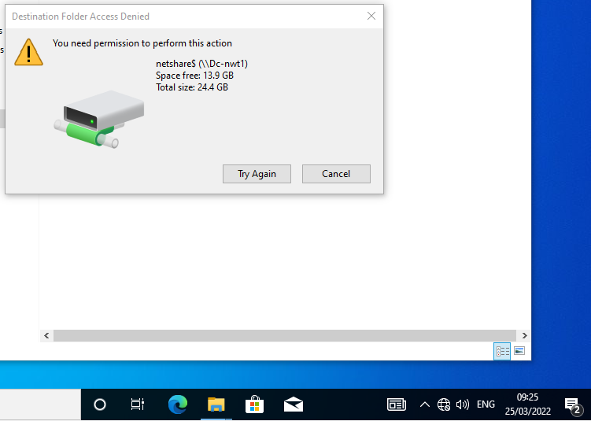
From Client 1, non-admin user, Mike, does not have authorisation to make changes in share.
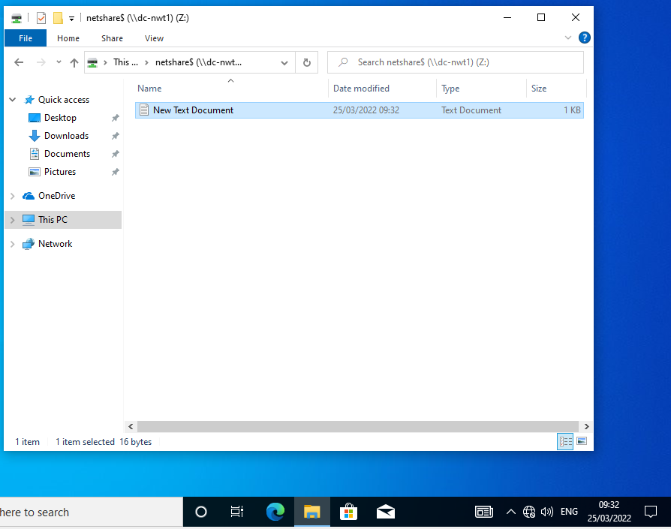
Again, from client 1, authorised user, administrator, has full access to items in this file.

Policy management
Group policy applies to all machines or users they are applied to. They are typically used to restrict certain process that certain user to machine do not require to complete their role.
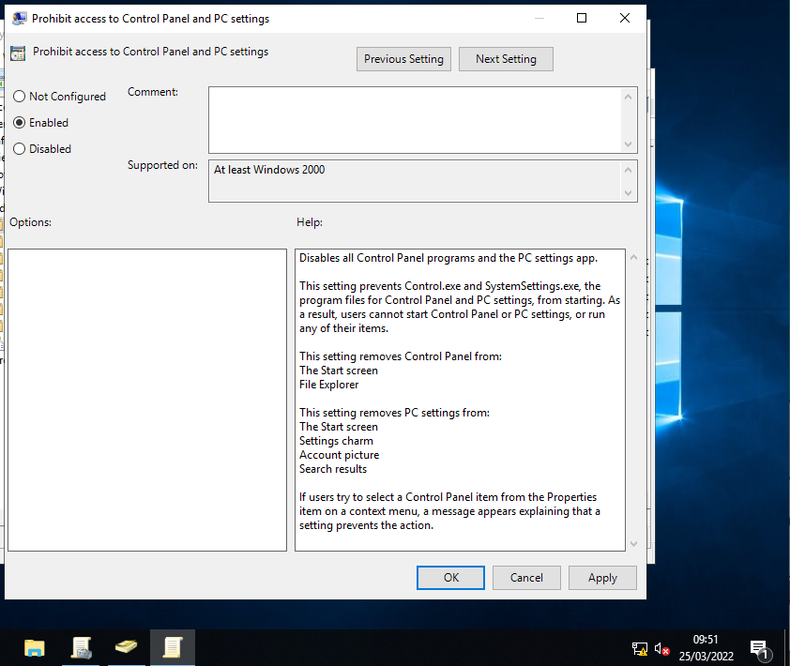
Prohibit access to control panel is now enabled for standard users.
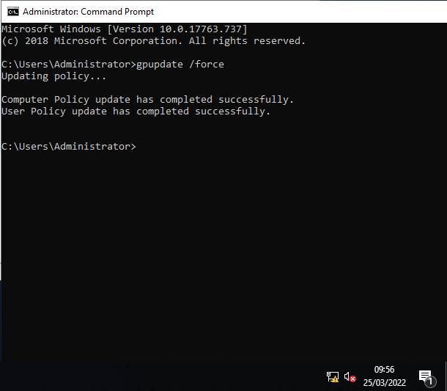
Group policy updates forces domain and objects to accept any policies that have been created. This needs to occur after each new policy
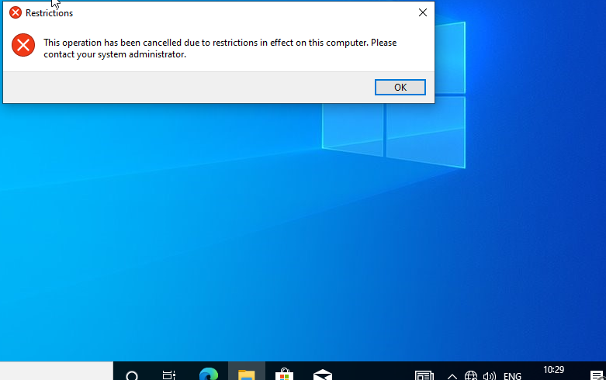
GPO 1: Control panel access is denied; test successful. Control panel cannot be opened by standard users.

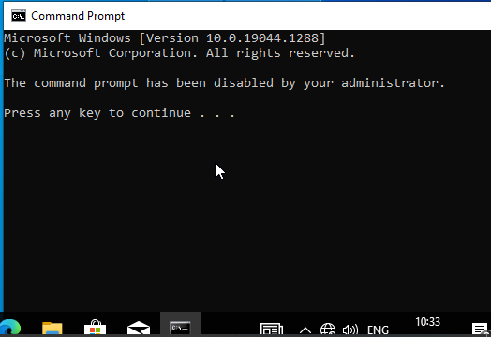
GPO 2: Access to command prompt has been removed; test successful. Command prompt cannot be used by standard users, if user attempts to type here, the panel closes on any key.
GPO 3: Removable storage classes denied access; test successful. When a USB is connected on a standard user account, the drive cannot be access or used.
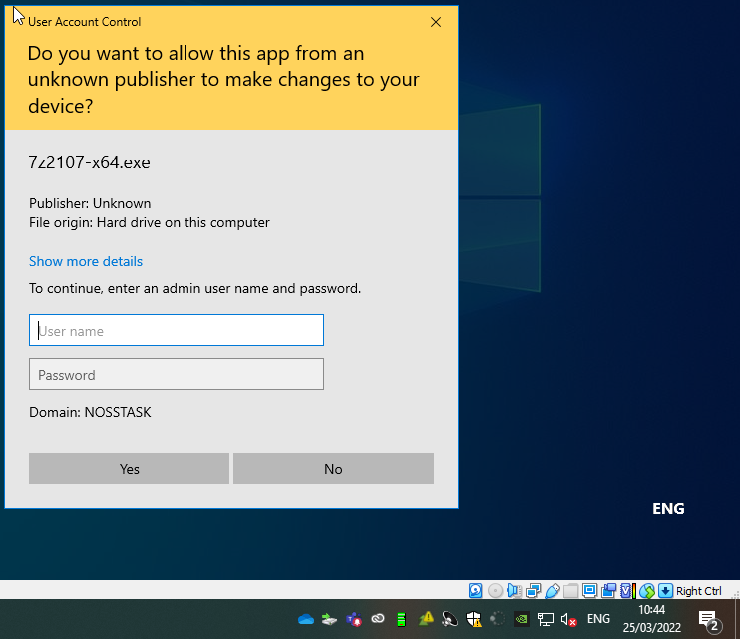
GPO 4: software installs are restricted; test successful. Administrator login required to download any software.
GPO 5: Password restrictions; test successful. If user creates a password that is less than 8 characters, or does not meet minimum complexity requirements, the password change is unsuccessful.

Task 2 - Fail cluster

2. FTP Server
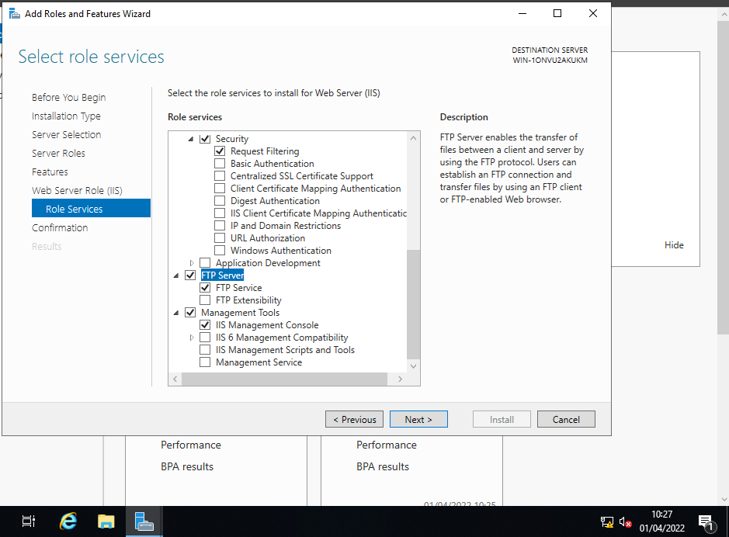
FTP server is being set up for deployment on server 1.
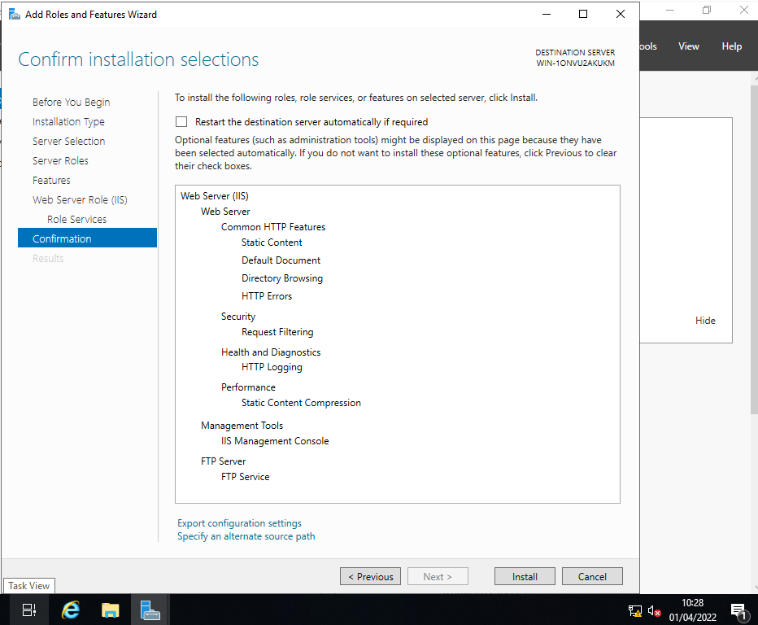
The above set up is ready for FTP installation.
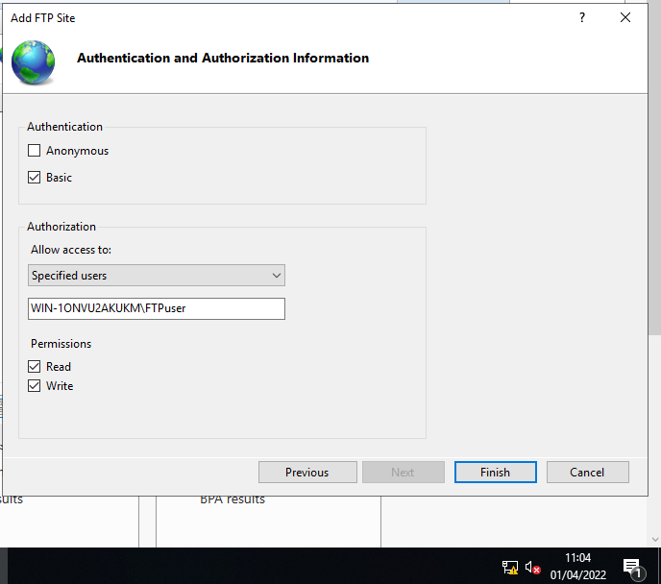
Creating a new FTP site with basic authentication, access for specific users, and the user in question, with both read and write permissions.
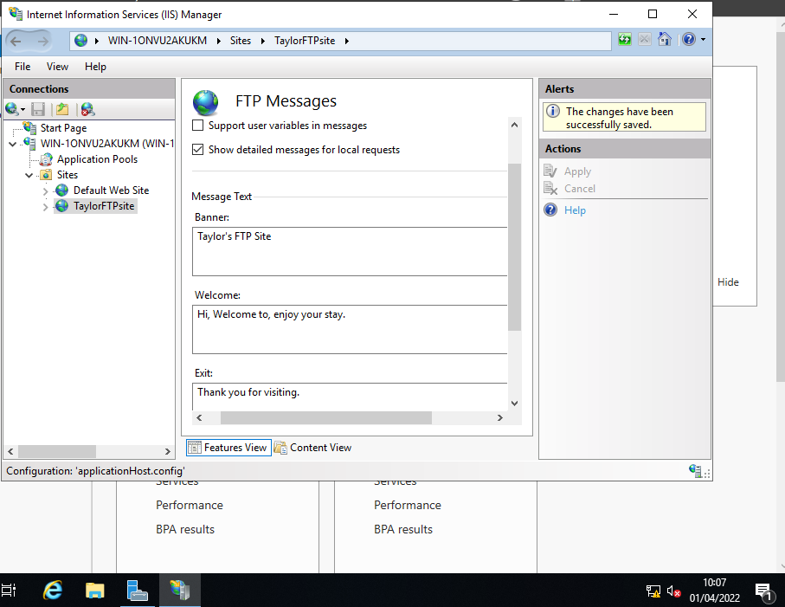
FTP page messages are set up to send the user banners when they login and log out.
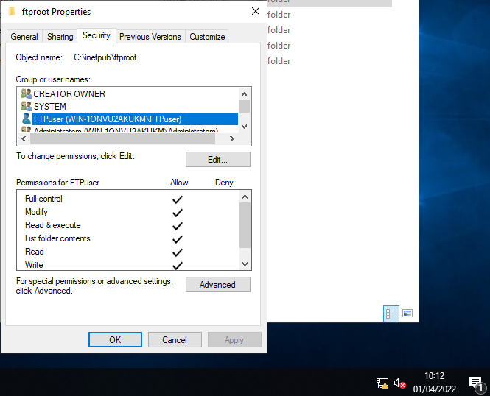
FTP user is given full access to this FTP site.
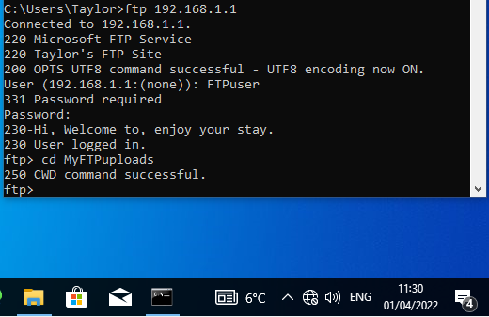
User logged in successfully. FTP messages were displayed. Command entered to move share file to MyFTP uploads file.
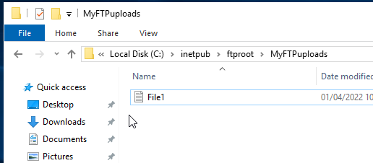
File has been uploaded to new location and is visible from the server.

3. remote access
Server 1 can ping server 2 successfully, and vice versa.
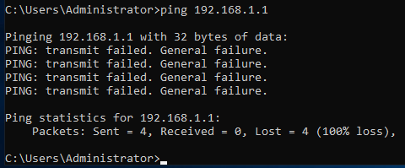
Server 2 cannot ping server 1 on private net 1, only on public net.
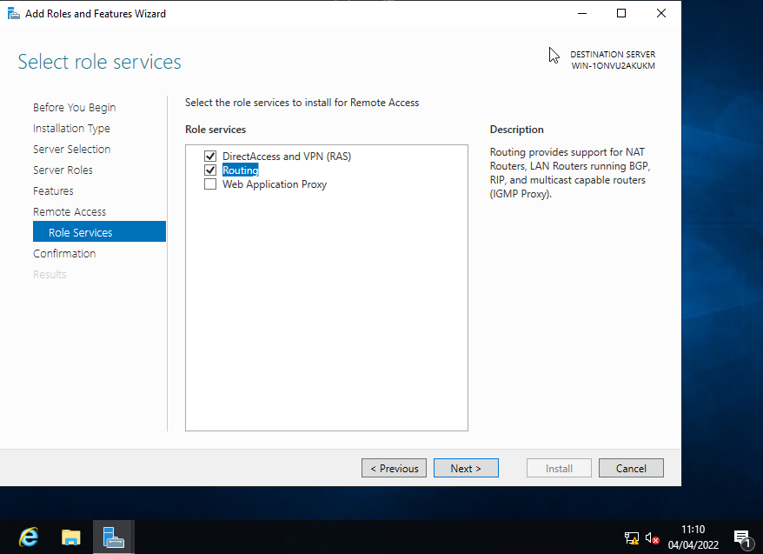
Other servers are now being assigned remote access privileges which allows the server to act like a router. Servers have DirectAccess and VPN, and routing capabilities.
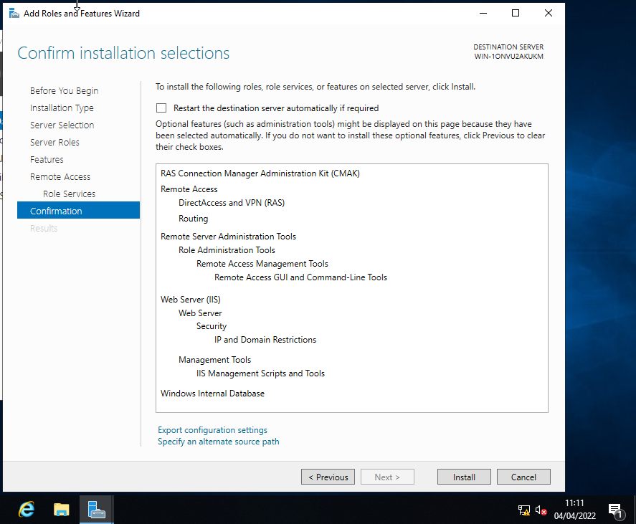
Summary of set up before installation.
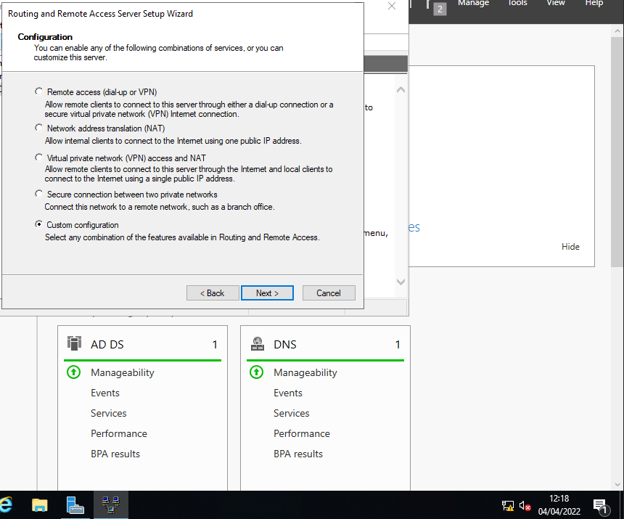
At the welcome wizard, custom configuration is selected.
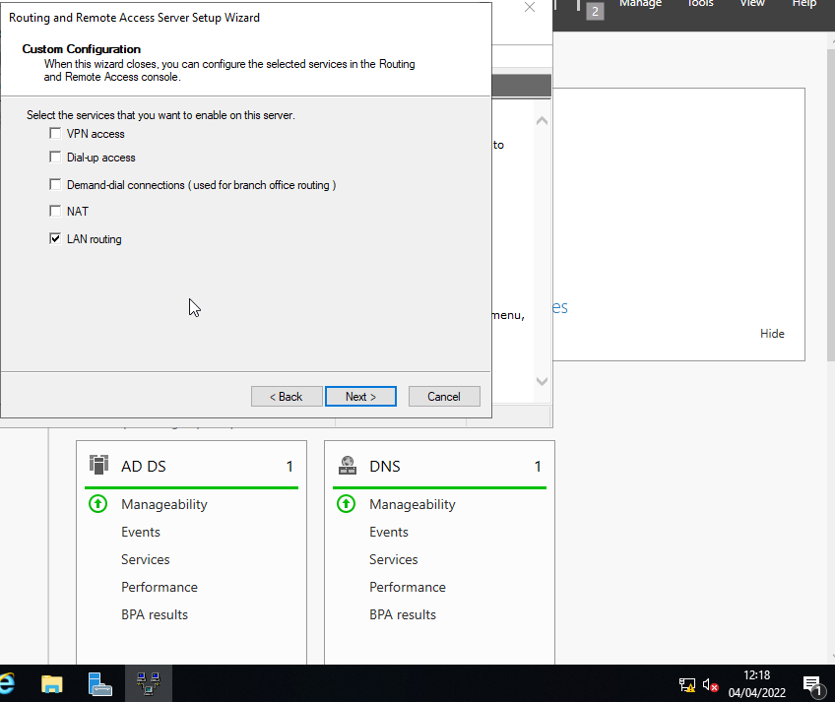
Lan router is selected. Install the router, and service is started.
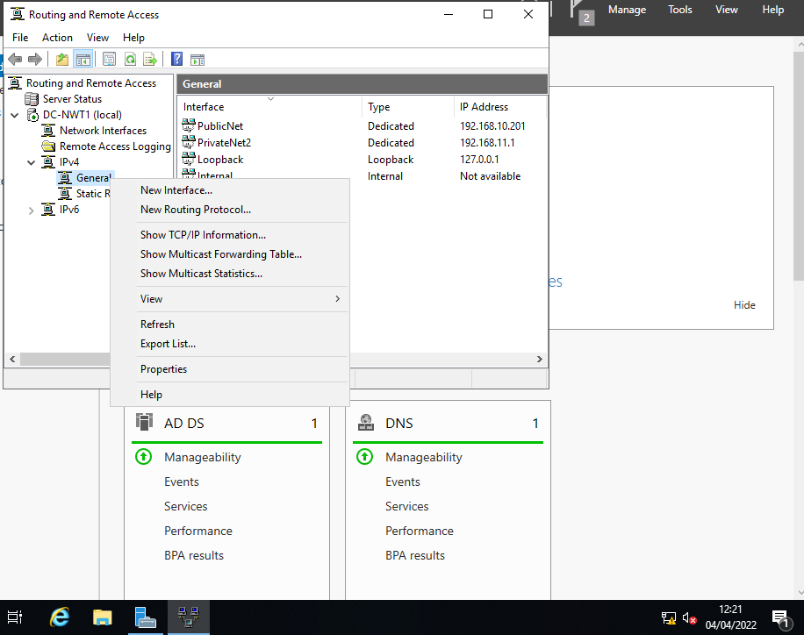
In routing and remote access, a new routing protocol called “RIP” is created. All networks on both Servers are added; on server 1 public net and private net 1 are added, and on server 2 public net and private net 2 are added.
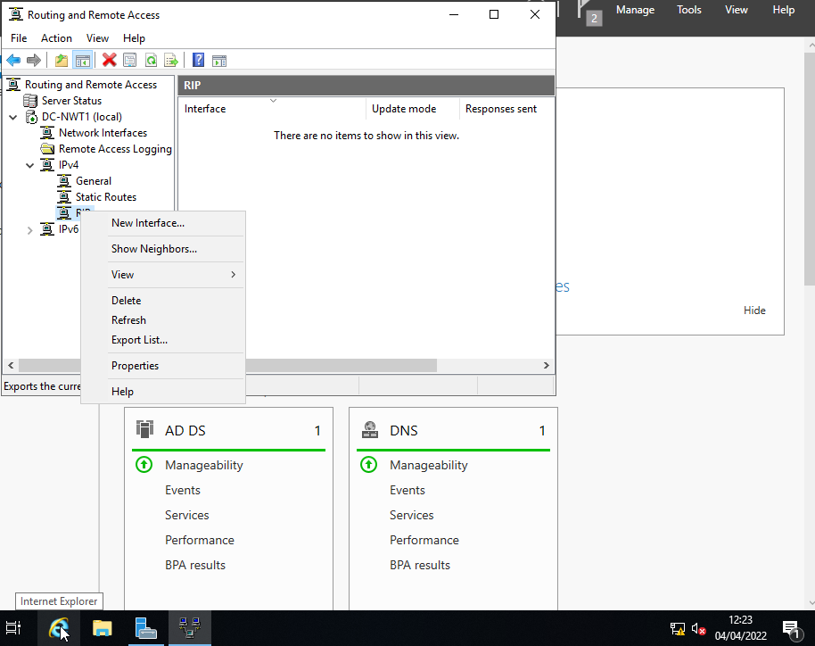
New interfaces are added.
Same set up is created on both servers.

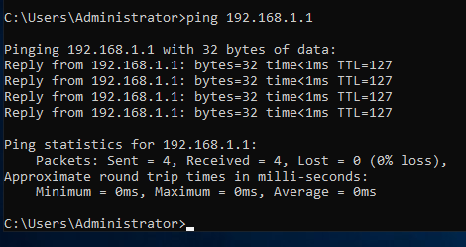
Now server 1 can ping server 2 using private network 2 now. Vice versa is also possible; server 2 can ping server 1 on private net 1.

4. IP Packet Filtering

Filter 1: Stopping anyone on private net 1 from pinging the router.
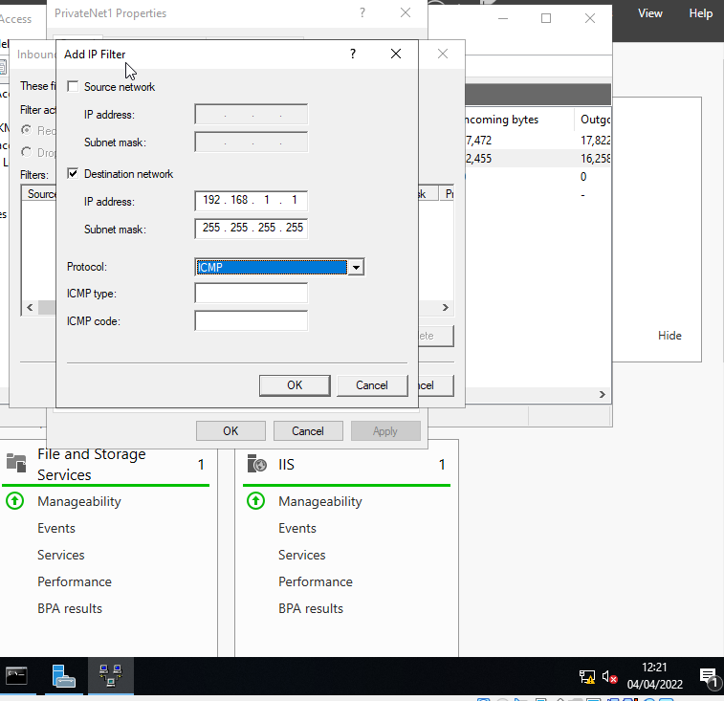
Inbound filter set: any source on private net 1 cannot sent ICMP (ping) requests to server 1. Stops client 1 from pinging server 1 on 192.168.1.1 address.
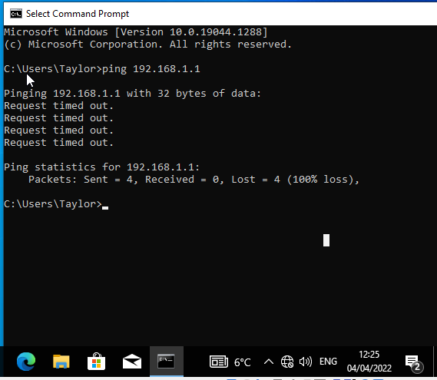
Client 1 ping to server 1 is unsuccessful as expected: test successful.

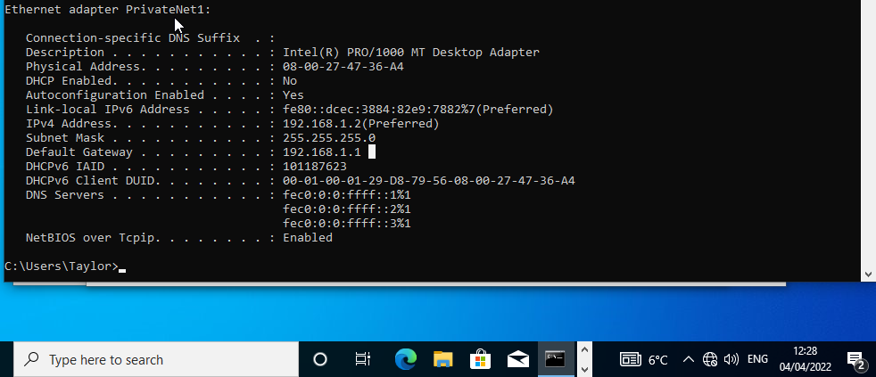
The default gateway for client 1 is set to server 1, and sends the client to the router.

Filter 2: Restrict access to FTP service
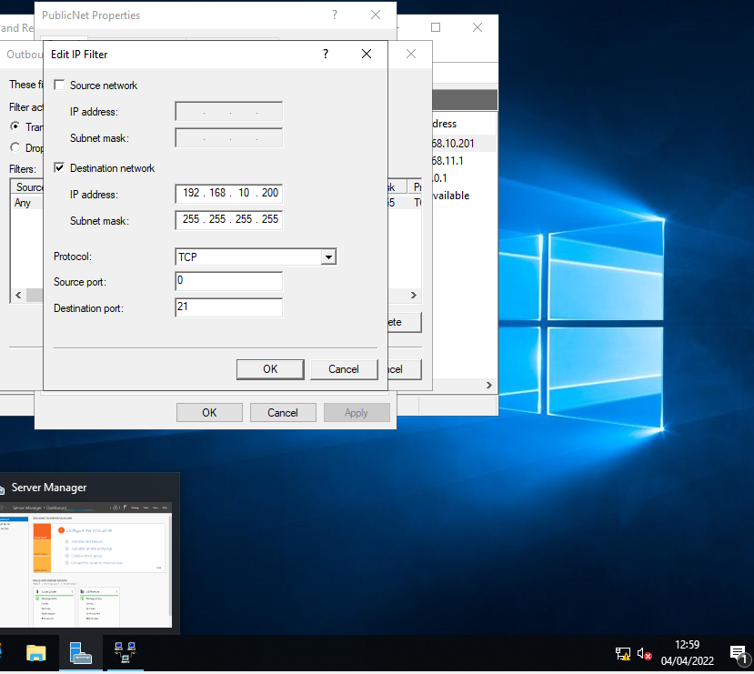
Outbound filter set: any TCP requests for TCP server location will not be accepted; test successful.

Filter 3: Only allow client 2 to access to FTP server
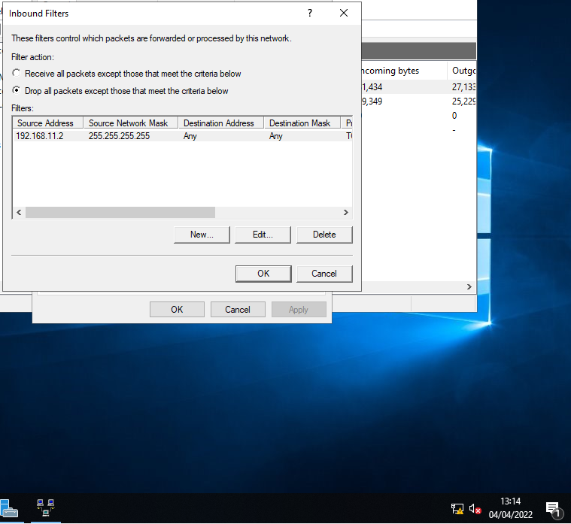
Server 1 can only accept TCP packets from client 2. Same set up was made for Server 2 to only allow TCP packets from client 1.

Task 3 - Observations

Sound Password Principals
Good passwords are long strings of characters that are not existing words or phrases nor names or personal dates as these can be easy to guess. E.g., a bad password: password123 [1]
Passwords need to use symbols and uncommon characters for security [2] [3], such as: !£$%&*@#~-?, etc.
A good password is an uncommon phrase combined with numbers, symbols, and a combination of upper and lowercase [3]. E.g., a good passphrase, ‘I like to boogie boogie’: !L1k32b0o9!eBO0gi3
Another passphrase technique would be to make a long relevant phrase and use the first letter of each word, substituting with letters and symbols where possible. E.g., a good phrase for Gmail could be ‘my dog, Anna, misses getting mail now that I get all my mail electronically on google’ and could translate into a good passphrase of: mD,@.M9m-nT!9@mM30g
Finally, passwords should never be reused, therefore, a technique for customised passphrases is to count the occurrences of a certain letter in the website URL and appending this number to the end of your usual passphrase [1]. E.g., for an Amazon login, the letter ‘a’ occurs in the URL twice, therefore, append the number ‘2’ to the end of your passphrase.
Additionally, multi factor authentication (MFA) is feature popular in organisations that enforces the user to pass multiple steps to gain access in addition to the password. These steps could be a call/text to a registered phone number/email, authenticator app, biometric scans, etc.

Failover Clustering

High Availability (HA) and Continuous Availability (CA)
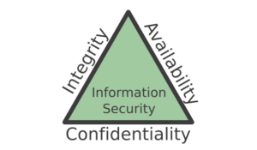
Figure 1: [4] Information security triangle depicts how confidentiality, integrity, and availability (CIA) works together to create security solutions for information.
Confidentiality is the state of keeping information private from unauthorised access [5].
Integrity is the state of accurate and trustworthy data [6].
Availability is providing an available service for relevant parties.
Failover clustering is the term given to a set of computer/servers that work together to provide HA or CA [7]; these servers are linked together in passive state with one node in active state, if the active server experiences server failure and goes down, another server will switch to active state to continue where the previous one left off with a minimum or no downtime [8] [9], this is how failover clusters create HA or CA.
Some examples of HA or CA systems are:
- Email servers
- The Internet
- AD servers
- DCHP servers
- Databases
- Firewalls
While failover clusters have advantages of low downtime as the standby machine has no need to power up, reboot, or configure as it is prepared to take over as the active node [10].
However, there are also potential for disadvantages if not properly managed; one major disadvantage is there is no preparation for disaster recovery scenario:
“A loss of the physical site could result in the destruction of the backup systems as well as the production systems.” [10]
To prevent this issue, a backup of data is required off-site to ensure that disasters that affect the main site, do not affect the backup site too.

Failover Cluster
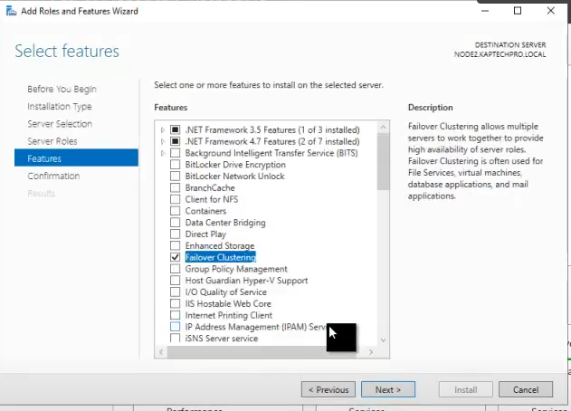
Figure 2: [11] On the Domain Controller (DC), the failover clustering feature is selected and installed.
The DC server the Failover is installed this is the primary management node in the cluster. The cluster manager is aware of all other nodes in the cluster. The DC can use load balancing to failover some services to other available nodes to distribute the workload. This occurs when a cluster node becomes bottlenecked with the workload placed upon it.

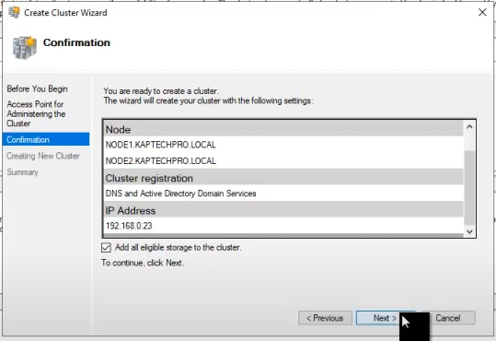
Figure 3: [11] Node 1 and Node 2 already on the domain is connected as failover machines.
Failover machines Node 1 & Node 2 that are on the same domain and have the same OS version of windows to avoid clashing updates [12].
Storage Area Networks (SANs) require a fast connection such as Internet Small Computer Systems Interface (iSCSi)

Network Policy
Assumptions:
- WAN contains three LANs
- Guest accounts are not required in this organisation.
Network Policy:
- Topology – three distinct LANs connected via the internet. Each LANs have their own server at the centre of a star topology in a distributed network. This enables off-site data backups between the various locations.
- Network Layout and Design –
Figure 4: Network layout.
  - Figure 1 shows the WAN comprised of three LAN networks connected in a star topology to a server connected through the internet.
- Network Access – Varying access for different user groups using AD services:
  - Various user groups
    - Administrators – full access.
    - Managers – full access to data, but not the ability to install, modify, or remove software.
    - General users – access to data only relevant to their job role. May not have access to certain applications. Will not have the ability to install, modify, or remove software.
  - Good strong passwords will prevent unauthorised users from accessing the network.
- Security Team –
  - Security administrators enforce appropriate access to the network.
  - Database administrators allow appropriate access to the data.
  - Information officer acts in the event of a data breach and responds to any data requests under GDPR or information requests under FOI.
- Security Policies –
  - Bring Your Own Device (BYOD) policy - allowing employees to work on their own device but states job role related restrictions.
  - Work from home policy – outlines expectations of employee while carrying out role from home.
  - Data access policy – defining which user groups and departments what access rights.
  - Data loss/corruption policy – various backups of data on each server.
  - Data breach/data theft – how to protect data and plan in event data is lost or stolen.
  - Physical security – key fobs, locked doors, gates and fences, Id cards, roaming guards, turnstiles.
- Security Risks Analysis –
  - Computer misuse – unauthorised access of other user’s machines.
  - Data loss – resulting in a large fine. High impact risk.
  - Physical risks - such as natural disasters, floods, fire, earthquakes.
  - Disgruntled employees – high impact risk with low likelihood, a mitigation to this risk would be to not enforce a notice period for employees leaving their role as this would eliminate their access to the network and the data.
- Security Operations –
  - Maintaining backups
  - Auditing employee access
  - Recording of potential data breaches
  - Acting on discovered data thefts
  - Ensuring all software including the OS is full updated with most recent patches.
  - Checking for accidentally installed malware and spyware
  - Educate staff in phishing identification and risks
  - Educate staff in GDPR and freedom of information

Bibliography

[1] | J. F. &. A. D. &. A. Durcikova, Business Data Communications and Networking, UK: Wiley, 2020.
[2] | LAFAYETTE, “Guidelines for Strong Passwords · Information Technology Services · Lafayette College,” LAFAYETTE, [Online]. Available: https://its.lafayette.edu/policies-draft/strongpasswords/. [Accessed 6 April 2022].
[3] | Webroot, “How Do I Create a Strong and Unique,” Webroot, [Online]. Available: https://www.webroot.com/us/en/resources/tips-articles/how-do-i-create-a-strong-password. [Accessed 6 April 2022].
[4] | A. Henderson, “The CIA Triad: Confidentiality, Integrity, Availability,” Panmore Institute, 24 December 2019. [Online]. Available: http://panmore.com/the-cia-triad-confidentiality-integrity-availability. [Accessed 26 April 2022].
[5] | i-scoop, “The CIA triad of confidentiality, integrity and availability,” i-scoop, [Online]. Available: https://www.i-scoop.eu/cybersecurity/cia-confidentiality-integrity-availability-security/. [Accessed 26 April 2022].
[6] | W. Chai, “confidentiality, integrity and availability (CIA triad),” Tech Target, January 2021. [Online]. Available: https://www.techtarget.com/whatis/definition/Confidentiality-integrity-and-availability-CIA#:~:text=Confidentiality%2C%20integrity%20and%20availability%2C%20also%20known%20as%20the,to%20avoid%20confusion%20with%20the%20Central%20Intelligence%20Agency.. [Accessed 26 April 2022].
[7] | Microsoft, “Failover Clustering,” Microsoft, February 11 2022. [Online]. Available: https://docs.microsoft.com/en-us/windows-server/failover-clustering/failover-clustering-overview. [Accessed 19 April 2022].
[8] | KepTechPro, “Failover Cluster Installation & Configuration Step By Step,” YouTube, 21 January 2021. [Online]. Available: https://www.youtube.com/watch?v=wmM38A3nJn8&t=56s. [Accessed 20 April 2022].
[9] | J. Emigh, “What is Failover Clustering?,” ServerWatch, 15 May 2019. [Online]. Available: https://www.serverwatch.com/servers/failover-cluster/. [Accessed 20 April 2022].
[10] | Miketalon, “Learn the pros and cons of high-availability systems,” TechRepublic, 17 June 2005. [Online]. Available: https://www.techrepublic.com/article/learn-the-pros-and-cons-of-high-availability-systems/. [Accessed 20 April 2022].
[11] | KapTechPro, “Failover Cluster Installation & Configuration Step By Step,” YouTube, 21 January 2021. [Online]. Available: https://www.youtube.com/watch?v=wmM38A3nJn8&t=56s. [Accessed 26 April 2022].
[12] | Microsoft, “Create a Failover cluster,” Microsoft, 2 November 2022. [Online]. Available: https://docs.microsoft.com/en-us/windows-server/failover-clustering/create-failover-cluster#validate-the-configuration. [Accessed 26 April 2022].

