


LEVEL 5 ASSESSMENT SPECIFICATION

Student name: | Sharifah Intan Nur Sufi Binti Syed Azhar | Student ID number: | 20200207
Programme: | IUMW
Module: | Changemakers: Creativity and Value Creation
Module code: | BMSW5008_SWAN | Contribution to Overall Module Assessment (%): | 50%
Lecturer: | Myfanwy Davies | Internal Verifier:
Assignment Title: | E-Portfolio Evidence of Learning | Word count (or equivalent): | 2000 or equivalent
Submission deadline: | 6th December, 2023 | Return date of provisional marks & written feedback:
Submission method: | All written assessments, where practical and possible, must be submitted via Turnitin unless otherwise instructed by the Lecturer. (Please DO NOT put this assessment specification into Turnitin or it will match many similarities with other students’ submissions.)  Alternative submission method (if applicable):  Late submission of the assessment will result in a late penalty mark. Penalties for late submission: Up to one week late, maximum mark of 40%. Over one week late, 0%. Only the Extenuating Circumstances Panel may approve a change to submission dates.
Academic honesty / referencing: | Academic honesty is required. In the main body of your submission, you must give credit to authors on whose research and ideas your work is based. Append to your submission a reference list that indicates the books, articles, etc. that you have used, cited or quoted in order to complete this assessment.

TABLE OF CONTENT

TASK 1 - RESEARCH QUESTION 2
1.1 RESEARCH QUESTION 2
1.2 RESEARCH APPROACH 3
1.2.1 DEDUCTIVE / INDUCTIVE / ABDUCTIVE 3
1.2.2 QUALITATIVE / QUANTITATIVE / MIXED METHODS 4
1.3 DATA COLLECTION METHOD(S) 5
1.3.1 PRIMARY / SECONDARY METHODS 5
1.4 DATA SAMPLING METHOD AND SAMPLE SIZE 6
1.4.1 DATA SAMPLING METHOD 6
TASK 2: RESEARCH TECHNIQUE 7
TASK 3: PRESENTATION ON IDEAS 11
TASK 4: DATA ANALYSIS 12
REFERENCES 13
APPENDIX 16

TASK 1 - RESEARCH QUESTION

1.1 RESEARCH QUESTION
This study delves into post-COVID-19 adaptive behaviours and the resilience of consumer intentions to use online food delivery platforms. It explores how consumers altered to pandemic challenges, factors influencing persistence, and the role of technology.

The global COVID-19 lockdown in 2020, prompted shifts in consumer behaviour, emphasising control over managing home entries and household hygiene. An article highlighted survey findings among Chinese shoppers, revealing 42% aimed to boost online grocery purchases post-pandemic, while only 8% considered to lessen online usage. For those bypassing home-cooked meals is making use of online restaurant delivery services to lessen trips outside the home.

Online-to-offline (O2O) platforms, especially food delivery apps (FDAs), interrupted the hospitality sector by combining digital promotions with physical channels. The lockdown fastened FDAs' acceptance, with features like 'contactless delivery' gaining popularity. Universal adoption of FDAs globally is driven by convenient food delivery and revenue opportunities for restaurants without capacity expansion (Tandon et al., 2021).

Changes in consumer lifestyles, especially with busy schedules, contribute to FDAs' appeal. Specifically relevant for urban consumers, FDAs attend to the demands of a fast-paced lifestyle. Young consumers, attracted by features like feedback options and personalised search results, actively adopt FDAs, contributing to their broad acclaim (Tandon et al., 2021).

This research is valuable for its insights into post-COVID-19 consumer behaviours in online food delivery. It highlights shifts caused by pandemic-induced consumer priorities and emphasises the substantial change of technology. Overall, the study contributes vital knowledge for businesses navigating the growing landscape of online food delivery services in the post-pandemic era.

1.2 RESEARCH APPROACH

1.2.1 DEDUCTIVE / INDUCTIVE / ABDUCTIVE
Deductive approach begins with general statements to achieve a logical conclusion. In deductive research, a researcher begins with a theory, often deduced from inductive reasoning. The deductive approach is used to test the theory's credibility. Valid conclusions result if the theory is accurate, while invalid conclusions suggest an inaccurate theory. Deductive approach is used to verify hypotheses, deductive research cannot happen in the absence of an established theory (Sirisilla, 2023).

Inductive approach progresses from specific observations to generalisations, deviating from the scientific method. It creates generalisations by identifying patterns. Inductive reasoning's effectiveness comes from strong arguments, where a true premise suggests a probable true conclusion. Weak arguments may imply false conclusions, making a compelling argument becomes challenging if it is weak or based on false premises (Sirisilla, 2023).

Abductive research involves making inferences to discern the best explanation or hypothesis when faced with limited or incomplete information. Unlike deductive reasoning, which employs general principles to specific cases, and inductive reasoning, which identifies patterns from specific observations, abductive reasoning starts with incomplete data, working towards determining the most plausible explanation (Hassan, 2023).

I choose to apply a deductive approach due to the fact that I am basing this research on existing theories and other studies done by researchers to further assist on this research. I also aim to look at this research from a general perspective to a specific one which I think goes with the flow of this topic.

1.2.2 QUALITATIVE / QUANTITATIVE / MIXED METHODS
Quantitative method utilises statistical analysis to connect existing knowledge with new insights. The process involves analysing and collecting data using inferential or descriptive statistics, which help make deductions regarding populations and estimate parameters. Visual aids such as graphs are employed, and conclusions are reached through logical reasoning, evidence, and argumentation. This approach flows from a general level to more specific (Soiferman, 2010).

While qualitative research is a meticulous and adaptable method conducted in natural settings, where the researcher serves as the instrument for data collection. The analysis entails using expressive language, focusing on participants' meanings, and identifying common themes. It demands extensive time in the field and participation due to human-focused research approaches. Conclusions develop with ongoing data collection, using inductive reasoning to start from specific observations to broader generalisations and theories (Soiferman, 2010).

Unlike the above approach, the abductive approach can develop, explain and change theoretical frameworks within the research process (Aberdeen, 2013). This approach underlines the importance of intentions, motives, and meanings in individuals' daily lives, translating the social world from within (Ong, 2012). It allows researchers to address weaknesses found in above approaches and conclude it with a True or False outcome (Aberdeen, 2013).

I choose to use a quantitative method because I would like to investigate and analyse this research through statistical results involving numbers. The aim is to focus on collecting figures data obtained through questionnaires, as an example from primary research. It goes with the flow of the research looking at general view to specific view, that is why this method is being chosen.

1.3 DATA COLLECTION METHOD(S)

1.3.1 PRIMARY / SECONDARY METHODS
Typically, primary research follows the scientific method, allowing researchers to investigate and understand the world through the formulation of observable, replicable, and measurable research questions or hypotheses. The main goal is to discover new knowledge validated by others, while lessen personal biases in the process (Driscoll, 2011).

Secondary research involves analysing existing data collected by others for different purposes, using sources like reports, books, databases, articles, and surveys. Unlike primary research, which involves first-hand data collection, secondary research relies on already published information from various outlets such as market research reports, online databases, government publications, industry studies, and academic journals (Taylor, 2023).

As for my primary research, due to the research being in quantitative methods, I will be measuring and observing the research questions in the form of questionnaires. Utilising the Google Form platform to create and distribute surveys to relevant participants.

A survey's success depends on a well-designed questionnaire. Questionnaires provide standardised data collection for analysis, aligning with research objectives. Its efficiency and cost-effectiveness make it optimal for resource-limited situations. Questionnaires ensure participant anonymity which encourages honest responses, and also serve as valuable confirmation tools when compared with studies using different data collection strategies (Roopa & Rani, 2012).

1.4 DATA SAMPLING METHOD AND SAMPLE SIZE

1.4.1 DATA SAMPLING METHOD
To address the research questions, it is doubtful that researchers can collect data from all cases. Therefore, it becomes necessary to do selection of samples. The population refers to the entire set of cases from which the researcher draws the sample. Due to limitations in time and resources, researchers employ sampling techniques to decrease the number of cases under analysis (Taherdoost, 2016).

For the sampling method, I will be using stratified random sampling. To further explain, stratified sampling involves dividing the population into subgroups based on relevant characteristics for this research and useful to ensure fair representation from all subgroups when there is substantial variation in the population (Taherdoost, 2016). For example, it can be age, frequency, and platform use.

1.4.2 SAMPLE SIZE
Sample size refers to the population subset needed to draw conclusions in a study. Sample size for this research is set to 30 participants for the questionnaire. Roscoe recommended for most behavioural studies to have a sample size between 30 and 500 participants. The right sample size relies on factors such as the research questions, problem, design, and population characteristics. For less complex research, a smaller group of around 30 individuals might be enough to effectively measure the collected data results, as outlined by Memon et al. (2020).

TASK 2: RESEARCH TECHNIQUE
The link to the survey: *If could not access it, please go to appendix for the responses*
https://docs.google.com/forms/d/e/1FAIpQLSeJN0H1_iKvg2J7VmvS1QRadlqWvxeVA8X9I0DJqNbuDbY4gg/viewform?usp=sharing

The growing demand for online food delivery (OFD) services, heightened by the COVID-19 pandemic, highlighting the need to understand customer preferences. The influence of internet technology has transformed retail, challenging traditional business models with the allure of competitive and convenience pricing in online shopping. OFD apps function as intermediaries between suppliers and consumers, promoting lasting social connections (Ali et al., 2021).

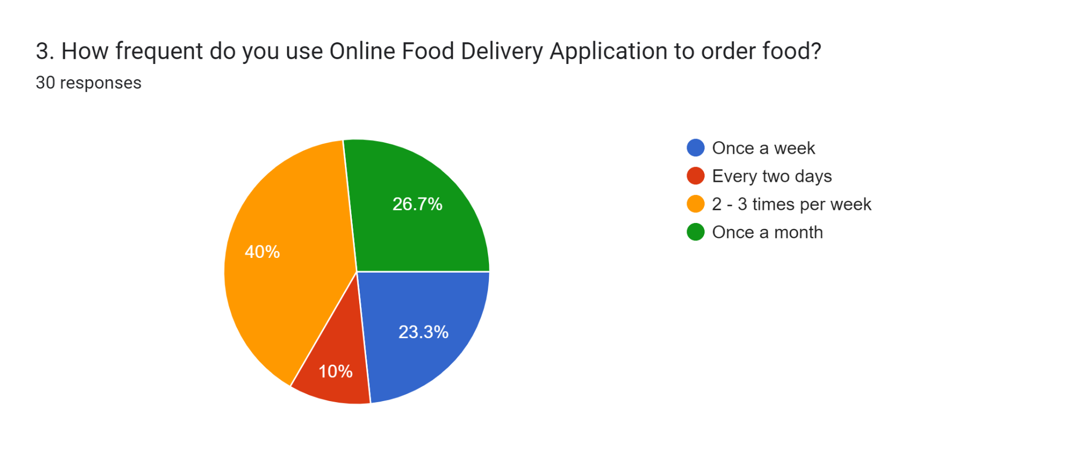
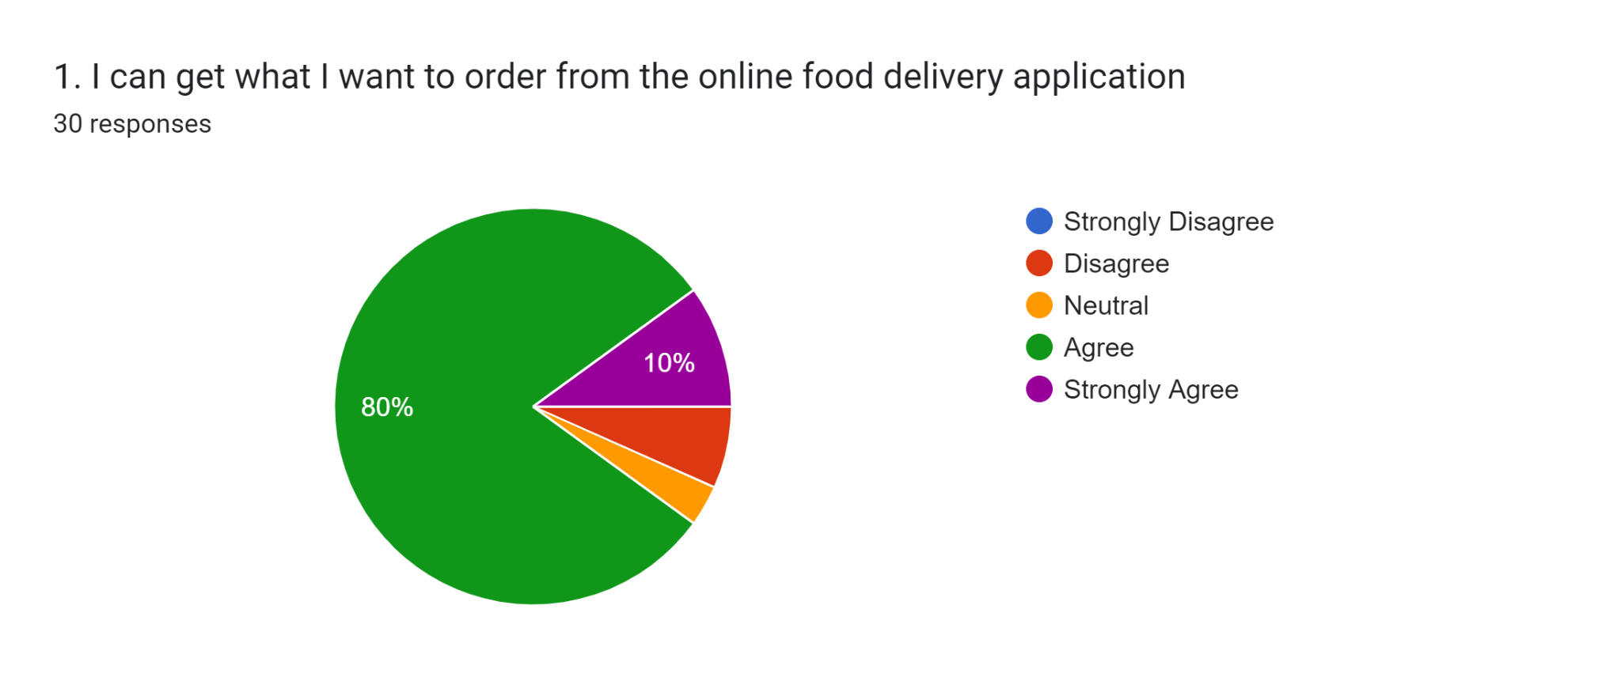

The growing demand can be seen through my research survey responses, whereby the majority 40% of participants are frequently using Online Food Delivery Application to order food after a pandemic. Followed by 80% of participants agreeing using OFD apps became one of the factors the usage of the apps increased due to its availability that attends to their preferences. This could also mean, most if not all, are already familiar with using technology to navigate the apps which can be a contribution to the growing demand.

The rise in demand for online food delivery services, motivated by a preference for contactless transactions and convenience, is expected to continue, shaping the market landscape. This pattern, heightened by the COVID-19 pandemic, requires a deep understanding of the process of customer’s decision-making and preferences to support the survival of foodservice businesses (Ali et al., 2021).

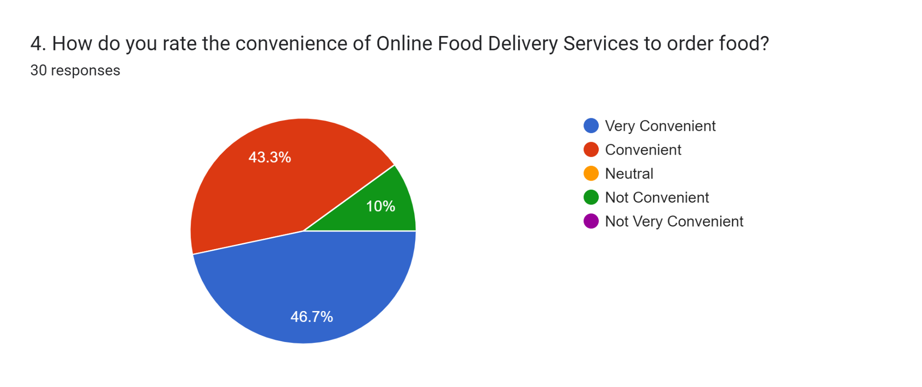

Based on my survey responses, a strong 46.7% of participants find it very convenient and another 43.4% find it convenient to use OFD to order food. Another 10% say otherwise. When people find the convenience to use a service, it will shape their motivation to rely on it when using the services app to order food. It also changes the decision-making and preferences of customers to adapt to contactless delivery and transactions, due to the convenience it gives them.

The quick transformation of internet technology has not only changed retail e-commerce but also restructured societal norms and consumer behaviours. Online shopping's attractiveness centres on personalised service, convenience, rapid delivery, extensive choices, and competitive pricing, disrupting traditional brick-and-mortar business models (Morell, 2022).

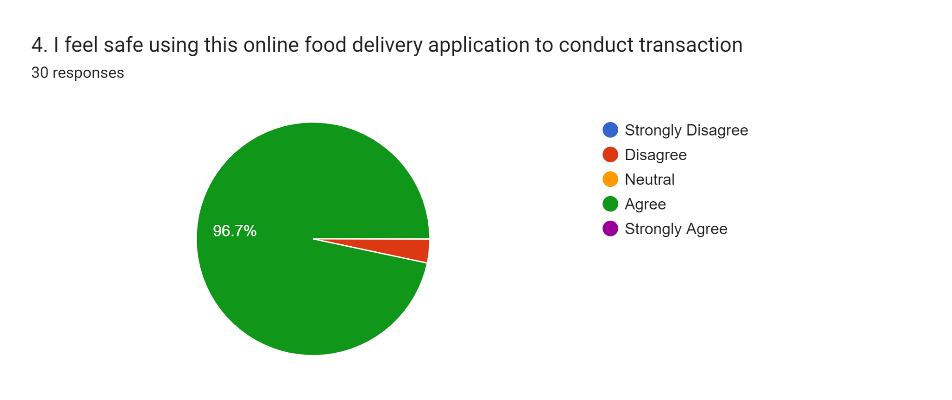

As technology rapidly grows, the risk of customer’s personal information also could be there. However, customers do put their trust towards OFDs apps to secure their information and online transactions process. It can be seen that 96.7% of participants feel safe using the apps to conduct transactions, which if there is no trust being put in the process, nobody would choose to conduct an online transaction on apps they do not trust. Technology has helped businesses to tighten their security as a way to provide a smooth experience for customers using their apps or website.

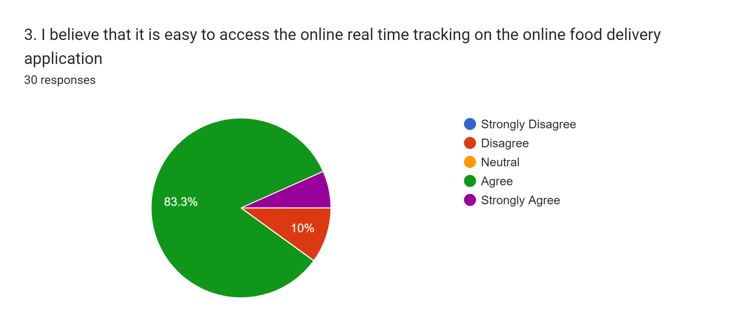

83.3% of participants also believe it is easy to access real time tracking for their food delivery. Technology has made it easier for people to have easy access on the internet to be able to track real time tracking to know the delivery driver and its food whereabouts. It has helped businesses to improve on how they provide convenience and easy use to people.

Online Food Delivery (OFD) apps have become essential in facilitating direct food orders, shifting from traditional restaurant-centric delivery to platform-to-consumer models. Popular apps such as Foodpanda, Grabfood, Shopeefood and so on act as intermediaries, forming enduring social relationships between suppliers and consumers (Morell, 2022).
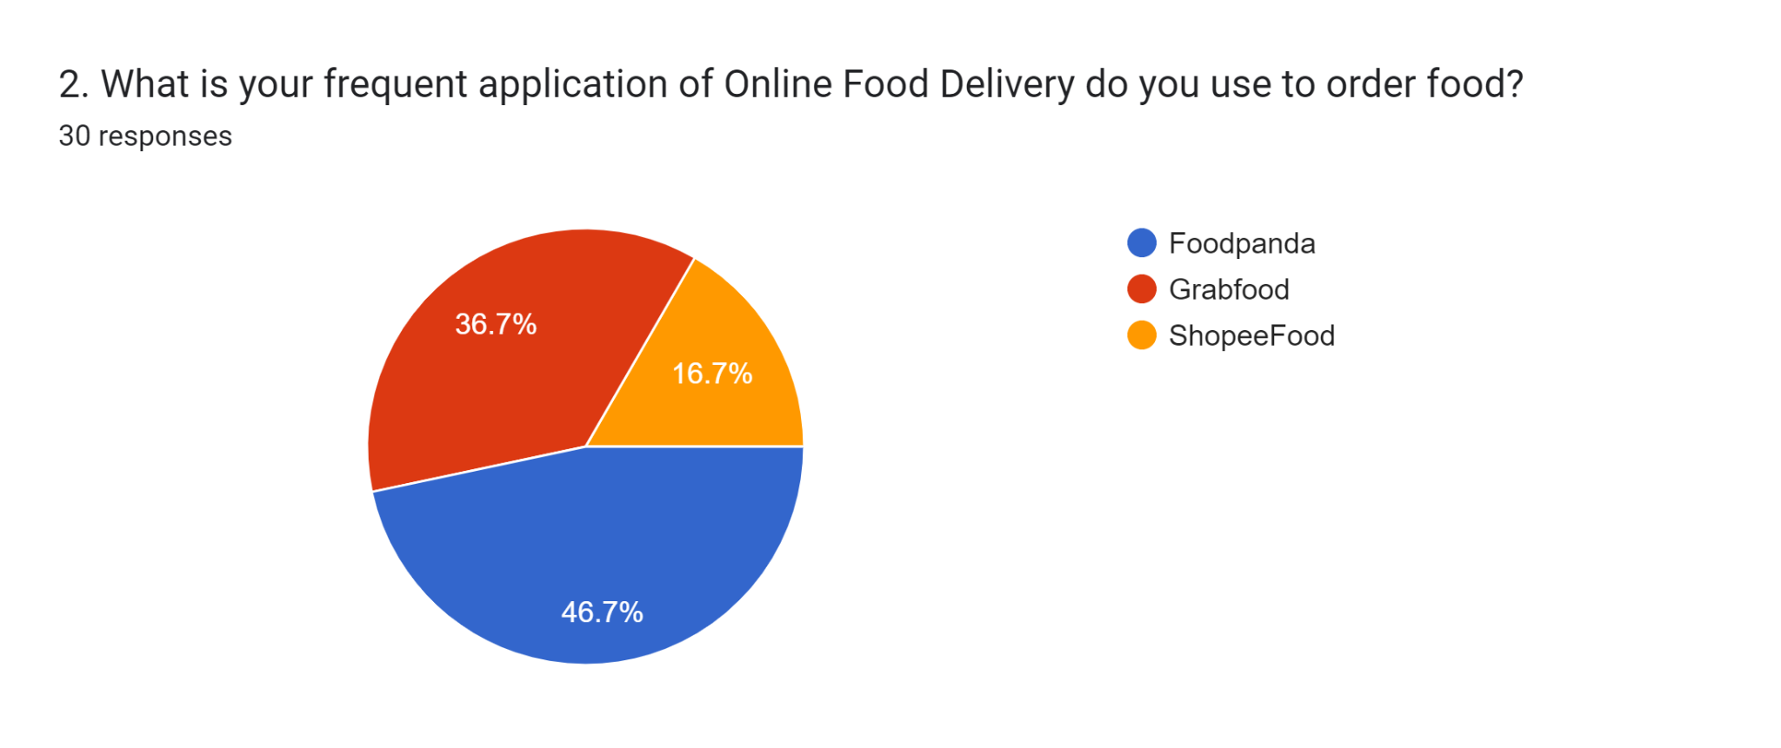
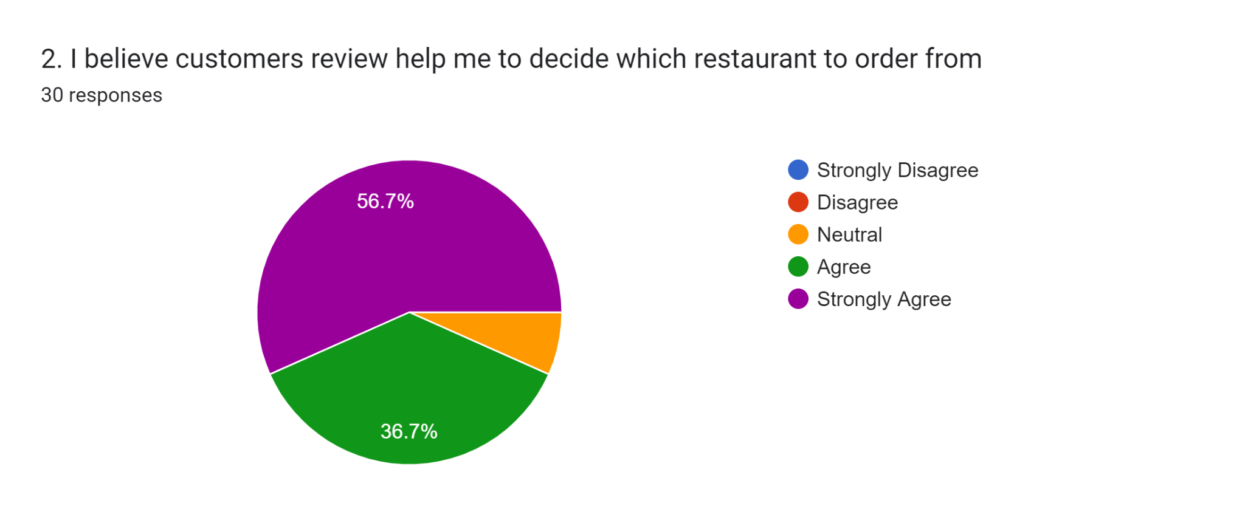

Shifting to platform-to-consumer has provided an alternative way for consumers to adjust their preferences to order food based on the review of restaurants on the app. For people that are indecisive about what food to order and which restaurant has made it easy. If you can see, 56.7% majorly agree that the review helped them when navigating which restaurant to choose from.

The pandemic has fastened the adoption of OFDs, shaping consumer reliance on these services which are now accessible 24/7 from anywhere. Prior to the pandemic, Online-to-Offline (O2O) delivery services were seeing growth, however, the shift to digital platforms for payment monitoring, order placement, and delivery organisation has become more evident (Morell, 2022).

TASK 3: PRESENTATION ON IDEAS
The link to the elevator pitch presentation video:
https://www.canva.com/design/DAF2EV_tF2g/P_WaiRNlExt22fkbwVlR4w/view?utm_content=DAF2EV_tF2g&utm_campaign=designshare&utm_medium=link&utm_source=recording_view

From my perspective, I value the positive feedback on the clarity and professionalism of the slides, as it indicates that the visual aspects were effective. I appreciate the constructive criticism regarding my vocal flow and confidence. It is a reminder for myself to work on maintaining a smoother delivery to convey more confidence in future presentations.

The feedback on the pitch duration is insightful, and I acknowledge the importance of complying to the recommended timing for an elevator pitch. I will focus on refining my content to fit within the intended 3-minute duration, ensuring that it remains concise and impactful.

The suggestion to incorporate a hook at the beginning is duly noted, and I will aim to capture the listener's attention right from the start in upcoming presentations.

I am encouraged by the positive remarks about the detailed information and discussions around each slide. Going forward, I will aim to strike a balance between providing comprehensive content and respecting the time constraints to maintain engagement.

TASK 4: DATA ANALYSIS
The link for the poster:
https://www.canva.com/design/DAF2Evn3kUE/QezpS8sdb-2HOLkgPyHodA/view?utm_content=DAF2Evn3kUE&utm_campaign=designshare&utm_medium=link&utm_source=editor

REFERENCES
TASK 1:
1.1 RESEARCH QUESTION
- Pollard, M., & O’Neill, C. T. (2019). How COVID-19 is impacting online food delivery platforms. Citi Global Perspectives & Solutions. Retrieved from https://www.citigroup.com/global/insights/citigps/how-covid-19-is-impacting-online-food-delivery-platforms
- Tandon et al. (2021). Why do people purchase from Food Delivery Apps? A consumer value perspective. Journal of Retailing and Consumer Services, 63, 102667. Retrieved from https://doi.org/10.1016/j.jretconser.2021.102667
1.2.1 DEDUCTIVE / INDUCTIVE / ABDUCTIVE
- Hassan, M. (2023). Abductive reasoning - definition, types and examples. Research Method. Retrieved from https://researchmethod.net/abductive-reasoning/
- Sirisilla, S. (2023). Inductive and deductive reasoning: Definitions, limits & stages. Enago Academy. Retrieved from https://www.enago.com/academy/inductive-and-deductive-reasoning/
1.2.2 QUALITATIVE / QUANTITATIVE / MIXED METHODS
- Aberdeen, T. (2013). case study research: Design and methods (4th ed.). Thousand Oaks, ca: Sage. The Canadian Journal of Action Research, 14(1), 69–71. Retrieved from https://doi.org/10.33524/cjar.v14i1.73
- Ong, B. K. (2012). Grounded theory method (GTM) and the Abductive Research Strategy (ARS): A critical analysis of their differences. International Journal of Social Research Methodology, 15(5), 417–432. Retrieved from https://doi.org/10.1080/13645579.2011.607003
- Soiferman, L. K. (2010). Compare and contrast inductive and deductive research approaches. Institute of Education Sciences. Retrieved from https://files.eric.ed.gov/fulltext/ED542066.pdf
1.3.1 PRIMARY / SECONDARY METHODS
- Driscoll, D. L. (2011). Introduction to primary research: Observations, surveys, and interviews. Writing spaces. Retrieved from https://wac.colostate.edu/books/writingspaces2/driscoll--introduction-to-primary-research.pdf
- Roopa, S., & Rani, M. (2012). Questionnaire designing for a survey. The Journal of Indian Orthodontic Society, 46, 273–277. Retrieved from https://doi.org/10.5005/jp-journals-10021-1104
- Taylor, E. (2023). What is secondary research? [+ examples and types]. Full-Service Market Research Company. Retrieved from https://www.driveresearch.com/market-research-company-blog/what-is-secondary-research-market-research-firm-syracuse-ny/
1.4.1 DATA SAMPLING METHOD
- Taherdoost, H. (2016). Sampling methods in research methodology; how to choose a sampling technique for research. SSRN Electronic Journal, 5(2), 18–27. Retrieved from https://doi.org/10.2139/ssrn.3205035
1.4.2 SAMPLE SIZE
- Memon, M. A., et al. (2020). Sample Size for Survey Research: Review and recommendations. Journal of Applied Structural Equation Modeling, 4(2), i–xx. Retrieved from https://doi.org/10.47263/jasem.4(2)01

TASK 2:
- Ali, S., Khalid, N., Javed, H. M., & Islam, D. Md. (2021). Consumer adoption of online food delivery ordering (OFDO) services in Pakistan: The impact of the COVID-19 pandemic situation. Journal of Open Innovation: Technology, Market, and Complexity, 7(1), 10. Retrieved from https://doi.org/10.3390/joitmc7010010
- Morell, L. (2022). The impact of the COVID-19 pandemic on Online Food Delivery Apps. UNLV. Retrieved from https://digitalscholarship.unlv.edu/cgi/viewcontent.cgi?article=5553&context=thesesdissertations

APPENDIX
RESPONSES FROM QUESTIONNAIRE:
SECTION A (PART 1): DEMOGRAPHIC
1.
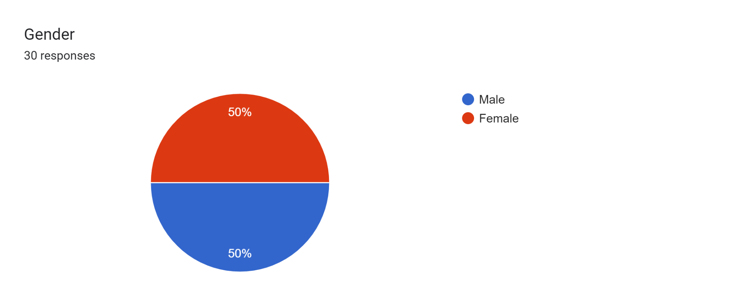
2.
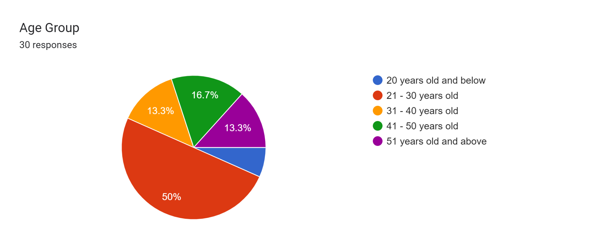
3.
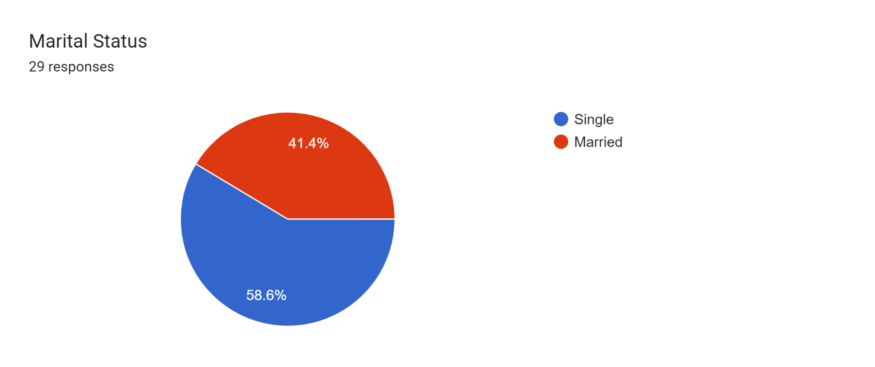
4.
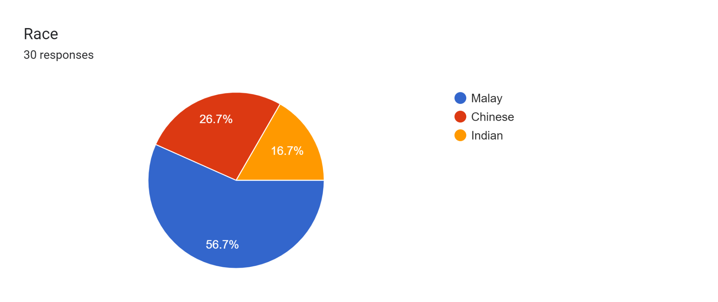
5.
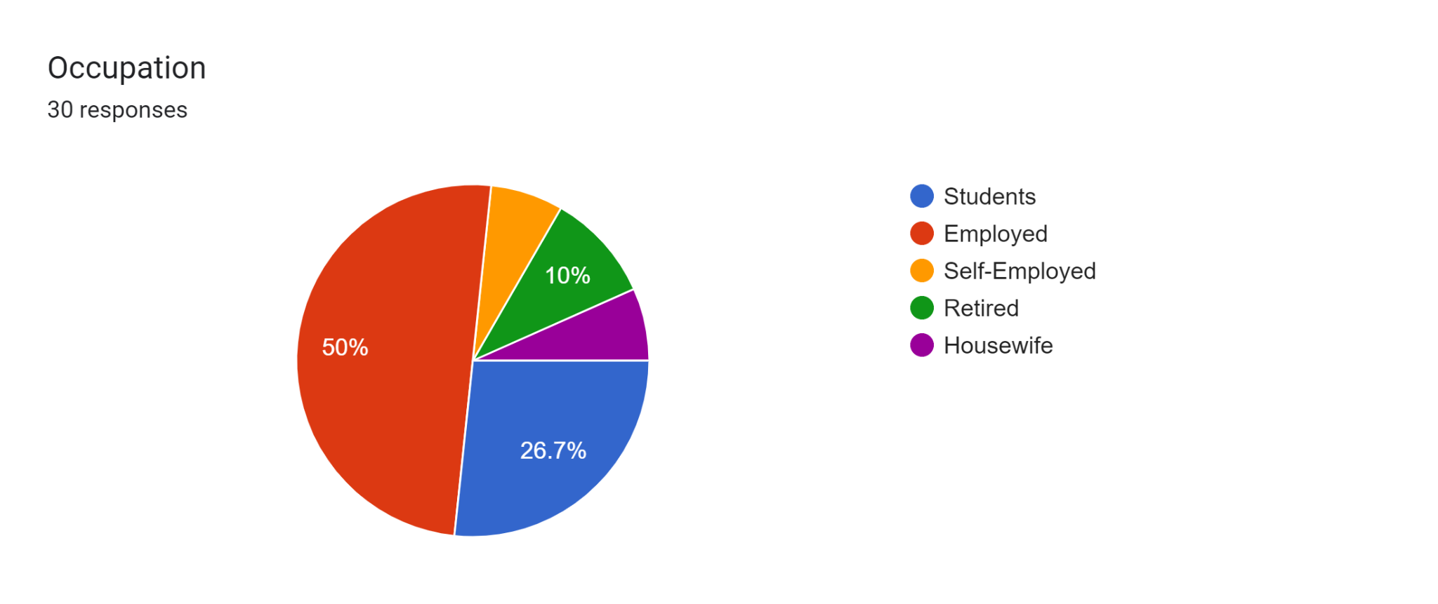
6.
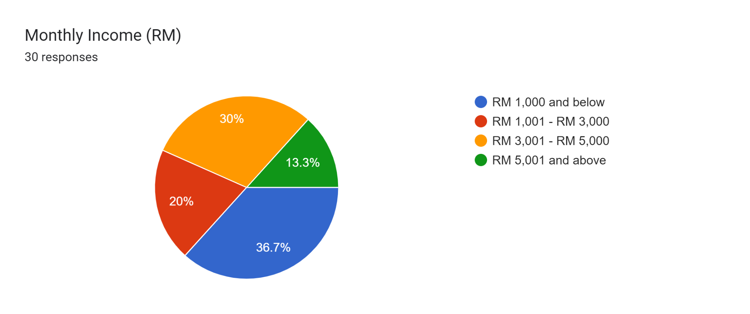
SECTION A (PART 2): FAMILIARITY WITH ONLINE FOOD DELIVERY SERVICES
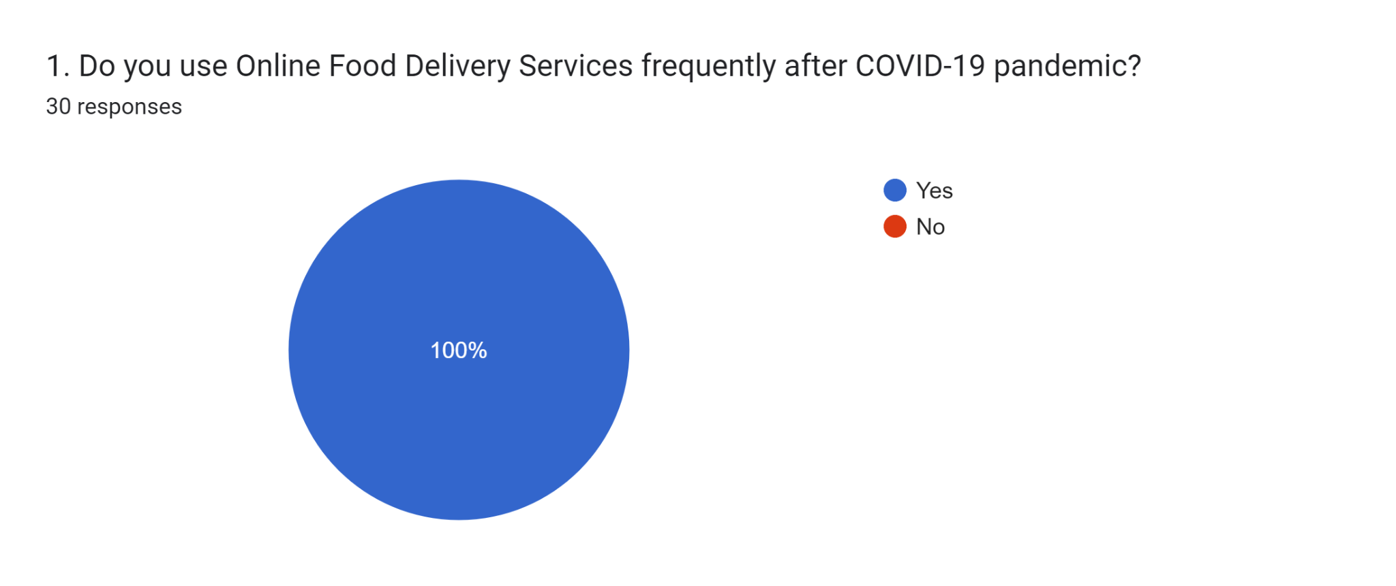
SECTION B: EFFICIENCY
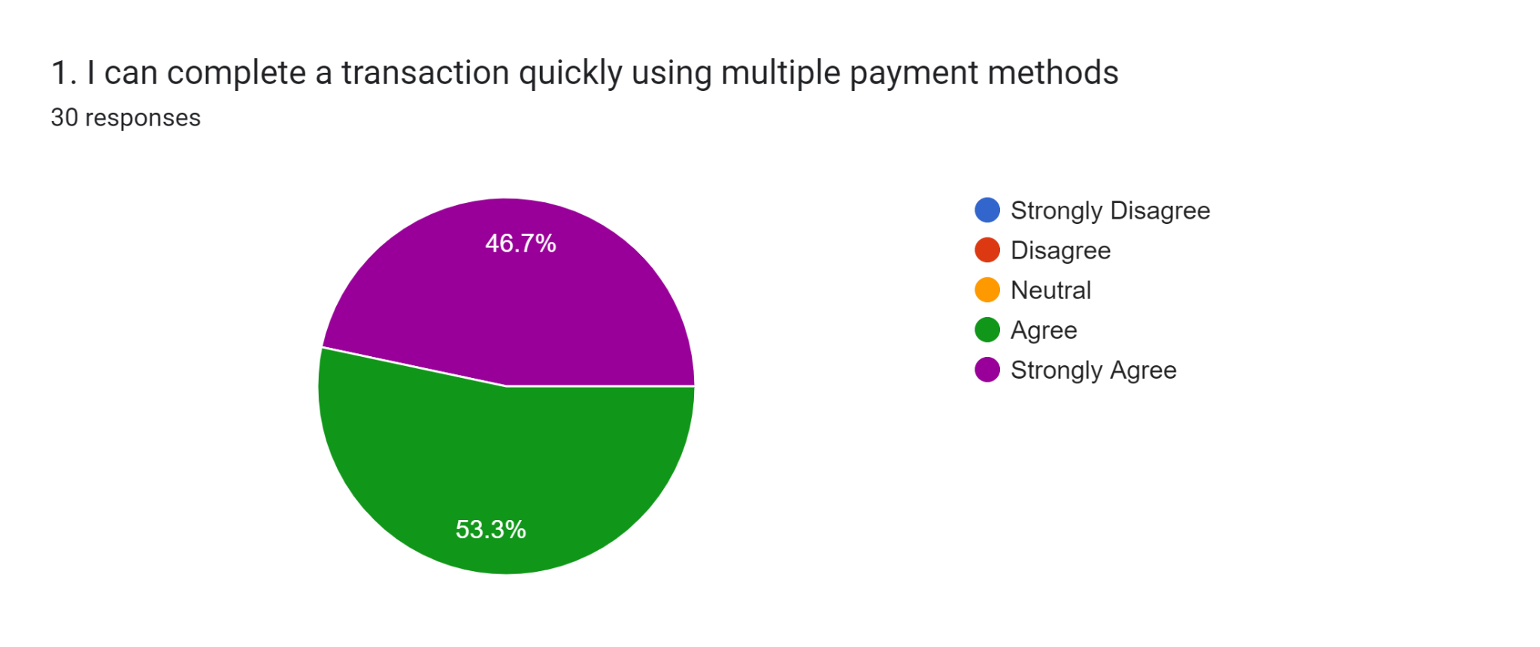
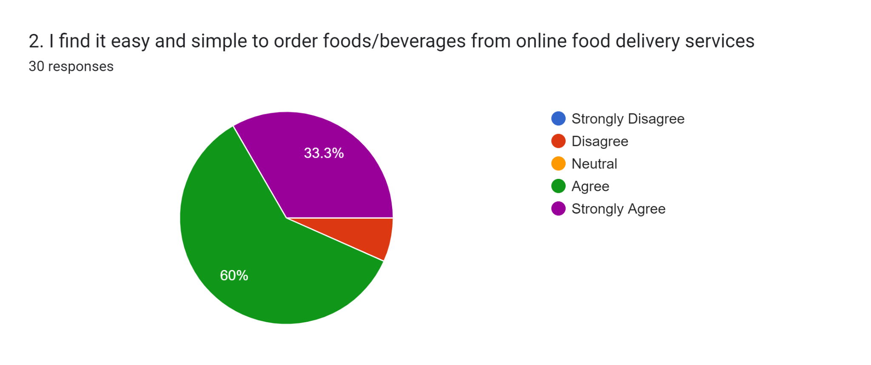
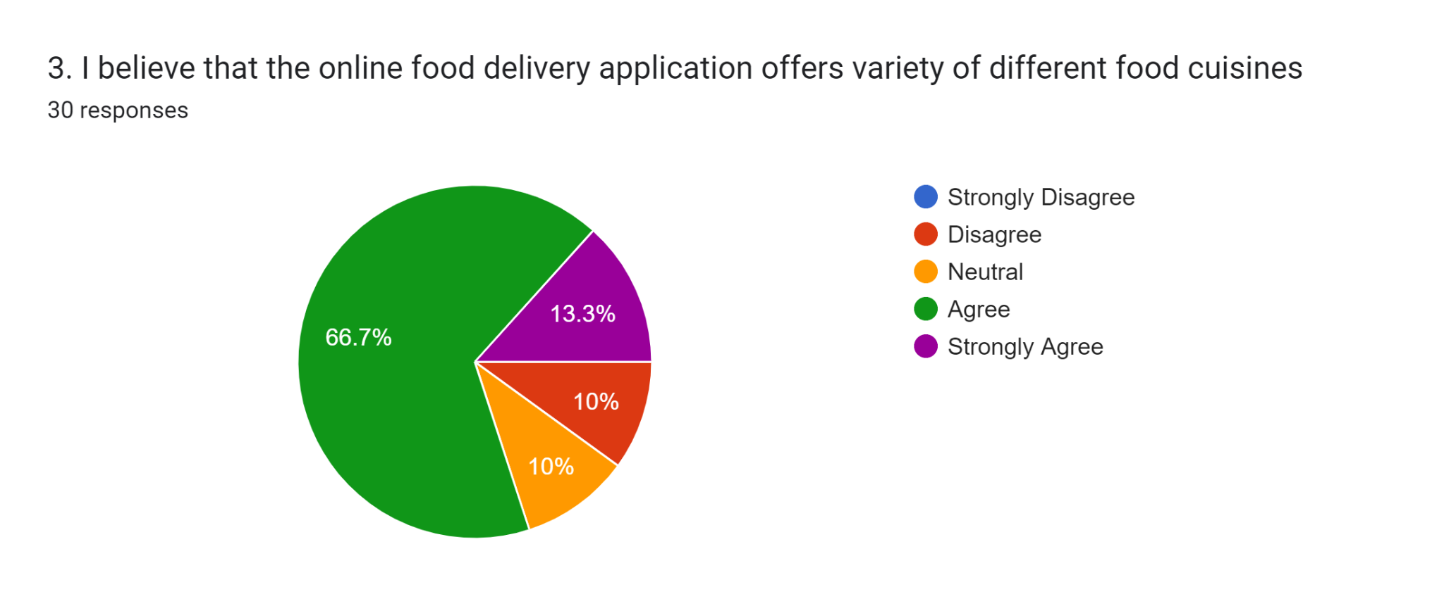
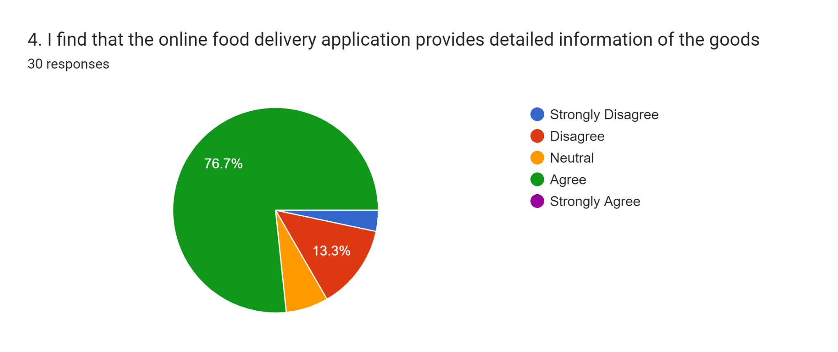

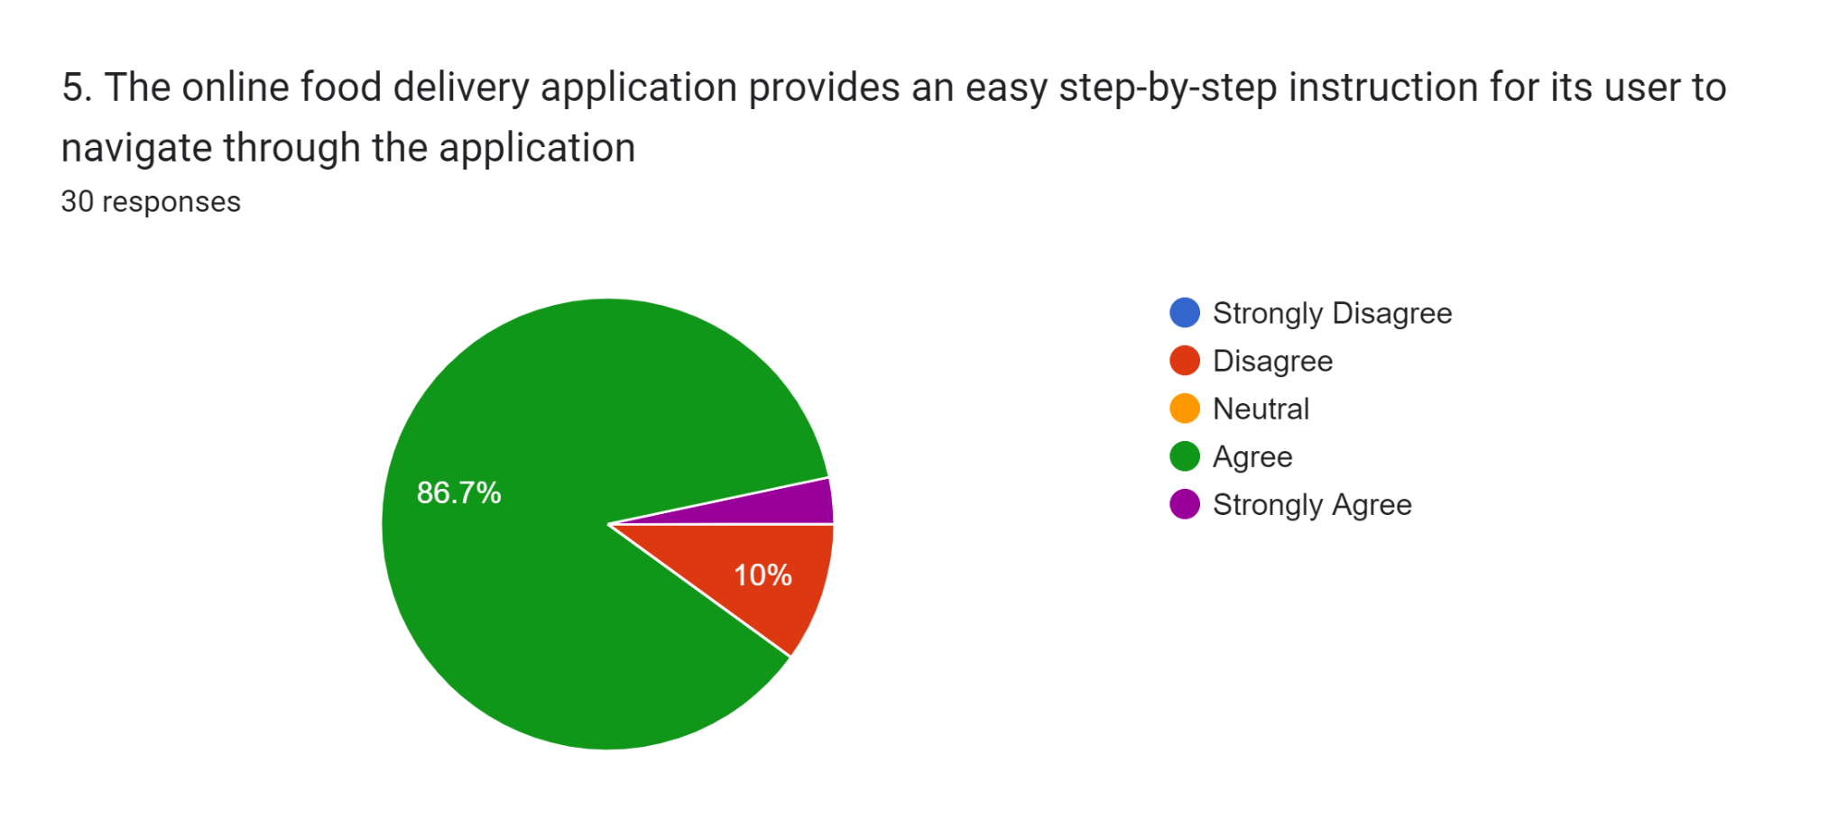
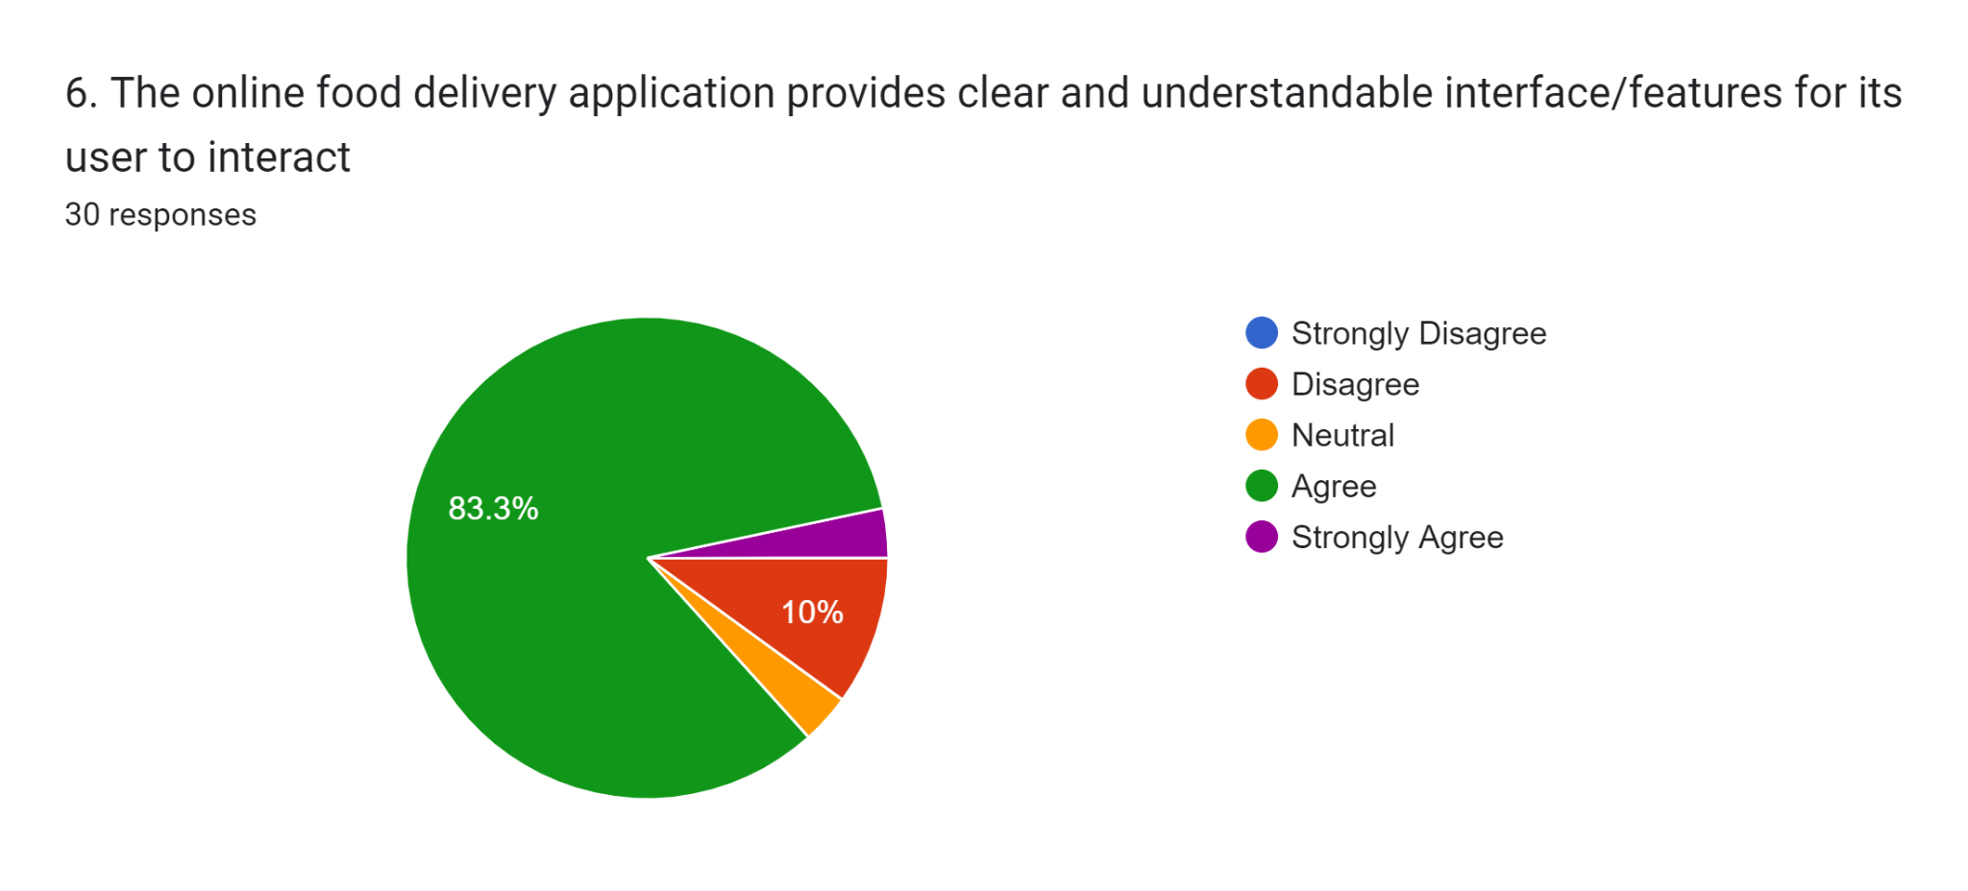

SECTION C: FULFILMENT
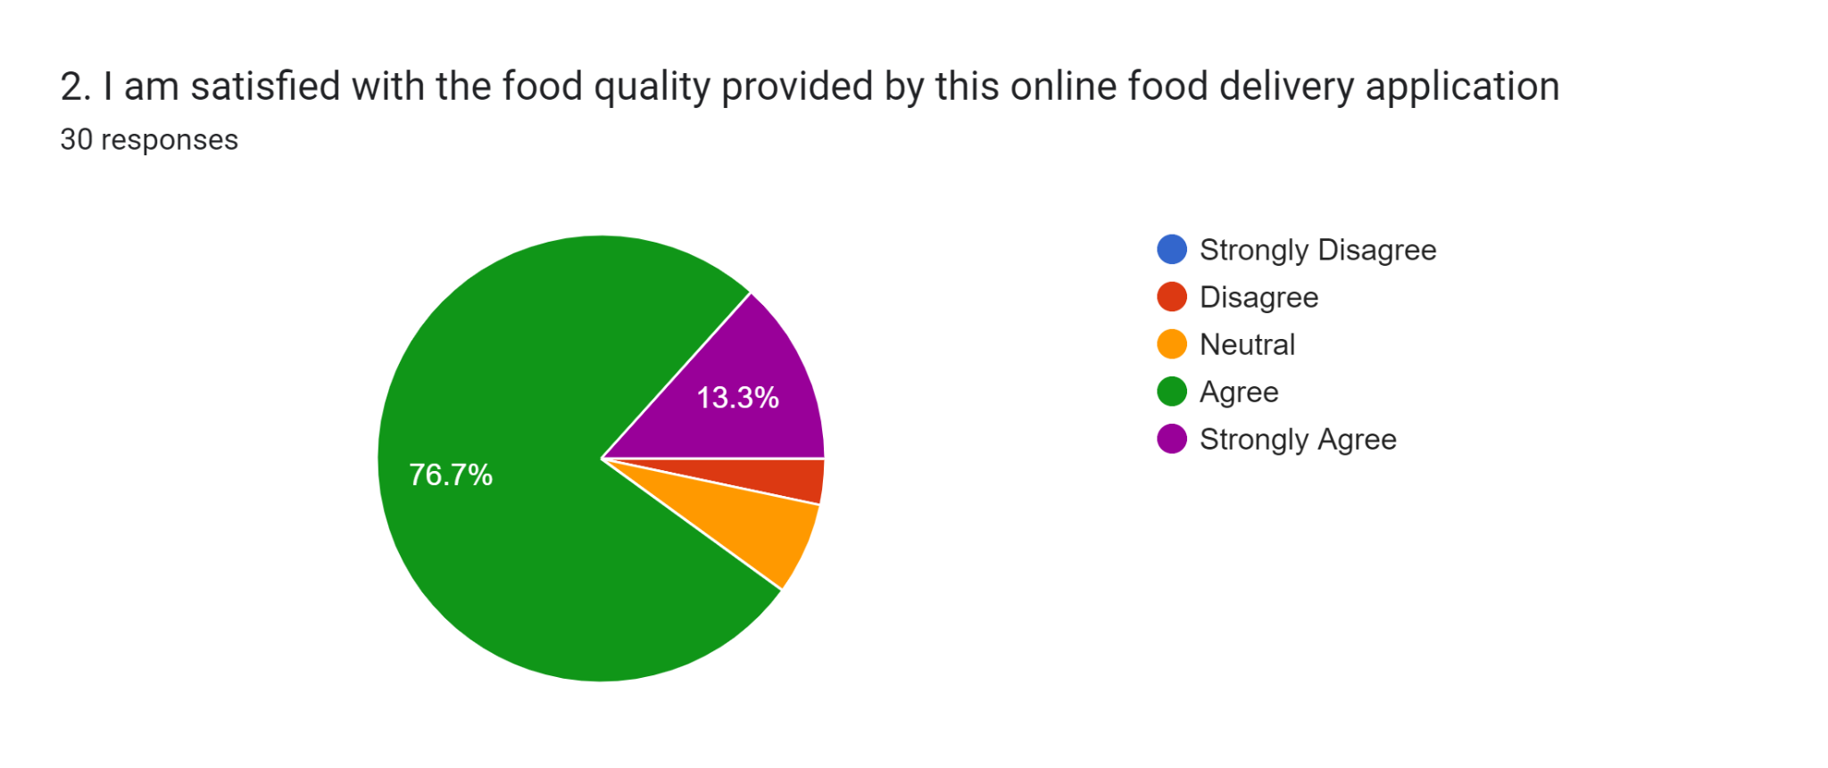
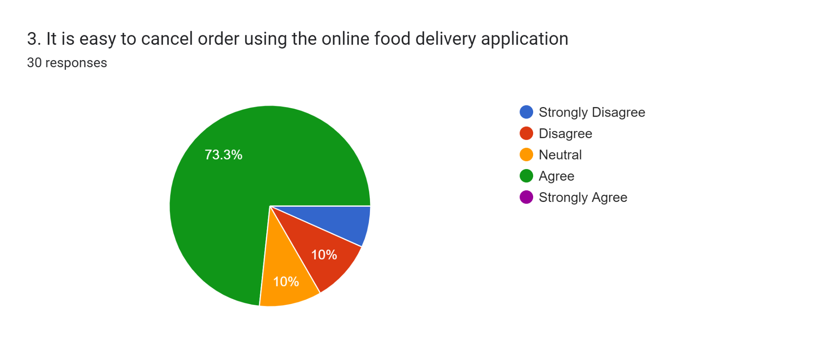
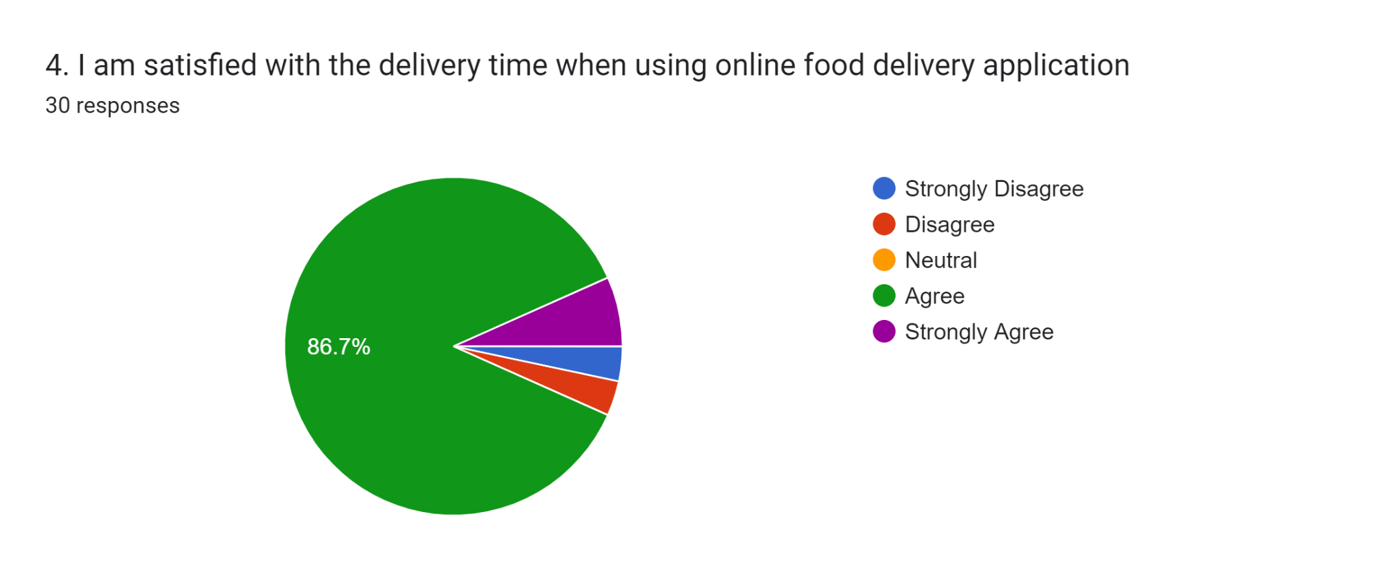
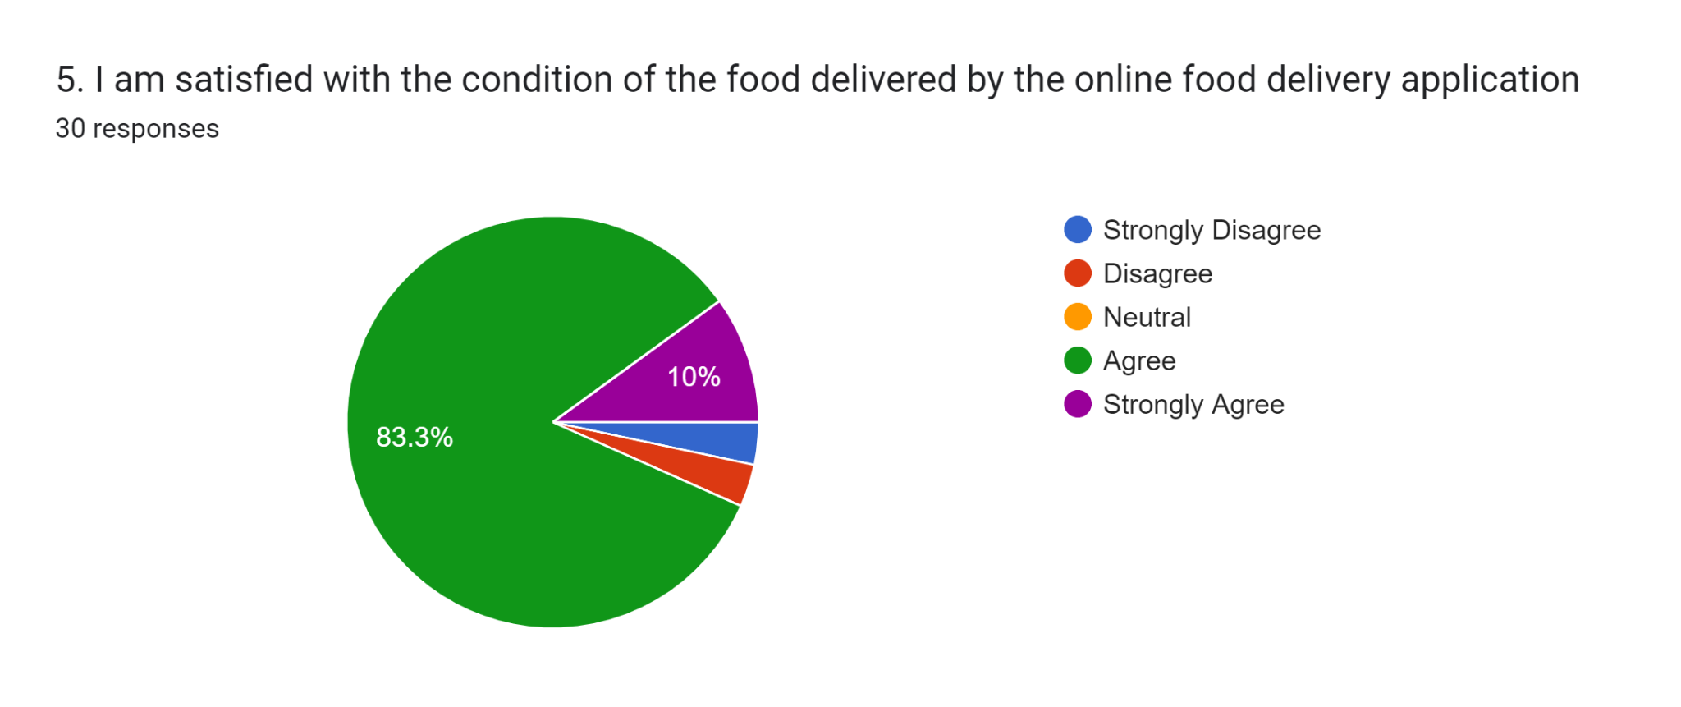

SECTION D: PRIVACY
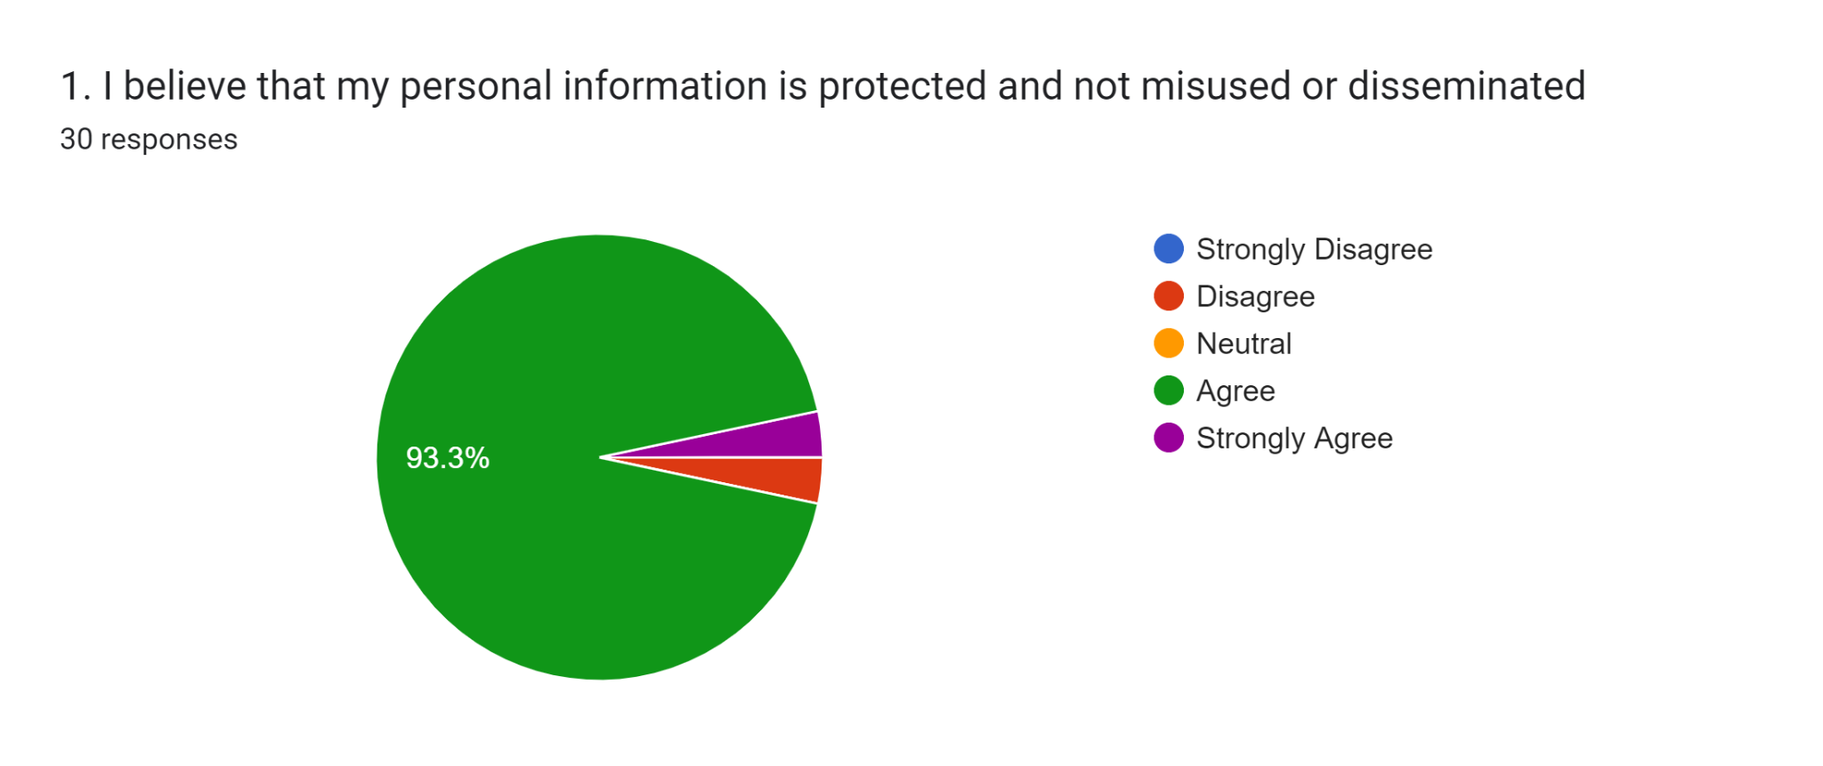
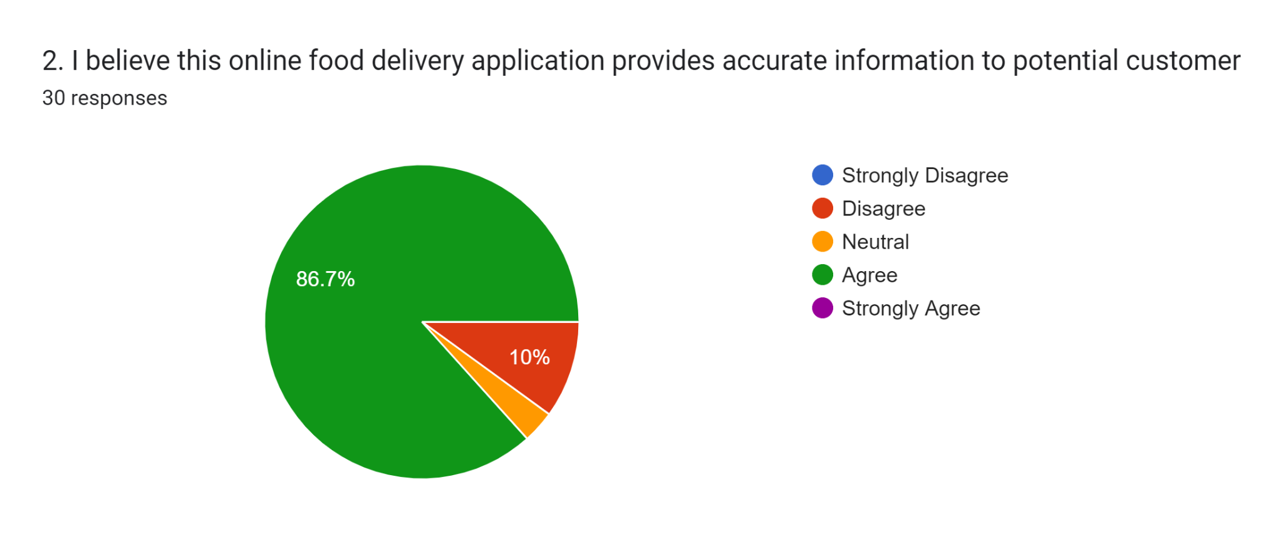
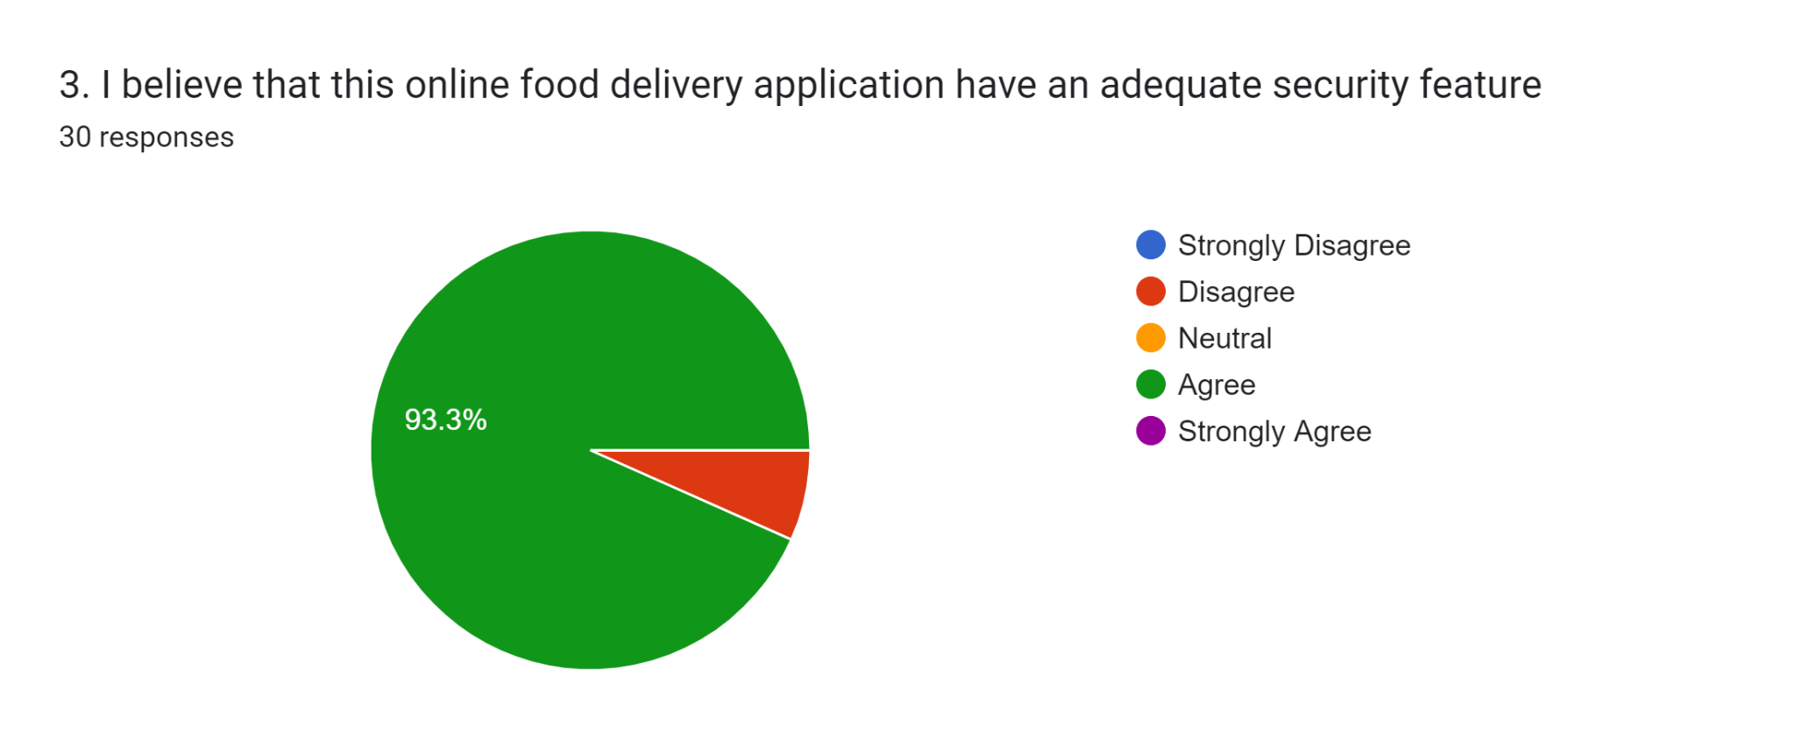
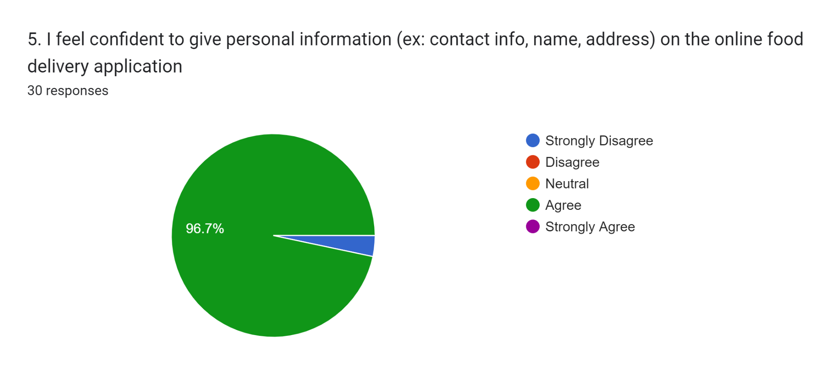

SECTION E: RESPONSIVENESS
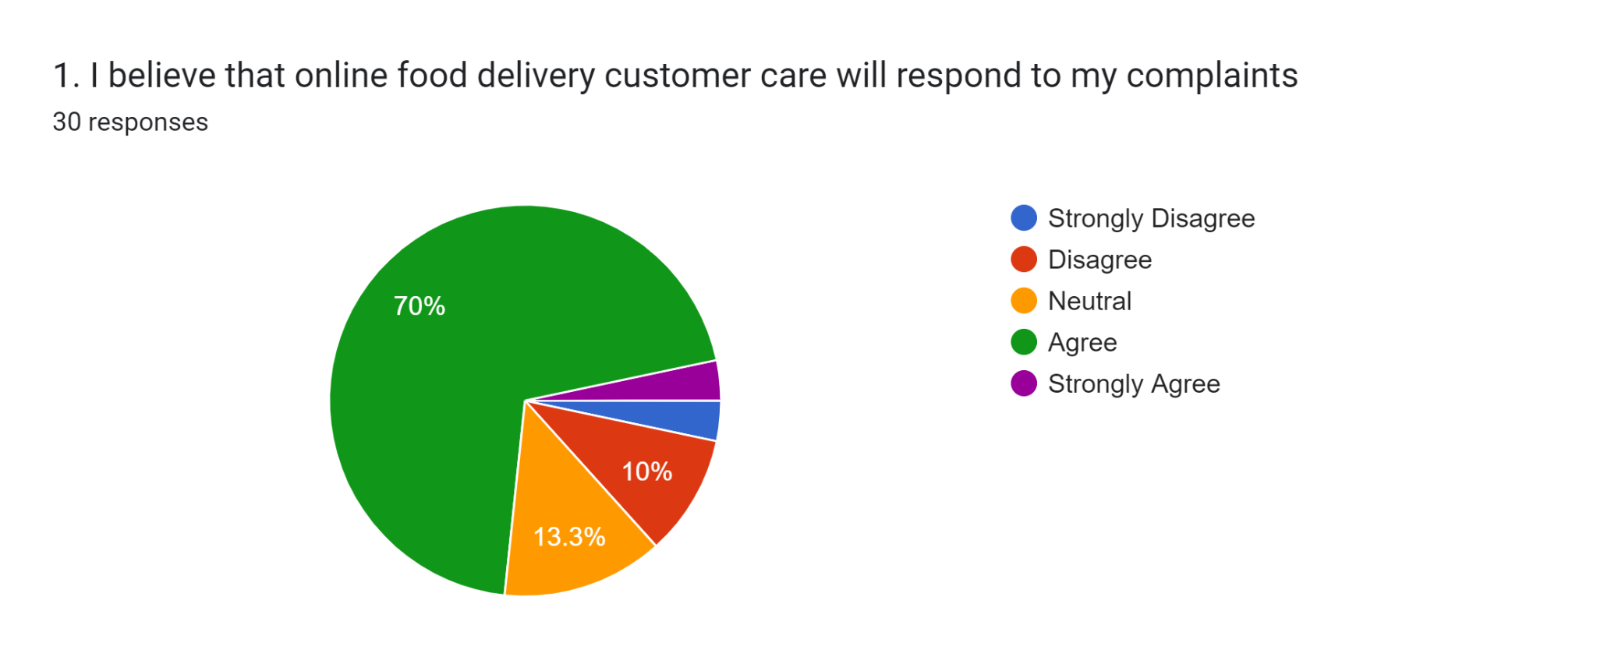
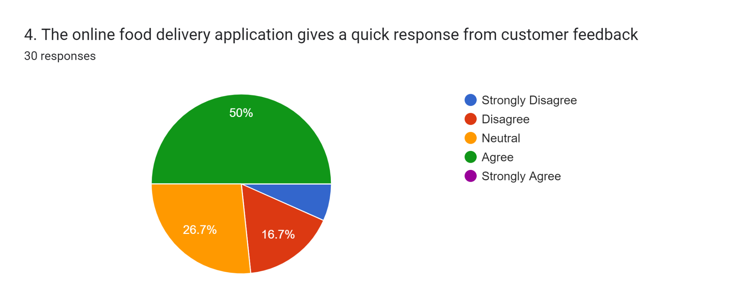

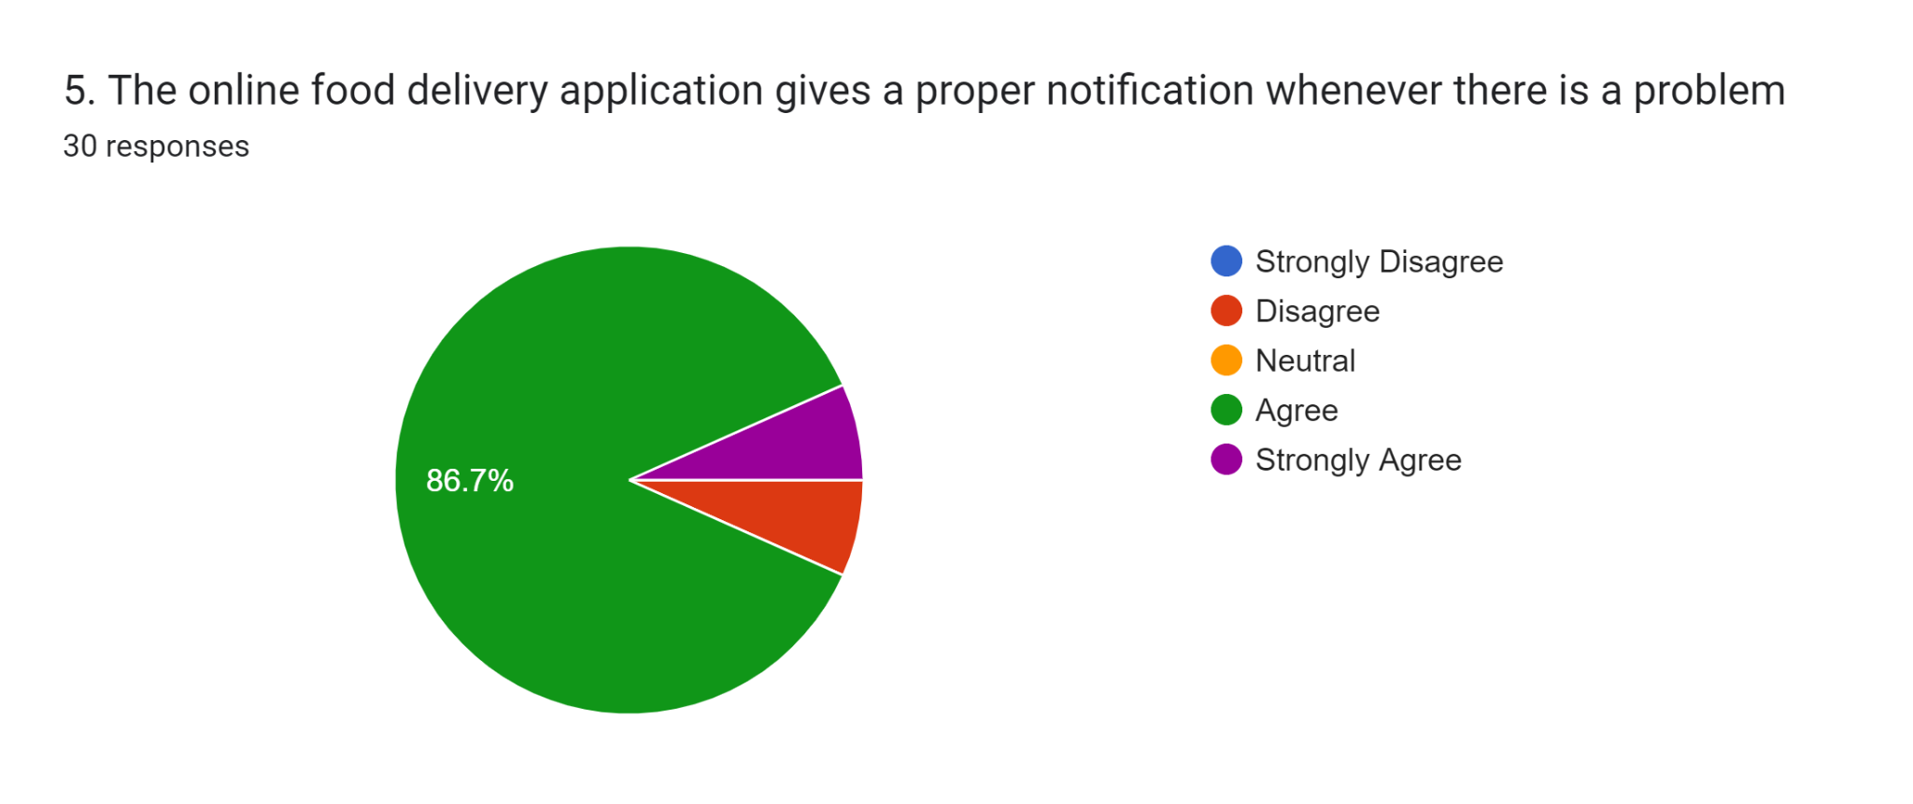

SECTION F: CUSTOMER SATISFACTION


