

Independent inquiry

Question: Is the representation of Sex and the sexualisation of women helping or harming the feminist movement in the film industry?

Rhiannon Thomas (1701798)
Submitted in partial fulfilment of the requirements for the degree of BA(Hons) Digital Film and television production

Table of contents
Introduction | Page 1-2
Chapter 1 | Page 2-9
Chapter 2 | Page 9-16
Chapter 3 | Page 16-17
Conclusion | Page 17
Bibliography | Page 17

List of illustrations
Fig 1 | Rolling Stone magazine March 2009,November 2002, October 2003
Fig 2 | “Allure or a Lure?” 1941-1945
Fig 3 | “Women of Britain say ‘go!’ 1941
Fig 4 | Susanna and the Elders by Artemisia Gentileschi 1610)
Fig 5 | Susanna and the elders by Jacob Jordaens The Elders
Fig 6 | Victoria’s secret 2014
Fig 7 | Dove campaign
Fig 8 | The Accused 1988
Fig 9 | Tom and Jerry
Fig 10 | Betty Boop
Fig 11 | The Avengers 2012

Question: Is the representation of Sex and the sexualisation of women helping or harming the feminist movement in the film industry?

Introduction
A taboo topic for some, the representation of women in the media has been discussed and picked at since the beginning of the industry. From Lara Croft to Minnie Mouse, the depictions of women and girls have been a topic that has divided opinions and caused effects on the audience watching, but is this in a positive or negative way?
The hyper sexualisation women and girls is not only seen in the film industry but across all media platforms in general, such as images of young girls scantily clad across the covers of magazines. The question I'd like to dive into is whether or not the exposure and the representation of women in media, focusing on film mostly, is a positive or negative representation and is it helping or harming the feminist movement. To try and answer this question, I will be researching into the history of the representation of women in film, examples of films and actresses’ experiences, feminist theorists and images of women throughout history. The purpose of this independent inquiry is to bring light to the lack of realistic representation of women in the film industry and discuss the effects this can have on the audiences watching such as discussing topics like self-esteem. During this independent inquiry I will be discussing ideas from feminist theorist such as Laura Mulvey, Judith Butler, Simone De Beauvoir and Christina Hoff Sommers and use them throughout my work. I have decided to focus on the representation of women in the film industry as it’s something that as a young girl I grew up seeing and saw the effects that it had on my self-esteem and self-worth. Now as an adult studying film I hope to learn, understand and come up with solutions for this issue if needed. As for what I learn during this, I hope to proceed to use that information further in my studies such as my graduate project and further into my career in the film Industry. During the independent inquiry I will be discussing it in three chapters, during chapter one I will be discussing the representation of women throughout history such as in propaganda posters. I will also be discussing hyper sexualisation in magazines and the effects that this has on women and girls. During the second chapter, I will be discussing the representation of women in film by looking into topics such as hyper sexualisation in cartoons, the superhero genre, male gaze and most importantly discussing whether the representation of women in these topics show sexualisation or empowerment?
During the third and final chapter I will be discussing how I will be using what ive learned through the independent inquiry and how it will help me with my graduate project. I will also be discussing how I will be representing women and sex in my documentary that I will be creating.

Chapter 1
Thursday, October 5th, 2017, a day in which the reputation of the film industry and some of its biggest and best contributors and creators were hit with allegations of sexual assault and harassment against women in the workplace, that workplace being the film industry as a whole. Sets and production offices became the backdrop for the victim’s horrific encounters with these powerful men and silence was no longer an option and by telling their stories the film industry shook not knowing how this day would go down in history as change was demanded. On this day, The Times newspaper alleged that film mogul and producer Harvey Weinstein had been sexually assaulting and harassing actresses and women alike for years. This shocking revelation began an outpour of women sharing their stories from cat calling, groping, sexual assault, harassment and rape throughout the internet being shared with the hashtag ‘#MeToo’ which was created by actress Alyssa Milano, named after a non-profit dedicated to helping survivors of sexual harassment and abuse. The #MeToo movement resonated with people worldwide and even expanded outside of the film industry, causing the Women's march in Washington and other cities worldwide. This demonstration was the biggest demonstration in American history and brought light to the issues of women's rights and gender equality. Although the movement seem to have brought women and victims of sexual assault and harassment together for a while, it seems that it has divided some with some saying that the #MeToo movement is not inclusive to women of colour and other minorities and only focuses on the stories of white women and forgets about the 1 in 6 of men who experience sexual assault or abuse. The faces of the #MeToo movement are usually beautiful, thin, able bodied white actresses, which some find hard to relate to and believe that their stories and experiences are not valid as they do not feel like a “model survivor”, The leaders and representatives of the movement seem to understand their privilege stating “We recognize our privilege and the fact that we have enormous platforms to amplify our voices”. A columnist for the Washington Post, Megan McArdle says "I think there are also lots of situations where the men do [have the power]. But I think we should teach those women to stand up and seize that power back."
By telling their stories these victims took back control of the narrative and the power from their abusers, which would usually have the power as they have high powered jobs, big names and money. But in these cases, all the privilege and class didn't matter as the truth overpowered them and the power dynamics shifted. When questioning what could have caused this unfair gender dynamic Natalie Collins, a gender specialist believes that pornography has affected women and men’s understanding of real sex and boundaries, caused by the misunderstanding of fantasy and reality. She says, "Porn culture has led her to have a particular understanding of what it means to have sexual interactions of what is erotic and what's not”. If pornography can be blamed for the unfair gender dynamic and lack of understanding towards sex, it’s fair to assume that media outlets such as film, magazines and adverts can also have an effect on how women see themselves and their worth, but also how men perceive women and sex.

There are many effects that can occur when a person's self-worth and idea of a perfect image is being manipulated by the media’s perception of these ideas. For example, images of the ‘perfect woman’ spread over magazines, ideal relationships and sex in films, and ideals and narratives in adverts. These media outlets are hard to avoid and easy to fall into the trap of following the ideals that they are selling, even at the cost of one’s self esteem and relationships in the future. Being surrounded by these images, it’s no surprise that there is a rise in appearance anxiety, or BPD, and leads to mental health issues. This is not just an issue for young girls though, it seems that the effects of seeing these ideal bodies and over fantasized sexual situations being played out have also had its effect on young boys. As boys have been raised with these hypersexualised versions of women, it has now come to light that boys struggle to find an ‘ideal’ female partner or enjoy realistic intimacy with women as they do not compare, or come close, to the ideals that they have been sold. The scary reality is that these images are not just selling clothes or advertising a film, they are selling a lifestyle which is unachievable to the average person. This led to girls, and some boys, trying to change and control themselves which causes anorexia nervosa or the use of steroids. It also causes a downward spiral in people's lives with many people who have a low self-esteem to turn to cigarettes. Also, the oversexualised image of girls has caused young girls’ sexual health to decrease with less girls using condoms. These issues seem to be overlooked when it comes to media being put out to the public, therefore intentions have to be questioned as to why they are still being distributed. On the other hand, changes are being made on some platforms to insure inclusivity, diversity and realistic interpretations of women. One reason for why films, characters, magazines and adverts are over sexualised is due to the use of the male gaze. Every action taken with these products is due to satisfy the male gaze, whether it's intentional or not. “The determining male gaze projects its phantasy on the female figure which is styled accordingly”, this quote suggests that from how a woman is posed, her outfit and whether her eyes meet the camera or not, it’s all decided upon to satisfy the male gaze and male fantasy. During this chapter, I will be discussing examples of media over the years and analyse whether they follow the traditional use of hyper sexualisation and the male gaze.

(Fig.1:Rolling Stone magazine March 2009,November 2002, October 2003)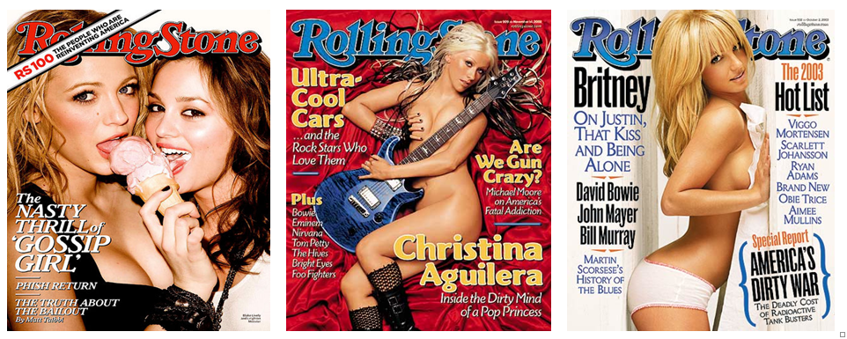

While looking at these magazine covers, it’s easy to be desensitised to the images of scantily clad women on the covers as this is todays norm. It’s a complicated and taboo to question whether these images are empowering or sexualisation of women, Dawn Hawkins of the National Centre on Sexual Exploitation says, “Yesterday’s pornography is today’s mainstream media.” Meaning that these images would have been shocking but are now the norm for today's society. These images could be seen as empowering as women are taking control of their bodies and have a right to show them if they wish, but others would argue the problem with mainstream media is that there is only one type of body is being shown, a white, thin, able bodied women. This is only a small representation of what could be represented on the cover of magazines, and what is shown is a photoshopped version of what real bodies look like. As Judith Butler said, “We lose ourselves in what we read, only to return to ourselves, transformed and part of a more expansive world”, this shows that what we read and watch is what becomes us as individuals and create our values, morals and self-worth. The use of the male gaze is clear in these images, from the hypersexualised poses such as Blake lively and leighton Meester licking the ice cream, Christina Aguilera covered by only a guitar and Britney spears bending her back and only wearing underwear. These poses scream towards the male audiences, all of the women on the covers are looking directly into the camera almost as if they are looking directly at the male audience and pulling them in. Although, by these women not being able to pose in such ways that would be censoring the female body from the public eye, Stephanie Murray of the blog Verily believes that not agreeing with the hyper sexualisation of women on the cover of magazines and other media outlets is not the same as wanting to censor women's bodies and giving no value to female sexuality saying “Opposing the hyper sexualization of women in the media is not the same as denouncing or demonizing female sexuality.”
The problem is not, mostly that women are nude or scantily clad on the cover of magazines. The problem is the option women have if they want to be on the cover of a magazine is to be nude or be in revealing clothes, as sex sells and that is the aim of the magazine, the numbers come before the worth of the woman on the cover. Another thing worth noting is the use of ‘buzzwords’ to amplify and highlight that this cover is sexual. Words such as ‘nasty’, ‘dirty’ and ‘kiss’ are all used to create the full package and appeal to the male gaze. The age of the girls posing on the covers of these magazines seem to be a problem as well, for example actress Brooke Shields posed nude for playboy at age 10. Now, there's no denying here that this is unacceptable and wrong and goes to show that the representation of girls and women in magazines has a dark side to it. Theorist Simone De Beauvoir would agree with this as she says, ‘One is not born, but rather becomes, a woman’, which highlights the idea that women and girls take what they see in magazines and other media and it makes them the person that they will be. This would suggest that a person who reacts negatively to seeing hypersexualisation of women and lack of diversity in magazines will take on the anxieties and insecurities into their adult life.
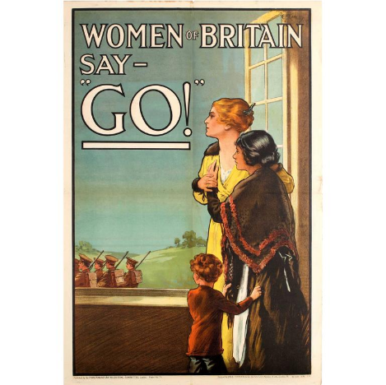
(fig.2: “Allure or a Lure?” 1941-1945) (fig.3: “Women of Britain say ‘go!’ 1941) 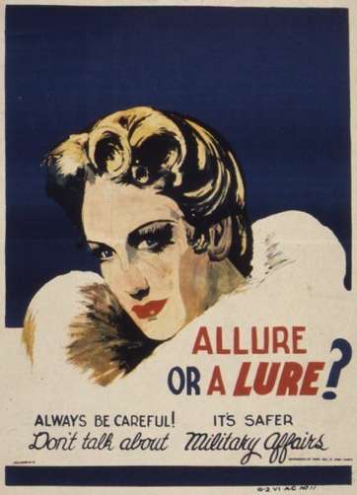

The use of women to persuade men has been a tactic used for years such as in Propaganda posters. These propaganda posters from World War 2, show how women were used negatively and positively inspire men of the time. In the first example, it almost paints women in a negative light and villainess them, the sexuality of a woman is being weaponized to create fear in men. In the second example, women are being used to provoke men to go to war, during this time, women were used to represent nations in propaganda. Although women started this time with household roles circumstances began to change and so did gender roles. Women began taking on bigger and more practical jobs during the war, causing a shift in how women were portrayed, they were no longer weak and vulnerable but strong and able.

(Fig 4:Susanna and the Elders by Artemisia Gentileschi 1610) (Fig 5:susanna and the elders by Jacob Jordaens The Elder)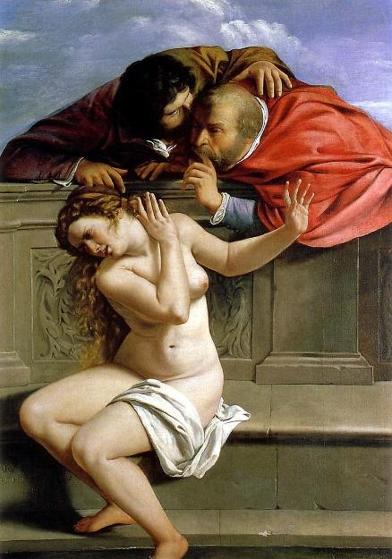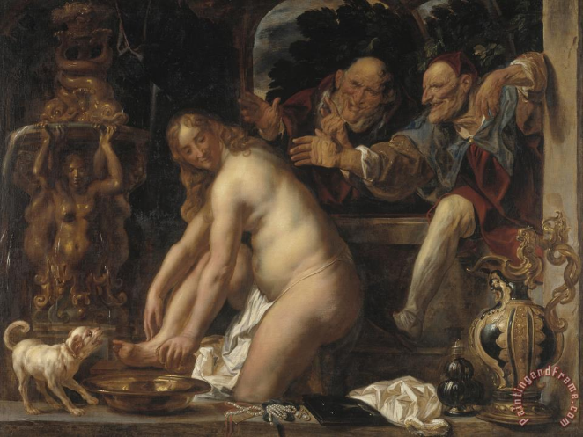

These paintings are examples and interpretations of the biblical story ‘Susanna and the elders’, which is the story of a Jewish woman being preyed upon while she takes a bath. The two men bargain with her that she sleeps with them or they will say that she was seen lying with another man. If so, she would have been sentenced to death, luckily she was saved and the judges were killed instead. Although, these are two very different depictions of the story with the first example showing that the woman does not want the men to touch her and is against it. While the other one, depicts the woman enjoying the act. This could show that the woman artist would understand what an actual woman would feel like in that situation and can represent women realistically.
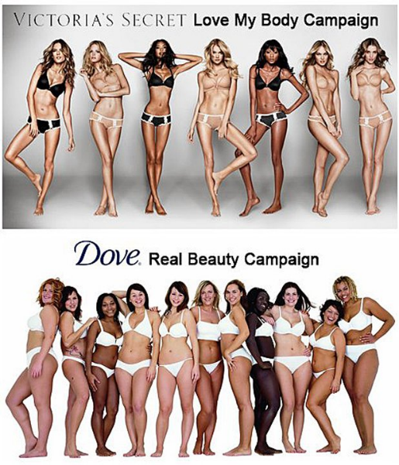
(Fig 6: Victoria’s secret 2014) (Fig 7: Dove campaign)
While comparing these two advertisements by Dove and Victoria’s Secret, although similar premises the representation is more realistic in the Dove advert. Not only that, but in the Victoria’s Secret advert the poses the models are doing are more sexualised and more appealing to the male gaze whereas the Dove advert seems to be focusing on the female audience and the idea of togetherness. Women empowerment can be seen as sexy and sexualised, but it can also be seen as women coming together and accepting ones and each other's flaws for what they are.
Chapter 2 (2000)
The Superhero genre is one that’s audience has developed over the years with more diversity including women, people of colour and other minorities enjoying the genre and attending conventions with attendance multiplying over the years. While the audience has diversified, the directors, writers and producers have stayed the same, that being white and male. Fans of the genre have complained about the lack of diversity in the creation of their favourite genre and the creators of the DC genre responded by saying “we hear you… we are committed to telling diverse stories with a diverse point of view (DC editorial 2011)”. This shows the importance and how powerful the opinion of the audience is to the creators. For example, “‘Fans’ appetite for diversity and change is re-shaping the market, and were doing our best to nudge that change along” (Alonso 2014), this shows that the creators are aware of the issues surrounding diversity and know that change is necessary to ensure that the audience is satisfied. While a call for diversification in the superhero genre is being noticed and change is coming, the representation and hyper sexualisation of women in the genre is a problem that has always been a problem in the genre. This could be due to the fact that there is a lack of diversification in the creation of the films and comics. Although the number of Superhero films are growing, single films dedicated to a female protagonist is still only at 7%, with most characters being pushed to the side or being seen as a love interest. With the lack of female representation in this genre, there seems to be a habit of stereotypes as women only valued for their sexual appeal whereas men are valued for their strength and heroism. This also falls into an example of the ‘Smurfette principle’ meaning that the role of a woman character is to be the only female with a large group of males, with her only character trait is being a woman, with a lack of a personality or clear storyline. This is explained by Pollitt in 1991 saying “Boys are the norm, girls are the variation, boys are central, girls peripheral; boys are individuals, girls types. Boys define the group, its story and its code values. Girls exist only in relation to boys”. A theory when discussing how males and females are portrayed in films in general is that there is an active male and passive female, meaning that the male role is always seen and changing as a character whereas the role of a woman is replaceable and not important.
An important example of a character who follows these traditional features but also defies them is the role of Wonder Woman, beginning in 1941 to the present day. The creator of the Wonder Woman believed that “men needed to be taught to accept “female love power”” and “thought that women needed to be taught their potential”. This is interesting and different for the time as he saw that women could be strong, powerful and interesting characters rather than resorting to the traditional use of a male persona. The traditional features of the character is that she is created and drawn by a mostly male team and has the features traditionally used by these artists, a white woman who is able bodied in a hypersexualised outfit. The exception, at the time, for the character of Wonder Woman was that she was given her own story while male characters surrounded her life, whereas usually the woman would be the side-kick or love interest. Some would argue although Wonder Woman was a step in the right direction at the time, she represents a small percentage of what women look like and most do not have the same privileges. While creating the strip Mullaney believed that the character could be seen as a positive role model for women, girls and boys saying;

It is a strip that will appeal to women for the strength and character of Wonder Woman; to men for her magnificent beauty and her sinuous agility, her daring exploits and her charm; to all boys for the sheer thrill and excitement of Wonder Woman; and girls who will take her for their idol and prototype. (Mullaney 2014)

Although this would and could have been true for the time times and traditional gender roles were changing and instead of looking up and admiring Wonder Women people found her sexualised and intimidating, with Werthham saying in 2008, “she is a frightening figure for boys, she is an undesirable ideal for girls, being the exact opposite of what they are supposed to be”. Just by being a woman, the character of Wonder Woman is bashed and criticised for her strength whereas her male counterparts, who do exactly the same, are seen as strong and powerful. Simone de Bouvoiur believes that if men and women stopped seeing each other as different entities and just recognising our differences then equality would become an easier thing to achieve. She says, ‘mutually recognising each other as subject, each will yet remain for the other an other’.
While discussing the sexualisation of the character of Wonder Woman, it’s easy to get lost in the sexualisation of the character and not really look into her personality, actions or dialogue, for example;

Traditionally, the woman has displayed as functions on two levels: as erotic objects for the characters within the screen story, and as erotic object for the spectator and that the male characters in the film are neatly combined without breaking narrative verisimilitude.

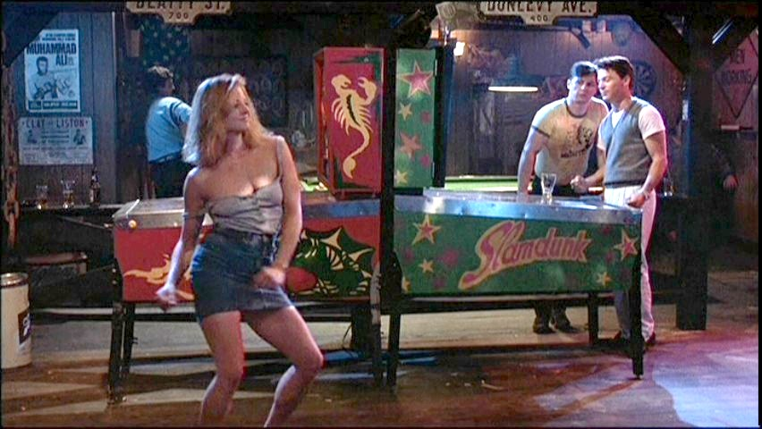
This also echoes the point that the female character is made for the male gaze and that male characters are there to keep the narrative going. Some would argue, that when female characters do receive powerful roles and archetypes it seems to come hand in hand with a sexual undertone, which at times in not needed or necessary. This could be a reason as to why the audience struggles to identify with such characters as the audience's age is younger whereas they are supposed to look up to and aspire to be a hypersexualised older woman which is an unrealistic goal.

(Fig 8: The Accused 1988)
An actress who plays characters that often defy these traditional sexualised and watered down stereotypes is Jodie Foster. She was described by her mother as a ‘traditional looking girl’ by her mother which seems to have helped her as she didn’t follow the sexualised roles that she was given, she was just herself. Jodie foster even said herself that “If I portray a victim, does this mean that I’m not wonder woman?”. This quote highlights the fact that Although the roles Jodie Foster plays in her films have flaws and are sometimes victimised, she never portrays the woman as week which is an interesting concept and one not seen very often. She often plays characters who are in their own right a strong female that always fights back even when she is seen as the weaker one with less dominance in the situation. An example of this is in the film the accused, Jodie defies what and where a woman’s place is and dances in the male dominated bar. She is in touch with herself, her sexuality and her self-confidence which makes her unashamed and proud of it. Jodie Foster is very outspoken about the freedom of every woman’s sexual expression and believes that there is nothing to be ashamed of therefore censorship is unnecessary, for example;

I believe women should be sexual. And why not? What a great thing to be: a sexual woman, coming of age and discovering sensuality and the intoxication of it. I've seen so many movies about who don’t like sex and really don’t want to have sex, or have that posey stuff in the Calvin Klein ads. Well that’s just not true and I'm sick of that myth being out there. What I'd like to do is develop movies that better reflect my generation of women (Jodie Foster, speaking at the Walker Art Centre, 1991)

This shows that not only does she think that sexuality is something that women should embrace and enjoy but that the representation of sex in the film industry is very unrealistic. She believes that the idea that a woman is not interested in sex is an unrealistic representation of this generation of women who are ready to embrace sexual empowerment.

Cartoons (300)
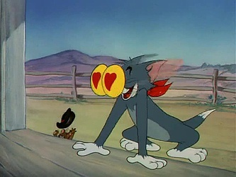
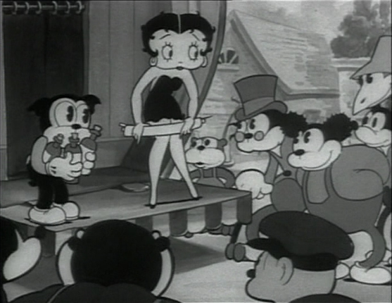
(Fig 9: Tom and Jerry) (Fig 10: Betty Boop)
Another example of the hyper sexualisation of women in the film industry is of that in Cartoons. While cartoons are supposed to be appealing to children, the representation and reaction to women could be seen as inappropriate. For example, characters such as Jessica Rabbit and Betty Boop have over exaggerated bodies and features making them appealing and following traditional film ideals on how a woman should look. Not only that but the reaction they get from male characters seem to emphasise this idea that the female character is there to represent the sexual ideals and fantasies of the male. On the other hand, some people believe that “many of the representations of women in cartoons suggest male anxiety”. This is an interesting point which could represent women as a fear and highlight the differences between men and women. As for the personalities of these female cartoon characters, it seems that most are there to either pick up or put down the male ego. For example, Minnie mouse is described as “teasing, flirtatious or winsome”, for a character aimed at young children it seems as though the purpose of the character is to be a depiction of female sexualisation.

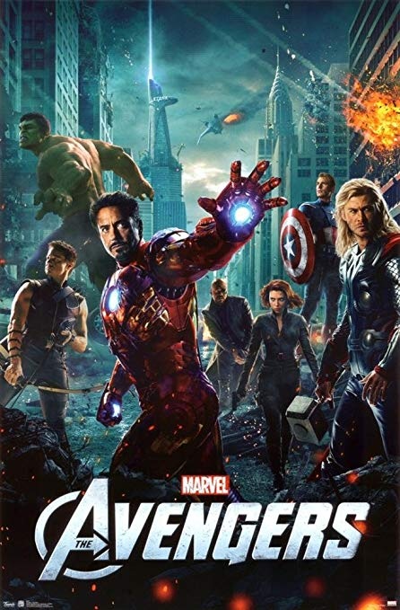
While looking into films and the film industry, it’s important to also look at film posters and compare how women are posed compared to men. For example, This poster from the movie franchise the Avengers;

(Fig 11: The Avengers 2012)

While looking and analysing this poster it’s quite easy to see that all of the male characters are positioned in what is called ‘power poses’, to represent their strength and power. Compare this to that of the character of the Black Widow that has taken a pose that shows little power with her guns facing down. She is also seen in a skin-tight black body suit, which extenuate her figure and she is looking directly into the camera. This tactic is similar to the ones used in magazines to entice the male audience in and play on the male gaze. This poster is a perfect example of how just something as simple as a pose has different standard when it comes to male and female representation, even in the modern age of film.
Chapter 3
For my major project this year I will be creating a documentary discussing Cam Girls and prostitution in Wales. During the film, I want to discuss morality and why there is a glamorisation of Cam Girls in the UK at the moment. To show the dark side of the sexualisation of women, I will be discussing prostitution and its dangers. I hope by discussing these topics to further my knowledge on if the hyper sexualisation of women in the media did or did not help in their decision making to become these things and also discuss whether using bodies for income is empowering or using women. I believe that this topic is relevant and an important discussion as the number of women getting into the sex industry is rising and its popularity isn’t hidden in our society. I hope to use this independent inquiry to shine a light on the reality of working in the sex industry and the realistic expectation of it, whether it’s positive or not.
As I will be a female director working on this film, I hope to ensure that the representation of women is correct but also not hide or censor the sexuality of a woman. The sexuality of women is important in my film and I do want that to be a major part in my film, but a realistic representation of sexuality is what I would like to achieve without glamorizing the subject at hand. Out of the top grossing films of 2018 only 4% of those were directed by female directors, therefore I believe that my role as a female director is an important one to ensure that I create change in the industry by representing women and their sexuality correctly.

Conclusion

To conclude, through writing and researching into this independent inquiry I believe that I have learned multiple different sides and opinions regarding not only the representation of women and their sexuality in the film industry, but also in the media in general. Referring back to my question ‘is the representation of Sex and the sexualisation of women helping or harming the feminist movement in the film industry?’, I believe that this topic is one that has many layers and has developed in both positive and negative lights throughout the years. For example, I do believe when comparing how far the film industry, media and society as a whole has come, I do believe drastic changes have been made. However, I do believe that the film industry does hold back on trying to change how it represents women as it realises that that is what draws audiences in, and they know that audiences love familiarity in films. While questioning if I believe censoring the sexuality of females in medias such as films and magazines, I don’t believe that that would be positive but what I do believe is that the sexuality of females should not be represented in a way to impress the male gaze but to empower and celebrate the female body. This can be done by diversifying who and what type of people we see in the media to ensure that the traditional version of what female beauty and sexuality is is not the only representation of women in media. To conclude, I believe that some aspects of the representation of women and their sexuality does help the feminist movement as it celebrates and shows a realistic view of what a woman and her sexuality is. But I do believe that major changes need to be made in these industries to ensure that the representation of women comes before how much money her sexuality will sell. I do believe that every day, the industry is striving to create change and move on from it’s past of hypersexuality, censorship and unrealistic representation.

Bibliography
- Cocca, C. (2016). superwoman. Bloomsbury, pp.1, 14, 16, 25,26,27, 29,31,31,221.
- Doane.MA (1991). Femme Fatales. Routledge
- Cook.P and Dodd.P(1997) Women and Film . The British Film institute
- Krzywinska.T (2006). Sex and the Cinema. Wallflower Press
- SCREEN (1992). The sexual subject. Routledge
- BBC News. (2019). Has a feminist movement divided women?. [online] Available at: https://www.bbc.co.uk/news/blogs-trending-44958160
- Refinery29.com. (2019). A #MeToo Timeline To Show How Far We've Come — & How Far We Need To Go. [online] Available at: https://www.refinery29.com/en-gb/2018/10/213189/me-too-movement-history-timeline-year-weinstein
- Félix, D., Félix, D., Filkins, D., Yaffa, J., Yorker, T., Rothman, J., Knight, S. and Waldman, K. (2019). One Year of #MeToo: We Need a More Inclusive Language of Abuse and Victimhood. [online] The New Yorker. Available at: https://www.newyorker.com/culture/culture-desk/one-year-of-metoo-we-need-a-more-flexible-language-of-abuse-and-victimhood
- Verily. (2019). Are “Sexy” Magazine Covers Empowering For Women? This Evidence Says No. [online] Available at: https://verilymag.com/2015/05/hypersexualized-womens-magazines-media-sexism-objectification-body-image
- Chnm.gmu.edu. (2019). Women in World History : MODULE 4. [online] Available at: http://chnm.gmu.edu/wwh/modules/lesson4/lesson4.php?menu=1&s=12

(BBC News, 2019)
(BBC News, 2019)
(BBC News, 2019)
(Refinery29.com, 2019)
SCREEN (1992)
(Verily, 2019)
(Butler.J 1990)
(Verily, 2019)
(Beauvoir & Parshley, 2007)
Cocca, C. (2016).
Cocca, C. (2016).
Cocca, C. (2016).
(Richard 1942)
(Mullaney 2014)
Cocca, C. (2016).
(Beauvoir & Parshley, 2007)
SCREEN (1992).
Cook.P and Dodd.P(1997)
Cook.P and Dodd.P(1997)
women (Jodie Foster, speaking at the Walker Art Centre, 1991)
Cook.P and Dodd.P(1997)

