The Professional Practitioner

Table of Contents:

Reflective Personal Development Plan (part 1) – page 2, 3
Briefing Paper (part 2) – page 4, 5
Reference list (briefing paper) – page 6, 7
Written essay (part 3) – 8, 9, 10, 11, 12
Reference list (essay) – page 13, 14, 15
Appendix - 16

Part 1: Personal Development Plan
The thinking, knowledge, skills and behaviours that I will change and develop in order to achieve my vision and goals, adhere to my values and become as resilient as possible
No | Improvement and Development Goals | What will this help me to achieve? | The actions I will take to achieve the goal | Timelines | What support I will need | Success Criteria  (How I will know when I have made this change)
1 | Improve knowledge about supporting and promoting children’s independent learning and learning through play.  Develop the outdoor learning environment to promote children’s independent learning through play. | This will help improve my confidence, communication and team working skills through attending meetings, sharing ideas and planning the way forward with regards to the outdoor environment.  Increase my confidence and knowledge within my role. More awareness of how to support and promote children’s independence skills and learning through play. This will prepare children for future challenges, fostering resilience and self-confidence within themselves. | Attend regular staff meetings to assess the development of the outdoor area, make changes and risk assess any changes to the area.  Communicate with staff members to plan the location of the outdoor learning corners and agree on equipment/furniture required to promote independence and play.  Speak to the pupils to allow the children a voice within the planning of the outdoor area including their ideas of what’s important to them.  Support the class teacher with collecting information from parent’s/guardians’/ community with any equipment or further help or funding available which will contribute towards the necessary changes.  Attend any relevant courses to support and promote children’s independence skills, learning through play, learning outdoors and the role of the practitioner.  Reflect with mentor. | 1 year-ongoing | Mentor – to reflect on practice.  Time to research.  Time to make any changes.  Information from courses to build on prior Knowledge and improve confidence. | The outdoor learning environment will have defined areas for the different areas of learning.  The areas will have equipment and resources which promote independence, e.g more exploration equipment, outdoor tap, wet weather clothing, storage.  The children can freely use the outdoor environment, learning through play and are showing progression with their independence.  I will feel more confident within my role, promoting and supporting independence and outdoor learning through play.
2 | Improve my knowledge on the effect of trauma on children. | Better knowledge and understanding of how best to meet the needs of each individual child dealing with trauma and the effect it has on them.  Increased confidence when dealing with children suffering with trauma, to implement any strategies or relevant activities that will support the child. | Attend a course –  Having a mentor to discuss any difficulties and support my confidence with gaining new knowledge and applying it.  Trauma Informed Schools UK (2015). Available at: https://www.traumainformedschools.co.uk/. | 1month- ongoing |  | When I am confident within my role that I am meeting the needs of children dealing with trauma. Using strategies and intervention programs which are catered for different needs and aspects of trauma.

Part 2: Briefing Paper
Linus, Kocsis and Burry 2023 explain that Schon believed that learning is not about acquiring knowledge, professionals improve and learn through reflection. This encourages critical thinking and the ability to continuously reflect both during and after an activity. He introduces two key concepts of reflection:  Reflection in action- This involves being able to think, adapt, reflect and respond effectively in the moment. Changing approach if needed allowing instant feedback.  Reflection on action- This is a deliberate process that happens after a task or event. Evaluating what went well and what didn’t, this includes deeper learning and informs future practice.  Dewey’s theory on reflective practice.  Dewey’s theory on reflective practice includes five stages: identification, gathering information, hypothesis, testing hypothesis and reflection. He believed in hands on experimental learning specific to child’s interest. According to Dewey, learning is not done through experience but through reflection, highlighting the importance of engaging learners in reflection. How experiences shape who we are and the significance of incorporating reflective practice into learning, fostering meaning and relevance thereby facilitating growth and change (Third 2022).  Schon’s theory on reflective practice.  What is reflection and reflective practice?  Reflection -Hickson (2011, quoted in Brock 2014, p8) defines reflection as similar to a reflection (as in water or a mirror) self-reflecting to self-examine thinking to purposefully evaluate practice and experiences. Reflection is important in early years and to the practitioner as it incorporates self-insight and the ability to evaluate thinking guided by evidence based on prior experiences. Seeing things from a fresh perspective and turning the focus inwards to enhance personal insight and awareness (Reed and Canning 2012).  Reflective practise-. Reflective practice involves a practitioner’s active participation in reflective thinking, learning from reflection and implementing the new knowledge as an ongoing approach, becoming continually adaptable to a constantly evolving environment (Reed and Canning 2021). This allows the practitioner to assess and improve their approaches to support child development, allowing a deeper understanding into the child’s needs and how they are best met. Reed and Walker (2019) refer to reflective practice as a process of thinking, learning and reflecting on evidence and experience, applying knowledge to the workplace to support further actions, promoting professional growth. Henson (2012, quoted in Reed and Walker, 2019, p25) defines reflective practice as actively engaging in the ongoing revaluation of one's assumptions, values, and methods. This process aims to transform and elevate both oneself and one’s practice to facilitate meaningful change and improvement, examining strengths and weaknesses to produce proactive problem solving. Reflective practice provides a structure for critical thinking, analyzing learning and progression. In addition to this reflective practice involves gaining insight into both practitioners and children’s mental states, such as thoughts, emotions, intentions, goals, desires, and needs, (Virmani 2020).  Why is reflective practice important to EY practice?  According to Barr and Leeson (2016) actively reflecting allows a greater understanding which leads to knowlagable, confident practise fostering extensive personal and professional progress. By Virmani (2020) describes how this can develop the ability to examine,listen,inquire and respond effectively. The practitioner may become more aware of children’s emotional experiences also their own emotional development bringing heightened awareness which equips them to offer more sensitive and responsive care. Reed and Walker (2015) belive that skilled practitioners should embrace reflective practice, consistently questioning thier role to enhance the quality of care and education provided to children and families. Reed and Canning (2012) explain how reflective practice supports child development and quality improvement in early years practice. Looking at more effective ways of working, identifying areas of concern, improving learning outcome for children and avoiding being stuck in habbits. According to Brockbank and Mc Gill (2007:143 quoted in Reed and Canning 2012) reflective practice in early years can help with revising approaches, preventing old habits that hinder progress. Early years, care and education often face continual changes in areas such as, regulations, curriculum, mental health and diversity and inclusion. As a result Reed and Canning (2012) also believe that the early years practitioner needs to be able to adapt positively and effectively within a changing professional environment and that this is strengthened by their understanding of that environment. Reflective practice therefore provides an oppertunity to implement change on a personal and societal level aimed at improving quality within early years practice, (Cable and Miller 2008:173 referenced in Reed and Canning 2012). | Linus, Kocsis and Burry 2023 explain that Schon believed that learning is not about acquiring knowledge, professionals improve and learn through reflection. This encourages critical thinking and the ability to continuously reflect both during and after an activity. He introduced two key concepts of reflection:  Reflection in action- This involves being able to think, adapt, reflect and respond effectively in the moment. Changing approach if needed allowing instant feedback.  Reflection on action- This is a deliberate process that happens after a task or event. Evaluating what went well and what didn’t, and includes deeper learning and informs future practice.  The theory of reflective practice – Schon’s theory.  Why is reflective practice important to EY practice?  According to Barr and Leeson (2016) actively reflecting allows a greater understanding which leads to knowlagable, confident practise fostering extensive personal and professional progress. Virmani (2020) describes how this can develop the ability to examine, listen, inquire and respond effectively to children’s needs within practise. The practitioner may become more aware of children’s emotional experiences also their own emotional development bringing heightened awareness which equips them to offer more sensitive and responsive care. Reed and Walker (2015) belive that skilled practitioners should embrace reflective practice, consistently questioning thier role to enhance the quality of care and education provided to children and families. Reed and Canning (2012) explain how reflective practice supports child development and quality improvement in early years practice. Looking at more effective ways of working, identifying areas of concern, improving learning outcomes for children and avoiding being stuck in habbits. According to Brockbank and Mc Gill (2007:143 quoted in Reed and Canning 2012) reflective practice in early years can help with revising approaches, preventing old routines and patterns hindering progress. Early years, care and education often face continual changes in areas such as, regulations, curriculum, mental health and diversity and inclusion. As a result Reed and Canning (2012) also believe that the early years practitioner needs to be able to adapt positively and effectively within a changing professional environment and that this is strengthened by their understanding of that environment. Reflective practice therefore provides an oppertunity to implement on a personal and societal level aimed at improving quality of care and education within practise, (Cable and Miller 2008:173 referenced in Reed and Canning 2012).
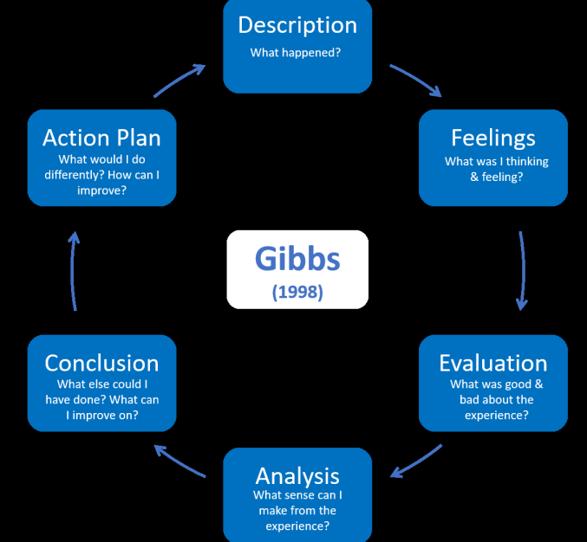

(UCD Teaching and Learning 2020)

Gibbs’s Model of Reflection
Gibbs’ model of reflection has a structured detailed process with guided questions through six stages. This method produces an action plan drawn from conclusions but also encourages personal reflection on emotions during experiences (UCD Teaching and Learning 2020, p3).

Advantages Disadvantages:

Is thorough Inflexible
In depth Superficial
Analysis feelings. Lengthy process
Creates an action plan. Self-centered
Evaluates strengths and feelings.
.

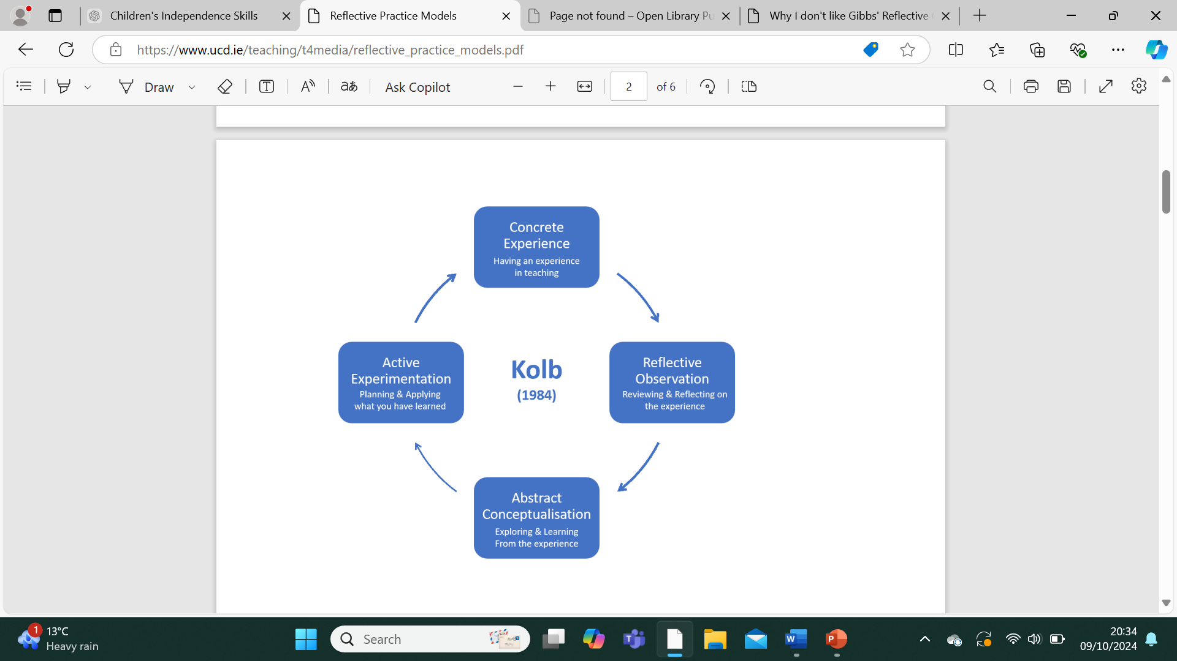
(UCD Teaching and Learning 2020)

Kolb’s Model of Reflection
Kolb’s model has four stages where the individual encounters a situation which leads to reflection. The third stage of abstract allows the individual to form ideas based on observation and finally through active experimentation new knowledge can be applied. Kolb’s model emphasizes the interaction between experience and action (Amenumey and Badu 2024, p.118).

Advantages Disadvantages

Is clear-cut Overly simplistic
Provides a good foundation for reflection. Does not account for different reflective
Enhances awareness. learning strategies.
Applicable in all areas of life.

Conclusion- Reflective theorists enable individuals to critically examine their experiences and themselves, providing understanding and methods to allow reflection and professional growth. Reflective models provide a framework to structure and fully capitalize on the learning potential of any experience. Reflective practice is crucial for the early years practitioner to continuously develop, value and recognize the importance of their own reflective process, to improve their approach to foster better outcomes for children’s care and development. Reflective practice is essential within early years as it supports ongoing learning producing positive outcomes.

Compare/Contrast – Gibbs model of reflection gives a detailed account of reflection which provides analyses of feelings and allows a deeper reflection on an event (UCD Teaching and Learning 2020, p3). However, the model could be seen as rigid and repetitive producing longer responses and seen as not time effective, focusing too much on the individual, leading to self-serving insights (Fallin 2021). The model successfully produces a way forward, room for progression through reflection. In contrast to Gibbs’ model Kolb’s model some may argue is overly simplified and based around learning from experience. Nonetheless the simplicity of the model means that the process could be interpreted as easy and straight forward and can be used in all areas of life, if anything more time effective also a good starting point for organized reflection. Due to its simplicity the model lacks an area that considers others’ viewpoints similar to Gibbs’ model, but also successfully develops awareness through reflection and highlights areas for personal growth (Study Prism, 2023).

References – Part 2
Amenumey, E.B. and Badu, Y.A. (2023). ‘Leaders’ Experiences of Integrated Leadership Development in Higher Education: Kolb’s Experiential Learning Theory and the 70:20:10 Model’. International Journal of African Higher Education, 10(2), pp.113–137. Available at: doi:https://doi.org/10.6017/ijahe.v10i2.17617. (Accessed 9 Oct 2024).
Brock, A. (2014) The Early Years Reflective Practice Handbook. Oxon: P-Taylor and Francis Group.
Cambell-Barr, V. and Leeson, C. (2016) Quality and Leadership in the Early Years: Research, Theory and Practice. London: SAGE Publications Ltd.
Fallin, L. (2021). ‘Why I Don’t Like Gibbs’ Reflective Cycle in Reflective Practice’. Available at: https://leefallin.co.uk/2021/10/why-i-dont-like-gibbs-reflective-cycle-in-reflective-practice/. (Accessed 9 Oct 2024).
Reed, R. and Walker, R. (2015) A Critical Companion of Early Childhood. London: SAGE Publications Ltd.
Sheryl Third, R. and Ece. C, B.A. (2022) Reflective Practice in Early Years Education. London: Fanshawe College Pressbooks. Available at: https://ecampusontario.pressbooks.pub/reflectivepracticeinearlyyears (Accessed 8 Oct 2024).

Study Prism (2023). Kolb’s Reflective Learning Cycle – StudyPrism. Available at: https://studyprism.co.uk/reflective-practice/models/kolbs-reflective-learning-cycle/. (Accessed 9 Oct 2024).

Tan, L., Kocsis, A. and Burry, J. (2023) ‘Advancing Donald Schön’s Reflective Practitioner: Where to Next?’, Design Issues, 39(3), pp. 3–18. Available at: https://doi:10.1162/desi_a_0072. (Accessed: 8 Oct 2024).
UCD Teaching and Learning (2020). Reflective Practice Models. Available at: https://www.ucd.ie/teaching/t4media/reflective_practice_models.pdf. (Accessed 9 Oct 2024).
Virmani, E. A. et al. (2020) ‘How are Preservice Early Childhood Professionals’ Mindfulness, Reflective Practice Beliefs, and Individual Characteristics Associated with Their Developmentally Supportive Responses to Infants and Toddlers?’, Early Education and Development, 31(7), pp. 1052–1070. Available at: https:// doi:10.1080/10409289.2020.1798718. (Accessed: 8 Oct 2024).

Part: 3
Recognizing and Analyzing Different Aspects of Professional Practice Ensuring that the Early Years Practitioner Meets the Needs of Children

According to Perez (2019 p. 212) there are certain characteristics that define being a professional which include specialized education and training, acknowledgment of the importance of practice standards and a dedication to offering a service that extends beyond personal gain. Gasper (2015) argues that being professional brings focus on principled practice, valued based, an ethical approach where practitioners place the needs of the child at the core offering support to both child and parents. Callanan, Anderson, Haywood and Speight (2017) refer to professional practice as the skills, knowledge, and ethical standards that practitioners apply to provide high quality care and education for young children. It includes creating an inclusive, safe, and nurturing environment that promotes children's physical, emotional, social, and cognitive development. Professional practice includes reflection, observation, and planning to meet the individual and inclusive needs of all children, engagement with parents and multi-agency teams, and adherence to regulations and safeguarding policies. This approach fosters the holistic development of the child ensuring they reach their full potential in a supportive setting where children’s needs are met, (Callanan. Anderson, Haywood and Speight, 2017).
The values of an early year’s practitioner are essential in guiding their approach to meeting the needs of children, Fulton (2019) stresses that values deeply influence practice, particularly in meeting children's emotional needs. Showing care and emotional support fosters compassion and creates an emotional bond between practitioner and child, nurturing trust and a sense of belonging. Researchers have identified that care and affection are crucial for young children's holistic development, as it builds positive relationships that promote engagement and learning (Fulton 2019). Building and maintaining positive relationships is an important value the practitioner must demonstrate, by getting to know children and their families, and observing their preferences and play, enables practitioners to better accommodate individual needs. Fulton (2019) describes how this approach allows practitioners who acquire in depth knowledge of child development to adopt a pedagogical strategy that supports children's learning and development, understanding how each child learns and how to enhance that process to meet both individual and inclusive needs. According to Fulton (2019) understanding the value of reflection and the impact of reflecting on each child's development enables practitioners to understand them as active participants in their own learning and essential in professional practise. Fulton's (2019) core values also include the practitioner taking an ethical approach by being a positive role model, teaching children respect and value through example, preparing children to participate in social situations and raising awareness of children's rights, ensuring that learning is personalized and inclusive, and all their diverse needs are meet. The United Nations Convention on the Rights of the Child (UNCRC) contains 54 articles that include the rights that are applicable to every child ensuring their safety, protection and a voice, explaining how government, adults including practitioners within practise should work collectively so that children can access and embrace all of the rights that they need in their lives. Article 30 supports Futon’s (2019) beliefs of being respectful within practice, explaining how every child’s education needs to encourage respect for others, human rights, themselves, different cultures and the environment, (UNICEF, 1989).
According to Wilson (2016) effective communication is crucial for fostering positive relationships and strong connections with parents, multi-agency professionals, and children, all of which enhance learning and development through sharing information regarding children’s needs and tailoring an approach to cater for those needs, which is key within professional practise. Care and Learning (2024) notes effective communication between practitioners and children involves speaking clearly at the level of the child, actively listening and using a friendly tone, this approach develops a safe and positive environment where children feel valued and can express their needs freely which enhances their learning. Information communicated between parents/guardians and practitioners needs to be shared within the setting and relayed to all relevant staff, as this information may impact the child during the day’s routine to ensure that practitioners are aware of any unknown needs likes or dislikes parents have shared promoting teamwork through professional practice in meeting the needs of the child. In primary school settings this can be done through the ‘Classdojo App’ this is an effective way of communicating with parents on a personal or collective way sharing key information, updates, pictures and announcements regarding their child, this is an alternative way of communicating any additional information with the setting, (The basics Parent Accounts, n.d.). Direct communication from parents to practitioner contributes to a supportive working environment, which is crucial in professional practice to ensure all children’s individual and inclusive needs are met (Care and Learning 2024). Evidence indicates that children thrive when their parents are actively involved in their educational development, this emphasises the role of the practitioner in having an approachable, enthusiastic, happy demeanour and a positive relationship with parents/guardians allowing communication to be relevant and necessary between setting and parents/guardians (Wilson 2019). Healthy supportive relationships within settings can build trust, allowing parents to express their anxieties and concerns with key individuals who can provide a point of contact and offer referral options ensuring all children’s needs are meet and information is shared with other relevant professionals providing a multi-agency approach (Wilson 2019). Mathivet and Pilcher (2019) explain how good professional practice means that information shared by parents/guardians with the setting remains confidential within the setting, this emphasises why practitioners need an awareness of policies and procedures regarding confidentiality and safeguarding to ensure children are protected and information regarding each child follows protocol. The UNCRC (article 8) highlights how children have a right to identity and this right must be respected and protected (UNICEF,1989) which supports Mathivet and Pilcher’s (2019) in ensuring the practitioner understands the importance of supporting the need for confidentiality within professional practice in protecting and safeguarding children’s identity.
Having in-depth knowledge and understanding of child development is essential for professional practice, and it is crucial that practitioners are fully aware when a child's needs are not being met and their role in referring to other agencies who can offer further support and knowledge. According to Ziggy (2024) professionals in practice should be open to questioning the norm, value diversity and be able to work together to achieve goals. NSPCC (2023) explain that referrals to external agencies are sometimes necessary, enabling a multi-agency approach that addresses special educational needs by working together to gain a comprehensive understanding of the child’s situation. This collaborative effort provides improved support and intervention to ensure all children’s diverse needs are met taking a holistic approach looking at the child’s emotional, academic, social and physical development (Ziggy 2024). This is important to professional practice as other professionals with areas of expertise can share information with the setting and home regarding how best to address a child’s needs with intervention programs, modifying the environment or equipment to remove barriers within the child's learning. Such collaboration provides deeper insight into the child’s needs and informs planning, ensuring that every child has access to education and care tailored to their individual and inclusive needs (NSPCC 2023). Ziggy (2024) explains how multiagency collaboration conduct thorough assessments of the child’s needs to quickly identify risks and necessary requirements offering the child and practitioners help and support to prevent issues getting worse, this promotes the child’s resilience and well-being which is imperative within practice and the role of the practitioner.
Multi-agency cooperation is also central to safeguarding and child protection (NSPCC, 2023). Davies (2022) notes how practitioners should work in compliance with procedures, legislation and policies regarding safeguarding. According to Welsh Government (2020) practitioners need to be able to recognise symptoms of abuse, neglect and harm in children and through sound understanding and knowledge of the safeguarding policies within the setting, professional practice would include practitioners reporting any concerns through the correct protocol ensuring child safety and protection. This is supported by the UNCRC, (article19) explaining how children have the right to be safe from abuse, neglect, violence and bad treatment.
Welsh Government (2022) explains how the planning cycle involves observing children’s interests, behaviours, and developmental progress, using these observations to inform planning. Rosa (2015, p.1) suggests that that observation is the beginning of planning and can be done after what has been learnt from observation and assessment. This process informs professional practice by providing opportunities to be reflective, to address what worked well and to be objective. According to Care Learning (2024), reflection as part of the planning cycle contributes to professional practice by offering practitioners the opportunity to evaluate their experiences and enhance their skills, providing increased knowledge and understanding to meet the inclusive needs of all children, through further training/courses promoting professional development. Through use of the planning cycle and analysing observations practitioners can tailor learning experiences through future planning to promote children’s holistic development, allowing opportunities for progression, (A Curriculum for Funded Non-maintained Nursery Settings, n.d). Rosa (2015) notes how this process promotes the practitioners thinking and questioning, at times communicating with parent/guardians for further information based on observations for a clearer picture to accommodate child’s needs and offer further support.
In conclusion, recognizing and analysing the various aspects of professional practice is essential to meeting the individual and inclusive needs of children within early years settings. Effective professional practice includes reflective practice, knowledgeable practitioners, collaboration with parents and multi-agency teams, ethical standards, and tailored planning based on observations. These elements ensure that practitioners are responsive to each child’s developmental needs but also foster an inclusive environment that supports holistic growth. By valuing diversity, promoting safeguarding, and following good practice the early years practitioners can create supportive and nurturing environments that help all children progress. Continiously reflecting and adapting in professional practice allows practitioners to respond to children’s needs, ensuring that each child’s potential and well-being is recognised and developed.

References-Part 3
A Curriculum for Funded Non-maintained Nursery Settings. (n.d) Available at: https://hwb.gov.wales/api/storage/3e89a21c-60fb-416c-99dd-6e1af3982409/a-curriculum-for-funded-non-maintained-nursery-settings2pdf
Brearley, M. (2022) Children’s Act 2004. Online Learning College. Available at: https://online-learning-college.com/knowledge-hub/early-years/childrens-act-2004/ (Accessed 21 Oct 2024).

Callanan, M., Anderson, M., Haywood, S., Hudson, R. and Speight, S. (2017) Study of Early Education and Development: Good Practice in Early Education. Department for Education (DFE).
Care Learning. (2024) Summarise Theoretical Perspectives on Reflection in Relation to Professional Development- Care Learning. Available at: https://carelearning.org.uk/qualifications/level-3-diploma-eyp/ unit-4-1-professional-development/2-1-summarise-theoretical-perspectives-on-reflection-in-relation-to-professional-development/ (Accessed 22 Oct 2024).
Care Learning. (2024) Explain How Communication Affects All Aspects of Own Practice- Care Learning. Available at: https://carelearning.org.uk/qualifications/level-2-early-years/eyp-1/4-2-explain-how-communication-affects-all-aspects-of-own-practice/ (Accessed: 21 Oct 2024).
Davies, C. (2022) Effective Safeguarding in Early Years Settings. Safeguarding Network. Available at: https://safeguarding.network/content-delivery/effective-safeguarding-in-early-years-settings/ (Accessed 20 Oct 2024).
Falch-Erksen, A. and Backe-Henson, E. (2019) Human Rights in Child Protection Implications for Professional Practice and Policy. Switzerland: Palgrave Macmillan Cham.
Fultan, D. (2019) Advanced Work Based Practice in the Early Years. London: Routledge.
Gasper, M. (2015) Professional Practice and Early Childhood Today. London: SAGE publications.

Castro-Kemp, S. and Samuels, A. (2022) Working together: A review of cross-sector collaborative practices in provision for children with special educational needs and disabilities. Research in Developmental Disabilities, 120, p. 104127. Available at: doi:https://doi.org/10.10.1016/j.ridd.2021.104127 (Accessed 20 Oct 2024).
Mathivet, S. and Pilcher, M. (2019) Safeguarding: Record Keeping & Confidentiality. Teach Early Years. Available at: https://teachearlyyears.com/a-unique-child/view/safeguarding-record-keeping-confidentiality (Accessed 22 Oct 2024).
NSPCC (2023) Multi-agency and Interdisciplinary Working. NSPCC Learning. Available at: https://learning.nspcc.org.uk/child-protection-system/multi-agency-working-child-protection#skip-to-content (Accessed 20 Oct 2024).

Perez, R. (2019) What Does it Mean to be a Professional? Professional Case Management, 24(4), p.212. Available at: https://doi.org/10.1097/ncm.0000000000000373 (Accessed 17Oct 2024).
Rosa, D. (2015) Effective Practice: Observation, Assessment and Planning. Available at: https://www.westsussex.gov.uk/media/5555/effective_poa_andplanning.pdf. (Accessed 21 Oct 2024).
The Basics Parent Account. (n.d) Available at: https//static.classdojo.com/docs/TeacherResources/ParentFAQs (Accessed 23 Oct 2024).

UK GOV. (2020) Guidance-Keeping Children and Young People Safe Safeguarding guidance for practitioners working with children (up to the age of18). Available at: http://assets.publishing.service.gov.uk/media/66d7301b9084b18b95709f75/keeping _children_safe_in_education_2024.pdf (Accessed 20 0ct 2024).

UNICEF (1989). UN Convention on the Rights of the Child (UNCRC). UNICEF. Available at: https://www.unicef.org.uk/what-we-do/un-convention-child-rights/ (Accessed 22 Oct 2024).

Welsh Government. (n.d) A Curriculum for Non-maintained Nursery Setting. Available at: http://hwb.gov.wales (Accessed 20 Oct 2024).
Wilson, T. (2016) Working with Parent, Carers and Families in the Early Years: The Essential Guide. Oxon: Routledge.

Ziggy. (2024) The Crucial Role of Multi-Agency Working in Social Care: A Balanced Perspective. Social Work. Available at: https://uksocialwork.co.uk/the-crucial-role-of-multi-agency-working-in-social-care-a-balanced-perspective/ (Accessed 22 Oct 2024).

Appendix

I have not used AI.

