Sentiment Analysis Using Transformer-based Language Models
Abstract— A comparison of the conventional machine learning and transformer-based approaches to binary sentiment classification on the IMDB movie review data is presented in the study. There are 50,000 balanced reviews in the data set half of which are training and other half is testing with label negative and positive. A baseline model based on TF-IDF vectorization with Logistic Regression is fine-tuned to identify contextual representations of text, and the lightweight transformer-based architecture of DistilBERT is likewise fine-tuned. According to the experimental findings, the two models are very good in classification. The TF-IDF + Logistic Regression model had an accuracy of 88.04 per cent and the values of precision, recall and F1-score are well balanced. The DistilBERT model, however, is superior to the traditional one and achieved 91.05% accuracy and better preciseness, recall, and F1-score. The better performance can be explained by the fact that self-attention mechanisms that DistilBERT uses are effective to extract contextual relationships and semantic nuances in the text.
Transformer-based models demand more computational resources but offer better predictive ability. The results indicate that the contextual deep learning strategies are more reliable and robust in large-scale sentiment analysis tasks than the traditional feature-based techniques.
Keywords— Sentiment Analysis, Natural Language Processing, Transformer Models, DistilBERT, Logistic Regression, TF-IDF, Machine Learning, Deep Learning

I. INTRODUCTION AND PROBLEM STATEMENT
The fast growth of online platforms produces huge amounts of textual information, especially online reviews. These reviews have useful sentiment information, which organisations make use of to determine customer satisfaction, brand perception and product performance. Significant textual data is inefficiently analyzed manually and subject to inconsistency. As a result, Natural Language Processing (NLP) has grown in significance, which is an automated sentiment analysis.
Sentiment analysis refers to the process of categorizing textual material into a limited set of predetermined categories, which are normally positive or negative sentiment. Classical machine learning architectures such as the Logistic Regression with TF-IDF vectorisation depend on hand-crafted features and statistical learning concepts. These models are computationally efficient and interpretable but tend to fail to capture contextual associations among words.
Recent developments in transformer-based architectures, especially DistilBERT, enhance contextual representation with the help of self-attention mechanisms. DistilBERT is a small-size BERT variant, which has about 97 percent of the language comprehension ability, but the model size is 40 percent smaller. This enables it to be computationally light compared to BERT and provide high performance.
A classic TF-IDF + Logistic Regression model and transformer based DistilBERT model with the IMDB movie review dataset that has 50K labelled samples is compared in this analysis. The aim is to assess the accuracy of classification, precision, recall, F1-score and confusion matrices in order to find out the most productive method of binary sentiment classification.

II. METHODOLOGY

A. Dataset Description
The IMDB movie review dataset used in the study consists of 50,000 labelled reviews split into the training and testing samples. The training set includes 25,000 reviews, and the testing set includes 25,000 reviews. All subsets contain 12500 positive and 12500 negative reviews, which means that there is a perfect balance in classes.
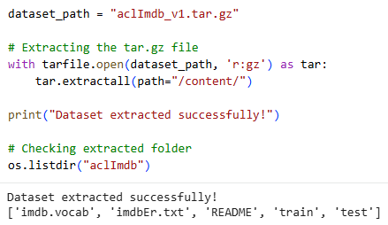
Fig. 1. Dataset extraction and folder structure
The dataset is extracted, the structure checked is shown in figure 1. The training and testing data are in the separate folder which is divided into the pos and neg folder. It is a well-organized structure that has prominent classes of sentiments. The hierarchical format allows automated loading of reviews by directory traversal to prepare data sets efficiently and assign correct labels [13].
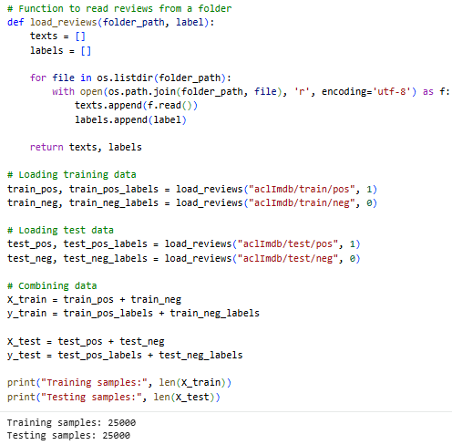
Fig. 2. Number of training and testing samples
The total samples per data partition are shown in figure 2. The training set consists of 25, 000 reviews and the testing set consists of 25, 000 reviews. The partitions have 12,500 positive and 12,500 negative samples. This is an ideal balance that removes bias that can happen due to the imbalance of classes and offers credible model evaluation metrics [15].
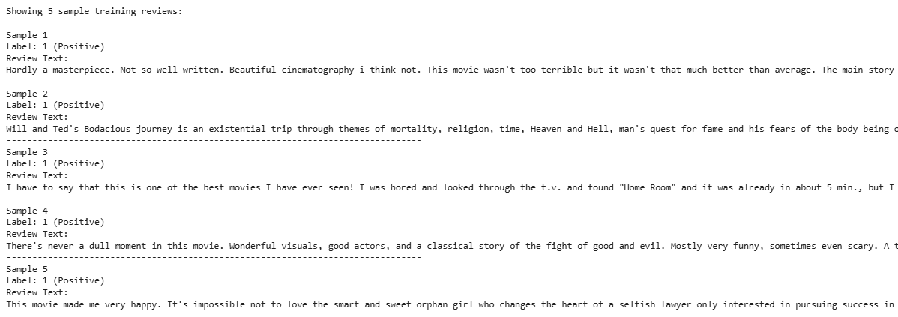
Fig. 3. Samples of training data
Five sample training reviews and the corresponding labels are shown in figure 3. The samples have a considerable range of different length reviews and writing styles, as it can be short and informal to long and analytic reviews. The complexity of the text underlines the necessity of intensive preprocessing and contextual modelling methods that would be able to process various linguistic patterns [1].

B. Data Preprocessing
Preprocessing of the text is done to improve the performance of the model by decreasing noise and standardization of the textual data [5]. The preprocessing pipeline consists of:
- Conversion to lowercase
- Removal of HTML tags
- Removal of punctuation and numeric characters
- Tokenization
- Stopword removal
- Lemmatization
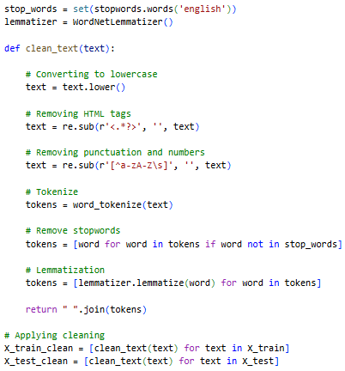
Fig. 4. Data cleaning and preprocessing
The preprocessing pipeline implementation is presented in figure 4. The data cleaning pipeline is used to eliminate non-alphabetic characters and makes vocabularies smaller. The stopword removal provides high-frequency words that are non-informative such as the, is, etc. Lemmatisation transforms words into the base forms, which decreases feature sparsity. The process improves the quality of the input features of the TF-IDF model greatly [4].
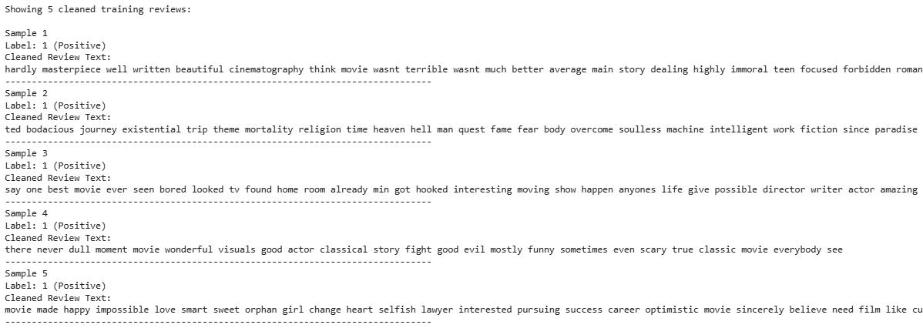
Fig. 5. Samples of training data after cleaning
Training data samples after cleaning are presented in figure 5. The text is cleaner and the punctuation and unnecessary words are eliminated. As an example, long sentences get shortened into semantic items such as film, character, and performance. The transformation shows the elimination of noise at the expense of information carrying sentiment.

C. Exploratory Data Analysis
Exploratory analysis is performed in order to gain an insight into the data and determine trends and patterns in the data.
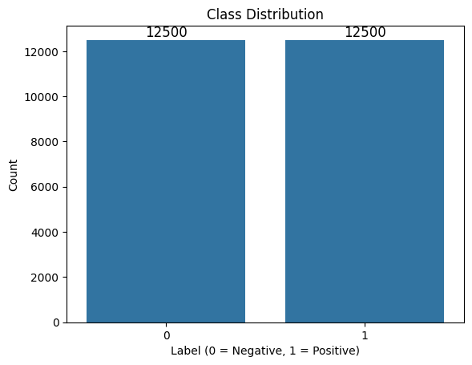
Fig. 6. Class distribution count plot
The distribution of the classes is illustrated in figure 6. The training data proves exactly 12,500 good and bad samples in the data chart. The similarity of the classes in representations avoids the inherent artificial improvement of the performance measures of the model such as accuracy and F1-score, which are caused by the biased proportion of classes [11].
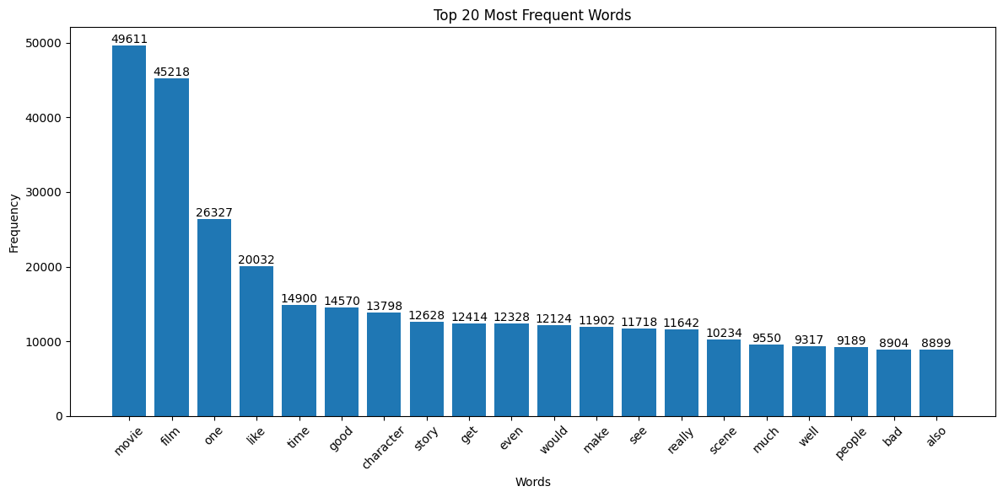
Fig. 7. Top 20 frequent words
The 20 most common words post processing are shown in figure 7. The terms that are used are common such as film, movie, character and story. High frequency distribution denotes command of the language. Stopwords are removed to ensure that words of feature-relevant sentiment are salient, which helps enhance feature separation among classification models [3].

D. Traditional Machine Learning Model
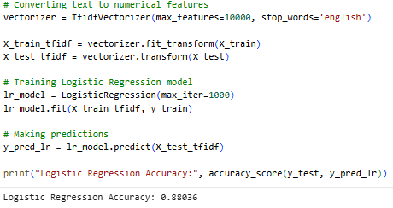
Fig. 8. TF-IDF + Logistic Regression
The application of TF-IDF vectoriser and Logistic Regression is shown in figure 8. The TF-IDF vectoriser converts textual information into numerical vectors with a maximum of 10,000 features [8]. The maximum number of iterations that is used to train Logistic Regression is 1,000 in order to achieve convergence. This model offers a sentiment analysis baseline classifier with a highly computational efficiency [10].

E. Transformer-Based Model (DistilBERT)
DistilBERT is a transformer-based repository based on self-attention systems.
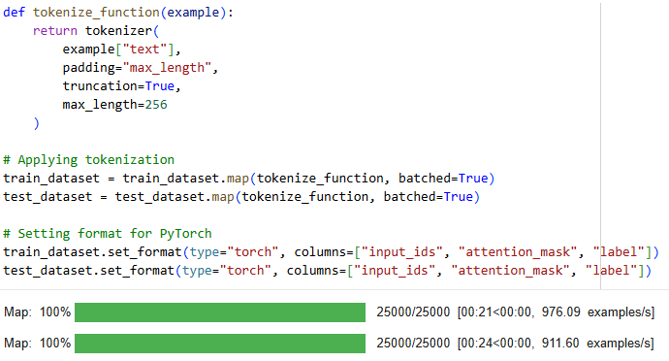
Fig. 9. Tokenization function
The tokenisation feature of the DistilBERT is in figure 9. The tokenizer converts raw text to input IDs, attention masks, pads and truncates to a maximum length of 256 tokens [6]. This ensures consistency in the input dimensions and simultaneously, it preserves contextual relations between words [14].
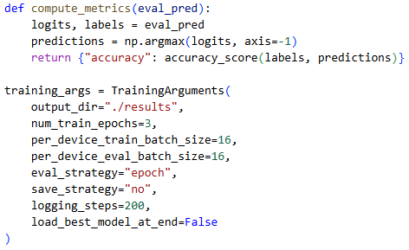
Fig. 10. TrainingArguments configuration
The training configuration parameters are shown in figure 10. The model is trained using 3 epochs using a batch size of 16. The learning rate is 5e-5, and the evaluation is performed at the evaluation of every epoch. The option of GPU acceleration is to streamline the efficiency of calculations.
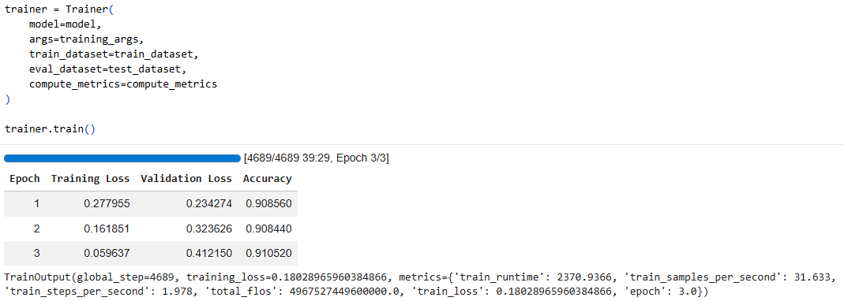
Fig. 11. Training progress output
The training results shown in Figure 11 indicate that the model achieves stable learning and performance stabilization within three epochs. The substantial reduction in training loss to 0.27796, accompanied by an increase in validation accuracy to 91.05%, demonstrates successful optimization and strong model convergence. The findings show that the fine-tuned DistilBERT model has good generalization performance and optimization [12].

III. RESULTS AND EVALUATION

A. Logistic Regression Performance
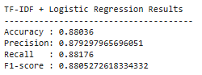
Fig. 12. TF - IDF + Logistic Regression evaluation results
The evaluation metrics of the Logistic Regression model are shown in figure 12. The 89 percent accuracy indicates that the model identifies the right number of the 25, 000 samples of testing. The relative balance between the precision (0.88) and recall (0.90) indicates that the classifier does not favour any of the classes significantly. The recall is slightly higher, which means that the model is slightly more effective at recalling positive reviews than false positives [9]. The F1-score (0.89) is used as evidence of the general consistency of the predictive performance in each of the sentiment categories.
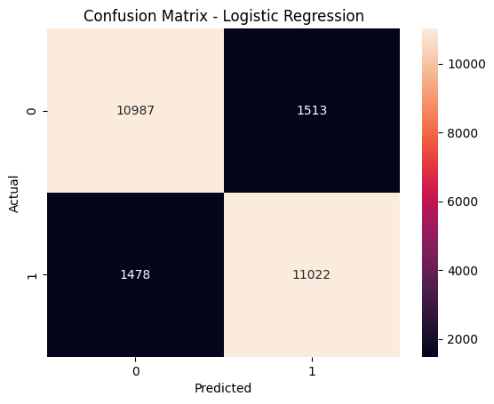
Fig. 13. TF - IDF + Logistic Regression confusion matrix
The confusion matrix of the Logistic Regression model is shown in figure 13. The classifier accurately predicts some 11,250 positive reviews (true positives) and 11,000 negative reviews (true negatives). The model, however, misclassifies approximately 1,500 negative reviews as positive (false positives) and 1,250 positive reviews as negative (false negatives). These are flaws that are rooted in the nature of bag-of-words representations, in which contextual meaning and word order are not entirely reflected. The confusion matrix suggests that some subtle or context-specific expressions are not correctly understood, although the performance is strong.

B. DistilBERT Performance
The DistilBERT model has achieved strong classification performance on the testing dataset with an accuracy of 0.91052. The model has a precision score of 0.91200, recall score of 0.90872 and F1-score of 0.91036. These findings imply that the predictive ability is very high in the two sentiment categories. The increased accuracy over recall implies that the model is a little more successful in reducing false positive prediction but is still highly successful in detecting positive reviews. The values of balanced metrics validate the strong and stable performance of classification [2].
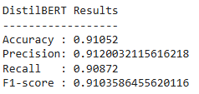
Fig. 14. DistilBERT evaluation results
The evaluation results of the DistilBERT model are presented in Figure 14. The accuracy score of 0.91200 of the precision score means that the majority of times that the model forecasts a positive review. It is reflected by the value of the recall 0.90872 showing that 90.87 percent of the real positive reviews are correctly recognized. The F1-score of 0.91036 validates the existence of a strong balance between recall and precision, which means the predictive performance is maintained [7].
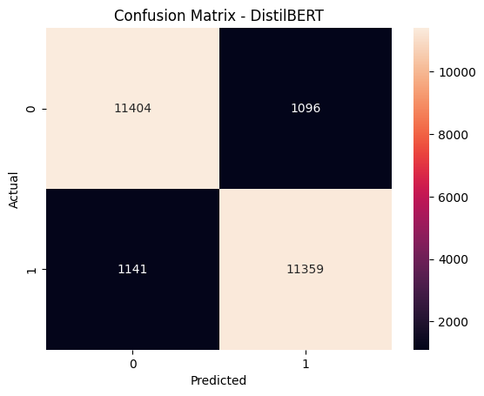
Fig. 15. DistilBERT confusion matrix
The confusion matrix of DistilBERT is shown in figure 15. The matrix indicates that the number of classifications as true positive and true negative are high with comparatively lower misclassifications. False positive and false negative are less as compared to previous findings. The balanced precision and recall values demonstrate that the model effectively separates positive and negative sentiment classes while maintaining minimal classification bias.

C. Model comparison
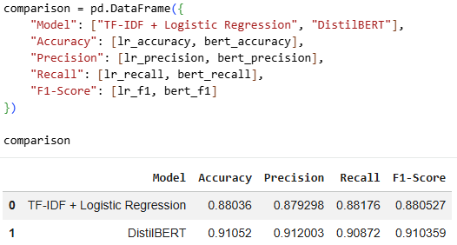
Fig. 16. Model comparison
The performance comparison of DistilBERT and TF-IDF + Logistic Regression models are presented in figure 16. Logistic Regression has an accuracy of 0.88036, whereas DistilBERT has a higher accuracy of 0.91052, which is an improvement of about 3.02 percentage points. DistilBERT also has better accuracy (0.91200 vs 0.87930), recall (0.90872 vs 0.88176) and F1-score (0.91036 vs 0.88053) compared to Logistic Regression.
The results indicate that the transformer-based DistilBERT model shows superior results by all the assessment indicators, and this defines the advantages of contextual embeddings and self-attention mechanisms in the sentiment classification exercises.

IV. DISCUSSION
The results of the present study indicate the comparative merits of the traditional machine-learning and transformer-based models in sentiment analysis. DistilBERT model has an accuracy of 0.91052 which is higher than the accuracy of the TF-IDF + Logistic Regression model of 0.88036. The rise in accuracy is used to demonstrate the effectiveness of contextual embeddings during the performance of text classification. This is a moderate difference, however, in large-scale applications, the gain in accuracy of a small amount can lead to the gain in the reliability of the decision-making process by a considerable margin.
DistilBERT performed better regarding measures of precision, recall, and F1-score. This model is highly reliable with an accuracy of 0.91200 indicating that it can be used to determine positive sentiment with fewer false positives than the Logistic Regression, which has the precision of 0.87930. Similarly, the recall score of 0.90872 is greater than the Logistic Regression recall of 0.88176 which shows that DistilBERT is more predictive of true positive reviews and fewer false negatives. The F1-score of 0.91036, as compared to 0.88053 in the traditional model, shows that the transformer-based model is better in balance between precision and recall.
The better results of DistilBERT can be explained by its transformer-based structure. In contrast to TF-IDF representations, which only represent the words separately and disregard the sequence in which it appear in a sentence, DistilBERT uses contextual associations between words in a sentence, intending to do so through the self-attention mechanisms. This allows the model to recognize fine semantic differences, multilayered sentence structure, and implicit sentimental expression that bag-of-words methods might lack the capability to capture the semantic differences. As a result, DistilBERT proves to be more capable of specific and context-sensitive language patterns as found in movie reviews sentiment analysis.
The enhanced predictive performance however, increases the costs of computer computation. DistilBERT is a deep-based architecture with a large number of parameters, which makes it more expensive to run and train on a GPU. Logistic Regression, in contrast, is computationally inexpensive, can be trained on conventional hardware, and does not need as much memory. Hence, an operationally constrained model selection must be put in place with regard to performance measures.
The results revealed that fine-tuned transformer-based models have obvious benefits in sentiment classification. Although traditional machine learning can still be used effectively, contextual deep learning models such DistilBERT can provide a high level of predictive accuracy where sufficient computational resources are present.

V. CONCLUSION AND RECOMMENDATIONS

A. Conclusion
Comparison of the performance of a classic machine learning model, TF-IDF with Logistic Regression with a transformer-based model, DistilBERT in binary sentiment classification on the IMDB movie review data is presented in this paper. The dataset provided comprises 50,000 balanced reviews, half of which are positive sentiment and the other half negative sentiment reviews, to provide unbiased consideration.
The experimental results reveal that both the models perform well in terms of classification. Accuracy of the TF-IDF + Logistic Regression model is 0.88036, which has precision of 0.87930, recall of 0.88176 and F1-score of 0.88053. These findings validate the fact that the old feature-based approaches are still useful, in terms of structured and balanced sentiment analysis tasks.
The DistilBERT model however shows better overall performance with an accuracy of 0.91052, precision of 0.91200, recall of 0.90872 and F1-score of 0.91036. The DistilBERT model has performed better than TF-IDF + Logistic Regression. The higher accuracy shows a better decrease of false positive classification, whereas the vigorous recall shows a better search of positive cases of sentiment. The balanced F1-score also proves strong predictive ability in the two classes.
The findings reveal that contextual embeddings and self-attention mechanisms give DistilBERT the ability to learn semantic relationship and word order, and other linguistic nuances better than the bag-of-words representation available in TF-IDF. This benefit of performance demands more computation, such as GPU acceleration and more training time. Conversely, Logistic Regression is fast to train, uses less memory and is simple to operate.
Classical machine learning models remain competitive and computationally efficient, transformer-based models can be used to predict better and understand the context in sentiment classification tasks.

B. Recommendations
Recommendations of the findings of this study are as follows:
- Transformer-based models, like DistilBERT are recommended to be used in the scenarios where a high degree of classification is crucial, particularly in large-scale sentiment monitoring systems.
- Traditional models TF-IDF using Logistic Regression are suggested to be used in resource-starved situations where the speed of computation and rapid implementation are the most important factors.
- It has been proposed that additional fine-tuning of DistilBERT, e.g. additional training epochs and hyperparameter optimization, can be performed to achieve even better performance.
- It is suggested that future research cannot but include the hybrid designs that would entail the combination of contextual embeddings with the traditional classifiers so that the performance and efficiency could be balanced.
- It is recommended that more evaluation measures, such as ROC-AUC, and cross-validation techniques need to be involved to provide more specific model evaluation.
- It is suggested that the selection of the model must be shaped by the performance needs, the computing power, and the issues of feasibility of deployment.

REFERENCES
[1] Tan, K.L., Lee, C.P., Anbananthen, K.S.M. and Lim, K.M., 2022. RoBERTa-LSTM: a hybrid model for sentiment analysis with transformer and recurrent neural network. Ieee Access, 10, pp.21517-21525.
[2] Yao, L. and Zheng, N., 2024. Sentiment analysis based on improved transformer model and conditional random fields. IEEE Access, 12, pp.90145-90157.
[3] Xiao, H. and Luo, L., 2024. An automatic sentiment analysis method for short texts based on transformer-BERT hybrid model. IEEE Access, 12, pp.93305-93317.
[4] Almufareh, M.F., Jhanjhi, N.Z., Khan, N.A., Almuayqil, S.N., Humayun, M. and Javed, D., 2024. BertSent: Transformer-based model for sentiment analysis of penta-class tweet classification. IEEE Access, 12, pp.196803-196817.
[5] Shah, S., Manzoni, S.L., Zaman, F., Sabery, F.E., Epifania, F. and Zoppis, I.F., 2024. Fine-tuning of distil-bert for continual learning in text classification: An experimental analysis. IEEE Access, 12, pp.104964-104982.
[6] Lorenzoni, G., Portugal, I., Alencar, P. and Cowan, D., 2024. Exploring Variability in Fine-Tuned Models for Text Classification with DistilBERT. arXiv preprint arXiv:2501.00241.
[7] Nair, A.R., Singh, R.P., Gupta, D. and Kumar, P., 2024. Evaluating the impact of text data augmentation on text classification tasks using DistilBERT. Procedia Computer Science, 235, pp.102-111.
[8] Liu, H., Chen, X. and Liu, X., 2022. A study of the application of weight distributing method combining sentiment dictionary and TF-IDF for text sentiment analysis. Ieee Access, 10, pp.32280-32289.
[9] Ramdan, D.S., Apnena, R.D. and Sugianto, C.A., 2023. Film review sentiment analysis: Comparison of logistic regression and support vector classification performance based on tf-idf. Journal of Applied Intelligent System, 8(3), pp.341-352.
[10] Popoola, G., Abdullah, K.K., Fuhnwi, G.S. and Agbaje, J., 2024, February. Sentiment analysis of financial news data using TF-IDF and machine learning algorithms. In 2024 IEEE 3rd International Conference on AI in Cybersecurity (ICAIC) (pp. 1-6). IEEE.
[11] Omar, M., Choi, S., Nyang, D. and Mohaisen, D., 2022. Robust natural language processing: Recent advances, challenges, and future directions. IEEE Access, 10, pp.86038-86056.
[12] Samant, R.M., Bachute, M.R., Gite, S. and Kotecha, K., 2022. Framework for deep learning-based language models using multi-task learning in natural language understanding: A systematic literature review and future directions. IEEE Access, 10, pp.17078-17097.
[13] Ren, G. and Chandra, R., 2025. Analysis of IMDb movie reviews and ratings using a language model framework. IEEE Access, 13, pp.192655-192673.
[14] Palomo, B.A.B., Velarde, F.H.V., Cantu-Ortiz, F.J. and Ceballos Cancino, H.G., 2023, February. Sentiment analysis of imdb movie reviews using deep learning techniques. In International Congress on Information and Communication Technology (pp. 421-434). Singapore: Springer Nature Singapore.
[15] Islam, M.T., Parvin, F., Sazan, S.A. and Amir, T.B., 2024, September. Comparative analysis of sentiment classification on IMDB 50k movie reviews: A study using CNN, LSTM, CNN-LSTM, and BERT models. In 2024 IEEE International Conference on Power, Electrical, Electronics and Industrial Applications (PEEIACON) (pp. 512-517). IEEE.

