
Report Title- Research Project Proposal
Name - Nimra Imran
Module Name & Title- Personnel Resourcing & Development (BMIH5005)
Lecturer’s name- Emily Williams

Contents
Introduction/ Background 3
Metholodgy & Discussion 5
Evaluation/ Conclusion……………………………………………………………………………….12
Reference 13
Metholodgy…………………………………………………………………………………………….15

Research Project Proposal



Introduction/background
Ibis hotel is vibrant place open to everyone. it has 1249 hotels, 157,544 rooms in 67 countries and 157 hotels in pipeline and 19,379 rooms in pipeline. Its mission is to open people’s wind through the music all over the world (Accor - Discover ibis, 2021)
In 2018 Accor hotel signs an agreement to purchase 21c museum hotels. 2017 Accor lodges & Qatar airways declared their collaboration to improve subsidies put forward by their loyalty program. 2016 exposes its 100th estate in India & Mgalery became Mgallery by Sofitel & they opened their first hotel in Israel & Brazil. 2015 Accor hotels celebrated their 500,000-room. (Accor - Open Innovation, 2021)

Methodology and Discussion
The report consists of identifying current issues that the proposal will examine based around that there was employee engagement and retaining talented works force. the current issues at this hotel are absenteeism and sickness.
Employee engagement is a right deal with getting the proper circumstances for the entire workers of the firm to offer their greatest time & dedication towards business targets & value, encourage towards promote success as well as developing their own wellbeing. It is based on responsibility, reliability & two-way dedication between company & employee. It is where there is a chance to growth of business to expand, promote to individual performance, efficiency well.
It is understanding a role in a company, being observed and motivated on wherever it measures in the company principle & intentions. It is giving a strong knowledge in achieving its purpose & goals. It is being centered on objectives, reliable, encouraged & accepting frequent response. As well as getting support in developing new skills, show gratitude & professional accomplishment.
It is company where employee feeling self-esteem, devotion & going extra mile to complete a piece of work. It is also about company actions that are coherent with the company values & keeping the promises. (What is Employee Engagement - Engage for Success, 2021)
For the hotel industry employee engagement is having a level of responsibilities & contribution employee has towards hotel & its values. It is positive & negative attachment to their job, colleague & hotel that influence & their knowledge to accomplish at work. It is a positive feeling employee has towards their job additionally motivation & effort they put in.
It is employee feeling positive emotions towards their work & find their work important. Moreover, feel that they could manage their workload. Employee engagement is where they feel positive, devoted, enthusiastic & energized & show their feeling in work performance. Hotel must work, develop & encourage & this can only be done by two ways relationship. This can be created by creating a positive work atmosphere, with positive emotions, dignity and support employee. This will improve hotels execution, lower gross revenue & better wellbeing.
Employee engagement is important to keep respected staff, because it is successful smooth way for Human Resource & to successively the hotel. However, if you don’t have employee engagement the hotel would not be able to endure.
By having a system within hotel that enables worker to work more effectively. The effects that this can impact on hotel & hospitality is they will remain in the hotel, more motivated. Additionally, there will be emotional attachment between staff & customer & this effect will make the customer return to the hotel. Engaged staff improves customer service & provides high energy work setting. (2021)

From the engagement multiplier it states that engagement is vital within hotel, because of the following reasons:
- It improves teamwork
- Addressing issues
- Planning resources
- Fostering improvements
- Differentiating meaningfully
- Transferable Insight
(How staff Meeting held in Hotel Business, 2021)
According to rewarding website employee engagement is important, because hotel trade is consumer assistance determined. Which requires teams exist most important who plays a part in the hotel. Engaged employee could make a difference between customer and hotel. Trained employees are more experienced in what they do and how to handle a customer for a customer to return to hotel. For example, more trained and engaged staff will encourage customer explore more in the menu than untrained and unengaged staff.

Engage staff will increase revenue etc. employees are the main people who helps with increasing revenue, reputation of the hotel so hotel needs to make sure that their employees are well engaged and happy. Staff who feel part of a hotel, have their voice & purpose in the company, there are more motivated than others & feel that they contribute to same objective with the purpose of the enterprise. A customer service centered needs to emphasis upon worker's commitment in demand to be lucrative. This means putting employees first that will advantage by giving customers the best service. (Kurtzman, 2021)

According to Typsy website employee engagement reimbursements by reducing revenue, rise production & increase revenue. It will also expand hotel business in long term.

Hotel can engage staff by

- strengthen hotel’s mission, vision & values.
- Create team bonding activities
- Celebrate staff innovative & personal dates
- Competition
- Mentoring program
- Personal development opportunity
(Cvetkovic, 2021)
The impact hotel has on unengaged employee does not fully concentrate, their do their job own their own, more sickness & excuses not to return to work, do not feel part of a hotel or team. To back this with evidence according to hospitality net states that more engaged staff leadership is strong, engagement levels are higher, more focused and concentrated.
However, to be more engaged hotel needs to take steps which includes:
- Employee focused culture
- Arrangements- focus on how they recruit new staff into existing team.
- Clarity- making sure everyone knows objective & expectation
- Competence
- Cooperation
- Control
- Conflict
- Compensation
- Change
(Net, 2021)

Factors effecting absenteeism are:
- Personal characteristics
- job situation
- ability to attend
- absenteeism and job satisfaction

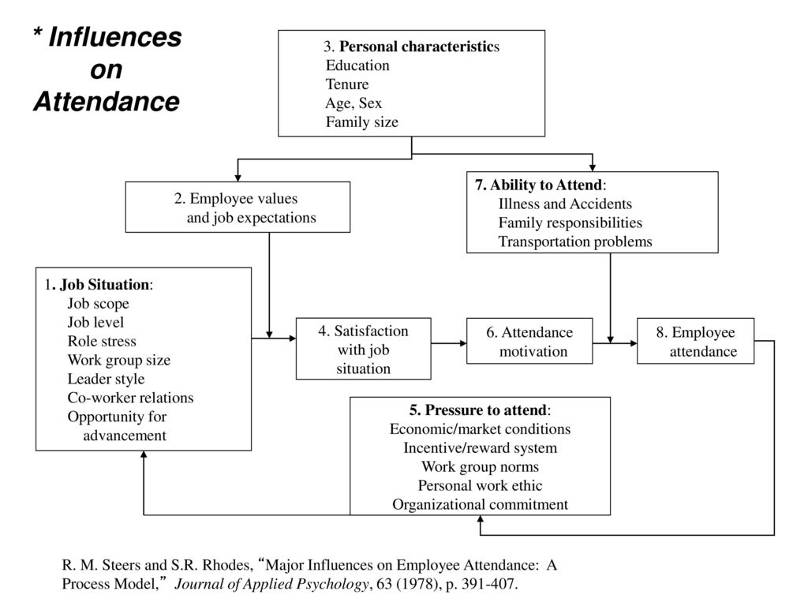
From the questionnaire it was identified that possibly reason cause of absenteeism and sickness.
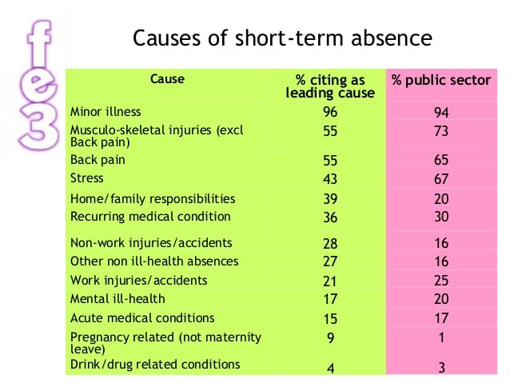

According to work nest organisations, can improve attendance by following:
- Incentives
- Flexible working
- Return to work
- Wellbeing strategy
- Engagement
(Guide | Improving attendance in Hospitality, 2021)
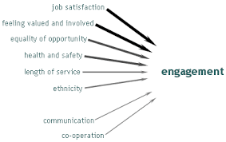
PMC article suggests that working from home promotes positive outcome. an example would be allowing to operate vaguely particularly through anxious contagion displays the corporation. Individual focussed organization price Supports business assistance the employee emotional on physical wellbeing. working from home promotes efficiency (Djeebet, 2020, Gurchiek, 2020). Example reports data suggests that working when household policy has succeeded to the data technology transactions branch to achieve 25 percentage and 13 percentage increase in efficiency correspondingly Anne has decreased turnover of whole centre to least in the past. (Gurchiek,2020)
Structural representation of 5C model. Covid-19, Wellbeing, Engagement
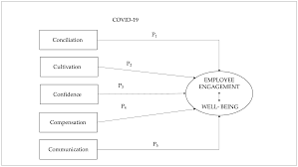
(2021)
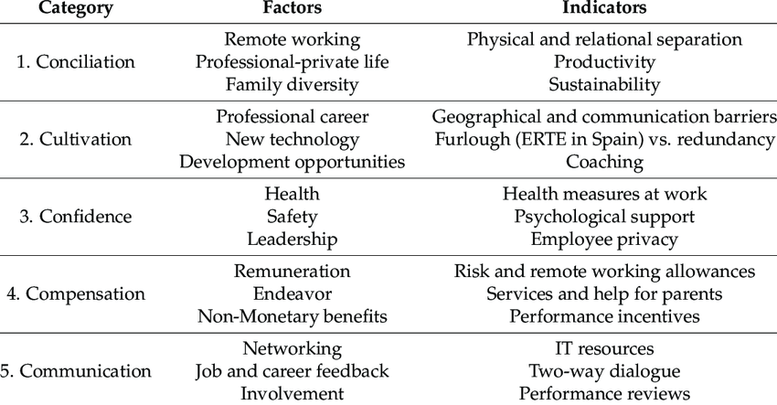
(2021)
Research gate website states that employee absenteeism/sickness effects on hotel by lack of unemployment and insecurity. There is a mismatch between the job context than personal intentionality. There may be a time pressure & lack of recognition as well as labor cost. Additionally, a bad atmosphere and extra workload, lack of job satisfaction & job motivations. (2021)
According to vintage circle website absenteeism/sickness effects by understaff, additional labor cost, loss of output, time theft, lack of flexible work schedule, workplace harassment & mental health issues. (What is Employee Absenteeism? Effect, Reasons, Remedies, 2021)
According to CIPD nearly third of company reports found that there is growth in trauma associated deficiency due to mental health problems. stress is now the most general reason for long term lack organisation needs to be more supportive towards mental health problems and encourage great mental health wellbeing. (2021)

Reasons for people go on sickness/absenteeism are:
According to crime agency recruitment there are six hospitalities stresses identified by Professor John W Neil (2021)
These stresses are:
- Interpersonal tension
- gender
- workload
- burnout
- overall job satisfaction
- Poor communication between managers and employees
Hotel can reduce absenteeism by being supportive manager, welcoming work atmosphere, wellness program, career development & incentives like discounted gym membership. (How to reduce absenteeism i3n your workplace – Prime Agency Recruitment, (2021)

Primary research is collecting original documents to research. However secondary research is desk investigation. It is where researcher does not collect information, it is trust on existing resource. This includes reports, census, website & article, these types of papers are based home printed on paper or on the internet.
Benefit of secondary research that it is available and affordable. However, disadvantage is information is old-fashioned and not identifiable. Primary research advantage that it is specific, in depth. Disadvantages time consuming and distorted data.
To conclude report purpose is to examine current issues of a hotel of employee engagement and provide solutions. Research discussed what employee engagement and role within hotel. it also discussed importance of engagement what impact engagement has on hotel and how absenteeism/sickness has impact on employee engagement own hotel and reason why it is important. Research also discussed pin death into absenteeism/sickness and how to improve. it also debated post pandemic impact within a hotel and possibly reason for absenteeism/sickness.

Evaluation & Conclusion

Reference
2021. [online] Available at: <HTTPS://SLIDEPLAYER.COM/SLIDE/12461335/> [Accessed 21 November 2021].
2021. [online] Available at: <https://www.researchgate.net/publication/328365842_ABSENTEEISM_AT_WORK_IN_HOTEL_EMPLOYEES> [Accessed 28 November 2021].
2021. [online] Available at: <https://www.researchgate.net/figure/5C-model-for-reinforcing-employee-engagement-in-times-of-COVID-19-and-assessment_tbl2_351713555 13/11/21 https://www.mdpi.com/journal/ijerph> [Accessed 13 November 2021].
Ajhtl.com. 2021. [online] Available at: <https://www.ajhtl.com/uploads/7/1/6/3/7163688/article_13_9_5_1161-1177.pdf> [Accessed 8 November 2021].
Cvetkovic, A., 2021. 7 creative ways to engage hospitality employees. [online] Blog.typsy.com. Available at: <https://blog.typsy.com/7-creative-ways-to-engage-hospitality-employees> [Accessed 28 November 2021].
Cipd.co.uk. 2021. [online] Available at: <https://www.cipd.co.uk/Images/absence-management_2016_tcm18-16360.pdf> [Accessed 8 November 2021].
Engage for Success. 2021. What is Employee Engagement - Engage for Success. [online] Available at: <https://engageforsuccess.org/what-is-employee-engagement/> [Accessed 27 November 2021].
Engagement Multiplier. 2021. How Employee Engagement Works in the Hospitality Industry. [online] Available at: <https://www.engagementmultiplier.com/resources/engaged-employees-happy-guests-how-employee-engagement-works-in-the-hospitality-industry/> [Accessed 28 November 2021].
En.wikipedia.org. 2021. Ibis (hotel) - Wikipedia. [online] Available at: <https://en.wikipedia.org/wiki/Ibis_(hotel)> [Accessed 12 November 2021].
Gursoy D., Can A.S., Williams N., Ekinci Y. Evolving impacts of COVID-19 vaccination intentions on travel intentions. Serv. Ind. J. 2021:1–15. doi: 10.1080/02642069.2021.1938555.
Google.com. 2021. Google Image Result for https://www.mdpi.com/ijerph/ijerph-18-05470/article_deploy/html/images/ijerph-18-05470-g001.png. [online] Available at: <https://www.google.com/imgres?imgurl=https%3A%2F%2Fwww.mdpi.com%2Fijerph%2Fijerph-18-05470%2Farticle_deploy%2Fhtml%2Fimages%2Fijerph-18-05470-g001.png&imgrefurl=https%3A%2F%2Fwww.mdpi.com%2F1660-4601%2F18%2F10%2F5470%2Fhtm&tbnid=SIK5_2ZsK2W9dM&vet=12ahUKEwjn9Z736pX0AhXDwYUKHVZgC7sQMygAegQIARAT..i&docid=KO4YSiapwM3XwM&w=4393&h=2475&itg=1&q=5c%20model%20and%20the%20propositions.%20covid%2019%20wellbeing%20and%20engagement&ved=2ahUKEwjn9Z736pX0AhXDwYUKHVZgC7sQMygAegQIARAT> [Accessed 13 November 2021].
Google.com. 2021. Redirect Notice. [online] Available at: <https://www.google.com/url?sa=i&url=https%3A%2F%2Fwww.slideshare.net%2FKarenCDrury%2Fsick-of-work-16-apr-2-2010&psig=AOvVaw0rYyHHX4iF3mLBEYzyrgCC&ust=1636832148058000&source=images&cd=vfe&ved=0CAsQjRxqFwoTCODuw47Jk_QCFQAAAAAdAAAAABAD> [Accessed 21 November 2021].
Group.accor.com. 2021. Accor - Discover ibis. [online] Available at: <https://group.accor.com/en/brands/economy/ibis> [Accessed 12 November 2021].
Group.accor.com. 2021. Accor - Open Innovation. [online] Available at: <https://group.accor.com/en/group/who-we-are/Open-Innovation> [Accessed 21 November 2021].
Howandwhat.net. 2021. [online] Available at: <https://howandwhat.net/advantages-and-disadvantages-of-primary-and-secondary-research> [Accessed 14 November 2021].
Kurtzman, J., 2021. Why is employee engagement in the hospitality industry important? [online] Blog.rewardian.com. Available at: <https://blog.rewardian.com/why-is-employee-engagement-in-the-hospitality-industry-important> [Accessed 28 November 2021].
Mindtools.com. 2021. Reducing Sick Leave: Decreasing Absenteeism. and Its Costs. [online] Available at: <https://www.mindtools.com/pages/article/newTMM_56.htm> [Accessed 8 November 2021].
Net, H., 2021. The Challenge of Employee Engagement | By Enda Larkin – Hospitality Net. [online] Hospitality Net. Available at: <https://www.hospitalitynet.org/opinion/4044076.html> [Accessed 28 November 2021].
Nurture an Engaged and Satisfied Workforce | Vantage Circle HR Blog. 2021. What is Employee Absenteeism? Effect, Reasons, Remedies. [online] Available at: <https://blog.vantagecircle.com/employee-absenteeism-hr-guide/> [Accessed 28 November 2021].
Primerec.co.uk. 2021. How to reduce absenteeism in your workplace – Prime Agency Recruitment. [online] Available at: <https://www.primerec.co.uk/latest-news/reduce-absenteeism-workplace/> [Accessed 8 November 2021].
Ryba, K., 2021. Checklist: 32 Employee Survey Questions About Management. [online] Quantumworkplace.com. Available at: <HTTPS://WWW.QUANTUMWORKPLACE.COM/FUTURE-OF-WORK/EMPLOYEE-SURVEY-QUESTIONS-ABOUT-MANAGEMENT> [Accessed 18 November 2021].
Ripublication.com. 2021. [online] Available at: <https://www.ripublication.com/gjfm-spl/gjfmv6n4_14.pdf> [Accessed 27 November 2021].
Srhe.ac.uk. 2021. [online] Available at: <https://srhe.ac.uk/arc/conference2010/abstracts/0193.pdf> [Accessed 14 November 2021].
WorkNest. 2021. Guide | Improving attendance in Hospitality. [online] Available at: <https://worknest.com/blog/improve-absence-hospitality/> [Accessed 8 November 2021].

Metholodgy

Questionnaire Format for Absenteeism of Employees
Personal Information
Title …………………………………………………………
Age…………………………. Gender……………………….……
1) Years worked for Ramada
0-1 1-2
2-5 less than 5 or more
2) Days absent?
A- 0 B-1 C-3 D-3 E-4
3) Primary excuse for absent?
Wellbeing crisis / family purposes Stress
Labor unhappiness on the job setting
Others (Please Specify) …………………………………………….
4) Interpretations of Non-attendance Procedure of Ramada Hotel
Tremendous Respectable
Open-minded Don’t know
5) are your aware of your work responsibilities
Well strong Excellent
Relatively strong Don’t know
6) how delighted are you with job?
fulfilled Great
Reasonable Non contented
7) point of view on Ramada ambience?
Superb Nice
Authentic Bad
8) coworkers’ behavior towards you?
Exceptional Excellent Honest Bad
9) boss performance in relation to your concern?
Exceptional Great Fine Deprived
10) Value services of Ramada Hotel?
Admirable Decent Open-minded Bad

