Business and Web MANAGEMENT (ACCA5019)
Walter Ernesto Melendez Dominguez (2413597)
BSc Applied Computing
Suneth Fernando
link: https://www.figma.com/proto/32Y1QuI2ZNPvkUYnNaum9q/Untitled?node-id=1-2&t=zQhxxAto0
Table of Contents
No table of contents entries found.
LCZOk7m-1

University of wales trinity saint david | London Campus
Component 1 – Website Redesign for Online Business Presence
2026
Table of Contents

Introduction 1
HealthyHarvest Website Redesign 3
Responsive Design Implementation 4
Implementation section 5
Desktop – Home 5
Desktop- Shop 7
Desktop-Guide 7
Desktop – About us 9
Desktop – Contact Us 10
Conclusion 11

Introduction

This report outlines the design process for the new HealthyHarvest website prototype. Currently, the HealthyHarvest website has several usability issues. The navigation is confusing, the site does not work well on mobile devices, and the visual design is outdated and does not reflect the brand's values. These problems make it difficult for customers to use the site and affect the company's overall goals.
The main aim of this project is to create a new interface design that improves usability, supports the brand's message, and helps increase conversions and subscription sign-ups. This document explains the different steps taken during the project, starting from visual research and mood boards, moving on to wireframes, and finishing with a high-fidelity interactive prototype. Finally, this report will justify the design choices made to solve the website's current problems and provide a better experience for the users.

HealthyHarvest Website Redesign

Navigation and Information Architecture: The current HealthyHarvest website suffers from a fragmented information architecture and confusing navigation paths, which significantly increase the user's cognitive load. Furthermore, the presence of broken links not only disrupts the user journey but also negatively impacts the site's overall credibility and usability. In my redesign, I focused on establishing a clear, intuitive, and accessible navigation system. By streamlining the connections between core pages—such as Home, Shop, and Guide—the new layout ensures that users can locate products and information effortlessly. This structured approach aims to reduce bounce rates, improve user retention, and provide a seamless browsing experience from the moment they land on the page.

Visual Design and Interface Modernization: The existing visual design feels noticeably rigid, blocky, and outdated. Modern users expect fluid, responsive, and aesthetically pleasing interfaces like the expressive Material Design principles found in modern ecosystems or the smooth aesthetics present in recent iOS and Windows 11 updates. The old site lacks these contemporary UI paradigms, making the brand appear disconnected from current digital standards. To resolve this, my redesign introduces a revitalized visual identity. I implemented softer layouts with rounded corners, organic colour palettes that reflect the brand's sustainable ethos, and high-quality imagery. This modern approach establishes a strong visual hierarchy, utilizes negative space effectively, and builds immediate trust with the target audience.

Checkout Optimization and Conversion Rates: Analysing the current purchasing process reveals a lengthy, multi-step flow that introduces unnecessary friction, which is a primary driver of shopping cart abandonment. My proposed redesign addresses this critical bottleneck by modernizing the transactional flow. A key feature of this optimization is the planned integration of standard digital wallets, specifically Apple Pay and Google Pay. By allowing users to bypass tedious manual data entry and complete purchases using secure, built-in device authentication, the checkout process becomes nearly instantaneous. This frictionless approach not only enhances the overall user experience but is also a proven, industry-standard strategy for maximizing conversion rates and encouraging recurring subscription sign-ups.

Responsive Design Implementation

Setting Up the Canvas and Layout Constraints: For the practical component of this assignment, I focused on translating my initial ideas into a tangible interactive prototype using Figma. To maintain a standard approach suitable for web design, I set my main frames to a desktop resolution of $1440×1024$ pixels. Working within these specific dimensions helped me understand how to better organize visual elements and maintain consistent spacing across different pages. As planned for this project, I developed five main screens: Home, Shop, Guide, About Us, and Contact Us. This scope allowed me to practice creating a cohesive user journey from start to finish, ensuring I could deliver a solid foundational structure without getting lost in overly complex features that are beyond my current level of study.
Exploring Interactive Components in Figma: One of the most significant learning curves during this practical exercise was moving from static designs to interactive elements. I wanted to improve the navigation experience, so instead of basic, sudden page jumps, I explored Figma’s Smart Animate tool. By learning to properly name and group my layers, I managed to create a transition where the active menu indicator (a "pill" shape) glides smoothly between different navigation links. Implementing this feature took some trial and error, but it was a valuable exercise in understanding how simple micro-interactions can provide clear visual feedback to the user and make the interface feel much more modern.
Applying User-Centric Principles: Throughout the design process, I made a conscious effort to apply the fundamental UI principles I have been learning. Because this application is intended for the public rather than a specialized corporate environment, I had to focus on simplifying my design choices. I deliberately avoided complicated layouts and stuck to universally recognizable navigation patterns. My primary goal as a student designer was to ensure that anyone visiting the site could easily browse the store, locate the organic products, and understand the brand's message without any confusion. This practical application highlighted the importance of prioritizing clear communication and usability over purely decorative design elements.

Implementation section
In this section, the initial structural concepts are compared with the final high-fidelity designs. By moving methodically from low-fidelity wireframes to a high-fidelity prototype, I was able to evaluate the information architecture and resolve navigation issues before finalizing the visual aesthetics. [1]

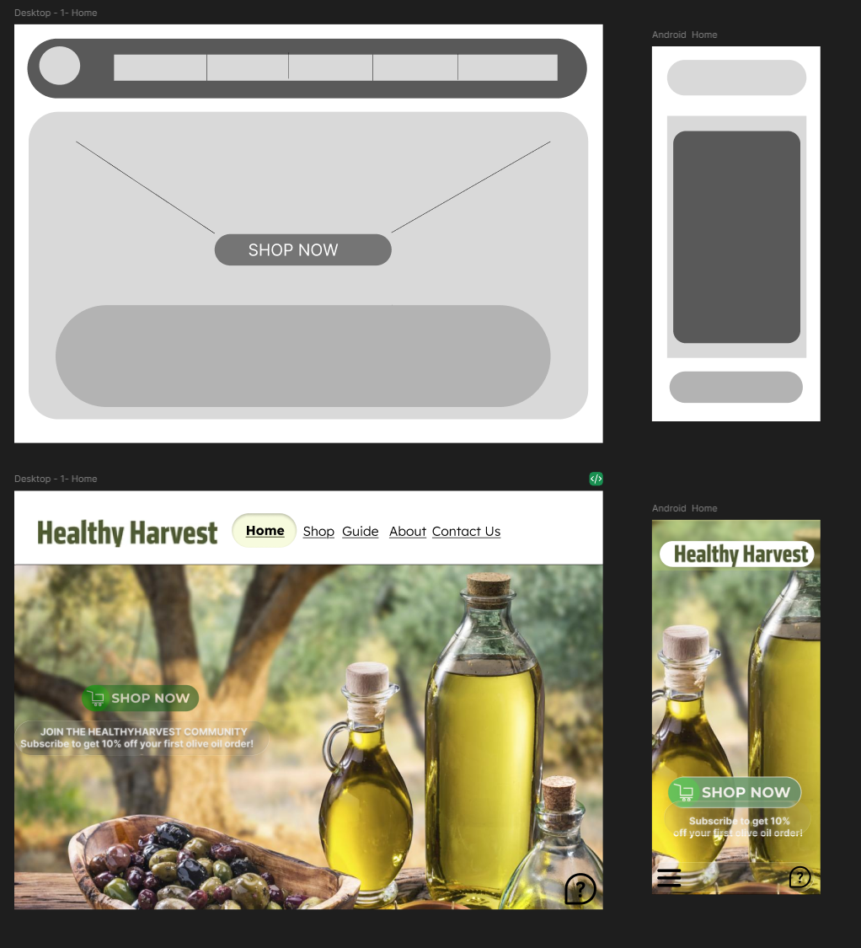
Desktop – Home

For the Desktop and Mobile Home Screen, my primary goal as a design was to create a welcoming first impression for the public, rather than a complex or overwhelming interface. When I initially created the wireframes, I focused purely on the basic skeleton of the page, placing the header and a simple call-to-action (CTA) button to establish the structure. However, as I progressed to the high-fidelity prototype, I realized that everyday users need a strong visual hook to stay on the site.
Therefore, I implemented a full-bleed background image showcasing the natural products to instantly communicate the brand's identity. I also learned the importance of visual hierarchy during this module, which is why I chose a contrasting green color for the "Shop Now" button to guide the user's eye. In the mobile version, I attempted to keep the experience just as impactful by collapsing the navigation into a standard hamburger menu, a practice I discovered is essential to save screen space without confusing the user.

Desktop- Shop
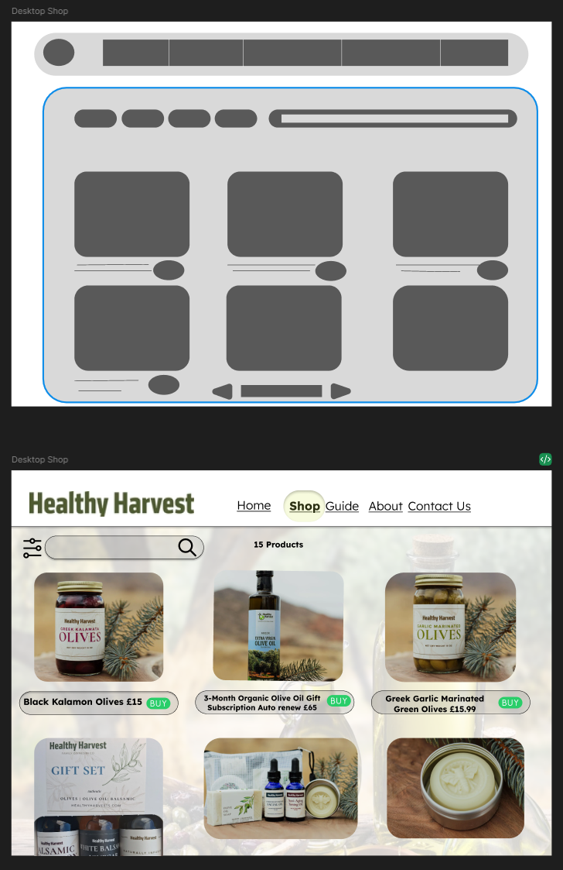

Moving on to the Shop interface, I focused my efforts exclusively on the Desktop version. My main objective here was to optimize usability and make the browsing experience as simple as possible. In my early wireframe sketches, I established a basic grid to organize multiple products without making the wide screen look cluttered. Transitioning this to the final high-fidelity design in Figma, I utilized the horizontal screen real estate to feature clear, high-resolution product images with readable pricing. [2]
I also incorporated a search and filter bar at the top for easier navigation. To ensure a frictionless shopping experience, I designed prominent, pill-shaped 'BUY' buttons for each item, providing clear and intuitive calls-to-action for users navigating with a mouse. Establishing a structured catalogue with direct interactive triggers reduces user effort during the browsing stage, aligning with standard e-commerce best practices.

Desktop-Guide
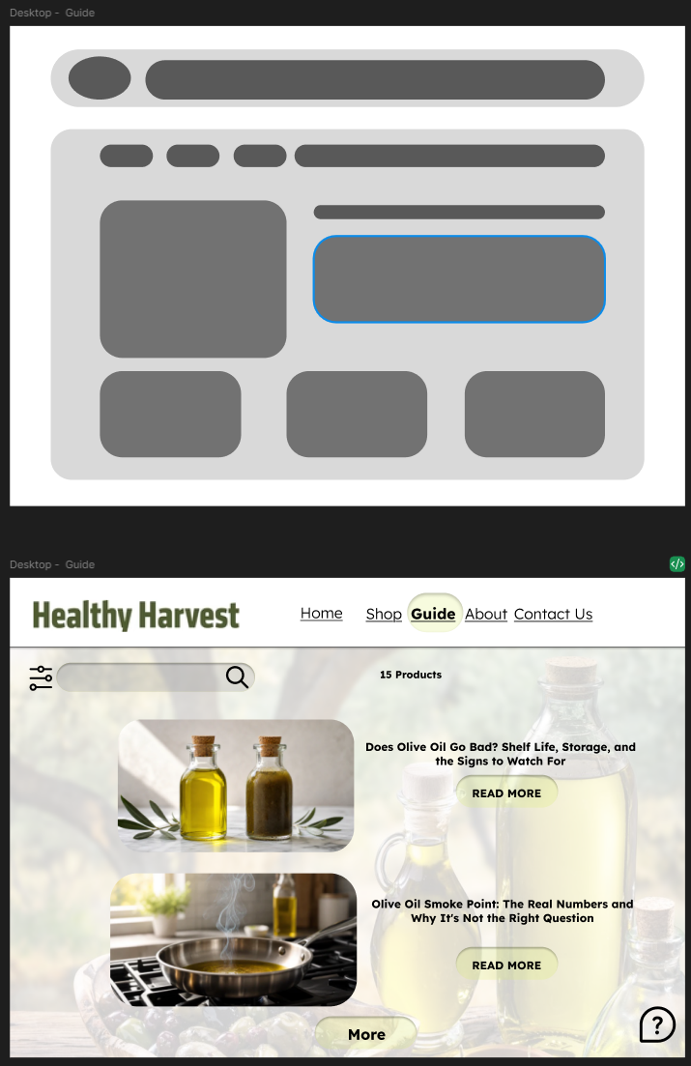

The Guide section was particularly interesting to design because its purpose is educational. Initially, the wireframes for this page simply mapped out basic structural blocks. As an apprentice designer, I recognized that presenting users with massive walls of text can lead to cognitive overload. To improve this in the high-fidelity version, I designed an interface based on article preview cards. [2]
Because I was developing this exclusively for a desktop environment, I used the extra space to pair engaging imagery with clear, bold headlines for each topic (such as olive oil shelf life). By adding distinct "READ MORE" buttons, I created a clear information architecture that allows users to quickly scan the page and choose exactly which healthy practices they want to learn about.

Desktop – About us
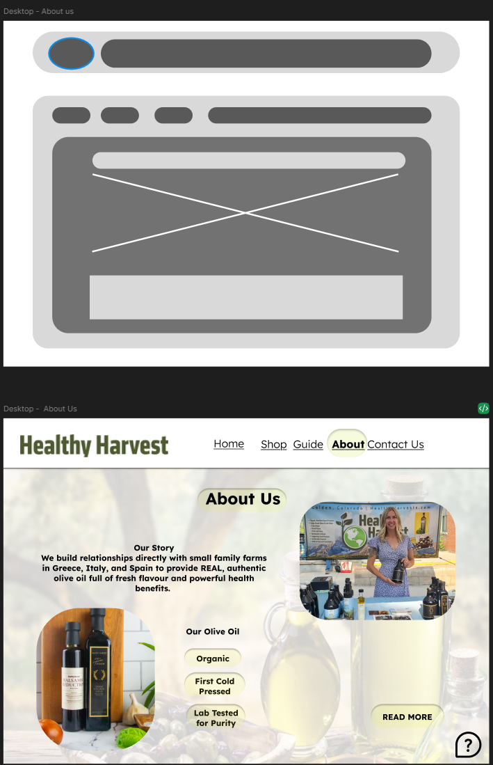
For the About Us page, the main objective was to tell the story of HealthyHarvest in a way that connects emotionally with the visitor. The initial wireframes were very structural and perhaps a bit too rigid for a storytelling page.
In the high-fidelity phase, I relied heavily on the earthy colours and natural greens selected in my mood board. Since this layout was strictly designed for desktop, I alternated wide text blocks with high-quality images. A specific design choice I made was to use rounded, organic shapes for the image frames rather than sharp squares. This softer visual approach deliberately breaks up the visual monotony and reinforces the brand's natural, approachable, and authentic core values as the user scrolls.

Desktop – Contact Us
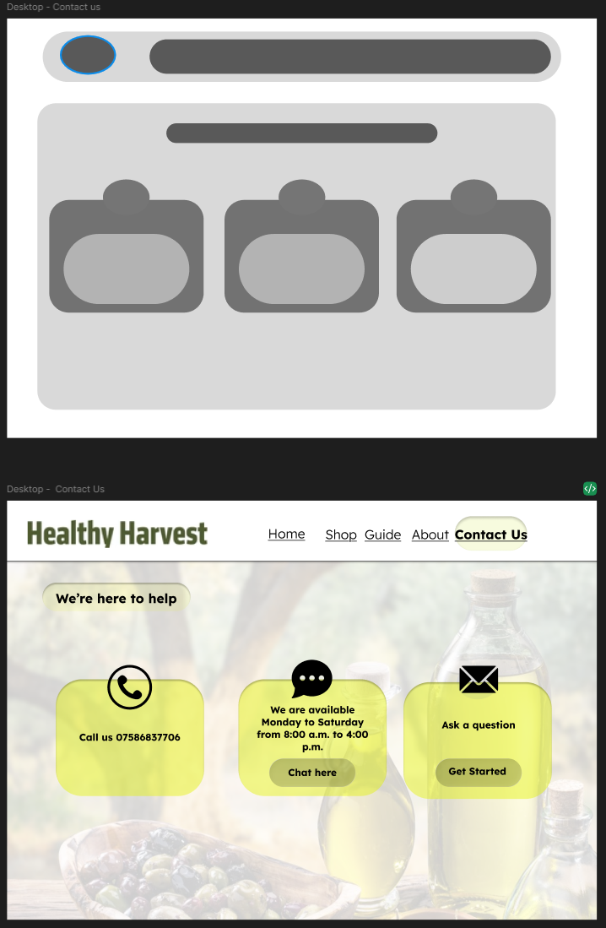

Finally, for the Contact Us screen, I focused on creating a frictionless and highly accessible user experience. Initially, many contact pages rely on long, tedious forms that can cause users to abandon the page. I decided to take a more modern and user-friendly approach. As seen in the wireframe, I planned for three distinct structural blocks. In the final high-fidelity design, these blocks were transformed into three clear, accessible communication channels: a direct phone line, a live chat option with specified operating hours, and an email inquiry button. Designing this specifically for a desktop screen allowed me to use a comfortable, spacious layout with large, clickable cards. By using clear iconography and high-contrast typography against a softly blurred background, I ensured that users can effortlessly find the contact method that best suits their needs.

Conclusion

The primary objective of this project was to completely redesign the HealthyHarvest web platform to resolve existing usability issues, modernize the user interface, and align the digital experience with the brand’s sustainable and organic ethos. Through a structured design methodology—beginning with the analysis of the original interface's flaws, progressing through mood board creation, and culminating in wireframing and high-fidelity prototyping—this project has successfully delivered a more intuitive, user-centred solution.
Key design improvements included the establishment of a clear visual hierarchy, the strategic use of negative space, and the implementation of a consistent, earthy colour palette to build brand trust. By addressing specific user pain points, such as the potential for cognitive overload on the educational Guide page and the frictional barriers on the Contact Us screen, the redesigned interfaces strictly prioritize accessibility and ease of use. Furthermore, developing a responsive mobile version for the home screen demonstrated the critical importance of adapting layouts to accommodate diverse devices, which is a fundamental requirement in modern web development.
From a student perspective, this assignment has been an invaluable learning experience. Initially, I found it challenging to balance my aesthetic ideas with strict functional requirements. However, working methodically through low-fidelity wireframes taught me that structural planning and information architecture must come first, long before focusing on visual details. I also learned through my work in Figma that every single design choice—from the organic, rounded corners of an image frame to the colour contrast of a "BUY" button—must be rigorously justified by how it directly benefits the end-user.
If this project were to be developed further in the future, the next logical step would be to conduct formal user testing sessions with the interactive prototype. Gathering real-world behavioural feedback would allow for iterative refinements to the interface. Ultimately, this redesign process successfully transforms HealthyHarvest from an outdated, confusing platform into an engaging, trustworthy, and efficient e-commerce environment.

References

[1] | J. Preece, Y. Rogers and H. Sharp, “Interaction Design: Beyond Human-Computer Interaction,” Wiley, 2023.
[2] | D. Chaffey and F. Ellis-Chadwick, Digital Marketing: Strategy, Implementation and Practice, Pearson, 2022.
[3] | J. Yablonski, Laws of UX: Using Psychology to Design Better Products and Services, O'Reilly Media, 2020.

