
APPENDIX GA36a

LEVEL 4 ASSESSMENT SPECIFICATION

Student name: | Saman koiek | Student ID number: | 2523416
Programme: | CertHE Computing Skills for Workplace
Module: | Analysing & Solving Problems
Module code: | ACCA4019 | Contribution to Overall Module Assessment (%): | 50%
Lecturer: | Dr Abdullah Usman | Internal Verifier: | Sadhana Jha
Assignment Title: | Component 2: Written assessment: Problem Analysis and Solution Development | Word count (or equivalent): | 2000
Submission deadline: | 23rd July 2026, 2:00 PM | Return date of provisional marks & written feedback: | 14th August, 2026, 2:00PM
Table of Contents
1.1 Requirements and Constraints 3
Section 2: Proposed Solution 5
2.4 Justification of the Approach 7
Section 3: Reflection and Justification 8

Section 1: Problem Deconstruction
Introduction
In today's life, students often struggle to manage their time because they must balance classes, independent study, part-time jobs, travel, and personal commitments. This makes organising group meetings difficult in computing courses where teamwork is important. Poor scheduling can lead to missed deadlines, uneven participation, repeated work, and lower performance.
This report examines the problem of scheduling group meetings for students and proposes a clear solution. It uses problem-solving methods such as abstraction, decomposition, logical reasoning, and prioritisation to identify the main needs, constraints, and factors. It also describes a flowchart process that can help students plan meetings, avoid conflicts, and respond when no perfect time is available. Finally, it reviews how well the solution works and suggests improvements.
The problem is important because group work is common in computing and reflects professional practice, where people coordinate meetings, share progress, and make decisions under time pressure.

1.1 Requirements and Constraints
Requirements / what it must do | Constraints are the limits or rules
The system must identify available times for all group members | Students have different schedules
The system must minimise timetable conflicts. | Limited overlapping availability
The system must ensure meetings occur before deadlines | Fixed weekly deadlines
The system must be easy to use | Limited technical knowledge of users
The system must allow updates to schedules | Time changes frequently
The system must be accessible online. | Internet access required

A requirement explains what the system needs to do, while a constraint sets limits on how it can be done. Here, student availability and deadlines are key constraints that shape how meetings can be scheduled.
These requirements show that the system must be practical, fair, and simple. A system that is difficult to use or fails to meet deadlines would not solve the problem effectively.

1.2 MoSCoW Analysis
Category | Features
Must Have | Identify common available times,  ensure meetings occur before deadlines,  minimising conflicts  allow students to create an account, add their weekly availability, choose online or face-to-face meetings, confirm attendance, and save the final meeting time
Should Have | Allow users to update schedules, send reminders, show the percentage of people available, provide a simple meeting agenda, and notify members when a meeting time changes.
Could Have | Suggest alternative meeting times, send notifications, allow students to add comments, show the most flexible members, offer backup meeting times, and include a simple progress tracker for group tasks.
Won’t Have | Integration with external paid systems, automatic task allocation, location tracking, advanced artificial intelligence predictions, and complex timetable automation would make the website too difficult or expensive for this project.

The MoSCoW technique helps prioritise system features and ensures that essential components are implemented first. It is widely used in project management to improve decision-making [1].
In this project, the Must-Have features are the most important because the system cannot fulfil its purpose without them. The Should Have and Could Have features improve usability but are not essential to the basic scheduling process. This prioritisation helps keep the solution realistic for a student project.

1.3 Key Variables

Several variables influence the scheduling process:

- Student schedules: These determine availability and vary daily.
- Meeting duration: The length of the meeting affects possible time slots.
- Deadline timing: Defines the latest possible meeting time.
- Number of group members: More members increase complexity.
- Availability overlap: Determines feasible meeting windows.

These variables are critical because they directly affect whether a suitable meeting time can be identified. For example, longer meetings need larger free periods, and larger groups create fewer shared options. Managing these variables efficiently is essential to solving the problem because the system must compare changing information and still reach a fair decision.
These variables are linked. If the deadline is close, the system may need to accept a shorter meeting or an online format. If the group is large, it may prioritise the time that includes the most members.

Section 2: Proposed Solution
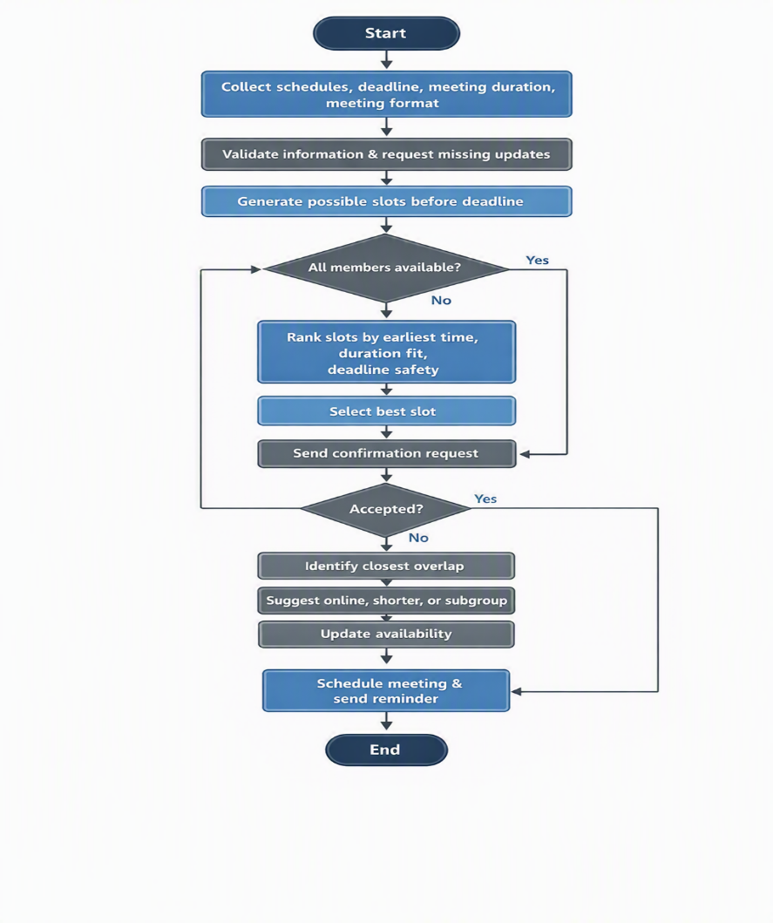
2.1 Flowchart
The advanced flowchart should show this logic:
- Start
- Collect group members' schedules, deadline, meeting duration, and preferred meeting format
- Validate schedule information and check for missing or outdated availability
- Generate possible meeting slots before the deadline
- Compare schedules and calculate availability overlap for each slot
- Is there a slot where all members are available?
Yes → Rank slots by earliest time, meeting length, and deadline safety → Select best slot
No → Identify closest overlap → Suggest online meeting, shorter meeting, or subgroup option
- Send the proposed time to group members for confirmation
- If accepted, schedule a meeting and send a reminder; if rejected, update availability and repeat the comparison
- End

The flowchart turns the scheduling problem into a clear sequence of decisions and actions. It shows the main route when a suitable meeting time is found, starting with collecting schedules, checking availability, comparing slots, and confirming the final choice. It also includes an alternative route where no perfect time is available, such as suggesting an online meeting, a shorter meeting, or the closest possible overlap. This makes the process easier for students to follow because each step has a clear purpose. Overall, the flowchart helps reduce confusion, supports fair decision-making, and improves group organisation before deadlines.

2.1.1 IPO Table
Input | Process | Output
StudentSchedules  AssignmentDeadlines  MeetingDurations  PreferredMeetingFormats  GroupMemberResponses  StudentAccountDetails  WeeklyAvailability  MeetingFormatChoice  StudentComments | ValidateInformation  CompareAvailability  CalculateOverlappingTimeSlots  CheckDeadlineLimits  RankSuitableOptions  RequestConfirmation  CreateStudentAccount  UpdateSchedules  SendReminders  ShowAvailabilityPercentage  ProvideMeetingAgenda  NotifyMeetingChanges  GenerateBackupMeetingTimes  TrackGroupTaskProgress | ConfirmedMeetingTime  AlternativeSuggestions  UpdatedAvailabilityRequest  MeetingReminder  FinalScheduledGroupMeeting  SavedStudentAccount  SelectedMeetingFormat  MeetingAgenda  MemberNotifications  BackupMeetingOptions  GroupTaskProgressSummary

2.2 Explanation of the Solution
The solution follows a step-by-step process to find meeting times that work for the whole group. First, it gathers students' schedules and assignment deadlines. This information is needed before any decision is made, as the system must compare availability with the latest possible meeting date.
Next, the system examines each person’s schedule to find available time slots. It compares these slots to show where they overlap, because overlapping times allow all members to attend at once. This stage supports fairness because the system is based on shared availability rather than one person’s preference.
The system then checks whether a suitable time is available for all members. If a shared slot is found, it chooses the earliest appropriate option before the deadline. This allows the group to start work sooner, allocate tasks, discuss any issues, and make improvements before submission.
If no time works for everyone, the system suggests alternatives instead of stopping. For example, it might recommend a shorter online meeting, smaller group discussions, or minor schedule changes. This makes the solution flexible because student schedules often change due to work, travel, illness, or unexpected study tasks.
After suggesting a time, the system asks group members to confirm attendance. If everyone agrees, the meeting is scheduled, and the group can prepare an agenda. If the time is rejected, the system repeats the process and searches for another workable option.
This process reduces informal decision-making. Instead of relying on long message threads, the group follows a consistent method that saves time and reduces disagreement.
Handling Conflicts: Sometimes, no time works for everyone. The system handles this by:
- Suggesting the nearest overlapping time slots
- Allowing minor schedule adjustments
- Offering alternative meeting formats (e.g., online meetings)
- Setting a cut-off point so the group can decide before the deadline becomes too close
- All students have access to the internet.
- Students provide accurate schedules.
- Online meetings are available when required.

2.3 Assumptions
This solution is based on a few key assumptions:
All members are willing to cooperate and respond to meeting requests.
These assumptions simplify the problem and let the solution focus on scheduling meetings.
They also show that the solution depends on both communication and technology. If students do not update their availability or ignore confirmation messages, the system may suggest a meeting time that is no longer realistic.

2.4 Justification of the Approach
This approach works well because it uses logical steps and clear decision-making. By breaking the problem into smaller parts, the system becomes less complex and more efficient. This aligns with problem-solving methods such as decomposition and abstraction [2].
Using flowcharts also makes the process clearer and easier to follow. Flowcharts are well known as helpful tools for showing logical steps [3].
The solution is fair because it treats all group members equally. It focuses on when everyone is available rather than on individual preferences, which promotes collaboration and reduces conflicts.
The approach is also flexible. It allows changes when conflicts arise and offers alternative solutions, so the system keeps working in different situations.
Overall, the approach is suitable for students because it is understandable, realistic, and does not require advanced technical knowledge.
The approach also supports accountability because confirmed meetings give members regular opportunities to check progress and redistribute tasks.

Section 3: Reflection and Justification
Abstract Thinking
Abstract thinking helped simplify the problem by focusing on key elements such as schedules, deadlines, meeting length, and availability overlap. Less key details, such as why a student is unavailable, were removed from the basic model. This made the problem easier to represent and solve [4].
Decomposition
Decomposition was applied by breaking the problem into smaller steps, such as collecting schedules, comparing availability, selecting a suitable time, and confirming attendance. This made the solution easier to design because each stage could be managed separately [5].
Logical Reasoning
Logical reasoning was used to design the flowchart and make sure each step followed a clear order. This helped make the solution systematic and dependable.
Using these problem-solving methods together has improved the quality of the proposed solution. Abstraction reduced unnecessary detail, decomposition created manageable stages, and logical reasoning connected the stages in a clear order. This combination made the final process easier to understand and justify.
3.2 Critical Evaluation
Although the solution is well-structured, it does have some limitations:
- It relies on students' accurate input.
- It may not always find a perfect time for everyone.
- It does not account for sudden schedule changes.
- It assumes full cooperation among group members.
These limitations show how complex real-world scheduling can be.
Another limitation is that the system treats all unavailable times equally. Some analyses/commitments, such as lectures, are fixed, while others may be flexible. A more advanced version could allow students to mark commitments as fixed or adjustable.
Despite these weaknesses, the solution is valuable because it reduces confusion and provides students with a shared decision-making process.
3.3 Improvements
With more time, the solution could be improved by:
- Integrating automatic calendar systems
- Using optimisation algorithms to improve scheduling [6]
- Adding AI-based suggestions for better time management
- Including real-time updates to schedules
These changes would make the solution more accurate and efficient.
A further improvement would be to add a priority score for each possible time, based on attendance, deadline pressure, and meeting format.
After confirmation, reminder messages could be sent to improve attendance and help students prepare.

Conclusion
In conclusion, this report examined the challenge of scheduling student group meetings and proposed a structured solution. By identifying the key requirements, constraints, and variables, it defined the problem clearly and divided it into manageable parts.
The flowchart-based solution provides a logical approach to collecting availability information, comparing schedules, choosing a suitable meeting time, and resolving conflicts. Problem-solving methods such as abstraction, decomposition, and logical reasoning helped create a practical and fair solution.
Although the solution has limitations, it gives a strong starting point for improving group work scheduling. With improvements such as automatic calendar integration, real-time updates, and priority scoring, it could become more accurate, efficient, and reliable.
Overall, the proposed system shows that even a common student problem can be improved through structured analysis. By breaking the issue into clear steps and decisions, the solution becomes easier to apply, evaluate, and further develop.

References
[1] K. Wiegers and J. Beatty, Software Requirements, 3rd ed. Microsoft Press, 2013.
[2] C. R. Wessels, Problem-Solving and Decision Making, Routledge, 2017.
[3] F. P. Brooks, The Mythical Man-Month, Addison-Wesley, 1995.
[4] J. Wing, “Computational thinking,” Communications of the ACM, vol. 49, no. 3, pp. 33–35, 2006.
[5] D. Knuth, The Art of Computer Programming, Addison-Wesley, 2011.
[6] M. J. Cormen et al., Introduction to Algorithms, MIT Press, 2009.

