CHRONIC KIDNEY DISEASE
Assignment Title:
Component 1 – Information Booklet of Long-Term Condition Management
Student Name:
Fahmidah faruk patel

Student ID Number:
2519425

Lecturer:
Dr raheela shaikh

Submission Date:
27 february 2026
Word Count:
3000

Table of Contents
Introduction 3
Global and UK Burden & Epidemiology 4
Global Burden 4
UK Burden 4
Aetiology and Risk Factors 5
Aetiology 5
Risk Factors 6
Staging, Signs and Symptomatology 7
Physical, Psychological and Social Impact 8
Physical Impact 8
Psychological Impact 8
Social Impact 9
Evidence-Based NHS Management 9
Early-Stage Management 9
Advanced CKD 10
Self-Management and Patient Education 10
Theoretical Models for Long-Term Condition Care 10
UK Model – House of Care 10
International Model – Chronic Care Model 11
Policy and Political Context 12
Recommendations 13
References 15

Figure 1: Chronic kidney disease 5
Figure 2: The prevalence of CKD in the United Kingdom 6
Figure 3: Primary cause of chronic kidney disease in the world is diabetes mellitus 7
Figure 4: Treatment of chronic kidney disease in older populations 7
Figure 5: Symptoms of Kidney disease 8
Figure 6: The chronic kidney disease's Physical Impact 9
Figure 7: Early-Stage M₹anagement 10
Figure 8: House of Care model 12
Figure 9: International Model – Chronic Care Model 13

Introduction
Chronic kidney disease (CKD) can be defined as constant kidney structural or functional abnormalities over a period of over three months, and the long-term health effects of chronic kidney disease include progressive impairment of renal function and systemic complications (NICE, 2021; Gilbert and Weiner, 2022).
In the world, CKD is impacting approximately 10% of all adults, and its prevalence is growing, as ageing populations become more common, and diabetes and hypertension rise as a global scourge (Kovesdy, 2022; Mark et al., 2025).
Currently, CKD has been estimated among the top causes of years lived with disability and premature mortality in the Global Burden of Disease 2023 analysis where ongoing epidemiological trends are rapidly increasing since 1990 (Mark et al., 2025; Wang et al., 2025).
In the United Kingdom, CKD is a rapidly increasing health issue affecting the populations with significant economic and service burdens due to its NHS-level health care (Kidney Research UK, 2023; Sanchez et al., 2023).
CKD comes with minimal or no symptoms at its first stages, which leads to poor timeliness in the diagnosis, referral to a specialist, complications that can be prevented, including cardiovascular disease and end-stage renal failure (NICE, 2021; Brown, 2023).
The burden of disease is higher among populations of socioeconomically deprived and ethnic minorities, which are an indicator of enduring global and national disparities in early disease detection and expert care (Bello et al., 2024).
Coordinated, person-centred and multidisciplinary strategies that involve the collaboration of primary, secondary, and community services are important to achieve the best results and mitigate the risk of progression (Francis et al., 2024; UK Kidney Association, 2024).
It is a critical appraisal of the CKD epidemiology, biopsychosocial effects, NHS management interventions, theoretical models of care and topical policy situations to guide the development of better long-term condition management.

Global and UK Burden & Epidemiology

Global Burden
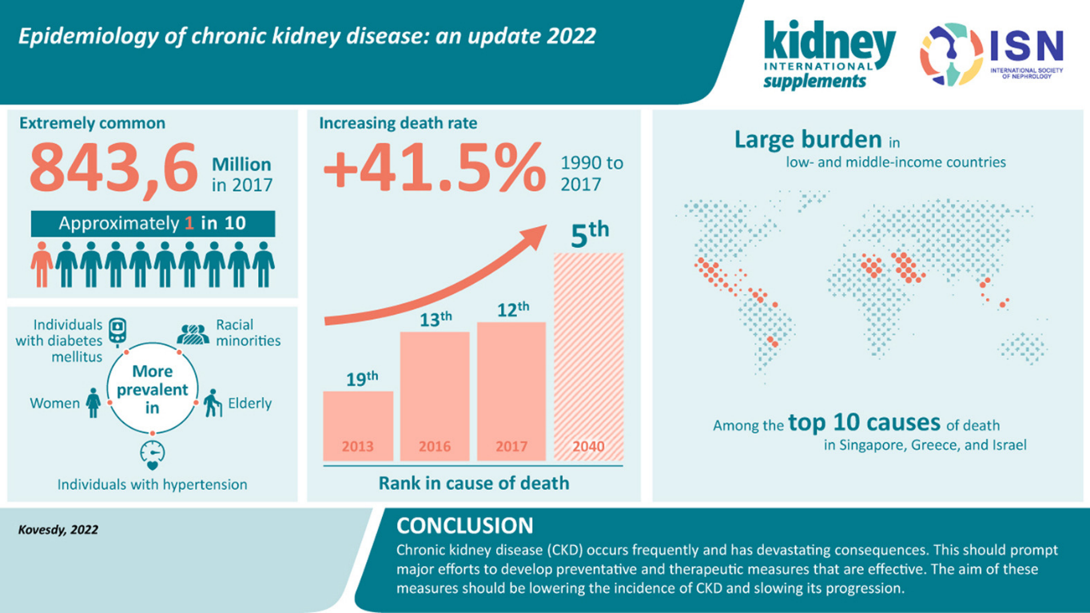

Figure 1: Chronic kidney disease
- Chronic kidney disease (CKD) has proven that it is undergoing a continual increase in prevalence across the world since 1990, which can be attributed to the growth in demographic ageing and to growing risk factors induced by metabolic processes globally (Mark et al., 2025; Wang et al., 2025).
- Recent Global Burden of Disease estimates place CKD in the top twenty in terms of years lived with disability and increase in its contribution to premature mortality in the world (Mark et al., 2025; Francis et al., 2024).
- Hypertension and diabetes are the attributable causes of the disease with significant epidemiological growth in the regions across hypertensive kidney disease (He et al., 2025; Kovesdy, 2022).
- There are still significant geographical inequalities, especially in the low- and middle-income nations where there is a lack of screening facilities and access to renal replacement therapy aggravates the outcomes (Bello et al., 2024).
- Asymptomatic progression and lack of health system capacity to adequately tackle it at an early-stage predisposes CKD as a clinical and global health inequality issue (Francis et al., 2024).

UK Burden
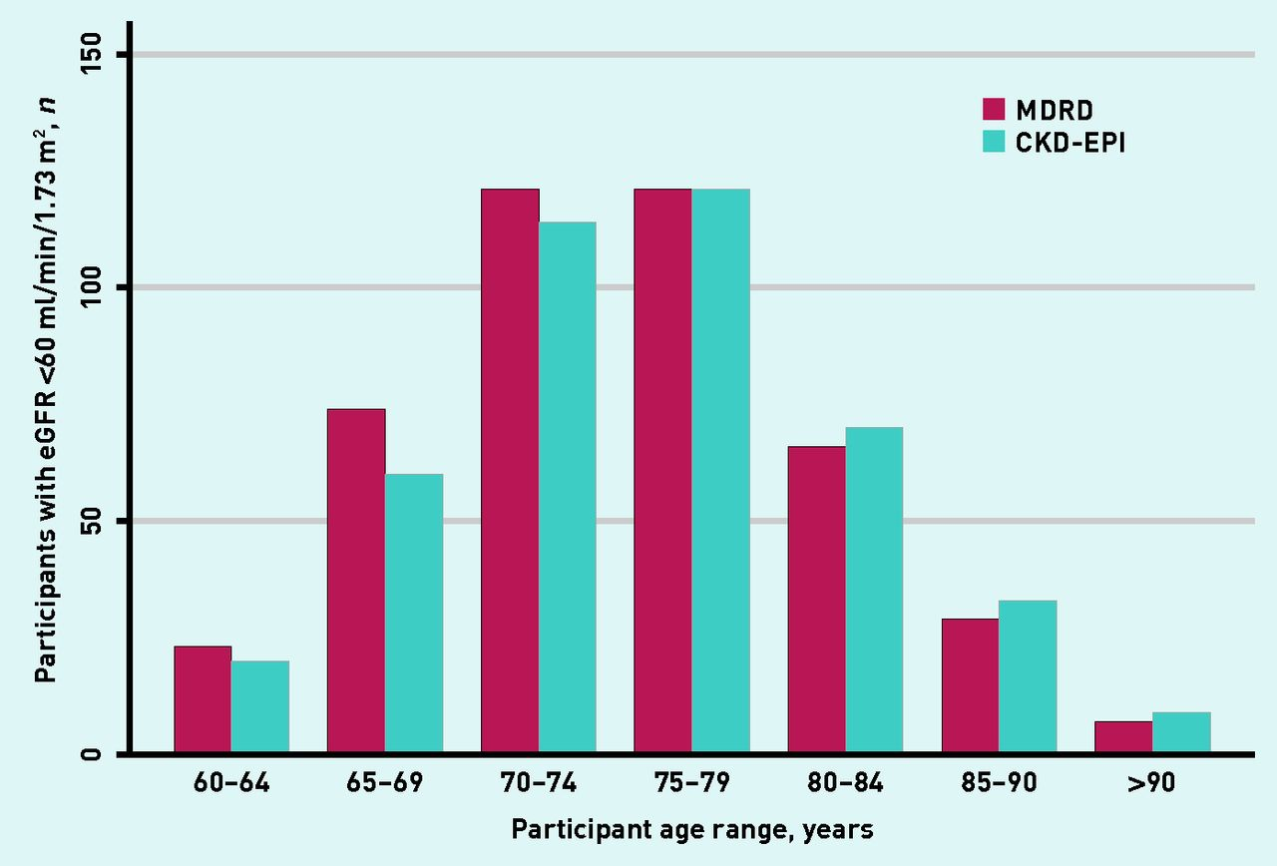

Figure 2: The prevalence of CKD in the United Kingdom
- The prevalence of CKD in the United Kingdom accounts for a significant percentage of adults, especially aged people, and patients with multimorbidity, which accounts for the situation observed in primary care data (NHS, 2023; NICE, 2021).
- Kidney disease is a significant secondary care cost driver because the advanced CKD which includes dialysis and transplantation services puts a significant economic burden on NHS resources (Kidney Research UK, 2023; Sanchez et al., 2023).
- Even though early-stage CKD is often detected during primary care, when using regular biochemical analyses, the late-stage manifestation is also still apparent among specific risk groups (UK Kidney Association, 2024).
- There is an evident deprivation gradient and ethnicity gradient in the UK, showing more prevalence and accelerated disease course among communities that are socioeconomically disadvantaged and minority (Kidney Research UK, 2023; Sanchez et al., 2023).

Aetiology and Risk Factors

Aetiology
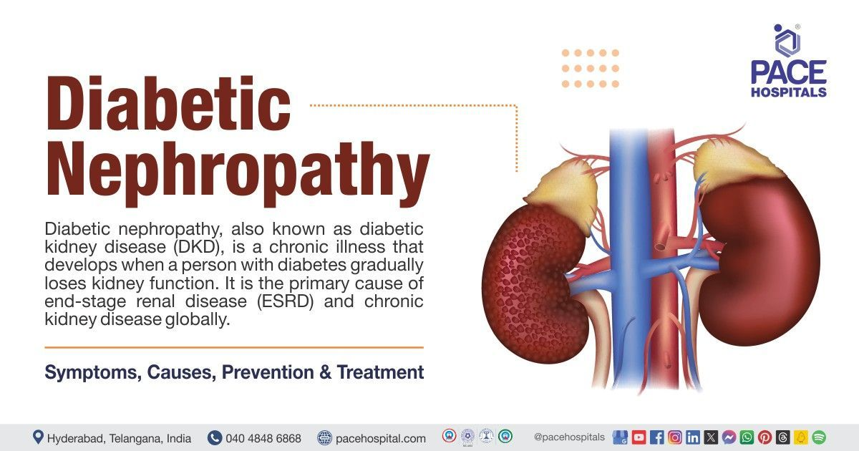

Figure 3: Primary cause of chronic kidney disease in the world is diabetes mellitus
- The primary cause of chronic kidney disease in the world is diabetes mellitus, which plays a major role in the progressive damage of the nephrons and increasing the levels of end-stage kidney disease among populations (Mark et al., 2025).
- Hypertension is one of the most critical independent and synergistic causes of CKD development, and hypertensive kidney disease can be shown to exhibit considerable increases in the analysis of global burden (He et al., 2025).
- Primary glomerular diseases, such as immune-mediated and inflammatory diseases, are also associated with structural renal injury and are also significant non-metabolic causes of CKD (Colvin et al., 2023).
- Other examples of genetic disorders that cause the disease, like autosomal dominant polycystic kidney disease, demonstrate the presence of inherited predisposition in the structural decline of the kidney (Gilbert and Weiner, 2022).

Risk Factors
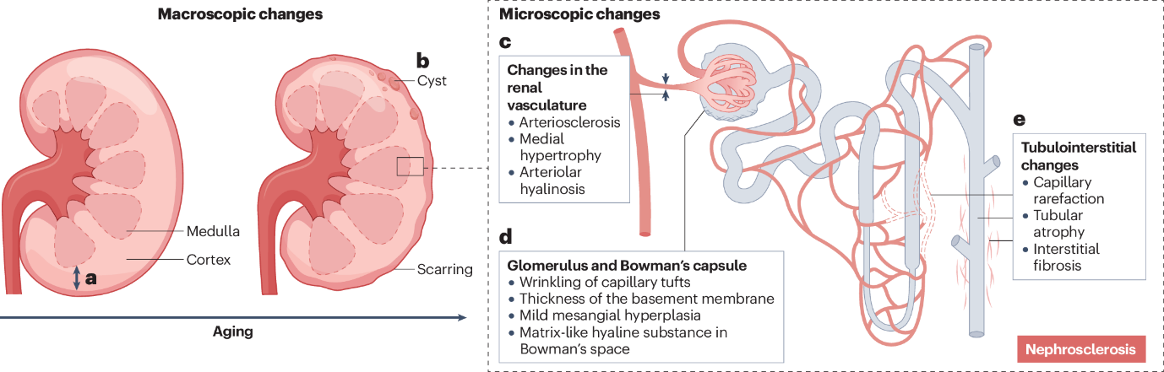

Figure 4: Treatment of chronic kidney disease in older populations
- Older age prompts the significant growth in the prevalence of CKD because of the physiological nephron loss combined with cumulative risks of exposure to metabolic and vascular risk factors (Kovesdy, 2022).
- Cardiovascular disease relates closely with CKD and displays common pathophysiology with mutual risks amplification (Francis et al., 2024).
- There is an indirect role of obesity in the insulin resistance, hypertension and systemic inflammation, which supports the modifiable metabolic risk pathways.
- Structural determinants not related to biological susceptibility have their exposures influenced by socioeconomic deprivation and ethnic disparities, as well as the healthcare accessibility and progressive rates (Bello et al., 2024).
- The difference between prevention and non-prevention of risks highlights the policy deficiencies in terms of early diagnosis, lifestyle change and equitable distribution of resources.

Staging, Signs and Symptomatology
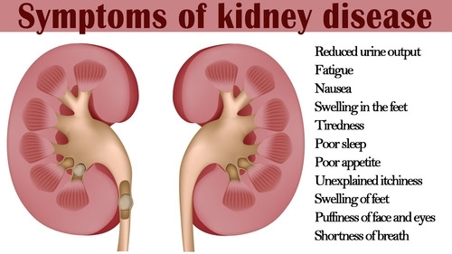

Figure 5: Symptoms of Kidney disease
- The chronic kidney disease is divided into five stages (1 -5) by estimated glomerular filtration rate (eGFR) and indicators of kidney damage, which offer a systematized approach to the stratification of risks and management designing (NICE, 2021).
- It is recommended to measure eGFR and albuminuria together since an elevated albumin value predicts increased pace of the disease and elevated cardiovascular risks (NICE, 2021).
- The initial CKD affects patients often without symptoms, so many of them do not even know that they are experiencing a deterioration of renal activity until the time when nephrons are considerably damaged (Brown, 2023).
- Subsequent to disease progression, fluid imbalance along with metabolic disruption may be observed in patients with the manifestation of persistent fatigue, peripheral oedema as well as poor exercise tolerance.
- Moderate-to-severe CKD has been identified to have increased cognitive impairment connected to a vascular and uraemic process, which influences the functioning of the nervous system (Kim et al., 2022).
- Later stages bring about anaemia, electrolyte imbalance and uraemic symptoms like nausea and pruritus that lead to high symptom burden (Nissenson et al., 2022).
- The subsequent insidious progression frequently leads to late entry into specialist care, which expands the risk of emergency dialysis-induced initiation and the increment in overall clinical load (NICE, 2021).

Physical, Psychological and Social Impact

Physical Impact
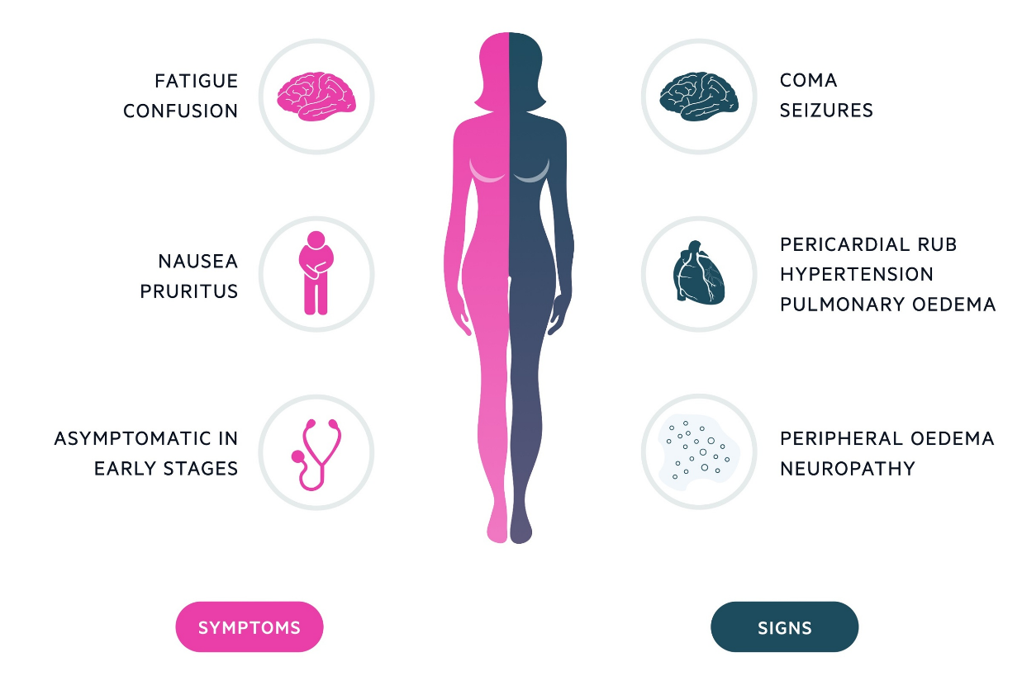

Figure 6: The chronic kidney disease's Physical Impact
- The chronic kidney disease has a significant symptom load that includes fatigue, pain, sleep disturbance and pruritus, which leads to impaired functioning and wellbeing every day (Fletcher et al., 2022).
- The reduction of cardiovascular complications is the primary cause of mortality in CKD and indicates a mosaic in the pathophysiological pathways, including the inflammation, endothelial dysfunction, and vascular calcification (Francis et al., 2024).
- Physical morbidity is further aggravated by treatment-related issues such as hypotension, infection and vascular access issues among patients who need to undergo dialysis (Nissenson et al., 2022).
- Together, both the progressive burden of symptoms and treatment requirements add to significant deteriorations in health-related quality of life.

Psychological Impact
- People with CKD have a very high rate of depression and anxiety, which is higher than the general population (Alshelleh et al., 2022).
- Poor clinical outcomes are linked to incident depression, such as higher hospitalisation, and morbidity and mortality rate (Zhu et al., 2023).
- There are also neurocognitive alterations associated with uraemia and vascular impairment that influence the regulation of emotions and decision-making abilities (Kim et al., 2022; Lefrère et al., 2025).
- The character of psychosocial interventions has proved to have significant advantages, though mental health burden is a two-way phenomenon that affects the adherence to the treatment and the development of the disease (Yang et al., 2024).

Social Impact
- The CKD often interferes with the working process, restricts the social environment and causes increased dependence because of the time spent in dialysis centers and physical exhaustion.
- Whether it is physical or emotional, family members are forced to take up care giving roles and this brings emotional and economic burden.
- The barriers to healthy self-management and shared decision-making can be health literacy issues, especially among the disadvantaged groups (Lin and Hwang, 2020).

Evidence-Based NHS Management

Early-Stage Management


Figure 7: Early-Stage M₹anagement
- The NHS prioritizes the management of blood pressure to decelerate the development of CKD and minimise cardiovascular risks by targeting personalised blood pressure levels, as well as by monitoring it regularly, in the initial stages of CKD management (NICE, 2021).
- The reduction in proteinuria and the maintenance of renal performance through the renin-angiotensin-aldosterone system (RAAS) inhibitors, i.e. ACE or angiotensin receptor blockers play a central role in management of proteinuria and preservation of renal functions.
- Glycaemic control of diabetic patients is necessary to avoid microvascular damage and slow the onset of nephropathy, which represent the metabolic causes of CKD (Francis et al., 2024).
- Risk reduction can be facilitated using lifestyle interventions as they include weight management, smoking cessation and dietary modification, however, long-term adherence to behaviour modifications is challenging to achieve in practice (Francis et al., 2024).

Advanced CKD
- In the case of advanced CKD, haemodialysis is the only life-sustaining renal replacement therapy with its drawbacks being high treatment burden and risk of complications (Nissenson et al., 2022).
- Home-based options Peritoneal dialysis has options that can increase autonomy but are not suitable in all clinical settings and social contexts.
- Kidney transplantation is the best long-term care of eligible patients who is more likely to survive and enjoy better life than dialysis (Gilbert & Weiner, 2022).
- Careful management of kidneys is increasingly being recognised in patients whose conditions do not warrant dialysis treatments with focus being on symptom control and quality of life.
- The existence of inequalities in the transplant waiting list programs, and the rising costs of dialysis also present some issues about the long-term financial sustainability at the NHS (Kidney Research UK, 2023).

Self-Management and Patient Education
- The use of structured education and teach-back approaches is an effective way to improve patient knowledge and self-management in CKD (Jagodage et al., 2024).
- The concept of Shared decision-making reinforces person-centred planning, especially during the conversation of the dialysis modalities and conservative pathways (Pal et al., 2026).
- Change interventions based on behaviour change and digital activator tools show possibilities to enhance adherence and patient activation, whereas implementation variability remains low (Farris et al., 2025; Lightfoot et al., 2024).
- Informed autonomous self-management that involves advanced education strategies further promotes disease-stage support (Faldu & Knicely, 2025).

Theoretical Models for Long-Term Condition Care

UK Model – House of Care
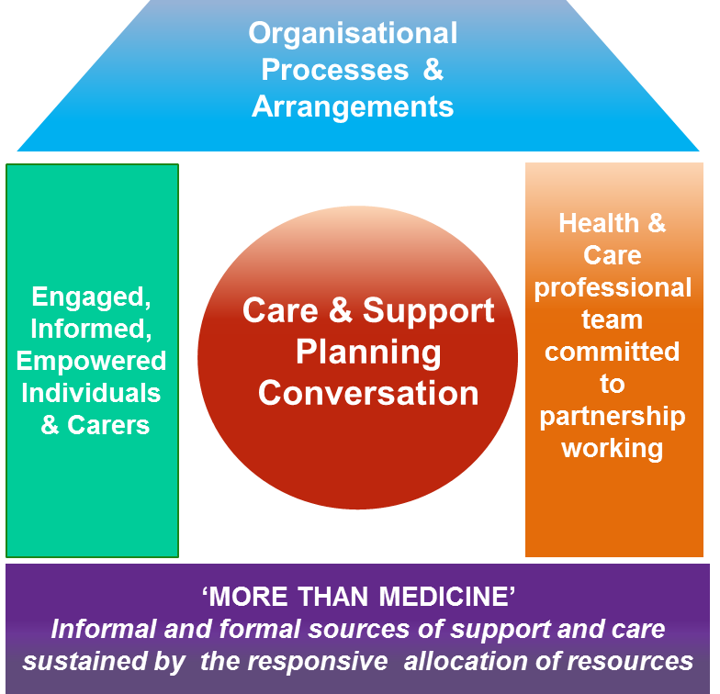

Figure 8: House of Care model
- House of Care model offers a systematic UK paradigm of offering person-centred long-term management of long-term conditions, with a tune on the interaction of informed, empowered patients and prepared, proactive health attendants and supportive organisational system.
- When applied to chronic kidney disease (CKD) structured care planning under this model allows the setting of individual goals, the improvement of pharmacological treatment, the proactive control of cardiovascular risks and active monitoring of renal activity, especially at the initial and intermediate stages of the development of the disease.
- When considering complex treatment options like haemodialysis, peritoneal dialysis, transplantation or conservative kidney management, shared decision-making is the chief element, as the clinical suggestions and patient values are consequently matched both in terms of life priorities and long-term preferences (Pal et al., 2026).
- Engaging in effective self-management support such as customised education, behavioural counselling, and skills enhancement increase patient activation, health literacy, adherence to medication and lifestyle change, and are important in reducing the CKD progression pace (Lin and Hwang, 2020).
- Nonetheless, there are variations in implementation among NHS renal services, and workforce capacity limits, time pressures and intermittent incorporation of care planning processes in renal pathways do not permit complete operationalisation to be achieved in routine renal pathways.

International Model – Chronic Care Model
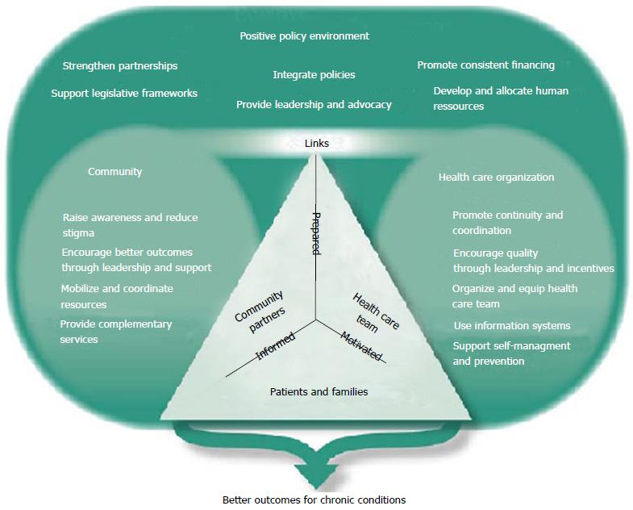

Figure 9: International Model – Chronic Care Model
- The Chronic Care Model takes a more comprehensive systems-based view of long-term condition management that facilitates the redesign of healthcare systems, multidisciplinary teamwork and proactive population health approaches in formal organisational settings.
- In the case of CKD management, this model assists in the combination of primary care with nephrology specialists and community-based services to respond to cardiovascular risk reduction, optimisation of metabolism and psychosocial support in a coherent way (Francis et al., 2024).
- The focus on community involvement, behavioural reinforcement and long-term self-management support is in line with the evidence of the effectiveness of organised behavioural change interventions to enhance long-term outcomes among dialysis-receiving patients (Farris et al., 2025).
- In comparison to the House of Care, Chronic Care Model gives more focus to system-level change and organisational architecture, as compared to the UK system, which puts more focus on individual clinical encounters and personalised care planning.
- Although both models have conceptual strength, they have practical impediments such as funding constraints, shortages in the workforce, disjointed service delivery, and difficulties in integrating the policies which could limit a uniform and equitable implementation across the various CKD care trajectories.

Policy and Political Context
- In England, the management of CKD is guided mainly by NICE NG203 that provides the standards of evaluation, risk stratification, and pharmacological intervention in the primary and secondary care routes (NICE, 2021).
- The NHS service frameworks focus on the early-detection of diseases, the reduction of cardiovascular risks, and the multidisciplinary coordination of care, but their implementation is different in all regions because of the lack of resources and workforce (NHS, 2023).
- Economic studies point to a large financial cost of high-level CKD in general and, specifically, dialysis and transplantation and cast doubts on its sustainability over time in publicly funded health care services (Kidney Research UK, 2023).
- According to epidemiological projections in the UK, there is an increasing prevalence of CKD associated with age and multimorbidity, putting the strains of nephrology care and management at the community level (Sanchez et al., 2023).
- It is still a vexing lack of balance between spending on preventive measures, including early screening and controlling of metabolic risks, and spending more money on expensive renal replacement therapies.
- Timely referral and continuum of care may be impeded by the workforce capacity constraints such as unavailability of specialist nephrology staff.
- Integrated Care Systems are meant to enhance cooperation between sectors, whereas structural inequalities and deprivation gradients persist in determining access, rates of progression and health outcomes among CKD populations (Kidney Research UK, 2023).

Recommendations
- In primary care, greater emphasis should be placed on earlier and more intensified screening of high-risk groups especially patients with diabetes, hypertension and cardiovascular disease to avoid late presentation and its unnecessary progression (Mark et al., 2025).
- It is advised to incorporate regular mental health evaluation and psychosocial care into renal care due to the prevalence of depression and its course of consequences and adherence levels (Yang et al., 2024).
- This could be improved by scaling up of digital health programs such as remote monitoring and patient activation platforms, which would improve both engagement, self-management and continuity of care especially in areas with low service accessibility (Lightfoot et al., 2024).
- There should be an ongoing integration of shared decision-making procedures in the CKD pathways, particularly in the conversation of dialysis modalities, or conservative management to guarantee that they fit the patient preferences and values (Pal et al., 2026).
- The presented solutions to the overcrowding of the service with greater use of home-based dialysis modalities where clinically suitable would allow to decrease service load and enhance quality of life, necessitating organized education and support systems (Nissenson et al., 2022).
- Commissioning in deprived and ethnically varied communities should be focused on to mitigate the constant inequalities in access and progression rates and outcomes (Bello et al., 2024).

Summary
Chronic kidney disease (CKD) is defined as a growing national and global health issue and epidemiological data indicate there is a progressive increase in case rates, disability and mortality among patients in varied geographic areas such as the United Kingdom (Mark et al., 2025). The ageing in population (demographic), rising incidences of diabetes and hypertension, and expansion of their metabolic susceptibility all work to push this trend upwards. In addition to gradual but inevitable renal malady, CKD produces a complex bio-psychosocial load which is typified by high symptom counts, cardiovascular co-morbidity, poor physical functioning, and low health-related quality of life (Fletcher et al., 2022).
Treatment burden is often accompanied by psychological distress, such as depression and anxiety, especially with people under dialysis or awaiting a transplant, which only exacerbates functional phenomena and difficulties with adherence. Social effects like loss of employment, financial burden and caregiver burden increase the impact of the disease and goes beyond the individual to include the families and communities. The continuous socioeconomic deprivation and ethnic inequality greatly reflect access to early diagnosis, specialist referral pathways and transplantation opportunities, which enhance structural inequalities in the outcomes (Bello et al., 2024).
Despite the NHS management frameworks which offer the evidence-based clinical advice and guidelines alongside the should-follow pathways to CKD care, the limitation to the consistent implementation remains in the form of the service fragmentation, workforce pressures, and financial constraints. It is essential to enhance multidisciplinary, integrated and person-centred care models, which can be achieved through early prevention strategies and a more powerful self-management intervention to enhance long-term outcomes and ensure fair practices in kidney care delivery.

References
Alshelleh, S., Alhouri, A., Taifour, A., Abu-Hussein, B., Alwreikat, F., Abdelghani, M., Badran, M., Al-Asa’d, Y., Alhawari, H. and Oweis, A.O., 2022. Prevelance of depression and anxiety with their effect on quality of life in chronic kidney disease patients. Scientific Reports, 12(1), p.17627. https://www.nature.com/articles/s41598-022-21873-2.pdf
Bello, A.K., Okpechi, I.G., Levin, A., Ye, F., Damster, S., Arruebo, S., Donner, J.A., Caskey, F.J., Cho, Y., Davids, M.R. and Davison, S.N., 2024. An update on the global disparities in kidney disease burden and care across world countries and regions. The Lancet Global Health, 12(3), pp.e382-e395. https://www.thelancet.com/pdfs/journals/langlo/PIIS2214-109X(23)00570-3.pdf
Bello, A.K., Okpechi, I.G., Levin, A., Ye, F., Damster, S., Arruebo, S., Donner, J.A., Caskey, F.J., Cho, Y., Davids, M.R. and Davison, S.N., 2024. An update on the global disparities in kidney disease burden and care across world countries and regions. The Lancet Global Health, 12(3), pp.e382-e395. https://www.thelancet.com/pdfs/journals/langlo/PIIS2214-109X(23)00570-3.pdf
Brown, R.S., 2023. Clinical Handbook of Nephrology-E-Book. Elsevier Health Sciences.
Colvin, R.B., Chang, A. and Cornell, L.D., 2023. Diagnostic Pathology: Kidney Diseases E-Book. Elsevier Health Sciences.
Faldu, C.T. and Knicely, D.H., 2025. Advanced chronic kidney disease and patient education. Kidney and Dialysis, 5(3), p.32. https://www.mdpi.com/2673-8236/5/3/32
Farris, O., Orbell, S., Lamarche, V.M. and Smith, R., 2025. Promoting self-management in chronic disease: a systematic review and meta-analysis of behaviour change interventions for patients on dialysis. Health Psychology Review, 19(2), pp.368-408. https://www.tandfonline.com/doi/pdf/10.1080/17437199.2025.2471775
Fletcher, B.R., Damery, S., Aiyegbusi, O.L., Anderson, N., Calvert, M., Cockwell, P., Ferguson, J., Horton, M., Paap, M.C., Sidey-Gibbons, C. and Slade, A., 2022. Symptom burden and health-related quality of life in chronic kidney disease: a global systematic review and meta-analysis. PLoS medicine, 19(4), p.e1003954. https://journals.plos.org/plosmedicine/article/file?id=10.1371/journal.pmed.1003954&type=printable
Francis, A., Harhay, M.N., Ong, A.C., Tummalapalli, S.L., Ortiz, A., Fogo, A.B., Fliser, D., Roy-Chaudhury, P., Fontana, M., Nangaku, M. and Wanner, C., 2024. Chronic kidney disease and the global public health agenda: an international consensus. Nature Reviews Nephrology, 20(7), pp.473-485. https://www.nature.com/articles/s41581-024-00820-6.pdf
Gilbert, S.F. and Weiner, D.E. eds., 2022. National kidney foundation primer on kidney diseases, E-Book. Elsevier Health Sciences.
He, Y., Tang, W., Chen, J., Tang, J., Zheng, Y., Wang, X., Xing, B., Li, X., Xu, Y. and Wang, X., 2025. Global burden of chronic kidney disease due to hypertension (1990–2021): a systematic analysis of epidemiological trends, risk factors, and projections to 2036 from the GBD 2021 study. BMC nephrology, 26(1), p.448. https://link.springer.com/content/pdf/10.1186/s12882-025-04386-8.pdf
Kidney Care UK, 2024. Chronic kidney disease (CKD). Available at: https://kidneycareuk.org/kidney-disease-information/kidney-conditions/patient-info-ckd-chronic-kidney-disease (Accessed: 24 February 2026).
Kidney Research UK, 2023. Kidney disease: A UK public health emergency. Available at: https://www.kidneyresearchuk.org/wp-content/uploads/2023/06/Economics-of-Kidney-Disease-full-report_accessible.pdf (Accessed: 24 February 2026).
Kim, D.S., Kim, S.W. and Gil, H.W., 2022. Emotional and cognitive changes in chronic kidney disease. The Korean Journal of Internal Medicine, 37(3), p.489. https://pmc.ncbi.nlm.nih.gov/articles/PMC9082446/pdf/kjim-2021-492.pdf
Kovesdy, C.P., 2022. Epidemiology of chronic kidney disease: an update 2022. Kidney international supplements, 12(1), pp.7-11. https://pmc.ncbi.nlm.nih.gov/articles/PMC9073222/pdf/main.pdf
Lefrère, A., Burtey, S., Bobot, S., Belzeaux, R. and Bobot, M., 2025. Depression in chronic kidney disease: Particularities, specific mechanisms and therapeutic considerations, a narrative review. Behavioural brain research, 483, p.115467. https://www.sciencedirect.com/science/article/pii/S0166432825000531
Lightfoot, C.J., Wilkinson, T.J., Sohansoha, G.K., Gillies, C.L., Vadaszy, N., Ford, E.C., Davies, M.J., Yates, T., Smith, A.C. and Graham-Brown, M.P., 2024. The effects of a digital health intervention on patient activation in chronic kidney disease. npj Digital Medicine, 7(1), p.318. https://www.nature.com/articles/s41746-024-01296-1.pdf
Lin, C.C. and Hwang, S.J., 2020. Patient-centered self-management in patients with chronic kidney disease: challenges and implications. International journal of environmental research and public health, 17(24), p.9443. https://www.mdpi.com/1660-4601/17/24/9443
Mark, P.B., Stafford, L.K., Grams, M.E., Aalruz, H., Abd ElHafeez, S., Abdelgalil, A.A., Abdulkader, R.S., Abeywickrama, H.M., Abiodun, O.O., Abramov, D. and Abrar, M.M., 2025. Global, regional, and national burden of chronic kidney disease in adults, 1990–2023, and its attributable risk factors: a systematic analysis for the Global Burden of Disease Study 2023. The Lancet, 406(10518), pp.2461-2482. https://www.thelancet.com/pdfs/journals/lancet/PIIS0140-6736(25)01853-7.pdf
MH Jagodage, H., McGuire, A., Seib, C. and Bonner, A., 2024. Effectiveness of teach‐back for chronic kidney disease patient education: A systematic review. Journal of Renal Care, 50(2), pp.92-103. https://onlinelibrary.wiley.com/doi/pdf/10.1111/jorc.12462
National Institute for Health and Care Excellence , 2021. Chronic kidney disease: assessment and management. NICE guideline [NG203]. Available at: https://www.nice.org.uk/guidance/ng203 (Accessed: 24 February 2026).
NHS, 2023. Chronic kidney disease. Available at: https://www.nhs.uk/conditions/kidney-disease/ (Accessed: 24 February 2026).
Nissenson, A.R., Fine, R.N., Mehrotra, R. and Zaritsky, J. eds., 2022. Handbook of dialysis therapy, E-Book. Elsevier Health Sciences.
Pal, S., Said, F.M. and Panduragan, S.L., 2026. Shared decision-making in patient-centered care for individuals with chronic kidney disease–A scoping review. Asian Journal of Medical Sciences, 17(1), pp.214-223. http://ajmsjournal.info/index.php/AJMS/article/download/5023/3942
Palleschi, G. and Rossi, V. eds., 2024. Chronic Kidney Disease-Novel Insights into Pathophysiology and Treatment: Novel Insights into Pathophysiology and Treatment. BoD–Books on Demand.
Sanchez, J.J.G., Wheeler, D.C., Brown, S., Priest, S., Guiang, H., Webber, C.J., Wharton, G., Barone, S. and Grima, D., 2023. # 4271 THE GROWING BURDEN OF CHRONIC KIDNEY DISEASE IN THE UK: AN IMPACT CKD ANALYSIS. Nephrology Dialysis Transplantation, 38(Supplement_1), p.gfad063c_4271. https://doi.org/10.1093/ndt/gfad063c_4271
UK Kidney Association, 2024. The UK eCKD Guide. Available at: https://www.ukkidney.org/health-professionals/information-resources/uk-eckd-guide (Accessed: 24 February 2026).
Wang, L., He, Y., Han, C., Zhu, P., Zhou, Y., Tang, R. and He, W., 2025. Global burden of chronic kidney disease and risk factors, 1990–2021: an update from the Global Burden of Disease Study 2021. Frontiers in Public Health, 13, p.1542329. https://www.frontiersin.org/journals/public-health/articles/10.3389/fpubh.2025.1542329/pdf
Yang, H., Qi, L. and Pei, D., 2024. Effect of psychosocial interventions for depression in adults with chronic kidney disease: a systematic review and meta-analysis. BMC nephrology, 25(1), p.17. https://link.springer.com/content/pdf/10.1186/s12882-023-03447-0.pdf
Zhu, N., Virtanen, S., Xu, H., Carrero, J.J. and Chang, Z., 2023. Association between incident depression and clinical outcomes in patients with chronic kidney disease. Clinical kidney journal, 16(11), pp.2243-2253. https://academic.oup.com/ckj/article-pdf/16/11/2243/52692085/sfad127.pdf

