ECEY40001/C

HUMAN DEVELOPMENT
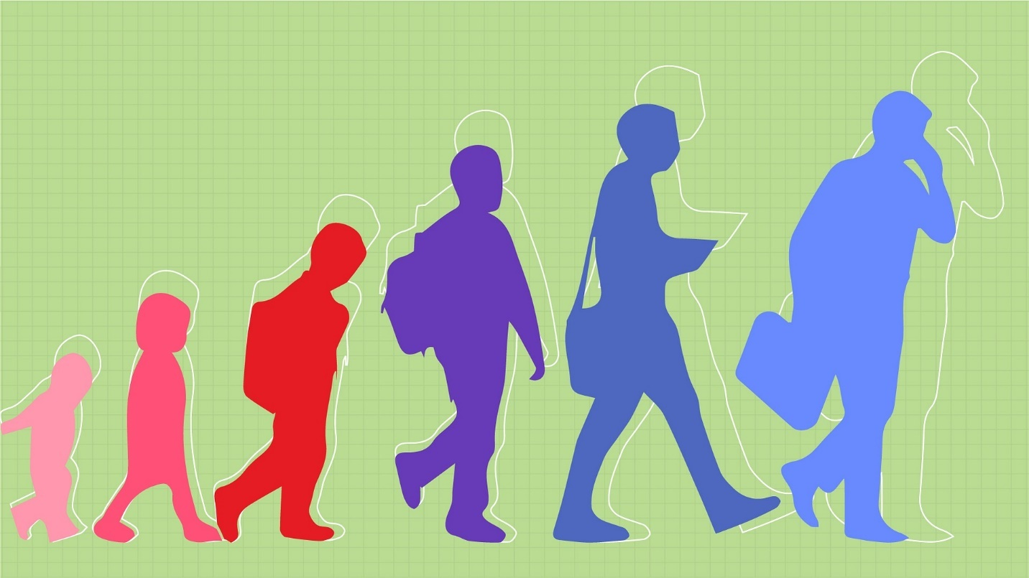
ALEISHA JOHNSON
2200646

INSTRUCTIONS

This handbook is useful for any practitioner in an early year setting, it will provide you with information on how to improve the child’s quality of care and their outcome. This handbook will provide information on how to create a same environment for children throughout their transitions and also things that may affect the outcome of the child in a setting or during a new transition.

The aim of the handbook is to provide information and to expand the knowledge of practitioners in any early years setting and also to help parents through any transitions with their child.

This handbook can help you understand how to create a calm, fun and safe environment for the children in your or a child in your care and also how to make them feel comfortable during new transitions. The aim is to provide you with information on attachment theories, how play Is vital in a child’s learning, and how many different attachments through a child’s life and during school time can have a positive or negatives outcome during different transitions.

CONTENT

Transitions 4
Why are transitions important in early years 5
Needs of the child 6
Role of an adult 7

Relationships 9
Parent and practitioner 9
Child and practitioner 10
Attachments 10

Play 11
Why is play important 11
Child-led play 11

Interventions 12

Reference list 13

Transitions

Transitions occur regularly throughout a person’s life; a transition is when a change occurs from one state to another. In the early years this may include a home-to-school setting, moving from nursery to primary school or moving year groups in primary school. There are also little transitions such as moving from room to room in a setting or moving from the playroom to the garden. The first day is not the only aspect of transition. Children build relationships, pick up new patterns, and understand a feeling of connection and belonging in the new environment throughout the course of time. Transitions can be difficult for many children. (Queensland gov 2022)

According to Alexandra Erickson, her research has shown that transition can be difficult for children and can have a positive or a negative effect on a child’s emotional well-being, but she also states that it is a vital part of a child’s development. Transitions can affect children in many ways, in both positive and negative ways. A child may feel overwhelmed or feel that they do not have control over the situation, but it can also create many positive relationships through the transitions. Having a positive relationship through the transitions can allow the child to cope with their emotions more effectively, this will be looked into further through this handbook. A child’s outcome of a stress-full experience such as a transition for a child depends on the level of support the child has at home, in a childcare setting and through the stress-full period.

Why are transitions important in early years?

Liz Brooker expresses that transitions through early years are essential for a child and their development. She states that ‘a child needs change in order to develop further’. Allowing a child to transition to change from one state to another provided the chance to express and explore their emotional, physical, intellectual and social well-being as they will be finding a way to overcome these new and maybe difficult feelings and situations. A website called early years matter seeing transitions as milestones for children and is effective for their development as transitions allow children to explore many new environments, new opportunities and growth for every child.

There are many thing during a child transitioning that needs to be met for the child to be able to feel safe and be able to tackle these challenges, For a child to be able to transition, one of the key things that must occur is putting the child’s needs first.
Many children may struggle with transitions, this may be going from one active to another or moving up a year group in their setting. Betterkidcare 2020 explains that children may find it hard and frustrating as they move from one task or activity to another this may be due to them being engaged and enjoying the activity that they have been taking part in. Allowing the child to finish the task that they are taking part in before moving to another may help the child move smoothly into another task and giving the child a warning before moving onto another task, this allows the child to understand what will be happening before it happens.
Betterkidcare 2020 also suggests that another reason for a child being unsettled during a transition is due to the lack of structure and routine in their lives. Different methods for children to react to uncertainty. When transitions come as a surprise or are poorly explained, the child may become confused, lose their temper, become more anxious, and have a negative effect on the rest of the day.

Needs of the child

The holistic approach is a way of looking at the child as an individual, this allows a person to look at the social, mental and physical factors. By applying the holistic approach in a child care setting this helps focus less on goals and realizes that a child academic success will start with how well the child is cared for in their setting as this can lead into a child cognitive needs. (little angles 2022) the holistic view looks at each child and seeing that each child has different needs and different levels of care. It is important to meet the child needs to allow the child to improve grow and develop into adulthood in all physical, social, emotional and intellectual aspects
Maslow’s hierarchy of needs theory links into the holistic approach. Maslows theory suggest that the basic needs of a child needs to be met before they are able to move onto more advanced needs.
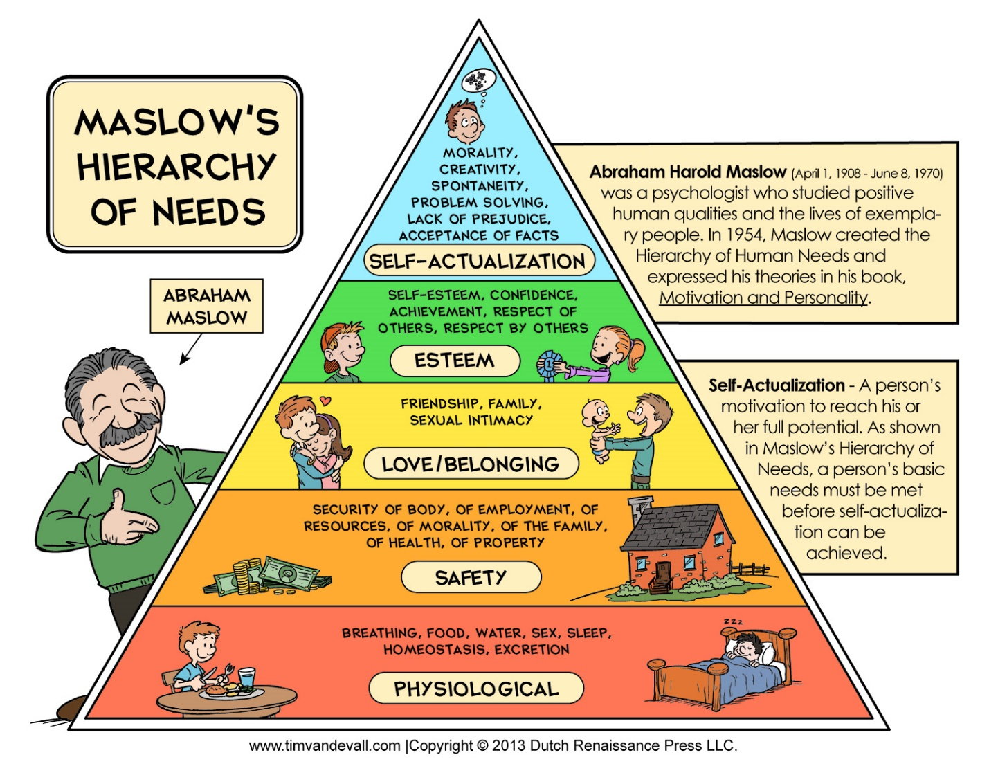

Maslow’s hierarchy of needs in a child care setting can help parents and practitioners understand a child’s specific needs such as food, water, clothing before moving onto any higher levels. If the lower levels of needs are not met it makes it harder for any child to feel safe, loved, may have poor self esteem and it makes it harder for the child to reach the highest level which is self- actualization.
The child’s needs should always be at the center of the care. his is when the a child is involved in their own care and learning. This allows the child to take control of the way they learn, this can allow the child to develop creativity and boost their self-confidence according to studymode essay 2018.
They also say that a child centered approach is beneficial for the child as they are working independently with little to no interference from others. Listening to the child allowing the child to make their own decisions and having their views be taken in will help the child see that their needs are being taken seriously which allows a better outcome for the child.
This may be difficult for nonverbal children to get their views across to their parents or practitioners, it is important that everyone is included in their decision of their own care. Holding up pictures and allowing a child to pick a certain activity, snack or games to in a setting gives the child some control over their own care despite any barriers that may being the child way these may include, language barriers, cultural barriers, disabilities, learning disabilities, their back ground and ethnicity should not be seen as reason to not be included in any decisions or activities in the child care.

Role of an adult

To be able to support a child, the role of the adult-child interaction plays a big part. Adults can have a massive effect and influence on the development of the child, as banduras 1986 theory states that adults act as a role model for children around them.

Banduras doll theory – during this experiment, bandura tested a group if children, these children observed a doll. In the first half of the experiment the doll was cared for and played with, when the child interacted with the doll the child interacted in the same way as they had previously seen. The same children where then shown the same doll treated poorly, showing the doll being hit and kicked, after seeing the doll being treated poorly the children went form treaty the doll nicely, they started hitting and kicking the doll just like they had seen in the second half of the experiment.
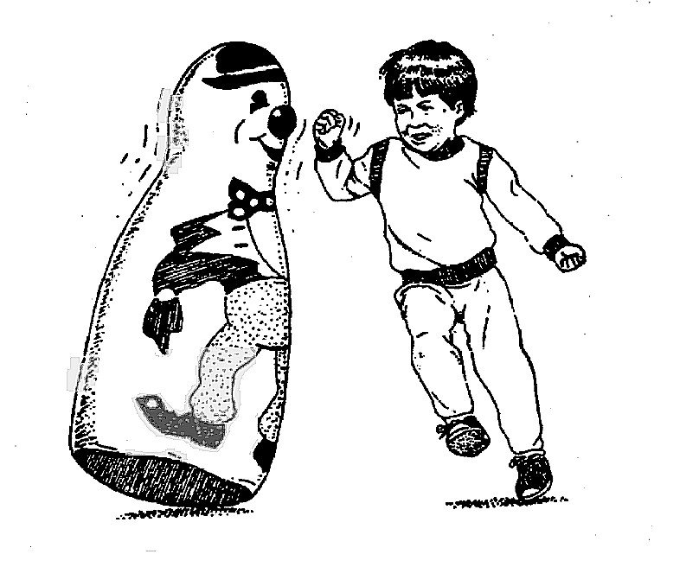
Crowley, K 2014 indicates that communication between adult and child is one of the main roles of the adult, he says ‘one important characteristics of effective early years setting is language used to interact with children’ this can be in the form of verbal and not verbal interactions, Eye contact, and showing that you are engaged. By doing this it shows the child that you are listening and let the know get a sense that they can trust you.
How a child is spoken to can play a massive role in child development. In early years children tend to copy what they see or hear.The role of an adult is to ensure they are talking correctly to the correct person, ensuring that they change their tones been talking to a parent to talking to a child. If the child has been asked a question giving the child time to answer the question gives the child to understand the question and answer, it also shows that the practitioner is engaged and is interested in what they have to say.
Effective communication, if that’s verbal or nonverbal make will give the child a sense of security and allows them to develop their communication skills as banduras theory shows children will mimic that they observe.

Relationships

Relationships throughout transitions
Transitions allow children to explore new relationships. It is important for children to form bonds and relationships with their key person in their setting. There also needs not be a positive relationship between parent and key person to ensure that the child had the best outcome of their care. Earlyyears.bucks states that children thrive best in an inclusive environment, this is where both the parent, child and practitioner all have a positive relationship allowing there to be a positive outcome on the child’s learning, wellbeing and outcome.

Parents and practitioners
Parents want to feel confident that their child is being cared for during their school time. This is done by creating a bond and positive relationship with the child’s parents. Creating a bond with the parents it has a positive outcome for the child as well as reassuring the parents. It can help the child feel that they are safe if they sense that their parents are comfortable with their key person.
Parents and practitioner relationship must have two way conversations to allow the child parents to interact with the practitioner and for the practitioner to express any concerns they may have about the child, any positive outcomes and the development of the child in their setting. This has a positive outcome for the child, they are working together to value and support the input of each others views to improve the child learning and development. (parenta 2016).
A negative and poor relationship between parent and key person put the children in the middle and makes the children the primary victim (sabater, 2021) children may pick up on the poor relationship between the two whether this may be, the parents do not have any interest in the child’s development and learning or the practitioner is not allowing the parent to have any input into the child care, not including them or may other reasons. The child will not get the best out of their, they may also start pulling away from their key person due to this and no longer feel safe. This can cause transitions to become a lot harder as they do not feel safe, secure or comfortable around this key person.
Child and practitioner
Children often turn to their parents for support and security but in school or early years this may often be a key person they turn to. A key person is often the person a child will spend the most time with during their time in their setting. Building a relationship with their key person ensures that they feel that they are safe, secure and cared for after leaving their caregiver when going into their setting. Sally Thomas uses the term key caring as a key person due to the focus on the relationship rather than the role of the practitioner.
In smaller setting this is easier to do as there are less children to build bonds with, in larger groups this may be difficult and it is easier to build a better bond with one child than the other often ends in the child feeling left out or not as important, so it is crucial for the key person to build relationships with every child in their care.
Having a positive relationship with the child allows transitions to become easier for both the child and practitioner, the child has their comfort person with them during the difficult period and the practitioner knows how to support the child best due to the bond that had been built.
Attachment
Attachments been child and parent, or child and practitioner will have a effect on the child during transitions whether this is positive or negative. Over and under attachment to their primary care giving can have a massive effect on their bonds in their setting. Bowlby’s theory shows this.
Bowlby’s theory shows that attachment bonds are innate. It also shows that when a child’s Immediate need for a secure attachment are not met, the child can feel threatened and react the way they think is appropriate.
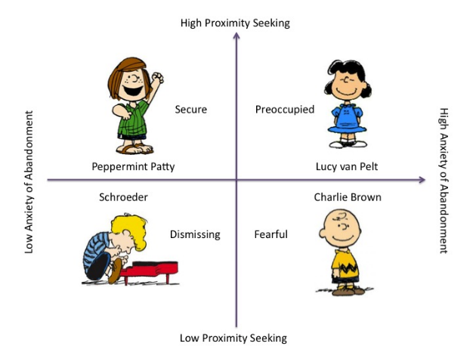
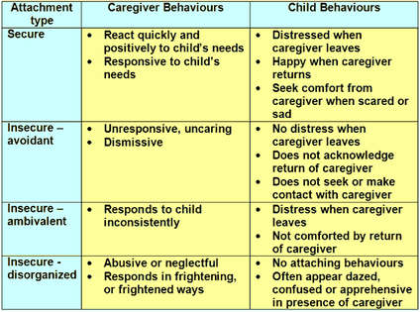
Cara Flanagan states that Bowlby’s theory suggest that the mother-love is as important for a child’s mental health as vitamins and protein is more physical health.
You can see below the 4 stages of attachment,
These four attachments can make transitions difficult. Due to the child’s behaviors listed in the table. Insecure-disorganized attachments can cause the child tot form any bonds with a key person and have poor emotional development having less control over their emotions but have little to no bonds with people to be bale to feel secure. A child with a secure attachment with their primary care giver may crave attention from their primary caregiver when in there setting until settles and creating bonds with they key person, these children may have a good emotional development due to the support of their primary care givers.

Play
why is play important?
UNCEF UK 2013 states that ‘every child has the right ti play, relax and take part in a wide range of cultural and artistic activities. Play is very important in development and is often over looked. Play van help communication skills, fine and gross motor skills, physical, cognitive, emotional ad social development. Robinson 2008 sees play and imagination as a natural and important part of a child’s growth, learning and development. When children manage their play, including what to play, who to play with, and how to organize it, they get more.
They develop and learn through play such as;
- Climbing- helps children upper body strength, co-ordination and balance.
- Joking, chatting and making up their own ages with other children helps them develop their communication skills
- Running and playing chase helps children get fitter.
- Walking or running along the top of walls helps children develop concentration and balance.
- Jumping off steps, riding a bike or skipping with a rope helps children develop co-ordination and confidence in what their bodies can do.
- Playing make believe develops children’s imagination and creativity. It can help them make sense of difficult things in their life.
- Playing gives children, the chance to let off steam and have fun.
Child-led play
Child led play is letting the children do what they need to do to learn. Child led play has little no adult structure and little adult interaction. This allows the child to learn through their own word and see their environment around them while learning about it in their own way. Nature play 2011 indicated that children learn best through their 5 senses, touch, taste, smell, feel and seeing. These can leave to bigger things such as balance and movement.
During child-led play it is important to ensure that any adult follows their lead, the adult needs to understand that the child needs to direct their own learning and explorations. #
Waiting and watching, taking a step back from the child while they are playing can help them explore the outside word but still knowing that they are safe with an adult there.
Intervention

Early intervention is a system of coordinated services that assists families in the crucial early years and encourages the child's development and growth at an appropriate age. The role of an intervention is to identify a child’s level of development and skills to identify if there are any delays, the role is to set goals in place to be able to support the child with their delays.
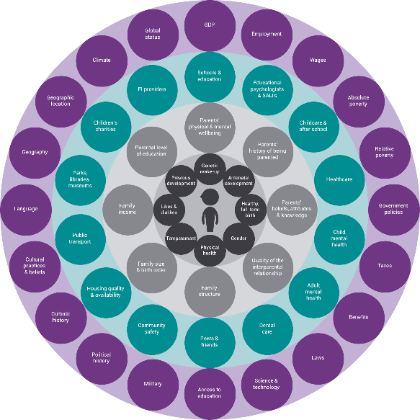
This will ensure the child get the best outcome possible for their development.
Meetings with the family should be held to ensure that they are comfortable with the intervention the practitioner is wanted to set into place for the child. Meeting with the family also ensures that the right choices are being made for the child.
Interventions should be specific to the child, not every child learns and develops the same way, so why would interventions be the same for every child. Making meeting with the parents every 2/3weeks helps to measure the child development, by measuring the development it checks to see if the interventions that are set in place are working correctly for that specific child.
Reference list

Brooker, L. (2008) supporting transitions in the early years. London: Bell and Brain Ltd, Glasgow. Available at:https://books.google.co.uk/books?hl=en&lr=&id=GtxEBgAAQBAJ&oi=fnd&pg=PP1&dq=transitions+in+the+early+years&ots=3G9BbtMfuj&sig=YyEC_zjAToxFAqRAc8KhmjhATGo#v=onepage&q&f=false (accessed date: 24th November)

Caro, C. (2022) Nature play- child-led play. Available at :Child-led Play - N A T U R E P L A Y (nature-play.co.uk) (accessed date: 26th November 2022)

Developmental Psychology - Early Social Development (weebly.com) –[digital photo] (accessed date: 3rd December 2022)

Early intervention foundation. Available at: mtc-risk-factors.png (2013×2013) (eif.org.uk) (accessed date: 4th December 2022)

Erickson, A. (2021) – how trnaisition may affect children and young people behaviours and development. Available at: https://edupro.cc/examples/how-transitions-may-affect-children-and-young-peoples-behaviour-and-development/#allow ( Accessed date : 25th November 2022)

Flanagan, C. et al (2016) aqa psychology. Gloucestershire: illuminate publishing ltd

Human development. Human Development | Lifespan Development | | Course Hero (accessed date : 30th November 2022) [digital photo]

Langston, A. (2012) Early years matters- transitions. Available at: https://www.earlyyearsmatters.co.uk/eyfs/positive-relationships/transitions/ (accessed date: 30th November 2022)

Parenta (2016) running a setting- 7 top tips to develop positive relations with parent. Available at: 7 top tips to develop positive relationships with parents | Parenta.com (accessed date: 3rd december 2022)

Penn state extension (2020) betterkidcare- Transition strategies for the early childhood classroom. Available at: https://extension.psu.edu/programs/betterkidcare/news/2020/transition-strategies-for-the-early-childhood-classroom (accessed date: 1st December 2022)

Positive relationships- key people -part1. Available at: Key-Person.pdf (happykids-childcare.co.uk) (accessed date: 24th November 2022)

Queensland government (2019) early childhood education and care- moving to an early years setting. Available at: https://earlychildhood.qld.gov.au/early-years/transitions/moving-to-an-early-years-setting (accessed date: 26th November 2022)

Steemit (2017) hierarchy of basic human needs by maslow. Available at: Hierarchy of basic human needs by Maslow — Steemit (accessed date: 2nd December 2022)

UNICEF UK (2013) A summary of the UN convention on the rights of the child. Available at: http://wwwnunicef.org.uk/document/publication-pdfs/betterlifeleaflet2012_press.pdf (accessed: 1st December 2022)

