 | Targed/target | Yr hyn yr wyf wedi'i wneud yn yr aseiniad hwn  What I have done in this assignment...
Targed/Target 1 | Check your use of punctuation and referencing, see Harvard-eng_v.1.2.pdf | For this assignment I thoroughly read through and checked my work. I looked at Harvard-eng_v.1.2.pdf for referencing tips to better my work
Targed/Target 2 | Ensure you critique the works you present - include more analysis of the issues you discuss | I have included more sources to implement more analysis of part A and B topics which has allowed me to critique the work
Targed/Target 3 | you could mention a researcher such as Denscombe to support. | For Part A of the assignment, I used Bronfenbrenner to support my work. Although Part B is based on school X SDP, I used researchers to support the SDP system and what it involves.

Kloe Cox
Student Number: 1809231

7003 Assignment Part B

How a school develops one aspect of its SDP: a report that critically reflects on the actions, impact and evidence base.

Word Count: 2746

Introduction
The assignment will focus on one aspect of the School Development Plan (SDP). Welsh Government (2014a) identify that a school development plan (SDP) is a strategic plan for improvement, and within an SDP are actions the school will take to improve their priorities and learner outcomes. Priority two is the aspect that will be focused on from the SDP of school X, which is: To continue to develop the school’s universal provision and practice to meet the needs of all learners (see appendix A).

Throughout the discussion of the SDP of the placement school, British Educational Research Association’s (BERA) guidelines will be adhered to in relation to anonymity. BERA, (2018) state the confidential and anonymous treatment of participants data when conducting of research should be the norm. The school will be kept anonymous and will be referred to as ‘School X’ for confidentiality purposes.

School X has 400 pupils enrolled aged three to eleven, Estyn (2017b) most recent inspection stated school X have 14 single-age classes and one mixed age class. Nearly all pupils speak English and a small number of pupils speak Welsh or another language, around 16% of pupils are eligible for free school meals which is lower than the Wales average of 19% and 27% pupils are on the additional learning needs register. The data above comes from School X’s most recent Estyn inspection in 2017, where the school were judged ‘Good’.
Literature review
In Wales, Estyn (2021) carryout school inspections at least once every seven-year period, a huge part of the inspection is to look at the school development plan. Bennett et al (2007) state the school development plan and its implementation form an important part of the evidence school inspectors use to judge the management and efficiency of how the school is. This highlights the importance of a schools SDP priorities and if they are working towards achieving them or not. Estyn (2017) self-evaluation inspection guidance highlights it is crucial for schools to self-evaluate their SDP process frequently on their performance and contextual data as it leads to improvements in educational experiences and outcomes for learners, it promotes positive change and innovation. Welsh Government (2022) state effective self-evaluation is to make implementations to improving the school SDP to support all achievable learning outcomes for all learners to thrive in their learning while contributing to the four purposes of the curriculum. This highlights that the school must be self-evaluating their performance for each priority regularly and update their progress towards achieving priorities or not.

The chosen aspect focused on within the SDP of School ‘X’ is the new ALN act and universal provision for all learners (see appendix b). School ‘X’ state universal provision is the responsibility of all teachers and staff within a mainstream school to make learning and the environment as accessible as possible for all learners. This SDP priority is a national priority as Welsh Government (2021) have passed new legislation called ‘Additional learning needs (Wales) Act 2018’, and ‘Additional learning needs (ALN) code 2021’. The new legislation will replace all existing legislation and guidance about special educational needs. Welsh Government (2021) want children, their parents and young people to have more of a say of the support they need, the new system will protect all rights of all children. School X priority allows them to continue to develop and deliver successful ALN universal provision.

Snap Cymru (2021) highlight the main changes to the new ALN act that schools must meet to provide the universal provision for all learners such as; providing the new single system for ALN, being more learner centred, providing learners with the same rights and entitlements, improving transitions between settings and improving Welsh language provision where needed being fair and transparent for all. Welsh Government (2018) identify 23% of learners within mainstream schools in Wales have ‘special education needs’ and the academic attainment of these learners is poor compared to the rest of the learners. However, under the new ALN system Welsh Government (2018) highlight planning will be more flexible, professions will be skilled and more confident in identifying needs and providing strategies to help learners learning and the learner will be the centre of everything they do. This reflects in the recent statistics of Welsh Government (2022b) which highlighted 74,661 pupils with ALN in mainstream schools in 2022, down from 92,668 in 2021 due to their needs being met and properly planned for and protected.

Estyn (2017b) state School ‘X’ has 27% of pupils are on the additional learning needs register, this is higher than the Wales average of 21%. This highlights the importance of school ‘X’ being up to date with the new ALN act 2018 as they have a higher percentage of learners with ALN that they need to accommodate appropriately for. Welsh Government (2018) state the implementation period of rolling the new ALN system will last three years until summer 2023 when all schools will be expected to be complying with the correct duties of the new act. By making this an SDP priority will allow the school to work closely on the new act and carry out appropriate duties to achieve the priority before the national deadline.

The principles underpinning school ‘X’ priority is well-being, equity and inclusion system where all learners are given opportunity to succeed with the right access to an education that meets their needs. This is in line with the new ALN act, Welsh Government (2018) state that they are determined for all schools to deliver a fully inclusive education system where needs are identified early and addressed quickly and where learners are supported correctly to reach their potential.

Welsh Government (2018) roll out workforce development programme to provide skills development for education practitioners which allows learners with ALN in mainstream to be able to have their needs met in the correct learning environment. Welsh Government (2021) identify inclusive education is where children with ALN are supported to participate fully in mainstream and a whole setting approach is to happen to meet the needs of learners with ALN. All learners at school ‘X’ will have access to ALN Universal Provision strategies and resources to ensure their individual needs are being met. To help achieve this Welsh Government (2018) have provided a two-year funding grant to local authorities which will be used for developing person-centred practice skills across the workforce to deliver the new ALN system. This links to the sub priority of school ‘X’ which is to continue to develop staff capacity to deliver successful ALN Universal Provision. Welsh Government (2018) also offers advanced skills development through the role of additional learning needs coordinators (ALNCos) which school ‘X’ are continuing to develop the role of.

Developing an action point
Welsh Government (2014a) identify the school SDP is informed by regular self-evaluation the school undertakes of its own performance and the data that is collected together with short and long-term targets. School X SDP is carried out over a year period, throughout the year it is continually developed to ensure they are on track to achieving all priorities. Welsh Government (2014b) highlight the importance of development and revision of the SDP, they state it is a live document which is a reference point for all staff and governors to reflect on and improve their practice.

School X use the school improvement cyclical system which outlines priorities and targets based on honest self-evaluation (see appendix C), key elements of this approach are the review and evaluation stages of the planning cycle. School X explained the school improvement cycle begins with what the school aspires to accomplish within the next year which is underpinned by logical strategies. Once a vision is set for the priorities the school will then begin with stage one of the planning process; self-evaluation. Chapman & Sammons (2022) declares when school self-evaluation is conducted it should be underpinned by a set of structures and framework that supports the processes using a range of data to help towards improving pupil and professional learning. This process of strategic planning provides School X opportunity for reflection and to assess strengths and areas for improvement throughout and key actions to support improvements.

Data analysis is another process school X undertake, both staff and pupils of school X have completed WSAEMW questionnaires which has produced quantitative data to highlight areas of weakness within priority 2 and used these as sub priorities and key actions to hopefully achieve the priority. However, critically this questionnaire could also be carried out towards the end of the year or as a ‘pit stop’ mid-way through the year to highlight and evidence if there are any changes towards the priority on the SDP. School X also use ‘well-being and a progression tracking tool’ to produce data analysis to measure the impact of their interventions which is used as evidence towards the priorities. As well as a range of assessments which further highlight and support the need for universal provision to be in classrooms and IDP process. School X develop suitable milestones throughout the year to measure and evaluate the progress. The SLT and ALNCo link monitoring and self-evaluation activities that will highlight evidence of impact on learners in support of meeting the priority.

For school X, some examples of stakeholders for priority 2 would be staff, pupils, governors, and parents. Valuing the views of stakeholders has enhanced the culture of school X, they also show interest in building the relationship between the school and community stronger since covid. Routine analysis of stakeholder’s views is collected yearly throughout the schools ‘My Voice’ questionnaires which creates quantitative data analysis. It is just as important to share the information considered back with the stakeholders involved. School X also run a ‘school development day’ for parents to attend alongside pupils to offer their views of the schools’ strengths and areas for development. This allows the school to respond to issues stakeholders may feel and make all feel involved. School X could aim to undertake these events more regularly to build the processes with stakeholders.

The ALNCo and Senior lead team (SLT) are the lead of priority 2 and hold regular SLT meetings to review and update the SDP, these regular meetings are important to listen to feedback and make changes to action points. Although, ALNCo and SLT lead this priority all teachers need to be aware of the universal provision for all learners and how they should be putting strategies in place to meet the needs of all learners. School X has provided all staff with class level training of the new ALN act and universal provision which has been evidenced through the ADDS timetable. Teachers are implementing ASD friendly strategies, Wellcomm and Speech link assessments and planning interventions with support from the ALNCo. This highlights the need for further training as the ALNCo is made up of one person so teachers need to be able to deliver these programmes independently to benefit pupils quickly which links to the early intervention of the new ALN act.

Teaching assistants have been appointed the additional roles of oracy, literacy, maths and well-being play strategies interventions. Within the SDP for school X, they have agreed to put more hours and TAs to assist these interventions. This links and supports the literature of Welsh Government (2018) that school X are determined to deliver a fully inclusive education system where needs are identified early and addressed quickly and where learners are supported correctly to reach their potential. This allows the needs of learners to be identified and provision put in place at the earliest opportunity and if possible, put interventions into place to prevent the development or escalation of ALN. With the appointment of more time for TA’s to carry out interventions in the SDP, the school should see a positive effect on learners who require any extra support, their needs and well-being. School X should continue the self-evaluation and processes they undertake to evidence their contribution to achieving SDP priorities and also the importance of implementation of universal provision to better all needs of learners and the environment.
Reflection and evaluation
In the previous year school X struggled to achieve priority 2 in the way they had intended too so they made it a priority on this year’s SDP in hope to achieve it. School X are very determined to work towards their priorities and have made development of universal provision in all classrooms. All learners have access to ALN resources which are accessible by all for example; reading tables feature coloured overlays, pen grips and spring-loaded scissors, listening stations, funky fingers / busy club activities accessible for all classes. This is evidenced through the ALN audit of equipment class visits and supports the literature of Welsh Government (2021) that children with ALN should be supported to participate in mainstream classes where the whole setting approach is to meet the needs of all learners. School X show a strong willingness to an inclusive education for all learners needs.

School X are making progress with implementing the new changes across to fit the new ALN act. Snap Cymru (2021) state as part of the new act all children with ALN will have an ‘individual development plan’ (IDP) this allows the pupil, parents and the school to create an individual plan which includes a one-page profile. This will make it easier to find information more easily for everyone who supports or works with that person. School X have witnessed great benefits from this new system which links to the positive statistics of Welsh Government (2022b). School X have shown enthusiasm to creating all pupils a one-page profile in the future, this will be a positive initiative as it will help adults to have an insight of the learner they are working with. However, it may be a time-consuming task which will require a lot of upkeeping as pupils change interests and situations throughout the years.

One suggestion, is when school X holds there three assemblies a week use this time to release TAs to focus on intervention time with pupils who need that extra support. This is in relation to the literature of Welsh Government (2018) where it is mentioned that if the needs are identified early and addressed quickly where learners are supported correctly. If needs are identified earlier the school should see positive progression on learners and will help create that positive learning environment for all. Releasing extra time throughout the day for more interventions will benefit the universal position and show practice to meeting all needs of learners which will help towards achieving priority 2.

As stated, earlier School X show willingness to building a stronger relationship between the school and local community post covid. One suggestion from the student teacher, would be to run a coffee morning or ‘Caffi Cynefin’ every so often to allow stakeholders especially local community to visit the school and share views and opinions in an informal setting. Although, the school run a ‘school development day’ this event is more frequently and less formal which may allow community, parents and other stakeholders to hold more of a discussion about the school and improvements. This is something the student teacher as witnessed before in previous schools which showed a positive impact on relationships of stakeholders and ways to improve the school environment.
Conclusion
The assignment has given the student teacher the opportunity to explore and become familiar with School X SDP. School X have shown great willingness towards hopefully achieving their priorities and have the best interest of supporting all learners and their needs within the universal provision.

From the assignment and the research undertaken, it has provided an in-depth awareness of the role and importance of SDP and the different factors school’s need to consider when a school creates their SDP. Witnessing the SDP as a live document and the constant adaptation and work put in has allowed an insight of how the profession is always trying to be better and working on skills and knowledge and always improving is helping the learners be better.

This assignment has benefited my future teaching career by providing me with knowledge and understanding of the importance of the SDP. However, it has also benefited my role as a teacher to always consider and support the needs of learners and to make the whole setting approach to meet the needs of learners in my future classes. School X has given a variety of ideas, resources and training to influence my professional development within the new ALN act and their universal provision.

References

Bennett, N. et al. (2007) ‘The Reality of School Development Planning in the Effective Primary School: technicist or guiding plan?’, School Leadership and Management, 20 (3)

British Educational Research Association (BERA). (2018) ‘Ethical guidelines for educational research, fourth edition’.
Available at: https://www.bera.ac.uk/publication/ethical-guidelines-for-educational-research-2018-online [Accessed 1st April 2023]

Chapman, C. & Sammons, P. (2022) ‘School self-evaluation for school improvement’ Available at: https://www.educationdevelopmenttrust.com/our-research-and-insights/research/school-self-evaluation-for-school-improvement [Accessed 9th April 2023]

Estyn (2017) ‘Supplementary guidance: Self-evaluation for post-16 providers’ Available at: https://www.estyn.gov.wales/system/files/2022-01/Post-16%2520Supplementary%2520guidance%2520self-evaluation.pdf [Accessed 3rd April 2023]

Estyn (2017b) ‘A report on Gowerton Primary School’ Available at: https://www.estyn.gov.wales/system/files/2020-08/Gowerton%2520Primary%2520School.pdf [Accessed 31st March 2023]

Estyn (2021) ‘How often does Estyn inspect’.
Available at: https://www.estyn.gov.wales/faq/how-often-does-estyn-inspect [Accessed 3rd April 2023]

Snap Cymru (2021) Available at: https://www.snapcymru.org/get-support/new-aln-system/ [Accessed 3rd April 2023]

Welsh Government (2014a) ‘School development plans’ Available at: https://www.gov.wales/sites/default/files/publications/2018-03/school-development-plans.pdf [Accessed 30th March 2023]

Welsh Government (2014b) ‘Consultation Document. Cardiff.’
Available at: https://gov.wales/sites/default/files/consultations/2018-01/080514-school-development-plans-consultation-en.pdf
[Accessed 4th April 2023]

Welsh Government (2018) ‘Additional learning needs (ALN) transformation programme’ Available at: https://www.gov.wales/sites/default/files/publications/2018-09/additional-learning-needs-aln-transformation-programme-v2.pdf [Accessed 4th April 2023]

Welsh Government (2021) ‘The additional learning needs code for Wales 2021’ Available at: https://www.gov.wales/sites/default/files/publications/2022-06/220622-the-additional-learning-needs-code-for-wales-2021.pdf [Accessed 4th April 2023]

Welsh Government (2022) ‘School Improvement guidance: framework for evaluation, improvement and accountability’ Available at: https://hwb.gov.wales/evaluation-improvement-and-accountability/school-improvement-guidance-framework-for-evaluation-improvement-and-accountability [Accessed 4th April 2023]

Welsh Government (2022b) ‘Schools' census results: February 2022’ Available at: https://www.gov.wales/schools-census-results-february-2022-html [Accessed 4th April 2023[

Appendices

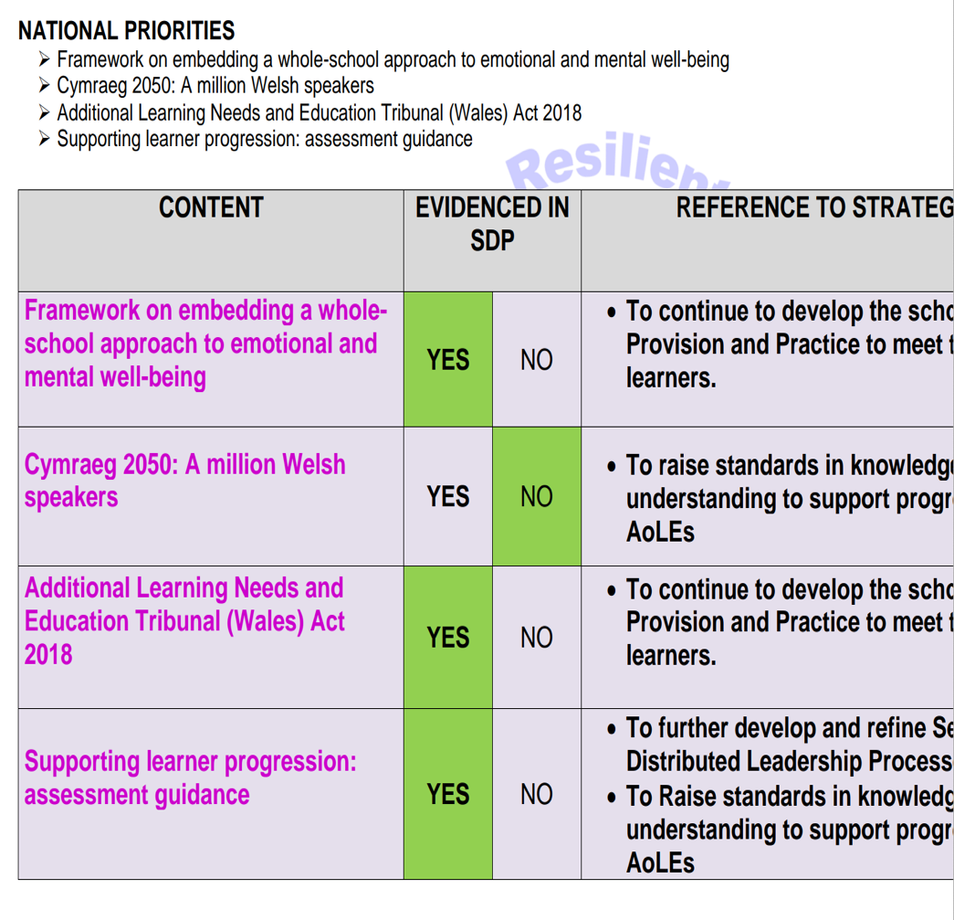
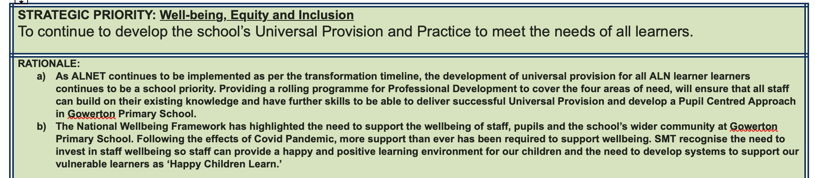
Appendix A- SDP priority 2

Appendix B- Chosen aspect (New ALN Act 2018)

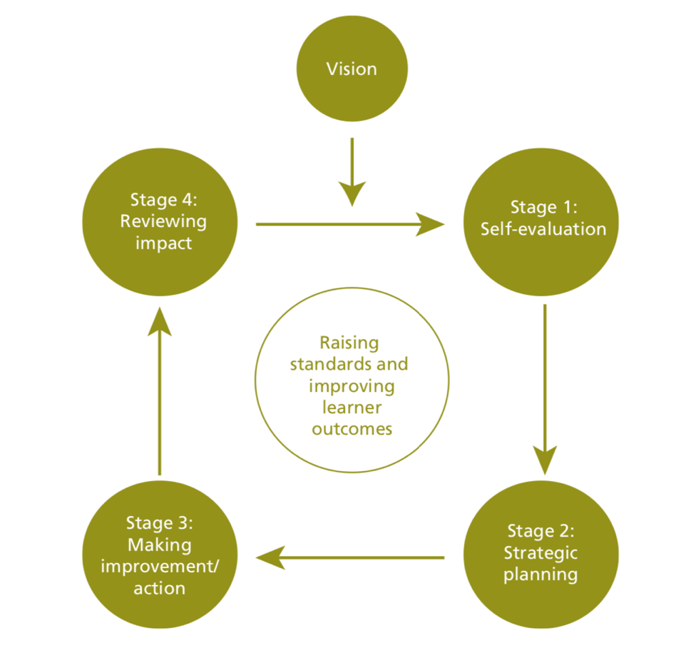
Appendix C- School improvement A cyclical system

