ASP.NET Web Development
  - Name: Ruaidhri Cook
  - Student Number: P148970
  - Module: Web Development
  - Lecturer: Kemi Ademoye

Contents
Introduction 3
Implementation 3
Description 3
Requirements - MoSCoW 3
Must have 3
Should have 3
Could have 3
Won’t have 4
Requirements - Revisited 4
Screenshots of the pages 4
Index Page 4
Search Page 5
Dog Profile page 5
5
Login Screen 6
6
Register Screen 6
6
7
Edit Dog Screen (Zoomed Out) 7
7
Evaluation 8
Testing 8
Evaluation of Application 8
Design 8
Functionality 8
Content 9
Improvements 9
Bibliography 10

Introduction
This report will first explain what the purpose of the Web application is, its target audience and the relevance of the application will be explored. In addition to this, requirements of the application will be identified and discussed, using the MoSCoW method. These requirements that were identified will then be examined retroactively and compared with the final functions of the web application. This report will also present what the application actually looks like when it is being run. Following this the application will be evaluated, including a discussion about how the application has been designed, its content and its functionality. Moreover, improvements for the application will be identified which could be used for any future changes.

Implementation

Description
The web application is for a dog shelter/adoption centre called Adopt-A-Dog, its primary purpose is so the dog shelter can showcase all the dogs it has in its care, in addition the application has a second purpose which allows people to pay for and reserve a dog from the shelter, so it can be picked up in person. The target audience for this application is very broad and would not fit a specific demographic other than those who like dogs or are interested in adopting a dog. This application is relevant because in an increasingly electronic world it is important for a charity to have an online presence, moreover it will also increase the knowledge about the charity which could lead to more of their dogs being adopted or an increase in donations.

Requirements - MoSCoW
The requirements will use the MoSCoW method, this stands for; Must have, Should have, Could Have, Won’t Have.

Must have
- A database containing all of the dogs at the shelter
- An Index page showcasing the dogs
- Individual pages for each dog with information about it

Should have
- Pictures of the dogs both on the index page and on their individual pages
- A database of Users
- A database of Adoption Transactions
- A Login & Registration page
- A page and system for reservations and payment for the dogs
- Remote editing, creating and deletion of dogs in the database
- Remote editing, creating and deletion of users in the database
- Remote editing, creating and deletion of adoption transactions in the database
- Security controls to prevent non-admins from altering the databases

Could have
- A video of each dog on their individual pages
- A search function to search for dogs by name, breed and colour

Won’t have
- A message board

Requirements - Revisited
The application created did fit the primary function, and it met all of the ‘must have’ requirements. This means that the database of dogs was successfully implemented, this was also coupled with it being connected to the website which allowed for the other must have requirements to be met.
The application did not meet all of the ‘should have’ requirements, however it did meet the majority. This meant that the website had pictures of each of the dogs on their separate profiles, as well as a login and registration system which allowed admins, and only admins, the ability to create and edit dogs. The remote deletion feature could not be implemented nor could the remote access features for the two other databases. In addition to this the system to pay and reserve dogs could also not be implemented.
Of the two requirements in the ‘could have’ section only one was partially successfully implemented, this was the search function however it was only able to search by dog name and could not search any other parameters. The other requirement was a video of each dog on their profile which could not be added.
The final MoSCoW requirement was a message board which was rightly put in the ‘won’t have’ section and was not implemented into the application.

Screenshots of the pages

Index Page
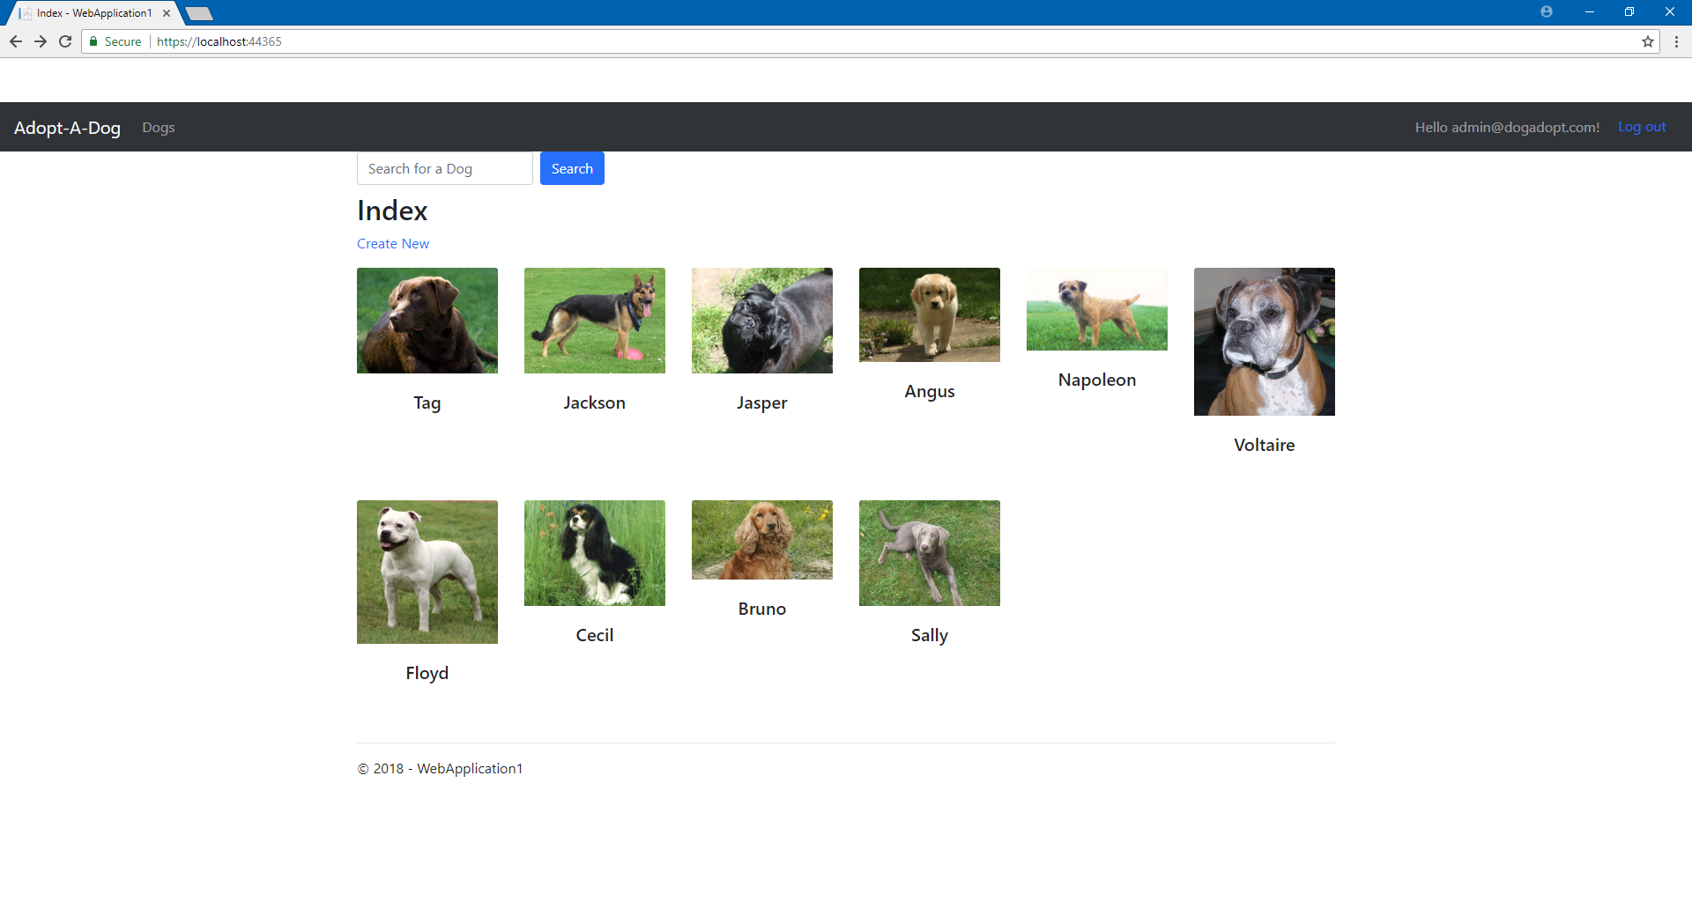

Search Page
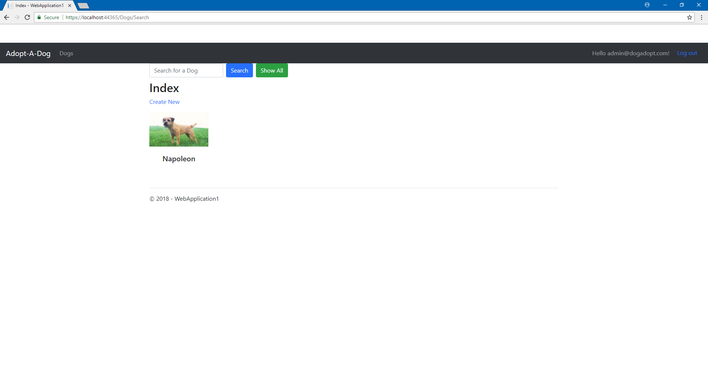

Dog Profile page

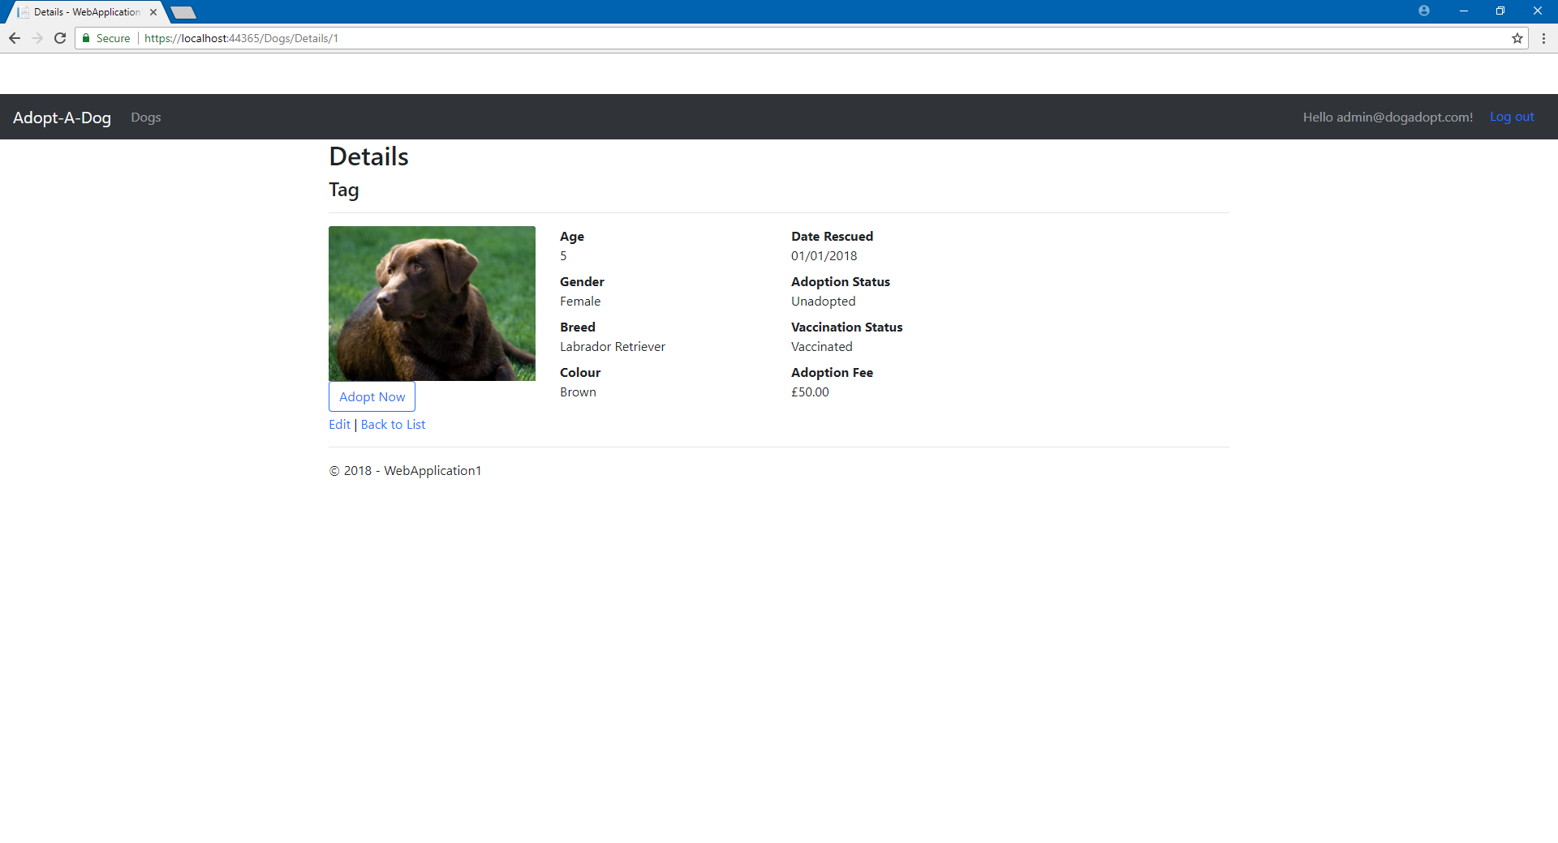

Login Screen

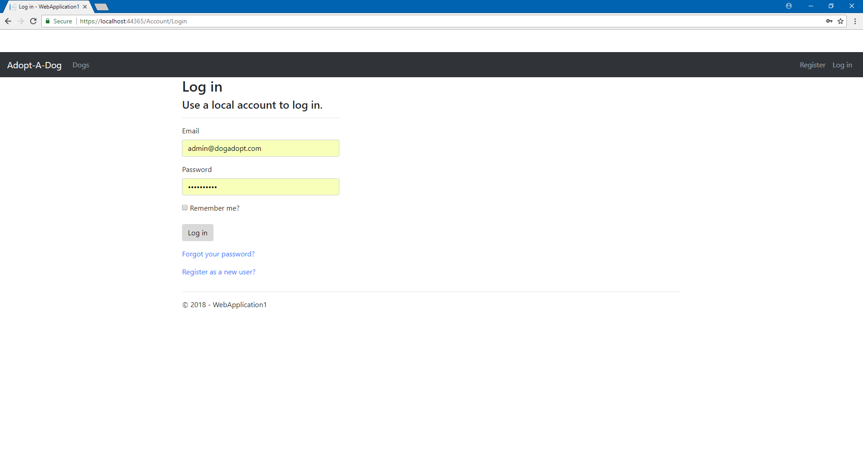

Register Screen

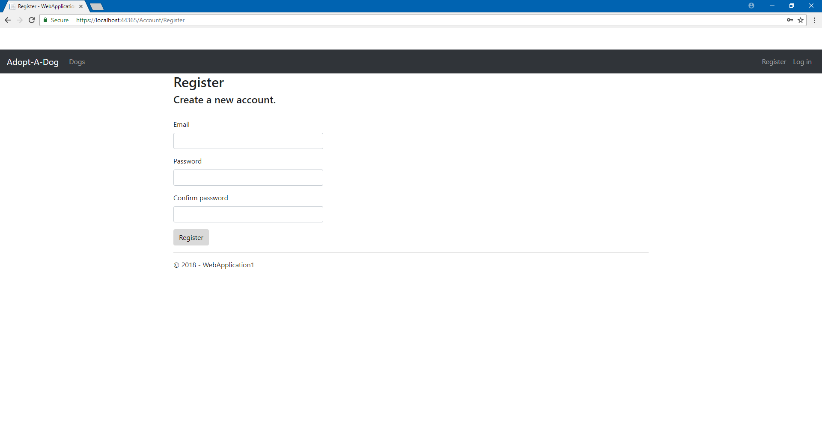

Create New Dog Screen (Zoomed Out)

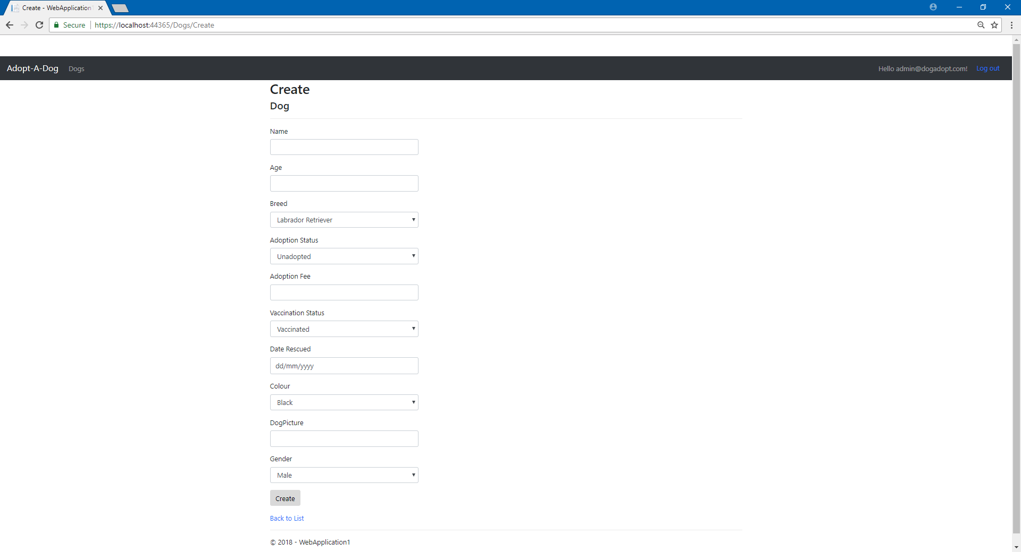

Edit Dog Screen (Zoomed Out)

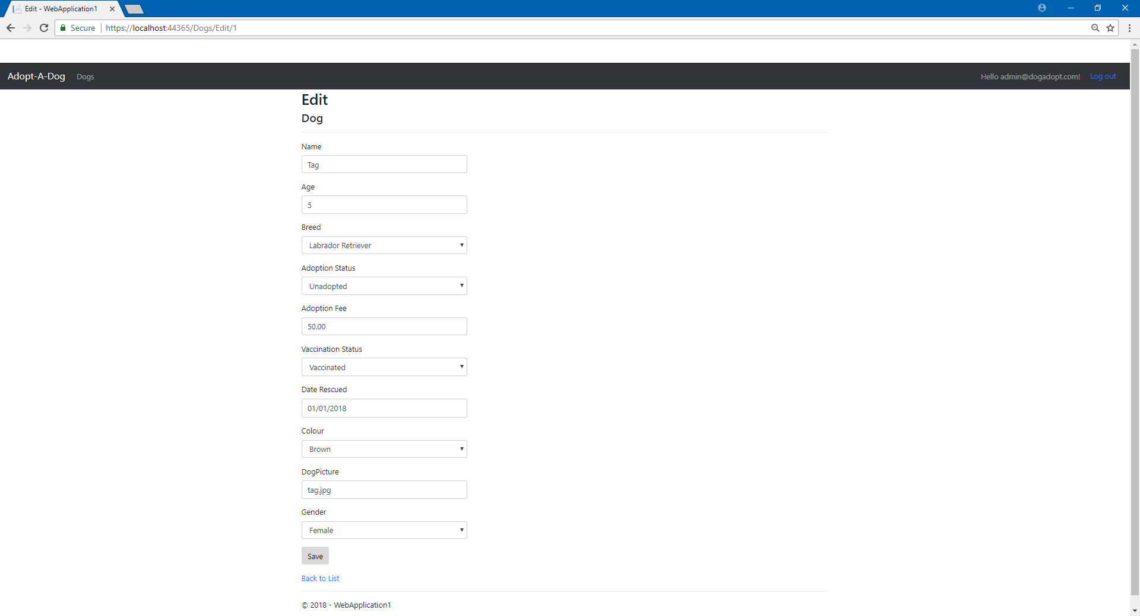

Evaluation

Testing
The application was tested in a number of different ways to identify what features actually worked. The first part that was tested was the data in the database itself, this testing was done firstly by opening up the SQL Server Object explorer. This allows the database to be viewed so that the tables in the database could be verified as present, in addition to this further checks could be made by viewing the data in the individual tables to make sure all the data that was supposed to be in there was in there. Other testing that was done was on the search feature, to ensure it worked the name of some dogs in the database were searched, if the dogs that were searched came up then the function must have worked. Other testing that was done was testing the edit function for the dogs, this was done by editing the data through the web application and seeing if the data was then displayed differently on the details page. Other testing that was done was checking if the login system worked and if that also implemented the correct security controls for editing or creating dogs. This feature was tested by using the login information that had been added to the database earlier, to ensure login was successful the top right corner of the website would be looked at, if it showed the ‘Hello <user>!’ message it would suggest that the user had been successfully logged in. This was further tested by clicking the ‘create New’ button which would display the appropriate security message based upon the privileges granted to the user.
The application did suffer from some challenges for the implementation, namely these were the inability to add the function that allowed for the dog to be adopted, despite the functions being partially added the ‘Adopt Now’ button would not work despite it being seemingly configured correctly so it would execute the methods detailed in the AdoptionCertificateContoller.
As a result of this error, the parts in the Controller which relied on the signal sent by the button could not be tested and thus it was impossible to know if they actually worked. The application also had a hurdle when migrating the database, the was the fact that in the appsettings.json the DefaultConnection had autoset the server to ‘mssqllocaldb’ rather than ‘MSSQLLocalDB’ which was something that had to be successfully identified and changed.

Evaluation of Application

Design
The design for this application was specifically made with the target audience in mind, for this reason non-gendered colours were used that would not show bias towards a certain group. The neutrality of the website would make it so that the website was suitable to use for any demographic. The design did have some problems however, the first of these was the white strip above the navigation bar which looks odd and out of place and has a negative effect on the aesthetic. In addition to this the images used on the index page of the different dogs were all different sizes and thus the look of each did not look uniform and looked unprofessional, which could cause a negative opinion of the dog shelter. Another problem with the design was the lack of padding around the search button on the front page and the adopt no button on the details page which did take away from the aesthetic of the pages.

Functionality
The application did have limited functionality because of some elements that could not be implemented, however the features that were included did function correctly and would have been easy for the user to operate. In comparison with the primary purpose of the application as detailed in the description, the website functions as it is supposed to and incorporates the key features of a gallery to showcase the dogs (Index page) and it also has a page where the dogs can be viewed in detail, moreover new dogs were able to be added to the database which would be essential for the admins of the page. The search bar did only have functionality as it was only able to search for the name of dogs.

Content
The page contained all the relevant information for each dog which would make the website very useful for anyone looking to adopt one of the dogs from the site as they would have the full information about the dog. With this said there was some serious information lacking, for instance there was no about page for the website to explain what it actually is, moreover there is no identifying information for the site that would tell a user where the dog shelter actually is. In addition to this there was also no information on how to actually operate the site or what each pages actually do.

Improvements
If this application was to be done again an information page actually detailing the purpose of the site would be essential as the site in its current form is vague and perhaps unsuitable for an actual business to use. In addition to this, tweaks to the aesthetic must be made so it looks more professional. The most vital improvement if this application was to be improved upon would be the correct implementation of the pay and reserve system.

Bibliography

[1] | Cupe International, “Moscow Prioritisation,” [Online]. Available: https://www.cupe.co.uk/moscow-prioritisation.html. [Accessed 1 May 2018].

marking criteria and Student FEEDBACK

This section details the assessment criteria. The extent to which these are demonstrated by you determines your mark. The marks available for each criterion are shown. Lecturers will use the space provided to comment on the achievement of the task(s), including those areas in which you have performed well and areas that would benefit from development/improvement.

Common Assessment Criteria Applied (Assignment 1) | Marks available | Marks  awarded
1. Research-informed Literature
Extent of research and/or own reading, selection of credible sources, application of appropriate referencing conventions.
There is some basic evidence of references consulted. Expand the scope of references consulted to improve the quality of your work. (Grade mark: 20.00%) | 5 | 1
2. Knowledge and Understanding of Subject
Extent of knowledge and understanding of concepts and underlying principles associated with the discipline.
Demonstrates a very good understanding of server-side coding with ASP.NET, but there is room for improvement and I would have liked to see some more functionality added. Simple, but good database design. (Grade mark: 60.00%) | 15 | 9
3. Analysis
Analysis, evaluation and synthesis; logic, argument and judgement; analytical reflection; organisation of ideas and evidence
Very good set of practical requirements for the chosen web application, with very good use of the MoSCoW prioritisation technique. Very good discussion of the challenges faced. You have also provided a good evaluation of the implemented application. (Grade mark: 72.00%) | 25 | 18
4. Practical Application and Deployment
Deployment of methods, materials, tools and techniques; application of concepts; formulation of innovative and creative solutions to solve problems.
A good attempt featuring a simple application. Your "Adopt Now" button did not work because the button was not enclosed within a <form> element. See your report for details. Also note that you could have contacted your tutor during working hours for assistance. The main area for improvement is enhancing the functionality of the application. (Grade mark: 65.00%) | 50 | 32.5
5. Skills for Professional Practice
Attributes in professional practice: individual and collaborative working; deployment of appropriate media; presentation and organisation.
The report is of a good standard, but note the difference between "its" and "it's". See your report for more details. (Grade mark: 70.00%) | 5 | 3.5

Assignment Mark (Assessment marks are subject to ratification at the Exam Board. These comments and marks are to give feedback on module work and are for guidance only until they are confirmed. ) | Late Submission Penalties (tick if appropriate) |  | 64%
 | Up to one week late |  | 64%
 | 1st/2nd/3rd attempt? |  | 64%

