

Perceptions of Carbohydrate Intake and Exercise Performance Among Regularly Active Adults

Oliver Karl Goble (2304524)

MSc Sport and Exercise Nutrition

University of Wales Trinity Saint David

- Table of Contents

Abstract

1. Introduction
  - Nutrition information, social media
  - Research Gap
  - Research rationale, aim and objectives

2. Literature Review
2.1 Search Strategy
2.2 Carbohydrates
2.3 Carbohydrate metabolism and exercise
2.4 Carbohydrate intake and exercise performance
2.5 Low-carbohydrate diets and exercise
2.6 Perceptions of carbohydrates
2.7 Nutrition information sources and social media
2.8 Research gap and rationale

3. Methodology
3.1 Research philosophy and approach
3.2 Study design
3.3 Participants
3.4 Recruitment and consent
3.5 Questionnaire development
3.6 Pilot testing
3.7 Reliability and validity
3.8 Ethical considerations
3.9 Data collection procedure
3.10 Statistical analysis
3.11 Methodological limitations
3.12 Study Timeline

4. Results
4.1 Participant characteristics
4.2 Carbohydrate beliefs
4.3 Differences in negative carbohydrate beliefs
4.4 Exercise characteristics and negative carbohydrate beliefs
4.5 Associations with negative carbohydrate beliefs

5. Discussion
5.1 Overview of findings
5.2 Nutrition education and carbohydrate beliefs
5.3 Nutrition information sources and carbohydrate beliefs
5.4 Exercise characteristics and carbohydrate beliefs
5.5 Strengths and limitations
  - Practical implications and future research

6. Conclusion

References

Appendices
Appendix A – Ethics Approval
Appendix B – Final Questionnaire
Appendix C - Anonymised Questionnaire Response Data

DECLARATION FORM

Master’s Degrees by Examination and Dissertation Declaration Form

- This work has not previously been accepted in substance for any degree and is not being concurrently submitted in candidature for any degree.

Signed: O.Goble

Date: 25/09/26

- This dissertation is being submitted in partial fulfilment of the requirements for the degree of MSc Sport and Exercise Nutrition.

Signed: O.Goble

Date: 25/09/26

- This dissertation is the result of my own independent work / investigation, except where otherwise stated.

Other sources are acknowledged by explicit references. A bibliography is appended.

Signed (candidate): O.Goble

Date: 25/09/26

- I hereby give consent for my dissertation, if accepted, to be available for photocopying, inter-library loan, and for deposit in the University’s digital repository.

Signed (Candidate): O.Goble

Date: 25/09/26

Supervisor’s Declaration.

I am satisfied that this work is the result of the student’s own efforts.

Signed: ………………………………………

Dated: ………………………………………….

- Abstract

Introduction: Carbohydrates have an established role in supporting exercise performance, particularly during prolonged and high-intensity activity (Thomas, Erdman and Burke, 2016). However, conflicting nutrition information, the popularity of low-carbohydrate diets and concerns surrounding weight and body composition may influence how carbohydrates are perceived by physically active individuals. This study aimed to investigate perceptions of carbohydrate intake and exercise performance among regularly active adults, with consideration given to nutrition education, sources of nutrition information and exercise characteristics.

Method: A quantitative, cross-sectional design was used, with data collected through an online questionnaire using Microsoft Forms. The final sample consisted of 81 adults who participated in structured exercise at least three times per week. Questionnaire responses were analysed using descriptive statistics, independent samples t-tests, one-way analysis of variance and Spearman’s rank-order correlations.

Results: Participants generally demonstrated positive perceptions towards carbohydrates, with a mean negative carbohydrate belief score of 2.20 ± 0.73 and a mean positive belief score of 4.38 ± 0.71. Negative carbohydrate belief scores were significantly lower among participants who had received formal nutrition education (p = .005) and those who used academic or scientific sources for nutrition information (p < .001). In contrast, participants who used social media as a nutrition information source reported significantly higher negative belief scores (p = .038). Negative beliefs also differed according to primary exercise type (p = .030) and weekly exercise frequency (p = .001). Greater weekly exercise frequency was associated with lower negative carbohydrate belief scores (rₛ = −.375, p < .001).

Conclusion: Overall, regularly active adults generally held positive perceptions of carbohydrates, although negative beliefs remained within the sample. Nutrition education, information sources and exercise behaviours were associated with these perceptions. The findings highlight the potential value of accessible, evidence-based and appropriately contextualised carbohydrate information for physically active populations.

Keywords: carbohydrate, carbohydrate beliefs, exercise performance, nutrition education, nutrition information, physically active adults

iii) List of Tables

Table 1. Participant characteristics of the study sample (N = 81) ................................ 28

Table 2. Negative carbohydrate belief scores according to nutrition education and information sources ................................ 29

Table 3. Negative carbohydrate belief scores according to exercise characteristics ................................ 30

Table 4. Spearman’s rank-order correlations with negative carbohydrate beliefs ................................ 31

iv) List of Figures

Figure 1. Timeline of the study from questionnaire development to interpretation of findings ................................ 39

- Introduction

Nutrition plays an important role in supporting health, physical activity and exercise performance. For individuals who regularly participate in exercise, nutritional requirements may vary according to factors such as training frequency, intensity, duration and individual goals. Appropriate energy and macronutrient intake can support training demands, recovery and adaptation, while inadequate nutritional intake may compromise the ability to perform and recover effectively. Within sports and exercise nutrition, carbohydrates have traditionally been recognised as an important dietary energy source, particularly during moderate to high-intensity exercise where reliance on carbohydrate metabolism increases (Hearris et al., 2018). Consequently, sports nutrition recommendations generally support adjusting carbohydrate intake according to the demands of training and competition rather than applying a single recommendation across all individuals (Thomas et al., 2016).

Carbohydrates are stored primarily as glycogen within skeletal muscle and the liver and can also be made available through circulating blood glucose. During exercise, these carbohydrate sources contribute towards adenosine triphosphate production and become increasingly important as exercise intensity rises (Hearris et al., 2018). Reductions in muscle glycogen during prolonged or demanding exercise may contribute to fatigue and a reduced ability to maintain exercise intensity, while carbohydrate intake before and during appropriate forms of exercise can support carbohydrate availability and performance. Carbohydrate intake following exercise can also contribute to glycogen restoration, which may be particularly relevant when recovery time between training sessions is limited (Burke, van Loon and Hawley, 2017). However, carbohydrate requirements are highly dependent on the demands of the activity, meaning that recommendations developed for endurance athletes or high-volume training cannot necessarily be directly applied to recreational exercise.

Despite the established physiological role of carbohydrates, public perceptions surrounding carbohydrate consumption remain varied. Low-carbohydrate dietary approaches have received considerable attention for weight management, metabolic health and other health outcomes. However, even within the scientific literature, there is variation in how a low-carbohydrate diet is defined. A recent scoping review of 508 clinical studies found that definitions varied considerably, although ≤30% of total energy intake and intakes below approximately 100 g per day were commonly used thresholds (Chacon et al., 2025). This variation illustrates some of the difficulty involved in communicating carbohydrate recommendations, as the term 'low carbohydrate' itself can represent substantially different dietary intakes.

Importantly, evidence that carbohydrate-restricted diets may be appropriate in certain contexts does not demonstrate that carbohydrates are inherently detrimental to health, weight management or exercise performance. Nevertheless, beliefs surrounding weight gain and health may influence an individual's decision to restrict carbohydrate intake. Churuangsuk et al. (2020) found that low-carbohydrate dietary behaviour within a UK population was associated with a combination of knowledge, beliefs and expected health outcomes. Within athletic environments, similar concerns have been reported. McHaffie et al. (2022) identified confusion surrounding fuelling alongside concerns about carbohydrate intake, weight gain and body composition within elite female football. Therefore, an individual may recognise carbohydrate as a source of energy for exercise while simultaneously holding negative beliefs regarding its effects on body composition or health.

This may be particularly relevant among regularly active adults. Recreationally active individuals may not have routine access to qualified sports nutrition support, despite making dietary decisions intended to improve performance, health or physical appearance. Their understanding of carbohydrates may therefore develop through a combination of personal experience, formal education and information obtained from online platforms, social media, health professionals or fitness professionals. Understanding these perceptions is important because beliefs surrounding carbohydrates may potentially influence dietary decisions and subsequent fuelling practices.

  - Nutrition information, social media

The way individuals access nutrition information has changed considerably with the increased use of digital and social media platforms. Nutrition advice is now widely available through social media, websites, podcasts and other online sources, alongside more traditional sources such as health professionals, coaches and academic literature. This increased accessibility can be beneficial, particularly for recreationally active individuals who may not have regular access to qualified nutrition support. However, the quality and accuracy of online nutrition information can vary substantially. Denniss et al. (2023) identified considerable variation in the quality of nutrition information available through websites and social media, with almost half of the studies included in their systematic review classifying the information assessed as low-quality or inaccurate.

Social media appears to be particularly relevant within physically active populations. Bourke et al. (2019) found that 65% of athletes surveyed had used social media for nutrition purposes during the previous 12 months, with recreational athletes more likely to use social media for nutrition than elite athletes. Participants valued the accessibility and presentation of information but also identified reliability as an important concern. More recently, Nath et al. (2024) highlighted the potential influence of social media on athletes' food choices, supplement use, body image and dietary approaches, including ketogenic diets. The authors also raised concerns regarding the credibility of nutrition information provided by influencers and other online sources.

This is relevant when considering carbohydrate perceptions because carbohydrate recommendations are more complex than simply encouraging high or low intake. Requirements differ according to exercise duration, intensity, training volume and individual goals (Thomas et al., 2016). Simplified online messages may therefore fail to communicate the context required to apply sports nutrition recommendations appropriately. Messages promoting carbohydrate restriction for weight loss or improved body composition may be particularly influential among individuals who exercise for both performance and appearance-related goals. At the same time, social media should not automatically be considered an unreliable source. Evidence-based practitioners and professional organisations can also use these platforms to communicate nutrition information, meaning that the credibility of the source may be as important as the platform itself.

Nutrition knowledge represents another consideration. Previous research has demonstrated considerable variation in sports nutrition knowledge among athletes and coaches (Trakman et al., 2016). An updated systematic review by Janiczak et al. (2022) similarly concluded that nutrition knowledge among athletes was generally limited, although substantial variation in the measurement tools used made comparisons between studies difficult. The review also identified weak-to-moderate positive associations between nutrition knowledge and positive dietary behaviours. This suggests that improving nutrition understanding may contribute to dietary behaviour, although knowledge alone is unlikely to explain food choices.

Importantly, nutrition knowledge and nutrition beliefs are not the same construct. An individual may understand that carbohydrate contributes to exercise performance while simultaneously believing that carbohydrate consumption promotes weight gain or should be restricted. Existing research has frequently examined factual sports nutrition knowledge, dietary intake or specific athletic populations rather than exploring broader perceptions of carbohydrate among regularly active adults. This leaves uncertainty regarding how this population views carbohydrates in relation to performance, energy, health and body composition, and whether these perceptions differ according to nutrition education, information sources or exercise characteristics. Addressing this gap may help identify where misconceptions remain and provide greater understanding of the factors associated with carbohydrate beliefs among individuals who regularly exercise.

  - Research Gap

Despite extensive research examining carbohydrate requirements and exercise performance, comparatively less is known about how carbohydrates are perceived among the wider regularly active population. Existing research has commonly focused on athletes, specific sporting populations or factual sports nutrition knowledge. For example, research within elite female football has identified concerns surrounding carbohydrate intake, weight gain and body composition (McHaffie et al., 2022), while research within a UK adult population has demonstrated that attitudes and beliefs can influence decisions to follow low-carbohydrate diets (Churuangsuk, Lean and Combet, 2020). However, these findings do not fully explain how regularly active adults participating in a range of exercise types perceive carbohydrates in relation to their own exercise performance.

There also appears to be limited research examining whether carbohydrate beliefs differ according to nutrition education, sources of nutrition information and exercise characteristics within the same regularly active population. Addressing this gap may provide greater understanding of the factors associated with carbohydrate perceptions among active adults and help inform future nutrition education and communication.

  - Research rationale, aim and objectives

Although the physiological role of carbohydrates within exercise has been extensively researched, less attention has been given to how this information is understood and perceived by regularly active adults. Existing evidence demonstrates that carbohydrate availability can support exercise performance, particularly during prolonged and high-intensity activity, while requirements vary considerably according to the demands of the exercise being performed (Hearris et al., 2018; Thomas et al., 2016). However, evidence-based recommendations exist alongside widespread messages promoting carbohydrate restriction for weight management, health and body composition. This creates an environment in which individuals may be exposed to conflicting information regarding the value of carbohydrates within an active lifestyle.

Previous research provides evidence that carbohydrate misconceptions exist, but much of this work has focused on specific populations. McHaffie et al. (2022), for example, identified concerns surrounding carbohydrate intake and body composition within elite female football, while Sampson et al. (2023) demonstrated substantial gaps in carbohydrate knowledge among endurance athletes. Research within the wider UK population has also shown that beliefs regarding health and weight loss can contribute to decisions to follow low-carbohydrate diets (Churuangsuk et al., 2020). Collectively, these studies demonstrate that carbohydrate knowledge and beliefs can vary considerably. However, findings from elite athletes, endurance populations or the general public cannot necessarily explain how carbohydrates are perceived by adults who regularly exercise across a range of training types.

There is also a need to consider the wider factors that may be associated with these perceptions. Regularly active adults may obtain nutrition information from social media, academic sources, health professionals, coaches and other sources, all of which may differ in their quality and credibility. Similarly, individuals with formal nutrition education or different levels of exercise participation may have different experiences of carbohydrates and exercise fuelling. Examining these factors alongside carbohydrate beliefs may provide greater understanding of why perceptions differ between individuals rather than simply identifying whether knowledge is correct or incorrect.

Aim
The present study aimed to investigate perceptions of carbohydrate intake and exercise performance among regularly active adults.

Objectives
The objectives of the study were to:
- Examine positive and negative beliefs surrounding carbohydrate in relation to exercise performance, energy, health, weight and body composition.
- Investigate whether negative carbohydrate beliefs differed according to formal nutrition education and sources of nutrition information.
- Examine whether negative carbohydrate beliefs differed according to exercise characteristics, including primary exercise type, weekly exercise frequency and training experience.
- Examine whether perceived reliability of nutrition information, weekly exercise frequency and training experience were associated with negative carbohydrate beliefs.

By examining these factors within a broader regularly active population, the study aimed to contribute to the existing evidence surrounding carbohydrate perceptions and identify areas that may be relevant to future nutrition education and communication.

2.0 Literature Review

Research has established an important role for carbohydrate availability within exercise metabolism and performance, particularly during prolonged endurance and high-intensity exercise (Thomas, Erdman and Burke, 2016; Hearris et al., 2018). However, the importance of carbohydrates is influenced by factors including exercise type, duration and intensity, with findings being less consistent within some exercise contexts, including resistance training and lower-intensity exercise. Research has also examined low-carbohydrate dietary approaches in relation to weight management, body composition and exercise performance.

This literature review will examine the role of carbohydrates in exercise metabolism and performance, evidence surrounding low-carbohydrate diets and carbohydrate restriction, and perceptions and beliefs surrounding carbohydrate intake. Consideration will be given to nutrition knowledge, sources of nutrition information and the potential role of social media. The review will then consider the current gap in research concerning carbohydrate perceptions among regularly active adults participating in a range of exercise types.

Carbohydrates are recognised as an important dietary energy source and have a well-established role within sports and exercise nutrition. During exercise, carbohydrate availability can contribute to energy production through the utilisation of blood glucose and stored muscle glycogen, particularly as exercise intensity increases. Consequently, sports nutrition guidelines have traditionally recommended that carbohydrate intake is adjusted according to the demands, duration and intensity of exercise (Thomas et al., 2016). However, despite the established physiological role of carbohydrates, attitudes towards their consumption have become increasingly varied. The popularity of low-carbohydrate diets, concerns surrounding weight gain and exposure to conflicting nutrition information may contribute to uncertainty regarding whether carbohydrates are beneficial or detrimental to health, body composition and exercise performance.

This is particularly relevant among regularly active adults, who may make dietary decisions with the intention of improving performance, physical appearance or general health without necessarily having access to professional nutrition support. Although considerable research has investigated carbohydrate requirements and their effects on athletic performance, the evidence is not equally applicable across all exercise situations. The importance of carbohydrate availability varies according to factors such as exercise intensity, duration, training status and the nutritional state of the individual. This creates a more complex picture than the generalised messages surrounding carbohydrates that may be communicated to the public.

The way nutrition information is accessed may further influence these perceptions. Social media and online platforms provide widespread access to dietary information, but the quality and accuracy of this information can vary considerably. A systematic review by Denniss et al. (2023) found that online nutrition information was frequently of low quality or accuracy, highlighting the potential for individuals to be exposed to misleading dietary information. This may be particularly important within fitness communities, where nutritional advice relating to fat loss, body composition and performance is commonly shared.

This literature review will therefore examine the physiological role of carbohydrates during exercise, the relationship between carbohydrate intake and different forms of exercise performance, and the evidence surrounding carbohydrate restriction. It will then consider perceptions and misconceptions surrounding carbohydrates, alongside the potential influence of social media and other sources of nutrition information. Finally, the existing evidence will be evaluated to identify the rationale for investigating carbohydrate perceptions among regularly active adults.

2.1 Search Strategy

Literature was identified using Google Scholar. Search terms were selected according to the main themes of the review and included combinations of keywords such as “carbohydrate intake”, “exercise performance”, “carbohydrate availability”, “low-carbohydrate diet”, “carbohydrate beliefs”, “carbohydrate perceptions”, “nutrition knowledge”, “nutrition information” and “social media”. Boolean operators such as “AND” and “OR” were used where appropriate to combine search terms and refine the literature identified. Emphasis was placed on peer-reviewed research relevant to exercise performance, carbohydrate perceptions and physically active populations. Reference lists of relevant articles were also reviewed to identify additional literature where appropriate.

2.2 Carbohydrates

Carbohydrates are a major dietary macronutrient and can be classified according to their chemical structure into sugars, oligosaccharides and polysaccharides. This includes monosaccharides such as glucose and fructose, disaccharides such as sucrose and lactose, and more complex carbohydrate structures including starch (Cummings and Stephen, 2007). Dietary carbohydrates are found across a wide range of foods, including grains, cereals, fruits, vegetables, legumes and dairy products.

Following digestion, available carbohydrates are broken down into monosaccharides and absorbed, with glucose providing an important substrate for energy metabolism. Glucose can be used directly for energy or stored as glycogen, predominantly within skeletal muscle and the liver. Muscle glycogen provides an important fuel source during exercise, with its utilisation increasing as exercise intensity rises (Murray and Rosenbloom, 2018; Hearris et al., 2018).

2.3 Carbohydrate Metabolism and its Role During Exercise

Muscle glycogen provides a locally available source of glucose for contracting muscle, while liver glycogen contributes towards the maintenance of blood glucose concentrations during exercise (Hearris et al., 2018). The contribution of these carbohydrate sources is influenced by several factors, including exercise intensity, duration, training status and carbohydrate availability (Hearris et al., 2018).

During exercise, adenosine triphosphate (ATP) is required to provide energy for muscular contraction. As ATP stores within skeletal muscle are limited, ATP must continually be regenerated through metabolic pathways using available substrates, predominantly carbohydrates and fats. Although both substrates can contribute considerably to energy production, their relative contribution changes according to exercise intensity. At lower intensities, fat oxidation can provide a greater proportion of energy requirements, whereas reliance on carbohydrate metabolism generally increases as exercise intensity rises (Hearris et al., 2018). Carbohydrates therefore become particularly important during moderate- to high-intensity exercise, where the requirement for rapid ATP production increases.

Muscle glycogen represents an important carbohydrate source during both prolonged and high-intensity exercise. The rate of glycogen breakdown increases with exercise intensity, meaning that demanding exercise can substantially reduce muscle glycogen availability (Murray and Rosenbloom, 2018). This relationship has been demonstrated across a considerable body of research. Areta and Hopkins (2018), for example, conducted a meta-analysis of 181 studies examining skeletal muscle glycogen concentrations during endurance exercise. Exercise duration and intensity were both associated with changes in muscle glycogen, supporting the importance of glycogen as an energy source across different exercise conditions.

As exercise continues, reductions in glycogen availability can influence the ability to maintain exercise intensity. Low muscle glycogen concentrations have traditionally been associated with fatigue during prolonged endurance exercise, which provides part of the rationale for carbohydrate intake before and during prolonged activity (Hearris et al., 2018). However, the relationship between glycogen availability and performance should not be considered in isolation. Exercise performance is influenced by multiple physiological and psychological factors, and carbohydrate requirements vary considerably according to the demands of the activity. Therefore, high-carbohydrate availability is unlikely to be equally important for every exercise session or individual.

Carbohydrates consumed during exercise can also provide an external source of glucose, reducing reliance on endogenous carbohydrate stores and helping to maintain carbohydrate oxidation during prolonged activity (Burke et al., 2018). This becomes increasingly relevant as exercise duration increases and endogenous glycogen availability declines. Burke et al. (2018) highlighted that manipulating carbohydrate availability before and during exercise can substantially alter substrate utilisation and may subsequently influence endurance performance. This supports the current approach within sports nutrition of matching carbohydrate availability to the demands of a particular training session or competition rather than recommending consistently high carbohydrate intake regardless of exercise demands.

Carbohydrate availability is also important following exercise. Exercise can substantially reduce muscle glycogen concentrations, particularly following prolonged or high-intensity activity, and carbohydrate consumption during recovery supports glycogen resynthesis. Burke, van Loon and Hawley (2017) identified both carbohydrate availability and the recovery period between exercise sessions as important factors influencing glycogen restoration. This may be particularly relevant for individuals completing multiple training sessions within a short period, where insufficient recovery of glycogen stores could affect the ability to perform subsequent high-intensity exercise.

However, the role of muscle glycogen extends beyond simply providing fuel for exercise. Research suggests that glycogen availability may also influence cellular signalling pathways involved in adaptations to exercise training (Hearris et al., 2018). Consequently, deliberately completing selected training sessions with reduced carbohydrate availability has received attention as a potential strategy for promoting some endurance training adaptations. Impey et al. (2018) proposed the concept of matching carbohydrate availability to the work required, whereby carbohydrate intake is adjusted according to the objectives and intensity of individual training sessions. This challenges the traditional view that high carbohydrate availability should be maintained at all times.

Overall, carbohydrate metabolism has an important role in supporting exercise, particularly when the intensity or duration of activity creates a substantial demand for muscle glycogen and blood glucose. However, carbohydrate requirements are not fixed and should be considered in relation to the type of exercise being performed. Understanding this distinction is important when examining perceptions of carbohydrates among regularly active adults, as general beliefs that carbohydrates are either universally necessary or detrimental may fail to reflect the more individualised role of carbohydrate availability within exercise nutrition.

2.4 Carbohydrate Intake and Exercise Performance

The relationship between carbohydrate intake and exercise performance has received considerable attention within sports nutrition research. As discussed previously, carbohydrate provides an important substrate during moderate and high-intensity exercise, meaning that carbohydrate availability may influence an individual's ability to maintain exercise intensity and delay fatigue (Thomas, Erdman and Burke 2016; Hearris et al., 2018). However, the extent to which additional carbohydrate improves performance is dependent on the type, intensity and duration of exercise, as well as the nutritional status of the individual (Thomas, Erdman and Burke, 2016). Therefore, the performance benefits associated with carbohydrate intake should be considered within the context of the exercise being performed rather than assuming that a higher carbohydrate intake will universally improve performance.

Endurance exercise provides some of the strongest evidence supporting carbohydrate consumption for performance. During prolonged exercise, muscle and liver glycogen stores progressively decline while blood glucose continues to contribute towards energy production. Consequently, carbohydrate consumption before and during prolonged exercise may help maintain carbohydrate availability and delay the development of fatigue. Thomas et al. (2016) recommend that carbohydrate intake should be adjusted according to the demands of training and competition, with greater carbohydrate availability generally required during prolonged or high-intensity exercise.

Evidence from controlled studies largely supports this relationship. Temesi et al. (2011) conducted a meta-analysis examining acute carbohydrate supplementation and endurance performance across 88 randomised crossover studies. Carbohydrate supplementation was associated with improvements in endurance performance, although the magnitude of the effect differed according to factors such as exercise duration, carbohydrate dose and the type of performance test used. Similarly, Pöchmüller et al. (2016) reviewed carbohydrate supplementation during endurance exercise and concluded that carbohydrate intake was generally associated with improved performance, particularly when exercise duration exceeded approximately 90 minutes. Collectively, this suggests that the ergogenic effect of carbohydrates becomes increasingly relevant as exercise duration and carbohydrate demand increase.

However, the relationship is not entirely straightforward. The performance benefit associated with carbohydrate intake can be affected by the quantity and type of carbohydrates consumed, timing of ingestion and an individual's ability to tolerate carbohydrates during exercise (Thomas, Erdman and Burke 2016; Hearris et al., 2018). Furthermore, performance improvements observed in highly trained endurance athletes cannot necessarily be directly applied to recreationally active individuals completing shorter or less demanding exercise (Thomas, Erdman and Burke, 2016). This distinction is relevant to the present study, as regularly active adults may participate in a broad range of activities that do not always require the carbohydrate strategies used by endurance athletes.

Interestingly, carbohydrates may influence performance through mechanisms beyond simply providing additional metabolic fuel. Research examining carbohydrate mouth rinsing has demonstrated that exposure to carbohydrate within the mouth may produce small performance benefits even when the carbohydrate is not swallowed. Brietzke et al. (2019) conducted a systematic review and meta-analysis and found that carbohydrate mouth rinsing produced a small improvement in mean power output during cycling time trials, although no significant improvement was observed for time to completion. This has led to the suggestion that carbohydrate receptors within the oral cavity may activate areas of the brain associated with reward and motor control. However, the relatively small effects and variation between experimental protocols mean that carbohydrate mouth rinsing should not be considered equivalent to carbohydrate ingestion during prolonged exercise.

Carbohydrate intake may also be relevant within intermittent sports such as football, rugby and other activities involving repeated periods of high-intensity exercise. These sports rely on both aerobic and anaerobic energy systems and can create substantial demands on muscle glycogen. Baker, Rollo, Stein and Jeukendrup (2015) reviewed the acute effects of carbohydrate supplementation on intermittent sports performance and reported that carbohydrate consumption generally improved intermittent high-intensity exercise capacity. However, findings were less consistent for individual outcomes such as sprint performance, jumping ability, skill, change of direction, speed and cognitive performance. This suggests that carbohydrates may help maintain overall exercise capacity during prolonged intermittent activity but do not necessarily improve every component of sporting performance.

The evidence becomes less consistent when considering resistance exercise. Carbohydrates are commonly consumed around resistance training because muscle glycogen contributes towards energy production during repeated high-intensity muscular contractions. It could therefore be assumed that increasing carbohydrate availability would improve strength and resistance training performance. However, current research does not consistently support this assumption.

Henselmans et al. (2022) systematically reviewed 49 studies examining carbohydrate intake and strength or resistance training performance. Of the studies investigating acute carbohydrate intake, most did not demonstrate an improvement in performance. Benefits appeared more likely when participants trained following a period of fasting, completed particularly high training volumes or performed exercise following glycogen depletion. The authors therefore concluded that carbohydrate intake itself is unlikely to substantially improve resistance training performance when individuals are already fed and complete workouts involving moderate training volumes.

A systematic review and meta-analysis by King et al. (2022) provides some contrasting evidence. Across 21 studies involving 226 participants, acute carbohydrate ingestion produced a significant improvement in total resistance training volume compared with placebo or control conditions. However, subgroup analysis indicated that the effect was greater when training sessions lasted longer than 45 minutes and when participants had fasted for at least eight hours. The number of maximal effort sets also influenced the effect of carbohydrate intake. These findings do not necessarily contradict Henselmans et al. (2022) but instead suggest that the benefits of carbohydrates for resistance exercise are dependent on the conditions under which training is performed.

This distinction is important when translating sports nutrition research into practical recommendations. An individual completing a moderate-volume resistance training session after consuming normal meals throughout the day may receive little immediate performance benefit from consuming additional carbohydrate immediately before or during the session. In contrast, an individual completing prolonged, high-volume training, exercising in a fasted state or beginning exercise with reduced glycogen availability may be more likely to benefit. Therefore, recommendations surrounding carbohydrates and resistance exercise should reflect training demands and existing carbohydrate availability rather than assuming that carbohydrate supplementation is always required.

The mixed findings within resistance exercise also demonstrate why perceptions of carbohydrates and performance may be difficult to interpret among regularly active adults. Individuals participating primarily in resistance training may not experience an obvious decline in performance when reducing carbohydrate intake, particularly during shorter training sessions (Henselmans et al., 2022; King et al., 2022). This personal experience could influence their wider beliefs regarding the importance of carbohydrates, despite carbohydrate availability becoming more relevant under different exercise conditions.

Overall, current evidence indicates that carbohydrate intake can support exercise performance, but the magnitude and consistency of this effect vary considerably according to the exercise performed. The evidence is strongest during prolonged endurance exercise, where maintaining carbohydrate availability can support sustained exercise capacity (Thomas, Erdman and Burke, 2016; Pöchmüller et al., 2016). Carbohydrates may also benefit prolonged intermittent exercise, although effects on individual aspects of performance are less consistent. Within resistance training, the benefits appear more dependent on training volume, session duration, fasting status and existing glycogen availability (Henselmans et al., 2022; King et al., 2022). Consequently, the scientific literature supports an individualised approach in which carbohydrate intake is matched to the demands of exercise rather than viewed as universally necessary or unnecessary. This complexity is particularly relevant when examining perceptions among regularly active adults, as simplified messages surrounding carbohydrates may fail to reflect the conditions under which carbohydrate intake is most likely to influence performance.

2.5 Low-Carbohydrate Diets and Carbohydrate Restriction

Low-carbohydrate diets have become a widely discussed approach to weight management, health and exercise nutrition. Although definitions vary between studies, these diets generally involve reducing carbohydrate intake while increasing the relative contribution of dietary fat and, in some cases, protein (Churuangsuk et al., 2020). More restrictive ketogenic diets typically reduce carbohydrate intake sufficiently to promote nutritional ketosis (Burke et al., 2017). The popularity of these approaches has contributed to debate surrounding whether carbohydrates are necessary for physically active individuals and whether restricting them may offer advantages for body composition or exercise performance (Burke et al., 2017; Churuangsuk et al., 2020).

One reason for the popularity of carbohydrate restriction is its effectiveness as a weight loss strategy. Low-carbohydrate diets are commonly defined as diets providing less than 130 g of carbohydrate per day or less than approximately 26% of total energy intake from carbohydrates (Churuangsuk et al., 2020). Silverii et al. (2022) conducted a meta-analysis of 25 randomised controlled trials comparing low-carbohydrate diets with control diets in individuals with obesity. Low-carbohydrate diets produced greater reductions in body weight at approximately three to eight months. However, significant differences were no longer observed at follow-up periods of 10 to 14 months or 18 to 30 months. This suggests that carbohydrate restriction can be an effective approach for weight loss, particularly in the shorter term, but does not demonstrate that carbohydrate consumption itself is responsible for weight gain. The longer-term reduction in differences between dietary approaches also suggests that factors such as total energy intake, adherence and individual dietary preference are likely to influence weight management outcomes.

Within exercise nutrition, low-carbohydrate and ketogenic diets have attracted interest because they substantially increase the body's capacity to utilise fat during exercise. This adaptation could theoretically be beneficial during prolonged endurance activity because endogenous fat stores are considerably greater than carbohydrate stores. However, an increased ability to oxidise fat does not necessarily result in improved exercise performance. Cao et al. (2021) conducted a systematic review and meta-analysis investigating ketogenic low-carbohydrate, high-fat diets in endurance athletes. Although these diets altered substrate utilisation, there was no significant improvement in maximal oxygen uptake, time to exhaustion or perceived exertion. This suggests that metabolic adaptation towards greater fat utilisation should not automatically be interpreted as an improvement in performance.

This distinction has also been demonstrated experimentally in highly trained endurance athletes. Burke et al. (2017) investigated elite race walkers completing three weeks of intensified training while consuming either a high-carbohydrate diet, a periodised carbohydrate diet or a ketogenic low-carbohydrate, high-fat diet. Athletes following the low-carbohydrate diet substantially increased their rates of fat oxidation. However, this was accompanied by a greater oxygen cost of exercise and no improvement in 10 km race performance. In comparison, both carbohydrate-supported groups improved race performance. These findings suggest that increasing fat oxidation may come at the expense of exercise economy when athletes are required to sustain higher exercise intensities.

Nevertheless, the effects of carbohydrate restriction should not be viewed as entirely negative. Some measures of aerobic capacity and lower-intensity exercise can be maintained following adaptation to a low-carbohydrate diet, despite potential limitations during higher-intensity exercise (Burke et al., 2017; Churuangsuk et al., 2020). Furthermore, individuals participating predominantly in lower-intensity activity may be less dependent on high-carbohydrate availability than athletes competing in prolonged events at higher intensities (Burke et al., 2017). This makes it difficult to directly apply findings from elite endurance athletes to the wider regularly active population. Differences in training status, exercise intensity and individual performance goals should therefore be considered when evaluating the potential effects of carbohydrate restriction.

A distinction should be made between chronic carbohydrate restriction and strategically completing selected training sessions with reduced carbohydrate availability. Within endurance sport, periodised carbohydrate approaches have been proposed as a method of stimulating adaptations associated with training under conditions of reduced glycogen availability while restoring carbohydrate availability for more demanding training and competition (Impey et al., 2018). Gejl and Nybo (2021) conducted a systematic review and meta-analysis examining carbohydrate periodisation and found no significant overall improvement in endurance performance compared with training under conditions of normal carbohydrate availability. Therefore, while strategically manipulating carbohydrate availability may influence physiological responses to training, there is currently limited evidence that these adaptations consistently result in superior exercise performance.

The implications of carbohydrate restriction may become more relevant during repeated high-intensity exercise. Higher-intensity exercise places a greater reliance on carbohydrate metabolism and muscle glycogen than lower-intensity activity (Hearris et al., 2018). Consequently, chronically restricting carbohydrate intake could reduce carbohydrate availability for demanding training sessions, particularly when repeated sessions are performed with limited recovery time (Burke et al., 2017; Impey et al., 2018). This provides an important distinction between an individual completing predominantly low-intensity exercise and someone regularly participating in repeated sprint, high-intensity or prolonged training. A dietary approach that is suitable for one exercise context may therefore be less appropriate for another.

Body composition represents another important reason why active individuals may choose to restrict carbohydrates. Ketogenic diets have demonstrated the potential to reduce body mass and fat mass in trained populations. However, Koerich et al. (2023) reported that while ketogenic diets may favour reductions in total body mass and fat mass, higher-carbohydrate diets tended to produce more favourable outcomes for time-trial performance, maximal strength and fat-free mass. This highlights an important distinction between body composition and exercise performance. A dietary strategy that successfully reduces body mass does not necessarily provide the optimal conditions for maintaining or improving physical performance.

The relationship between carbohydrate restriction and weight loss is particularly relevant when considering public perceptions of carbohydrates. An individual who reduces carbohydrate intake and subsequently loses weight may attribute the change directly to the removal of carbohydrates, even though several aspects of their overall diet may have changed simultaneously. For example, restricting carbohydrate-rich foods may also reduce total energy intake or change food choices more broadly. Consequently, successful weight loss while following a low-carbohydrate diet should not automatically be interpreted as evidence that carbohydrate consumption independently promotes fat gain.

Overall, low-carbohydrate diets can provide an effective dietary strategy in certain circumstances and should not be considered inherently unsuitable for physically active individuals. However, current evidence provides limited support for chronic carbohydrate restriction as a method of improving exercise performance. Increased fat oxidation does not necessarily translate into improved performance, while reduced carbohydrate availability may become increasingly disadvantageous as exercise intensity and duration increase. Equally, the effectiveness of low-carbohydrate diets for weight loss does not demonstrate that carbohydrates are uniquely responsible for increases in body fat. This distinction is particularly relevant to the present research, as positive experiences of weight loss following carbohydrate restriction may contribute to wider beliefs that carbohydrates are unhealthy, fattening or unnecessary for exercise. Understanding whether such perceptions exist among regularly active adults may therefore help identify differences between current sports nutrition evidence and beliefs surrounding carbohydrate intake.

2.6 Perceptions and Misconceptions Surrounding Carbohydrates

Despite the established role of carbohydrates within exercise nutrition, perceptions surrounding their consumption are not always consistent with current scientific evidence. Carbohydrates have frequently been associated with concerns surrounding weight gain, body fat and poor health, while low-carbohydrate diets are often promoted as an alternative approach for improving body composition (Churuangsuk, Lean and Combet, 2020). These messages may be particularly relevant among physically active individuals who are attempting to balance performance goals with a desire to maintain or improve their physique. As a result, an individual may recognise that carbohydrates provide energy for exercise while simultaneously believing that consuming too much will negatively affect their body composition.

Research within the general population suggests that beliefs surrounding carbohydrates can influence dietary behaviour. Churuangsuk, Lean and Combet (2020) investigated carbohydrate knowledge, dietary guideline awareness and beliefs associated with low-carbohydrate dietary behaviour in a UK sample. Individuals following a low-carbohydrate diet were commonly motivated by weight loss and perceived health benefits, while carbohydrate knowledge and awareness of dietary recommendations varied between participants. Importantly, the study demonstrated that decisions to restrict carbohydrates were influenced by a combination of knowledge, personal beliefs and expected health outcomes rather than knowledge alone. This is relevant when considering regularly active adults, as dietary choices may similarly be influenced by perceptions of what carbohydrates do to the body rather than an accurate understanding of their physiological role.

Concerns surrounding body composition may be particularly important within sporting and fitness environments. McHaffie et al. (2022) explored nutrition culture within elite female football through interviews with players, parents, coaches and support staff. Considerable confusion was identified regarding fuelling requirements, alongside what the authors described as a "carbohydrate fear" among some players. This was associated with concerns that carbohydrate consumption could negatively affect body composition and lead to weight gain. External influences, including social media, coaches and the culture surrounding body composition assessment, were also identified as contributing factors. Although this research was conducted within elite female football and therefore cannot be directly generalised to recreationally active adults, it demonstrates how concerns about appearance and weight can influence attitudes towards carbohydrate even within environments where adequate fuelling is important for performance.

Evidence also suggests that misunderstandings surrounding carbohydrates are present across athletic populations. Trakman et al. (2016) systematically reviewed nutrition knowledge among athletes and coaches and identified considerable variation in overall nutrition knowledge. Misconceptions were apparent across several areas of sports nutrition, including carbohydrate intake and nutrition surrounding competition. For example, some of the studies included within the review identified incorrect beliefs regarding carbohydrate intake before exercise and its effects on performance. However, the authors also highlighted substantial differences in the quality of nutrition knowledge questionnaires used across studies. This makes direct comparison between populations difficult and demonstrates the importance of using carefully constructed measures when investigating nutrition-related beliefs.

More recent research has focused specifically on carbohydrate knowledge. Sampson, Morton and Areta (2023) assessed knowledge of carbohydrate recommendations in 1,016 endurance athletes from several countries, including a large proportion from the United Kingdom. The average questionnaire score was approximately 50%, indicating substantial gaps in knowledge despite participants being involved in endurance exercise. Only 28% correctly identified current carbohydrate-loading recommendations, while 29% correctly identified recommendations for post-competition recovery. Knowledge surrounding carbohydrate intake before and during competition was also limited. These findings are notable because endurance athletes represent a population for whom carbohydrate availability is particularly relevant, yet substantial uncertainty regarding appropriate carbohydrate intake remained.

However, poor knowledge should not automatically be interpreted as a negative perception of carbohydrates. An individual may believe that carbohydrates are beneficial for performance while being unable to identify recommended intake quantities. Conversely, an individual could possess reasonable factual nutrition knowledge while choosing to restrict carbohydrates because of concerns surrounding body composition or personal dietary preferences. This distinction is particularly important for the present research because the purpose is not to assess whether participants can correctly recall sports nutrition guidelines. Instead, the study aims to understand how carbohydrates are perceived and whether individuals associate their consumption with positive or negative outcomes.

This distinction is supported by evidence suggesting that nutrition knowledge does not necessarily translate directly into dietary behaviour. Sampson, Morton and Areta (2024) compared carbohydrate knowledge with actual competition intake among endurance athletes and found no significant relationship between knowledge of carbohydrate recommendations and carbohydrate consumption. For example, only 10% of participants achieved carbohydrate-loading recommendations in practice, despite a greater proportion being able to correctly identify the recommended intake. Similarly, knowledge of carbohydrate requirements during competition was not associated with actual carbohydrate intake (Sampson, Morton and Areta, 2024). Therefore, improving factual knowledge alone may not be sufficient to change dietary behaviour, as preferences, previous experiences, practical barriers and personal beliefs can also influence food choices.

Perceptions of carbohydrate may also differ according to exercise background. Carbohydrate loading, sports drinks and carbohydrate gels are commonly associated with endurance performance (Thomas, Erdman and Burke, 2016), whereas different nutritional priorities may be encountered within resistance training and body composition-focused environments (Henselmans et al., 2022). This raises the possibility that attitudes towards carbohydrate could differ across exercise groups. However, direct research comparing carbohydrate perceptions across different groups of recreationally active adults appears limited.

It is also important to recognise that carbohydrates represent a diverse group of foods rather than a single dietary exposure. Foods such as whole grains, fruit, vegetables and legumes can provide carbohydrates alongside fibre and micronutrients, whereas other carbohydrate-containing foods may contain substantial quantities of added sugars and have different nutritional characteristics. Generalised messages that describe carbohydrates as either "good" or "bad" therefore risk oversimplifying both nutritional quality and the role of carbohydrate within an individual's overall diet. Similarly, evidence that reducing carbohydrate-rich foods assists with energy restriction does not demonstrate that carbohydrate as a macronutrient is inherently responsible for increased body fat.

Overall, the available literature suggests that misunderstandings surrounding carbohydrate intake remain present even among individuals involved in sport and exercise. Concerns regarding body composition and weight gain may contribute to carbohydrate avoidance, while factual knowledge of carbohydrate recommendations also appears limited in some athletic populations. However, much of the existing research has focused on elite athletes, endurance athletes or assessments of factual nutrition knowledge. Comparatively less attention has been given to broader perceptions of carbohydrates among regularly active adults participating in different forms of exercise. Examining these perceptions may therefore provide greater understanding of whether carbohydrates are viewed as beneficial for performance, detrimental to body composition, or unnecessary within the diets of recreationally active individuals.

2.7 Social Media and Nutrition Information

The way individuals access nutrition information has changed considerably with the increased use of social media. Platforms such as Instagram, TikTok and YouTube allow nutrition information to be accessed quickly and from a wide range of sources, including qualified professionals, athletes, coaches and social media influencers. While this provides opportunities for evidence-based nutrition information to reach large audiences, it also allows individuals without relevant qualifications to provide dietary advice. This may make it difficult for users to distinguish between credible recommendations and information based primarily on personal experiences, opinions or popular dietary trends.

The use of social media as a nutrition resource appears to be particularly relevant within physically active populations. Bourke, Baker and Braakhuis (2019) investigated social media use among 306 New Zealand athletes and found that 65% had used social media for nutrition purposes during the previous 12 months. Recreational athletes were also more likely to use social media for nutrition than elite athletes. Participants identified accessibility, presentation and the amount of available information as advantages, while the reliability of information was a major concern. These findings are particularly relevant to regularly active adults, who may use freely available social media content as a source of nutrition information.

Reliability concerns are supported by research examining the quality of online nutrition content. Denniss, Lindberg and McNaughton (2023) systematically reviewed 64 studies evaluating nutrition information published through websites and social media. Almost half of the included studies classified the quality or accuracy of the information assessed as low. However, the authors also identified substantial variation according to who produced the information, suggesting that online nutrition information should not automatically be considered inaccurate. Instead, the credibility of the source appears to be an important consideration when individuals use online platforms to inform dietary decisions.

Social media influencers may be particularly important because popularity and perceived credibility are not necessarily dependent on formal nutrition qualifications. Rogers et al. (2022) reviewed how social media influencers communicate nutrition information and identified several characteristics used to increase engagement, including attractive presentation, relatable language and creating a sense of connection with followers. These communication methods may increase the appeal of nutrition messages regardless of the strength of the scientific evidence supporting them. This presents a potential issue within exercise nutrition, where complex recommendations can be simplified into messages that are easier to communicate through short-form content.

This may be especially relevant to carbohydrate intake. Recommendations surrounding carbohydrates are dependent on exercise intensity, duration, overall energy requirements and performance goals. As demonstrated throughout the previous sections, carbohydrate intake cannot easily be categorised as either beneficial or detrimental in every situation. However, social media content may promote more simplified dietary messages, including low-carbohydrate or ketogenic approaches for weight loss, health or performance. Nath et al. (2024), in a review examining social media and athletes, identified the potential influence of social media on food choices, dietary supplements, body image and dietary approaches including ketogenic diets. The authors also highlighted concerns regarding the credibility of advice provided by influencers and other online sources.

Importantly, exposure to nutrition information does not necessarily mean that an individual will accept or act upon it. Dietary behaviours are influenced by multiple factors, including previous experience, personal goals, food preferences and access to professional advice. Nevertheless, repeated exposure to messages may contribute to how foods or nutrients are perceived. Within fitness-related social media, messages associating carbohydrate restriction with fat loss or improved body composition could potentially contribute to negative perceptions of carbohydrates, particularly when the distinction between weight loss resulting from overall dietary change and the specific effects of carbohydrate restriction is not clearly communicated.

Overall, social media provides both opportunities and challenges for sports nutrition communication. It allows evidence-based information to reach physically active populations but also exposes users to information of varying quality and credibility. Given that recreational athletes appear to use social media for nutrition information, investigating whether these sources are associated with perceptions of carbohydrate intake is relevant. Understanding where regularly active adults obtain nutrition information, and whether social media influences their attitudes towards carbohydrates, may therefore help explain some of the perceptions identified within this population.

2.8 Research Gap and Rationale

The literature demonstrates that carbohydrate availability has an established role within exercise metabolism and can support performance, particularly during prolonged endurance and high-intensity exercise. However, the importance of carbohydrates varies according to exercise type, duration and intensity, with the evidence being less consistent within resistance training and lower-intensity exercise. Similarly, although low carbohydrate diets can be effective for weight management, this does not demonstrate that carbohydrate consumption itself is responsible for increases in body fat or that carbohydrate restriction provides a consistent performance advantage.

Despite the established research surrounding carbohydrate metabolism and exercise performance, less is known about how carbohydrates are perceived by the wider regularly active population. Existing research has commonly focused on athletes, specific sporting populations or factual sports nutrition knowledge. For example, research within elite female football has identified concerns surrounding carbohydrate intake, weight gain and body composition (McHaffie et al., 2022), while research within a UK adult population has demonstrated that attitudes and beliefs can influence decisions to follow low-carbohydrate diets (Churuangsuk et al., 2020). However, these findings do not fully explain how regularly active adults participating in a range of exercise types perceive carbohydrates in relation to their own exercise performance.

This represents an important area for further investigation. Regularly active adults may receive nutrition information from a combination of social media, fitness professionals, health professionals and personal experience, potentially resulting in differing perceptions of carbohydrate intake. Therefore, the present study aims to investigate perceptions of carbohydrate intake and exercise performance among regularly active adults. It will explore attitudes towards carbohydrates in relation to performance, energy, weight and body composition, while also considering whether sources of nutrition information may be associated with these perceptions. This may provide greater understanding of whether current perceptions among regularly active adults reflect the existing evidence surrounding carbohydrate intake and exercise performance.

3.0 Methodology

3.1 Research Philosophy

This study adopted a positivist research philosophy, which was consistent with the quantitative nature of the research. Positivism is based on the principle that phenomena can be observed and measured objectively, with numerical data used to identify patterns, relationships and differences between variables (Creswell and Creswell, 2017). This approach was appropriate for the present study as it aimed to quantify perceptions of carbohydrate intake and exercise performance among regularly active adults rather than explore individual experiences through
qualitative methods.

The use of a structured questionnaire supported this philosophical approach by providing participants with standardised questions and response options. These allowed perceptions surrounding carbohydrate intake to be converted into numerical data and subsequently analysed using statistical methods. Although perceptions are inherently subjective, the purpose of the study was not to explore the individual meaning behind each participant's beliefs. Instead, the research aimed to identify broader patterns across the sample. A positivist approach was therefore considered appropriate for addressing the research aims and
supporting the quantitative, cross-sectional design used within the study.

3.2 Research Design

This study used a quantitative, cross-sectional research design to investigate perceptions of carbohydrate intake and exercise performance among regularly active adults. Cross-sectional research involves collecting data from a population at a particular point in time and is appropriate when investigating the prevalence of particular characteristics, behaviours or attitudes within a population (Setia, 2016). This design was considered suitable for the present study because data were collected at a single point in time, with no intervention or follow-up required. The study aimed to identify current perceptions surrounding carbohydrate intake and examine whether these perceptions differed according to participant characteristics, exercise behaviours and sources of nutrition information. A cross-sectional design therefore allowed these variables to be examined simultaneously within a sample of regularly active adults, making it appropriate for identifying patterns and associations within the population.

A quantitative approach allowed participants' responses to be converted into numerical data and analysed statistically. This was appropriate for the research question because the study aimed to establish patterns within the sample rather than explore individual experiences in depth. An online questionnaire was used as the primary method of data collection, allowing the same questions to be presented consistently to all participants.

The questionnaire was administered using Microsoft Forms. Online questionnaires provide an accessible method of collecting responses from participants across different geographical locations, although potential limitations include participant self-selection and difficulties establishing how representative an online sample is of the wider target population (Eysenbach, 2004). These limitations were considered when interpreting the findings.

3.3 Participants

The target population consisted of regularly active adults aged 18 years and over. For the purpose of this study, a regularly active adult was defined as an individual who participated in structured exercise at least three times per week. This included activities such as resistance training, running, cycling, fitness classes and recreational sport. The study focused on this population because individuals who regularly exercise may make nutritional decisions in relation to their health, body composition or exercise performance.

An initial recruitment target of a minimum of 100 participants was established. This target was considered achievable within the timeframe and resources available for a master’s dissertation while providing a sample from which descriptive statistics and exploratory comparisons could be conducted. The final sample size following recruitment and data screening is reported within the Results section.

Participants were recruited using convenience sampling, primarily through social media and online fitness networks. Convenience sampling involves recruiting participants who are readily accessible to the researcher and can provide an efficient method of accessing a specific target group. However, findings obtained through convenience sampling cannot automatically be generalised to the wider population because individuals who volunteer to participate may differ from those who do not (Andrade, 2021). This limitation was considered when interpreting the findings.

Participants were required to be aged 18 years or over and participate in structured exercise at least three times per week. Professional and elite athletes did not form the target population because their access to professional nutrition support may result in perceptions that differ considerably from those of recreationally active individuals. Eligibility requirements were communicated to participants before they began the questionnaire.

3.4 Recruitment and Consent

81 participants were recruited through an electronic advertisement distributed through social media and relevant fitness networks. The advertisement provided a brief description of the research and contained a link to the questionnaire hosted on Microsoft Forms.

On accessing the questionnaire, participants were first presented with information explaining the purpose of the research and what participation involved. This included information regarding the voluntary nature of participation, anonymity of responses, intended use of the data and the participant's right to withdraw before submitting their completed questionnaire.

Participants were required to provide informed consent electronically before accessing the main questionnaire. Individuals who did not provide consent were unable to proceed. No directly identifying information was requested as part of the questionnaire. Names, email addresses and contact details were not collected. The voluntary nature of participation, recruitment method and online administration of the questionnaire were reported in line with recommendations for transparent reporting of internet-based surveys (Eysenbach, 2004).

3.5 Questionnaire Design

The questionnaire was designed specifically for the present study to examine perceptions of carbohydrate intake and exercise performance among regularly active adults. The purpose of the questionnaire was not to test participants' factual sports nutrition knowledge or to determine whether participants were consuming sufficient quantities of carbohydrate. Instead, it aimed to identify whether regularly active adults held positive or negative perceptions of carbohydrates and whether these perceptions related to exercise performance, energy, health, weight and body composition.

Careful questionnaire development is important within nutrition research because inappropriate wording or poorly constructed questions can affect the quality of responses obtained (Trakman et al., 2017). Previous sports nutrition questionnaire development has also demonstrated the importance of considering participant understanding, question relevance and the ability of individual items to measure the intended construct (Trakman et al., 2017).

The final questionnaire contained 31 questions and included sections addressing participant characteristics, exercise behaviour, perceptions of carbohydrates, social media and online influences, and sources of nutrition information. Demographic questions collected information on age and gender. Exercise-related questions examined weekly structured exercise frequency, primary exercise modality and the length of time participants had regularly exercised. These variables allowed the characteristics of the sample to be described and were also used to examine whether carbohydrate perceptions differed according to exercise characteristics. This structure corresponded with the final questionnaire used for data collection.

The main section of the questionnaire assessed participants' perceptions of carbohydrates. Participants responded to statements concerning the perceived health effects of carbohydrates, their relationship with weight and body composition, and their perceived influence on exercise and performance. Negative statements included beliefs that carbohydrates are unhealthy, contribute to weight gain or body fat, are unnecessary for improving fitness, or may negatively affect exercise performance.

The questionnaire also included statements relating to exposure to online nutrition information and social media. These examined whether participants had encountered online content suggesting carbohydrates were detrimental, whether social media influenced their feelings towards carbohydrate consumption, whether they trusted carbohydrate information presented on social media, whether influencers had shaped their eating habits and whether online information had contributed to carbohydrate avoidance.

Four positively framed statements examined whether participants believed carbohydrates could support training and exercise performance, increase feelings of energy during workouts, form part of a healthy balanced diet and support fitness goals.

Responses to the perception statements were collected using a five-point Likert scale ranging from strongly disagree to strongly agree. Likert scales provide a method of measuring the extent to which participants agree or disagree with a statement and are widely used when investigating attitudes and perceptions (Sullivan and Artino, 2013). Individual Likert items were treated as ordinal responses, while theoretically related items were combined into composite scores following assessment of their internal consistency.

Participants were also asked where they obtained most of their nutrition information and could select multiple sources. Options included social media influencers, friends or family, personal trainers or coaches, health professionals, academic or scientific sources and online articles or blogs. Participants subsequently rated the perceived reliability of their main nutrition information source and reported whether they had previously received formal education or training in nutrition.

A final optional open response question allowed participants to provide any additional views they wished to express regarding carbohydrates. As the study used a quantitative design, these responses were not included within the primary inferential statistical analysis.

3.6 Pilot Testing

Prior to full distribution, the questionnaire underwent pilot testing with a small sample of individuals representative of the intended study population. Pilot testing can help identify issues relating to question wording, interpretation and usability before a questionnaire is distributed to the full sample (Trakman et al., 2017).

Approximately ten individuals were asked to complete the questionnaire and provide feedback regarding clarity, readability and ease of completion. Attention was given to whether participants understood the terminology used and whether any questions were considered ambiguous or repetitive. Feedback from this process was used to make minor amendments to the questionnaire before formal data collection began. Responses collected during pilot testing were not included within the final dataset.

3.7 Reliability and Validity

Consideration was given to the reliability and validity of the questionnaire. As the questionnaire was developed specifically for this research, it was not described as a previously validated measure. Instead, steps were taken to increase confidence that the questions appropriately represented the areas being investigated.

Face validity was considered during pilot testing by assessing whether participants understood the questions as intended. Content validity was supported by ensuring that the questionnaire addressed the main areas relevant to the research question, including general carbohydrate perceptions, body composition beliefs, exercise performance beliefs, social media influences and sources of nutrition information. Previous questionnaire development research within sports nutrition has demonstrated the importance of assessing whether questionnaire items appropriately represent the intended area of investigation (Trakman et al., 2017).

Where several questionnaire items were combined to represent a common construct, internal consistency was assessed using Cronbach's alpha. A value of approximately 0.70 or above was considered indicative of acceptable internal consistency, although this threshold was not interpreted as evidence of validity by itself (Tavakol and Dennick, 2011). Where appropriate, theoretically related items were combined to create separate composite scores representing negative and positive carbohydrate beliefs, with mean scores calculated across the relevant items. The results of the reliability analysis are presented within the Results section.

3.8 Ethical Considerations

Ethical approval was obtained from the relevant University Research Ethics Committee before recruitment and data collection began. Participation was voluntary, and all participants received information about the research before deciding whether to take part.

Informed consent was obtained electronically before participants accessed the questionnaire. Participants were informed that they could stop completing the questionnaire at any point before submission without providing a reason. As responses were anonymous, it was not possible to identify and remove an individual's responses after the questionnaire had been submitted. This was communicated within the participant information presented before consent.

The questionnaire did not request names, email addresses, contact details or other directly identifying information. The final questionnaire informed participants that responses were anonymous and would be used solely for research purposes. Data were stored securely and handled in accordance with the University's data management requirements and applicable UK data protection legislation. Access to the dataset was restricted to the researcher and relevant academic supervisors where necessary.

The study was considered to present a low level of risk to participants because it examined general perceptions of nutrition and exercise. Participants were not provided with individualised nutritional recommendations as part of the research.

3.9 Data Collection

Following ethical approval and completion of pilot testing, the final questionnaire was distributed electronically through Microsoft Forms. Recruitment continued throughout the planned data collection period. Although an initial target of at least 100 completed responses had been established, the final sample available for statistical analysis consisted of 81 participants.

Microsoft Forms automatically recorded submitted responses. Following completion of data collection, responses were exported into Microsoft Excel to allow the dataset to be checked and organised. Responses were screened for eligibility and completeness before statistical analysis.

Following data screening, the final dataset was imported into IBM SPSS Statistics. Variables were coded numerically before analysis, including numerical coding of the five-point Likert responses and categorical participant characteristics. Multiple response variables relating to participants' sources of nutrition information were also coded to allow comparisons between those who selected and did not select individual sources.

3.10 Statistical Analysis

Statistical analysis was conducted using IBM SPSS Statistics. Descriptive statistics were initially used to summarise participant characteristics and questionnaire responses. Categorical variables were reported using frequencies and percentages, while means and standard deviations were calculated for relevant composite variables (Field, 2018).

Individual Likert responses were examined using frequencies and percentages to establish the distribution of responses to individual statements. This approach recognised the ordinal nature of individual Likert items (Sullivan and Artino, 2013). Internal consistency was assessed using Cronbach's alpha before theoretically related questionnaire items were combined into composite perception scores.

The distribution of the composite variables was examined using descriptive statistics and normality testing. Independent samples t-tests were used to compare mean negative carbohydrate belief scores between two independent groups, including comparisons according to formal nutrition education and sources of nutrition information. One-way analysis of variance (ANOVA) was used to examine differences in negative carbohydrate belief scores between variables containing more than two groups, including exercise type, weekly exercise frequency and training experience.

Spearman's rank-order correlations were used to examine associations between negative carbohydrate belief scores and ordinal variables, including weekly exercise frequency, training experience and perceived reliability of participants' main nutrition information source.

Statistical significance was set at p < 0.05. Effect sizes were calculated to provide additional information regarding the magnitude of observed differences, with Cohen's d reported for independent samples t-tests and eta-squared (η²) reported for one-way ANOVA (Field, 2018).

3.11 Methodological Limitations

Several methodological limitations should be recognised. Convenience sampling may have resulted in selection bias because participants who chose to complete a nutrition-related questionnaire may have had a greater interest in nutrition than the wider regularly active population. The findings should therefore not be assumed to represent all regularly active adults (Andrade, 2021). Recruitment through social media may have further influenced the characteristics of the sample, while online surveys can be affected by participant self-selection (Eysenbach, 2004).

The achieved sample of 81 participants was lower than the initial recruitment target of 100. This should be considered when interpreting subgroup analyses, particularly where some exercise or training experience categories contained relatively small numbers of participants. Smaller groups may produce less precise estimates and reduce the ability to detect differences between groups.

The use of self-reported information also introduced the possibility of response bias. Participants' responses represented their reported perceptions and may have been influenced by interpretation of individual questionnaire statements or socially desirable responding. Importantly, the study examined perceptions of carbohydrates rather than objectively measured carbohydrate intake. Conclusions therefore cannot be made regarding whether participants consumed adequate quantities of carbohydrate or whether their reported perceptions translated directly into their usual dietary behaviour.

The questionnaire was developed specifically for the present study rather than using a previously validated carbohydrate perception measure. Although pilot testing, consideration of face and content validity, and internal consistency analysis were used to support the questionnaire's suitability, these approaches do not establish full construct validity.

Finally, the cross-sectional nature of the study means that associations can be identified, but causality cannot be established (Setia, 2016). For example, an association between social media use and negative perceptions of carbohydrates would not demonstrate that social media exposure caused those perceptions. Despite these limitations, the design provided an appropriate approach for exploring carbohydrate perceptions within a sample of regularly active adults.

3.12 Study Timeline

The study was conducted between September 2025 and July 2026, progressing from questionnaire development and ethical approval through to pilot testing, participant recruitment, data collection, statistical analysis and interpretation. An overview of the study timeline is presented in Figure 1.
September 2025
Questionnaire Development and Ethical Approval
October - November 2025
Pilot testing and questionnaire refinement
December 2025 – February 2026
Questionnaire distribution and participant recruitment
February – March 2026
Data collection completed and final sample obtained (N = 81)
March 2026
Data exported and cleaned for analysis
April – May 2026
Statistical analysis using SPSS
May – July 2026
Interpretation and reporting of findings
Figure 1.
Timeline of the study from questionnaire development to interpretation of findings
4.0 Results

4.1 Participant characteristics

The final sample consisted of 81 regularly active adults. Most participants were aged 25–34 years (60.5%, n = 49), and the sample consisted of 50 males (61.7%) and 31 females (38.3%). Five structured exercise sessions per week was the most frequently reported training frequency (34.6%, n = 28), while more than half of participants reported over five years of training experience (53.1%, n = 43). Resistance training was the most reported primary exercise type (58.0%, n = 47). Full participant characteristics are presented in Table 1.

Table 1
Participant characteristics of the study sample (N = 81)

Characteristic | Category | n | %
Age | 18–24 | 24 | 29.6
 | 25–34 | 49 | 60.5
 | 35–44 | 6 | 7.4
 | 45–54 | 1 | 1.2
 | 55+ | 1 | 1.2
Gender | Female | 31 | 38.3
 | Male | 50 | 61.7
Exercise frequency | 3 times/week | 26 | 32.1
 | 4 times/week | 14 | 17.3
 | 5 times/week | 28 | 34.6
 | 6 times/week | 9 | 11.1
 | 7+ times/week | 4 | 4.9
Training experience | <6 months | 9 | 11.1
 | 6–12 months | 5 | 6.2
 | 1–2 years | 9 | 11.1
 | 2–5 years | 15 | 18.5
 | >5 years | 43 | 53.1
Primary exercise type | Resistance training | 47 | 58.0
 | Endurance/cardio | 20 | 24.7
 | Mixed/other | 14 | 17.3

4.2 Carbohydrate Beliefs

The negative carbohydrate beliefs scale demonstrated high internal consistency (Cronbach’s α = .914). Across the 81 participants, the mean negative carbohydrate belief score was 2.20 (SD = 0.73), indicating that negative carbohydrate beliefs were generally not strongly endorsed within the sample. The four-item positive carbohydrate beliefs scale also demonstrated high internal consistency (Cronbach’s α = .875), with participants reporting a mean score of 4.38 (SD = 0.71), indicating generally positive perceptions towards the role of carbohydrates in health and exercise performance.

4.3 Differences in Negative Carbohydrate Beliefs

Independent samples t-tests identified significantly lower negative carbohydrate belief scores among participants who had received formal nutrition education (p = .005) and those who used academic or scientific sources for nutrition information (p < .001). Participants who used social media as a nutrition information source reported significantly higher negative carbohydrate belief scores (p = .038). Group statistics and effect sizes are presented in Table 2. No significant differences were identified for health professionals, personal trainers or coaches, friends or family, or online articles or blogs (all p > .05).

Table 2
Negative carbohydrate belief scores according to nutrition education and information sources.

Variable | Group | n | M | SD | p | Cohen’s d
Formal nutrition education | No | 46 | 2.40 | 0.71 | .005 | 0.64
 | Yes | 35 | 1.95 | 0.69
Academic/scientific sources | No | 43 | 2.46 | 0.71 | <.001 | 0.79
 | Yes | 38 | 1.92 | 0.66
Social media | No | 56 | 2.09 | 0.74 | .038 | 0.51
 | Yes | 25 | 2.46 | 0.65
Note. M = mean; SD = standard deviation. p values represent independent samples t-tests.

4.4 Exercise Characteristics and Negative Carbohydrate Beliefs

One-way ANOVA identified a significant difference in negative carbohydrate beliefs according to primary exercise type, F(2, 78) = 3.67, p = .030, η² = .086. Participants undertaking mixed/other exercise reported the highest negative belief scores (M = 2.60, SD = 0.58), compared with endurance/cardio (M = 2.31, SD = 0.75) and resistance training (M = 2.04, SD = 0.72).

Negative carbohydrate beliefs also differed significantly according to weekly exercise frequency, F(4, 76) = 4.93, p = .001, η² = .206. Scores were highest among participants training three times per week (M = 2.63, SD = 0.74) and lowest among those training seven or more times per week (M = 1.73, SD = 0.55). No significant difference in negative carbohydrate beliefs was identified according to training experience, F(4, 76) = 1.71, p = .156.

Table 3
Negative carbohydrate belief scores according to exercise characteristics

Variable | Group | n | M | SD | F | p | η²
Primary exercise type | Resistance training | 47 | 2.04 | 0.72 | 3.67 | .030 | .086
 | Endurance/cardio | 20 | 2.31 | 0.75
 | Mixed/other | 14 | 2.60 | 0.58
Exercise frequency | 3 times/week | 26 | 2.63 | 0.74 | 4.93 | .001 | .206
 | 4 times/week | 14 | 2.22 | 0.61
 | 5 times/week | 28 | 1.87 | 0.61
 | 6 times/week | 9 | 2.21 | 0.74
 | 7 or more times/week | 4 | 1.73 | 0.55
Training experience | <6 months | 9 | 2.38 | 0.84 | 1.71 | .156 | .083
 | 6–12 months | 5 | 2.08 | 0.86
 | 1–2 years | 9 | 2.71 | 0.51
 | 2–5 years | 15 | 1.98 | 0.39
 | >5 years | 43 | 2.15 | 0.80
Note. M = mean; SD = standard deviation; η² = eta-squared. F, p and η² values represent the overall one-way ANOVA for each variable.

4.5 Associations with Negative Carbohydrate Beliefs

Spearman’s rank-order correlations were used to examine associations with negative carbohydrate beliefs. A significant negative association was identified between weekly exercise frequency and negative carbohydrate beliefs (rs = −.375, p < .001), indicating that participants who exercised more frequently tended to report lower negative carbohydrate belief scores. Perceived reliability of participants’ main nutrition information source was also negatively associated with negative carbohydrate beliefs (rs = −.309, p = .005). In contrast, no significant association was found between training experience and negative carbohydrate beliefs (rs = −.140, p = .213).
Table 4
Spearman’s rank-order correlations with negative carbohydrate beliefs

Variable | Spearman’s ρ | p
Weekly exercise frequency | −.375 | <.001
Perceived reliability of main nutrition information source | −.309 | .005
Training experience | −.140 | .213
Note. n = 81 for all analyses.

5.0 Discussion

5.1 Overview of Findings

The present study investigated perceptions of carbohydrate intake and exercise performance among regularly active adults, with consideration given to exercise characteristics, nutrition education and sources of nutrition information. Overall, participants demonstrated relatively positive perceptions towards carbohydrates. The mean negative carbohydrate belief score was 2.20 out of 5, while the mean positive carbohydrate belief score was 4.38. This suggests that although negative perceptions surrounding carbohydrates were present within the sample, they were not generally strongly endorsed. This is relevant given previous research demonstrating continued uncertainty surrounding carbohydrate intake among both general and athletic populations. For example, Churuangsuk et al. (2020) identified that beliefs surrounding weight loss and health were important factors associated with low-carbohydrate dietary behaviour, while McHaffie et al. (2022) reported concerns surrounding carbohydrate intake and body composition within elite female football. The present findings suggest that these negative perceptions may also exist within a broader regularly active population, although they do not appear to represent the dominant view.

Several factors were associated with negative carbohydrate beliefs. Participants who had received formal nutrition education demonstrated significantly lower negative carbohydrate belief scores than those who had not. Similarly, participants who reported using academic or scientific sources for nutrition information had lower negative belief scores. In contrast, the use of social media as a nutrition information source was associated with higher negative carbohydrate belief scores. These findings suggest that both nutrition education and the type of information individuals access may be relevant to how carbohydrates are perceived.

Exercise behaviour was also associated with carbohydrate perceptions. Negative carbohydrate beliefs differed according to primary exercise type and weekly exercise frequency, while no significant difference was identified according to training experience. Furthermore, weekly exercise frequency was negatively correlated with negative carbohydrate beliefs, indicating that individuals who exercised more frequently tended to report fewer negative perceptions. Perceived reliability of participants' main nutrition information source was also negatively associated with negative carbohydrate beliefs. Taken together, these findings suggest that carbohydrate perceptions among regularly active adults may be influenced by a combination of education, information sources and exercise behaviours rather than simply the length of time an individual has participated in exercise.

5.2 Carbohydrate Perceptions Among Regularly Active Adults

The generally positive perceptions identified within the present study are broadly consistent with the established role of carbohydrate within exercise nutrition. Carbohydrate availability contributes to energy production during exercise, with reliance on carbohydrates typically increasing as exercise intensity increases (Hearris et al., 2018). Current sports nutrition recommendations therefore support adjusting carbohydrate intake according to exercise intensity, duration and individual requirements rather than universally restricting carbohydrate intake (Thomas et al., 2016). The high positive belief score observed within the present sample may indicate that many regularly active adults recognise at least some of these benefits, particularly the relationship between carbohydrate intake, energy availability and exercise performance.

However, the presence of some negative carbohydrate beliefs remains important. Previous research suggests that an individual can understand that carbohydrates provide energy while still holding concerns about their effects on weight or body composition. Churuangsuk et al. (2020) demonstrated that low-carbohydrate dietary behaviour was influenced not only by nutrition knowledge but also by beliefs about weight loss and health. Similarly, McHaffie et al. (2022) identified concerns that carbohydrate consumption could contribute to weight gain among elite female football players, despite carbohydrate being an important fuel source within the sport. This supports the idea that carbohydrate perceptions are not simply divided into individuals believing carbohydrates are either 'good' or 'bad'. Instead, individuals may hold positive performance-related beliefs alongside negative beliefs relating to health or body composition.

This distinction is relevant to the present study because the questionnaire was designed to examine perceptions rather than factual nutrition knowledge. Previous research has frequently assessed whether athletes can correctly identify carbohydrate recommendations. Sampson et al. (2023), for example, identified considerable gaps in carbohydrate knowledge among endurance athletes, including limited knowledge of carbohydrate loading and recovery recommendations. However, poor factual knowledge does not necessarily demonstrate negative attitudes towards carbohydrate, while positive attitudes do not necessarily indicate accurate knowledge of recommended intakes. The present findings therefore add a slightly different perspective by suggesting that regularly active adults generally viewed carbohydrates positively despite variation in specific negative beliefs.

The findings should also be considered in relation to the characteristics of the sample. All participants exercised at least three times per week, and more than half reported over five years of training experience. Consequently, this was a relatively active sample and may have had greater exposure to exercise nutrition information than the general population. It would therefore be inappropriate to assume that the relatively positive perceptions identified in this study represent carbohydrate beliefs among all UK adults. Nevertheless, the findings provide useful evidence within the population of interest and indicate that negative carbohydrate messaging remains relevant even among individuals who regularly participate in exercise.

5.3 Nutrition Education and Sources of Nutrition Information

One of the clearest findings from the present study was the relationship between nutrition education and carbohydrate beliefs. Participants who had received formal nutrition education reported significantly lower negative carbohydrate belief scores than those without formal education. This may suggest that greater exposure to structured nutrition information is associated with perceptions that more closely reflect current evidence surrounding carbohydrate intake. However, formal education cannot be assumed to have caused these differences, particularly as the type, duration and level of nutrition education received were not assessed within the questionnaire.

The findings relating to information sources provide further support for the potential importance of where individuals obtain nutrition information. Participants who used academic or scientific sources had lower negative carbohydrate belief scores, with a moderate to large difference between users and non-users. This is consistent with previous research demonstrating considerable variation in the quality of nutrition information available to the public. Denniss et al. (2023) found that almost half of the studies included within their systematic review classified the quality or accuracy of online nutrition information as low, although quality varied according to the source. This distinction is important, as the present findings do not suggest that all online nutrition information is problematic. Instead, access to information based more directly on scientific evidence may be associated with fewer misconceptions surrounding carbohydrates.

In contrast, participants who used social media as a source of nutrition information demonstrated significantly higher negative carbohydrate belief scores. This supports concerns raised within previous literature regarding the variable quality of nutrition information communicated through social media. Bourke et al. (2019) found that social media was commonly used for nutrition purposes among athletes, particularly recreational athletes, while reliability was identified as an important concern. Similarly, Nath et al. (2024) highlighted the potential influence of social media on dietary behaviours and approaches among athletes, including exposure to ketogenic and other restrictive dietary practices. These findings may be particularly relevant to carbohydrates, as simplified messages surrounding carbohydrate restriction, fat loss and body composition can be communicated easily through fitness-related social media.

The way nutrition information is presented may also contribute to this relationship. Rogers et al. (2022) identified that nutrition influencers can use relatable language, attractive presentation and perceived personal connection to increase engagement with their content. Such characteristics do not necessarily indicate that the information provided is inaccurate, but they may allow messages to gain attention independently of their scientific quality. Therefore, the association observed in the present study should not be interpreted as evidence that social media itself causes negative carbohydrate beliefs. Individuals who already hold negative beliefs may also be more likely to seek out or engage with content that supports these views.

Perceived reliability of participants' main nutrition information source was also negatively associated with negative carbohydrate beliefs. This adds to the findings concerning specific information sources by suggesting that perceptions of source credibility may be relevant alongside the platform through which information is accessed. However, perceived reliability is subjective, and participants may consider a source reliable even when the information provided is not scientifically accurate. Nevertheless, the combined findings relating to formal education, academic sources, social media and perceived reliability suggest that nutrition information exposure may be an important factor associated with carbohydrate perceptions among regularly active adults.

5.4 Exercise Characteristics and Carbohydrate Beliefs

Exercise behaviour was also associated with negative carbohydrate beliefs within the present study. Negative belief scores differed significantly overall according to primary exercise type. Descriptively, participants undertaking mixed or other forms of exercise reported the highest scores, while resistance training participants reported the lowest. This finding is interesting because the importance of carbohydrate availability differs according to the metabolic demands of different forms of exercise. Carbohydrates are particularly important during prolonged and higher-intensity exercise, where glycogen utilisation and carbohydrate oxidation are increased (Hearris et al., 2018). However, this physiological importance does not necessarily mean that individuals participating in these activities have a greater understanding or more positive perception of carbohydrate.

Previous research has demonstrated that misconceptions can remain even within sporting populations where carbohydrate availability is particularly relevant. Sampson et al. (2023) identified substantial gaps in carbohydrate knowledge among endurance athletes, despite the importance of carbohydrate intake for endurance performance. Similarly, McHaffie et al. (2022) identified confusion surrounding fuelling and concerns regarding carbohydrates and body composition within elite female football. These findings may help explain why participation in a particular exercise type does not automatically result in more evidence-based carbohydrate beliefs. Individuals remain exposed to other influences, including body composition goals, dietary preferences and external nutrition information.

Weekly exercise frequency demonstrated a clearer relationship with carbohydrate beliefs. Negative carbohydrate beliefs differed significantly overall according to weekly exercise frequency. Descriptively, participants exercising three times per week reported the highest negative belief scores, while those exercising seven or more times per week reported the lowest. This was supported by the significant negative correlation between exercise frequency and negative carbohydrate beliefs. One possible explanation is that individuals who exercise more frequently have greater exposure to situations where carbohydrate availability and fuelling become relevant. Higher training volumes may increase the importance of maintaining energy availability, replenishing glycogen and recovering between exercise sessions. Carbohydrate intake during recovery can support glycogen restoration, which may become particularly important when multiple training sessions are completed within a short period (Burke, van Loon and Hawley, 2017). Greater practical experience with these demands could potentially contribute to more positive perceptions of carbohydrate.

However, this explanation should be treated cautiously because exercise frequency does not directly measure nutrition knowledge or carbohydrate intake. Individuals exercising more frequently may differ from less frequent exercisers in several other ways, including training goals, exercise intensity or engagement with sports nutrition information. Furthermore, the group exercising seven or more times per week contained only four participants, meaning that the particularly low negative belief score within this group should not be overinterpreted.

Interestingly, training experience was not significantly associated with negative carbohydrate beliefs. This suggests that simply exercising for a greater number of years may not be related to more positive carbohydrate perceptions. This differs somewhat from the relationship observed for weekly exercise frequency and may indicate that current engagement with exercise is more relevant than accumulated years of participation. However, the cross-sectional design prevents conclusions regarding the direction of this relationship. Overall, the findings indicate that exercise characteristics may be associated with carbohydrate perceptions, although these relationships are likely to interact with nutrition education, information exposure and individual dietary beliefs.

5.5 Strengths and Limitations

The present study has several strengths. Firstly, the research focused specifically on regularly active adults rather than elite athletes or a single sporting population. Previous research surrounding carbohydrate perceptions and nutrition knowledge has often focused on specific athletic groups, including endurance athletes and elite football players (McHaffie et al., 2022; Sampson et al., 2023). Including participants undertaking different forms of exercise therefore provides a broader perspective on carbohydrate perceptions within a recreationally active population. The questionnaire also examined beliefs rather than solely assessing factual nutrition knowledge, allowing perceptions surrounding health, body composition and exercise performance to be considered.

A further strength was the internal consistency demonstrated by the carbohydrate belief scales. Both the negative and positive carbohydrate belief scales produced high Cronbach’s alpha values, suggesting good consistency between the items used to represent each construct. However, internal consistency should not be interpreted as evidence that the questionnaire was fully validated. As the questionnaire was developed specifically for the present study, further validation would be required before it could be considered an established measure of carbohydrate beliefs.

Several limitations should also be acknowledged. The final sample consisted of 81 participants and was recruited using convenience sampling, primarily through social media and fitness networks. This may have introduced selection bias, as individuals with a greater interest in exercise or nutrition may have been more likely to participate. The sample was also relatively young, with the majority aged between 18 and 34 years, and resistance training was the most common exercise type. Consequently, the findings should not be generalised to all regularly active adults.

The study also relied on self-reported questionnaire responses. Participants' reported exercise behaviours, nutrition information sources and carbohydrate perceptions could not be independently verified and may have been affected by recall or response bias. In addition, some subgroup sizes were small. For example, only four participants reported exercising seven or more times per week. Comparisons involving these smaller groups should therefore be interpreted cautiously. The study also assessed perceptions rather than objectively measuring carbohydrate intake. Therefore, it cannot be determined whether participants with more negative carbohydrate beliefs consumed less carbohydrate or whether these beliefs translated into their usual dietary behaviour.

Finally, the cross-sectional design means that the direction of the identified relationships cannot be established. Although formal nutrition education, academic information sources, social media use and exercise frequency were associated with negative carbohydrate beliefs, these findings do not demonstrate causation. For example, social media exposure may influence carbohydrate perceptions, but individuals who already hold negative carbohydrate beliefs may also be more likely to engage with content supporting those beliefs. Longitudinal or intervention-based research would be required to investigate these relationships more directly.

5.6 Practical Implications and Future Research

The findings of the present study have practical implications for nutrition communication among regularly active adults. Although participants generally demonstrated positive perceptions of carbohydrates, differences according to nutrition education and information sources suggest that misconceptions remain relevant. Practitioners working with active populations should therefore consider not only whether individuals understand the performance benefits of carbohydrates, but also whether they hold concerns surrounding weight gain, body composition or health. Providing context around when and why carbohydrate is beneficial may be more useful than simply encouraging greater carbohydrate intake.

The association between social media use and higher negative carbohydrate belief scores also highlights the importance of how evidence-based nutrition information is communicated. Social media remains an accessible source of nutrition information for recreationally active individuals (Bourke et al., 2019), meaning that avoiding these platforms is unlikely to provide a realistic solution. Instead, qualified nutrition professionals may have an important role in communicating evidence-based information in formats that are accessible and understandable to active populations. This could be particularly useful for challenging simplified messages surrounding carbohydrate restriction while still recognising that carbohydrate requirements differ according to training demands and individual goals.

Future research should investigate carbohydrate perceptions in larger and more diverse samples. Greater representation across age groups, exercise types and training frequencies would allow more reliable comparisons between subgroups. Further validation of the carbohydrate belief scales developed for this study would also strengthen their potential use in future research. Research could examine whether negative carbohydrate beliefs are associated with actual carbohydrate intake or dietary restriction, as the present study assessed perceptions rather than dietary behaviour.

Longitudinal and intervention-based research may also help establish whether nutrition education can directly influence carbohydrate perceptions. For example, changes in carbohydrate beliefs could be assessed before and after an evidence-based nutrition education intervention. Qualitative research may provide additional value by exploring why regularly active adults develop beliefs about carbohydrates and how experiences with social media, exercise and body composition goals contribute to these perceptions.

Conclusion

The present study investigated perceptions of carbohydrate intake and exercise performance among regularly active adults, with consideration given to nutrition education, sources of nutrition information and exercise characteristics. Overall, participants demonstrated relatively positive perceptions of carbohydrates, with positive beliefs strongly endorsed and negative beliefs generally less prominent. However, variation within the sample indicated that negative perceptions surrounding carbohydrates remain present among some regularly active individuals. This is consistent with previous research identifying continued concerns surrounding carbohydrate intake, particularly in relation to health, weight and body composition (Churuangsuk, Lean and Combet, 2020; McHaffie et al., 2022).

Nutrition education and information sources appeared to be particularly relevant. Participants who had received formal nutrition education reported lower negative carbohydrate belief scores, while the use of academic or scientific sources was also associated with fewer negative beliefs. In contrast, participants who used social media as a nutrition information source reported higher negative carbohydrate belief scores. Perceived reliability of participants' main nutrition information source was also negatively associated with negative carbohydrate beliefs. These findings support previous research highlighting the importance of nutrition knowledge and the quality of nutrition information available to active populations, as well as concerns surrounding nutrition information communicated through online and social media environments (Trakman et al., 2017; Denniss, Lindberg and McNaughton, 2023).

Exercise characteristics were also associated with carbohydrate perceptions. Negative carbohydrate beliefs differed according to primary exercise type and weekly exercise frequency, with greater exercise frequency associated with fewer negative beliefs. However, training experience was not significantly associated with negative carbohydrate beliefs. This suggests that simply participating in exercise for a greater number of years may not necessarily result in more positive or evidence-based perceptions of carbohydrate. This adds to previous research showing that nutrition knowledge and dietary behaviours do not necessarily correspond directly, suggesting that greater exposure to exercise alone may not be sufficient to develop evidence-based nutrition beliefs (Sampson, Morton and Areta, 2024).

The findings should be considered alongside the limitations of the study, including the relatively small convenience sample, reliance on self-reported data and cross-sectional design. Therefore, causal relationships between nutrition information, exercise behaviours and carbohydrate beliefs cannot be established. Further research using larger and more diverse populations, validated measures and longitudinal or intervention-based designs would provide greater understanding of how these beliefs develop and whether they translate into actual dietary and fuelling behaviours.

In conclusion, the findings suggest that regularly active adults generally recognise the positive role of carbohydrates, although negative carbohydrate beliefs remain and appear to vary according to nutrition education, information sources and exercise behaviours. Improving access to clear, evidence-based and appropriately contextualised nutrition information may therefore be valuable in helping active individuals make informed decisions surrounding carbohydrate intake. Rather than viewing carbohydrates as universally beneficial or detrimental, nutrition communication should reflect the differing requirements associated with exercise demands, individual goals and overall dietary context.

References
Andrade, C., 2021. The inconvenient truth about convenience and purposive samples. Indian journal of psychological medicine, 43(1), pp.86-88.
Areta, J.L. and Hopkins, W.G., 2018. Skeletal Muscle Glycogen Content at Rest and During Endurance Exercise in Humans: A Meta-Analysis: JL Areta, WG Hopkins. Sports Medicine, 48(9), pp.2091-2102.

Baker, L.B., Rollo, I., Stein, K.W. and Jeukendrup, A.E., 2015. Acute effects of carbohydrate supplementation on intermittent sports performance. Nutrients, 7(7), pp.5733-5763.

Bourke, B.E.P., Baker, D.F. and Braakhuis, A.J., 2019. Social media as a nutrition resource for athletes: a cross-sectional survey. International journal of sport nutrition and exercise metabolism, 29(4), pp.364-370.

Brietzke, C., Franco-Alvarenga, P.E., Coelho-Junior, H.J., Silveira, R., Asano, R.Y. and Pires, F.O., 2019. Effects of Carbohydrate Mouth Rinse on Cycling Time Trial Performance: A Systematic Review and Meta-Analysis: C. Brietzke et al. Sports Medicine, 49(1), pp.57-66.

Burke, L.M., Hawley, J.A., Jeukendrup, A., Morton, J.P., Stellingwerff, T. and Maughan, R.J., 2018. Toward a common understanding of diet–exercise strategies to manipulate fuel availability for training and competition preparation in endurance sport. International journal of sport nutrition and exercise metabolism, 28(5), pp.451-463.

Burke, L.M., Ross, M.L., Garvican‐Lewis, L.A., Welvaert, M., Heikura, I.A., Forbes, S.G., Mirtschin, J.G.,
Cato, L.E., Strobel, N., Sharma, A.P. and Hawley, J.A., 2017. Low carbohydrate, high fat diet impairs exercise economy and negates the performance benefit from intensified training in elite race walkers. The Journal of physiology, 595(9), pp.2785-2807.

Burke, L.M., van Loon, L.J. and Hawley, J.A., 2017. Postexercise muscle glycogen resynthesis in humans. Journal of applied physiology, 122(5), pp.1055-1067.

Cao, J., Lei, S., Wang, X. and Cheng, S., 2021. The effect of a ketogenic low-carbohydrate, high-fat diet on aerobic capacity and exercise performance in endurance athletes: a systematic review and meta-analysis. Nutrients, 13(8), p.2896.

Chacon, V., Cara, K.C., Chung, M. and Wallace, T.C., 2025. Defining “low-carb” in the scientific literature: a scoping review of clinical studies. Critical Reviews in Food Science and Nutrition, 65(10), pp.1792-1801.

Churuangsuk, C., Lean, M.E. and Combet, E., 2020. Carbohydrate knowledge, dietary guideline awareness, motivations and beliefs underlying low-carbohydrate dietary behaviours. Scientific reports, 10(1), p.14423.

Creswell, J.W. and Creswell, J.D., 2017. Research design: Qualitative, quantitative, and mixed methods approaches. Sage publications.

Cummings, J.H. and Stephen, A.M., 2007. Carbohydrate terminology and classification. European journal of clinical nutrition, 61(1), pp.S5-S18.
Denniss, E., Lindberg, R. and McNaughton, S.A., 2023. Quality and accuracy of online nutrition-related information: a systematic review of content analysis studies. Public health nutrition, 26(7), pp.1345-1357.

Eysenbach, G., 2004. Improving the quality of Web surveys: the Checklist for Reporting Results of Internet E-Surveys (CHERRIES). Journal of medical Internet research, 6(3), p.e34.

Field, A., 2018. Discovering statistics using IBM SPSS statistics (Vol. 5). London: sage.

Gejl, K.D. and Nybo, L., 2021. Performance effects of periodized carbohydrate restriction in endurance trained athletes–a systematic review and meta-analysis. Journal of the International Society of Sports Nutrition, 18(1), p.37.

Hearris, M.A., Hammond, K.M., Fell, J.M. and Morton, J.P. (2018) ‘Regulation of muscle glycogen metabolism during exercise: implications for endurance performance and training adaptations’, Nutrients, 10(3), p. 298.

Henselmans, M., Bjørnsen, T., Hedderman, R. and Vårvik, F.T., 2022. The effect of carbohydrate intake on strength and resistance training performance: a systematic review. Nutrients, 14(4), p.856.

Impey, S.G., Hearris, M.A., Hammond, K.M., Bartlett, J.D., Louis, J., Close, G.L. and Morton, J.P., 2018. Fuel for the work required: a theoretical framework for carbohydrate periodization and the glycogen threshold hypothesis. Sports Medicine, 48(5), pp.1031-1048.

Janiczak, A., Devlin, B.L., Forsyth, A. and Trakman, G.L., 2022. A systematic review update of athletes’ nutrition knowledge and association with dietary intake. British Journal of Nutrition, 128(6), pp.1156-1169.

King, A., Helms, E., Zinn, C. and Jukic, I., 2022. The Ergogenic Effects of Acute Carbohydrate Feeding on Resistance Exercise Performance: A Systematic Review and Meta-analysis: A. King et al. Sports Medicine, 52(11), pp.2691-2712.

Koerich, A.C.C., Borszcz, F.K., Thives Mello, A., de Lucas, R.D. and Hansen, F., 2023. Effects of the ketogenic diet on performance and body composition in athletes and trained adults: a systematic review and Bayesian multivariate multilevel meta-analysis and meta-regression. Critical reviews in food science and nutrition, 63(32), pp.11399-11424.

McHaffie, S.J., Langan-Evans, C., Morehen, J.C., Strauss, J.A., Areta, J.L., Rosimus, C., Evans, M., Elliott-Sale, K.J., Cronin, C.J. and Morton, J.P., 2022. Carbohydrate fear, skinfold targets and body image issues: a qualitative analysis of player and stakeholder perceptions of the nutrition culture within elite female soccer. Science and Medicine in Football, 6(5), pp.675-685.

Murray, B. and Rosenbloom, C., 2018. Fundamentals of glycogen metabolism for coaches and athletes. Nutrition reviews, 76(4), pp.243-259.

Nath, S., Bhattacharya, S., Golla, V.B. and Kumar, R., 2024. Effect of social media on diet, lifestyle, and performance of athletes: a review of current evidence. Current nutrition reports, 13(2), pp.240-250.

Pöchmüller, M., Schwingshackl, L., Colombani, P.C. and Hoffmann, G., 2016. A systematic review and meta-analysis of carbohydrate benefits associated with randomized controlled competition-based performance trials. Journal of the International Society of Sports Nutrition, 13(1), p.27.

Rogers, A., Wilkinson, S., Downie, O. and Truby, H., 2022. Communication of nutrition information by influencers on social media: A scoping review. Health Promotion Journal of Australia, 33(3), pp.657-676.

Sampson, G., Morton, J.P. and Areta, J.L., 2023. Mind the gap: limited knowledge of carbohydrate guidelines for competition in an international cohort of endurance athletes. Journal of nutritional Science, 12, p.e68.

Sampson, G., Morton, J.P. and Areta, J.L., 2024. A broken link: Knowledge of carbohydrate requirements do not predict carbohydrate intake around competition in endurance athletes. European journal of sport science, 24(10), pp.1395-1404.

Setia, M.S. (2016) ‘Methodology Series Module 3: Cross-sectional studies’, Indian Journal of Dermatology, 61(3), pp. 261–264.

Silverii, G.A., Cosentino, C., Santagiuliana, F., Rotella, F., Benvenuti, F., Mannucci, E. and Cresci, B., 2022. Effectiveness of low‐carbohydrate diets for long‐term weight loss in obese individuals: a meta‐analysis of randomized controlled trials. Diabetes, Obesity and Metabolism, 24(8), pp.1458-1468.

Sullivan, G.M. and Artino Jr, A.R., 2013. Analyzing and interpreting data from Likert-type scales. Journal of graduate medical education, 5(4), pp.541-542.

Tavakol, M. and Dennick, R., 2011. Making sense of Cronbach's alpha. International journal of medical education, 2, p.53.

Temesi, J., Johnson, N.A., Raymond, J., Burdon, C.A. and O'Connor, H.T., 2011. Carbohydrate Ingestion during Endurance Exercise Improves Performance in Adults1, 2. The Journal of nutrition, 141(5), pp.890-897.

Thomas, D.T., Erdman, K.A. and Burke, L.M., 2016. Position of the Academy of Nutrition and Dietetics, Dietitians of Canada, and the American College of Sports Medicine: nutrition and athletic performance. Journal of the Academy of Nutrition and Dietetics, 116(3), pp.501-528.

Trakman, G.L., Forsyth, A., Devlin, B.L. and Belski, R., 2016. A systematic review of athletes’ and coaches’ nutrition knowledge and reflections on the quality of current nutrition knowledge measures. Nutrients, 8(9), p.570.

Trakman, G.L., Forsyth, A., Hoye, R. and Belski, R., 2017. Developing and validating a nutrition knowledge questionnaire: key methods and considerations. Public health nutrition, 20(15), pp.2670-2679.

Appendices

Appendix A – Ethics Form / Approval

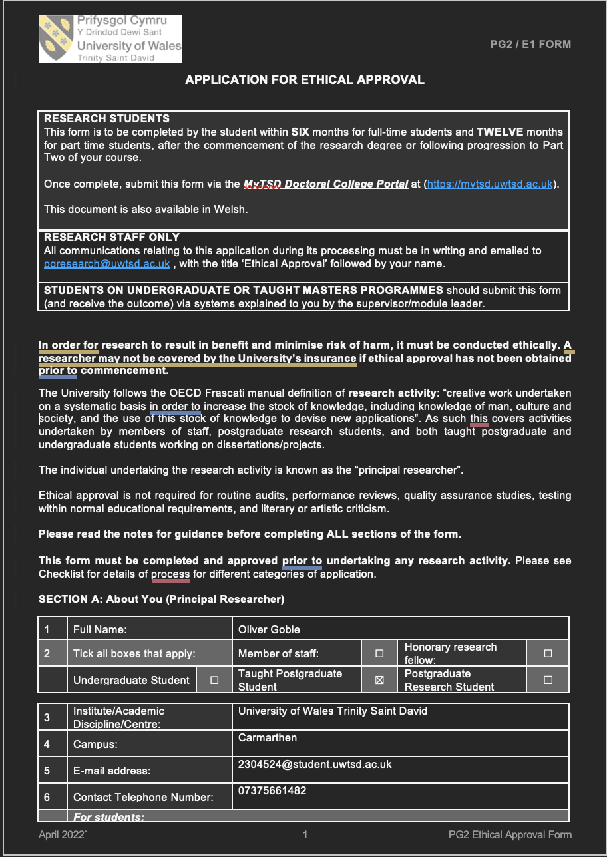
The following pages provide evidence of the ethical approval documentation for the present study, including study details and supervisor approval.
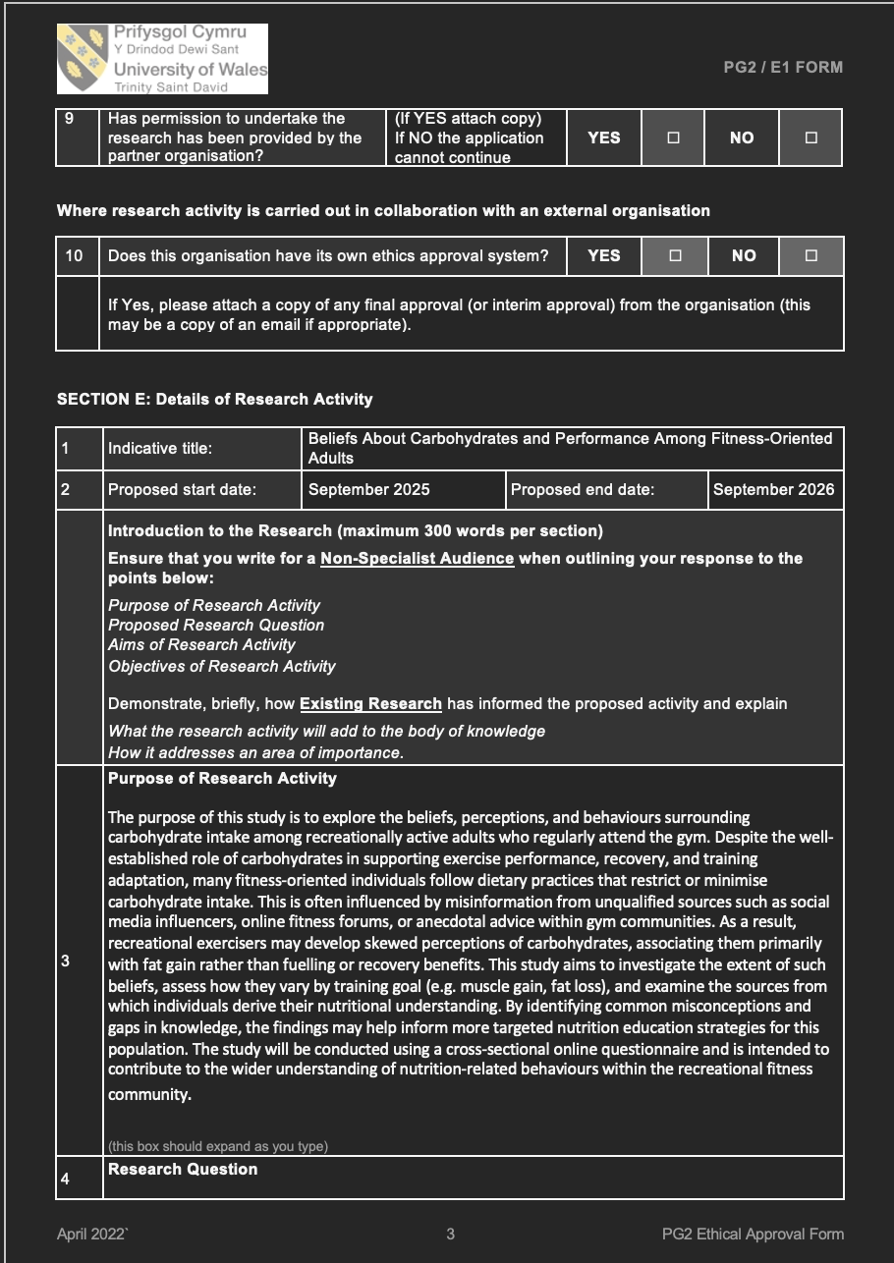

Appendix B – Final Questionnaire


The following pages present the final questionnaire distributed to participants via Microsoft Forms as part of the present study


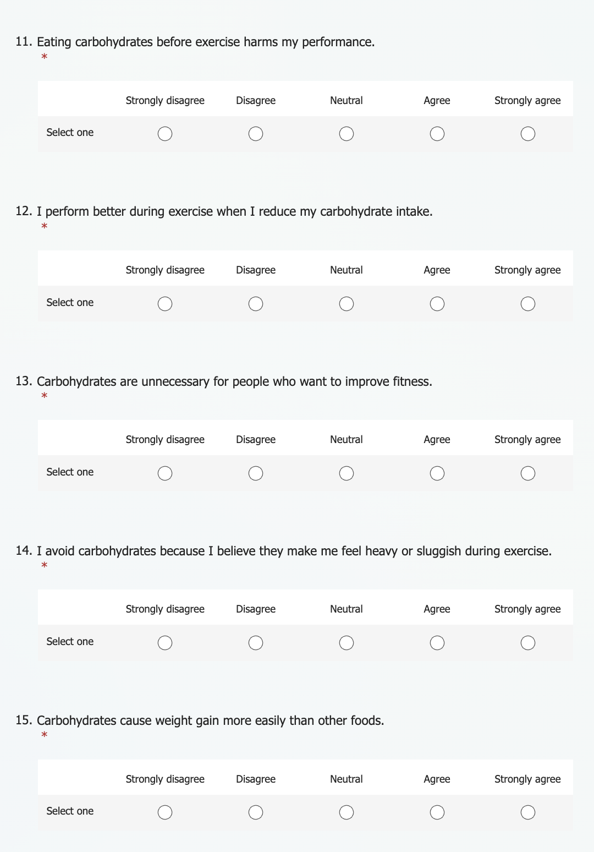
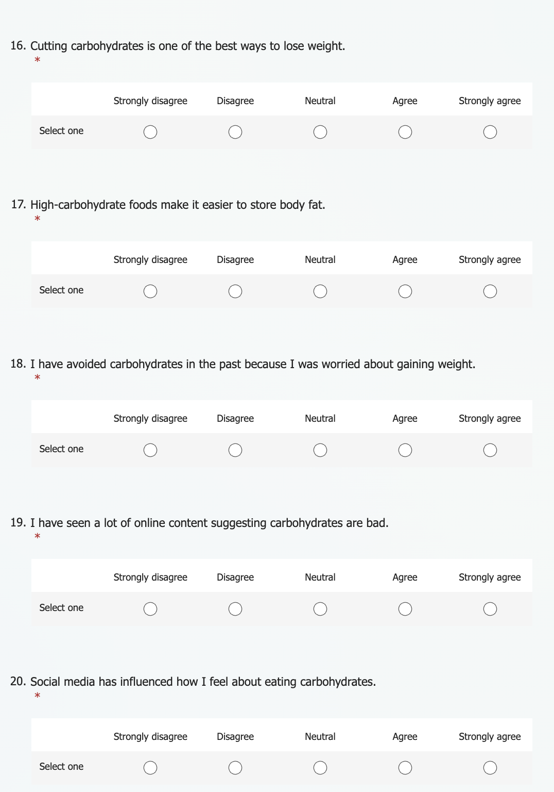
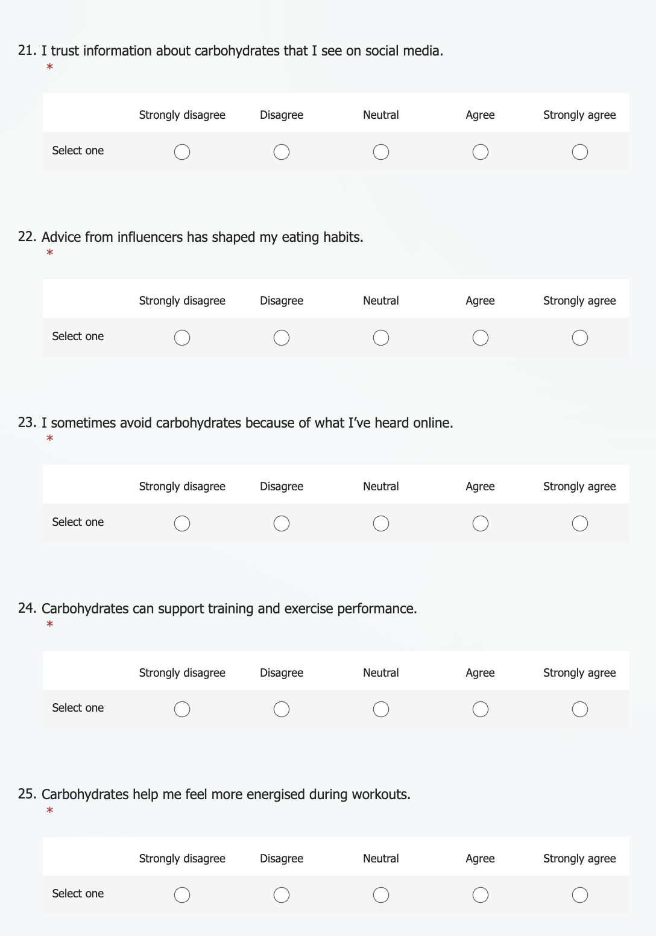



Appendix C – Anonymised Questionnaire Response Data

The questionnaire response data were exported from Microsoft Forms into Microsoft Excel. An extract of the anonymised dataset is presented below. The complete dataset was retained for statistical analysis.


