

Software Solutions for Business

Prepared by:
Ivan Yordanov Ivanov - 2434440
The program : CERTHE Computing Skills for the Workplace
Module name : Software Solutions for Business
Module code : ACCA4026
Lecturer’s name : Dr Olusola Adeniyi

Table of Contents

List of figures / tables ---------------------------------------- 2
1. Introduction ----------------------------------------------- 3
2. Task 1 ------------------------------------------------------ 4
3. Task 2 ------------------------------------------------------ 6
4. Task 3 ------------------------------------------------------ 7
5. Task 4 ------------------------------------------------------ 11
6. Conclusion -------------------------------------------------- 15
References ----------------------------------------------------- 16
Abbreviations -------------------------------------------------- 17
Appendix ------------------------------------------------------- 18

Abstract
In modern businesses, software applications are very important for carrying out everyday tasks. Companies use a range of different programs to help with communication, handling data, and making decisions. However, it is not always easy to choose the most suitable software or know how to use it properly.
This report looks at several types of software commonly used in business, such as e-commerce platforms, mind mapping tools, office software, and tools for communication and teamwork. It also includes examples to show how these applications can be used in real-life business situations.
The research suggest that using the right software can help organisations work more efficiently, improve communication, and increase overall productivity. In conclusion, software is now a vital part of how businesses operate today.

- Introduction

In today’s business world, software applications are widely used to support everyday business tasks. They make it easier for organisations to handle things like communication, managing information, and making decisions. Without these systems, many tasks would take much longer and would need to be done manually.
Over the past few years, businesses have started relying more on digital tools. Many organisations now use software like office programs, communication platforms, and cloud services to make their work more organised and efficient. For example, Microsoft Office is often used for writing documents, working with data, and creating presentations, while tools like Microsoft Teams and email help employees stay connected and work together.
Software has also made business operations faster and more accurate. It allows companies to store and deal with large amounts of information, which supports better decision-making. Because of this, businesses can react more quickly to changes and improve how they perform overall.
This report will look at different types of software used in businesses and explain how they help support a range of business activities.



Figure 1. Software Solutions for Business [1]

- Task 1

e-Commerce Website builders/software solutions
E-commerce website builders are platforms that allow businesses to create online stores where they can sell products or services. These tools are widely used because they make it easier for businesses to operate online without needing advanced technical or coding skills. They also include important features such as payment processing, product management, and customer tracking, which are essential for running an online business [2].
One well-known e-commerce platform is Shopify. Shopify is a cloud-based system that enables users to build and manage an online store easily. It provides ready-made templates that can be customised depending on the type of business. One of the main advantages of Shopify is that it offers secure payment options, allowing customers to make purchases safely from anywhere. It also supports features such as inventory management and order tracking, which help businesses stay organised [3].
Another advantage of Shopify is its ease of use, especially for beginners. Users can quickly upload products, manage sales, and monitor store performance through a simple interface. However, one disadvantage is that Shopify requires a monthly subscription, which may not be suitable for very small businesses or individuals who are just starting out. Despite this, it is still considered a strong platform for businesses that want to grow their online presence [4].
Another popular platform is Wix. Wix is known for its drag-and-drop website builder, which allows users to design websites without coding knowledge. It also offers e-commerce features that allow businesses to sell products online. Users can create product pages, manage orders, and accept payments through the platform. One of the main strengths of Wix is its flexibility in design, as it provides a wide range of templates and customisation options [5].
Wix is more suitable for small businesses or beginners who want a quick and simple way to build an online store. It offers basic e-commerce tools that are easy to understand. However, compared to Shopify, Wix may not be as effective for larger businesses or more complex operations. Some advanced features are also only available in paid plans [6].
In conclusion, both Shopify and Wix are useful tools for creating e-commerce websites. Shopify is more suitable for businesses that require advanced features and plan to expand, while Wix is better for beginners who prefer simplicity. Overall, these platforms help businesses improve their operations by making it easier to sell products online and reach a wider audience.

- Task 2

Mind-map of contemporary software applications
A).
Mind mapping is a method used to organise ideas in a visual way. It usually starts with a main topic in the centre, and then related ideas are added around it as branches. This makes it easier to understand how different ideas are connected and helps to present information clearly [7].
In business, mind mapping is often used for planning and organising tasks. For example, when working on a project, a business can break it down into smaller parts such as marketing, finance, and operations. This makes the process easier to manage and ensures that all important areas are covered [8].
One key benefit of mind mapping is that it improves understanding. Instead of reading long paragraphs of text, information is shown visually, which helps people remember it more easily. This is useful in meetings and brainstorming sessions where ideas need to be shared quickly and clearly.
Another advantage is that it increases productivity. When ideas are organised properly, employees can focus better on their tasks and complete work more efficiently. It also supports teamwork, as everyone can see the same structure and understand what needs to be done.
Mind mapping also helps with decision-making. By showing different ideas and options in one place, businesses can compare them and choose the best solution. This reduces confusion and allows managers to make better decisions.
In addition, mind mapping can improve creativity. It allows users to explore different ideas freely and make connections between them, which can lead to new and innovative solutions in business.
Overall, mind mapping is a useful tool for businesses because it helps organise information, improves communication, and supports better planning and decision-making [7].
B).
Mind Map of Software Applications in Business

4.Task 3
A).

Office Applications for creating, storing, presenting, and analysing information/data
Microsoft Word
Microsoft Word is a word processing application that is widely used in businesses to create, edit, and manage documents. It is commonly used for writing reports, letters, and other professional documents. One of its main features is text formatting, which allows users to change font styles, sizes, and layouts to produce clear and professional-looking documents. It also includes tools such as spell check and grammar check, which help reduce errors and improve the quality of writing [9], [10].
Another important feature of Microsoft Word is the ability to insert tables, images, and charts. This helps users organise information in a structured way and present it clearly. For example, businesses can use tables to display data or charts to explain trends. Word also includes templates, which make it easier to create documents quickly without starting from scratch.
In addition, Microsoft Word supports collaboration through features such as comments and track changes. These tools allow multiple users to review and edit documents, which is useful in team environments. This improves communication and ensures that documents are accurate before they are finalised.
The main benefit of Microsoft Word is that it increases productivity by making document creation faster and more efficient. It is also easy to use and widely available, which makes it suitable for most organisations.
However, one limitation is that Microsoft Word is mainly designed for text-based tasks, so it is not suitable for analysing large amounts of data or performing complex calculations.

Microsoft Excel

Microsoft Excel is a spreadsheet application used for organising, analysing, and storing data. It is widely used in businesses for financial tasks, budgeting, and data management. One of its key features is the use of formulas and functions, such as IF and VLOOKUP, which allow users to perform calculations automatically and efficiently [9], [11].
Excel also includes tools such as charts and graphs, which help users present data visually. This makes it easier to understand patterns and trends. Another important feature is Pivot Tables, which allow users to summarise large datasets quickly and extract useful information.
The main benefit of Excel is that it helps businesses make better decisions by analysing data effectively. It also reduces manual work by automating calculations and improving accuracy.
However, Excel can be challenging for beginners, especially when using advanced functions. In addition, errors in formulas can lead to incorrect results if they are not checked carefully.

Microsoft PowerPoint

Microsoft PowerPoint is a presentation software used to create slideshows for meetings, training sessions, and business presentations. It allows users to present information in a clear and visual format.
One of its main features is slide design, which includes templates and themes that help create professional presentations. It also supports multimedia elements such as images, videos, and animations, which make presentations more engaging and easier to understand [12].
Another useful feature is the use of transitions and animations, which control how information appears on slides. These features can improve the flow of a presentation if used correctly.
The main benefit of PowerPoint is that it improves communication by presenting information visually. This helps audiences understand complex ideas more easily.
However, one limitation is that presentations can become less effective if too much text or too many animations are used. It can also take time to create a well-designed presentation.

Microsoft Access
Microsoft Access is a database management system used to store and organise large amounts of data. Businesses use Access to manage information such as customer details, employee records, and inventory data.
One of its key features is the ability to create databases using tables, queries, forms, and reports. Tables are used to store data, while queries allow users to search and retrieve specific information. Forms make data entry easier, and reports help present data in a structured format.
Another important feature is the ability to create relationships between different tables. This helps connect related data and improves data organisation.
The main benefit of Microsoft Access is that it improves data management by reducing duplication and increasing accuracy. It allows businesses to handle large amounts of data efficiently [13].
However, Access can be difficult for beginners and may require some training. It is also not suitable for very large organisations that need more advanced database systems.
B).
Practical task
Figure 2. IF Function in Excel showing formula and results


The IF function in Excel is used to check whether a condition is true or false and return a result based on that condition.
In this task, I created a table showing students and their marks. I used the IF function to display “Pass” if the marks are 50 or above, and “Fail” if they are below 50.
The formula I used was:
=IF(B2>=50,"Pass","Fail")
This function is useful in business because it helps automate decision-making and saves time when analysing data.

Figure 3. VLOOKUP Function in Excel showing formula and result



VLOOKUP is used in Excel to search for a value in a table and return related information from another column.
In this task, I created a product table that includes product IDs, names, and prices. I then used the VLOOKUP function to find the price of a product based on its ID.
The formula I used was:
=VLOOKUP(E2,A2:C5,3,FALSE)
This function is useful in business because it allows users to quickly find information in large datasets, which improves efficiency and reduces errors.

5.Task 4

Communication and Collaboration applications

Communication Tool: Email
Email is one of the most widely used communication tools in modern businesses. It allows employees to send messages, share files, and communicate with colleagues, clients, and external organisations. Email is especially useful for formal communication, such as sending reports, updates, and official information.
One of the main features of email is asynchronous communication, which means messages can be sent and received at different times. This allows employees to communicate even when they are not available at the same time. Email also allows users to attach files, organise messages into folders, and keep records of communication for future reference.
A key benefit of email is that it provides a reliable and professional way of communication. It is widely used across businesses and is easy to access from different devices. It also allows communication with people outside the organisation, which makes it essential for business operations.
However, email also has some limitations. For example, it can become difficult to manage when there are too many messages, leading to information overload. Important messages can sometimes be missed, and communication can be slower compared to instant messaging tools.
Overall, email remains an important communication tool in businesses because it supports formal communication and record keeping [14].

Collaboration Tool: Microsoft Teams
Microsoft Teams is a widely used collaboration tool that allows employees to communicate and work together in real time. It combines features such as chat, video meetings, and file sharing into one platform, making teamwork easier and more efficient.
One of the main features of Microsoft Teams is instant messaging, which allows users to communicate quickly through chats and group conversations. It also supports video conferencing, enabling teams to hold meetings online. Another important feature is file sharing, which allows users to upload and work on documents together. Teams also integrates with other Microsoft applications such as Word, Excel, and PowerPoint, allowing users to collaborate on files directly within the platform [15].
Another key feature is real-time collaboration, where multiple users can edit the same document at the same time. This improves teamwork and reduces the need to send files back and forth. Teams also includes tools such as calendars, notifications, and task management, which help users stay organised.
The main benefit of Microsoft Teams is that it improves communication and collaboration by bringing different tools into one place. It reduces the need for multiple applications and helps employees work more efficiently [16]. It is also very useful for remote working, as employees can communicate and collaborate from different locations.
However, Microsoft Teams also has some limitations. It can be difficult for new users to learn all its features, and it requires a stable internet connection. In addition, too many notifications can sometimes be distracting.
Overall, Microsoft Teams is an effective collaboration tool that helps businesses improve productivity, teamwork, and communication.

Figure 4. Sending an Email using a Communication Application

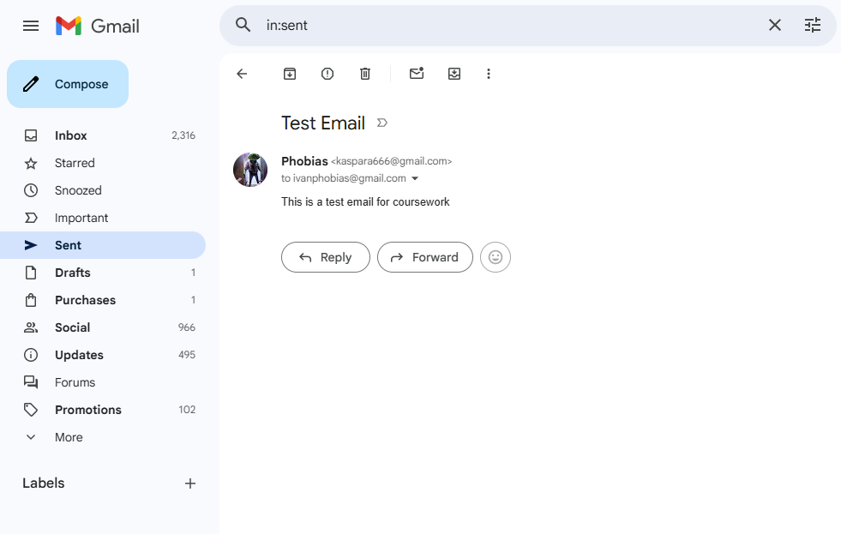

The screenshot above shows an example of sending an email using a communication application. In this task, I used Gmail to send a message with a subject and content.
This feature allows users to communicate quickly and share information with others. It is useful in business because it supports formal communication, allows file sharing, and keeps records of messages.

Figure 5. Sending a Message using Microsoft Teams



The screenshot above shows an example of using Microsoft Teams to send a message. In this task, I used the chat feature to communicate with another user.
This feature allows users to communicate instantly and collaborate in real time. It is useful in business because it improves teamwork, supports remote working, and allows quick sharing of information.

6.Conclusion

To sum up, this report explained how different software applications are used in modern businesses to support daily activities. Tools such as e-commerce platforms, office software, and communication systems help organisations work more efficiently and manage tasks better. The practical examples also showed how applications like Excel and communication tools can be used in real situations. It is important for businesses to keep using and updating these technologies to stay competitive. In the future, newer technologies and automation could make business operations even faster and more effective.

References

[1] | IBM, "IBM Design Language – Gallery," IBM, 25 March 2026. [Online]. Available: https://www.ibm.com/design/language/gallery/.
[2] | K. C. Laudon and C. G. Traver, E-commerce 2023: Business, Technology, Society, Pearson: Pearson, 2023.
[3] | S. Inc., "What is Shopify and how does it work," Shopify Inc., 2024. [Online]. Available: https://www.shopify.com. [Accessed 25 March 2026].
[4] | A. Mishra, "E-commerce platforms comparison and analysis," International Journal of Computer Applications, vol. 182, no. 45, 2019.
[5] | Wix.com Ltd., "Create a professional website with Wix," 2024. [Online]. Available: https://www.wix.com. [Accessed 25 March 2026].
[6] | R. K. Gupta, "Comparative study of website builders for small businesses," Journal of Information Systems, 2022.
[7] | T. Buzan and B. Buzan, The Mind Map Book, London: BBC Active, 2006.
[8] | J. Davies, "The use of mind mapping in business decision making," Journal of Business Strategy, vol. 42, no. 3, 2021.
[9] | K. C. Laudon and J. P. Laudon, Management Information Systems: Managing the Digital Firm, Pearson, 2022.
[10] | Microsoft, "Microsoft Word," [Online]. Available: https://www.microsoft.com/word.
[11] | Microsoft, "Microsoft Excel," [Online]. Available: https://www.microsoft.com/excel.
[12] | Microsoft, "Microsoft PowerPoint," [Online]. Available: https://www.microsoft.com/powerpoint.
[13] | Microsoft, "Microsoft Access," [Online]. Available: https://www.microsoft.com/access.
[14] | K. Morrison, S. Iqbal and E. Horvitz, "AI-Powered Reminders for Collaborative Tasks," 2024.
[15] | Microsoft, "Microsoft Teams," [Online]. Available: https://www.microsoft.com/teams.
[16] | Aztech IT, "Microsoft Teams benefits for businesses," 2024. [Online]. Available: https://www.aztechit.co.uk/blog/microsoft-teams-benefits.

Abbreviations

IT – Information Technology
MS – Microsoft
PDF – Portable Document Format
URL – Uniform Resource Locator
IEEE – Institute of Electrical and Electronics Engineers

Appendix
No additional materials were included in this report.

