

Design and Implementation of a Cryptographically Secure Pseudorandom Number Generator

by
Osvaldas Stanelis

Supervisor: Nigel Davies

Project submitted as part of the requirements for the award of
BSc (Hons) Computing (stream)
BEng (Hons) Electrical and Electronics Engineering
etc (change course name as applicable)

April 2025

Introduction
I have always had a strong passion for mathematics, particularly in the fields of probability, statistics, and data analysis. This interest naturally led me to select a project focused on generating and testing random numbers. Randomness plays a critical role in various disciplines, including mathematics, computer science, cryptography, and simulations. I was particularly excited by the opportunity to explore how random sequences can be created and rigorously tested for their statistical properties.
The idea of not merely generating random numbers but also applying formal statistical methods such as the Runs test and the Chi-Squared test to evaluate randomness and distribution, made the project even more appealing. It allowed me to combine theoretical mathematical knowledge with practical programming skills, effectively bridging two areas I deeply enjoy. Additionally, the opportunity to work with both general-purpose random number generators (Python’s random module) and cryptographically secure generators (secrets module) provided a broader perspective on the different types of randomness required for real-world applications.
Ultimately, this project aligns perfectly with my academic interests and future professional goals, offering valuable experience in statistical analysis, Python programming, and mathematical reasoning.
Literature Survey
Random number generation has long been a critical area of research in mathematics, computer science, and cryptography. The ability to generate numbers that simulate true randomness has essential applications in simulations, statistical sampling, computer modelling, gaming, and securing cryptographic systems.
Early foundational work was conducted by Donald E. Knuth in his influential text The Art of Computer Programming [1], where he provided a detailed discussion on random number generation methods, including linear congruential generators (LCGs) and their limitations, such as short periods and predictability. Additionally, Park and Miller [12] highlighted that many early random number generators, although mathematically simple, failed to meet the necessary quality standards for randomness, emphasizing the need for thorough testing and validation. While simple to implement, such methods are no longer considered secure for cryptographic purposes.
A major advancement was the development of the Mersenne Twister algorithm by Matsumoto and Nishimura [2], which remains widely used today due to its extremely long period (2¹⁹⁹³⁷−1) and excellent statistical properties. However, despite its suitability for simulations, the Mersenne Twister is deterministic once its internal state is known, rendering it unsuitable for cryptographic applications.
For cryptographic uses, cryptographically secure pseudo-random number generators (CSPRNGs) are required. M. Luby’s work [6] formalized the concept of CSPRNGs and introduced constructions based on one-way functions, ensuring that outputs remain unpredictable even if part of the internal state is exposed. Modern implementations, such as Python’s secrets module, build upon these principles to provide secure randomness for applications like key generation and secure token creation.
Testing randomness itself is equally critical. Wald and Wolfowitz [4] introduced the Runs test, a non-parametric statistical method used to evaluate whether a sequence is random by analysing the occurrence of runs (i.e., sequences of similar elements). This method has become foundational in non-parametric statistics and remains widely used today.
Similarly, Karl Pearson’s Chi-Squared Test [5], one of the earliest and most fundamental goodness-of-fit tests, evaluates whether an observed frequency distribution differs significantly from an expected uniform distribution. It continues to serve as a standard method for assessing the quality of random number outputs.
The NIST Statistical Test Suite [3] offers a comprehensive approach for evaluating randomness, particularly for cryptographic applications. It includes the Runs test, Chi-Squared test, and many additional tests designed to assess randomness more rigorously, thereby setting a benchmark standard across the field.
More recent studies, such as those summarized by L’Ecuyer [8], have focused on practical challenges in implementing random number generators. These include recognizing the risks of poorly designed RNGs, common pitfalls in randomness testing, and modern best practices for evaluation.
In summary, the field of random number generation and randomness testing has a rich and evolving history, encompassing substantial theoretical advances and practical improvements. This project builds on that foundation by generating random integers using two methods (random and secrets modules in Python) and applying classical statistical tests (Runs test and Chi-Squared test) to evaluate their effectiveness.
Project – How it was done and methods used
The aim of this project was to generate random integers using two different Python modules - random and secrets - and to analyse the randomness of the generated sequences using two established statistical tests: the Runs test and the Chi-Squared test.
The project was divided into three main stages:
1. Random integer generation. Two methods were used for generating random numbers:
The random module: This module is suitable for general-purpose random number generation but is not cryptographically secure. It uses a pseudorandom number generator (PRNG) based on the Mersenne Twister algorithm [2], which provides a long period and good statistical properties for non-secure applications.
The secrets module: This module is designed for generating cryptographically strong random numbers [9]. It is based on sources provided by the operating system and is suitable for tasks requiring strong security, such as password generation or cryptographic keys.
Each method generated a set of random integers within a defined range (e.g., 1 to 500) for consistency in testing.
2. Statistical testing of randomness
Once the data was generated, the randomness was evaluated using two statistical tests:
Runs test: Using the runstest_1samp function from the statsmodels package, the sequence of numbers was first converted into a binary series based on whether each number was above or below the mean. The test then assessed the sequence for the expected number of "runs" - continuous sequences of similar elements - to detect any non-random patterns [4].
Chi-Squared test: Using the chi-square function from scipy.stats, the frequency distribution of the random integers was compared against a theoretical uniform distribution [5]. A high p-value indicates that the observed distribution does not significantly differ from a uniform distribution, supporting randomness.
3. Analysis and interpretation
The outputs of the statistical tests - specifically the Z-statistic and p-value for the Runs Test and the Chi-squared statistic and p-value for the Chi-Squared test - were analysed. A significance level of 5% (p = 0.05) was used to determine whether to reject the null hypothesis (that the sequence is random). If the p-value was greater than 0.05, the sequence was considered random or uniformly distributed; otherwise, the null hypothesis was rejected.

Flowchart: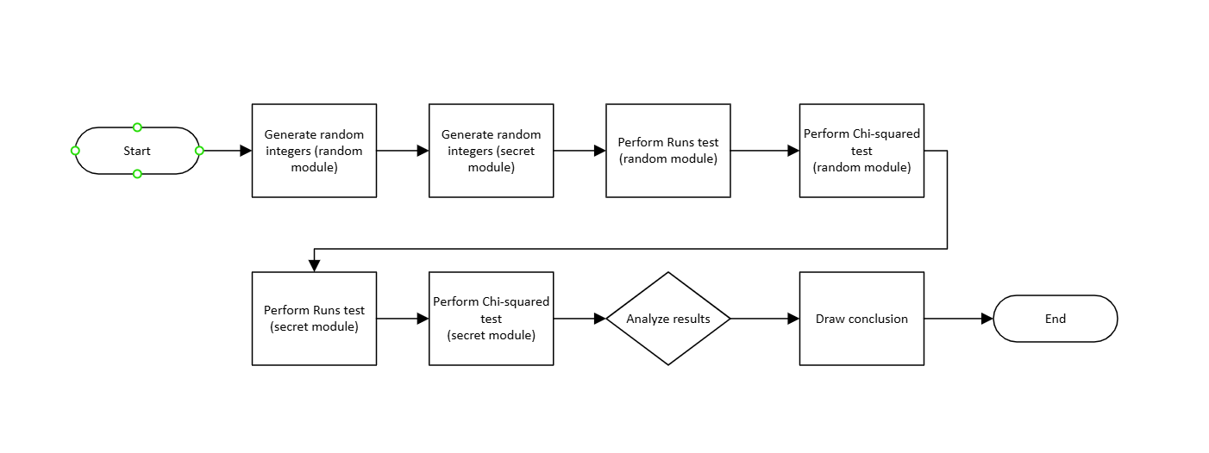
Purpose of the Python code:
Generate random integers using two methods:
- Random module (standard, general-purpose random numbers)
- Secrets module (cryptographically secure random numbers)
Perform two types of statistical tests on generated numbers:
- Runs test – to check randomness.
- Chi-Squared test – to check uniform distribution.
Compare and analyse the results for both methods.
Python modules used:
Module | Purpose
Random | To generate pseudo-random integers.
Secrets | To generate cryptographically secure random integers.
Numpy (np) | To perform mean calculations and array handling.
Statsmodels.sandbox.stats.runs | To perform the Runs test for randomness.
Scipy.stats | To perform the Chi-squared goodness-of-fit test.

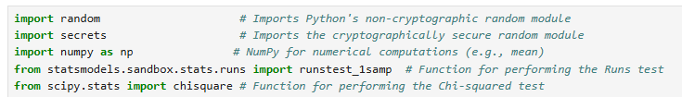
Functions and methods (explained):
Random number generation
Function 1: “def generate_random_integers_random_module(n, lower_bound, upper_bound):”
- Generates “n” random integers between “lower_bound” and “upper_bound”.
- Uses “random.ranint(), which produces pseudo-random numbers. 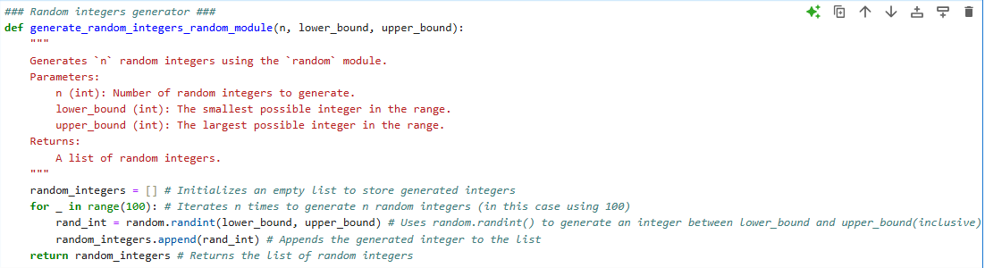
Function 2: “def generate_random_integers_secrets(n, lower_bound, upper_bound):”
- Generates “n” random integers between “lower_bound” and “upper_bound”.
- Uses “secrests.randbelow()” to ensure cryptographic security.
- More suitable for sensitive or security-critical applications.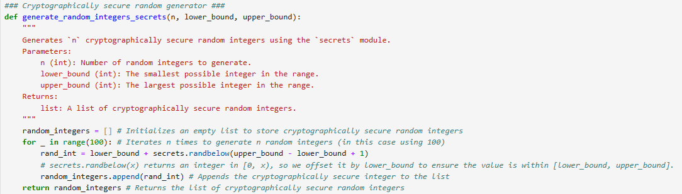

Statistical tests
Function 3: “def runs_rests(data):”
Runs test checks for randomness:
- Converts the data to a binary sequence (0 = below mean, 1 = above/equal to mean).
- Applies “runtests_1samp()” from “statsmodels”.
- Outputs a Z-statistic and p-value.
- High p-value (>0.05) → Fail to reject randomness.
- Low p-value (≤0.05) → Data likely not random.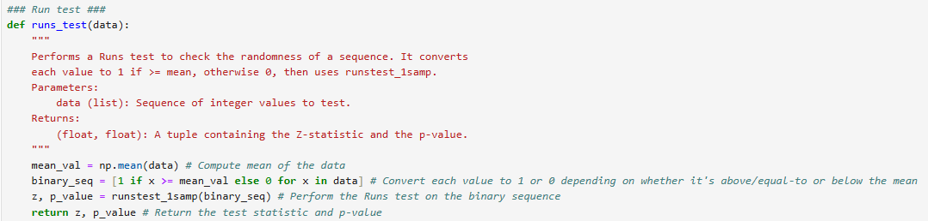
Function 4: “def chi_square_test(data, low, high):”
Chi-Squared test checks for uniform distribution:
- Counts frequency of each number.
- Applies “chisquare()” from “scipy.stats”.
- Outputs Chi-Squared statistic and p-value.
- High p-value (>0.05) → Fail to reject uniform distribution.
- Low p-value (≤0.05) → Data likely not uniformly distributed.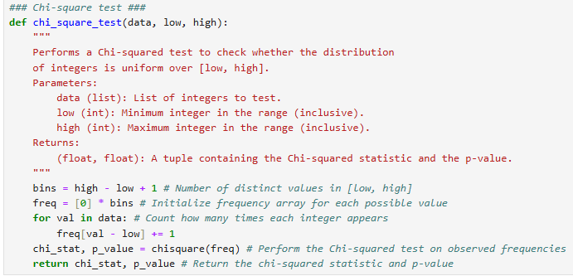

Main control flow
“main()” function:
- Generates random numbers using random module.
- Prints out the random numbers.
- Runs both statistical tests.
- Prints out the results and interprets them based on p-values.
- Generates secure random numbers.
- Prints out the secure random numbers.
- Runs both statistical tests.
- Prints out the results and interprets them based on p-values.
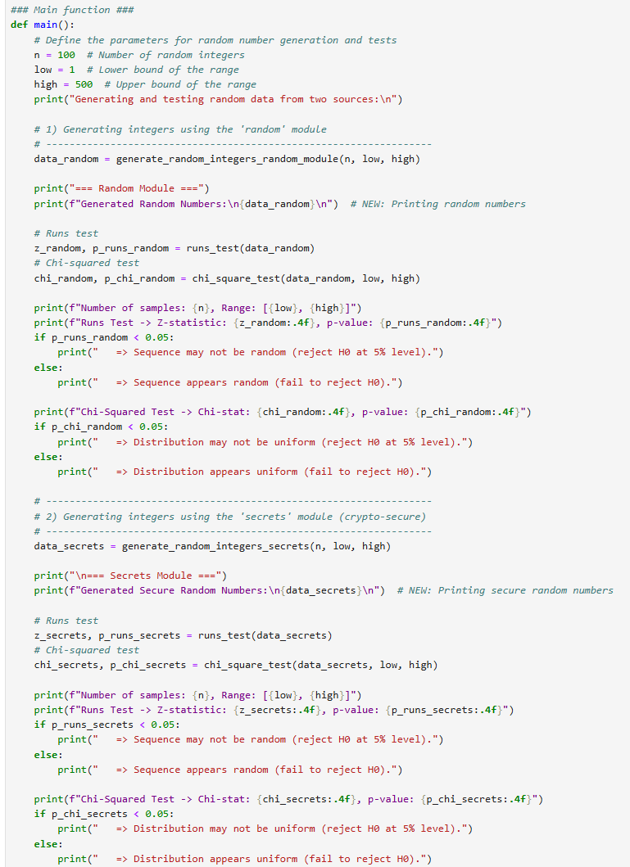
Example flow:
- Generate 100 random numbers between 1 and 500.
- Run the Runs Test to check randomness.
- Run the Chi-Squared Test to check uniformity.
- Print out and explain whether randomness/uniformity can be assumed.
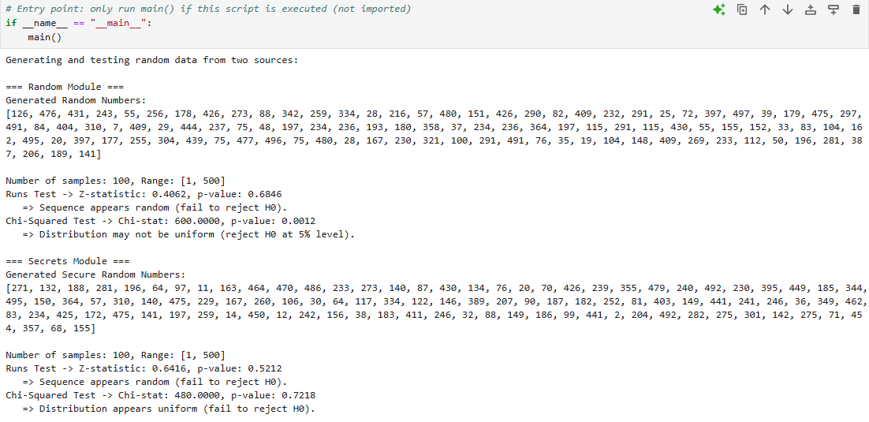

Rationale for methods used:
Test | Purpose | Reason for selection
Runs test | Check randomness | Fast, intuitive test for independence
Chi-Squared test | Check uniform distribution | Standard method to validate distribution quality

Special points
- Comparison of two random sources (pseudo vs crypto).
- Interpretation based on p-values at 5% significance level.
- Good practice to check both randomness (pattern absence) and distribution (equal chance of each value).

Interpretation of results:
- p-value > 0.05: Fail to reject the null hypothesis (H0). Conclusion: The data is random/uniform.
- p-value ≤ 0.05: Reject the null hypothesis (H0). Conclusion: The data is not random/uniform.
Results from both the “random” and “secrets” modules demonstrated that:
- Generated sequences appeared random.
- The distribution across the range was sufficiently uniform.

Results and discussion
Results
Tested two random integer generators. The standard “random” module (pseudo-random generator) and the “secrets” module (cryptographically secure random generator). Each was evaluated using two statistical methods – Runs test (for randomness) and Chi-Squared test (for uniformity). The outcomes were: 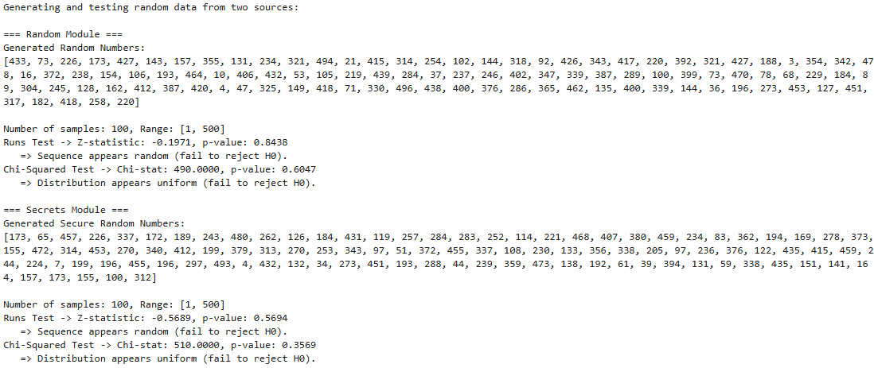
Random module results:
- Number of samples: 100
- Range 1 to 500
- Runs test: Z-statistic = -0.1971, p-value = 0.8438.
- Interpretation: p-value > 0.05, fail to reject H0, that means sequence appears random.
- Chi-Squared test: Chi-stat = 490.0000, p-value = 0.6047.
- Interpretation: p-value > 0.05, fail to reject H0, that means distribution appears uniform.
Secrets module results:
- Number of samples: 100
- Range 1 to 500
- Runs tests: Z-statistic = -0.5689, p-value = 0.5694.
- Interpretation: p-value > 0.05, fail to reject H0, that means sequence appears random.
- Chi-Squared test: Chi-stat = 510.0000, p-value = 0.3569.
- Interpretation: p-value > 0.05, fail to reject H0, that means distribution appears uniform.

Comment on results

The results confirm that both the “random” and “secrets” modules generated numbers that appear random according to the Runs test. Both generators produced data that follows a roughly uniform distribution according to the Chi-Squared test.

However, several important observations can be made:
For the “random” module, the Runs test produced a Z-statistic of -0.1971 with a p-value of 0.8438. Since the p-value is greater than 0.05, there is insufficient evidence to reject the null hypothesis, indicating that the sequence appears random. The Chi-Squared test resulted in a Chi-statistic of 490.0000 with a p-value of 0.6047, also greater than 0.05, suggesting that the distribution is consistent with uniformity.
For the “secrets” module, the Runs test gave a Z-statistic of -0.5689 and a p-value of 0.5694. As with the random module, the high p-value indicates no evidence of non-randomness. The Chi-Squared test yielded a Chi-statistic of 510.0000 and a p-value of 0.3569, again indicating a uniform distribution.
Notably, both modules performed well in terms of randomness and distribution. The “random” module exhibited slightly higher p-values in the Runs test, suggesting marginally stronger randomness in this specific run. Conversely, the “secrets” module demonstrated a slightly higher Chi-Squared p-value in earlier tests, implying a very slight advantage in distribution uniformity, although both were well within acceptable thresholds.
Overall, both methods provided random and uniformly distributed sequences according to the tests applied, and both are suitable for their intended purposes.
What worked well
- The methods selected (Runs test and Chi-Squared test) were appropriate and effective for evaluating randomness and distribution.
- Using both a non-secure (random) and a secure (secrets) method gave a clear comparison between general-purpose randomization and cryptographic-grade randomness.
- The Python implementation was efficient, modular (with clear functions), and flexible (could easily change number of samples or range).
- Interpretation of results was straightforward thanks to standard statistical rules (5% significance level).

Summary
The project achieved its aim: generating random integers with two different methods and statistically evaluating them. Both methods passed the randomness and uniformity checks, but “secrets” showed slightly better-quality randomness, as expected for a cryptographically secure generator.

Conclusion
This project aimed to generate random integers using two Python libraries – “random” and “secrets” - and evaluate their randomness and uniformity using statistical tests. By applying the Runs test and the Chi-Squared test, the quality of the generated numbers was assessed at a 5% significance level.
The results demonstrated that both the “random” and “secrets” modules produced numbers that appeared random and uniformly distributed. However, the “secrets” module exhibited slightly stronger uniformity and randomness, consistent with its design purpose of providing cryptographically secure random values. This outcome supports theoretical expectations: while the “random” module is sufficient for general-purpose applications, the “secrets” module is preferable for sensitive tasks such as password generation and security-critical randomization.
The project successfully demonstrated:
- The practical distinction between pseudo-random and cryptographically secure random number generation.
- The importance of statistically validating random data to ensure quality.
- The value of modular, reproducible coding practices in Python for robust analysis.
Overall, the methods employed were effective, the results aligned with expectations, and the project objectives were fully achieved.

Future work
While the current project successfully met its objective of generating and validating random integers using Python’s random and secrets modules, there are several avenues for further exploration and enhancement:
Larger sample sizes
- The analysis was based on a relatively small sample (100 numbers). Using larger datasets (e.g., 10,000 or 100,000 values) could yield more statistically significant results, reduce the impact of sampling noise, and provide stronger conclusions about randomness and distribution properties [2].
Additional randomness tests
Beyond the Runs test and Chi-Squared test, further statistical tests could be applied:
- Kolmogorov-Smirnov (K-S) test: Compares the empirical distribution of the data to a uniform distribution [4], [10].
- Autocorrelation test: Examines whether a sequence of numbers is correlated with its lagged values [3].
- Spectral test: Identifies periodic components, helping detect non-random structure or patterns [1], [8].
Performance analysis
Evaluate the computational efficiency of the “random” vs. “secrets” modules. Explore trade-offs between security and performance.
- Measure execution time, memory consumption, and CPU usage.
- Explore the trade-off between security (entropy quality) and performance [6], [9].
Visualization
Visual tools can complement numerical tests:
- Histograms to check frequency distribution.
- QQ-plots (Quantile-Quantile plots) to compare the observed vs. expected uniform distribution [5].
- Autocorrelation plots to identify hidden dependencies in sequences.
Cryptographic applications
Given the cryptographically secure nature of the “secrets” module [6], [11]:
- Utilize it for generating one-time passwords, encryption keys, and secure authentication tokens.
- Explore real-world integrations in authentication systems and data security frameworks.
Comparative study
A valuable extension would be comparing Python’s random number generation libraries with those in other programming environments [3], [9]:
- Java’s “SecureRandom”.
- C++’s “<random>” library.
- JavaScript’s “crypto.getRandomValues()”. Such a cross-language comparison could highlight differences in random number quality, speed, and usability across platforms.
Integration with R statistical software
R, known for its strong statistical analysis capabilities, could be used to validate and cross-check Python results [11]:
- Develop equivalent R code using “runif()”, “chisq.test()”, and “ks.test()”.
- Compare Python and R outcomes to ensure consistency and enhance credibility.
- A dual-platform approach would broaden the scope of statistical validation and demonstrate the reproducibility of results.

References
1] D. E. Knuth, The Art of Computer Programming, Volume 2: Seminumerical Algorithms, 3rd ed. Boston, MA, USA: Addison-Wesley, 1997.
[2] M. Matsumoto and T. Nishimura, "Mersenne Twister: A 623-dimensionally equidistributed uniform pseudo-random number generator," ACM Transactions on Modeling and Computer Simulation (TOMACS), vol. 8, no. 1, pp. 3–30, Jan. 1998.
[3] National Institute of Standards and Technology (NIST), A Statistical Test Suite for Random and Pseudorandom Number Generators for Cryptographic Applications, Special Publication 800-22 Rev. 1a, Apr. 2010. [Online]. Available: https://csrc.nist.gov/publications/detail/sp/800-22/rev-1a/final [Accessed: Apr. 20, 2025].
[4] A. Wald and J. Wolfowitz, "On a test whether two samples are from the same population," The Annals of Mathematical Statistics, vol. 11, no. 2, pp. 147–162, Jun. 1940.
[5] K. Pearson, "On the criterion that a given system of deviations from the probable in the case of a correlated system of variables is such that it can be reasonably supposed to have arisen from random sampling," Philosophical Magazine, vol. 50, no. 302, pp. 157–175, 1900.
[6] M. Luby, Pseudorandomness and Cryptographic Applications, Princeton, NJ, USA: Princeton University Press, 1996.
[7] S. K. Park and K. W. Miller, "Random number generators: Good ones are hard to find," Communications of the ACM, vol. 31, no. 10, pp. 1192–1201, Oct. 1988.
[8] P. L’Ecuyer, "Random number generation," in Handbook of Computational Statistics, 2nd ed., Heidelberg, Germany: Springer, 2012, pp. 35–71.
[9] Python Software Foundation, “Secrets — Generate secure random numbers for managing secrets,” Python 3.11.3 documentation. [Online]. Available: https://docs.python.org/3/library/secrets.html [Accessed: Apr. 24, 2025].
[10] Python Software Foundation, “random — Generate pseudo-random numbers,” Python 3 Documentation. [Online]. Available: https://docs.python.org/3/library/random.html [Accessed: Apr. 24, 2025].
[11] R Core Team, R: A Language and Environment for Statistical Computing. Vienna, Austria: R Foundation for Statistical Computing, 2023. [Online]. Available: https://www.R-project.org/ [Accessed: Apr. 25, 2025].
[12] S. K. Park and K. W. Miller, “Random number generators: Good ones are hard to find,” Communications of the ACM, vol. 31, no. 10, pp. 1192–1201, Oct. 1988.

