ACDB5021 – Systems Engineering Fault Tree Report

Samuel Hawkins¹

¹ UWTSD IQ Campus, Waterfront, IQ Campus University of Wales Trinity, Swansea SA1 8EW, UK; 2216506@student.uwtsd.ac.uk

Contents
1. Abstract 1
2. Introduction 2
3. Calculation of Probabilities 2
4. Application of Human Factors 5
5. Conclusion 5
References 7
Annex 8

Table of Figures
Figure 1 - Proforma Fault Tree 3
Figure 2 - Typical Conditions FTA 4
Figure 3 - Abnormal Conditions FTA 4

Table of Tables

Table 1 - Proforma Event Probabilities 3

Abstract

This report has shown how to use Fault Tree Analysis and how it has yielded two diagrams that have demonstrated that Bill’s ability to make a cup of coffee at night is very poor. When coupled with degraded bottom level events such as water supply, Bill’s ability becomes worse. The same methodology can be taken and used in an OME engineering environment/project to determine root cause event.

Introduction

  - The aims of this report will be to determine the failure rate of an unwanted event in a system or process, in this case making a cup of coffee/tea, that is caused by the effects of a combination of failures.

  - Fault Tree Analysis is a binary logic top-down technique depicted graphically. This fault tree is built by relating sequences of events which individually or in combination lead to the top event. To determine this, Boolean logic gates such as “And” and “OR” are used to bring events together or exclude them. [1]

  - The concept of expressing system failures in a logic diagram was established in the early 1960’s by Watson working at Bell Telephone Labs on the launch control system of the Minuteman intercontinental ballistic missile. [2]

  - Typically, FTA is used for system level risk assessments as it can easily identify the root cause of specific accidents enabling preventative or mitigating measures to be put in place to reduce the likelihood or impact of the event occurring.

Calculation of Probabilities

  - To produce the fault tree, the values (table 1) have been taken from the supplied proforma [3] as instructed which has defined the structure of the tree (figure 1) and the values of causes that subsequently feed up the to the top-level event. To be able to calculate the failure rate of the fault tree, it is important to define the “And” and “OR” formulas used in the calculations. See formulas below:

And Formula [4] [5]

$$P (A ∩ B ∩ C)$$

$$= P(A) * P(B) * P(C)$$

OR Formula [4]

$$P(B) = P(B1 ∪ B2 ∪ B3)$$

$$= 1 – [1 – P(B1)] [1 – P(B2)] [1 – P(B3)]$$

Table 1 - Proforma Event Probabilities
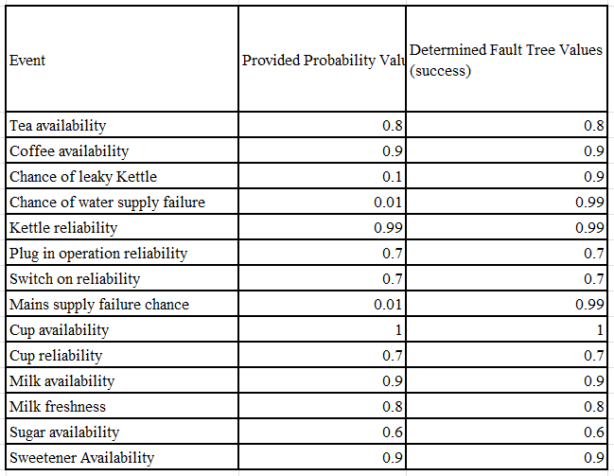

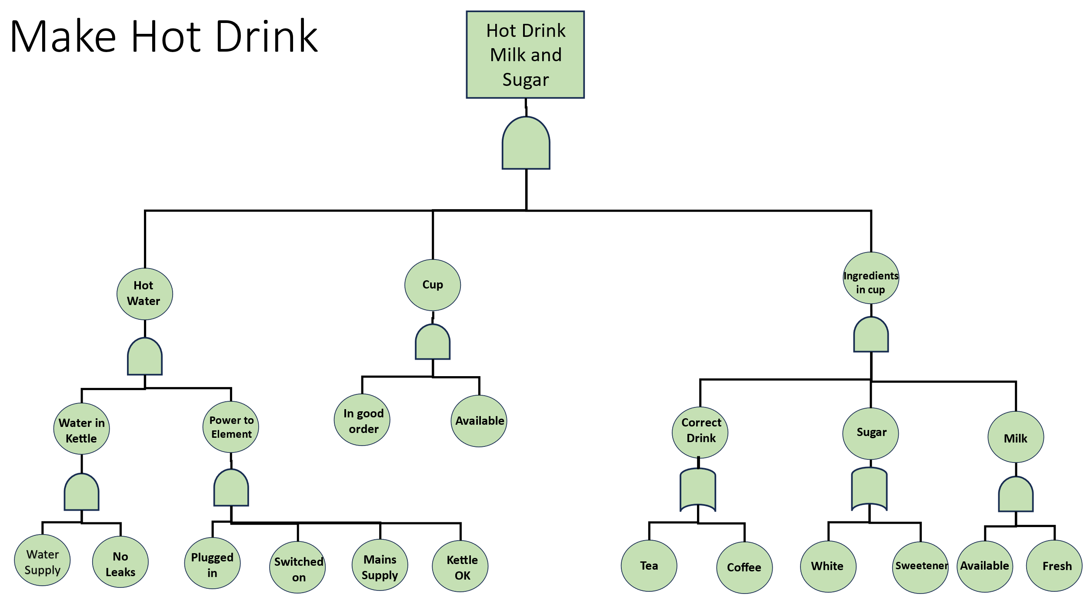
Figure 1 - Proforma Fault Tree

Calculations

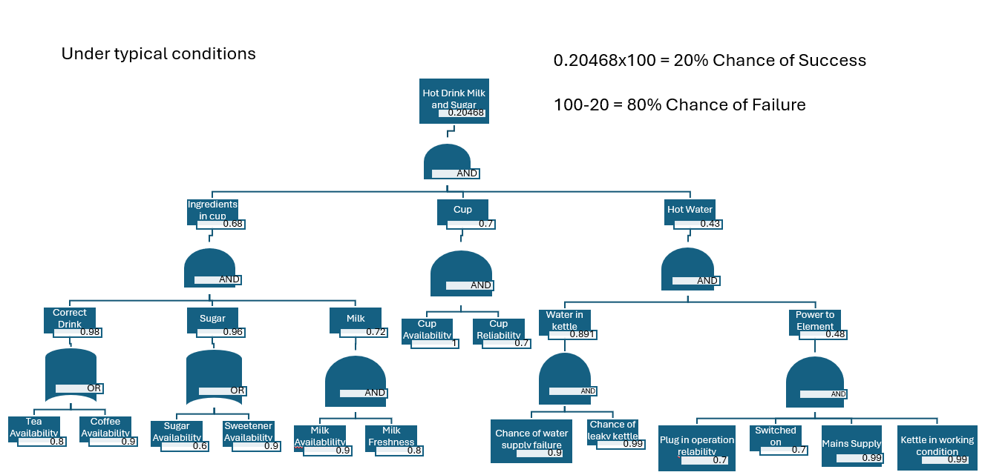
Figure 2 - Typical Conditions FTA
  - As seen in Figure 2, the result of the FTA is an 80% chance of failure. Bill’s key errors are the “power to element” and subsequently “hot water” being successfully provided as the “And” gate yields the lowest value of 0.43. Calculation can be found in Annex A.

  - As a result of these errors, his chance of success is now 20% to make his tea or coffee. It appears that Bill is not very good at this task and may fair better at a glass of water.

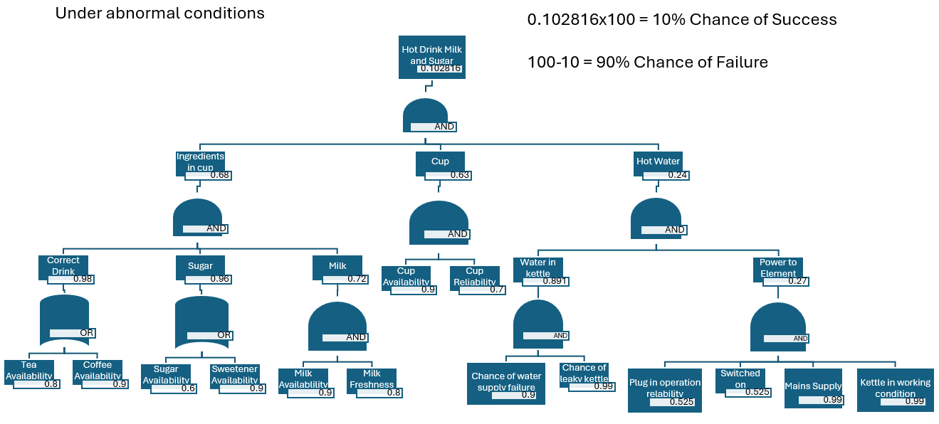
Figure 3 - Abnormal Conditions FTA
  - As seen in figure 3, with the change in scenario Bill’s ability to plug in and switch on the kettle has dropped to 75% of normal. These new values have been determined and substituted into the FTA. Calculations can be found in Annex B.

Cup Availability: $1*90\%= 0.9$
Plug and Kettle: $0.7*75\%=0.525$

  - As seen in Figure 3, Bill’s key errors have become worse with the “power to element” decreased with the overall value for “hot water” being successfully provided is lower.

  - As a result of the being awake in the middle of the night and fatigued, these factors influence Bill’s overall success chance resulting in 90% chance of failure. Bill should really stay in bed and sleep.

  - To improve upon this, minimal cut set can be used. This is a technique for manipulating the logic structure of a fault tree to identify all combinations of basic events that result in the top event, if any event is removed from a minimal cut set, the remaining events no longer constitute a failure scenario. As such, this would effectively narrow down the minimal events sufficient to cause the top-level event. Doing this will reduce the burden and time required for engineering to identify issues. [6]

  - To take this further, FTA can be used in conjunction with bowtie event trees to understand the implication of the top-level event (cause) and how it can branch out into subsequent consequences. These can be combined into a single visual representation which can allow for suitable changes to process or barriers to be introduced. [7] [8]

Application of Human Factors
  - Human Factors is a field that focuses on the interactions between people and the tools, systems and environments they operate in. For example. the goal is to design as system in such a way that the design complements the strengths and abilities of the people and minimise the effects of their limitations. [9]

In relation to the scenario given, human factors illustrates that the risk of errors is higher at night and when fatigued which has led to unintended slips in actions. As a result of no procedures, alarms, redundancies or fail safes, the failure will manage to pass through the Swiss cheese model resulting in failure. To understand human reliability, approaches such as Human Error Assessment and Reduction Technique (HEART) and Technique for Human Error Rate Prediction (THERP) to evaluate the probability of human error occurring throughout the completion of a task. Using this, issues can be identified, and appropriate measures can be taken to reduce likelihood of errors occurring. [10] [11]

Conclusion

  - In conclusion, the FTA has shown that Bill’s ability to make a cup of coffee successfully at the top event is very poor, initially 20% success chance then 10%. This is due to the already poor inputs showing that hot water is a critical event. In addition, human factors shows that the time this activity occurs, and fatigue drives down success chance further.

  - However, to be successful FTA relies on accurate input data and can become cumbersome in systems with high interdependencies. Additionally, it primarily focuses on single-point failures and may not fully capture dynamic interactions or cascading events within a system.

  - Alternatives to FTA, tools such as Failure Modes and Effects Analysis (FMEA) or the Ishikawa (Fishbone) Diagram as it also provides a visual tool that categorizes potential causes of a problem and helps teams brainstorm and organize contributing factors. [12]

References

[1] | A. online, “Fault Tree Analysis: ASEMS online,” ASEMS online, [Online]. Available: https://www.asems.mod.uk/toolkit/fault-tree-analysis. [Accessed 22 April 2025].
[2] | J. Andrews and S. Lunt, “An introduction to fault tree analysis,” [Online]. Available: https://www.nottingham.ac.uk/research/groups/resilience-engineering/documents/nxgen/outputs/an-introduction-to-fault-tree-analysis.pdf. [Accessed 22 April 2025].
[3] | D. Holley, “Fault Tree Analysis Proforma,” [Online]. Available: https://moodle.uwtsd.ac.uk/pluginfile.php/912997/mod_folder/content/0/Fault%20tree%20analysis%20proforma.docx?forcedownload=1. [Accessed 22 April 2025].
[4] | U. N. R. Commision, “Fault Tree Handbook,” January 1981. [Online]. Available: https://www.nrc.gov/docs/ML1007/ML100780465.pdf. [Accessed 22 April 2025].
[5] | T. O. Educator, Fault Tree Analysis FTA Explained With Example Calculation, 2020.
[6] | C. f. C. P. Safety, “Minimal Cut Set Analysis,” in Guidelines for Chemical Process Quantitative Risk Analysis, 2010, p. Appendix D.
[7] | PISYS, “Understanding Bowtie Analysis: A Comprehensive Guide,” PISYS, [Online]. Available: https://pisys.co.uk/2024/07/08/understanding-bowtie-analysis-a-comprehensive-guide/. [Accessed 22 April 2025].
[8] | N. N. D. -. U. A, “Fault Tree Analysis (FTA) and Event Tree Analysis (ETA),” [Online]. Available: https://www.icao.int/sam/documents/2014-adsafass/fault%20tree%20analysis%20and%20event%20tree%20analysis.pdf. [Accessed 22 April 2025].
[9] | HSE, “Introduction to human factors,” HSE, [Online]. Available: https://www.hse.gov.uk/humanfactors/introduction.htm . [Accessed 22 April 2025].
[10] | N. Turner, “Human Factors in Product and Process Design,” [Online]. Available: https://moodle.uwtsd.ac.uk/pluginfile.php/892222/mod_folder/content/0/Human%20Factors%20in%20Product%20and%20Process%20Design.pptx?forcedownload=1. [Accessed 22 April 2025].
[11] | Wikipedia, “Technique for human error-rate prediction,” Wikipedia, [Online]. Available: https://en.wikipedia.org/wiki/Technique_for_human_error-rate_prediction. [Accessed 22 April 2025].
[12] | L. Liliana, “A new model of Ishikawa diagram for quality assessment,” in IOP Conference Series: Materials Science and Engineering, 2016.

Annex

Annex A

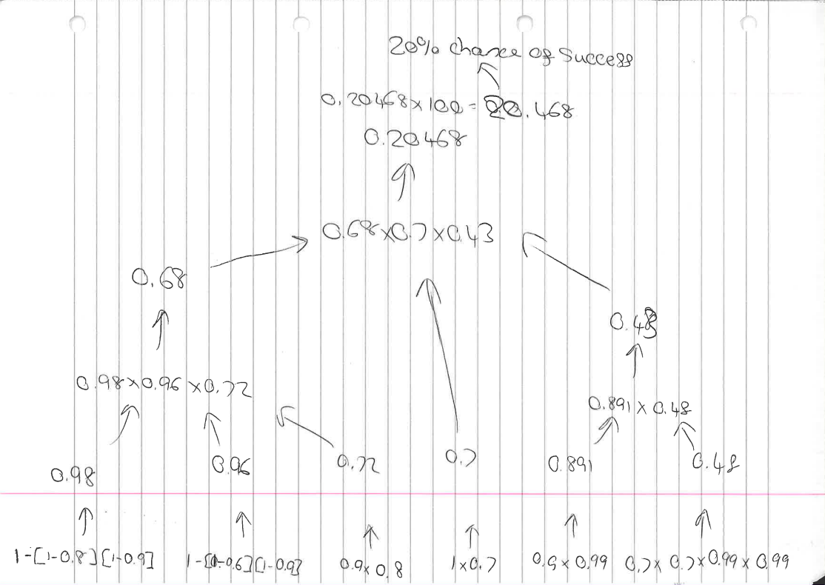
Annex B

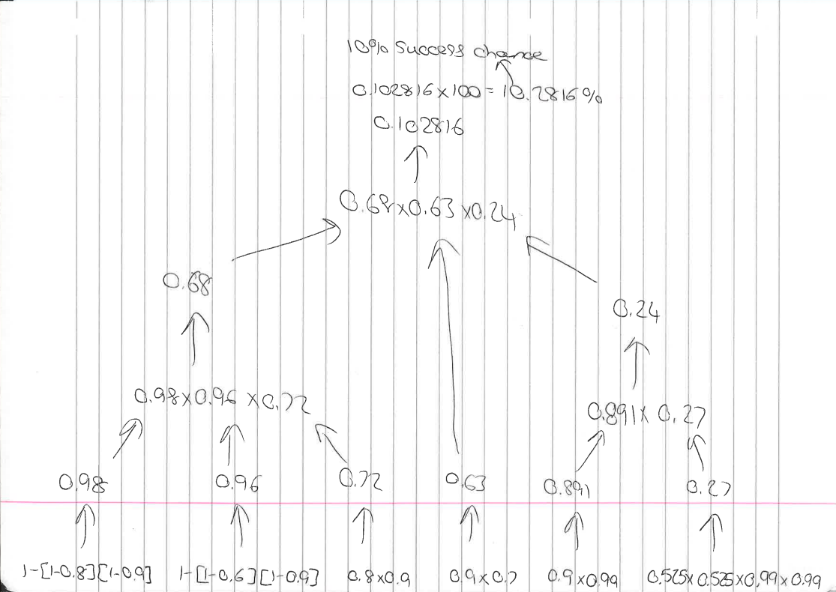

Typically, events can be mutually independent of each other. Meaning that over the course of multiple repetitions, the occurrence of A has no influence on the occurrence of B or vice versa. As such the multiplication rule for probability is used at an “And” gate. Page 60. [4]
This formula is used in regard to when one event occurs or none occur. The events can still be independent of each other but only one car occur. Page 62. [4]

