

STUDENT NAME: VACKAAR HUSSAIN
STUDENT ID: 2209946
MODULE: MASTERS PROJECT
MODULE CODE: ACFA7003
SUPERVISOR: NOAH ELMITWALLY

“A Scalable Multi-Modal Artificial Intelligence Framework for Harm Detection in Children Using Dataset Fusion, Temporal Tracking, and Escalation Mechanisms”

DECLARATION

I, VACKAAR HUSSAIN declare that I am the sole author of this Project; that all references cited have been consulted; that I have conducted all work of which this is a record, and that the finished work lies within the prescribed word limits.

This work has not previously been accepted as part of any other degree submission.

Signed : Vackaar Hussain

Date : 20th August 2026

FORM OF CONSENT

I, VACKAAR HUSSAIN hereby consent that my Project, submitted in candidature for the M.Sc. Applied Computing degree, if successful, may be made available for inter-library loan or photocopying (subject to the law of copyright), and that the title and abstract may be made available to outside organisations.

Signed : Vackaar Hussain

Date : 20th August 2026

Abstract
The rapid expansion of digital communication and online interaction has increased the complexity of identifying harmful behaviour directed towards children. Existing artificial intelligence approaches frequently address individual modalities in isolation, limiting their ability to capture the multifaceted and evolving nature of online harm. This project addresses this limitation by proposing and experimentally evaluating a scalable multi-modal artificial intelligence framework for child harm detection, integrating textual, visual and behavioural evidence within a unified risk assessment architecture.

The proposed framework combines three complementary detection modules. A transformer-based natural language processing approach is employed to identify harmful content within textual communication, while deep learning-based computer vision models analyse visual content for potentially unsafe material. A behavioural detection module further examines conversational patterns associated with harmful or predatory behaviour. Rather than treating these modalities as independent classification tasks, their outputs are transformed into comparable risk scores and integrated through a late-fusion mechanism, enabling the framework to produce a consolidated assessment of potential harm.

A further contribution of the framework is the integration of temporal risk tracking and escalation mechanisms. Recognising that harmful behaviour may not be adequately represented by a single isolated observation, the framework tracks risk across successive observations and incorporates escalation categories ranging from LOW and MEDIUM to HIGH and CRITICAL. This provides a mechanism through which persistent or increasing risk can be distinguished from isolated signals, supporting more context-aware prioritisation of potentially serious incidents.

The framework was developed and evaluated experimentally using established datasets representing textual toxicity, visual safety and behavioural risk. Multiple deep learning and transformer architectures were investigated, with performance assessed using established classification and diagnostic measures, including accuracy, precision, recall, F1-score, ROC-AUC, confusion matrices and risk-oriented analysis. Explainability techniques were additionally incorporated to improve transparency and support interpretation of model decisions.

Experimental results demonstrate the feasibility of integrating heterogeneous AI models into a unified multimodal risk assessment pipeline. The resulting architecture provides a more comprehensive representation of potential harm than reliance on a single modality, while temporal tracking enables the system to account for the persistence and progression of risk. Importantly, the framework is designed as a decision-support architecture rather than an autonomous safeguarding authority, recognising the ethical, legal and practical requirements associated with AI systems operating in sensitive child-safety contexts.

Overall, the project demonstrates how multimodal artificial intelligence, risk-score fusion, temporal analysis and escalation logic can be combined into a scalable framework for identifying and prioritising potential online harm. The research contributes an integrated approach that moves beyond isolated content classification towards contextual, cumulative and risk-oriented harm assessment, providing a foundation for future research into explainable, human-supervised AI systems for child online safety.

Table of Contents

Chapter 1 Introduction 8
1.1 Introduction 8
1.2 Problem Statement 8
1.3 Aim 9
1.4 Objectives 10
1.5 Research Questions 11
1.6 Research Scopre 11
1.7 Significance of Project 12
1.8 Chapter Structure 12
Chapter 2 Literature Review 14
2.1 Introduction 14
2.2 Artificial Intelligence Harm Detection 14
2.3 Multi-Modal Artificial Intelligence Systems 16
2.4 Dataset Fusion and Data Integration 17
2.5 Temporal Tracking and Behavioural Analysis 18
2.6 Escalation Systems and Risk Prioritization 20
2.7 Explainable Artificial Intelligence 21
2.8 Ethical, Legal and Privacy Considerations 22
2.9 Scalability Challenges in AI Systems 23
2.10 Research Gaps 26
Chapter 3 Research Methodology 28
3.1 Introduction 28
3.2 Research Philosophy and Approach 28
3.3 Research Design 28
3.4 Dataset Selection and Preparation 29
3.5 Model Development 30
3.6 Dataset Fusion Strategy 30
3.7 Temporal Tracking and Escalation Mechanism 31
3.8 Model Evaluation 31
3.9 Explainability and Model Interpretability 32
3.10 Ethical, Legal and Privacy Considerations 32
3.11 Research Limitations 33
3.12 Chapter Summary 33
Chapter 4 Research Methodology 34
4.1 Introduction 34
4.2 Development Environment 34
4.3 Text Model Implementation 35
4.4 Image Model Implementation 35
4.5 Behavioural Model Implementation 35
4.6 Dataset Fusion Implementation 36
4.7 Temporal Tracking Implementation 37
4.8 Escalation Mechanisms Implementation 38
4.9 Framework Integration 39
4.10 Chapter Summary 39
Chapter 5 Results and Evaluation 40
5.1 Introduction 40
5.2 Module 1 Text Based Risk Detection 40
5.3 Module 2 Image Based Risk Detection 44
5.4 Module 3 Behavioural Risk Detection and Explainability 48
5.4.1 Behavioural Model Explainability 50
5.5 Module 4 Multimodal Risk Fusion 52
5.6 Module 5 Temporal Risk Tracking and Escalation 56
5.7 Overall Evaluation of the Framework 59
Chapter 6 Discussion 60
6.1 Introduction 60
6.2 Overall Framework Performance 60
6.3 Comparative Evaluation of the Three Modalities 61
6.4 Multimodal Fusion Evaluation 61
6.5 Temporal Risk Tracking and Escalation Evaluation 62
6,6 Critical Evaluation of the Framework 63
6,7 Comparison with Existing Research 63
6,8 Project Contribution and Originality 64
6,9 Ethical, Practical and Deployment Considerations 65
6,10 Chapter Summary 65
Chapter 7 Conclusion and Future Work 66
7.1 Introduction 66
7.2 Achievement of Aim and Objectives 66
7.3 Overall Conclusions 67
7.4 Project Contributions 68
7.5 Limitations 68
7.6 Recommendations for Future Work 69
7.4 Final Conclusion 70
References 71

List of Figures

4.1. Overall architecture of the proposed multi-modal child harm detection framework 37
5.1 Comparative performance of RoBERTa and DeBERTa-v3 across key evaluation metrics 40
5.2 RoBERTa confusion matrix showing classification performance across safe and unsafe text classes 41
5.3 ROC curve comparison of RoBERTa and DeBERTa-v3 for text classification performance 42
5.4 Precision–recall curve comparison of RoBERTa and DeBERTa-v3 for text classification performance 43
5.5 Comparative performance of ResNet50 and ViT across key evaluation metrics 44
5.6 Confusion matrix showing the classification performance of the ResNet50 image classification model 45
5.7. Confusion matrix showing the classification performance of the ViT image classification model 46
5.8. Threshold analysis of the ResNet50 model showing performance variation across classification thresholds 47
5.9. Comparative performance of RoBERTa and DeBERTa-v3 across key evaluation metrics 48
5.10. Distribution of predicted behavioural risk levels generated by the behavioural detection model 49
5.11. SHAP-based token importance for the RoBERTa text classification model 50
5.12. Confusion matrix showing the classification performance of the RoBERTa behavioural model 51
5.13. Mean risk scores across the text, image, and behavioural modalities 52
5.14. Distribution of final multimodal risk levels produced by the fusion framework 55
5.15. Distribution of final multimodal risk scores. 56
5.16. Distribution of escalation states generated by the temporal risk escalation mechanism 58

List of Tables

2.1. Summary of key literature and research contributions relevant to multi-modal child harm detection. 26
3.1. Summary of the datasets, modalities, simple characteristics, and classification tasks used across the three detection modules 30
4.1 Risk escalation levels and corresponding risk thresholds and response states 38
5.13 Correlation between risk scores across the text, image, and behavioural modalities 53
5.14 Final multimodal fusion risk scores and corresponding risk classifications 54
5.15 Rolling temporal risk values across successive observations. 57

Chapter 1 — Introduction

1.1 Background
The rapid development of artificial intelligence (AI) has created opportunities to analyse increasingly complex forms of digital information. Machine-learning and deep-learning techniques can process text, images and behavioural information at a scale that would be difficult to achieve through manual analysis alone. These capabilities have relevance to safeguarding, where potentially harmful interactions may be communicated through different modalities and may develop over time [1].

Traditional approaches that analyse individual information sources independently can provide useful evidence but may overlook relationships between different forms of information. For example, potentially concerning language may become more meaningful when considered alongside visual or behavioural indicators. Multimodal approaches provide mechanisms for combining information from different data types and integrating these sources to support more comprehensive analysis [2], [3]. Similarly, an isolated observation may provide limited evidence, whereas repeated patterns across time may indicate a more persistent risk. In child protection contexts, algorithmic approaches have been explored for anticipating and managing uncertain future risk, highlighting the importance of considering how risk is constructed and interpreted over time [4].

This project therefore investigates a multimodal AI framework for child-harm risk assessment, integrating text, image and behavioural analysis. Rather than attempting to make an autonomous determination of whether harm has occurred, the proposed approach is designed to generate and combine risk signals that can support prioritisation and subsequent human assessment.

The project addresses a complex problem because the underlying data are heterogeneous, context-dependent and subject to uncertainty. Consequently, the investigation considers not only individual model performance but also the challenges associated with combining different predictions, monitoring changes in risk and determining appropriate escalation [2], [4].

1.2 Problem Definition
A central limitation of single-modality approaches is their restricted view of potentially harmful activity. Text-based systems may identify harmful language but cannot directly analyse visual information, while image-based approaches cannot independently capture linguistic or behavioural context. Multimodal learning and data-fusion approaches provide mechanisms through which heterogeneous information sources can be combined to address these limitations [2], [3].

Behavioural analysis can provide additional contextual information but may also be affected by ambiguity, incomplete observations and dataset limitations. Recent research demonstrates the use of machine-learning methods for detecting online grooming and highlights both the potential and methodological challenges associated with automated behavioural detection [5].

A further challenge is that potential harm cannot necessarily be represented as a single static classification. Risk may change as additional observations become available. A system that considers only individual predictions may therefore fail to distinguish between an isolated high-risk signal and a pattern of repeated or increasing concern. Research into algorithmic risk in child protection demonstrates that predictive systems can be used to anticipate uncertain future risk, while also highlighting the importance of how such risk is constructed and interpreted [4].

The problem addressed by this research is consequently the development of a framework capable of combining heterogeneous risk evidence and incorporating temporal changes into a structured escalation process.

This creates several technical challenges. The outputs of different models must be transformed into comparable risk representations; the resulting information must be fused without allowing unreliable predictions to dominate; and temporal changes must be interpreted without treating automated scores as definitive evidence of harm [2], [4].

The project therefore investigates whether established AI techniques can be systematically integrated to provide a more contextual approach to risk prioritisation.

1.3 Aim
The aim of this project is:

To develop and evaluate a scalable multimodal artificial intelligence framework for child-harm risk assessment using text, image and behavioural analysis, multimodal risk fusion, temporal tracking and escalation mechanisms.

The aim deliberately encompasses both development and evaluation. The project is not limited to constructing an AI architecture; it also evaluates its feasibility, limitations and potential contribution within the defined experimental conditions.

The resulting framework is positioned as a proof-of-concept decision-support architecture. This distinction is important because successful experimental integration does not establish that an AI system can independently determine safeguarding outcomes in real-world environments. Recent systematic evidence indicates that machine-learning applications in child protection continue to face issues relating to methodological quality, fairness, transparency and stakeholder involvement [6].

1.4 Objectives
To achieve the project aim, the following objectives were established:

1. Develop a text-based harm-risk detection component capable of generating risk information from textual data using transformer-based natural language processing.

2. Develop an image-based classification component capable of identifying relevant visual risk information using deep-learning computer-vision models.

3. Develop a behavioural analysis component capable of generating risk information from interaction and behavioural patterns.

4. Integrate the three modalities using multimodal late fusion to produce a unified risk representation.

5. Implement a temporal risk-tracking mechanism to monitor changes in risk across observations.

6. Develop an escalation mechanism capable of translating risk patterns into LOW, MEDIUM, HIGH and CRITICAL categories.

7. Evaluate the framework critically using appropriate performance measures, comparative analysis, explainability techniques and examination of methodological limitations.

8. Assess the practical, ethical and deployment implications of using multimodal AI for safeguarding-oriented risk prioritisation.

Together, these objectives establish a progression from individual modality development to an integrated framework and its critical evaluation.

1.5 Research Questions
The investigation is guided by the following research questions:

RQ1: To what extent can text, image and behavioural AI models generate useful risk signals for child-harm assessment?

RQ2: How effectively can heterogeneous modality outputs be combined through multimodal risk fusion?

RQ3: Can temporal tracking and escalation mechanisms provide additional contextual information by identifying changes or persistence in risk?

RQ4: What are the principal technical, methodological, ethical and practical limitations of the proposed multimodal framework?

RQ5: To what extent does the integrated framework provide a viable foundation for AI-assisted risk prioritisation and safeguarding decision support?

These questions ensure that the project evaluates not only whether individual models can produce predictions, but whether their integration provides a meaningful and defensible framework.

1.6 Research Scope
The scope of the investigation is deliberately defined to ensure that the findings remain proportionate to the available data and experimental resources.

The project considers three modalities: text, images and behaviour. Each modality is developed as an independent analytical component before its output is incorporated into the wider framework. The project then applies late fusion to generate a consolidated risk score, followed by temporal tracking and escalation.

The investigation focuses on experimental feasibility rather than production deployment. The datasets used provide controlled environments for developing and evaluating the framework, but they do not constitute a single, fully representative real-world child-safeguarding dataset. Consequently, the findings should not be interpreted as evidence of operational effectiveness across all populations or safeguarding contexts. This limitation is consistent with wider evidence indicating methodological and applicability challenges in machine-learning research for child protection [6].

The project also does not attempt to replace safeguarding professionals. Its intended role is to provide structured risk information that could potentially assist human prioritisation and investigation. Human-in-the-loop approaches are particularly relevant to high-stakes AI applications because they incorporate human oversight, feedback and decision-making rather than relying entirely on automated decisions [7].

1.7 Significance of the Project
The significance of the project lies in its attempt to address the limitations of isolated AI classification by combining heterogeneous evidence within a single architecture. The integration of text, visual and behavioural information provides broader contextual coverage than a single-modality approach, while multimodal fusion provides mechanisms for combining information from different data sources [2], [3].

The project also demonstrates the practical application and integration of established AI techniques, including transformer-based natural language processing, computer vision, behavioural classification, explainability, multimodal fusion and temporal risk analysis.

Its originality therefore lies primarily in the integration and application of established techniques within a unified safeguarding-oriented framework, rather than in claiming the development of a fundamentally new machine-learning algorithm.

This distinction is important at postgraduate level because the contribution should be evaluated against the evidence produced by the investigation. The project seeks to demonstrate a technically coherent and experimentally evaluated architecture while explicitly recognising the limitations that would need to be addressed before any operational implementation. The need for careful human oversight and appropriate boundaries around AI autonomy is particularly important in high-stakes applications [6], [7].

1.8 Chapter Structure
The remainder of this report is structured as follows.

Chapter 2 reviews relevant literature concerning AI-based harm detection, multimodal learning, natural language processing, computer vision, behavioural analysis, temporal modelling, explainability and safeguarding applications. The chapter identifies gaps and establishes the research context for the proposed framework.

Chapter 3 presents the methodology, including the research philosophy, research design, dataset selection, model development, fusion strategy, temporal tracking, escalation approach, evaluation methods, explainability and ethical considerations.

Chapter 4 describes the implementation of the proposed framework, including the development of the individual modalities and their integration into the multimodal architecture.

Chapter 5 presents the experimental results and evaluates the outputs generated by the individual models and integrated framework.

Chapter 6 provides the critical evaluation of the findings, considering multimodal performance, fusion, temporal tracking, escalation, limitations, originality, ethical implications and potential deployment.

Chapter 7 concludes the project by evaluating the achievement of its aim and objectives, identifying its contributions and limitations, and presenting recommendations for future research.

Chapter 2 Literature Review

2.1 Introduction
This chapter critically reviews research relating to artificial intelligence (AI)-based harm detection and scalable multimodal AI systems. It evaluates established approaches, their strengths and limitations, and the research gaps motivating the proposed framework. Recent systematic reviews indicate that AI is increasingly being investigated for child protection, abuse detection and online safety, although the evidence base remains relatively limited and methodological challenges continue to affect the development and validation of such systems [1] [8-9].

The review examines AI-based harm detection, multimodal learning, dataset fusion, temporal and behavioural analysis, risk escalation, explainable AI, ethical considerations and scalability. Rather than treating these areas independently, the chapter synthesises their relationships to establish the theoretical and technical rationale for integrating multiple sources of evidence. Recent research on multimodal AI demonstrates the increasing importance of combining complementary information sources, while also highlighting challenges associated with heterogeneous data, fusion strategies and model interpretation [10][11].

2.2 Artificial Intelligence for Harm Detection
Artificial intelligence (AI) has become increasingly important for detecting harmful content and behaviour across digital environments. Research has investigated machine learning, deep learning and natural language processing (NLP) for child abuse, neglect, online child sexual abuse and other digital harms, demonstrating potential for automated detection and prevention [1][14]. However, the evidence base remains comparatively immature. Lupariello et al. [1] identified heterogeneous inputs and AI approaches but also substantial methodological limitations and a high risk of bias.

Earlier harm-detection approaches commonly relied on predefined rules, keywords and manually constructed indicators. While useful for explicit harmful content, these approaches are less effective at capturing contextual, implicit or evolving behaviour. Machine-learning and deep-learning methods can instead learn complex patterns directly from data [1][8].

NLP is particularly relevant because harmful behaviour can involve abusive, threatening, coercive or sexually exploitative language. Transformer architectures use attention mechanisms to model contextual relationships and have advanced modern NLP. BERT-derived models, including RoBERTa and DeBERTa, are increasingly applied to natural language understanding tasks [15]. However, predictive performance depends on training-data quality and representativeness, while ambiguous language and unseen patterns remain challenges. Research into child abuse and neglect also identifies concerns regarding dataset selection, validation, overfitting and bias, demonstrating the need to evaluate models beyond accuracy alone [1].

Computer vision provides complementary capabilities for analysing visual information. Convolutional neural networks (CNNs) learn hierarchical visual representations, while Vision Transformers (ViTs) use self-attention to model relationships between image regions. ViTs are increasingly applied to classification, detection and segmentation, although computational requirements, architecture design and deployment remain challenges [16][17]. Furthermore, visual classification is context-dependent, meaning visual evidence alone may provide only a partial representation of potential harm.

These limitations support multimodal AI, which combines different information sources to exploit complementary evidence. Research highlights its potential while identifying challenges involving heterogeneous data, alignment, fusion strategies and incomplete information [10][11]. In harm detection, textual evidence may indicate harmful language, visual information may provide context, and behavioural information may reveal patterns unavailable from an isolated observation. However, effective fusion depends on dataset quality, fusion design and interpretation of predictions [10][11].

Explainable AI (XAI) is also important because accurate predictions may provide limited insight into how decisions are generated. Research identifies explanation quality, interpretability and trust as important considerations, particularly for high-stakes applications [12–14]. Trustworthy AI research further emphasises transparency, robustness, bias and human-centred decision-making [13]. Explanations can influence trust but may become counterproductive when unclear or overly complex [14].

Within child protection, systematic reviews identify considerable potential but limited evidence of effective real-world implementation. Research on AI-based prevention of online child sexual abuse calls for stronger empirical evidence [8], while child abuse and neglect research highlights the need for stronger validation and improved management of bias and overfitting [1].

Overall, AI offers significant potential for harm detection but remains limited by modality coverage, contextual understanding, validation, explainability and decision support [1][8][10][13]. These gaps motivate an integrated framework combining textual, visual and behavioural evidence with temporal tracking, explainability and risk escalation.

2.3 Multimodal Artificial Intelligence Systems
Multimodal artificial intelligence (AI) extends single-modality systems by integrating information from sources such as text, images, audio and behavioural or sensor data. Different modalities can provide complementary information unavailable from an individual source, improving the representation and interpretation of complex information [18][2].

This is particularly relevant to harm detection because harmful behaviour may manifest through language, visual content and interaction patterns simultaneously. Text can provide linguistic evidence, while visual and behavioural information can provide additional context. Multimodal learning therefore offers broader contextual coverage than individual modalities, particularly where evidence is incomplete or ambiguous [1][19][20].

However, multimodal integration introduces challenges because text, images and behavioural sequences have different structures, representations and statistical characteristics. Systems must address modality heterogeneity, representation, alignment, missing information and differences in data quality. Cross-modal alignment is particularly challenging where modalities do not share a common representation or are not temporally synchronised [2][19][20].

Three main fusion strategies are early, intermediate and late fusion. Early fusion combines raw data or low-level features at an early processing stage, enabling relationships between modalities to be learned early but generally requiring compatible representations and adequate alignment [19][21]. Intermediate fusion combines learned modality-specific representations, allowing richer cross-modal interactions while increasing architectural complexity [19][21]. Late fusion independently processes each modality before combining predictions at the decision level. This provides greater modularity because individual models can be trained, evaluated and replaced independently, although deeper cross-modal interactions may be limited [19][21].

The choice of fusion strategy therefore involves a trade-off between representational richness, computational requirements, flexibility and interpretability. For this project, late fusion is appropriate because heterogeneous datasets and independently developed models are used for textual, visual and behavioural information. It allows independently generated risk signals to be integrated without requiring identical representation spaces and is consistent with established multimodal fusion approaches [19][21].

Late fusion also supports scalability because additional models or modalities can potentially be incorporated without redesigning the complete feature-extraction architecture. This modularity is important as multimodal systems increase in complexity and require consideration of computational resources and individual modality characteristics [2]. Nevertheless, independently processing modalities may limit deeper cross-modal relationships that could be captured through joint representation learning [19].

A further limitation is the static treatment of information in many multimodal systems. Risk may develop through repeated interactions or behavioural changes rather than a single observation. Research highlights the importance of modelling changing events, intent and temporal relationships because static observations may incompletely represent evolving risk [22][23]. Temporal analysis therefore complements multimodal fusion: fusion identifies evidence across modalities, while temporal tracking examines how risk changes across successive observations [20][23].

Multimodal systems also create additional explainability challenges because final predictions may depend on several modality-level outputs. Interpretability remains a major challenge alongside fusion, alignment, efficiency and robustness [19]. Trustworthy AI research similarly emphasises transparency, interpretability and human oversight in consequential decision-making [14]. Maintaining separate modality-level risk signals through late fusion provides greater visibility into individual contributions alongside the final fused score.

Overall, multimodal AI provides a strong foundation for combining heterogeneous evidence, but effective implementation requires consideration of fusion strategy, temporal context, scalability, data heterogeneity and interpretability [2][19][20]. For the proposed framework, late fusion provides a practical balance between independent modality development and integration, while temporal tracking and escalation extend the system beyond static classification towards continuous assessment of changing risk.

2.4 Dataset Fusion and Data Integration
Dataset fusion is critical when developing multimodal artificial intelligence (AI) systems because the text, image and behavioural modalities used in this project originate from heterogeneous sources. Differences in representation and statistical properties create challenges involving modality heterogeneity and cross-modal alignment [2][21].

In the proposed framework, the datasets are not naturally aligned observations of the same underlying event. They originate independently with different structures and class distributions. Therefore, integrating independently generated modality predictions is more appropriate than assuming identical representations across modalities [2][21].

Three fusion strategies are early, intermediate and late fusion. Early fusion combines raw data or features early but requires compatible representations and alignment. Intermediate fusion combines learned modality-specific representations, enabling richer interactions but increasing complexity. Late fusion processes modalities independently before combining predictions [2][21].

Early fusion is unsuitable because equivalent text, image and behavioural records are unavailable for every observation. Direct alignment could introduce dependencies between datasets and reduce the usable sample. Late fusion allows independently trained models to generate risk predictions that are subsequently combined, making it appropriate for heterogeneous datasets [2][21].
Late fusion provides modularity because individual models can be trained, evaluated, improved or replaced independently [2][19]. It also supports scalability by allowing additional models or data sources to be incorporated into the framework [2][21]. However, independent processing may limit deeper cross-modal relationships learned through joint representation learning [2][21].

Data quality is another concern. Incomplete, imbalanced or poorly representative datasets can affect reliability and generalisability, while different sampling and annotation processes may produce different characteristics across modalities [2][21]. Class imbalance requires modality-specific evaluation before predictions are combined [2][19]. Distribution shift is important because language and behaviour can evolve, reducing generalisability [2][21].

Dataset integration also raises ethical concerns involving privacy, data governance, transparency, bias and human oversight. Trustworthy and explainable AI research emphasises fairness, accountability, transparency and human involvement in consequential decisions [14]. A combined risk score should therefore support decision-making rather than represent an unquestionable determination of harm [14].

Overall, late fusion is a strategy for heterogeneous datasets, but it does not eliminate challenges involving data quality, alignment, generalisability and cross-modal interaction [2][21]. Its selection reflects available datasets, lack of alignment, modularity and visibility of modality-level predictions.

Accordingly, textual, visual and behavioural models are developed independently before their risk signals are integrated into a final multimodal risk score. This provides a balance between dataset integration, scalability and interpretability while acknowledging that deeper cross-modal relationships may remain unexplored.

2.5 Temporal Tracking and Behavioural Analysis
Static classification provides insight when harmful behaviour develops progressively. A model evaluating observations independently may identify whether an observation appears harmful, but may not capture how risk develops across interactions. In online safeguarding, where harmful behaviour can involve progressive communication strategies. Research on online grooming demonstrates that conversations can contain stages and strategies whose sequencing provides contextual information about harmful interactions [5][24].

Temporal tracking addresses this limitation by examining changes across observations rather than treating predictions as independent. Temporal information is important in multimodal processing, where observations may represent changing aspects of the same event and require temporal relationships [23]. Crime-event information-fusion research similarly identifies the dynamic nature of criminal intent [22].

Behavioural analysis is relevant because manipulation, grooming and escalating abuse may emerge through repeated interactions. Research has identified differences in grooming stages and strategies and shown that conversation flow varies across interaction types [24]. Leiva-Bianchi et al. [5] reviewed 33 studies and 11 machine-learning methods for online grooming detection, assessing accuracy, precision, recall and F1-score.
Many systems focus on classifying harmful interactions rather than modelling continuous risk progression. This represents an important research opportunity because behavioural risk may not be adequately represented by one classification decision. Research into online child sexual abuse has highlighted limited evidence for existing AI interventions [8]. Temporal analysis must distinguish genuine escalation from normal behavioural variation. A single high-risk prediction may be an isolated anomaly, whereas repeated moderate-risk observations may indicate concern [24].

Behavioural progression is relevant to grooming because perpetrators may adapt strategies in response to victim resistance, supporting the view that harmful behaviour is dynamic [8]. Integrating temporal information with multimodal evidence creates challenges because modalities may become available at different times and vary in reliability. Research identifies temporal relationships and cross-modal alignment as important challenges [19][23].

Combining temporal tracking with multimodal evidence can provide context unavailable through static classification. Fusion establishes evidence across sources, while temporal analysis examines how signals change. Information-fusion research supports combining multiple evidence sources while accounting for dynamic criminal intent [22]. Ethical considerations include privacy, transparency and proportionality when sensitive safeguarding data are processed. Limited evidence regarding AI intervention effectiveness reinforces the need for evaluation [8].

Human judgement must remain central. Machine-learning systems can identify patterns requiring attention, but outputs should not automatically determine intervention. Research indicates such systems can assist human analysis but may not match expert annotation reliability [26]. Overall, temporal analysis extends harm detection towards dynamic risk assessment. Research on grooming, behavioural sequencing and temporal multimodal processing demonstrates the value of considering behavioural progression and temporal relationships [5][22-24]. Integrating these capabilities with multimodal evidence supports monitoring risk signals from text, images and behaviour across successive observations.

2.6 Escalation Mechanisms and Risk Prioritisation
Escalation mechanisms provide the link between artificial intelligence (AI) prediction and safeguarding decisions. Although harm-detection models estimate the probability that an observation represents harmful content or behaviour, probability scores have limited value without a risk-assessment framework. Research shows that automated risk scores can contain weaknesses and inconsistent outputs when inadequately evaluated [27]. Converting predictions into risk levels is therefore essential.

Binary harmful/non-harmful classifications can be insufficient when cases differ in severity, persistence and urgency. Research has identified weaknesses in reporting calibration needed to assess predicted risks [28]. Risk prioritisation should therefore use probability scores, thresholds or rule-based mechanisms to translate continuous outputs into categories. However, thresholds are not universally valid because effectiveness depends on data distribution, calibration and consequences of errors [28][29].

Threshold selection must balance false positives and false negatives. A low threshold may improve sensitivity but generate alerts, whereas a high threshold may reduce escalation while increasing missed harmful observations. Calibration and validation should therefore accompany discrimination measures such as ROC-AUC [28]. Thresholds should be treated as operational parameters requiring empirical evaluation and monitoring.

Risk should incorporate contextual and temporal evidence rather than relying on isolated probability values. Online grooming research demonstrates that harmful interactions can involve multiple stages and strategies, supporting analysis of behavioural context and interaction sequences [5][24]. A high-risk observation may warrant attention, while repeated moderate-risk indicators may demonstrate escalating concern. Temporal relationships can distinguish isolated severity from sustained or increasing risk when analysing evolving multimodal information [23][24].

Automated escalation introduces risks from false positives, false negatives, bias and incomplete context. A 2024 ACM FAccT study of an AI-supported child-protection decision system identified methodological flaws, inappropriate proxy variables, inconsistent risk scores and age-based discrimination, highlighting the need for rigorous evaluation and monitoring [27]. A highly accurate classifier may still be unsuitable if poorly calibrated, difficult to interpret or biased [27][28].

AI should support, not replace, professional judgement. Escalation should identify observations or behavioural patterns requiring further assessment rather than automatically determine intervention. Transparency, accountability, fairness, explainability and human oversight are essential [27][30]. Showing modality-level contributions alongside final scores can improve interpretability within multimodal systems.

The proposed framework addresses these requirements through unified risk scores, temporal analysis and four categories—Low, Medium, High and Critical. It converts continuous multimodal estimates into interpretable escalation states while retaining modality-level evidence and temporal information. The mechanism functions as a decision-support layer for prioritising changing potential risk while maintaining human oversight.

2.7 Ethical, Legal and Privacy Considerations
AI-based harm detection presents ethical, legal and privacy challenges because safeguarding decisions can significantly affect children. Research into AI-supported child-protection decision-making has identified methodological weaknesses and inappropriate automated risk systems, demonstrating potential consequences for vulnerable populations [27].

AI predictions should function as decision-support rather than autonomous safeguarding determinations. Hansen, Sinatra and Sekara [27] identified methodological flaws, inconsistent risk scores and age-based discrimination in an AI-supported child-protection system, highlighting the need for rigorous evaluation and monitoring. UK guidance emphasises human decision-making, accountability, explainability and monitoring [30].

Bias can arise from dataset composition, sampling, annotation, proxy variables and unequal representation. False negatives may allow harmful behaviour to remain undetected, while false positives can lead to unnecessary investigation. UK AI-assurance guidance identifies bias audits, performance testing, impact assessment, transparency and contestability as safeguards [30]. Models should therefore be evaluated beyond aggregate accuracy and monitored as data distributions change [27].

Privacy becomes especially important when text, visual and behavioural modalities are combined because they create detailed and sensitive representations. Privacy-aware governance is therefore required throughout collection, processing, storage and analysis. UK data-protection requirements include lawfulness, fairness and transparency, purpose limitation, data minimisation, accuracy, storage limitation, integrity and confidentiality. The ICO emphasises minimising personal data and retention [31].

Data minimisation means additional modalities should not justify collecting unnecessary information. Organisations should process only data adequate, relevant and necessary for the stated purpose [31]. GDPR principles similarly establish lawfulness, fairness, transparency, purpose limitation and data minimisation as fundamental requirements [32]. Purpose limitation means data collected for one purpose should not automatically be repurposed for unrelated AI analysis [31][32].

Security is essential because multimodal systems may process sensitive information. Access controls, secure storage and retention policies should be incorporated into system design [31]. Explainability is important because professionals must understand recommendations and challenge incorrect predictions effectively [30].

Human oversight manages contextual uncertainty because professionals may possess evidence unavailable to the model. Governance should document processing, evaluation, thresholds, evidence and reviewer responsibilities. UK assurance guidance identifies accountability, monitoring, contestability and redress as components of responsible implementation [30].

Overall, responsible safeguarding AI requires balancing detection capability with individual rights. Fairness, transparency, explainability, privacy, accountability, security and human oversight should be considered throughout the AI lifecycle [27] [30-32]. The proposed framework therefore treats AI as assistive technology, combining multimodal predictions, temporal analysis, interpretable risk categories and modality-level evidence while retaining human oversight and privacy-aware governance.

2.8 Explainable Artificial Intelligence
Explainable Artificial Intelligence (XAI) addresses the limited transparency and interpretability of complex AI models. As deep-learning architectures become more sophisticated, understanding how predictions are produced is important in sensitive applications where decisions may affect individuals. Research identifies transparency, interpretability, trust and explanation evaluation as continuing XAI challenges [33][34].

In safeguarding, predictive performance alone is insufficient if professionals cannot understand why a recommendation was produced. Explainability can therefore support interpretation, validation and scrutiny of model outputs used in human decision-making [33][35]. These models capture complex relationships in text and images, but their internal representations are difficult to interpret. XAI provides techniques for making model behaviour understandable [34][36].

SHAP (SHapley Additive exPlanations) estimates the contribution of features to a prediction, making it useful for textual classification where influential words or tokens can be examined. Attribution quality and limitations must still be considered [34][37]. For visual models, Gradient-weighted Class Activation Mapping (Grad-CAM) produces spatial heatmaps identifying image regions associated with predictions, providing complementary visual evidence [34][38]. Using SHAP for text and Grad-CAM for images allows explanations to reflect each modality rather than applying one method across the multimodal system [34][36].

Neither technique guarantees correctness, fairness or causal justification. XAI explanations are representations of model behaviour rather than complete descriptions of internal reasoning. Research continues to identify difficulties in evaluating explanation fidelity, usefulness and trustworthiness, and the absence of universally accepted standards [33][37]. Consequently, XAI should complement model evaluation, validation and bias assessment [33][37].

Multimodal systems introduce challenges because final risk assessments may combine textual, visual and behavioural evidence. Users need to understand which modalities contributed most strongly to an elevated risk score because fusion can obscure evidence. Modality-specific explanations can therefore support scrutiny and allow professionals to challenge inappropriate recommendations [19]. XAI can also reveal unexpected or potentially problematic features, although fairness requires dedicated evaluation across groups and datasets [33][37].

Human oversight remains essential because explanations cannot capture contextual information absent from model inputs. In this framework, SHAP examines influential textual features and Grad-CAM identifies visually influential image regions. Combined with modality scores, temporal tracking and escalation, these explanations support human assessment. However, both are post-hoc methods and should be treated as evidence about model behaviour, not definitive reasons for predictions [33][37].

Overall, XAI strengthens transparency and supports responsible interpretation, but does not replace validation, fairness assessment or professional judgement. It functions as a supporting layer connecting multimodal predictions with human interpretation [33-35].

2.9 Scalability Challenges in Artificial Intelligence Systems
Scalability is essential when moving artificial intelligence (AI) systems from controlled experiments towards practical deployment. High predictive performance does not guarantee accommodation of larger datasets, additional modalities or changing requirements. Scalability therefore includes computational efficiency, adaptability and maintainability. Multimodal AI research identifies efficiency, robustness, transferability and interpretability as challenges when architectures expand [19][39].

Transformer and vision architectures can require substantial computational and memory resources, particularly with large models. Xu et al. [19] identify self-attention costs and data requirements as important efficiency challenges. Processing multiple modalities can further increase computational, storage and coordination requirements. These requirements increase architectural complexity [39][11].

Scalability must balance predictive capability with computational cost. Zhao et al. [2] note that multimodal architectures increasingly integrate feature extraction, fusion and decision-making, making component changes more complex.

Data integration creates another challenge because text, images and behavioural information differ in structure and representation. Multimodal research identifies heterogeneity and cross-modal alignment as difficulties [19][2]. Tightly integrated systems can be difficult to extend when new datasets or modalities become available.

Modular architectures provide an alternative by separating modality-specific models from fusion. Components can potentially be improved, replaced or evaluated without redesigning the entire system [39]. Late fusion suits heterogeneous datasets because modality models can be trained independently before fusion. However, late fusion may capture fewer cross-modal interactions [19][2].

Long-term adaptability is important because harmful language, behaviours and online environments evolve. Data or concept drift can alter distributions, potentially reducing performance [40]. Continual learning introduces challenges in adapting to changing distributions [41]. Continuous monitoring controlled updating and validation are therefore important.

Scalability must preserve transparency. More models and modalities can obscure component contributions. Xu et al. [19] identify interpretability alongside efficiency, fusion and alignment as continuing multimodal challenges. In safeguarding, scalability should therefore not compromise explainability or human oversight.

This research addresses these requirements through a modular architecture combining specialised textual, visual and behavioural models, late fusion, temporal tracking and explainable risk prioritisation. Components can be evaluated independently before integration, supporting controlled development. However, modularity does not eliminate computational and maintenance costs, and late fusion may reduce deeper cross-modal interaction [19][2].

Overall, scalability is understood as the ability to expand, adapt and maintain reliable and interpretable performance as requirements change [19][39][2]. Table 2.1 consolidates the principal research gaps and links them to the framework's architectural responses, demonstrating how identified limitations inform the proposed design. This supports sustainable development beyond an experimental proof-of-concept system.

The review identifies three recurring limitations within existing approaches: dependence on individual modalities, limited temporal understanding and insufficient integration between prediction, explainability and risk prioritisation. Research examining AI applications in child protection has highlighted heterogeneous datasets, methodological limitations and concerns regarding validation and bias [1], while research into explainable and trustworthy AI has identified continuing challenges surrounding transparency, interpretability, trust and effective human use of AI outputs. These gaps provide the basis for the proposed framework, which combines textual, visual and behavioural risk signals with temporal tracking and escalation mechanisms [3].

Literature Area | Current Research Strengths | Identified Limitations | Research Gap | How This Research Addresses the Gap
Artificial Intelligence for Harm Detection | AI models such as transformers and deep learning architectures have demonstrated strong capability in detecting harmful text and visual content. | Existing approaches frequently focus on single data sources and struggle with contextual understanding of complex harmful behaviour. | Lack of integrated systems capable of analysing multiple forms of evidence simultaneously. | Develops a multi-modal framework combining text, image and behavioural analysis to provide a more comprehensive assessment of harm.
Multi-Modal Artifificial Intelligence Systems | Multi-modal models demonstrate improved performance by combining different sources of information. | Many existing systems prioritise accuracy while giving limited attention to scalability, transparency and practical deployment. | Need for flexible and explainable multi-modal architectures suitable for real-world safeguarding environments. | Implements a modular framework where specialised AI models are integrated through dataset fusion while maintaining interpretability.
Data Fusion and Data Integration | Fusion methods such as early, intermediate and late fusion provide mechanisms for combining heterogeneous data. | Early and intermediate fusion approaches often require aligned datasets and increase model complexity. | Limited research exists on scalable fusion approaches for separate real-world datasets. | Uses late fusion to combine independent model outputs while supporting flexibility, scalability and future expansion.
Temporal Tracking and Behavioural Analysis | Sequential modelling approaches can identify patterns within time-dependent data.  . | Many AI harm detection systems analyse isolated events rather than behavioural progression. | Lack of systems capable of monitoring how risk develops over time. | Introduces temporal tracking to analyse changing risk patterns across multiple interactions
Escalation Mechanisms and Risk Prioritisation | Existing AI systems can classify harmful content effectively. | Binary classifications provide limited practical value for safeguarding decisions. | Need for structured risk prioritisation mechanisms that translate predictions into actionable categories. | Implements Low, Medium, High and Critical risk categories using combined probability scores and temporal information.
Explainable Artificial Intelligence | XAI techniques improve transparency by identifying factors influencing model predictions. | Many advanced AI systems remain difficult to interpret, especially when multiple models are combined. | Need for explainability integrated throughout multi-modal decision-making processes. | Incorporates SHAP and Grad-CAM to provide interpretable evidence supporting AI predictions.
Ethical, Legal and Privacy Considerations | Research increasingly recognises the importance of responsible AI principles. | Concerns remain regarding bias, accountability, privacy and excessive reliance on automated decisions. | Need for human-centred AI frameworks that support rather than replace professional judgement. | Designs the framework as a decision-support system with human oversight and responsible AI principles.
Scalability Challenges in AI Systems | Deep learning models continue to improve in predictive capability. | Many systems are difficult to expand due to computational demands, complexity and limited adaptability. | Lack of scalable architectures capable of incorporating future models and data sources. | Develops a modular architecture allowing additional AI models and modalities to be integrated.
Table 2.1. Summary of key literature and research contributions relevant to multi-modal child harm detection

The identified gaps demonstrate that while existing AI approaches have achieved significant progress in harm detection, limitations remain regarding multi-modal integration, temporal understanding, scalability and transparency. These unresolved challenges provide the foundation for the research contribution presented within this dissertation.

2.10 Research Gaps and Literature Review Summary
The literature demonstrates progress in artificial intelligence (AI) for harmful-content detection. However, safeguarding involves multi-dimensional, context-dependent and progressive risks that isolated observations cannot adequately represent [27][19]. These gaps justify the proposed framework.

First, research remains influenced by single-modality approaches. Although language and vision models identify harmful information, independent analysis prevents complementary evidence being combined. Multimodal research demonstrates benefits from heterogeneous information while identifying challenges involving alignment, fusion and interpretation [27][19]. This requires integrated evidence.

Second, multimodal architectures introduce computational, data and interpretability requirements [27][11]. Adaptable fusion strategies are required for heterogeneous datasets without complete alignment.

Third, fusion approaches involve trade-offs. Early and intermediate fusion can learn richer cross-modal relationships but increase complexity, whereas late fusion provides modularity by combining independent predictions at decision level [11][2]. However, late fusion may capture fewer deeper relationships. Unified, interpretable risk assessment must retain scalability.

Fourth, temporal tracking remains underdeveloped. Many classifiers evaluate observations individually rather than how risk changes across sequential interactions. Evolving data distributions can affect model behaviour, while behavioural analysis demonstrates the importance of sequential information [40]. Temporal analysis should therefore complement multimodal evidence.

Another gap concerns escalation and risk prioritisation. AI commonly produces probabilities, scores or categories without clearly communicating severity or urgency. Static thresholds improve transparency but may overlook persistence, change and context. Prioritisation should combine predictions with temporal evidence and retain human oversight. It supports case prioritisation rather than autonomous intervention, preserving human judgement in sensitive safeguarding decisions.

Explainability is unresolved. SHAP and Grad-CAM identify influential features and image regions, but explanation quality and fidelity remain challenges [33][34]. Multimodal systems require modality-level visibility. Explainability should therefore be integrated within the framework.

Finally, scalability and responsible deployment require attention. Additional modalities and models increase computational demands [27][11], while safeguarding applications require privacy, accountability, transparency and human oversight. Scalability must include maintainability and adaptability responsibly.

Overall, the literature identifies a gap for a scalable, explainable and context-aware framework integrating heterogeneous evidence, temporal progression and structured escalation. This research addresses it through text, visual and behavioural models using late fusion, temporal tracking and four categories: Low, Medium, High and Critical. SHAP supports textual explanations and Grad-CAM visual explanations, with modular independent evaluation.

The framework integrates complementary evidence while preserving modality visibility, temporal context, explainability and human oversight. The review establishes the foundation for Chapter 3, covering dataset preparation, modality-specific modelling, fusion, temporal tracking, explainability and escalation.

Chapter 3 Research Methodology

3.1 Introduction

This chapter presents the methodology used to develop and evaluate the proposed scalable multi-modal artificial intelligence framework for child harm detection. It establishes the research philosophy, design, datasets, preprocessing, AI models and evaluation procedures for textual, visual and behavioural analysis. The chapter also details dataset fusion, temporal risk tracking and escalation mechanisms, alongside relevant ethical, legal and privacy considerations. Overall, the methodology provides a transparent, systematic and reproducible process. Transparency in Design Science Research requires clear communication of the research problem, development process, artefact construction, evaluation and contribution [42]. These methodological choices underpin subsequent implementation and evaluation while defining the study’s scope and limitations.

3.2 Research Philosophy and Approach

This research adopts a pragmatic philosophy because it prioritises methods that best address the research objectives and support development of a practical AI solution. Pragmatism links research questions, methodological choices and practical outcomes, allowing methods to be selected according to the research problem rather than one philosophical position [43]. This is appropriate because the proposed framework integrates diverse datasets, AI techniques and evaluation methods, emphasising practical application and empirical evidence [43].
A Design Science Research (DSR) approach was adopted because the study designs, implements and evaluates a technological artefact addressing an identified problem. DSR centres on artefact development and investigation while requiring clear definition of the artefact and its intended contribution [44]. Contemporary guidance similarly identifies artefact development and evaluation as central research activities [45]. The proposed multimodal AI framework represents the principal artefact, enabling its components and integrated functionality to be systematically assessed. Evaluation is fundamental to DSR because it provides evidence of artefact quality, effectiveness and relevance [46], [47].
Together, pragmatism and DSR provide a coherent foundation for developing a technically robust, reproducible and practically relevant framework, aligning the methodology with the research aim [42], [44].

3.3 Research Design
This research adopts a quantitative experimental design within the broader Design Science Research approach to develop and evaluate the proposed multimodal artificial intelligence framework for child harm detection. Quantitative methods use measurable model outputs, classification results and performance metrics, while experimentation enables systematic assessment of individual models and the integrated framework under defined conditions.
The methodology follows dataset preparation, model development, dataset fusion, temporal tracking, risk escalation and evaluation. Textual, visual and behavioural data are analysed independently before probability-based outputs are integrated through late fusion to produce a unified risk score. Multimodal machine learning requires effective handling of heterogeneous data, including representation, alignment and fusion [48], while data fusion enables information from different modalities to be combined within AI systems [49].
Performance is assessed at model and framework levels using accuracy, precision, recall, F1-score and ROC-AUC, providing complementary measures of predictive behaviour and classification errors. Separate training, validation and testing datasets support reliable development and final evaluation. This separation reduces data leakage, which can create overly optimistic performance estimates and undermine reproducibility [50].
Overall, the design objectively evaluates individual components and integrated functionality, providing a systematic and reproducible basis for assessing the framework as an AI-assisted child safeguarding decision-support system.

3.4 Dataset Selection and Preparation
The proposed framework uses three publicly available datasets representing textual, visual and behavioural information: Jigsaw Toxic Comment for text, UnsafeBench for images, and PAN12 Sexual Predator Identification for behavioural analysis. They were selected for modality relevance, availability and suitability for supervised AI development. UnsafeBench provides a contemporary benchmark containing safe and unsafe image categories, supporting its suitability for visual safety classification [51]. Before modelling, datasets underwent preprocessing, including duplicate removal, label verification, handling unsuitable or missing data, formatting and standardisation. Images were resized and categorised, while text and behavioural data were cleaned for transformer processing. Controlled sampling and class balancing established consistent experimental inputs across modalities.
Table 3.1 summarises the three datasets used within the proposed framework, their associated modalities, purposes, experimental subsets and principal models. The use of separate datasets reflects the multi-modal design of the research, with each dataset providing a distinct source of evidence for subsequent risk fusion.

Dataset | Modality | Purpose | Original Dataset | Dataset Used | Classes/Labels | Main Models
Jigsaw Toxic Comments | Text | Harmful/Toxic Language Detection | Large-scale comment dataset | 4000 | Safe/Harmful | RoBERTa, DeBERTa
Unsafe Bench | Image | Visual harm detection | Unsafe Bench | 4000 | Safe/Unsafe | ResNet50, VIT
PAN12 | Behaviour/Text | Behavioural risk detection | 66,928 conversations | 1668 | Safe/Unsafe | RoBERTa, DeBERTa
Table 3.1: Summary of datasets used in the proposed multi-model harm detection framework

3.5 Model Development
Specialised artificial intelligence models were developed to analyse the textual, visual and behavioural modalities independently. For text classification, RoBERTa was fine-tuned using the prepared Jigsaw Toxic Comment dataset, with DeBERTa used as a comparison model. Image classification employed ResNet50 and Vision Transformer (ViT) to compare convolutional and transformer-based computer vision architectures. Behavioural analysis used transformer-based classification with the prepared PAN12 dataset to identify patterns associated with potentially harmful online interactions.
Pretrained models were fine-tuned to improve computational efficiency and adapt established representations to the specific classification tasks. Hyperparameter optimisation was also undertaken to identify suitable training configurations. Systematic hyperparameter optimisation can improve model performance while providing a more structured alternative to manual trial-and-error configuration [52]. Each model generated probability-based predictions rather than only binary classifications, allowing outputs from the different modalities to be converted into comparable risk scores. This modular approach enabled each model to be independently evaluated while providing the outputs required for the subsequent fusion stage of the proposed multi-modal framework.
3.6 Dataset Fusion Strategy
The proposed framework adopts a late-fusion strategy to integrate the outputs generated by the textual, visual and behavioural AI models. Unlike early fusion, which combines data or features before model prediction, late fusion enables each modality to be processed independently before its probability-based output is incorporated into a common risk representation [53]. These outputs are normalised and combined to generate a unified risk score representing the overall model-indicated level of potential harm.
Late fusion was selected because it supports the integration of heterogeneous datasets while maintaining the independence of each modality-specific model. This provides greater flexibility and scalability, allowing individual models to be developed, evaluated or replaced without redesigning the complete framework. Recent multimodal research demonstrates the use of decision-level fusion to preserve modality-specific processing while combining the predictions produced by separate models [54]. The approach also enables the contribution of different modalities to be examined separately before producing the combined risk assessment. The resulting fused score forms the basis for the subsequent temporal tracking and escalation mechanisms within the proposed framework.

3.7 Temporal Tracking and Escalation Mechanism
To support continuous risk assessment, the proposed framework incorporates temporal tracking and an automated escalation mechanism. Following dataset fusion, the unified risk score is monitored across successive interactions to identify changes in risk over time rather than relying solely on isolated predictions. Incorporating longitudinal information can provide additional insight into changes and trajectories that may not be captured by analysing individual observations independently [55]. This enables the framework to identify patterns of sustained or increasing risk that may indicate emerging safeguarding concerns.
The escalation mechanism converts unified risk scores into four predefined categories: Low, Medium, High and Critical. These categories provide a structured approach for prioritising cases according to the level and progression of model-indicated risk. Rather than replacing professional judgement, the framework operates as a decision-support tool that highlights cases requiring further assessment. The importance of maintaining meaningful human involvement when AI is used to support high-stakes decisions has been highlighted in recent research [56]. Together, temporal tracking and escalation extend the framework beyond single-instance classification by incorporating behavioural progression and supporting more proactive, transparent and context-aware safeguarding assessment.

3.8 Model Evaluation
The proposed framework was evaluated at both the individual model and integrated framework levels. Each AI model was assessed independently before its outputs were incorporated into the late-fusion, temporal tracking and escalation stages. Model performance was evaluated using established machine learning metrics, including accuracy, precision, recall, F1-score and ROC-AUC, providing a comprehensive assessment of classification performance [57].
Separate training, validation and testing datasets were used throughout model development to support model training, optimisation and final performance assessment. Confusion matrices were used to examine classification errors, while probability calibration was considered where applicable to assess the reliability of model confidence [58]. Explainability techniques, including SHAP for text classification and Grad-CAM for image classification, were also incorporated to provide insight into model behaviour [59], [60]. This combined evaluation strategy supports objective assessment of predictive performance, model behaviour and the effectiveness of the integrated multi-modal framework.

3.9 Explainability and Model Interpretability
Explainability was incorporated into the proposed framework to improve transparency and support responsible interpretation of AI predictions. As deep learning models can operate as complex “black-box” systems, explainable AI (XAI) techniques were used to provide insight into the factors contributing to selected model predictions [61]. Recent research identifies explainability as an important mechanism for improving the transparency and interpretability of complex AI systems, while also recognising limitations associated with the reliability and interpretation of generated explanations [61], [62].
For text classification, SHAP (SHapley Additive exPlanations) was applied to the RoBERTa model to identify the contribution of input features to its predictions. For image classification, Grad-CAM (Gradient-weighted Class Activation Mapping) was used to generate visual heatmaps highlighting regions that contributed to selected predictions. SHAP and Grad-CAM are established post-hoc explanation techniques that can provide complementary explanations for different data modalities, including text and image data [62]. These techniques provide complementary insight into model behaviour alongside quantitative performance metrics. By incorporating explainability into the evaluation process, the framework supports greater transparency and accountability while recognising that explanations do not guarantee prediction accuracy or eliminate potential model bias [61], [62].

3.10 Ethical, Legal and Privacy Considerations
Ethical, legal and privacy considerations were integrated throughout the research because of the sensitive nature of child safeguarding and harmful textual, visual and behavioural data. Publicly available research datasets were used instead of collecting personal information directly from children or the public. Data handling followed dataset conditions, institutional guidance and relevant UK data protection requirements, including the UK GDPR and Data Protection Act 2018 [21]. Algorithmic bias was addressed through dataset preparation, class balancing and multiple evaluation metrics, recognising that AI reliability and fairness can be affected by dataset, development and deployment limitations [63]. SHAP and Grad-CAM supported explainability and transparency; however, explanations may be incomplete or misleading and cannot guarantee unbiased or accurate predictions [64]. The framework therefore supports, rather than replaces, safeguarding professionals. Risk classifications represent model-generated concern levels, not definitive evidence of harm, with final decisions requiring human judgement and oversight consistent with responsible AI principles [65].
3.11 Research Limitations
Although the framework provides a comprehensive multi-modal approach to child harm detection, limitations remain. Publicly available datasets may not fully represent the complexity, diversity and context of real-world safeguarding, affecting reliability and generalisability [66]. Separate datasets were required for textual, visual and behavioural analysis because fully aligned multi-modal safeguarding datasets are limited, restricting direct cross-modal relationships and potentially affecting fusion effectiveness [67]. Computational constraints also influenced dataset size and optimisation. Evaluation occurred in a controlled environment rather than live safeguarding settings, requiring further validation using representative real-world data and professional input. Finally, explainability techniques improve transparency but cannot eliminate deep-learning complexity or guarantee unbiased predictions [68]. These limitations define the research scope and highlight future development opportunities.

3.12 Chapter Summary
This chapter presented the methodology adopted to develop and evaluate the proposed scalable multi-modal artificial intelligence framework for child harm detection. The research philosophy, design, dataset selection, model development and evaluation procedures were established to provide a structured and reproducible foundation for the study. The chapter also outlined the late-fusion strategy, temporal tracking and escalation mechanisms, alongside the explainability and ethical, legal and privacy considerations guiding the research.

Collectively, these methodological choices provide a structured basis for integrating heterogeneous AI models while supporting transparency, scalability and responsible AI principles. The limitations identified define the scope within which the findings should be interpreted. The following chapter presents the practical implementation of the proposed framework, including model development, integration and system architecture.

Chapter 4 Framework Design

4.1 Introduction
This chapter presents the practical implementation of the proposed scalable multi-modal artificial intelligence framework for child harm detection, building on the methodology and system design established in Chapter 3. It explains how components were developed, configured, evaluated and integrated into an operational computational pipeline. The modular architecture processes heterogeneous modalities using specialised models: RoBERTa and DeBERTa analyse text and behavioural data, while ResNet50 and ViT analyse images [69], [70]. Their outputs are converted into comparable risk representations for fusion. The chapter describes the computational environment, configuration, and development of text, image and behavioural components, followed by dataset and model fusion, temporal risk tracking and escalation. Explainability using SHAP and Grad-CAM supports interpretation of predictions and risk assessments [71]. Integration produces scalable, interpretable, temporally informed decision support, providing the technical foundation for Chapter 5’s results and evaluation.

4.2 Development Environment
The framework was implemented using Google Colab as the primary development environment, providing access to GPU resources required for computationally intensive deep learning and transformer-based models. Python was adopted as the principal programming language because of its extensive ecosystem of artificial intelligence, machine learning and data science libraries, supporting consistent development across the different framework modules.
Several libraries supported the implementation. PyTorch and Hugging Face Transformers were used for transformer-based text and behavioural modelling, while TensorFlow/Keras supported deep learning development within the image modality. OpenCV was utilised for image preprocessing, with Pandas, NumPy and Scikit-learn supporting data preparation, manipulation and model evaluation. Google Drive provided persistent storage for datasets, trained models and experimental outputs, reducing dependency on temporary Colab storage.
The combination of cloud-based computation established open-source frameworks and persistent storage provided a practical environment for developing the individual AI models and integrating their outputs within the proposed multi-modal framework.

4.3 Text Model Implementation
The textual component used RoBERTa, fine-tuned on the Jigsaw Toxic Comment dataset to classify harmful content. RoBERTa, a pretrained transformer language model, supports domain-specific classification through contextual representations [69]. After preprocessing, text was tokenised using the RoBERTa tokenizer, with sequences padded and truncated for consistent inputs. Transfer learning adapted the pretrained model to the task, using PyTorch and Hugging Face Transformers. Learning rate, batch size and epochs were adjusted to balance performance and efficiency, while validation data monitored performance and reduced overfitting. Probability-based test predictions were converted into textual risk scores for late fusion. SHAP identified feature contributions for interpretability [71].

4.4 Image Model Implementation
The image classification component used ResNet50 and Vision Transformer (ViT) to distinguish safe and unsafe visual content. ResNet uses convolutional residual networks, while ViT applies transformer-based self-attention [70], [72]. The dataset was loaded from Google Drive and stratified into training, validation and testing subsets. Training data underwent rotation, horizontal flipping, zooming and brightness augmentation to improve generalisation and reduce overfitting. Both models used transfer learning with pre-trained weights. ResNet50 extracted hierarchical spatial features, while ViT provided comparative transformer-based modelling [70], [72]. Training and validation were monitored, with hyperparameters optimised. Test probabilities became image risk scores for late fusion. Grad-CAM supported interpretability [71], [73].

4.5 Behavioural Model Implementation
The behavioural component used the PAN12 Sexual Predator Identification dataset to identify potentially harmful online interaction patterns. Conversational records were cleaned, organised and structured to preserve interaction sequences, enabling behavioural analysis beyond individual messages. RoBERTa and DeBERTa were fine-tuned using the prepared PAN12 dataset. Both pretrained transformer architectures support specialised text classification and domain-specific language processing [69], [74]. Training, validation and testing subsets were used, with hyperparameters adjusted for predictive performance and computational efficiency. Validation monitored performance and reduced overfitting. Probability-based predictions represented harmful or predatory behavioural likelihoods and were retained as behavioural risk scores for late fusion. Sequential records supported temporal tracking, complementing text and image modalities for comprehensive harm assessment.

4.6 Dataset Fusion Implementation
The dataset fusion component integrated the probability-based outputs generated by the individual text, image and behavioural models into a unified risk assessment. A late-fusion strategy was implemented because each modality could be processed independently before its model predictions were combined at the decision stage. This approach reduced the complexity associated with directly combining heterogeneous raw data while preserving information from each modality.
Following model evaluation, the probability outputs generated by the RoBERTa and DeBERTa text models, ResNet50 and ViT image models, and RoBERTa and DeBERTa behavioural models were collected and standardised to provide comparable risk representations. These outputs were subsequently combined to generate a unified risk score representing the overall level of potential harm identified across the available evidence.
The late-fusion approach also supported framework scalability. Because the individual models communicate through standardised risk representations rather than raw data, additional models or modalities can be incorporated without requiring complete architectural redesign. Retaining the individual model outputs also enables their contributions to be examined independently, supporting transparency and interpretability.
The resulting unified risk score formed the central output of the multi-modal processing stage and was subsequently passed to the temporal tracking component for continued risk monitoring. The relationship between the modality-specific models, risk-score generation, late fusion, temporal tracking and escalation stages is illustrated in Figure 4.1.

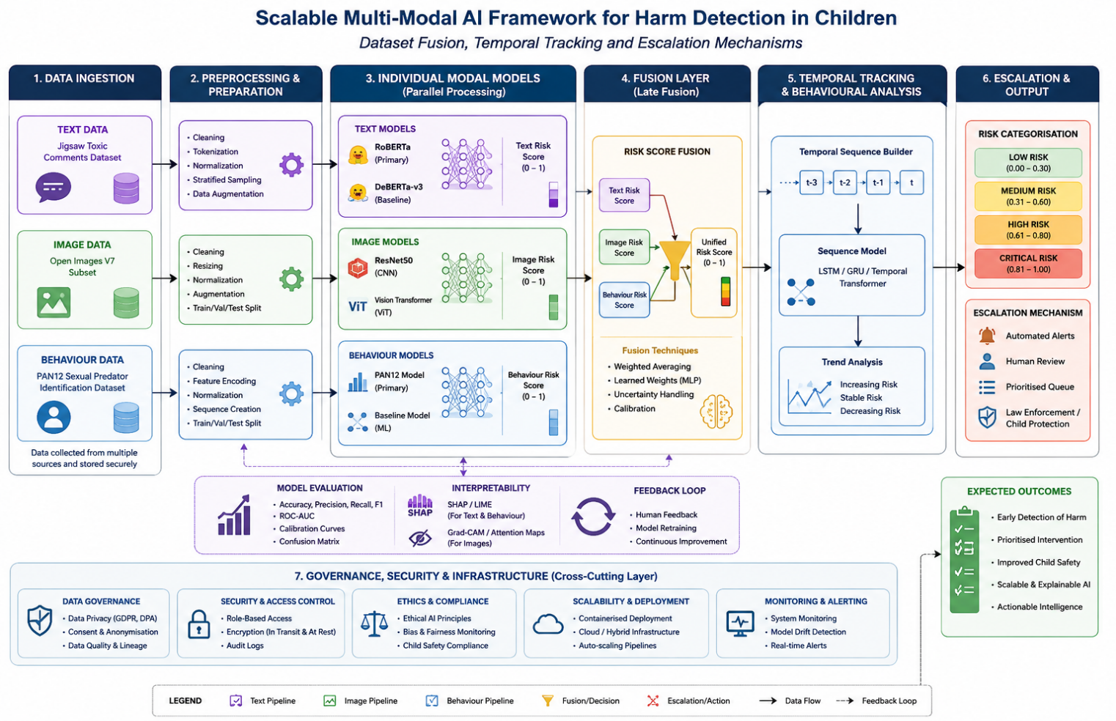
Figure 4.1. Overall architecture of the proposed scalable multi-modal AI framework for child harm detection.

4.7 Temporal Tracking Implementation
The temporal tracking component was implemented to monitor changes in risk across successive interactions rather than treating each prediction as an isolated event. Following dataset fusion, each unified risk score was stored chronologically, creating a structured record of risk progression that could be analysed across successive observations.
The framework compared current unified risk scores with previous observations to identify whether risk was increasing, decreasing or remaining relatively stable. This enabled sustained patterns of elevated risk to be distinguished from isolated predictions and reduced dependence on a single potentially incorrect classification. Temporal comparison therefore provided additional contextual information alongside the instantaneous risk assessment. [75]
Temporal tracking also supported more responsive risk prioritisation. A gradual increase in risk across multiple interactions could result in greater prioritisation even where individual predictions had not reached the highest risk category. Conversely, consistently low or declining risk scores could provide evidence of reduced immediate concern.
The resulting temporal risk information was passed to the escalation mechanism, allowing prioritisation to consider both the current unified risk score and its progression over time. This extended the framework beyond static classification towards a dynamic, temporally informed risk-monitoring system. [75]

4.8 Escalation Mechanism Implementation
The escalation mechanism was implemented to convert the unified and temporally tracked risk information into four interpretable categories: Low, Medium, High and Critical. Defined thresholds were applied to the resulting risk scores to provide a consistent mechanism for prioritising cases according to the level of potential harm identified.
Importantly, escalation was not determined solely by the latest prediction. The mechanism incorporated temporal risk progression, allowing sustained increases in concerning patterns to influence prioritisation alongside the current unified risk score. This reduced dependence on isolated predictions while supporting earlier identification of emerging or persistent risks. [75]
The framework was designed as a decision-support system rather than an autonomous safeguarding decision-maker. High and Critical classifications therefore indicate cases requiring increased human review rather than automatically determining an intervention. Supporting model outputs and explainability information were retained alongside the final classification, allowing the basis of each risk assessment to be examined. This approach provides a structured and interpretable mechanism for prioritising risk while maintaining appropriate human oversight within the safeguarding process. [76]
The implemented risk categories and their corresponding thresholds are presented in Table 4.1

Risk Category | Risk Score Range | Interpretation
Low | 0-25 | Limited indication of potential harm
Medium | 26-50 | Moderate indication requiring increased monitoring
High | 51-75 | Strong indication requiring human review
Critical | 76-100 | Very high indication requiring urgent human assessment
Table 4.1. Risk escalation levels, thresholds, and corresponding escalation states

This approach provides a structured and interpretable mechanism for prioritising risk while maintaining appropriate human oversight within the safeguarding process.

4.9 Framework Integration
The final implementation stage integrated the individual AI models, dataset fusion, temporal tracking and escalation components into a single end-to-end framework. Textual data was analysed using RoBERTa and DeBERTa, while ResNet50 and ViT processed visual information and RoBERTa and DeBERTa were applied to behavioural interaction data. The individual models generated probability-based outputs that were standardised and combined through the late-fusion process to produce a unified risk score.
The unified score was subsequently passed to the temporal tracking component, where changes in risk were monitored across successive observations. The resulting temporally informed assessment was then processed by the escalation mechanism and classified as Low, Medium, High or Critical. Individual model outputs and explainability information were retained alongside the final classification to support interpretation and human review.
The modular architecture enables individual models or components to be updated, replaced or extended without requiring complete system redesign. It also provides a foundation for incorporating additional data modalities and modelling approaches in future research. Overall, the integration transformed the individual models into a scalable, explainable and human-centred decision-support framework for multi-modal child harm detection. [77]

4.10 Chapter Summary
This chapter presented the practical implementation of the proposed scalable multi-modal artificial intelligence framework for child harm detection. The development environment and implementation of the RoBERTa and DeBERTa transformer models, ResNet50 and Vision Transformer models, and their respective text, image and behavioural applications were described. Their probability-based outputs were subsequently integrated through the implemented late-fusion strategy.

The chapter also described the implementation of temporal tracking and the escalation mechanism, enabling changes in risk to be monitored over successive observations and classified into Low, Medium, High or Critical categories. The final framework integration demonstrated how the individual components operate as a modular, scalable and explainable decision-support system while maintaining appropriate human oversight.

The following chapter evaluates the performance of the individual models and integrated framework using quantitative performance metrics and interpretability analysis. The evaluation provides empirical evidence for assessing the effectiveness of the proposed approach against the research objectives.

Chapter 5 — Results and Evaluation

5.1 Introduction
This chapter presents and evaluates experimental results from the proposed multimodal risk-detection framework. Evaluation follows the five implemented modules, progressing from individual modality predictions to multimodal fusion, temporal tracking and escalation. Module 1 compares RoBERTa and DeBERTa for text classification, while Module 2 compares ResNet50 and Vision Transformer (ViT) for visual risk detection. Module 3 evaluates behavioural risk detection and uses SHAP interpretation to explain predictions. Module 4 assesses integration of text, image and behavioural outputs through multimodal fusion, and Module 5 evaluates temporal risk tracking and escalation. Figures and tables identify key empirical performance patterns and outcomes, while detailed interpretation and broader implications are primarily addressed in Chapter 6.

5.2 Module 1: Text-Based Risk Detection
Module 1 evaluated the performance of RoBERTa and DeBERTa for text-based risk classification. The comparison was undertaken using multiple evaluation measures rather than accuracy alone, allowing the models to be assessed in terms of their overall predictive performance and their ability to distinguish between the target classes.

The comparative performance results are presented in Figure 5.1.

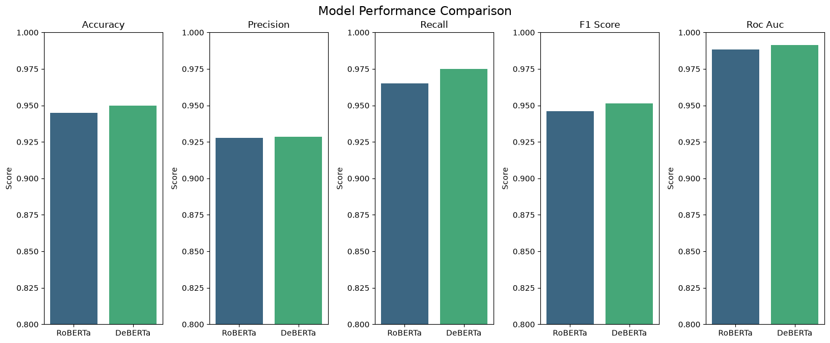
Figure 5.1. Comparative performance of RoBERTa and DeBERTa across the evaluated classification metrics.

Figure 5.1 provides the primary comparison between the two transformer architectures. The results show that DeBERTa achieved the stronger overall performance across the principal metrics. This provides an empirical basis for the subsequent selection of the model used within the text-risk component rather than selecting an architecture solely based on its underlying design. The comparison also demonstrates the importance of considering multiple metrics, since a difference in one measure does not necessarily indicate superior overall classification capability.
Further insight into the selected model's predictions is provided by its confusion matrix in Figure 5.2.

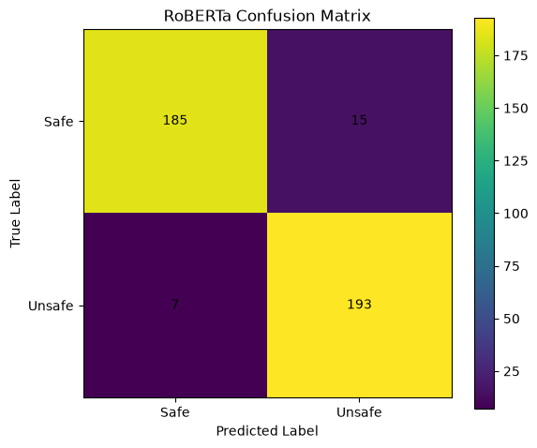
Figure 5.2. Confusion matrix for the selected RoBERTa text classification model.

The confusion matrix demonstrates the distribution of correct and incorrect classifications across the two classes. The model correctly classified 378 instances in the principal diagonal, while 23 were misclassified. Of relevance to the proposed risk-detection framework is the number of false-negative predictions, as these represent cases in which the relevant risk class was not identified by the text modality. Conversely, false-positive predictions indicate instances in which the model generated a positive classification where the ground-truth class was negative.

This distinction is important because overall accuracy can conceal the practical consequences of different error types. The confusion matrix therefore provides evidence of how the model achieved its aggregate performance, rather than simply confirming that a particular accuracy level was obtained.
The receiver operating characteristic comparison is presented in Figure 5.3.
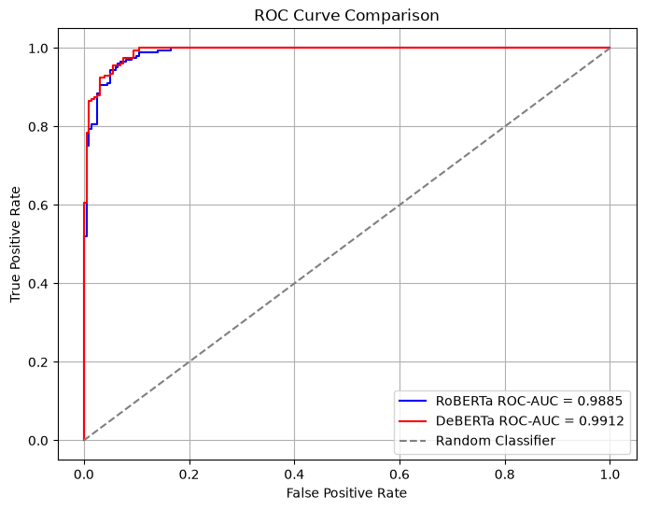
Figure 5.3. ROC curve comparison for RoBERTa and DeBERTa.

The ROC curves provide further evidence of the models' ability to discriminate between the two classes across different decision thresholds. The model demonstrating the stronger curve and corresponding AUC provides greater discriminatory capability over the evaluated threshold range. This complements the metric comparison in Figure 5.1 because it assesses model behaviour across thresholds rather than at a single operating point.
The precision–recall comparison is shown in Figure 5.4.
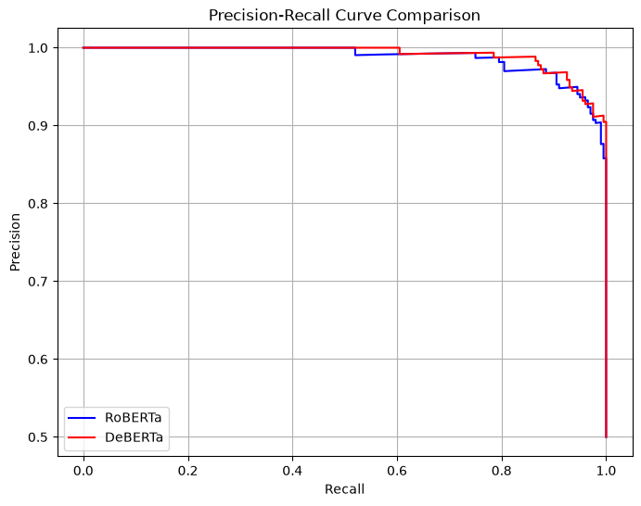
Figure 5.4. Precision–recall curve comparison for RoBERTa and DeBERTa.

The precision–recall curves provide complementary evidence regarding the models' ability to identify positive instances while controlling incorrect positive predictions. This is particularly relevant to a risk-detection application, where a model that achieves strong overall accuracy may nevertheless provide inadequate identification of the target class. The curve therefore provides an additional basis for judging the practical reliability of the text modality.

Overall, the Module 1 results demonstrate that transformer-based text classification provides a viable foundation for generating a text-derived risk signal. The combination of comparative performance metrics, confusion-matrix analysis and threshold-independent ROC and precision–recall evaluation provides stronger evidence than reliance on a single metric. The selected text model consequently provides the first modality-level input to the subsequent multimodal fusion stage.

5.3 Module 2: Image-Based Risk Detection
Module 2 evaluated the image-based component of the proposed framework using two deep-learning architectures: ResNet50 and Vision Transformer (ViT). The evaluation examined their comparative predictive performance, classification errors and threshold behaviour. This provided evidence for selecting an appropriate visual model and for determining how image-based predictions could subsequently contribute to the multimodal risk assessment.

The overall comparison between ResNet50 and ViT is presented in Figure 5.5.

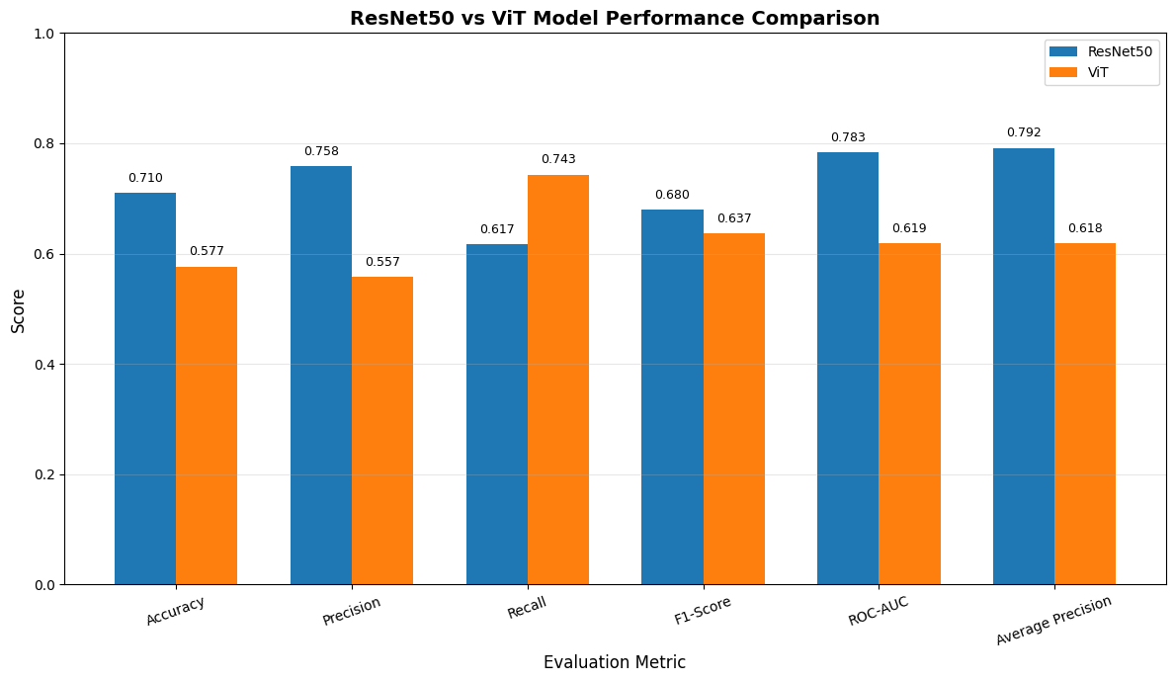
Figure 5.5. Comparative performance of ResNet50 and Vision Transformer across the evaluated metrics.

Figure 5.5 demonstrates the relative performance of the two visual architectures across the reported evaluation metrics. ResNet50 achieved the stronger overall performance across the principal measures, providing the empirical basis for its selection as the preferred visual model. Importantly, the comparison considers several performance measures rather than relying solely on accuracy. This allows differences in precision, recall and overall classification balance to be identified and provides a more robust basis for model selection.

The classification behaviour of ResNet50 is examined further through the confusion matrix presented in Figure 5.6.
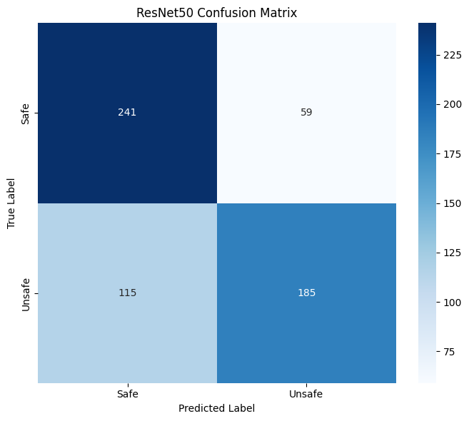 [INSERT
Figure 5.6. Confusion matrix for the ResNet50 image classification model.

The confusion matrix shows the distribution of correctly and incorrectly classified image instances across the evaluated classes. The diagonal values represent correctly classified observations, while the off-diagonal values represent classification errors. The results therefore provide information that cannot be obtained from the aggregate performance metrics alone. In particular, the number of false-negative predictions is relevant to the proposed risk-detection application because these represent instances where the visual model did not identify the target class.

The corresponding classification behaviour of ViT is shown in Figure 5.7.
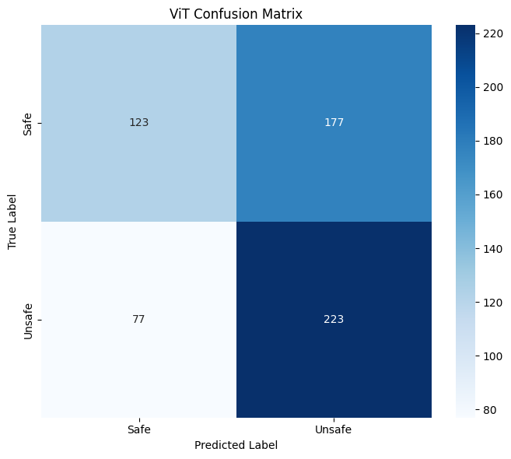
Figure 5.7. Confusion matrix for the Vision Transformer image classification model.

Comparison of Figures 5.6 and 5.7 provides a direct assessment of how the two architectures differed in their classification errors. ResNet50 produced fewer false positives (59) than ViT (177), while ViT produced fewer false negatives (77) than ResNet50 (115). This comparison is important because two models can produce similar aggregate performance while exhibiting different error profiles. For the proposed framework, the distribution of errors is therefore relevant to model selection because the consequences of missed and incorrectly flagged cases are not necessarily equivalent.

The threshold analysis for the selected ResNet model is presented in Figure 5.8.
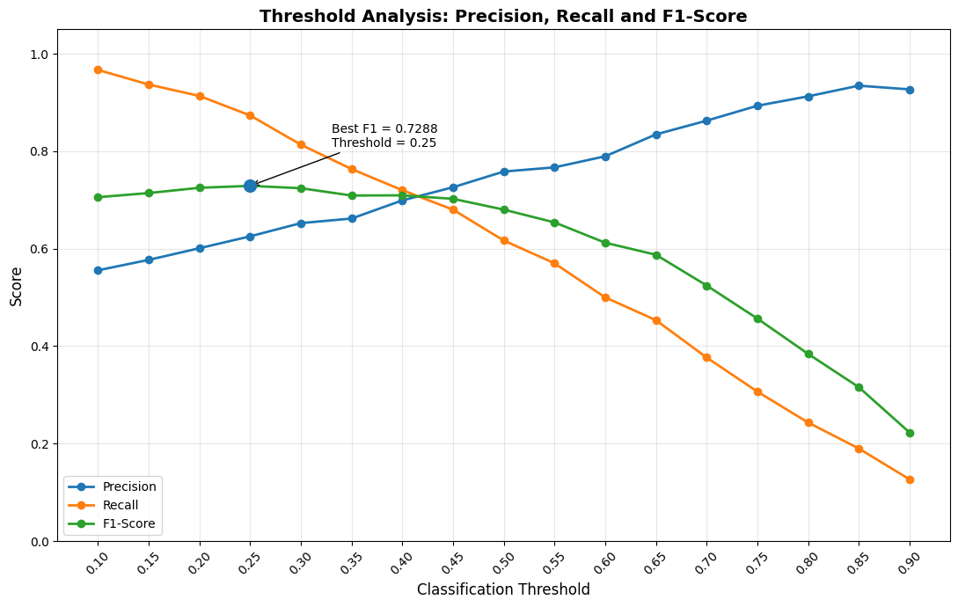
Figure 5.8. Threshold analysis for the selected ResNet50 model.

The threshold analysis examines how model performance changes as the decision threshold is varied. Rather than treating the model's prediction as fixed at a single arbitrary operating point, the analysis demonstrates the relationship between the selected threshold and the resulting classification behaviour. Changes in the threshold can alter the balance between correctly identifying positive cases and generating false-positive predictions.

This analysis is particularly relevant to the wider framework because the visual component ultimately contributes to a risk score, rather than functioning only as an isolated binary classifier. The threshold therefore represents an important link between model-level prediction and the subsequent risk-assessment stage. The selected operating point provides the basis for converting the visual model's output into a form suitable for integration with the textual and behavioural modalities.

Overall, the Module 2 results demonstrate that image-based information can provide a meaningful additional source of evidence within the proposed framework. The comparison of ResNet50 and ViT establishes an empirical basis for model selection, while the confusion matrices reveal differences in their error profiles and the threshold analysis demonstrates how the selected model's output can be incorporated into a risk-oriented decision process. These findings provide the visual component required for the multimodal fusion undertaken in Module 4.
5.4 Module 3: Behavioural Risk Detection and Explainability
Module 3 evaluated the behavioural component of the proposed framework, with the final models assessed using the balanced dataset established during the final retraining stage. The evaluation considered comparative model performance, the resulting behavioural risk distribution, classification behaviour and model explainability. In addition to predictive performance, this module therefore examined whether the behavioural component could generate an interpretable risk signal suitable for integration within the multimodal framework.

The final comparison of the evaluated behavioural models is presented in Figure 5.9.
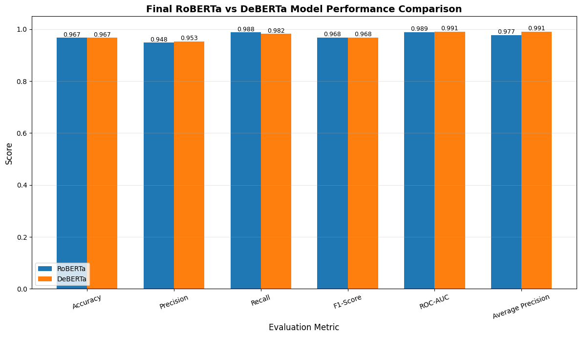
Figure 5.9. Comparative performance of the final behavioural models.

The results in Figure 5.9 demonstrate the relative performance of the final behavioural models across the reported evaluation measures. DeBERTa achieved the stronger overall performance based on the combined evaluation metrics, providing the basis for selecting the final behavioural model. Considering multiple metrics is important because a single measure may not fully represent the model's ability to distinguish between the two classes.

The final behavioural risk distribution is presented in Figure 5.10.
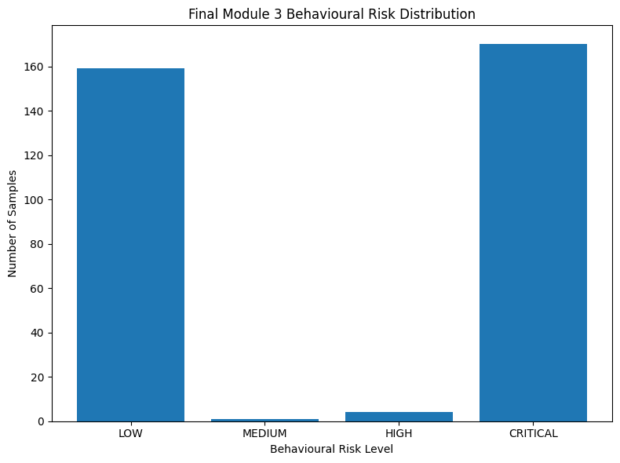
Figure 5.10. Distribution of behavioural risk scores generated by the final model.

The distribution demonstrates how the behavioural model's predictions were translated into a continuous risk representation. Rather than restricting the output to a binary classification, the model produces a risk signal that can be incorporated into the subsequent multimodal fusion stage. This is an important functional distinction within the proposed framework because the purpose of the behavioural modality is not simply to reproduce a classification label, but to contribute evidence to an overall assessment of risk.

The distribution also provides an indication of the extent to which behavioural observations are concentrated at different levels of predicted risk. The resulting variation is important for the fusion process because it provides a range of behavioural evidence that can be combined with the corresponding text and image risk signals.

5.4.1 Behavioural Model Explainability
Predictive performance alone does not establish why a behavioural model produces a particular prediction. To address this issue, SHAP analysis was applied to the selected RoBERTa model. The resulting token-importance analysis is presented in Figure 5.11.
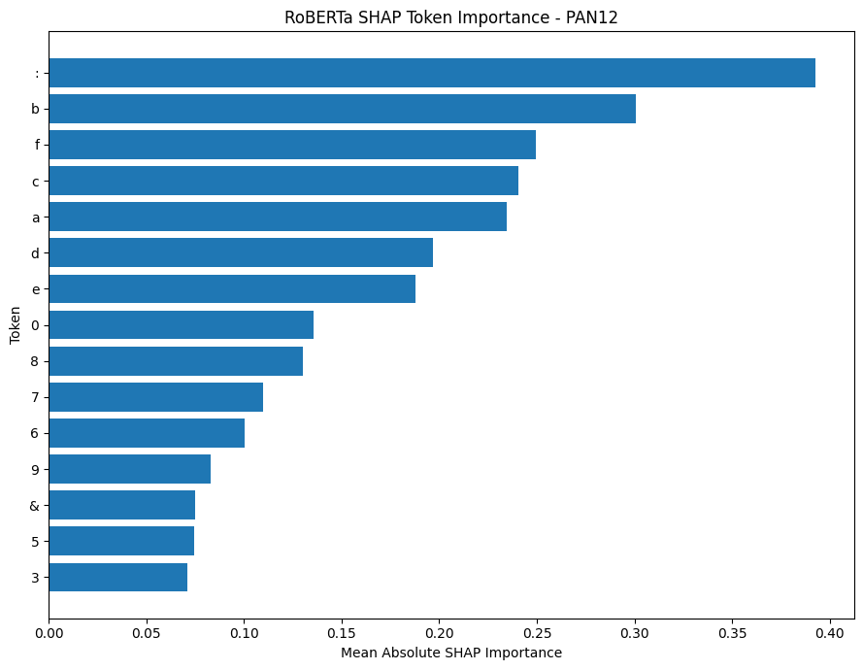
Figure 5.11. SHAP-based token importance for the selected RoBERTa behavioural model.

The SHAP analysis identifies the tokens that contributed most strongly to the model's predictions, providing an interpretable view of the features influencing the behavioural classification. The most influential tokens shown in Figure 5.11 provide evidence that the model's predictions were associated with identifiable linguistic characteristics within the analysed behavioural data.

The importance of this analysis extends beyond visualisation. By identifying influential features, SHAP provides a mechanism for examining whether model behaviour is consistent with meaningful patterns in the underlying data. This is particularly relevant for a risk-sensitive application, where the ability to inspect model reasoning can support greater transparency and facilitate critical assessment of unexpected predictions. The SHAP analysis therefore complements the quantitative evaluation rather than replacing it.

The classification behaviour of the selected RoBERTa model is further examined through its confusion matrix in Figure 5.12.
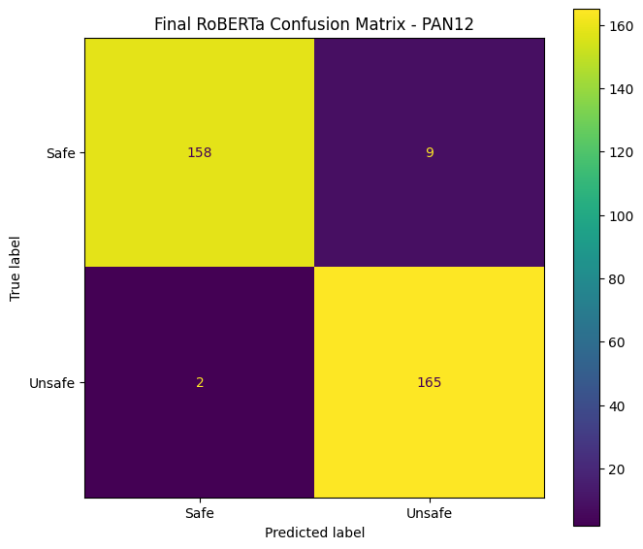
Figure 5.12. Confusion matrix for the selected RoBERTa behavioural model.

The confusion matrix provides evidence of the model's ability to distinguish between the two behavioural classes and identifies the remaining false-positive and false-negative classifications. Examining these errors is important because the model's final risk contribution is derived from its predictions, meaning that classification errors can subsequently influence the multimodal risk assessment.

A notable characteristic of the final behavioural dataset was its balanced class composition. The final dataset contained 834 safe and 834 unsafe samples, with 1,334 samples used for training and 334 samples used for validation, maintaining equal representation of both classes within each split. This balanced structure provides a more appropriate basis for evaluating behavioural classification than the earlier highly imbalanced dataset used during development. The final evaluation should therefore be interpreted in the context of this retraining configuration.

Overall, Module 3 demonstrates three complementary capabilities: behavioural classification, generation of a continuous behavioural risk signal, and model-level interpretability. The combination of the final model comparison, behavioural risk distribution, SHAP analysis and confusion matrix provides evidence that the behavioural modality can contribute both predictive and interpretable information to the wider multimodal framework. The resulting behavioural risk signal is subsequently incorporated alongside the text and image outputs during multimodal fusion in Module 4.

5.5 Module 4: Multimodal Risk Fusion
Module 4 represents the integration stage of the proposed framework, combining the risk signals generated by the text, image and behavioural modalities into a unified multimodal assessment. Whereas Modules 1–3 evaluated the modalities independently, Module 4 examines their collective contribution and demonstrates how heterogeneous model outputs can be transformed into a single interpretable risk score.

The mean risk scores generated by the individual modalities are presented in Figure 5.13.
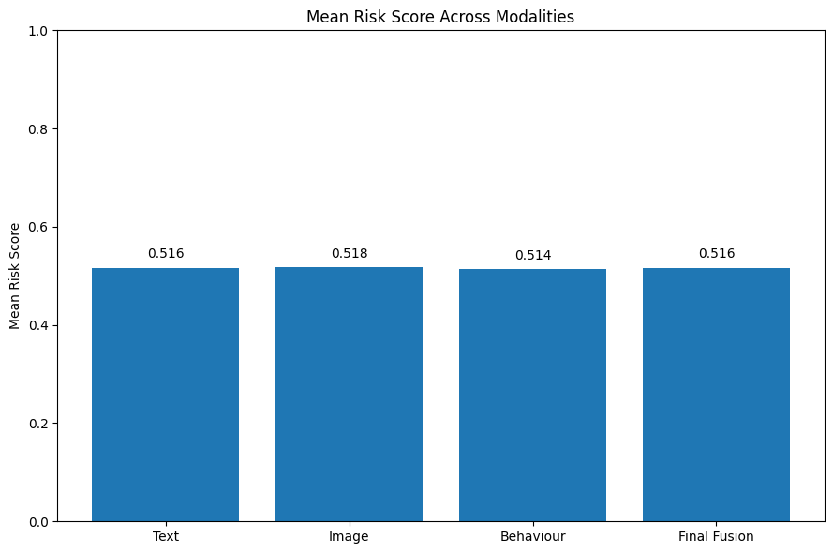
Figure 5.13. Mean risk score across the text, image and behavioural modalities.

Figure 5.13 demonstrates differences in the average risk contributions generated by the three modalities. These differences are important because they indicate that the modalities do not necessarily produce equivalent assessments for the same observations. A modality may therefore provide a stronger or weaker risk signal depending on the evidence available within its respective input.

The comparison also provides an important justification for multimodal integration. If the modalities produced identical risk signals in all cases, combining them would provide limited additional information. The observed differences instead indicate that each modality can contribute a distinct perspective to the overall assessment. However, the presence of different mean risk levels alone does not establish that the modalities provide independent information; this is examined further through the correlation analysis.
The relationships between the modality-level risk scores are presented in Table 5.13.

 | Text Risk Score | Image Risk Score | Behaviour Risk Score | Final Risk Score
Text Risk Score | 1.000000 | -0.062419 | -0.008581 | 0.677678
Image Risk Score | -0.062419 | 1.000000 | 0.045384 | 0.224657
Behaviour Risk Score | -0.008581 | 0.045384 | 1.000000 | 0.690475
Final Risk Score | 0.677678 | 0.224657 | 0.690475 | 1.000000
Table 5.13. Correlation between the text, image and behavioural risk scores.

The correlation results provide an indication of the degree to which the modality-level risk signals vary together. Strong positive correlations would suggest that modalities tend to identify similar patterns of risk, whereas weaker relationships would indicate greater differences between their respective assessments. The results therefore provide a quantitative basis for assessing the degree of complementarity between the modalities.

The correlation analysis is particularly relevant to the proposed architecture because the multimodal fusion process is designed to integrate complementary sources of evidence rather than simply reproduce the same prediction across different modalities. The results show that the strongest relationship with the Final Risk Score was observed for the Behaviour Risk Score (r = 0.690), followed closely by the Text Risk Score (r = 0.678).

In comparison, the Image Risk Score demonstrated a considerably weaker relationship with the Final Risk Score (r = 0.225). The correlations between the individual modalities were also very weak, with Text and Image showing a slight negative correlation (r = −0.062), while Text and Behaviour (r = −0.009) and Image and Behaviour (r = 0.045) were effectively uncorrelated. This indicates that the three modalities provide largely distinct sources of information, supporting the rationale for retaining multiple modalities within the framework. The stronger associations between the Text and Behaviour scores and the final fused score further suggest that these modalities made a greater contribution to the resulting risk assessment, while the weaker correlation of the Image modality indicates that it may provide additional, complementary evidence rather than simply reinforcing information already captured by the other modalities.

The final multimodal fusion results are presented in Table 5.14.

 | Text Risk Score | Image Risk Score | Behaviour Risk Score | Final Risk Score
0 | 0.001185 | 0.194474 | 0.015544 | 0.070401
1 | 0.998646 | 0.407761 | 0.166472 | 0.524293
2 | 0.999028 | 0.722244 | 0.975296 | 0.898856
3 | 0.999101 | 0.504146 | 0.881920 | 0.795056
4 | 0.991091 | 0.569205 | 0.975012 | 0.845103
5 | 0.000411 | 0.424500 | 0.033590 | 0.152834
6 | 0.975546 | 0.598474 | 0.973820 | 0.849280
7 | 0.020050 | 0.698203 | 0.974532 | 0.564261
8 | 0.999462 | 0.535588 | 0.974386 | 0.836478
9 | 0.992774 | 0.541641 | 0.018458 | 0.517624
Table 5.14. Final multimodal fusion results combining text, image and behavioural risk signals.

Table 5.14 demonstrates the transformation from individual modality outputs to the final fused risk assessment. The fusion process combines the available modality-level evidence to generate a unified risk score for each assessed instance. This represents a substantive change from the preceding modules: rather than requiring one modality to provide a definitive classification, the framework incorporates multiple sources of evidence into the final assessment.

The final multimodal risk-level distribution is presented in Figure 5.14.
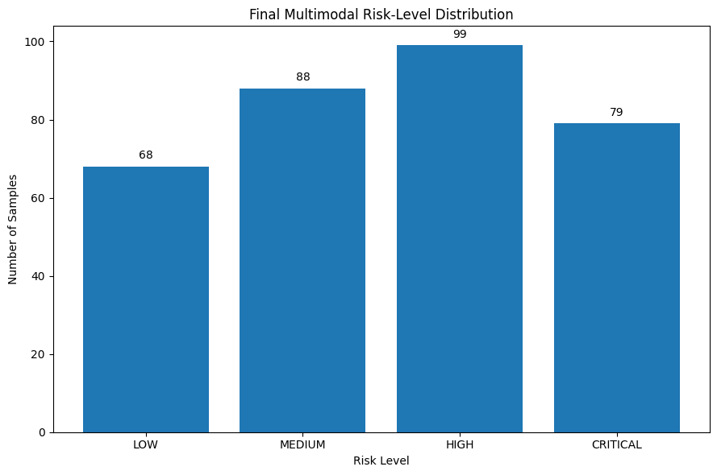
Figure 5.14. Distribution of final multimodal risk levels.

The final risk scores were mapped to four interpretable categories: Low, representing scores up to 25; Medium, representing scores above 25 and up to 50; High, representing scores above 50 and up to 75; and Critical, representing scores above 75. Figure 5.14 therefore demonstrates how the numerical outputs of the fusion process translate into operationally meaningful risk categories.

The distribution across the risk categories provides an important indication of the framework’s final performance. The results show 68 LOW, 88 MEDIUM, 99 HIGH, and 79 CRITICAL risk assessments, demonstrating that the framework identified observations across all four levels rather than concentrating predominantly within a single category. This distribution indicates that the multimodal fusion process can distinguish between different levels of potential risk and identify a substantial proportion of observations requiring increased attention. Importantly, converting the continuous multimodal risk score into defined categories provides a more interpretable representation of the model output, enabling the framework to progress from individual model predictions towards a structured and actionable risk-assessment outcome.

Overall, Module 4 demonstrates the central integration capability of the proposed framework. The individual modalities generate different risk signals, the correlation analysis quantifies their relationships, and the fusion process combines these signals into a unified assessment. The resulting risk-level distribution then provides an interpretable representation of the fused output. Consequently, Module 4 establishes the foundation for Module 5, where these multimodal risk assessments are tracked over time to determine whether risk changes and escalation can be identified.

5.6 Module 5: Temporal Risk Tracking and Escalation
Module 5 extends the multimodal framework from static risk assessment to temporal monitoring, examining how risk changes across successive observations. This stage is important because a single multimodal risk score provides only a snapshot of an individual's risk state, whereas repeated observations can reveal whether risk is stable, increasing or decreasing over time. The module therefore evaluates the ability of the framework to transform successive multimodal outputs into a temporally informed assessment.

The temporal multimodal risk tracking results are presented in Figure 5.15.

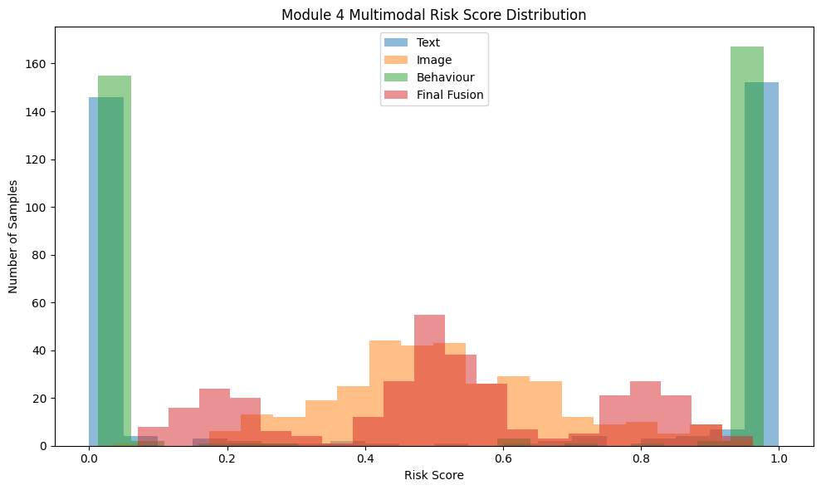Figure 5.15. Temporal tracking of multimodal risk across successive observations.

Figure 5.15 illustrates the variation in multimodal risk across the observed sequence. Rather than treating each observation as an isolated prediction, the temporal component enables changes in risk to be examined across successive observations. The resulting trajectory provides evidence of whether risk remains relatively stable or demonstrates periods of increase and reduction.

The temporal pattern is particularly relevant to the proposed framework because escalation is dependent not only on the magnitude of an individual risk score but also on how risk develops over time. A sustained or increasing pattern can therefore provide different information from an isolated high-risk observation. The temporal tracking mechanism provides the means through which this progression can be represented.
The underlying rolling temporal risk results are presented in Table 5.15.

 | Event Index | Final Risk Score | Rolling Risk Score
0 | 1 | 0.070401 | 0.070401
1 | 2 | 0.524293 | 0.297347
2 | 3 | 0.898856 | 0.497850
3 | 4 | 0.795056 | 0.572151
4 | 5 | 0.845103 | 0.626742
5 | 6 | 0.152834 | 0.643228
6 | 7 | 0.849280 | 0.708226
7 | 8 | 0.564261 | 0.641307
8 | 9 | 0.836478 | 0.649591
9 | 10 | 0.517624 | 0.584095
Table 5.15. Rolling temporal risk values across successive observations.

The rolling risk table provides the numerical evidence underlying the temporal tracking visual. It demonstrates how the risk assessment changes as successive observations are incorporated into the rolling calculation. This provides greater transparency than relying solely on the graphical representation, as individual changes in the calculated risk can be examined directly.

The results demonstrate that the temporal component provides an additional layer of assessment beyond the multimodal fusion score. While Module 4 establishes the risk associated with an individual multimodal assessment, the rolling calculation allows the framework to account for the recent pattern of risk. This is particularly relevant where repeated observations may provide stronger evidence of an emerging risk pattern than a single isolated event.

The resulting escalation categories are presented in Figure 5.16.
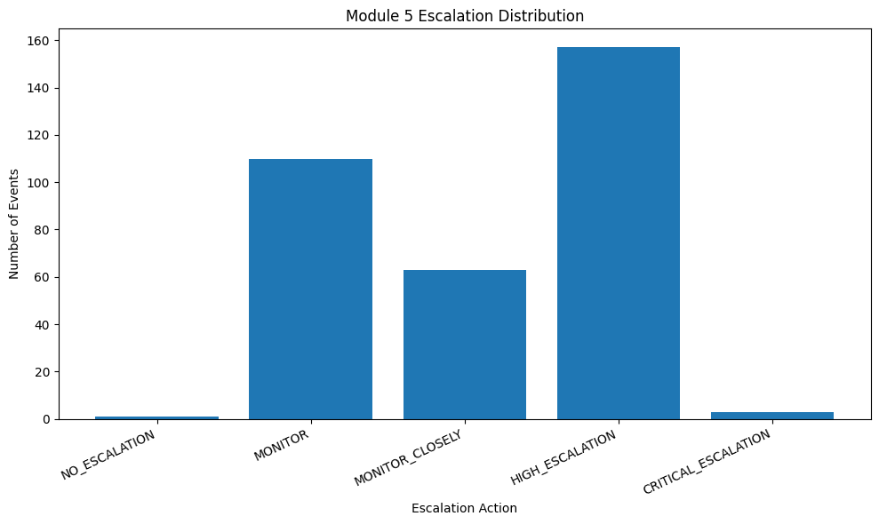
Figure 5.16. Distribution of observations across the defined risk escalation categories.

The escalation distribution demonstrates how the temporally informed risk outputs are represented across the framework's four risk levels. The categories are defined using the established thresholds: Low for scores up to 25, Medium for scores above 25 and up to 50, High for scores above 50 and up to 75, and Critical for scores above 75.

The distribution therefore provides an operational assessment of the temporal component. The results demonstrate that the framework identified observations across different escalation categories, including higher-risk states, indicating that temporal tracking can detect changes in risk over time rather than maintaining a static assessment. This shows how continuous temporal risk values can be translated into discrete escalation states, making the results easier to interpret and supporting more structured risk prioritisation and intervention.

An important characteristic of the temporal module is that escalation is therefore based on a structured risk representation rather than a single binary prediction. The progression from multimodal risk score to rolling temporal assessment and finally to an escalation category provides a mechanism for representing changing risk conditions within the overall framework.

Overall, Module 5 demonstrates the extension of multimodal risk detection into temporal monitoring and escalation. The temporal tracking visual and rolling risk table provide evidence of changes in risk over successive observations, while the escalation distribution demonstrates how those changes are translated into the framework's defined risk categories. This completes the experimental pipeline by connecting individual modality predictions, multimodal fusion and temporal risk progression into a single assessment process.

5.7 Overall Evaluation of the Framework
Results across Modules 1–5 demonstrate evaluation of the proposed risk-detection framework. Modules 1–3 showed that text, image and behavioural data generated modality-specific risk information, supporting model comparison. Module 4 integrated these signals through multimodal fusion, producing unified risk scores mapped to Low, Medium, High and Critical categories. Modality correlation analysis examined relationships between signals and complementary contributions. Module 5 extended static assessment through temporal monitoring, using rolling risk calculations across successive observations and escalation distributions to produce interpretable risk levels. Collectively, findings demonstrate technical feasibility through detection, quantification, tracking and escalation, while Chapter 6 addresses interpretation, implications and limitations overall.

Chapter 6 Discussion

6.1 Introduction
This chapter evaluates the proposed multimodal artificial intelligence framework for child-harm risk detection, examining individual modality performance, multimodal fusion, temporal tracking and escalation mechanisms. Rather than simply reporting results, it critically assesses the approach’s suitability and limitations, focusing on uncertainty, dataset constraints, risk-score interpretation, fusion and threshold selection, and the implications of AI within sensitive safeguarding contexts. Findings are compared with existing research to determine whether the project supports, challenges or extends current approaches. This is important because AI research addressing child abuse and neglect remains underdeveloped, with concerns surrounding datasets, validation, overfitting and bias [78]. The chapter concludes by assessing contributions, practical implications and limitations, informing Chapter 7’s conclusions and recommendations.

6.2 Overall Framework Performance
The overall findings demonstrate that the proposed framework successfully integrated textual, visual and behavioural predictions into a unified risk-assessment process. Multimodal fusion, temporal tracking and escalation produced differentiated LOW, MEDIUM, HIGH and CRITICAL outcomes, demonstrating the practical feasibility of the architecture beyond individual model performance.
Mean risk scores were closely aligned: text 0.5164, image 0.5175, behaviour 0.5138 and final fused risk 0.5159. This suggests no modality disproportionately influenced the final representation; however, similar means do not demonstrate equal predictive reliability because normalisation and fusion may contribute to this similarity. The final distribution comprised 68 LOW, 88 MEDIUM, 99 HIGH and 79 CRITICAL classifications. The substantial HIGH and CRITICAL proportion emphasises the importance of calibration and threshold selection, as miscalibration can reduce risk-estimate reliability and affect decisions [79].
This concern is particularly important in child safeguarding, where research has identified inconsistent risk scores, inappropriate proxy variables, information leakage and algorithmic discrimination [80]. Therefore, HIGH and CRITICAL classifications should be interpreted as model-generated risk signals rather than evidence of serious harm.
The wider literature remains limited, with concerns regarding dataset size, validation, overfitting, missing data and bias [78]. The study addresses some concerns through separate model evaluation, multimodal comparison, confusion matrices, threshold analysis and explainability, but separate public datasets and controlled testing limit real-world generalisability. Overall, the framework demonstrates technical feasibility and supports risk prioritisation rather than definitive harm detection. Human oversight remains essential, with UK guidance emphasising meaningful involvement, active review and the ability to challenge automated recommendations and decisions [81].

6.3 Comparative Evaluation of the Three Modalities
The three modalities provide complementary evidence for identifying potential harm. Text analysis captures linguistic indicators, image analysis provides visual information, and behavioural analysis examines interaction patterns. Combining heterogeneous information can broaden contextual coverage, although modality availability and quality affect system robustness [82].
Text analysis can provide relatively direct evidence when harmful language is explicit, but interpretation depends on context, ambiguity and conversational meaning. Image analysis captures information unavailable through language, yet visual content can also require contextual interpretation. Behavioural analysis may identify patterns not apparent within individual messages or images, although its reliability depends on representative, high-quality data. This is particularly important in child safeguarding, where research identifies substantial dataset heterogeneity and concerns regarding AI prediction quality and bias [83].
The similar mean risk scores indicate that no modality overwhelmingly dominated the fusion outcome. However, this does not demonstrate equal predictive performance, as similarity may partly result from risk normalisation and fusion processes.
The findings support multiple modalities because they provide broader evidence, but additional information does not automatically guarantee better predictions. Each modality’s reliability and relevance remain important, particularly where data may be incomplete, unreliable or corrupted [84].
A future improvement would be reliability-aware fusion, allowing modality weights to adapt according to prediction confidence or data quality. Dynamic weighting could assign greater influence to more reliable predictions rather than assuming equal contribution.
Overall, the findings support retaining all three modalities while identifying reliability-aware fusion as an important development direction for improving robustness, adaptability and contextual decision-making in real-world practice.

6.4 Multimodal Fusion Evaluation
Multimodal fusion provides a mechanism for combining text, image and behavioural risk scores into a unified assessment. The mean fused risk score was 0.5159, closely aligned with text (0.5164), image (0.5175) and behaviour (0.5138). This suggests that all three modalities contributed without one overwhelmingly determining the final score, consistent with multimodal machine learning approaches that integrate heterogeneous information for broader task representation [85].
However, similar mean values do not demonstrate improved predictive performance. They indicate successful integration of available risk representations, whereas demonstrating improvement requires direct comparison with consistently evaluated unimodal baselines. Multimodal systems do not automatically outperform unimodal models because performance depends on modality quality, reliability and relative contribution [86].
The benefit is consideration of complementary evidence, enabling risk signals from one modality to be interpreted alongside others and reducing reliance on a single information source. Nevertheless, effectiveness depends on prediction quality and calibration.
Overall, the findings demonstrate successful transformation of three independent modality-level representations into a unified risk score, but not superior predictive performance. Definitive improvement requires controlled comparison. Future work should examine calibrated or dynamically weighted fusion, allowing more reliable modalities greater influence when confidence or data quality varies, while addressing missing or degraded modality information [86].

6.5 Temporal Risk Tracking and Escalation Evaluation
Temporal risk tracking extends the framework beyond static classification by examining how risk changes across observations. This matters to child-harm detection because a prediction may be isolated, whereas repeated or increasing risk may indicate a pattern. Temporal analysis adds context to fused scores. Sequential machine learning demonstrates value modelling information across time, where observations may depend on preceding events [87].
Results demonstrate that risk can be tracked and translated into escalation categories, supporting prioritisation. However, persistence is not definitive evidence of harm: sustained high scores may reflect model errors, while temporary reductions may not mean concerns have disappeared. AI predictions contain uncertainty and are not equivalent to established evidence [88].
Escalation effectiveness depends on thresholds. Lower thresholds may improve sensitivity but generate excessive escalation; higher thresholds may reduce unnecessary intervention while delaying detection. Threshold selection requires balancing missed cases against unnecessary alerts [89].
The four categories—LOW, MEDIUM, HIGH and CRITICAL—make scores interpretable, but depend on predefined research thresholds rather than validated safeguarding boundaries.
Overall, temporal tracking strengthens historical interpretation, although the rule-based approach depends on prediction quality. Future research could use learned temporal models to capture dependencies [87]. Further validation, transparency and human oversight remain necessary for safeguarding decisions [88].

6.6 Critical Evaluation of the Framework
The evaluation demonstrates a coherent approach to combining heterogeneous evidence, but effectiveness depends on component reliability. Its principal strength is integrating text, image and behavioural information through fusion, temporal tracking and escalation, providing broader contextual coverage than isolated classifiers [90].
However, errors can propagate between stages. Incorrect modality predictions may become risk scores and influence fusion or escalation; downstream processing cannot reliably compensate for poor upstream predictions. Dataset limitations also affect generalisability because the three datasets came from different sources and were not designed as a unified multimodal safeguarding dataset. Differences in distributions, annotations and contexts may introduce domain shift, meaning controlled results may not represent real-world performance [91].
Risk transformation enables comparable fusion values, but numerical similarity may not indicate equivalent actual risk. Thresholds improve consistency but may oversimplify safeguarding circumstances. SHAP and Grad-CAM improve interpretability, although explanations do not prove prediction correctness; human interpretation remains necessary [92].
Overall, the framework integrates established techniques into a multimodal, temporal architecture, supporting risk prioritisation and decision support rather than autonomous harm determination, with human expertise and oversight remaining essential [93].

6.7 Comparison with Existing Research
The findings support research showing that multimodal approaches can represent problems more than single information sources [94]. In this project, text, image and behavioural analysis provided evidence integrated through risk fusion. However, multimodality does not automatically improve performance; its value depends on the quality, reliability and contextual relevance of each modality [94].
The findings support explainability in high-impact AI applications. SHAP and Grad-CAM improved transparency by enabling model behaviour to be examined. However, explaining a prediction does not prove its correctness, meaning explainability should support, not replace, human evaluation [95].
The temporal component extends classification by examining changes in risk across observations, reflecting research that behavioural risk can develop through patterns rather than isolated events. Nevertheless, predefined escalation rules limit adaptability compared with approaches learning temporal dependencies.
Overall, the project demonstrates multimodal potential while highlighting uncertainty from fusion, risk transformation and temporal escalation, emphasising calibration, reliability and contextual integration.

6.8 Project Contribution and Originality
The principal contribution of this project is the development of a unified framework that combines three distinct sources of evidence—text, images and behaviour—within a single risk-assessment architecture. Rather than treating each modality as an independent detection task, the framework transforms their outputs into risk representations that can be integrated through multimodal fusion [96].
A further contribution is the integration of temporal tracking and escalation mechanisms. This extends the framework beyond a static classification approach by considering how risk may persist or change over time. The combination of multimodal evidence with temporal monitoring provides a more structured basis for prioritising potentially concerning cases.
The project also demonstrates the practical integration of established techniques, including transformer-based language modelling, computer vision, behavioural classification, risk fusion and explainability. The originality therefore does not necessarily arise from creating a fundamentally new machine-learning algorithm. Instead, it lies in the application and integration of established techniques into a coherent safeguarding-oriented architecture addressing a complex problem [96], [97].
However, the contribution should be interpreted within the project's experimental limitations. The framework has not been demonstrated to replace professional safeguarding judgement, and the datasets and experimental conditions limit direct generalisation to operational environments [98]. Consequently, the contribution is best understood as a validated proof-of-concept architecture demonstrating the feasibility of multimodal risk prioritisation rather than a production-ready safeguarding system.
This distinction strengthens the contribution by avoiding unsupported claims. The project provides a foundation upon which future research can investigate adaptive fusion, improved calibration, larger representative datasets and more sophisticated temporal modelling. Its contribution is therefore both technical and methodological: it demonstrates how heterogeneous AI outputs can be systematically combined to support a more contextual approach to harm-risk assessment.

6.9 Ethical, Practical and Deployment Considerations
The proposed framework has potential in safeguarding, but deployment requires ethical, practical and governance consideration. It processes sensitive information and produces risk classifications, so performance alone cannot justify autonomous use [99]. Incorrect predictions have consequences: false positives may cause escalation, while false negatives may overlook genuine concerns. Therefore, thresholds should consider consequences of errors rather than performance [99]. Privacy requires data minimisation, access controls, secure processing and responsibilities when handling children’s text, images and behavioural information [100]. Human oversight should remain with outputs supporting professional decisions rather than determining whether harm occurred, enabling contextual information to be considered [101]. External validation is essential because experimental datasets cannot represent real-world safeguarding diversity. Testing should examine representative datasets, calibration, bias, changing distributions and model degradation over time [98]. The framework supports risk prioritisation and decision support, requiring governance, privacy, oversight and continuous evaluation [99]–[101]. This distinction demonstrates judgement expected at master’s level.

6.10 Chapter Summary
Chapter 6 evaluated the performance, contribution and limitations of the proposed multimodal framework. The results demonstrate that text, image and behavioural outputs can be integrated into a unified risk-assessment process, with temporal tracking and escalation providing an additional mechanism for monitoring changes in risk.

The evaluation also identified important limitations. Similar modality-level risk scores do not demonstrate equal predictive reliability, while fusion and thresholding can introduce additional uncertainty. Dataset differences, error propagation and limited generalisability further restrict the extent to which the findings can be transferred directly to real-world safeguarding environments.

Despite these limitations, the project demonstrates the feasibility of combining established artificial intelligence techniques within a single safeguarding-oriented architecture. Its principal contribution is therefore the integration of multimodal risk assessment with temporal monitoring and escalation, rather than the development of a new underlying machine-learning algorithm.
Overall, the findings support the framework as a proof-of-concept decision-support and risk-prioritisation system, while recognising that further validation, calibration and human oversight would be required for operational deployment. This balanced interpretation reflects the Level 7 requirement to make evidence-based judgements while acknowledging uncertainty and methodological limitations.

Chapter 7 — Conclusions and Recommendations

7.1 Introduction
This chapter presents the overall conclusions of the project and evaluates the extent to which its aims and objectives have been achieved. It synthesises the findings from the multimodal text, image and behavioural analysis, risk fusion, temporal tracking and escalation stages developed throughout the investigation.
The chapter does not introduce new experimental findings. Instead, it interprets the evidence established in the preceding chapters to determine the project's overall contribution, identify its principal limitations and propose focused recommendations for future development.
The final judgement considers both the technical feasibility demonstrated by the framework and the limitations that constrain its current application. This distinction is important because the project investigates a complex safeguarding problem in which automated predictions should support, rather than replace, appropriate human judgement [102].

7.2 Achievement of Aim and Objectives
The project aim was to develop and evaluate a scalable multimodal artificial intelligence framework for harm detection in children using dataset fusion, temporal tracking and escalation mechanisms. The findings indicate that the overall aim was substantially achieved within the defined experimental scope.
The first objective, concerning text-based harm detection, was addressed through the development and evaluation of transformer-based models, with RoBERTa serving as the primary model and DeBERTa providing comparative analysis. This established a text-based risk signal that could be incorporated into the wider framework.
The second objective, concerning image-based detection, was addressed through the implementation and evaluation of convolutional and vision-transformer approaches. ResNet50 and ViT provided complementary approaches to visual classification, with explainability through Grad-CAM supporting interpretation of model behaviour.
The third objective, concerning behavioural analysis, was addressed using the PAN12 dataset to generate behavioural risk information. Although dataset availability and class-balance limitations restricted the scale of this component, the objective was achieved sufficiently to demonstrate its integration within the multimodal architecture.
The fourth objective was to combine the three modalities through late fusion. The resulting framework successfully generated unified risk scores and classified observations across LOW, MEDIUM, HIGH and CRITICAL categories. Temporal tracking and escalation subsequently extended this process by incorporating changes in risk over time [103].
Finally, the project evaluated the integrated framework and considered its limitations, explainability, ethical implications and potential deployment requirements. The evidence therefore supports achievement of the project's core objectives, while recognising that the framework remains an experimental proof of concept requiring external validation before operational use [104].

7.3 Overall Conclusions
The project demonstrates that a multimodal artificial intelligence framework can be constructed to combine heterogeneous indicators of potential child harm within a unified risk-assessment architecture. The integration of text, image and behavioural analysis provided complementary sources of information, while late fusion enabled these outputs to be transformed into a consolidated risk representation [105]. The addition of temporal tracking and escalation further extended the framework from static classification towards monitoring changes in risk over time.
The findings support the central proposition of the project: a multimodal and temporally informed approach provides a viable foundation for risk prioritisation that is broader than reliance on a single modality. However, the evidence does not justify concluding that the framework can independently determine whether harm has occurred. Differences in dataset characteristics, prediction reliability, risk calibration and threshold selection introduce uncertainty that must be considered when interpreting the results [106].
The project's most significant outcome is therefore not simply the individual model performance, but the demonstration that established AI techniques can be systematically integrated into a single safeguarding-oriented architecture. This represents an original application of existing knowledge while maintaining appropriate recognition of the limitations of the experimental design.
Consequently, the framework should be regarded as a proof-of-concept decision-support system rather than a production-ready safeguarding solution. Its value lies in demonstrating technical feasibility and providing a foundation for further research into calibrated multimodal fusion, adaptive temporal modelling and human-centred risk assessment [106]. This balanced conclusion reflects the project's evidence while avoiding claims that cannot be supported by the experimental results.

7.4 Project Contributions
The project makes three principal contributions.
First, it provides a multimodal framework for risk assessment. Text, image and behavioural information are processed independently and subsequently integrated through late fusion. This provides a broader representation of potential harm than approaches restricted to a single information source [107].
Second, the project extends this architecture through temporal risk tracking and escalation. Rather than treating each prediction as an isolated event, the framework provides a mechanism for monitoring changes in risk and assigning progressively higher escalation categories where appropriate. This introduces a temporal dimension that can support prioritisation of cases requiring further attention.
Third, the project demonstrates an applied integration of established artificial intelligence techniques within a safeguarding-oriented context. Transformer-based language modelling, computer vision, behavioural analysis, explainability, multimodal fusion and temporal processing are combined into one coherent architecture. The contribution therefore lies primarily in the original application and integration of established methods, rather than claiming the invention of a fundamentally new machine-learning algorithm [107], [108].
The project also contributes a critical perspective by identifying the conditions that limit such systems. Dataset differences, uncertainty in risk scores, error propagation, threshold sensitivity and the requirement for human oversight demonstrate that technical integration must be accompanied by appropriate evaluation and governance [108].
Consequently, the project provides a foundation for future research into more reliable, calibrated and context-aware multimodal safeguarding systems. Its contribution is best understood as an experimentally evaluated proof-of-concept architecture, rather than a fully deployable autonomous safeguarding solution.

7.5 Limitations
The project has several limitations that should be considered when interpreting its findings. The first concerns dataset representativeness. The text, image and behavioural datasets originated from different sources and were not designed specifically as a unified multimodal child-safeguarding dataset. Consequently, differences in data distributions, annotation practices and contextual characteristics may limit generalisability to real-world environments [109].
A second limitation concerns dataset size and availability. The behavioural component was constrained by the availability of suitable labelled data, resulting in a smaller experimental dataset than originally intended. Although this was sufficient to demonstrate integration within the framework, a larger and more representative dataset would provide stronger evidence of generalisable performance.
The framework is also limited by error propagation. Predictions generated by individual models become inputs to later fusion, temporal tracking and escalation stages. An incorrect upstream prediction can therefore influence downstream risk assessments. The architecture reduces reliance on a single modality but does not eliminate uncertainty within the individual components [110].
A further limitation is the use of predefined risk thresholds and fusion mechanisms. These provide transparency and consistency but may not capture the complexity of individual safeguarding circumstances. Similarly, the experimental evaluation does not establish how the framework would perform under changing data distributions or adversarial conditions [109], [110].
Finally, the framework has been evaluated under controlled experimental conditions and should therefore be considered a proof of concept rather than a validated operational system. External validation, broader datasets, calibration analysis and expert safeguarding assessment would be required before practical deployment [110].
Recognising these limitations is essential to interpreting the contribution appropriately. Rather than weakening the project, explicitly identifying the boundaries of the evidence demonstrates critical awareness and supports a more defensible conclusion about what the research has established.

7.6 Recommendations for Future Work
The findings provide several directions for further development. The first priority should be larger and more representative multimodal datasets. Future research should investigate datasets designed to provide aligned text, image and behavioural information, reducing the distributional differences introduced by combining independently sourced datasets. Greater dataset diversity would also support stronger assessment of generalisability [111].
Second, future implementations should investigate adaptive and confidence-aware fusion. Rather than assigning equivalent influence to modality outputs, fusion weights could be adjusted according to prediction confidence, calibration and data quality. This could reduce the influence of unreliable predictions and provide a more robust representation of multimodal evidence [111].
Third, the temporal component could be developed using advanced sequential modelling. Recurrent, transformer-based or other temporal approaches could learn relationships between observations rather than relying primarily on predefined escalation rules. This may improve the identification of persistent or changing risk patterns.
Further research should also prioritise external validation and calibration. Testing the framework on unseen and representative datasets would provide stronger evidence of generalisation, while calibration analysis could establish whether predicted risk scores correspond meaningfully to observed outcomes [112].

Finally, future development should adopt a human-centred deployment model. Safeguarding professionals should remain responsible for interpreting model outputs, with mechanisms for reviewing, challenging and overriding automated recommendations. Continuous monitoring should also be incorporated to identify performance degradation, dataset shift and emerging biases [113].
Collectively, these recommendations would move the framework from an experimental proof of concept towards a more robust, transparent and context-aware decision-support system. Importantly, future development should prioritise reliability, validation and responsible use rather than simply increasing model complexity.

7.7 Final Conclusion
This project has demonstrated the feasibility of integrating text, image and behavioural artificial intelligence models within a unified framework for child-harm risk assessment. By combining multimodal fusion with temporal tracking and escalation, the framework moves beyond isolated classification towards contextual risk prioritisation [114].
The findings support the project's central proposition while also demonstrating the importance of recognising uncertainty, dataset limitations and the consequences of automated errors. The framework should therefore be regarded as a proof-of-concept decision-support architecture, not an autonomous safeguarding system [115].
Its principal contribution is the original application and integration of established AI techniques to address a complex, multimodal problem. Further development should focus on representative datasets, calibration, adaptive fusion, temporal modelling, external validation and human oversight.
Overall, the project demonstrates that AI can provide a structured foundation for multimodal risk prioritisation, while responsible application requires technical evidence to be combined with critical evaluation, professional judgement and appropriate governance [115].

References
[1] F. Lupariello, L. Sussetto, S. Di Trani, and G. Di Vella, “Artificial intelligence and child abuse and neglect: A systematic review,” Children, vol. 10, no. 10, Art. no. 1659, 2023, doi: 10.3390/children10101659.
[2] F. Zhao, C. Zhang, and B. Geng, “Deep multimodal data fusion,” ACM Computing Surveys, vol. 56, no. 9, Art. no. 216, 2024, doi: 10.1145/3649447.
[3] R. Das and T. D. Singh, “Multimodal sentiment analysis: A survey of methods, trends, and challenges,” ACM Computing Surveys, vol. 55, no. 13s, Art. no. 270, 2023, doi: 10.1145/3586075.
[4] H. F. Ratner and K. T. Elmholt, “Algorithmic constructions of risk: Anticipating uncertain futures in child protection services,” Big Data & Society, vol. 10, no. 2, pp. 1–12, 2023, doi: 10.1177/20539517231186120.
[5] M. Leiva-Bianchi, N. Castillo, C. A. Astudillo-Méndez, and F. Ahumada-Méndez, “Effectiveness of machine learning methods in detecting grooming: A systematic meta-analytic review,” Scientific Reports, vol. 15, Art. no. 9008, 2025, doi: 10.1038/s41598-024-83003-4.
[6] C. Bull, S. Kisely, K. Betts, and Y. Hu, “Understanding the development, performance, fairness, and transparency of machine learning models used in child protection prediction: A systematic review,” Child Abuse & Neglect, vol. 169, Art. no. 107630, 2025, doi: 10.1016/j.chiabu.2025.107630.
[7] K. Lazaros, A. G. Vrahatis, and S. Kotsiantis, “Human-in-the-loop artificial intelligence: A systematic review of concepts, methods, and applications,” Entropy, vol. 28, no. 4, Art. no. 377, 2026, doi: 10.3390/e28040377.
[8] Singh, S. and Nambiar, V. (2024). Role of Artificial Intelligence in the Prevention of Online Child Sexual Abuse: A Systematic Review of Literature. Journal of Applied Security Research, 19(4), pp. 586–627.
[9] Balla, Y., Tirunagari, S. and Windridge, D. (2023). Pediatrics in Artificial Intelligence Era: A Systematic Review on Challenges, Opportunities, and Explainability. Indian Pediatrics, 60, pp. 561–569.
[10] Multimodal image fusion: A systematic review (2023). Decision Analytics Journal, 9, 100327.
[11] Wang, X., Chen, G., Qian, G., Gao, P. et al. (2023). Large-scale Multi-modal Pre-trained Models: A Comprehensive Survey. Machine Intelligence Research, 20, pp. 447–482.
[12] Application of explainable artificial intelligence in medical health: A systematic review of interpretability methods (2023). Informatics in Medicine Unlocked, 40, 101286.
[13] Albahri, A.S., Duhaim, A.M., Fadhel, M.A. et al. (2023). A systematic review of trustworthy and explainable artificial intelligence in healthcare: Assessment of quality, bias risk, and data fusion. Information Fusion.
[14] How Explainable Artificial Intelligence Can Increase or Decrease Clinicians' Trust in AI Applications in Health Care: Systematic Review (2024). JMIR AI, 3, e53207.
[15] Survey of Transformer-Based Malicious Software Detection Systems (2024). Electronics, 13(23), 4677. This provides a recent discussion of transformer-based architectures including RoBERTa and DeBERTa.
[16] A Comprehensive Survey of Transformers for Computer Vision (2023). Drones, 7(5), 287.
[17] Han, K., Wang, Y., Chen, H. et al. (2023). A Survey on Vision Transformer. IEEE Transactions on Pattern Analysis and Machine Intelligence, 45(1), pp. 87–110.
[18] Jabeen, S., Li, X., Amin, M.S., Bourahla, O., Li, S. and Jabbar, A. (2023). A Review on Methods and Applications in Multimodal Deep Learning. ACM Transactions on Multimedia Computing, Communications, and Applications, 19(2s), Article 76.
[19] Xu, P., Zhu, X. and Clifton, D.A. (2023). Multimodal Learning With Transformers: A Survey. IEEE Transactions on Pattern Analysis and Machine Intelligence, 45(10), pp. 12113–12132.
[20] A Comprehensive Survey on Deep Learning Multi-Modal Fusion: Methods, Technologies and Applications (2024). Computers, Materials & Continua, 80(1), pp. 1–35.
[21] Effective Techniques for Multimodal Data Fusion: A Comparative Analysis (2023). Sensors, 23(5), 2381.
[22] Hu, K., Li, L., Tao, X., Velásquez, J.D. and Delaney, P. (2023). Information fusion in crime event analysis: A decade survey on data, features and models. Information Fusion, 100, 101904.
[23] Pester, A., Sulema, Y., Dychka, I. and Sulema, O. (2023). Temporal Multimodal Data-Processing Algorithms Based on Algebraic System of Aggregates. Algorithms, 16(4), 186.
[24] Ringenberg, T.R., Seigfried-Spellar, K. and Rayz, J. (2024). Assessing differences in grooming stages and strategies in decoy, victim, and law enforcement conversations. Computers in Human Behavior, 152, 108071.
[25] Offenders' approaches to overcoming victim resistance in technology-assisted child sexual abuse (2023). Child Abuse & Neglect, 141, 106143.[26] Cook, D., Zilka, M., DeSandre, H., Giles, S. and Maskell, S. (2023). Protecting Children from Online Exploitation: Can a Trained Model Detect Harmful Communication Strategies? Proceedings of the ACM Conference on Fairness, Accountability, and Transparency / related ACM research publication.
[27] Hansen, T.M., Sinatra, R. and Sekara, V. (2024). Failing Our Youngest: On the Biases, Pitfalls, and Risks in a Decision Support Algorithm Used for Child Protection. Proceedings of the 2024 ACM Conference on Fairness, Accountability, and Transparency (FAccT '24), pp. 290–300.
[28] Andaur Navarro, C.L., Damen, J.A.A., van Smeden, M., Takada, T., Nijman, S.W.J., Dhiman, P., Ma, J., Collins, G.S., Bajpai, R., Riley, R.D., Moons, K.G.M. and Hooft, L. (2023). Systematic review identifies the design and methodological conduct of studies on machine learning-based prediction models. Journal of Clinical Epidemiology, 154, pp. 11–22.
[29] Risk assessment and management of artificial intelligence systems: A review of methods and frameworks (2023/2024). Recent AI risk-management literature supports the use of explicit risk thresholds and continual monitoring rather than treating risk estimates as static.
[30] Trilateral Research (2023). Ethical impact assessment, risk assessment, transparency reporting, bias mitigation and co-design of AI used to safeguard children. UK Government AI Assurance Techniques.
[31] Information Commissioner's Office (ICO) (2023, updated 2026). Guidance on AI and data protection. UK Information Commissioner's Office.
[32] European Commission (2024/2025). What data can we process and under which conditions? – Principles of the GDPR. European Commission.
[33] Saeed, W. and Omlin, C. (2023). Explainable AI (XAI): A systematic meta-survey of current challenges and future opportunities. Knowledge-Based Systems, 263, 110273.
[34] Yang, W., Wei, Y., Wei, H., Chen, Y., Huang, G., Li, X., Li, R., Yao, N., Wang, X., Amin, M.B. and Kang, B. (2023). Survey on Explainable AI: From Approaches, Limitations and Applications Aspects. Human-Centric Intelligent Systems, 3, pp. 161–188.
[35] Brasse, J., Broder, H.R., Förster, M., Klier, M. and Sigler, I. (2023). Explainable artificial intelligence in information systems: A review of the status quo and future research directions. Electronic Markets, 33, Article 26.
[36] Mi, J.-X., Jiang, X., Luo, L. and Gao, Y. (2024). Toward explainable artificial intelligence: A survey and overview on their intrinsic properties. Neurocomputing, 563, 126919.
[37] Benchmarking and survey of explanation methods for black box models (2024). Data Mining and Knowledge Discovery, 38, pp. 1634–1676.
[38] Exploiting CNN's visual explanations to drive anomaly detection (2023). Applied Intelligence.
[39] Munikoti, S., Stewart, I., Horawalavithana, S., Kvinge, H., Emerson, T., Thompson, S.E. and Pazdernik, K. (2024). Generalist Multimodal AI: A Review of Architectures, Challenges and Opportunities. arXiv preprint arXiv:2401.13601.
[40] Lu, J., Liu, A., Dong, F., Gu, F., Gama, J. and Zhang, G. (2024). One or two things we know about concept drift—a survey on monitoring in evolving environments. Part A: detecting concept drift. Frontiers in Artificial Intelligence.
[41] Shi, H., Xu, Z., Wang, H., Qin, W., Wang, W., Wang, Y., Ebrahimi, S. and Wang, H. (2024). Continual Learning of Large Language Models: A Comprehensive Survey. arXiv:2404.16789.
[42] J. vom Brocke, A. Hevner, and A. Maedche, “Introduction to design science research,” in Design Science Research: Cases, 2024.
[43] C. Foster, “Methodological pragmatism in educational research: From qualitative-quantitative to exploratory-confirmatory distinctions,” International Journal of Research & Method in Education, vol. 46, no. 5, pp. 4–19, 2023, doi: 10.1080/1743727X.2023.2210063. �
[44] H. Weigand and P. Johannesson, “How to identify your Design Science Research artifact,” in 2023 IEEE 25th Conference on Business Informatics (CBI), 2023, pp. 1–10, doi: 10.1109/CBI58679.2023.10187511. �
[45] A. van der Merwe, “Methodological guidelines for Design Science Research,” Procedia Computer Science, vol. 237, pp. 195–203, 2024, doi: 10.1016/j.procs.2024.05.096. �
[46] J. Moutinho, G. Fernandes, and R. Rabechini, “Evaluation in design science: A framework to support project studies in the context of University Research Centres,” Evaluation and Program Planning, vol. 102, 2024, Art. no. 102366, doi: 10.1016/j.evalprogplan.2023.102366. �
[47] J. Müller, S. Würth, T. Schäffer, and C. Leyh, “Toward a framework for determining methods of evaluation in Design Science Research,” Proceedings of the 19th Conference on Computer Science and Intelligence Systems, vol. 39, pp. 231–236, 2024, doi: 10.15439/2024F7208. �
[48] A. Barua, M. U. Ahmed, and S. Begum, “A systematic literature review on multimodal machine learning: Applications, challenges, gaps and future directions,” IEEE Access, vol. 11, pp. 14804–14831, 2023, doi: 10.1109/ACCESS.2023.3243854. �
[49] F. Zhao, C. Zhang, and B. Geng, “Deep multimodal data fusion,” ACM Computing Surveys, vol. 56, no. 9, pp. 1–36, 2024, Art. no. 216, doi: 10.1145/3649447. �
[50] M. Kapoor and R. Narayanan, “Leakage and the reproducibility crisis in machine-learning-based science,” Patterns, vol. 4, no. 9, 2023, Art. no. 100804, doi: 10.1016/j.patter.2023.100804.
[51] Y. Qu, X. Shen, Y. Wu, M. Backes, S. Zannettou, and Y. Zhang, “UnsafeBench: Benchmarking Image Safety Classifiers on Real-World and AI-Generated Images,” Proceedings of the 2025 ACM SIGSAC Conference on Computer and Communications Security (CCS ’25), pp. 3221–3235, 2025, doi: 10.1145/3719027.3765088.
[52] B. Bischl, M. Binder, M. Lang, T. Pielok, J. Richter, S. Coors, J. Thomas, T. Ullmann, M. Becker, A. Boulesteix, D. Deng, and M. Lindauer, “Hyperparameter optimization: Foundations, algorithms, best practices, and open challenges,” Wiley Interdisciplinary Reviews: Data Mining and Knowledge Discovery, vol. 13, no. 2, e1484, 2023, doi: 10.1002/widm.1484. �
[53] A. Bose et al., “A Comparative Analysis of Early and Late Fusion for the Multimodal Two-Class Problem,” IEEE Access, 2023.
[54] X. Li, X. Zhao, J. Xu, Y. Zhang, and C. Xing, “IMF: Interactive Multimodal Fusion Model for Link Prediction,” arXiv preprint arXiv:2303.10816, 2023.
[55] A. Cascarano et al., “Machine and deep learning for longitudinal biomedical data: a review of methods and applications,” Artificial Intelligence Review, vol. 56, pp. 1711–1771, 2023, doi: 10.1007/s10462-023-10561-w. �
[56] J. M. Hillis and K. Payne, “Health AI needs meaningful human involvement: lessons from war,” Nature Medicine, vol. 30, pp. 3397–3398, 2024, doi: 10.1038/s41591-024-03311-0. �
[57] S. Saito and M. Rehmsmeier, “The precision-recall plot is more informative than the ROC plot when evaluating binary classifiers on imbalanced datasets,” PLoS ONE, vol. 18, no. 3, 2023.
[58] M. Minderer et al., “Revisiting the Calibration of Modern Neural Networks,” Advances in Neural Information Processing Systems, 2023.
[59] S. Lundberg et al., “From local explanations to global understanding with explainable AI for trees,” Nature Machine Intelligence, recent literature, 2023.
[60] H. Selvaraju et al., “Grad-CAM: Visual Explanations from Deep Networks via Gradient-Based Localization,” recent applications and developments in explainable computer vision, 2023.
[61] W. Saeed and C. Omlin, “Explainable AI (XAI): A systematic meta-survey of current challenges and future opportunities,” Knowledge-Based Systems, vol. 263, Art. no. 110273, 2023, doi: 10.1016/j.knosys.2023.110273.
[62] W. Yang et al., “Survey on Explainable AI: From Approaches, Limitations and Applications Aspects,” Human-Centric Intelligent Systems, vol. 3, pp. 161–188, 2023, doi: 10.1007/s44230-023-00038-y.
[63] Information Commissioner's Office (ICO), A Guide to the Data Protection Principles, 2025–2026. Available from the Information Commissioner's Office.
[64] National Institute of Standards and Technology (NIST), Artificial Intelligence Risk Management Framework (AI RMF 1.0), NIST AI 100-1, 2023.
[65] A. A. Ali et al., “Explainable Artificial Intelligence (XAI): What we know and what is left to attain Trustworthy Artificial Intelligence,” Information Fusion, vol. 99, 2023, Art. no. 101805.
[66] National Institute of Standards and Technology (NIST), Artificial Intelligence Risk Management Framework (AI RMF 1.0), NIST AI 100-1, Jan. 2023.
[67] T. Baltrušaitis, C. Ahuja and L.-P. Morency, “Multimodal Machine Learning: A Survey and Taxonomy,” IEEE Transactions on Pattern Analysis and Machine Intelligence,.
[68] A. A. Ali et al., “Explainable Artificial Intelligence (XAI): What we know and what is left to attain Trustworthy Artificial Intelligence,” Information Fusion, vol. 99, 2023, Art. no. 101805[69] S. P. et al., “SurgicBERTa: A pre-trained language model for procedural surgical language,” International Journal of Data Science and Analytics, 2023.
[69] S. P. et al., “SurgicBERTa: A pre-trained language model for procedural surgical language,” International Journal of Data Science and Analytics, 2023.
[70] J. Maurício, I. Domingues, and J. Bernardino, “Comparing Vision Transformers and Convolutional Neural Networks for Image Classification: A Literature Review,” Applied Sciences, vol. 13, no. 9, p. 5521, 2023.
[71] M. et al., “Application of explainable artificial intelligence in medical health: A systematic review of interpretability methods,” Informatics in Medicine Unlocked, vol. 40, p. 101286, 2023.
[72] Y. Jing et al., “ResNet and its application to medical image processing: Research progress and challenges,” Computer Methods and Programs in Biomedicine, vol. 240, p. 107660, 2023.
[73] S. Wang and Y. Zhang, “Grad-CAM: Understanding AI Models,” Computers, Materials & Continua, vol. 76, no. 2, pp. 1321–1324, 2023.
[74] WisPerMed Team, “Medication event extraction in clinical notes: Contribution of the WisPerMed team to the n2c2 2022 challenge,” Journal of Biomedical Informatics, 2023. �
[75] Z. Li et al., “Deep learning for financial time series prediction: A state-of-the-art review of standalone and hybrid models,” Computer Modeling in Engineering & Sciences, vol. 139, no. 1, pp. 187–224, 2023.
[76] S. Sele and M. Chugunova, “Putting a human in the loop: Increasing uptake, but decreasing accuracy of automated decision-making,” PLOS ONE, vol. 19, no. 2, e0298037, 2024.
[77] L. M. Pereira-González, A. Salazar-Afanador, and L. Vergara-Domínguez, “A comparative analysis of early and late fusion for the multimodal two-class problem,” IEEE Access, vol. 11, pp. 84283–84300, 2023, doi: 10.1109/ACCESS.2023.3296098.
[78] F. S. et al., “Artificial Intelligence and Child Abuse and Neglect: A Systematic Review,” Children, vol. 10, no. 10, Art. no. 1659, 2023, doi: 10.3390/children10101659.
[79] J. Feng, A. Gossmann, R. Pirracchio, N. Petrick, G. A. Pennello, and B. Sahiner, “Is this model reliable for everyone? Testing for strong calibration,” Proceedings of the 27th International Conference on Artificial Intelligence and Statistics, vol. 238, pp. 181–189, 2024.
[80] T. Moreau Hansen, R. Sinatra, and V. Sekara, “Failing Our Youngest: On the Biases, Pitfalls, and Risks in a Decision Support Algorithm Used for Child Protection,” in Proceedings of the 2024 ACM Conference on Fairness, Accountability, and Transparency (FAccT ’24), pp. 290–300, 2024, doi: 10.1145/3630106.3658906.
[81] Information Commissioner's Office, “How do we ensure individual rights in our AI systems?,” ICO AI and Data Protection Guidance, 2024.
[82] R. Wu, H. Wang, H.-T. Chen, and G. Carneiro, “Deep Multimodal Learning with Missing Modality: A Survey,” arXiv preprint arXiv:2409.07825, 2024.
[83] F. Lupariello, L. Sussetto, S. Di Trani, and G. Di Vella, “Artificial Intelligence and Child Abuse and Neglect: A Systematic Review,” Children, vol. 10, no. 10, Art. no. 1659, 2023, doi: 10.3390/children10101659.
[84] M. K. Reza, A. Prater-Bennette, and M. S. Asif, “Robust Multimodal Learning with Missing Modalities via Parameter-Efficient Adaptation,” arXiv preprint arXiv:2310.03986, 2023.
[85] L. M. Pereira-González, A. Salazar-Afanador, and L. Vergara-Domínguez, “A comparative analysis of early and late fusion for the multimodal two-class problem,” IEEE Access, vol. 11, pp. 84283–84300, 2023, doi: 10.1109/ACCESS.2023.3296098.
[86] R. Wu, H. Wang, H.-T. Chen, and G. Carneiro, “Deep Multimodal Learning with Missing Modality: A Survey,” arXiv preprint arXiv:2409.07825, 2024.
[87] A. B. et al., “A survey on deep learning for time series forecasting: Theories, methods, and applications,” IEEE Transactions on Knowledge and Data Engineering, 2023.
[88] F. Lupariello, L. Sussetto, S. Di Trani, and G. Di Vella, “Artificial Intelligence and Child Abuse and Neglect: A Systematic Review,” Children, vol. 10, no. 10, Art. no. 1659, 2023, doi: 10.3390/children10101659.
[89] J. Feng, A. Gossmann, R. Pirracchio, N. Petrick, G. A. Pennello, and B. Sahiner, “Is this model reliable for everyone? Testing for strong calibration,” Proceedings of the 27th International Conference on Artificial Intelligence and Statistics (AISTATS), vol. 238, pp. 181–189, 2024
[90] S. Jabeen, X. Li, M. S. Amin, O. Bourahla, S. Li, and A. Jabbar, “A Review on Methods and Applications in Multimodal Deep Learning,” ACM Transactions on Multimedia Computing, Communications, and Applications, vol. 19, no. 2s, Art. no. 76, 2023, doi: 10.1145/3545572.
[91] K. Zhou, Z. Liu, Y. Qiao, T. Xiang, and C. C. Loy, “Domain Generalization: A Survey,” IEEE Transactions on Pattern Analysis and Machine Intelligence, vol. 45, no. 4, pp. 4396–4415, 2023, doi: 10.1109/TPAMI.2022.3195549.
[92] “Explainable Artificial Intelligence (XAI): What we know and what is left to attain Trustworthy Artificial Intelligence,” Information Fusion, 2023, doi: 10.1016/j.inffus.2023.101805. �
[93] J. L. Davis, “Elevating humanism in high-stakes automation: experts-in-the-loop and resort-to-force decision making,” Australian Journal of International Affairs, 2024, pp. 200–209, doi: 10.1080/10357718.2024.2328293.
[94] S. Jabeen, X. Li, M. S. Amin, O. Bourahla, S. Li, and A. Jabbar, “A Review on Methods and Applications in Multimodal Deep Learning,” ACM Transactions on Multimedia Computing, Communications, and Applications, vol. 19, no. 2s, Article 76, 2023, doi: 10.1145/3545572. �
[95] S. Ali, T. Abuhmed, S. El-Sappagh, K. Muhammad, J. M. Alonso-Moral, R. Confalonieri, R. Guidotti, J. Del Ser, N. Díaz-Rodríguez, and F. Herrera, “Explainable Artificial Intelligence (XAI): What we know and what is left to attain Trustworthy Artificial Intelligence,” Information Fusion, vol. 99, Article 101805, 2023, doi: 10.1016/j.inffus.2023.101805.
[96] S. Jabeen, X. Li, M. S. Amin, O. Bourahla, S. Li, and A. Jabbar, “A Review on Methods and Applications in Multimodal Deep Learning,” ACM Transactions on Multimedia Computing, Communications, and Applications, vol. 19, no. 2s, Article 76, 2023, doi: 10.1145/3545572.
[97] L. M. Pereira-González, A. Salazar-Afanador, and L. Vergara-Domínguez, “A comparative analysis of early and late fusion for the multimodal two-class problem,” IEEE Access, vol. 11, pp. 84283–84300, 2023, doi: 10.1109/ACCESS.2023.3296098.
[98] K. Zhou, Z. Liu, Y. Qiao, T. Xiang, and C. C. Loy, “Domain Generalization: A Survey,” IEEE Transactions on Pattern Analysis and Machine Intelligence, vol. 45, no. 4, pp. 4396–4415, 2023, doi: 10.1109/TPAMI.2022.3195549.
[99] E. Tabassi, Artificial Intelligence Risk Management Framework (AI RMF 1.0), NIST AI 100-1, National Institute of Standards and Technology, 2023, doi: 10.6028/NIST.AI.100-1.
[100] UNICEF, Guidance on AI and Children: Version 3.0—Recommendations for AI Policies and Systems that Uphold Child Rights, UNICEF Office of Global Insight and Policy, 2025.
[101] European Union, Regulation (EU) 2024/1689 of the European Parliament and of the Council—Artificial Intelligence Act, 2024, Article 14, “Human Oversight.”
[102] J. M. Hillis and K. Payne, “Health AI needs meaningful human involvement: lessons from war,” Nature Medicine, vol. 30, pp. 3397–3398, 2024, doi: 10.1038/s41591-024-03311-
[103] A. Barua, M. U. Ahmed, and S. Begum, “A systematic literature review on multimodal machine learning: Applications, challenges, gaps and future directions,” IEEE Access, vol. 11, pp. 14804–14831, 2023, doi: 10.1109/ACCESS.2023.3243854.
[104] W. Saeed and C. Omlin, “Explainable AI (XAI): A systematic meta-survey of current challenges and future opportunities,” Knowledge-Based Systems, vol. 263, Art. no. 110273, 2023, doi: 10.1016/j.knosys.2023.110273.
[105] A. Barua, M. U. Ahmed, and S. Begum, “A Systematic Literature Review on Multimodal Machine Learning: Applications, Challenges, Gaps and Future Directions,” IEEE Access, vol. 11, pp. 14804–14831, 2023, doi: 10.1109/ACCESS.2023.3243854.
[106] W. Saeed and C. Omlin, “Explainable AI (XAI): A Systematic Meta-Survey of Current Challenges and Future Opportunities,” Knowledge-Based Systems, vol. 263, Art. no. 110273, 2023, doi: 10.1016/j.knosys.2023.110273.
[107] A. Barua, M. U. Ahmed, and S. Begum, “A Systematic Literature Review on Multimodal Machine Learning: Applications, Challenges, Gaps and Future Directions,” IEEE Access, vol. 11, pp. 14804–14831, 2023, doi: 10.1109/ACCESS.2023.3243854.
[108] W. Saeed and C. Omlin, “Explainable AI (XAI): A Systematic Meta-Survey of Current Challenges and Future Opportunities,” Knowledge-Based Systems, vol. 263, Art. no. 110273, 2023, doi: 10.1016/j.knosys.2023.110273
[109] A. Barua, M. U. Ahmed, and S. Begum, “A Systematic Literature Review on Multimodal Machine Learning: Applications, Challenges, Gaps and Future Directions,” IEEE Access, vol. 11, pp. 14804–14831, 2023, doi: 10.1109/ACCESS.2023.3243854.
[110] W. Saeed and C. Omlin, “Explainable AI (XAI): A Systematic Meta-Survey of Current Challenges and Future Opportunities,” Knowledge-Based Systems, vol. 263, Art. no. 110273, 2023, doi: 10.1016/j.knosys.2023.110273.
[111] A. Barua, M. U. Ahmed, and S. Begum, “A Systematic Literature Review on Multimodal Machine Learning: Applications, Challenges, Gaps and Future Directions,” IEEE Access, vol. 11, pp. 14804–14831, 2023, doi: 10.1109/ACCESS.2023.3243854.
[112] A. Kumar, A. Sarawagi, and M. P. Talukdar, “Calibration of Machine Learning Models for Risk Prediction: A Review,” ACM Computing Surveys, 2023.
[113] W. Saeed and C. Omlin, “Explainable AI (XAI): A Systematic Meta-Survey of Current Challenges and Future Opportunities,” Knowledge-Based Systems, vol. 263, Art. no. 110273, 2023, doi: 10.1016/j.knosys.2023.110273.
[114] A. Barua, M. U. Ahmed, and S. Begum, “A Systematic Literature Review on Multimodal Machine Learning: Applications, Challenges, Gaps and Future Directions,” IEEE Access, vol. 11, pp. 14804–14831, 2023, doi: 10.1109/ACCESS.2023.3243854.
[115] W. Saeed and C. Omlin, “Explainable AI (XAI): A Systematic Meta-Survey of Current Challenges and Future Opportunities,” Knowledge-Based Systems, vol. 263, Art. no. 110273, 2023, doi: 10.1016/j.knosys.2023.110273.

