DS 1 Template

My Screenshots/Photos
- Please add 4–6 screenshots or photos of your digital life.
- You can use your phone or laptop.
- For each screenshot, write one or two sentences explaining what it shows.

Screenshot/Photo 1
[WhatsApp]
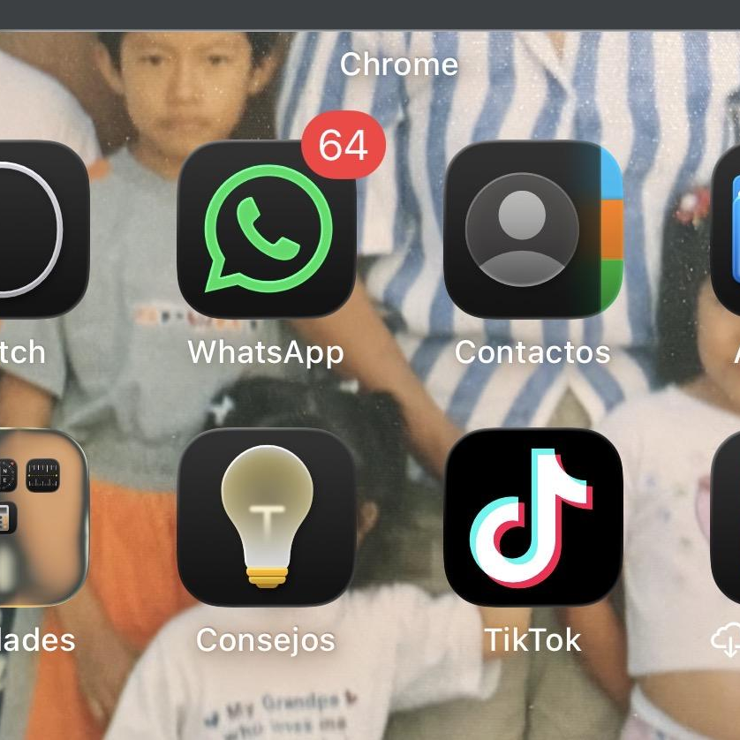. I use WhatsApp every day to communicate to my family and my friends and work. This app to help me to stay connect .

Screenshot/Photo 2
[Google ]
. This platform is the most importantly to search information
Google has many special features to help me find exactly what Iam looking

Screenshot/Photo 3
[Google maps]
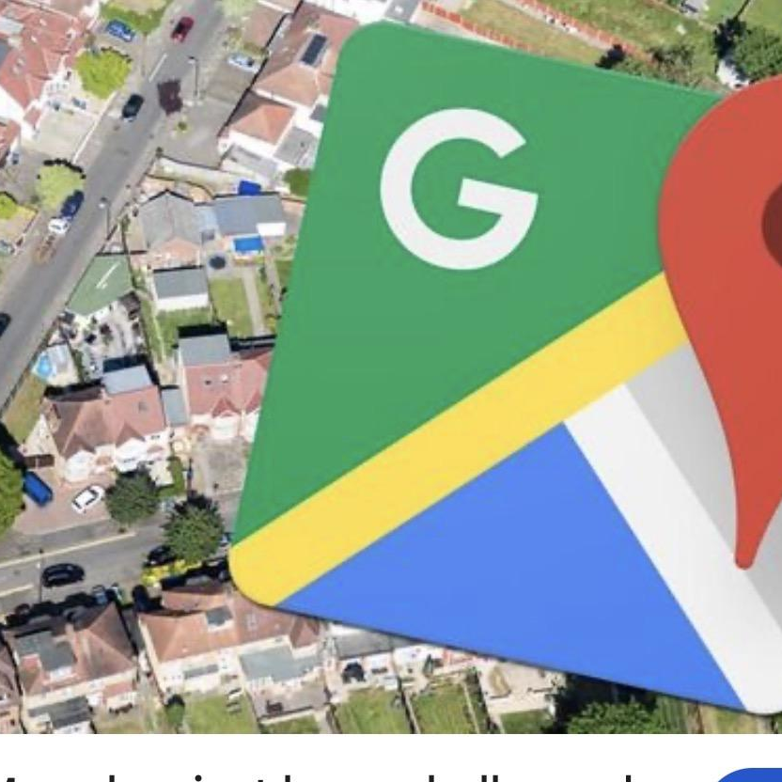
[Write what this shows of your digital life]

Screenshot/Photo 4
[Microsof word]
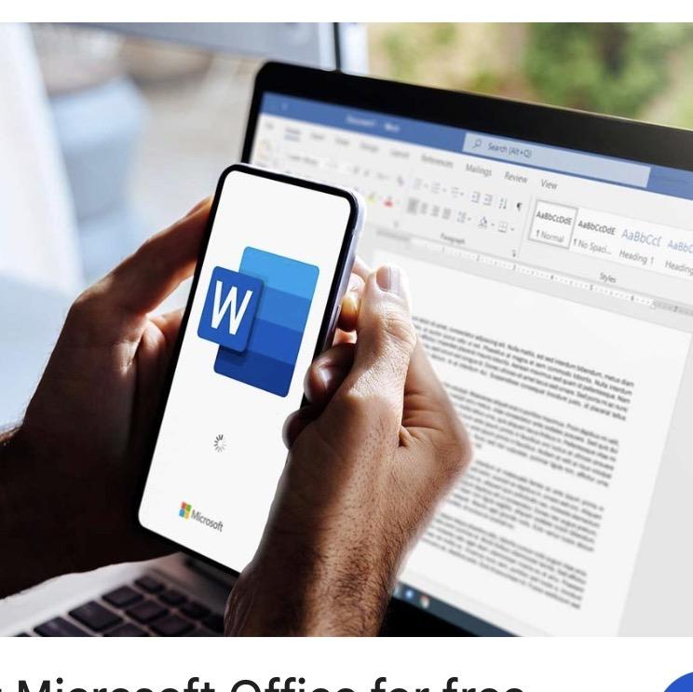
This app it’s help to my university work. I use to write assessments
add pictures and organise my documents . I am learning to use this app
Because it’s very important for my study.

Screenshot/Photo 5
[Moddle]

The moddle it’s the more important to use for my university the have all course I needed and check everything about my assessment , time table, lessons etc. All about my course .

Screenshot/Photo 6
[Google Gmail]
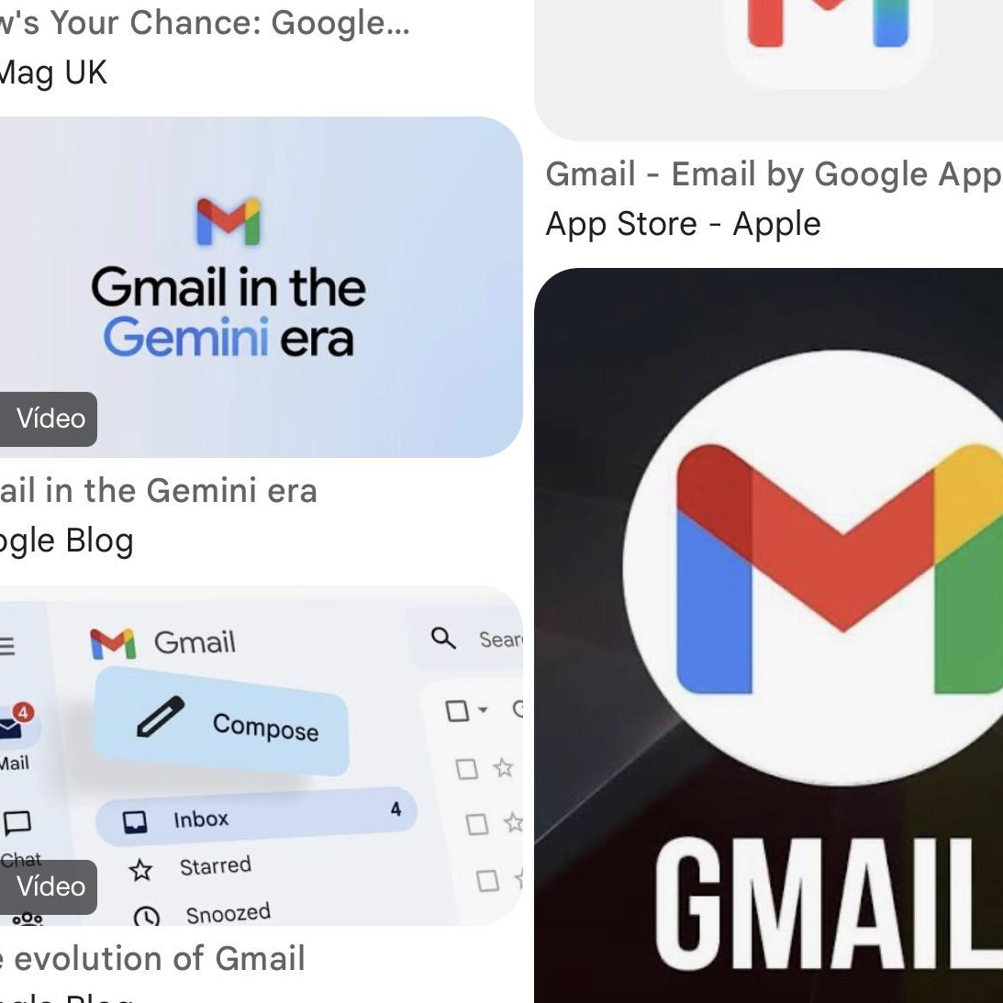
I use this app for save my email the have all information about my life .
Event, travels. Bills, etc . I use for send email received email
It’s help to organize my emails

My Short Reflection
- Write 5–8 simple sentences about your digital life.
- You can use the sentence starters below if helpful.
I use different digital tools in my daily life Microsoft Word,
WhatsApp, Google, Facebook,’Moodle . I feel confident when I can use my phone or my laptop to communicate apps .
I would like to improve all app and the most important for my study example I need to improve in Microsoft word , excel… to use for make document, saved . So need to improve my skill for this apps .
Digital skill is very important for me because it help to my study and for my work live . Know all thing it’s technology. So I have the pop to learning how can I use this digital knowledge

Sentence starters
- I use digital tools to …
- I feel confident when I …
- I want to improve …
- I often use these tools: …
- I sometimes feel nervous about …
- I hope this module will help me …
- Digital skills are important for me because …
You can write more if you want.

Submission Checklist
Before you submit, please check:
​​​☐ I added 4–6 screenshots
☐ I wrote short sentences for each screenshot
☐ I wrote my short reflection
☐ My work is my own
☐ My file opens correctly
​​☐ My file opens correctly

