Designing an Automatic Traffic Light Controller for a T- Junction Road.

Electronics 1

ACDB5002
Embedded Electronics Systems

Samuel Peppard
2308344
Contents
1. Introduction 3
2. Background Research 4
2.1 Concept of Traffic Lights 4
2.2 Traffic light limitations and solutions 5
3. Circuit Designs 6
4. Flowchart of systems operation 7
5. Software 8
5.1 Main overview of code 8
5.2 Arrays 8
5.3 Main code 11
6. Details of testing & Results 12
7. Conclusion 16
References 17

Table of Figures
Figure 1 - The Four stages of United Kingdom traffic lights [1] 5
Figure 2 - A screengrab of the Traffic light schematic 7
Figure 3 - An image of a flowchart to show the system of operations 8
Figure 4 - A screenshot of the whole code 9
Figure 5 - An example of a traffic light array 9
Figure 6 - An example of the timer array 10
Figure 7 - An image of the main code 12
Figure 8 - An image of the main code controlling the timer 12
Figure 9 - An image of the main code for the traffic lights 12
Figure 10 - Initial light state 13
Figure 11 - 2nd Light State 13
Figure 12 - 3rd Light state 14
Figure 13 - 4th Light State 14
Figure 14 - 6th Light State 15
Figure 15 -- 5th Light State 15
Figure 16 - 8th Light State 15
Figure 17 - 7th Light State 15
Figure 18 - 9th Light State 16
Figure 19 - 10th Light State 16
Figure 20- 11th Light State 16

Introduction

Within this task the main objective is to understand the electronics behind a traffic light system and be able to recreate the electronics for this. There are two main sections to this. The software and hardware. The hardware is physically creating the circuit and placing down components whereas the software is the coding segment of the traffic lights.

Initially with this task there is a segment of background research to understand what should be intended with regards to the traffic lights and be able to gain a further understanding of the methods of how traffic lights can work.

After the background research it was then time to create the circuit and add the hardware to ensure that the circuit is electronically correct.

The final stage is to plan and deliver a suitable set of code to ensure that the traffic lights run as they are intended. This includes creating a flowchart of operations and then moving on to actually writing the code. For this task the decision was to write the software in C as this is an easy to understand language which is very versatile offering a wide range of capabilities.

Background Research

2.1 Concept of Traffic Lights

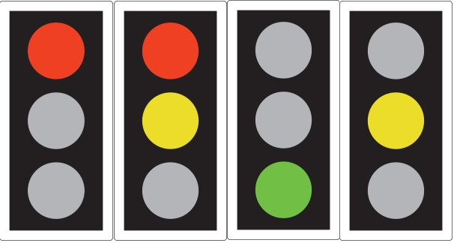
Initially the first task when designing traffic lights is to understand the concept of traffic lights, including the order of colours. From this research [1] it is concluded that there are 4 main stages of traffic lights as shown below:
Figure 1 - The Four stages of United Kingdom traffic lights [1]
The sequence begins with a red light which indicates to the motorist that they should stop and not go past the traffic lights. This is then followed by a simultaneous red and amber light which alerts the motorist to get ready to move off. Thirdly, there is a green light which indicates that it is okay to go through the lights. The final stage of lights is the amber light which tells the motorists to stop if safe to do so. This is in place to allow drivers who are too close to stop time to carry on to ensure maximum safety on the road [2].

Traffic lights within the United Kingdom on average of 60-90 seconds to change [3]; but for the proteus design we are going to work at a change every 10 seconds. This is mainly to allow the user to see the changes immediately without having to sit around for 4 minutes to witness the full simulation.

Traffic lights are an automated circuit. This therefore increases the reliability if traffic lights ensuring that road safety is the number one priority. There are many different types of circuits used to create traffic lights. Typically traffic lights incorporate a 555 timer and 3 Light Emitting Diodes of different colours; Red, Amber and Green. The 555 timer is used to generate a clock signal and add time delays [4]. This is crucial within traffic light systems as it allows delays for vehicles to pass through, additionally with time delays to allow drivers to have time to notice the changing colours.

2.2 Traffic light limitations and solutions

The majority of modern traffic lights use Light Emitting Diodes (LED’s) but then the question can be raised. What happens If the LED’s break or fail? This question has been asked multiple times and there is a simple solution to ensure that if there is an LED failure the traffic lights can still be used in a safe manner as the LED will still be operational but just with less of a light output. Another issue that has been raised is that LEDs do not produce any heat so therefore if the light is frozen over or covered in snow you would not be able to see which light is on [5]. The solution to this is to add a resistive heater wire system that can be placed across the lens of the LED bulb [6].

Circuit Designs

When designing the traffic light, the main things to consider is how many sets we need, how we will power these sequentially and then how we can acknowledge the time scale.

The first stage was creating enough sets of lights to ensure each direction of road is covered with traffic lights. For this scenario of a T-Junction the correct amount of lights would be three (north/east/west traffic).

The next stage would be to comprehend how to synchronise the lights so that when one of the sets is green the other two are on red. To ensure that this occurs the easiest method would be to power all lights on a singular PIC. The chosen PIC is the PIC16F877A. This PIC has 256 bytes of EEPROM data [7] which would be sufficient for the simple simulation of running 3 traffic lights and a timer.

The system runs 5 different setups (North, East, West lights, seconds timer and ten second timer) . So, when deciding a suitable PIC. It was crucial that it had 5 separate ports to run all 5 of these functions. Therefore, the PIC16F84A was the ideal PIC for this scenario.

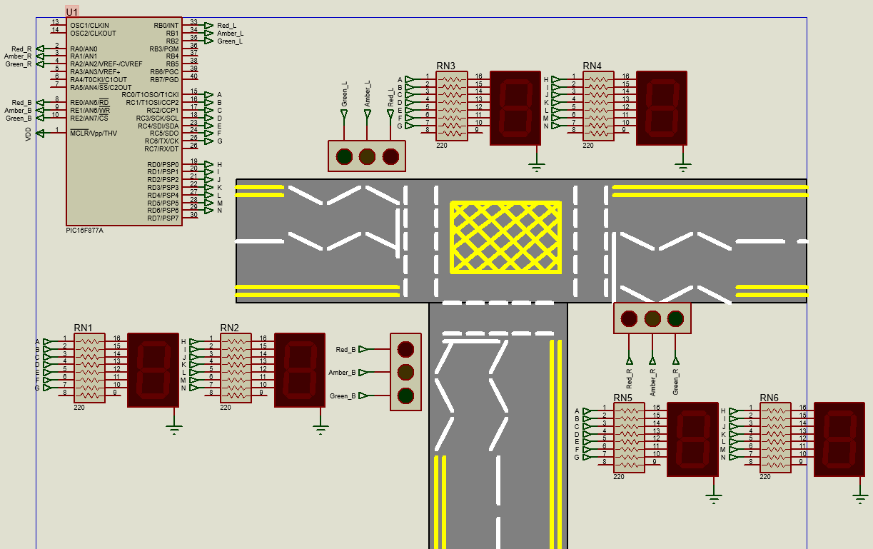
After this the next section which needed to be designed is the counter. To do this, two 7 segment displays are used, one for the seconds and one for the 10 seconds. This therefore will give you the ability to count up to 99 which will be a surplus to the 40 seconds we need it for. To ensure the 7-segment display does not get overloaded with current; 7 220Ω resistors have been put into series with the display.
Figure 2 - A screengrab of the Traffic light schematic

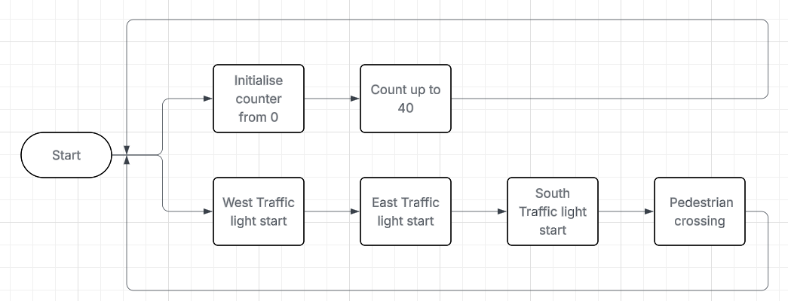
Flowchart of systems operation
Figure 3 - An image of a flowchart to show the system of operations

The system of operations for this project is rather simple. There is two main segment which need to work simultaneously with each other. This is the traffic lights and the timer. Therefore, when the simulation starts simultaneously the counter will start counting from 0 up to 40 and the traffic lights will start to change from red to green sequentially. Initially within the first 10 seconds the west (left) traffic light will change from red to red amber and then to green, stay green for 6 seconds and then change back to red when the timer hits 10 seconds. This process will then repeat for the east (left) set of traffic lights and then the south (bottom) traffic light. After all, three of the traffic lights have changed, the timer will be on 30 seconds, allowing the final 10 seconds for the pedestrians to cross safely due to all lights being red. After the 40 seconds has been completed the simulation will then repeat this process with the timer going back to 0.

Software

Main overview of code
The code for this project is rather simple. In total the software took only 43 lines to run the operations needed.
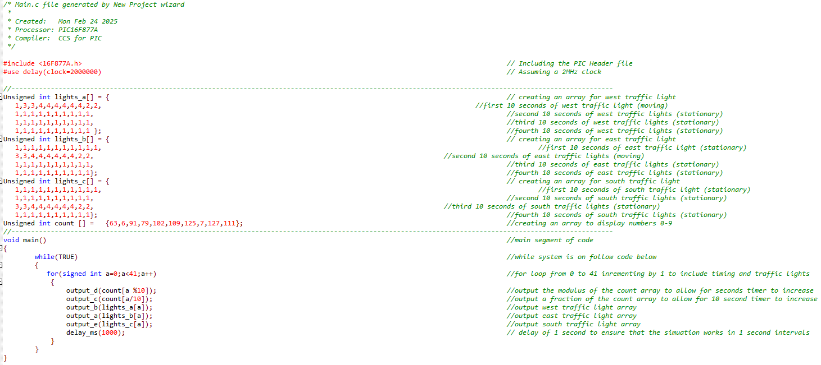
As an overview this code there is 2 main sections. The arrays and the main code. The arrays define the values needed to light the correct lights to show the correct order and sequence. The main code is put in place to run these arrays in an effective order to allow it to run smoothly and in order.
Figure 4 - A screenshot of the whole code

Arrays
There are 4 arrays used in this code. One for each traffic light and then one for the timer.
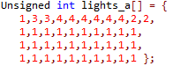
Figure 5 - An example of a traffic light array
The traffic light arrays are all very similar to each other with the order of values being the only difference. The values are calculated to match with each of the traffic light colours. On every traffic light pin 0 is red, pin 1 is amber and pin 2 is green. To ensure the light turns on the binary value has to equal 1 for each of the pins you want to light up. For example, to light just the red light you will need to output the binary value of 00000001 on each pin which just equals 1 in decimal.
This array has 41 values in it. This is to incorporate all sections of the timer from 0-40 to simplify how the array works it is spread across 4 separate lines to indicate the 10 second intervals for lights to change

For all the other values needed you can reference table 1 below

Table 1 - comparison of traffic light output binary/decimal inputs
Light state | Binary Value | Decimal Value
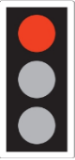 | 00000001 | 1
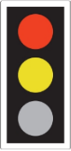 | 00000011 | 3
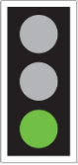 | 00000100 | 4
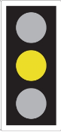 | 00000010 | 2

The count array is created in a very similar process to the traffic light arrays as it uses the binary values needed to light the specific sections of the 7-segment display. The key difference between the 7-segment display and the traffic lights is there is 7 LEDs instead of 3, therefore the values needed would be much larger.
Figure 6 - An example of the timer array

As you can see above in Figure 6, the array is much smaller and simplified. This is due to it being only 10 values as then the array can loop 4 times giving us the same response as if a clock was counting from 0-40. The values within the array are worked out in the same format as they are for the traffic lights which will be shown in table 2 below
Table 2 - comparison of 7-segment display output binary/decimal and hexadecimal inputs
Hex display Value | Binary value to display on 7 Segment display | Decimal equivalent | Hex equivalent | Visual representation of 7 segment display
0 | 0111111 | 63 | 3F | 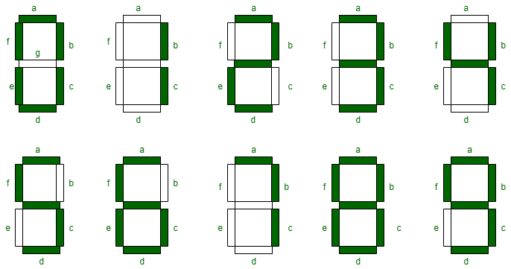
1 | 0000110 | 6 | 6
2 | 1011011 | 91 | 5B
3 | 1001111 | 79 | 4F
4 | 1100110 | 102 | 66
5 | 1101101 | 109 | 6D
6 | 1111101 | 125 | 7D
7 | 0000111 | 7 | 7
8 | 1111111 | 127 | 7F
9 | 1101111 | 111 | 6F

Main code

The main section of code is very simplistic written using only 8 lines of code. This section of code is put into place to allow the arrays to run uniformly and in the correct order. The key instruction in the main code is the for statement. the for loop is used to repeatedly execute a block of code as many times as instructed [8]. This loop therefore executes the arrays in increments of 1 from 0 to 41. Therefore, running through the values in the arrays 41 times. This therefore will run through the whole of the traffic light arrays once and the timer array 4 times.
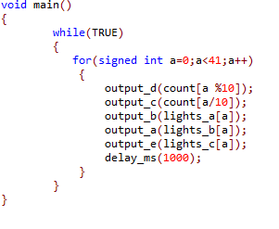
Figure 7 - An image of the main code
The lines below the “for” statement state what section of code it should run when the for loop is running. The lines in figure 8 below show the section of code which runs the timer, there is two lines; the first line controls the 1-second display and the second controls the 10-second display. The

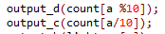
Figure 8 - An image of the main code controlling the timer
The lines of code in figure 9 below can show us the code which runs the traffic lights. This code is very simple as it is just outputting the correct array onto the correct pin outputs for each traffic light. The final line is a delay of 10 seconds this accounts for the pedestrians to cross.

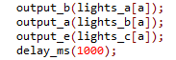
Figure 9 - An image of the main code for the traffic light

Details of testing & Results
On testing all was successful with the code running smoothly and correctly. The methodology of testing incorporated assurance that the lights all switch correctly and within the timeframes that should be predicted with a timer showing us the time.

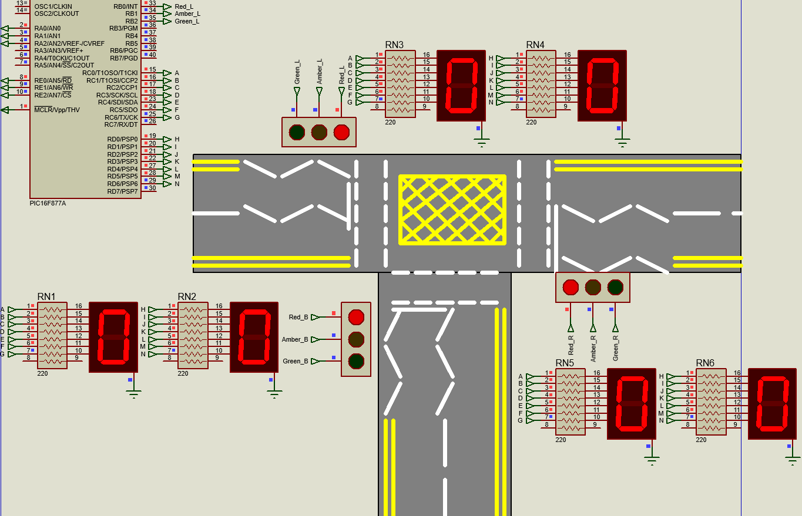
The first stage was the initial light state with all lights on red and the timer starting at 0 which was successful as seen in Figure 10.
Figure 10 - Initial light state

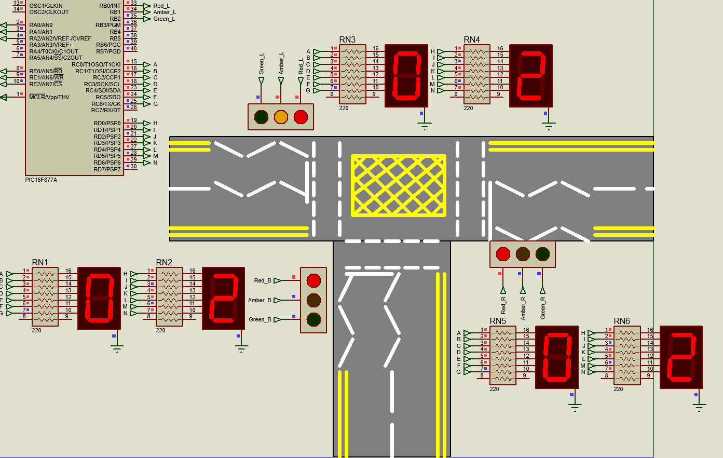
The 2nd light state shows the west light turning to red/amber with all other lights staying red. This occurs from 1 to 3 seconds as shown in figure 11.
Figure 11 - 2nd Light State

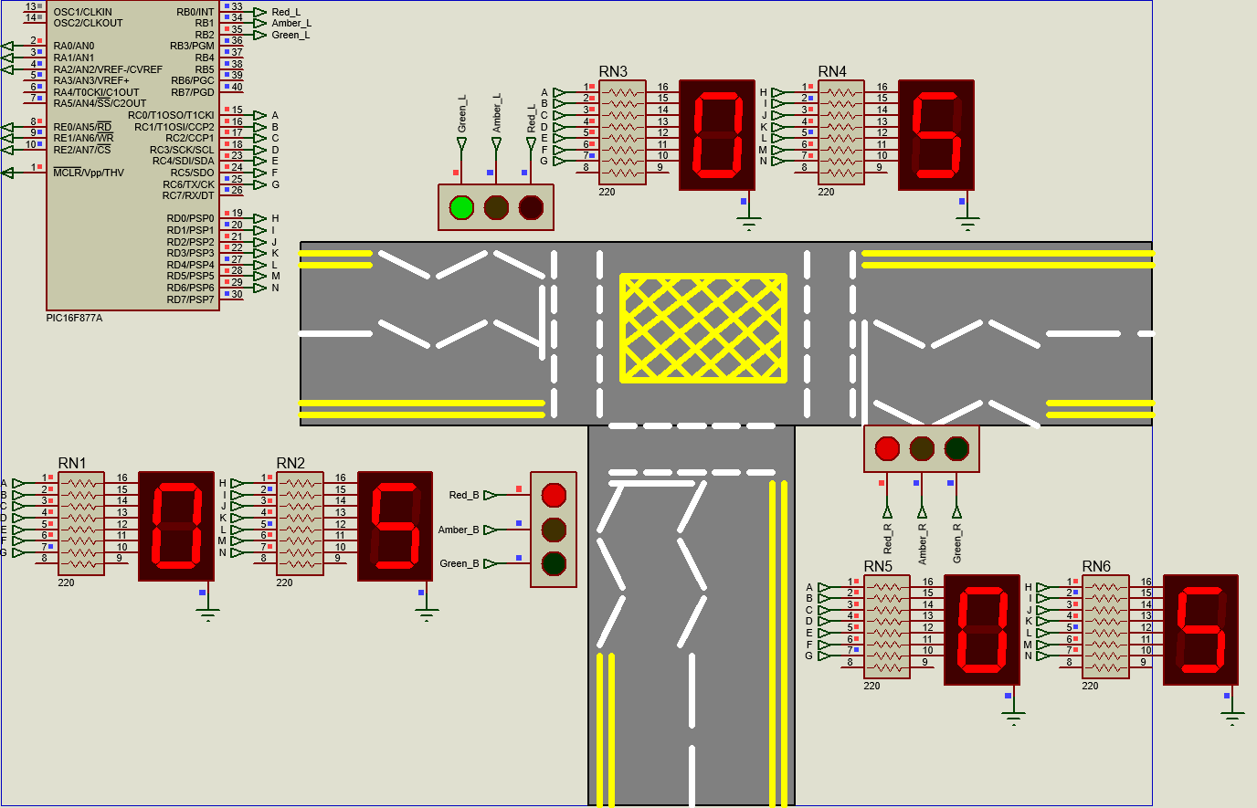
The third light state shows the western lights turning green with the other sets of lights staying red. This occurs between 2 and 8 seconds. As shown in figure 12 below.
Figure 12 - 3rd Light state

The fourth state shows the western light turning to amber; Again, with the other sets of lights staying red. This will occur between 8-10 seconds this can be proven below in figure 13.
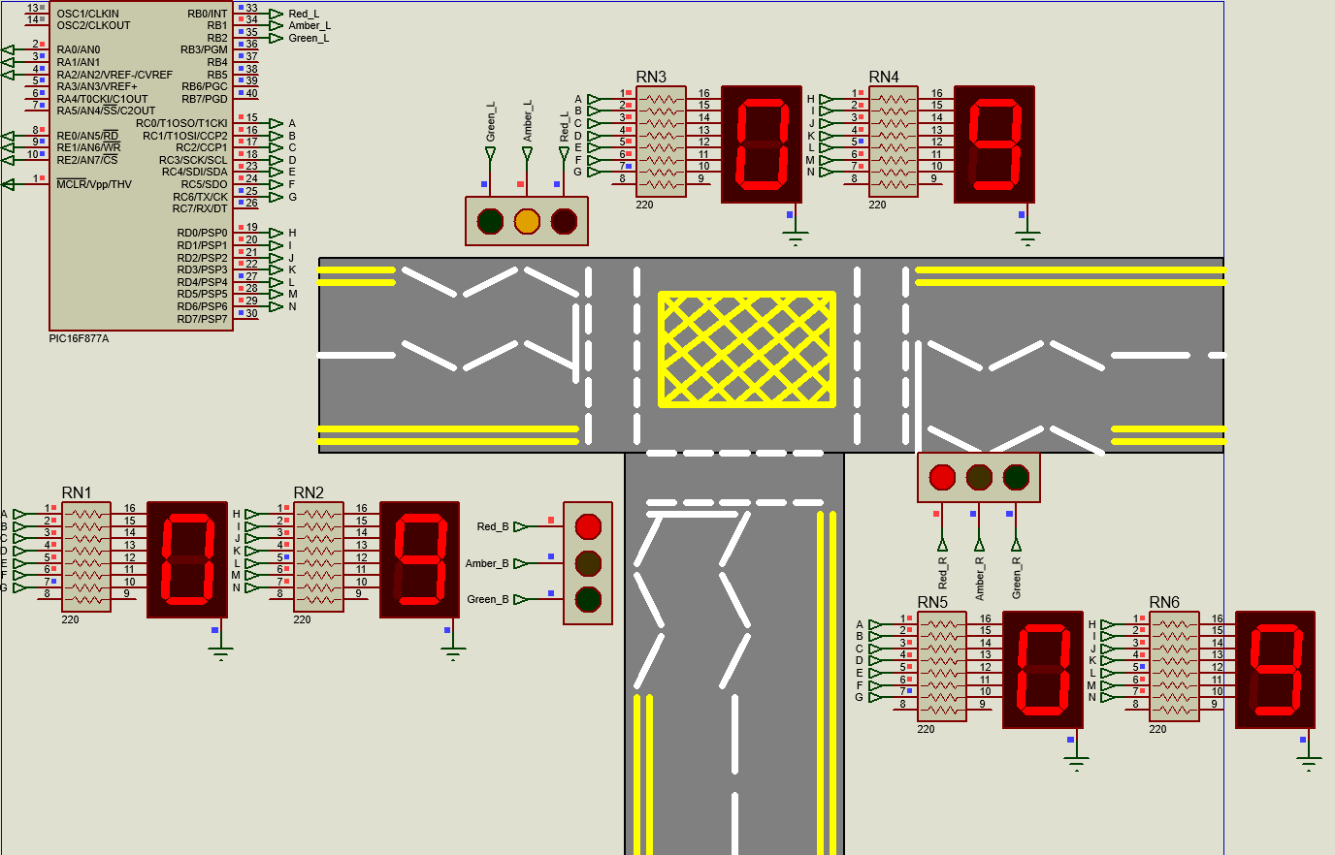
Figure 13 - 4th Light State

After the western light has turned amber it will then reset back to red with the eastern lights going through the same cycle. And then followed by the southern lights. As shown in Figures 14-19
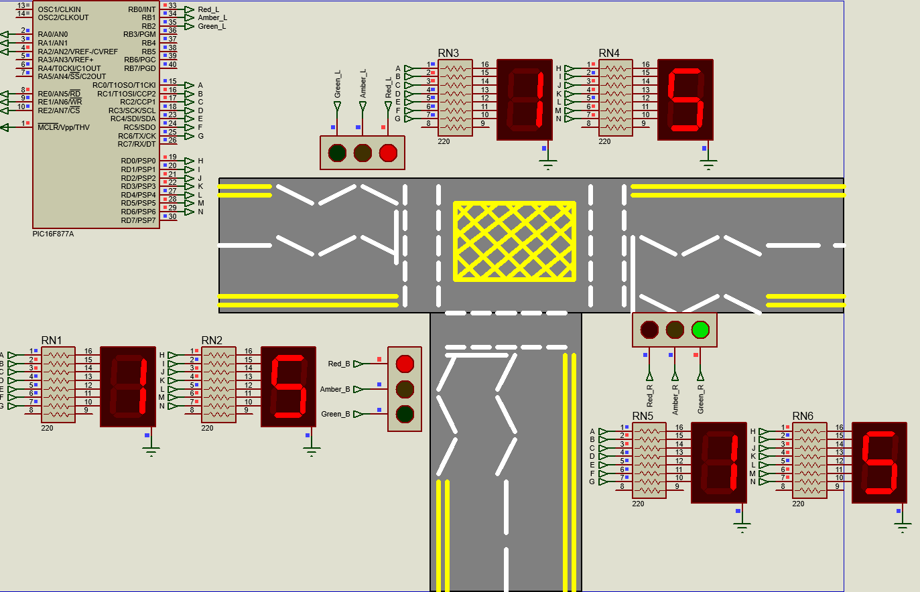
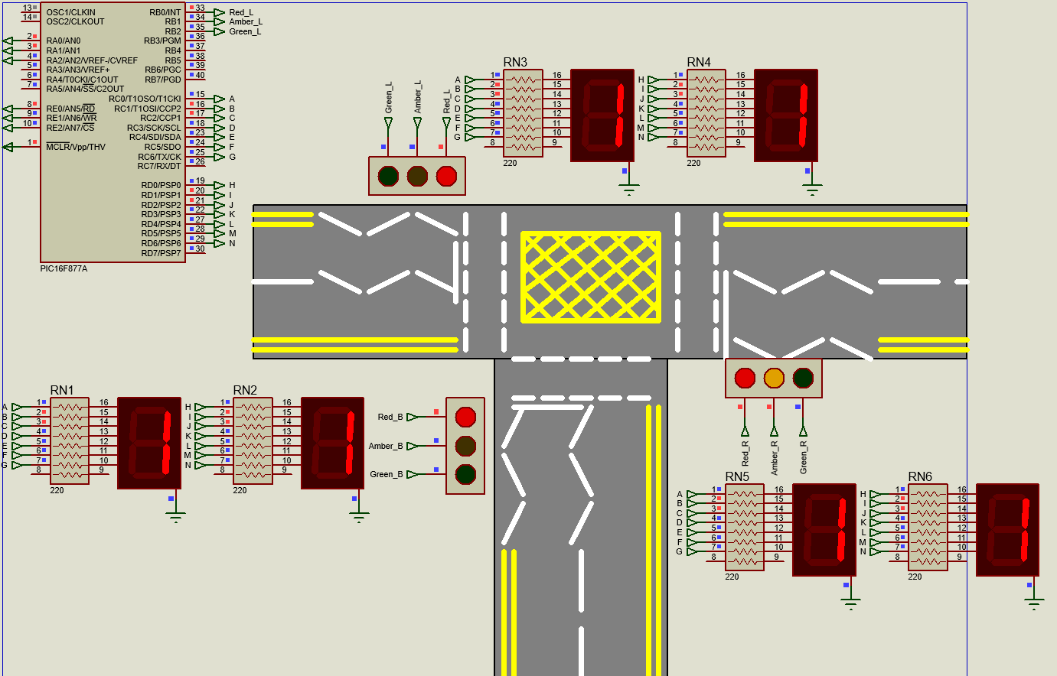
Figure 14 - 6th Light State
Figure 14
Figure 15 -- 5th Light State

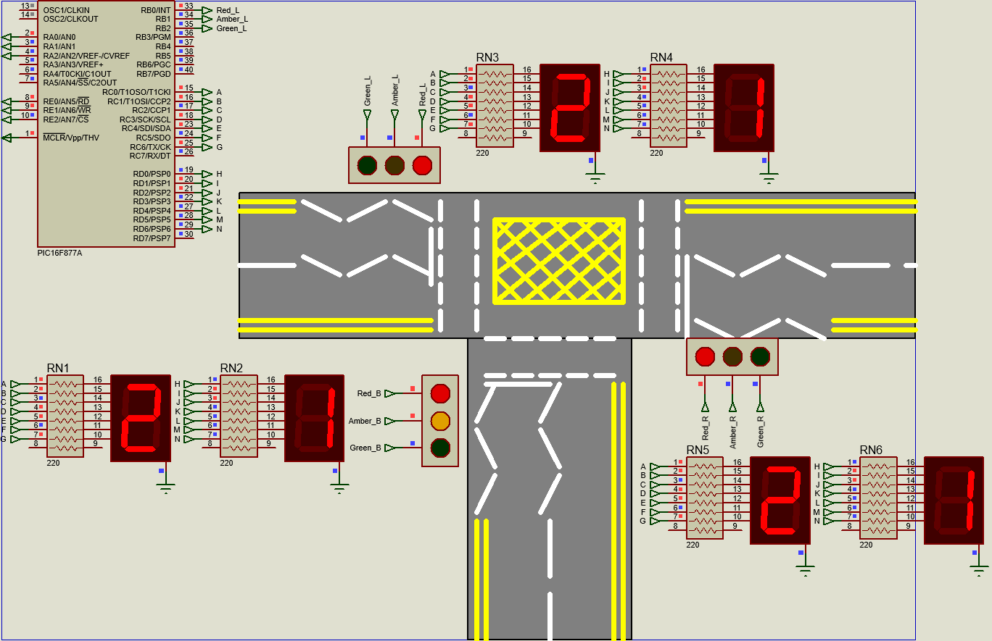
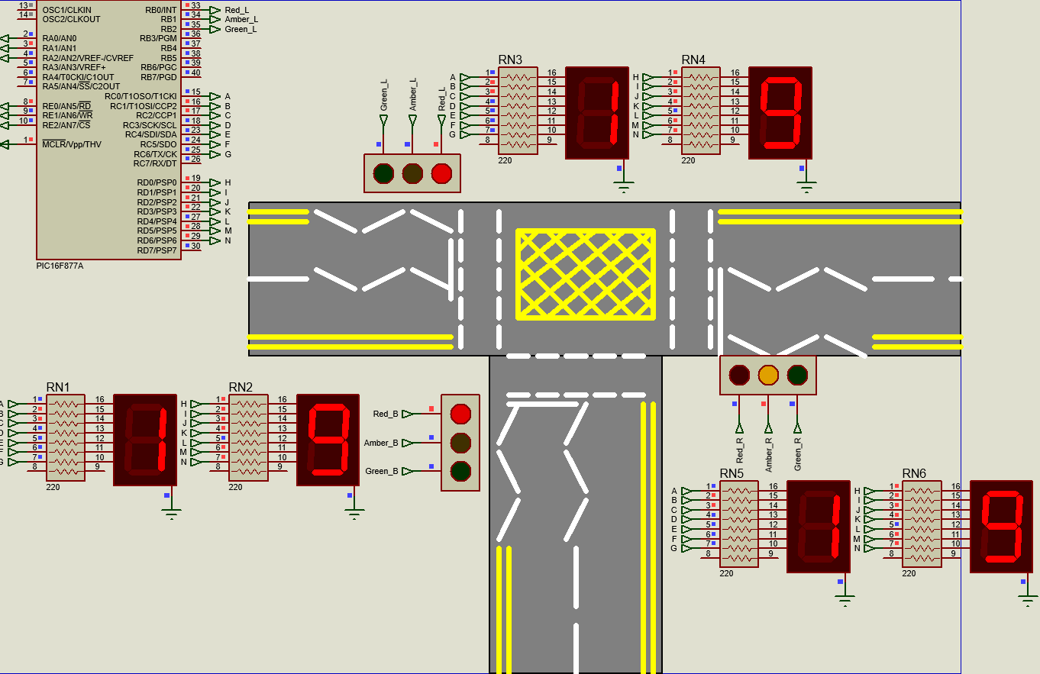
Figure 16 - 8th Light State
Figure 17 - 7th Light State

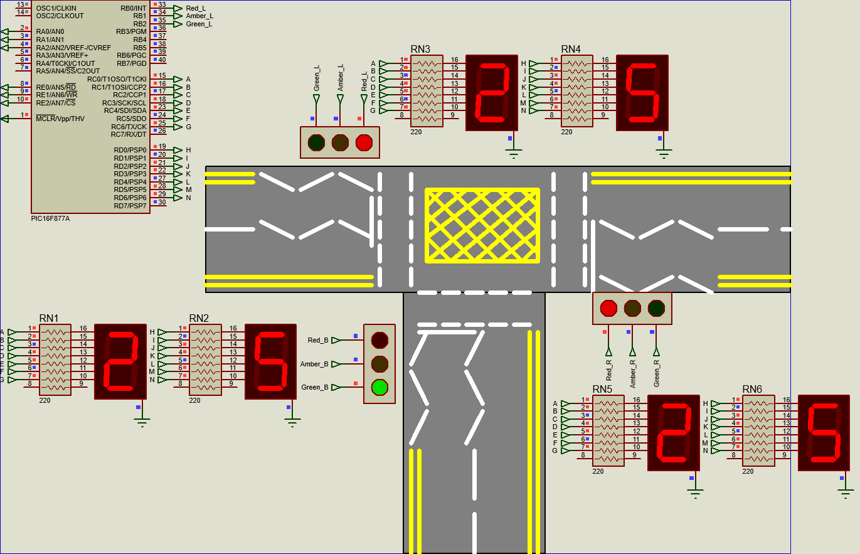
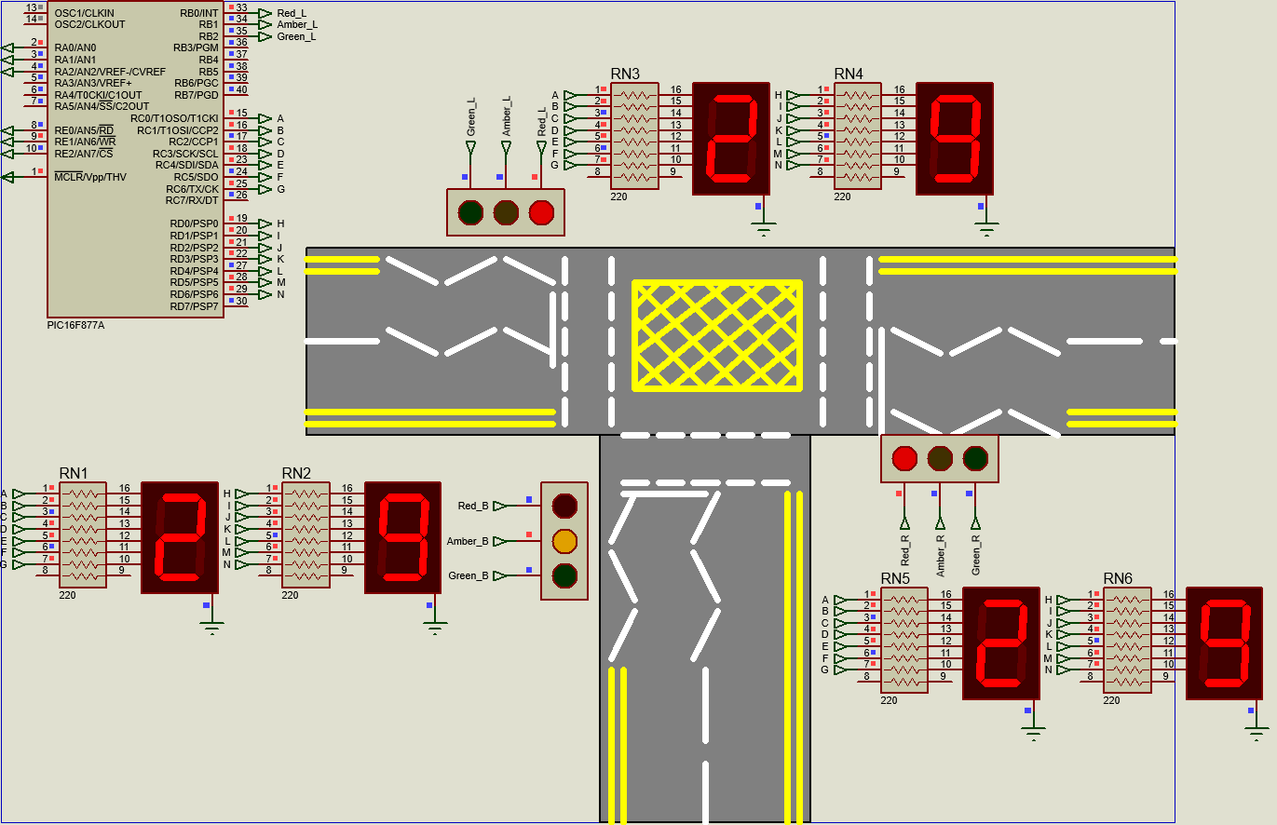
Figure 18 - 9th Light State
Figure 19 - 10th Light State
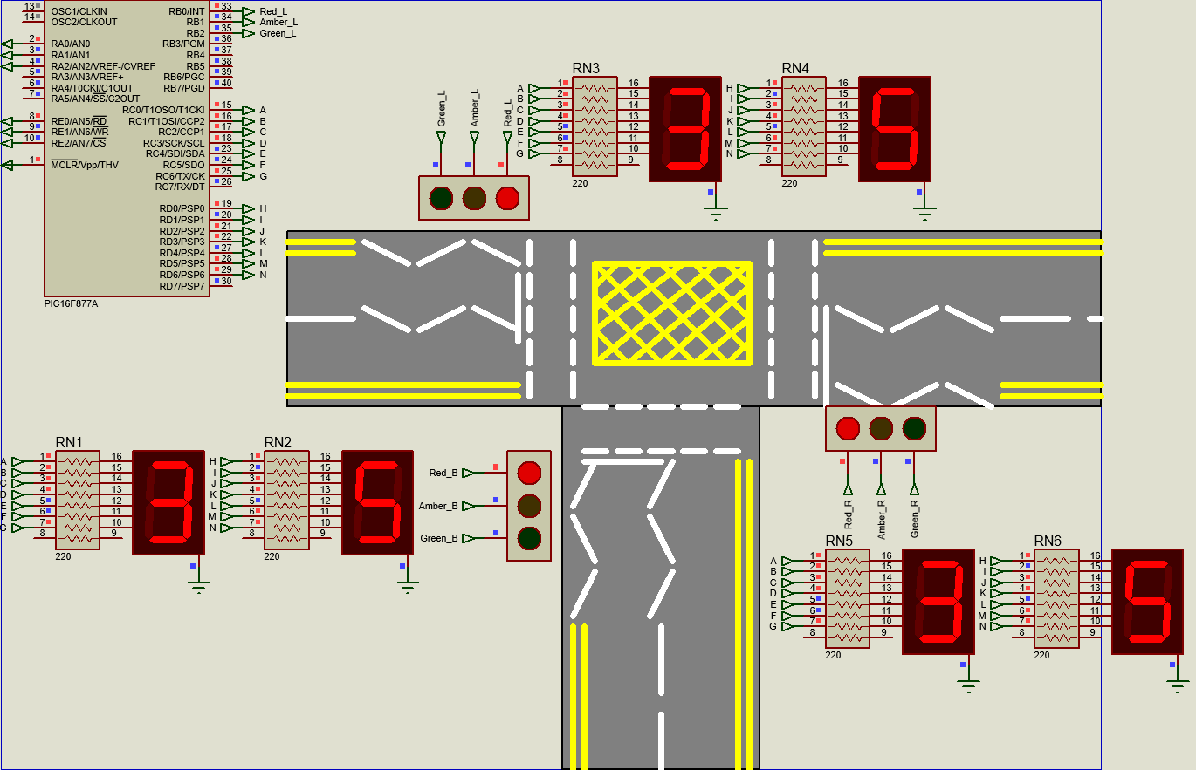
After all three sets of lights have gone through their cycle there is a 10 second period where all 3 lights stay red. This is so that pedestrians have a time to cross the road safely. This can be seen in Figure 20 below.
Figure 20- 11th Light State
After all of these phases have passed the lights reset and the timer resets back to 0 seconds. With all of these results, confidence is high that the system would function reliably in real-world conditions.

Conclusion

To summarise this task. The creation of a 3-way traffic light system was highly successful. After initially researching into how traffic lights work and gaining an understanding of how to tackle the challenge of making a sets of traffic lights. It was clear that there are multiple ways to replicate the same as what has been created above in this task.

After testing and fault finding, the system works smoothly without any interruptions. The biggest challenge with the simulation is the software used; Proteus. As a low-quality application, it is a challenge to see if there are any minor faults within the code and schematic.

If this task was to be done again there is some minor changes that could be made, for example introducing slip roads and real-life traffic light timings. This would therefore make the task more realistic to how real-world traffic lights actually work. additionally, there could have been a pedestrian light to allow pedestrians to know when to cross safely. To stretch, it would have been interesting to add motion sensors and a pedestrian button to the system; like real world traffic lights. This would be able to sense when cars are approaching the junction and change depending on the direction of vehicles.

References

[1] | Department for Transport, “Light signals controlling traffic,” GOV.UK, 1 October 2015. [Online]. Available: https://www.gov.uk/guidance/the-highway-code/light-signals-controlling-traffic. [Accessed 14 April 2025].
[2] | RAC, “Traffic light sequence: the ultimate guide to traffic lights,” RAC, 24 September 2024. [Online]. Available: https://www.rac.co.uk/drive/advice/road-safety/traffic-light-sequence-the-ultimate-guide-to-traffic-lights/. [Accessed 14 April 2025].
[3] | “How long do you spend waiting at traffic lights?,” Patons Insurance, 8 August 2022. [Online]. Available: https://www.patonsinsurance.co.uk/how-long-to-you-spend-waiting-at-traffic-lights/#:~:text=While%20it%20might%20seem%20like%20an%20eternity%20waiting,or%20air%20conditioning%20or%20grabbing%20a%20quick%20snack.. [Accessed 14 April 2025].
[4] | “555 Timer - 1. Introduction to 555 Timers,” CircuitBread , 06 April 2022. [Online]. Available: https://www.circuitbread.com/tutorials/555-timer-1-introduction-to-555-timers#:~:text=It%20can%20be%20used%20to%20generate%20various%20types,timers%20is%20to%20generate%20clock%20signals%20for%20circuits.. [Accessed 18 April 2025].
[5] | ABC News, “Stoplights' Unusual, Potentially Deadly Winter Problem,” ABC News, 2010.
[6] | B. Marmarelli, “Engineering Team Develops Device to Aid LED Traffic Signals in Inclement Weather & Places Overall in Campus's Senior Design Competition,” planet blue - University of Michigan, Michigan, 2011.
[7] | Microchip, “PIC16F877A,” 29 November 2012. [Online]. Available: https://ww1.microchip.com/downloads/aemDocuments/documents/MCU08/ProductDocuments/DataSheets/39582C.pdf. [Accessed 20 April 2025].
[8] | geeks for geeks, “C for Loop,” Geeks for Geeks, 16 December 2024. [Online]. Available: https://www.geeksforgeeks.org/c-for-loop/. [Accessed 23 April 2025].

Appendix

/* Main.c file generated by New Project wizard
*
* Created: Mon Feb 24 2025
* Processor: PIC16F877A
* Compiler: CCS for PIC
*/

#include <16F877A.h> // Including the PIC Header file
#use delay(clock=2000000) // Assuming a 2MHz clock

//---------------------------------------------------------------------------------------------------------------------------------------------------------
Unsigned int lights_a[] = { // creating an array for west traffic light
1,3,3,4,4,4,4,4,4,2,2, //first 10 seconds of west traffic light (moving)
1,1,1,1,1,1,1,1,1,1, //second 10 seconds of west traffic lights (stationary)
1,1,1,1,1,1,1,1,1,1, //third 10 seconds of west traffic lights (stationary)
1,1,1,1,1,1,1,1,1,1 }; //fourth 10 seconds of west traffic lights (stationary)
Unsigned int lights_b[] = { // creating an array for east traffic light
1,1,1,1,1,1,1,1,1,1,1, //first 10 seconds of east traffic light (stationary)
3,3,4,4,4,4,4,4,2,2, //second 10 seconds of east traffic lights (moving)
1,1,1,1,1,1,1,1,1,1, //third 10 seconds of east traffic lights (stationary)
1,1,1,1,1,1,1,1,1,1}; //fourth 10 seconds of east traffic lights (stationary)
Unsigned int lights_c[] = { // creating an array for south traffic light
1,1,1,1,1,1,1,1,1,1,1, //first 10 seconds of south traffic light (stationary)
1,1,1,1,1,1,1,1,1,1, //second 10 seconds of south traffic lights (stationary)
3,3,4,4,4,4,4,4,2,2, //third 10 seconds of south traffic lights (stationary)
1,1,1,1,1,1,1,1,1,1}; //fourth 10 seconds of south traffic lights (stationary)
Unsigned int count [] = {63,6,91,79,102,109,125,7,127,111}; //creating an array to display numbers 0-9
//---------------------------------------------------------------------------------------------------------------------------------------------------------
void main() //main segment of code
{
while(TRUE) //while system is on follow code below
{
for(signed int a=0;a<41;a++) //for loop from 0 to 41 inrementing by 1 to include timing and traffic lights
{
output_d(count[a %10]); //output the modulus of the count array to allow for seconds timer to increase
output_c(count[a/10]); //output a fraction of the count array to allow for 10 second timer to increase
output_b(lights_a[a]); //output west traffic light array
output_a(lights_b[a]); //output east traffic light array
output_e(lights_c[a]); //output south traffic light array
delay_ms(1000); // delay of 1 second to ensure that the simuation works in 1 second intervals
}
}
}

