Marketing Fundamentals (LCBB4004)
Assessment 1: Individual Blog Marketing Fundamentals Analysis and Evolution

Submission Date: 28/03/2023
Name of the Lecture: TUSHARA BALENDRAN
Student ID: 2236843
Student name: ANDRIYANA EFTIMOVA



Background
The history of Yves Saint Laurent

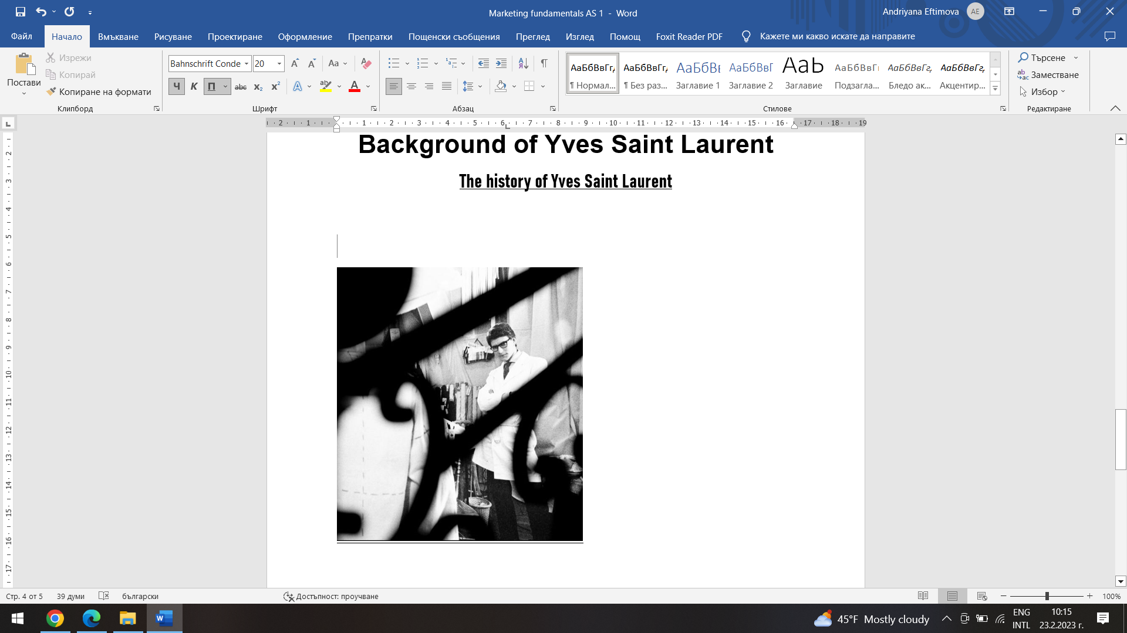

After being one of Cristian Dior’s most successful students, Yves Saint Lauren created his own line with business partner Pierre Berge in 1961. They immediately found loyal customers by creating traditional clothing.

1964 the company releases its first fragrance.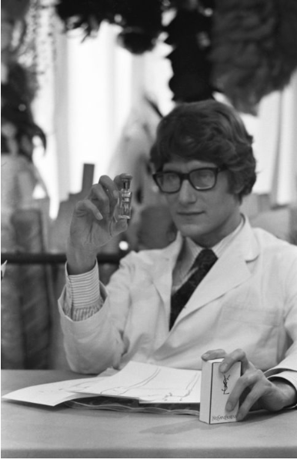 First Fragrance: Y - Musée Yves Saint Laurent Paris (museeyslparis.com)

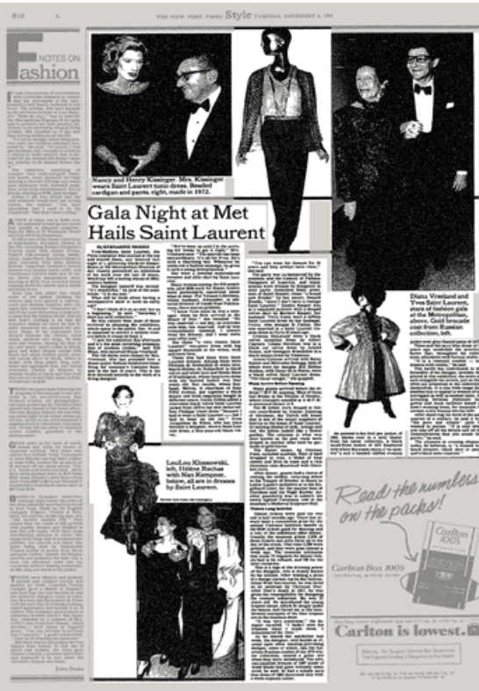

The Metropolitan Museum of Art in New York celebrated Laurent as the first living designer with exhibition in 1983.
1985 Iman honored as the subject of YSL African Queen collection, which honors the designer′s longtime muse.
1989 The Paris Stock Exchange lists the $500 million – valued YSL brand.
Albert Elbaz left the company in 1999. The business is sold to Gucci Group (now Kering) for $1 billion in the same year.
2000 In Paris, the Yves Saint Laurent Archival Institute is established.
2008 Yves Saint Laurent passes away.
The history of Yves Saint Laurent: A timeline - Haute History
Saint Laurent occupies a leading position in the world of fashion. They compete with some of the most famous, exclusive luxury brands worldwide and occupy a dominant position. Under the leadership of Antoni V. and Francesca B., the brand has created strong foundations for its rise and continues its growth to ensure its presence in the global fashion market.
1402308_KERING RA-GB_2013.indd

Changing the name of Yves Saint Lauren to Saint Laurent Paris.
Under the new creative director H. Slimane in 2012, Saint Laurent has taken new direction.
“H. Slimane′s exceptional talent and understanding of the spirit of Yves Saint Laurent heralds a promising new chapter in their story” (Paul D., previous CEO of Saint Lauren Paris.
Slimane made a rather bold new beginning (Posner, 2011) by changing the brand name to Saint Laurent Paris. He also undertook the relocation of the creative studio of the fashion house from Paris to Los Angeles.
Slimane wanted to evoke “youth, freedom and modernity” with his “retro - branding” (Kering report 2012). In order to reposition the brand for the younger market, the men's and women's collections, leather goods, and shoes have all been updated. The brand's contemporary and youthful identity is also reflected in the new dynamic and minimal web design.
Mission statement
Saint Lauren Paris seeks to create and promote highly desirable items via innovation, unrivalled quality, and elegant design. The firm intends to continue its worldwide retail footprint by opening additional sites in developing countries using the new shop concept. Saint Laurent is revamping and modernizing its retail presence to make it more unified by redesigning the new shop idea and focusing on growing into new areas. (Kering Report, 2013)
https://keringcorporate.dam.kering.com/m/3d168cf67f0c21d1/original/2013-Annual-Report.pdf

Market segmentation, Targeting strategies and Positioning.
As a part of the segmentation, targeting and positioning marketing strategy, the characteristics of the Saint Lauren consumer are identified in the segmentation analysis presented below. (Posner, 2011). It is crucial for Saint Lauren to divide up its target market in order to comprehend the needs and preferences of the extremely fragmented global consumer.
Demographic Segmentation:
- Women
- Born between 1961 – 1981.
- Multicultural
- High academic achievement throughout childhood; university studies
- Multicultural
- High earnings
- A-C1 socioeconomic group
Geographic Segmentation
- Europe: United Kingdom, France, Italy, Germany, Spain, Turkey, Monaco, Poland
- Australia
- North America: Florida, California, New York, Las Vegas, Los Angeles
- Asia: South Korea, China, Hong Kong, Indonesia, Singapore
- Africa: United Arab Emirates, Saudi Arabia, Kuwait, Lebanon
Psychographic Segmentation
- Social lifestyle.
- Strong career goals.
- Purchasing motives are to improve status.
- Rock music interest.
- Enjoys travelling.
- Highly confident.
- Freedom.
Posner H. (2011) Marketing Fashion, London, Laurence King Publishing
Jackson T. and Shaw D. (2009) Mastering Fashion Marketing, Palgrave MacMillan
Advantages and Disadvantages
- Advantages: Promotes their business to the target audience.
- Advantages: Helps to understand their customers.
- Advantages: Helps brand to develop the business.
- Disadvantages: Marketing expense.
- Disadvantages: Time and effort may not be rewarded.

Targeting
In general, Yves Saint Laurent's target market has always been high, consisting of customers who are fashion connoisseurs, therefore they are mostly middle and upper class. It can also be divided into men and women between the ages of 20 and 40 who have a sophisticated style. Wealthy individuals who want to project more professional image.
In order to successfully target younger consumers, strategies will focus on the core customer segment (Jackson and Shaw, 2009) that will satisfy a specific group of customers. As a result, they will be able to complete and reconfirm additional costs for a market that is unlikely to provide value. Being overly focused on the market and remove current clients from an older generation. To keep the elder customer, the strategy must therefore be true to the brand.

Brand Positioning

According to the Posner (2011), in order for a business to have a clear target, it must position its brand in the market. It is more complicated than segmentation because it focused on where brands are perceived by consumers.
Posner (2011) suggested that a positioning map (perceptual map) would provide more precise image.

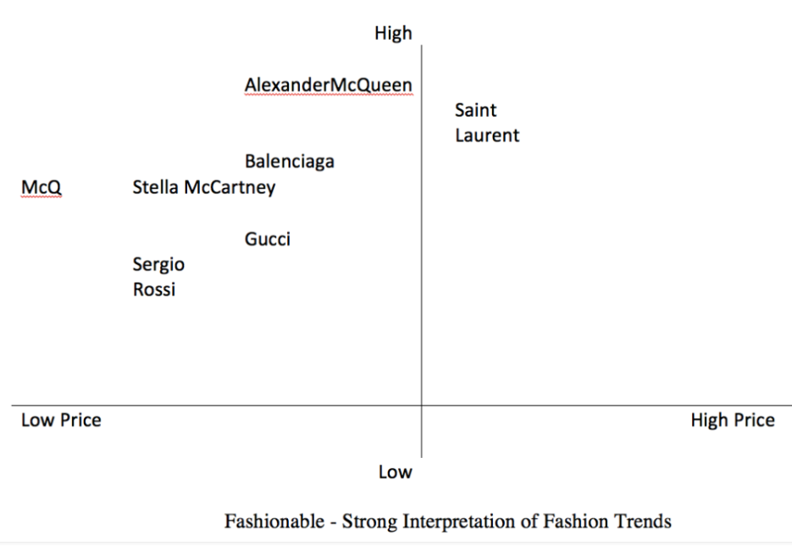

According to the position map Saint Laurent's rivals within the Kering Group are Alexander McQueen and Balenciaga.
A brand's position can be determined analytically by comparing Saint Laurent t its main rivals (Jackson and Shaw, 2009). The brand must have unique marketing concept because the luxury industry is so fiercely competitive.
Due to similarities to Saint Laurent, such as their connection to the music business and their connection to the music business and their young target demographic, Balenciaga is currently a “threat of replacement in the market” (Poster Five Forces). Saint Laurent will convey clear marketing efforts to leave a lasting impression in order to make sure they create “significant differential advantage” over their rivals (Jackson and Shall, 2009). Consumer perception of the rebranding will be heavily supported by this element of the marketing mix. The key distinction between the two labels shown by timeless pieces of clothing. As a result, they will set themselves apart from Balenciaga through “product differentiation” (Jackson and Shall, 2009). What makes them competitive is the high value of the good they offer.

Marketing mix
The marketing strategy that Saint Laurent uses is that of the 4Ps (Product, Price, Place and Promotion). Product innovation, selected pricing strategies, well-planned promotion and other various tactics. The success that the brand has is due, on the one hand, to their strategies that they use over time.
https://www.mbaskool.com/marketing-mix/products/18114-yves-saint-laurent.html
Product

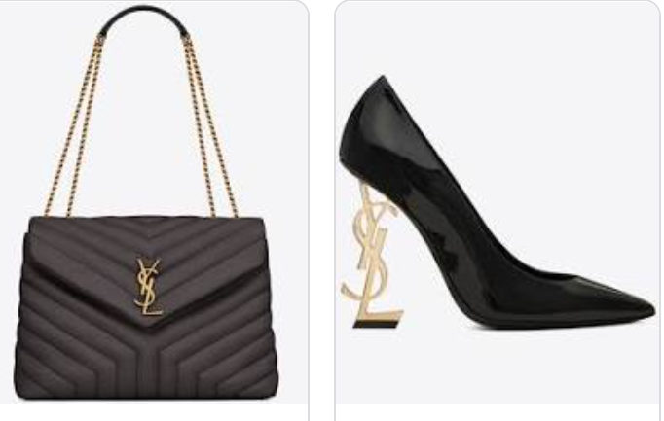
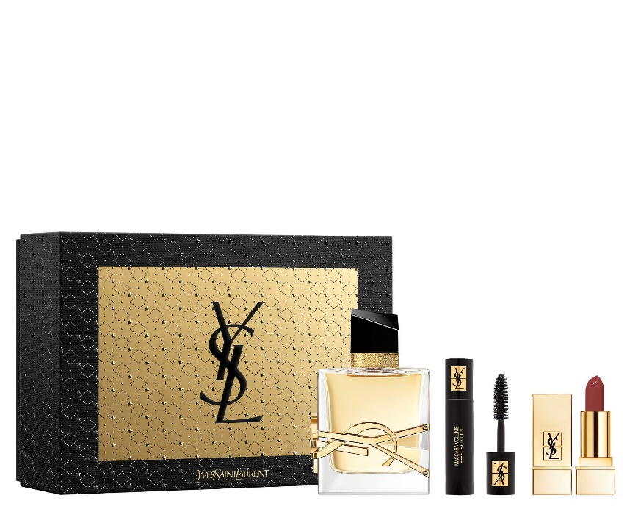

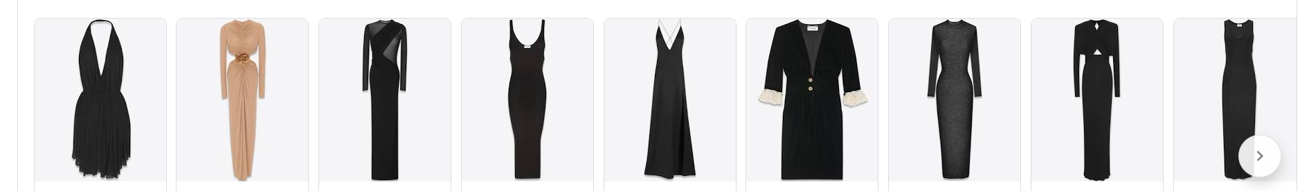

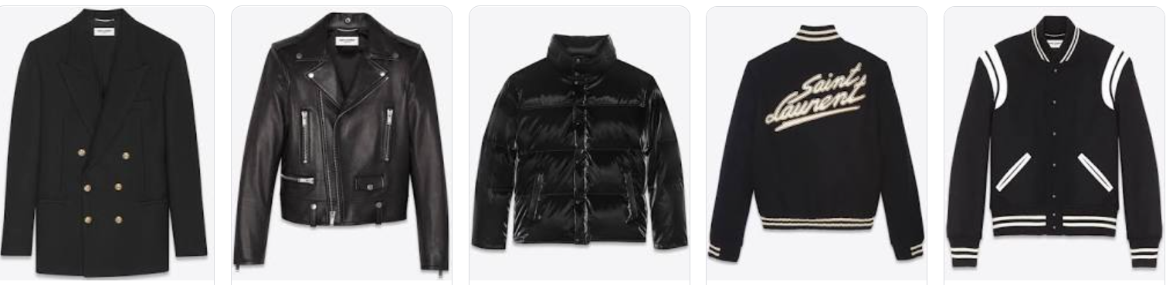

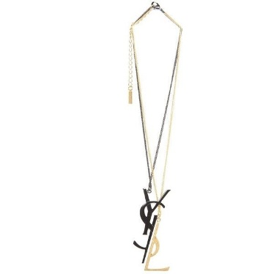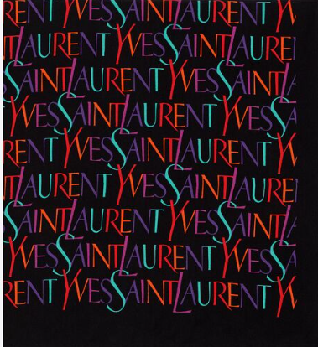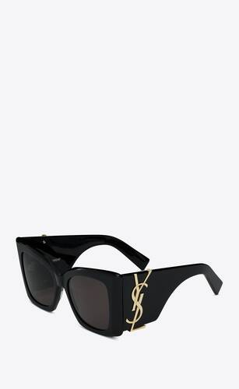

The Saint Lauren product line is “Varied and extensive”. The extensive product selection includes ready-to-wear for woman and man, jewelry, scarves, handbags, shoes, small leather goods, ties, eyewear, fragrance and cosmetics. However, the “high income group” can only purchase a limited numbers of sizes and stock of each product in the store (Jackson and Shaw, 2009). Products lead to “self - actualization” by satisfying a desire for the brand (Maslow's Hierarchy of needs, 1943).
Price
Due to fact that Yves Saint Laurent is aiming for a certain group of customers, the company’s pricing strategy is aimed at a high-end pricing policy. They manage to successfully maintain their pricing policy. For example, their product range from £100 to £3000, which attracts buyers. We should also note that the prices reach up to £ 5000 who seized a new collection.
What is Yves Saint Laurent's marketing strategy? | BluCactus

Products of Saint Laurent official website:
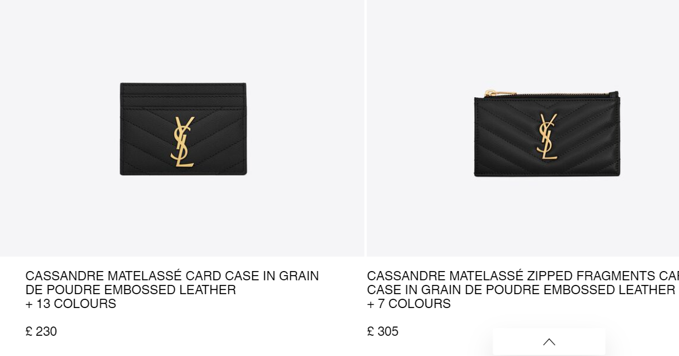 Women's Small Leather Goods | Saint Laurent UK | YSL

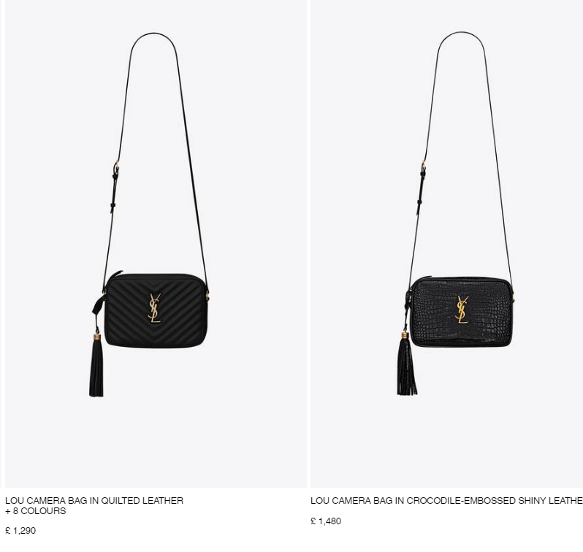 Handbags for Women | Saint Laurent United Kingdom | YSL.com

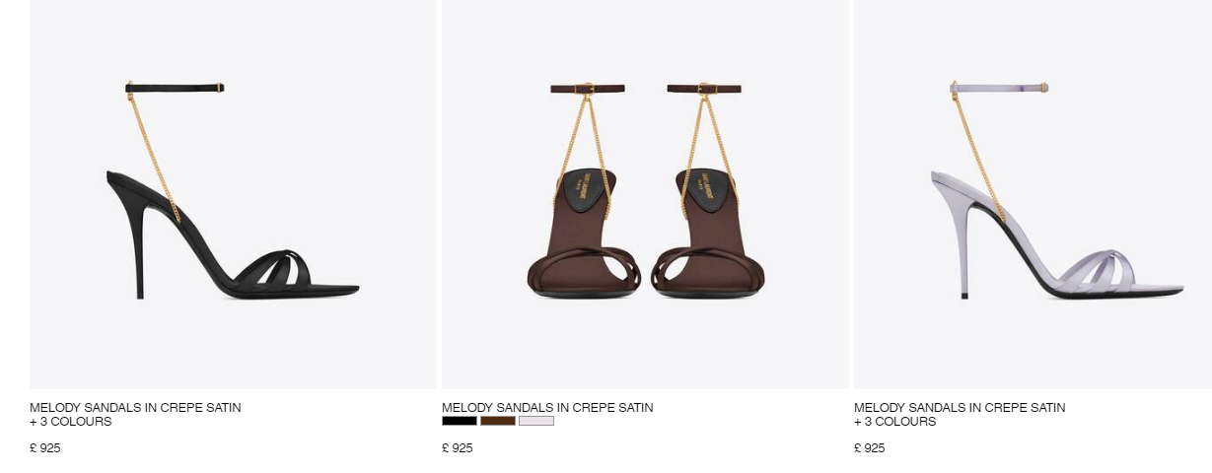

Women's Shoes | New Collection | Saint Laurent UK | YSL
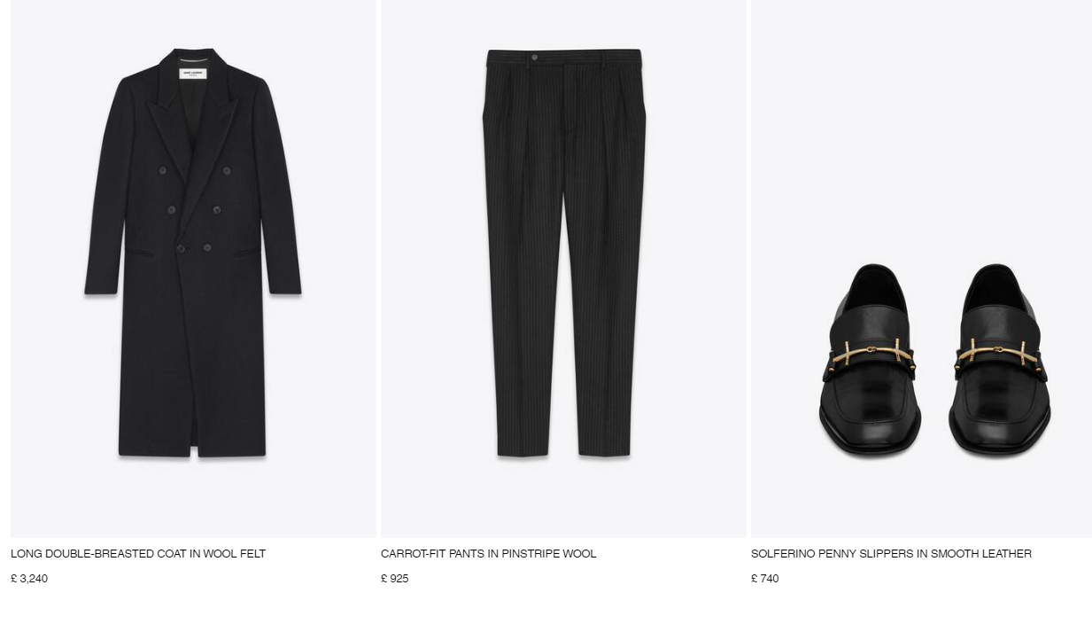NEW - SPRING SUMMER 23 | Saint Laurent | YSL

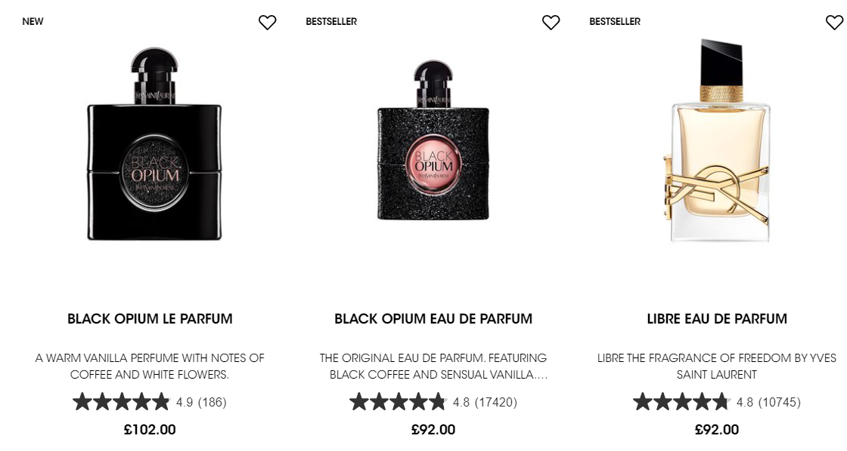Fragrance | Perfume, Aftershave & Cologne | YSL Beauty UK

Place
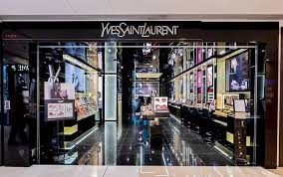 YSL, Hong Kong
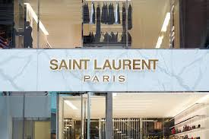 YSL, Paris
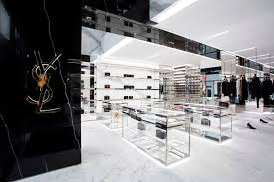 YSL, Oslo
Saint Laurent sells its good online trough www.ysl.com ; www.yslbeauty.co.uk ;
www.notino.co.uk ; AMAZON as well as in 280 operated boutiques worldwide. To reach their global customer, they are located in important cities like New York, Paris, London and Hong Kong. Their e-commerce strategy makes them more accessible to tech-savvy customers, and they offer an in-store experience in 39 emerging markets.
The brand has been revitalized by the substantial investment in new market. According to FERNIE and MOORE (2004), this place Saint Laurent in the “retail life cycle” growth stage.
Number of directly operated YSL stores worldwide in 2022, by region:
https://www.statista.com/statistics/442821/number-of-saint-laurent-stores-worldwide-by-region/
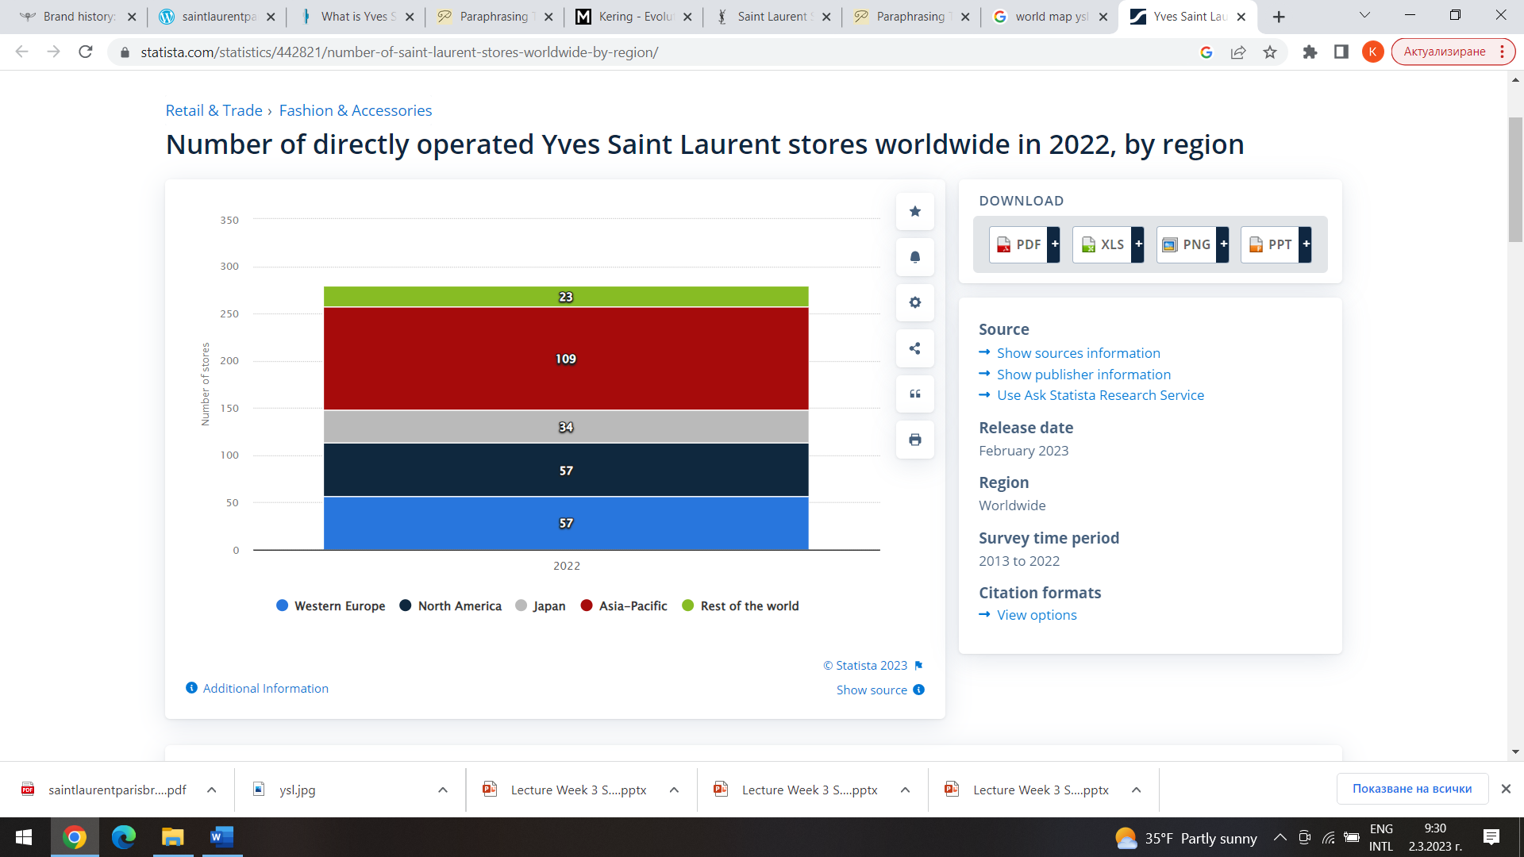
Promotion
As we all know we live in a time where everything is digitized, and high-end brands are successfully benefiting from this. YSL advertise a lot of their products on social networks and so they take advantage of them.
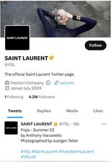 https://twitter.com/YSL?ref_src=twsrc%5Egoogle%7Ctwcamp%5Eserp%7Ctwgr%5Eauthor&fbclid=IwAR3k_xzIt893d6SSISKaI24_q0pd0ZCL9afcQGIr3ZwPLB2Yh40XIcQdoDw

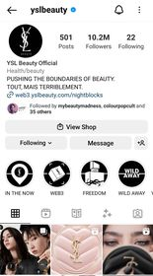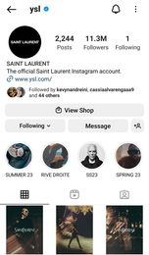
YSL Beauty Official (@yslbeauty) • Instagram photos and videos
https://instagram.com/ysl?igshid=YmMyMTA2M2Y=

They demonstrate the elegance and high quality of each of their products on You tube channel.

The design of physical stores is eco-friendly and emphasizes visual merchandising because it stirs up potential customers who want to become devoted clients.
Saint Laurent - YouTube

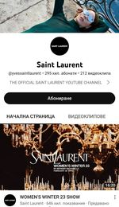

References
Online resources:
- First fragrance (no date) Musée Yves Saint Lauren Paris. Available at: First Fragrance: Y - Musée Yves Saint Laurent Paris (museeyslparis.com) [Accessed on 05/03/23].
- The History of Yves Saint Laurent: A timeline (no date) Haute History. Available at: The history of Yves Saint Laurent: A timeline - Haute History [Accessed on 05/03/23].
- Brand History: Saint Laurent, Kering. Available at: Brand history: Saint Laurent | Kering [Accessed on 05/03/23].
- Kering annual report (2013). Available at: 1402308_KERING RA-GB_2013.indd [Accessed on 05/03/23].
- Team, M.B.A.S. (2021) Yves Saint Laurent Marketing Strategy & Marketing Mix (4pc), MBA Skool. Available at: Yves Saint Laurent Marketing Strategy & Marketing Mix (4Ps) | MBA Skool [Accessed on 05/03/23].
- What is Yves Saint Laurent's marketing strategy? Available at: What is Yves Saint Laurent's marketing strategy? | BluCactus [Accessed on 05/03/23].
- Women's Small Leather Goods: Saint Laurent UK (no date) YSL. Available at: Women's Small Leather Goods | Saint Laurent UK | YSL [Accessed on 05/03/23].
- Handbags for Women: Saint Laurent United Kingdom (no date) Handbags for Women | Saint Laurent United Kingdom | YSL.com. Available at: Handbags for Women | Saint Laurent United Kingdom | YSL.com [Accessed on 05/03/23].
- Women's Shoes: New Collection: Saint Laurent UK (no date) Available at: Women's Shoes | New Collection | Saint Laurent UK | YSL [Accessed on 05/03/23].
- New - Spring Summer 23: Saint Laurent (no date) YSL. Available at: NEW - SPRING SUMMER 23 | Saint Laurent | YSL [Accessed on 05/03/23].
- Fragrance | Perfume, Aftershave & Cologne | YSL beauty UK (no date). Available at: Fragrance | Perfume, Aftershave & Cologne | YSL Beauty UK [Accessed on 05/03/23].
- Saint Laurent Official Online Store. Available: www.yslbeauty.co.uk [Accessed on 05/03/23].
- Sabanoglu, T. (2023) Number of stores of Yves Saint Lauren worldwide 2022 by region. Available at: Yves Saint Laurent stores by region worldwide 2022 | Statista [Accessed on 17/03/23].
- YSL Beauty Official (@yslbeauty) • Instagram photos and videos [Accessed on 05/03/23].
- SAINT LAURENT (@ysl) • Instagram photos and videos [Accessed on 05/03/23].
- Saint Laurent - YouTube [Accessed on 05/03/23].
- https://twitter.com/YSL?ref_src=twsrc%5Egoogle%7Ctwcamp%5Eserp%7Ctwgr%5Eauthor&fbclid=IwAR3k_xzIt893d6SSISKaI24_q0pd0ZCL9afcQGIr3ZwPLB2Yh40XIcQdoDw [Accessed on 24/03/23].
Books:
- Posner. H (2011) Marketing Fashion, London, Laurence King Publishing.
- Jackson, T. and Shaw, D. (2009) Mastering Fashion Marketing. Place of publication: Palgrave MacMillan.
- Chernev, A. (2012) Strategic Marketing Management, Cerebellum press.

