

Programme Name: Master of Business Administration
Module Code: LCMB7026
Title: International Marketing: Principles and Practices
Lecturer Name: Dian Mayasari
Student Name: Hafez Hossen Bishal
Student ID: 2439638
Word Count: 5363
Submission Date: 27th March, 2026

Contents
1. Introduction 5
2. Brand and Country Overview 6
2.1 Mercedes-Benz as a Global Automotive Brand 6
2.2 Germany as the Home Market 6
2.3 India as the Host Market 6
3. Comparative Market Analysis of Germany and India 7
3.1 PESTEL Framework Overview 7
3.2 Political Factors 7
3.3 Economic Factors 7
3.4 Social and Cultural Factors 8
3.4.1 Consumer Lifestyle and Buying Behaviour 8
3.4.2 Luxury Perception and Status Consumption 9
3.5 Technological Factors 9
3.6 Environmental Factors 9
3.7 Legal Factors 9
3.8 Summary of Key Differences and Similarities 10
4. Comparative Analysis of STP Strategies 11
4.1 Segmentation Strategy in Germany 11
4.2 Segmentation Strategy in India 11
4.3 Targeting Strategy in Germany 11
4.4 Targeting Strategy in India 12
4.5 Positioning Strategy in Germany 12
4.6 Positioning Strategy in India 12
4.7 Comparative Judgement on Standardisation versus Adaptation in STP 13
5. Comparative Analysis of International Marketing Mix (7Ps) 14
5.1 Product Strategy 14
5.2 Price Strategy 14
5.3 Place Strategy 15
5.4 Promotion Strategy 15
5.5 People 16
5.6 Process 16
5.7 Physical Evidence 17
5.8 Comparative Judgement on Standardisation versus Adaptation in the 7Ps 17
6. Directional Development Strategy in India 18
6.1 Choice of Country for Analysis: India 18
6.2 Mercedes’ Development Direction in India 18
6.3 Market Penetration, Market Development, or Other Strategic Direction 18
6.4 Why This Direction Fits India 18
7. Evaluation of Performance of Mercedes’ Marketing Strategies 19
7.1 Performance in Germany 19
7.2 Performance in India 19
7.3 Comparison Using Available Indicators 19
8. Evaluation of Ethical Issues in Marketing Mix 20
8.1 Ethical Issues Linked to Segmentation and Positioning 20
8.2 Ethical Issues Linked to Pricing or Exclusivity 20
8.3 Ethical Issues Linked to Sustainability, Green Claims, or Product Responsibility and Others 20
9. Recommendations and Conclusion 21
9.1 Strategic Recommendations for Germany 21
9.2 Strategic Recommendations for India 21
9.3 Recommendations on Balancing Global Consistency and Local Adaptation 21
9.4 Conclusion 21
10. Reflective Account 22
10.1 Introduction to Reflection 22
10.2 Use of Gibbs Reflective Cycle or Kolb’s Cycle 22
10.3 Reflection on Researching the Topic 23
10.4 Reflection on Analyzing Germany and India Comparatively 23
10.5 Reflection on Challenges, Learning, and Skill Development 24
10.6 Reflection on How This Process Will Influence Future Academic or Professional Work 24
11. References 25

1. Introduction
International marketing is something that represents reaching customers beyond the border of the country of the origin country of business. It is more than just marketing. It refers to a shift towards more integrated economy than the business’ current economies where it operates. International marketing facilitates expansion of brands all over the world. For example, Mercedes-Benz is a good example. This is a German brand. The brand has been developed in Germany and the company has increased its market share all over the world. The brand has ensured a good brand name in terms of quality, performance, and innovation. This is how the brand has reached a huge population all over the world and sells its vehicles in different countries.
To do this, the company has highly prioritized the behavior of local customers, first. When the company has ensured significant market share of the country, it shifted its focus from domestic market to foreign market. Here, the report will evolve Mercedes-Benz’s dynamics. To be more specific, the report will go through an analysis of Mercedes-Benz brand, its origin country Germany, and operating country India, which is a very growing market of automobile sector. Germany known as the mother country of Mercedes-Benz, its people expect quality, performance, and safety. On the opposite direction, Idina known as growing automobile sector, its people expect luxury, aspiration, and status. They have different perception, it becomes obvious. In this report, we will see how the brand has The aim of this report is to compare the marketing mix, segmentation, targeting, and positioning strategies of Mercedes-Benz in both countries using frameworks like PESTEL and 7Ps. In this report, we will highly prioritize some other issues such as directional development strategy, ethical foundations, some well-structured recommendations for company to do business in both countries. Besides these, the report will include both the opportunities and challenges of the company in different regions.

2. Brand and Country Overview

2.1 Mercedes-Benz as a Global Automotive Brand
In 1926, a brand was founded to serve people of Germany by providing services of automobile vehicles. The brand was named Mercedes-Benz. The brand was designed to promote excellence, performance, durability, and innovation in the market of the German automobile sector. The brand expanded its production to a diverse production line. The brand initiated the production of cars to high-performance sports cars and SUVs. The brand also focuses on sustainability. The footprint of sustainability is obvious in the production of the brand’s electric vehicles (Cambra Fierro, 2010).

2.2 Germany as the Home Market
Germany is a very advanced country in sense of different technological aspects besides others. The country has been one of the world’s most sophisticated engineering practicing countries as well as the largest economies in the world (Kotler and Keller, 2016). The brand is always been one of the top revenue-generating brands in Germany since the brand represents the social factors of the country, for this, a huge base of people like to purchase Mercedes-Benz vehicles. Generally, the customer base that like to buy premium vehicles prefer Mercedes-Benz. Here, the company includes for its customer base:
- Good quality
- Advanced technology
- Safety
- Tech-savvy vibe.

2.3 India as the Host Market
India is a developing country in the recent world. The country is highly growing its economic development. The country possesses a huge population that is eager to do something economic. For human resources, the country is thriving towards development in economics. This has resulted in some high-class societies. They require luxury cars. These societies consider Mercedes-Benz as the symbol of excellence, success, and exclusivity (Cavusgil et al., 2018).

3. Comparative Market Analysis of Germany and India

3.1 PESTEL Framework Overview
The PESTEL framework is a digital analysis helper to know about market conditions. This analysis includes six different factors. Those factors highly influence business in any market. This analysis framework facilitates business to know six-dimensional dynamics in a complex scenario. Those dimensions are political, economic, social, technological, environmental, and legal. In this scenario, this section of the report will evolve basing on this analysis associated with business environment including both macro and micro level (Dinçer and Yuksel, 2020).

3.2 Political Factors
In the very beginning of the analysis, this section will cover the first element of the analysis named political factors. Political factors refer to the elements of society that are about instability or stability of any ruling system in any country. When talking about Germany, the country is very stable in terms of politics. The country has been going through a very sound and systematic regime change policy resulting the economy one of the biggest economies in the world. In addition to this, the country is a member of European union. This enables the country more suitable for businesses to grow since the business of this country gets free access of trade in several countries which are also developed. On the other hand, India also is going towards a more stable politics but it has some extent of complex regulatory issues. Both countries are focusing on sustainability. For this, both of them prioritize electric vehicles (Manrai, 2020).

3.3 Economic Factors
Economic factors in general expresses the ability of people of a country to purchase product at some extent. Here, Germany is a very developed country, the country has ensured good infrastructure, business within the country, and stable inflation rate. For this, the purchasing power of the people of the country is very high. On the other hand, India is a developing country and the country is thriving towards productivity. This express that the concern of the company. the company provide financing options for India to better reach the customer base. On the other hand, Germany already has achieved the excellence, people of the country can afford Mercedes-Benz easily (Samiee and Chirapanda, 2019).

3.4 Social and Cultural Factors

3.4.1 Consumer Lifestyle and Buying Behaviour
In Germany, the people of the country have become more logical, sustainability-concerned, success oriented, and performance-thriving. Here, Mercedes-Benz offers innovation, smooth performance, excellency in engineering, and more importantly safety. These qualities make the brand a good choice to the customers (Pavel Slutskiy, 2025).
In India, the people of the country are going towards efficiency to have a better output. The country is in a process to be a developed country. For this, it creates aspirational values among people, creating need for luxury. Mercedes-Benz has become itself the symbol of luxury (Schlegelmilch, 2023, pp.129–159).
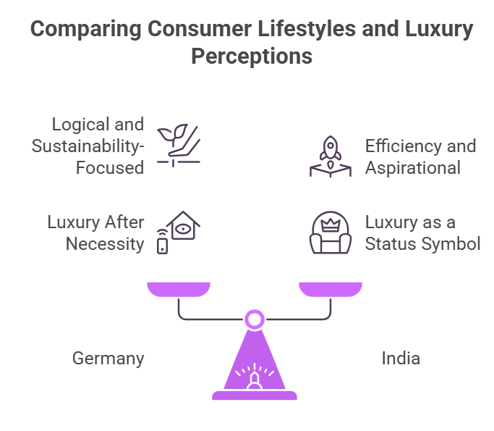
Figure 1: Necessity Versus Luxury

3.4.2 Luxury Perception and Status Consumption
German people desire luxury after they have reliance on other necessity. Safety and utility become the most priority. But in India, people desire luxury first since luxury represents the higher societal symbol (Graf, 2023).

3.5 Technological Factors
Germany has established its presence like a powerhouse in the automobile sector. It has resulted in the advancement in the automobile producing companies also. Mercedes-Benz is now focusing on innovating smart autonomous driving system while ensuring EV technology, and connectivity. But talking about India, the customer base of India is not ready yet to use the tech-savvy technology, though the urban customers may have the ability to adapt (Katsikeas, Leonidou and Zeriti, 2020).

3.6 Environmental Factors
Germany is a member of European union. For this, the country must obey some rules imposed by the authority. The authority has set goal for countries to achieve the net zero carbon emission by 2050. This directly complies the operation of automobile industry. Here, Mercedes-Benz is a direct player of this goal. To achieve this goal, the brand is now producing electric vehicles that are fully according to government regulations. In recent phenomenon, sustainability concern is raising in India as well by the initiatives taken by government in social media, television, and many events (Hadley, 2024).

3.7 Legal Factors
Due to a long journey in European Union and being part of Brexit, the country has been going under some standard rules and regulations. These common rules and regulations have brought the country in a line of development and more civilized customer base. Some legal factors are:
- Free trade barriers among European countries, which result in lower import duties, taxes, and VAT
- Sustainability concerning laws and regulations such as achieving net zero carbon by 2050

3.8 Summary of Key Differences and Similarities
Germany is a developed country and thriving towards excellence and people of this country prefer sustainability, safety, easy utility, and comfort first than luxury. On the other hand, India is a developing country. The country is highly concentrating on productivity and efficiency based on its human resources. For this, high class has been established in this country, they prioritize luxury over other things. Both countries accept innovation and use of new technologies. But people of India are not aware enough to adapt with new and complex technologies.

4. Comparative Analysis of STP Strategies

4.1 Segmentation Strategy in Germany
Segmentation refers to centering customer base for different products. Here, the company applies psychographic segmentation. How? In Germany, Mercedes-Benz has created its brand recognition in a different level. It has patronized itself as the symbol of comfort, excellent engineering, quality, performance, advanced technology, and luxury at some extent. For this, the company attracts a huge customer base since the purchasing power of the people of the country is very high. It targets entrepreneurs, businessmen, government officer, job holders, and others. Since these rich people generally live in urban areas, the brand continues its branding in urban regions (Katsikeas et al., 2016).

4.2 Segmentation Strategy in India
Segmentation in India is designed in a different matrix since the company targets only people in India who seek luxury in vehicles. Since a high-class society has raised in India, that group of people seeks luxury very much. This society belongs to some major cities like Delhi, Panjab, Mumbai, Bengaluru, Chennai, and Kolkata, resulting in demographic segmentation. The brand generally attracts government of the country, businessmen, entrepreneur, and some wealthy families. These people are normally younger and very speedy generation, who really want people to know about their status. This results in the branding approach of the brand in those major cities of the big country. This is how the company differentiates the market in both India and Germany (Baines, Fill and Rosengren, 2022).

4.3 Targeting Strategy in Germany
Targeting refers to directly connecting production and service for a specific segment. In Germany, this targeting becomes the most crucial part for its customer base since the company highly analyzes factors of its customer base. In Germany, the brand highly focuses on people who are genuinely rich and have high-income, because they care more about comfort, quality, performance, sustainability, and innovation; resulting in a very differentiated market. For this, the brand produces electric vehicles for this segment. Because electric vehicles are normally environment-friendly and these vehicles have less noise as well as having excellence engineering. In essence, the company targets the most appropriate segments to serve (Yang, 2024).

4.4 Targeting Strategy in India
But the brand has designed its target customer base in India in a very centralized way. The brand’s only target portion of the customer is the affluent customer base, resulting in a niche market. The member of the base solely focuses on owning an expensive and luxurious car. Here, individuals who are entrepreneurs, businessmen, and people with high net worth are the member of that high-class people. They want prestige over other factors associated with the vehicles (Gbadamosi and Oniku, 2021).

4.5 Positioning Strategy in Germany
Positioning refers to setting an image about the brand in the mind of the people. For example, think about Apple Inc. What comes in our mind? The brand is about premium, quality, performance, and luxury.
In Germany, Mercedes-Benz has created a good image in the mind of people about being the sustainable oriented brand while ensuring safety, quality, performance and comfort at the same time. People in Germany think about Mercedes-Benz as the global leader in the automobile industry. More specifically, the brand has ensured that its characteristics comply with the tech-savvy customer base in the market (Jobber and Ellis-Chadwick, 2024).

4.6 Positioning Strategy in India
On the other hand, in India, Mercedes-Benz has established its image as the symbol of great excellence and success. People whoever successful tend to purchase vehicles from this brand. Here, the brand has targeted a fully grown and exclusive customer base, and that customer base is good enough to bring good payback. For this, the brand has created an image of the brand in the minds of the people in India about luxury, social status, and success. This helps the brand keep a good customer base by offering S-Class and GLS models of the brand (Kapferer, 2015).

4.7 Comparative Judgement on Standardisation versus Adaptation in STP
Standardization refers to a set-criteria for all the production in all the countries. Here, brands or companies keep same products and features in all the countries. For example, Mercedes-Benz delivers comfort, premium products, quality, and innovation in all the countries in the same way. But every company does not sell same products in all the counties (Bhaumik, Driffield and Zhou, 2016).
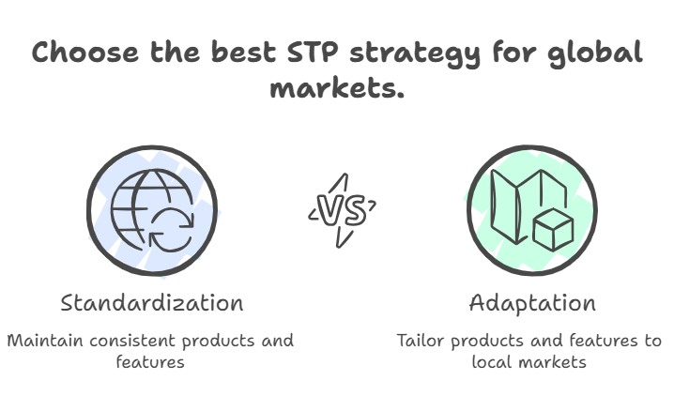
Figure 2: Standardization Versus Adaptation
For example, see CocaCola. CocaCola produces different types of bottles in different countries with different types of coke. Here, Mercedes-Benz segments, targets, and positions itself in different categories in different regions. For example, Mercedes-Benz produces different products in different regions. Mercedes-Benz uses advanced technologies in Germany while usual technologies in India, since German people are more aware of new technologies but Indians are not. Mercedes-Benz targets huge population in Germany since its people have more purchasing ability but selective customer base in India such as businessmen, entrepreneur, and high net-worth people (Seligman, 2018).

5. Comparative Analysis of International Marketing Mix (7Ps)

5.1 Product Strategy
Mercedes-Benz is a world-class automobile service providing brand in the world. The brand focuses on very consistent policy while producing car for consumers. It always keeps the standard quality of cars. For this, the brand focuses on its supply chain very thoroughly. To be more specific, the company has set some fixed suppliers who continuously supply raw materials for the brand. The company always analyzes new technologies to advance the cars and increase safety, performance, and luxury, all in one. Here, the brand uses technologies such as sedans, SUVs, and electric vehicles (EVs) (Singh et al., 2023).
When talking about India, people in India normally want to have larger cars. For this, Mercedes-Benz produces larger cars for India. For India, the brand has developed some new variants of SUVs. Some notable SUVs are GLE and GLC.

5.2 Price Strategy
Pricing is the most sensitive element of marketing while reaching people and making the products profitable. Different brands set price of products basing on different policies. But Mercedes-Benz always maintains a very high standard price strategy. The brand always sets premium price on its cars to attract the high net-worth people while ensuring luxury image of the cars. For example, we can talk about the flagship S-Class sedan. This was launched in Germany for €110,000. On the other hand, in India, the starting price was over ₹1.7 crore. This represents the willingness of consumers to purchase the products at that price while navigating advanced technologies, comfort, innovation, safety, and luxury (Yang et al., 2024).
It is true that India has a very rapid growing market, but in India, this is a very price-sensitive market and price sensitive price needs a huge flexibility while market dynamics change. To grab this, the brand has initiated new attempt that is about providing financing options for lower-price variants. This initiative taken by the brand helps the brand to connect more audience that is diverse including higher income people and middle-income people, both.
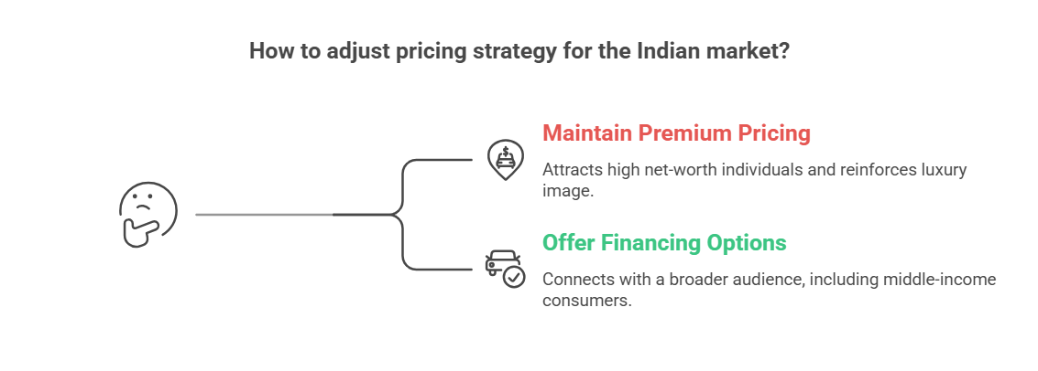
Figure 3: Pricing Strategy of Mercedes-Benz

5.3 Place Strategy
The company uses an indirect selective distribution strategy globally. For example, we can talk about the dealership offered by the company to different third parties to manage those regional businesses in an effective way. The place strategy includes the scenarios and factors associated with the place where located, logistic facilities, channels of transportation, dynamics of foreign regulations, and others. Here, Germany is a member of the European Union. This enables the company access in other European countries very smoothly. This clears confusion about the communication barriers. Being a member of the European Union provides the country and the brand both the ability to do business in all other member countries of the European Union easily. This facilitates the smooth import of raw materials to export full-produced products to those countries. In India, this changes. How? The brand only chooses affluent and high net-worth people. Generally, this group of people of the country stay at top urban areas. For this, the communication channel in India is designed in a different system (Hult, 2002).

5.4 Promotion Strategy
Promotion is the most important part of business when connecting people with the product of any brand. In Germany, people are more likely to be concerned with sustainability, safety, innovation, advanced engineering options, and luxury. For this, the brand considers performance excellence in Germany as a tool of promotion. On the other hand, in India, the brand considers some regional areas to concentrate its focus. Because the target customer base of the brand live in some major urban areas. Moreover, India is not yet segregated in terms of an affluent population that can afford a Mercedes-Benz. Here, the brand includes promotions with the help of celebrity engagement, social media, and other luxury fairs. In addition to these, Mercedes-Benz does its promotion internationally also. For example, the brand participates on Motor Show in Frankfurt.
For a better overview, the promotions in different countries of the company look like:
Market | Campaign Example | Key Visuals/Messaging
Germany | Vision EQ Silver Arrow | Sleek electric prototypes, tech specs, green innovation
India | Dream Days / Ah My God YouTube​ | Celebrities in luxury settings, emotional "success" narrative

5.5 People
When employees do not know fully about the products and the business, business cannot fully thrive because unknowingly no business can do the accurate thing. Here, Germany has the most skilled and knowledgeable employees since the country has developed a good environment for sophisticated automobile industry and the country already has several automobile companies, resulting affluent number of candidates for Mercedes-Benz as the brand has a well-known image and offers good facilities to its employees. For this, candidates compete for employment in the brand. In India, it changes. In India, the brand recruits employees who are capable to offer personalized service to customers since customers are not aware of the products properly.
For both processes, the brand has to undergo tremendous amount of training, session, and other skilling, upskilling and reskilling process.

5.6 Process
The degree of efficiency, effectiveness, excellence in advanced engineering, way of ensuring convenience to the consumers is the ultimate goal and factors of process. Process is a thing which ensures the tasks fulfillment of the business. Mercedes-Benz has achieved the excellence engineering in this part of business. The business has automated its process almost with a small degree of human intervention in this process. To deal with customer relationship management, the brand offers online service. Here, customers are allowed to see configurations, and customization while consuming consultations. The brand has developed after-sale service also on online so that customers can have answers of their query and has ensured customers opportunities to claim maintenance and repairs service. In addition to these, consumers have opportunities to consume test drives that are very structured, consultations based different perspectives of people, and flexible financing options (Ivanov, 2022).

5.7 Physical Evidence
Layout is the important thing while both producing and selling products. When selling, Mercedes-Benz ensures that the outlets of the brand look like premium and satisfies customers that the brand represent some other symbols. For example, in Germany, the brand designs its outlets as such it represents comfort, performance, quality, and convenience; and in India, those outlets represent luxury and upper-class vibe. These outlets also include the good vibes of the products in terms of quality, standards, and excellence so that customers get attracted to the products (Tung, 2018).

5.8 Comparative Judgement on Standardisation versus Adaptation in the 7Ps
Due to regional changes, the policies and strategies change also. For this, the brand has to adopt a mixed strategy. The brand manages standards of the products while adapts with the local market dynamics. When talking about both countries, Germany and India, the brand keeps consistency in factors like quality, brand perception, and performance appraisal.
But in case of Germany, the brand focuses more on sustainability, safety, quality, performance, engineering excellence, and convenience. And in terms of India, the brand focuses on solely luxury because higher-class people only purchase this product to own the luxury. In addition to this, Indians prefer larger cars due to more members in families, for this, the brand produces comparatively larger cars for this regional market. Now, in some sort of sustainability is increasing in India.

6. Directional Development Strategy in India

6.1 Choice of Country for Analysis: India
India is now an emerging giant economy in the world. The human resources of the country also back its economy through providing cheap labor and skilled managers. This is how the economy is growing, and some affluent businessmen are being created. These businessmen and entrepreneurs have created another dimension of society; that is higher-class. Mercedes-Benz locates this customer base in India (Tung, 2018).

6.2 Mercedes’ Development Direction in India
Since the brand finds long-term future in India, the brand wants to grab the significant market share of the part in which the brand operates its business. This is why the brand has adopted market development strategy in India. The brand is developing the market to sell cars. For example, the brand is focusing on some tier 2 and tier 3 cities in India to sell cars. The establishments of the outlets in those cities represent the ultimate market development because those outlets will attract new customers. Even if they do not have capability to purchase at once, they will claim financial options.

6.3 Market Penetration, Market Development, or Other Strategic Direction
Mercedes-Benz is highly focused on expansion. The brand is trying to do its business in some new markets. For this, the brand is expanding its business in tier 1 and tier 2 cities in India. The brand is connecting more younger people who are enthusiastic to new technologies, such as the S-Class and GLC.

6.4 Why This Direction Fits India
Since India is growing fast using its cheap and skilled labor while ensuring good governance of the government and political stability, some new businessmen and entrepreneurs are doing quite well in terms of net worth. Besides these, younger people are very comfortable with new technologies and in some sort, they want things to be tech-savvy. This results in the long-term market in India for the S-Class and GLC (Kano and Verbeke, 2018).

7. Evaluation of Performance of Mercedes’ Marketing Strategies

7.1 Performance in Germany
German people want good performance since they are very logical with terms and conditions and the country is developed resulting more people capable of purchasing Mercedes-Benz. This results in good number of people who want safety, sustainable cars, performance, and convenience, along with luxury. For this, demand for of electric vehicles (EVs), such as the EQ series have been increased drastically in Germany.
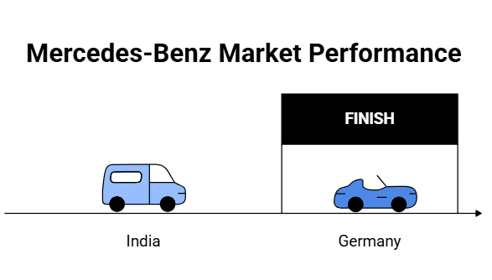
Figure 4: Different Market Concepts in Germany and India

7.2 Performance in India
In India, the market has just begun to grow. The brand is trying to connect more people who want luxury and larger cars. Even the brand is trying to grab the local market by positioning itself marker leader and connecting tier 1 and tier 2 cities in the country. Moreover, the company has designed some affordable models, along with financing options (Johnson and Stretcher, 2023).

7.3 Comparison Using Available Indicators
Available indicators provide insights that the brand is doing quite well in both markets. In Germany, there are some competitors of the brands, but the brand has positioned itself a good brand. On the other hand, in India, the brand has been one of the significant player by leading the small but powerful segment; that is higher-class (Meghna Bharadwaj et al., 2020).

8. Evaluation of Ethical Issues in Marketing Mix

8.1 Ethical Issues Linked to Segmentation and Positioning
In both markets of the company, there are some issues relating to the social factors existing in those environments. The brand has developed a social divide between the rich and the poor by defining luxurious and normal cars. This could lead to a potential struggle in society (Ellis-Chadwick, 2010).

8.2 Ethical Issues Linked to Pricing or Exclusivity
The price set by the company is also a symbol of discrimination. How? In India, many people are suffering from poverty. Here, purchasing luxury products sometimes represents the visual of the suppression of poor labor. In the case of Germany, the brand sells products at a higher price, but the brand’s process of maintaining exclusivity in this manner may not comply with the sustainable consumers’ interests (Grewal et al., 2017).

8.3 Ethical Issues Linked to Sustainability, Green Claims, or Product Responsibility and Others
Mercedes-Benz aims to provide sustainable cars while producing them in a green environment and reducing the effect of pollution by contributing to society, such as planting trees and doing some benevolent tasks in society. But this contribution impacts society in how much positivity remains vague. Because pollution is unjust, it cannot be justified with other initiatives. Mercedes-Benz should find ways to reduce pollution to zero (Tang et al., 2014).

9. Recommendations and Conclusion

9.1 Strategic Recommendations for Germany
Since the whole world is going towards a new trend, that is, sustainability concerns, Mercedes-Benz should go towards sustainability at full scale. To be more relevant, the brand should focus more on sustainability in developed countries like Germany. Besides these, the brand should ensure overall good advancements in technologies since developed countries have more educated people who are interested in new technologies.

9.2 Strategic Recommendations for India
Being a developing country and an emerging economy in the world, India has been expertise in efficiencies and lowering costs of products by offering cheap labor. This is how the economy is growing and businesses are growing. For this, some affluent people are arising in this region. For this, Mercedes-Benz should allocate its focus more on diverse regions like including tier 1, tier 2, and tier 3 cities in India.

9.3 Recommendations on Balancing Global Consistency and Local Adaptation
Mercedes-Benz should develop a good balance between safety, comfort, convenience, and luxury. Since they hold different markets, the brand should navigate factors associated with different dynamics. For example, the India market needs financial options; on the other hand, German market needs safety and convenience, along with sustainability concern.

9.4 Conclusion
Mercedes-Benz has been world’s most dominating automobile brand for a long period. The brand has created a strong image in the mind of the customers. People think of the brand safe, luxurious, convenient, and sustainable. The brand has been a top leader in developed country and expanding its business in emerging countries as well. In addition to this, the brand has some more things to attract more customers.

10. Reflective Account

10.1 Introduction to Reflection
From the report, a good number of insights about Mercedes-Benz have been achieved. Those insights include both dynamics; containing developed country and developing country. The brand is shown in this report at a different viewpoint. This report increased my ability to find and understand problems and reasons of those problems. In this journey, the report helped me to understand PESTEL and STP analysis. The use of these frameworks support humans to better understand other dynamics, along with business. This is how I understood how Mercedes-Benz does different business in different markets.

10.2 Use of Gibbs Reflective Cycle or Kolb’s Cycle
Gibb’s Reflective Cycle is one of the top reflective cycles to analyze and evaluate the process mentioned in the report. This includes description, evaluation, and analysis.
- Description part of the report enabled me to know the strategies taken by Mercedes-Benz in both India and Germany. This seems soothing but the brand had to go under very pressure due to the data gap of Indian market.
- In the case of the feeling stage, I found the German market very mature in terms of the automobile industry, and I found the Indian market has just begun to comply with the automobile industry.
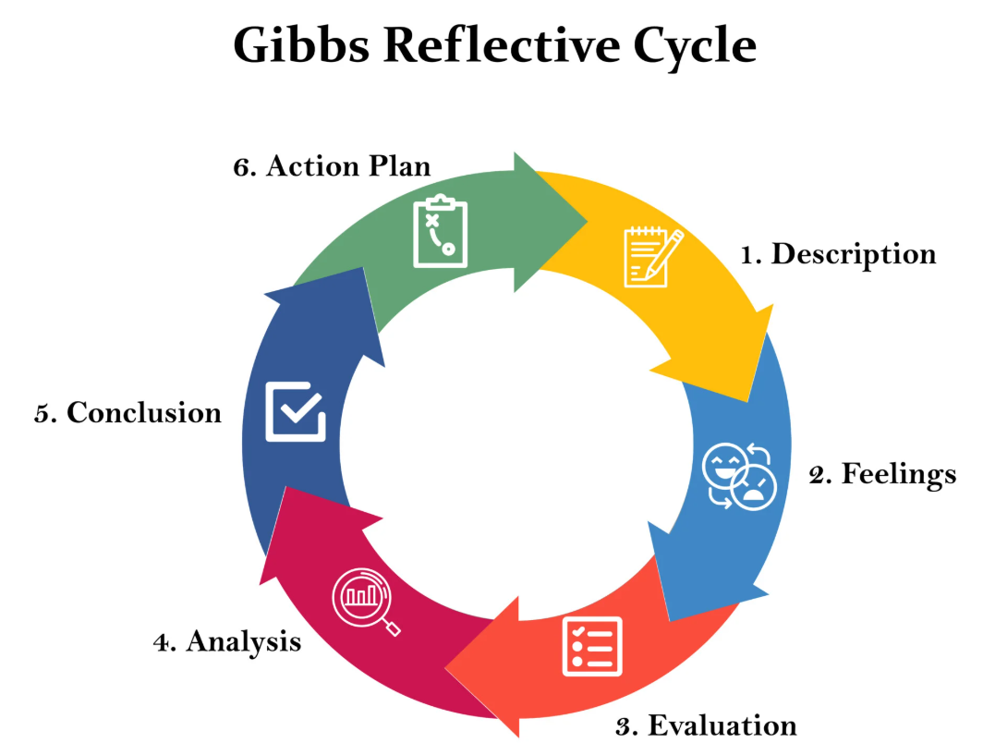
Figure 5: Gibbs Reflective Cycle
- In the evaluation part, I experienced the effectiveness of those strategies, such as grabbing a diverse group of people in India in some tier 1 and tier 2 cities. The brand has also been in trouble when talking about achieving sustainability.
- The analysis part in this report enabled me to learn how to do PESTEL analysis and go through the STP model. These analyses helped me to boost my analytical ability to judge the market dimensions of business analytics.
- This report concluded and enhanced my analytical capability to analyze the market conditions of the company and the dynamics that need to be changed. This is how my analytical capability has been increased in this report.
- In the action plan, after concluding all the scenarios, it has been much easier for me to deal with my future dynamics in life. Teachings achieved in this report will help me to do jobs, maintain deadlines, analyze both positive and negative sides, and being neutral when making decisions.

10.3 Reflection on Researching the Topic
This report has increased my analysis ability, which has contributed to do research and evaluate dynamics and options. After that I become able to make decisions.
Here, in the report, Mercedes-Benz does its business in two different regions, including Germany and India. Here, Germany is the home country of Mercedes-Benz; on the other hand, India is the host country of the brand. Here, I understood different types of market targeting, positioning, and segmenting. In Germany, the brand segments markets into some categories and targets sustainability-concern people who want safety, convenience, innovation, and knowledge of advanced engineering. On the other hand, India is an emerging country in the world. The emerging economy is creating new wealthy persons. Here, the brand has achieved good brand value and market share. In essence, the brand keeps consistency in some factors keeping some features intact and on the other hand, the company has customized some options for different market zones.

10.4 Reflection on Analyzing Germany and India Comparatively
The analysis in the report has drastically increased my capability to make decision on market dynamics about whether and why the company follow a path-line towards a market segment. The analysis showed that the company focus on luxury demanding customer base since there is a high-class society. The people of that society want luxury over other things in better way. The company now wants to expands its market towards tier 1 and tier 2 cities, also. On the other hand, the company focuses on sustainability concerning people in Germany. The people of that segment want safety, innovation, technological innovation, and convenience.

10.5 Reflection on Challenges, Learning, and Skill Development
I faced several challenges while navigating all other factors. For instance, it was troublesome when collecting data for the report regarding different market zones and segments. I faced problems while navigating analyses; including PESTEL and STP. Because some data are very confidential for the company, for this, those are not on online. On the other hand, understanding different factors, such political factors, social factors, economic factors, and others became very problematic to understand. In addition to this, understanding local market consumers is the most important thing to define market conditions.

10.6 Reflection on How This Process Will Influence Future Academic or Professional Work
This assignment has enriched my employability. How:
- I can assess market information
- I can synthesize information from different sources
- I understand the local market conditions; for instance, understanding local consumers’ mindset
- I can make decision on which segment the business should operates regarding options available based on profitability and scope of expansion
- This has increased my belief in flexibility since different market needs different types of products, requiring business to adapt with those changes

11. References
Baines, P., Fill, C. and Rosengren, S. (2022). Marketing. Oxford University Press.
Bhaumik, S.K., Driffield, N. and Zhou, Y. (2016). Country specific advantage, firm specific advantage and multinationality – Sources of competitive advantage in emerging markets: Evidence from the electronics industry in China. International Business Review, 25(1), pp.165–176.
Cambra Fierro, J.J. (2010). G. Armstrong, P. Kotler, M. Harker, y R. Brennan. Cuadernos de Economía y Dirección de la Empresa, 13(43), pp.150–151. doi:https://doi.org/10.1016/s1138-5758(10)70014-1.
Cavusgil, S.T., Deligonul, S., Kardes, I. and Cavusgil, E. (2018). Middle-Class Consumers in Emerging Markets: Conceptualization, Propositions, and Implications for International Marketers. Journal of International Marketing, 26(3), pp.94–108. doi:https://doi.org/10.1509/jim.16.0021.
Dinçer, H. and Yuksel, S. (2020). Handbook of research on decision-making techniques in financial marketing. Hershey, PA: Business Science Reference, an imprint of IGI Global.
Ellis-Chadwick, F. (2010). E-marketing strategy. The Business & Management Collection, 2010(2), p.e1002297. doi:https://doi.org/10.69645/rlql6426.
Gbadamosi, A. and Oniku, A.C. (2021). Religion and consumer behaviour in developing nations. Cheltenham, UK: Edward Elgar Publishing.
Graf, E. (2023). International marketing in times of sustainability and digitalization. Walter de Gruyter GmbH & Co KG.
Grewal, D., Roggeveen, A.L., Sisodia, R. and Nordfält, J. (2017). Enhancing Customer Engagement Through Consciousness. Journal of Retailing, [online] 93(1), pp.55–64. doi:https://doi.org/10.1016/j.jretai.2016.12.001.
Hadley, S. (2024). A Reader on Audience Development and Cultural Policy. Taylor & Francis.
Hult, G.Tomas.M. (2002). Cultural Competitiveness in Global Sourcing. Industrial Marketing Management, 31(1), pp.25–34. doi:https://doi.org/10.1016/s0019-8501(00)00101-2.
Ivanov, D. (2022). Viable supply chain model: integrating agility, resilience and sustainability perspectives—lessons from and thinking beyond the COVID-19 pandemic. Annals of Operations Research, [online] 319(1), pp.1411–1431. doi:https://doi.org/10.1007/s10479-020-03640-6.
Jobber, D. and Ellis-Chadwick, F. (2024). Principles and Practices of Marketing. 10th ed. McGraw Hill.
Johnson, S. and Stretcher, R. (2023). A Method for Teaching the Black-Scholes Option Pricing Model Using Excel. Journal of Instructional Techniques in Finance, 2(1). doi:https://doi.org/10.54155/jitf.v2i1.44.
Kano, L. and Verbeke, A. (2018). Theories of the multinational firm: A microfoundational perspective. Global Strategy Journal, 9(1), pp.117–147. doi:https://doi.org/10.1002/gsj.1332.
Kapferer, J.-N. (2015). The Future of luxury: Challenges and Opportunities. Journal of Brand Management, 21(9), pp.716–726. doi:https://doi.org/10.1057/bm.2014.32.
Katsikeas, C., Leonidou, L. and Zeriti, A. (2020). Revisiting International Marketing Strategy in a Digital Era. International Marketing Review, 37(3), pp.405–424. doi:https://doi.org/10.1108/IMR-02-2019-0080.
Katsikeas, C.S., Morgan, N.A., Leonidou, L.C. and Hult, G.T.M. (2016). Assessing Performance Outcomes in Marketing. Journal of Marketing, 80(2), pp.1–20. doi:https://doi.org/10.1509/jm.15.0287.
Kotler, P. and Keller, K.L. (2016). Marketing Management. 15th ed. Pearson.
Manrai, A.K. (2020). New Perspectives in International Marketing Research. Journal of Global Marketing, 33(2), pp.67–68. doi:https://doi.org/10.1080/08911762.2020.1744334.
Meghna Bharadwaj et al., M.B. et al., (2020). Use of Project Management Software by NGO’s and Its Impact on Employee Efficiency. International Journal of Mechanical and Production Engineering Research and Development, 10(3), pp.6579–6596. doi:https://doi.org/10.24247/ijmperdjun2020627.
Pavel Slutskiy (2025). Global Communication. Springer Nature.
Samiee, S. and Chirapanda, S. (2019). International Marketing Strategy in Emerging-Market Exporting Firms. Journal of International Marketing, [online] 27(1), pp.20–37. Available at: https://journals.sagepub.com/doi/full/10.1177/1069031X18812731.
Schlegelmilch, B.B. (2023). Global marketing strategy : an executive digest. Cham: Springer, pp.129–159.
Seligman, J. (2018). Customer experience management - the experiential journey. Lulu.com.
Singh, S., Suman, R.S., Hadoussa, S., Obaid, A.J. and Regin, R. (2023). Data-Driven Intelligent Business Sustainability. IGI Global.
Tang, C., Liu, Y., Oh, H. and Weitz, B. (2014). Socialization Tactics of New Retail Employees: A Pathway to Organizational Commitment. Journal of Retailing, [online] 90(1), pp.62–73. doi:https://doi.org/10.1016/j.jretai.2013.11.002.
Tung, L.T. (2018). The effect of fiscal deficit on economic growth in an emerging economy: Evidence from Vietnam. Journal of International Studies, 11(3), pp.191–203. doi:https://doi.org/10.14254/2071-8330.2018/11-3/16.
Yang, K. (2024). Golden Arches Across Cultures: Understanding McDonalds Global and Local Consumer Behavior. Advances in Economics Management and Political Sciences, 68(1), pp.85–91.
Yang, T., Peattie, K., Skeete, J.-P. and Koenig-Lewis, N. (2024). Navigating Transitions: How Electric Vehicle Sharing Is Shaping Sustainable Mobility in Chinese Cities. Sustainability, 16(19), p.8364. doi:https://doi.org/10.3390/su16198364.

