

Managing Enterprise in the 21st Century

Business Plan

Please put name/logo/website of your company here
Business plan GREEENCYCLE REFILL & REPAIR HUB

Submission Date:
Lecturer:

Table of Contents
Group Information 2
Executive Summary 4
Business Concept 5
Business Description 5
Product Description 5
Business Objectives (SMART Objectives) 5
Short-Term Objectives (less than a year) 5
Long-Term Objectives (less than a year) 5
Market Analysis and Marketing Plan 6
Market Analysis (Competitors, Customers, Target Groups) 6
PESTEL Analysis 6
SWOT Analysis 6
Marketing Mix (4Ps) 6
Management Team 6
Management Team and Their Background 7
Organisational Chart 7
Key Milestones 7
Financial Plan (One Year) 7
Sources of Finance 7
Cash Flow Forecast 7
Sales Forecast 7
Cost of Production Forecast 7
Break Even Analysis 7
Operations and Management Plan 7
Production of Good and Service 7
Technology Plan 7
Human Resource Plan 7
Expansion Plan 8
Reference List 8
Appendices: 9

Executive Summary

Green Cycle Refill & repair Hub is a community-focused retail and service business based in a community-focused retail and service business based in a medium-sized UK town. Our mission is to reduce household waste and support local sustainability by offering package-free refills for everyday essentials. Furthermore, we aim to offer affordable repair services for household items, electronics, and clothing. We address growing demand for low-waste alternative and extend product lifespans, aligning with investor priorities for environmental and social impact. The business will operate as a private limited company with a lean management structure. Initial startup funding is expected to be £45,000 to cover shop setup (including insurance, maintenance, salaries and so on) as well as stock and tools. we project breaking even by month 14 with steady growth in revenue and community membership.

Business Concept green cycle is a one stop hub to help households cut waste and save money as this is a key concern for many UK households in the current era (Francis-Devine, 2026).

Francis-Devine, B. (2026) ‘High cost of living: Impact on household’, Research Briefing. 10100.

Business Description We offer refill station unpackaged food staples (such as rice, pasta and grains) as well as cleaning products, personal care items, and laundry supplies. Customers would bring their own containers or buy reusable ones in-store as a way of supporting them to save money and make a positive impact on the environment.

Product Description our products fall into four core categories. All supplied in buik without single- use packaging;
1)dry food staples; organic and conventional rice. Pasta. Oats. Lentils. Flour. Sugar. Herbs. Spices, and nuts
2) HOUSEHOLD CLEANING; multi- surface cleaners, washing-up liquid. Laundry detergent. Fabric softener. And dish soap. All plant – based and biodegradable.
3) PERSONAL CARE; SHAMPOO. CONDITIONER. BODY WASH. HAND SOAP. AND HAND SANITZER. FREE FROM HARSH CHEMICALS AND MICROPLASTICS.
4) GLASS JARS, COTTON PRODUCE BAGS. BEESWAX WRAPS. AND BAMBOO BRUSHES. FOR CUSTOMERS WHO NEED CONTAINERS TO GET STARED.

Business Objectives (SMART Objectives)
1)Financially achieve break-even point withing 14 months of opening and reach £78,000 annual revenue by the end of year 2. Regular quarterly reviews will be carried out to assess the progress and adapt the plan of action as required
2) customer growth; build a loyal customer base of 450+ registered members within the first month with average monthly footfall of 22+customers. A social media advertising campaign will be used to attract potential customers and with a link to the company website as well as a registration form. For those who may not have access to social media an alternative approach will be used such as a poster campaign in key locations supermarkets, libraries, local cafes and bingo halls.
3) sustainability impact; Prevent at least 25.000 single – use plastic bottles and packaging units from entering landfill in year (1,( 4) COMMUNITY ENGAGEMENT; host 12 free zero – waste workshops and local sustainability events annually. And partner with 3 local schools or community groups by Month 9. (5) Profitability maintains a gross profit margin of no less than 45% from the first full year of trading onwards.

Short-Term Objectives (less than a year) (1) launch & operations; secure a suitable retell space. Complete shop fit out, obtain all required uk licenses and insurance. And open for trading within the first 3 months. (2) customer base; acquire 250+ registered members and reach an average of 180+customer visits per month by month 12. (3) Sustainability Milestone; divert a minimum of 25.000 single-use plastic packaging units from landfill in the fist 12 months. (4) Community OUTREACH; host 4 free zero-waste workshops and establish partnerships with 2 local community groups or schools by month 9. (5) Financial Maintain a month gross margin of at least 42% and keep operating costs within the projected budget. Aiming to hit positive cash flow by month 10.

Long-Term Objectives (More than a year)
(1) Financial Growth; achieve an annual turnover of £100.000 by the end of year 3. And maintain a consistence gross profit margin of 45%0f higher
(2) Market Expansion; build a loyal customer base of 800+ members and consider opening a second location or adding a delivery service withing3 years. (3) Environmental Impact; increase annual plastic waste reduction to 60.000+ units by year 3 . and switch 100% of supplies to fully organic of zero- waste certified sources. (4) Community leadership; run 12+ educational events each year. Become the go-to local hub for sustainability advice. And donate 5% of annual profits to local environmental projects. (5) Service development; add small repair and upcycling services to the offering by year 2, creating a complete circular economy hub for the area.

Market Analysis and Marketing Plan Market Overview; The UK zero-waste and sustainable goods sector is growing 12% annually. Driven by rising awareness of plastic pollution. Cost-of-living pressures. And government targets to cut single use packaging. Target Audience: Environmentally conscious households. Families students, and eco-focused professionals aged 25 to 65 looking for affordable alternatives to pre-packaged goods.
Competitors: indirect major supermarkets limited options. High plastic packaging.

Market Analysis (Competitors, Customers, Target Groups)

PESTEL Analysis
STRONG BRAND IDENTITY FOCUSED ON SUSTAINABILITY AND ETHICAL SOURCING
LOYAL LOCAL CUSTOMER BASE AND GOOD COMMUNITY REPUTATION
CENTRAL LONDON LOCATION WITH HIGH FOOTFALL
SKILLED BARISTES AND HIGH-QUALITY FAIR TRADE PRODCUTS
ZERO SINGLE-USE PLASTICS POLICY
WEAKNESSES HIGHER PRICES THAN LARGE CHAINS DUE TO ETHICAL SOURCING COSTS. LIMITED BUDGET FOR LARGE SCALE MARKETING. SMALL SEATING CAPACITY NO DEDICATED PARKING. RELIES ON A SMILL NUMBER OF SUPPLIERS POOPRTUNITIES. LANCH SUBSCRIPTION/ COFFEE DELIVERY SEVICES FOR REMOTE WORKS. PARTNER WITH LOCAL BUSINESSES FOR CORPORATE CATERING. EXPAND RETAIL LINE BRANDED BEANS REUSABLE CUPS VAGAN SNACKS. APPLY FOR GOVERNMENT GREEN BUSINESS GRANTS.THREATS. DOMINANT CHAINS (COSTA/STARBUCKS) OFFERING CHEAPER ALTERNATIVES. FURTHER RISES IN RENT AND UTILTY COSTS. NEW INDEPENDENT CAFES OPENING NEARBY. ECONOMIC DOWNTURNREDUCING CUSTOMER VISITS MARKETIN MIX(4Ps) PRODUCT. CORE: SPECIALITY COFFEE, HOMEMADE PASTRIES PLANT BASED OPTIONS. EXTRAS: FAIR TRADE CERTIFICATION, COMPOSTABLE PACKAGING FREE WATER REFILLS. ADD ONS: LOYALTY SCHEME REUSABLE CUP DISCOUNT FREEWI-FI. PRICE: PREMIUM PRICING (10-15% ABOVE CHAINS) TO REFLECTQUALITY AND ETHICS. BUNDLE DEALS (COFFEE+PASTRY) FOR VALUE.DISCOUNTS FOR BRINGING REUSABLE CUPS. STUDENT/REMOTE WORKER OFFERS PLACE PHYSICAL STORE IN BUSY CENTRAL LONDON AREA. ONLINE PRE ORDER FOR COLLECIOTN. LOCAL DELIVERY VIA UBER EAT. DELIVEROO POP-UPS AT LOCAL MARKETS AND COMMUNITY EVENTS PROMOTION SOCIAN MEDIAL: HIGH- QUALITY PHOTOS/VIDEOS OF PRODUCTS ANDSUSTAINABILITY EFFORTS LOCAL PARTNERSHIPS: COLLABORATE WITH NEARBY BOOKSHOPS/ GYMS. WORD- OF-MOUTH: ENCOURAGE REVIEWS AND SHARE CUSTOMER POSTS

SWOT Analysis
STRENGHS
CLEAR, TRUSTED BRAND IDENTITY BUILT AROUND SUSTAINABILITY, ETHICAL SOURICING AND COMMUNITY FOCUS CENTRAL LONDON LOCATION WITH CONSISTENE HIGH FOOT TRAFFIC. HIGHER SKILLED BARISTAS AND PREMIUM. FAIR TRADE CERTIFIED PRODUCT RANGE. STRONG LOCAL REPUTATION AND LOYAL REPEAT CUSTOMER BASE. ZERO SINGLE-USE PLASTIC POLICY AND FULLY COMPOSTABLE PACKAGING WEAKNESSES HIGHER OPERATING COSTS FROM ETHICAL SOURCING LEADING TO PRICES10-15% ABOVE LARGE NATIONAL CHAINS
LIMITED MARKETING BUDGET COMOARED TOMAJOR COMPETITORS
SMALL SEATING CAPACITY. WITHNO DEDICATED PARKING OR LARGE EVENT SPACE
RELIANCE ON A SMILL NUMBEROF SPECIALIST SUPPLIERS. CRATING SUPPLY CHAIN RISK
LIMITED ONLINE PRESENCE BEYOND BASIC SOCAIAL MEDIAL OPPORTUNITIES. LAUNCE A LOCAL DELIVERY SERVICE AND SUBSCRIPTION COFFEE SCHEME FOR REMOTE WORKES PARTNER WITH NEARNY OFFICES, UNIVERSITIES, AND INDEPENDENT BUSISESSES FOR CORPOREAT CATERING. EXPAND RETAIL LINES: BRANDED REUSABLE CUPS HOME COFFEE BEANS AND VEGAN RETALL SNACKS APPLY FOR UK GOVERNMENT GRANTS FOR SMALL SUSTAINABLE BUSINESSES. HOST COMMUNITY EVENTS COFFEE WORKSHOP AND POP- UP TO BOOST VISIBILITY. THREATS DOMINANT CHAINS (STARBUCKS COSTA) LAUNCHING LOWER COSTA SUUSTAINABLE PRODUCT LINES ONGOING RISES IN LONDON RENT ENERGY COSTS AND THE NATIONAL LIVING WAGE. NEW INDEPENDENT COMPETITORS OPENING NEARBY ECONOMIC UNCERTAINT REDUCING CONSUMER SPENDING ON NON-ESSENTIAL ITEMS. GLOBAL CLIMATE VOLATILITY AFFECTING COFFEE CROP YIELDSAND IMPORT PRICES: MARKETING MIX (4Ps) PRODUCT CORE OFFREING: HOMEMADE PLANE BASED PASTRIES AND SEASONAL DRINKS. ALL PRODUCTS ARE FAIR TRADE WITH CLEAR ALERGEN LABELING AND FULL TRANSPERENCY ON SOURCING ADDITIONALVALUE INCLUDES FREE WI- FI, LOYALTY REWARDS AND FREE WATER REFILLS TO SUPPOTR REMOTE WORKERS AND REGULARS. PRICE USES A PREMIUM PRICING MODLE TO REFLECT QUALITY AND ETHICAL STANDARDS, OFFSET BY TARGETED DISCOUNTS:25p OFF FOR REUSABLE CUPS STUDENT PRICING AND BUNDLED COFFEE+ SNACK DEALS PRICES ARE POSITIONED TO BE COMPETITIVE AGAINST OTHERINDEPENDEN CAFES WHILE REMEININGDISTINCT FROM BUDGETCHAINS:

Marketing Mix (4Ps)
Product Clearly define what you offer core product service, key features unique selling points (USPs) quality standards and how it solves customer needs or stands out from competitors.
Include details such as range branding design aftercare and any guarantees or warranties
Price: set pricing aligned with your positioning cost plus competitive premium or value-based pricing outline pricing structures (e.g. standard rates bundles discounts for bulk early payment) payment terms and how pricing reflects your brand value and covers cost while generating profit
PLACE: Explain where and how customers can access your offering physical premises online store delivery channels distributors or partners cover distribution methods logistics coverage areas and how you ensure convenient reliable access for your target market
PROMOTION detail how you will reach and persuade customers advertising social media PR events email marketing sales promotions and word of mouth strategies align all messaging with your brand identity and target audience and set out how you will measure the effectiveness of each channel

Management Team
This section confirms thar the business is led by experienced capable professionals with the skills industry knowledge and track record to deliver on all plans ne

Management Team and Their Background

FOUNDER & LEAD Broadcaster | Colin Charles

Organisational Chart

Production & compliance lead | Colin Charles

Key Milestones
Month1-2  MONTH 3-4  MONTH 5-6  MONTH 7-9  MONTH 10-12 | Finalise business setup branding portfolio showreel and service packages launch professional online profiles  Secure first 3-5 regular clients contracts establish partnerships with production houses and event organisers  Deliver consistent high quality output build client testimonials and case studies expand service reach to digital podcast projects  Increase contract volume by 30%explore new opportunities like corporate hosting and voiceover campaigns  Review annual performance set targets for year 2 invest in upgraded production capability if required

Financial Plan (One Year)
Total cash available  Total non operating outflows (non p&l)  Total non operating outflow (non p&l)  Net cash surplus year to date  Opening cash balance  Year end cash position | £93,535  £31,420  £40,970  £2`,145  £100  £90,628

Sources of Finance
The business is funded through a balanced mix of owner equity operational revenue and structured extremal financial ensuring stability liquidity and capital for growth
Amount; 5,000
TYPE; Personal investment seed funding
PURPOES; Initial working capital studio setup licensing and opening cash buffer ; Commitment; Backed by over 30 years of broadcast industry experience including 10 years at the BBC ; Internal Finance Operational Revenue

Cash Flow Forecast

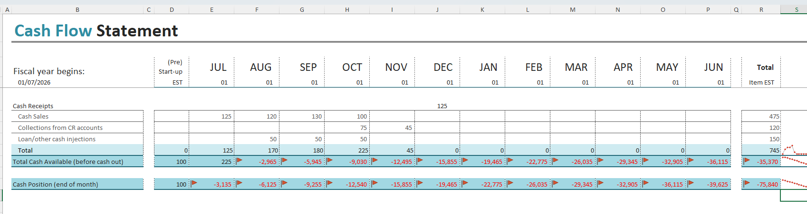

Sales Forecast
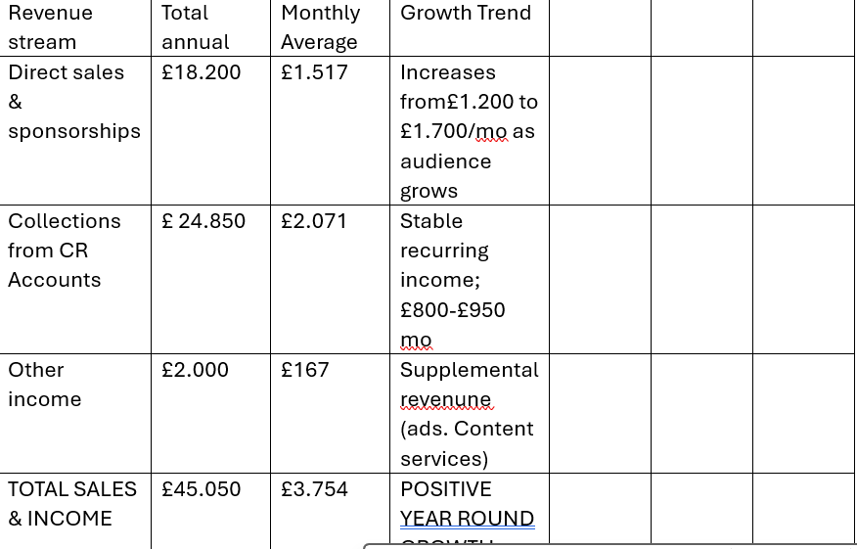

Cost of Production Forecast
MONTHLY AVERAGE | GROWTH TREND
£ 1.517 | increases from £1.200. to £1.700 / mo. as audience grows
£ 2.071 | Stable recurring income; £800-£ 950/mo.
£ 167 | Supplemental revenue (ads, content services)
£3,754 | Positive year-round growth

Break Even Analysis

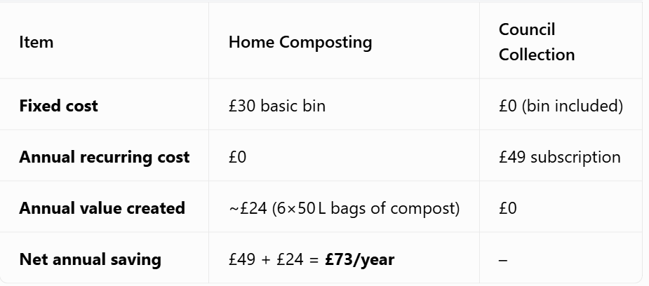

Operations and Management Plan

Production o
Our garden waste recycling service provides curd side collection efficient transport and full processing of green waste ( gras, leaves branches hedge trimmings soil into hogh quality compost wood products or responsible disposal
WORKFLOW (1) Scheduling & Collection; weekly/ fortnight round; customers receive wheelie bins sack a routes optimized for fuel/time efficiency.(2) transport; fleet of 3.5t-7.5t vehicles fitted with tall lifts segregated loads to avoid contamination(3)processing secure Yarde operation waste weighed sored shredded and composted aerobic method non compostable residues sent to EA licensed facilities (4) Quality control end product tested for contaminants compost screened for resale landscaping use (5) Compliance fully registerd waste carrie duty of care environmental permits and public safety protocols followed at all stages

Technology Plan
Technology drives efficiency tracking and compliance across the service
Core systems routing & logistics GPS rout planning software real time vehicle tracking to cut fuel costs. Operation digital weighbridge inventor tracking cloud-based job cards and customer databases. Processing industrial shredders trommel screens and moisture monitoring automated aeration for compost piles. Digital & portal for bookings payments and service updates mobiles apps for drivers proof service safety checks and waste logs security CCTV,perimeter alarms and encrypted cloud backups. Maintenance & Upgrades; preventive daily vehicle weekly machinery service annual calibration. Evolution yearly tech refresh invest in solar electric vehicles as volume grows

Human Resource Plan
We build a safe skilled and reliable team with clear roles and training. Organizational structure . operations manager ; Oversees fleet yard compliance and staff. Collection team drivers loaders (4)FTE)trained in manual handling and safety

Expansion Plan
Strategic growth to scale profit coverage ands1-3 years. Years 1 current establish core service in tower hamlets build fleey to 3 vehicles reach 250 tonnes month throughput launch compost sales; year(2) Expand to 4 neighbouring yyboroughs add 2 vehicles+ electric trials introduce bulk trade contract services years(3)open regional satellite yard process 600+ tonnes /month; sell branded compost to garden centres offer garden clearance + soil blending

Reference List
Environmental agency [Ea] 2026 waste carrier licensing guidance .uk government .
Environment agency [EA].2026 enviornmental permitting regulations.; waste operations
GOV.UK .[2026].waste duty of care code of practice.department for environment ,food$rural affairs
Ofcom .[2026].broadcasting code ; content $compliance for radio services .
HMRevenue$customs .[2026] .bussiness income $expenses ;self assessment guidance .
Health safety executive [HSE] .[2026].safe use of machinery $vehicles in waste operations

Appendices:

