Ceri Dacey (2415538)
UWTSD HNC in Computing (Computer Networks & Cybersecurity)
Eco-Ride Database project

Table of Contents
Introduction 2
Scenario Analysis 3
Entity-Relationship Diagram (ERD) 3
Database Screenshots 5
Query Development 6
Testing 7
Conclusion 7
References 8

Introduction
This project is based on a recently launched green initiative by the local authority called Eco Ride. It is a service aimed at making commuting greener and healthier by offering an electric bike rental service. The electric bikes are located at several locations and riders can scan their ID at any rental point. Users can then use that bike and return it to any rental point when they are finished. There is a growing need to digitalise this system and for a structure database to be created due to the ongoing issues the management team are facing regarding paper forms. The database needs to include information such as Riders names, contact information and ID numbers. There needs to be a record of all the bikes, their condition, location and maintenance history. Bike rental transactions including costs and rental/return dates need to be included along with staff information such as who serviced each bike.
This report will begin with a Scenario Analysis, identifying and describing the main entities involved in this scenario along with the relationships connecting them. An Entity-Relationship Diagram will be presented showing the entities, primary & foreign keys and relationships with the appropriate cardinality.
Screenshots of the database will be shared which will include sample data population. The results from Queries run on the database will also be shared along with validation and testing.

Scenario Analysis
The Eco Ride system is built using five key entities which are:
- Riders
- Bikes
- Rental
- Maintenance
- Staff
Riders interact with the system by renting bikes with each rental transaction connecting one rider to one bike. On the other hand, bikes can be rented by many different riders and can also undergo a plethora of maintenance checks. Each member of staff can be linked with multiple maintenance checks too. These one-to-many relationships within the database will enable efficient tracking of the bikes.

Entity-Relationship Diagram (ERD)
An Entity-Relationship Diagram (ERD) is used in the conceptual design stage of databases. It is a visual modelling diagram representing the entities, associated attributes and relationships in a database system [1].
Figure 1 includes the ERD for the Eco Ride database. It shows five entities connected through one-to-many relationships. Referential integrity is maintained through the use of primary and foreign keys, allowing all records to be accurately linked.
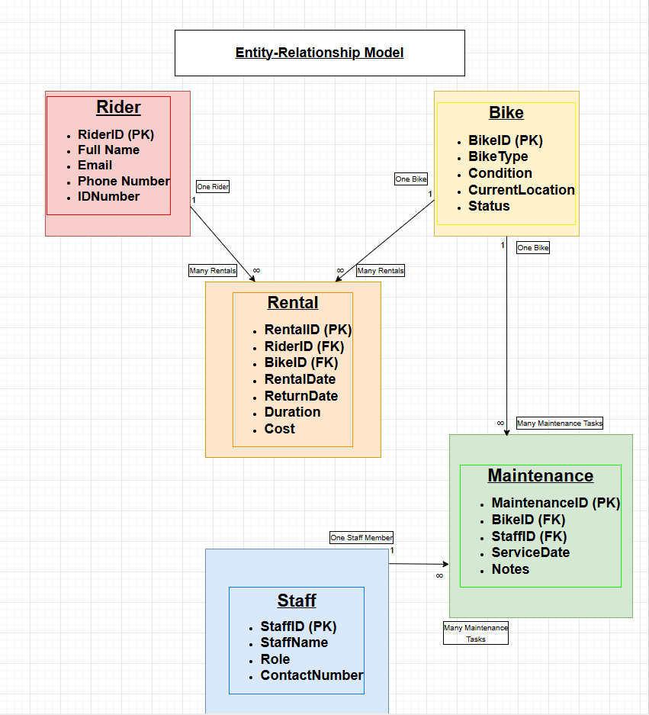
Fig.1 – The Entity-Relationship Diagram for the Eco Ride database.

Database Screenshots
Figure 2 shows the ‘Rider’ section of the database. The Rider ID has been set as the Primary Key so that each rider can be identified uniquely.

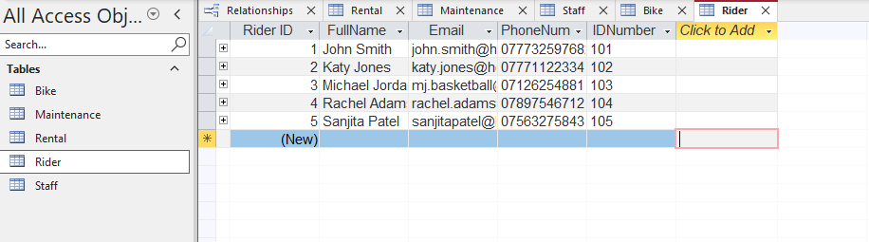
Fig.2 – A screenshot of the ‘Rider’ section of the database with sample data.
Figure 3 shows the ‘Bike’ section of the database. The Bike ID has been set as the Primary Key so that each bike can be identified uniquely.
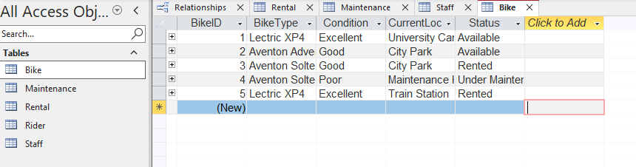
Fig.3 – A screenshot of the ‘Bike’ section of the database with sample data.
Figure 4 shows the ‘Staff’ section of the database. The Staff ID has been set as the Primary Key so that each staff member can be identified uniquely.
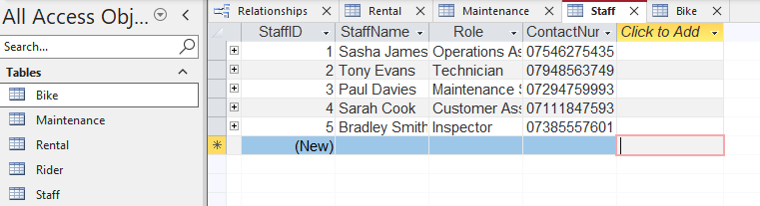
Fig.4 – A screenshot of the ‘Staff’ section of the database with sample data.

Figure 5 shows the ‘Rental’ section of the database. The Rental ID has been set as the Primary Key so that each rental transaction is uniquely identified. Rider ID and Bike ID have been set as Foreign Keys so that each rental is linked to a specific rider and bike.
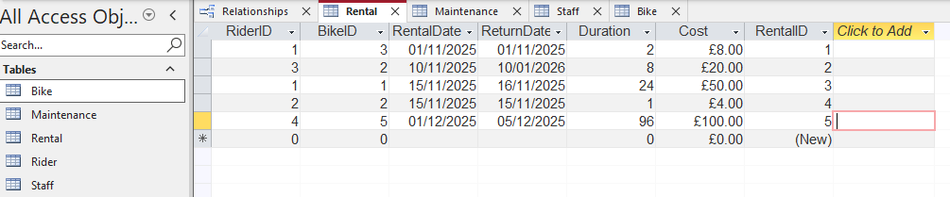
Fig.5 – A screenshot of the “Rental’ section of the database with sample data.
Figure 6 shows the ‘Maintenance’ section of the database. The Maintenance ID has been set as the Primary Key to uniquely identify each maintenance record. Bike ID and Staff ID have been set as Foreign Keys so that each maintenance activity is linked to a. specific bike and staff member.
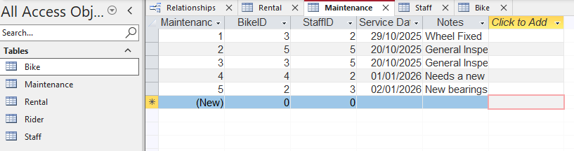
Fig.6 – A screenshot of the ‘Maintenance’ section of the database with sample data.

Query Development
Once the database was complete, a number of queries were created to test the functionality and to examine if useful information could be extracted. The first query was ‘Which bikes are currently under maintenance?’ Figure 7 shows the results to this query.
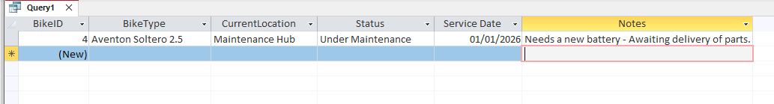
Fig.7 – A screenshot of Query no.1

The second query was ‘Which bikes are currently available?’ Figure 8 shows the results to this query.
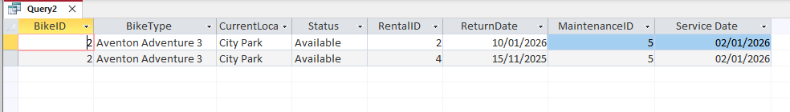
Fig.8 – A screenshot of Query 2.
In both instances the queries are using table relationships, selection criteria and aggregate functions to filter and organise the data efficiently. This shows that the database supports operational monitoring.

Testing
The database was tested and validated in various ways. Sample data was used to confirm accurate data entry, referential integrity and correct query results. Another test that was performed was in the Maintenance table. A Bike ID that didn’t exist in the Bike table was entered into the Maintenance table however, the database prevented this action, displaying an error message as shown in Figure 9. This shows that referential integrity has been enforced.
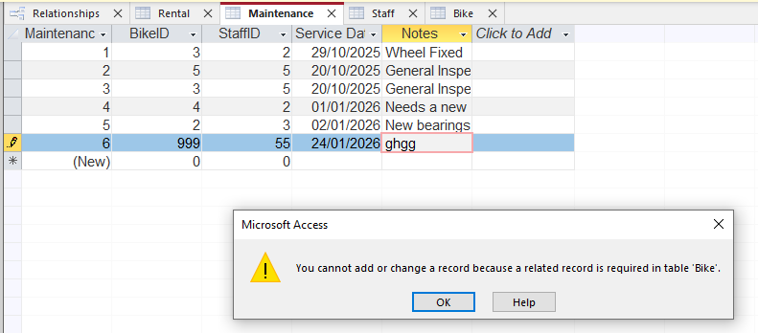
Fig.3 – A screenshot of the error message shown when an incorrect Bike ID was entered.

Conclusion
Overall the system successfully supports the operational needs of the Eco Ride scheme as bike rental, availability and maintenance can all be tracked. The normalised design also reduces redundancy and improves reliability, making it fit for the intended purpose.

References
P. P.-S. Chen, “The Entity-Relationship Model: Toward a Unified View of Data,” ACM Transactions on Database Systems, vol. 1, no. 1, pp. 9–36, Mar. 1976, doi: 10.1145/320434.320440

