Data Handling and Business Intelligence
LCBB5000

Student name: Lucian Pop
Student number: 2023565, Year 2, Assessment2, Term 2
Business management (Weekend classes)

Introduction

1.Current trends in data warehousing, business intelligence and data mining……..2
2. Current trends in data analysis…………………………………………………………….4
3. Data visualisation. A story containing data
4.Data Analysis and Visualisation……………………………………………………………5
Fig. 1……………………………………………………………………………………………….6
Fig. 2……………………………………………………………………………………………….7
Fig. 3……………………………………………………………………………………………….8
Fig. 4
5.Advantages and disadvantages of data visualization using Excel………………….9
6.Data visualization using SPSS……………………………………………………………..10
7.Data and text mining methods……………………………………………………………..11
8.Advantages and disadvantages of data visualization using IBM SPSS (Statistical Package for Social Sciences)
Conclusion……………………………………………………………………………………….14
References……………………………………………………………………………………….16

Data analysis & Visualisation

Introduction

What is data analysis and visualization?
According to Cambridge Dictionary, data analysis is a process of examining data using a computer with the purpose of finding the right information necessary for decision making.
Data visualization is the way to see the data using diagrams, charts, or pictures helping us to work with huge amounts of data and complex information to extract and conclude the results necessary in decision making.
Business operations generate an enormous amount of data every day from customer interactions, costs, inventories, marketing, sales, revenue, etc, which are difficult to interpret. Here are the benefits of data visualization. Ways on how data analysis and visualization can help in better decision making:
- See the image of a hole
- Identify the significance
- Make informed decisions
- Track trends over time

- Current trends in data warehousing, business intelligence, and data mining

Business intelligence: Is defined as a set of mathematical models that exploit the available data to generate the information necessary for decision-making processes. (UWTSD, 2022). Tools used by Business Intelligence: -Techniques and software to provide managers the information needed for decision-making processes. BI tools include data warehousing, online analytical processing, social media analytics, reporting, and data mining. (e.g., a spreadsheet tool is Microsoft Excel)
BI Trends in 2022- According to bi-survey.com (2022) research, a couple of trends have been identified as follows: the most important trends identified are data governance, data quality, and data management followed by advanced analytics, machine learning, artificial intelligence, augmented analytics, data warehouse modernization, decision automation.
BI applications and advantages: -Customer Relations (highly identify value customers, improve customers relations, mana the image of the brand), health care ( in diagnosis, in more effective treatment, manage eventually frauds and abuses, management of public health), Education (used for student enrolment, courses), retail (improves sales promotions, optimize inventories at different locations, optimize logistics), etc. Other areas of use: -banking, financial, services, manufacturing, insurance, government, and telecommunications. Advantages and disadvantages: Increase the speed, quality, and reliability of management information, combine data needed, enabling the right tools for each application, data integration map is clear, enables combining data from multiple sources. However, Caleb Danziger, business2community.com (2020) found a couple of disadvantages that should be avoided as follows: data breaches (the risk of information leaks due to security issues), High prices (the software can be expensive, which can be a potential barrier of using it by small companies), different data sources are analysed with difficulty (is well known that using different sources can bring the benefit of well-rounded analytics, but using different platforms in interconnecting them) poor data quality (a data surplus means that a lot of analysed data is irrelevant resulting in slowing down processes), resistance to adoption (employees or departments not wanted to integrate into operations represent an obstacle facing BI).

Data Warehousing is the process of transforming data into real-time information using techniques, methodologies, or tools for storing the data in an electronic repository. (V.V. Subrahmanyam, 2012)
The trends driving the adoption of data warehousing haven’t changed since the early days of technology, but they are becoming more broadly applicable to businesses in every sector.
John Foley, contributor for Forbes (2014) identified a couple of trends and opportunities related to data warehousing:
- Enterprises ‘’datafication’’ requires more capable data warehouses -due to the increase in the amount of data, generated by sources such as mobile devices, social media, and other sources, sorting and processing of data will require new capabilities to handle more and faster
- Reducing costs by the logical and physical consolidation-A combination of compression, virtualization, and multi-tenant databases, will consolidate the databases as the increase of data shouldn’t necessarily have to attract more costs.
- Data warehouse environment optimized by Hadoop- An open-source program, Hadoop, with its distributed file system and parallel MapReduce paradigm, is a good companion standard data warehouse.
- Real-time analytics through customer experience strategies to improve marketing campaigns-the role in the customer experience of data warehouses is important because they keep the data use to establish a comprehensive view.
- Data compression enables higher volume and value analytics- using compression methods the organizations can store and use more valuable data without huge costs.
- In-database analytics simplify analysis- data analysis capabilities are minimizing the need of moving data to other systems resulting in optimizing data discovery.
- Data warehouses are more critical than ever to business operations- the value of warehouses keeps growing are they can apply for new applications.
Data warehouse benefits: - enhanced business decision, timely access to data, consistency of data, system performance, staff productivity increasing, customer satisfaction increasing, timesaving, quality enhancement, and historical intelligence provider.
Data warehouses own the most valuable data in the world running hundreds of terabytes and containing highly refined economic data.
Data warehouse limitations and disadvantages: maintenance costs, data rigidity, hidden source problems (problems related to original source systems involved in importing of data), and inability to capture required data.
Data mining it is characterized by: - available data, rather than collected specifical data for research; pattern recognition methods are non-traditional; tools with special graphic user interface design for easy use. Data mining was created to discover useful information by businesspeople from big quantities of data without getting statisticians or other professionals’ help.
Advantages of data mining and domains of utilization -retailing (information provided gives a competitive advantage to a retailer for gaining cost-effective marketing), insurance companies (they can observe inside the organization the efficiency of processing of some types of claims more efficiently than others, good practices used within the organization and spread them. This will speed up the services to the customers and reduce the costs), law enforcement prioritizing cases (analysing the relevant data decrease the ineffective processes, working toward efficiency), manufacturing sector (identification of the warning signs of chemicals spills can prevent accidents, environment protection and avoid unnecessary costs and litigations.
Disadvantages and limitations of using data mining:- Costs (best tools are expensive and there is the need to invest in them), effort (takes effort to be used properly), if the technical details are ignored, the information is useless for the real applications (there is a risk for which data miners would have to validate the information they’ve found, not the right information for every need (in data mining it is used the data which can get it, not data collected for a purpose and this can trigger not having the right information for every need), however using a realistic approach and being aware of limitations, data mining can bring valuable information in supporting business decisions.
- Current trends in data analysis
According to Statistica (2020), the size of the digital universe is expected to reach 175 zettabytes by 2025. According to Forbes (2022), there are eight trends predicted to define data analytics:
- Artificial intelligence -is making rapid progress in this field and helps to derive better business value.
- Composable Data Analytics -by this process the organizations are combining the capabilities from different sources across the enterprise to take a more effective decision.
- Data Fabric As A New Industry Standard -this is a way of thinking about unused data by unifying the architecture that serves as an integrated layer connecting data endpoints and processes to make data more discoverable.
- AnalyticsOps - makes it easier to deliver composable analytics.
- Shift From Big Data To Small And Wide Data -enable organizations to examine a combination of small and large data by applying techniques useful for small and microdata tables use.
- Data Democratisation -data analytics is no anymore considered a secondary activity but a key for intelligent decision-making at the beginning of every new project.
- Analytics Everywhere- in the future personalized and dynamic insights can help consumers to extract what is the most value from data.
- Analytics In Edge Computing -this market is growing every year as the power of processing moves to the edge, and the technologies which are supporting it also move to the edge. (Amarnath, 2022)
- Data visualization. A story containing data
Until is turned into a story, data is just a collection of numbers. The addition of small details can drive to completion of the image in someone’s mind which will turn those numbers into a story. Telling a story that contains great data can help both, customers, and stakeholders to take better decisions within an organization or buying decisions. But how to better turn this collection into a story?
Nicole Martin, the owner of Digital Consulting and former contributor for Forbes (2018), opines that the audience always prefers charts, graphs, infographics, and visual elements over numbers in presentations. Knowing what questions, you need to answer or what issue you need to solve as well as knowing the audience is the most important aspect. Next step is collecting data from the first, second and third party. The audience will prefer simple visualizations, which can have the biggest impact driving to success and keeping you ahead of the game.
- Data Analysis and Visualisation
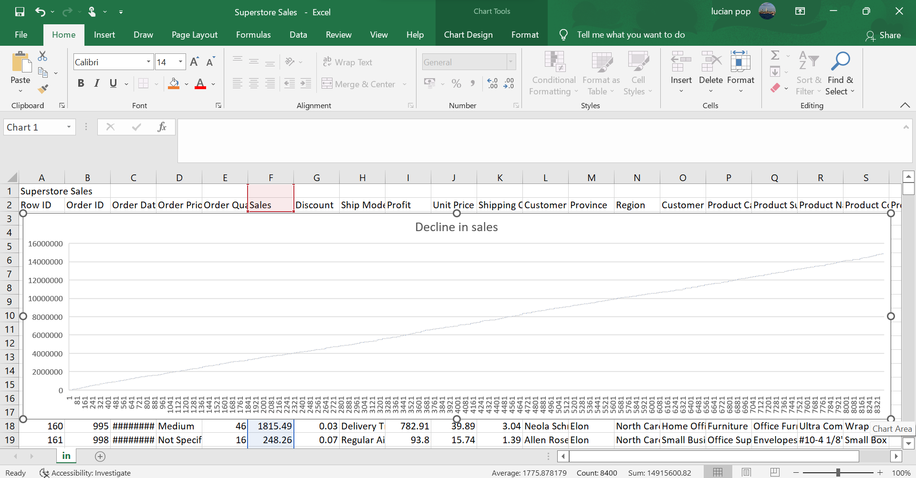
Fig. 1
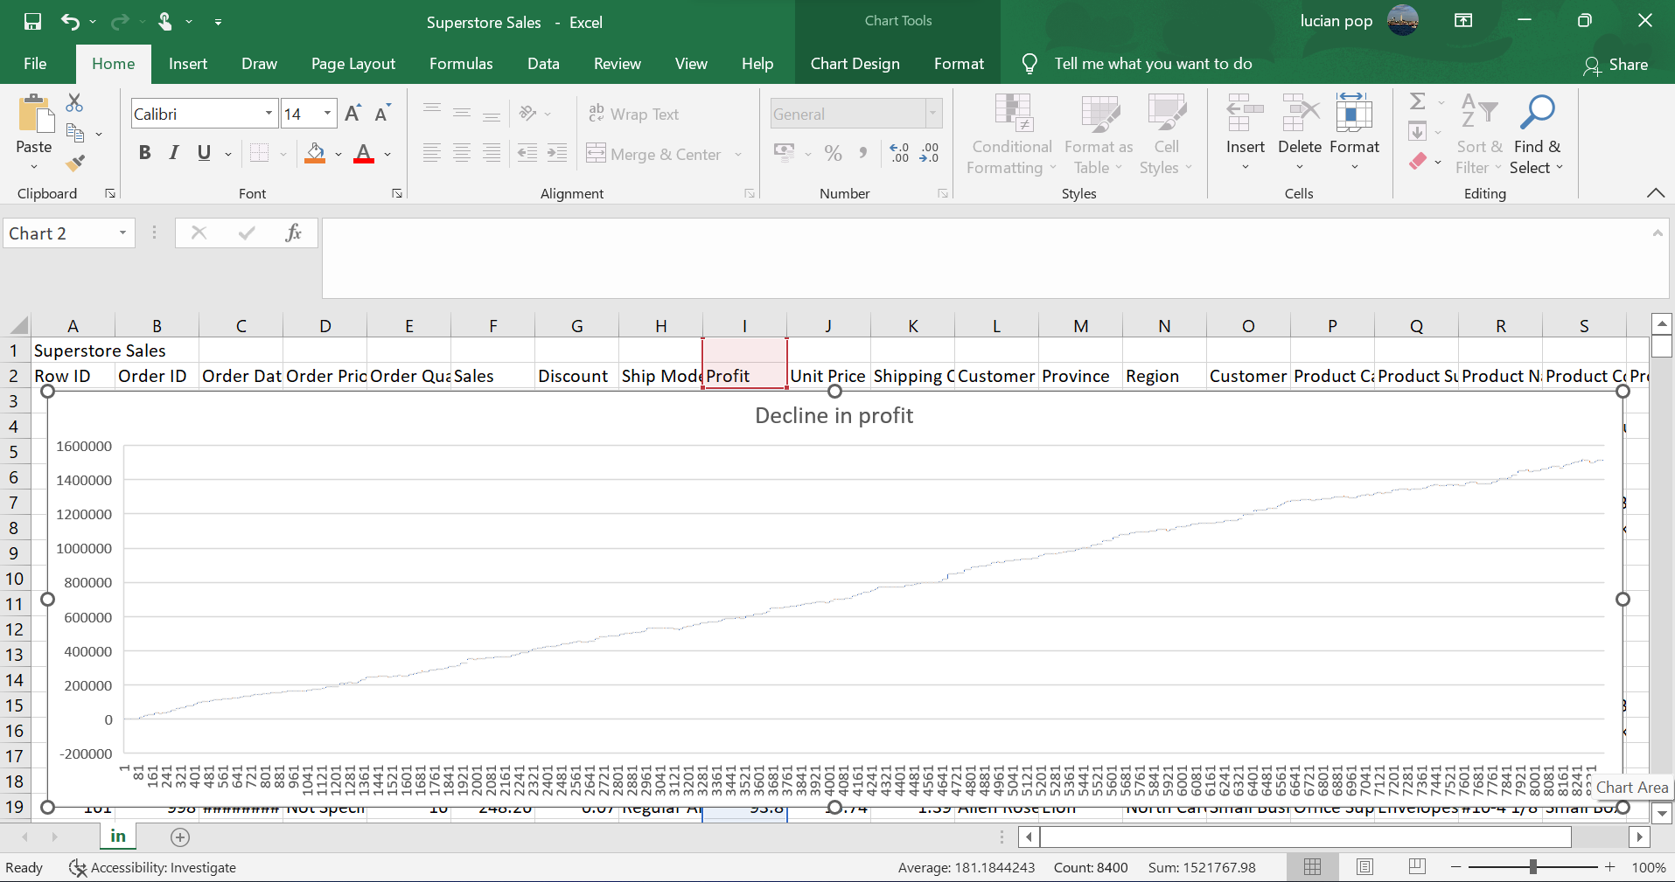
Fig. 2
In the images above (Fig. 1 and Fig. 2) it is presented the decline in sales respectively the decline in profit over the years from the Superstore data provided. Analysing the data in Excel gives you the power to understand it through natural language. By simply select the cells you are interested in and select Analyse Data button from Home tab, the program will return interesting visuals and easy to visualize charts which you can choose the appropriate for the purpose. In addition, you can add a question in the query box, and the program will return answers as tables, charts, or PivotTables. You can get high level summarising or trends without being necessary of using complicated formulas. Based on your data, Excel will analyse and generate PivotTables and charts. If you want to know something more specifical about the data, you can ask a question or use one of the suggestions. However, you can use different methods for getting the same results as not all versions of Microsoft Office, Excel have this tool.
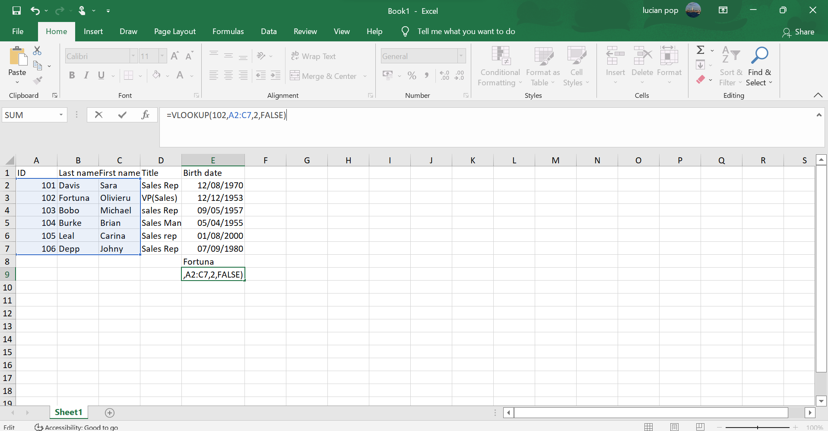
Fig. 3
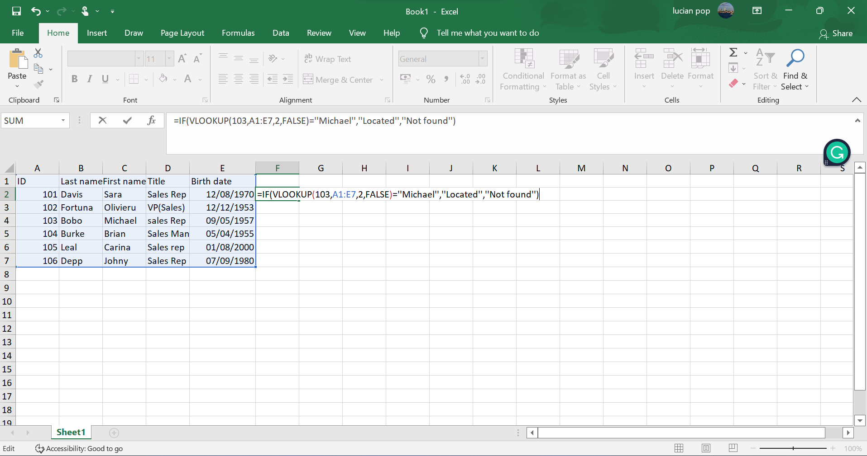
Fig.4
In Fig.3, using the formula =VLOOKUP in Excel we looked for exact match (FALSE) of the last name for ID 102 (lookup_value)in the second column (column B) in the A2:C7 range and returned Fortuna
In Fig.4, IF checks to see if VLOOKUP returns Michael, as the last name corresponding to 103 (lookup_value) in A1:E7 (table_array). Because the last name corresponding to 103 is Bobo, the IF condition is false, and Not found is displayed.
To evolve and stay competitive, all companies must implement and use software that can help the organization and employees stay on top. With the abilities provided by Excel, the quantitative data can be organized, and evaluated, enabling the managers to a better decision making. Both management and employees can benefit from the use of Excel as the information can be presented better at all levels in the organization.
- Advantages and disadvantages of data visualization using Excel
Benefits for Employees
Advanced functions of Excel can help employees improve their work. They can visualize, evaluate, and create equations that be vital for company functions such as financial projections, inventories, budgets, etc. They can design and comprehend spreadsheets containing data from other departments, or from customers, and maintain the work organized, which will trigger an increase in efficiency and productivity, also making those trained to use these functions a more valuable member of the company. The job can become easier allowing the employee to work faster using the features provided, reducing the need of re-entering the information resulting in happier and more productive employees.
Advantages for Employers The benefits are not only for employees but using Excel brings advantages for employers as well. The efficiency of using advanced features of Excel will drive projects to get done quickly and will provide better services for the customers, allowing more work in a shorter time to be done with little expense and effort. In Excel tables are easy to create, they are dynamic and have calculated columns, structured references, and more the fifty predefined styles, easy to select and refer. A lot of data can be stored, and available on different operating systems (Windows, MAC, iOS, and Android), offering the option of password protection for security.
Disadvantages using Excel
The features of the spreadsheets in Excel are basic. Excel is using cells and rows to manipulate and organize data and utilize mathematic calculations, used for statistical, financial, or engineering needs.
Excel is vulnerable to viruses which can be injected in a file and the computer would be also attacked. the formulas used in Excel are difficult to learn, using a wrong formula in this program will drive the data to become wrong, also discovering the errors in this program is difficult, if is working with a lot of data, the program will become slow. They are difficult to analyse, and important data is hidden because it shows the raw data it is difficult to know what is important or not in results. It is difficult to share, and the spreadsheets are not designed to store historical data,
- Data visualisation using SPSS
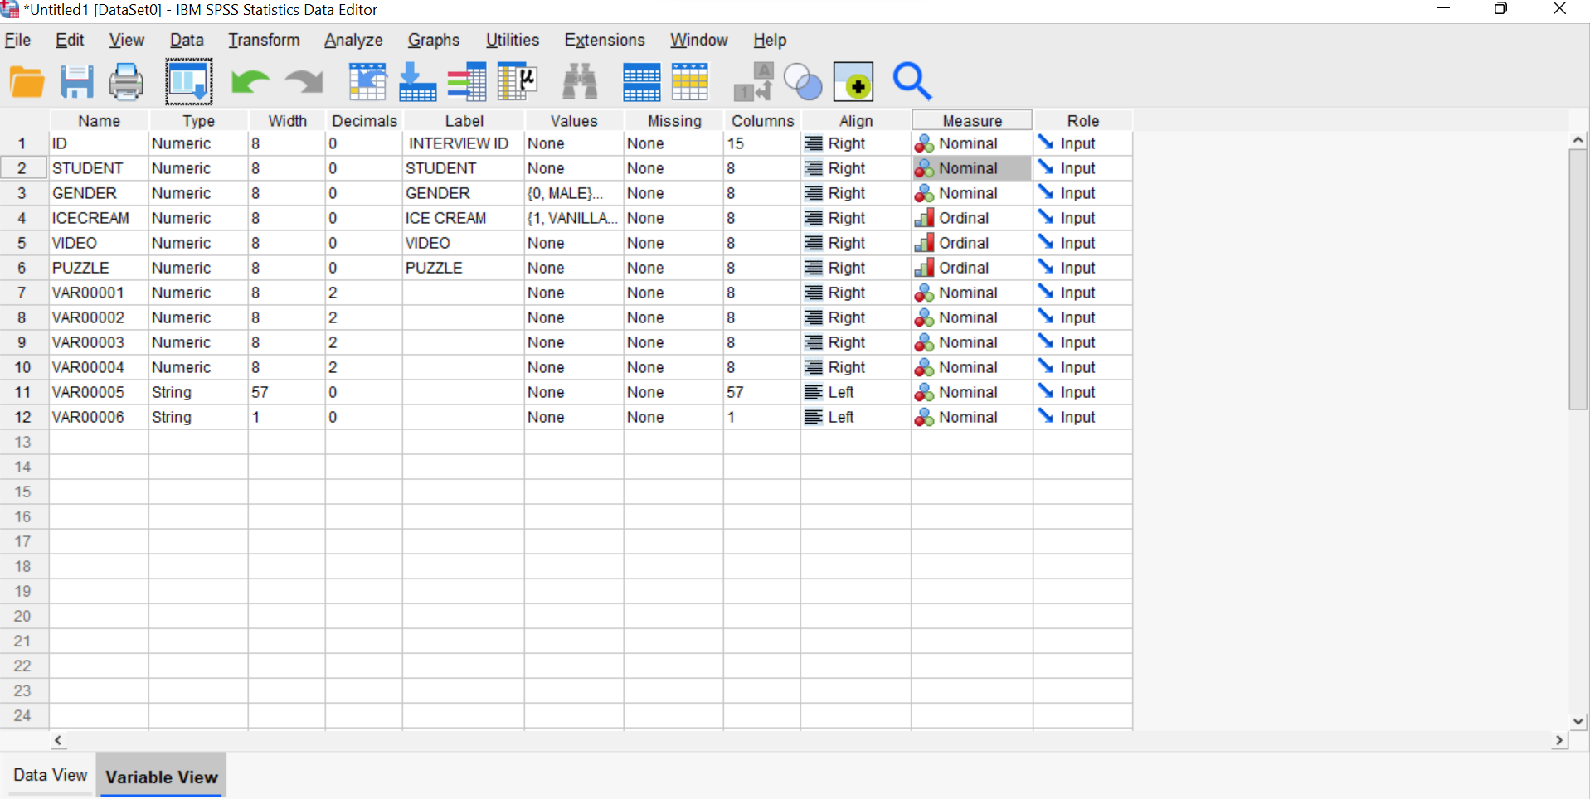
Fig. 5
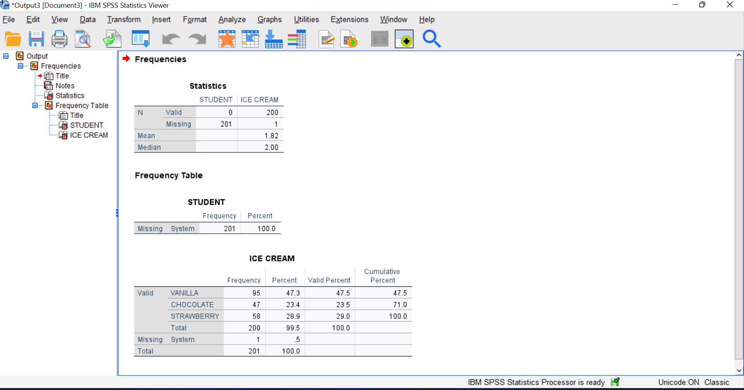
Fig. 6
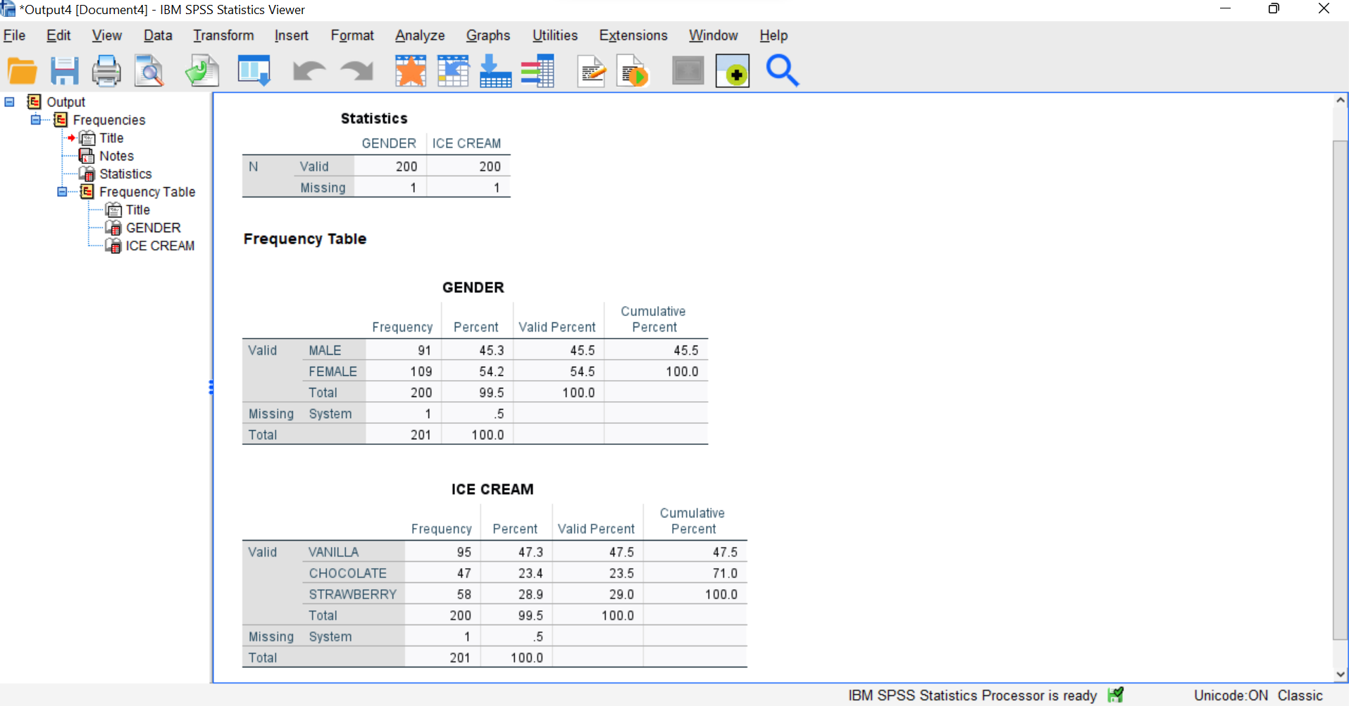
Fig. 7
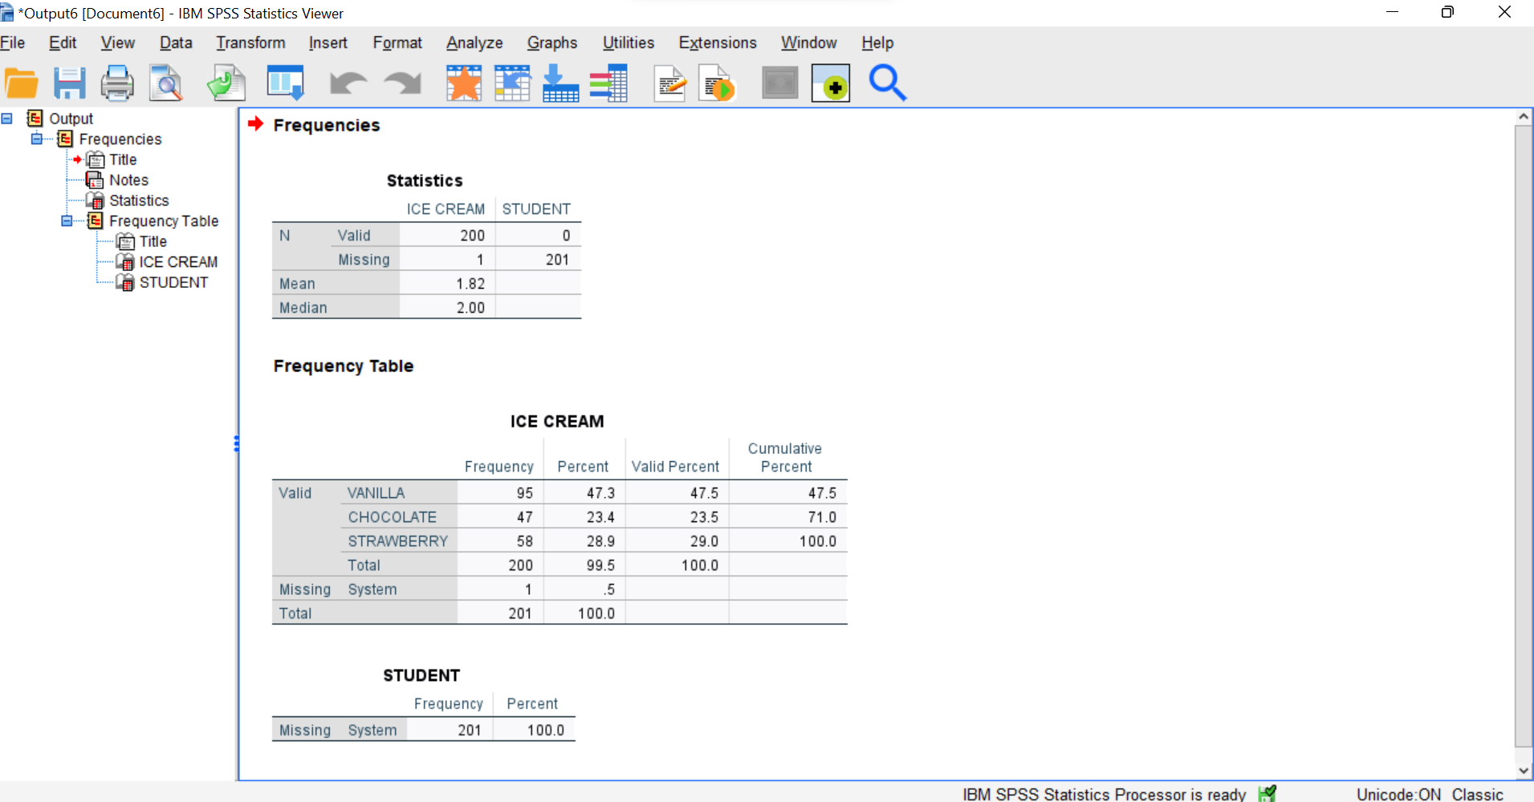
Fig. 8
To analyse the data contained in the Ice cream.xls document, using SPSS we first set up the variables and copy-paste the information provided in the Excel document into the SPSS one. (Fig. 5), then to find up how many students like the vanilla flavour of ice cream we go to Analyse-Descriptive Statistics-Frequencies, then in the dialog box, we transfer ice Cream and Student (Fig. 6) and then select Statistics or charts. In order to find out how many students are male or female we do the same thing but in the dialog box we choose Gender and Ice Cream (Fig. 7) and for Mean and Median we choose Student and Ice Cream, and, in the Statistics box, we tick Mean ad Median. The result is shown in Fig. 8.

K-means is an unsupervised clustering algorithm designed to partition unlabelled data into a certain number of distinct groupings. K-means find observations that share important characteristics and classify them together into clusters
- Data and text mining methods
Data mining methods: Association is the correlation between more items by identification of the hidden patterns (for example a supermarket manager wants to identify which products are sold together)
Classification -this method is used to distinguish the items in the data sets into classes or groups (for example a company will identify applicants for a loan at low, medium, or high credit risks)
Clustering analysis- the associations are made depending on the similarities of data items
Prediction- is used to make predictions based on past trends (for example a manager will predict the amount of revenue that each item will generate)
Sequential patterns -identify patterns that frequently occur over a period (for example the sales of jackets will increase before the winter season)
Decision trees- a structure in form of a tree (for example the government will classify the citizens by age)
Anomaly analysis- identifies data items that don’t comply with the expected behaviour
Neural networks based on biological neural networks
Text mining techniques
Information retrieval- returns relevant information based on a predefined set of phrases. Is commonly used in popular search engines such as Google, and Bing.
Natural-Language Processing- uses methods from various disciplines (science, AI, linguistics) to enable the understanding of human language by the computer.
Information extraction-extracting structured information from free text and storing the information attributes in databases.
Data mining- identifying patterns and extracting useful information from big data.

- Advantages and disadvantages of data visualization using IBM SPSS (Statistical Package for Social Sciences)
Advantages of using SPSS -data from other sources where data is organized in databases can be imported, comprehensive data management tools (the initial data entry is critical as the data is introduced in a wrong way the data analysing won’t be possible), very good graphical display options (SPSS provides boxplots, scatterplots, and histograms that helps to see patterns in your data. The graphics will provide a general framework to understand this data, making it possible and easier to be understood), a range of statistical models (even you’ll have a general idea about which statistic model to choose, as this can change when you examine the data. By using SPSS you’ll be able to choose from a range of flexible statistical models), an easy to learn interface, speed, and performance, etc.
SPSS limitations- One of the biggest limitations is that cannot analyse a very large amount of data, the functionality is limited, and is very similar in some aspects to Excel, the price, etc., however, Excel is a spreadsheet software in time that SPSS is a statistical analysis software. SPSS is more powerful than Excel and can allow you to perform complex analytics such as factor analysis, logistic regression, cluster analysis, etc.

- Conclusion
As the data increases in volume, also hardware and software capabilities will have to keep the steps. By using sophisticated programs, companies can offer services of better quality, resulting in customer satisfaction. The applicability domain of what a computer can do and the huge amount of data a computer can analyse using this type of software it is quite impressive, but the edge is still far away. The newest trends just keep the step with the quick evolutions of these systems, but the domains of the applicability help everybody to gain a better life, by using the technology. This work tried to bring a taste from this huge quantity of information available, but the limitations are obviously as also the benefits of using the technology.

References
(Forbes), M. S. B., 2018. Data Mining Concepts That Business People Should Know. [Online]
Available at: https://www.forbes.com/sites/metabrown/2018/07/31/basics-of-data-mining-that-business-people-should-know/?sh=338d125c515f&fbclid=IwAR18cFWQMhZ4c0Yuctu30ZYOHO2ps207hivXFydIKENlQ9md6roqWIO1m0I
[Accessed 8 September 2022].
), R. A. F. T. C., 2022. Eight Trends Predicted To Define Data Analytics in 2022. [Online]
Available at: https://www.forbes.com/sites/forbestechcouncil/2022/02/25/eight-trends-predicted-to-define-data-analytics-in-2022/?sh=803a4ceffd7e&fbclid=IwAR2FpQVyZDKysUkRwG04utZ-Io4Uc-bjmlp9dzaYl6M7P8lGY7SdqQ8CtOw
[Accessed 09 September 2022].
al., A. e., 2021. Integration Challenges for Analytics, Business Intelligence, and Data Mining. 1st ed. Hershey: ICI Global.
al, P. K. e., 2022. Top Business Intelligence Trends, s.l.: BI-Survey.com.
Amarnath, R., 2022. Forbes Technology Council. [Online]
Available at: https://www.forbes.com/sites/forbestechcouncil/2022/02/25/eight-trends-predicted-to-define-data-analytics-in-2022/?sh=803a4ceffd7e&fbclid=IwAR3gDUr4IbxDd7PMkXilRyfV52U8KUuJw0-iDvqetbmWMFFQXgS7LfZoYFw
[Accessed 06 September 2022].
Blazques, A., 2021. www.statista.com. [Online]
Available at: https://www.statista.com/statistics/238667/tesco-plc-number-of-outlets-worldwide/#:~:text=Tesco%27s%20number%20of%20stores%20worldwide%20from%202008%20to,%20%207%2C033%20%209%20more%20rows%20
[Accessed 31 August 2021].
Blokand, A. B. v., 2018. Forbes. [Online]
Available at: https://www.forbes.com/sites/anettebvanblokland/2018/12/01/what-to-say-to-convince-your-boss-about-flexible-working/
[Accessed 03 May 2022].
Brojo Kishore Mishra, R. K., 2021. Natural Language Processing in Artificial Intelligence. Burlington: Apple Academic Press.
Deepmala Singh, A. S. A. O. S. G., 2022. Business Intelligence and Human Resource Management. 1st Edition ed. New York: Productivity Press.
Dunning, D., 2022. BI Advantage Service. [Online]
Available at: https://www.digitalmarketplace.service.gov.uk/g-cloud/services/569245712440813
[Accessed 09 September 2022].
IBM Cloud Education, 2020. Text mining. [Online]
Available at: https://www.ibm.com/cloud/learn/text-mining
[Accessed 09 September 2022].
Lim, Y. Y. T. A. P., 2020. Realizing the strategic impact of business intelligence utilisation. Strategic direction, 36(4), pp. 7-9.
Marr, B., 2021. Enterprise Tech. [Online]
Available at: https://www.forbes.com/sites/bernardmarr/2021/10/25/the-biggest-cloud-computing-trends-in-2022/?sh=41e1044b2267
[Accessed 30 August 2022].
Mehryar Mohri, A. R. A. T., 2018. Foundation of machine learning. 2nd Edition ed. Cambridge: MIT Press.
Nicole, M., 2018. Forbes. [Online]
Available at: https://www.forbes.com/sites/nicolemartin1/2018/11/01/data-visualization-how-to-tell-a-story-with-data/?sh=3b81ebf64368&fbclid=IwAR0crm_gFRmEQgdiuaQUGkdL9mOHUuKhi5aKJ754uV5id_pIiHqVR_TNiBg
[Accessed 06 September 2022].
Stuart Russell, P. N., 2021. Artificial Intelligence, A Modrn Approach. Fourth Edition, Global Edition ed. Harlow, UK: Pearson.
UWTSD, 2022. Data Handling and Business Intelligence. London: UWTSD.
Vennam, S., 2020. Cloud Computing. [Online]
Available at: https://www.ibm.com/cloud/learn/cloud-computing
[Accessed 30 August 2022].
Vercellis, C., 2009. Business Intelligence: data mining and optimization for decision making. electronic ed. Chichester, UK: Wiley.

