

KNOWLEDGE AND INFORMATION MANAGEMENT SKILLS FOR THE WORKPLACE
(BMSW 5106)
Role and extent of Knowledge and Information Management in contemporary organizations

Lecturer: Akinseye Aluko

Executive Summary

This report will evaluate and express different approaches to knowledge management how it impacts the companies and how organizations succeed in implanting them with an understanding of culture. The report aims to provide answers to the following questions: What specific techniques are available for managing knowledge and information efficiently? How does knowledge management help organizations in maintaining and functioning well in the modern business environment?

Contents
Executive Summary 2
Introduction 4
Knowledge and Information Management 5
Evaluation of Knowledge and Information Management Models/theories 6
Wagamama 10
Conclusions and recommendations 12
List of references 14

Introduction

Knowledge and information management skills. How do we manage information? How do we achieve knowledge? How Is it possible to manage both together? There are different aspects of management knowledge to be exploited. Different information and knowledge management skills must be acquired. Knowledge can be acquired by experience, by interpreting information, by brainstorming, investigating, asking questions, reading, and so forth. Knowledge management emerged as a legitimate academic discipline in the early 1990s. Knowledge is characterised by factors such as perceptions and beliefs that we have come across. Our experiences and culture shape our perception of life, pre-determining what we know. Knowledge management aims to collect all the insights, needs, and certain things of an organisation that function well (Sarayreh, B., Mardawi, A. and Aldmour, R., 2012). These elements need to come together for to succeed in the business environment and walk in the modern day. The organisation needs employees that will bring new understanding and value to the organisation. That is why we should act within a network of professionals. Understanding the critical knowledge management process is a fundamental requirement for organisational development. Appropriate information management and learning systems must be developed in an organisation, establishing a real understanding culture. From this perspective, knowledge represents a crucial and critical organisational asset realized through the action and behaviour of managers and employees who represent the most vital asset of the organisation as well. For that sake, communication is to be considered a carrier of information and knowledge exchange. It has to be understood the communication that takes place within organisations. If a visit to an organisation has been placed today, the only communication activities that will be noticed at first glance would be activities such as: sending emails, writing memos, making phone calls, going to meetings, taking part in teleconferences and video conferences, giving presentations, and speaking in front of people. This kind of activity is, therefore, more traditional. It is the first kind of communication that comes to mind when considering organisational communication. Communication is all about disseminating information within the organisation. Organisations deliver the appropriate information to the right people at the correct times and in the right ways, so the work processes can be worked out in an effective and efficient way. Customers are unhappy with the service they receive if that system falls apart. Therefore, having effective communication within organisations is unquestionably crucial. So, in the first consideration communication can be seen just as the exchange of information, on the second consideration communication is a fundamental activity that shapes our social reality. Instead of merely transmitting previously formed facts between senders and receivers, communication is a articulated and complex process that requires ongoing development and negotiation of the meanings and interpretations that shape our existence (Faerch, C. and Kasper, G., 1984)

Knowledge and Information Management

The value of knowledge management to our society has been hotly contested in recent years. The importance and necessity of knowledge management for organisational survival and the maintenance of competitive advantage are frequently emphasised by those who support it. Companies must be able to hire, retain, develop, manage, and exploit their employees' skills if they want to stay competitive. The importance of knowledge management for organisational sustainability consists in increasing knowledge components as a part of product or service offered to a variety of markets. At a level of segmentation, it is essential to refer to different stakeholders, who include among others, clients/customers, suppliers, shareholders, as well as other group of actors have to do with the organisation. What kind of knowledge is present? The primary stakeholders as investors would be interested in knowing what kind of knowledge is available within the firm and what kind of technology the company uses to report specific outlines. People worldwide have different perspectives on how organisations can benefit from knowledge management. Basically, information is created when we process and inform the data. What, therefore, is knowledge? Being unique to each individual, as mentioned above, the accumulation of past experience and insight that shapes the lens by which we interpret and assign meaning to information. Knowledge is needed to make information actionable so that it can lead to an impact on reality. When someone succeeds in acting, this is a sign that the information used can be considered correct and precious. The information we get, if we understand it, becomes a basic resource when understood and applied. Conceptually there are various sorts of knowledge, the main ones are explicit and implicit. Explicit knowledge can be documented, transmitted, and learned by people from outside. Implicit knowledge, often called also tacit knowledge, is the kind of knowledge difficult to transmit to other individuals and to verbalize. It is defined as experience, culture, and ideas. What is the role of data? Analysing data, for instance, of previous years, might predict the future and forecast future events. Whatever element can be collected can be considered data, while the organised and refined data become information. After all, data is considered “refined” when it has been transformed and when it is possible to be interpreted as information. Some information can be held, can be measured, and can be carried, or moved. In this case, it can be considered as the base of tangible knowledge. Unlike intangible knowledge, it is difficult to handle (“untouchable”). Management theories deliver the method in defining of principles of organization and work processes. Moreover, in many organizations in recent times, different technologies have been used to enhance the performance (Demarest, M., 1997). Integrating information from the fields of strategy, structure, procedures, and technology is necessary such as it is technology for applying knowledge management (K.M.) in an organisation. These fields frequently use well-known K.M. models published in the literature to support roadmaps for widespread K.M. implementation. The knowledge-based division of organisational structure is frequently supported by pioneering models demonstrating the comprehensive 'development' of knowledge within an organisation. However, some authors look down on these theoretical models and recommend knowledge process-based models that emphasise the "circulation" of knowledge as a more helpful way to put K.M. into practice. The essential K.M. concepts described in these models are modified and combined in this study to create an integrated K.M. model, which builds on the implementation-oriented approach. The organisation's vast knowledge efforts provide a helpful framework. The fundamental elements of the suggested integrated model are the knowledge activities that permeate an organisation and are classed following the cyclical knowledge processes of knowledge generation, organisation, distribution, and use. Due to the organisational hierarchy, some of these processes are cut. Based on the cyclic knowledge processes, the corporation is proposed to be divided into departments, that are interfaced with each other. A framework for implementation is also provided that depicts the cyclical flow of information across the business unit based on the proposed integrated model. The conceptual categorisations in K.M. models and the actual implementations involving people and technologies in the real world might be connected by employing a circular framework in the K.M. roadmaps (North K., Kumta G. 2018).

Evaluation of Knowledge and Information Management Models/theories

The SECI model was widely adopted, particularly among management practitioners, because of its clear logic and unambiguous split of information types between tacit and explicit knowledge—using this knowledge delineation that was first promoted in management theory by Polanyi (1958). The idea incorporated an interaction dynamic that enables knowledge to spiral outward, enabling the organisation to increase the value of knowledge through interaction between individuals and groups (Gourlay, S., 2003). This framework breaks down knowledge into four categories: socialisation, externalisation, combination and internalisation, created by Nonaka in 1990, developing the idea through the years (Sarayreh, B., Mardawi, A. and Aldmour, R., 2012).
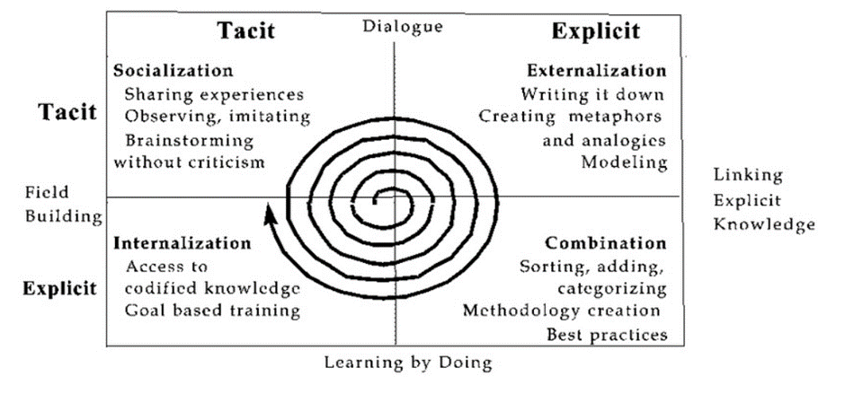

KMPI (Knowledge Management Process Index) assesses the past, present, and future performance of the business. The Customer Satisfaction Index measures client satisfaction with the goods and services they utilise. The American CSI (ACSI) uses a multiple-indicator technique that is sufficiently standardised to allow comparisons between enterprises, markets, sectors, and nations. ACSI is rooted in cause-and-effect interactions and serves as the focal point of a chain of relationships that connects expectations, perceived quality, and value, the antecedents of total customer satisfaction, to its outcomes—a decrease in complaints and an increase in customer loyalty. When the cause-and-effect link is appropriately handled, the company is successful in turning dissatisfied customers into dedicated ones (Lee, K.C., Lee, S. and Kang, I.W., 2005).

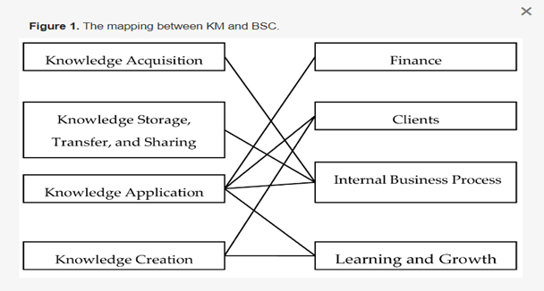

As a result of their work on the design and production of information products, where they defined "information" to encompass knowledge content, Michael H. Meyer and Michael H. Zack created the Zack KMC in 1996. They have included information that has circulated both internally and externally. This cycle provides a number of useful metaphors to underline the concept of value-added processing required to use the knowledge of an organisation, such as the idea of a product platform (the knowledge repository) and the information process platform (the knowledge refinery). This cycle of processes is made up of tools, environments, and methods used for manufacturing things and rendering services (Dalkir, 2005). The Zack KMC provides information on tangible goods, but it can also be readily modified to include information about intellectual goods (Mohapatra et al., 2016). Information systems are used externally, either in written or electronic form (Meyer and Zack, 1996). In this paradigm, the connections between the stages are designed to be standardised and logical. Physical goods follow within an enterprise and can be utilised to manage knowledge assets. This paradigm suggests that a KMC can be built using the results of research and development on the intellectual side of the design of physical information commodities (McKeen, J. D., Zack, M. H., & Singh, S. 2006).
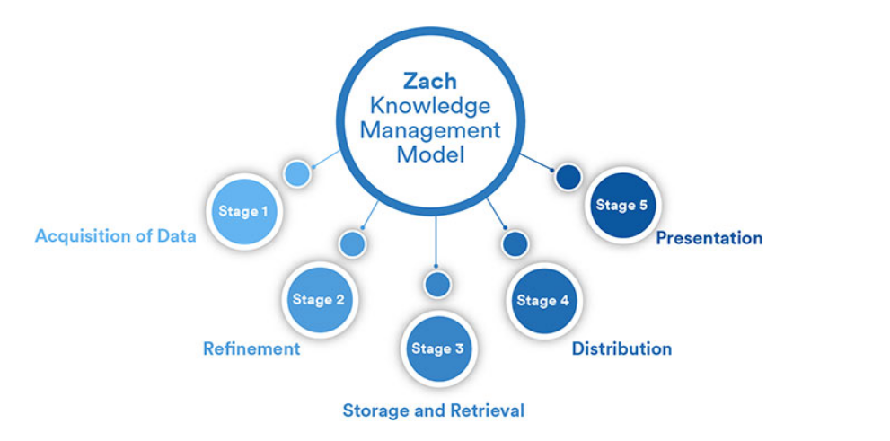

Information processing concepts are known to apply to the data-information-knowledge-wisdom (DIKW) model, similar to how IT System Management has experienced quick industry acceptance. ITSM is a set of procedures for overseeing I.T. infrastructure and providing I.T. services. However, data generated for ITSM tasks, and their support frequently remains at the information stage. The information, knowledge, and wisdom levels serve as the most effective cues for organisational change, hence (Conger, S. and Probst, J., 2014).

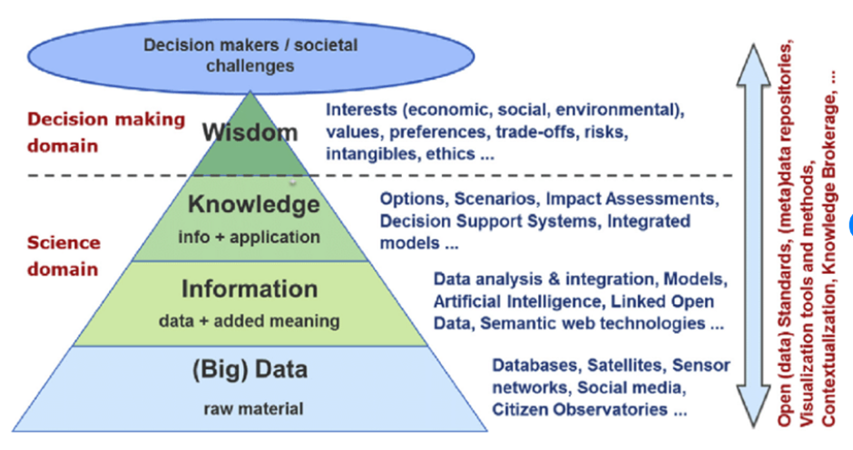

The knowledge pyramid has undergone significant mergers from the viewpoint of organisations. When two businesses merge, they have a foundation to share. They might be obtained through acquisition consulting, outsourcing, or outside training using a database. As businesses strive to generate excellent customer experiences, compete on expertise, and empower their workforces, expertise management has never been more crucial. It needs to be analytical to understand the problem, the cognitive and social context. To explore the nature of interactions and discuss problems, we need to dig further into the exchange models created and how they combine throughout the solution process. Therefore, we will consider three of them. The relationship between some interventions and others, especially how transitions between them happen (such as pauses, overlapping, or interruptions); The syntactic forms use in interventions (such as assertions, questions, requirements of validation, answers, validations, and answers of validations) (Cobo, P. and Fortuny, J.M., 2000). Today, however, even parts of many organisations that were once considered perfect for using knowledge, such as customer service, I.T. support, and human resources, have yet to do so entirely. The good news is that, despite the uncertain situation of the economy, most businesses are keeping or even increasing their investments in knowledge management this year, which is a wise move given that knowledge management may help reduce operational costs (kmworld.com, 2023). Michael Porter reveals that as a tiny portion of corporate expansion should comprehend the source of the force for any firm to survive. As a result, he has identified five forces that affect customer and supplier negotiating power, new entrants, retaining knowledge, and exchange or sharing of information and expertise. Michael Porter is advising us to comprehend how businesses compete. We must comprehend the strength of sources. If the competitor's bargaining power increases, other types of bargaining power will also increase in strength when there is no competition in the market. The supplier gains significant negotiating power only if there are few providers. If there are only a small number of buyers but an infinite number of suppliers, what would a supplier decide when we decide on the price if there are only a few buyers but an infinite number of suppliers. We need to know who has the negotiating position. Assuming to be a billionaire in the area, customers could be very influential. Whatever item they buy. Therefore, going back to knowledge transfer, there are so many technologies we usually use for knowledge sharing, knowledge exchange, and knowledge styles. However, it is all about how the knowledge is used and applied. In a business environment, as mentioned earlier, it is who has the bargaining power, so whatever item one wants to sell, it has to be understood how the others operate as well (Porter, M.E., 2008).

Wagamama

In the Japanese style, Wagamama Ltd. (Wagamama) operates several noodle shops. The company's menu options, and utilisation of cutting-edge technologies contributes its main benefits, but maintaining a highly concentrated revenue stream is still a significant reason for concern. The U.K.'s rising food service sector, near-term economic prospects, and the prognosis for the travel and tourist industry are all likely to offer the organisation options for expansion. The company's future performance could be affected by rising U.K. salaries, a new epidemy outbreaks, and tainted food products. The corporation maintains a strong market position by using its extensive menu options to fulfill a sizable customer base. Wagamama is one of the noodle restaurants that offers Japanese cuisine. The typical Japanese ramen bars, which can accommodate up to 20 dinars on either side of a long table and serve Asian food, influenced the restaurant's design. Its menu features a variety of pan-Asian dishes that combine ingredients from many Asian civilisations. It uses fresh ingredients when preparing the food to have the authentic flavours, aromas, and hues of Japan. It offers a vegan menu along with substantial entrees, sides, desserts, and drinks that include gluten. It has a competitive advantage over rivals in its operating segment because of its focus on innovation. Wagamama uses modern software and technology in all its locations to enable quick ordering for customers. With the aid of personal digital assistants (PDAs) that are wirelessly connected to the kitchen, restaurant staff members collect customer orders. Orders can be placed online through the wagamamatakeout.com website by customers who buy takeaway from Wagamama. The company has launched an iPhone ordering app as the first restaurant chain in the U.K. Wagamama adopted cutting-edge technologies to offer customers speedy service. Such a focused history of changes has a favourable impact on consumers' purchasing habits. Training development is formal and helps the whole team with the approach to the unique Japanese cuisine. Standard operating procedures to ensure consistency across locations, Wagamama establishes and maintains processes through a customer feedback system, which continuously improves customer experience. Other tools include platforms to manage operational data, track inventory levels, monitor sales data, and analyse financial metrics (line advantage-marketing-com, 2023). The core principle of Kaizen is to improve things incrementally rather than through radical transformation. Setting and maintaining standards without significant capital expenditures is involved. The goals of Kaizen include reducing waste or actions that add expense but no value, delivering goods just in time, balancing the number and types of production loads, standardising work, pacing moving lines, and using the appropriate equipment. In essence, Kaizen disassembles systems, products, processes, and services before rebuilding them better. Kaizen and comprehensive quality control go hand in hand (Prošić, S., 2011). As a company, Wagamama follows this philosophy. In fact, through surveys, feedback, and appraisal, the company strives to do better, not eradicate what is wrong but enhance and bettering what went wrong. Through data analysis, it is possible to manage and forecast better for performance to be enhanced by technologies and data; both resources are essential. Organisations benefit from various things when human informational, and technological resources are united. Businesses can develop new methods to operate, increase the effectiveness of their procedures, save expenses, and obtain the performance indicators they need to manage improvement by utilising information and technology. What benefit do the organisations receive from these resources? Most of the time, when we use the phrase "management of information technology," technology is the only thing we are talking about. Professor Thomas Davenport emphasises that managerial attention should be directed more toward information management practices than technology. The evaluation of the situation is required to scan or assess both the indoor and outside settings as part of the scenario analysis. Scanning happens when creating a plan and continuing to react to competitors: the objectives and reason. The goals and vision must be evident. Clarity is required to communicate the strategy's goal to the market and the workforce. The objectives are also crucial since they allow companies to evaluate their plan's effectiveness. Method, concept generation, evaluation, and selection are the processes in designing a strategy. Reviewing several options and choosing the best one based on its qualities is frequently the first step towards a sound approach.

Conclusions and recommendations

Why is knowledge management or similar work necessary? Why is it significant, then? The issue that causes behind all the activities mentioned above now is conductible to one single problem area. Collaboration involves sharing knowledge with others in organisations, which goes beyond simple knowledge generation. To do outstanding work, it takes a lot of people and groups to organise human knowledge in a highly methodical manner, to create world-class information at a rapid clip, and then apply it. So how can we begin to practice effective knowledge management? The three essential components—Knowledge, Core Competencies, and Requirements—genuinely help. They stress that the vital competency is developing, distributing, and using information for the organisation and personal gain. What are the three elements that knowledge management depends on? Culture is one. It has to be established the proper corporate culture. Ensuring the organisational method is correct is the second component of knowledge management. The last is infrastructure. The three main components of knowledge management are culture, procedure, and infrastructure, so when we say infrastructure, we do not only mean technology. We also mean physical infrastructure and other types of infrastructure. They must create a favourable environment. The management process is enhanced when a supportive climate is fostered. How long will knowledge management, education, creation, and innovation take? How innovate is one thing that will stay the same as great organisations build out their knowledge management infrastructure. Because communication in the workplace can only occur through people, so we use the same tools that the people providing the information do. As a result of their expertise, knowledge, and comprehension of the material, these individuals carry out their analysis and conclude that these are the tools used by decision-makers. Additionally, it is crucial to create, to build an atmosphere or culture that will enable us to understand others better and to engage them in better communication. As we can see, the effects of effective knowledge management and communication within an organisation can produce different outcomes. Therefore, if they are turning knowledge into something useful, it contributes to the organisation's incremental strategy. It will be necessary to procced gradually because the issues are the ones of non-knowledge management challenges genuinely ingrained in the culture. Organisations need to be familiar with employees to educate them or motivate them to learn more. However, organisations today must give their workers the freedom to use their knowledge to boost productivity and profitability. Moreover, just as professionals with leadership consciousness and specialised training comprehend, leadership is not just about wanting to lead but also about giving back. While it is true that leading the team is essential, it also gives the team members a chance to grow as individuals and become experts in their fields. In order to build a new generation of leaders, the organization’s defense consists in been able to think creatively. To do this, it must consider how it can increase its knowledge and invest in the organisation so that it begins to become more productive. All information activities can be combined to make business decisions quickly and effectively. A culture that encourages open communication at all levels throughout the business will enhance innovation and information exchange. A sound investment strategy for technology and information systems enables prompt reactions to threats and opportunities by ensuring that everyone within the company is informed of potential risks and opportunities.

List of references

Chaffey, D. and White, G., 2010
Cobo, P. and Fortuny, J.M., 2000. Social interactions and cognitive effects in contexts of area-comparison problem solving. Educational Studies in Mathematics, 42, pp.115-140.
Conger, S. and Probst, J., 2014. Knowledge management in ITSM: Applying the DIKW Model. Engineering and Management of IT-based Service Systems: An Intelligent Decision-Making Support Systems Approach, pp.1-18.
Demarest, M., 1997. Understanding knowledge management. Long range planning, 30(3), pp.374-384
Faerch, C. and Kasper, G., 1984. Two ways of defining communication strategies. Language learning, 34(1), pp.45-63.
Joe McKendrick, 2023 https://www.kmworld.com/
Lee, K.C., Lee, S. and Kang, I.W., 2005. KMPI: measuring knowledge management performance. Information & management, 42(3), pp.469-482.
McKeen, J. D., Zack, M. H., & Singh, S. 2006. Knowledge management and organizational performance: an exploratory survey. In Proceedings of the 39th Annual Hawaii International Conference on System Sciences (HICSS'06) (Vol. 7, pp. 152b-152b). IEEE.
North K., Kumta G. (2018).Knowledge Management
Prošić, S., 2011, June. Kaizen management philosophy. In I International Symposium Engineering Management And Competitiveness, June (Vol. 24, No. 25, pp. 173-178).
Gourlay, S., 2003. The SECI model of knowledge creation: some empirical shortcomings.
Porter, M.E., 2008. The five competitive forces that shape strategy. Harvard business review, 86(1), p.78.
Sarayreh, B., Mardawi, A. and Aldmour, R., 2012. Comparative study: The Nonaka model of knowledge management. International Journal of Engineering and Advanced Technology, 1(6), pp.45-48 .

