Entrepreneurship
[report]

Table of Contents
INTRODUCTION 3
MAIN BODY 3
Famous Entrepreneur Mark Zuckerberg 3
Achievements of Mark Zuckerberg 5
Motivations Driving Zuckerberg 5
CONCLUSION 7
REFERENCES 8

INTRODUCTION
This report will help into the accomplishments and the life journey of Mark Zuckerberg, who is an great entrepreneur and have revolutionised the way in which people connect and interact with each other from any part of the world. This report will explore his entire journey from being a Harvard student to one of the biggest entrepreneur and founder of Facebook, which is now Meta. This report will further examine the key factors that have led to his success. This report will carefully examine his motivation, entrepreneur trades, as well as the great impact office innovation in the society. Analysing his strategies and his skills, this report will provide insights into the qualities that helps in becoming a successful entrepreneur.

MAIN BODY

Famous Entrepreneur Mark Zuckerberg
Mark Zuckerberg is a very famous entrepreneur, who is known for his innovation as well as entrepreneur spirit. Through his hard work and dedication, he has left an unable mark on the world. Mark Zuckerberg was born on May 14,, 1984 in New York. He had a very unique journey from the time when there was no technological advancement. Since his childhood, he was a curious young programmer, who became founder of the biggest social media platforms, like Facebook, Instagram, etc. He bought up a technological revolution by bringing in the world, famous social media platforms (Creech, 2024).
He was passionate for technology since his childhood. While attending the hardwood University, he created Facemash which is a website that helps its users to compare the photos of students and what on their overall attractiveness. This was his first project that successfully engaged the online communities of students. Getting inspired by the success of his first project, Mark Zuckerberg, along with his other college friends, Eduardo Saverin, Andrew McCollum, Dustin Moskova as well as Chris Hughes launched Thefacebook in the year 2004. This platform quickly gained popularity among the hard students and also quickly spread it over other universities and later on it was open for the general public as well (Jougleux, 2022).
With the leadership of Zuckerberg, Facebook gained immense popularity and success. This platform revolutionised the entire way in which people connect and share their information and engage with each other that too on a global level irrespective of the geographical boundaries. This immensely impacted the communication, the businesses and also led to the social activism as well.
However, journey of Mark Zuckerberg was not easy. He have faced Lord of criticism for the data, privacy concern, for the spread of miss information as well as for its role of political polarisation. Despite of all these hurdles, Zuckerberg was always committed towards his mission of connecting the world and creating meaningful interactions among the people.
Mark Zuckerberg is also a philanthropist. In the year 2015, he and his wife founded Chan Zuckerberg initiative which is a philanthropy organisation that completely focuses upon advancing the potential of human beings and promoting the equality at the same time. This initiative highly supports the research in the areas of education, health, as well as scientific discovery. Also, the impact of this great entrepreneur is beyond business. He also has a great spirit of innovation, resilience, as well as social responsibility. This is why, he have an inspiring story that never fails to boost the morale of the young entrepreneurs (Vallely, 2020).
Personally, Mark Zuckerberg is my favourite entrepreneur because of several reasons. his extraordinary vision of connecting the people from all across the world was truly remarkable. He has completely transformed the way in which we communicate and share the information. In addition to this, his philanthropic efforts also showcase his deep commitment towards making the world a better place. Ultimately, the story of Zuckerberg consist of every aspect like technology, human enquiry, positivity, etc
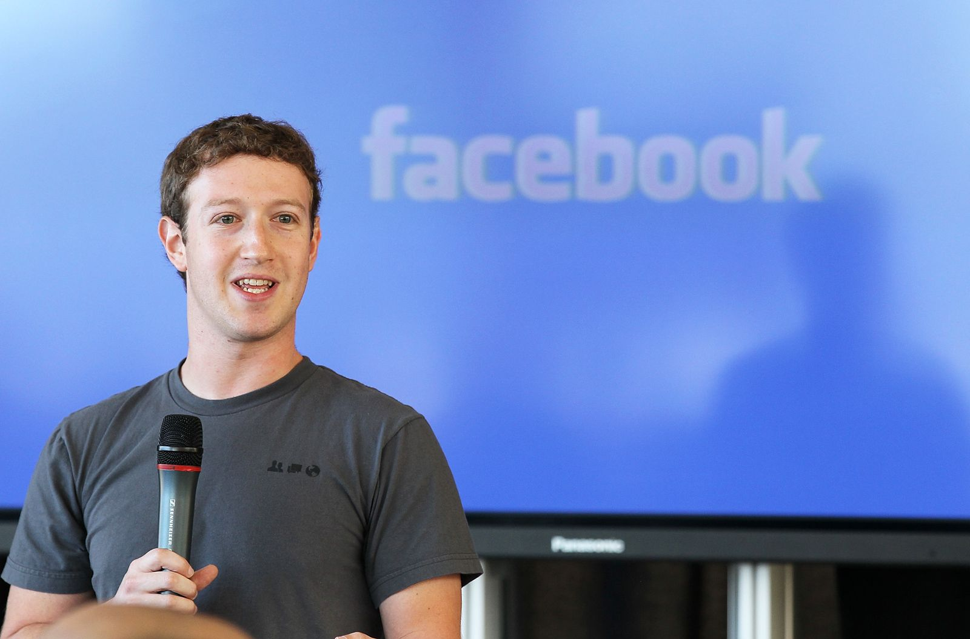

Achievements of Mark Zuckerberg
Here are the great achievements of Mark Zuckerberg over the years:
Founding Facebook: In the year 2004, while he was a student at Harvard University, he founded Facebook, which is a social media platform that completely changed the way in which people communicate on the global level, irrespective of the boundaries (Levy, 2020).
Global expansion: And by the time, as Mark became CEO of Facebook, it rapidly expanded beyond the campus of the college and became a global platform adopted by everyone of every age group. Today, it have billions of active users all across the world.
Technological innovation: Moreover, Zuckerberg played the major role behind all of the technological advancements within meta. This consist of various advancements like development of virtual and augmented reality. With the help of the initiatives like oculus VR
Philanthropy: He also founded Chan Zuckerberg Initiative with his wife. It is a philanthropic organisation that is entirely dedicated towards enhancing the potential of the human being and promoting the equality all across the world .
Business acumen: Moreover, Mark Zuckerberg have also demonstrated great business acumen by successfully leading the matter, irrespective of several challenges in order to ensure the continuous growth all across the world
Impact on society: Moreover, Zuckerberg have also significantly impacted the way in which people interact, engage in social and political contacts or even conduct a business with the help of social media. It have played a very huge role in the life of millions of people, even in the social movements or global events as well (Leong, 2021)
All of these achievements have further helped in strengthening the position of Mark Zuckerberg as one of the most influential figures in the field of technology in the world

Motivations Driving Zuckerberg
Mark Zuckerberg is the mastermind behind Facebook, which is now known as Meta. He is one of the best examples of entrepreneur brilliance. In his entire journey from the classroom of hardwood to the CEO of biggest tech giant in the world have been very inspiring. He had great belief in his own vision and his ideas of creating a society which can connect at a single platform from all across the world.
These are the motivation that drive Zuckerberg towards success of his Facebook company
Passion for technology: Zuckerberg had a great passion for technology as well as coding, which have helped him in continuously innovating the Facebook, and creating a tech giant over the years (Lalka, 2024).
Connecting people: His great desire of connecting the people from all across the globe has been the mission of Facebook. The vision of Zuckerberg for a more interconnected world have further helped in evolving this platform to its best.
Solving problem: He also have a great problem identifying skills with the help of which he was also able to develop great innovative solutions. He went from simplifying the college communication to reimagining the entire way in which people interact in the society, he have actually addressed the real world challenges that existed because of the geographical boundaries
Building of lasting legacy: Through his innovations, he have and lasting impact on the entire world, which have further Inspired the upcoming entrepreneurs to push their boundaries and take risk (Bucher, 2021).
Entrepreneur traits of Zuckerberg that I would love to develop are -
Visionary thinking: The great ability of Zuckerberg to imagine the future and predict the trends have been the important aspects of his success. He also has the unique ability to identify the opportunities to successfully work upon them to create the most innovative products according to the market needs.
Risk taking: And positively taking on the risk is just like an hallmark of a good entrepreneur. The Zuckerberg has a great willingness to calculate the risk like launching Facebook while still being a student has greatly paid him off (Llanos-Contreras, 2020).
Resilience: Success does not come without the challenges or any ither setbacks. But, Zuckerberg have a great residence to face the tough situations like privacy issues and even intense competition.
Adaptability: The technological industry constantly changes and evolves, which requires great adaptability. And the adaptability of the Zuckerberg to continuously grab on the changing tech technologies.
Learning from failures: Moreover, mistakes are irreplaceable part of the journey of an entrepreneur. Zuckerberg have also learnt from his failures and even used his failures as the opportunity to grow and improve (Moran, 2020).
Building a strong team: Moreover, he have also built a strong team of talented individuals with the help of which he have achieved success of Facebook. The shared visions of the professionals have been very important for him, which have further helped him in staying on top.
Embracing failure: Also, he beautifully embrace is the failure and think it as an learning opportunity. He understands that failures are the natural part of the process for any entrepreneur, which ultimately leads to the success (Williams, 2020).
By knowing about the journey of Mark Zuckerberg and gaining his entrepreneur characteristics, I can also become a great entrepreneur in future

CONCLUSION
This report demonstrated how Mark Zuckerberg successfully revolutionise the way in people connect with each other from all across the globe by creating Facebook. The report demonstrated his passion for technology and great determination which helped him in building a global platform that have transformed the way in which people socially interact. It further showcased the ability of Zuckerberg to adapt to the rapidly-evolving world of technology and to constantly come up with new ideas to address user needs which assisted very much in his transformation into a tech giant. Furthermore, the article demonstrates that the person is not only a businessman but also a very caring donor who wants to change the world for the better.

REFERENCES
Books and Journals
Bucher, T., 2021. Facebook. John Wiley & Sons.
Creech, B. and Maddox, J., 2024. Thus spoke Zuckerberg: Journalistic discourse, executive personae, and the personalization of tech industry power. New Media & Society, 26(7), pp.4201-4218.
Jougleux, P., 2022. Introduction to the “Facebook” Phenomenon. In Facebook and the (EU) Law: How the Social Network Reshaped the Legal Framework (pp. 1-12). Cham: Springer International Publishing.
Lalka, R., 2024. The Venture Alchemists: How Big Tech Turned Profits Into Power. Columbia University Press.
Leong, A.D. and Ho, S.S., 2021. Perceiving online public opinion: The impact of Facebook opinion cues, opinion climate congruency, and source credibility on speaking out. New Media & Society, 23(9), pp.2495-2515.
Levy, S., 2020. Facebook: The inside story. Penguin UK.
Llanos-Contreras, O., Alonso-Dos-Santos, et.al., 2020. Entrepreneurship and risk-taking in a post-disaster scenario. International Entrepreneurship and Management Journal, 16, pp.221-237.
Moran, R.E., 2020. Examining switching power: Mark Zuckerberg as a novel networked media mogul. Information, Communication & Society, 23(4), pp.491-506.
Vallely, P., 2020. Philanthropy: From Aristotle to Zuckerberg. Bloomsbury Publishing.
Williams, T.A., Thorgren, et.al., 2020. Rising from failure, staying down, or more of the same? An inductive study of entrepreneurial reentry. Academy of Management Discoveries, 6(4), pp.631-662.

