
“PROFESSIONAL CAREER DEVELOPMENT”

Submitted by: Samuel Edayi
Student Number: 1706729
Module Code: BMSK4005

Table of Contents
Introduction 3
Portfolio of Evidence 3
Getting to Know Myself 3
Personal values and exercise in Career and Professional Stage 5
Self-skills audit 6
Learning style questionnaires 6
VAK Learning 10
Career Management and personal effectiveness 12
Making it Happen 13
Employment Goal and Personal Development Plan 13
Assessment on the self-development 16
Employment status (CV) 17
Sample of personal orientation 19
Conclusion 20
References 21

Introduction
Personal development is the part of career development and career in healthcare sector is always challenging for its sensitivity. The personal development is highly required for fundamental development of career as a professional in healthcare. Strategies are not only the reliable factors that can extend the personal skills, but the strategies guide a person to carry on the career goal in the right direction. This is obvious that a skilled person will treat most fairly to the service users than a person who has less skills. Career goal selection is really necessary that’s why as per the boosting self-confidence, thinking power, comparison ability to appraise the personal and other’s progress. Good communication for effective manage of partnership in healthcare will also be presented throughout the assignment. Personal skills comparison with the level of personal improvement areas and utilization of skills will also mention to make good understating about the career development.

Portfolio of Evidence
Knowledge and understanding are connected with other in respect of the personal skills development for career. Practice of social and environmental factors from both public and private ownership is necessary. Supervision creates the accountability inside a person’s mind to apply the best use of knowledge in professional development. By considering the portfolio, private and public mix will come under consideration because the relationship between these two sectors have influencing power for the pharmaceutical companies. Availability and fair distribution of diagnostic services come out with better treatments. Regulatory organizations like- NHS, WHO and other voluntary healthcare originations also work for skill development and they run career counselling programs too.

Getting to Know Myself
Application of the learning style is the best method to know about the most significant way to judge individual preferences, the best manners, thinking power, process of Information and it demonstrates the learning approaches. An individual differences make different and that's why the learning styles approaches is also different as per the capability to catch. Individuals habit the strategies of planning and the regular mental behavior are directly involved with the learning style, the learners deliberately learn from the education some of the largest island from the surrounding and some of the learner learn from the significant approaches of learning (Segers, 2014).
Job Left
Professional diploma
Bachelor program
Higher Diploma
Job in healthcare org.
1 to 5---- 10---15---- 20----25----30---- 35----40----- 45----- 50----- 55----- 60-----65----- 70
5 10 15 20 25 30 35 40 45 50 55 60 65 70

-
+
Get living benefits
Start professional learning
HAACP course
Administrative skills
School learning
Personal learning (home)
At the early age of myself, I have started to learn from the surrounding and family members were played major role there. At the age of 10 I have completed the secondary school, after that the higher secondary schooling has started. Higher diploma in healthcare, BTEC level learning, professional diploma, Professional learning has started after starting employment in a healthcare organization.

Personal values and exercise in Career and Professional Stage
Though I am a Muslim, it’s my duty to show respect to the other people who belong to other religious view. While working in the healthcare company, I have to show adequate respect to the people who belongs to different culture and society. I should avoid showing any negative behaviour to any patient who are from different social and cultural aspects. Though healthcare is a noble profession, positive behaviour should be shown everywhere while in there.
In my organisation I always try to behave properly because it is necessary to build a proper communication pathway in the healthcare society. The behaviour of human is largely depends on the personality which they belong to. Each individual behaves according to the personality of his own. This is the reason why the personality reflection tool is considered by the behaviour of human and the communication management should be reflected by the best personality traits and human behaviour. Positive behaviour ensures the positive attitude which helps to improve the service quality of the health care organisation. The people associated with the healthcare system should behave properly with the patients. In addition, with this, they should be capable to develop their personality (Sadock, 2016).
Though there are different types of persons who work in a healthcare organisation, but it is necessary for them to provide equal service to the patients. They should increase their interest in gathering necessary knowledge about the service and consider it as their first priority. They should improve their behaviour and responsibility to implement their tasks within the most efficient way.
It is mandatory for the healthcare specialists and employees to maintain the rules of maintain privacy of the service users. The healthcare specialists should be able to gain the trustworthiness of the service users by securing their personal data and privacy. I try to preserve the personal data of service users properly, so the information leakage will not be leaked and only used for medication purposes.

Self-skills audit
The skills audit required thinking about personal full list about the skills and not just the obvious things that I have that where I am good. anything relevant to my career is needed to consider in the skill development and this will help me to compare the lacking and improve my personal development as well. by considering the professional career every problem need to maintain some social media activities and networking and other connections because of comparing the surrounding can find out the development. self-learning style is not just to compare the own skills but also the application of the skills and where the improvement is necessary are judged here.
Knowledge and Development | Scoring (out of 10)
Practical learning skills from school | 7
Job experience in healthcare | 8
Learning enthusiasm | 7.5
Behavioural impact positively for learning | 8

Learning style questionnaires
Honey and Mumford Learning-
Honey and Mumford learning style has been developed by Peter Honey and Alan Mumford in 1986, the main purpose of this work is inspire people about learning and this learning style has developed upon Kolb’s learning style model. According to the learning style human beings are derived with 5 different styles. Some of the learners prefer to learn from home judgement and they are called as activist while some of the learners like to compare the situations before taking any kind of decision, at the same time some learners are categorised in nearest, some of the learner pragmatist because here the individuals have own capacity how to apply the learning into reality by comparing the scenario.
Activist learners learn enthusiastically and they are very much passionate about learning (Martin, 2011). They like to respectively deal with the learning including them with competency and knowledge. Also, here the learners try to compare the situations to take decision and they never feel puzzle during learning. Activist learners like to apply practical skills and brain storming that is the main theme of the activist learners.
In the theorist learning, the learners get a kick out of the chance to comprehend the hypothesis behind all of the activities about reality. They like to consider specific model, ideas and truth and while taking decisions. Consistent hypothesis and applying knowledge theoretically and statistical data is also common approach to take decision.
The pragmatic learners have the capacity to perceive the reality and they always apply past knowledge according to the reality. Conceptual tell ideas are practically utilised by the pragmatic planners and the learners take time to think and they always try to make decisions very perfectly.
Reflector learners closely observe the surrounding and they compiling everything that is happening in the surrounding (John, 2012). The learners want to remain back and encounter the viewpoint by generating information and knowledge, they also search opportunity about learning. The application of personal learning and observation are properly managed here along with the collection of feedback by reflector learners.

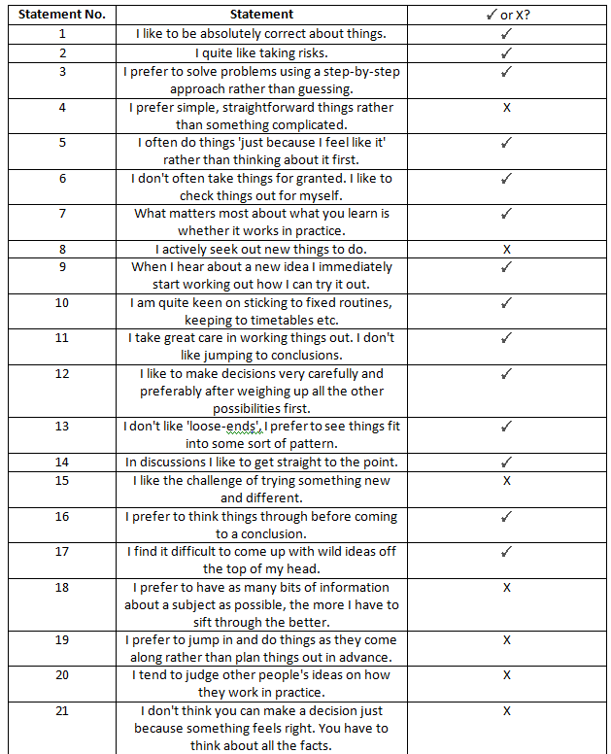
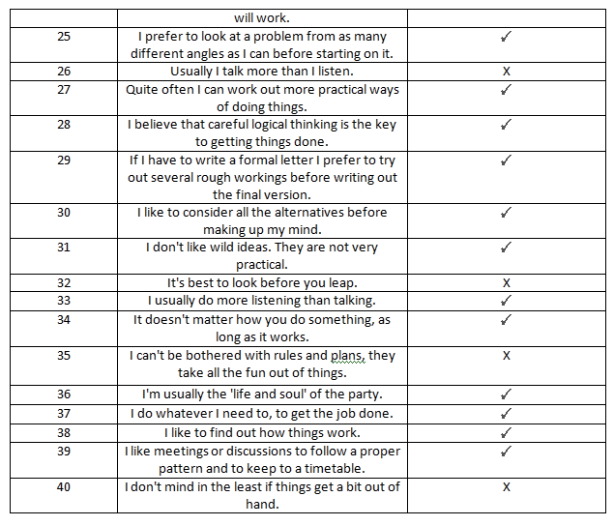

Reflection
It is important for the healthcare specialist to thing strategically and logically while taking any decision regarding to the healthcare service. I follow the instinct judgement method while taking any decisions. Additionally, I consider the outside factors which affects my decision. Personal learning styles are reflected by the Honey and Mumford Honey questionnaires. It is one of the most effective tools of identifying the best learning methods. I have picked question number 5, 11, 31 and 39 and according to these questions, I have represented as a theorist and activist learner.

VAK Learning
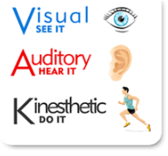
The VAK learning is developed with visual, authority and Kinesthetic movement that is able to determine the learning styles of a person (Rosenthal, 2013). VAK model is modified with the human expression and human thinking power which is commonly represent the perception and memory of a person.
Visual learners are connected with two sub channels like linguistic and special knowledge. Visual-linguistic likes to learn from the written language and they also like to learn from the reading and writing article from someone that is always presented and clearly visible. They also like to learn from visual applications like- video, graphical presentation and other live activities that very useful to make sense inside the mind of learner.
The authority indicates by interacting with others and they mainly move their leaves and read out loudly anything. Here the learners have inconsistency in speaking out anything and like to hear the recorded voice of others or interacting with them near people by using silent language
Kinesthetic learners prefer to learn by touching and moving. Kinesthetic indicates the movement activity and tactile indicates the touch (James, 2017). Here the learners have tendency to lose concentration and there is no external stimulation.

SWOT analysis
Strength | Weakness
My biggest strength is, I can manage any kind of difficulties with patience and behave ethically while giving service o any patient. Moreover, I follow the best communication method to communication with my subordinates as well as with my patience. | Sometimes I feel restless and confused while conducting a lot of tasks together. The reason behind this is, lack of past experience of working in a health and social care organisation.
Management skills, technical knowledge and professional degrees along with some other academic qualifications. | Patience is the prior condition in healthcare profession. While I’m failed to deal with a big number of service users, some other professionals can manage them effectively though they have lacking in professional skill but they are good with people negotiation.
While I perform with my peers, team members and colleagues, I try to interact with everyone for effectively managing the tasks and informing the top management about regular progresses. So the management body and the peers also encourage me for this skill and hopefully this will add positive values in my career. | I have noticed that some of the team members are not that much happy to work with me just because of nervous nature to while manage bulk work. They try to formally or informally inform about their unwillingness to work with me but they help me as well to resolve these lacking.
Opportunity | Threat
I have the opportunity to improve my professional skills by developing my personal traits as well as my professional skills and expertise. | If I fail to overcome my dilemmas, it will be difficult for me to continue my career and work in a healthcare organisation.
As I’m very concerned about my career development and skills as well. I have the opportunity to be the part of top management body in healthcare organization. | The competitions in career development at healthcare organizations are rising day by day. So, if I fail to effectively manage my lacking and develop interpersonal skills more; it may backfire me from own goal in career.

Career Management and personal effectiveness
Healthcare industry is reliable to the satisfaction of the service users. The service users are the asset for the healthcare specialists and they should be careful while treating any of the patients. In addition, with this, they should be able to cope up with any kind of difficult situation which can arrive at any time. Positive attitude is a valuable treasure which influences the positive behaviour of an individual (Hume, 2015). In the healthcare organisation, there are a variety of people who come for getting healthcare services. They belong to different cultural regions. As a result, the healthcare professionals may find it difficult to manage the cultural traits with them. The healthcare professionals should be able to cope up with people who belong to different culture. So, I always try to consider there matter while interact with the service users and always try to inform the colleagues and others about best use of knowledge in healthcare development. The people who are working in the healthcare organisations should be alert while treating any disable person in their organisation. They should be able to cope up with the critical situations. They should handle the negative occurrence with adequate patience. They should abide by the rules and regulations of the company. Moreover, they have to be a person with positive attitude. In addition, with this, they have to develop their personal capability and traits in order to improve the organisational environment. At present the government of UK maintains all the rules and regulations of healthcare and the services are being improved a lot day by day. As being a healthcare expert, I have to improve my own personality traits in order to ensure the best service to the people who are vulnerable. In addition, with this, it is my duty to monitor all the activities and make necessary remedies to the problems regarding to the healthcare services. I have taken part in the developmental phase in the organisation in order to improve my personality traits and skills.

Making it Happen
When a person wants to achieve some object is the person needs to improve own skills and also apply the strategic approaches for achieving the objectives. Objectives of the set of possible outcome that needs to achieve by personal and professional activities and that's a career development is really necessary to support those activities.
When an individual chalk out the action plan for individual development like personal development or professional development and also in relationship development, there is no alternative of development plan. Because, the development play will finally drive the activities according towards right directions.
Professional development plan is necessary for an individual in respect of career objectives selection and other skill development. Every professional development plan for career growth is necessary for finding out the regular mistake on improvement areas.

Employment Goal and Personal Development Plan
What do I want/need to learn? | What will I do to achieve this? | What will my success criteria be? | Target dates for review and completion | What resources or support will I need? | What do I want/need to learn?
Management skills | Developing the management skills is crucial for the healthcare professionals in order to improve the service quality which will be beneficial for the betterment of the vulnerable people. | I have to gain the skills the skill within first of June 2018 | Gathering necessary Knowledge and suggestions form the experts is mandatory for me to grow up my skills. | I have to be updated with the latest communication skills and keep in touch with the related academic contents. | It is difficult for me to achieve success in this issue due to the difficulties of the skills.
IT skills | I have to put more emphasis on doing the works related to the office in order to improve my technical skills.  . | It is necessary for me to achieve this goal by the  Beginning of April 2019. | Getting updated with the issues related to the ID department is necessary for me to achieve the success in this goal. | I have to attain the classes in a regular basis in order to develop my IT skills. | Regular practise is mandatory for me to be an expert in this technique.
HACP | I have to join an organisation in where I can achieve my professional degree in this skill. | Next two years from August 2019 to 2021. | When all the courses will be completed successfully, I will be able to be an expert in these skills. | It is important for me to attend the classes regularly and practise the theories properly. | I have to study regularly. Moreover, I have to be dedicated a lotin order to achieve this success.

Personal Self-Care Plan
ELEMENTS | Spiritual | Emotional | Mental | Physical | Social
DESCRIPTION | I will e able to add necessary values after achieving this skill. This management training will be helpful enoughfor me to reach my goal. | I will be capable of giving the desired service to the vulnerable people who need it badly. | If I become capable of service large portion of the disable people, It will be a great pleasure for me. | I will be able to help the vulnerable people physically. Mental and physical improvement is needed for the people who are disable and vulnerable. | The people from every social and cultural aspect have the right to get the health care service from the organisation.
ANTICIPATED ACTIONS | Necessary monitoring of the activities is crucial for me to achieve the success. I have to monitor the activities and it will be helpful for me to know my lacking. | It is crucial for me to understand t inside perception of the people. It will be helpful for t=me to treat them according to the most appropriate way. | The source of the problem should be identified by me. Otherwise, it will be difficult for me to give the best service. | I ill workout regularly in order to achieve my success of developing my personal and professional skills. It will be beneficial for me to develop my mental needs which will helps me to work more on this issue. | Interacting with the people of all society and culture is minatory for me to treat them well. In addition with this, effective communication with the management will be beneficial for me to understand my roles and responsibilities properly in the healthcare organisation.

Assessment on the self-development

Personality traits and culture affects a lot in an individual’s attitude and behaviour. Though here are many disable and vulnerable people rely on the service on healthcare organisation, it is crucial to maintain the perfect behaviour with the service users (Gough, 2014).
While working in the healthcare organisation, many difficulties can arrive. Everyone should be able to handle those critical situations with patience. Necessary respects should be shown to the vulnerable people of the organisation. In addition, with this, the healthcare specialists should be able to take care of the patients according to the most efficient way. Any kind of bad behaviour or misconduct to the patients should avoided
The healthcare professionals should be capable of handling the developmental aspects of the organisation and work with adequate efforts to improve them. The healthcare practise in UK is satisfactory. But the healthcare professionals should be attentive in their work. They should be able to cope up with the inappropriate situation and take necessary steps to solve it. Developing one’s personal attitude and dignity is one of the most effective way of improving the service quality of the healthcare organisation.
The healthcare professionals should work with their combined intelligence and effort in order to give the best service to the disable people of the healthcare community. The social workers should be able to handle every ups and downs with patience. They should be able to develop their own personal skills and expertise in order to behave well with the disable and vulnerable patients of the community (Benjamin, 2016).
- In order to avoid any misjudgement, the healthcare experts and workers should take necessary remedies to solve the problem by ensuring the perfect flow of behavioural aspects.
- As a healthcare professional I should adapt the strategy of developing personal traits and skills in order to improve the organisational environment of the healthcare organisation.
- As a part of healthcare organisation, I need to be able to get update with the various cultural aspects of the people and diversity of value and norms.

Employment status
Selection of an employee is basically done by the combined judgement of an organisational member and the judgement is basically made by the higher authority of an organization Leonard, (Kimberly, 2016). Employment status removes the unemployment status of a person and the status assures by the policy and practices of the organisation. Healthcare is the most sensitive part in employment. Because, this is entirely connected with the personal curing of a person and life oriented activities are regularly running here. While selecting an employee the employer must need to be very much fair about the job criteria and selection process. An employee is not allowed to show any kind of special activity which is in favour of a person by considering the race, religion or gender or any other personal orientation and special criteria those have no connectivity with the personal skill.
The people who are responsible for recruiting play the major role in recruitment process of an organisation. They choose the job position, job criteria and the requirements that needs to achieve by the candidate who is interested to apply. The job descriptions and other related conditions are properly designed by the recruiter inside an organisation. HR team mainly screening the application application and they used primarily selection employees for viva or any other further selection process.
The main purpose of job description is to prepared the applicant mentally about the responsibility and the organisation of functions that he or she needs to play after getting chance in the organisation. Job description also inform informally about the job roles and the activities and which an organisation needs to follow during performing inside organisation.
On the other hand, person’s specification is necessary to identify the status that a person against so far for the personal development. Personal specification mentions learning skills, cooling activities and other professional experiences that does the employer to identify the actual skilled person for the offered job.

Sample of personal orientation
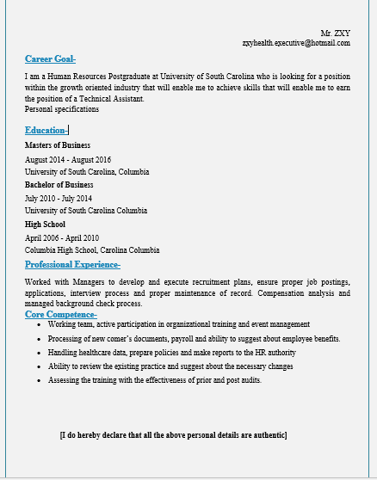
If I consider my personal opinion about the professional skills or personal development skills I should mention that, I have completed some basic educational degrees that are needed to groom a person properly to perform in an organisation. I have professional skills that always support me inside and outside my organisation to perform properly and at the beginning of my professional career I have started working as an office assistant in a pharmaceutical company and that was a good experience for me which is he now I am utilising in my new Healthcare organisation. I am well known about the safety of people and how to fairly treat the service users. I have shared level of knowledge about the quality of service. I also can support service users with required activities that will help them to get proper Healthcare treatment and I also support their teammates while performing inside organisation. I always try to connect with vocational training or professional development training programs because these will surely improve my personal skills and I’m learning every day.

Conclusion
Personal and professional Development is equally necessary in respect of the career development. Making personal development plan helps a person to drive activities in the right way. There are multiple learning styles have been developed to compare own skills and make judgement. Healthcare is the sensible area where individuals need to apply several knowledge at the same time because of professional development. This assignment has been developed with the practical and theoretical ideas of learning where the assessment and personal contributions have been mentioned too.

References
Benjamin; Sadock, (2016). Kaplan and Sadock's Comprehensive Textbook of Psychiatry. Wolters Kluwer. ISBN 9781451100471.
Gough, (2014) "Who Cares? Examining the Health and Social Care Workforce", Journal of Integrated Care, Vol. 10 Iss: 4, pp.9 – 14\
Klasa K, Sobański JA, Stolarska D (2015). "KON-2006 Neurotic Personality Questionnaire" (PDF). Archives of Psychiatry and Psychotherapy. 1: 21–2.
Segers, (2014) "Employee motivation for personal development plan effectiveness", European Journal of Training and Development, Vol. 37 Iss: 6, pp.527 - 543
Martin, (2011) "Reflections of Two Pragmatists: A Critique of Honey and Mumford's Learning Styles", Industrial and Commercial Training, Vol. 26 Iss: 1, pp.16 – 20
ocke, John (2012). An Essay Concerning Human Understanding. Toronto: Random House.
James, William (2017). Pragmatism and other essays. New York: Washington Square Press. p. 69.
Hume, David (2015). An Inquiry Concerning Human Understanding. USA: Liberal Arts Press Inc.
Leonard, Kimberly (2016). "Could Universal Health Care Save U.S. Taxpayers Money?". U.S. News & World Report. Retrieved July 12, 2016.
Rosenthal, Elisabeth (2013). "News Analysis – Health Care's Road to Ruin". New York Times. Retrieved December 22, 2013.

