HND Computing Application Development Assignment 1
By James David Joseph Pugh
Tutor Sarah Williams

Contents
HND Computing Application Development Assignment 1 1
Part A 4
Question 1. 4
Question 2. 4
Question 3. 5
Question 4. 6
Part B 7
Exercise 1 tests with screenshots 7
Test 1: how the app responds to a non-convertible string being passed as the number of spoons to be made. 7
Test 2: How the app responds to a non-full number being passed as the number of spoons to be produced. 8
Test 3: How the app responds if a convertible string is parsed as the number of spoons to be produced: 8
Exercise 2 tests with screenshots 9
Test 1: What happens if the user enters a non-parseable text string when declaring the X coordinates of one of the circles 9
Test 2: What happens if the user enters a non-parseable text string when declaring the Y coordinates of one of the circles 9
Test 3: What happens if the user enters a non-parseable text string when declaring the radius of one of the circles. 10
Test 4: How the app responds valid input is provided to the two circles which results in them not overlapping. 10
Test 5: How the app responds when valid input is provided to the two circles which results in them overlapping 11
Exercise 3 tests with screenshots 11
Test 1: What happens if the user enters a non-parseable text string when declaring how many products they wish to purchase 11
Test 2: What happens when a user passes in an invalid product id when choosing what to purchase 12
Test 3: What happens when a user enters a non-parseable text string as a products price 12
Test 4: What happens when the user successfully purchases 1 of each product type 13
Part C 14
UML class diagram of part C source code 14
Part D 15
Research and discussion into the importance of software testing 15
Appendix 17
Full code with comments 17
Exercise 1 17
Exercise 2 19
Exercise 3 23

Part A

Question 1.
The core difference between a class and an object is that, a class acts almost like a blueprint for creating objects while an object is simply a creation or instance of that class. It is within the class that properties such as the range of valid values, along with any default values for variables within an object are determined. Furthermore, any methods that change an objects behaviour are created within the class from which it is derived.
Due to the class acting like a blueprint for objects, while it is possible to create multiple objects from one class, it is not possible to declare more than one version of a specific class. Thus, attempting to do so will create an entirely new separate class. In addition, while each new object created from a class requires its own location within memory, the class itself does not actually get stored within memory as it does not physically exist, rather it simply provides the logic to create objects of its type. However, despite objects existing within memory, it is important to note that they only exist for the duration of the program’s execution. Once the program shuts down any objects allocated to memory are destroyed.
Another key difference between classes and objects is where they can be declared within a program. For example, in C# it is not possible to create a class directly within the program’s main method.
The only valid ways to declare a new class in C# are either to declare it within the program file outside the main method, or in a separate .cs file included in the main program folder. In contrast, instances of a class object can either be declared directly within the programs main method, or within a method inside of the class from which it is derived.

Question 2.

In OOP, there are two key concepts that must be understood known as Inheritance and Polymorphism respectively.
Inheritance refers to when a class gains access to all the attributes and functions within another class. When this is implemented, the class that inherits the attributes and functionality from another is called the child class or subclass while the class proving these additional features is known as the parent or superclass.
Due to the subclass gaining access to all the attributes and methods within it’s parent class, one of inheritance’s main implications is that the overall amount of code written is reduced as there is no need to rewrite any of the inherited functionality within the subclass.
This reduction in code size has further implications, as not only is the readability of an application’s code likely to improve due to being more concise, but also the testing process may become less time consuming. This is because if a method within the superclass is found to be functional, it will be fully usable when creating and manipulating an object of the subclass type meaning the application’s reliability increases.
However, one of the main negative implications of utilising inheritance, is that the superclass and its subclasses become tightly coupled. This means that if any changes need to be made to the functionality present in the superclass, it will also impact the use of its subclasses as they highly depend on the superclass.
For large applications, tight coupling caused by inheritance could prove disastrous as alterations may need to be made to all instances of the superclass’s subclasses thereby significantly increasing development time and intern the overall cost of developing said application. For example, if the name of a method within the superclass was changed, this change would also need to be made wherever an instance of either the superclass or its subclasses attempted to call the method using the old name.
Polymorphism refers to code that can take many forms hence its name which comes from the Greek words poly meaning many and morph meaning form. One way to implement polymorphism is through method overriding. This process involves creating methods within subclasses that have different implementation but the same name, number of parameters and type of parameters as a method within their’ superclass.
Therefore, through polymorphism one method name can represent multiple implementations, with the type of object being the key factor in determining which implementation of the method is called. Thus, polymorphism can boost the understandability of large application code as methods with similar functionality can all be grouped under the same method name. Thereby making sections of large applications more understandable between members of large development teams.
Alternatively, polymorphism can be implemented through method overloading. This involves creating methods within subclasses that have the same name, but different numbers or types of parameters as a method within their’ superclass. The only similarity between a method and any overloaded versions is their name. Therefore, polymorphism loosens coupling between classes as changes to the functionality of a method in the superclass won’t impact any overloaded methods with the same name in any subclasses. Thus, polymorphism can make large applications easier to expand while also somewhat future proofing them.

Question 3.
To understand when to use an interface over a class, we must first determine what we mean by an interface. In basic terms, an interface acts like a contract that can be taken up by classes within an application. This is because while an interface will contain methods reflecting its purpose, it is up to the classes that inherit from this interface to determine how these will be implemented.
One of the main times an interface should be utilised over a class, is when we want a class to take advantage of what’s known as multiple inheritance. normally, a class can inherit attributes and methods from only one other class which is referred to as the base class for the class inheriting from it. However, through using interfaces a class can inherit traits from a virtually infinite number of sources in addition to the standard single base class.
This aspect of interfaces not only allows the functionality of a class to be greatly expanded, but also can help when trying to implement the SOLID design principle known as single responsibility principle. The principle states that each class within an application should focus only on one aspect of the app’s functionality and each of its’ methods and attributes should be relevant to that functionality. Multiple inheritance through interfaces makes the principle more achievable, due to how classes in the application need not contain functionality irrelevant methods and attributes to compensate for being the sole parents to their subclasses.
Another time where interfaces should be used over classes, is when we believe that unrelated classes will need to implement similar methods. For example, imagine we have a bird class and a plane class and we want them both to take advantage of a method called fly. While at first, we may think to create the fly method in the bird class and make it virtual so if plane inherits from bird the method can be overridden, this approach is not practical. This is because while plane would be able to override the fly method, it would also gain access to all the bird classes’ attitudes such as feather colour which aren’t relevant to it. Alternatively using an interface would allow both classes to have separate implementations of the fly method without one class inheriting access to irrelevant attributes.

Question 4.
Dependency inversion principle states that high level classes should not depend on lower level classes. Rather, both should depend upon a form of abstraction. In OOP abstraction is the process of only showing the necessary aspects of an object while keeping any irrelevant information hidden.
Commonly, abreaction is implemented through either an abstract class or even more commonly an interface. It is through that fact that the main advantage of dependency inversion becomes clear. Due to both the high level and low-level classes being dependent on the abstraction layer i.e. the interface/abstract class we are in effect breaking any strong coupling between the high and low-level classes.
This has significant benefits, such as making an application far easier to expand upon and modify as any alterations or additions made to the code in either class will not require any changes to be made to the functionality of the other. Thus, in addition to improving the flexibility the class, through dependency inversion we are also able to make the process of debugging less arduous due to fewer errors arising from functionality alterations.
Another benefit of applying dependency inversion principle, is that due to the previously mentioned reduction in coupling, testing methods such as unit testing become easier to conduct as the code’s functionality is more segment anted into individually testable parts.

Part B

Exercise 1 tests with screenshots

Test 1: how the app responds to a non-convertible string being passed as the number of spoons to be made.

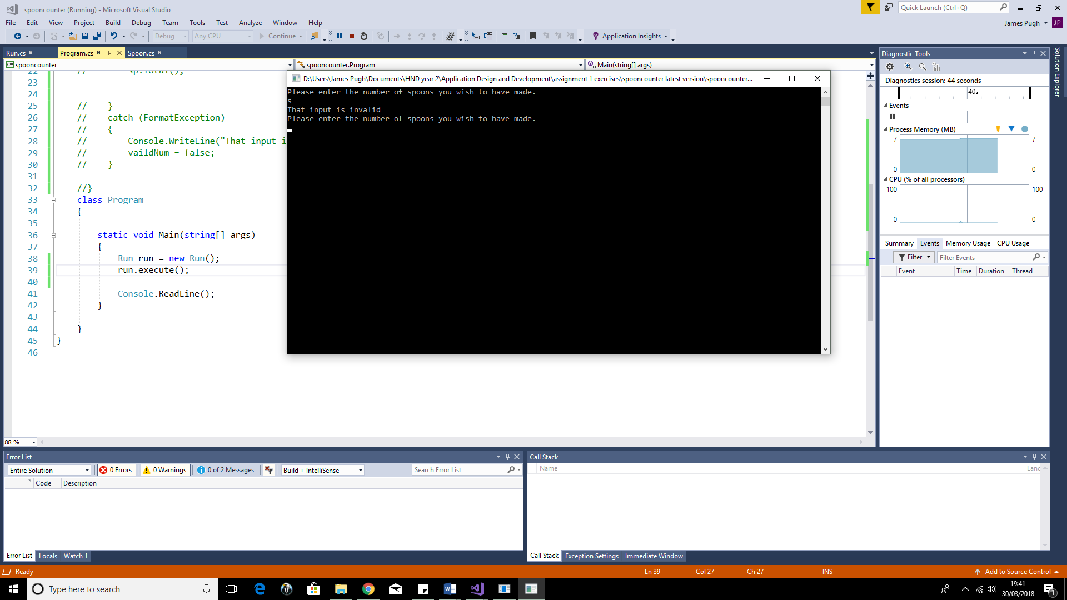

Test 2: How the app responds to a non-full number being passed as the number of spoons to be produced.
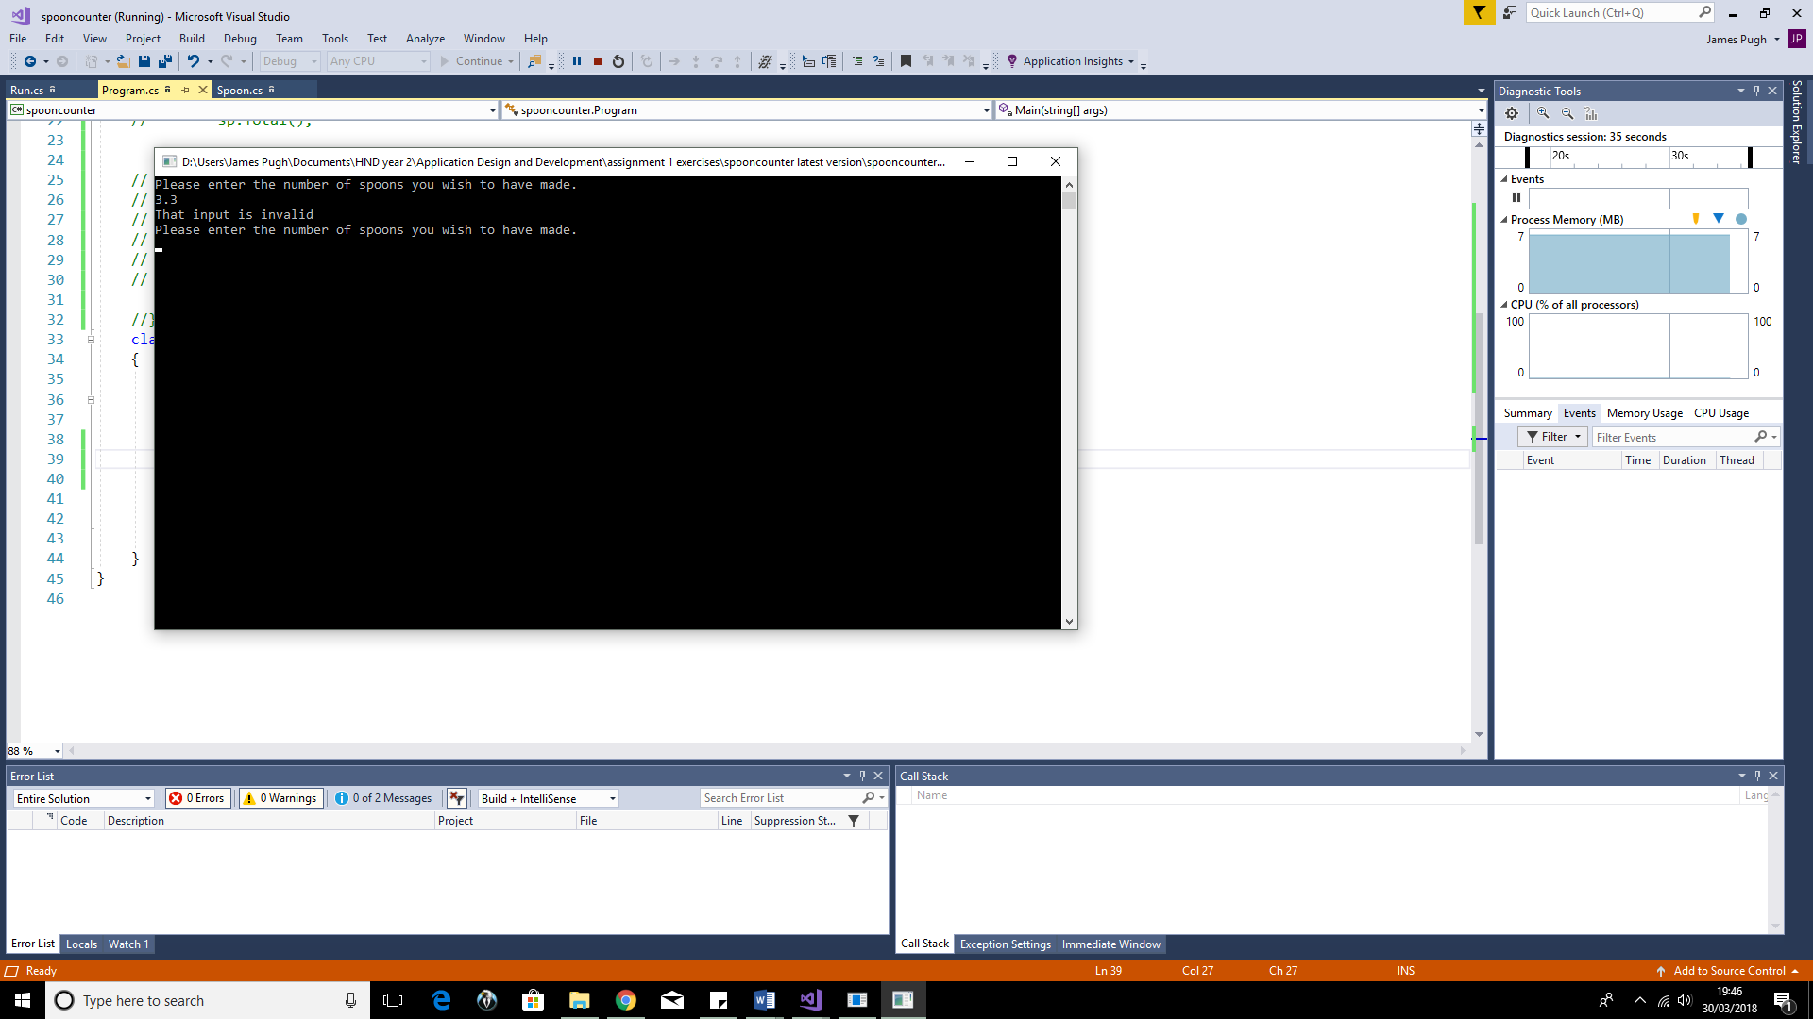

Test 3: How the app responds if a convertible string is parsed as the number of spoons to be produced:

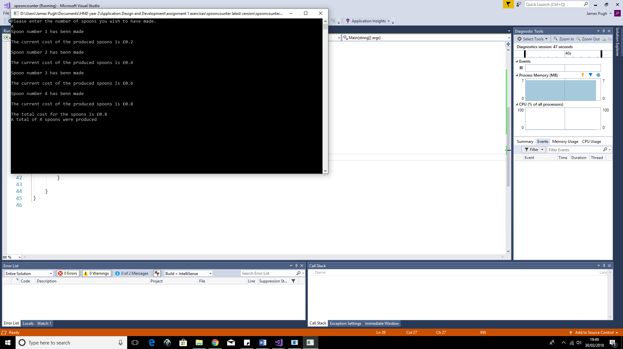

Exercise 2 tests with screenshots

Test 1: What happens if the user enters a non-parseable text string when declaring the X coordinates of one of the circles

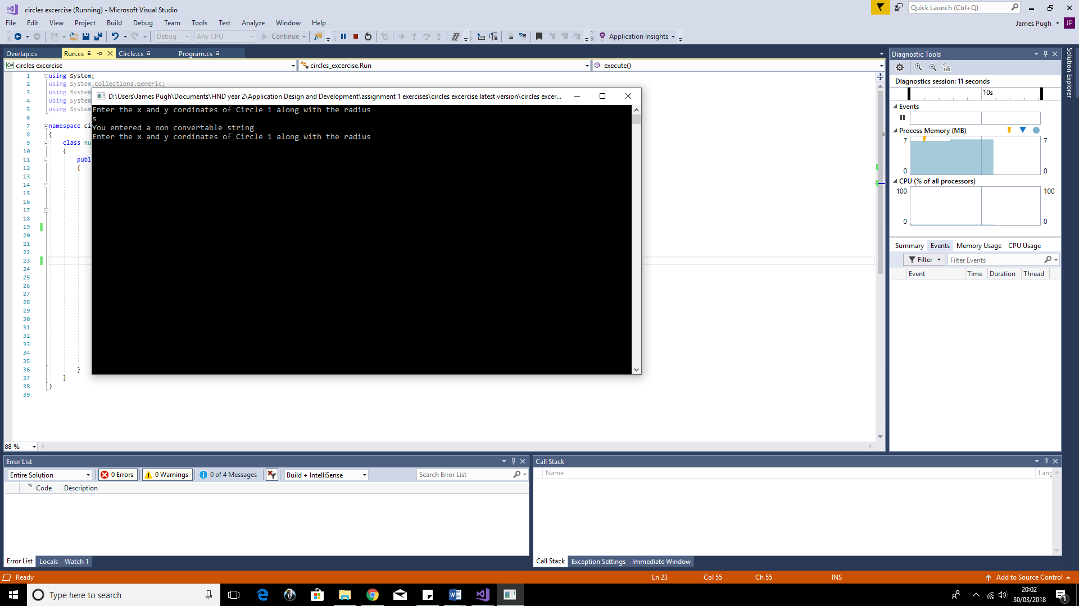

Test 2: What happens if the user enters a non-parseable text string when declaring the Y coordinates of one of the circles
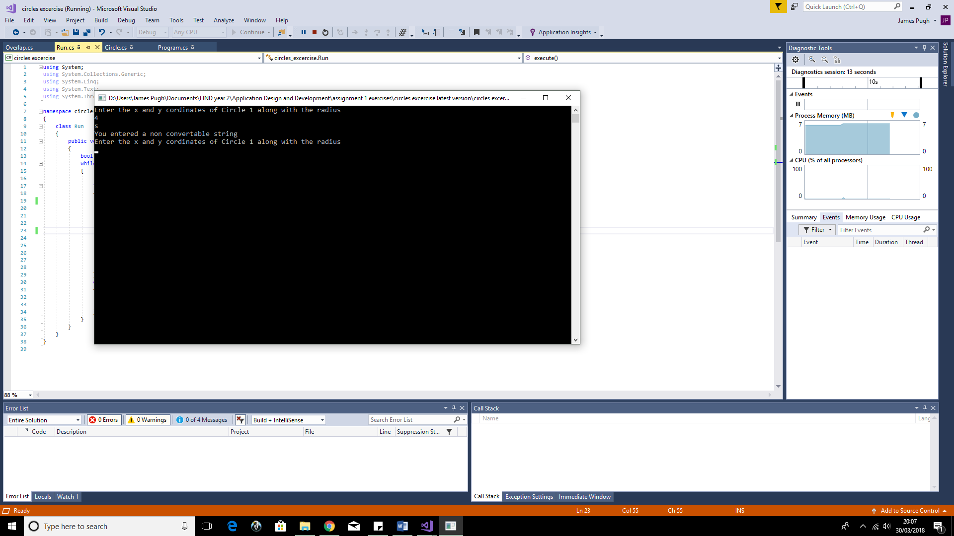

Test 3: What happens if the user enters a non-parseable text string when declaring the radius of one of the circles.
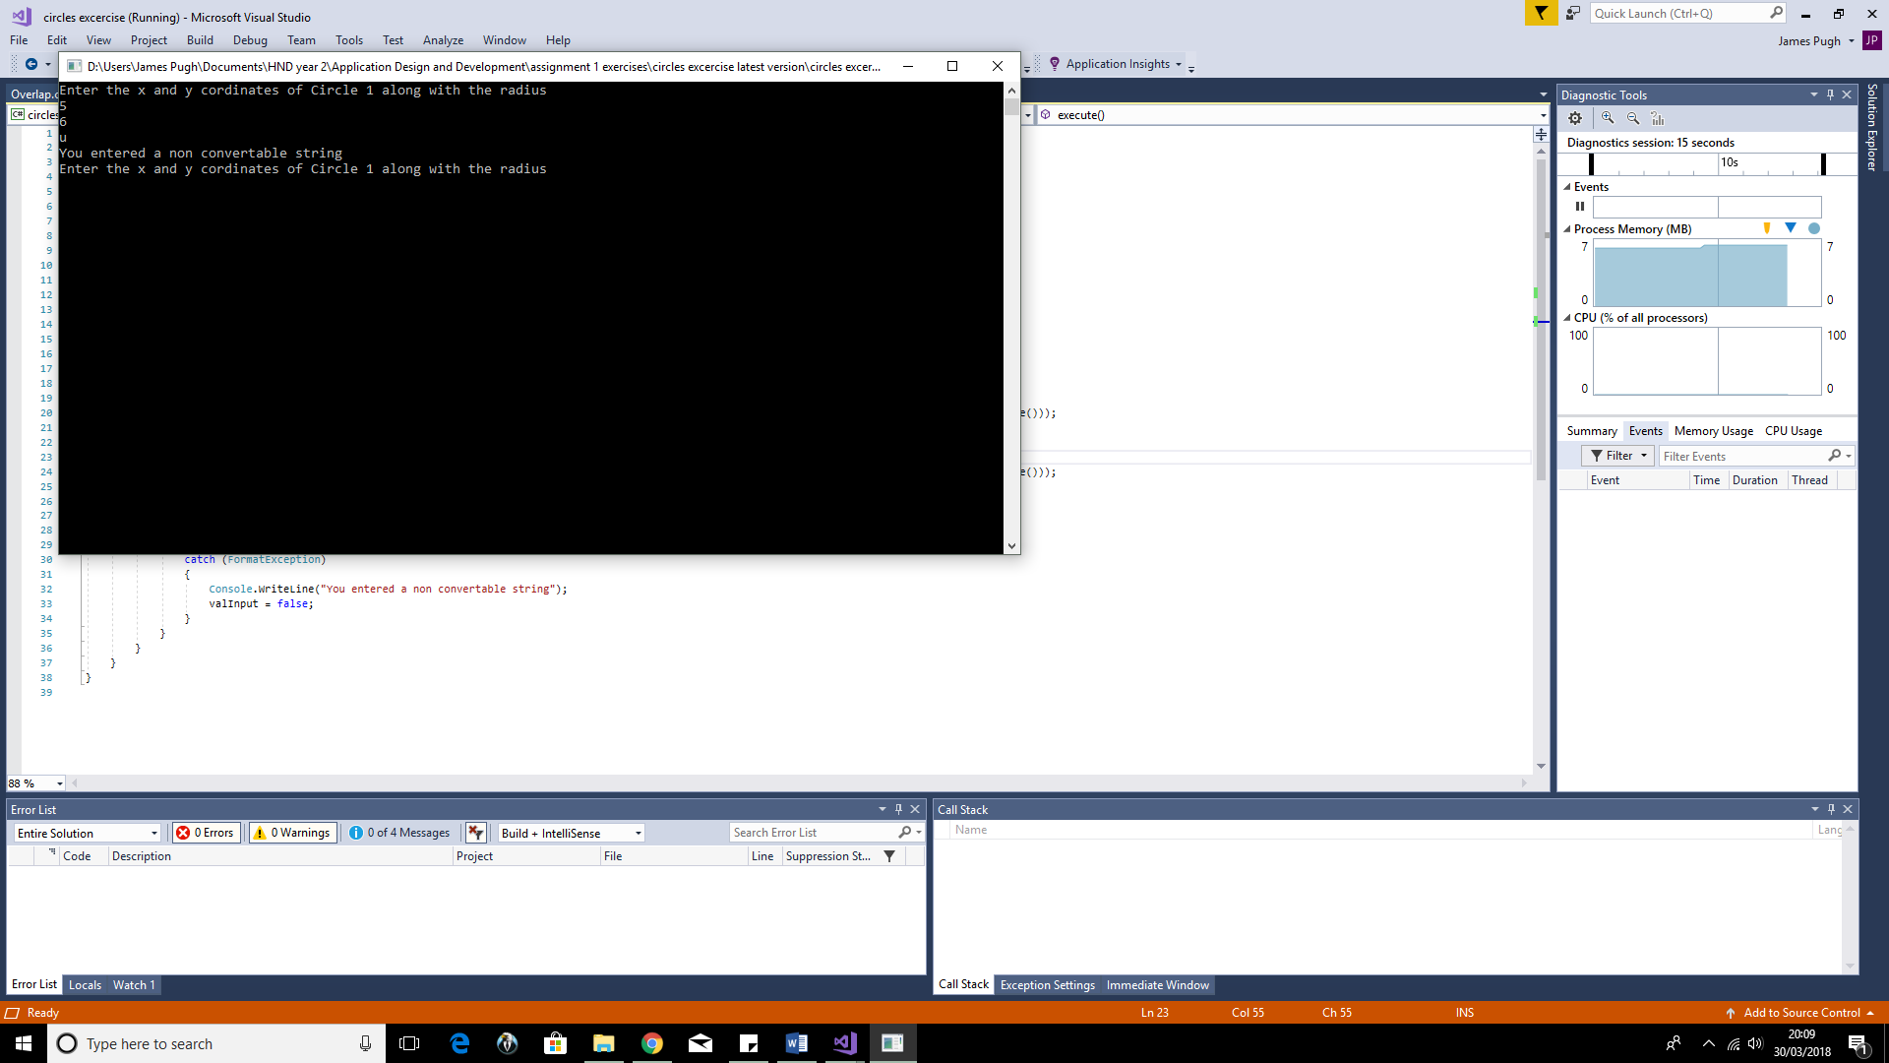

Test 4: How the app responds valid input is provided to the two circles which results in them not overlapping.

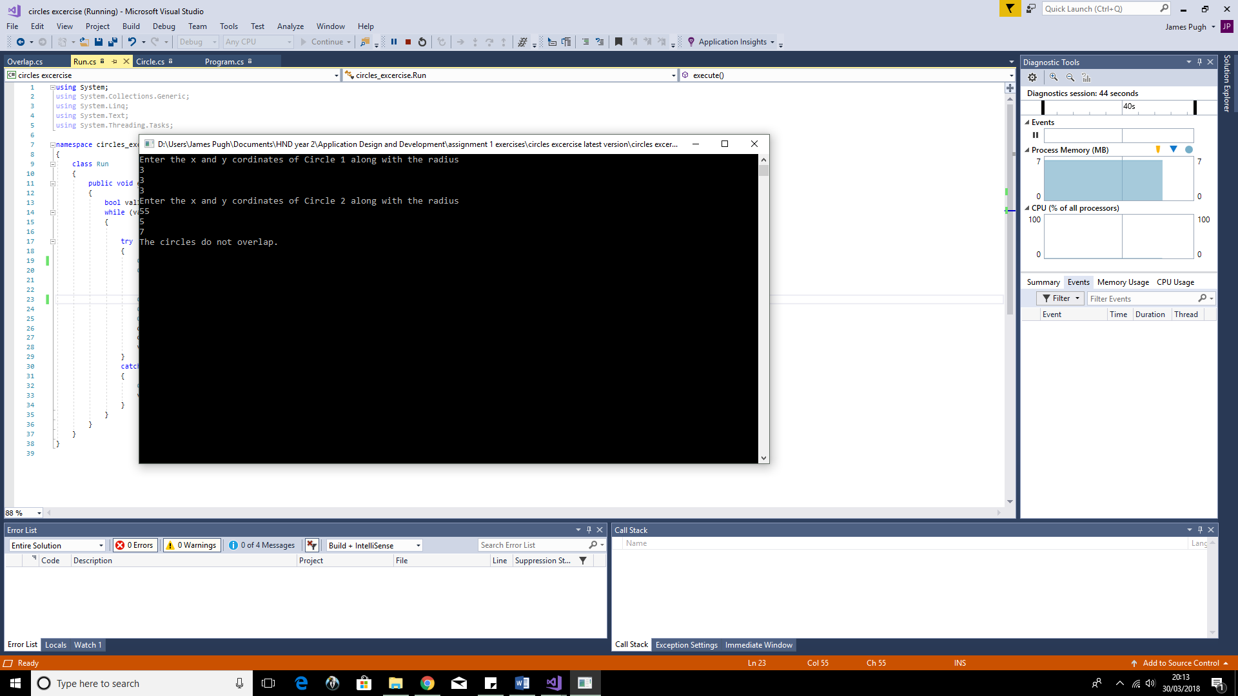

Test 5: How the app responds when valid input is provided to the two circles which results in them overlapping

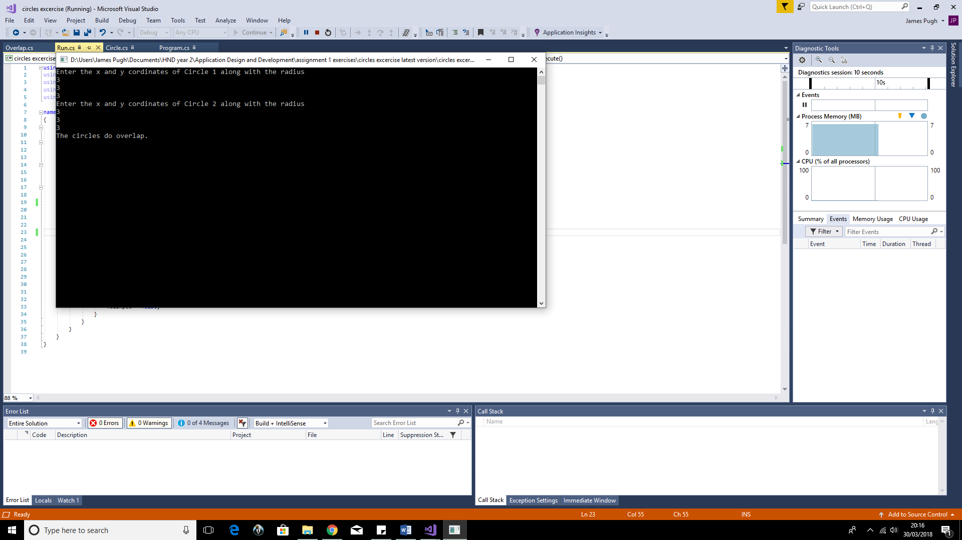

Exercise 3 tests with screenshots

Test 1: What happens if the user enters a non-parseable text string when declaring how many products they wish to purchase
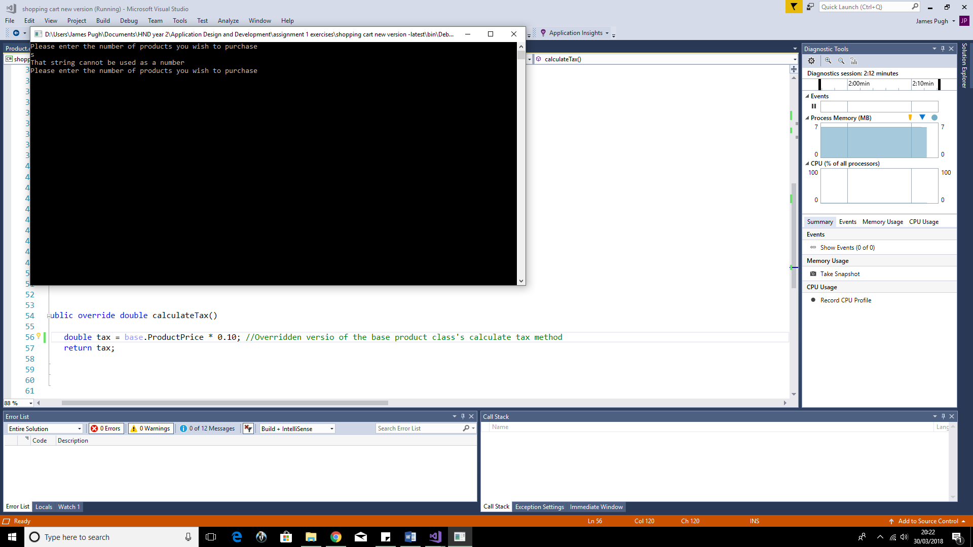

Test 2: What happens when a user passes in an invalid product id when choosing what to purchase
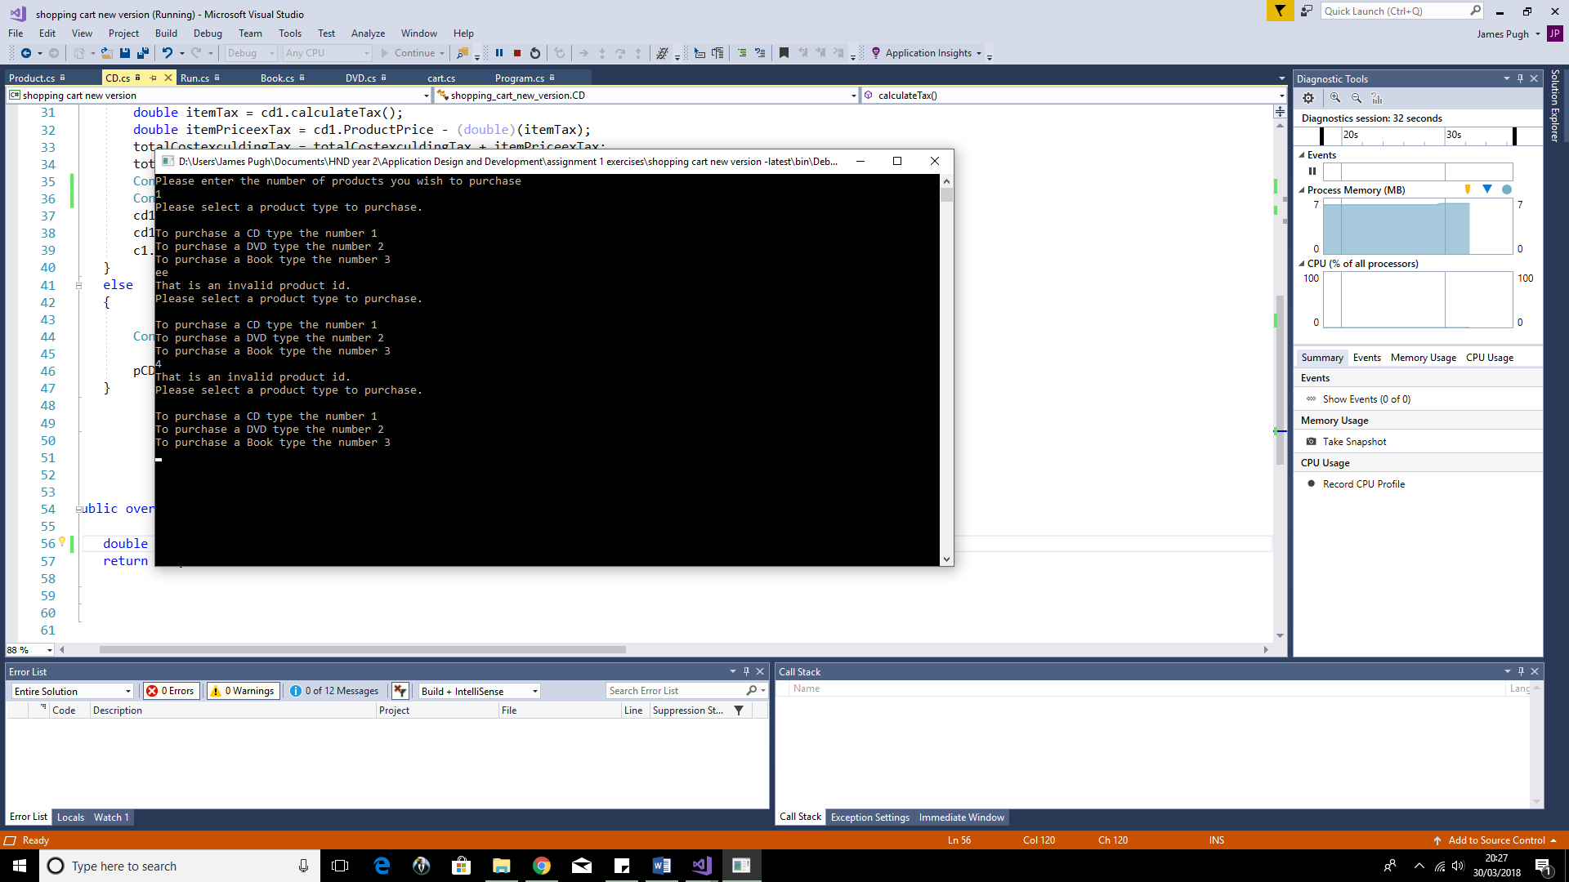

Test 3: What happens when a user enters a non-parseable text string as a products price
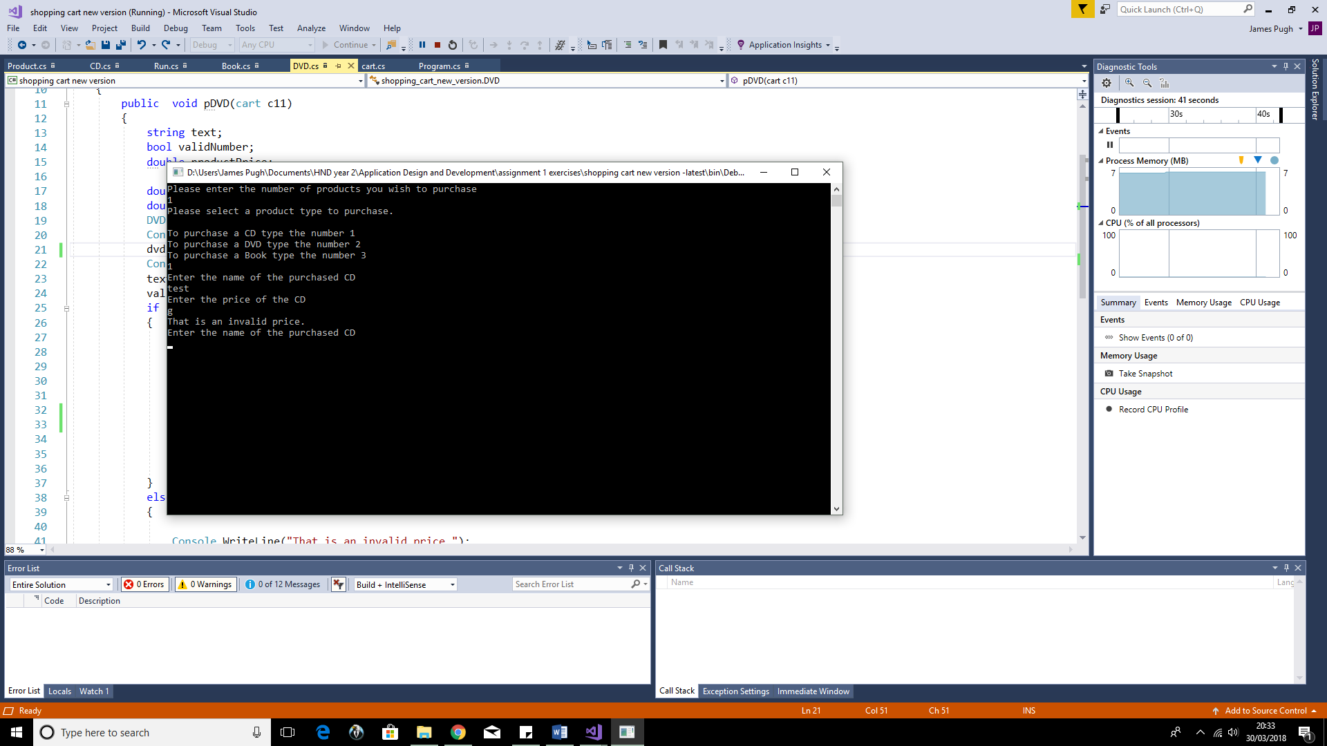

Test 4: What happens when the user successfully purchases 1 of each product type
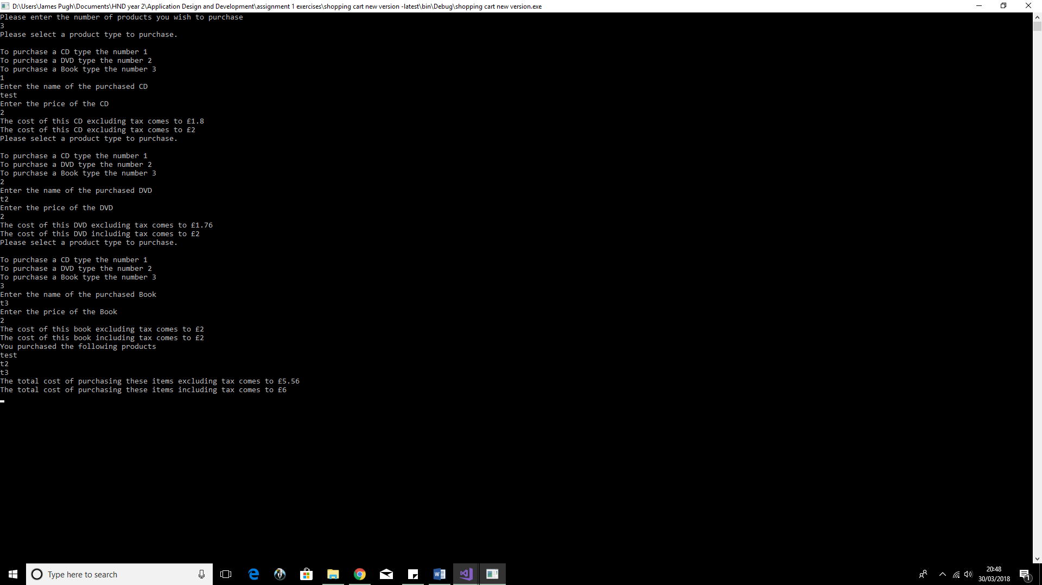

Part C

UML class diagram of part C source code (Note: if diagram is unreadable refer to the PNG version that accompanies this report inside the uploaded zipped folder)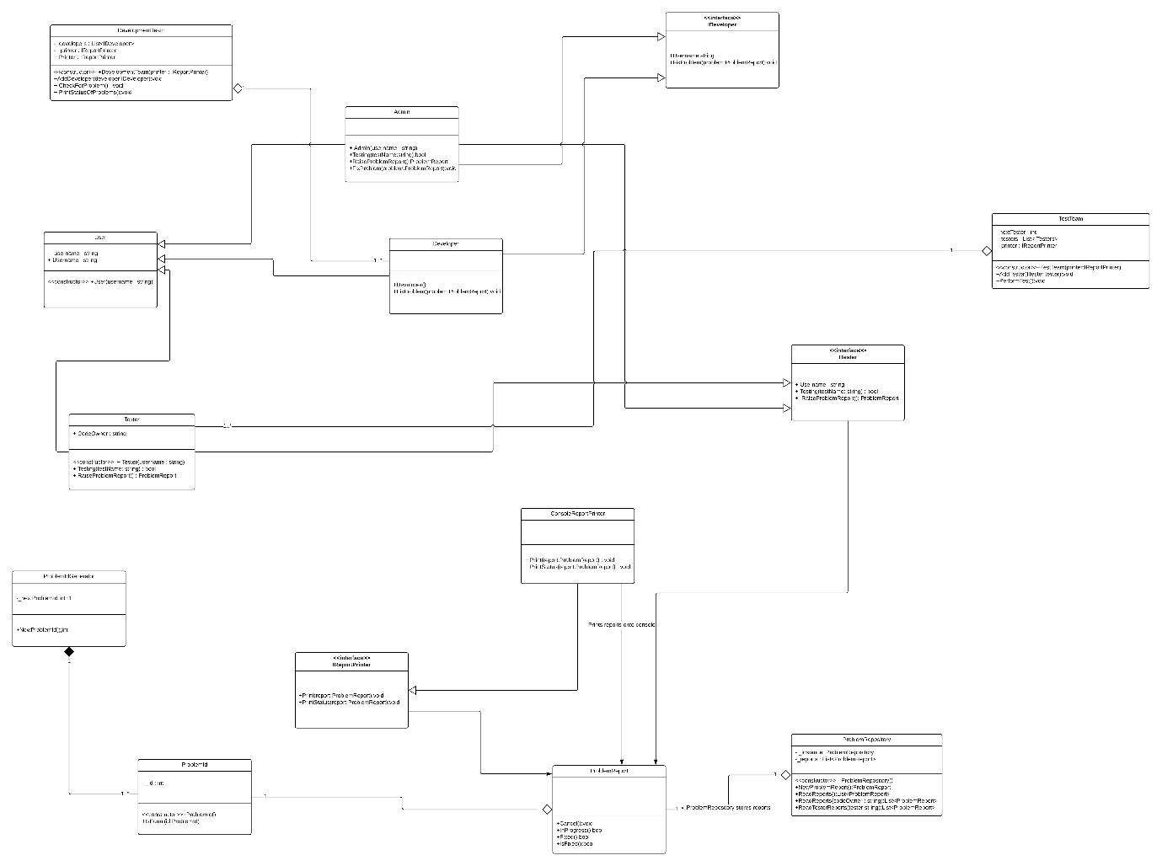)

Part D

Research and discussion into the importance of software testing
Software testing can take many forms including, unit, white box, and black box testing.
White box testing is an approach which centres around analysing and testing the underlying structure and implementation of the application/system. it goes by many other names such as open and glass box testing. This is due to the focus on viewing the often-invisible backend of an app.
There are 3 main parts to WBT, known as statement coverage, branch coverage and path coverage respectively.
Statement coverage involves checking each line of code for successful execution. Branch coverage means testing all possible outcomes including conditional statements and loops, while path coverage refers to testing both all available statements and branches.
White box testing highlights the importance of software testing as without testing the internal structure of an application, developers cannot guarantee that the finished product is fully function let alone in an efficient and future proof state. Furthermore, by achieving aspects of WBT such as maximum statement and branch coverage, developers can more accurately determine, the extent to which the current implementation meets application requirements. This is because, the higher the level of coverage, the more opportunities arise to identify both anomalies in the flow of an application and functional/conditional gaps prior to any user feedback.
In contrast to WBT, Black box testing involves directly testing both functional and non-functional aspects of an application/system without the tester knowing the internal structure or processes occurring in the program’s code.
Part of the process of BBT, is the development of test cases which are tailored small tailored tests typically used to either see if a certain input generates it’s expected output or to see first-hand if the current implementation meets all specification requirements. In addition, BBT expands on WBT by allowing for testing and analysis of secondary factors such as the usability and understandability of an application’s UI. This is due to the tester not being able to access and manipulate the code to navigate/operate the application.
Therefore, BBT provides clear evidence for why software testing is important as through BBT developers can witness first hand virtually the entire process of a user utilising their application. This vital information can then be used to not only focus on meeting unachieved specification requirements but also work to improving the ease of use of the application.
The ability to clearly see whether specification requirements have been met is a major advocate for why testing through methods such as WBT and BBT is important, because if a program does not at least reach the minimum requirements requested, it undoubtedly calls into question whether the current implementation was worth developing at all.
Unit testing is a testing method and part of white box testing, which centres around breaking down an applications code into small individually testable pieces known as units. The main purpose of unit testing is to establish that key features of an application function correctly individually before they are combined to form the full application. This can involve testing to see whether methods within the application respond to user input as expected such as returning the correct values, or handle errors in a smooth manner that doesn’t result in a crash and forced reset. For example, rather than crashing, an input error message is displayed detailing the occurring issue.
Unit testing highlights the importance of software testing in how it necessitates the writing of concise and maintainable code due to requiring that each unit should be simple to test. This has implications both in and out of testing, as more concise code means it should be more readable thereby making further testing less arduous.
Furthermore, the more concise the code, the less likely it is that redundant code is present, thus making the application more efficient and possibly capable of performing more smoothly on release. Redundant code not only could slow the app’s performance, but also open it up to unnecessary risk from unseen errors. These could go unnoticed without implementing unit testing, first appearing when users encountered them. Thus, unit testing also highlights the importance of software testing regarding developers maintaining a reliable image in the eyes of their’ userbase.
Ultimately software is vital not just in terms of creating efficient applications, but also in terms developers never losing sight of an app’s core purpose and audience.
Final word count = 2164

Appendix

Full code with comments

Exercise 1
using System;
using System.Collections.Generic;
using System.Linq;
using System.Text;
using System.Threading.Tasks;

namespace spooncounter
{

class Program
{

static void Main(string[] args)
{
Run run = new Run();
run.execute();

Console.ReadLine();
}

}
}

using System;
using System.Collections.Generic;
using System.Linq;
using System.Text;
using System.Threading.Tasks;

namespace spooncounter
{
class Spoon
{
private int _numOfspoons; //Attribute for storing the number of spoons that are produced. an int was chosen as it is not possble to have a fraction of a spoon produced

public Spoon (int numOfspoons){ // constructor used to allow the user to specify the number of spoons to be produceed
NumberofSpoons = numOfspoons;

}

public void Total() //Method used to calculate the overall cost of producing the desired number of spoons in addition to the total number of spoons produced
{

double Totalcost = _numOfspoons *0.2;
Console.WriteLine("The total cost for the spoons is £" + Totalcost);
Console.WriteLine("A total of "+_numOfspoons+ " spoons were produced");
}
public int NumberofSpoons
{
get
{
return _numOfspoons;
}
set
{
_numOfspoons = value;
}

}

public void spooncount() //method which calculates the latest spoon that has been produced along with providing a current total cost for the produced spoons
{
for (int i=1; i<=_numOfspoons; i++) // A for loop seamed ideal for tackling the issue of keeping a running total of not only the number of spoons made but also the current total cost. This is because, the user passes the number of spoons into the instance of the spoon object located in the main. therby making it easy to loop through these processes for as long as the number of loops is less than the number of spoons to be made. Any other approach seams needlessly complex as this apprach has achived the desired functionality for this method in barely over 10 lines
{
Console.WriteLine ("Spoon number "+i+" has benn made");
double currentTotal = i * 0.2;
Console.WriteLine("");
Console.WriteLine("The current cost of the produced spoons is £" + currentTotal);
Console.WriteLine("");
}
}
}
}
using System;
using System.Collections.Generic;
using System.Linq;
using System.Text;
using System.Threading.Tasks;

namespace spooncounter
{
class Run //The purpose of the run class was to make the application fully object orientated as now the program's main method only requires one declaration of an instance of the run class along with then calling the execute method seen below
{
public void execute()
{
bool vaildNum = false;

while (vaildNum == false) //This while loop combined with the below try catch statement helps the application be more convinient for the user as no matter how many times they enter an invalid value to represent the number of spoons to be made, they can instantly try again with no noticable negative concequences. This is important in the contest of user support as if the user cannot easily and quickly correct mistakes, they are likely to become frustrated and stop using the application regardless of how functional it is in all other situations
{
try
{
Console.WriteLine("Please enter the number of spoons you wish to have made.");

Spoon sp = new Spoon(int.Parse(Console.ReadLine()));
sp.spooncount();
sp.Total();
vaildNum = true;

}
catch (FormatException) // A try catch that looks for a format exception was seen as ideal for removing the issue of a user attempting to pass a not integer convertible string as the number of spoons to be made. Importantly, this approach prevents the application from crashing in the event of a format extension being thrown. Therby making the application more robust while also preventing the user from having to restart the app due to simple errors in input
{
Console.WriteLine("That input is invalid");
vaildNum = false;
}

}
}
}
}

Exercise 2
using System;
using System.Collections.Generic;
using System.Linq;
using System.Text;
using System.Threading.Tasks;

namespace circles_excercise
{
class Program
{

static void Main(string[] args)
{
Run run = new Run();
run.execute();

Console.ReadLine();
}
}
}
using System;
using System.Collections.Generic;
using System.Linq;
using System.Text;
using System.Threading.Tasks;

namespace circles_excercise
{
class Overlap
{
private bool overlapfound = false;

public void overlapdetected(Circle cir1, Circle cir2)
{
double cir1R = cir1.getr;
double cir1X = cir1.getx;
double cir1Y = cir1.gety;

double cir2R = cir2.getr;
double cir2X = cir2.getx;
double cir2Y = cir2.gety;

double Distance;

Distance = ((cir1X - cir2X) * (cir1X - cir2X) + (cir1Y - cir2Y) * (cir1Y - cir2Y)); // This is the raw mathematics behind calculating the distance between the two circles
Distance = Math.Pow(Distance , 0.5);
if (cir1R + cir2R > Distance)
{
overlapfound = true;

}
else
{
overlapfound = false;
}
}
public void overlapmessage() //This method simply displays a message detailing whether the two circles overlap. Simple clear output like this was deemed vital in order to ensure that users could easily grasp the results of the complex formula involved in determining whether the two circles overlap. If this output were not used, the only alternative the writer could see would involve printing the raw calculation results to the console. However, this input would not really be practical when we consider that using it would greatly increase the required knowledge of mathematics from the applications users. It can be argued that creating an app that requires great knowledge somewhat defeats the purpose of designing it as generally software is used as a tool to make tasks easier and more widely understandable.
{
if (overlapfound ==true)
{
Console.WriteLine("The circles do overlap.");
}
else
{
Console.WriteLine("The circles do not overlap.");
}
}

}
}

using System;
using System.Collections.Generic;
using System.Linq;
using System.Text;
using System.Threading.Tasks;

namespace circles_excercise
{
class Circle
{
private double x;
private double y;
private double r;

public Circle(double X,double Y, double R)
{
getx = X;
gety = Y;
getr = R;
}

public double getx
{
get
{
return x;
}
set
{
x = value;
}
}
public double gety
{
get
{
return y;
}
set
{
y = value;
}
}
public double getr
{
get
{
return r;
}
set
{
r = value;
}
}

}

}

using System;
using System.Collections.Generic;
using System.Linq;
using System.Text;
using System.Threading.Tasks;

namespace circles_excercise
{
class Run //The purpose of the run class was to make the application fully object orientated//The purpose of the run class was to make the application fully object orientated
{
public void execute()
{
bool valInput = false;
while (valInput == false)
{

try
{
Console.WriteLine("Enter the x and y cordinates of Circle 1 along with the radius");
Circle c1 = new Circle(Convert.ToDouble(Console.ReadLine()), Convert.ToDouble(Console.ReadLine()), Convert.ToDouble(Console.ReadLine()));// It was deemed necessary for the user to have the ability to enter in their own desired values for the X and Y coordinates as without doing so the writer could not guarantee that the program would prove functional in unpredictable non-happy path situations.

Console.WriteLine("Enter the x and y cordinates of Circle 2 along with the radius");
Circle c2 = new Circle(Convert.ToDouble(Console.ReadLine()), Convert.ToDouble(Console.ReadLine()), Convert.ToDouble(Console.ReadLine()));
Overlap ov = new Overlap();
ov.overlapdetected(c1, c2);
ov.overlapmessage();
valInput = true;
}
catch (FormatException)
{
Console.WriteLine("You entered a non convertable string");
valInput = false;
}
}
}
}
}

Exercise 3
using System;
using System.Collections.Generic;
using System.Linq;
using System.Text;
using System.Threading.Tasks;

namespace shopping_cart_new_version
{
class Program
{

static void Main(string[] args)
{

cart c11 = new cart();
Run run = new Run();
run.shop(c11);

c11.contents(c11);

Console.ReadKey();
}

}
}

using System;
using System.Collections.Generic;
using System.Linq;
using System.Text;
using System.Threading.Tasks;

namespace shopping_cart_new_version
{
public abstract class Product // This class was made abstract so it would not be possible to create an instance of just the base product class. this was done since their will be no times where a user will have the option to purchase an item that isn’t of the book, CD or DVD types
{
private double _productPrice; //Field which stores the price of a product
private string _productName; // Field which stores the name of a product
private double _totalexTax; //Field which stores the price of a product excluding tax
private double _totalincTax; //Field which stores the price of a product including tax
public string ProductName //Property which gets and sets the _productName field's value
{
get
{
return _productName;
}
set
{
_productName = value;
}
}
public double ProductPrice //Property which gets and sets the _productPrice field's value
{
get
{
return _productPrice;
}
set
{
_productPrice = value;
}
}
public double totalexTax //Property which gets and sets the _totalexTax field's value
{
get
{
return _totalexTax;
}
set
{
_totalexTax = value;
}

}
public double totalincTax //Property which gets and sets the _totalincTax field's value
{
get
{
return _totalincTax;
}
set
{
_totalincTax = value;
}
}
public abstract double calculateTax(); //abstract method used as the base for future overriding in the CD, Book, and DVD classes. It was made abstract since any implementation code in this method in the base product class would never be used.

}

}
using System;
using System.Collections.Generic;
using System.Linq;
using System.Text;
using System.Threading.Tasks;

namespace shopping_cart_new_version
{
class CD : Product
{

public void pCD(cart c1)
{
string text; //This string is used as the variable which is checked through double.TryParse to see if the user input a valid number when entering the price of the CD. This was needed since one issue the writter found during this excercise was how to ensure the user could only continue after entering the correct type of input
bool validNumber; //this boolean is used to check if the price input by the user is a valid numerical value. The main reason why these steps were taken to prevent mistakes in user input was to handle the difficult balencing act of providing a non error filled user interface while also allowing users to perform the shopping process quickly and efficiently
double productPrice;
double totalCostexculdingTax = 0;
double totalCostincludingTax = 0;

CD cd1 = new CD();
Console.WriteLine("Enter the name of the purchased CD");
cd1.ProductName = Console.ReadLine();
Console.WriteLine("Enter the price of the CD");
text = Console.ReadLine();
validNumber = double.TryParse(text, out productPrice);
if (validNumber == true)
{
cd1.ProductPrice = productPrice;
double itemTax = cd1.calculateTax();
double itemPriceexTax = cd1.ProductPrice - (double)(itemTax);
totalCostexculdingTax = totalCostexculdingTax + itemPriceexTax;
totalCostincludingTax = totalCostincludingTax + cd1.ProductPrice;
Console.WriteLine("The cost of this CD excluding tax comes to £"+totalCostexculdingTax);
Console.WriteLine("The cost of this CD excluding tax comes to £"+totalCostincludingTax);
cd1.totalexTax = totalCostexculdingTax;
cd1.totalincTax = totalCostincludingTax;
c1.PurchasedProducts.Add(cd1);
}
else
{

Console.WriteLine("That is an invalid price.");

pCD(c1); //While rerunning the product purchase method if the entered price is invalid forces the user to re-enter the name of the purchased item, the naming process and only secods to the overall time from when a user starts the purchas process to when it is complete. However, in an indeal world the writter would take the time to patch this issue out in order to provide a smoother
}

}

public override double calculateTax()
{
double tax = base.ProductPrice * 0.10; //Overridden versio of the base product class's calculate tax method
return tax;
}
}
}
using System;
using System.Collections.Generic;
using System.Linq;
using System.Text;
using System.Threading.Tasks;

namespace shopping_cart_new_version
{
class Book : Product
{
public void pB(cart c11)
{
string text;
bool validNumber;
double productPrice;

double totalCostexculdingTax = 0;
double totalCostincludingTax = 0;
Book book1 = new Book();
Console.WriteLine("Enter the name of the purchased Book");
book1.ProductName = Console.ReadLine();
Console.WriteLine("Enter the price of the Book");
text = Console.ReadLine();
validNumber = double.TryParse(text, out productPrice);
if (validNumber == true)
{
book1.ProductPrice = productPrice;
double itemTax = book1.calculateTax();
double itemPriceexTax = book1.ProductPrice - (double)(itemTax);
totalCostexculdingTax = totalCostexculdingTax + itemPriceexTax;
totalCostincludingTax = totalCostincludingTax + book1.ProductPrice;
Console.WriteLine("The cost of this book excluding tax comes to £"+totalCostexculdingTax);
Console.WriteLine("The cost of this book including tax comes to £"+totalCostincludingTax);
book1.totalexTax = totalCostexculdingTax;
book1.totalincTax = totalCostincludingTax;
c11.PurchasedProducts.Add(book1);
}
else
{

Console.WriteLine("That is an invalid price.");

pB(c11);

}
}

public override double calculateTax()
{
double tax = 0;
return tax;
}
}
}
using System;
using System.Collections.Generic;
using System.Linq;
using System.Text;
using System.Threading.Tasks;

namespace shopping_cart_new_version
{
class DVD : Product
{
public void pDVD(cart c11)
{
string text;
bool validNumber;
double productPrice;

double totalCostexculdingTax = 0;
double totalCostincludingTax = 0;
DVD dvd1 = new DVD();
Console.WriteLine("Enter the name of the purchased DVD");
dvd1.ProductName = Console.ReadLine();
Console.WriteLine("Enter the price of the DVD");
text = Console.ReadLine();
validNumber = double.TryParse(text, out productPrice);
if (validNumber == true)
{
dvd1.ProductPrice = productPrice;
double itemTax = dvd1.calculateTax();
double itemPriceexTax = dvd1.ProductPrice - (double)(itemTax);
totalCostexculdingTax = totalCostexculdingTax + itemPriceexTax;
totalCostincludingTax = totalCostincludingTax + dvd1.ProductPrice;
Console.WriteLine("The cost of this DVD excluding tax comes to £" + totalCostexculdingTax);
Console.WriteLine("The cost of this DVD including tax comes to £" + totalCostincludingTax);
dvd1.totalexTax = totalCostexculdingTax;
dvd1.totalincTax = totalCostincludingTax;
c11.PurchasedProducts.Add(dvd1);
}
else
{

Console.WriteLine("That is an invalid price.");

pDVD(c11);

}
}

public override double calculateTax()
{
double tax = base.ProductPrice *0.12;
return tax;
}

}
}
using System;
using System.Collections.Generic;
using System.Linq;
using System.Text;
using System.Threading.Tasks;

namespace shopping_cart_new_version
{
class cart
{
private List<Product> purchasedProducts = new List<Product>(); // Using a list to store the purchased products made more sense mentally than using an array as lists are often associated with shoping. Therefore, the writter believed that through utilising a list he would find it easier to visualise the processes involved in implementing the shopping cart.

public List<Product>PurchasedProducts
{

get
{
return purchasedProducts;
}
set
{
purchasedProducts = value;
}

}
public void contents(cart cart)
{
double totalextax = 0;
double totalinctax = 0;
Console.WriteLine("You purchased the following products");
foreach(var product in cart.purchasedProducts)
{
Console.WriteLine(product.ProductName);
totalextax = totalextax + product.totalexTax;
totalinctax = totalinctax + product.totalincTax;

}
Console.WriteLine("The total cost of purchasing these items excluding tax comes to £"+totalextax);
Console.WriteLine("The total cost of purchasing these items including tax comes to £"+totalinctax);
}

}
}
using System;
using System.Collections.Generic;
using System.Linq;
using System.Text;
using System.Threading.Tasks;

namespace shopping_cart_new_version
{
class Run
{
public void shopmenu() // The goal of this shopmenu method was to create an easily readable and understandable user interface as due to the mass appeal of shopping both in store and online, the writter could not garentee that all users of this software would be computer savay and as such tried to cater to as wide an audiance as possible
{
Console.WriteLine("Please select a product type to purchase.");
Console.WriteLine("");
Console.WriteLine("To purchase a CD type the number 1");
Console.WriteLine("To purchase a DVD type the number 2");
Console.WriteLine("To purchase a Book type the number 3");

}
public void shop(cart cart)
{
string text;
int numOfproducts;

bool valinput = false;
bool validNumber;

while (valinput == false)
{
try
{

Console.WriteLine("Please enter the number of products you wish to purchase");
text = Console.ReadLine();
numOfproducts = int.Parse(text);
for (int i = 0; i < +numOfproducts; i++)
{
Run r1 = new Run();
r1.shopmenu();
valinput = true;
text = Console.ReadLine();
int productTypeid;
validNumber = int.TryParse(text, out productTypeid);
if (productTypeid == 1 || productTypeid == 2 || productTypeid == 3)
{
validNumber = true;
}
else
{
validNumber = false;
}
if (validNumber == true)
{
switch (productTypeid)
{

case 1:
CD cd1 = new CD();
cd1.pCD(cart);
break;
case 2:
DVD dvd1 = new DVD();
dvd1.pDVD(cart);
break;
case 3:
Book book1 = new Book();
book1.pB(cart);
break;
}
}

else
{
Console.WriteLine("That is an invalid product id. ");
i = i - 1;
}
}

}
catch (FormatException) //
{
Console.WriteLine("That string cannot be used as a number");
}
}
}

}
}

