Sophie Michelle Evans
(2108843)
Blaenafon
Distinctiveness and Regeneration (BMSP4005)
Blaenafon

The Industrial Revolution started in Britain in the latter half of the 18th Century and with it brought technological, socioeconomic and cultural changes. As The Editors of Encyclopaedia Britannica (No Date) mentions these technological advancements ushered in new methods of working and living, drastically altering civilization. Some of the technological changes were use of new materials such as iron and steel. As Thomas (No Date) mentions with the development of new machinery such as the water wheel, which was used to power machinery, and the steam engine which contributed to the acceleration of manufacturing.
As The Big Pit National Museum (No Date) mentions prior to the Industrial Revolution, the only structure in Blaenafon, which is located in the South Wales Valleys, was a single church. However, the mountains' wealth in coal, limestone, fireclay and iron ore provided Blaenafon with a role to play as three of those components iron stone, limestone, and coke were utilised to make the iron and steel that powered the industrial revolution. But with the hunger for coal and iron events at Blaenafon soon began to prosper.
As Everything Everywhere (No Date) mentions in 1788, iron makers from the West Midlands Thomas Hill, Thomas Hopkins, and Benjamin Pratt came to Blaenavon with knowledge of the mineral resources available in the mountains and built a new large ironworks, bringing the latest Industrial Revolution technology and organisation to life in a new and resource-rich location. The ironworks featured three steam-powered blast furnaces by 1789.
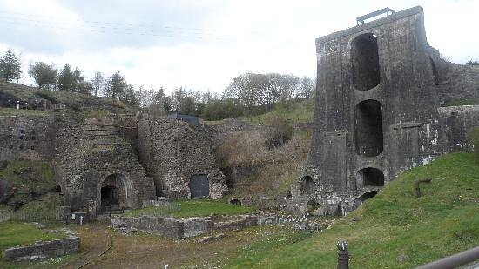
As Big Pit National Coal Museum (No Date) mentions towns were developed around the iron works and quarries to house workers and their families. By the 1800s there were a 1000 people living in Blaenafon and by the mid-19th century the population increased through the mitigation of workers from rural areas. Blaenafon became one of the most important iron making areas and at one time it was the 2nd largest iron works in the world.
TripAdvisor (No Date) Blaenavon Ironworks

During the industrial revolution there was an increase in demand for iron. As Cadw (No Date) mentions Welsh iron created ground-breaking engines, tools, and machineries. It constructed bridges, ships, and rail lines. According to Blaenavon Ironworks (No Date) due to Great Britain's continual international wars in the 18th century, iron was in great demand as a supply of weaponry was required to create cannonballs and other weapons. According to Cadw (No Date) By 1852, 666,000 tonnes of pig iron was being produced using six blast furnaces.

As the Big Pit National Coal Museum (No Date) mentions in 1879 Sidney Gilchrist Thomas and his cousin Percy developed a revolutionary technological development to transform iron into steel by eliminating the phosphorus and generating pure steel. This method was so successful that iron and steel companies all over the world began utilising it. This revolutionised the way people worked all across the world, and Blaenafon became the birthplace of the steel industry as a result.
Working life during this time was still extremely tough considering the technological changes, As Wales Online (2013) mentions workers that included men, women and children worked extremely hard to keep the furnaces going which was a daily task 7 days a week. As Cadw (No Date) mentions the environment in which the workers worked in exposed them to continuous dangers of fire or molten metal, poisonous fumes, and heavy machinery, resulting in many workers having a reduced life expectancy. As Cadw (No Date) mentions in 1842 Government Inspectors discovered 185 children under the age of 13 working at the Iron Works and the mines, even children at the age of 5 were required to work.

As Big Pit (No Date) mentions Big Pit was one of several collieries that operated in the Blaenavon area during the 19th and 20th century. The Blaenavon Company sunk it to a depth of 200 feet in 1860, and it was deepened to 300 feet in 1880, earning its name "Big Pit" due to its exceptionally massive elliptical shaft. Welsh coal was used to power locomotives, steam ships, factories, and homes. Blaenavon specialised in coal production in order to capitalise on the high demand. Blaenafon coal was shipped around the world.
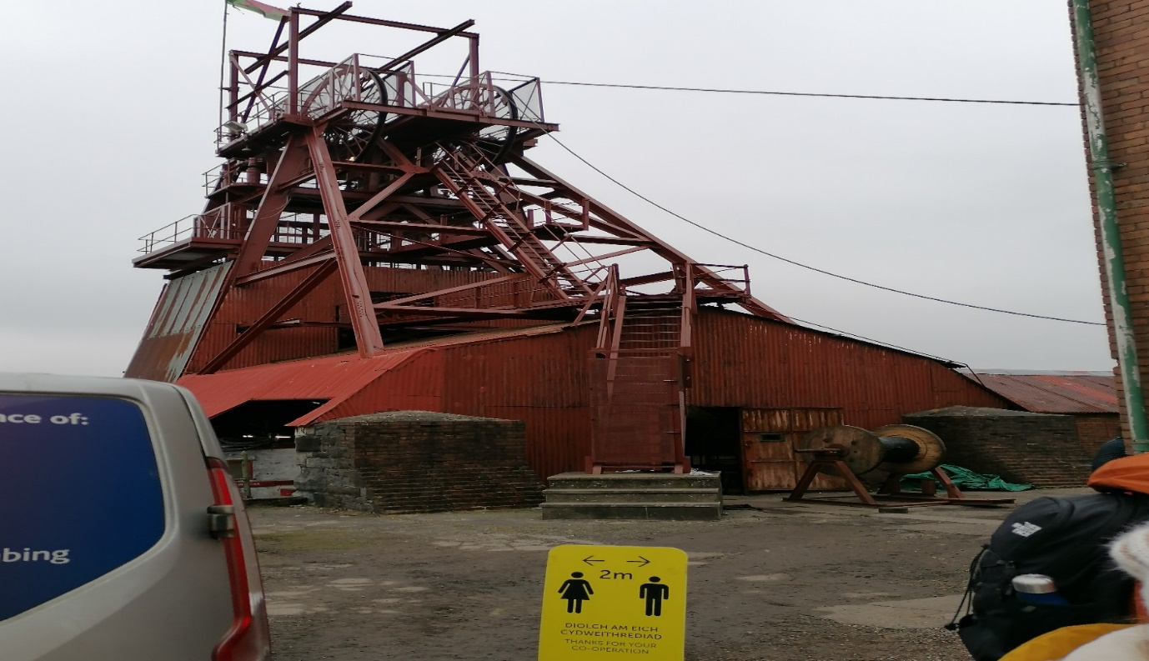
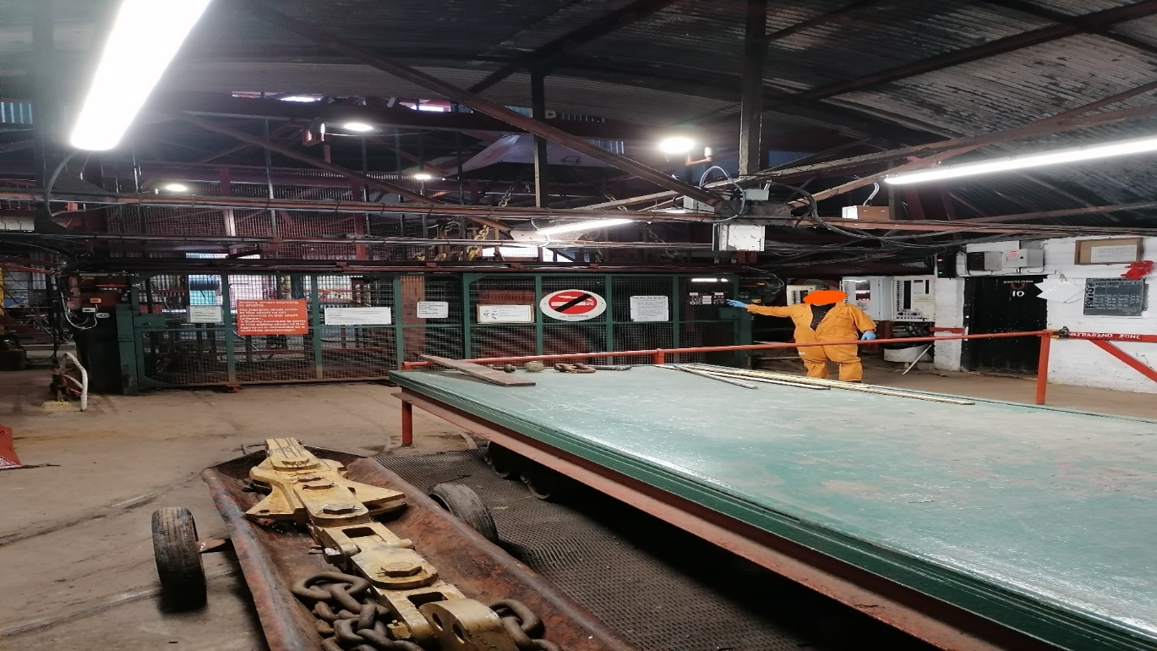
Big Pit National Museum Fieldtrip Images (2022)

As Big Pit National Coal Museum (No Date) mentions Miners always returned home in their workwear , which were covered in coal dust and sweat; once home, miners could only take a tin bath in front of a fire to get rid of as much dirt as possible, or they had to wash outside in the back yard. This meant they had to return home to their families in this state, which lead to health issues. However, the introduction of Pithead Baths changed the game for the workers and their families. According to the Pig Bit National Coal Museum (No Date), after their shift in the mine, the miners would place their workwear in a locker where it would be hung to dry, have a shower, and utilise the second locker provided for their clean clothes.

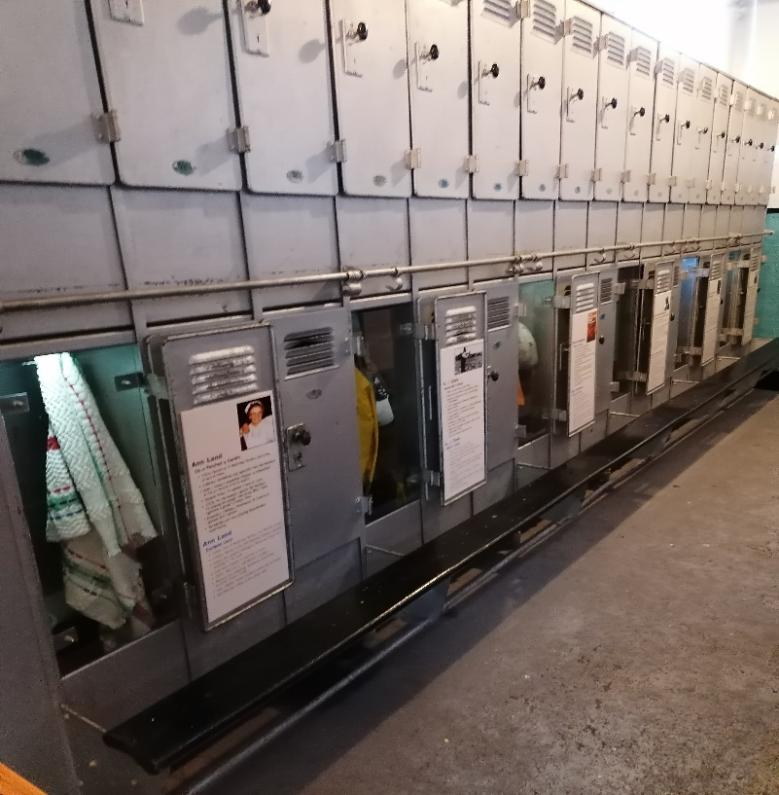
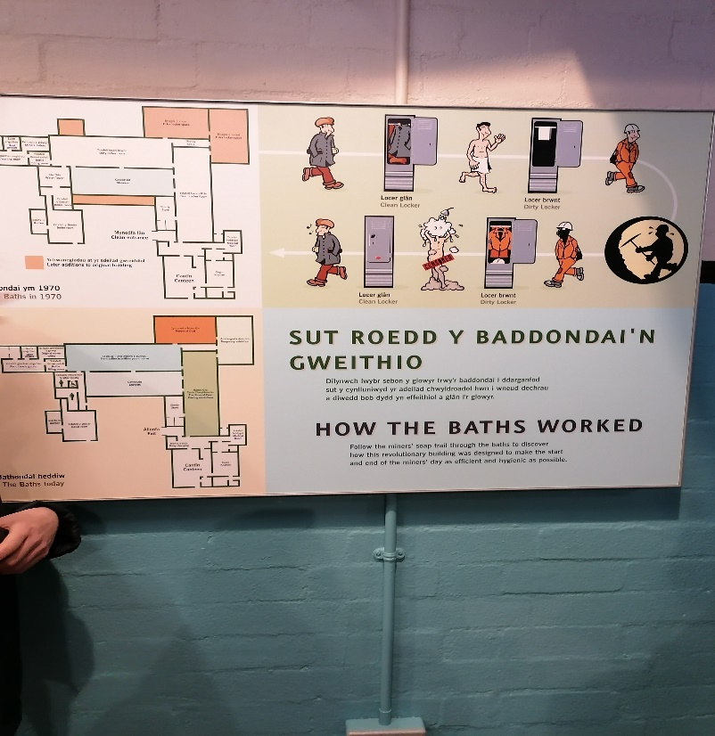
Big Pit National Coal Museum Fieldtrip Images (2022)

As Historic Landscape Characterisation (No Date) mentions The Blaenavon iron company controlled an industrial landscape that included iron ore patches, coalmines, limestone quarries, iron forges, brickworks, tramroads, watercourses, and workers' homes.

Essential Travel Guide (No Date) mentions the Pontypool and Blaenavon Railway was built in 1866 to aid in the transportation of coal to the Midlands region of the United Kingdom. A few years later, the line was expanded to run all the way through Pontypool and on to Newport on the coast.
As Blaenavon Workmen`s Hall (No Date) mentions in 1895 The Workers Hall was opened in Blaenavon, which was funded by contributions from Blaenavon’s workers weekly wages. The Hall became the focal point of Blaenavon’s cultural life. Concerts, political gatherings, and other events were held at the Hall. There was a library available to workers and their families. There was also a snooker room and cinema provided for recreation and entertainment purposes.

As Alexander, N (2017) mentions In the 1840`s Blaenavon’s commercial centre arose through the efforts of a businessman John Griffith Williams, who established the towns first covered market in 1840. Over the next few decades, a wide array of stores were developed along the new road that connected the iron works to the market. This new road was given the name Broad Street in 1860. The potential to sell goods and services to the local community of ironworkers and miners drew immigrants just as much as the ironworks did in the late 18th and early 19th centuries. Shopkeepers from all over the country and world gathered to Blaenavon to open shops, providing jobs for the locals, including women. The town sustained well over 150 businesses in the second part of the nineteenth century, providing residents with practically everything they needed

Conclusion

Blaenafon achieved economic success during the industrial revolution and helped underpin the modernisation of the world with the use of the materials that resided in the area. Blaenavon was a major centre for iron production and coal mining. Bath Pits, together with new technology methods and improved working conditions, contributed to workers' working life. Blaenafon prospered as its commercial centre grew.

References

Alexander, N (2017) Blaenavon Townscape Heritage Programme: The Historical Context. pp9. Retrieved From: The-Blaenavon-Townscape-Story.pdf (visitblaenavon.co.uk)

Blaenavon World Heritage Site (No Date) Visit Blaenavon. Retrieved From: Visit Blaenavon - Blaenavon World Heritage Site

Big Pit National Coal Museum (No Date) Iron Town: Blaenafon and its part in the Industrial Revolution. [Video] Retrieved From: Iron Town: Blaenafon and its part in the Industrial Revolution | National Museum Wales

Big Pit National Coal Museum [Fieldtrip]

Big Pit National Coal Museum (No Date) The Pithead Baths. Retrieved From: The Pithead Baths | National Museum Wales

Big Pit (No Date) Big Pit: A Brief History. Retrieved From: Microsoft Word - Big Pit (visitblaenavon.co.uk)

Blaenavon Workmen`s Hall (No Date) History. Retrieved From: History - Blaenavon Workmen's Hall (blaenavonworkmenshall.uk)

Blaenavon Ironworks (No Date) Blaenavon Ironworks: A Brief History. Retrieved From: Microsoft Word - Blaenavon Ironworks (visitblaenavon.co.uk)

Cadw (No Date) Danger: Children at Work. Blaenavon Iron Works. Retrieved From: More about Blaenavon Ironworks | Cadw (gov.wales)

Cadw (No Date) Giant of the industrial age still stands tall on the shoulders of its workers. Blaenavon Iron Works. Retrieved From: Blaenavon Ironworks | Cadw (gov.wales)

Cadw (No Date) Blaenavon Industrial Landscape Heritage Site. Retrieved From: Blaenavon Industrial Landscape World Heritage Site | Cadw (gov.wales)

Everything Everywhere (No Date) Blaenavon Industrial Landscape. Retrieved From: Blaenavon Industrial Landscape UNESCO World Heritage Site (everything-everywhere.com)

Essential Travel Guide (No Date) Blaenavon Industrial Landscape. Retrieved From: Blaenavon Industrial Landscape | Visitor Information for Blaenavon (essentialtravelguide.com)

Historic Landscape Characterisation (No Date) Blaenavon Historical Processes, Themes and Background. Retrieved From: Blaenavon Historical Processes, Themes and Background (ggat.org.uk)

The Editors of Encyclopaedia Britannica (No Date) Industrial Revolution. Britannica. Retrieved From: Industrial Revolution | Definition, History, Dates, Summary, & Facts | Britannica

TripAdvisor (NO Date) Blaenavon Ironworks [Photograph] Retrieved From: Blaenavon Ironworks - 2022 All You Need to Know Before You Go (with Photos) - Blaenavon, Wales | Tripadvisor

Thomas (No Date) History of the Industrial Revolution: Man – Made to Machining. Thomas A Xometry Company. Retrieved From: History of the Industrial Revolution: Man-Made to Machining (thomasnet.com)

Wales Online (2013) Welsh History Month: Blaenavon Iron Works. Wales Online. Retrieved From: Welsh History Month: Blaenavon Ironworks - Wales Online

