Log in Details
Website: Cinematic Delights
Log in: alinaolaru_95@yahoo.com
Password: Thomas13!
Digital skills and research methods
Lecturer: Christian Felices
Student: Alina Olaru 2123361

Table of Contents
Introduction 3
Importance of market research for businesses 4
Analysis of the questionnaire data and its influence 6
Rationale for how questionnaire data influenced website design 9
Importance of SEO and how primary research informs SEO strategy 13
Conclusion 14
References 15

Introduction
Entrepreneurships are built on the very idea of solving a problem of the target market segment. An existing demand that was not identified or fulfilled by the organisations operating in the market or a demand that has yet to be realised, this is the primary selling point for the organisations (Szerb, 2018). So is only natural that in-depth idea of the market is of absolute importance for any entrepreneurships and then to promote the product accordingly. Market research is changing the entrepreneurial decisions based on what the people actually want is the key.

Importance of market research for businesses
The contemporary business environment is focusing greatly on personalised advertisements where broadcasting promotional messages to general populace is no longer considered effective. More and more organisations are going for personalised advertisements where these ads are targeted to attracted only those have vested interested in them (Freeling, 2019). This is possible due to market research. Market research is the organised effort to accumulate information about the target market segment in order to identify their preferences and needs. Market research makes little differences no matter how enriched it may be (Freeling, 2019). It only becomes the highly effective cutting edge tool when used in formulate the business strategy. Organisations of today’s business landscape are taking the customer centric approach day by day and to adopt this approach understanding the core consumers, their habits & preferences and other such facts is a must (Chadwick, 2014). This is where market research come in. market research is all about understanding the customers and it is proven from research that companies that took a customer centric approach are 60% more profitable than companies that don’t (Chadwick, 2014). Entrepreneurships are based on solving a customer problem or pain points, market research ensures that the organisation understands these pain points and preferences and in this way are be able to deliver the greatest value for the customers (Yallapragada and Bhuiyan, 2011).
Now to take a customer centric approach a company may take the STP approach which means segmentation, targeting and positioning (Gupta and Ramachandran, 2021). These points mean that the organisation first find out the probable separate groups of potentials customers. After that it identifies the segments with greatest potential. And finally, set the marketing & promotional strategies to set a unique position for the brand in the customer’s minds (Gupta and Ramachandran, 2021). This is the implementation stage of market research. This work as bridge between the company’s marketing strategy and the customers where the reaching the customers is made possible by the market research done.
Market research not only makes marketing strategies well-informed but also it make them much more efficient and effective. In the traditional marketing strategies, segmentation is much more generalised and was aimed at vast numbers of peoples. This made them perfect their messages through trial & error basis (Harwood and Ward, 2013). As an example, may be one gadget was deemed necessary for half of the urban population but after extensive marketing campaigns it may become evident that only the teenagers and young adults are attracted to the gadget and not the older generations (Harwood and Ward, 2013). This means that resources were lost promoting to the groups that do not find the particular product attractive and does not suit their needs (Harwood and Ward, 2013). But market research also shows ways of more effective ways of utilising company’s competitive advantage. In-depth market research brings out under served segments and enable the company to capture great market share by reaching out towards this segments.
Now market research is mainly two types: primary and secondary. Secondary market research is where the organisation use the data and information already existing on the market. but this is a weak form of market research as any information is available to one organisation, also should be available for the other ones as well (Harwood and Ward, 2013). So, to achieve true advantage through market, primary market research is necessary where the organisation gathers data and information itself or through experts in order to create meaningful perceptions.

Analysis of the questionnaire data and its influence
The data gathered from the questionnaire provided insight into how the business should be presented before the customers. This is a primary market research of the potential customers and this way their responses provide relevant data on their perception off the business. The perception of the customers about the business is the key element of market research. This perception is how they see the products offered by the business and ultimately how they would respond to the promotional activities. It would support the business decisions of my enterprise in numeros ways. The effectiveness of decision making in business relies greatly on reliable and timely insight as a well-informed decision is aimed at the key problems or factors that would result in positive growth and expansions or negating the negative points. A business decision that may seem like an appropriate option and provide benefits for the business in the short run but if the decision is not supported by proper data and information may lead to adverse perception from the customers. Such decisions often come from less investment in quality and thus customers associate the company with lesser quality in the long run even though cheap products are offered.

Now firstly, this chart shows the geographical locations of the respondents of the questionnaire. From this we can see that the greatest number of potential customer would hail from Bristol, as most of the customers are based in Bristol, Bristol was Cinematic Delights’s home-town for 8 years, followed by Newport, where recently relocated. Now geography is an important part of the segmentation process and if the business wants to serve the largest number customers, it should aim where the greatest number of customers are located. So for the business decision making process of my journey, Bristol and Newport would be location where I would primarily serve at the first phase of the business. But there would be expansion plans to Cardiff as well, which is my main goal.
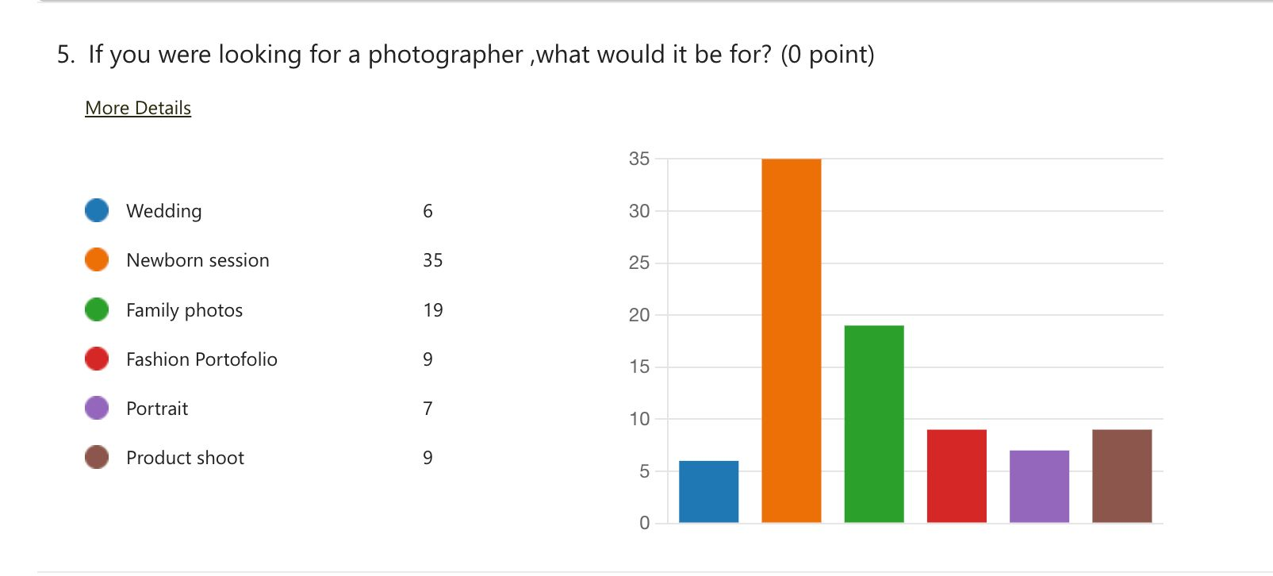
Now this chart dives even deeper in to the segmentation process and would ultimately decide the nature of the service itself. As a business, there’re is the option of aiming for general photography where the company serves all categories, but this would result in the drop of quality due to the fact that photographers would not get the opportunity for specialisation. Here, New-born photography is the most in demand category of photography by the customers, this has been chosen as the point of specialisations. This would also give us competitive advantage over general photography services.

Now finally, we can see that most potential customers preferred to have the shoot in the studio and then in nature. So this means that my company will have to provide with the studio location in ordered to attract these customers and also have the option to do photoshoots in nature. As there is high possibility that customers would want both.
This is the final response chart where the customers responded with their perception of the service. As it can be seen that the customers are highly positive about the business idea and thus it can be said that the market response would be positive.

Rationale for how questionnaire data influenced website design
The questionnaire have provided insight into what the customers demand and their preferences. Based on this information, my website was set up. As the largest number of people said that they would hire a professional photographer for new-born photoshoots. So based on that information, new-born photography specialisation was selected, and the website was designed accordingly. Now colour theory was used in order to design the background and the designs & pictures in the website (Watson, 2014). Colour theory represents the set of rules and guidelines that dictate how the designers utilise colour in order to convey their message to the target audience (Watson, 2014). It was established by Sir Isaac Newton with his invention of the colour wheel. There are many colour schemes that can be used to convey proper messages. Monochromatic, analogous, and complementary are a few of these schemes.
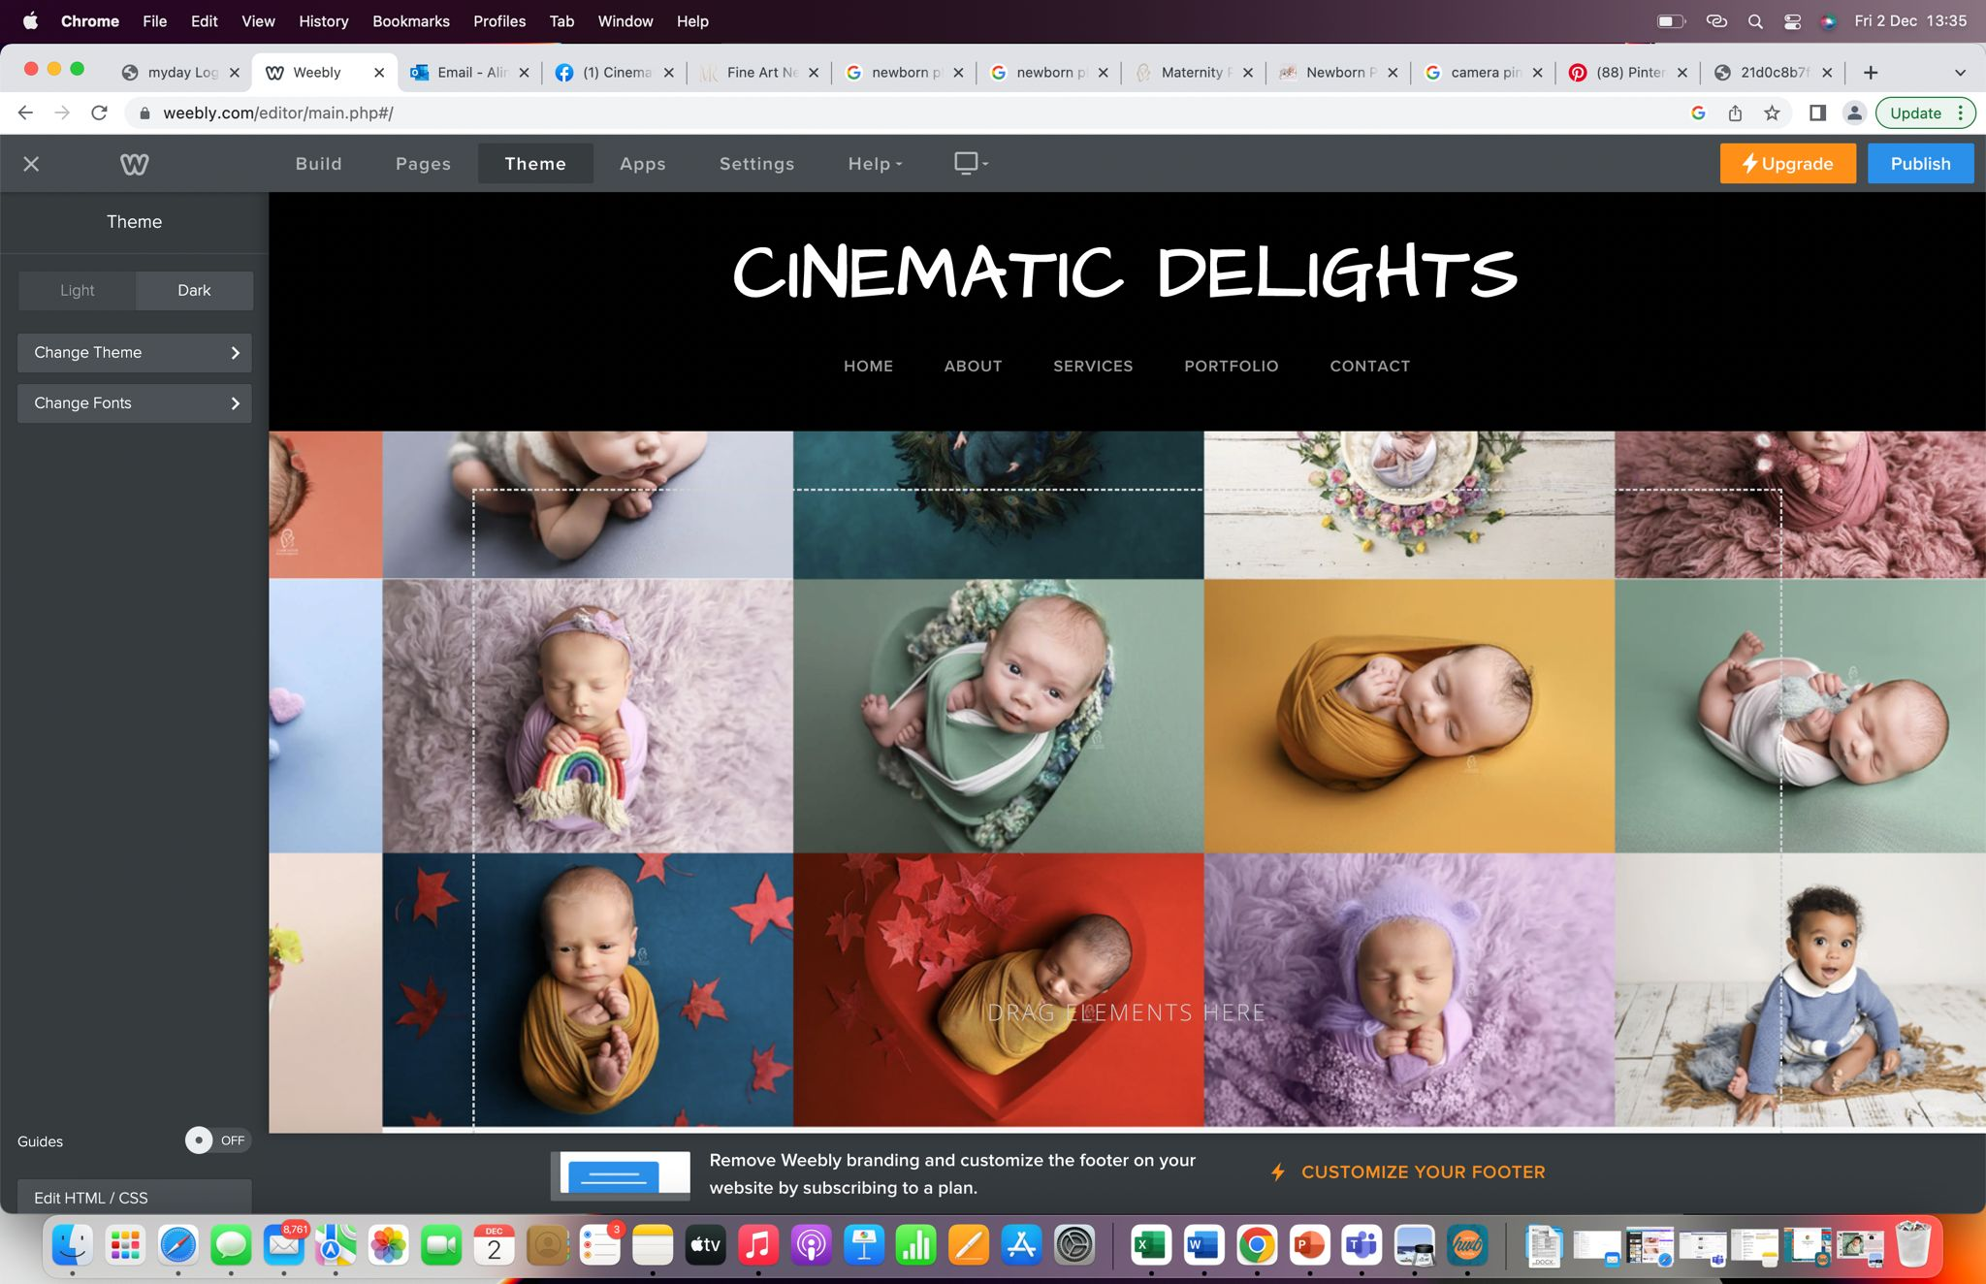
This would be the first page the customers would land in when they enter the website. New-borns bring happiness to anyone and as such following the theme of the website, the bright and colourful pictures that part of the portfolio would be shown. This would create interest for the customers.

The website proceeds with the welcome note and a small description of what are possible services provided. This website would be the first impressions for the customers and this would give them an idea of what to expect.
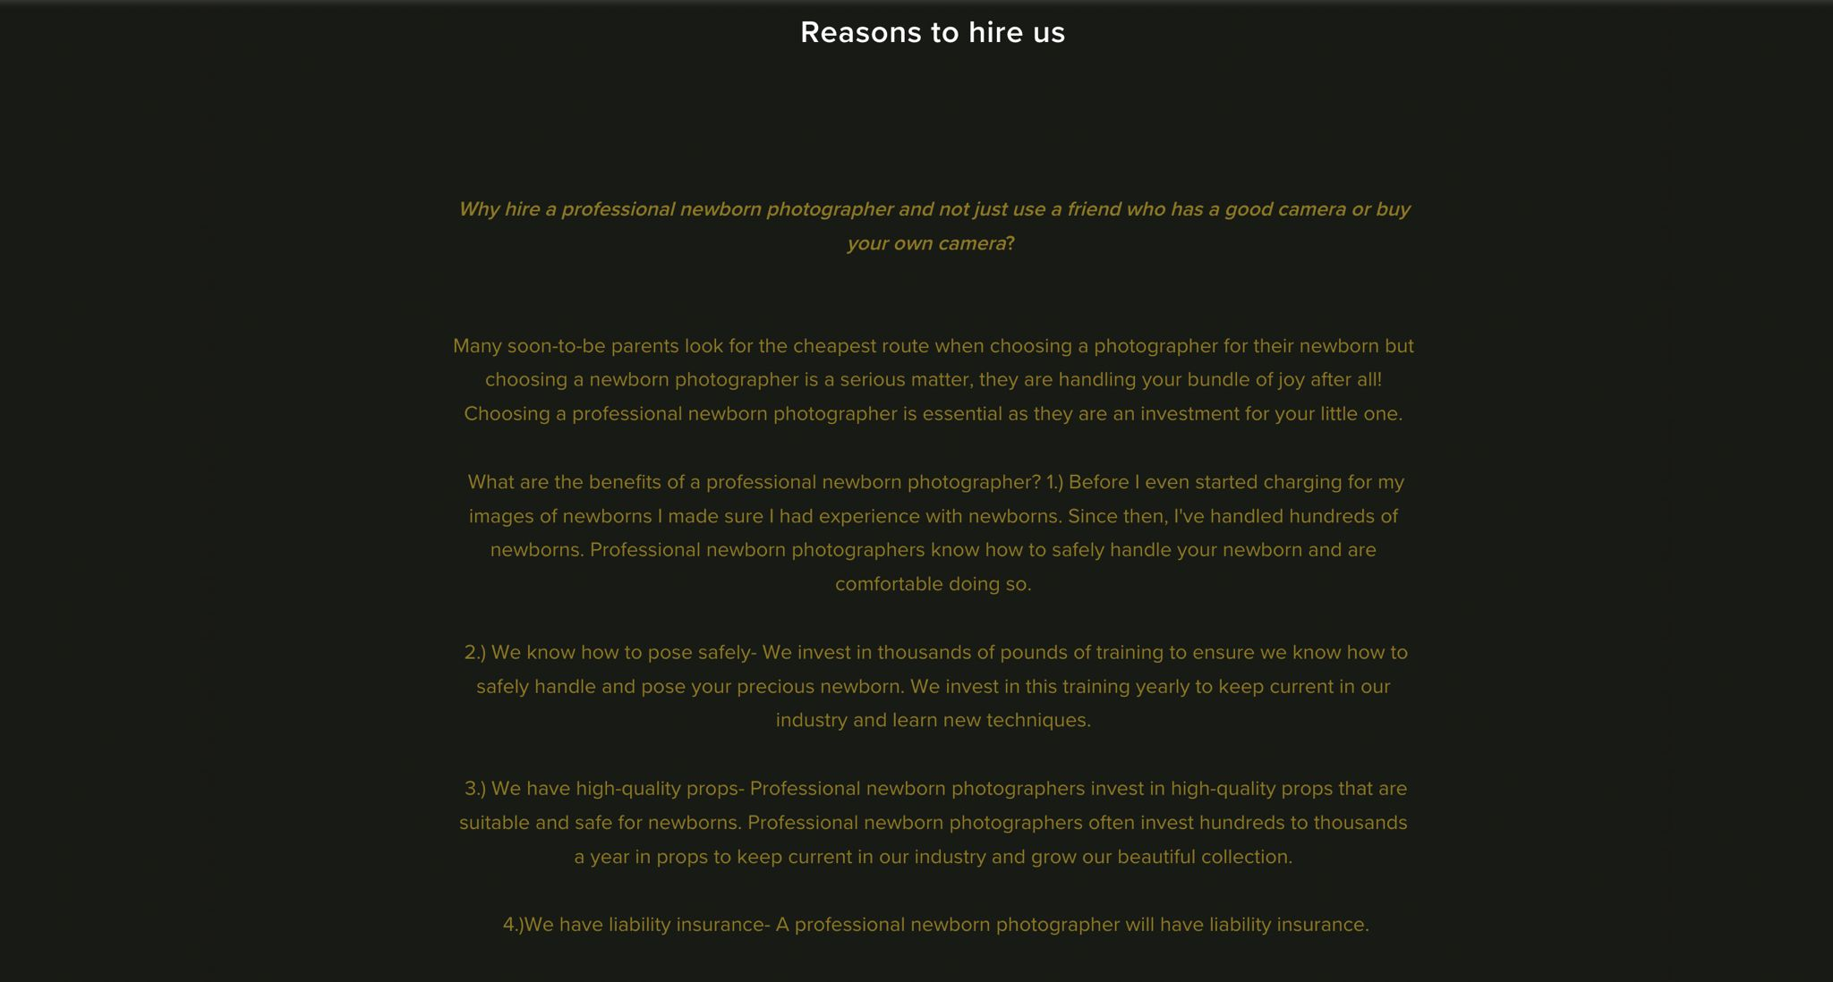
In this page, the specialties would be promoted and customers would be convinced to get our services. This would also provide how we differ from others and how we can ensure the safety and security of their new-born child.
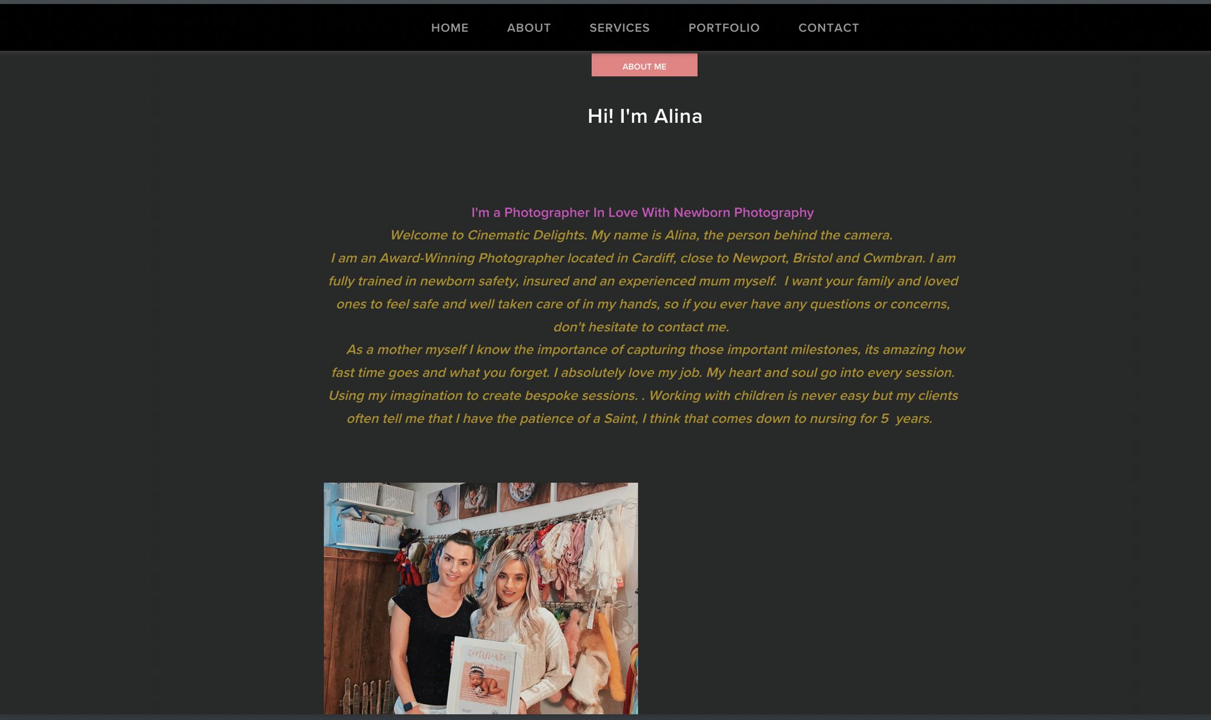
In this part, I have shown my personal motivations for coming into this career and also my passion about the profession would be shown.
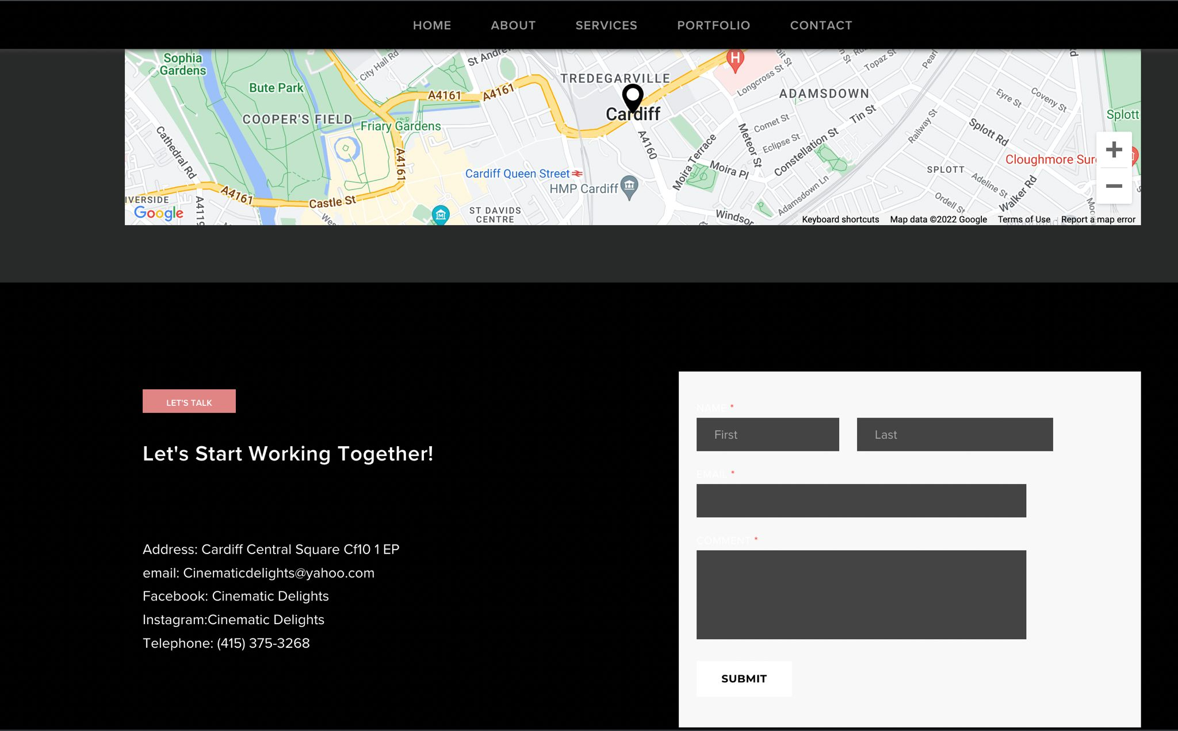
This is the part where the company contact and address is located.
Now, for the most part the website is given a monochromatic look and only the new-born photography parts are in bright colours. Now this is done in order to put the key focus on these photos and the rest of the website as a background. This would bring to focus the professionalism and capability of the photographers. Also this monochromatic scheme aligns with the contemporary minimalist outlook.

Importance of SEO and how primary research informs SEO strategy
SEO mean search engine optimisation is the process of increasing the visibility of the website to the target audience when they search for the product or service in the search engines. This is have come from the process by which the search engines create their indexes in order to provide the best possible search results (Berman and Katona, 2011). The search engine boots crawl from website to website across the internet in order to scan and create indexes about the contents of these websites (Berman and Katona, 2011). These indexes are used when a user search for a particular item on the internet and the information from the website that contains the best possible match is shown. So to enhance the probability that a particular site will come up when a user searches can be enhanced by creating content that aims towards that user (Berman and Katona, 2011). This is one of many ways that search engine optimisation can be done.
Now there is three C’s of SEO. First and the most important part of SSEO is content. These are the articles and writted content that exists in that website. Now visuals are important for human eyes to see but for the search engine bots, articles, and such written content gains far more weight and utilisation proper phrases is also necessary (Gudivada, Rao and Paris, 2015). The bots also scan the internal coding of the website and will index the code according to its ease of access across platforms (Gudivada, Rao and Paris, 2015). Finally, credibility is another important aspect for SEO. Now credibility depends on many, but the key is to have URL link to relevant websites. These three dictates how further to the top the website will appear in the searches and in this way you get more visitors.
Primary market research would show what the customers want and their preferences. This information is vital for SEO as it would mean the website can be made to contain the necessary content that attract the right kind of attention from both visitors and the bots (Gudivada, Rao and Paris, 2015). Fromm primary market research, it can be identified exactly what they look for a website for their interest or when they go to buy something. And this can be used to make the three C’s to aim at those preferences.

Conclusion
The contemporary business world is a dynamic place where the information is the key differentiating factor for which company would be successful and which would not be. Primary market research is the key in this as this would give the organisation idea about exactly what the customer would prefer. This would enable them to utilise their competitive advantage achieve business objectives.

References
Berman, R. and Katona, Z. (2011). The role of search engine optimization in search marketing. SSRN Electronic Journal, 32(4). doi:10.2139/ssrn.1745644.
Chadwick, S. (2014). Market research is dead; Long live market research! Research World, 2014(49), pp.6–7. doi:10.1002/rwm3.20164.
Freeling, A. (2019). Marketing is in Crisis - Can Market Research Help? Market Research Society. Journal., 36(2), pp.1–6. doi:10.1177/147078539403600202.
Gill, J., & Johnson, P. (2010). Research Methods for Managers. London: Sage.
Gudivada, V.N., Rao, D. and Paris, J. (2015). Understanding Search-Engine Optimization. Computer, 48(10), pp.43–52. doi:10.1109/mc.2015.297.
Gupta, S. and Ramachandran, D. (2021). Emerging Market Retail: Transitioning from a Product-Centric to a Customer-Centric Approach. Journal of Retailing, 97(4). doi:10.1016/j.jretai.2021.01.008.
Harwood, T.G. and Ward, J. (2013). Market Research within 3D Virtual Worlds: An Examination of Pertinent Issues. International Journal of Market Research, 55(2), pp.247–266. doi:10.2501/ijmr-2013-022.
Marshall, Catherine & Rossman, Gretchen B. (1998). Designing Qualitative Re- search. Thousand Oaks, CA: Sage.
Pabitha C. (2015). Search Engine Optimization by Eliminating Duplicate Links.
Szerb, L. (2018). The Comparison of the Global Entrepreneurship Monitor and the Global Entrepreneurship and Development Index Methodologies. Foundations and Trends® in Entrepreneurship, 9(1), pp.1–142. doi:10.1561/0300000046.
Watson, V. (2014). Colour Sensation and Empathy: Arthur Schopenhauer’s Negative Philosophy and Colour Theory as the Basis of an Elemental Colour Architecture. Architectural Theory Review, 19(2), pp.193–202. doi:10.1080/13264826.2014.967333.
Yallapragada, R.R. and Bhuiyan, M. (2011). Small Business Entrepreneurships In The United States. Journal of Applied Business Research (JABR), 27(6), p.117. doi:10.19030/jabr.v27i6.6470.

