Q1 Having achieved Independent Patrol Status, reflect on the impact of organisation culture within policing on your wellbeing and resilience (organisation change, retaining personal values in a wider organisational culture).

I will start the question by explaining what organisational culture is and use a reference.

I will the go on to explain how there is a culture longer serving officers are shown respect because of their length of service

I will then use a model to reflect on the impact of organisational culture and my wellbeing. This will start by giving a brief explanation about the model.

The first point of this will be the culture of newbies having to make the cups of tea and taking on workloads. I will explain that it serves a purpose and a way to bond with others.
As part of this model I will talk about my feelings and I have experienced emotional stress. This will lead to a definition and how speaking to others has helped.

I will then move onto explain that there is negativity within the police force from senior officers. I will explain the impact this has had on me and what I have done to manage this and the impact this could have on the public if they are aware of what is being said. I will end then by explaining how I manage stress.

In my conclusion I will explain how important culture is within the team and what techniques I use to avoid the negative culture that exists within the job.

Q2 Give a brief description of the problem including social and legislative contexts and any relevant cultural, ethnicity and language issues.

To answer this question, I will use Bortons model of reflection to reflect on an incident I have attended. By using this model, I will be able to systematically review the action I have taken. By using this reflective tool, it will allow me to review the action I have in a real life situation and learn from the experience both personally and professionally.

The framework was developed in 1970 and involves three essential questions, What? So What? And Now What?
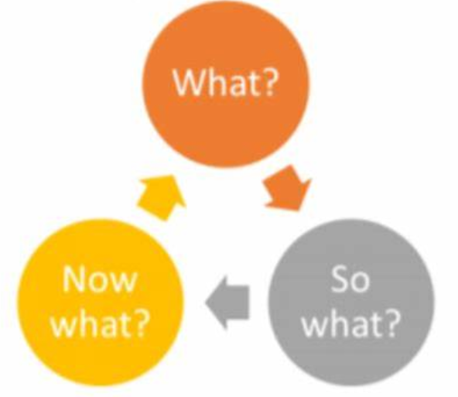
Figure 1 (Stephen Ellwood 2018).

This incident related to a call to the emergency services where a female had reported that she and her partner had been involved in a argument and the male had left in possession of drugs. The information taken from the caller was limited but was enough to grade the call as a priority. This is done using the THRIVE model.

The THRIVE model stands for Threat, Harm, Risk, Investigation, Vulnerability and Engagement. The Threat is what is communicated or perceived from the caller. Harm, is anyone injured or likely to be injured. Risk is the chance of what the caller is describing what actually is happening. I is for the investigation and the act or process of examining what is reported and then considering what action is required. V is for vulnerability which research has shown me that Gov.uk defines as someone in need of special care, support or protection because of someone’s disability, their age and their risk of neglect or abuse (Gov.uk, 2022). E is for Engagement in which the organisation and person build a more positive partnership for those involved (West Midlands Police, 2021).

The THRIVE model aligns itself to the Code of Ethics and the National Decision Model (NDM) which allows the call handler to make the most ethical decision making.

The NDM

The THRIVE model allows the initial call taker to make ethical decisions in line with the code of ethics and the NDM.

I will go on to explain why I did a stop and search incl legislation used and what I did following seizure of evidence incl powers used. I will also explain how the code of ethics was used prior to the search and what led me to comp[letting a search.

I will explain what the consequences were following an arrest and the impact this would have had on the victim.

In conclusion, If I was in the same circumstances again I would take the same action as described in this question. Discretion is a tool that allows officers to deal with a situation that doesn’t require further action

Q3 Evaluate theories of team dynamics as a means of developing team cohesion (reasons why some teams cannot function, theories and models relating to team dynamics, ways to improve team cohesion).

Consider why inter-personal conflict can occur within a team and outline what strategies can be adopted to enhance individual and team performance.

Consider how team dynamics within the police service can result in failing to comply with professional standards requirements (Code of Ethics, policies, procedures, protocols or legislation).

I will start by explaining the term team dynamics and how as a team of police officers we share the same common goal.

I will explain how good team cohesion leads to better results and how a poor team has the opposite effects.

I will then use a model to demonstrate team cohesion and development and give a brief description

I will also use a model to show a dysfunctional model. I will hen explain how this can be a benefit to under stand what/why your dysfunctional and how you can improve.
I will list and explain the common reasons why a team cannot function

I will then explain why team cohesion is important and how peoples background are important.

What good team dynamics lead to

I will then complete a conclusion based on my findings.

Q4 Explain how information and intelligence can be used in the disruption of the more prevalent criminal activity (e.g. drug smuggling, human trafficking, child sexual exploitation, counterfeit goods, organised crime groups and ‘county lines’) by effective policing of the roads.

An efficient road network is important to an growing economy. Nearly 80% of domestic freight in the UK is transported by road (Department For Transport 2020). Most of us today use the road network for our day today commuting but unfortunately, what works for commercial use will also works for criminal activity. Whether it is the illegal trafficking of people, drugs or other stolen parts, roads will be used by criminals for the proceeds of crime and their socially damaging enterprises. Organised Criminal Gang’s (OCG) will use the road network to facilitate crime. Research shows the crime committed on the road includes smuggling and cargo theft, county lines exploitation, facilitating burglary and crimes of violence (Department For Transport 2020)

HERE I NEED TO EXPLAIN WHAT MORE PREVELANT CRIME IS AND WHY/WHY OCG’S USE THE ROADS.
The police service face difficult challenges when it comes to disrupting criminal activity on the road network. Our roads are growing which is making cities and more rural areas more accessible. According to The Department Of Transport 95% of the population use the road network everyday (Department of Transport 2014). That is a staggering amount of people on the road whether it be a car, truck or a motorbike the police have a difficult job targeting those involved in crime.
To target criminals using the road network, Greater Manchester Police (GMP)) have Been targeting criminals in and around Greater Manchester and Cheshire on an operation called operation Crossbow.
Operation Crossbow, which took place on Wednesday 22 September 2021, is part of ongoing efforts to disrupt criminal activity across our roads and borders.
It involved more than 80 officers from Greater Manchester Police (GMP) and Cheshire Constabulary, including officers from roads policing, motorcycles, dogs, drones and local policing units. This enabled both forces to work collaboratively and police the border between the two counties.
Following an afternoon briefing, vehicles made their way en-masse to key locations and worked into the early hours. Many took up key strategic positions along the arterial routes while others roamed – ensuring that if there were any drivers or vehicles linked to criminal activity, they would be caught.
The operation resulted in six Traffic Offence Reports issued for use of a phone, vehicle defects and window tints reported, four vehicles seized and recovered due to no insurance, driving license offences and MOT issues, one summon to court for traffic related offences, one vehicle seized for dangerous conditions, two stolen vehicles recovered and three arrested for drugs offences and possession of an offensive weapon. (gmp.police.uk)

The police service have a vast amount of tools when it comes to disrupting such activity. Technology is transforming how police tackle criminals using the road network
“Automatic Number Plate Recognition (ANPR) technology is used by the police and other Law Enforcement Agencies (LEAs), to help detect, deter and disrupt criminality at a local, force, regional and national level”
(Home Office)
Research from the college of policing shows ANPR is a network of cameras throughout the UK positioned at strategic locations. These cameras will capture a image and read a number plate as the vehicle passes. Within a split second the camera will complete a series of checks that includes checking insurance, tax and a MOT expiry date. This information can then be passed to law enforcement agencies including the police. (College of Policing)
The use of ANPR cameras have had great success and is widely used throughout the country. Northamptonshire Police launched a three day operation named Operation Jaguar. By using ANPR cameras Northamptonshire police were able to target criminals using the road network. This resulted in 143 vehicles being stopped, 26 arrests made, 44 vehicles seized, 76 traffic offences identified and 34 searches completed (Northants.police.uk).

There are those who oppose the use of ANPR cameras as they feel the cameras are taking away liberties. Campaigners often post information about the locations of the cameras which informs those wanting to avoid there locations.

Birmingham to fight a 'ring of steel' encircling parts of the city with Automatic Number Plate Recognition (ANPR) cameras.
(no-cctv.org.uk 2010)

Campaigners against ANPR cameras believe that the cameras are intruding on our privacy and watching the movements on innocent members of the public. To catch a few offenders we are recording every person that passes by a camera which takes their liberties away.
Campaigners against cameras call for others to help them abolish the network of cameras by protesting and causing delays to motorists. These protests have often led to criminal damage which has been reported on main stream media.

In conclusion having reviewed results the police forces have released following successful operations, using the ANPR cameras myself within my role as a Police officer and reading anti ANPR articles I agree the cost is expensive however the results are incredible. The road network is being used daily in the aide of committing crime however the ANPR network is a great tool the police force has to detect and deter crime.

