Consultancy Report

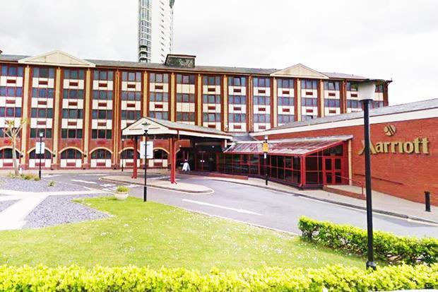

Jaliya De Silva
Student Number – 1803778
University of Wales Trinity Saint David

Hotel Solution
87, Lakeside
Cardiff
CF37 3EL

Swansea Marriott Hotel
Maritime Quarter,
Swansea SA1 3SS

12 August 2020

Dear General Manager,

Audit Letter 2020,

I am pleased to present the Audit summery of year 2020.The purpose of this document is to summarise the outcome of the external audit of Swansea Marriott Hotel, Great Britain. The Hotel Operations, Financial Stability been audited as requested. Therefore, our team has reviewed and analyse the health of the hotel’s efficiency and effectiveness.

We carried out our audit in accordance with the Code of Audit Practice prepared by the Comptroller and Auditor General as required by the Local Audit and Accountability Act 2014. I would like to express my
sincere gratitude to the staff who supported me during the audit process.

Hotel solutions delighted to announce that the Swansea Marriott hotel has successful completed its 12 weeks audit which commenced on the Start Date - 1st of June 2020 to 31 August 2020. Therefore, we are delighted to pronounce that hotel have scored 89% of overall markings of the audit. Please refer the documents enlisted.

If you would like to discuss any matters in more detail, then please do not hesitate to contact.

Yours faithfully,

Jaliya De Silva.

(Audit Manager)

Part 1: Environmental Scanning …………………………………………………....................... ………………….. 3
  - Company Information
  - Macroenvironmental analysis ……………………………………………………. 4
  - Microenvironmental analysis ……………………………………………............. 5
  - Swot Analysis ……………………………………………………………… …… 6
- Audit Assessment ………………………………………………………….......................... 7
  - Audit Process ……………………………………………………………………… 7
  - Pricing ………………………………………………………………………... …... 8
- Brand Standard Audit………………………………………………………………..……. 10
  - Front Office…………………………………………………………………….…. 10
  - Guest Experience……………………………………………………………….…. 10
  - Guest check inn………………………………………………………………........ 10
  - Lobby Bar…………………………………………………………………………. 11
  - Room Service……………………………………………………………….…. …. 11
  - Restaurant ………………………………………………………………………… 11
  - General Bedrooms…………………………………………………………………. 12
  - Bathrooms…………………………………………………………………….……. 12
  - Lobby………………………………………………………………………………. 12
  - Public Restrooms……………………………………………………………......... 13
  - Elevator……………………………………………………………………………. 13
  - Corridors…………………………………………………………………………. . 13
  - Fitness and Pool…………………………………………………………………... 13
  - Meetings …………………………………………………………………...……... 14
  - Food Safety ……………………………………………………………….………. 14
  - Marketing ……………………………….………………………………………… 14
  - Guest Service delivery …………………………………………………………...... 15
  - Financial Management ……………………………………………………...……. 15
  - Employee Engagement …………………………………………………………..... 15
  - Leadership ……………………………………………………………………..….. 16
  - Green Hotel ……………………………………………………………………….. 16
  - Property Maintenance …………………………………………………………...... 16
  - Theoretical background ………………………………………………………..…. 17
  - Strategy Implementation ……………………………………………….………… 17
  - Conclusion …………………………………………………………………..……. 18
  - Reference …………………………………………………………………….…… 19
  - Appredix (1) ……………………………………………………………………… 20
  - Appendix (2) ……………………………………………………………………… 21

Purpose of Document

The purpose of the document is to define the audit and hotel consultation which will be done in Swansea Marriott Hotel by the Hotel Solution Limited, which specifies the scope of the program and what needs to be delivered and how it can implement, monitored and put in place relevant measures for the overall success

Part 1: Environmental Scanning

1.1 Company Information

Overview

The Marriott Hotel located in the city center of Swansea. It is one of the prominent hotels in Swansea due to the well-known brand image and service also it has been operating over two decades in the area. This hotel has been renovated several times initially started in 2007 and later refurbished the exterior of the hotel during the year of 2018/2019 period.

This building was initially used by the Holiday inn hotels, which transformed it then to Marriott in 1980’s. Hotel consists of 121 rooms which includes Single, double, twine, queen and King categories across four floors, this property has two banqueting rooms which comprise of 365 M² and five meeting rooms. The hotel provides the leisure, swimming pool, free parking and WIFI facilities, outside terrace, in house restaurant which serves classic British cuisine. The Hotel is situated to all transport s and the beachfront is just side to the hotel and all rooms have sea and marina views.

The hotel operated by the Marriott group, leading hospitality giant who operates accommodation and lodging facilities. It owns over Thirty brands and over 7000 hotels around the globe. Marriott plays predominate position in the hospitality industry and the biggest hotel company in the world.

1.2. Macroenvironmental analysis

Swansea

Swansea is known to be the Wales second biggest city, located in the Walsh coastal lines, according to the latest released census, Swansea has the urban population of 239,000. It is well known for sports as it homes for Swansea football club that plays in the welsh premier league.

Over the years Swansea has shown an extensive progress in tourism and city has a special attraction for tourists including local and foreign. The city blends with strong culture and it has its own signature attractions like Mumbles, Gower peninsula.

Swansea is a very multicultural city, as to the higher proportion of Non-Welsh residence in Swansea such as Students as Swansea has best universities who provides internationally recognized qualifications. Swansea has shown a great business potential and will be new business opening in the city as well as the Music area where it can accommodate over 3000 people and many more opportunities will be launched in Swansea near future.

Tourism/ Hospitality data in Swansea
According to the statistics of Visit Wales, Swansea becoming a high regarded travel destination in Wales, ahead of other welsh destinations. Overnight stay grew up to 66% and day travellers 13%. Those statistics clearly evident that city experienced a rise in tourism 2019 (Figure 1). The statistics exhibits it has a strong allure as a touristic oriented destination (visit Wales,2019).
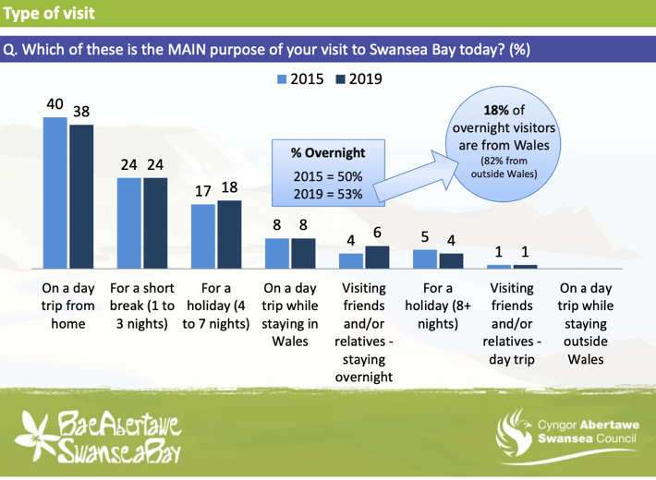
Figure 1- Visit wales types of accommodation (visit wales,2019).

Over the year of 2019, tourists had been accommodated in over 50 hotels and there will be more pipeline projects will be introduced in Swansea such as Hilton, JW Marriott hotels etc. This shows a potential in growth in tourism which results in higher occupancy rates and ability to charge greater prices for hotel accommodations and such (Figure 2) (Visit Wales,2019).
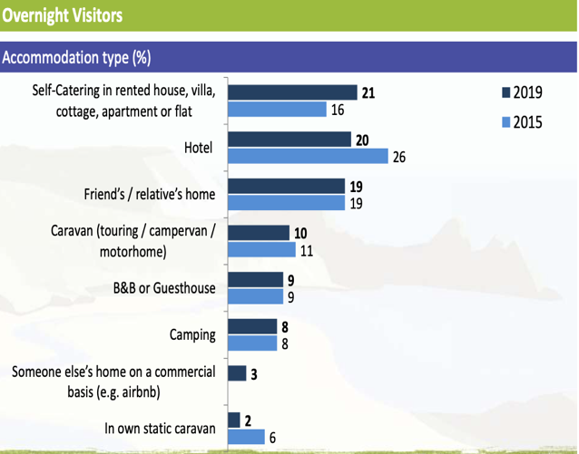

Figure - (Visit Wales ,2019).

1.3 Microenvironmental analysis

Intermediaries
Marriott hotel collaborates with various consorts to obtain repeat guest such as global distribution systems (GDS) including TravelClick, agency 360° American express, Expedia, booking.com, Agoda and Hotels.com.

Customers
Mostly during the weekdays 70% of the occupancy of the hotel is business travellers and weekend it’s the you’ll find mostly Leisure travellers.

Competitors
All four star classified hotels within Swansea vicinity are considered competition. All hotels located in the same proximity to each other as well rated. Principal competition includes Village hotel, Dragon’s hotel, and Morgan’s hotel.

- Village hotel Swansea opened its doors in 2007, It consist of 116 rooms, gym, swimming pool, restaurant etc.
- Dragon’s opened in 2009 and it consist of 109 room with all-inclusive facilities like the above.

1.4 Analytical tools
A SWOT analysis assists to get a bigger picture of the organisation in terms of environmental factors, it enables an understanding of the hotel’s positioning within the competitive marketplace. While concurrently identify the ways to be more competitive with their rivals.

SWOT analysis of Marriott Swansea based on PESTLE
Strengths | Weaknesses
- Good reputation  - Location  - Beautiful view/ Beach front  - Loyalty program  - Banqueting and meeting room facilities | - Old building  - Lack of marketing channels  - Lack of staff/ unmotivated  - Centralised promotions

Opportunities | Treats
- Swansea City becoming touristic venue  - City has a business potential  - Partnership with Manchester United  - Working with UWTSD | - Economic Downturn (pandemic, Brexit)  - Existing rivals and new entrance  - Vulnerability to terrorism

2. 1. Audit Assessment
Company overview (Who We Are).
Hotel Solutions LTD, is one of the leading hotel consultation firms based in London, our company has professional core team who has experience in wide array of field such as Hotel General managers, Restaurant managers, chefs, engineers etc. who has gained experienced form star class hotels to Michelin star restaurants.

Audit Team


Annie Williams Richard Lenoir Patrick Sullivan
Consultant Back office Project Manager. Consultant F&B
And Rooms

Audit process

Primary search mainly focusses on Facilities, Cleanliness, Operations, conditions, Service, Financial Performance, Employment engagement, Facilities Management and Leadership. During the 1 month our team will be working with Marriot staff to detect Improvement areas where necessary and will be monitored weekly basis on performance. Also acknowledge the staff of requirement BSA to show the uniformity of the brand and its standards around the globe.
- Month 1 Detection Areas of Improvement
By the involvement of the consultants will be detecting all the departmental improvements. In the recent past Marriott Swansea had demonstrated a decrease of standards as well as online reputation which clearly evident on referring to online reputation on guest feedback surveys via online platform.

E.g.
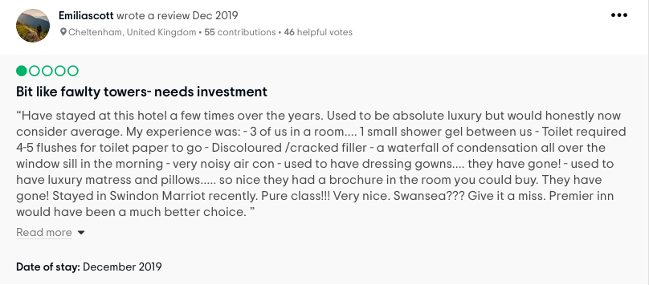
Figure 3 – Guest reviews on Marriott Swansea hotel (TripAdvisor, 2019)

In order to identify the fall in hotel standards our consultants would analysis the main key areas such as
- Online reputation
- Habitual complaints (includes all areas stated above)
- Management feedback

Identification of employee Training needs (Month 2)
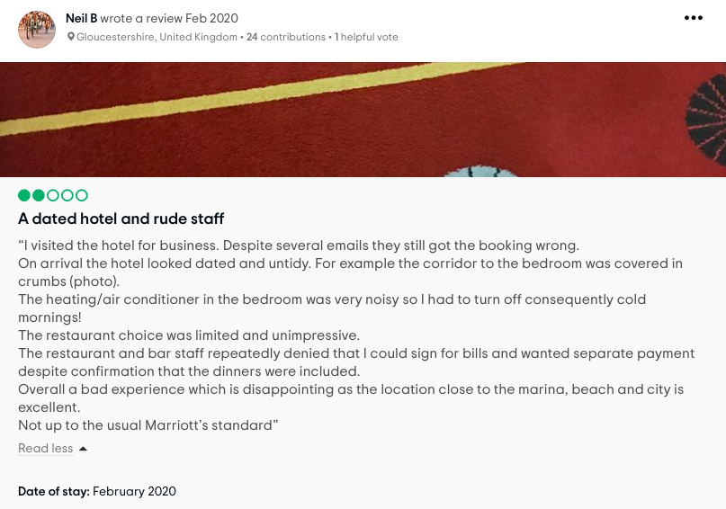
Figure 4 – guest reviews on Marriott Swansea (TripAdvisor, 2020)

The hotel management team needs to be seen that; training process is a very vital aspect of a hotel. therefore, it needs to maintain continuously. Our consultants will be mainly identified whether the hotel training and development programme is effective in order to meet the hotel goals and requirement. Therefore, they will assess the needs and gap to rectify the errors such as
- The difference between job performance, hotels expected level and the current level of performance (and cause for that)
- The difference between the hotel expectations, what’s happening
- The difference between skilled required by the HR and what skill actually they got.

Implementation of Waste management (Month 3)
The month 3 consultants mainly focus on procument and facilities and operational cost management procedures to reduce the unnecessary spending such as
- Waste management
- Water management
- Energy management
Which allows to align with Marriott 360 program and enhance on sustainability practise where the hotel can benefit for noticeable cost savings.

During the 12-week period consultants well be working on deferent areas with assigned receptibilities such as
- Consultant Back Office – Marketing Research, Administration and managing data base, Analyse gust trends. Reservations,
- Project Manager - analyse job performance of the hotel, Risk assessment procedures, communication channels, Business analysis, Trainings
- F&B consults - Food and hygiene procedures, training of etiquettes, provide adequate knowledge on food and beverage operations.

After completion of 12 weeks audit, Hotel Solutions company in a capacity to direct the hotel to improve its performance and augment its value of service and also to gain higher market share. Our consultants presume
That hotel will get expected Return on Investment and build the relationship between service quality and performance e.g.- guest satisfaction, retention, loyalty and brand image, cleanliness, operations and leadership.

After successful completion of the audit Hotel Solutions in the position to provide a full internal validity of the property with a full dashboard report.

2.2. Hotel Solution in a position to begin to start the Audit
Start Date - 1st of June 2020
Finish Date – 31 August 2020

Pricing
Month 1 – Two Consultants will be in operation - £1000
Month 2 - Two Consultants will be in operation - £1000
Month 3 - Three Consultants will be I operation - £1500
In total Amount payable. £3500
3.0 Brand Standard Audit

3.1. Front Office / Lobby Arrival Total Points: 30/34

During the audit our team noticed that, Front Office (FO) staff demonstrated a pleasant and courteous service to its guests where they have acted positively during stressful moments by coping negative behaviour from guests. Since the Marriott Swansea gets business travellers, their expectations are reasonably high thus, tendency of getting negative comments due to conditions of the hotel are higher than normal. Therefore, FO employees handles negative emotions very well at all times. Eye contact, politeness showcases an extra mile of service in order to win the of customer retention. FO staff was given the authority to offer complementary car park or breakfast in the event of reasonable guest complaints which showcases the decision-making power and empowerment which highlights the company’s culture. There wasn’t a lobby hosting personal in place due to budgetary issues, but cross training is highly recommended to replace someone for that position in the event of a busy period. Additionally, FO staff was very well groomed and met the Brand Standard audit requirements. Our team recommends to have the Marriott scent available in the property in order to manifest the uniformity of the brand.

3.2 Guest Experience Total Points: 8/12
Marriott employees always work towards providing the utmost best service to its guests to meet the guest satisfaction. Therefore, Staff focuses on customer driven objectives in order to enhance the current existing process and improve what is already there. All departments worked together in order to maintain departmental loyalty and therefore, they strived to provide the best experience to increase quality of guest’s stay

3.3. Guest Check inn Total Points: 102/106
FO staff aims to provide check inn process with in five minutes or less if the type of room is cleaned and available. Most stressful event they find when unavailability of the requested rooms and finding acceptable replacements. In terms of checkout, the procedure takes approximately two minutes as long as the GSA not having to separate charges on the guest’s bill.

3.4. Lobby Bar Total Points: 108/164

Due to stressful work event, bar person demonstrated negative emotions towards guest’s by not giving neither adequate attention nor salutations. When it was busy with one person behind the bar and didn’t show any smoothness of the service. Therefore, our team recommended that, entertainment facilities for guest’ are highly pivotal and hotel needs multi skilling of staff which involves cross training of different task areas, and this way it’s easy to allocate available staff when there’s a service demand.

3.5. Room Service Total Points: 58/82
Room service staff demonstrated slightly a robotic behaviour without delivering its services with warm hospitable manner s. Therefore, interaction with guests are highly necessary without showing a gap between the guest and employee. It is highly crucial to bridge the gaps between staff and employee in order to deliver a satisfactory service with a remarkable experience.

3.6. Restaurant Total Points: 262/262
Restaurant staff provided quality food and service in a comfortable ambiance by providing a friendly and professional manner, ensured every patron return. However, due to the hotel’s location it showcases a stiff competition with other independent restaurants in the Swansea high street as well as in other hotels. Therefore, hotel management analyse their operations to identify ways to increase the capture rate and the percentage of guests who stays to dine onsite. Castle -Iron staff strives to offer personalised service to gain a competitive advantage over rivals especially Maître d’hôtel who works in the morning.

3.7 General Bedroom Total Points: 136/178

Overall guest rooms are Okay. Audit team found out damn carpets and dated furniture placed in rooms, also dirty ceiling and non-availability of ice bucket may affect the Marriott brand standard requirements dramatically. Therefore, Housekeeping Manager need to closely communicate with engineering departments to solve those problems. Housekeeping Manager must allocate adequate number of staff in order to run the department smoothly which compliance with Service operating procedures.
3.8 Bathroom Total Points: 68/100
Overall cleanliness of the bathroom considered to be okay. There are some cracks on the bathroom tiles, and shower curtains needs replacement with an immediate effect due to fugus stains. Recent study demonstrated over 70 percent of guest’s judge cleanliness of the rooms by the state of the bathroom. Therefore, every corner of the bathroom needs to be clean such as nook, cranny shelfs, cupboards and it should be dry and buffed. Bathroom needs to comply with the sanitation standards.

3.9. Lobby Total Points: 32/32
Lobby maintains quite decent, with the recent upgrades, but lobby has shown the absence of the Marriott fragrant “well smell” and elegance. Guest experience is the main objective when running a hotel. Marriott Swansea hotel’s lobby is quiet comprises of couches which you can tuck yourself away in a conference call etc and the lobby provides decent level of mobile signal and undisrupted WIFI connection.

3.10. Public Restrooms Total Points: 32/46

Public restrooms need to be maintained according to the brand standard requirements. There were certain areas needed special attention which reflected bad experience for guests, and it may damage the brand image and reputation. All defaults have stated in the audit report for the reference. From public health perspective the findings were absolutely significant. Therefore, restrooms needed constant cleaning such as toilet seats, surfaces, and soap dispenses. Proper sanitation of restrooms can be ensured its cleanliness with aesthetically and hygienically. Most commonly seen microbes in public restroom are norovirus, Hepatitis A, Shigella, E-coli, Salmonella etc therefore, disinfecting protocol needs to maintain with a stringent manner.

3.11. Elevator Total Points: 8/8
Elevator area was properly maintained and there are two functioning elevators in the property “private and public”. Elevator is one of the key elements which highly vital in a hotel despite the size of the property. elevators can effortlessly dominate the reputation of the property. Out of order lifts and filthy lifts lead to negative guest review on internet.

3.12. Corridors Total Points: 18/22
Hotel corridors were well maintained, stairway needs more attention as it showcases lack of attention was given, overall corridors were good. All signages were put up properly.

3.13 Fitness Centre and pool Total Points: 80/84
Fitness centre and pool needed more attention as it showcased lacking standards, also in the guest point of view fitness centre is one of the main vital elements in the hotel setting. Swansea Marriott needs more selection of cardiovascular equipment’s. Overall fitness centre maintaining is Okay. The hotel has UK certified personal trainers at their disposal.

3.13 Meetings Total Points: 48/48

Overall meeting and conference rooms were maintained to the required standards. overall cleanliness was absolutely spot on, employees worked on timely manner; all the amenities provided as stated on the events sheets, communication maintained to the adequate level in order to execute the task to the best level. Corporate guests accounted for a significant portion of generating revenue to the hotel. with the rapid development in Swansea many high-ranking managers and executives choose to book and set meetings, functions at Swansea Marriott.

3.14 Back of House Total Points: 146/146

Overall back office performances were fair as they met required Marriott standards. There were few things needed attention such as WIFI speed and mounted TV in the lobby needed to be replaced or repaired with an immediate effect. Back office work performance complied with the Marriott logos and other administrative work which met the brand standard requirements, also departments collaborated well with one another. Reservation manager focused on maximise the sales such as catered events, weddings conventions, meeting and etc; All agreements made on a written contract and delivered with unambiguous manner. Sales team followed the more structured and well-planned job with great results. Back office staff succeed all the goals set by the company with a positive result.

3.15 Food Safety Total Points: 16/16

Overall food safety audit went really well with good results. Around 7 am purchasing manager or person in charge inspected the quality of food delivered with the right temperatures. This included rejection of incorrect and inferior products which then communicate with the vendor to rectify the issues. Hotel needed to comply with various British laws governing the food safety standards. According to the Food Safety Act 1990, and Food Law Regulation (EC) No 178/2002, regulates everything from food processing and labelling to packaging. Food and beverage sales are solely control by the acts above also with the HCCP and COSHH, which governing the food and beverage sales such as all food and beverages to be fit for human consumption and warranty needs to apply whatever food and beverages are sold. However, in order to protect from lawsuits all chefs and other management inspected food preparation sections frequently to ensure no hazards exits. During my audit I have seen there is a section by the kitchen where they left glassware, presumably chef had regular checks to avoid any glass debris which can easily get into food. Head chef does regular checks to find out chefs are handling food with safety in order to prevent food poisoning., E-coli and other bacteria can live in uncooked meet which can be highly dangerous and deadly. Sous Chef make extra attention on cooking temperatures and cooling down procedures in order to prevent contamination and poising. Kitchen maintains the temperatures logs and comply with FIFO method, overall cleanliness of the kitchen is satisfactory, during the audit, team members have notice, disposable aprons weren’t available as well as not wearing them when necessary, this needs to be implemented with the immediate effect. Due to malfunction of the dishwasher, kitchen porter had to clean plates manually, therefore all cutlery and crockery need to wash in a certain temperature to destroy micro-organisms.

3.16 Marketing
Marketing team made a great effort to maximise the revenue, in order to maintain healthy business in the face of rapidly changing marketplace. Overall performance was satisfactory. Audit team believed marketing team needed to implement a marketing strategy in order to build a profitable relationship with clients. Therefore, Marketing team needs to find a way to attract target customers by creating superior customer value. Marketing team needs to understand that they cannot serve all customers, therefore, hotel needs to select certain selection of customers where they can serve with profitability. Marketing team showed lack of competence on social media marketing, building new customers relationships from social media marketing, such as web sites, online adds, mobile apps, Facebook, and twitter. Modern world social media plays a very vital role which helps to engage more deeply. Therefore, marketing team needs to focus on more towards identifying long term business opportunities, focus lifetime value of the customers etc. Marketing team needs to be more active on social media, since it has become the trend and it showcases our strengths.

3.17 Guest service delivery
Overall font desk functions are Okay, but certain areas need special attention
- Front desk employees should be very focused on creating these personal connections with guests
- Needs to develop a professional relationship with other debarments despite the status if the department whether its outsourced or not
- Front desk manager needs to brief the team about the brand and the gaols.

3.18 Financial Management:
After the demerge of the housekeeping department, WCG group has the authority to do purchasing orders without prior approvals by using the technology purchases. Finance team strictly focused on receivables and payables, food and beverage control, payrolls, night and income audits, and cash management. Finance team highly involved with operational aspects of the hotel, such as instruct management to convince subordinates to upsell products and services to increase revenue management. Finance team demonstrated good understanding of risk management and contingency plans in when unexpected event happens.

3.19 Employee Engagement; Training & Creative Development
HR practise needed rigorous and reasonable recruitment process as noticed under skilled and unknowledgeable staff have been recruited in some areas. Training and development programs as highly needed which they can enhance their knowledge through learning, experience and coaching, to fill the gaps such as ICT knowledge, food and hygiene, company brand standards expectations. HR also concerns about the employee engagement in order to provide best customer service to its guests. Through the behaviour of the employees it highlights the creation of the organisational culture which ensures nurtured and sustained.
HR practise abide with the equal opportunities act, HR empowered the team to act like entrepreneurs, such example’s Marketing team works hard as entrepreneurs to generate sales in order to contribute to the revenue of the hotel. Performance management analysis is highly vital in this regard.
HR team and maintenance team happy involved with the student’s project held during their placement and made it success. Those credit needed to go to those staff for their commitments for make it success.

3.20. Leadership
Swansea Marriott showcased good leadership qualities such as people skills which demonstrated that faire play among the employees, mutual respect on each other, instant decision-making capabilities, focus on completing tasks, willingness to tolerate frustration and sense of personality identity.
3.21. Green Hotel
According to Marriott 360° sustainable programme, all employees compelled to abide with the sustainable practises. Therefore, Marriott bi- monthly audit collects energy awareness measures. Thus, Managers / Supervisors needed to demonstrate daily routine inspection ensures property’s energy conservation action plan was in place. Each quarter, Hotel general manager and energy conservation committee reviewed the audit reports to see the progression compared to the previous months. Marriott focused on sustainability through “Environmental Conscious Hospitality Operations” which focuses on Energy and energy conservation, recycling aspects.
- Chefs strive to minimize food waste
- Separation on garbage (cardboard and food waste)
- Energy saving programmes
- Water management systems (haven’t noticed in Swansea Marriott)

3.22. Property Maintenance
Facilities Management
Needed more cleanliness around the pool area, gym and changing room area, in order to reach customer perceived value. Also, Maintenance team carrying a very great job, as they’ve strived to do their best maintain a trouble free hotel environment . Facilities management has increased awareness of energy cost, also it needed more attention on how to upgrade the property with the ICT systems as it was a highly crucial aspect. However, it is very important to improve building infrastructure, furniture, fixtures and equipment’s to improve the market segmentation. Facilities Management helps to improve the operational efficiency of the hotel and build up better image in the property.

3.23. Theoretical background
Online Reputation
Maintaining service standards are absolutely a crucial factor for hotel industry (Kandampully and Suhartanto, 2000; Whitla et al., 2007), also can be classified as the key expectation of guests. Specially most reputed Marriott properties. Therefore application of social media within hospitality industry has seen a significant growth, especially with the emergence of user generated web “ web 2.0” where website capture online reviews such as opinions, recommendations shared by guests (Ayeh et al., 2013; Cantallops and Salvi, 2014; Wu et al., 2010). It is a great impact to the industry (Leung et al., 2013; Schuckert et al., 2015). However, guests pre purchase information – seeking and evaluation process (Browning et al., 2013; Ye et al., 2011). Online reputation relied on source by guests which helps to make a choice Lu and Stepchenkova, 2015; Murphy et al., 2007)

Frequent access to social media within the hospitality industry can review electronic word of mouth (eWOM) – which defines the comments posted on internet about the products and services. (Bronner and de Hoog, 2010). eWOM impacts significantly the hotel industry. with the rapid growth of the reviews it hard to distil the information required for the usefulness.
3.24. Strategy Implementation and timeframe
The table below delineates what actions need to be taken as well as person responsible for the task and the time frame expected for the implementation
Action | Responsible | Time Frame
- Fixing dish washer  - Deep clean leisure centre  - Deep clean Rooms  - Staff Training  - Creating a new position of the hotel | Kitchen Manager / Maintenance Manager  Front desk Manager  Housekeeping Manager  HR manager  General Manager | 4 weeks  2 Weeks  3 Weeks  4 weeks  4 weeks

3.25. Conclusion
General Manager must be able to identify the internal strength and weakness in the hotel. Since Swansea has emerging mega development projects, Swansea Marriott hotel needs to strengthen it position in the domestic market in the first place and it needs to differentiate its products and services and target markets over rivals. It needs more aggressive knowlege and obtain core competencies from most prominent global leaders. General manager and the top management need to establish clear vision and strategies to overcome the obstacles. By establishing those strategies, it may be able to build concentrate brand images over rivals. It also, improves its brand image and to build strong global networks. After analysing the problems that the hotel facing at present it requires to find the solution with the given timeframes, such as feedback, suggestions, actions implementations etc. This consultancy report mainly focusses on the needs which requires full attention to fulfil the guest satisfaction. In term of social media, hotel does not have wide knowledge on maintaining an appropriate Facebook and Instagram accounts such result can be viewed on the appendix 2. Rival hotels maintain their social media as a marketing tool whereas Swansea Marriott posting very dull pictures on social media. Marriott Swansea hotel posted videos on YouTube; therefore, it needs to improve its quality of the video’s which showcased very low-level viewers “less than 500 views”. All employees need to work better to maintain the online reputation, which impacts the hotel room purchase decisions.

Reference:
Ayeh, J.K., Au, N. and Law, R., 2013. “Do we believe in TripAdvisor?” Examining credibility perceptions and online travelers’ attitude toward using user-generated content. Journal of Travel Research, 52(4), pp.437-452.
Bronner, F. and De Hoog, R., 2011. Vacationers and eWOM: Who posts, and why, where, and what?. Journal of Travel Research, 50(1), pp.15-26.
Chan, N.L. and Guillet, B.D., 2011. Investigation of social media marketing: how does the hotel industry in Hong Kong perform in marketing on social media websites?. Journal of Travel & Tourism Marketing, 28(4), pp.345-368.
Cooper, D.J., Ezzamel, M. and Qu, S.Q., 2017. Popularizing a management accounting idea: The case of the balanced scorecard. Contemporary Accounting Research. [online] Available at: https://www.researchgate.net/publication/315060630 [Accessed 08 June 2020]
Chu, S.C. and Kim, Y., 2011. Determinants of consumer engagement in electronic word-of- mouth (eWOM) in social networking sites. International journal of Advertising, 30(1), pp.47-75.
Dolle, R., 2014. Online reputation management (Thesis University of Twente). [online] Available at: http://essay.utwente.nl/66224/1/Dolle,ten_BA_MB.pdf. [Accessed O9 June 2020]
Kandampully, J., Zhang, T. and Bilgihan, A., 2015. Customer loyalty: a review and future directions with a special focus on the hospitality industry.International Journal of Contemporary Hospitality Management, 27(3), pp.379-414.
Leung, D., Law, R., Van Hoof, H. and Buhalis, D., 2013. Social media in tourism and hospitality: A literature review. Journal of Travel & Tourism Marketing, 30(1-2), pp.3-22.
Lu, W. and Stepchenkova, S., 2015. User-generated content as a research mode in tourism and hospitality applications: Topics, methods, and software. Journal of Hospitality Marketing & Management, 24(2), pp.119-154.
Nadel, S. (2013). Online Hotel Reviews: How to manage both negative and positive feedback effectively. [online]Available at: http://hotelexecutive.com/business_review/2618/online- hotel-reviews-how-to-manage-both-negative-and-positive-feedback-effectively [Accessed 06 July 2020].
McGuire, K. (2013). Pricing in a social world: How consumers use ratings, reviews and price when choosing a hotel. The Analytic Hospitality Executive. SAS Institute Inc. https://www.hospitalitynet.org/opinion/4062687.html [Accessed 07 June 2020]
Oracle, 2017. Creating the Coveted Hotel Guest Experience – Oracle Hospitality-Phocuswright Study. [online] Available at: https://www.oracle.com/webfolder/s/delivery_production/ docs/FY16h1/doc35/Guest-Experience-Report-2016-V7.pdf [Accessed 05 June 2020].
Rageh, A. 2008. An investigation into the relationship between customer experience and brand loyalty: a study in the service sector. (ONLINE) Available at: https://www.brunel.ac.uk/__data/assets/file/0017/90602/phdSimp2008RagehAhmed.pdf [Accessed 09 June 2020].

Appendix 1
Brand Standard Audit

Date: | Consultancy Company Name:
Front Office / Lobby Arrival

Front Office / Lobby Arrival | Points | Category / Area to Address | Points Awarded
Warm welcome/greeting provided | 16 | Operations / Service | 16
Good posture, smile, eye contact, and attentive listening maintained throughout the interaction | 4 | Operations / Service | 4
Well-groomed and professional, wearing a uniform | 4 | Operations / Service | 4
Host present during peak arrival times  Mark N/A if the Host/Leader is engaged with another guest  The Host (e.g. Door, Bell Valet, Lobby Greeter) must:  • Be present during peak arrival hours  It is acceptable for the Host to be in the lobby or front entrance (inside or outside) | 4 | Brand / Branded Service | NO
Further assistance offered to the guest | 2 | Operations / Service | 2
Warm and sincere closing offered, and appreciation demonstrated | 4 | Operations / Service | 4
Comments:

- Hotel no longer has lobby hosting role available as there were budget cuts and it was merged with leisure however it is still a brand standard
- sophie said it was a position they no longer had

Total Points: 30/34

Arrival Experience - General Exterior Cleanliness | Points | Category / Area to Address | Points Awarded
Arrival Experience - General Exterior Condition | 4 | Operations / Condition | 4
Marriott logo flag meets standard  -Wear and Tear  -Marriott Logo | 4 | Brand / Branded Feature | NO
Walk-off mat meets standard  All guest-facing walk-off mats must minimally be:  • In current brand voice with current logo  • Charcoal-grey or black in colour | 4 | Brand / Branded Feature | 4
Comments:

*curb appeal*

Total Points: 8/12

Guest Check-in | Points | Category/Area to Address | Points Awarded
If standing in a queue, an attempt to acknowledge the guest was made in a timely manner | 2 | Operations / Service | 2
Warm welcome/greeting provided | 16 | Operations / Service | 16
Well-groomed and professional, wearing a uniform | 4 | Operations / Service | 4
Uniform and name tag meet standard  Name tag must minimally contain first name, if worn | 4 | Brand / Branded Service | 4
Room number provided discreetly, non-verbally | 2 | Operations / Service | 2
The Host welcomed the mobile check-in guest with the appropriate language  The Host must welcome the mobile check-in guest minimally with:  • Acknowledgement that they are a mobile guest (e.g. Thank you for using mobile check-in, what did you think of mobile check-in?)  • Convey a sense of "We've been expecting you" (e.g. Because you used mobile check-in, we have your keys prepared for you; We've been expecting you; Thank you for using mobile check-in , we have your room ready; We have been preparing for you)  It is NOT acceptable to ask the question "Are you checking in?" | 4 | Operations / Service | 4
The Host reviewed the method of payment | 2 | Operations / Service | 2
The Host handed the guest his/her key card packet and provided directions to the elevator or guestroom | 4 | Operations / Service | 4
The Host executed payment and key delivery components for mobile check-in  The Host must:  • Prepare keys and keys packets in advance  It is acceptable if keys/key packets are not pre-prepared if room is not ready (e.g. guest cannot be assigned a room and must wait)  If room ready notification was received, key packets must be prepared in advanced  • Hand the guest his/her key packet  • Provide directions to the elevator/guestroom  • Step from behind the kiosk, if front desk design allows • Verbally confirm the method of payment (e.g. using last 4 digits of credit card) | 4 | Operations / Service | 4
Gold Elite, Platinum Elite, Titanium Elite, and Ambassador Elite members offered room upgrade | 2 | Operations / Service | 2
The check-in procedure met standard for time and was error free  The Host must:  • Provide a working key to the guest • Assign the guest a clean and vacant room • Perform check-in process, including time standing in queue within: (10) minutes | 2 | Operations / Service | 2
The Host was knowledgeable about property offerings and the local area, as applicable  Pick (1) of the following topics and inquire of the Host:  • Hotel offerings • Local area  Mark NO if the Host is not knowledgeable about the above | 4 | Operations / Service | 4
Guest name used during the experience, when known | 16 | Operations / Service | 16
The Host Created a Personal Connection  The Host must Create a Personal Connection (e.g. inquiring about the nature of visit, asking about travel experience, commenting on the guest's travel origin, inquiring about any special needs or requests, mentions something about guest's previous or future visits, avoid Host to Host conversations) during the interaction  Mark NO if the Host did not Create a Personal Connection during interaction | 4 | Brand / Branded Service | 4
The Host Responds to Cues  The Host must Respond to Cues by being aware of guest's verbal and non-verbal cues and customizing the interaction appropriately without being prompted or asked  Examples include:  • Engaging in conversation when personal details about a guest are learned • Modelling behaviour after the guest (e.g. if the guest is in a hurry, act with a sense of purpose) • Offering extra towels to guests (e.g. traveling with families) • Paying special attention to children (e.g. kid's key to the hotel, sending milk and cookies to the room)  Mark NO if the Host did not Respond to Cues during interaction | 4 | Brand / Branded Service | 4
Further assistance offered to the guest | 2 | Operations / Service | 2
Warm and sincere closing offered, and appreciation demonstrated | 2 | Operations / Service | 2
MH arrival scent program meets standards | 4 | Brand / Branded Feature | NO
All Marriott Bonvoy members are recognized at check-in:  Marriott Bonvoy members must be verbally acknowledged at check-in  Examples include:  • "I see you are a Platinum Elite Member" • "Thank you for being a Gold Elite member of our Marriott Bonvoy program" • Thank member for loyalty  Mark NO if the above criteria is not met | 16 | Operations / Service | 16
Platinum Elite, Titanium Elite, and Ambassador Elite members’ check-out time confirmed at check-in:  Hotel must verbally confirm check-out time with Platinum Elite, Titanium Elite, and Ambassador Elite members at time of arrival.  Platinum Elite, Titanium Elite, and Ambassador Elite members receive a guaranteed late check-out as late as 4pm as part of their Elite benefits | 4 | Operations / Service | 4
Marriott Bonvoy signage meets brand standard | 4 | Operations / Operations Standards  Points | 4
Comments:

- refresher training on mobile check in (possibly other places)
- lack of understanding about the Marriott scent
- no visual marriott reward that wasnt for Marriott Bonvoy

Total Points: 102/106

Lobby Bar

Lobby Bar | Points | Category/Area to Address | Points Awarded
If standing in a queue, an attempt to acknowledge the guest was made in a timely manner | 2 | Operations / Service | NO
Warm welcome/greeting provided | 16 | Operations / Service | NO
Good posture, smile, eye contact, and attentive listening maintained throughout the interaction | 4 | Operations / Service | NO
Well-groomed and professional, wearing a uniform | 4 | Operations / Service | 4
Name tag meets standard | 2 | Brand / Branded Service | 2
The Host acknowledged the guest within one minute of their arrival | 16 | Brand / Branded Service | 16
The Host offered to take a food order | 2 | Brand / Branded Service | 2
The Host offered to make suggestions | 2 | Brand / Branded Service | NO
Beverages, except for cocktails, were delivered within three minutes of their order | 4 | Brand / Branded Service | 4
The Host checked back with the guest, ensuring satisfaction | 2 | Brand / Branded Service | 2
Hosts offer a 2nd round of beverage assistance when the glass is 1/3 full | 16 | Brand / Branded Service | 16
The Host Created a Personal Connection:  The Host must Create a Personal Connection (e.g. inquiring about the nature of visit, recommending a wine or beer, stays focused on the guest at hand, following up on answers to questions) during the interaction  Mark NO if the Host did not create a Personal Connection during interaction | 16 | Brand / Branded Service | NO
The Host Responds to Cues:  The Host must Respond to Cues by being aware of guest's verbal and non-verbal cues and customizing the interaction appropriately without being prompted or asked  Examples include:  • Pointing out power sources to guests using mobile devices • Tailoring food and beverage offerings (e.g. groups, single diners, business meetings) • Offering assistance with services and information unrelated to food and beverage • Offering bar seating if waiting for a table • Suggesting technology solutions related to guest activity (e.g. charging, printing, use of free wi-fi) • Offering personal reflections, recommendations related to requests for local area or hotel information  Mark NO if the Host did not Respond to Cues during interaction | 16 | Brand / Branded Service | NO
Guest name used during the experience, when known | 4 | Operations / Service | 4
Further assistance offered to the guest | 2 | Operations / Service | 2
Warm and sincere closing offered, and appreciation demonstrated | 4 | Operations / Service | 4
Food and beverage contents and plate presentation meet standard  Food and beverage contents and plate presentation must be:  • Served at appropriate temperature (i.e. Hot Food is Served Hot, Cold Food is Served Cold) • Served in appropriate glassware  Mark NO if any of the above criteria is not met | 4 | Operations / Service | 4
The music was appropriate for the time of day:  The music must be appropriate for the time of day:  • Properly set for evening time Must be clear and audible for all business levels o Must create an upbeat energy  Mark NO if any of the above criteria is not met | 16 | Brand / Branded Feature | 16
Lounge/Bar Service Area/Equipment – Cleanliness | 4 | Operations / Condition | 4
Lounge/Bar Service Area/Equipment - Condition | 4 | Operations / Condition | 4
Lounge Cleanliness - Floor | 4 | Operations / Cleanliness | 4
Lounge Condition - Floor | 4 | Operations / Condition | 4
Lounge Cleanliness - Wall/Doors/Ceiling/Windows/Treatments | 4 | Operations / Cleanliness | 4
Lounge Condition - Wall/Doors/ Ceiling/Windows/Treatments | 4 | Operations / Condition | 4
Lounge Cleanliness - Furniture/Equipment/Décor Items | 4 | Operations / Cleanliness | 4
Lounge Condition - Furniture/Equipment/Décor Items | 4 | Operations / Condition | 4
Comments:

- some issues with consistency of operational services by associates
- news or sport was on tv but no variety of music

Total Points: 108/164

Room Service

Room Service | Points | Category/Area to Address | Points Awarded
Telephone – Warm welcome/greeting provided | 2 | Operations / Service | 2
Telephone - Guest name used during the experience, when known | 4 | Operations / Service | 4
Telephone - The guest name, room number and number of guests being served is verified | 2 | Operations / Service | 2
Telephone - The room service order was properly taken | 2 | Operations / Service | 2
Telephone - The Host was knowledgeable about menu offerings | 2 | Operations / Service | 2
Telephone - Warm and sincere closing offered and appreciation demonstrated | 2 | Operations / Service | 2
Delivery - Room Service order was accurate and delivered within 45 minutes:  The Host must deliver:  • The correct order • The order within (45) minutes • Condiments • Service ware  Mark NO if any of the above criteria is not met | 4 | Operations / Service | 4
Delivery - The server asked permission before entering the room | 2 | Operations / Service | 2
Delivery - Warm welcome/greeting provided | 16 | Operations / Service | NO
Delivery - Good posture, smile, eye contact, and attentive listening maintained throughout the interaction | 4 | Operations / Service | 2
Delivery - Well-groomed and professional, wearing a uniform | 4 | Operations / Service | 4
Delivery - Name tag meets standard:  Name tag must minimally contain first name, if worn  Mark NO if any of the above criteria is not met | 2 | Brand / Branded Service | 2
Delivery - The Host followed all proper delivery procedures:  The Host must minimally:  • Position themselves in front of the door viewer • Knock on the guestroom door a minimum of (3) times • Identifies him or herself department | 4 | Operations / Service | 4
Delivery - The check was presented in a check cover and accompanied by a Marriott pen | 2 | Operations / Service | 2
Delivery - The Host Created a Personal Connection:  The Host must Create Personal Connection (e.g. inquiring about the nature of visit, inquiring about guest's stay, asking about the guest's travel origin, staying focused on the guest at hand, inquiring about any special dietary needs or requests, making recommendations based on selections) during the interaction  Mark NO if the Host did not create a Personal Connection during interaction | 4 | Brand / Branded Service | NO
Delivery – The Host Responds to Cues:  The Host must Respond to Cues by being aware of guest’s verbal and non-verbal cues and customizing the interaction appropriately without being prompted or asked  Examples include:  • Paying special attention to children • Offering personal reflections, recommendations related to request for local area or hotel information • Modelling behaviour after the guest (e.g. if the guest is in a hurry, match their sense of urgency) • Mentioning hotel/area details unique to the guest  Mark NO if the Host did not Respond to Cues during interaction | 4 | Brand / Branded Service | NO
Delivery – Guest name used during the experience, when known | 4 | Operations / Service | 4
Delivery - Further assistance offered to the guest | 2 | Operations / Service | 2
Delivery - Warm and sincere closing offered and appreciation demonstrated | 4 | Operations / Service | 4
Food and beverage contents and plate presentation meet standard:  Food and beverage contents and plate presentation must be:  • Served at appropriate temperature (i.e. Hot Food is Served Hot, Cold Food is Served Cold) • Served in appropriate glassware and tableware (applicable for traditional room service only)  Mark NO if any of the above criteria is not met | 4 | Operations / Service | 4
Doorknob breakfast menu is available in room | 4 | Brand / Branded Feature | 4
Room Service/A La Carte menus are available:  Room Service menus must be present in current Brand Voice  Traditional Room Service menu must be:  • Present • In brand voice | 4 | Brand / Branded Feature | 4
Comments:

Overall satisfactory service received throughout the order as well as delivery process and general brand standards met in communication and uniform, grooming standards

Full marks could not be awarded to the greeting provided as it came across more robotic than warm, with background noise from the bar and restaurant areas, due to the location of the recipient telephone.

Improvements must be made within creating a personal connection and responding to guest cues. No personal questions were asked, conversation was kept at a minimal and no recommendations of nearby locations were provided. I had several cues dotted around the room that were not picked up on.

Total Points: 58/82

Restaurant

Restaurant (Breakfast) | Points | Category/Area to Address | Points Awarded
Host/Hostess - If standing in a queue, an attempt to acknowledge the guest was made in a timely manner | 2 | Operations / Service | 2
Host/Hostess - Warm welcome/greeting provided | 16 | Operations / Service | 16
Host/Hostess - Good posture, smile, eye contact, and attentive listening maintained throughout the interaction | 4 | Operations / Service | 4
Host/Hostess - Well-groomed and professional, wearing a uniform | 4 | Operations / Service | 4
Host/Hostess - Name tag meets standard | 2 | Brand / Branded Service | 2
Host/Hostess - The Host escorted the guest to a table and followed proper seating procedures:  The Host must:  • Escort the guest to the table at a comfortable pace • Confirm that the table is to the guest's satisfaction • Explain the menu and buffet options (as available)  Mark NO if any of the above criteria is not met | 4 | Operations / Service | 4
Host/Hostess - Guest name used during the experience, when known | 4 | Operations / Service | 4
Host/Hostess - Further assistance offered to the guest | 2 | Operations / Service | 2
Host/Hostess - Warm and sincere closing offered and appreciation | 4 | Operations / Service | 4
Breakfast table setting meets standard, is clean and in good condition:  Tables and place settings must minimally be set with:  • Salt and pepper • Sugar caddy  Simple napkin fold  Cup with saucer or mug  Table and table setting must be clean and in good condition  Mark NO if any of the above criteria is not met | 2 | Operations / Service | 2
Server - Warm welcome/greeting provided | 16 | Operations / Service | 16
Server - The Host greeted the guest with coffee service within one minute of seating  The Host must:  • Greet the guest within (1) minute of seating • Approach the table with coffee service in-hand o It is acceptable if individual coffee servings are freshly brewed from a machine or specialty coffee (e.g. Americano, cappuccino, espresso) is offered  Mark NO if any of the above criteria is not met | 16 | Operations / Service | 16
Server - Good posture, smile, eye contact, and attentive listening maintained throughout the interaction | 4 | Operations / Service | 4
Server - Well-groomed and professional, wearing a uniform | 4 | Operations / Service | 4
Server - Name tag meets standard  Name tag must minimally contain first name, if worn  Mark NO if any of the above criteria is not met | 2 | Brand / Branded Service | 2
Server - The Host offered to take beverage order  The Host must:  • Leave the coffee pot on the table with the guest, if applicable • Offer and pour coffee as appropriate • Suggest beverage alternatives or the coffee was pre-set  Mark NO if any of the above criteria is not met | 4 | Operations / Service | 4
Hot tea service included a selection of teas, pot of hot water, offer of condiments | 4 | Operations / Service | 4
A la cart breakfast availability meets standard  The restaurant must offer an a la carte breakfast menu, even if a buffet (hot or cold) is offered  Mark NO if the above criteria is not met | 16 | Brand / Branded Feature | 16
Server - The Host was efficient, yet unhurried and sensitive to the manner of the guest:  The server took the guest order in an efficient manner, repeating each order to ensure accuracy  The Host must:  • Maintain a comfortable pace of service • Be sensitive to the manner of the guest • Repeat the order back to ensure its' accuracy  Mark NO if any of the above criteria is not met | 4 | Operations / Service | 4
Server - Service at the table during breakfast meets standard  The Host must:  • Offer/suggest refills  • Remove empty plate, service ware and debris  Mark NO if any of the above criteria is not met | 16 | Operations / Service | 16
A la cart breakfast delivery time meets standard  A la carte items must be delivered within fifteen minutes of ordering unless a specific item is marked on the menu that it requires more time  Mark NO if the above criteria is not met | 16 | Operations / Service | 16
Server - The check was accurate when presented to the guest  If a check is presented, it must be:  • Accurate • For Buffet Service - presented after the guest returns from the buffet • For A La Carte Service - placed on table after entree is served  Mark NO if any of the above criteria is not met | 4 | Operations / Service | 4
Drip/Brewed coffee “to go” cup and lid offered during the interaction  If drip/brewed coffee is ordered during breakfast, the Host must:  • Offer drip/brewed coffee “to go” cup and lid  Mark NO if any of the above criteria is not met | 16 | Operations / Service | 16
The overall restaurant was kept clean and tidy  The restaurant must:  • Clear/bus tables in a timely fashion • Reset tables in a timely fashion  Mark NO if during the guest's visit the restaurant was not properly maintained | 4 | Operations / Service | 4
Server - The Host Created a Personal Connection  The Host must Create a Personal Connection (e.g. inquiring about the nature of visit, asking about travel experience, asking about the guest's travel origin, staying focused on the guest at hand, inquiring about any special dietary needs or requests, following up on answers to questions, avoids Host to Host conversations) during the interaction  Mark NO if the Host did not Create a Personal Connection during interaction | 4 | Brand / Branded Service | 4
Server - The Host Responds to Cues  The Host must Respond to Cues by being aware of guest's verbal and non-verbal cues and customizing the interaction appropriately without being prompted or asked  Examples include:  • Tailoring food and beverage offerings to the guest (e.g. groups, single diners, business meetings) • Offering personal reflections, recommendations related to request for local area or hotel information • Offering assistance with services and information unrelated to food and beverage • Offering appropriate condiments without prompting • Suggesting technology solutions related to guest activity (e.g. charging, printing)  Mark NO if the Host did not Respond to Cues during interaction | 4 | Brand / Branded Service | 4
Server - Guest name used during the experience, when known | 4 | Operations / Service | 4
Server - Further assistance offered to the guest | 2 | Operations / Service | 2
Server - Warm and sincere closing offered and appreciation demonstrated | 4 | Operations / Service | 4
Food and beverage contents and plate presentation meet standard  Food and beverage contents and plate presentation must be:  • Served at appropriate temperature (i.e. Hot Food is Served Hot, Cold Food is Served Cold) • Served in appropriate glassware and tableware  Mark NO if any of the above criteria is not met | 4 | Operations / Service | 4
Breakfast buffet cooking station meets standard  Cooking station must minimally include eggs and omelettes cooked to order  Omelette station signage must be present and include:  • Cured ham and aged cheddar • Local omelette, hotel developed • Egg white omelette, hotel developed  The omelette station must offer the following:  • (3) Meats • (3) Cheeses • (5) Vegetables  Mark NO if any of the above criteria is not met | 16 | Brand / Branded Feature | 16
Healthy food options must be noted on menu  Breakfast menu must minimally include:  • (4) Items with 500 calories or less • Calories listed next to description of these (4) items  Mark NO if any of the above criteria is not met | 16 | Brand / Branded Feature | 16
Kids menu must be available | 2 | Brand / Branded Feature | 2
Restaurant Buffet Area and Equipment - Cleanliness | 4 | Operations / Cleanliness | 4
Restaurant Buffet Area and Equipment - Condition | 4 | Operations / Condition | 4
Dining Area Cleanliness - Floor | 4 | Operations / Condition | 4
Dining Area Condition - Floor | 4 | Operations / Condition | 4
Dining Area Cleanliness - Walls/Doors/Ceiling/ Windows/Treatments | 4 | Operations / Condition | 4
Dining Area Condition - Walls/Doors/Ceiling/ Windows/Treatments | 4 | Operations / Condition | 4
Dining Area Cleanliness - Furniture/ Equipment/Décor Items | 4 | Operations /  Condition | 4
Dining Area Condition - Furniture/ Equipment/Décor Items | 4 | Operations / Condition | 4
Comments:

- members of staff on department have been working there for years and know their job role well
- window treatments
- nice decor
- nice candles on table provide slight but nice upgrade

Total Points: 262/262

General Bedroom

General Bedroom | Points | Category/Area to Address | Points Awarded
Laundry/Dry Cleaning Service available at least 5 days | 2 | Brand / Branded Feature | 2
Guestroom linen and terry reuse collateral is implemented and in use  Linen and Terry Reuse collateral must include:  • Sustainability Card/Guest Services Directory Insert  Must be in current brand voice specification  Terry reuse hanger card must be in current brand voice specification  Mark NO if linen and terry reuse program is not implemented and in use | 2 | Brand / Branded Feature | 2
Guestroom recycling meets brand standard  Guestroom recycling must minimally include:  • Recycling bin or recycling portion of split waste/recycling bin  Recycling bin/portion meets brand specification  Recycling bin/portion is labelled with the appropriate label (depicting what should be recycled, i.e. paper, glass, etc.) | 4 | Operations / Operations Standards | 4
Bedroom | Points | Category/Area to Address | Points Awarded
Coffee equipment meets standard  (1) Electric kettle • (2) Mugs, matching in colour • (2) Disposable cups with lids • (2) Napkins • (2) Coasters • (2) Wood or plastic stir sticks, or spoons  It is acceptable to have ice bucket items and coffee items on one tray  Mark NO if any of the above criteria is not met | 2 | Brand / Branded Feature | 2
Coffee products meet standard  • (2) Soluble regular coffee • (2) Decaffeinated coffee • (4) Tea envelopes / Variety of tea selected by hotel • (2) Sugar sticks • (2) Sweetener sticks • (2) Milk or creamer sticks | 2 | Brand / Branded Feature | 2
Guest Services Directory meets standard  Guest Services Directory must minimally:  • Be present • Be in Brand voice • Use template and correct style  Electronic guest directory on the television are acceptable only if:  • Hotel is using new Guestroom Entertainment (GRE) platform • Directory in brand voice  Mark NO if any of the above criteria is not met | 2 | Brand / Branded Feature | 2
Closet amenities meet standards  • Hangers: Match in colour (4) clip with hooks (6) regular with hooks • (1) Luggage rack • (1) Robe (Executive/Suites) • (1 pair) Slippers (Executive/Suites) • (2) Robes (Resort Executive/Suites) • (2 pairs) Slippers (Resort Executive/Suites) • (2) Valet/laundry/dry-cleaning bags  Mark NO if any of the above criteria is not met | 2 | Brand / Branded Feature | 2
Ironing amenities meet standards  Ironing amenities must minimally include:  • Iron • Ironing board and cover | 2 | Brand / Branded Feature | 2
Ice bucket set-up meets standard  All guestrooms must minimally have:  • (1) Ice bucket with plastic bag and lid. If ice is available through room service, a notice indicating such must be provided in place of the ice bucket, bag and lid  (2) Coasters • (2) Glasses Inverted on coasters. Not wrapped | 2 | Brand / Branded Feature | NO
Guestroom water meets standard  Water, when required, must minimally be provided as follows:  • Complimentary in Concierge/Suite rooms • (1) Bottle  It is acceptable if hotels offer water for sale, in addition to the complimentary water  Mark NO if any of the above criteria is not met | 2 | Brand / Branded Feature | 2
In-room safe is present | 2 | Brand / Branded Feature | 2
Television meets standard  Guest room/suite must minimally include (1) television:  • Flat panel HDTV •  Screen size: 32 inches (81.3 cm)  42 inches (106.7 cm) suites  - Remote control | 2 | Brand / Branded Feature | 2
Alarm clock/clock radio meet standards  Alarm clock/clock radio if present must:  • Be in the off position • Alarm clock/clock radio with a battery back-up option must have a battery installed • Battery back-up has a cover (if applicable) • Time is set correctly within 5 minutes  It is acceptable for alarm clock to be on TV, if time is displayed and alarm operates while TV is in an OFF position | 2 | Brand / Branded Feature | NO
Brand collateral and reading materials meet standard  Bible  Book of Mormon  DND/Privacy Please | 2 | Brand / Branded Feature | 2
Note pad and pen meet standards  Required items:  • (2) Note cards in current Brand Voice. It is acceptable to use Notepad in place of note cards • (1) Pen in current Brand Voice  Mark NO if any of the above criteria is not met | 4 | Brand / Branded Feature | 4
Telephones meet standard  Guest room/suite must minimally have:  • (1) Telephone • Message waiting light • Voice mail button • Speed dial button programmed for guest service • Visible telephone cords are neatly bound | 2 | Brand / Branded Feature | 2
Pillows meet standard  Pillows must be present and include:  • King beds: (4) King size  • Queen beds: (4) Queen size  • Double beds: (4) Standard size  • Twin/Super Twin: (2) Natural fill standard size  • Pillowcases • Pillow covers/protectors  All pillow fill must be natural  Mark NO if any of the above criteria is not met | 2 | Brand / Branded Feature | 2
Bedroom Cleanliness - Doors/Walls/Baseboards/Mirrors/Artwork | 4 | Operations / Condition | 4
Bedroom Condition - Doors/Walls/Baseboards/Mirrors/Artwork | 4 | Operations / Condition | 4
Bedroom Cleanliness – Ceiling | 4 | Operations / Condition | NO
Bedroom Condition – Ceiling | 4 | Operations / Condition | NO
Bedroom Cleanliness - Flooring/Carpet  Dampen a washcloth slightly  To dampen cloth:  • Take a clean white washcloth and unfold it completely • With sink stopper engaged, fill sink with 1 inch of water • Let water drain completely out of sink • Use open clean white washcloth to dry sink • Washcloth should be only slightly damp • Fold washcloth into quarters  Ensure all the drapes/blackouts are opened and all lights are turned on  To complete carpet test/hard surface floor test:  Position yourself in a high traffic area away from the main entry • Place your back towards the window/sliding glass door • Kneel and with medium pressure take 5 swipes 12 inches long in same area with a back and forth motion • While kneeling, hold washcloth at arm's length to evaluate washcloth  Check underneath the beds (if applicable)  Check carpet, carpet base, hard surface floor and transition strip  Mark NO if any of the following:  • Any cleanliness issues • Dirt is clearly visible on the washcloth | 4 | Operations / Condition | NO
Bedroom Condition - Flooring/Carpet | 4 | Operations / Condition | NO
Bedroom Cleanliness - Closet Area/Ironing Board/Iron/Safe | 4 | Operations / Condition | 4
Bedroom Condition - Closet Area/Ironing Board/Iron/Safe | 4 | Operations / Condition | 4
Bedroom Cleanliness - Coffee Set Up/Ice Bucket/Trays/Accessories/Refrigerator/ Microwave/Mini Bar/Wet Bar | 4 | Operations / Condition | 4
Bedroom Condition - Coffee Set Up/Ice Bucket/Trays/Accessories/Refrigerator/ Microwave/Mini Bar/Wet Bar | 4 | Operations / Condition | 4
Bedroom Cleanliness - Case Goods - Dresser/Nightstands/End Coffee Tables | 4 | Operations / Condition | 4
Bedroom Condition - Case Goods - Dresser/Nightstands/End Coffee Tables | 4 | Operations / Condition | 4
Bedroom Cleanliness - Telephone/Clock/Audio Equipment/Television(s)/Remote Control/Collateral | 4 | Operations / Condition | NO
Bedroom Condition - Telephone/Clock/Audio Equipment/Television(s)/Remote Control/Collateral | 4 | Operations / Condition | 4
Bedroom Cleanliness - Desk/Desk Chair/Trashcan(s) | 4 | Operations / Condition | 4
Bedroom Condition - Desk/Desk Chair/Trashcan(s) | 4 | Operations / Condition | 4
Bedroom Cleanliness - Upholstered Furniture (Chairs/Ottoman/Sofa) | 4 | Operations / Condition | 4
Bedroom Condition - Upholstered Furniture (Chairs/Ottoman/Sofa) | 4 | Operations / Condition | 4
Bedroom Cleanliness - Lamps/Lighting | 4 | Operations / Condition | 4
Bedroom Condition - Lamps/Lighting | 4 | Operations / Condition | 4
Bedroom Cleanliness - Windows/Window Treatments | 4 | Operations / Condition | NO
Bedroom Condition - Windows/Window Treatments | 4 | Operations / Condition | NO
Bedroom Cleanliness - HVAC/Ventilation | 4 | Operations / Condition | 4
Bedroom Condition - HVAC/Ventilation  Bedroom Condition - HVAC/Ventilation  Turn on the PTAC or adjust the HVAC unit thermostat and check that the following settings are operational and quiet:  • Low and high heat • Low and high cool • Fan only | 4 | Operations / Condition | 4
Bedroom Cleanliness - Headboard/Bed Frame/Mattress/Box spring | 4 | Operations / Condition | 4
Bedroom Condition - Headboard/Bed Frame/Mattress/Box spring | 4 | Operations / Condition | 4
Bedroom Cleanliness - Bedding/Linens/Coverlets/Free of Wrinkles | 4 | Operations / Condition | 4
Bedroom Condition - Bedding/Linens/Coverlets | 4 | Operations / Condition | 4
Room/Suite is free of pests | 4 | Operations / Condition | 4
Bedroom Cleanliness – Pillows | 4 | Operations / Condition | 4
Bedroom Condition - Pillow Fold Test  To complete the pillow fold test:  Assign two associates: one to time the Hold, and the other to time the Release using the stopwatch feature on your phone • A third associate will complete the fold test • Place pillow on a flat surface • Place both hands palms up, under each end of the pillow. Make sure hands are 2 inches from the end of the pillow when folding • Fold one hand on top of the other, but do not push down • 4Hold for account of 3 seconds and then release by removing hands • If your pillow opens flat within 8 seconds, it will pass the test • If your pillow does not open flat within 8 seconds, it will not pass the test  Mark NO if pillow does not open flat within 8 seconds | 4 | Operations / Condition | 4
Bedroom Condition - Pillows/Shams  Condition issues are generally defined as something that needs to be repaired, replaced, or renovated  For pillows, some of the most common condition issues are:  • Appears flat, lifeless • Faded or threadbare • Split seams • Holes, burns, rips or tears • Mildew • Stains, marks or graffiti  Mark NO if the pillow is in poor condition | 16 | Operations / Condition | 16
Total Points: 136/178
While most of the bedroom was clean, tidy and well-presented some of the furniture in the property seemed dated as well as there being damp carpet in the corner of the bedroom and the room having a dirty ceiling.
Also no ice bucket available and no notice on how guests can get ice

Bathroom | Points | Category/Area to Address | Points Awarded
Branded bath amenities meet standard:  Guestroom amenities must minimally include:  • Shampoo - 30 ml • Conditioner - 30 ml • Shower gel - 37 ml • Lotion - 22 ml • Soap  It is not acceptable to mix product lines in guestrooms  Mark NO if any of the above criteria is not met | 4 | Brand / Branded Feature | 4
Bathroom amenities meet standard:  Wastebasket  Hairdryer, 1500 watts  Bath tissue  Tissue box cover  Facial tissue | 4 | Brand / Branded Feature | 4
Bath terry meets standards:  Bath terry must minimally be/include:  • White • (1) Bathmat  • Bath towels  (2) in room with (1) bed  (3) in room with (2) beds  • Hand towels  (2) in room with (1) bed  (3) in room with (2) beds  • Washcloths  (2) in room with (1) bed  (3) in room with (2) beds  Mark NO if any of the above criteria is not met | 4 | Brand / Branded Feature | 4
Bathroom Cleanliness - Doors/Walls/Baseboards | 4 | Operations / Condition | 4
Bathroom Condition - Doors/Walls/Baseboards | 4 | Operations / Condition | NO
Bathroom Cleanliness – Ceiling | 4 | Operations / Condition | 4
Bathroom Condition – Ceiling | 4 | Operations / Condition | NO
Bathroom Cleanliness – Floor | 4 | Operations / Condition | 4
Bathroom Condition – Floor | 4 | Operations / Condition | NO
Bathroom Cleanliness - Sink/Counter/Shelves/Faucets | 4 | Operations / Condition | 4
Bathroom Condition - Sink/Counter/Shelves/Faucets | 4 | Operations / Condition | NO
Bathroom Cleanliness - Mirrors/Lighting/Light Fixtures | 4 | Operations / Condition | 4
Bathroom Condition - Mirrors/Lighting/Light Fixtures | 4 | Operations / Condition | NO
Bathroom Cleanliness - Vents/Exhaust Fans | 4 | Operations / Condition | NO
Bathroom Condition - Vents/Exhaust Fans | 4 | Operations / Condition | NO
Bathroom Cleanliness – Toilet | 4 | Operations / Condition | 4
Bathroom Condition – Toilet | 4 | Operations / Condition | 4
Bathroom Cleanliness - Fixtures (Towel Bars/Hair Dryers/Amenity Tray/Waste Can/Tissue Holder/Toilet Tissue Holder) | 4 | Operations / Condition | 4
Bathroom Condition - Fixtures (Towel Bars/Hair Dryers/Amenity Tray/Waste Can/Tissue Holder/Toilet Tissue Holder) | 4 | Operations / Condition | 4
Bathroom Cleanliness - Linens/Terry | 4 | Operations / Condition | 4
Bathroom Condition - Linens/Terry | 4 | Operations / Condition | 4
Bathroom Cleanliness - Shower Curtain/Shower Doors/Shower Rod | 4 | Operations / Condition | 4
Bathroom Condition - Shower Curtain/Shower Doors/Shower Rod | 4 | Operations / Condition | NO
Bathroom Cleanliness - Bathtub/Shower Enclosures/Plumbing Fixtures | 4 | Operations / Condition | 4
Bathroom Condition - Bathtub/Shower Enclosures/Plumbing Fixtures | 4 | Operations / Condition | 4
Comments:

Overall very satisfied with the cleanliness of the bathroom.

Marks were mainly deducted due to uncontrollable condition issues regarding dated fixtures that require renovation.
The shower curtain requires replacement, it is clean but has clearly been well-used which may act as a deterrent for some guests.

There are some cracked tiles on the bathroom floor that also require maintenance.

However, despite these uncontrollablles, the general condition of the bathroom is satisfactory.

Total Points: 68/100

Lobby

Lobby | Points | Category/Area to Address | Points Awarded
Business services meet standards:  Business Services must minimally provide:  • Computer access • Printing services  It is acceptable for business services to be provided in a public area other than a dedicated business centre (e.g. Front Desk)  Business services must be accessible to all guests  Mark NO if any of the above criteria is not met | 4 | Brand / Branded Feature | 4
Main Entry/Vestibule Cleanliness - General | 4 | Operations / Cleanliness | 4
Main Entry/Vestibule Condition - General | 4 | Operations / Cleanliness | 4
Lobby Cleanliness - Floor | 4 | Operations / Cleanliness | 4
Lobby Cleanliness - Walls/Doors/Ceiling/Vents/Lighting/Windows/Treatments | 4 | Operations / Cleanliness | 4
Lobby Condition - Walls/Doors/Ceiling/Vents/Lighting/Windows/Treatments | 4 | Operations / Cleanliness | 4
Lobby Cleanliness - Furniture/Equipment (Luggage Carts)/Décor Items | 4 | Operations / Cleanliness | 4
Lobby Condition - Furniture/Equipment (Luggage Carts)/Décor Items | 4 | Operations / Cleanliness | 4
Comments:

lobby has a general clean and well maintained feel as it seems there have been some recent upgrades

Total Points: 32/32

Public Restrooms

Public Restrooms | Points | Category/Area to Address | Points Awarded
Public restroom supplies meet standard:  Public restrooms must minimally provide:  • Hand soap • Bathroom tissue • Facial tissue • Single use paper hand towels  (It is acceptable for an air hand dryer to be in place in addition to hand towels)  • Wastebasket  It is not acceptable if the following items are present:  • Bar soap • Jumbo roll towel (for toilet tissue or hand towel dispensing)  Mark NO if any of the above criteria is not met | 4 | Brand / Branded Feature | 4
Public Restrooms Cleanliness - Floor | 4 | Operations / Cleanliness | NO
Public Restrooms Condition – Floor | 4 | Operations / Cleanliness | 4
Public Restrooms Cleanliness - Walls/Doors/Ceiling/Vents/Lighting/Partitions | 4 | Operations / Cleanliness | NO
Public Restrooms Condition – Walls/Doors/Ceiling/Vents/Lighting/Partitions | 4 | Operations / Cleanliness | 4
Public Restrooms Cleanliness - Toilets/Urinals | 4 | Operations / Cleanliness | NO
Public Restrooms Condition - Toilets/Urinals | 4 | Operations / Cleanliness | 4
Public Restrooms Cleanliness - Sinks/Vanity/Mirrors | 4 | Operations / Cleanliness | 4
Public Restrooms Condition - Sinks/Vanity/Mirrors | 4 | Operations / Cleanliness | 4
Public Restrooms Cleanliness - Furniture/Equipment/Décor Items | 4 | Operations / Cleanliness | 4
Public Restrooms Condition - Furniture/Equipment/Décor Items | 4 | Operations / Cleanliness | 4
Comments:

- Wall grout joints need cleaning as it looks so dirty.
- Some of the door locks in gents’ toilets needs replacement (broken locks) ASAP.
- Urinals need odour eliminator and extra-strength disinfectant.
- Sink overflow needs to be cleaned as it filled of dirt in the disable toilet.
- Vents need cleaning in male, ladies, and disable toilets.
- Wash basin was clogged in ladies rest room.
- Dirty flooring in the corners of the disable toilet.

Total Points: 32/46

Elevator

Elevator | Points | Category/Area to Address | Points Awarded
Elevators Cleanliness - General | 4 | Operations / Condition | 4
Elevators Condition - General | 4 | Operations / Condition | 4
Comments:
Elevator area was clean, in good condition and in working order.
Does not always work but guests can use employee elevator

Total Points: 8/8

Corridors

Corridors | Points | Category/Area to Address | Points Awarded
Guest hallway/stairwell signage is professional, well maintained, and in good condition:  The property signage in the guest corridors and stairwells must be:  • Professional • Well maintained • In good condition  Mark NO if any of the above criteria is not met | 2 | Brand / Branded Feature | 2
Corridors/Stairways Cleanliness - Floor | 4 | Operations / Condition | 4
Corridors/Stairways Condition - Floor | 4 | Operations / Condition | 4
Corridors/Stairways Cleanliness - Walls/Doors/Ceiling/Vents/Lighting/Windows/Treatments | 4 | Operations / Condition | NO
Corridors/Stairways Cleanliness - Furniture/Equipment/Décor Items | 4 | Operations / Condition | 4
Corridors/Stairways Condition - Furniture/Equipment/Décor Items | 4 | Operations / Condition | 4
Comments:

Main corridors in the hotel look bright and welcoming with decent wall decor however stairwell was dated, cold and seemed unmaintained.

Total Points: 18/22

Fitness Centre & Pool

Fitness Centre | Points | Category/Area to Address | Points Awarded
Fitness Centre meets minimum hours of operation:  Fitness centre must be accessible 24 hours a day, 7 days a week  • It is acceptable for hours of operations to be 6:00 am - 11:00 pm when access to fitness centre is through the pool that is always not staffed  It is acceptable for hours of operations to be 6:00 am -11:00 pm for hotels where the fitness centre is adjacent to guestrooms  Mark NO if any of the above criteria is not met | 16 | Brand / Branded Feature | 16
Fitness Centre amenities meet standard:  Fitness centre amenities must minimally include:  • Anti-bacterial wipes • Clock • Newspapers/magazines • Towels • Water: Fountain/cooler or bottled water • Whole seasonal fruit (complimentary during peak times) • Soiled towel disposal • Wall-mounted telephone  Mark NO if any of the above criteria is not met | 16 | Brand / Branded Feature | 16
Fitness Centre/Exercise Room Cleanliness – Floor | 4 | Operations / Cleanliness | 4
Fitness Centre/Exercise Room Condition – Floor | 4 | Operations / Cleanliness | 4
Fitness Centre/Exercise Room Cleanliness Walls/Doors/Ceiling/Vents/Lighting/Windows/Treatments | 4 | Operations / Cleanliness | NO
Fitness Centre/Exercise Room Condition - Walls/Doors/Ceiling/Vents/Lighting/Windows/Treatments | 4 | Operations / Cleanliness | 4
Fitness Centre/Exercise Room Cleanliness - Furniture/Equipment/Décor Items | 4 | Operations / Cleanliness | 4
Fitness Centre/Exercise Room Condition - Furniture/Décor Items | 4 | Operations / Cleanliness | 4
Fitness Centre/Exercise Room Condition - Equipment | 4 | Operations / Cleanliness | 4
Pool Area Cleanliness - Floor/Dec | 4 | Operations / Cleanliness | 4
Pool Area Condition - Floor/Deck | 4 | Operations / Cleanliness | 4
Pool Area Cleanliness - Walls/Fencing/Doors/Ceiling/Windows/Treatment | 4 | Operations / Cleanliness | 4
Pool Area Condition - Walls/Fencing/Doors/Ceiling/Windows/Treatments | 4 | Operations / Cleanliness | 4
Pool Area Cleanliness - Furniture/Equipment/Décor Items | 4 | Operations / Cleanliness | 4
Pool Area Condition - Furniture/Equipment/Décor Items | 4 | Operations / Cleanliness | 4
Comments:

- Vents need cleaning full of dust and dirt
- Unsatisfactory facilities, Needs more equipment’s such as excise machines
- General changing areas needs to be better
- Poolside showerheads need dissolve calcium deposits
- Floor edger’s needs cleaning
- Washbasin plug hole is filthy in gent’s toilet

Total Points: 80/84

Meeting

Pre-function | Points | Category/Area to Address | Points Awarded
Pre-Function Cleanliness – Floor | 4 | Operations / Condition | 4
Pre-Function Condition – Floor | 4 | Operations / Condition | 4
Pre-Function Cleanliness - Walls/Doors/Ceiling/Windows/Treatments | 4 | Operations / Condition | 4
Pre-Function Condition - Walls/Doors/Ceiling/Windows/Treatments | 4 | Operations / Condition | 4
Pre-Function Cleanliness - Furniture/Equipment/Décor Items | 4 | Operations / Condition | 4
Pre-Function Condition - Furniture/Equipment/Décor Items | 4 | Operations / Condition | 4
Meeting Room Cleanliness – Floor | 4 | Operations / Condition | 4
Meeting Room Condition – Floor | 4 | Operations / Condition | 4
Meeting Room Cleanliness - Walls/Doors/Ceiling/Vents/Lighting/Windows/Treatments | 4 | Operations / Condition | 4
Meeting Room Condition - Walls/Doors/Ceiling/Vents/Lighting/Windows/Treatments | 4 | Operations / Condition | 4
Meeting Room Cleanliness - Furniture/Equipment/Décor Items | 4 | Operations / Condition | 4
Meeting Room Condition - Furniture/Equipment/Décor Items | 4 | Operations / Condition | 4
Total Points: 48/48

- tired, needs updating but is generally in good order

Back of House

Brand Identity logo's use with marketing materials meets standard:  Marketing communications materials may include:  • Brochures, business cards, directories, direct mail, in-room materials (ads, info), Marriott Bonvoy materials (enrolment, marketing), note cards, graphics, posters, rack cards, rate cards, signage, stationery, and web site addresses  As you walk the hotel, check for:  Logos and marketing materials compliance with Marketing Communication Standards:  • No presence of non-Marriott lodging brand or management/ownership company collateral or materials (e.g. management company directory, business cards with management company logo only, business cards with Marriott logo and management company logo, brochures with Marriott logo and other non-Marriott hotel company logo)  • Brand logo must not appear with other non-Marriott lodging brands  Mark NO if any of the following:  • Marriott brand logos shared with non-Marriott lodging brand logos • Non-Marriott lodging brand presence in hotel | 16 | Brand / Branded Feature | 16
Internet bandwidth:  Use the following minimum requirements:  1000-1499 rooms - 450 Mbps  500-999 rooms - 300 Mbps  350-499 rooms - 150 Mbps  150-349 rooms - 150 Mbps  75-149 rooms - 100 Mbps  < 75 rooms - 50 Mbps | 16 | Operations / Operations Standards | 16
GuestVoice Alert Response Rate meets Standards:  Hotel must respond to guestVoice Alerts within 48 hours by an approved method for GSS, TripAdvisor and Marriott Verified Reviews (MVR)/SPG Ratings & Reviews  Response must be one of the following:  Email to the guest using a rapid response template within the guestVoice platform for GSS  Response posted to a MVR through guestVoice  Response posted to a SPG Ratings & Review through guestVoice, or TripAdvisor review response posted online | 16 | Operations / Operations Standards | 16
Host has a Brilliant card:  Hosts must minimally:  • Carry a current Brilliant card  An electronic or digital copy is acceptable (e.g. smartphone) | 4 | Brand / Branded Feature | 4
Art of Hosting Stand-Up meeting meets standard:  Daily meetings must minimally have:  • Hosts attend their department's daily Art of Hosting Stand-Up  Identify yourself as the Quality Assurance Auditor  • Ask Host how long have you been working at the hotel?  • Ask Host if their department has conducted its daily Art of Hosting Stand-Up meeting today?  • Ask: "Did you attend your department's daily Art of Hosting Stand-Up meeting today?"  "Tell me at least (3) topics that were discussed"  Topics discussed in Art of Hosting Stand-up may include:  • Discussion of any Art of Hosting move or moves (i.e. Create Personal Connection, Respond to Cues, Make it Brilliant)  • Recognition of a host for Art of Hosting efforts • Theme of the week  • Hotel-specific information: - VIP's in hotel; Hotel Forecast; News to note; Team recognition; Birthdays, Anniversaries, new team members  Mark NO if any of the following:  • Host cannot recall (3) discussion topics • Host did not attend Art of Hosting Stand-Up meeting  Brand collateral meets standard: | 4 | Brand / Branded Feature | 4
Hotel must use brand key card with Marriott Bonvoy key packet. Marriott Bonvoy key packet must be delivered based on membership level (i.e. non-member/member or Elite) | 16 | Brand / Branded  Feature | 16
Red Coat Direct usage meets standards:  Red Coat Direct usage must minimally include:  • Offer the Red Coat Direct app via custom event link to all meeting planners • Introduce/demonstrate meeting planners to use or try the app to meet | 4 | Operations / Service | 4
Guestroom entertainment platform is implemented | 16 | Operations / Operations Standards | 16
Associate can explain Marriott Bonvoy member benefits:  Ask associate to name (2) benefits Silver Elite members receive at the Brand Hotel:  • 10% bonus points • Priority late check-out • Ultimate Reservation guarantee • Member rates • Dedicated Elite reservation line • Dedicated Elite guest services line  Ask associate to name (2) benefits Gold Elite members receive in addition to Silver Elite tier at the Brand Hotel you are at:  • 25% bonus points • 2pm late check-out (based on availability) • Gold Elite welcome gift • Room Upgrade (based on availability) • Free enhanced Wi-Fi  Ask associate to name (2) benefits Platinum Elite members receive in addition to Gold Elite tier at the Brand Hotel you are at:  • 50% bonus points • Platinum Elite Welcome Gift Choice, e.g. breakfast or amenity or points • Access to concierge/club/executive lounge  4pm late check-out  Guaranteed Room Type  Ask associate to name (2) benefits Titanium Elite members receive in addition to Platinum Elite tier at the Brand Hotel you are at:  • 75% bonus points • 48-hour Guarantee  Ambassador Elite Member Program:  Ambassador Service | 16 | Operations / Service | 16
Average Chat Response Time meets standard:  • Full-Service Hotels: 4 minutes | 16 | Operations / Operations Standards | 16
Marriott Hotels brand logo in use and meets standard:  Hotels must use the current Marriott Hotels logo (red, bold M)  Hotels must not use previous Marriott Hotel or property specific logo (Marriott with red "smiley")  Logo use applies to, but not limited to: brochures, business cards, digital signage, guest directories, direct mail, in-room materials (ads, info), note cards, on-property graphics, posters, rack cards, rate cards, signage, stationery, and web site addresses  Mark NO if any of the above criteria is not met | 2 | Brand / Branded Feature | 2
Pepsi standard is compliant:  • Pepsi • Diet Pepsi or equivalent (i.e. Diet Pepsi, Pepsi Light, Pepsi Max, Pepsi Black, Pepsi Zero) • 7-Up • Britvic Mixers (United Kingdom) • (3) of the above options must be available in any retail outlet o (4) required United Kingdom | 16 | Operations / Operations Standards | 16
Straws, regardless of material, must only be provided upon request (by guest requesting or by associate asking):  All F&B areas including but not limited to events/banquets, restaurants, bars, in-room dining, lobby lounge, fitness etc. are required to only provide straws upon request in accordance with the standard.  Approved alternatives to plastic straws must be used. Aligning global environmental concerns on the use of single use plastics with Marriott International’s Serve 360 2025 goals, properties must only offer straws upon request.  It is acceptable for straws (e.g. plastic, paper, stainless steel etc.) to be used in frozen drinks, blended drinks, children’s cups with lids and atypical vessels (i.e. coconut, heavily garnished glass) used for alcoholic beverages or their virgin alternatives | 4 | Operations / Operations Standards | 4
Total Points: 146/146

- hotel meets internet mbps speed standard
- tv in rooms were okay but broken in lobby and did not have the right part for repair

Food Safety

Refrigerator and freezer temperature logs (HACCP Log A-3) are completed and on file for 90 days | Pass/ Fail | Operations / Food Safety | PASS
Temperature Logs (HACCP Log A-1) for cooking, holding and reheating food items are completed and on file for the past 90 days | Pass/Fail | Operations / Food Safety | PASS
Food Cooling Logs (HACCP Log A-2) are completed and on file for the past 90 days | Pass / Fail | Operations / Food Safety | PASS
Personal hygiene procedures are followed  Personal hygiene must include:  • No eating, drinking, smoking, or tobacco use in areas with exposed food, food contact surfaces, food contact packaging  It is acceptable if closed beverage containers (e.g., sports bottles, cups with lids, cups with lids and straws) are present if stored below or adjacent to workstations so they cannot contaminate the food and food contact surfaces  • All dedicated hand washing sinks are stocked (disposable towel/air dryer, soap, trash can nearby), functional (hot water) and accessible (not blocked, used for food prep)  • All associates washing hands following:  Touching face, hair; Using restrooms; Touching raw food product; Changing gloves  • No bare hand contact with ready-to-eat-foods  • No associates working who display symptoms of illness:  Diarrhoea; Vomiting; Fever; Sore throat with fever Jaundice (yellowing of the eyes)  Mark NO if the above criteria is not met | Pass /Fail | Operations / Food Safety | PASS
Ice Machines are clean and in good condition  Mark NO if any of the following:  • Interior of ice machine dirty • Mould, mildew or fungus on ice contact areas • Rust on the inside of ice machine or ice contact areas • Access to inside of ice machine is not available | Pass/Fail | Operations / Food Safety | PASS
Cold potentially hazardous foods maintained at 41F (5C) or below in all cold holding devices | Pass/Fail | Operations / Food Safety | PASS
Facility is clean and in good condition:  This item will be evaluated whenever it is encountered or observed during the BSA process, including the evening service experience  (e.g. if unsanitary practices were observed during the evening Lounge experience, this would be evaluated and scored as part of the food safety evaluation)  As you walk through the facility evaluate the food contact surfaces, equipment and non-food contact surfaces:  Check baseboards, cabinets, ceilings, counters, doors, drains, drain covers, floors (grout lines), equipment, grease traps, hardware, mats, outlet covers, switch plate covers, tables, vents, walls, and windows in all food production, food service, food storage and food transportation areas of the operation  There should be no evidence of pests including:  • Active cockroaches or rodents • (5) or more pests in a small area (e.g. (6) fruit flies in drain) • Evidence of pests breeding • Birds nesting inside building • Trailing ants in food preparation area • Dead pests  Mark NO if any of the following:  • More than (4) cleanliness or conditional issues are observed or encountered • Any evidence of pests | Pass/Fail | Operations / Food Safety | PASS
Dishwashing machines properly maintained and operated  For Low temp machines:  • Test only once using non-damaged strips • Verify concentration of chemical sanitizer is at proper level (e.g. Chlorine: 50100 ppm) • Run machine with full rack of equipment, plates or glasses • Immerse strip for exactly the specified time in water on plate, glass or equipment  For High temp machines:  • Test only once using a thermometer or strips • Non-chemical sanitizing in a dishwashing machine must be at 160F (71C) on dish surface • If machine has not been used recently, run it through a cycle or (2) before testing • Test High temp machines: o Attach a 160F (71C) test strip, heat tape using a plate or fork or use a waterproof thermometer. o Run tape or waterproof thermometer through the machine o Check heat tape for activation or thermometer for correct temperature of the food contact surface in the machine  Mark NO if any of the following:  • High temp machine - heat tape is not activated or required temperature is not achieved • Low temp machine - chemical sanitizer not in correct range • Low temp machine - hotel does not have a method to test the dish machine sanitizer (e.g. test strip)  • Dish machine is not functioning or out of order | Pass/Fail | Operations / Food Safety | FAIL
Cutting board policy meets standards  Cutting board system must be in place if hotel offers ready-to-eat or non-ready to eat food items that require the use of cutting boards during food preparation (e.g. chicken, fruit, or drink garnish all require a cutting board system):  • White plastic, polypropylene or acrylic, used for preparing only ready-to-eat food items (including Sushi and Sashimi)  • Second/other colour used for food items that are not ready-to-eat • It is acceptable to use a multiple colour cutting board system for non-ready-to eat food items  Wood cutting boards may only be used for:  • Butcher blocks • Bakery worktables • Food displays  Mark NO if any of the following:  • White cutting boards not used for ready-to-eat products • Preparing non ready-to-eat and ready-to-eat food on the same cutting boards • Using only one-color cutting boards if both ready-to-eat and non-ready-to-eat food items are prepared • Using wooden boards for applications other than those approved | Pass / Fail | Operations / Food Safety | PASS
Cross-contamination prevention procedures are followed:  This item will be evaluated whenever it is encountered or observed during the BSA process, including the evening service experience (e.g. if an unsanitary practice was observed during the evening lounge experience, this would be evaluated and scored as part of the food safety evaluation)  Hotel must store items with the highest cooking temperature requirement on the bottom shelf, and place food items with lower cooking temperature requirements above these items  Examples of such hazards include but are not limited to:  Raw animal products above ready-to-eat foods, commingling raw animal species, and thumb tacks/staples  Mark NO if any of the following are observed or encountered:  • Raw animal products stored above or commingled with ready-to-eat products • Food items with higher cooking temperature requirements stored over food items with lower-cooking temperature requirements  • Physical hazards that would present an imminent health hazard, such as push pins used directly above food prep surfaces  • Chemicals stored above food or food contact surfaces • Cross-contamination or potential for cross-contamination exist with food or food contact surfaces  • Food stored or thawing in a dedicated hand washing sink | Pass / Fail | Operations / Food Safety | PASS
Quarterly Global Food Safety Audit (GFSA) is completed and documented:  Hotel must complete a Global Food Safety Audit (GFSA) self-inspection each calendar quarter  • Quarters are as follows:  1st Quarter: January-March  2nd Quarter: April-June  3rd Quarter: July-September  4th Quarter: October-December  GFSA must be completed and uploaded to the QA website | 16 | Operations / Operations Standards | PASS
Comments:

DISHWASHER WAS NOT WORKING FOR MOST OF THE 12 WEEKS AND SO WILL NEED TO BE ACTIONED AGAINST AND FIX3D WITHIN 30 DAYS OF AUDIT REPORT BEING DELIVERED

Total Points: 16/16  (10 areas) Pass / Fail: 9/1 | Points | Pass (9) | Fail (1)
Audit Report Results:

Final Points Awarded All Sections: 1,350 | Total Points 🡪 | 1,152
Operations Standards Pass | Number of Pass 🡪 | 9
Operations Standards Fail  -Action Plan Required | Number of Fail 🡪 | 1
Final Comments:

General Summary of Property
Observations
Marketing Essentials
Sales and Marketing

Hospitality and Guest Services
Guest Service Delivery

Financial Management:

Personnel Resourcing & Development; Employee Engagement; Cultural Awareness
Entrepreneurship
Employee Engagement; Training & Creative Development

Management & Organisational Behaviour
Leadership

Sustainability Objectives & initiatives
Green Hotel

Property Maintenance
Facilities Management

Signed:

Jaliya de Silva

Date: 12/06/2020

Appendix 2
Hotel Marriot Pictures

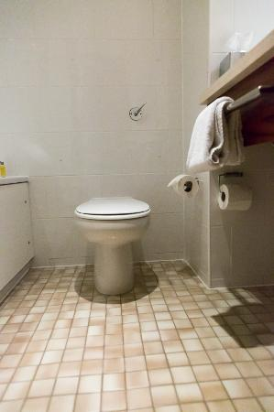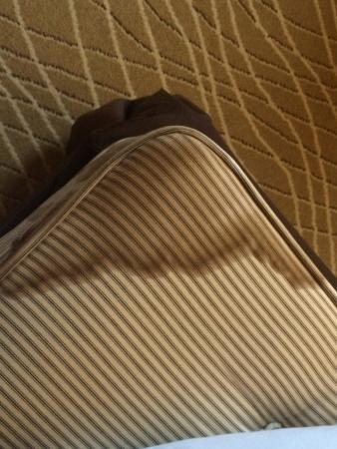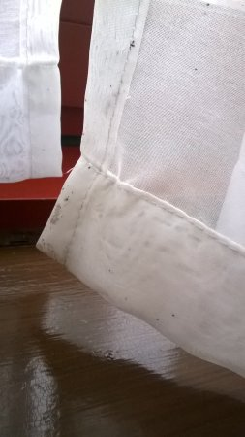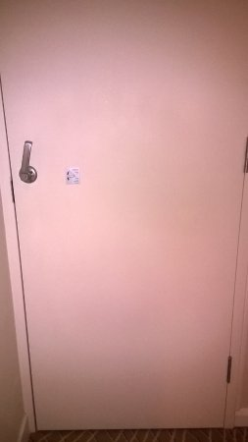

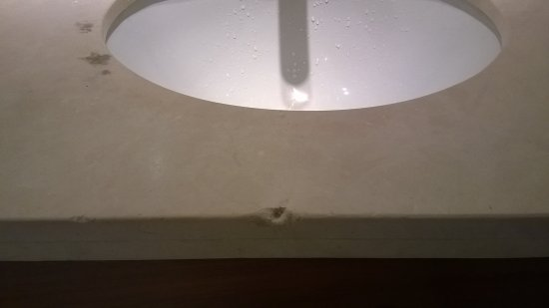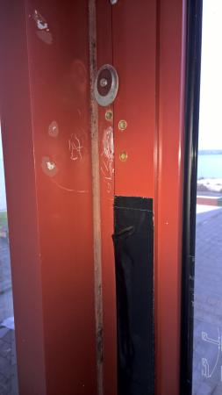

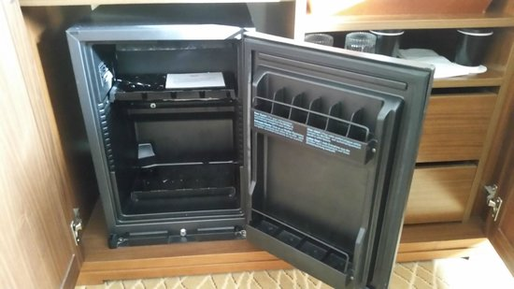

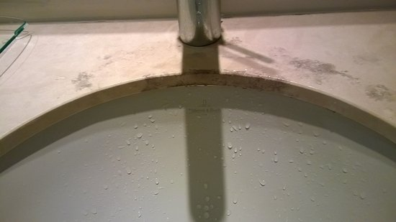

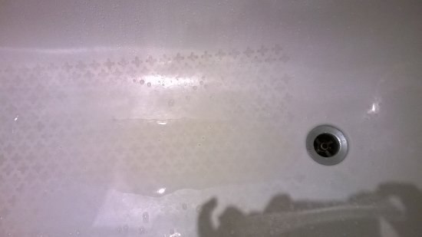

TripAdvisor Comment, 2019

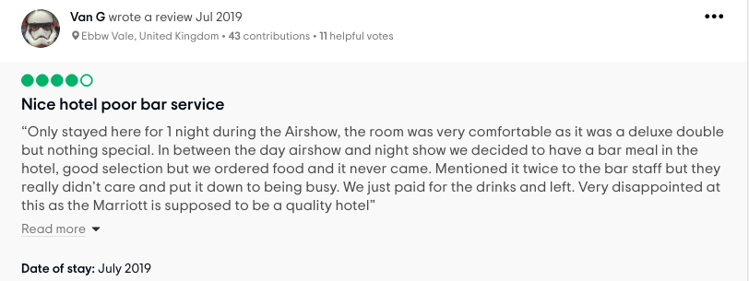
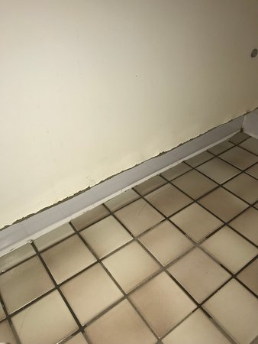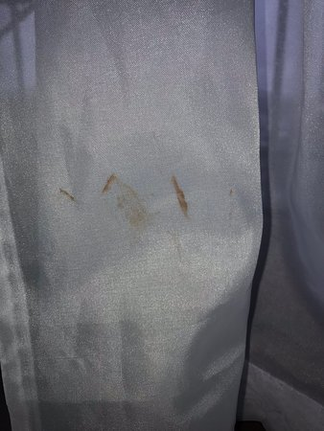

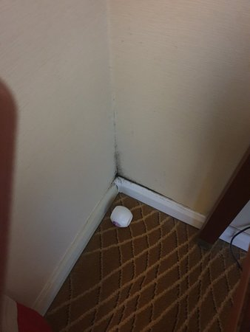

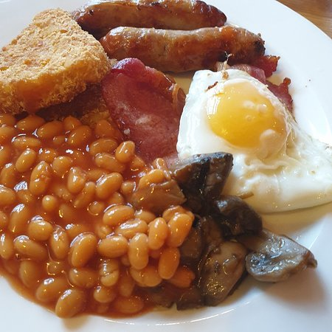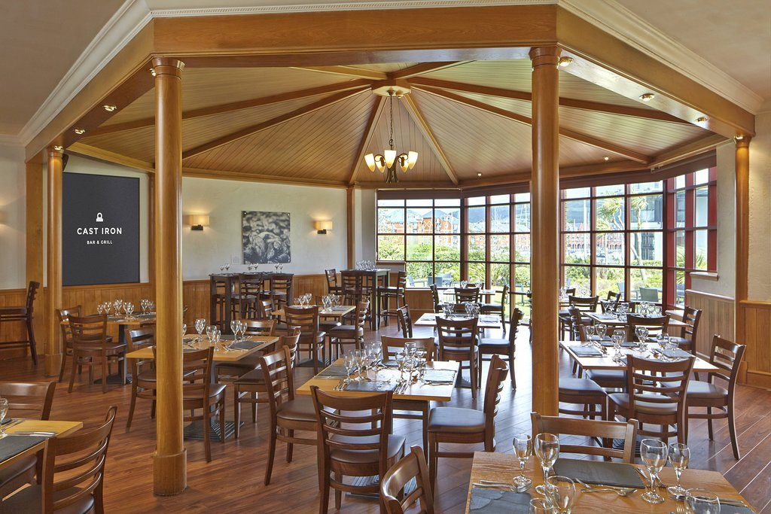

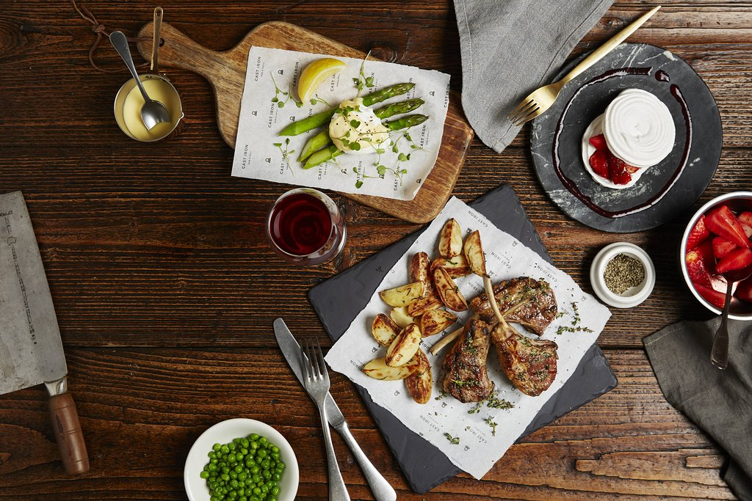

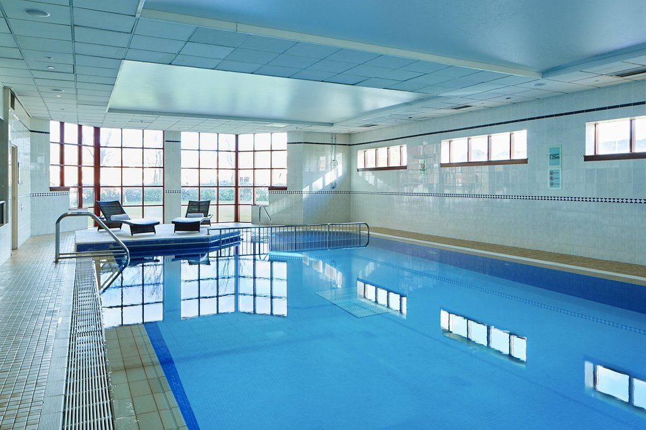

Marriott Facebook image

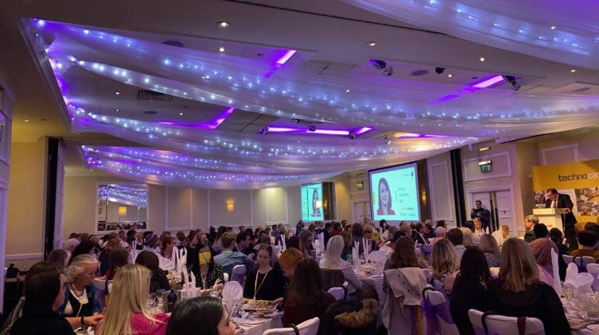

Village hotel Swansea FB images

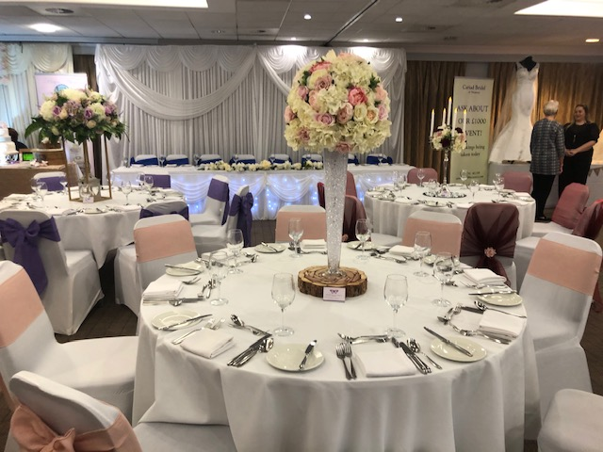

Images source - Facebook

