Travel Review

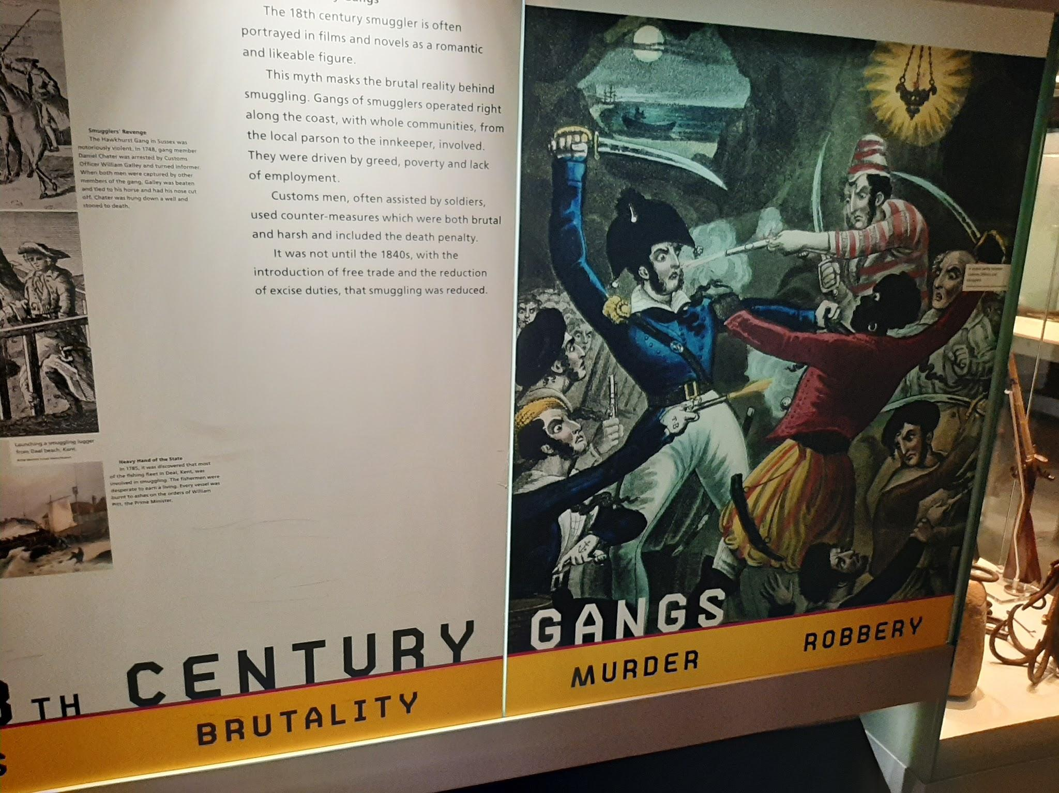
As I was focusing on the Dark Tourism in Liverpool I thought to visit a few of the museums and ended up visiting the national slavery museum. The history that goes behind this niche tourism is a sad time for the city but is interesting as it is part of history. I decided to visit the Merseyside Maritime Museum whilst I was in Liverpool as there was a lot of history about the different periods of time and I learnt about the 18th century gangs that were basically smugglers that included murder and robbery.

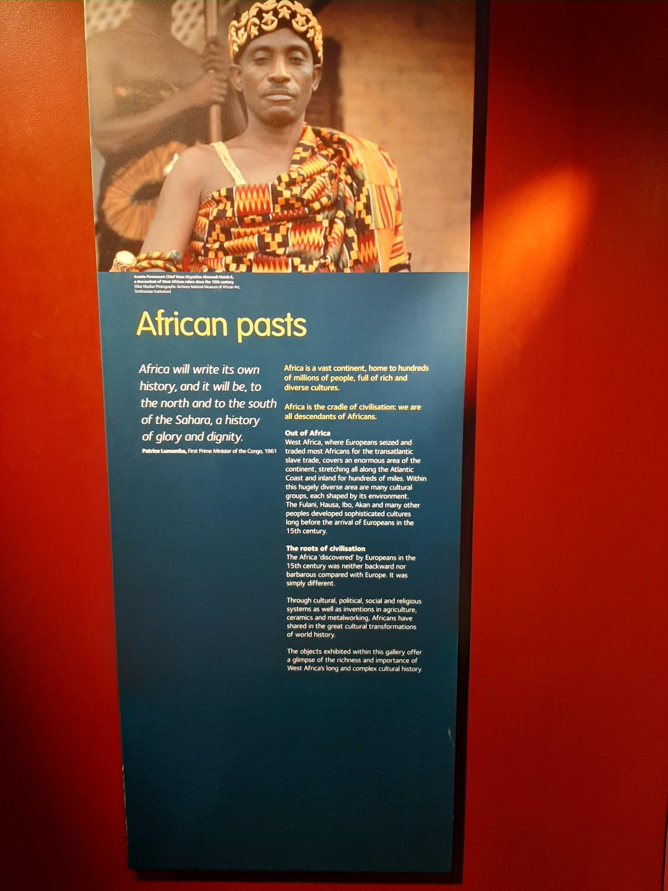
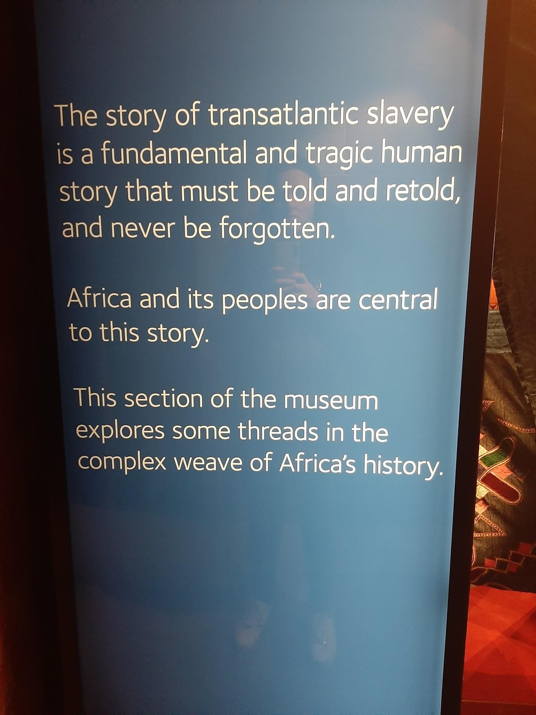
Onward, to the International Slavery museum which focused a lot on the slavery of the africans to work in the american colonies. It then went on around the museum showing how much the africans have had to fight for their freedom over the centuries.

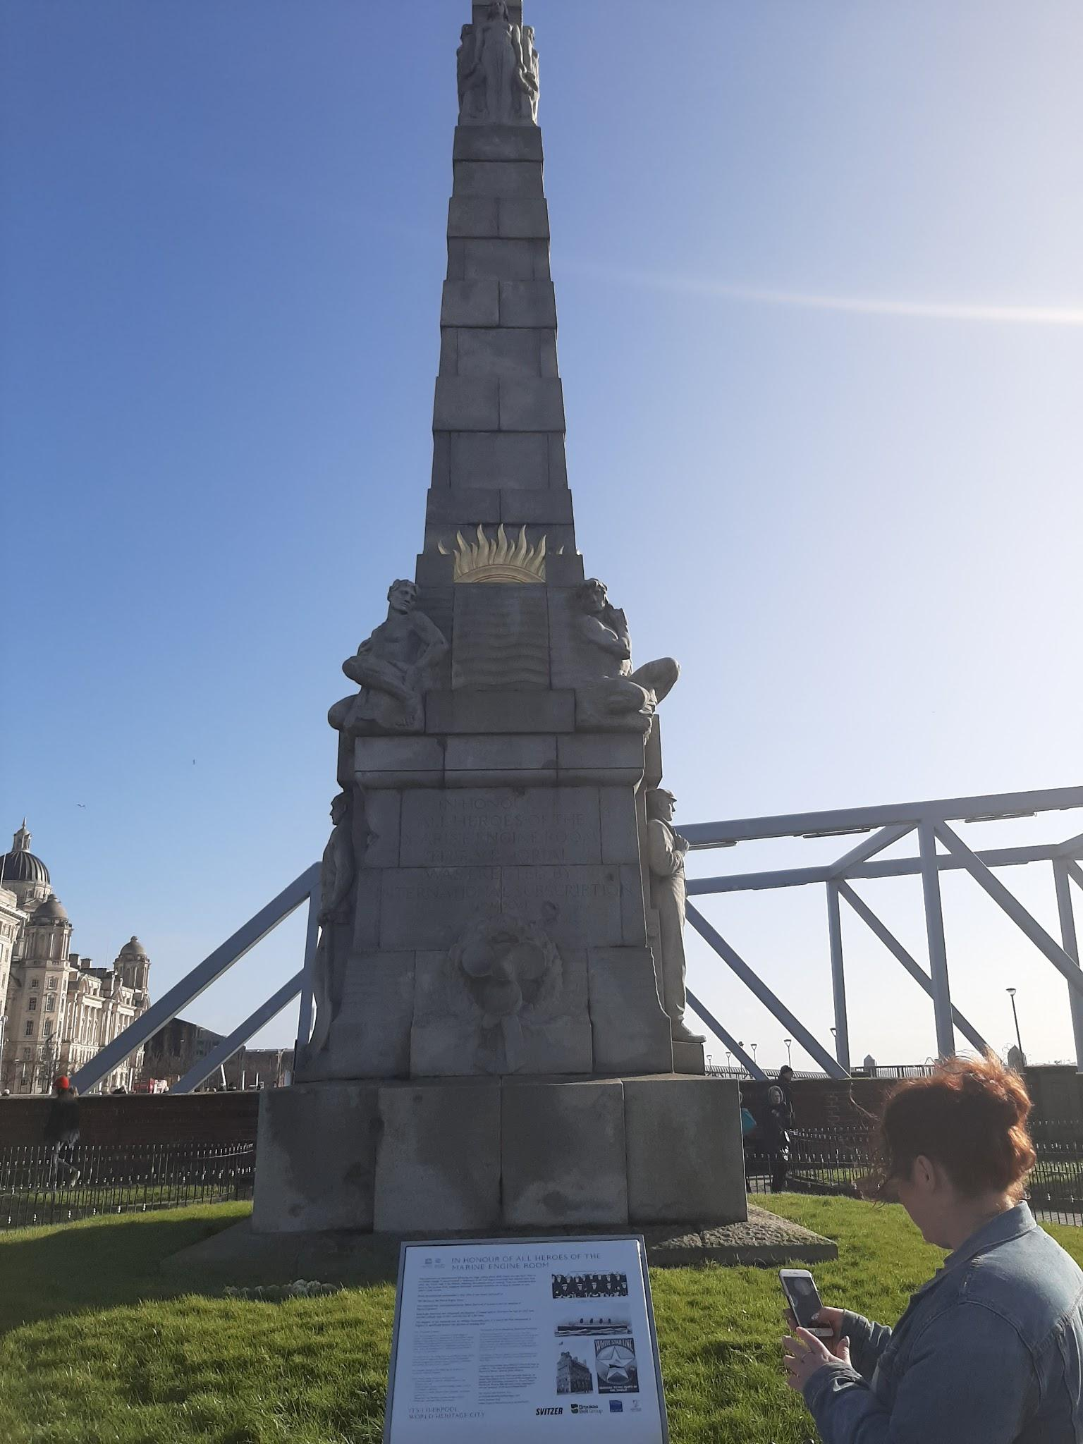

One of the most tragic events that is remembered in Liverpool is the RMS Titanic that sank on the 15th of April 1912 and there is a memorial for all of those who died in the marine engine room even though the Titanic never set foot in Liverpool it was owned by Liverpool.

Another of Liverpool’s tragedies was the Hillsborough disaster on the 15th of April 1989 which saw the lives of 96 Liverpool fans taken that day.


