MSc Digital Transformation
for the Health and Care Professions
BMDS7005

Review of Outpatient reform in Wales before, during, and after the COVID-19 pandemic
Dissertation submitted in partial fulfilment of the award of
Master of Science in Digital Transformation for the Health and Care Professions

Carl Davies
2317968
<Insert submission date here>

Acknowledgements
“Do not be afraid to ask, do not be afraid to challenge, but most importantly, do not be afraid to be wrong.”
(Davies, 2024)
I spoke the words above in 2024, when presenting my observations on the first year of my MSc course to the new intake on the course induction day. The words came to me about fifteen minutes before the presentation as I saw the fear and anticipation on the faces of those about to start the course, and I had to hastily rewrite part of it so everything else would tie in and make sense. I stand by those words even today, as they have served me well with those I mentor, train, and support in my day job. I am sure my lecturers during the course will, however, have other observations and recollections on my newfound way of learning that may differ from mine!
I am indebted to the guidance and gentle nudging in the right direction by Dr Philip Scott, without whom I would not have managed to arrive at the document you view today. I’d also like to thank Dr Ed Conley and Dr Simona Ferraraccio for their patience and enthusiasm during the lectures and for imparting their knowledge so well to the group during our team sessions.
Of course, my family must have the highest honours here, as they have had to endure me at all hours while I have been preparing my essays for marking over the past three years. To my wife, Susan, who has always been my rock; my son, Aled, who could proofread anything I wrote, and still make sense of it, and my daughter, Lowri, who has always been there to lend support, this has been a team effort.
And finally, to Myrddin - who would have thought that after 26 years I would still be looking after you, you would continue to support NHS Wales, and would still be surprising me every day?

Declaration

This work has not previously been accepted in substance for any degree and is not being concurrently submitted in candidature for any degree.

Signed………Carl Davies……………………

Date………………………………………………

Use of Generative AI

RESEARCH | For this assessment, you can use Generative AI to support you in research, including searching for bibliography, using tools to summarise, compare and interrogate materials. | Yes ☒  No ☐
STRUCTURE | For this assessment, you can use Generative AI to support you in structuring your submission, including creating a draft argument structure, identifying parts and headings, etc. | Yes ☐  No ☒
PROOFREADING | For this assessment, you can use Generative AI to check your own text/creation for grammatical and syntactical mistakes, including rephrasing of your own work within specific standards. | Yes ☐  No ☒
WRITING | For this assessment, you can use Generative AI to create text for submission. | Yes ☐  No ☒
CREATIVE | For this assessment, you can use Generative AI to create creative materials, such as images. | Yes ☒  No ☐
PROGRAMMING | For this assessment, you can use Generative AI to create and check code. | Yes ☐  No ☒

Contents
Contents 4
List of Tables 6
List of figures 7
1. Introduction 9
1.1. Background and Context 9
1.2. Scope 13
2. Literature Review 16
2.1. Introduction 16
2.2. Focus 16
2.3. Method 17
2.4. Limitations 18
2.5. Literature findings 19
3. Research Methodology 30
3.1. Introduction 30
3.2. Introduction to the research design 30
3.3. Choice of data collection method 30
3.4. Quantitative data 31
3.5. Qualitative Data 35
3.6. Research question breakdown and how the selected method for analysis can be used to help answer the questions posed 37
3.7. Project Planning and Management 38
3.8. Ethical, Legal, and Professional Considerations 41
4. Results and Data Analysis 43
4.1. Introduction 43
4.2. Quantitative findings 43
4.3. Qualitative results 52
5. Discussion 62
5.1. Has the rise in capacity and investment reduced outpatient waiting lists? 62
5.2. Have changes in clinical practice patterns offset the increase in outpatient capacity? 62
5.3. Has the introduction of virtual appointments increased follow-up rates rather than reduced them? 63
5.4. How successful have PIFU, SoS, and “discharge as default” been in reducing follow-up demand? 64
5.5. Have changes in administrative outcomes following the pandemic resulted in longer outpatient pathways? 65
5.6. Summary of findings 65
5.7. Validity, Reliability, and Limitations of Results 65
5.8. Future research 67
6. Conclusions 68
References 69
Appendix 1 – Further detailed charts from the quantitative data extract of NHS Wales data 76
Additional Quantitative charts 76
Additional Qualitative charts and diagrams 78
Appendix 2 – Ethical Review document 79
Appendix 3 – Qualitative survey provided to staff as part of this research 96
Appendix 4 – Documents used for the Literature Review in Chapter 2 106

This document has a word count of 16,374 (optimal = 15,000, lower = 13500, higher = 16,500)

List of Tables
Table 1: Literature search filtering in PubMed 17
Table 2 Literature search and filtering in NHS Wales e-Library (Telemedicine) 17
Table 3 Literature search and filtering in NHS Wales e-Library (Patient-Initiated Follow-up) 17
Table 4 Major and minor themes identified as a barrier to adopting virtual care (Chan-Nguyen et al., 2022) 20
Table 5 Health Boards served by WelshPAS 31
Table 6 Data elements that were retrieved from WelshPAS as part of this research project, and their context. 33
Table 7 Breakdown, showing the different parts of the Research question, and how the selected methods will be used to answer them 37
Table 8 Average Attendances v Hospital Cancellations 2019 - 2025 (New Patients Only, highlighting the first lockdown period. 45
Table 9 Barriers to Wider or Sustained Use of PIFU / SOS 56
Table 10 Themes Identified: Enhancing Patient Flow and Reducing Waiting Times 57
Table 11 How outpatient care has changed since the COVID-19 pandemic - overarching themes 59
Table 12 Documents used for the literature review noted in Chapter 2 106

List of figures
Figure 1 A simple timeline of COVID-19 management in Wales (Welsh Parliament Senedd Research, 2022) 9
Figure 2 Change in GP referral rates over time, 2019 – 2025 (derived from the data retrieved as part of this research) 13
Figure 3 Comparison of GP Referrals v Out-patient Waiting List, 2019 - 2025 (derived from the data retrieved as part of this research) 13
Figure 4 A Rich picture to illustrate how some perceived the effect of COVID and Winter Pressures on the NHS in Wales and the anticipated benefits of SoS and PIFU 15
Figure 5 PRISMA flow diagram, used to highlight the search and filtering used in the literature review 18
Figure 6 Image highlighting some of the benefits and challenges to achieving the Quintuple Aim for healthcare during COVID-19, and the introduction of virtual appointments, SoS, and PIFU 25
Figure 7 Sample of the additional text and placeholders added to graphs to indicate a significant modification to WelshPAS, or NHS Wales, during the research period. Note: Data 35
Figure 8 GANTT chart part 1 showing the timeline of the dissertation 39
Figure 9 GANTT chart part 2 showing the timeline of the dissertation 40
Figure 10 Outline of the sample period, 2019 – 2025, showing GP Referrals and the overall Outpatient WL 44
Figure 11 Outpatient hospital attendance cancellations, per month (New Patients only) 45
Figure 12 Overall Outpatient activities, per month (New and Follow-up patients combined) 46
Figure 13 Percentage of overall outpatient activities, per month, by action (New and Follow-up combined) 47
Figure 14 Outpatient planned activities, per month, by mechanism (New and Follow-up combined) 47
Figure 15 Outpatient virtual activities, per month, by patient action (New and Follow-up patients combined) 48
Figure 16 Outpatient face-to-face activities, per month, by patient action (New and Follow-up patients combined) 49
Figure 17 Comparison of PIFU, SoS numbers against other stop reasons for outpatients that have attended, per month (New and Follow-up patients combined) 49
Figure 18 Outpatient outcome, by month (New patients only) 51
Figure 19 Outpatient outcome, by month (Follow-up only) 52
Figure 20 Breakdown of respondents to the survey, by role 53
Figure 21 Breakdown of respondents, by participating service 53
Figure 22 Analysis of workload perception following COVID-19 54
Figure 23 Analysis of follow-up rate perception 54
Figure 24 Perceived frequency of virtual appointments 55
Figure 25 Analysis of how often a virtual appointment leads to a face-to-face review 55
Figure 26 Are you aware of, and do you use the "Discharge as default" model for managing Outpatients? 58
Figure 27 Analysis of "Discharge as default" in outpatient areas 59
Figure 28 Breakdown of Outpatient Attendances by Activity Source 76
Figure 29 Breakdown of Outpatient activities that are then managed by PIFU or SoS 76
Figure 30 Breakdown of New Outpatient activities by Administrative Outcome, per month 77
Figure 31 Breakdown of Follow-up Outpatient activities by Administrative Outcome, per month 77
Figure 32 Breakdown of Follow-up Virtual Outpatient Activities by Administrative Outcome, per month 77
Figure 33 Breakdown of New Virtual Outpatient Activities by Administrative Outcome, per month 78
Figure 34 How long have you worked in Secondary care? 78
Figure 35 Breakdown of respondents, by organisation 78

Introduction

Background and Context
The COVID-19 pandemic affected healthcare globally, leading to delayed services and changes in outpatient care (Radley, 2020). In Wales, it reduced NHS capacity, prompting the rapid adoption of telemedicine (Welsh Government, 2021b). Many faced long waits to see secondary care clinicians, as waiting lists were paused and only urgent cases were prioritised. Figure 1 shows a simple timeline of how COVID-19 was managed in Wales (Welsh Parliament Senedd Research, 2022).
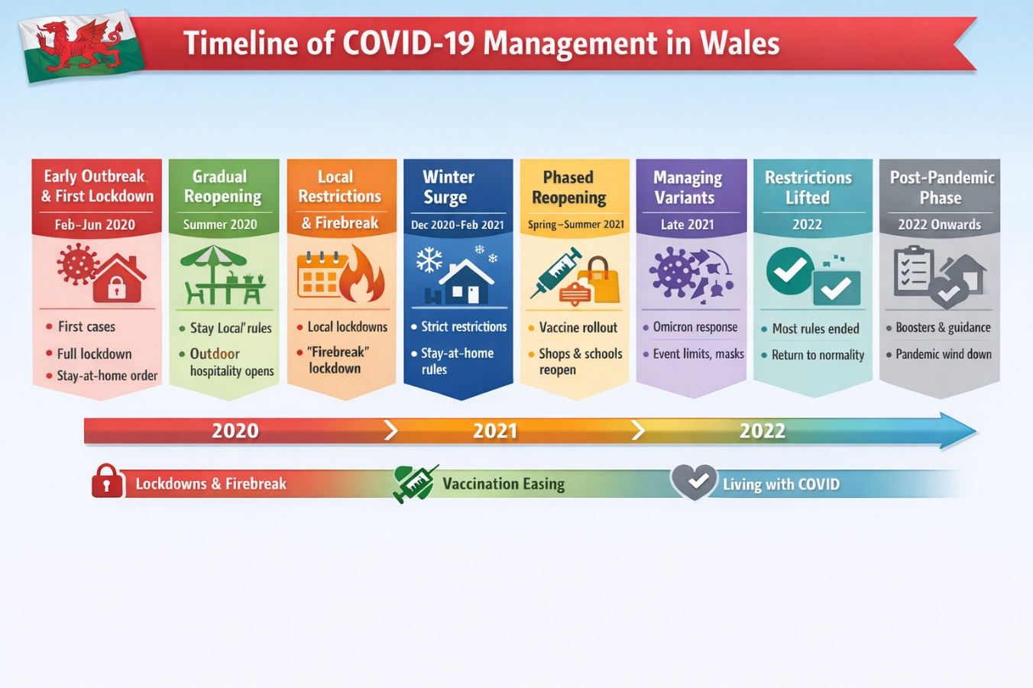
Figure 1 A simple timeline of COVID-19 management in Wales (Welsh Parliament Senedd Research, 2022)
The introduction of Telemedicine, or virtual appointments, was intended to manage and discharge patients without in-person visits unless needed. Other NHS Wales initiatives, such as Patient-Initiated Follow-Up (PIFU), and See on Symptom (SoS), which had also been in the pipeline or had recently been rolled-out aimed to expand outpatient capacity and reduce waiting lists (Welsh Government, 2021b).
Telemedicine, more commonly referred to in an outpatient setting as Virtual appointments, is a form of consultation carried out remotely, usually via telephone or video, instead of in-person hospital visits. In NHS Wales, they are commonly utilised across outpatient services for follow-ups, initial assessments, triage, and continuous monitoring, often combined with models like PIFU and SoS. This form of virtual care enhances accessibility by minimising travel, saving time for patients and clinicians, and allowing more flexible scheduling. Additionally, it supports the wider digital transformation of healthcare, helping maintain efficiency while ensuring safe, patient-centred care. (Wootton, 1998; Ohannessian, Duong and Odone, 2020; Welsh Government, 2021b, 2023a)
Patient Initiated Follow-Up (PIFU) is a model in NHS Wales where patients take responsibility for arranging their own follow-up appointments rather than being given routine, pre-scheduled reviews. This approach is usually applied to individuals with stable or long-term chronic conditions who can recognise changes in their symptoms. Patients are provided with explicit instructions on when and how to contact the service if necessary. They continue to be managed by the specialist team without a formal discharge process. The goals are to reduce unnecessary outpatient visits, encourage self-management, enhance access to care when concerns arise, and foster shared decision-making between patients and clinicians. (BCU, 2019; Welsh Government, 2023a). A doctor, nurse, or consultant reviews the medical records and care plan at set intervals (usually every 2 years) to ensure compliance with guidelines and the continued suitability of the care plan.
See on Symptom (SoS) is a model that allows patients to request a follow-up review only when their symptoms return or worsen, rather than attending routine appointments. Unlike PIFU, SoS includes a fixed time limit during which patients can re-engage with care, if necessary. If no contact occurs within this timeframe, the patient is automatically discharged without further review. SoS is usually employed for short-term or resolved conditions that don't need continuous monitoring but still require a safety net. This method helps optimise clinical resources while providing reassurance and access to care if problems recur. (ABHB, 2023; Welsh Government, 2023a)
These innovations were not limited to Wales, with digitalisation efforts rapidly implemented worldwide to ensure continuity of care and the overall delivery of services, even as conditions deteriorated. (Meskó, 2022)
In 2021, the Welsh Government set five goals for its planned care strategy, which was updated in 2023 with an improved Outpatients plan. (Welsh Government, 2023a)
The goal of effective referrals was to ensure that patients were sent to specialist services only when truly necessary. This was to be done through clearer referral criteria, better adherence to guidelines, and improved communication between primary and secondary care providers. By minimising unnecessary or inappropriate referrals, fewer patients occupy waiting lists, enabling those with the most urgent needs to be seen sooner. This approach hoped to shorten wait times and enhance safety and the quality of care by ensuring patients were directed to the most appropriate service at the right point in their treatment.
The advice and guidance goal assists primary care clinicians, such as GPs, by providing access to specialist input without a formal referral. These measures were intended to alleviate pressure on hospital outpatient services and help prevent unnecessary delays for patients needing specialist care. As a result, waiting lists should be shortened, enabling faster decision-making and more convenient, local care for patients.
The treat accordingly goal set out to guarantee that patients had the appropriate care at the right location and time. It involved optimising pathways, implementing “straight to test” diagnostics, and moving suitable care to community settings or specialist centres. By enhancing efficiency and eliminating unnecessary steps in the patient journey, it was planned that services could accommodate more patients with the same resources. This would, in turn, boost capacity, reduce waiting times, and lead to better outcomes through prompt diagnosis and treatment.
The follow-up prudently aimed to reduce unnecessary routine appointments and replace them with more adaptable methods, such as patient-initiated follow-ups or remote monitoring. Many conventional follow-ups lacked clinical value, it was thought, so reducing these would free up appointment slots for new patients. This would then help reduce waiting lists and give patients more control over their care. Furthermore, it was felt that it would enhance the patient experience by minimising unnecessary hospital visits and concentrating care where it was most needed.
Finally, the measure-what’s-important goal was highlighted using data, outcomes, and patient feedback to enhance planned care services. By analysing waiting times, clinical results, and service efficiency, health boards can improve patient prioritisation, spot inefficiencies, and allocate resources more effectively. This method promotes better decision-making and continuous service enhancements. Ultimately, it aims to sustain reductions in waiting lists and uphold high-quality care, focusing on outcomes rather than activity volume.
In this context, initiatives such as PIFU and SoS, which had already been partially implemented, now raised awareness of the need to manage patients differently in the future, with a focus on discharge-first or on empowering patients to manage their recall themselves, if required. In 2019, the 'discharge as default' initiative made discharge the primary option, focusing outpatient care on those most in need. In the aftermath of the pandemic, an extra £185 million annually for four years was secured to reduce waiting lists and build a sustainable planned care system (Auditor General for Wales, 2022).
Discharge as Default is a principle within NHS Wales outpatient transformation that encourages discharging patients from specialist services unless there is a clear clinical reason to continue with a follow-up plan. Instead of automatically booking review appointments, clinicians are advised to refer patients back to primary care or empower them to manage their own health once treatment is completed or their condition remains stable. Follow-up appointments are scheduled only when beneficial or when safety-net options like PIFU or SoS are in place. This approach supports the idea of prudent healthcare, which aims to reduce unnecessary care, make better use of available service capacity, and allocate specialist resources to those who need them most. (Welsh Government, 2022; ABHB, 2023)
Together, these initiatives aim to decrease unnecessary demand, enhance pathway efficiency, and make better use of outpatient capacity.

The challenges faced by outpatient services during and after the COVID-19 pandemic can be analysed using queueing theory, which explores how demand, capacity, and system structure affect waiting times and backlog build-up (Hall et al., 2013). In this context, outpatient waiting lists function as queues, with patients arriving via referrals and being “served” through appointments. When patient inflow exceeds service capacity, queues expand, leading to increased waiting times and reduced system performance (Green, 2006).
Interventions implemented within NHS Wales are used to influence various parts of the queueing system. For instance, virtual appointments can boost the effective service rate by allowing more patients to be accommodated within current resources. Models like Patient-Initiated Follow-Up (PIFU) and See on Symptom (SoS) aim to manage demand by decreasing unnecessary follow-up visits. Additionally, “discharge as default” removes patients from the queue unless they need ongoing care, which helps reduce queue length and enhance throughput. These strategies exemplify broader efforts to balance demand and capacity in outpatient services.
Additionally, the COVID-19 pandemic acted as a system shock—a sudden and major disruption affecting both demand and capacity within complex systems (Hodgins et al., 2022). During the early lockdowns, outpatient services experienced a steep decline in capacity due to infection-control measures, staff redeployment, and the prioritisation of urgent care. Simultaneously, demand was initially reduced but then rebounded. This mismatch caused large waiting lists to accumulate.
Although service capacity improved, the backlog from the disruption persisted, demonstrating that short-term shocks can have prolonged impacts on system performance (OECD, 2020). From a queueing theory perspective, this indicates a system operating beyond equilibrium, with demand exceeding service capacity over time. Viewing COVID-19 as a system shock offers a helpful framework for understanding why waiting lists stayed high even as outpatient activity increased after the pandemic.
Queueing theory, combined with system shock, offers a conceptual framework for analysing how outpatient systems respond to disruptions and reforms. It also considers how interventions such as virtual care, PIFU, and discharge as the default affect waiting list dynamics and appointment throughput.
Since 2021, outpatient activity has grown markedly, and GP referral rates have gone back to pre-pandemic levels (Figure 2). However, waiting lists remain high, reflecting the ongoing imbalance between demand and capacity (Figure 3). This indicates that COVID-19's effects are lasting, causing persistent strain on outpatient services.
This study explores the strategies used to handle outpatient demand and throughput, such as virtual appointments, PIFU, SoS, and default discharge, evaluating their effectiveness from an administrative standpoint (BCU, 2019). It does not consider clinical outcomes and assumes that these administrative choices do not negatively impact patient care. The analysis aims to assess whether these measures have significantly enhanced capacity and alleviated waiting list pressures in NHS Wales.
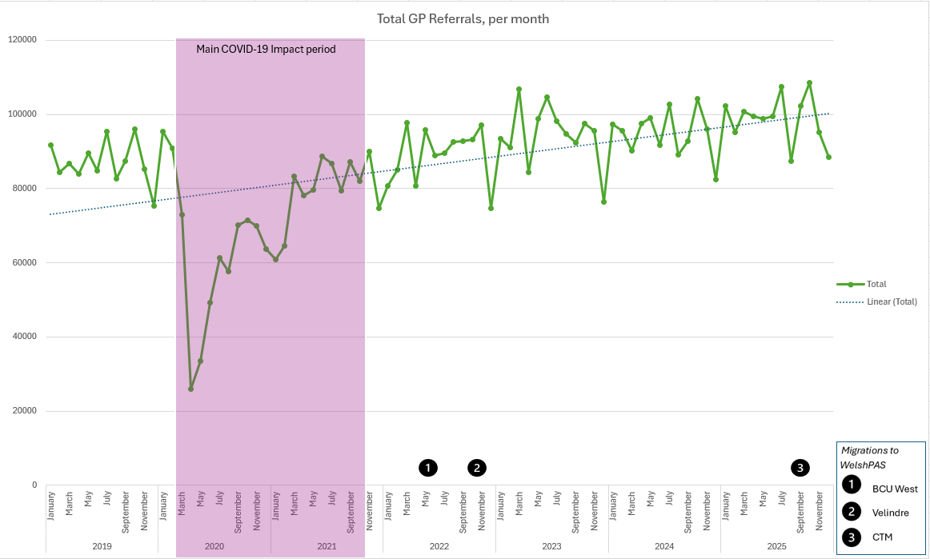
Figure 2 Change in GP referral rates over time, 2019 – 2025 (derived from the data retrieved as part of this research)
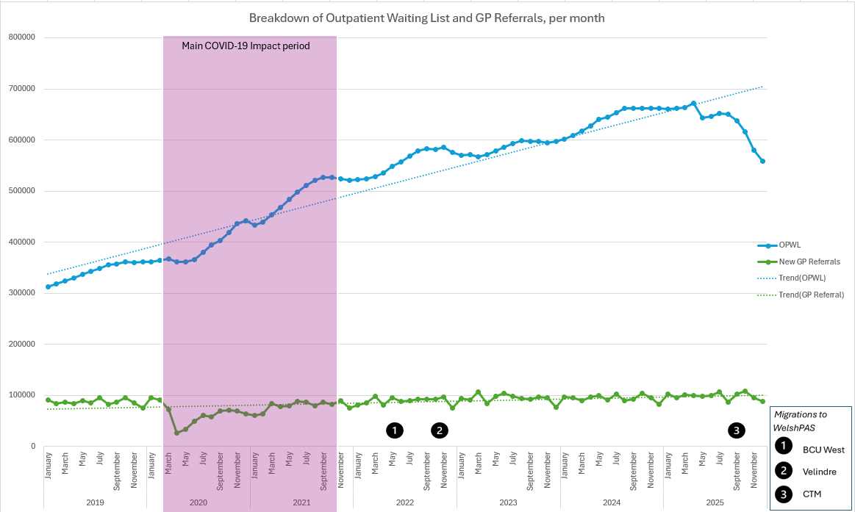
Figure 3 Comparison of GP Referrals v Out-patient Waiting List, 2019 - 2025 (derived from the data retrieved as part of this research)

Scope
This work examines clinicians' administrative decision-making regarding patient reviews and discharges in Wales before, during, and after COVID-19, with an emphasis on waiting times and treatment numbers. It also explores how virtual clinics, 'discharge as a default', PIFU, and SoS have influenced outpatient management and follow-up.
In Wales, the use of these patient management methods increased during the pandemic to address backlogs and prioritise care. There is growing interest in how these changes influenced clinicians' behaviours, particularly their decisions to review or discharge patients, which in turn affected waiting lists and access to care (BCU, 2019). The results of the data analysis will also enable us to determine whether the changes have been maintained throughout the period, whether patient throughput has increased, or whether the perceived delay in seeing patients in a timely manner has worsened.
Examining these shifts is crucial for evaluating service transformation and ensuring equitable, sustainable healthcare (Welsh Government, 2022). 'Discharge as default’, SoS, and PIFU represent a cultural shift, placing greater responsibility on patients to manage their own care. While these strategies may lower follow-up demand, their effects on health outcomes and waiting lists are understudied. Figure 4 illustrates the perception by some of the impact of both COVID and Winter pressures on the NHS in Wales at the time when PIFU, SoS, and Discharge as default were being introduced.

Research objectives
Based on the aims noted above, the research objectives of this work can be broken down into five key areas:
- To analyse historical data on clinician administrative decision-making trends regarding outpatient reviews and discharges in Welsh secondary care from January 2019 to December 2025, divided into pre-pandemic, pandemic, and post-pandemic phases.

- To explore the relationship between clinician decisions, waiting times, and patient volumes on waiting lists during these periods

- To evaluate the implementation and use of virtual clinics, "discharge by default," PIFU, and SoS models, assessing their uptake across health boards and specialties

- To assess how these initiatives affect follow-up appointment rates, re-referrals, and patient flow or service efficiency.

- To review clinician feedback and perceptions to identify factors supporting or hindering ongoing adoption.

From these key objectives, we can begin to formulate a single research question that can then be broken down into multiple parts:

Research Question
During and immediately after the COVID-19 pandemic in the UK, NHS Wales introduced the widespread use of virtual appointments in secondary care. This period also saw the introduction and reinforcement of policies such as “discharge by default”, See on Symptom (SoS), and patient-initiated follow-up (PIFU). Do “discharge by default”, PIFU and SoS, and other shifts in clinical practice, reduce the need for follow-up visits, or have they resulted in longer outpatient pathways, thereby contributing to persistent long wait times for initial outpatient appointments?

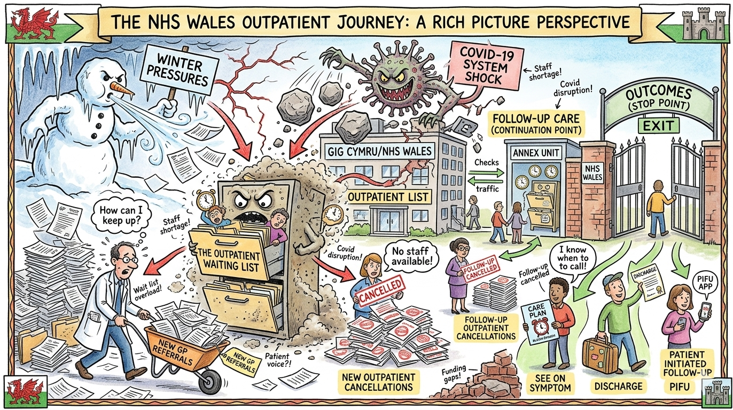
Figure 4 A Rich picture to illustrate how some perceived the effect of COVID and Winter Pressures on the NHS in Wales and the anticipated benefits of SoS and PIFU

Literature Review

Introduction
This chapter provides a critical review of the existing literature on the deployment of technologies and processes in outpatient settings across the UK and other regions, including virtual appointments, “Patient Initiated Follow-up (PIFU)”, and “See on Symptom (SoS)”.
Accelerated by the COVID-19 pandemic, the expansion of virtual appointments and patient-initiated follow-up (PIFU) in Wales reflected a broader shift towards flexible, demand-led healthcare delivery. (NHSWales, 2018; Welsh Government, 2022). The review examines how the new working methods associated with these technologies and policies were implemented and monitored elsewhere to assess their efficacy, thereby guiding the discussion and interpretation of the data presented in Chapters 4 and 5 of this document. This helps us determine whether the initial expected benefits of measures aimed at reducing outpatient waiting lists were achieved and maintained, and whether new methods improved or maintained patient care.

Focus
The subject matter in the review is large. As a result, the review was focused on these specific elements:
- Effects of these activity management policies and mechanisms on the patient experience. Healthcare systems should aim to provide safe, effective, and patient-centred care (Bevin, 2021). Policies involving virtual consultations, SoS, and PIFU may be justified because they enhance accessibility, autonomy, and convenience (Lavin et al., 2020). Evaluating patient experience is essential to determine whether these policies achieve their primary goal, and some of these documents assist in analysing whether the experiences met the anticipated expectations.

- Effects of these activity management policies and mechanisms on the waiting list, if any. A primary reason for implementing these models is to address the rising waiting lists and capacity challenges in outpatient services (Newton, Beaver and Clegg, 2022a). As a result, evaluating their effect on waiting times is crucial, and some of the chosen documents assist in this analysis (Mallick, Balakumar and Drysdale, 2022).

- Limitations of any policies related to patient management, safety, and equity of use. Although innovation is generally seen as beneficial, the literature may suggest that virtual care, SoS, and PIFU also entail new risks and limitations (Khanji et al., 2023). Assessing these aspects is crucial for a comprehensive and critical evaluation (Child, Victoria A Goodwin, et al., 2015).

Method
The databases used to search and select materials were PubMed and the NHS Wales e-Library for Health.
A similar approach was made to all searches. However, PubMed enables more rigorous, comprehensive, and reproducible searching due to its use of controlled vocabulary (MeSH), advanced Boolean functionality, and consistent indexing (Help - PubMed, no date). In contrast, the NHS Wales e-Library is better suited to accessing resources than to systematically identifying them, as its reliance on keyword searches and multiple database interfaces limits search precision and consistency (NHS Wales LibrarySearch, no date).
Table 1 presents the search criteria and filtering methods used for the initial paper selection in PubMed. In contrast, Table 2 and Table 3 illustrate the search parameters applied for a similar search in the NHS Wales e-Library. Due to the e-Library search engine's limitations, the search was divided into two sections: PIFU and Telemedicine.
Table 1: Literature search filtering in PubMed
PubMed search criteria | Number of papers returned from search
( "2019/01/01"[Date - Publication] : "2027"[Date - Publication] )  – Filter on English | 10,910,299
AND ( "digital follow-up"[tiab] OR "remote follow-up"[tiab] OR "telemedicine"[MeSH] OR telemedicine[tiab] OR barriers[tiab] )  AND  ( "Evaluation Study"[pt] OR "Review"[pt] OR "Systematic Review"[pt] ) | 39,013
AND ("outpatient s"[All Fields] OR "outpatients"[MeSH Terms] OR "outpatients"[All Fields] OR "outpatient"[All Fields]) | 714
AND  ( "COVID-19"[MeSH] OR COVID-19[tiab] OR SARS-CoV-2[tiab] ) | 230

Table 2 Literature search and filtering in NHS Wales e-Library (Telemedicine)
NHS Wales e-Library search and filtering (Telemedicine) | Number of papers returned from search
("Telemedicine" OR "Virtual appointment") between 2018 and 2026. Peer-reviewed journals only, in English. | 31,157
AND “COVID” | 2,019
AND “United Kingdom” | 87

Table 3 Literature search and filtering in NHS Wales e-Library (Patient-Initiated Follow-up)
NHS Wales e-Library search and filtering (Patient-Initiated Follow-up) | Number of papers returned from search
("PIFU" or "Patient initiated Follow up") between 2018 and 2026. Peer-reviewed journals only, in English. | 79
AND “Outpatient” | 28

During scrutiny and citation verification, additional documents were identified and added to the final list for viewing. After scrutiny, documents deemed unsuitable due to lack of relevance, low value, or duplication were removed from the cohort, and the final 36 documents were selected for review. Figure 5 shows a representation of how studies were identified, screened, and selected as a standardised PRISMA flow diagram (Haddaway et al., 2022). Details of the final documents selected for use in this literature review appear in Appendix 4.

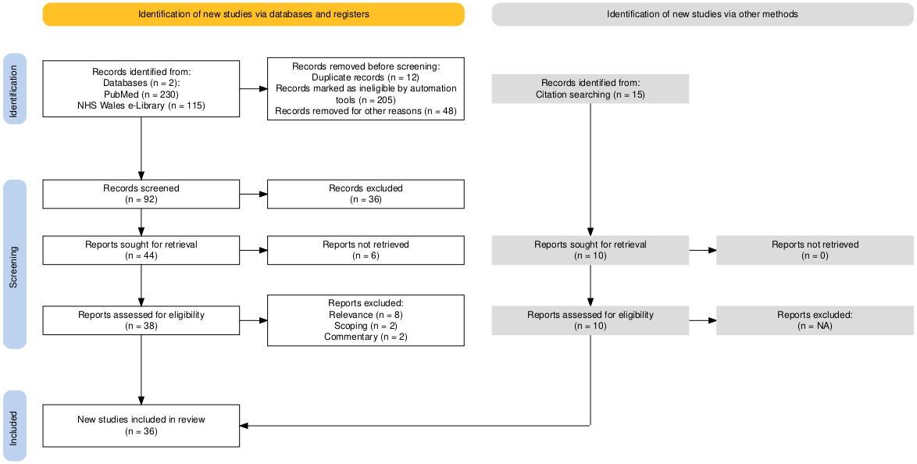
Figure 5 PRISMA flow diagram, used to highlight the search and filtering used in the literature review

Limitations
While this overall document also explores the ideas of “Discharge as default" and “See on Symptom", some limitations were identified during the literature search.
- In researching “Discharge as default,” it became clear that its interpretation in Wales differed from that in other regions, where it was primarily considered a result of PIFU and SoS review activities. Consequently, the term and related work were excluded from this review due to insufficient evidence to treat it as a separate item. However, whilst it is excluded from the formal literature synthesis due to limited and inconsistent evidence, “discharge as default” is retained within the conceptual and policy discussion because of its practical relevance within NHS Wales outpatient reform.

- The deployment method for “See on Symptom” (SoS) closely resembles Patient-Initiated Follow-up (PIFU), leading to frequent interchangeable use of the terms across different texts. Unlike PIFU, SoS usually has a fixed few-month reassessment period, after which patients are discharged if no contact occurs. It's used for short-term or resolved conditions needing a safety net. As a result of this similarity, this review mainly covers PIFU, but the principles also apply to SoS.

Literature findings

Introduction to literature findings
Outpatient healthcare has seen a major shift over the last decade, driven by rising demand, workforce constraints, and the need for greater efficiency in publicly funded systems such as NHS Wales. Innovations such as virtual appointments, Patient-Initiated Follow-Up (PIFU), and See on Symptom (SoS) pathways have been seen as essential for tackling increasing waiting times and service pressures. Although established before 2020, the COVID-19 pandemic sped up their adoption, integrating digital and patient-led approaches into everyday care (Bhaskar et al., 2020). Whilst virtualisation, SoS, and PIFU have the potential to boost efficiency and patient independence, their impacts are complex and differ across contexts.
The Quadruple Aim guides NHS Wales policy (Bodenheimer and Sinsky, 2014), emphasising population health, patient experience, cost reduction, and workforce wellbeing (NHSWales, 2018). Recently, healthcare literature has extended this to the Quintuple Aim by explicitly incorporating health equity as a key goal (Nundy, Cooper and Mate, 2022). This change acknowledges that healthcare innovations, especially digital and patient-led models, can both help reduce and worsen existing inequalities.
While NHS Wales officially adheres to the Quadruple Aim, its recent policy initiatives and service changes increasingly embody the broader principles of the Quintuple Aim (Welsh_Government, 2021). Initiatives aimed at expanding access and tailoring care pathways suggest a move towards integrating equity into system redesign. This literature review uses the Quintuple Aim as an analytical lens to assess the effects of virtual appointments, PIFU, and SoS models on outpatient care. This approach allows for a thorough evaluation of how these innovations impact not just efficiency and patient experience, but also workforce sustainability and access equity (Kadel et al., 2022). The review critically explores existing evidence on patient outcomes, waiting times, and system performance, highlighting the opportunities and potential unintended consequences of these evolving care models.

Virtual appointments and the impact on patients
The benefits of virtual appointments are well supported by evidence, as they improve convenience and accessibility for patients, mainly by eliminating the need to travel and minimising disruptions to daily routines (Lavin et al., 2020). Across multiple studies, patients report that remote consultations allow them to attend appointments without taking time off work, arranging childcare, or undertaking potentially burdensome journeys—factors that are particularly relevant in geographically dispersed populations such as those served by NHS Wales (Donaghy et al., 2019; Gilbert et al., 2020).
For individuals with chronic conditions who require frequent follow-up, reducing travel and other pressures improves engagement and continuity of care. This has been shown in paediatric and specialist settings where families appreciate the ease of integrating healthcare into daily life (Akintomide & Peters, 2020). These benefits were amplified during the COVID-19 pandemic (see Section 2.5.5). Other evidence indicates that virtual care’s flexibility, such as attending from home or at work, can reduce missed appointments and enhance service efficiency, helping manage waiting lists (Evans et al., 2025; Ruggiero, Waite and Stayt, 2026).
Although convenience is often cited as a key benefit, it’s important to recognise that these advantages are not universal; they rely on digital access and literacy, which may limit some patient groups, underscoring the need for equitable deployment (Wherton et al., 2020). In qualitative studies, patients described virtual care as efficient but impersonal, highlighting a trade-off between convenience and perceived quality of interaction.(Ruggiero, Waite and Stayt, 2026). In addition, some patients highlighted barriers to adopting virtual appointments and care, as noted in Table 4 (Chan-Nguyen et al., 2022)

Table 4 Major and minor themes identified as a barrier to adopting virtual care (Chan-Nguyen et al., 2022)
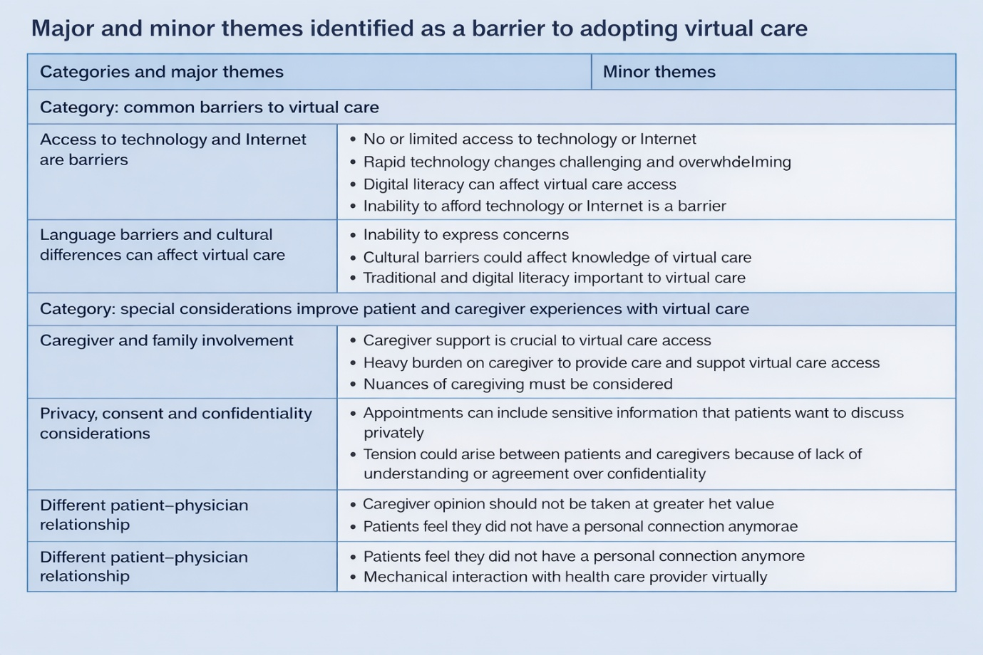
The literature shows that virtual appointments substantially reduce time, financial, and logistical barriers typical of outpatient care, making them a vital tool for improving access in contemporary healthcare systems.

The clinical effectiveness of virtual appointments and their outcomes
Many of the reviewed documents evidence that the clinical effectiveness of virtual appointments generally matches that of in-person care for low-risk and follow-up visits (Howren et al., 2020; Kim et al., 2021). At a specialist children’s hospital, for example, clinicians found virtual consultations effective in many cases, although limitations were noted in physical examinations and complex decision-making (Akintomide et al., 2021). In specialties such as dermatology and ENT, evidence indicates that remote consultations achieve satisfactory clinical results (Mallick, Balakumar and Drysdale, 2022; Pennington et al., 2022).
However, while virtual appointments can effectively maintain service delivery, they may subtly affect clinical practices. In chronic and complex conditions, the literature raises concerns about fragmentation and decreased continuity of care. Lee and Manalew (Lee and Manalew, 2024) observed that although virtual prenatal care increased access to care during pregnancy, it was associated with lower postpartum follow-up engagement. This suggests that virtual pathways can unintentionally disrupt continuity of care, especially among higher-risk maternal groups. It highlights that even when virtual care suits one stage, it might cause unintended consequences later in more vulnerable care phases.
Safety issues are especially apparent in paediatrics, where virtual consultations have limited clinicians’ ability to observe non-verbal cues and address safeguarding issues, including child maltreatment (Lim-Reinders et al., 2024). Similarly, during COVID-19, delays in physical assessments for patients with stroke and diabetes sometimes led to poorer outcomes, highlighting the risks of replacing in-person consultations (Jaly et al., 2020; Venketasubramanian et al., 2021).

Virtual Appointments and their effect on waiting lists
Virtual appointments are often promoted as a way to boost throughput and cut waiting times. By lowering Did Not Attend (DNA) rates and offering more flexible scheduling, they can enhance clinic efficiency (Bhaskar et al., 2020). Additionally, virtual care can aid triage systems by helping reserve in-person appointments for patients with the most urgent needs (Evans et al., 2025). This approach could help reduce backlog pressures, but the evidence on reducing overall waiting lists is mixed. An analysis of NHS outpatient services through Freedom of Information requests showed that, despite innovations, waiting lists remained high, suggesting that virtual care alone cannot fully address systemic demand (Abelleyra Lastoria et al., 2024).
When used on their own without other guardrails in place, virtual appointments might also lead to increased demand, as easier access could result in more frequent consultations or require follow-up due to uncertainty (Khanji et al., 2023). This unintended effect of virtual care is sometimes referred to as “supply-induced demand” (Rice and Unruh, 2015), where easier access leads to more frequent consultations, potentially counteracting efficiency improvements (Khanji et al., 2023). Virtual pathways might also lead to additional follow-ups due to diagnostic uncertainty, further increasing the workload (Wherton et al., 2022; Ruggiero, Waite and Stayt, 2026).
As a result, the literature indicates that the effects of virtualising appointments on waiting lists are generally neutral or mixed, rather than consistently positive.

The introduction of Patient Initiated Follow-Up (PIFU) and See on Symptom (SoS), and the impact on patients
Patient Initiated Follow-Up (PIFU) and See on Symptom (SoS) models aim to transfer control from healthcare providers to patients, allowing them to start follow-up when needed (BCU, 2019). Studies show that this approach increases patient independence and satisfaction, particularly in managing chronic conditions such as rheumatoid arthritis (Bech et al., 2020). Patients often feel more involved and responsible for their care, aligning with person-centred care principles (Child, Victoria A. Goodwin, et al., 2015). In other areas, such as orthopaedics, PIFU has improved efficiency without compromising outcomes in low-risk patients (Fan et al., 2025), underscoring the importance of careful patient selection.
Not all patients feel empowered, however, with some experiencing anxiety about recognising symptoms or delaying treatment, especially in cancer care (Bech et al., 2020; Newton, Beaver and Clegg, 2022b). As a collective, these documents show that while many value the flexibility and independence of patient-initiated follow-up, a subset is uncertain about recognising symptoms and when to seek help. This situation can lead to a decreased sense of safety and greater emotional stress for some patients. Patients involved in PIFU appreciate the flexibility and engagement it offers, but they require relevant information to effectively take on their new role (Bech et al., 2020). For example, engaging with rheumatologists and nurses, including dedicated time for discussion, broadens their understanding, clarifies areas for improvement in their treatment and experiences, and boosts their ability to participate in follow-up care.

The impact of COVID-19 on the rollout of virtual appointments, SoS, and PIFU.
The COVID-19 pandemic represented one of the most significant disruptions to modern healthcare systems, with almost all studies finding that COVID-19 fundamentally changed how outpatient care was delivered by reshaping policies, service delivery models, and workforce practices, starting in 2020, and continuing to today (Bhaskar et al., 2020; Meskó, 2022).
The pandemic was seen as a catalyst for a swift shift to digital methods, making telemedicine the primary mode of care in many areas (Bhaskar et al., 2020; Kim et al., 2021). This change ensured ongoing care while reducing infection risks, especially for vulnerable groups. Specialties such as ophthalmology and stroke care rapidly adopted remote monitoring and triage systems via virtual clinic appointments, demonstrating the feasibility of large-scale virtualisation (Kim et al., 2021; Venketasubramanian et al., 2021). Virtual clinics in epilepsy care were viewed as a necessity rather than just an optimisation strategy (Lavin et al., 2020), while Governments and healthcare organisations rapidly introduced policies promoting remote consultations, reduced face-to-face contact, and the prioritisation of urgent and high-risk care (Greenhalgh et al., 2016; Welsh_Government, 2021) .
These changes were immediate and sweeping rather than gradual, marking a shift away from the usual cautious approaches to service redesign. Consequently, COVID-19 effectively eliminated many regulatory and organisational barriers, allowing for rapid experimentation and deployment.
However, the evidence reviewed here indicates that the long-term sustainability of telemedicine, which was rapidly adopted during the COVID-19 pandemic, remains uncertain. Challenges relating to scale-up, integration into routine care, and organisational readiness persist, indicating that digital models may still not be fully embedded within health systems (Bhaskar et al., 2020; Meskó, 2022; Valdes et al., 2025).
At the same time, SoS and PIFU became essential in modern outpatient care, aiming to reduce unnecessary routine appointments and promote patient independence by enabling individuals to request follow-up care as needed. The significant and immediate reduction in capacity for routine outpatient follow-up was caused by a combination of COVID infection control measures, staff redeployment, and the prioritisation of urgent care. This created a pressing need to reduce unnecessary appointments, making PIFU and SoS viable alternatives (Bech et al., 2020; Jaly et al., 2020; Newton, Beaver and Clegg, 2022b). Although these models existed before the COVID-19 pandemic, the pandemic's disruptions accelerated their adoption and widespread implementation. Throughout the literature, COVID-19 is consistently linked to accelerated service redesign, with PIFU, SoS and other patient-driven models gaining increasing importance (Valdes et al., 2025).
While PIFU and SoS have shown benefits such as reducing unnecessary visits, increasing efficiency, and promoting patient independence, they have also introduced notable challenges related to safety, equity, and patient experience. These issues were especially prominent in high-risk groups such as cancer patients, where anxiety and uncertainty could diminish the advantages of patient-led care (Jeppesen et al., 2018; Newton, Beaver and Clegg, 2022b; Srikumar et al., 2025).
PIFU and SoS have a more direct and consistent effect on reducing routine follow-up appointments, freeing up capacity for new patients. By removing unnecessary scheduled reviews, PIFU can notably decrease outpatient backlog, especially in high-volume specialties (Newton, Beaver and Clegg, 2022b). This supports findings from cardiology service assessments, in which pathway redesigns improved adherence to waiting time targets (Demetriades et al., 2024). However, PIFU and SoS may cause latent demand, as patients may initiate appointments unpredictably. This can pose challenges for service planning and necessitate strong triage systems (Child, Victoria A. Goodwin, et al., 2015; Newton, Beaver and Clegg, 2022b).
This review indicates that PIFU and SoS are beneficial in healthcare, but their implementation should follow a structured framework that involves patient selection, education, support, and a combination of virtual and in-person care. COVID-19 underscored both the opportunities and limitations of rapid innovation, emphasising the importance of balanced, evidence-based service redesign. (Wherton et al., 2020; Evans et al., 2025; Valdes et al., 2025).

The effect of virtual clinics, SoS, and PIFU on the Quintuple aim in healthcare
The Quintuple Aim is a healthcare framework that builds upon earlier healthcare models by setting five key goals for high-quality, sustainable care (Nundy, Cooper and Mate, 2022):
- Improving population health by tackling health determinants and preventing disease.
- Enhancing patient experience through safe, person-centred services
- Reducing costs by increasing efficiency and eliminating unnecessary interventions
- Supporting the well-being of healthcare staff, recognising that protected and satisfied staff provide better care (Bodenheimer and Sinsky, 2014)
- Promoting health equity to lessen disparities in access, treatment, and outcomes.
These goals emphasise the importance of healthcare balancing clinical results, patient satisfaction, cost management, staff health, and fairness to achieve real progress. The Quintuple Aim offers a broad approach to healthcare reform that benefits both individuals and society. A rich picture outlining some of the benefits and challenges highlighted by the review appears in Figure 6.

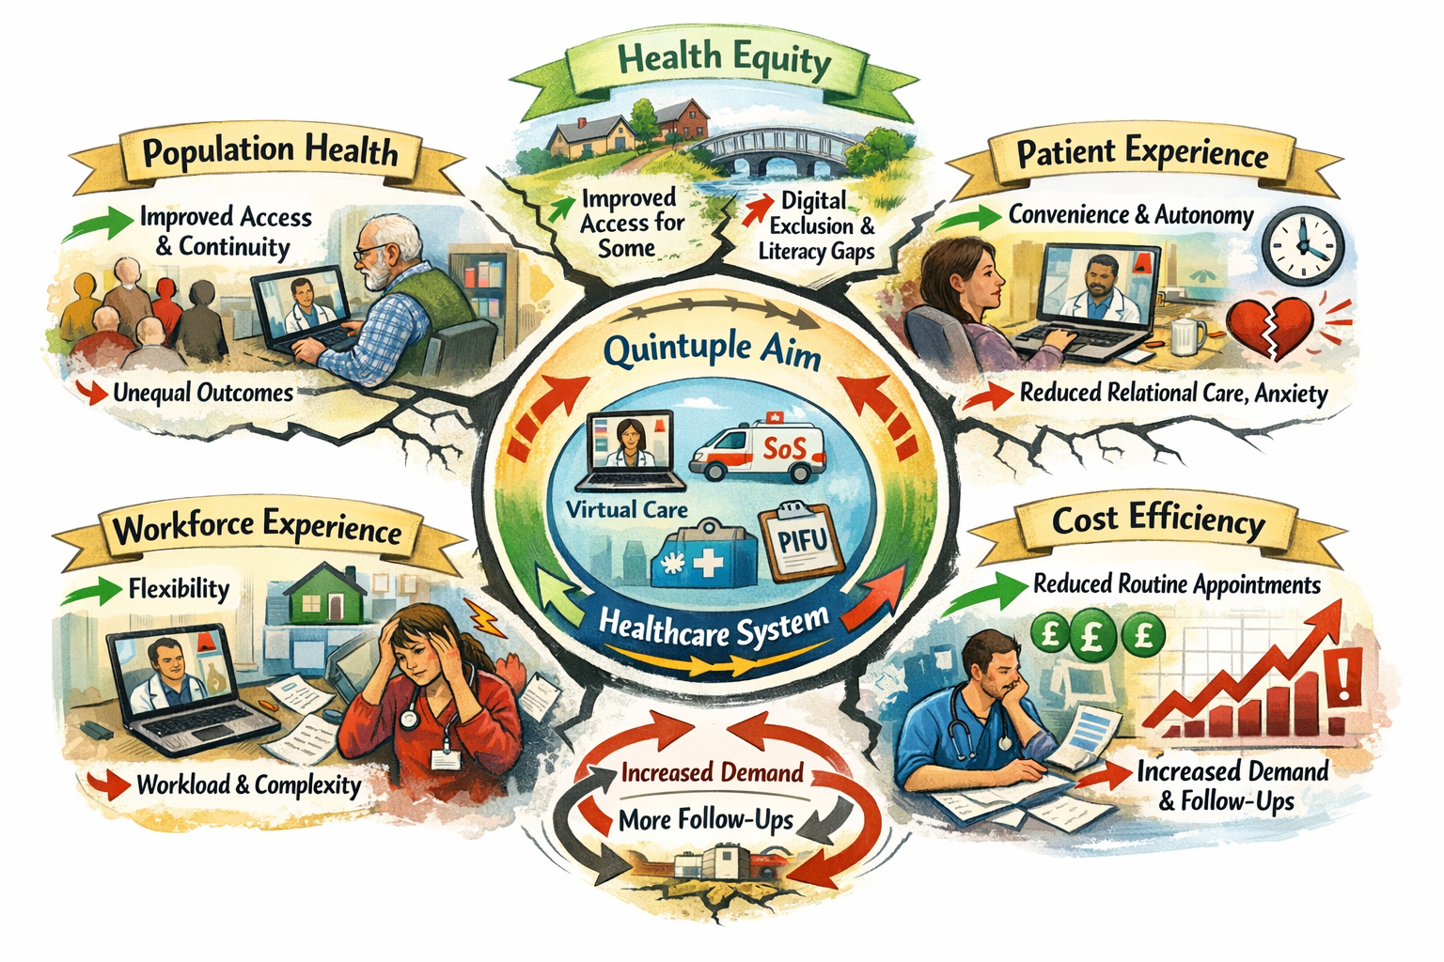
Figure 6 Image highlighting some of the benefits and challenges to achieving the Quintuple Aim for healthcare during COVID-19, and the introduction of virtual appointments, SoS, and PIFU

The introduction of virtual clinics, PIFU, and SoS marked a major change in outpatient services. These strategies aimed to improve efficiency, responsiveness, and patient focus, particularly as demand increased and services bounced back after COVID. While these innovations provided notable benefits, they also posed challenges to equity, safety, and the long-term sustainability of health systems (Lavin et al., 2020; Akintomide et al., 2021; Newton, Beaver and Clegg, 2022b).

Population Health
By helping stabilise population health through enhanced access to care and continuity of care during the COVID-19 pandemic, telemedicine and virtual clinics maintained essential services despite widespread disruptions. PIFU and SoS supported this by enabling patients to seek care as needed, allowing earlier interventions and reducing unnecessary visits (Fan et al., 2025). However, health benefits may not have been equally accessible, especially in areas with limited digital access. Additionally, with PIFU and SoS, patient outcomes largely depended on timely care-seeking, but some patients delayed seeking help, risking poorer outcomes in high-risk conditions.

Patient Experience
Earlier evidence indicated that convenience enhancements improved patient experience, but for some groups, perceived safety diminished, highlighting a trade-off between autonomy and reassurance across the Quintuple Aim domains. PIFU and SoS further improved this experience by giving patients greater control, letting them initiate care when necessary (Child, Victoria A. Goodwin, et al., 2015; Bech et al., 2020). However, patient feedback was mixed, with some feeling less connected and reassured during virtual appointments (Morrison et al., 2021). In using SoS and PIFU, some patients experienced anxiety and uncertainty, particularly in cancer care, where recognising recurrence symptoms was crucial (Newton et al., 2022a). This indicated that while fostering autonomy, there was a temporary compromise in perceived safety.

Cost Efficiency
Evidence indicated that virtual clinics, SoS, and PIFU improved cost efficiency by reducing unnecessary appointments and optimising resource management, with the appropriate use of SoS and PIFU reducing the need for routine follow-ups (Newton, Beaver and Clegg, 2022b; Fan et al., 2025). However, these efficiency benefits were not automatic (Khanji et al., 2023); In addition, it was noted that while easier access may lead to higher usage, virtual consultations often required additional follow-up and safety-netting (Wherton et al., 2020), potentially offsetting efficiency gains with increased demand and workload (Rodriguez Socarrás et al., 2020).

Workforce experience
Virtual clinics offered more flexible work options, potentially boosting work-life balance and workforce sustainability (Lavin et al., 2020). However, research highlighted increased cognitive demands and complexity, with some clinicians adapting their communication and decision-making approaches, and those providing remote care experiencing mixed outcomes (Child, Victoria A. Goodwin, et al., 2015). These findings suggest that while the benefits of flexibility are clear, workload and stress levels could also escalate, particularly during rapid implementation.
The introduction of SoS and PIFU significantly impacted the quintuple aim, particularly regarding workforce experience, revealing both benefits and challenges. Both could enhance staff satisfaction by reducing low-value, routine follow-ups, enabling clinicians to focus on patients with active needs (Newton, Beaver and Clegg, 2022b). Similarly, by encouraging patient autonomy and self-management, PIFU reduced unnecessary consultations, easing pressure on overstretched outpatient services (Bech et al., 2020). The evidence also points to notable difficulties, however. Transitioning from scheduled to patient-initiated care introduced new administrative and triage duties, requiring clinicians and staff to handle unpredictable demand and respond promptly to patient contacts that sometimes imposed cognitive and organisational burdens, especially where systems for rapid access and communication were lacking (Child, Victoria A. Goodwin, et al., 2015; Bech et al., 2020).

Health Equity
The review found evidence suggesting that SoS and PIFU could promote fairness by reducing unnecessary hospital visits, thereby improving access for patients facing geographical, financial, or other obstacles to routine care (Bech et al., 2020; Newton, Beaver and Clegg, 2022b). However, the evidence indicated the benefits could be unevenly distributed, as SoS and PIFU rely on patients’ health literacy, confidence, and symptom recognition. Those with lower education, limited health knowledge, or fewer support systems are disadvantaged. (Bech et al., 2020; Newton, Beaver and Clegg, 2022b). This variation indicated that while PIFU improved access for some groups, it could also unintentionally deepen disparities without proper education, assistance, and safeguards.
Virtual clinics improve healthcare access, especially in remote areas, by reducing travel and offering flexible services, as Lavin et al. note (Lavin et al., 2020). They help “bridge the healthcare gap” in epilepsy care by providing access to specialists without long-distance travel. During COVID-19, telemedicine expanded access and overcame physical barriers, benefiting families managing work, caregiving, or school (Akintomide et al., 2021). Virtual clinics support health equity by addressing geographic disparities and promoting consistent care (Bhaskar et al., 2020). However, benefits are not equal for all and may cause new inequalities, such as the unavailability of digital access, good telephony, or a lack of digital skills (Wherton et al., 2020; Morrison et al., 2021). In addition, while remote consultations improve access for some, they might reduce interaction quality when technology or context hinders communication (Ruggiero, Waite and Stayt, 2026)

Summary of findings
This literature review has explored how virtual clinics, PIFU, and SoS represent a significant change in outpatient healthcare, further accelerated by COVID-19. These models improve access, efficiency, and patient autonomy but have complex, context-dependent impacts.
Virtual appointments were reported to enhance access and convenience, reduce travel, and enable flexible engagement (Lavin et al., 2020; Akintomide et al., 2021). However, this evidence mainly comes from qualitative and observational studies, which might overstate patient satisfaction and underplay clinical limitations. During COVID-19, virtual appointments and telemedicine in general helped maintain continuity of care despite disruptions (Bhaskar et al., 2020). While effective for low-risk and follow-up cases, limitations were identified in complex or high-risk situations needing physical exams or safeguarding (Akintomide et al., 2021; Lim-Reinders et al., 2024). As a result, virtual appointments should be seen as a complementary tool rather than a replacement for in-person appointments.
PIFU and SoS are frequently associated with increased patient autonomy, reductions in routine follow-up appointments, and a boost for system efficiency, especially in high-volume areas (Newton, Beaver and Clegg, 2022b; Fan et al., 2025). They promote person-centred care by improving choice and access (Bech et al., 2020), but benefits vary. Some patients feel uncertain and anxious about recognising symptoms, especially in high-risk fields such as oncology (Newton, Beaver and Clegg, 2022b). This raises concerns about the equitable use of PIFU and SoS, since their success may depend heavily on patients' health literacy and confidence. As a result, although both SoS and PIFU could lower scheduled demand, it might also lead to inconsistent access and results, especially among more vulnerable patient groups, making proper patient selection and education essential.
Effects on waiting lists and efficiency are mixed. Virtual appointments, SoS, and PIFU can increase throughput and reduce unnecessary visits, but they can also raise demand due to improved access (Khanji et al., 2023; Ruggiero, Waite and Stayt, 2026). These innovations alone can't solve systemic capacity issues.
When viewed through the framework of the Quintuple Aim, the results show a mix of advantages and challenges. These models can enhance population health and patient experience, improve efficiency, and provide workforce flexibility. However, they also create additional pressures on healthcare workers and raise concerns about health equity. Digital exclusion, disparities in health literacy, and variation in patient confidence can lead to unequal access and outcomes, meaning that without targeted efforts, these innovations might unintentionally widen existing gaps.
Although NHS Wales policies officially align with the Quadruple Aim, the evidence suggests that current service changes elsewhere increasingly align with the broader goals of the Quintuple Aim, particularly regarding equity. This reflects a shift from a narrow focus on efficiency and experience toward a more comprehensive view of healthcare quality – a shift that is partially reflected in later NHS Wales guidance and documents (Welsh_Government, 2021; Kadel et al., 2022).
Overall, research shows that virtual appointments, PIFU, and SoS are valuable components of modern outpatient care but do not fully resolve systemic problems such as increasing waiting times. Their effectiveness depends on careful integration into broader service redesign, supported by robust triage, patient education, and ongoing assessment. Future policies should aim for balanced deployment to maximise benefits and actively address risks related to safety, workforce stability, and equity. Although there is a wealth of research, little evidence exists on the long-term system-wide impacts of combining virtual care with patient-initiated pathways in NHS Wales. This study addresses that gap by analysing longitudinal administrative data alongside clinician perspectives within NHS Wales outpatient services.

Research Methodology

Introduction
This chapter describes the methodology used to assess and review the impact of the Outpatient reform in Wales before, during, and after the COVID-19 pandemic.
By detailing the research design, data collection, and analysis methods used to examine how initiatives and policy changes were integrated into workflows and adopted by healthcare and administrative staff, the document will show the impact on patient wait times, capacity, and discharges from the changes.

Introduction to the research design
Between 2019 and 2025, outpatient reform in Wales involved expanding virtual consultations, Patient-Initiated Follow-Up (PIFU) pathways, and improved referral triage and management (Welsh Government, 2021a). These efforts aimed to meet policy objectives such as reducing long waits, increasing digital appointments, and speeding up referral-to-treatment times through the planned care transformation programme.
Because reforms take time to fully implement and show measurable results, analysing data from this period is essential for evaluating whether these structural changes have genuinely improved performance. The review of policies and initiatives addressing waiting lists and capacity issues in NHS Wales outpatient services examines data to detect changes in discharge or follow-up requests after appointments. Using this extensive timeframe captures the pre-pandemic baseline, COVID-19 disruptions, and long-term recovery and reform impacts. Analysing data over such a period also strengthens the reliability of conclusions about the sustained effects of policy changes on healthcare delivery and patient outcomes.
Gathering opinions from clinicians and others on outpatient reform in Wales is also crucial, as changes such as Patient-Initiated Follow-Up (PIFU), “See on Symptom” (SoS), discharge by default, and virtual clinics directly affect clinical workflows, patient management, and care pathways. Quantitative performance data alone cannot fully reflect how these models work in practice. Therefore, clinician perspectives are vital for providing contextual insights into the effectiveness, safety, and practicality of these interventions.

Choice of data collection method
This research project will employ a mixed-methods approach for data collection and analysis, integrating quantitative outpatient activity data with qualitative insights from staff surveys. This approach helps us achieve our objectives by analysing changes in appointment types and volumes while understanding the underlying reasons. Benefits include leveraging qualitative data to identify trends in quantitative data; for example, surveys may uncover practices impacting efficiency. Furthermore, quantitative data indicates the frequency of issues, while qualitative data provides context for the causes and staff responses. Section 3.6 shows how the original question posed above can be broken down into its constituent parts and how the collection methods can help answer those sub-questions.

Quantitative data

Introduction
For this research project, the main source of quantitative data will be from the Welsh Patient Administration system (WelshPAS). This is the largest IT system in NHS Wales in terms of usage and activity, managing the core administration functions for six of the seven Health Boards in Wales (Table 5) (DHCW, 2025a), WelshPAS has been running at the Health Boards for over ten years and has a good resource of historical waiting list and encounter data to work with.
Since the Health Board with the largest population (Cardiff and Vale) does not utilise the WelshPAS system, its data will be excluded from this analysis. This ensures consistency of data from the Health Boards in Wales that do use WelshPAS.
Table 5 Health Boards served by WelshPAS
Aneurin Bevan | Betsi Cadwaladr
Cwm Taf Morgannwg | Hywel Dda
Swansea Bay | Powys

Health services research studies often use multi-site samples rather than full population coverage, provided the sites encompass a range of service contexts (Bowling, 2014). It can be justified as a practical method for obtaining high-quality, timely data analysis:
- Although Cardiff and Vale Health Board is the largest by population, the other Welsh health boards together still account for a significant share of the national healthcare system and serve diverse geographic and demographic populations.
- Using the same PAS guarantees consistent collection, coding, and storage of patient data. This enhances the reliability of comparisons and allows for meaningful aggregation and trend analysis without requiring extensive data cleaning. (Raghupathi and Raghupathi, 2014).
- Shared systems adhere to standard data governance protocols, which improve data accuracy, minimise duplication, and ensure consistent recording across sites, thereby strengthening the dataset for reliable conclusions. (Weiskopf and Weng, 2013).
- Using one PAS across most boards simplifies the integration of diverse datasets, saving time and resources that would otherwise be spent on reconciling different data formats. (Kahn et al., 2016).
- Including Cardiff & Vale Health Board would necessitate system-specific data conversion or dual-system analysis, which could lead to delays, increased costs, and complications in study design due to limited access or compatibility problems. (Ammenwerth et al., 2003).

To identify and understand the impact of changes to outpatient services, it’s important to retrieve data that accurately reflects the changes over time.

Establish a baseline
Establishing a baseline from 2019, before the pandemic, provides a reference point for outpatient service performance prior to COVID-19's impact on healthcare systems. This baseline is crucial for distinguishing whether subsequent changes stem from the pandemic or from policy reforms such as outpatient transformation initiatives. Before COVID-19, Wales saw relatively stable planned care activities and waiting times, in contrast to the sharp increases observed later (Welsh Government, 2021b). Having this reference helps detect deviations from normal trends and assess the extent of disruptions. It also enables precise comparison of healthcare performance pre- and post-major disruptions and helps differentiate pandemic effects from ongoing structural trends, such as changes in demographic pressures.

Capturing the Immediate Impact of COVID-19 (2020–2021)
During the pandemic, healthcare systems dramatically cut back on routine and elective services to focus on COVID-19 care (Welsh Government, 2022). This led to a significant effect on outpatient services and waiting lists. For instance, the number of individuals waiting over 36 weeks for treatment increased sharply, and those waiting more than a year hit record highs due to reduced routine activity. Highlighting this period demonstrates the extent of service disruption and enables assessment of how outpatient services adapted, such as through more virtual consultations, the introduction of Patient Initiated Follow-up, See on Symptom, and “Discharge as default”

Assessing Post-Pandemic Backlog and Recovery (2022–2025)
Understanding the situation beyond the second wave in 2021 is essential because COVID-19's impacts have lingered for several years. Waiting lists and treatment delays continued to increase after the pandemic for many reasons, including accumulated unmet demand (Welsh Government, 2023a). Analysing this data allows us to assess whether outpatient reforms effectively reduced the backlog and if delayed demand from patients who postponed care during the pandemic is evident in how services are responding to this increased demand.

Identifying Long-Term System Trends
Analysing data over a long period helps researchers identify underlying structural pressures affecting outpatient services, including population ageing and rising care demands. In Wales, outpatient appointment referrals reached record highs by 2024–25, driven by demographic changes and the postponement of referrals during the pandemic. As a result, the retrieved data can help distinguish short-term disruptions from ongoing demand trends and provide valuable context for understanding outpatient reform outcomes.

Improving the Validity of Policy Evaluation
Health policy impacts often take years to become apparent. Short-term data can be misleading since healthcare systems require time to recover capacity and clear backlogs. Analysing data from 2019 to 2025 allows for monitoring recovery progress and assessing whether reforms have improved waiting times and access to care (Welsh Government, 2025).

Data Collection Tools
WelshPAS, the largest patient administrative system in Wales (Davies, 2025)contains all the necessary data to identify GP referrals, outpatient attendances, and other core indicators essential to this research. Consequently, data from WelshPAS was used as the primary source for analysis, covering the period from 2019 to 2025.

Selection criteria
WelshPAS uses a Relational Database Management System (RDBMS) to store and manage its data. In this research project, the data items extracted are listed in Table 6.The data extracted covered the period from 1-Jan-2019 to 31-Dec-2025.
Table 6 Data elements that were retrieved from WelshPAS as part of this research project, and their context.
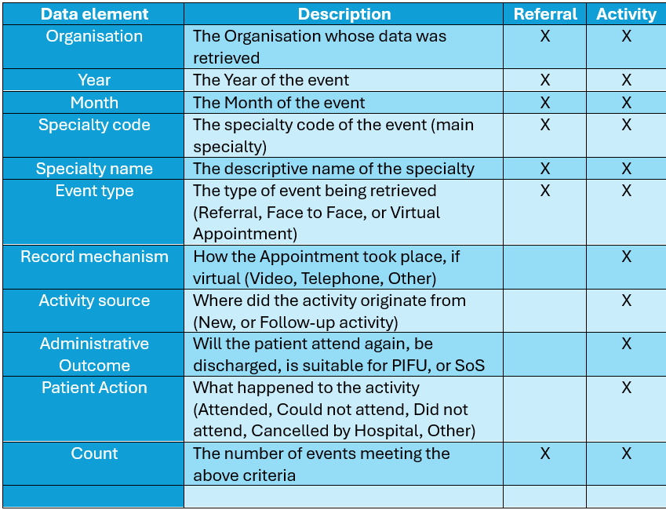

Policy regarding small data points
As the underlying data for this research project comprises actual patient activities, categories with very few activities have been combined into the group “Other”. This practice is important because it reduces the risk that individuals could be identified from the data, thereby protecting privacy and ensuring ethical and legal compliance (European Union, 2016).

Potential issues when analysing the data.
During this research, it was identified that the following modifications had been made to IT systems in general, and WelshPAS in particular, over the research period, which could have impacted the data being collected and analysed:
- WelshPAS in BCU(West) went live in May 2022. Due to data migration challenges and implementation decisions, the data for this region of BCU from 2019 to 2022 may be incomplete (BCU Informatics Team, 2017). Where possible, this has been identified within the results and other datasets in this document.
- WelshPAS in Velindre went live in October 2022. As a result of data migration challenges and implementation decisions, data for this Organisation between 2019 and 2022 may be incomplete. Where possible, this has been identified within the results and other datasets in this document.
- In 2025, Swansea Bay HB and Cwm Taf Morgannwg HB finished a disaggregation project that had been ongoing for five years. This has been recognised as a hugely complex data migration (DHCW, 2025b). Whilst the overall data remained unchanged, some duplication may have occurred during the disaggregation of data from one organisation to another, leading to higher waiting list figures in this document for 2025, although national statistics were unaffected by this work.
All charts were generated to include, where possible, identifiers indicating when the modifications occurred, similar to Figure 7.
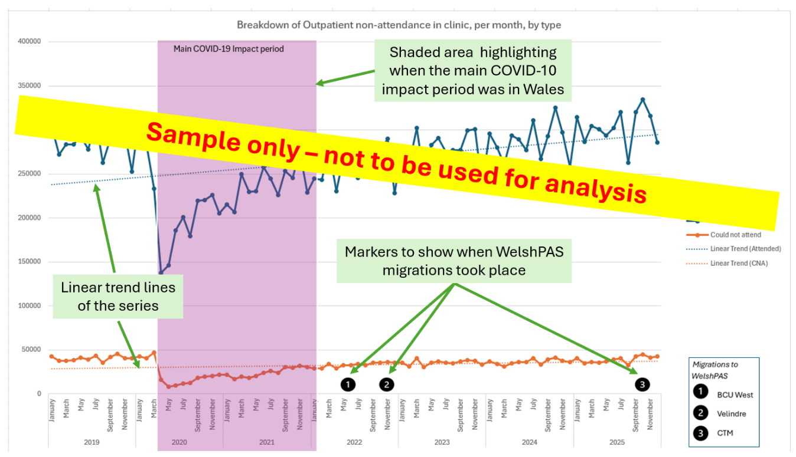
Figure 7 Sample of the additional text and placeholders added to graphs to indicate a significant modification to WelshPAS, or NHS Wales, during the research period. Note: Data
As presented in the results section, these changes are unlikely to significantly alter overall trends, although localised distortions might occur and should be taken into account when analysing specific time periods.
Additionally, linear trend lines were included to help readers visualise overall trend patterns, and a shaded region was added to highlight the main impact period of COVID-19 in Wales.

Qualitative Data
We will use qualitative survey data to analyse the identified issues and will additionally interview some respondents to clarify any points raised. This approach ensures our observations are grounded in the meanings derived from personal experiences. It also allows us to identify and develop themes from responses to open-ended questions. The survey supplied to staff appears as Appendix 3 of this document.

Real-World effects of change
Understanding how initiatives and policy changes are applied in the real world is key because healthcare reforms can vary widely among different specialties, hospitals, and clinical teams. Frontline healthcare providers, such as doctors and nurses who directly implement new procedures, are well placed to identify practical barriers or facilitators that may not be evident in administrative data. For instance, while data might show an increase in PIFU or virtual consultations, clinicians can clarify whether these genuinely enhance efficiency or merely shift the workload, such as increased patient questions or follow-up tasks. Insights from frontline staff are essential to understanding how policy changes operate in daily clinical practice (Greenhalgh et al., 2004).

Assessing clinical safety and suitability
Clinicians play a key role in determining which patients are appropriate for models such as SoS, PIFU or “discharge as default”. Their insights help evaluate the clinical safety of these pathways across various conditions and patient groups. For example, PIFU might work well for stable chronic illnesses but may not be suitable for patients needing frequent monitoring. Clinicians can also identify potential risks such as delayed diagnosis, missed signs of deterioration, or patient confusion about follow-up procedures. Expert judgment remains a crucial element in assessing patient-initiated care models – a point that may not be reasonably identified and demonstrated by looking at statistical data in isolation (NHS England, 2022).

Understanding why things happen
Quantitative data, such as waiting lists, appointment numbers, and referral-to-treatment times, serve as key indicators of system performance. However, they do not clarify why the use of outcome choices differs across services, hospitals, and organisations. Clinician and other staff insights enhance quantitative analysis by aiding interpretation of trends and distinguishing whether observed changes stem from the reform or other influences, such as pandemic-related disruptions. Therefore, designing a survey that enables staff to explain the reasons behind events, identify shortcomings, and suggest improvements is crucial for interpreting the quantitative results.

Research question breakdown and how the selected method for analysis can be used to help answer the questions posed
Table 7 Breakdown, showing the different parts of the Research question, and how the selected methods will be used to answer them
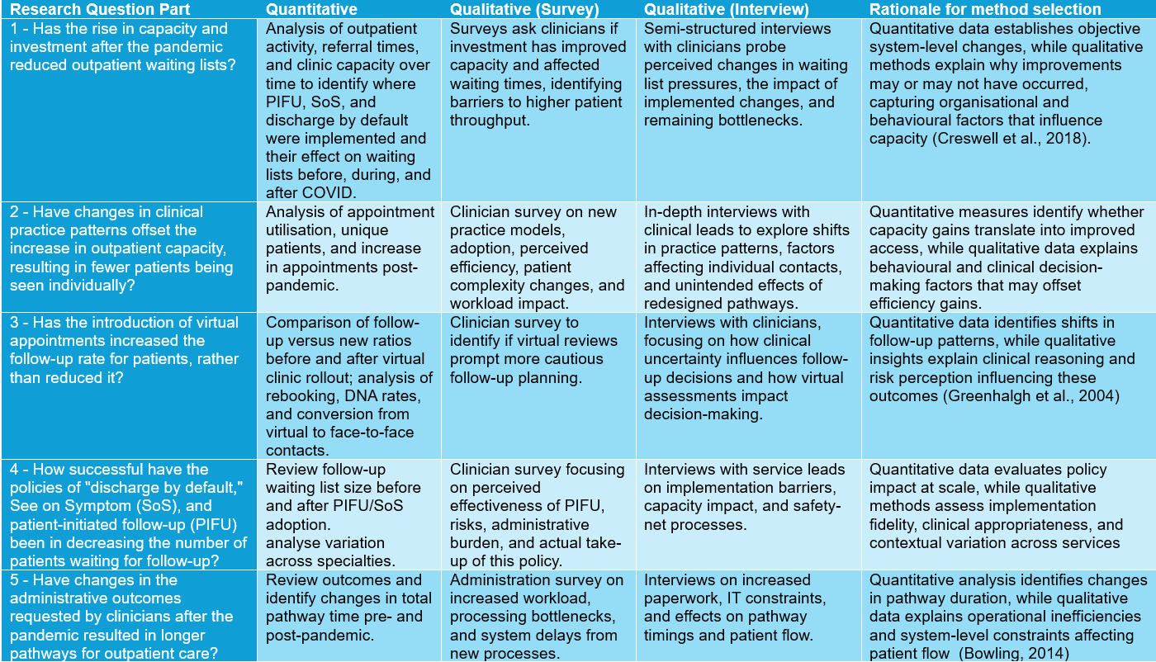

Project Planning and Management
This project followed a structured plan for research alignment and completion. It took place in phases, including a literature review, research design, data extraction from WelshPAS, qualitative data collection via surveys and interviews, data analysis, and documentation. These phases were sequential with some overlap to enhance efficiency.
A project timeline was established at the start, outlining the schedule for each phase as seen in Figure 8 and Figure 9. This helped guide the research process and ensure that milestones such as data collection, analysis, and drafting were completed in a timely manner.
The main resources for the project were WelshPAS data, survey tools, and NHS Wales systems for data handling and analysis, ensuring study feasibility and governance compliance.
During the project, deviations occurred, including delays caused by system changes in WelshPAS that required additional validation and interpretation. In addition, the researcher and those assisting with data access faced additional pressures due to an organisation-wide restructuring, which delayed some of the research work. Some analysis phases overlapped with writing, but these adjustments did not affect the study's overall aims and were managed within the original timeframe.
Finally, some interviews took place towards the latter part of this research's documentation, outside the originally planned timeline. This required extra revisions between different drafts discussed with the supervisor, which impacted the final discussion section and conclusion of this document.

Figure 8 GANTT chart part 1 showing the timeline of the dissertation
Figure 9 GANTT chart part 2 showing the timeline of the dissertation

Ethical, Legal, and Professional Considerations

Introduction
This dissertation analyses healthcare administrative data alongside qualitative feedback from NHS Wales staff. The study was designed and conducted in line with relevant ethical, legal, and professional standards, including those applied within NHS Wales, UK legislation, and the research governance framework of the University of Wales Trinity Saint David (GOV UK, 2019; Welsh Government, 2023b; University of Wales Trinity Saint David, 2025; Digital Health and Care Wales, 2026).
These principles guided handling of quantitative and qualitative data, especially administrative datasets and staff feedback, with regard to confidentiality, security, and interpretation.

Data Protection and Governance
In this study, UK GDPR principles and the Data Protection Act 2018 were applied through the secure handling and anonymisation of WelshPAS data. The legal basis for processing relates to research and service evaluation within NHS Wales, where the aim is to better understand system performance rather than identify individuals (Digital Health and Care Wales, 2026).
All data were anonymised prior to analysis, and no identifiable patient-level information was accessed at any stage. As described in Section 3.4, small data counts were grouped into broader categories to further reduce any risk of re-identification. This is important given the multi-site nature of the dataset, where small numbers could otherwise increase the risk of identification.
Data was accessed and analysed within secure NHS Wales environments, in line with organisational data security policies. Access was restricted to the researcher only, ensuring that sensitive operational data remained controlled and was not shared outside approved systems.
This study also considers digital rights under UK GDPR, including access, rectification, and fair processing (GOV UK, 2019). Despite anonymisation, concerns about transparency and accountability were considered and addressed as part of the work. The research aligns with HCPC standards (Health and Care Professions Council, 2024), emphasising confidentiality, ethical data use, and public trust.

Ethical Approval and Institutional Requirements
Ethical approval for the study was obtained through the University of Wales Trinity Saint David and Digital Health and Care Wales, ensuring compliance with their respective research governance frameworks (University of Wales Trinity Saint David, 2025). This covered both the use of secondary administrative data and the collection of primary qualitative data.
In the qualitative section, which involved staff surveys and interviews, healthcare professionals discussed service changes, and maintaining participant trust was a key consideration. Participation was voluntary, informed consent was obtained, and responses were anonymised. This approach was intended to allow participants to share honest perspectives without concern for professional or organisational repercussions.

Intellectual Property and Academic Integrity
The data used in this study remain the intellectual property of NHS Wales and was accessed in accordance with organisational governance arrangements. No data was used outside these agreed conditions, and no unauthorised sharing or reproduction has occurred.
All sources have been referenced using Harvard conventions, and the work complies with academic integrity expectations set by the University of Wales Trinity Saint David. Generative AI was used only as a supporting tool during the research process, for example, to identify and summarise literature. It was not used to generate submitted content, and care was taken to ensure that any tools used operated within secure or firewalled environments to prevent exposure of sensitive information.
Some images in this dissertation were generated using Google Gemini, Microsoft Co-Pilot, or ChatGPT based on text prompts written by the author and subsequently edited for clarity.

Risk, Bias, and Responsible Interpretation
Although the dataset used in this study was fully anonymised, there are still limitations associated with its use. Quantitative administrative data does not capture the full clinical context behind decision-making, while qualitative responses may reflect individual perspectives shaped by local practices.
To address this, a mixed-methods approach was used to combine statistical analysis with staff insights, allowing patterns in the data to be interpreted alongside real-world experience. This was particularly important when considering complex service changes, such as PIFU, SoS, and virtual care.
The study also recognises that these policies may have unintended effects, including changes in workload, patient behaviour, and demand patterns. As a result, the findings have been interpreted, with an emphasis on balancing potential benefits against associated risks in the context of NHS Wales.

Results and Data Analysis

Introduction
This chapter summarises the findings from three different methods used to examine the effects of COVID-19, as well as the impact of the policies "Discharge as default," “See on Symptom (SoS)," and “Patient Initiated Follow-up (PIFU)” on outpatient waiting lists and activity throughput in NHS Wales. The findings derive from data analysis, survey responses, and interviews, offering both quantitative and qualitative insights into the effectiveness of policy implementation, whilst the qualitative feedback provides context on user experiences, perceptions, and respondents' ideas for future initiatives.
For ease of reading, some of the more detailed charts can be found in Appendix 1 – Further detailed charts from the quantitative data extract of NHS Wales data
Appendix 1

Quantitative findings

A note on the underlying data
The search criteria for all data in this section is 1st Jan 2019 to 31st December 2025. All data retrieved into the result sets comes from the raw data of the Welsh Patient Administration System (WelshPAS), and as a result, some figures may differ from the officially published data. There could be many reasons for this, but in the main, they fall into these categories:
- Reportable data is taken as a snapshot in time, usually 5-7 days after the end of the previous month. This allows enough time for the hospital's administrative side to catch up and complete its work. However, data is sometimes updated retrospectively after this end date. As the data used in this research was taken on the 3rd of February 2026, the research data will include this updated data, whereas the published data may not.

- Some waiting lists and activities are not reportable for publishing (DHCW, 2024). However, the research data here will include all data recorded, irrespective of its usual exclusion for official figures.
Before analysing PIFU, SoS, and Discharge results, we must consider the COVID-19 context. The pandemic accelerated policies to reduce waiting lists, but without examining what happened before and during COVID, it is difficult to assess the impact of those changes.

Outpatient referrals and waiting lists
Figure 6 compares new GP referrals and the Outpatient waiting list (OPWL), with trend lines showing their progress since 2019. Whilst the OPWL was increasing prior to COVID-19, the increase was gradual; at the same time, the new GP referral rate was fairly constant, indicating that there were pressures on the system, but new GP referrals were not the root cause. The figures then show an overall decrease in the waiting list from March to June 2020, coinciding with a significant drop in new GP referrals. This period aligns with the first national lockdown, during which many patients could not visit their local GP, leading to fewer referrals to secondary care (Mansfield et al., 2021). A simple timeline of the management of COVID-19 in Wales appears in Figure 1.
Following COVID restrictions easing, monthly GP referrals rose from July 2020 but didn't reach pre-pandemic levels until July 2021. During this period, the OPWL increased sharply by nearly 147,000, while, from March 2019 to February 2020, it grew by less than 47,000, averaging nearly 88,000 monthly. During COVID-19, referrals averaged around 72,000 per month, leading to a faster rise in waiting lists. GP referrals, the “front door” to elective secondary care, aren’t directly affected by PIFU, SoS, and Discharge, but help analyse system pressure. These policies are expected to indirectly impact OPWL by increasing clinic capacity, either in person or virtually.

Figure 10 Outline of the sample period, 2019 – 2025, showing GP Referrals and the overall Outpatient WL

Hospital cancellations for new patients
Figure 11 begins to illustrate how the cancellation of hospital appointments for new outpatient visits showed the first signs of a system shock caused by COVID in secondary care (Hodgins et al., 2022). Prior to COVID, the average number of hospital cancellations per month was 9,800, with October 2019 showing the highest single-month total of 10,500.
In March and April 2020, however, cancellations reached approximately 33,000 and 28,000, respectively, as hospitals limited access to urgent cases only and travel restrictions were in place during the first lockdown (Welsh Parliament Senedd Research, 2022). This resulted in over 61,000 patients remaining on the OPWL longer than anticipated during those two months, contributing to the backlog evident later in the OPWL data.
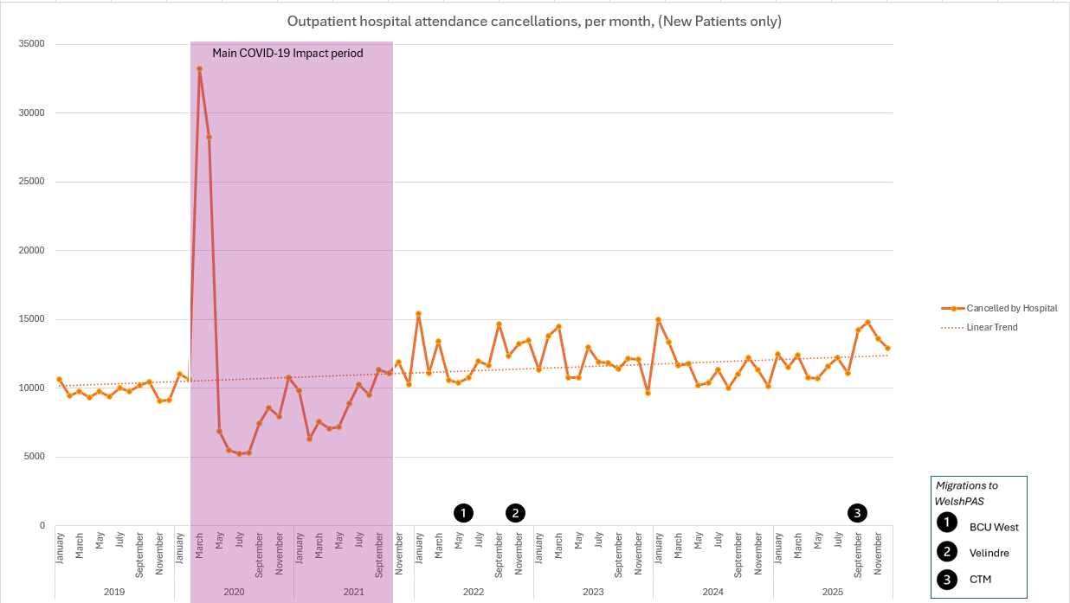
Figure 11 Outpatient hospital attendance cancellations, per month (New Patients only)

From April 2020 to July 2021, the number of hospital cancellations appears to have reduced. However, as can be seen in Table 8, this is mainly due to the reduction of appointments overall during this period due to the ongoing effects of COVID restrictions (Welsh Parliament Senedd Research, 2022). The average cancellation rate outside of this period is higher after COVID than before.
Table 8 Average Attendances v Hospital Cancellations 2019 - 2025 (New Patients Only, highlighting the first lockdown period.
 | Avg Attendances per month | Avg Cancelled by Hospital (CbH) | %age CbH
Jan – Dec 2019 | 88,002 | 9,761 | 9.98
Jan – Feb 2020 | 92,965 | 10,843 | 10.45
Mar – Apr 2020 | 48,467 | 30,748 | 38.82
Apr – Dec 2020 | 56,305 | 7,210 | 11.35
Jan – Dec 2021 | 75,231 | 9,271 | 10.97
Jan – Dec 2022 | 84,548 | 12,436 | 12.82
Jan – Dec 2023 | 90,846 | 11,942 | 11.62
Jan – Dec 2024 | 91,221 | 11,546 | 11.24
Jan – Dec 2025 | 102,458 | 12,372 | 10.77

Overall outpatient activities and non-activities analysed
Figure 12 displays the results for all activities conducted with both new and follow-up patients over the sample period, without reference to the mechanism of activity, which will be discussed later. This is broken down into patient actions during the activity, such as Attended, Cancelled by Hospital (CBH), Cancelled by Patient (CBP), or Did Not Attend (DNA). From this chart, we can clearly see that Outpatient activity took longer to rebound to pre-COVID levels, and it was not until November 2022 that monthly outpatient attendance surpassed February 2020 levels.

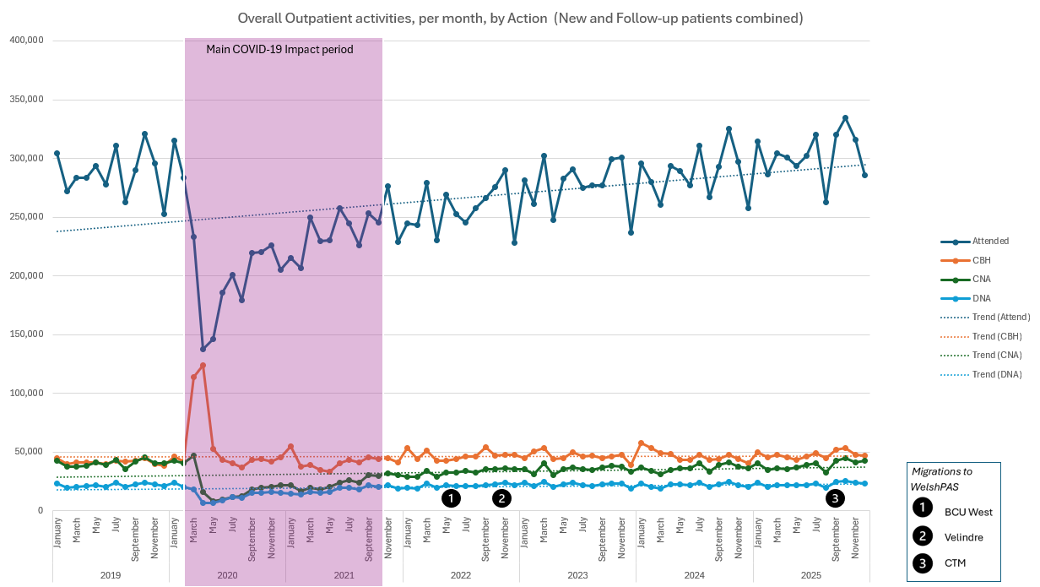
Figure 12 Overall Outpatient activities, per month (New and Follow-up patients combined)
This chart shows that the rates of actions other than attended remained stable following the initial system shock of COVID. This is demonstrated in Figure 13 which shows a slow, steady increase in the average attendance rate for all activities from 72.2% in September 2021 to 73.5% by November 2025.
Overall, these findings show that, although the number of attendances over the period rose significantly, the attendance and CBH rates remained relatively stable, but with notable increases in both CNA and DNA outcomes following September 2021. Potential reasons for this are discussed in Chapter 5.

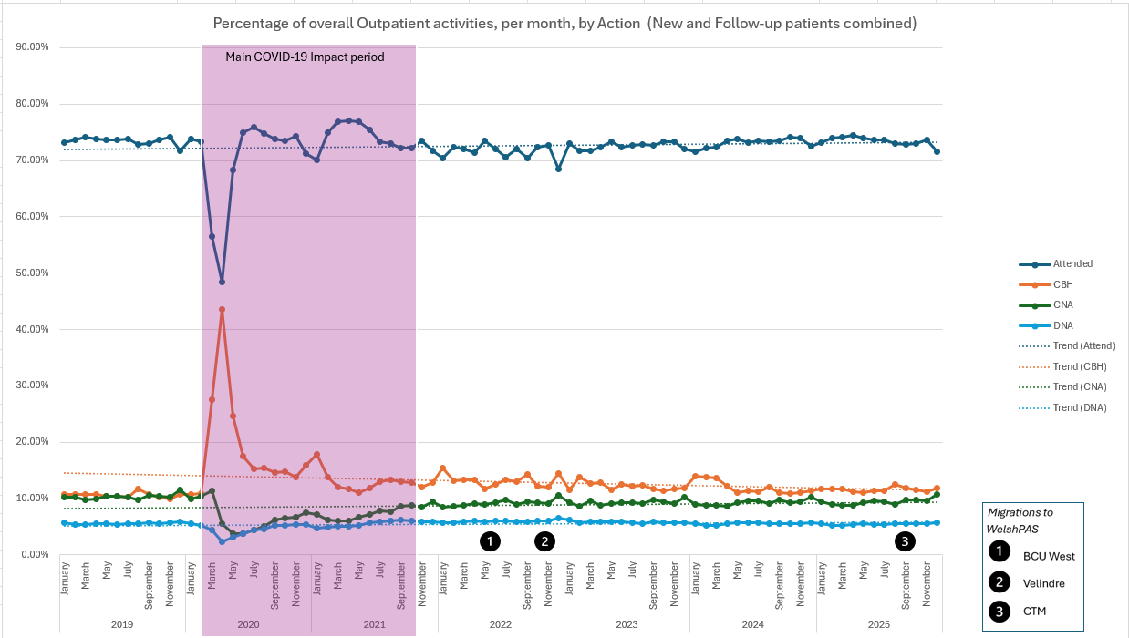
Figure 13 Percentage of overall outpatient activities, per month, by action (New and Follow-up combined)

The mechanisms of an appointment
In this research, the mechanism of an appointment refers to how it was scheduled. This section focuses on the mechanisms of Face-to-Face (F2F) and Virtual interactions. Figure 14 shows how these two mechanisms compare during the research period. Virtual appointments were introduced at scale in response to COVID, with minimal or no prior utilisation within NHS Wales (Auditor General for Wales, 2022), and their use peaked in March 2021. This correlates with the evidence gathered as part of the literature review (see 2.5.6, above) (Wherton et al., 2020)

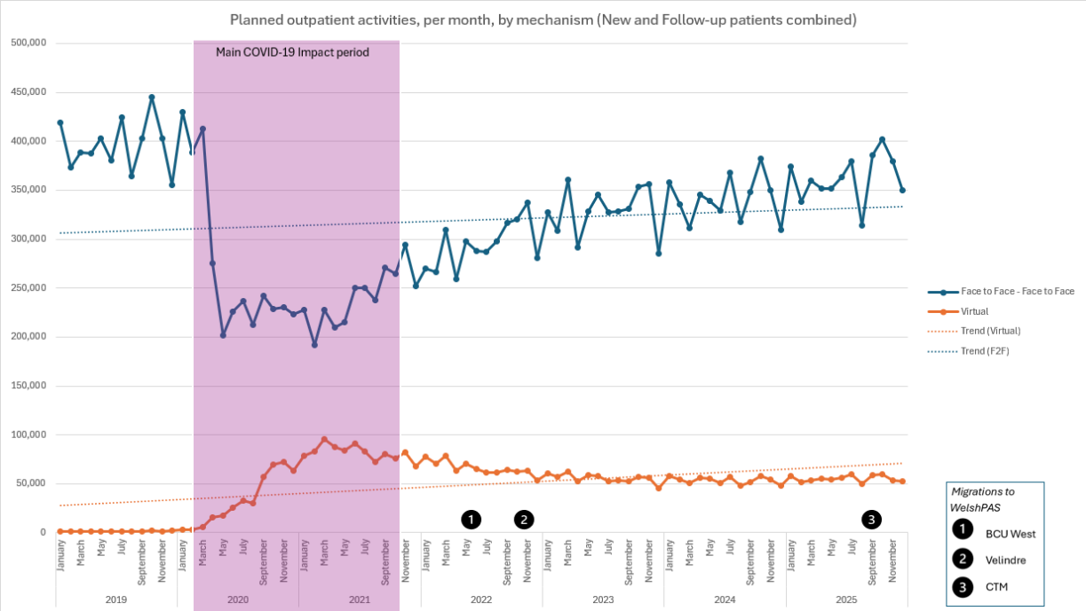
Figure 14 Outpatient planned activities, per month, by mechanism (New and Follow-up combined)

Finally, Figure 15 breaks down planned virtual appointments by their subsequent patient action. In this instance, it shows the relation of Attended to CBH, CBP, and DNA. Figure 16 shows a similar chart, but for Face-to-face patients. Comparing these charts shows differences in patient behaviour between appointment types, especially in non-attendance and cancellations, suggesting virtual appointments may lower access barriers for some patients.
The inverse relationship between face-to-face and virtual activity during COVID indicates virtual appointments substituted for face-to-face interactions to maintain service. (Greenhalgh et al., 2020; Murphy et al., 2021).
After this period, face-to-face activity partially recovered but stayed below pre-pandemic levels, while virtual activity declined from its peak and stabilised. This indicates a shift from emergency-driven care to a hybrid model, in which virtual appointments demonstrate ongoing clinical and operational value.

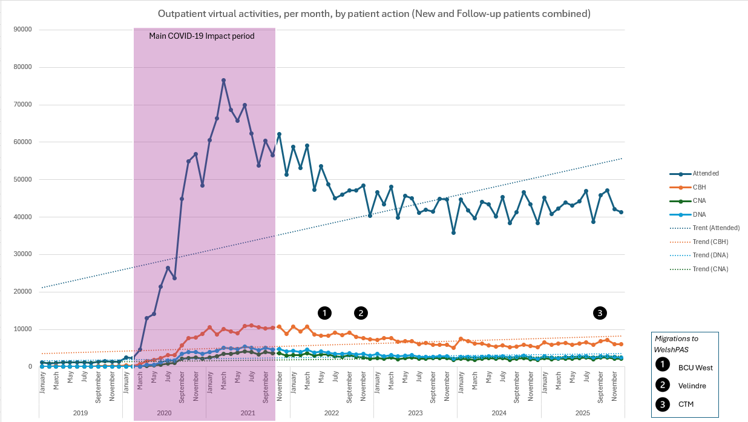
Figure 15 Outpatient virtual activities, per month, by patient action (New and Follow-up patients combined)

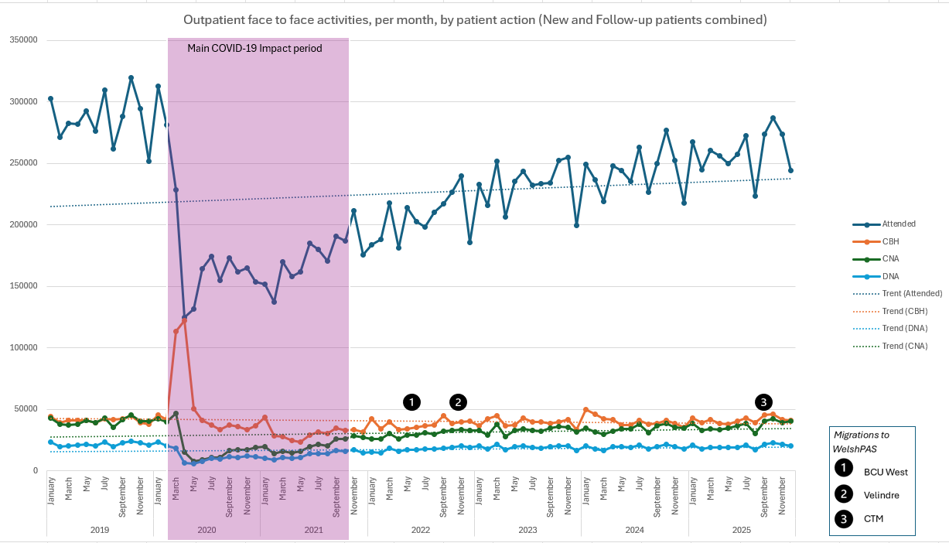
Figure 16 Outpatient face-to-face activities, per month, by patient action (New and Follow-up patients combined)

See on Symptom (SoS) and Patient-Initiated Follow-up (PIFU)
Figure 17 illustrates the number of patients who have reached a stop point during an attendance. A stop point typically occurs at the appointment when a decision is made that no further treatment is needed, usually at discharge. In this instance, we are showing SoS and PIFU, with all other discharge reasons grouped as “other stop”.
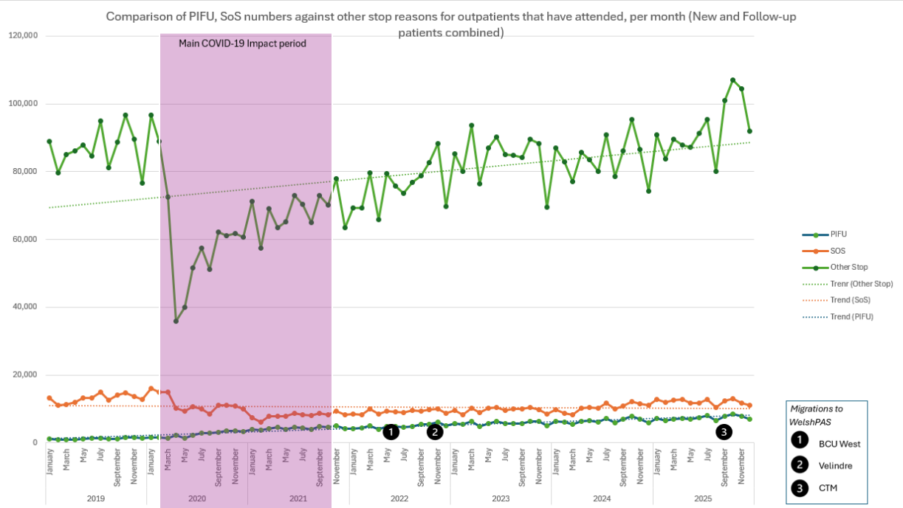
Figure 17 Comparison of PIFU, SoS numbers against other stop reasons for outpatients that have attended, per month (New and Follow-up patients combined)
Unlike virtual appointments and “discharge as default”, SoS and PIFU had already been rolled out across NHS Wales prior to COVID, with varying levels of adoption (BCU, 2019). As illustrated both here and elsewhere, the system shock of COVID reduced all activities for an extended period. However, the chart shows SoS stabilising at moderate, if reduced, levels after this period of instability.
In contrast, PIFU shows consistent growth in absolute numbers over time. PIFU has partially replaced SoS activities; before COVID-19, most self-managed follow-up was done via SoS, with little formal use of PIFU. After COVID, the combined volume of SoS and PIFU appears similar to pre-pandemic SoS levels, indicating some redistribution. However, the different activity patterns—including a relative increase in overall activity—suggest this is more than just a relabelling of outcomes. It reflects limited adoption aligned with new work practices and policies, rather than being driven solely by emergency-led implementations of other new ways of working, such as virtual appointments. However, the adoption of PIFU and SoS appears low relative to NHS Wales patient throughput. Chapter 5 will discuss why this may be the case.

Discharge as default
In 2021, the Welsh Government proposed a suite of changes to how outpatients were managed after attending their secondary care appointment (Welsh Government, 2021a).

“The default for follow up care will be discharge. Where this is not appropriate, the “See on Symptoms” and “Patient Initiated Follow Up” pathways will become the norm. This will empower patients to take responsibility for their own health and well-being. Wherever possible, patients will be supported to be on a self-managed pathway. Together these new approaches could in time reduce the need for over 50% of all outpatient appointments.
Excerpt from "Health and Social Care in Wales - COVID-19: Looking forward" (Welsh Government, 2021a)
As well as “See on Symptom”, and “Patient-Initiated Follow-up”, it was proposed that the default action following an outpatient appointment should be to discharge, where clinically appropriate.
Since that document was published, some time has passed, allowing this research to analyse the data and assess its impact on patient care and capacity expansion. Figure 18 illustrates how the management of new outpatient attendances has altered over the entire period.

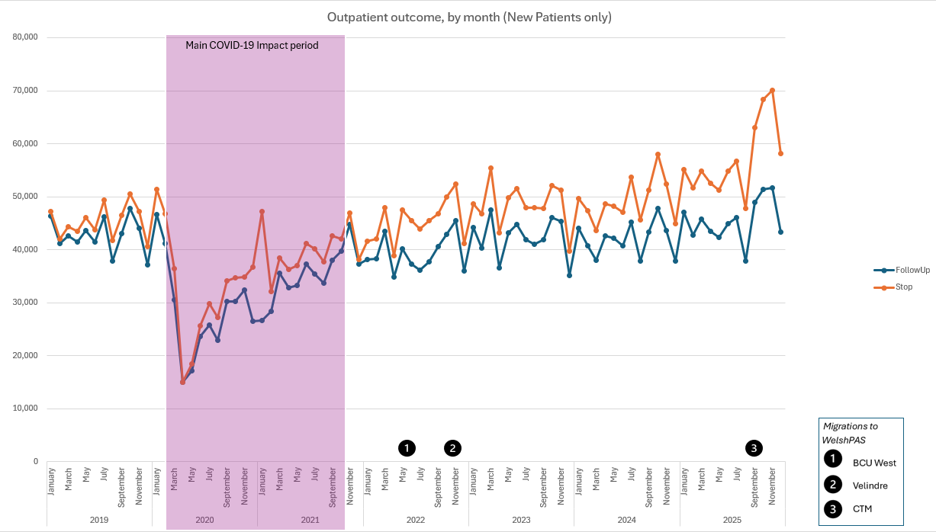
Figure 18 Outpatient outcome, by month (New patients only)

Since 2021, outpatient management shifted, with more new patients reaching a ‘stop’ point, likely discharge, than follow-up appointments. Discharge rates now surpass first appointments, showing a policy-driven change in clinical behaviour. Clinicians are less likely to schedule routine follow-ups, initially due to policies and capacity limits from COVID-19, leading to more selective follow-up decisions.
Follow-up outpatient activity analysis (Figure 19) shows that although ‘stop’ (discharge) outcomes have increased, follow-up appointments have risen even more, widening the gap and contradicting policy expectations that discharge and alternative pathways would reduce routine follow-up (Welsh Government, 2021a). While PIFU and SoS have grown, as evidenced in 4.2.6 above, they remain too small to offset the overall increase. The data suggests that both follow-up and stop (discharge) activities are increasing simultaneously, indicating limited change in care pathways, as the increase is a natural product of the system continuing to recover from the system shock of COVID-19 in 2020.

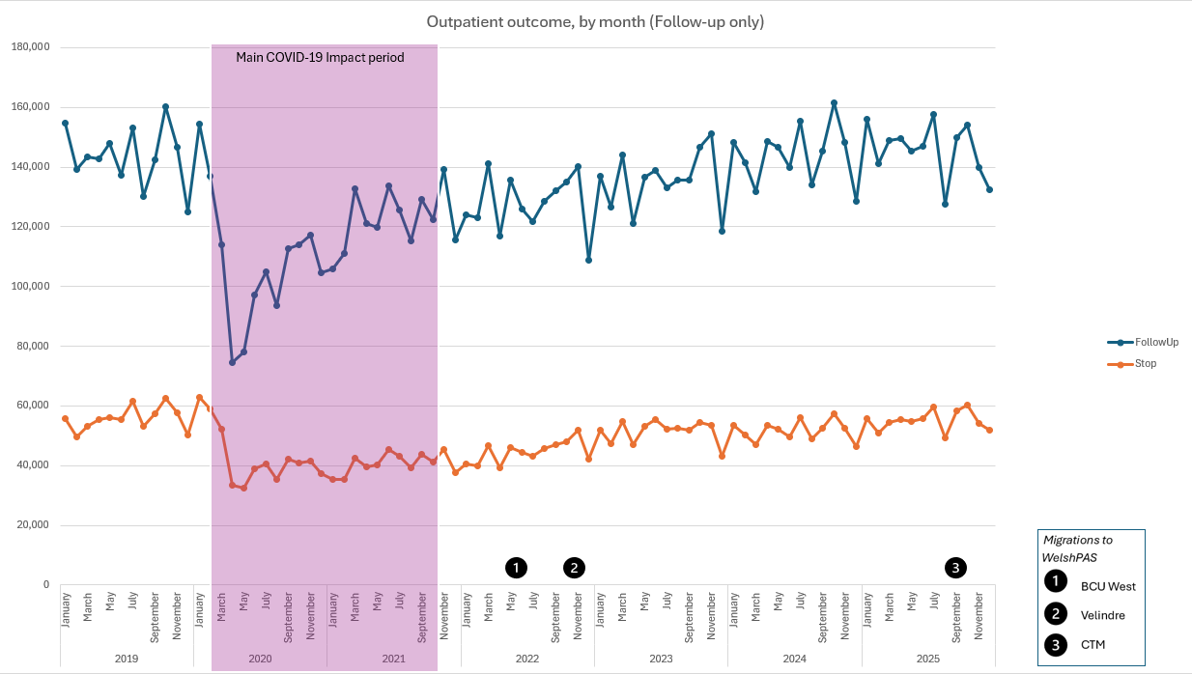
Figure 19 Outpatient outcome, by month (Follow-up only)

Qualitative results

A note on the underlying data
This qualitative part of the results chapter analyses survey responses and follow-up interviews. The survey took place between the 17th of February and the 10th of April 2026 and was delivered via Microsoft Forms. The original planned four-week timespan was extended following technical difficulties accessing the survey. The form used for the survey appears as “Appendix 3 – Qualitative survey provided to staff as part of this research”. Based on the data retrieved, 3 interviews were scheduled and took place between the 14^{th of} April and the 24th of April 2026.
All survey responses remained confidential and anonymous unless respondents opted to provide contact details for the voluntary interview. Additionally, some Welsh Government teams involved in developing the new policies and work methods were contacted. Their representatives agreed to participate in interviews for this research; like the original respondents, their responses were confidential and anonymous.

The demographic of the survey respondents
There were 45 respondents to the survey. Figure 20 shows a breakdown of survey respondents by role, while Figure 21 shows the breakdown of respondents by service and organisation, and Figure 34 illustrates how long the respondents have worked in secondary care.
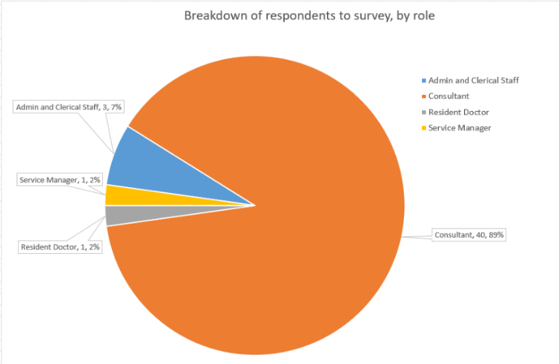
Figure 20 Breakdown of respondents to the survey, by role
From these figures, we can see that most staff were recorded as consultants (89%), and almost all respondents (93%) had over 10 years’ experience in the NHS. In addition, the majority of respondents (71%) were based in a single Health Board (HB1).

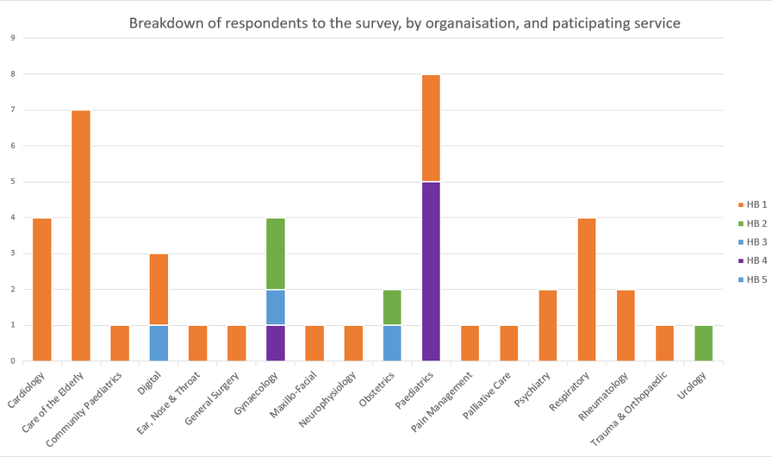
Figure 21 Breakdown of respondents, by participating service

The effect of COVID-19 on workloads and practice
53% of respondents felt their outpatient workload remained the same or decreased slightly compared to before COVID. Meanwhile, 20% reported their workload was now much higher, and 12% noted it had become slightly higher (Figure 22).

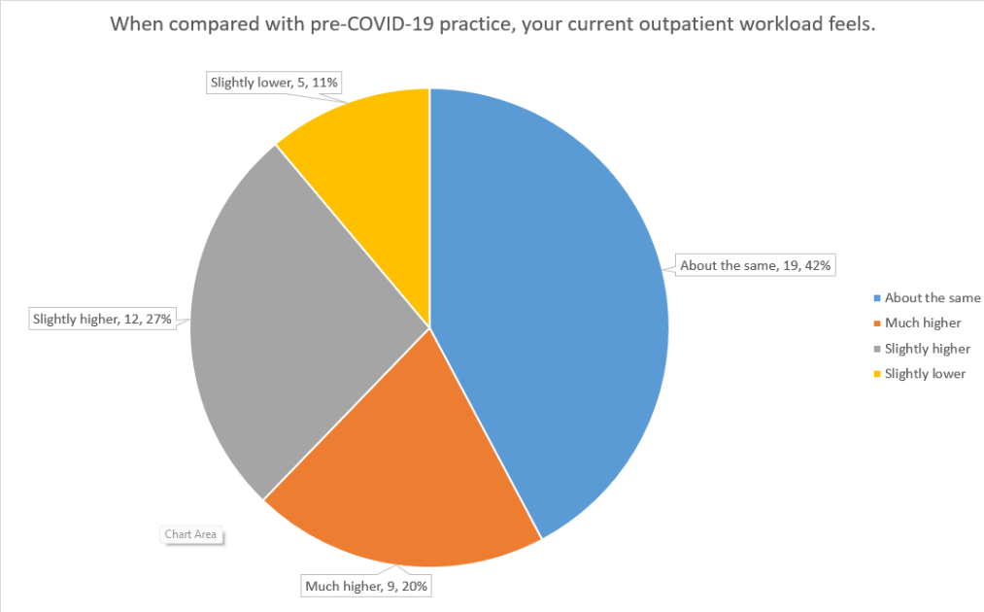
Figure 22 Analysis of workload perception following COVID-19

When asked about their outpatient decision-making and patterns, especially for new patients, 38% reported no change in their approach, while 15% reported seeing patients more frequently after the initial visit following the COVID pandemic (Figure 23).

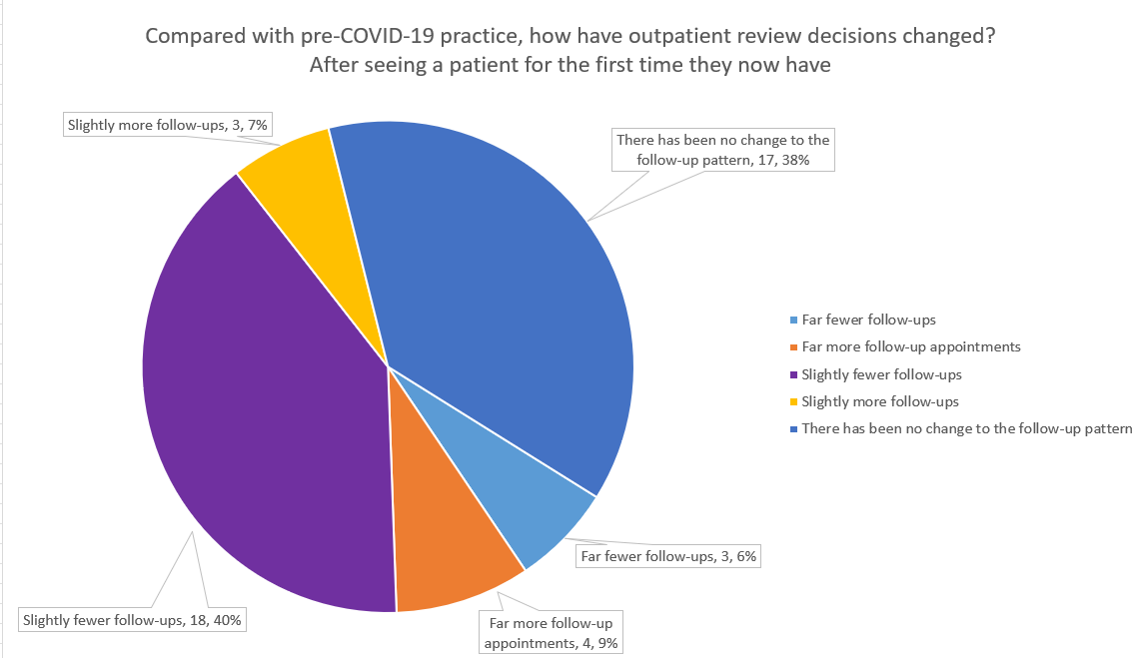
Figure 23 Analysis of follow-up rate perception

Virtual appointments, and their place in prudent care
When asked about virtual appointments, only 4 (9%) reported not using this method, while 17 (18%) said they conducted at least half of their appointments virtually (Figure 24).

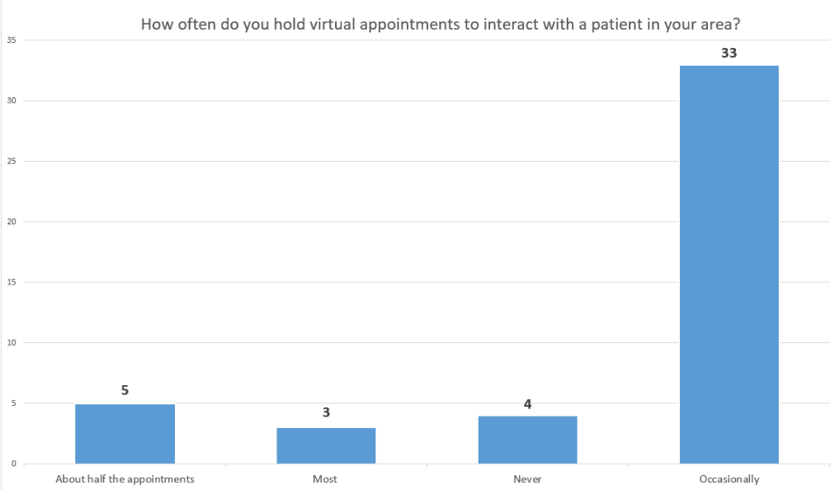
Figure 24 Perceived frequency of virtual appointments
When asked whether virtual appointments result in face-to-face reviews, 11% of respondents believed that a virtual review never leads to in-person contact afterwards, with a further 18% believing that this outcome was rare (Figure 25). The validity of this perception, when compared to the quantitative results, will be discussed later.

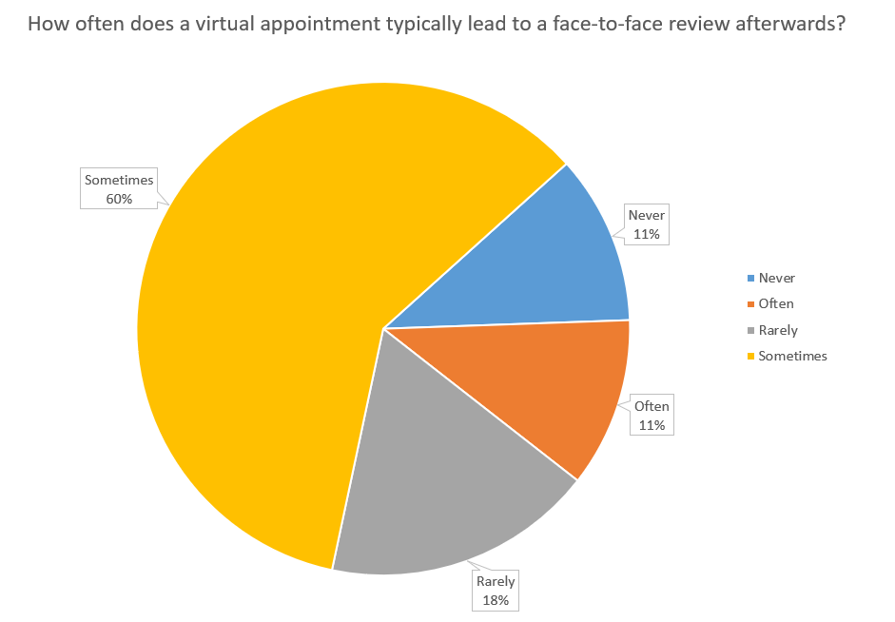
Figure 25 Analysis of how often a virtual appointment leads to a face-to-face review

PIFU and SoS, barriers to continued and wider use
This free-text question was designed to understand why there might have been a noticeable reduction in the use of PIFU and SoS, as a percentage of the overall increase in attendance, since COVID. Table 9 shows the overall themes and summaries of the barriers identified.
Table 9 Barriers to Wider or Sustained Use of PIFU / SOS
Theme | Number of Mentions (n) | Percentage of Respondents (%) | Summary of Barrier
Patient factors & inequalities | 11 | 26.8% | Frailty, cognitive impairment, safeguarding, children, language barriers limiting ability to self-initiate follow-up
Access, booking & administrative difficulties | 10 | 24.4% | Difficulty contacting services, overloaded secretarial teams, unreliable routes back into care
Clinician culture, confidence & risk aversion | 7 | 17.1% | Anxiety about missing deterioration, defensive practice, lack of trust in patients or systems
System & IT limitations | 5 | 12.2% | WPAS limitations, inaccurate lists, poor visibility of SOS/PIFU patients and workflows
Capacity & resourcing constraints | 5 | 12.2% | Insufficient clinic slots, admin support or job-planned time to support SOS/PIFU returns
Clinical appropriateness & safety concerns | 2 | 4.9% | Conditions requiring face-to-face examination or close monitoring perceived as unsuitable
Note: multiple themes were identified in the responses. As a result, the figures will not equate to 100% in the table above.

The survey responses identified several barriers to broader or ongoing use of PIFU and SOS pathways. However, most concerns seemed less about opposition to these ways of working than about patient safety, system reliability, and operational support.
Many noted patient factors and inequalities, with concerns about older adults, frail patients, those with cognitive issues, language barriers, safeguarding needs, or children’s ability to recognise deterioration or re-initiate contact.
Access and administrative difficulties, such as unreliable service routes, overstretched secretarial teams, and patients struggling to contact them by phone or email, also undermined clinician confidence in safely discharging patients onto PIFU or SOS.
System and IT limitations, such as poor visibility into PIFU/SOS patients, inaccurate lists, and workarounds, lead to data-quality issues.
Finally, opinions were shared that clinician culture and risk aversion, including anxiety about missing deterioration, fear of complaints, defensive practice, and inconsistent adoption, also posed challenges

How could processes be altered to enhance patient flow and minimise waiting times?
This was a free-text question allowing respondents to fully express their opinions, and the responses can be categorised into main themes, as illustrated in Table 10.
There was widespread acknowledgment of the need to enhance triage processes, standardise referral criteria, and establish “straight to test” pathways. These measures align with prudent healthcare principles and have proven effective in decreasing unnecessary outpatient demand (Welsh Government, 2022, 2023a). Some of the commentary additionally described shifting care to community services and GP-led models, which aligns with the national strategy. However, the responses provided limited commentary on the potential rise in workload and costs in the primary care sector, as the survey has focused primarily on secondary care.
Table 10 Themes Identified: Enhancing Patient Flow and Reducing Waiting Times
Theme | Number of Mentions (n) | Percentage of Respondents (%) | What this reflects
Better triage & referral quality | 13 | 28.9% | Consultant-led vetting, referral criteria, straight-to-test pathways
Primary care integration | 13 | 28.9% | Advice & guidance, GP education, community services
Digital, virtual & AI solutions | 10 | 22.2% | Virtual clinics, OBD, AI dictation, interoperability
Expand capacity & workforce | 8 | 17.8% | More clinicians, nurses, extended hours and sustainable staffing
Clinic efficiency & pathways | 8 | 17.8% | Standardised templates, booking systems, one-stop clinics
Improved access to diagnostics | 6 | 13.3% | Faster investigations, straight-to-test, community diagnostics
Note: multiple themes were identified in the responses. As a result, the figures will not equate to 100% in the table above.
The responses showed a clear understanding of the complex factors behind poor patient flow in NHS Wales; however, they also highlighted the need to increase capacity in some areas rather than fundamentally redesign services. While the emphasis on digital innovation, like AI documentation and integrated systems, demonstrated an awareness of administrative inefficiencies, practical challenges, such as digital maturity and infrastructure limitations throughout Wales, were acknowledged but were not highlighted as barriers to providing equity of care to all patients, as noted in other literature on the subject (Robinson, 2024).
Overall, the responses offered valuable, experience-based insights and would benefit from clearer prioritisation, a stronger emphasis on system-wide redesign, and closer alignment with the principles of value-based and prudent healthcare in NHS Wales.

Discharge as Default
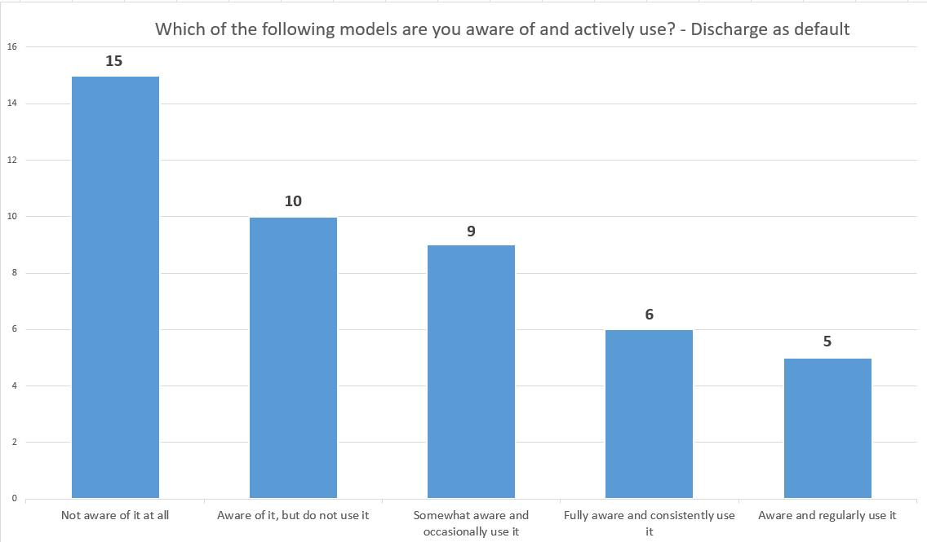
Figure 26 Are you aware of, and do you use the "Discharge as default" model for managing Outpatients?
When asked about the "discharge as default" model for managing patients (Figure 26), a third of respondents were unaware of it, despite it being part of the outpatient management plan since 2022 (Welsh Government, 2022). 22% were aware of the model but did not use it, while only 24% used it regularly and consistently.
As a result, it's understandable that the follow-up question, "Is discharge now the default option in the outpatient arena?" (Figure 27), found 49% of respondents disagreeing with the statement, while only 31% agreed that this was not the case in some form.

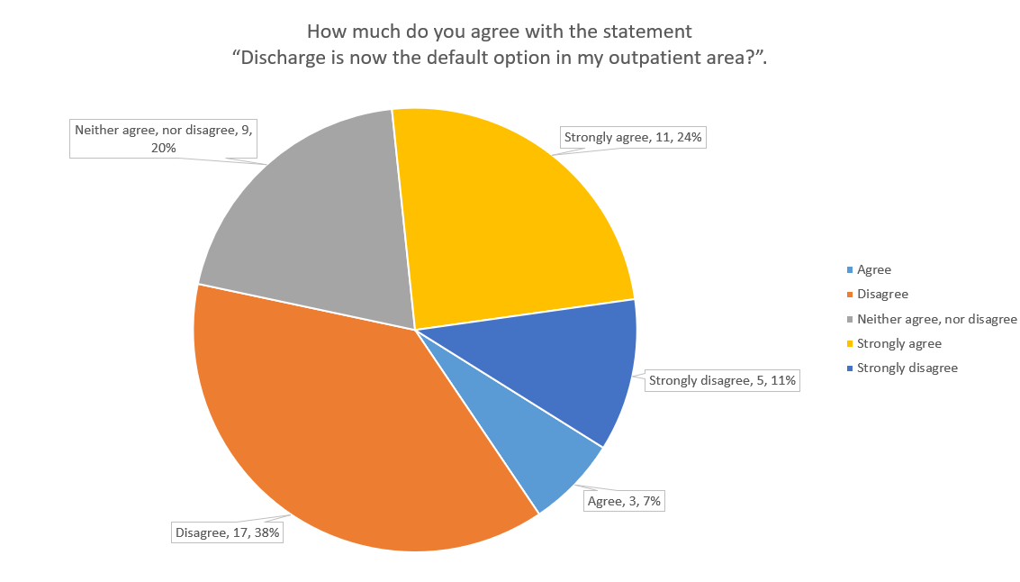
Figure 27 Analysis of "Discharge as default" in outpatient areas

Overall view of how outpatient care has changed since the COVID-19 pandemic in the survey
This was the final free-text question on the survey and allowed those responding to provide any final commentary on how outpatient care has changed since COVID, with the themes that appeared here shown in Table 11.
Table 11 How outpatient care has changed since the COVID-19 pandemic - overarching themes
Theme | Number of Mentions (n) | Percentage of Respondents (%) | Summary of Viewpoint
Virtual care embedded, but needing refinement | 9 | 31.0% | Telephone and virtual clinics are routine but need better selection, consistency, and digital support
Concerns about safety and quality | 3 | 10.3% | Risk of missed diagnoses or reduced assessment when virtual models are overused
Variable impact across specialties and populations | 3 | 10.3% | Changes suit some specialties but are less appropriate for paediatrics, frailty, or in safeguarding contexts
Workforce strain and morale pressures | 3 | 10.3% | Ongoing pressure on staff, reduced capacity, and fragile recovery since the pandemic
Positive transformation and optimism | 2 | 6.9% | Perceived long-term efficiency gains, convenience for patients, and service modernisation
The responses reinforced the thoughts that outpatient care has shifted since COVID-19, with virtual consultations now the norm for follow-up and patient convenience in specific areas. However, some noted that these models need refinement, better case selection, and improved digital infrastructure to maintain quality and equity. It was felt that the benefits were uneven across specialties and patient groups, with paediatrics, frail older adults, and safeguarding services less suited for remote care.
It was noted that workforce capacity and morale continue to face pressure, with high demand exceeding available support. However, some responses were more positive, highlighting efficiency improvements and a shift away from unnecessary face-to-face visits. Overall, there was a sense that outpatient care is stabilising, with an emphasis on safely, equitably, and sustainably adopting new models where appropriate.

Review of the interviews
As part of the qualitative research, three interviews were conducted between 1-Apr-2026 and 24-Apr-2026 to provide more in-depth answers to some questions raised by the survey.
Whilst all interviewees were from different organisations and areas of the NHS in Wales, they had all been in their relevant posts for over 10 years and could provide good knowledge of the NHS prior to COVID. The interviews were used to explore further some of the comments made in the survey and to ask for their thoughts on what could be changed to improve the adoption of the research initiatives and ways of working.
For most, the main themes of the interview responses were the necessity of transforming NHS culture in Wales to adopt new technologies and to push through the organisational and systemic changes required to achieve that goal.
Most recognised that there had been a “system shock” as part of the COVID response, and that some services were taking longer than anticipated to recover. However, it was also felt that those teams that had recovered more quickly than others had done so by using the core COVID period as a catalyst to reassess how their services were being managed and to drive through transformational changes that continue to this day.
“A long waiting list should not be the currency for purpose and importance” – interview comment
Some services have taken the time to re-categorise their patients, and, together with the adoption of PIFU, SoS, and virtual clinics, this has reduced waiting lists in those services from 4 months pre-pandemic to 8 weeks now, which is at odds with many other services that have seen massive and continued increases in waiting lists over the same period. Although the administrative workload increased, staff believed the results justified their efforts. It was acknowledged that recording these new events as they occur is essential. Often, work that isn't classified as outpatient attendance, such as some office-based decisions, is not properly documented or allocated time, even though it is crucial for reducing waiting lists and delivering optimal patient care.
A common theme in the interviews was that different services serving various patient groups with unique needs couldn't all adopt SoS or PIFU. For example, paediatricians frequently need face-to-face visits to build trust and familiarity, since long intervals between appointments for young people can lead patients to forget who their clinician is or what they look like. Conversely, certain services are better suited for SoS or PIFU when patients are capable and ready to self-manage their condition and request additional appointments as needed and appropriately.
During the interviews, participants frequently described scenarios where improvements could be made. Many noted that people often do not pause to consider the broader benefits of PIFU, SoS, and virtualisation. They believed that many thought these innovations originated solely due to COVID and were only relevant during that period. Interviewees saw the pandemic as either a catalyst for existing initiatives or a chance to reassess their service management from a fresh perspective. This prompted meaningful transformation choices and their implementation, guiding teams toward safer, more suitable methods of delivering care.
All believed that Digital was a key enabler. Most knew that the evidence was there and was referenced in the strategies and other documents, but these and other innovations may not be fully implemented, potentially due to a lack of clarity, guidance or meaning. One respondent pointed out that “discharge as default” actually implies that the initial step after an appointment should be to assess whether it is clinically appropriate to return the patient to primary care for follow-up. Some people might not fully grasp this subtlety, which indicates that follow-up care continues, just outside of secondary care.
In summary, the interviews offered valuable, detailed insights into why events occur as they do. They also revealed ongoing innovations at the local level that warrant further investigation for potential broader implementation.

Discussion
This chapter interprets the findings in relation to the research question in section 3.6, examining whether outpatient reforms—including virtual appointments, PIFU, SoS, and “discharge as default” —have reduced follow-up demand or contributed to longer outpatient pathways.

Has the rise in capacity and investment reduced outpatient waiting lists?
The findings reveal a clear divergence between service activity and waiting list size over the study period, suggesting that demand continues to exceed effective throughput. This supports broader evidence that simply expanding capacity doesn’t solve systemic waiting list issues, especially when demand continues to grow (OECD, 2020).
During the early COVID-19 pandemic, referral rates declined sharply, reflecting reduced access to primary care and prioritisation of urgent cases. This drop was temporary; referrals steadily increased from 2021 onward as the previous restrictions on referring patients and then seeing them were lifted, reaching or surpassing pre-pandemic levels. This demonstrates that demand far exceeded effective throughput, as evidenced by the backlog identified and processed. This also aligns with research showing healthcare systems as dynamic queues, where increasing service rates won't clear backlogs if demand remains high or rises (Green, 2006).
Meanwhile, outpatient activity grew significantly as capacity expanded through restored and new delivery methods such as virtual appointments. From a queueing theory perspective, strategies such as virtual clinics and pathway redesign appear to have increased nominal capacity but haven't fundamentally balanced supply and demand.
The findings suggest that post-pandemic demand extends beyond merely returning to pre-pandemic levels, encompassing unmet needs and more complex cases following the “system shock” of COVID itself. This shows that ongoing waiting lists are not solely caused by capacity constraints but also reveal underlying systemic issues. Thus, policies focused mainly on boosting activity could overstate their ability to clear long-term backlogs unless they also tackle the root causes of demand.

Have changes in clinical practice patterns offset the increase in outpatient capacity?
Outpatient activity returned to pre-pandemic levels and increased further after additional investment. However, the rise in appointments did not result in more unique patients, as many required multiple visits. Follow-up appointments continued to account for a significant portion of overall activity, indicating that capacity was largely absorbed by ongoing patient care rather than by efforts to reduce waiting times. This suggests that the adoption of PIFU and SoS might have been more restricted than expected. These findings also align with research showing that clinician behaviour is a key factor in system efficiency, especially when managing uncertainty and risk (Wherton et al., 2020).
This pattern may be explained by changes in both patient presentation and clinical behaviour following the pandemic. Post-pandemic, new patients tended to present with more advanced or complex conditions, which may have required extra monitoring and follow-up care. Simultaneously, clinicians may have adopted more cautious decision-making, especially when using newer care models such as virtual consultations. Together, the rise in clinical complexity and a more risk-averse approach to decision-making appear to have maintained high follow-up rates, which in turn restricted the capacity available for new patients.
These findings highlight how behavioural factors interact with system-level interventions. For example, policies such as “discharge as default” aim to reduce unnecessary follow-ups, but their effectiveness depends on clinician confidence, perceived risk, and patient factors. This suggests that outpatient reforms are not just structural or operational issues but also involve behavioural considerations, particularly how clinicians adapt to new models of care in practice.

Has the introduction of virtual appointments increased follow-up rates rather than reduced them?
The shift toward adopting virtual appointments as a mechanism for delivering outpatient care during the study period marked a major change in outpatient services, with adoption increasing rapidly after COVID-19. The findings show that this enabled continued access but did not lead to the planned reduction in face-to-face follow-up for individual patients. In some cases, virtual consultations led to additional face-to-face visits, sometimes due to clinical uncertainty about not seeing the patient in person. This is supported by literature showing that the introduction of virtual appointments on overall demand can be mixed (Abelleyra Lastoria et al., 2024).
This pattern may be explained by the inherent limitations of virtual consultations in certain clinical contexts. The qualitative results indicate that clinicians in certain services tend to adopt a more cautious approach to decision-making when they cannot physically examine patients, often resulting in additional follow-up visits to verify diagnoses or monitor progress. This is particularly relevant for more complex cases, where virtual consultations may be less suitable as a standalone approach. In such cases, virtual appointments can serve as an extra step in the patient process rather than replacing face-to-face care.
These findings indicate that virtual care functions primarily as a tool for redistributing and managing demand, not for expanding system capacity. Although it enhances accessibility and flexibility, its impact on efficiency depends on how well it is integrated into clinical workflows and supported by effective triage and decision-making. This underscores the need to align digital innovations with clinical practice, ensuring that virtual models are used to support care delivery rather than inadvertently increasing follow-up demand. This also reflects broader concerns in the literature about limitations of physical assessments and the reduced availability of non-verbal cues in remote environments (Wherton et al., 2022).

How successful have PIFU, SoS, and “discharge as default” been in reducing follow-up demand?
The introduction of PIFU, SoS, and “discharge as default” was intended to reduce unnecessary follow-up visits and improve patient flow in outpatient clinics. However, their impact on follow-up demand has been more limited than anticipated. Although these models were adopted across various services, follow-up activity remained a major part of the workload, indicating that routine follow-up demand was not substantially reduced at a system level.
This may be explained by variation in how these models are applied in practice. The qualitative results indicate that clinicians selectively adopt PIFU and SoS, depending on the patient's condition, perceived risk, and their confidence in the model. For stable or low-risk patients, these approaches can reduce the need for scheduled follow-ups. However, for more complex cases, clinicians are more likely to retain traditional follow-up pathways, reflecting concerns around safety and uncertainty. This aligns with existing research highlighting that the success of patient-initiated pathways relies heavily on patient selection, engagement, and clinician confidence (Newton, Beaver and Clegg, 2022b). In addition, some patients may not engage with patient-initiated models as intended, leading to continued reliance on clinician-led follow-up.
These findings suggest that PIFU, SoS, and “discharge as default” models primarily serve as tools for managing and redistributing follow-up demand rather than eliminating it. Their effectiveness depends on appropriate patient selection, clinician confidence, and patient engagement. While these approaches can improve flexibility and support more efficient use of resources in specific contexts, they do not in themselves create additional system capacity. This highlights the importance of considering behavioural and contextual factors when evaluating outpatient reform, as policy implementation alone does not guarantee system-wide impact.
Evidence from the reviewed literature indicates that PIFU and related models can improve care, provide faster access when needed, and release capacity by reducing non-essential activity (Pennington et al., 2022). This research expands the literature by demonstrating that these models tend to shift, rather than reduce, system workload. Although scheduled follow-ups may decline in some cases, this could be offset by an increase in less-visible administrative tasks and the need to manage patient-initiated contact. Therefore, evaluating the success of these models requires more than simply measuring the number of appointments reduced for a patient; it must also consider their impact on workload distribution and system coordination. Without proper support, these models may not deliver their full system-wide benefits.

Have changes in administrative outcomes following the pandemic resulted in longer outpatient pathways?
This study indicates that changes in administrative procedures may have lengthened outpatient pathways rather than significantly shortened them. This highlights an important but often overlooked aspect of outpatient reform, where operational and administrative factors play a key role in overall system performance. While initiatives such as PIFU and virtual care are intended to improve efficiency and release capacity, they can also introduce new coordination challenges, such as managing patient-initiated contact, maintaining scheduling flexibility, and integrating different modes of care. This added complexity can contribute to inefficiencies, particularly in already strained systems. The study highlights the operational challenges of implementing new care models and suggests that outpatient reforms may shift workload rather than reduce it, with administrative systems becoming increasingly central to efficiency.
While alternative models have potential benefits, their effectiveness depends on system-level factors that influence implementation and day-to-day operations, alongside a change in culture, supported by evidence on patient safety and risk. Variability across services can lead to inconsistent pathway management, further complicating care delivery.

Summary of findings
These findings both support and expand on existing research about outpatient transformation. Consistent with the literature, virtual care and patient-initiated pathways improve access, flexibility, and patient autonomy. However, this study demonstrates that these benefits do not automatically translate into shorter waiting lists or greater system efficiency.
The analysis shows that while outpatient reform has increased activity levels, it has not fundamentally addressed the demand-versus-capacity imbalance. From a queueing-theory perspective, increased service capacity has been offset by sustained and growing demand, maintaining pressure on the system. The COVID-19 pandemic, acting as a system shock, created a backlog that persists despite higher activity levels.
The findings highlight a complex relationship among structural changes, clinician behaviour, and patient demand. Outpatient transformation should, therefore, be viewed as a system-wide challenge, requiring coordinated interventions that target capacity, demand, behaviour, and operational processes. Without adopting this comprehensive approach, reforms may improve isolated system components but fail to produce long-term performance gains across the whole system.

Validity, Reliability, and Limitations of Results
As with any research of this kind, these findings should be approached cautiously due to limitations in data quality, NHS Wales organisation and staff representation, and the methodology. To address these challenges, a mixed-methods approach improves the validity of the results by triangulating data sources, allowing for a more comprehensive understanding of outpatient reform.
As noted in section 3.4.10, the quantitative analysis used data from the main patient administration system for Wales, WelshPAS, which, despite being comprehensive, underwent system changes, such as health board data migrations, that may have introduced inconsistencies or gaps, affecting trend validity, especially in earlier years. To address concerns about data quality, all charts are clearly labelled with major WelshPAS events, and the raw data was verified at each point during collection and analysis to ensure it closely matched the routinely published data available from other sources. Additionally, the reliability of the data is supported using consistent data extraction criteria across the full study period (2019–2025) and the application of standardised definitions within WelshPAS.
Excluding Cardiff and Vale Health Board limits generalisability across NHS Wales, although the included boards represent a significant and diverse sample for system-level analysis.
The qualitative data from clinicians and staff may be influenced by response and recall biases. However, the mixed methods improve overall reliability by contextualising quantitative trends. The sample includes a high proportion of experienced clinicians, with 40 respondents serving as consultants, and many having over 10 years of experience within NHS Wales. This provides depth of insight and supports the credibility of the findings (Creswell, 2003; Bryman, 2016). However, these strengths are counterbalanced by key challenges. The small sample size (n=45) limits the statistical robustness of the study (Polit and Beck, 2021), while the concentration of respondents from a single health board introduces a potential geographical and organisational bias. While responses from other health boards generally aligned, some findings may mirror local practices rather than representing the broader NHS Wales context.
The limited number of interview participants (n=3 from 15 expressions of interest) may also affect the depth of qualitative interpretation. However, the participants came from various organisations and services, including both clinical and administrative roles, which helped provide a broader perspective on the survey findings and system-level data.
Finally, the study identifies relationships rather than causation, particularly regarding interventions such as virtual appointments, which involve multiple factors, including clinical decision-making. Despite these limitations, the consistent patterns from different sources strengthen confidence in the findings. The combined methodological approach provides a credible and appropriate analysis of outpatient reform in NHS Wales.

Future research
While this research provides a strong foundation, the collected data has additional potential that could not be fully explored within the scope of this study. The dataset can facilitate more in-depth analysis of specific services or organisations, providing clearer insights into the implementation of outpatient reforms and how their effects differ across various clinical environments.
Future research might build on these findings by incorporating patient-level outcomes and tracking longer-term care pathways. This would help assess whether administrative changes such as PIFU, SoS, and virtual care affect not only system efficiency but also clinical outcomes, patient safety, and continuity of care.
There is also scope to investigate behavioural factors affecting outpatient reform, particularly how clinicians' decisions and patient participation influence the model's effectiveness. Understanding how and why these approaches are adopted could help explain variation across services and facilitate more consistent implementation.
Further studies might directly examine the links among activity, capacity, and demand, clarifying whether increases in activity reflect genuine capacity improvements or simply shifts in workload within the system.
Exploring the administrative and operational challenges of these models could provide a more comprehensive view of their impact on healthcare delivery.
Overall, future studies should adopt a comprehensive, system-wide approach that integrates both quantitative and qualitative methods. This will provide a deeper understanding of how outpatient reforms impact capacity, demand, behaviour, and patient outcomes over time.

Conclusions
This study set out to examine whether outpatient reform in NHS Wales, particularly patient-initiated follow-up (PIFU), See on Symptom (SoS), and “discharge as default”, has reduced follow-up demand and improved waiting list performance following COVID-19. The findings indicate that although these initiatives have enhanced flexibility and supported local improvements in access and patient management, they have neither reduced follow-up demand nor addressed system-wide capacity issues.
This longitudinal system-level analysis of outpatient reform demonstrates an ongoing imbalance between demand and available capacity, driven by increased referral volumes, an accumulated backlog, hidden waits resulting from hospital cancellations, and shifts in clinical and administrative decision-making. Digital tools such as virtual appointments are now common in some services, enhancing access and continuity of care, but many others have not yet successfully adopted them. Similarly, policies such as patient-initiated follow-up, See on Symptom, and “discharge as default” have shown inconsistent adoption and limited overall impact at the system level. Although these models are useful in specific situations and have provided benefits in individual services, their broader role in decreasing follow-up demand and boosting throughput remains limited by factors such as clinician risk aversion, patient eligibility, administrative capacity, and system reliability. The qualitative findings further demonstrate that these reforms tend to redistribute workload rather than reduce it, highlighting the importance of considering administrative and workforce effects alongside patient activity metrics.
Whilst not an initial aim, treating the COVID-19 pandemic as a systemic shock has shown how short-term disruptions can have prolonged effects on service performance and behaviour. The persistence of high waiting lists despite increased funding and activity demonstrates that outpatient reform cannot rely on capacity expansion alone. The complexity of transforming outpatient services within large public healthcare systems warns against considering digital solutions as standalone fixes. Digital and policy efforts are most successful when integrated into a comprehensive system redesign, backed by strong governance, workforce capacity, patient-focused safeguards, and good communication.
While the findings are specific to NHS Wales, the methodological approach and insights provide valuable contributions to broader discussions on how health systems can evaluate and manage digital transformation after major service disruptions. Outpatient transformation should be viewed as a complex system challenge, where isolated actions are unlikely to produce sustained improvements in waiting times without coordinated, system-wide change.

References
Abelleyra Lastoria, D.A. et al. (2024) ‘An evaluation of outpatient service provision in the National Health Service in Great Britain: A freedom of information request’, Journal of Evaluation in Clinical Practice, 30(7), pp. 1309–1318. doi:10.1111/JEP.14057.
ABHB (2023) Changing How We Deliver Outpatients Services - Aneurin Bevan University Health Board, https://abuhb.nhs.wales/news/news/changing-how-we-deliver-outpatients-services/.
Akintomide, E. et al. (2021) ‘Clinical perception of effectiveness of virtual appointments and comparison with appointment outcomes at a specialist children’s hospital’, Future healthcare journal, 8(3), pp. e660–e665. doi:10.7861/fhj.2021-0044.
Ammenwerth, E. et al. (2003) ‘Evaluation of health information systems - Problems and challenges’, in International Journal of Medical Informatics. doi:10.1016/S1386-5056(03)00131-X.
Auditor General for Wales (2022) Tackling the Planned Care Backlog in Wales. Cardiff.
BCU (2019) See on Symptom (SOS) and Patient Initiated Follow-Up (PIFU), https://bcuhb.nhs.wales/services/hospital-services/sos-pifu/.
BCU Informatics Team (2017) WelshPAS Implementation in BCU Central - Lessons Learned. St Asaph.
Bech, B. et al. (2020) ‘Patient-Initiated Follow-Up (PIFU) as reorganized support for increased patient involvement - Focus group discussions among patients’ with inflammatory arthritis’, BMC Rheumatology, 4(1). doi:10.1186/S41927-020-00143-6.
Bevin, A. (2021) ‘Embracing the technological age: virtual appointments in 2021’, Journal of kidney care, 6(1), pp. 6–8. doi:10.12968/jokc.2021.6.1.6.
Bhaskar, S. et al. (2020) ‘Telemedicine as the New Outpatient Clinic Gone Digital: Position Paper From the Pandemic Health System REsilience PROGRAM (REPROGRAM) International Consortium (Part 2)’, Frontiers in Public Health, 8. doi:10.3389/fpubh.2020.00410.
Bodenheimer, T. and Sinsky, C. (2014) ‘From triple to Quadruple Aim: Care of the patient requires care of the provider’, Annals of Family Medicine, 12(6). doi:10.1370/afm.1713.
Bowling, A. (2014) ‘Research Methods In Health [electronic resource] : Investigating Health And Health Services’, Mc Graw hill [Preprint].
Bryman, A. (2016) Social Research Methods - Alan Bryman - Oxford University Press, Oxford University Press.
Chan-Nguyen, S. et al. (2022) ‘Patient and caregiver perspectives on virtual care: a patient-oriented qualitative study’, CMAJ open, 10(1). doi:10.9778/cmajo.20210065.
Child, S., Goodwin, Victoria A, et al. (2015) ‘Implementing a patient-initiated review system in rheumatoid arthritis: a qualitative evaluation’, BMC health services research, (1), pp. 157-.
Child, S., Goodwin, Victoria A., et al. (2015) ‘Implementing a patient-initiated review system in rheumatoid arthritis: A qualitative evaluation’, BMC Health Services Research, 15(1). doi:10.1186/S12913-015-0837-9.
Creswell, J.W. (2003) ‘Research design Qualitative quantitative and mixed methods approaches’, Research design Qualitative quantitative and mixed methods approaches [Preprint]. doi:10.3109/08941939.2012.723954.
Davies, C. (2024) ‘Reflections on the first Year of an MSc’, UWTSD Showcase event [Preprint].
Davies, P.C. (2025) Internal: Patient Administration Systems in Wales – Core Statistics 2019 - 2024. Swansea.
Demetriades, P. et al. (2024) ‘26 A service evaluation of the mechanisms that improve compliance with RTT targets in modern cardiology’, Heart (British Cardiac Society), (Suppl 3), pp. A29–A31.
DHCW (2024) DHCW NHS Wales Data Dictionary, https://dhcw.nhs.wales/information-services/information-standards/data-standards/nhs-wales-data-dictionary/.
DHCW (2025a) DHCW Product Directory, https://dhcw.nhs.wales/product-directory/.
DHCW (2025b) Extraordinary Programme Delivery Committee Meeting, https://dhcw.nhs.wales/about-us/board-committee-and-advisory-boards/programmes-delivery-committee/meeting-9-september-2025-extradordinary/documents/extraordinary-pdc-agenda-and-papers-09-september-2025/.
Digital Health and Care Wales (2026) Welsh Information Governance Toolkit - Digital Health and Care Wales. Available at: https://dhcw.nhs.wales/ig/information-governance/welsh-information-governance-toolkit/ (Accessed: 11 April 2026).
Donaghy, E. et al. (2019) ‘Acceptability, benefits, and challenges of video consulting: A qualitative study in primary care’, British Journal of General Practice, 69(686). doi:10.3399/bjgp19X704141.
European Union (2016) ‘Regulation (EU) 2016/679 (General Data Protection Regulation – GDPR)’, Official Journal of the European Union, EN(679).
Evans, C. et al. (2025) ‘How to Implement Digital Clinical Consultations in UK Maternity Care: the ARM@DA Realist Review’, Health and Social Care Delivery Research, 13. doi:10.3310/JFQT1054.
Fan, K.S. et al. (2025) ‘Efficient patient-initiated follow-up after orthopaedic injections’, European Journal of Orthopaedic Surgery and Traumatology, 35(1). doi:10.1007/S00590-025-04193-9.
Gilbert, A.W. et al. (2020) ‘Rapid implementation of virtual clinics due to COVID-19: Report and early evaluation of a quality improvement initiative’, BMJ Open Quality, 9(2). doi:10.1136/BMJOQ-2020-000985.
GOV UK (2019) ‘Guide to the General Data Protection Regulation (GDPR)’, Guide to the General Data Protection Regulation [Preprint], (May).
Green, L. (2006) ‘Queueing analysis in healthcare’, in International Series in Operations Research and Management Science. doi:10.1007/978-0-387-33636-7_10.
Greenhalgh, T. et al. (2004) ‘Diffusion of innovations in service organizations: Systematic review and recommendations’, Milbank Quarterly. doi:10.1111/j.0887-378X.2004.00325.x.
Greenhalgh, T. et al. (2016) ‘Virtual online consultations: Advantages and limitations (VOCAL) study’, BMJ Open, 6(1). doi:10.1136/bmjopen-2015-009388.
Greenhalgh, T. et al. (2020) ‘Video consultations for covid-19’, The BMJ. doi:10.1136/bmj.m998.
Haddaway, N.R. et al. (2022) ‘PRISMA2020: An R package and Shiny app for producing PRISMA 2020-compliant flow diagrams, with interactivity for optimised digital transparency and Open Synthesis’, Campbell Systematic Reviews, 18(2), p. e1230. doi:https://doi.org/10.1002/cl2.1230.
Hall, R. et al. (2013) ‘Modeling patient flows through the health care system’, in International Series in Operations Research and Management Science. doi:10.1007/978-1-4614-9512-3_1.
Health and Care Professions Council (2024) Revised Standards of Conduct , Performance and Ethics, The Health and Care Professions Council.
Help - PubMed (no date). Available at: https://pubmed.ncbi.nlm.nih.gov/help/ (Accessed: 4 April 2026).
Hodgins, M. et al. (2022) ‘The COVID-19 System Shock Framework: Capturing Health System Innovation During the COVID-19 Pandemic’, International Journal of Health Policy and Management, 11(10). doi:10.34172/ijhpm.2021.130.
Howren, A. et al. (2020) ‘Virtual rheumatology appointments during the COVID-19 pandemic: an international survey of perspectives of patients with rheumatic diseases’, Clinical rheumatology, 39(11), pp. 3191–3193. doi:10.1007/s10067-020-05338-3.
Jaly, I. et al. (2020) ‘Redefining diabetic foot disease management service during COVID-19 pandemic’, Diabetes and Metabolic Syndrome: Clinical Research and Reviews, 14(5), pp. 833–838. doi:10.1016/j.dsx.2020.06.023.
Jeppesen, M.M. et al. (2018) ‘Patient-initiated follow up affects fear of recurrence and healthcare use: a randomised trial in early-stage endometrial cancer’, BJOG: An International Journal of Obstetrics and Gynaecology, 125(13), pp. 1705–1714. doi:10.1111/1471-0528.15396.
Kadel, R. et al. (2022) ‘Cost of health inequality to the NHS in Wales’, Frontiers in Public Health, 10. doi:10.3389/fpubh.2022.959283.
Kahn, M.G. et al. (2016) ‘A Harmonized Data Quality Assessment Terminology and Framework for the Secondary Use of Electronic Health Record Data’, eGEMs (Generating Evidence & Methods to improve patient outcomes), 4(1). doi:10.13063/2327-9214.1244.
Khanji, M.Y. et al. (2023) ‘Remote consultations: review of guiding themes for equitable and effective delivery’, Current Problems in Cardiology, 48(8). doi:10.1016/j.cpcardiol.2023.101736.
Kim, S.E. et al. (2021) ‘Digital Transformation in Ophthalmic Clinical Care during the COVID-19 Pandemic’, Asia-Pacific Journal of Ophthalmology, 10(4), pp. 381–387. doi:10.1097/APO.0000000000000407.
Lavin, B. et al. (2020) ‘Bridging the healthcare gap: Building the case for epilepsy virtual clinics in the current healthcare environment’, Epilepsy and Behavior, 111. doi:10.1016/j.yebeh.2020.107262.
Lee, J. and Manalew, W.S. (2024) ‘Adoption of virtual prenatal visits linked to recurrent virtual or forgone visits for postpartum care’, Midwifery, 129, p. 103904. doi:10.1016/j.midw.2023.103904.
Lim-Reinders, S. et al. (2024) ‘Identifying child maltreatment during virtual medical appointments through the COVID-19 pandemic: A physician-based survey’, Paediatrics & child health, 29(1), pp. 23–28. doi:10.1093/pch/pxad064.
Mallick, S., Balakumar, R. and Drysdale, A. (2022) ‘Telephone clinic outcomes during the coronavirus disease 2019 pandemic: results from an ENT department’, Journal of laryngology and otology, (7), pp. 611–614.
Mansfield, K.E. et al. (2021) ‘Indirect acute effects of the COVID-19 pandemic on physical and mental health in the UK: a population-based study’, The Lancet Digital Health, 3(4). doi:10.1016/S2589-7500(21)00017-0.
Meskó, B. (2022) ‘COVID-19’s Impact on Digital Health Adoption: The Growing Gap Between a Technological and a Cultural Transformation’, JMIR Human Factors, 9(3). doi:10.2196/38926.
Morrison, C. et al. (2021) ‘Testing and implementing video consulting for outpatient appointments: Using quality improvement system thinking and codesign principles’, BMJ Open Quality, 10(1). doi:10.1136/bmjoq-2020-001259.
Murphy, M. et al. (2021) ‘Implementation of remote consulting in UK primary care following the COVID-19 pandemic: A mixed-methods longitudinal study’, British Journal of General Practice, 71(704). doi:10.3399/BJGP.2020.0948.
Newton, C., Beaver, K. and Clegg, A. (2022a) ‘Patient initiated follow-up in cancer patients: A systematic review’, Frontiers in Oncology, 12. doi:10.3389/FONC.2022.954854/PDF.
Newton, C., Beaver, K. and Clegg, A. (2022b) ‘Patient initiated follow-up in cancer patients: A systematic review’, Frontiers in Oncology, 12. doi:10.3389/FONC.2022.954854/PDF.
NHS England (2022) Implementing patient initiated follow-up: guidance for local health and care systems, https://www.england.nhs.uk/publication/implementing-patient-initiated-follow-up-guidance-for-local-health-and-care-systems.
NHS Wales LibrarySearch (no date). Available at: https://nhswaleslibrarysearch.cardiff.ac.uk/discovery/search?vid=44WHELF_CAR:44WHELF_NHS_VU1 (Accessed: 4 April 2026).
NHSWales (2018) A Healthier Wales: our Plan for Health and Social Care. Available at: https://www.gov.wales/healthier-wales-long-term-plan-health-and-social-care (Accessed: 19 November 2023).
Nundy, S., Cooper, L.A. and Mate, K.S. (2022) ‘The Quintuple Aim for Health Care Improvement: A New Imperative to Advance Health Equity’, JAMA, 327(6). doi:10.1001/jama.2021.25181.
OECD (2020) ‘Beyond Containment: Health systems responses to Covid-19 in the OECD’, Tackling Coronavirus (COVID-19): Contributing to a Global Effort [Preprint], (April).
Ohannessian, R., Duong, T.A. and Odone, A. (2020) ‘Global telemedicine implementation and integration within health systems to fight the COVID-19 pandemic: A call to action’, JMIR Public Health and Surveillance. doi:10.2196/18810.
Pennington, Z. et al. (2022) ‘Positive impact of the pandemic: The effect of post–COVID-19 virtual visit implementation on departmental efficiency and patient satisfaction in a quaternary care center’, Neurosurgical Focus, 52(6). doi:10.3171/2022.3.FOCUS2243.
Polit, D. and Beck, C.T. (2021) Nursing research: Generating and assessing evidence for nursing practice. 9th Edition, Lippincott, Williams & Wilkins, Philadelphia., Wolters Kluwer Health.
Radley, S. (2020) ‘Manifesto for recovery’, Professional Engineering, 15(4).
Raghupathi, W. and Raghupathi, V. (2014) ‘Big data analytics in healthcare: Promise and potential’, Health Information Science and Systems. doi:10.1186/2047-2501-2-3.
Rice, T. and Unruh, L. (2015) The Economics of Health Reconsidered, Fourth Edition, AUPHA/HAP Book.
Robinson, J. (2024) Why the Quintuple Aim is key to transforming healthcare, https://www.healthdatamanagement.com/articles/why-the-quintuple-aim-is-key-to-transforming-healthcare.
Rodriguez Socarrás, M. et al. (2020) ‘Telemedicine and Smart Working: Recommendations of the European Association of Urology’, European Urology, 78(6), pp. 812–819. doi:10.1016/j.eururo.2020.06.031.
Ruggiero, C., Waite, M. and Stayt, L. (2026) ‘Experiences of remote nurse consultations in chronic disease management: A systematic review.’, International journal of nursing studies, 175, p. 105319. doi:10.1016/j.ijnurstu.2025.105319.
Srikumar, G. et al. (2025) ‘Remote Follow-Up After Colorectal Cancer Surgery: A Systematic Review’, ANZ Journal of Surgery, 95(11), pp. 2273–2282. doi:10.1111/ans.70141.
University of Wales Trinity Saint David (2025) Research Integrity and Ethics | University of Wales Trinity Saint David. Available at: https://www.uwtsd.ac.uk/research/research-integrity-and-ethics (Accessed: 11 April 2026).
Valdes, D. et al. (2025) ‘Global Evidence on the Sustainability of Telemedicine in Outpatient and Primary Care During the First 2 Years of the COVID-19 Pandemic: Scoping Review Using the Nonadoption, Abandonment, Scale-Up, Spread, and Sustainability (NASSS) Framework.’, Interactive journal of medical research, 14, p. e45367. doi:10.2196/45367.
Venketasubramanian, N. et al. (2021) ‘Stroke Care during the COVID-19 Pandemic: International Expert Panel Review’, Cerebrovascular Diseases, 50(3), pp. 245–261. doi:10.1159/000514155.
Weiskopf, N.G. and Weng, C. (2013) ‘Methods and dimensions of electronic health record data quality assessment: Enabling reuse for clinical research’, Journal of the American Medical Informatics Association, 20(1). doi:10.1136/amiajnl-2011-000681.
Welsh Government (2021a) Health and Social Care in Wales – COVID-19: Looking forward, https://www.gov.wales/sites/default/files/publications/2021-03/health-and-social-care-in-wales--covid-19-looking-forward_0.pdf.
Welsh Government (2021b) The Health and Social Care Winter Plan in Wales 2021/2022, https://www.gov.wales/sites/default/files/publications/2021-10/health-and-social-care--winter-plan-2021-to-2022.pdf.
Welsh Government (2022) Our programme for transforming and modernising planned care and reducing waiting lists in Wales, https://www.gov.wales/transforming-and-modernising-planned-care-and-reducing-nhs-waiting-lists.
Welsh Government (2023a) The role of outpatients in transforming planned care in Wales, https://www.gov.wales/role-outpatients-transforming-planned-care-wales-html.
Welsh Government (2023b) Welsh Government (2021) Digital and data strategy for health and social care in Wales. Cardiff: Welsh Government. - Google Search. Available at: https://www.google.com/search?q=Welsh+Government+(2021)+Digital+and+data+strategy+for+health+and+social+care+in+Wales.+Cardiff%3A+Welsh+Government. (Accessed: 11 April 2026).
Welsh Government (2025) Trends in NHS planned care activity: as at March 2025, https://www.gov.wales/trends-nhs-planned-care-activity-march-2025-html.
Welsh Parliament Senedd Research (2022) Coronavirus timeline: the response in Wales, Research Briefing.
Welsh_Government (2021) ‘A Healthier Wales: our Plan for Health and Social Care’.
Wherton, J. et al. (2020) ‘Guidance on the introduction and use of video consultations during COVID-19: Important lessons from qualitative research’, BMJ Leader, 4(3). doi:10.1136/leader-2020-000262.
Wherton, J. et al. (2022) ‘The Role of Information Infrastructures in Scaling up Video Consultations During COVID-19: Mixed Methods Case Study Into Opportunity, Disruption, and Exposure’, Journal of Medical Internet Research, 24(11). doi:10.2196/42431.
Wootton, R. (1998) ‘Telemedicine in the National Health Service’, Journal of the Royal Society of Medicine. doi:10.1177/014107689809101202.

Appendix 1 – Further detailed charts from the quantitative data extract of NHS Wales data

Additional Quantitative charts
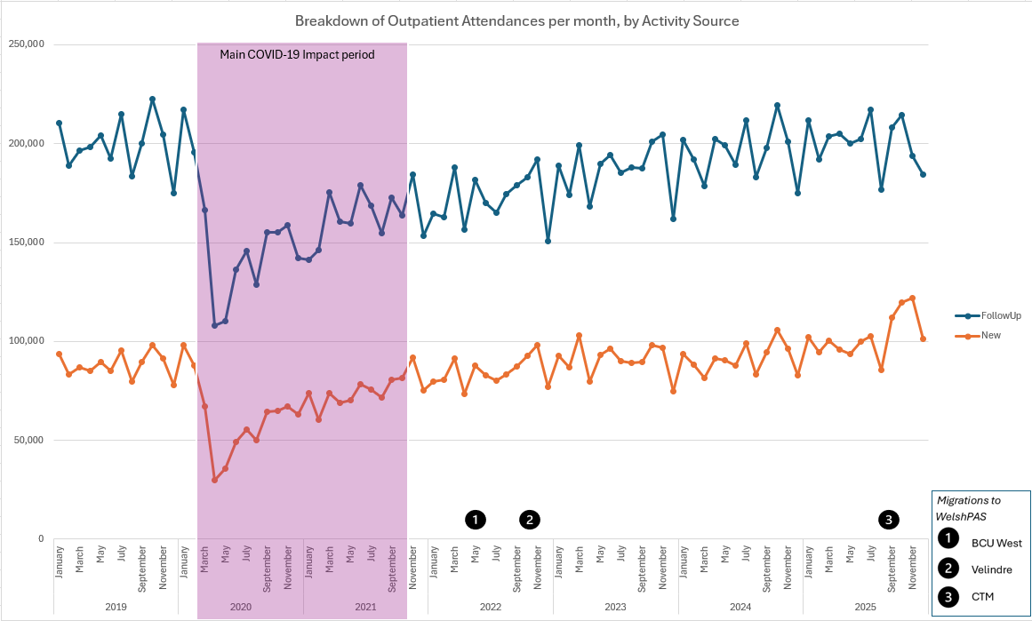
Figure 28 Breakdown of Outpatient Attendances by Activity Source

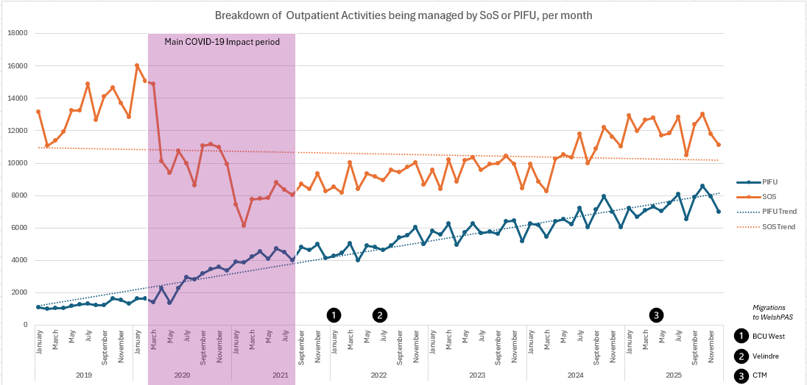
Figure 29 Breakdown of Outpatient activities that are then managed by PIFU or SoS

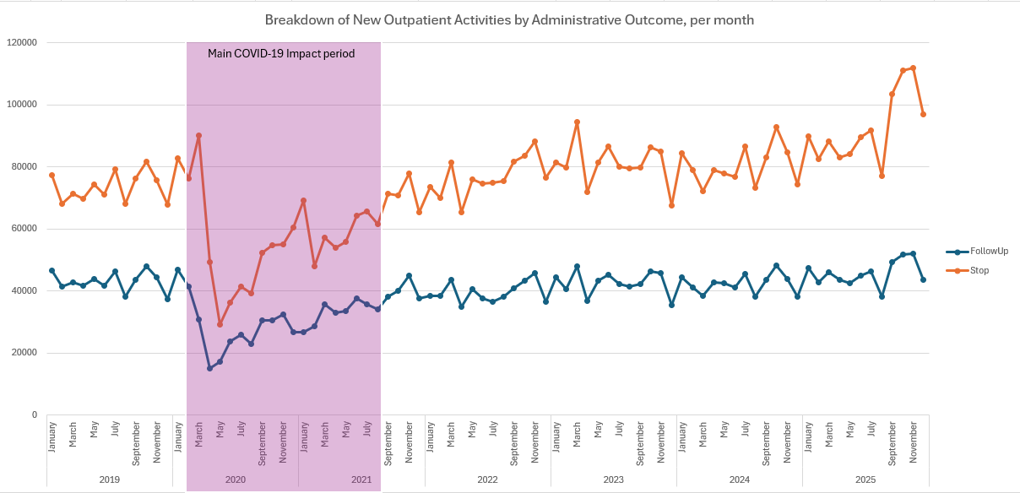
Figure 30 Breakdown of New Outpatient activities by Administrative Outcome, per month

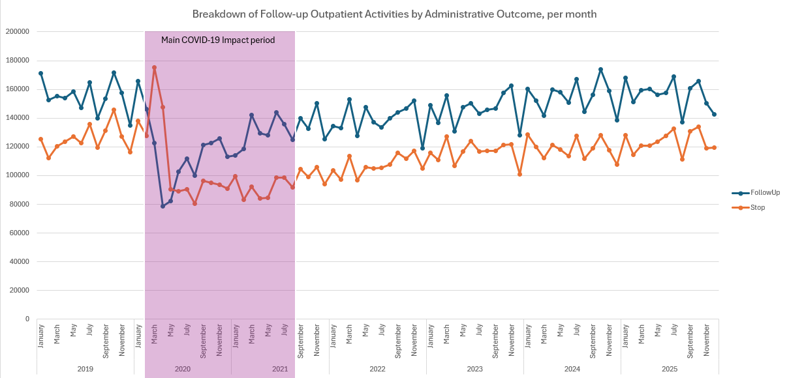
Figure 31 Breakdown of Follow-up Outpatient activities by Administrative Outcome, per month

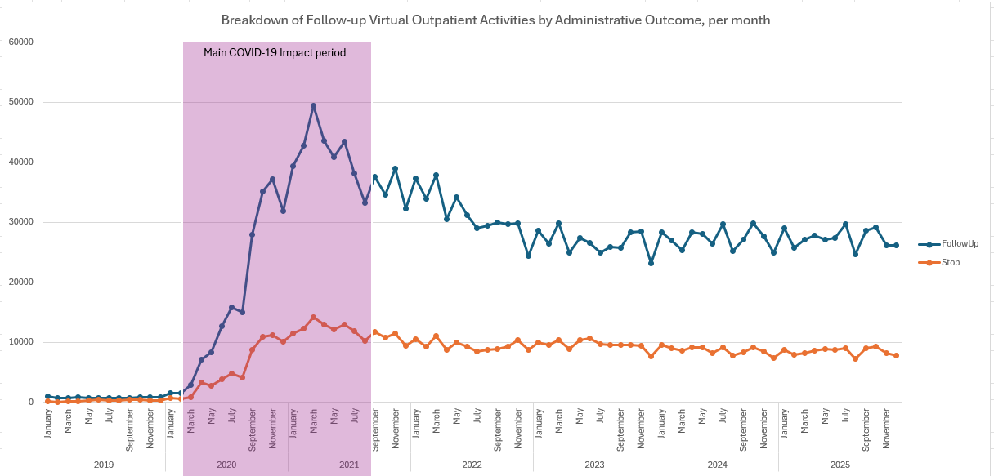
Figure 32 Breakdown of Follow-up Virtual Outpatient Activities by Administrative Outcome, per month

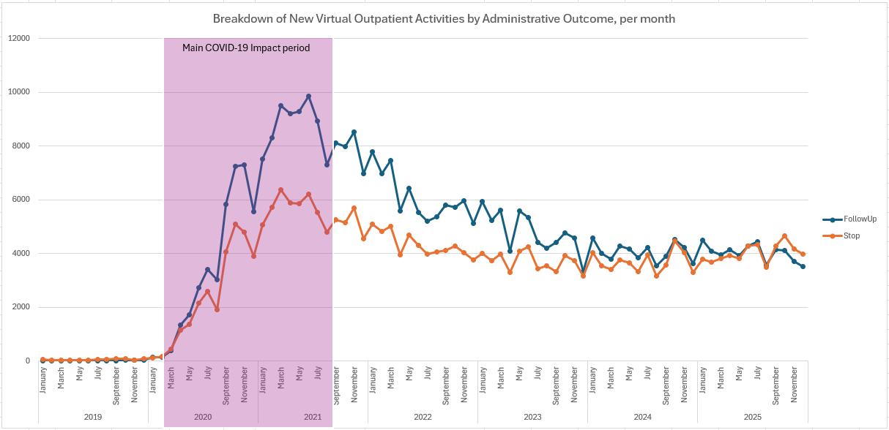
Figure 33 Breakdown of New Virtual Outpatient Activities by Administrative Outcome, per month

Additional Qualitative charts and diagrams
Back to Qualitative results
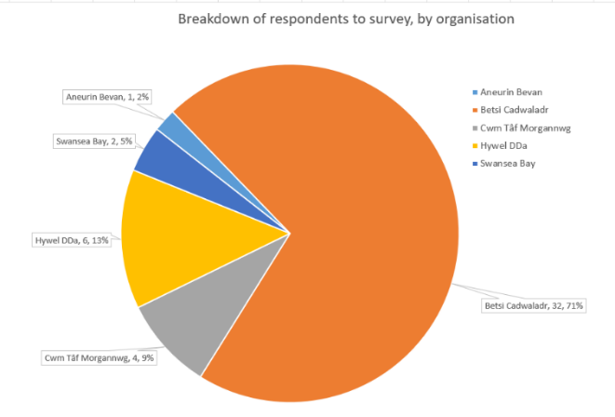
Figure 34 How long have you worked in Secondary care?

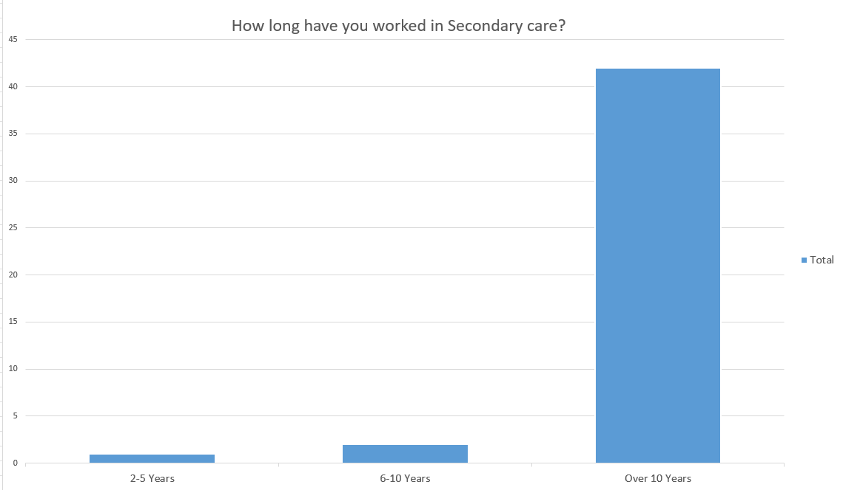
Figure 35 Breakdown of respondents, by organisation

Appendix 2 – Ethical Review document
APPLICATION FOR ETHICAL APPROVAL
ADAPTED FOR MSC DIGITAL TRANSFORMATION DISSERTATIONS
STUDENTS should submit this form (and receive the outcome) via systems explained to you by the supervisor/module leader.

In order for research to result in benefit and minimise risk of harm, it must be conducted ethically. A researcher may not be covered by the University’s insurance if ethical approval has not been obtained prior to commencement.

The University follows the OECD Frascati manual definition of research activity: “creative work undertaken on a systematic basis in order to increase the stock of knowledge, including knowledge of man, culture and society, and the use of this stock of knowledge to devise new applications”. As such this covers activities undertaken by members of staff, postgraduate research students, and both taught postgraduate and undergraduate students working on dissertations/projects.

The individual undertaking the research activity is known as the “principal researcher”.
Ethical approval is not required for routine audits, performance reviews, quality assurance studies, testing within normal educational requirements, and literary or artistic criticism.
Please read the notes for guidance before completing ALL sections of the form.
This form must be completed and approved prior to undertaking any research activity. Please see Checklist for details of process for different categories of application.
SECTION A: About You (Principal Researcher)
1 | Full Name: |  | Carl Davies
2 | Tick all boxes that apply: |  | Member of staff: | ☐ | Honorary research fellow: | ☐
 | Undergraduate Student | ☐ | Taught Postgraduate Student | ☒ | Postgraduate Research Student | ☐

3 | Institute/Academic Discipline/Centre: | IMH
4 | Campus: | Distance learning
5 | E-mail address: | Carl.Davies3@wales.nhs.uk
6 | Contact Telephone Number: | 02920 503309
 | For students:
7 | Student Number: | 2317968
8 | Programme of Study: | MSc Digital Transformation for the Health & Care Professions
9 | Director of Studies/Supervisor: | Philip Scott

SECTION B: Approval for Research Activity
1 | Has the research activity received approval in principle?  (please check the Guidance Notes as to the appropriate approval process for different levels of research by different categories of individual) |  | YES | ☐ | NO | ☒
 |  |  |  |  | Date
2 | If Yes, please indicate source of approval (and date where known): Approval in principle must be obtained from the relevant source prior to seeking ethical approval | Research Degrees Committee |  | ☐ | N/A
2 |  | Institute Research Committee |  | ☐ | N/A
2 |  | Other (write in) |  | ☐

SECTION C: Internal and External Ethical Guidance Materials
 | Please list the core ethical guidance documents that have been referred to during the completion of this form (including any discipline-specific codes of research ethics, location-specific codes of research ethics, and also any specific ethical guidance relating to the proposed methodology). Please tick to confirm that your research proposal adheres to these codes and guidelines. You may add rows to this table if needed.
1 | UWTSD Research Ethics & Integrity Code of Practice | ☒
2 | UWTSD Research Data Management Policy | ☒
3 | [List any other relevant documents here] | ☐

SECTION D: External Collaborative Research Activity
If there are external collaborators then you should gain consent from the contact persons to share their personal data with the university. If there are no external collaborators then leave this section blank and continue to section E.
1 | Institution
2 | Contact person name
3 | Contact person e-mail address
4 | Is your research externally funded? |  | YES | ☐ | NO |  | ☐
5 | Are you in receipt of a KESS scholarship? |  | YES | ☐ | NO |  | ☐
6 | Are you specifically employed to undertake this research in either a paid or voluntary capacity? | Voluntary | YES | ☐ | NO | ☐
7 |  | Employed | YES | ☐ | NO | ☐
8 | Is the research being undertaken within an existing UWTSD Athrofa Professional Learning Partnership (APLP)? | If YES then the permission question below does not need to be answered. | YES | ☐ | NO |  | ☐
9 | Has permission to undertake the research has been provided by the partner organisation? | (If YES attach copy)  If NO the application cannot continue | YES | ☐ | NO |  | ☐

Where research activity is carried out in collaboration with an external organisation
10 | Does this organisation have its own ethics approval system? | YES | ☐ | NO | ☐
 | If Yes, please attach a copy of any final approval (or interim approval) from the organisation (this may be a copy of an email if appropriate).

SECTION E: Details of Research Activity
1 | Indicative title: | The effect of the COVID-19 pandemic on the recall patterns of clinicians in an outpatient setting – why more outpatient capacity does not always mean shorter waiting times.
2 | Proposed start date: | 1-Dec-2025 | Proposed end date: | 1-May-2026
Introduction to the Research (maximum 300 words per section)
Ensure that you write for a Non-Specialist Audience when outlining your response to the points below:
- Purpose of Research Activity
- Proposed Research Question
- Aims of Research Activity
- Objectives of Research Activity
Demonstrate, briefly, how Existing Research has informed the proposed activity and explain
- What the research activity will add to the body of knowledge
- How it addresses an area of importance.
3 | Purpose of Research Activity  Following the COVID-19 pandemic, NHS Wales faces high waiting times despite increased funding. This study will explore whether changes in clinician engagement, such as the introduction of virtual appointments, contribute to this issue.  (this box should expand as you type)
4 | Research Question  During and immediately after the COVID-19 pandemic in the UK, NHS Wales introduced the widespread use of virtual appointments in secondary care. This period also saw the introduction and reinforcement of policies such as “discharge by default” and patient-initiated follow-up (PIFU). Do these initiatives and shifts in clinical practice reduce the need for follow-up visits, or have they resulted in longer outpatient pathways, thereby contributing to persistent long wait times for initial outpatient appointments?  (this box should expand as you type)
5 | Aims of Research Activity  This project will examine clinician decision-making patterns in Wales related to patient reviews and discharges before, during, and after the COVID-19 pandemic. It specifically aims to assess whether these behaviours have positively or negatively influenced patient waiting times and the number of patients awaiting treatment. Additionally, the project will evaluate the effects of key policy initiatives - specifically virtual clinics, the "discharge as a default" approach, and patient-led models like "patient-initiated follow-up" (PIFU) and "see on symptom" (SOS) - on the management of outpatient care and follow-up processes  (this box should expand as you type)
6 | Objectives of Research Activity  - To analyse historical data on clinician decision-making trends concerning outpatient reviews and discharges in secondary care in Wales from January 2019 to December 2024, divided into pre-pandemic, pandemic, and post-pandemic phases.  - To explore the relationship between clinician decisions, overall waiting times, and patient volumes on waiting lists in Wales during the same periods.  - To evaluate the implementation and use of virtual clinics, "discharge by default," PIFU, and SOS models, assessing their uptake across health boards and specialties.  - To evaluate how these initiatives affect follow-up appointment rates, re-referrals, and any noticeable changes in patient flow or the efficiency of health services.  - Review clinician feedback and perceptions about these initiatives to identify the factors supporting and hindering ongoing adoption.  (this box should expand as you type)
Proposed methods (maximum 600 words)
Provide a brief summary of all the methods that may be used in the research activity, making it clear what specific techniques may be used. If methods other than those listed in this section are deemed appropriate later, additional ethical approval for those methods will be needed. You do not need to justify the methods here, but should instead describe how you intend to collect the data necessary for you to complete your project.
7 | Choice of data collection method  This project will employ a mixed-methods approach for data collection and analysis, integrating quantitative outpatient activity data with qualitative insights from staff surveys. This approach helps us achieve our objectives by analysing changes in appointment types and volumes while understanding the underlying reasons. Benefits include leveraging qualitative data to identify trends in quantitative data; for example, surveys may uncover practices impacting efficiency. Furthermore, quantitative data indicates the frequency of issues, while qualitative data provides context for the causes and staff responses.  Quantitative data  For this project, the main source of quantitative data will be from the Welsh Patient Administration system (WelshPAS). The largest IT system in NHS Wales, managing the core administration functions for six of the seven Health Boards in Wales (Table 1), WelshPAS has been running at the Health Boards for over ten years and has a good resource of historical waiting list, and encounter data to work with.  Since the Health Board with the largest population (Cardiff and Vale) does not utilise the WelshPAS system, its data will be excluded from this analysis. This ensures data consistency from the Health Boards in Wales that do use WelshPAS.  Qualitative Data  We will use qualitative data from surveys to analyse the issues identified and will additionally interview some respondents to clarify any points raised. This approach ensures our observations are grounded in the meanings derived from personal experiences. It also allows us to identify and develop themes from responses to open-ended questions.  (this box should expand as you type)
  Aneurin Bevan | Betsi Cadwaladr
  Cwm Taf Morgannwg | Hywel Dda
  Swansea Bay | Powys
Location of research activity
Identify all locations where research activity will take place.
8 | Research activity will take place online, analysing data from the Welsh Patient Administration System, and analysis of surveys sent to clinicians via email.  (this box should expand as you type)
Research activity outside of the UK
If research activity will take place overseas, you are responsible for ensuring that local ethical considerations are complied with and that the relevant permissions are sought. Specify any local guidelines (e.g. from local professional associations/learned societies/universities) that exist and whether these involve any ethical stipulations beyond those usual in the UK (provide details of any licenses or permissions required). Also specify whether there are any specific ethical issues raised by the local context in which the research activity is taking place, for example, particular cultural and/or legal sensitivities or vulnerabilities of participants. If you live in the country where you will do the research then please state this.
9 | (this box should expand as you type)

10 | Use of documentation not in the public domain: Are any documents NOT publicly available? | NO | ☐
10 |  | YES | ☒
11 | If Yes, please provide details here of how you will gain access to specific documentation that is not in the public domain and that this is in accordance with the current data protection law of the country in question and that of England and Wales.  Proprietary Digital Health and Care Wales (DHCW) documents will be used to help determine how data can be used and manipulated as part of the research.  This has been authorised by Griff Williams, Associate Director, Products, DHCW  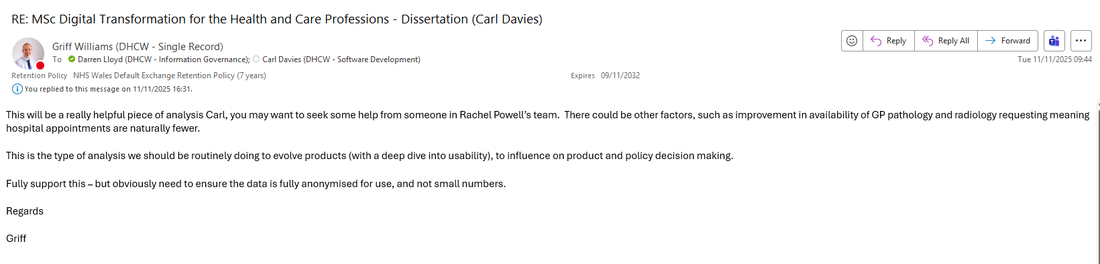  (this box should expand as you type)

 | Does your research relate to one or more of the seven aims of the Well-being of Future Generations (Wales) Act 2015? | YES | NO
12 | A prosperous Wales | ☒ | ☐
13 | A resilient Wales | ☐ | ☐
14 | A healthier Wales | ☒ | ☐
15 | A more equal Wales | ☐ | ☐
16 | A Wales of cohesive communities | ☐ | ☐
17 | A Wales of vibrant culture and thriving Welsh language | ☐ | ☐
18 | A globally responsible Wales | ☐ | ☐
19 | If YES to any of the above, please give details:
The work will focus on how the citizen accesses patient services within NHS Wales and how, following the pandemic, decisions made by clinicians may inadvertently result in longer waiting times to be seen and treated.

(this box should expand as you type)

SECTION F: Scope of Research Activity
 | Will the research activity include: | YES | NO
1 | Use of a questionnaire or similar research instrument? | ☒ | ☐
2 | Use of interviews? | ☒ | ☐
3 | Use of focus groups? | ☐ | ☒
4 | Use of participant diaries? | ☐ | ☒
5 | Use of video or audio recording? | ☒ | ☐
6 | Use of computer-generated log files? | ☐ | ☐
7 | Participant observation with their knowledge? | ☐ | ☒
8 | Participant observation without their knowledge? | ☐ | ☒
9 | Access to personal or confidential information without the participants’ specific consent? | ☐ | ☒
10 | Administration of any questions, test stimuli, presentation that may be experienced as physically, mentally or emotionally harmful / offensive? | ☐ | ☒
11 | Performance of any acts which may cause embarrassment or affect self-esteem? | ☐ | ☒
12 | Investigation of participants involved in illegal activities? | ☐ | ☒
13 | Use of procedures that involve deception? | ☐ | ☒
14 | Administration of any substance, agent or placebo? | ☐ | ☒
15 | Working with live vertebrate animals? | ☐ | ☒
16 | Procedures that may have a negative impact on the environment? | ☐ | ☒
17 | Other primary data collection methods. Please indicate the type of data collection method(s) below. | ☒ | ☐
 | Details of any other primary data collection method:  Collection of non person-identifiable data from the Welsh Patient Administration System to allow the analysis and research into the topic noted above.  (this box should expand as you type) | ☒ | ☐
If NO to every question, then the research activity is (ethically) low risk and may be exempt from some of the following sections (please refer to Guidance Notes).

If YES to any question, then no research activity should be undertaken until full ethical approval has been obtained.

SECTION G: Intended Participants
If there are no participants then do not complete this section, but go directly to section H.
 | Who are the intended participants: | YES | NO
1 | Students or staff at the University? | ☐ | ☒
2 | Adults (over the age of 18 and competent to give consent)? | ☒ | ☐
3 | Vulnerable adults? | ☐ | ☒
4 | Children and Young People under the age of 18? (Consent from Parent, Carer or Guardian will be required) | ☐ | ☒
5 | Prisoners? | ☐ | ☒
6 | Young offenders? | ☐ | ☒
7 | Those who could be considered to have a particularly dependent relationship with the investigator or a gatekeeper? | ☐ | ☒
8 | People engaged in illegal activities? | ☐ | ☒
9 | Others. Please indicate the participants below, and specifically any group who may be unable to give consent. | ☒ | ☐
 | Details of any other participant groups:  Questionnaires / Surveys will be sent to NHS Wales clinicians to help with the qualitative aspect of the project.  (this box should expand as you type) | ☒ | ☐

Participant numbers and source
Provide an estimate of the expected number of participants. How will you identify participants and how will they be recruited?
10 | How many participants are expected? | 50+  e-mail sent to suitable participants asking for their support and involvement in the research project.  5 – 10 interviews as a target  (this box should expand as you type)
11 | Who will the participants be? | NHS Wales clinicians and service delivery managers  (this box should expand as you type)
12 | How will you identify the participants? | Initial analysis of the data will indicate the specialty services to be used for the survey. The emails will be sent to the delivery managers of these services asking them to pass the forms on to the relevant staff.  (this box should expand as you type)

 | Information for participants: | YES | NO | N/A
13 | Will you describe the main research procedures to participants in advance, so that they are informed about what to expect? | ☒ | ☐ | ☐
14 | Will you tell participants that their participation is voluntary? | ☒ | ☐ | ☐
15 | Will you obtain written consent for participation? | ☒ | ☐ | ☐
16 | Will you explain to participants that refusal to participate in the research will not affect their treatment or education (if relevant)? | ☐ | ☐ | ☒
17 | If the research is observational, will you ask participants for their consent to being observed? | ☐ | ☐ | ☒
18 | Will you tell participants that they may withdraw from the research at any time and for any reason? | ☐ | ☐ | ☒
19 | With questionnaires, will you give participants the option of omitting questions they do not want to answer? | ☒ | ☐ | ☐
20 | Will you tell participants that their data will be treated with full confidentiality and that, if published, it will not be identifiable as theirs? | ☒ | ☐ | ☐
21 | Will you debrief participants at the end of their participation, in a way appropriate to the type of research undertaken? | ☒ | ☐ | ☐
22 | If NO to any of above questions, please give an explanation
 | (this box should expand as you type)
24 | Will participants be paid? | ☐ | ☒ | ☐
25 | Is specialist electrical or other equipment to be used with participants? | ☐ | ☒ | ☐
26 | Are there any financial or other interests to the investigator or University arising from this study? | ☐ | ☒ | ☐
27 | Will the research activity involve deliberately misleading participants in any way, or the partial or full concealment of the specific study aims? | ☐ | ☒ | ☐
28 | If YES to any question, please provide full details
 | (this box should expand as you type)

SECTION H: Anticipated Risks

Outline any anticipated risks that may adversely affect any of the participants, the researchers and/or the University, and the steps that will be taken to address them.

If you have completed a full risk assessment (for example as required by a laboratory, or external research collaborator) you may append that to this form.
1 | Full risk assessment completed and appended? |  | Yes | ☐
1 |  |  | No | ☒
2 | Risks to participants  For example: sector-specific health & safety, emotional distress, financial disclosure, physical harm, transfer of personal data, sensitive organisational information
 | Risk to participants:  Workload pressures  (this box should expand as you type) | How you will mitigate the risk to participants:  Create a clear workload plan with regular reviews to monitor the workload and try and redistribute tasks if possible.  Provide support and flexibility, with signposting to Wellbeing support people and sites, such as  Mental Health first aid staff and Employee Assistance Programmes.  (this box should expand as you type)
3 | If research activity may include sensitive, embarrassing or upsetting topics (e.g. sexual activity, drug use) or issues likely to disclose information requiring further action (e.g. criminal activity), give details of the procedures to deal with these issues, including any support/advice (e.g. helpline numbers) to be offered to participants. Note that where applicable, consent procedures should make it clear that if something potentially or actually illegal is discovered in the course of a project, it may need to be disclosed to the proper authorities
NA

(this box should expand as you type)
4 | Risks to the investigator  For example: personal health & safety, physical harm, emotional distress, risk of accusation of harm/impropriety, conflict of interest
 | Risk to the investigator:  None anticipated  (this box should expand as you type) | How you will mitigate the risk to the investigator:  (this box should expand as you type)
5 | University/institutional risks  For example: adverse publicity, financial loss, data protection
 | Risk to the University:  None anticipated  (this box should expand as you type) | How you will mitigate the risk to the University:  (this box should expand as you type)
6 | Environmental risks  For example: accidental spillage of pollutants, damage to local ecosystems
 | Risk to the environment:  None anticipated  (this box should expand as you type) | How you will mitigate the risk to environment:  (this box should expand as you type)

 | Disclosure and Barring Service
 | If the research activity involves children or vulnerable adults, a Disclosure and Barring Service (DBS) certificate must be obtained before any contact with such participants. | YES | NO | N/A
7 | Does your research require you to hold a current DBS Certificate? | ☐ | ☒ | ☐
8 | If YES, please give the certificate number. If the certificate number is not available please write “Pending”; in this case any ethical approval will be subject to providing the appropriate certificate number.

SECTION I: Feedback, Consent and Confidentiality

1 | Feedback  What de-briefing and feedback will be provided to participants, how will this be done and when?
A draft copy and final copy of the results will be made available to the participants. In additon, a MS Teams session and presentation will be made to explain the results of the work.

(this box should expand as you type)
2 | Informed consent  Describe the arrangements to inform potential participants, before providing consent, of what is involved in participating. Describe the arrangements for participants to provide full consent before data collection begins. If gaining consent in this way is inappropriate, explain how consent will be obtained and recorded in accordance with prevailing data protection legislation.
An email will be sent to potential participants asking for them to complete a survey form in MSForms

(this box should expand as you type)
3 | Confidentiality / Anonymity  Set out how anonymity of participants and confidentiality will be ensured in any outputs. If anonymity is not being offered, explain why this is the case.
No person identifiable information will be held on the MSForm. Where data is analysed and assessed, it will be at main specialty level and not at clinician level.

(this box should expand as you type)

SECTION J: Data Protection and Storage

 | Does the research activity involve personal data (as defined by the General Data Protection Regulation 2016 “GDPR” and the Data Protection Act 2018 “DPA”)? | YES | NO
1 | “Personal data” means any information relating to an identified or identifiable natural person (‘data subject’). An identifiable natural person is one who can be identified, directly or indirectly, in particular by reference to an identifier such as a name, an identification number, location data, an online identifier or to one or more factors specific to the physical, physiological, genetic, mental, economic, cultural or social identity of that natural person. Any video or audio recordings of participants is considered to be personal data. | ☒ | ☐
 | If YES, provide a description of the data and explain why this data needs to be collected:
2 | Email address will be used to communicate with those being interviewed etc, but will not be linked to any analysis  (this box should expand as you type)
 | Does it involve special category data (as defined by the GDPR)? | YES | NO
3 | “Special category data” means sensitive personal data consisting of information as to the data subjects’ –  (a) racial or ethnic origin,  (b) political opinions,  (c ) religious beliefs or other beliefs of a similar nature,  (d) membership of a trade union (within the meaning of the Trade Union and Labour Relations (Consolidation) Act 1992),  (e) physical or mental health or condition,  (f) sexual life,  (g) genetics,  (h) biometric data (as used for ID purposes), | ☐ | ☒
 | If YES, provide a description of the special category data and explain why this data needs to be collected:
4 | (this box should expand as you type)

 | Will data from the research activity (collected data, drafts of the thesis, or materials for publication) be stored in any of the following ways? | YES | NO
5 | Manual files (i.e. in paper form)? | ☐ | ☒
6 | University computers? | ☐ | ☒
7 | Private company computers? | ☐ | ☒
8 | Home or other personal computers? | ☐ | ☒
9 | Laptop computers/ CDs/ Portable disk-drives/ memory sticks? | ☐ | ☒
10 | “Cloud” storage or websites? | ☒ | ☐
11 | Other – specify: | ☒ | ☐
12 | For all stored data, explain the measures in place to ensure the security of the data collected, data confidentiality, including details of backup procedures, password protection, encryption, anonymisation and pseudonymisation:
Data will be stored within the Digital Health and Care Wales (DHCW) data servers and DHCW cloud instance

(this box should expand as you type)

 | Data Protection
 | Will the research activity involve any of the following activities: | YES | NO
13 | Electronic transfer of data in any form? | ☒ | ☐
14 | Sharing of data with others at the University outside of the immediate research team? | ☐ | ☒
15 | Sharing of data with other organisations? | ☒ | ☐
16 | Export of data outside the UK or importing of data from outside the UK? | ☐ | ☒
17 | Use of personal addresses, postcodes, faxes, emails or telephone numbers? | ☐ | ☒
18 | Publication of data that might allow identification of individuals? | ☐ | ☒
19 | Use of data management system? | ☒ | ☐
20 | Data archiving? | ☒ | ☐
21 | If YES to any question, please provide full details, explaining how this will be conducted in accordance with the GDPR and Data Protection Act (2018) (and any international equivalents, where appropriate):
Data will be made available to the source organisations for the purpose of verification of the results. Data will be transferred via the NHS Wales network
Data will be archived and managed via DHCW systems

(this box should expand as you type)
22 | List all who will have access to the data generated by the research activity:
Principal Researcher, Carl Davies
Director of Studies, Philip Scott

(this box should expand as you type)
23 | List who will have control of, and act as custodian(s) for, data generated by the research activity:
Carl Davies

(this box should expand as you type)
24 | Give details of data storage arrangements, including security measures in place to protect the data, where data will be stored, how long for, and in what form. Will data be archived – if so how and if not why not.
Data will be stored in DHCW servers and in the cloud. Data will be subject to DHCW policies on storage, retention, and deletion as appropriate.

(this box should expand as you type)
25 | Please indicate if your data will be stored in the UWTSD Research Data Repository (see https://researchdata.uwtsd.ac.uk/ ). If so please explain. (Most relevant to academic staff)
No

(this box should expand as you type)
26 | Confirm that you have read the UWTSD guidance on data management (see https://www.uwtsd.ac.uk/library/research-data-management/) | YES | ☒
27 | Confirm that you are aware that you need to keep all data until after your research has completed or the end of your funding | YES | ☒

SECTION K: Declaration
The information which I have provided is correct and complete to the best of my knowledge. I have attempted to identify any risks and issues related to the research activity and acknowledge my obligations and the rights of the participants.

In submitting this application I hereby confirm that I undertake to ensure that the above named research activity will meet the University’s Research Ethics and Integrity Code of Practice which is published on the website: https://www.uwtsd.ac.uk/research/research-ethics/
1 | Signature of applicant: |  | Date:

For STUDENT Submissions:
2 | Director of Studies/Supervisor: | Prof Philip Scott | Date: 27/11/25
3 | Signature: |  | Date: 27/11/25

Checklist: Please complete the checklist below to ensure that you have completed the form according to the guidelines and attached any required documentation:
☒ | I have read the guidance notes supplied before completing the form.
☒ | I have completed ALL RELEVANT sections of the form in full.
☐ | I confirm that the research activity has received approval in principle
☐ | I have attached a copy of final/interim approval from external organisation (where appropriate)
☐ | I have attached a full risk assessment (where appropriate) ONLY TICK IF YOU HAVE ATTACHED A FULL RISK ASSESSMENT
☒ | I understand that it is my responsibility to ensure that the above named research activity will meet the University’s Research Ethics and Integrity Code of Practice.
☒ | I understand that before commencing data collection all documents aimed at respondents (including information sheets, consent forms, questionnaires, interview schedules etc.) must be approved by the Supervisor and the Programme Director.

STUDENTS ON UNDERGRADUATE OR TAUGHT MASTERS PROGRAMMES should submit this form (and receive the outcome) via systems explained to you by the supervisor/module leader.

Appendix 3 – Qualitative survey provided to staff as part of this research


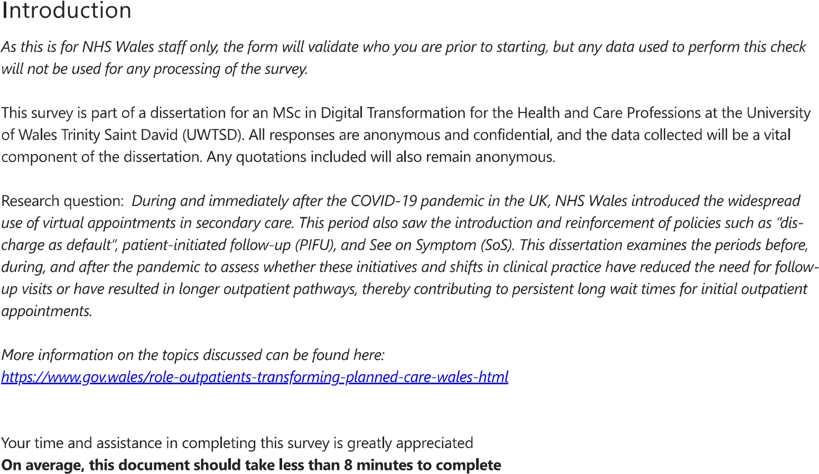
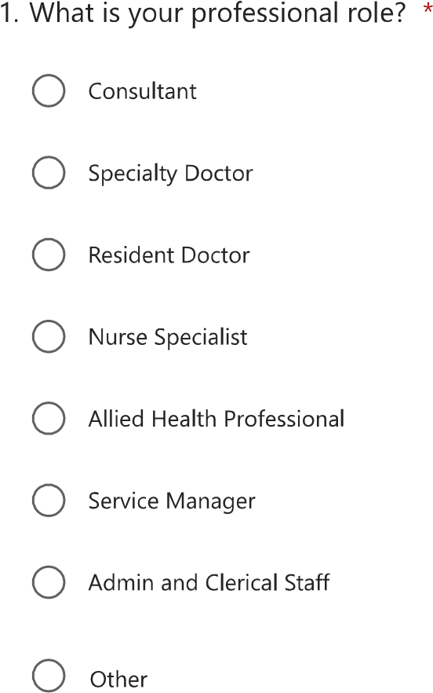
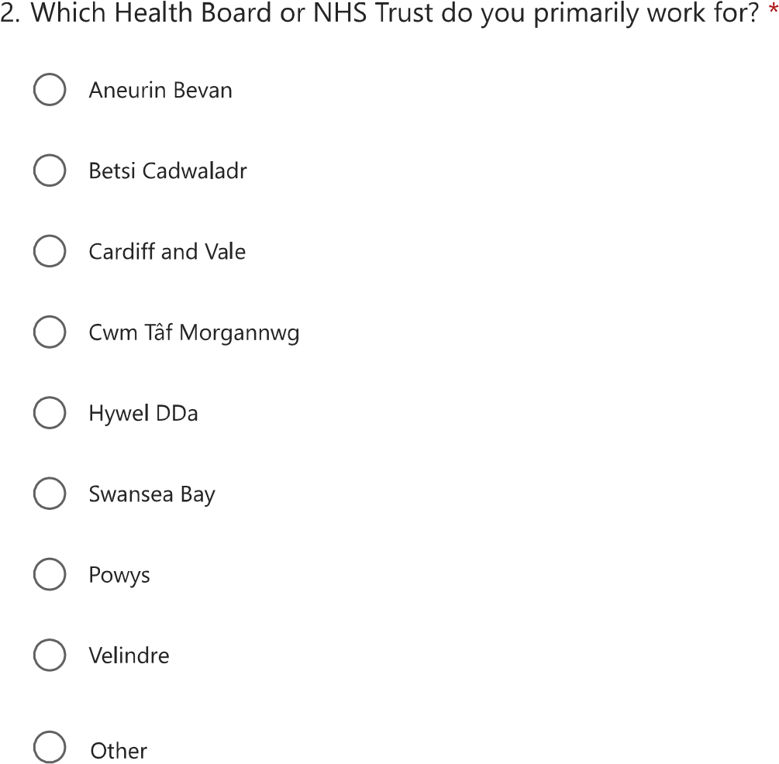

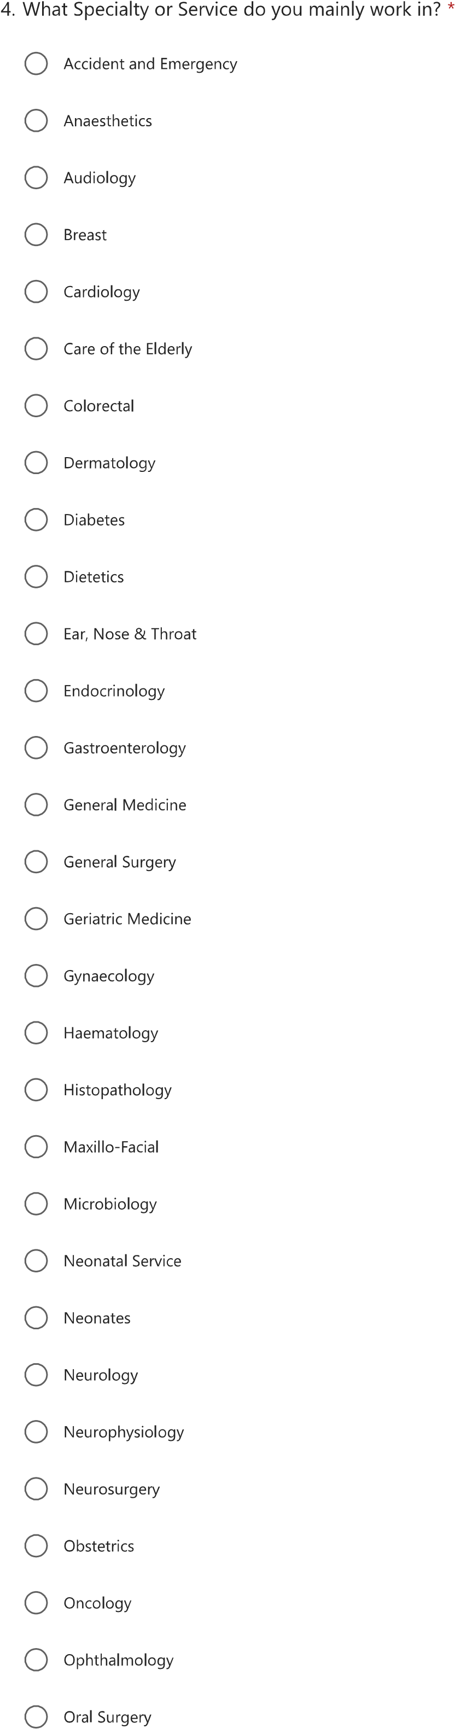
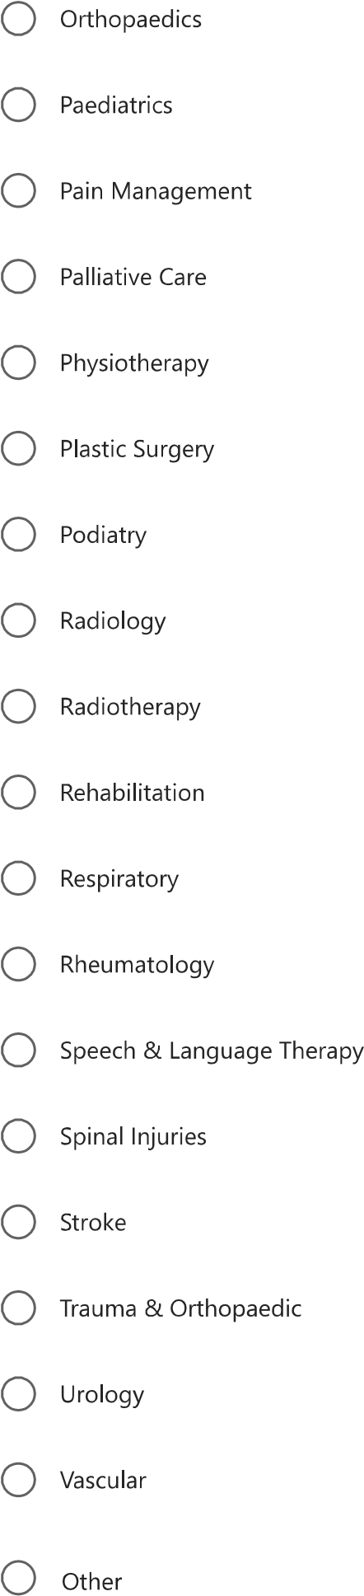

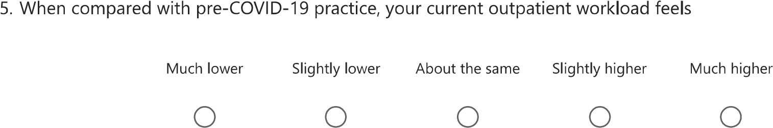
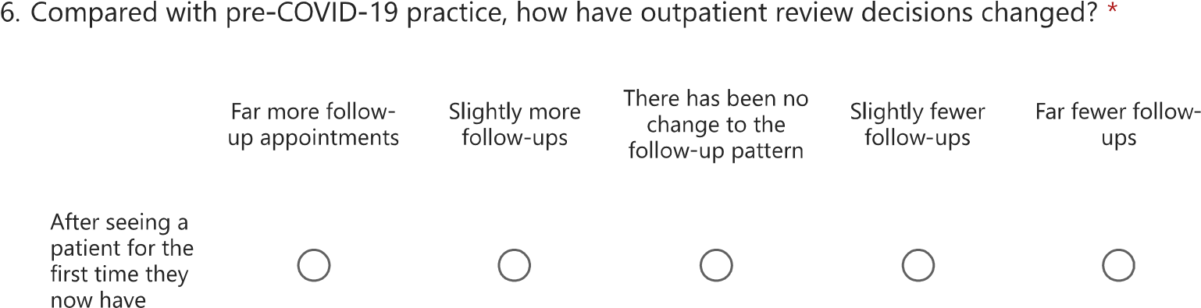
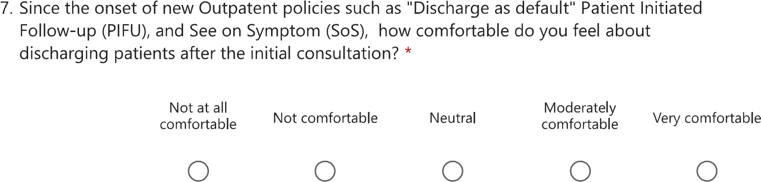
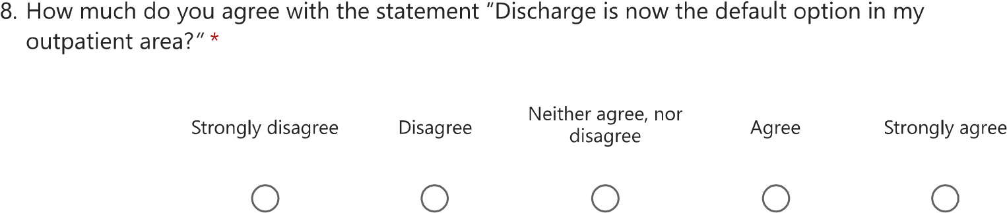
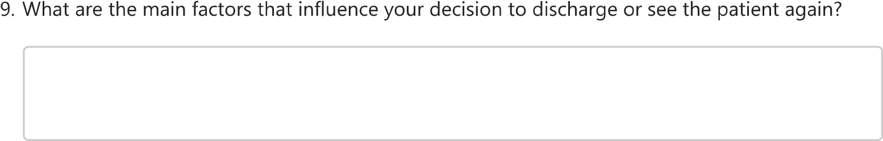
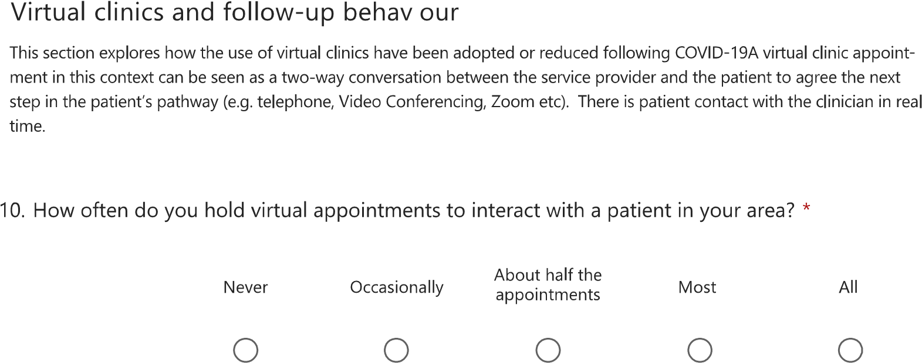
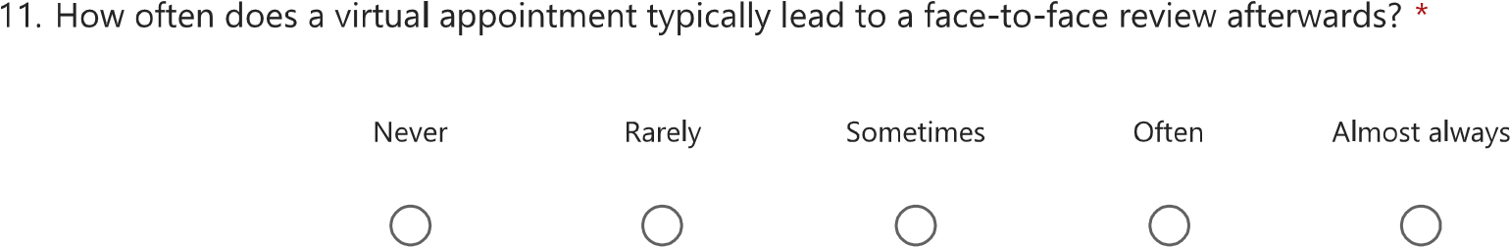
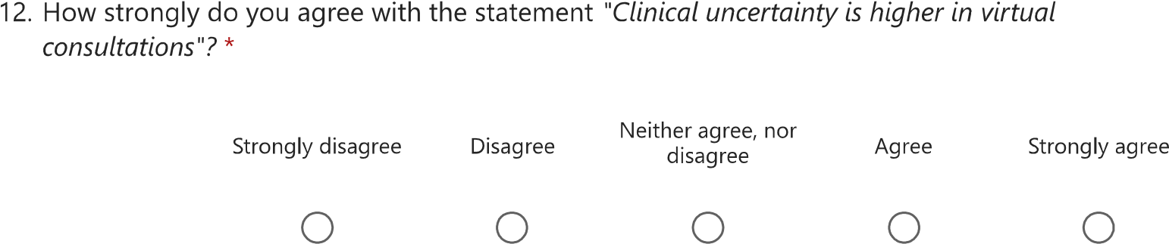
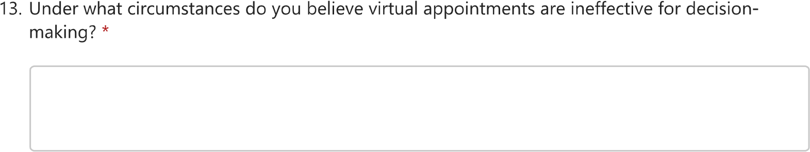
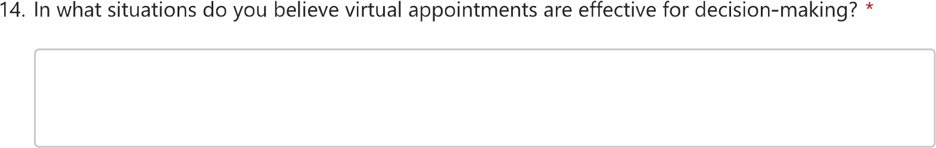

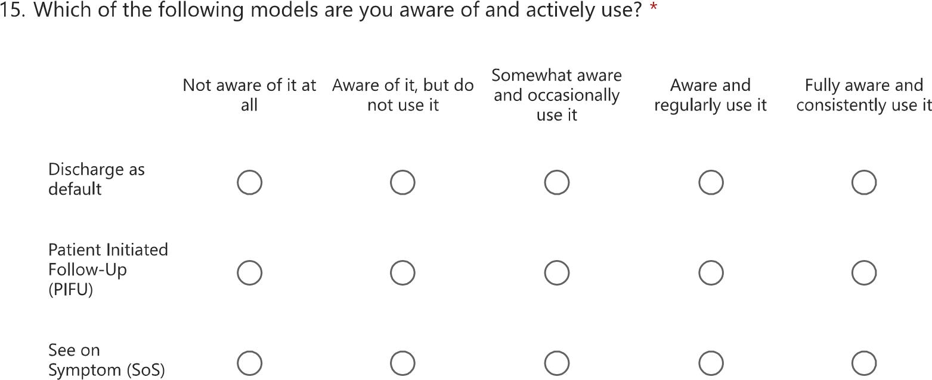
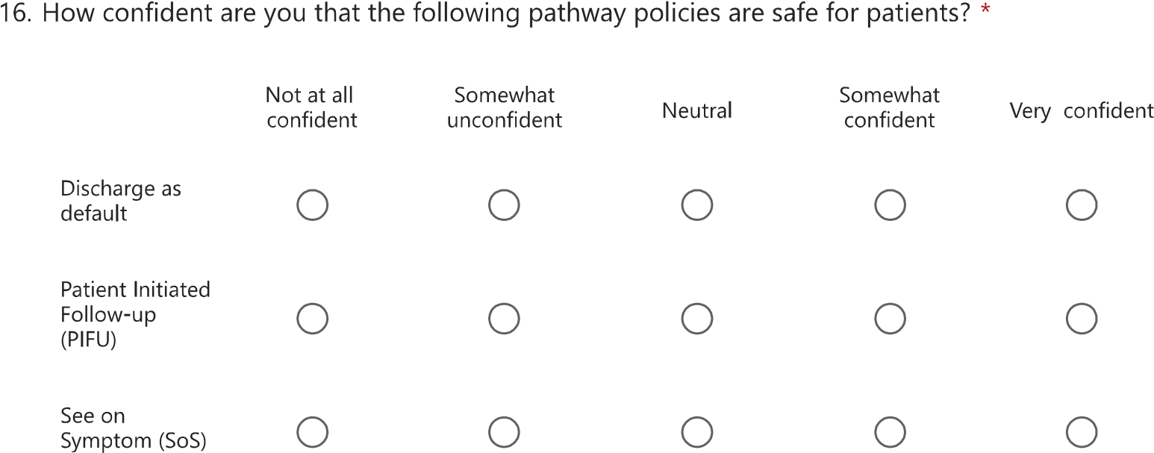
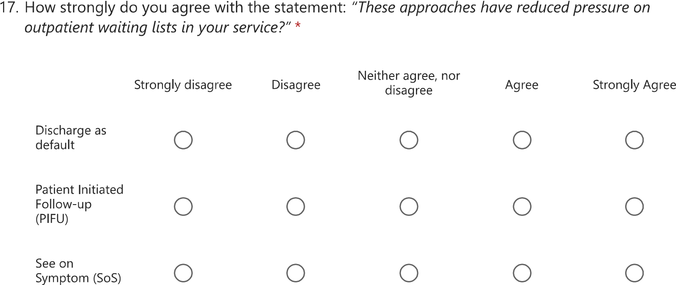
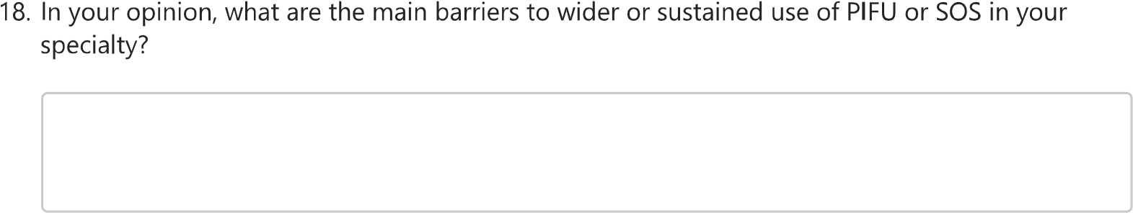

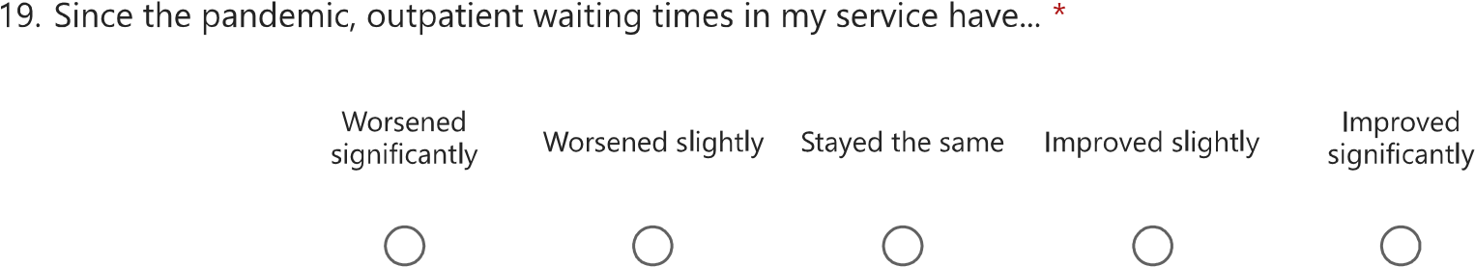
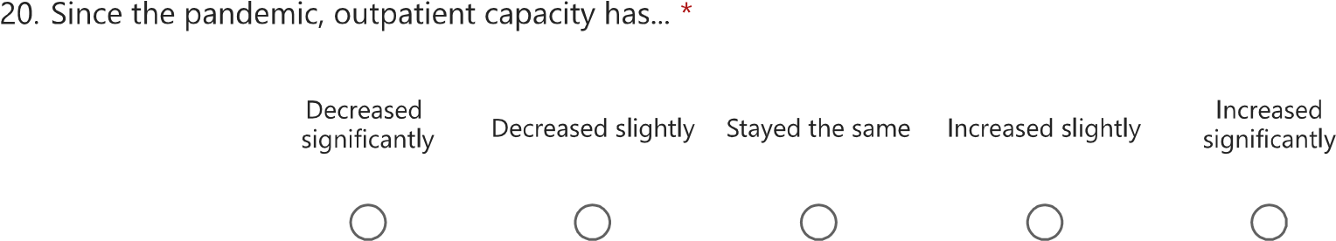
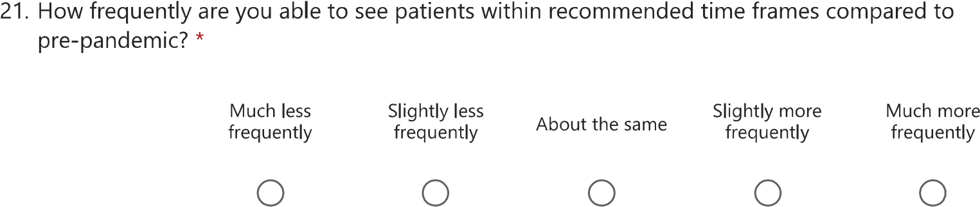
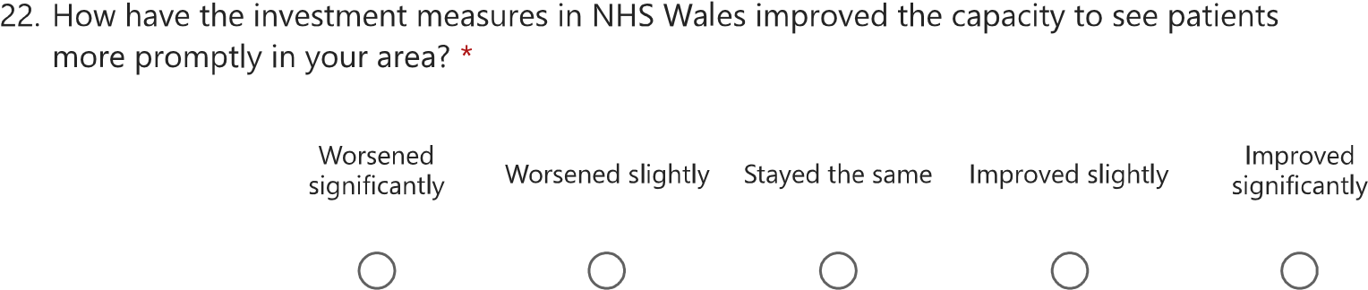
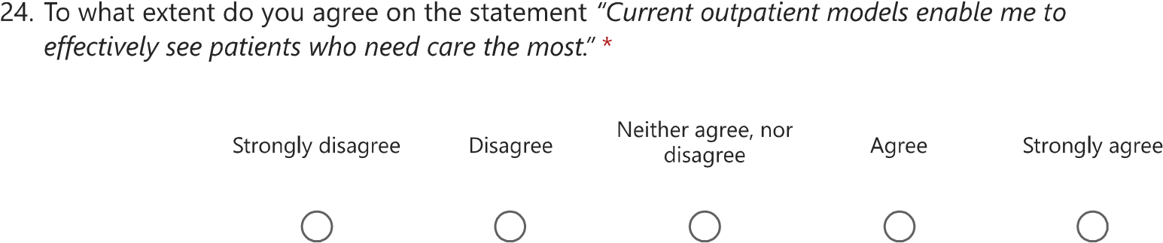

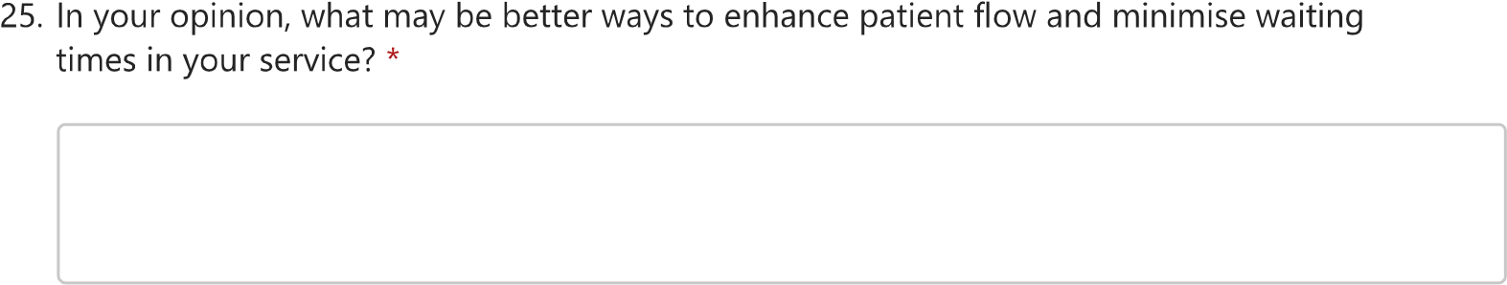
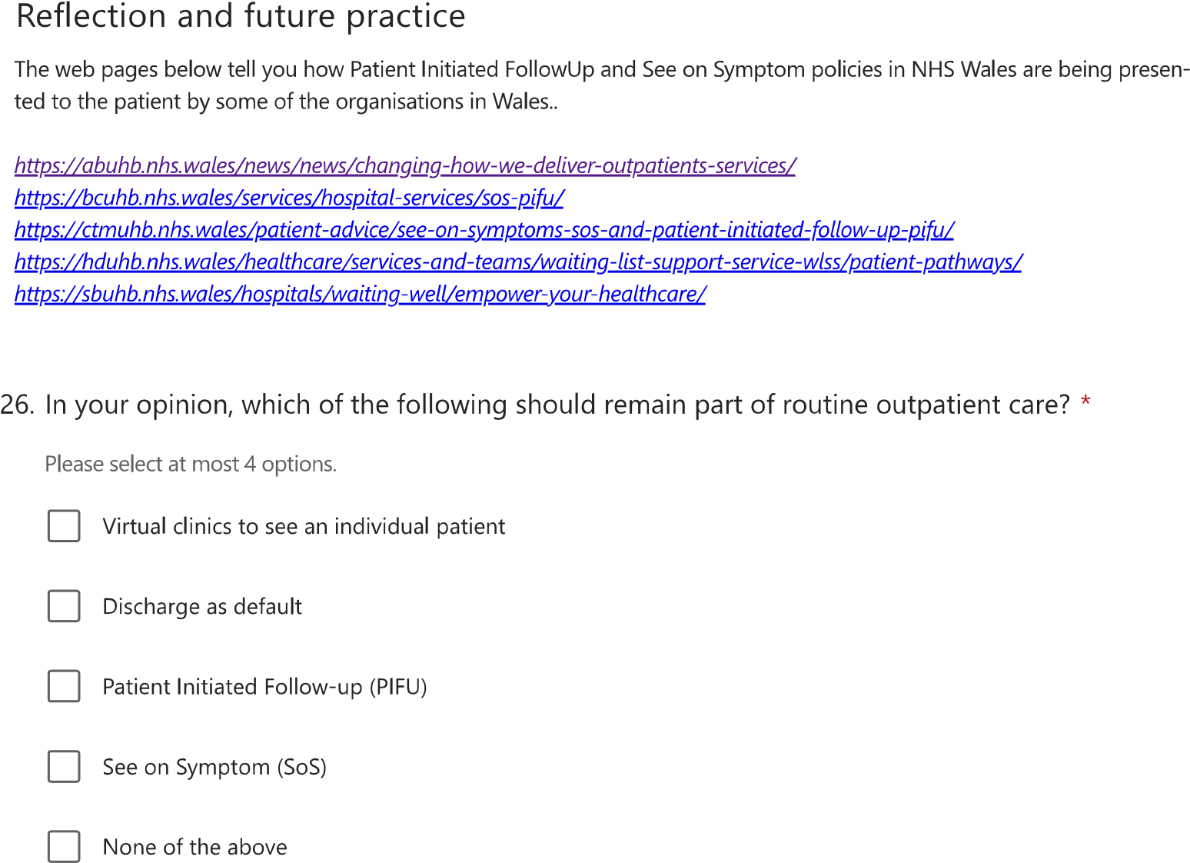

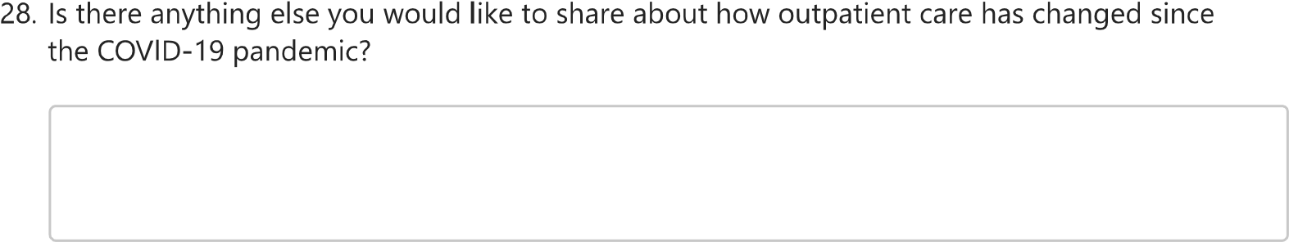
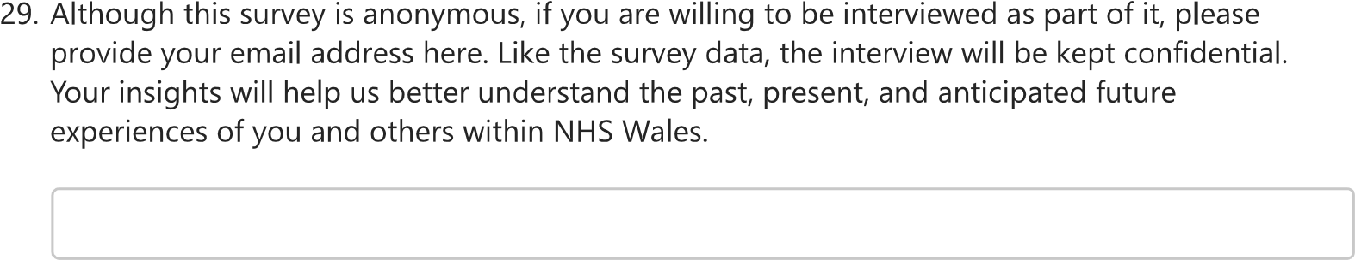

Appendix 4 – Documents used for the Literature Review in Chapter 2

Table 12 Documents used for the literature review noted in Chapter 2
Documents forming the Literature Review
Abelleyra Lastoria, D. A., Sanderson, A., Mangion, D., & Hing, C. B. (2024). An evaluation of outpatient service provision in the National Health Service in Great Britain: A freedom of information request. Journal of Evaluation in Clinical Practice, 30(7), 1309–1318. https://doi.org/10.1111/JEP.14057
Akintomide, E., Shah, B., Sridharan, S., Visram, S., Sebire, N. J., & Peters, C. (2021). Clinical perception of effectiveness of virtual appointments and comparison with appointment outcomes at a specialist children’s hospital. Future Healthcare Journal, 8(3), e660–e665. https://doi.org/10.7861/fhj.2021-0044
Bech, B., Lykkegaard, J. J., Lundbak, T., Schrøder, H. M., Birkeland, L. M., Schlyter, M. L., Hansen, L. H., Dalsgaard, L., & Esbensen, B. A. (2020). Patient-Initiated Follow-Up (PIFU) as reorganized support for increased patient involvement - Focus group discussions among patients’ with inflammatory arthritis. BMC Rheumatology, 4(1). https://doi.org/10.1186/S41927-020-00143-6
Bevin, A. (2021). Embracing the technological age: virtual appointments in 2021. Journal of Kidney Care, 6(1), 6–8. https://doi.org/10.12968/jokc.2021.6.1.6
Bhaskar, S., Bradley, S., Chattu, V. K., Adisesh, A., Nurtazina, A., Kyrykbayeva, S., Sakhamuri, S., Moguilner, S., Pandya, S., Schroeder, S., Banach, M., & Ray, D. (2020). Telemedicine as the New Outpatient Clinic Gone Digital: Position Paper From the Pandemic Health System REsilience PROGRAM (REPROGRAM) International Consortium (Part 2). Frontiers in Public Health, 8. https://doi.org/10.3389/fpubh.2020.00410
Chan-Nguyen, S., O’Riordan, A., Morin, A., McAvoy, L., Lee, E. Y., Lloyd, V., & Appireddy, R. (2022). Patient and caregiver perspectives on virtual care: a patient-oriented qualitative study. CMAJ Open, 10(1). https://doi.org/10.9778/cmajo.20210065
Child, S., Goodwin, V. A., Perry, M. G., Gericke, C. A., & Byng, R. (2015). Implementing a patient-initiated review system in rheumatoid arthritis: A qualitative evaluation. BMC Health Services Research, 15(1). https://doi.org/10.1186/S12913-015-0837-9
Demetriades, P., Kusyk, E., Bingcang, J., Samuel, N., Tsagkridi, A., & Lloyd, G. (2024). 26 A service evaluation of the mechanisms that improve compliance with RTT targets in modern cardiology. Heart (British Cardiac Society), (Suppl 3), A29–A31.
Donaghy, E., Atherton, H., Hammersley, V., McNeilly, H., Bikker, A., Robbins, L., Campbell, J., & McKinstry, B. (2019). Acceptability, benefits, and challenges of video consulting: A qualitative study in primary care. British Journal of General Practice, 69(686). https://doi.org/10.3399/bjgp19X704141
Evans, C., Clancy, G., Evans, K., Booth, A., Nazmeen, B., Sunney, C., Clowes, M., Jones, N. W., Timmons, S., & Spiby, H. (2025). How to Implement Digital Clinical Consultations in UK Maternity Care: the ARM@DA Realist Review. Health and Social Care Delivery Research, 13. https://doi.org/10.3310/JFQT1054
Fan, K. S., Haq, I., Taha, A., Carne, A., Gademsetty, C., & Solan, M. (2025). Efficient patient-initiated follow-up after orthopaedic injections. European Journal of Orthopaedic Surgery and Traumatology, 35(1). https://doi.org/10.1007/S00590-025-04193-9
Gilbert, A. W., Billany, J. C. T., Adam, R., Martin, L., Tobin, R., Bagdai, S., Galvin, N., Farr, I., Allain, A., Davies, L., & Bateson, J. (2020). Rapid implementation of virtual clinics due to COVID-19: Report and early evaluation of a quality improvement initiative. BMJ Open Quality, 9(2). https://doi.org/10.1136/BMJOQ-2020-000985
Grant, H., & Skamagki, G. (2024). Clinicians’ perspectives on remote patient management: A qualitative exploration of physiotherapists using the DiAL (Direct Access Line) programme. Musculoskeletal Science & Practice, 103132–103132.
Haddaway, N. R., Page, M. J., Pritchard, C. C., & McGuinness, L. A. (2022). PRISMA2020: An R package and Shiny app for producing PRISMA 2020-compliant flow diagrams, with interactivity for optimised digital transparency and Open Synthesis. Campbell Systematic Reviews, 18(2), e1230. https://doi.org/https://doi.org/10.1002/cl2.1230
Howren, A., Aviña-Zubieta, J. A., Rebić, N., Dau, H., Gastonguay, L., Shojania, K., Davidson, E., & de Vera, M. A. (2020). Virtual rheumatology appointments during the COVID-19 pandemic: an international survey of perspectives of patients with rheumatic diseases. Clinical Rheumatology, 39(11), 3191–3193. https://doi.org/10.1007/s10067-020-05338-3
Jaly, I., Iyengar, K., Bahl, S., Hughes, T., & Vaishya, R. (2020). Redefining diabetic foot disease management service during COVID-19 pandemic. Diabetes and Metabolic Syndrome: Clinical Research and Reviews, 14(5), 833–838. https://doi.org/10.1016/j.dsx.2020.06.023
Jeppesen, M. M., Jensen, P. T., Hansen, D. G., Christensen, R. D., & Mogensen, O. (2018). Patient-initiated follow up affects fear of recurrence and healthcare use: a randomised trial in early-stage endometrial cancer. BJOG: An International Journal of Obstetrics and Gynaecology, 125(13), 1705–1714. https://doi.org/10.1111/1471-0528.15396
Kadel, R., Allen, J., Darlington, O., Masters, R., Collins, B., Charles, J. M., Asaria, M., Dyakova, M., Bellis, M., & Cookson, R. (2022). Cost of health inequality to the NHS in Wales. Frontiers in Public Health, 10. https://doi.org/10.3389/fpubh.2022.959283
Khanji, M. Y., Gallagher, A. M., Rehill, N., & Archbold, R. A. (2023). Remote consultations: review of guiding themes for equitable and effective delivery. Current Problems in Cardiology, 48(8). https://doi.org/10.1016/j.cpcardiol.2023.101736
Kim, S. E., Logeswaran, A., Kang, S., Stanojcic, N., Wickham, L., Thomas, P., & Li, J. P. O. (2021). Digital Transformation in Ophthalmic Clinical Care during the COVID-19 Pandemic. Asia-Pacific Journal of Ophthalmology, 10(4), 381–387. https://doi.org/10.1097/APO.0000000000000407
Lavin, B., Dormond, C., Scantlebury, M. H., Frouin, P. Y., & Brodie, M. J. (2020). Bridging the healthcare gap: Building the case for epilepsy virtual clinics in the current healthcare environment. Epilepsy and Behavior, 111. https://doi.org/10.1016/j.yebeh.2020.107262
Lee, J., & Manalew, W. S. (2024). Adoption of virtual prenatal visits linked to recurrent virtual or forgone visits for postpartum care. Midwifery, 129, 103904. https://doi.org/10.1016/j.midw.2023.103904
Lim-Reinders, S., Ward, M. G. K., Malic, C., Keely, K., Kang, K., Jain, N., & Zwicker, K. (2024). Identifying child maltreatment during virtual medical appointments through the COVID-19 pandemic: A physician-based survey. Paediatrics & Child Health, 29(1), 23–28. https://doi.org/10.1093/pch/pxad064
Mallick, S., Balakumar, R., & Drysdale, A. (2022). Telephone clinic outcomes during the coronavirus disease 2019 pandemic: results from an ENT department. Journal of Laryngology and Otology, (7), 611–614.
Meskó, B. (2022). COVID-19’s Impact on Digital Health Adoption: The Growing Gap Between a Technological and a Cultural Transformation. JMIR Human Factors, 9(3). https://doi.org/10.2196/38926
Mickelsen, R., Triplett, C., Wong, M., & Yamamoto, M. (2024). Virtual appointments: current practices and perspectives of gynecologic surgeons. American Journal of Obstetrics and Gynecology, 230(4), S1233–S1234. https://doi.org/10.1016/j.ajog.2024.02.140
Morrison, C., Beattie, M., Wherton, J., Stark, C., Anderson, J., Hunter-Rowe, C., & Gray, N. M. (2021). Testing and implementing video consulting for outpatient appointments: Using quality improvement system thinking and codesign principles. BMJ Open Quality, 10(1). https://doi.org/10.1136/bmjoq-2020-001259
Newton, C., Beaver, K., & Clegg, A. (2022). Patient initiated follow-up in cancer patients: A systematic review. Frontiers in Oncology, 12. https://doi.org/10.3389/FONC.2022.954854/PDF
Owens, A. P., Hinds, C., Manyakov, N. v, Stavropoulos, T. G., Lavelle, G., Gove, D., Diaz-Ponce, A., & Aarsland, D. (2020). Selecting Remote Measurement Technologies to Optimize Assessment of Function in Early Alzheimer’s Disease: A Case Study. Frontiers in Psychiatry, 11, 582207. https://doi.org/10.3389/fpsyt.2020.582207
Pennington, Z., Michalopoulos, G. D., Biedermann, A. J., Ziegler, J. R., Durst, S. L., Spinner, R. J., Meyer, F. B., Daniels, D. J., & Bydon, M. (2022). Positive impact of the pandemic: The effect of post–COVID-19 virtual visit implementation on departmental efficiency and patient satisfaction in a quaternary care center. Neurosurgical Focus, 52(6). https://doi.org/10.3171/2022.3.FOCUS2243
Rice, T., & Unruh, L. (2015). The Economics of Health Reconsidered, Fourth Edition. In AUPHA/HAP Book.
Rodriguez Socarrás, M., Loeb, S., Teoh, J. Y. C., Ribal, M. J., Bloemberg, J., Catto, J., N’Dow, J., van Poppel, H., & Gómez Rivas, J. (2020). Telemedicine and Smart Working: Recommendations of the European Association of Urology. European Urology, 78(6), 812–819. https://doi.org/10.1016/j.eururo.2020.06.031
Ruggiero, C., Waite, M., & Stayt, L. (2026). Experiences of remote nurse consultations in chronic disease management: A systematic review. International Journal of Nursing Studies, 175, 105319. https://doi.org/10.1016/j.ijnurstu.2025.105319
Srikumar, G., Finlayson, C., Bissett, I., & Harmston, C. (2025). Remote Follow-Up After Colorectal Cancer Surgery: A Systematic Review. ANZ Journal of Surgery, 95(11), 2273–2282. https://doi.org/10.1111/ans.70141
Valdes, D., Shanker, A., Hijazi, G., Mensah, D. O., Bockarie, T., Lazar, I., Ibrahim, S. A., Zolfagharinia, H., Procter, R., Spencer, R., Dale, J., Paule, A., Medlin, L. J., & Tharuvara Kallottil, K. (2025). Global Evidence on the Sustainability of Telemedicine in Outpatient and Primary Care During the First 2 Years of the COVID-19 Pandemic: Scoping Review Using the Nonadoption, Abandonment, Scale-Up, Spread, and Sustainability (NASSS) Framework. Interactive Journal of Medical Research, 14, e45367. https://doi.org/10.2196/45367
Venketasubramanian, N., Anderson, C., Ay, H., Aybek, S., Brinjikji, W., de Freitas, G. R., del Brutto, O. H., Fassbender, K., Fujimura, M., Goldstein, L. B., Haberl, R. L., Hankey, G. J., Heiss, W. D., Henriques, I. L., Kase, C. S., Kim, J. S., Koga, M., Kokubo, Y., Kuroda, S., … Hennerici, M. G. (2021). Stroke Care during the COVID-19 Pandemic: International Expert Panel Review. Cerebrovascular Diseases, 50(3), 245–261. https://doi.org/10.1159/000514155
Wherton, J., Greenhalgh, T., Hughes, G., & Shaw, S. E. (2022). The Role of Information Infrastructures in Scaling up Video Consultations During COVID-19: Mixed Methods Case Study Into Opportunity, Disruption, and Exposure. Journal of Medical Internet Research, 24(11). https://doi.org/10.2196/42431

