
University of Wales Trinity Saint David
School of Applied Computing
Smart and connected devices 2
Internet of Things – Smart Cities Applications
Ceri Puddle (P150771)
13/12/19
John Rees

Contents
Abstract 3
Introduction 3
Background research 4
What is IOT 4
Why is there a push for IOT? 4
Population increase and density 4
Pollution 5
Different types of pollution 5
Land pollution 5
Water pollution 5
Air pollution 5
Smart Solutions 6
Smart pollution monitoring 6
Road safety 6
Smart motorways 7
Proposed protype 8
Sensor list 8
Conclusion 9
References 10

Abstract
The aim of this paper is to carry out an investigation to answer this following question.
“How can cities leverage the benefits of digitalisation to relieve stress on overstretched services and resources”. The approach for this paper will be based around creating a device to control a smart road safety solution and a pollution management monitoring system.
Whilst answering this question, there will also be some background research into the different global crisis that we face in modern-day along with the types of smart solutions that are in place for road safety and pollution management.
There will also be a proposed prototype with some suggested sensors that would be used in a real-world implementation.

Introduction
As the population grows, so does the need to rely on technology to help us throughout our day, whether it be a personal assistant controlling your home or a simple traffic light system to provide traffic safety on the road. There is technology all around us, but still, the need for more technology is ever-growing as the population density increases [2].
There are a couple of key issues that growing cities are faced with on a day to day basis, such as issues with overcrowded roads. This effects all road users and can have a major impact not only just on safety on road users but can produce delays and tailbacks that could affect more than just the original affected area.
Another issue with cities is pollution, more and more people are entering the cities each year, whether the reason is for social, commuting or living.
“In May 2016, the World Health Organization (WHO) reported that more than 80% of urban areas now have levels of air pollution higher than the limits it recommends for health reasons.” [1]
This has caused such health problems that affect more children in main city areas compared to those who live in the countryside. Traffic is the biggest contributor to pollution in urban areas, and there have been measures put in place to reduce the pollution levels by European law.
“46% of nitrous oxide emissions are produced from transport in urban areas” [3].
The goal is to design and prototype a device that can help control traffic safety while also reducing unnecessary pollution on our roads during the busiest times of the day. The importance of reducing carbon emissions is getting more apparent every day with the natural event becoming more common such as flooding and fires, for example.
The idea of implementing a smart city environment is very daunting in some respects, but there are quite a few cities such as Amsterdam and London that are making strides towards creating the infrastructure needed to support multiple smart solutions across a metropolitan area.

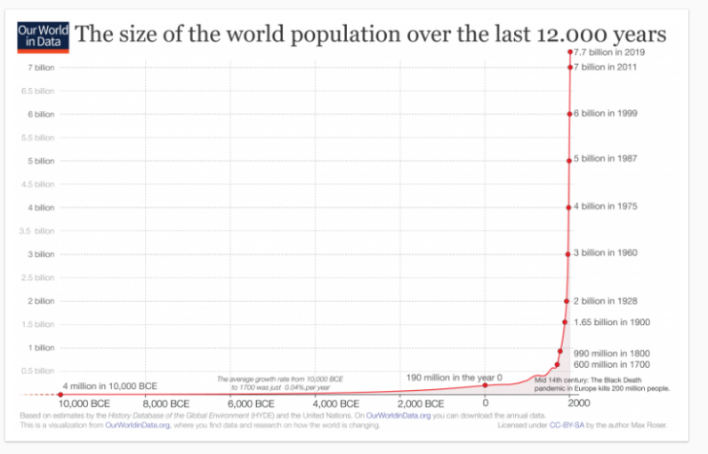
Background research
Figure 1 growth of population since 10,000BCE

What is IoT
Internet of things in a very broad sense is the idea that everything is connected to the internet, Things such as toasters and fridges are just some examples of items that have been adopted by IoT, these are considered ‘dumb’ items. I can be implemented in multiple different ways, for example, connected machines and object in factories around the world provide the potential to create a fourth industrial revolution, and it has been predicted by experts that more than 50% of new businesses will use IoT by 2020. [4]
For example, Switzerland and demark, both leading the way when I come to smart farming. Switzerland is using IoT to connect feeding machinery to improve their dairy industry. Denmark is using IoT for geographic positioning systems to control machines in farms remotely. According to this provided by sure universal. [5]

Why is there a push for IoT?
The reason IoT is currently being pushed and funded is because of necessity; one of the current necessity’s is to solve glob crisis. There are a couple of global crises that can be identified to this present day; this effects not just humans beings but also wildlife and the general health of the earth itself. By identifying these issues, governments and independent bodies have made awareness of the detrimental effects these issues can have on the planet and everyday life.

Population increase and density
A graph produced by “Our world in data”, [6] shows the growth of the human population from 10,000BCE to the current year of 2019. (figure 1) Labelled “The size of the world population over the past 12,000 years”, shows a sharp increase in population growth starting in the year 1700 where the figure of the population was 600 million.
Between the 1700’s and the 1900s, there was an increase of 175% growth of the population from 600million to 1.65 billion people. The next hundred years would see an increase of 263% from 1.65 billion to 6 billion. [6]
As the population has increased, so has population density, there are many different reasons why an area may become densely populated, some of the most common reasons why is due to necessity.
- This could be for work or ease of access to local services, Better transport infrastructure links, reduced commuting time.
- This can be caused by centralised industries, such as factories and commercial work.
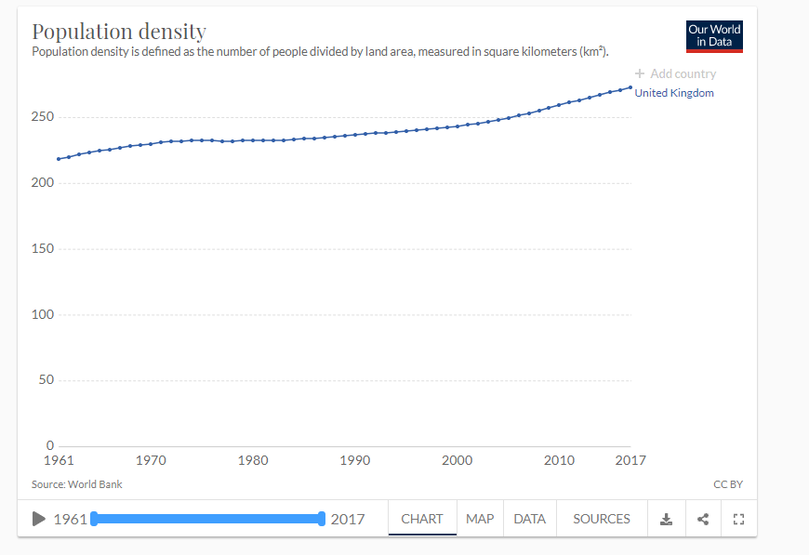
- Size of liveable area in each country. Especially if a county has some harsh environments such as steep mountains or deserts, for example. Russia is a large country that is mainly made up of unforgiving tundra, for example.
Figure 2 The population increase for the UK

Population density is measured based on people per kilometre squared in a chart created by our world in data. This data was recorded from 1961 to 2017 in the United Kingdom the past, and present UK figures are as followed. [6]. (figure 2)
- 1961, The UK had a population density of 218 people per a kilometre squared
- 2017, The UK had a population density of 278 people per a kilometre squared

Pollution
There are multiple different variations of pollution that has affected the earth for a very long time; different pollution affects different areas of the world. Pollution is the result of introducing contaminants into a natural environment; the contaminants can be produced in many ways and are not always be perceivable by touch. Here is the board example of the types of pollution that have been identified as harmful for the environment.

Different types of pollution

Land pollution
Land can be polluted by the release of contaminants that can be produced from household rubbish or industrial waste. According to the U.S sentimental protection agency, only 34% of household and industrial waste was recycled or composted in 2014. The other 66% was mainly composed of organic material that can be composted. Waste produced by industry and commerce was the largest portion of solid waste. This was a study that was carried out by the University of Utah. [7]
Hazardous waste is any type of waste which could be either solid, sludge or liquid that can have a potential effect on human waste and the environment. Hazardous waste can be produced from major industries such as oil refining, pesticide manufacturing and mining, just to name a few. Household also produces bad waste such as paint and motor oil, just to name a few.

Water pollution
Water pollution occurs when foreign substances are mixed in with water. These foreign include waste chemicals, sewage and agricultural by-products. Farms use pesticides that will soak into the ground and can eventually run off away from the farm through streams and rivers. These streams and rivers will eventually make its way to the sea where it can affect the biodiversity of the environment in the water.
According to a study carried out by the environmental protection agency (EPA), 44% of assessed stream miles, 64% of lakes and 30% of the bay and estuarine areas are not clean enough for fishing and swimming. [7]

Air pollution
Air has a very specific chemical mixture, according to an acritical produced by thought co, nearly all of the earth’s atmosphere is made of five gases: Nitrogen, Oxygen, Water Vapor, argon and carbon dioxide. There is also a mixture of other elements present. [8]
One of the most common types of air pollution is when particles are released into the atmosphere from burning fuels. This produces tiny particles that float in the air creating smog. Some other type of air pollution is created from dangerous gases such as carbon monoxide, nitrogen oxides and other chemical vapours. These can cause chemical reactions once in the atmosphere creating smog and acid rain.
Air pollution can also take the form of greenhouse gasses which is a big discussion with it being one of the leading causes of climate change. Greenhouse gases such as carbon dioxide are warming up the planet through an effect that is known as the greenhouse effect. The EPA has defined the greenhouse effect as infrared radiation that then gets absorbed by the greenhouse gas. [7] This, in turn, doesn’t allow heat to escape the atmosphere easily. This is a natural way of keeping the planet warm, but if there are too many gases, the greenhouse effect will mean that more heat is trapped and can force the planet warmer than it should be.
Air pollution has a vast impact on human health and kills more than 2 million people a year. This was the figure from a study published in the journal of environment research letters. The typical people who most suffer from air pollution are the very young and the old, and this is because they have the weakest immune systems.

Smart Solutions
This section will be based upon creating an IOT device to carry out a specific task to answer the following question and carrying out an investigation on how digitisation can relieve stress on overstretched services and resources.
“How can cities leverage the benefits of digitalization to relieve stress on overstretched services and resources?”
Though this question, the paper is going to cover two aspects for the investigation: Smart road safety solutions and pollution management/monitoring systems.

Smart pollution monitoring
The 2008 ambient air quality directive (2008/50/EC) was set in European law in 2008, and this direct requires air quality to be lower than a specific limit. Most importantly, it focuses on major air pollutants that have an impact on health such as certain particulate matter (PM10 and PM2.5) and nitrogen dioxide (NO2). As diesel vehicles are a major source of PM2.5, there have been calls to ban diesel vehicles from entering the densely populated area. [9]
There have been smart air quality meters implemented on the most frequently used roads to measure the air quality of the ambient air. By collecting this data governing bodies can easily be shown in a quantitative manner of the current and past air quality measurements and take steps to improve upon the air quality.
In a news article published by wales online, [10] they discussed what speed limit cuts are doing to pollution levels on welsh roads. In the article, they covered the section of the M4 just outside of Port Talbot. This section had an average speed camera put into place to reduce the speed from 70Mph to 50Mph.
The initial findings of the study have shown that NO2 has been reduced as a result of the speed cut and has been implemented in 4 more locations, since then, where similar results have been shown. These changed were implemented to help the welsh government hit EU and welsh rules on air quality. Port Talbot was one of the locations that surpassed the legal limits of NO2.

Road safety
Here is a government article published by Bristol city council through the local government association.
‘Bristol City Council and NHS Bristol are jointly piloting two large 20 miles per hour (mph) limits in parts of the city with higher health needs. As well as fewer injuries and deaths, other potential benefits could include more physical activity, less traffic noise and better air quality. These can lead to reductions in obesity, diabetes, heart disease and mental health conditions.’[11]
The council of Bristol and NHS Bristol are pushing for 20 mph speed limits in areas of high health inequalities. According to the study, there has been a link between people from poorer backgrounds and health issues that have resulted in casualties and road accident from at least the 1980s.
The approach of reducing the speed limit in certain areas was based on the following evidence:
- Reducing speeds to 20 mph won't affect journey times
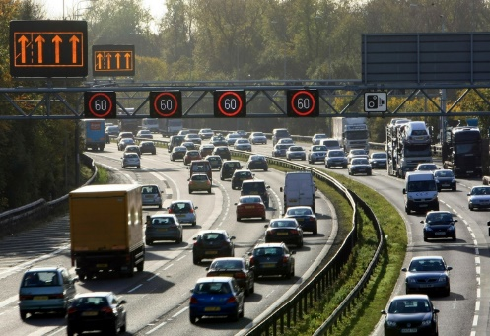
- A child hit by a car at travelling at 40 mph has an 85 per cent chance of dying - if they are hit at 20 mph that risk plummets to five per cent
Figure 3 [13]
- Lower speeds reduce air and noise pollution
- Public support for the new speed limit is very strong - the local ‘Twenty is Plenty' campaign is backed by all the organisations that make up Bristol Partnership, Living Streets, Streets Alive and Sustrans. [11]

Smart motorways
Highways England has recently invested in the use of smart motorways, and in October of 2019, they revealed that an additional 300 miles of the smart motorway would be implemented in England by 2025. The smart motorways that are being put in place use traffic management methods to increase the capacity and reduce congestion in busy times of the day.
Some of the methods are to dynamically change the operation of the hard shoulder to act as an active lane and have variable speed limits to control the flow of the traffic. [12] Highways England created smart motorways to manage traffic in a certain way that allows them to reduce the environmental impact and save time without the need to build upon additional lanes on a motorway.
Though the implementation of a smart motorway, it has been predicted that journey reliability will be improved as much as 22% and the chance of personal injury accidents could be reduced to almost half. Along with the variable speed limit technology, there will be sensors that will automatically measure traffic volume, by doing this the variable speed will be adjusted accordingly based upon the density of the traffic to improve safety and reduce the risk of an incident cause delays. Previously this was either done based on the time of day or manually managed in a control room.[13]

Proposed prototype
The proposed prototype will be created to provide the service of smart road safety and pollution management. The initial design will be carried out with a topology diagram, and then there will be a physical prototype.
The goal of the device is to carry out the following tasks.
- Monitor traffic density.
- Monitor Air quality.
- Monitor the average speed of road users.
- Provide and collect data which will be stored in a database.
- Variable adjust the speed limit based upon traffic density and air pollution.
- To be implemented on average speed limit roads in urban areas.
To make this possible and viable to the design of the prototype must have a clear agenda in mind. The creation of the prototype will be modelled for Fabian Way (a483), Which is one of the major roads heading into the urban area of Swansea. The image below is the typical traffic density at 4 pm during the weekday.
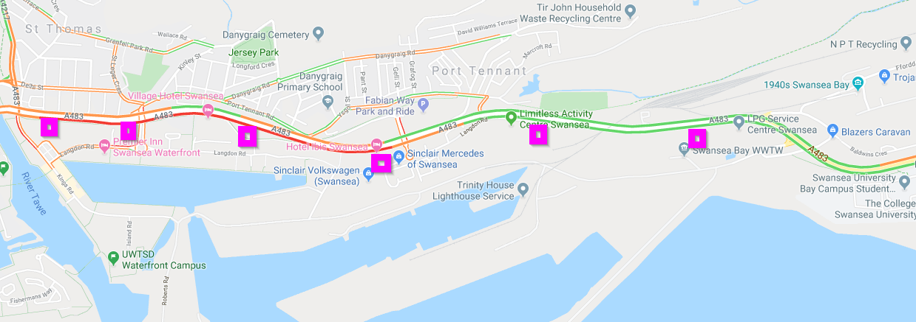
In the image, the pink squares represent a possible distribution of the devices along Fabian way. The assumption is that the devices will be using a cellular network in order to forward the information to a central server that would control the speed limits based upon the traffic density and air quality in real-time.
For a fully operational device, there are a couple of sensors that must be sourced and selected to ensure proper functionality and reliability. The device is going to need the following sensors in order to carry out its functions.

Sensor list
- Air quality sensors that measure individual values of the air composition as well as a summary of the air quality on the form of value. For proper implementation, there is a Micro air quality monitor produced by aeroqual [15] which is a low cost and accurate device that allows accurate and flexible communications to allow it to forward data to a central server.
- Radar sensors are going to be used to measure the average speed of the vehicles on the road. For example, the ISYS-4001 produced by innosent [14] would be the best radar sensor for the precision needed and supports a wide variance in configurations.
- Laser tripwires sensors are going to be implemented to measure the traffic density of the road. This would allow the device to measure how many vehicles are using the road at any given time.

Conclusion
It is apparent that there is a clear correlation between speed and pollution. Along with speed and road safety, the goal of the proposed device is to improve health and safety for all road users and the environment and people who live in urban areas.
IoT has come a long way and is starting to become implemented in many ways over the past couple of years. The push for digitization will mean the potential for relief on public service and improve quality of life. Digitalization will help reduce the current stress on the system and free up some resource that could be put to better use such as reinvestment into the community and supporting individuals.
With the recent push to clean up the environment and possibly reverse climate change, the world needs technology to help monitor and dictate what needs to be done to solve global crisis such as overpopulation and climate change.

References
[1] N. Notman, “Urban Air pollution,” Chemistry World, 2017. [Online]. Available: https://www.chemistryworld.com/features/urban-air-pollution/2500224.article. [Accessed: 10-Dec-2019].
[2] Julia Sommerfeld, “Will technology save us from over popualtion,” NBC news. [News Article]. Available: http://www.nbcnews.com/id/3072069/ns/us_news-only/t/will-technology-save-us-overpopulation/.
[3] EU Environment, Air Pollution in cities. EU, 2017.
[4] MATT BURGESS, “What is the Internet of Things?,” WIRED, 2018. [Online]. Available: https://www.wired.co.uk/article/internet-of-things-what-is-explained-iot. [Accessed: 10-Dec-2019].
[5] Sure, “The Top Countries Adopting IoT (And What That Means for You),” 2017.
[6] H. R. and E. O.-O. Max Roser, “world population growth,” Our World in data, 2019. [Journal]. Available: https://ourworldindata.org/world-population-growth.
[7] bradford, “Pollution facts and types of pollution,” LIVEscience, 2018. [Online]. Available: https://www.livescience.com/22728-pollution-facts.html.
[8] P. . Anne Marie Helmenstine, “The chemical composition of air,” Thought CO, 2019. [Online]. Available: https://www.thoughtco.com/chemical-composition-of-air-604288.
[9] EPuk, “EUROPEAN AIR QUALITY LAWS.” [Article]. Available: https://www.environmental-protection.org.uk/policy-areas/air-quality/air-pollution-law-and-policy/european-air-quality-laws/. [Accessed: 10-Dec-2019].
[10] E. Farell-Roig, “What speed limit cuts are doing to pollution levels on these Welsh roads,” Wales Online, 2019.
[11] P. Health, “Bristol – 20mph speed limits in areas of high health inequalities,” 2010.
[12] U. Goverment, “How to drive on a smart motorway,” .gov, 2017. [Online]. Available: https://www.gov.uk/guidance/how-to-drive-on-a-smart-motorway.
[13] RAC, “Smart motorways - what are they and how do you use them?,” RAC, England, 2019.
[14] innosent, “ISYS-4001 Radar,” 2018. [Online]. Available: https://www.innosent.de/en/radar-systems/isys-4001/.
[15] Areoqual, “AQY – Micro Air Quality Monitor.” [Online]. Available: https://www.aeroqual.com/outdoor-air-quality/micro-air-quality-monitor.

