gROUP-BASED WORK INDIVIDUAL ALARP STATEMENT
BEN LLOYD - 2219811

SAFETY & HAZARD ASSESSMENT – ACDB5013
TABLE OF CONTENTS
- Abstract(Page 2)
- Background information(Page 2)
- Group Work(Page 2 – Page 6)
- ALARP Statement for Hazard(Page 6 – Page 9)
- References(Page 9)

- Abstract
As a small group, an assignment has been set to create an ALARP statement against an OME-related artefact; the Storm Shadow Weapon System (SSWS) has been selected for this exercise. Identification of Hazards, Hazard Mitigation, Probabilities and Severities of Accident Scenarios, FMECA (Failure Mode, Effects, and Criticality Analysis) and CBA (Cost-Benefit Analysis) must all be carried out in order for a conclusionary ALARP (As Low As Reasonably Practicable) Statement to be created.

- Background Information

SSWS is an Air-Launched Standoff Missile project developed by MBDA intended for long Range Precision Strike use, in 2016 it was upgraded as part of the SPEAR (Selectable Precision Effects At Range) 4 programme and is currently used by the Air Forces of the UK, France and Italy.

As befitting it’s role, the SSWS is a guided weapon (primarily using GPS but other navigational methods are available, it is powered by a small Turbojet engine, it generates its own lift by using explosively deployed wings and contains a tandem shaped charge/follow through bomb warhead (which collectively will be referred to as the Lethal Package), these features create their own set of Hazards which must be accounted for. As many of the details of Storm Shadow are either Secret or Official Sensitive, this document has been written in a way that obscures more sensitive data and results in many sources of information being unavailable for reference.

- Group Work

Before a Safety Argument can be made, there must first be a Safety Framework. For the MoD, this has taken the form of Acquisition Safety and Environmental Management System (ASEMS) [1]and its subsections define how an aspect of Safety Management may be made. For this exercise, the missile while in flight (either carried by the aircraft or while cruising) shall be considered, there are other safety concerns during Storage, Ground Handling, Maintenance but this would be impossible to discuss within the set word count. As per ASEMS SMP07 (Risk and ALARP Evaluation) [2], a Risk must first be evaluated and a Risk Criteria established before attempting to reduce it.

To evaluate a risk, Severity and Probability criteria have to be created, which define frequency and seriousness of any given accident scenario. Probabilities used for this exercise are defined in the table below and will be values used for this exercise.
Probability | Likelihood of Occurrence | Numerical over the Service
Probability | (Systematic Failure) | Life (< 20 years)
Frequent | Likely to occur frequently | 1x10⁻² < P
Probable | Likely to occur several times in the life of the missile | 1X10⁻³ < P ≤ 1X10⁻²
Occasional | Likely to occur sometime in the life of the missile | 1X10⁻⁴ < P ≤ 1X10⁻³
Remote | May be possible to occur in the life of the missile | 1X10⁻⁵ < P ≤ 1X10⁻⁴
Improbable | Unlikely but may be possible to occur in the life of the missile | 1X10⁻⁶ < P ≤ 1X10⁻⁵
Incredible | Extremely unlikely to occur at all | P ≤ 1X10⁻⁶

Severity is the same, it is a means of classifying how serious an Accident may be based on the amount of damage it may cause, be it material damage, lives lost or injury.
Severity | 1st Party | 3rd Party | Material Safety
Catastrophic | More than two deaths. | One fatality. | Significant Collateral
Catastrophic | More than two deaths. | Multiple severe injuries or occupational illnesses. | Damage in addition to the loss of the Launch Aircraft.
Critical | One or two deaths | A single severe injury or occupational illness. | Collateral Damage in addition to the loss of the Launch Aircraft.
Critical | (e.g. crew of one aircraft). | Multiple minor injuries
Critical | Multiple severe injuries or occupational illnesses. | or occupational illnesses.
Major | A single severe injury | A single minor injury or occupational illness. | Launch aircraft fails to return (SD3).[1]
Major | or occupational illness. | A single minor injury or occupational illness. | Launch aircraft fails to return (SD3).[1]
Major | Multiple minor injuries | A single minor injury or occupational illness. | Launch aircraft fails to return (SD3).[1]
Major | or occupational illnesses. | A single minor injury or occupational illness. | Launch aircraft fails to return (SD3).[1]
Marginal | A single minor injury | Less than a minor injury. | Major damage to aircraft or equipment.
Marginal | or occupational illnesses. | Less than a minor injury. | Major damage to aircraft or equipment.
Negligible | Less than a minor injury. | Not Applicable. | Minor damage to aircraft or equipment.
These two may seem unimportant, but when combined, it results in a Risk Matrix. Risk Matrices are a way of cross-referencing the criteria of Severity and Probability to create a Risk Category.
Probability | Accident Severity
Probability | Catastrophic | Critical | Major | Marginal | Negligible
Frequent | A | A | A | B | C
1x10⁻² < P
Probable | A | A | B | C | C
1X10⁻³ < P ≤ 1X10⁻²
Occasional | A | B | C | C | D
1X10⁻⁴ < P ≤ 1X10⁻³
Remote | B | C | C | D | D
1X10⁻⁵ < P ≤ 1X10⁻⁴
Improbable | C | C | D | D | D
1X10⁻⁶ < P ≤ 1X10⁻⁵
Incredible | C | D | D | D | D
P ≤ 1X10⁻⁶

The letters A-D are a short-hand classification of the overall Tolerability of the Accident scenario, Accidents that would frequently result in the deaths of multiple people are given and A rating and are Intolerably dangerous unless in the direst of circumstances. A full list of Risk Category definitions are available in the table below.

Risk Category |  | Definition
A | Intolerable | Urgent action required as such risk may not be justified except in extraordinary circumstances.
B | Tolerable | Undesirable and shall only be accepted in exception circumstances and if risk is proven to be ALARP
C | Tolerable & ALARP | Residual risk is Tolerable & ALARP only if further risk reduction is impossible.
D | Broadly Acceptable | Level of residual risk is regarded as insignificant and further effort to reduce risk is not likely to be practicable.

Putting all this information together, a rudimentary Hazard Log can be created in accordance with ASEMS SMP11 (Hazard Log) [3]. Hazard Logs are a way of tracking all of the previously covered information in a single package, Probability, Severity, Risk Category, Personnel Involved, Hazards and Risk Reduction Strategies are all accounted for. This Hazard Log shall be the basis for the ALARP Statement. Several other documents will be used but are tightly controlled and will not be referenced due to security reasons.

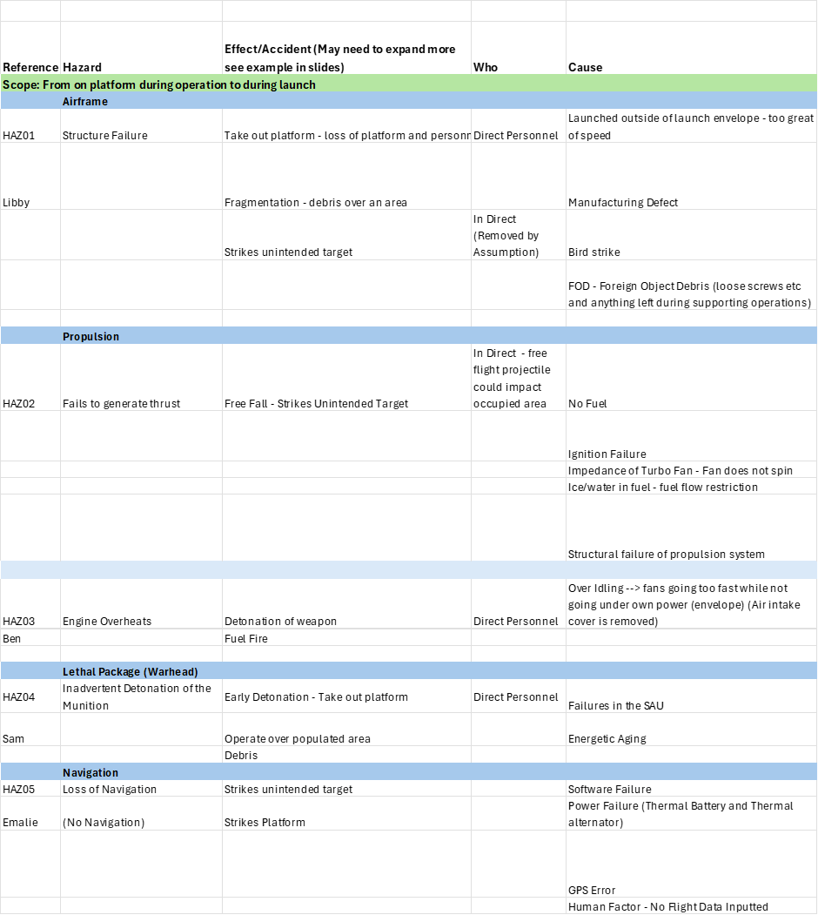
Draft Storm Shadow Hazard Log (Part 1 of 2)

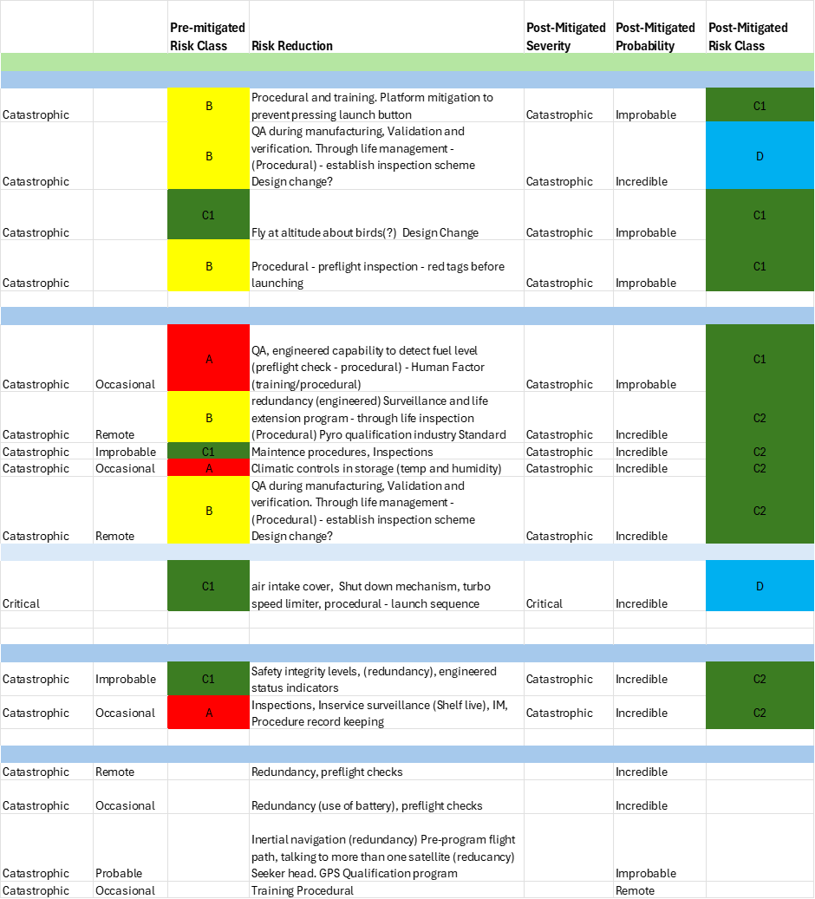
Draft Storm Shadow Hazard Log (Part 2 of 2)

- ALARP Statement for Hazard (Hazard 03)

With these details in mind, an ALARP statement against Hazard 03 outlined in the created Hazard Log is to be created in accordance with ASEMS SMP07. As mentioned in Para ii, the SSWS is powered by a small Turbojet engine that not only propels the missile, but also provides electrical power to the missile by way of a pair of alternators located at the front and rear of the Turbojet shaft. Hazard 03 refers to this Turbojet engine inadvertently catching fire, which in turn could lead to the fire spreading to the missile’s internal fuel tanks (which on SSWS are flexible polymer bags) and lead to cookoff of the either the missile’s internal Pyromechanisms or it’s Lethal Package (Hazard 04). Should this happen, the worst credible result would be loss of the aircraft and/or death of the pilot, for this reason Hazard 03 has been classified as Critical in line with the criteria outlined within the created Hazard Log.

Hazard 03 may occur due to a variety of causes linked to how SSWS is intended to operate. One such example is prior to the missile’s launch, airflow through the missile’s Air Intake (pictured below) passively turns the Turbojet shaft and the attached alternators provides power to the missile’s electrical systems. The aircraft also has a Controlled Release and Jettison (CR&J) envelope that dictates the altitude and speed the missile may be released within. If this this envelope is exceeded, there is a possibility of the alternators being over-rotated and burning out, creating sparks that could ignite fuel (especially vapours that may be present) and cause a fire.
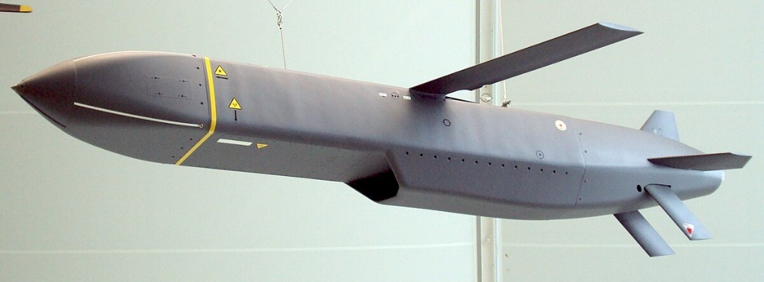
Figure 1 - Storm Shadow Air Intake (Circled)

Linked to this is the possibility that the there may be a fault in the missile’s fuel system, as previously mentioned the missile’s onboard fuel is contained within flexible polymer bags that could rupture, degrade or leak. Loose fuel or vapours leaking into the missile amplify the chances of there being an on-board fire caused by the Turbojet or one of the Pyromechanisms (of which there are many).

One such Pyromechanism are dual the Engine Igniters used to activate the Turbojet, MBDA’s safety documents describe these devices as “Roman Candles” that are designed to deflagrate and ignite injected fuel, it is possible that due to structural failure that flames may escape the engine and reach the fuel system, leading to an onboard fire.

Electrostatic Discharge may be another culprit of onboard fire, stray static electricity may ignite fuel or vapours, leading to the same outcome as any other source of fire inside the missile; Lethal Package or Pyromechanism cookoff, resulting in loss of a £62 million aircraft or the death of the aircraft’s pilot, a value impossible to quantify.

As there are multiple points of failure within SSWS, the probability of Hazard 03 has been assessed as Remote (it may be possible for this to occur over the lifespan of the missile), with a precise probability of occurrence between 1x10^-5 and 1x10^-4 as outlined within the SSWS Risk Matrix. While there are many points of failure within the missile, there are just as many controls (be it designed or procedural) intended to mitigate the risk of an onboard engine fire.

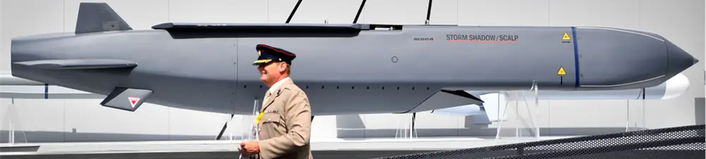
As previously mentioned, air flowing through the Turbojet turns the engine and provides electrical power to the missile’s electrical components. Should the aircraft keep increasing its airspeed, the Turbojet will turn excessively quickly and eventually burn out the missile’s alternators and potentially causing a fire, obviously this puts limits on the aircraft’s performance which the RAF considers unacceptable. So to combat this issue, there are numerous controls in place; the implementation of an Air Intake Cover (pictured below) is one such control.
Figure 2 – Storm Shadow Air Intake Cover (Circled)

This cover blocks airflow into the Turbojet and prevents any rotation of the engine, thereby protecting the alternators and removing the chance of an onboard fire. This also allows the aircraft to perform manoeuvres and fly at a wider range of airspeeds than if it were not in place. The missile still requires electrical power, this is solved by the Air Intake Cover detaching immediately prior to the missile’s launch, air can now enter the Turbojet and turn the engine, thus giving power. The detachable cover means that the engine is only exposed to a minimum of time under “passive” airflow and is therefore protected for the majority of the missile’s aircarriage flight.

The relationship between airspeed and engine rotation speed also forms the basis of the CR&J Envelope; it is a procedural control intended to prevent alternator burnout. By controlling the speed and altitude a Storm Shadow may be launched, the rotation of the Turbojet may also be controlled to within designed limits and prevent fires. However if defined airspeed from the CR&J Envelope is exceeded due to human error or aircraft fault, the missile’s weapon control computer will automatically shut the engine down and prevent alternator wear. To prevent human error, adding acceptable launch conditions to aircrew Flight Reference Cards and ensuring pilots are trained on correct SSWS procedure is critical to safe operation of the weapon.

As noted, the fuel within Storm Shadow is contained within flexible polymer bags and as a relatively weak material, it is far easier to damage than a solid fuel tank, however these are inspected during regular maintenance and can be easily replaced if a leak is detected. Even if it does leak, it would be immediately obvious it is doing so because prior to fitment to the aircraft, spilled fuel would pool in the base of the All up Round Container (AURC) and Armourers would simply not fit the missile to the aircraft. However as a design feature, there is potential for improvement; the polymer bags may be replaced by reinforced versions or (if space inside the weapon permits) a solid fuel tank that is more resilient than the current version.

The fuel system has further safety measures too; on launch the weapon control computer begins to pump fuel into the Turbojet during the transition between aircarriage and self-propulsion, if the Engine Igniters fail to fire (fuel is still being pumped into the Turbojet at this point), the onboard computer will register this and operate the Fuel Cutoff Valve, stopping any further fuel being transferred into the weapon. This may give rise to Hazard 02 on our Hazard Log, but ultimately results in both pilot and airframe survival.

The Engine Igniters also have designed features that ensure safety of the weapon, they have been designed with a Reserve Factor of 1.5, meaning they can survive without damage 1.5 times the maximum gas pressure they would be expected to operate within and are fully enclosed units. If an engine Igniter does accidentally inadvertently operate, then any flame would be directed into the engine and without fuel present, the pyrotechnic composition would quickly burn out with no threats to personnel. The Engine Igniters are also managed under the Surveillance And Life Extension (SALE) programme to prevent inadvertent operation due to aging.

Static Electricity is also a managed threat, at all stages missile handling (be it ground handling, storage, aircarriage or maintenance) the missile is earthed to prevent ESD from initiating any pyrotechnics, the Lethal Package or the fuel. Prior to fitment of the missile to the aircraft, the aircraft’s Ejector Release Units (ERU’s) are subject to a No Volts Safety Test (NVST) to check that no stray electrical currents are present inside the weapon. This procedure is a fundamental concept in Armourer training and appears on all weapon handling Air Publications.

Based on the information outlined within previous paragraphs and the mitigations that are in place, the Probability of an engine fire on the Storm Shadow can reasonably be decreased from Remote to Incredible (which is inline with the real SSWS Hazard Log). Even with mitigations in place, Severity has not changed; it remains Critical as Hazard 03 represents a threat to both the life of the pilot and the integrity of the aircraft. These two criteria would place Hazard 03 into Category D (Broadly Acceptable) on the Risk Matrix and any changes to this Risk Category would require endorsement from a Quorate Project Safety and Environmental Panel in accordance with ASEMS SMP02 [Source]. While there is an area for improvement concerning the missile’s fuel bags, the SSWS is a mature and in-service weapon system with only a handful of fuel leaks being documented over the weapon’s service life, Cost/Benefit Analysis dictates that any improvement would not be worth the resource spend to take full advantage of this improvement. As such, we can consider the risk of Hazard 03 to be ALARP.

- References
[1] – ASEMS, https://www.asems.mod.uk/
[2] – ASEMS SMP07, https://www.asems.mod.uk/guidance/posms/smp07
[3] – ASEMS SMP11, https://www.asems.mod.uk/guidance/posms/smp11

