Core Network Services as a Service (CNSaaS) Project Proposal

Paul M Lawrence

Computer Networks and Cyber Security

Dr Tim Bashford

5070 Words

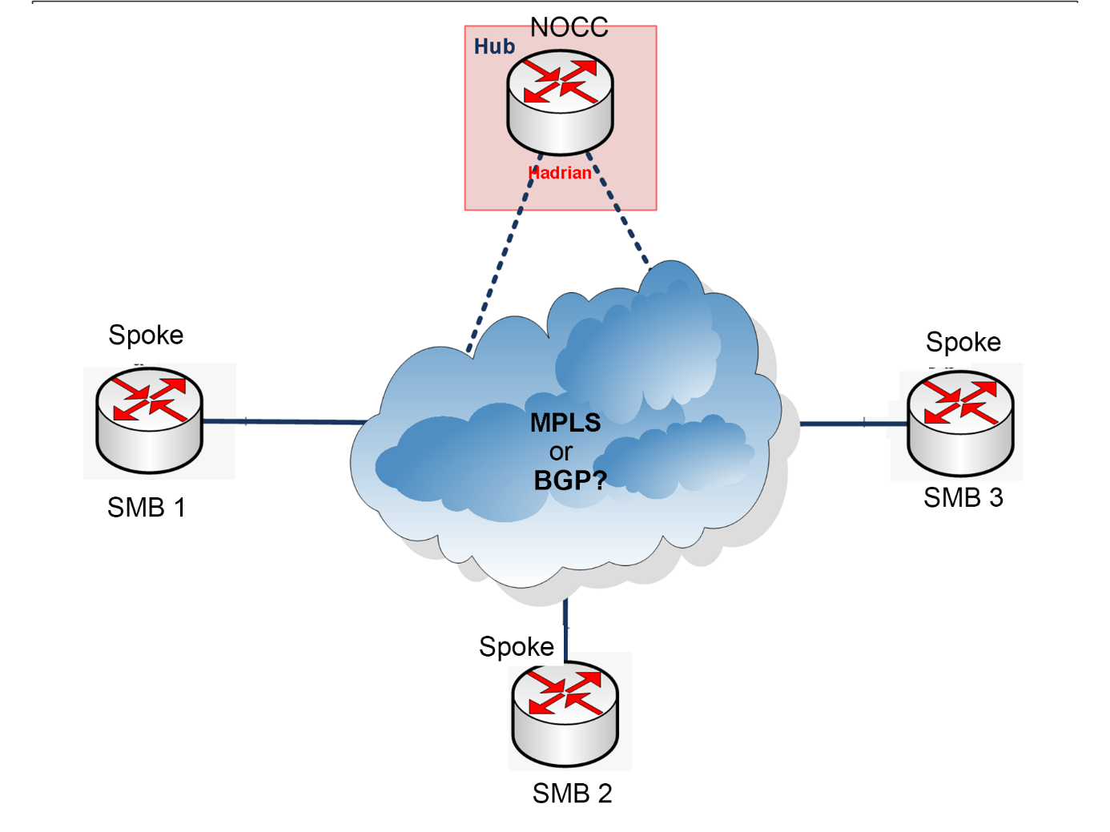

Table of Contents

Core Network Services as a Service (CNSaaS) Project Proposal 1
Table of Contents 2
Table of Figures 3
Introduction 4
Background Literature 5
[X]aaS 5
SMB IT Overheads 6
Local Area Networks (LAN) 6
Wide Area Networks (WAN) 7
Systems Administration and Services 9
Further Research 9
CNSaaS 9
Aims and Objectives 9
Research Methodology 10
Case Study: 10
Document Review: 11
CNSaaS Network and Systems Development: 11
Research Methodology Conclusion 11
Development Methodology 11
Spiral Methodology Invariants 11
Spiral Methodology Integration within the CNSaaS Project 12
Advantages of the Methodology 13
Disadvantages of the Methodology 13
Risks 14
Ethical Issues 15
Analysis and Deliverables 15
Environmental Sustainability 16
Physical Resources 16
Human Resources 16
Timeline 16
References 18
Bibliography 18
Appendix I: CNSaaS Project - Gantt Chart 19

Table of Figures

Figure 1:CNSaaS Preliminary Logical Topology [11] 5
Figure 2: XaaS Industry Service Model Features [27] 6
Figure 3: Example LAN Topology [41] 8
Figure 4: Example WAN Mesh Topology [42] 8
Figure 5: WAN Hub and Spoke Example Topology [23] 10
Figure 6: CNSaaS Spiral Development Model 14
Figure 7: CNSaaS Risk Matrix 15
Figure 8: Gantt Chart for CNSaaS Project 18

Introduction
X as a service (XaaS) is a marketing business model developed by the Information Technology (IT) industry to describe remote IT services that end users i.e. company’s, individuals etc can purchase. There are many different types of XaaS that all offer bespoke network, software and hardware features which will be researched and analysed in further detail within the background literature section of this report. [1]
The remote services sector within IT is highly lucrative because IT hardware and knowledgeable staff can be very expensive for a company, especially if the focus of the Small-to-Medium Business (SMB) does not include IT as its core services i.e. Law firms, Hospitals, Photography studios etc, IT expenditures within these companies are viewed as non-profitable overheads. So, outsourcing various IT services for a fraction of the cost is very attractive to these types of companies. [2]
Core Network Services as a Service (CNSaaS) will aim to encompass and remotely deliver all facets of Local Area Network (LAN) [3] engineering services to SMB’s [4] from; configuration and maintenance of internetworking hardware i.e. Routers and Switches etc [5] to bespoke core administrative services [6]. For the purpose of this project a sample selection of core network services will be implemented and then remotely delivered from a control centre LAN segment to three business client LAN segments as an example of how CNSaaS will function. Each of the LAN’s will be serviced by a different Operating System (OS) [7]with the focus on monitoring, analysing and then identifying the most effective server OS to be used within the final CNSaaS deployment model. Two separate Wide Area Network (WAN) [8] protocols will also be tested within the CNSaaS network; Border Gateway Protocol (BGP) [9] and Multiple Protocol Label Switching (MPLS) [10] to identify the most efficient WAN protocol to be utilised within the CNSaaS model. A preliminary draft of the CNSaaS logical network topology can be found in figure 1.
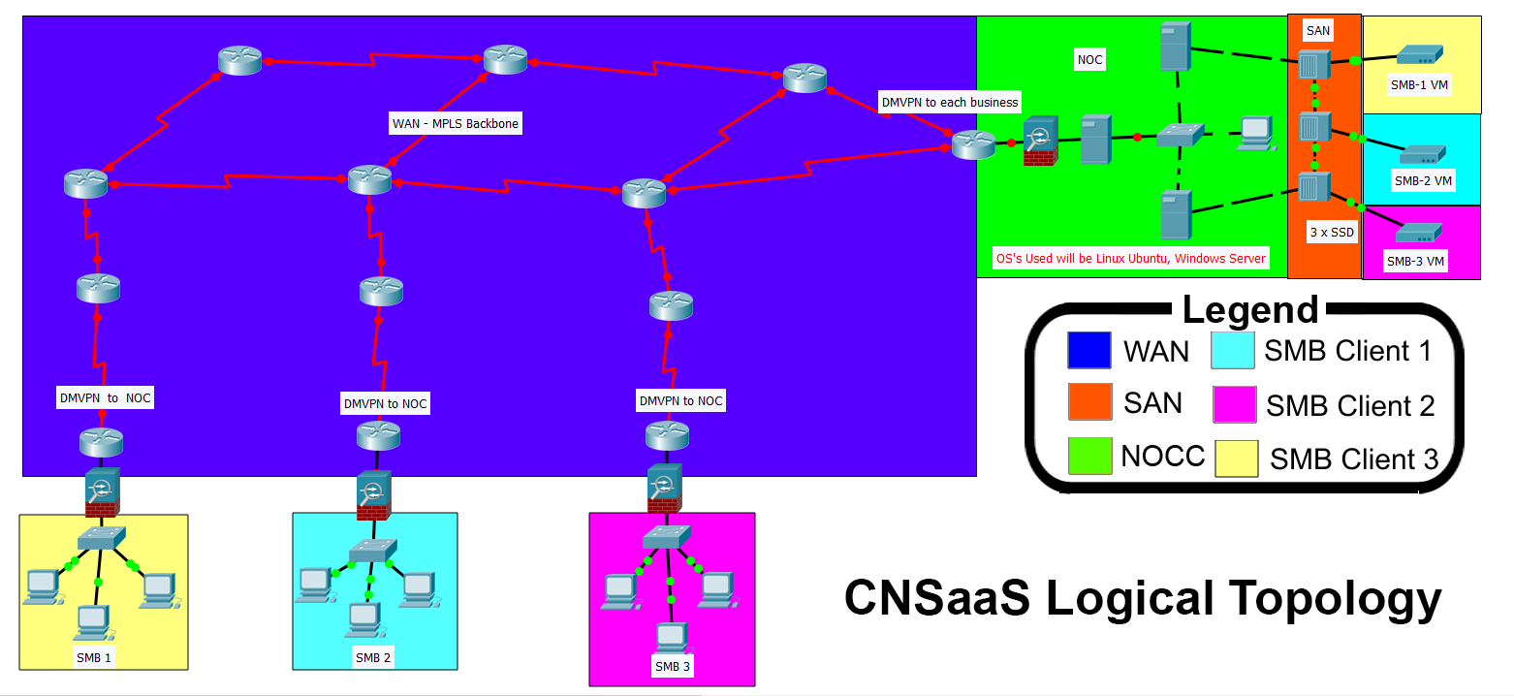
Figure 1:CNSaaS Preliminary Logical Topology [11]
The core network services that will be delivered to each of the LAN’s include; Web Services, File Services [12], Domain Name Services (DNS) [13], Active Directory (AD) [14], Dynamic Host Configuration Protocol (DHCP)[15] and Internet Protocol Address Management (IPAM) [16]. These services will be provided by two hypervisor servers configured as a redundant failover cluster to offer a hybrid of both the advantages of a physical and virtual network infrastructure without each of their disadvantages [17], [18]. The tier-1 hypervisor will deliver the services remotely and securely from a Network Operations Control Centre (NOCC) [19] across a fibre optic [20] [21]Wide Area Network (WAN) i.e. the Internet, secured end-to-end by a Dynamic Multipoint Virtual Private Network (DMVPN) [22] to each of the business clients LAN’s.
The NOCC will be an external IT company that specialises in offering core network services remotely to businesses within a hub and spoke network design topology [23]. Each client’s data that NOCC are delivering services to will be stored separately within a Storage Area Network (SAN) [24] as Virtual Machines (VM) [25] for the tier-1 hypervisor to utilise. This configuration also provides additional security of client data.
The CNSaaS solution would outsource an estimated 95% of all IT services currently being provided internally within a SMB, this economic saving would negate the need for; core IT hardware and highly skilled IT staff which as previously stated can be a very large overhead for a non-IT services company. [26]

Background Literature
Preliminary background research has been conducted for the proposed CNSaaS project. The research has been broken down into logical segments that encompass the entire CNSaaS project. The following segments are as follows:

[X]aaS
As previously discussed, [X] as a service is a marketing term coined by the IT industry to describe a remote services business model that is delivered to business clients and/or individual end users via the WAN, this model is most commonly referred to as cloud services.
There are many types of cloud service frameworks available in today’s market, the most popular and widely used are can be found in figure 2.
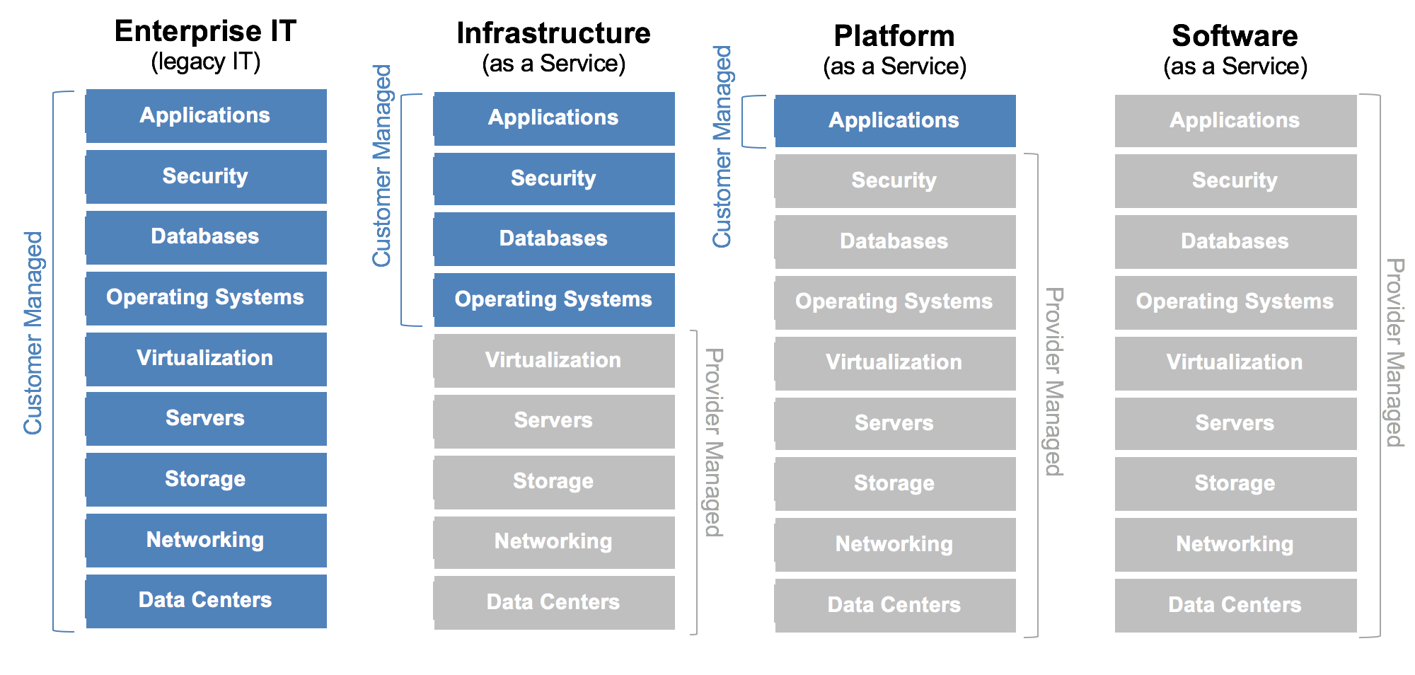
Figure 2: XaaS Industry Service Model Features [27]
These models focus on delivering remote application services and storage to companies.

Infrastructure as a Service (IaaS)
This cloud service model offers clients the rental of a cloud service providers (CSP) underlying data centre infrastructure that contain many servers that would typically be located at the client’s premises. This infrastructure is very expensive to purchase and maintain for non-IT services SMB. The IaaS model leases a small portion their server’s computational power and SAN. The client is responsible for installing the server OS’s, configuring and maintaining the E-Mail services, database services, web services, web applications and file services that they install and staff within a company can access via a web browser via the Internet.[28], [29]

Platform as a Service (PaaS)
This cloud service model builds on the IaaS model and offers added features such as software Application (APP) development tools, pre-configured middleware for functionality, database management and business analytics. [30] [27]

Software as a Service (SaaS)
This cloud service model further builds on the PaaS model and offers all the above features as a web interface that have all been pre-configured and maintained by the CSP along with a virtual firewall as a gateway to the SMB LAN. A SMB network administrator would be responsible for adding/removing users and updating the company policies etc within this cloud model. [31], [32]
The prominent CSP’s within the remote services industry are; Amazon: Web services (AWS) [33], Google G suite [34] and Microsoft: Azure [35].

SMB IT Overheads
According to Gartner [36] who are one of the leading bodies within IT statistical analysis, a SMB is categorised as a company that has fewer than 100 employees [37]. A 2017 study [26] conducted by the Centre for Economics and Business Research (CEBR) within the cost of IT in SMB’s that had fewer than 50 employees. The CEBR concluded that SMB’s have an annual average expenditure of £1,000,000, 24% of this figure was spent on staff, 20% was spent on paying external services and 19% was invested into new technologies. SMB with fewer than 50 employees spent an average of £3,000,000 in the same year. These economic figures suggest there would be a demand for CNSaaS for SMB’s to substantially lower their IT overheads. [38] [39]

Local Area Networks (LAN)
A LAN can be defined as two or more computer devices sharing information within a single internal network. A LAN typically covers a geographical area the size of a building. Common Internetworking devices that are implemented within a LAN are; hardware firewalls, routers, layer-2 and/or layer-3 switches, wireless access points (AP) and servers shown in figure 3. Servers within a LAN topology provide services such as; internal web services, DHCP, DNS and AD to end clients within a LAN topology. [14], [15], [40]
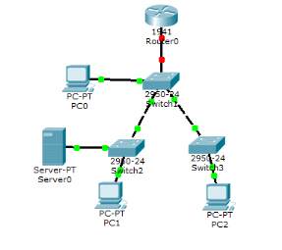
Figure 3: Example LAN Topology [41]

Wide Area Networks (WAN)
A WAN is defined as a network media connection that generally covers a geographical area greater than 1km, they are most commonly owned by Internet Service Providers (ISP) who lease the connection to businesses and home users. A WAN is considered an intermediary network that connects multiple LAN’s so that they can share information. The Internet is comprised of many WAN’s within a mesh configuration shown in figure 4. For the purpose of this project the research focus within WAN’s are as follows:[8]
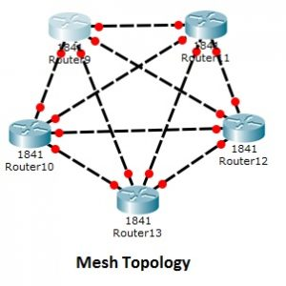
Figure 4: Example WAN Mesh Topology [42]

WAN Communication Protocols
External BGP: External BGP is a very complex traditional WAN communication protocol utilised by ISP’s to locate and deliver data packets to routers across large geographical areas located in various Autonomous Systems (AS). The BGP process starts with a Customer Edge (CE) router that is located within a LAN sending a packet to a destination outside of its own network, the packet is then forward to the closest Provider Edge (PE) that starts the external BGP routing process by reading the public Internet Protocol (IP) addresses located within the data packets header and then distributing the packet to its neighbour Provider (P) core WAN router that is located within a pre-defined AS that the IP address is associated with within its routing table, the packet is then passed through various P routers and AS routers until the packet reaches the destination PE router that then forwards it on to the CE router located within the LAN destination. This process is very complex and puts a lot of overhead on the core P routers within the WAN reducing throughput and adding latency to the communication process. [9], [43], [44]
MPLS (Layer-3): Layer-3 MPLS is a modern WAN protocol that distributes packets differently to the traditional BGP protocol. MPLS functions by tagging packets at the LAN ISP router which is called the Label Edge Router (LER) with a predetermined short path label that correspond with the packets destination. The labelled packets are then distributed to preconfigured MPLS routers located within the WAN called Label Switching Routers (LSR), these routers don’t read the packet header to look for the IP address just the short path label applied by the LER so that it can distribute the packet to the next LSR router that the label is associated with. This process is repeated until the packet arrives at its LAN destination where the tag is ‘popped’ by the destination LER router which is also called the egress node. The egress node then distributes the packet internally within its own LAN network until it reaches the end device that requested the packet. [45], [46]
This label switching functionality negates the need for the LSR routers to read the long IP address associated with the packet then search its large routing table for the correct path to send the packet. MPLS massively reduces the overhead on core routers located within the WAN because of this functionality. [10]
WAN communications that use DMVPN security to secure the connection will also be researched in detail within the project literature review. [22], [47], [48]

WAN Hub and Spoke Topology
A ‘Hub and Spoke’ topology is a centrally managed networking design. It consists of a ‘Hub’ that is the central component within the network that contains the core internetworking equipment i.e. core routers, core switches and servers for the underlying network. The hub is a gateway for each of the spokes that are generally smaller LAN sites that connect to the hub via a WAN to create one privately converged network over a large geographical area. Using this network design gives granular control, consolidation and efficiency of network resources i.e. file services, web services, user services (AD), security permissions etc. Individual administration and monitoring of multiple remote networks can be very expensive and complicated, so this solution is implemented when a corporation (enterprise) comprises of multiple locations spread out over a large geographical area shown in figure 5. [23], [49]
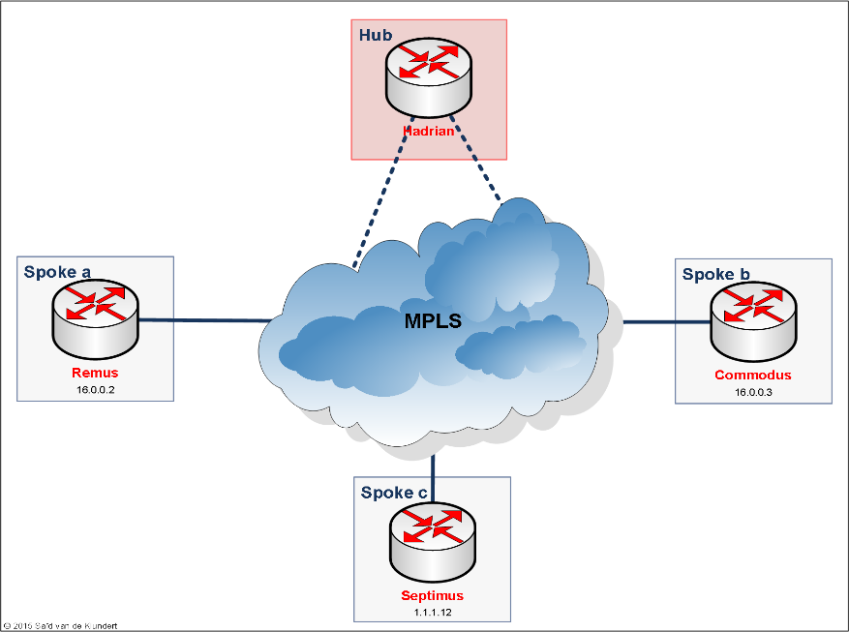
Figure 5: WAN Hub and Spoke Example Topology [23]

Systems Administration and Services
Systems administration/engineering is a field within the IT industry that focuses on developing, configuring, maintaining and delivering IT services via an internal core networking infrastructure. Systems administrators/engineers specialise within server hardware and OS software technologies that range from open source Linux server variants to Microsoft Windows server, these different vendor OS each have unique features and functionality, but all have the same primary purpose of delivering IT services to end clients within a network. [7], [50]

Further Research
Further research will need to be conducted within each of the identified areas above in alot more depth to further understand the problem so that a solution can be tailored accordingly in order for the project to be understood, designed and implemented successfully.

CNSaaS
CNSaaS aims to go a step further than the traditional cloud service models identified previously within the preliminary research literature section of this report, to not only provide the infrastructure for the Internet services such as web, E-Mail, database management and business analytics. But consolidate and maintain all LAN services that make a network function internally such as AD, DHCP, DNS, network monitoring, router and switch maintenance etc as previously discussed. These transparent core network services have been overlooked by traditional cloud service models. [51]–[53]

Aims and Objectives
The aim of this project is to further research, develop, implement and then benchmark (analyse) core network services delivered across a WAN, configured within a hub and spoke WAN topology to offer the CNSaaS cloud services model to SMB clients whom are not knowledgeable with the IT Industry from a computer network engineering perspective. The end goal of this project will be for SMB clients to outsource and centralise an estimated 95% of their internal IT LAN operations to an external company who will deliver, monitor and maintain these services remotely, securely and efficiently from a NOCC as previously discussed.
The project has been broken down into six manageable objectives that need to be obtained to achieve the aim previously discussed so that the project can be completed to a high standard. These objectives are as follows:
Objective 1: Research, design and implement a NOCC LAN that comprises of a; Hardware Firewall, Tier-1 hypervisor, Layer-2/-3 Switches, ISP Routers and SAN with redundancy, security and efficiency as the focus. Also configure three small client LANS that will comprise of a firewall, layer-2 switches, ISP routers and end devices. [3], [19]
Objective 2: Research and implement a Linux- ‘Free BSD’ Server that will be stored within the SAN at the NOCC as a VM to provide; Web services, File services, DHCP, DNS, LDAP (Linux equivalent of AD) and IPAM services for a business client. [54]
Objective 3: Research and implement a Linux- ‘Red Hat’ Server that will be stored within the SAN at the NOCC as a VM to provide; Web services, File services, DHCP, DNS, LDAP (Linux equivalent of AD) and IPAM services for a business client. [55]
Objective 4: Research and implement a ‘Windows 2012 RS’ Server that will be stored within the SAN at the NOCC as a VM to provide; Internal Web services, File services, DHCP, DNS, AD and IPAM services for a business client. [7]
Objective 5: Research and implement a fibre optic WAN within a computer laboratory with emphasis on BGP and MPLS for connectivity and throughput. Also, to secure the WAN connection between the hub (NOCC) and spokes (client premises), a DMVPN WAN tunnel will need to be further researched and then implemented to provide end to end encryption of network traffic between each of the ISP routers configured at the proposed sites. [8]–[10], [19], [22], [23]
Objective 6: Converge the network segments from objectives 1-5 and then benchmark the CNSaaS solution that has been developed using industry standard network monitoring software ‘SolarWinds’ [51], to identify and then provide the most efficient OS and WAN communication protocol configuration of CNSaaS to business clients. [52], [53]

Research Methodology
The philosophical research methodology chosen for this project will be positivistic [56] because a real-world working solution to an IT business problem is the final goal of this research project based on the quantitative [57]data generated from the CNSaaS network.
The approach that will be utilised is ‘deductive’ since logical decisions will be made after analysing the data from three OS experiments and the data produced from the WAN connectivity experiment to identify the most efficient configuration for the final CNSaaS solution to verify the reliability and validity of the system.[58]
This project has been identified as a network/systems development project as there are many cloud service modals available that encompass the core technologies that will be utilised for the CNSaaS solution proposed. [58]
The secondary research strategy processes that will be followed for this project are as follows:
Case Study: A technical case study of a cloud services model that utilises similar cloud technologies as the CNSaaS cloud services model proposed will be researched and further analysed to identify any problems that were found during development of the model, to learn of any compatibility issues or specific hardware requirements that may have arisen during the development of the case study cloud model.
This research process will be conducted to save time within the development stage of the project by negating the need to solve problems that may have already been previously identified and solved by other researchers.
An in-depth case study within the field of business management and economics will also be conducted with focus on; SMB IT costs and IT services that are delivered to end clients internally within SMB’s will be analysed at this stage to identify the validity of CNSaaS within the real world to evaluate the economic savings and percentage of internal IT services that could be outsourced if SMB’s were to adopt the CNSaaS solution. [59]
Document Review: CNSaaS has been identified as a development project, therefore there will be a lot of emphasis within research of vendor documentation/academic white paper reviews due to the masses of technologies that are available within this field and the vendor specific products that will be utilised during the project. [60]
This stage of the research will identify the correct hardware/software technologies that will be utilised within the design of CNSaaS i.e. firewall, routers, servers, OS’s, dynamic routing protocols etc and the network engineering theory that will need to be applied to successfully complete this project to avoid design/configuration issues later in the project. [61]
CNSaaS Network and Systems Development: This stage of the research process will identify the correct configuration commands, OS versions and installation for each of the identified technologies, and the vendor specific hardware that will be utilised i.e. Juniper, Cisco, Microsoft, Linux etc within the designing and development of the proposed network. [62]

Research Methodology Conclusion
Using this research strategy will validate the authenticity and requirement of the CNSaaS solution within the IT arena of modern SMB by triangulating the results from the research gathered within the identified areas previously discussed. The research strategy proposed will also save time and identify potential problems at the physical development stage of the CNSaaS project, so that a high quality, efficient and cost-effective product can be delivered on time at the end of the project.[57], [61], [63]

Development Methodology
The ‘Spiral’ Methodology has been chosen as the development strategy for this project. It’s a combination of the waterfall and iterative models. It was developed and then published by Barry Boehm in a white paper "A Spiral Model of Software Development and Enhancement" in 1986 [64] for software engineering development projects, however it can be effortlessly adapted for the CNSaaS network/systems development project as opposed to other development methodology’s i.e. Waterfall, SCRUM, Rapid Application Development (RAD) etc that are aimed at developing a prototype (build) software product in one linear cycle, that requires end user testing. These methodologies do not map across easily within a computer network architecture that aims to deliver transparent services to end devices comprising of many separate entities, that relies on performance metrics as its testing bed without end user testing and feedback during the initial build, as opposed to the spiral model that allows for flexibility within these areas. [62] [65] [64], [66]

Spiral Methodology Invariants
The ‘Spiral’ methodology consists of six prerequisite invariants [67]; these conditions must be met for the methodology to be effective within a project. They state:

- End requirements for the system must be known from the start.
- There are no unresolved high risks within the project i.e. cost, scheduling, staff, unrealistic timeframe etc.
- The end goal of the project will not change substantially during development.
- The requirements are realistic and compatible for the proposed system.
- The correct design for the system is clearly understood so that the requirements can be successfully implemented.
- There is enough time allotted for each spiral to be completed to a high standard.

Invariants are further applied to each stage of the spiral cycle that include:
- Research and planning
- Design
- Implementation of the proposed design
- Testing and Risk Analysis of Spiral Development i.e. time, hardware/configuration issues etc.
These invariants must be strictly adhered to for the successful completion of a project developments lifecycle when using this methodology. [64], [66]

Spiral Methodology Integration within the CNSaaS Project
By utilising the ‘Spiral’ methodology, the project can be separated into manageable segments called ‘Spirals’ each representing the first five objectives of the CNSaaS project that can be individually iterated using the spiral cycle invariants; research/planning, design, implementation and then troubleshooting/risk analysis. The last spiral within the project will be the integration of all the completed network segments (Spirals) to create and further troubleshoot the entire network. Benchmark analysis of the entire system will also take place at the final spiral. A spiral project development diagram of the CNSaaS project can be found in figure 6.
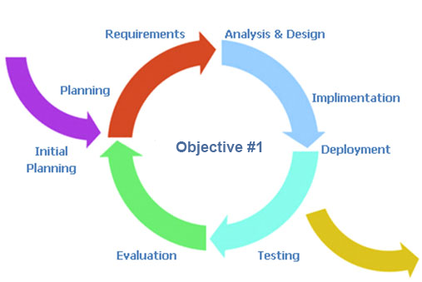
Figure 6: CNSaaS Spiral Development Model

Advantages of the Methodology
The advantage of this methodology is that it reduces failure of the entire system by identifying, localising and conducting risk analysis of any issues that arise at each of the individual network segments (spirals) making troubleshooting and configuration less complex. It also allows for the end requirements to be known in advance but not necessarily the order or processes utilised to get there, giving flexibility within approaching solutions to problems that may arise within a spiral i.e. knowledge of a specific technology, configuration issues, hardware issues etc this ethos is suited for a research project where the steps to solving a problem are not always known in advance. These issues often add high risk to a project within other development methodologies. [64], [68], [69]
This model equally allows for further functionality to be added at a later date which is ideal for a cloud model that can deliver many tailored services to end clients.
Time scheduling is equally an advantage when using this methodology within a research project, because each spiral has a pre-determined objective, start and end cycle so planning realistic time slots for each of the spirals will be a lot more accurate during time slot management estimations within the projects ‘Gant’ chart.

Disadvantages of the Methodology
The disadvantage of this methodology is that it is not designed for small projects because it can often run over budget and behind schedule because of the granular design, configuration and risk analysis at each of the spirals. These disadvantages within the CNSaaS project have been minimised by identifying all hardware/software, resources, time constraints and staff requirements before the development stage of the project.
This methodology also demands a high level of risk analysis and foresight of issues within each of the spirals as to not run into configuration/design problems that could take a lot of time to resolve. Within the proposed CNSaaS project a broad understanding of all the underlying technologies already exists within the project team. Time has been allotted for in depth research within each of the objectives identified pertaining to the spirals to fill any gaps within the project team’s knowledge as discussed within the research methodology section of this report. [64], [68], [69]

Risks
The preliminary risk analysis of the key components to the CNSaaS project were identified at the project idea brainstorming stage. The severity of the risks to the project were identified by utilising a risk management strategy to mitigate and/or minimise the identified risks to the project before it could go ahead.[70][71] These risks have been mapped onto a risk matrix shown in figure???
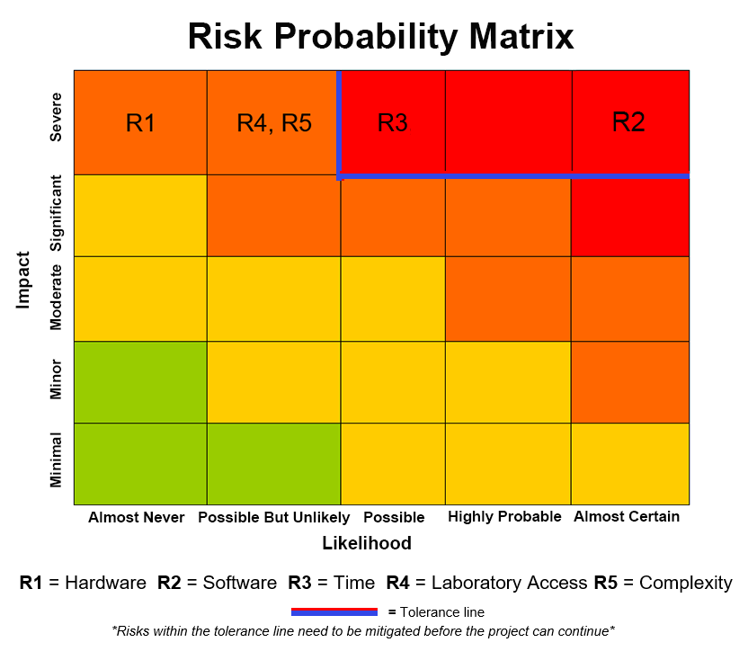
Figure 7: CNSaaS Risk Matrix [72]
A risk mitigation strategy was immediately implemented for the risks identified within the tolerance line. The mitigation strategy proposed for these risks are:
Software: The Network monitoring software was identified as an almost certain risk, that would have severe implications of the project not being viable because the industry standard network analysis and monitoring software ‘SolarWinds’ that was proposed to be used within the project is a very expensive product which costs $2,995 [51], and due to the low budget of this project this would not have been affordable. After further research it was discovered that, ‘SolarWinds’ offers its full software package as a 30-day free trial, this time frame would be enough to gather, correlate and analyse the traffic within the network mitigating the risk.
The rest of the software that will be utilised for the project was not categorised as a risk because the university own software licenses for; ‘Windows server 2012 RS’ OS, ‘Windows 10 client’ OS and a tier-1 hypervisor. The Linux OS software that was also proposed to be implemented within the project is opensource, so that will be downloaded for free during development.
Time: Time was categorised as a possible risk because there are a lot of technologies that need to be researched within this project before it can be implemented within a 6-month time frame. To mitigate this risk, it was decided to start the project 3 months early during the university summer break to research all of the network engineering and systems engineering theory needed to achieve the objectives along with the technologies that will be used to create the CNSaaS model previously discussed within this report.
The low risks that were identified outside of the tolerance line were also briefly analysed so that they don’t develop into high risks later within the project. These were:
Laboratory Access: Laboratory access was identified as a severe but unlikely event of happening because the university has a Cisco laboratory that students have access to which has multiples of internetworking hardware equipment for students to use. The availability of the laboratory could escalate the identified risk if it was not available at certain times/days due to lectures, holidays etc when key milestones of the project were being completed. To mitigate this issue time slots will be booked for access to the laboratory throughout the project development lifecycle using the project time management Gantt chart that has been created, which can be viewed later in this report.
Complexity: The complexity of the project was identified as a severe but unlikely event of happening because all the complex technologies that will be utilised within the project have been studied and configured in detail at university for the previous two years. Also, utilising the research methodology discussed previously in this report along with the additional allocated research time discussed within the ‘Time’ risk mitigation gives the project team confidence they will develop CNSaaS to a high standard.
Hardware: The hardware needed for the project was categorised as a severe but an almost never chance of happening because, the university that the project is being created for is a Cisco academy that has a computer laboratory as previously discussed that contains all the internetworking and end device hardware that is needed for the project, that can be used by students. The university also has two HP blade servers that can be configured as a tier-1 hypervisor for student use.

Ethical Issues
The CNSaaS prototype project does not currently contain any ethical issues, however if CNSaaS was to be implemented for a real-world SMB in which client data would be stored within the network at the NOCC, the new General Data Protection Regulations (GDPR) legislation that was created by the European Union (EU), that came into force on the 25/5/2018 would have to be adhered to by the external company that houses the data.

Analysis and Deliverables
Network traffic monitoring and analysis software ‘SolarWinds’ will be used to collect the network traffic that is generated by the CNSaaS network with emphasis on network performance metrics;
Latency: Latency can be defined as how long a data packet takes to be sent from one node to the next within a network. This metric is measured in milliseconds. [73]–[75]
Packet loss: Packet loss within networking is defined as how many packets are lost during transmission from one node to another. This metric is measured as a percentage. [76]–[78]
Throughput: Throughput within networking is defined as the amount of data that is sent successfully from one node to the next through a physical or wireless media i.e. ethernet cable, fibre optic cable, radio waves etc within a given time frame. This metric is measured in bits i.e. Kilobits (Kb), Megabits (Mb) or Gigabits (Gb) and seconds i.e. 10 Mb/s. [79]–[81]
These metrics will be used to identify the most efficient communication protocol to be utilised within the WAN segment of the network; BGP or MPLS and to also identify the most efficient server OS to deliver the remote services within the hub and spoke topology; Windows Server 2012, Linux-Free BSD Server or Linux-Red Hat Server. The most efficient configuration will then be incorporated into the final CNSaaS cloud model as previously discussed in this report.
Research conducted by Cisco who are the industry leaders within network engineering theory and products concluded the minimum acceptable latency within a SMB network is 200ms and the minimum acceptable packet loss is less than 1%. [82]
The minimum throughput metrics that the CNSaaS network will still be 100% efficient and transparent to the end client will be identified during the network monitoring and analysis stage of the project.

Environmental Sustainability
This project would have a positive effect on the 1st order of environmental sustainability because internetworking equipment i.e. routers, switches and servers use alot of electricity that have a negative effect on the environment. The proposed CNSaaS network would remove an estimated 95% of these internetworking devices from SMB’s and consolidate them within one location, utilising there power efficiently by operating only two hypervisor servers that can compute several VM server OS’s at a time, as apposed to SMB’s that currently each utilise a minimum of one of these servers within their networks running only one server OS’s on each of them. [83] [84], [85]

Physical Resources
A Computer laboratory that contains:

- 2 x Enterprise Blade Servers
- 10 x ISP Routers
- 2 x Layer-3 Switches
- 4 x Hardware Firewall
- 8 x Layer-2 Switches
- 7 x End Devices (PC)
- 12 x Single Mode Fibre Optic Patch Cables
- 20 x Straight Through Ethernet Cables
- Access to IEEE Journal (Whitepapers)

Human Resources
Project Mentor Dr Tim Bashford and a 3rd year university student Mr Paul M Lawrence.

Timeline
Using the information from the preliminary research and the physical/human resources section of this report, a Gantt chart [86] was created to depict a timeline for allocated time slots to research and develop the identified objectives and milestones within the project, along with the scheduled project progress meetings with the project mentor Dr Tim Bashford shown in figure 8. The time to complete this project has been estimated at 200 hours.

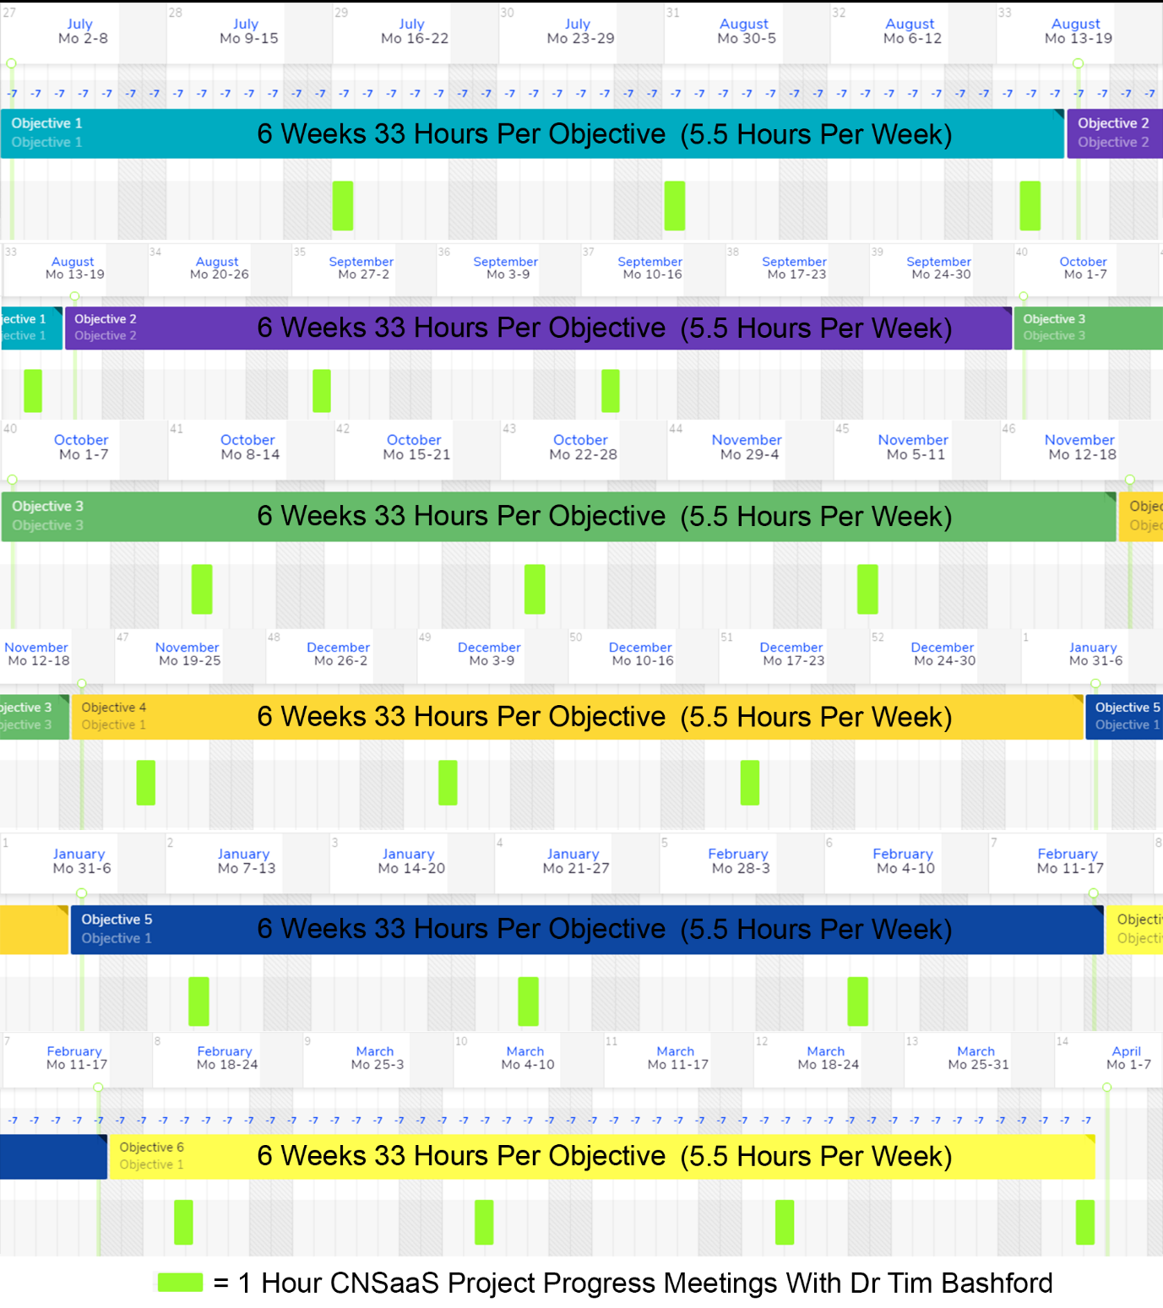
Figure 8: Gantt Chart for CNSaaS Project

References
[1] R. C. Garcia and J. M. Chung, “XaaS for XaaS: An evolving abstraction of web services for the entrepreneur, developer, and consumer,” in Midwest Symposium on Circuits and Systems, 2012, pp. 853–855.
[2] nssit, “What is the Cost of IT Support for Small Business? - IT Services in Denver | Denver IT Support | Network Technology Consultants,” nssit.com, 2018. [Online]. Available: http://www.nssit.com/what-is-the-cost-of-it-support-for-small-business/. [Accessed: 04-May-2018].
[3] Cisco, “Cisco Network Topologies and LAN Design &gt; Foundation Topics,” ciscopress.com. [Online]. Available: http://www.ciscopress.com/articles/article.asp?p=24101. [Accessed: 04-May-2018].
[4] M. Ayyagari, T. Beck, and A. Demirguc-Kunt, “Small and medium enterprises across the globe,” Small Bus. Econ., vol. 29, no. 4, pp. 415–434, 2007.
[5] Cisco, “Internetwork Design Guide -- Internetworking Design Basics - DocWiki,” cisco.com, 2016. [Online]. Available: http://docwiki.cisco.com/wiki/Internetwork_Design_Guide_--_Internetworking_Design_Basics. [Accessed: 04-May-2018].
[6] Microsoft, “Developing Windows Services Applications | Microsoft Docs,” microsoft.com, 2017. [Online]. Available: https://docs.microsoft.com/en-us/dotnet/framework/windows-services/. [Accessed: 04-May-2018].
[7] Microsoft, “Windows Server OS Overview,” microsoft.com, 2018. [Online]. Available: https://msdn.microsoft.com/en-us/library/dn636873(v=vs.85).aspx. [Accessed: 04-May-2018].
[8] Cisco, “WAN Technologies Overview (2.1) &gt; Cisco Networking Academy Connecting Networks Companion Guide: Connecting to the WAN,” ciscopress.com, 2014. [Online]. Available: http://www.ciscopress.com/articles/article.asp?p=2202411&seqNum=4. [Accessed: 04-May-2018].
[9] Cisco, “IP Routing: BGP Configuration Guide, Cisco IOS Release 15M&amp;T - Cisco BGP Overview [Cisco IOS 15.4M&amp;T] - Cisco,” cisco.com, 2018. [Online]. Available: https://www.cisco.com/c/en/us/td/docs/ios-xml/ios/iproute_bgp/configuration/15-mt/irg-15-mt-book/irg-overview.html. [Accessed: 04-May-2018].
[10] Cisco, “Introduction to MPLS,” cisco.com, vol. 1, no. 1, p. 72, 2003.
[11] P. U. Lawrence, “CNSaaS Topology Packet Tracer.”
[12] F. Reid, “FTP,” in Network programming in .NET, 2004, pp. 163–194.
[13] T. Piltzecker, B. Posey, T. Piltzecker, and B. Posey, “Chapter 5 – Configuring DNS,” in The Best Damn Windows Server 2008 Book Period, 2008, pp. 251–347.
[14] S. Clines and M. Loughry, “Active Directory For Dummies,” in Active Directory For Dummies, 2008, p. 360.
[15] J. R. Shapiro and J. Boyce, “DHCP,” in Windows Server 2003 bible, R2 and SP1 edition, 2006, p. 547.
[16] Microsoft, “What’s New in IPAM | Microsoft Docs,” microsoft.com, 2018. [Online]. Available: https://docs.microsoft.com/en-us/windows-server/networking/technologies/ipam/what-s-new-in-ipam. [Accessed: 04-May-2018].
[17] N. R. Danielle Ruest, “Understanding virtualization hypervisor usage,” Tech Target, 2010. [Online]. Available: http://searchservervirtualization.techtarget.com/tip/Virtualization-hypervisor-comparison-Type-1-vs-Type-2-hypervisors.
[18] T. C. Bressoud and F. B. Schneider, “Hypervisor-based fault tolerance,” ACM Trans. Comput. Syst., vol. 14, no. 1, pp. 80–107, 1996.
[19] DATA-Projections, “Understanding How A Network Operations Center Works,” dataprojections.com, 2017. [Online]. Available: https://www.dataprojections.com/dp-blog/understanding-how-a-network-operations-center-works/. [Accessed: 04-May-2018].
[20] P. Lecoy, Fibre-Optic Communications. 2010.
[21] K. Thyagarajan and A. Ghatak, Fiber Optic Essentials. 2007.
[22] N. Angelescu, D. C. Puchianu, G. Predusca, L. D. Circiumarescu, and G. Movila, “DMVPN simulation in GNS3 network simulation software,” in Proceedings of the 9th International Conference on Electronics, Computers and Artificial Intelligence, ECAI 2017, 2017, vol. 2017–Janua, pp. 1–4.
[23] SAID VANDEKLUNDERT, “Hub and Spoke Topology,” www.saidvandeklundert.nl, 2017. [Online]. Available: https://www.saidvandeklundert.nl/hub-and-spoke-vpn.php. [Accessed: 04-May-2018].
[24] IBM, “IBM Knowledge Center - SAN fabric overview,” ibm.com, 2018. [Online]. Available: https://www.ibm.com/support/knowledgecenter/en/HW94I/svc_sanfabricoverview_27wwma.html. [Accessed: 04-May-2018].
[25] G. M. Os, “VM ( operating system ),” System, 2011. .
[26] Centre for Economics and Business Research, “SME investment | Centre for Economics and Business Research,” cebr.com, 2017. [Online]. Available: https://cebr.com/reports/london-loves-business-talent-is-number-one-priority-for-sme-investment/. [Accessed: 04-May-2018].
[27] J. Bond, “Who Manages Cloud IaaS, PaaS, and SaaS Services – The Enterprise Cloud Blog,” mycloudblog7.wordpress.com, 2013. [Online]. Available: https://mycloudblog7.wordpress.com/2013/06/19/who-manages-cloud-iaas-paas-and-saas-services/. [Accessed: 04-May-2018].
[28] C. Heinle and J. Strebel, “IaaS adoption determinants in enterprises,” in Lecture Notes in Computer Science (including subseries Lecture Notes in Artificial Intelligence and Lecture Notes in Bioinformatics), 2010, vol. 6296 LNCS, pp. 93–104.
[29] A. Iosup, R. Prodan, and D. Epema, “IaaS Cloud Benchmarking: Approaches, Challenges, and Experience,” in Cloud Computing for Data-Intensive Applications, 2014, pp. 83–104.
[30] D. Beimborn, T. Miletzki, and S. Wenzel, “Platform as a service (PaaS),” Bus. Inf. Syst. Eng., vol. 3, no. 6, pp. 381–384, 2011.
[31] S. FINEBERG, “To SaaS or not to SaaS….,” Account. Today, vol. 24, no. 5, p. 29, 2010.
[32] W. S. McNee, “SaaS 2.0,” J. Digit. Asset Manag., vol. 3, no. 4, pp. 209–214, 2007.
[33] Amazon Web Services, “Amazon Elastic Compute Cloud (Amazon EC2),” Amaz. Web Serv. LLC, vol. 2010, 2011.
[34] Google, “Google App Engine,” Development, vol. 2009, pp. 1–10, 2011.
[35] Microsoft, “Microsoft Azure,” Microsoft, 2016. [Online]. Available: https://azure.microsoft.com/en-in/.
[36] Gartner, “Gartner,” IT glossary, 2018. [Online]. Available: https://www.gartner.com/it-glossary/digitalization/.
[37] Gartner Inc, “What is a SMB? - Gartner Defines Small and Midsize Businesses,” gartner.com, 2018. [Online]. Available: https://www.gartner.com/it-glossary/smbs-small-and-midsize-businesses. [Accessed: 04-May-2018].
[38] Vitesse Media Plc, “One million pound average expenditure for UK SMEs,” smallbusiness.co.uk, 2017. [Online]. Available: http://smallbusiness.co.uk/million-average-expenditure-uk-smes-2540658/. [Accessed: 04-May-2018].
[39] S. M. Rosecrans, Marie (SVP, “Small &amp; Medium Business Trends Report,” sfdstatic.com, vol. 1, no. 1, p. 1, 2017.
[40] Wikipedia, “Apache HTTP Server,” English. pp. 6–9, 2012.
[41] Memoireonline, “Memoire Online - LAN Toplogy,” memoireonline.com, 2014. [Online]. Available: https://www.memoireonline.com/07/15/9211/Design--implementation-and-management-of-secured-lan.html. [Accessed: 04-May-2018].
[42] fschub, “Wan topology Archives,” 2017, 1AD. [Online]. Available: http://fschub.com/tag/common-physical-wan-topology/. [Accessed: 04-May-2018].
[43] J. G. Scudder and R. Dube, “BGP scaling techniques revisited,” ACM SIGCOMM Computer Communication Review, vol. 29, no. 5. p. 22, 1999.
[44] J. H. Park, R. Oliveira, S. Amante, D. McPherson, and L. Zhang, “BGP route reflection revisited,” IEEE Communications Magazine, vol. 50, no. 7. pp. 70–75, 2012.
[45] D. Medhi and K. Ramasamy, “MultiProtocol Label Switching (MPLS),” in Network Routing, 2018, pp. 734–764.
[46] L. De Ghein, MPLS Fundamentals. 2006.
[47] Y. Zhao and Z. Deng, “A design of WAN architecture for large enterprise group based on MPLS VPN,” in Proceedings - 2012 International Conference on Computing, Measurement, Control and Sensor Network, CMCSN 2012, 2012, pp. 340–342.
[48] A. A. Jaha, F. Ben Shatwan, and M. Ashibani, “Proper Virtual Private Network (VPN) solution,” in Proceedings - The 2nd International Conference on Next Generation Mobile Applications, Services, and Technologies, NGMAST 2008, 2008, pp. 309–314.
[49] M. E. O’Kelly, “A geographer’s analysis of hub-and-spoke networks,” J. Transp. Geogr., vol. 6, no. 3, pp. 171–186, 1998.
[50] Oracle, “OSM System Administration Overview,” oracle.com, 2008. [Online]. Available: https://docs.oracle.com/cd/E35413_01/doc.722/e35414/adm_sysadmin_about.htm. [Accessed: 04-May-2018].
[51] J. Griffin, “SolarWinds.,” Database Trends & Applications, vol. 28, no. 6. p. 41, 2014.
[52] Solarwinds, “orion_netflow_traffic_analyzer-59953-1,” www.solarwinds.com, 2016. [Online]. Available: http://www.solarwinds.com/netflow-traffic-analyzer.
[53] B. Xi, H. Chen, W. S. Cleveland, and T. Telkamp, “Statistical analysis and modeling of internet voip traffic for network engineering,” Electron. J. Stat., vol. 4, pp. 58–116, 2010.
[54] FreeBSD Project, “Linux Free BSD Server,” https://www.freebsd.org/, 2018.
[55] RedHat, “Red Hat - We make open source technologies for the enterprise,” redhat.com, 2018. [Online]. Available: https://www.redhat.com/en. [Accessed: 04-May-2018].
[56] Research-methodology, “Positivism - Research Methodology,” research-methodology.net, 2018. [Online]. Available: https://research-methodology.net/research-philosophy/positivism/. [Accessed: 04-May-2018].
[57] BL Business UK ltd, “What is Quantitative Research?,” www.bl.uk, vol. 1, 2017.
[58] P. L. Weaver, Success in your project : a guide to student system development projects. Prentice Hall Financial Times, 2004.
[59] A. Bennett and C. Elman, “Case Study Methods in the International Relations Subfield,” Comp. Polit. Stud., vol. 40, no. 2, pp. 170–195, Feb. 2007.
[60] Lusthaus C, A. M. Anderson, and Carden F, “What are the advantages of document review?,” Int. Dev. Res. Cent., 1999.
[61] bcps.org, “Develop a Research Proposal - Document Review and Analysis,” bcps.org, 2018. [Online]. Available: https://www.bcps.org/offices/lis/researchcourse/develop_docreview.html. [Accessed: 04-May-2018].
[62] D. E. Avison and G. (Guy) Fitzgerald, Information systems development : methodologies, techniques and tools. McGraw-Hill, 2006.
[63] M. N. K. Saunders, P. Lewis, and A. Thornhill, Research methods for business students. Pearson, 2012.
[64] B. Boehm, “A Spiral model of software development and enhancement,” in Software Management, Seventh Edition, 2007, pp. 37–48.
[65] itinfo, “Software Development Methodologies,” itinfo.am. [Online]. Available: http://www.itinfo.am/eng/software-development-methodologies/. [Accessed: 04-May-2018].
[66] B. Boehm, “Spiral Development : Experience , Principles , and Refinements,” Spiral Dev. Work. Febr. 9, 2000, no. July, p. 49, 2000.
[67] A. J. M. Spencer, “Theory of Invariants,” in Mathematics, 1971, pp. 239–353.
[68] dcsl software, “The pros and cons of Spiral Software Development | DCSL Software Ltd,” dcslsoftware.com, 2017. [Online]. Available: https://www.dcslsoftware.com/pros-cons-spiral-software-development/. [Accessed: 04-May-2018].
[69] istqbexam-certification, “What is Spiral model- advantages, disadvantages and when to use it?,” http://istqbexamcertification.com, 2017. [Online]. Available: http://istqbexamcertification.com/what-is-spiral-model-advantages-disadvantages-and-when-to-use-it/. [Accessed: 04-May-2018].
[70] C. Norris, J. Perry, and P. Simon, “Project Risk Analysis and Management-a Guide By the Association for Project Management,” Proj. Risk Anal. Manag., pp. 1–11, 2000.
[71] PRINCE2, “Risk Management Strategy - PRINCE2 2017 Primer - PRINCE2 Practitioner Self Study Tuition Exam Training Online,” prince2primer.com, 2018. [Online]. Available: https://www.prince2primer.com/risk-management-strategy/. [Accessed: 04-May-2018].
[72] P. U. Lawrence, “Risk Matrix - Microsoft Word.”
[73] SAS, “What is network latency and how do you use a latency calculator to calculate throughput?,” sas.co.uk, 2018. [Online]. Available: https://www.sas.co.uk/blog/what-is-network-latency-how-do-you-use-a-latency-calculator-to-calculate-throughput. [Accessed: 04-May-2018].
[74] D. Patterson, “Latency lags bandwidth,” in Proceedings - IEEE International Conference on Computer Design: VLSI in Computers and Processors, 2005, vol. 2005, p. 3.
[75] F. Latency, S. F. Latency, and W. Latency, “Latency on a Switched Ethernet Network 1,” Network, no. 905, pp. 4–9, 2008.
[76] A. R. Reibman and D. Poole, “Predicting packet-loss visibility using scene characteristics,” in PACKET VIDEO 2007 - 16th International Packet Video Workshop, 2007.
[77] J. Bi, Q. Wu, and Z. Li, “Packet delay and packet loss in the Internet,” in Proceedings - IEEE Symposium on Computers and Communications, 2002, pp. 3–8.
[78] J. C. Bolot, “Characterizing end-to-end packet delay and loss in the internet,” J. High Speed Networks, vol. 2, no. 3, pp. 305–323, 1993.
[79] A. Dunkels, “Throughput,” Science (80-. )., pp. 1–12, 2008.
[80] V. D’Argenio, “The High-Throughput Analyses Era: Are We Ready for the Data Struggle?,” High-Throughput, vol. 7, no. 1, p. 8, 2018.
[81] T. Johnson, “Throughput,” Annals of Internal Medicine, vol. 155, no. 2. p. 133, 2011.
[82] Cisco, “Understanding Jitter in Packet Voice Networks (Cisco IOS Platforms) - Cisco,” cisco.com, 2006. [Online]. Available: https://www.cisco.com/c/en/us/support/docs/voice/voice-quality/18902-jitter-packet-voice.html. [Accessed: 04-May-2018].
[83] E. Sustainability, “Globalization and its Impact on Environmental Sustainability,” Acad. World Bus. Mark. Manag. Dev., pp. 259–289, 2000.
[84] thwink, “The Three Pillars of Sustainability,” thwink.org, 2018. [Online]. Available: http://www.thwink.org/sustain/glossary/ThreePillarsOfSustainability.htm. [Accessed: 04-May-2018].
[85] install, “Renewables Obligation: Sustainability Criteria,” 2015.
[86] G. Chart, “Gantt chart,” tutorialspoint, 2013. [Online]. Available: http://www.tutorialspoint.com/management_concepts/gantt_chart_tool.htm.

Bibliography

Bruno, Anthony; Jordan, Steve CCDA ‘Cisco Network Design’ 200-310 official cert guide (2016)
ISBN-10: 1-58714-454-9

Horine, Gregg Project Management Absolute Beginners Guide, Fourth Edition (2017)
ISBN-10: 0-7897-5675-7

Odom, Wendell CCNA ‘Routing and Switching’ 200-105 official cert guide cisco press (2016)
ISBN-10: 1-58720-580-7

Santos O, Stuppi J, Cisco CCNA security 210-260 official cert guide (2016)
ISBN: 1587205661

