“I confirm that I have not used any AI tools in the research and creation of this assignment. I confirm that I have not presented any AI generated materials as my own work. I confirm I have copies of my drafts, notes, and other resources I used, which I may be asked to provide in evidence.”
  placement research project  The influence of inclusive and transformational leadership on employee motivation and service quality in hotels. A case study. | Module: Hotel Placement Research Project  Module code: BMIH6008  Lecturer: Kathryn Flynn  Author: Marinela Covasneanu  Student number: 1920078  Word count: 7317

Acknowledgement


I would like to express my appreciation to everyone who supported me throughout the development of this research. I am grateful to the lectures of University of Wales Trinity Saint David that helped me, during my three years of academic classes, to gain all necessary knowledge, gave me guidance, constructed feedback, and encouragement, to shape the direction of this study. Also, my sincere gratitude to the Novotel Cardiff Centre Hotel’s management team and staff for allowing me to do my placement in order to gain hospitality experience.
My heartfelt thanks extend to my family and friends for their support, patience, and belief in me and my abilities. Their encouragement was a constant source of motivation to continue.

Abstract
This case study investigates the influence of leadership behaviours on employee motivation and service performance within the multicultural environment of Novotel Cardiff Centre. The Hospitality sector relies heavily on frontline employees to deliver consistent, high-quality service, yet the pressure of dynamic operations, diverse teams, and fluctuating guest expectations create complex challenges for effective leadership. Drawing on qualitative findings and established theoretical frameworks, the study examines how inclusive and transformational leadership shape employee experiences, team cohesion, and service outcomes, while also identifying the contextual limitations that affect their practical application in hotel settings.
The research highlights that inclusive leadership plays a foundational role in creating a supportive and psychologically safe workplace. Employees reported feeling more valued, respected, and confident when leaders demonstrate fairness, active listening, and openness to diverse perspectives. These behaviours were particularly important in a multicultural workforce, where differenced in communication styles and cultural expectations can easily lead to misunderstandings or feeling of exclusion. Inclusive leadership was found to strengthen trust, encourage participation, and enhance motivation, ultimately contributing to a more harmonious and collaborative service environment.
Transformational Leadership also emerged as a crucial driver of service quality. Leaders who communicate a sense of purpose, show enthusiasm, and encourage personal development were perceived as inspiring and animating. Employees feel motivated to exceed expectations and take greater ownership of guest experiences when transformational leaders guide them. The finding also revealed that effectiveness of this leadership style is shaped by operational realities. High workloads, emotional labour, emotional labour, and staffing pressures can limit leader’s ability to consistently provide coaching, vision, and development support. In some cases, the aspirational nature of Transportational Leadership risked creating additional pressure for employees already working under demanding conditions.
A central theme across the findings is the role of motivation as an engine linking leadership behaviours to service performance. When employees feel supported, recognised, and empowered, they were more likely to demonstrate initiative, maintain a positive attitude, and engage in discretionary effort. Inconsistent leadership practices or unclear expectation weakened motivation and contributed to variability in service delivery. The study highlights that while cultural differences enrich service interaction and broaden the hotel’s capabilities, they require intentional management to prevent communication challenges and uneven participation. The discussion emphasises the need for leadership approaches that balance inspiration with practicality, cultural sensitivity, and operational awareness. Recommendations include implementation of structural leadership development programmes, strengthening communication systems, promoting consistency across shifts, investing in employee wellbeing, and leveraging diversity as a strategic asset. These measures aim to create a more cohesive leadership culture, enhance motivation, and support sustainable service excellence. Overall, the study shows how leadership practices directly influence employee experience and service quality in a multicultural hotel setting. The insights gained offer practical guidance for hospitality organisations.

Table of Contents
Acknowledgement 1
Abstract 1
Table of Contents 3
Introduction 5
Literature Review 6
❖ Understanding Leadership within Hotel Industry 6
❖ Transformational Leadership and Service Performance 8
❖ Inclusive Leadership and Employee Motivation 9
❖ Identified Gaps in the Literature. 11
Methods 12
❖ Research Design 12
❖ Data Sources 13
❖ Search Strategy 14
❖ Ethical Considerations 15
❖ Feasibility and Limitations 15
Findings and Discussion 15
Findings 16
1. Influence of Inclusive Leadership on Employee Motivation 16
Fairness, Belonging, and Motivation 16
Psychological Safety and Employee Voice 18
Boosting Confidence and Independence 19
2. Impact of Transformational Leadership on Service Quality 19
Intellectual Stimulation and Service Innovation 20
Individual Tailored Support and Employee Development 20
Inspirational Motivation and Service Climate 21
3. Leadership Behaviours and Employee Experiences in Diverse Hotel Workforces 22
Diversity as a Strength and a Challenge 22
4. The Joint Impact of Inclusive and Transformational Leadership 23
Discussions 24
1. Interpreting Inclusive Leadership in Light of Existing Literature 24
Limitation in Inclusive Leadership Practices Application 25
2. Transformational Leadership and Service Climate 26
Limitation in Transformational Leadership Application 27
Conclusion 30
Recommendations 32
❖ Strengthen Internal Communication Channels 33
❖ Invest in Employee Wellbeing and Workload Management 33
❖ Align Leadership Practices with Operational Realities 33
❖ Implement Systems for Recognising Employees Contributions 34
❖ Enhance Opportunities for Employees Development 34
❖ Leverage Workforce Diversity as a Strategic Asset 34
❖ Establish a Structured Leadership Development Programme 34
❖ Promote Consistency Across Shifts Through Clear Leadership Standards 35
❖ Implement a Continuous Feedback and Reflection System 35
References 35
Appendices 47

Introduction
The interest in Transformational Leadership, Employee Wellbeing and Strategic Organisational Change, combined with first-hand exposure to the diverse workforce within the author of this case study placement hotel, has informed the selection of this topic “The influence of Inclusive and Transformational Leadership on Employee Motivation and Service Quality in hotels. A case study.”
Leadership has long been considered as a decisive factor of employee attitude, operational performance, and service quality in the hotel industry. The hotel working force must deliver excellence experiencing emotional demands and shifting customer expectation. As a result, leadership styles that foster motivation, engagement, inclusivity, and emotional safety are extremely dominant in shaping service outcomes. Within this context Inclusive and Transformational Leadership styles make an appearance as the two most relevant approaches for enhancing employee motivation and improving service quality in modern hotel and hospitality industry.
This study focuses on Novotel Cardiff Centre, a mid-scale hotel, part of Accord hotel chain, situated near many Cardiff attractions such as: Cardiff Bay, Cardiff Castle, Shopping Centre Mall, and Bute Park (ALL Accor, 2026). The hotel is offering a variety of facilities: swimming pool, steam room, gym, meeting rooms, bar and two restaurants, tailored for a wide variety of customers from family with children to business travellers (Appendix 2), (Tripadvisor, 2025).
To ensure academic precision the research for this case study adopts a structured and systematic approach to secondary data analysis. The framework includes a structured search strategy, clear inclusion and exclusion criteria, critical evaluation of sources, and subject related mixture of findings. Peer reviewed journals, books, industry reports, company websites, and existing studies are the base of the research sources, and Transformational Leadership Theory, Inclusive Leadership, and Motivation Theory provide the conceptual foundation.
Considering the fact that the hospitality industry relies heavily on frontline staff to deliver consistent guest experiences and understanding how leadership influences the environment and workforce, this research aims to provide an in-depth knowledge of how inclusive and Transformational Leadership influence and shape employee motivation and service quality in hotels. And by examining employee perceptions, leadership driven motivational mechanisms, and barriers to inclusive practice, is focusing to clarify how leadership behaviours translate into service quality and measurement performance.
Following this introduction, the case study examines the key findings from the literature highlighting the elected subject. The discussion interprets these findings by comparing leadership behaviours, identifying motivational mechanisms, and acknowledging barriers that limits inclusive practice, such as organisational culture or inconsistent managerial capability. The conclusion synthetises all insights, emphasising the importance of supportive, empowering leadership for sustaining service excellence. Finally, the recommendations outline practical, realistic, measurable strategies for hotel managers, including strengthening communication, developing inclusive leadership competencies, and fostering motivational climates that translate into improved guest experiences.

Literature Review

This literature review examines existing research on Transformational and Inclusive Leadership style applied in contemporary hotel management strategies, its impact on employee motivation and their relationship with performance and service quality.
With a raised customer contact service, using a heavy emotional labour, and depending on diverse workforce effective leadership is essential for sustaining motivation and service quality for the hotel industry employee (Baytok et al, 2023). Transformational and Inclusive Leadership have a significant importance because of their positive and constructive influence on the workforce wellbeing (Mullins & Dossor, 2013).

Understanding Leadership within Hotel Industry

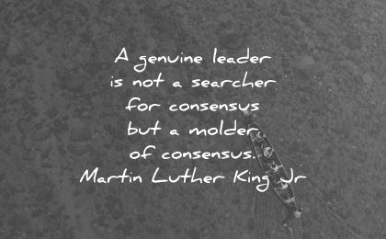
Martin Luther Jr said, “A genuine leader is not a searcher for consensus but a moulder of consensus” highlighting that a leader does not just follow what everyone says, rules, and what is expected, he helps people to agree on a correct, shared understanding.
(AZQuotes.com, 2026)
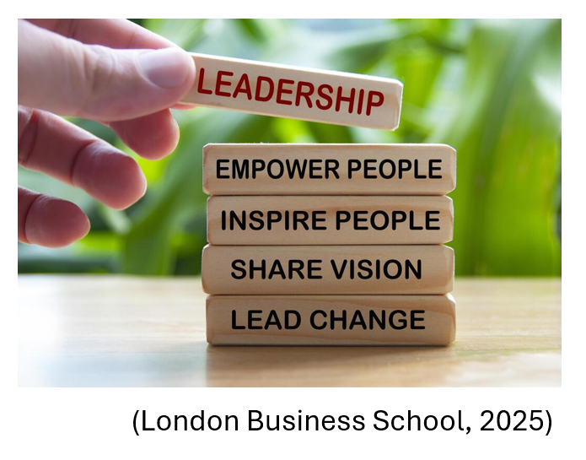
Leadership is about helping people to do their best work by guiding them, supporting them, and showing them the right direction to go toward organisational goals (Bolden et al, 2023).
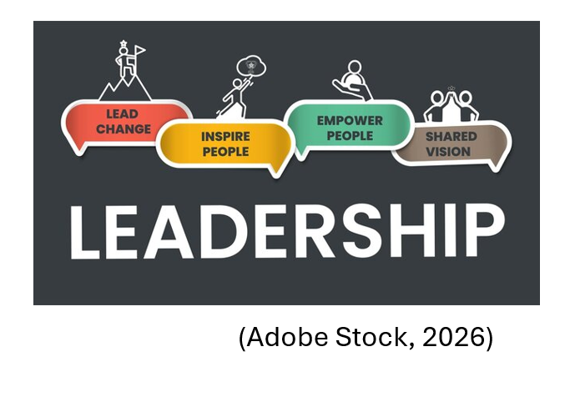
Academic literature sustains that leadership in hotel industry is a complex process that shapes both service quality and organisational performance (Yukl & Gardner, 2020). Scholars in hotel industry management highlights that effective leadership involves communicating a clear, customer centred vision that aligns company culture with employee wellbeing, and employee behaviour with guest expectations (Rumsey, 2013). A theme consistent with Transformational Leadership theories that highlights inspiration and shared purpose.
Also, accentuates that leadership is the key driver of employee engagement, motivation, and discretionary effort. These factors are considered essential for maintaining service quality (Brownlee & linkedin.com, 2023). In addition, hospitality scholars argue that its effectiveness is increase due the industry specific continuous challenges: unpredictable guest demand, emotional labour, multicultural teams, and high turnover. Taking in consideration a PESTLE analysis of the hotel industry (Appendix 1) these conditions require leaders who can inspire, support, and empower employees, to align with contemporary customer expectations.

Transformational Leadership and Service Performance
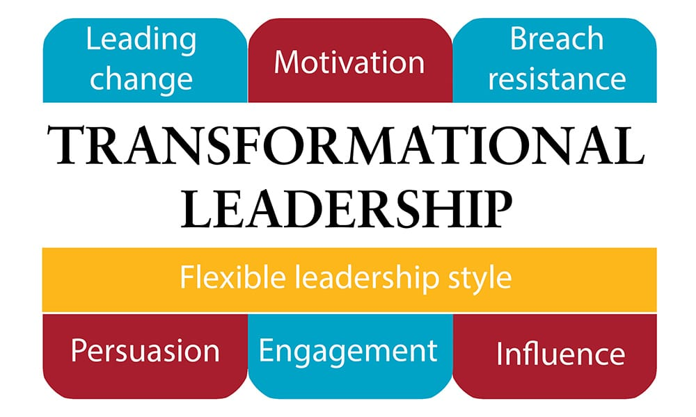
(Online Pictures, 2026)
The leadership style adopted by a business, became an essential part of the management adaptation to the necessary organisational change (Zheng et al, 2017). The first-hand experience offered to the author of this case study, by the student placement at Novotel Cardiff Centre Hotel, revealed that the management team and its employees work together to do the correct changes to reach higher levels of motivation, development, and implicitly higher quality in guest experience. Their Transformational Leadership encourage innovation and provides personalised support. Recent studies reveal that applying this kind of leadership has a positive impact on both individual and organisational performance (Dias & Magalhães, 2023). In one of the first studies by Hinkin and Tracey (1996), their findings show that when hospitality managers adopt Transformational Leadership style, employees experience more open communication, clearer understanding of their roles and goals, greater satisfaction with their leaders, and higher perceptions of leadership effectiveness.
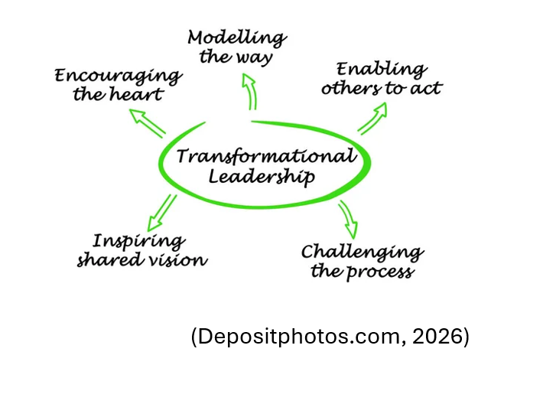
In addition, this style promotes creativity and problem solving, enabling employees to deliver personalised experience and respond effectively to customer needs (Kim et al, 2023). This is a key in hotel service, where experience differentiation often depends on employee skills and ability to exceed the guest expectations (Ortega, 2024).
The research on hospitality management reveal that a vital role plays the creation of a positive service climate (Szende et al, 2021). Setting high expectation, providing support, and recognising employee contribution the management team encourage people to engage in discretionary service behaviours that enhance customer expectation (Kandampully et al, 2018).
While Transformational Leadership is widely praised, scholars note that it may be less effective in highly standardised services environments with limited employee autonomy (Duan et al,2017), requires strong emotional intelligence (Pulido-Martos et al, 2024) and interpersonal skills, and it is dependable of cultural and organisational norms and structures (Katsaros, 2025).

Inclusive Leadership and Employee Motivation

Evidence from Inclusive Leadership research is directly applicable to Novotel Cardiff Centre, whose ethnically diverse workforce highlights the need for leadership behaviours that foster equity, psychological safety, and meaningful employee participation (Calori et al, 2000). Studies consistently show that Inclusive Leadership is most effective in environments where diversity is prominent, as it promotes fairness and open communication. Within Novotel Cardiff Centre, these behaviours are essential for ensuring that employees feel valued and supported, regardless of their origine and background (Tschelisnig & Westerlaken, 2022).
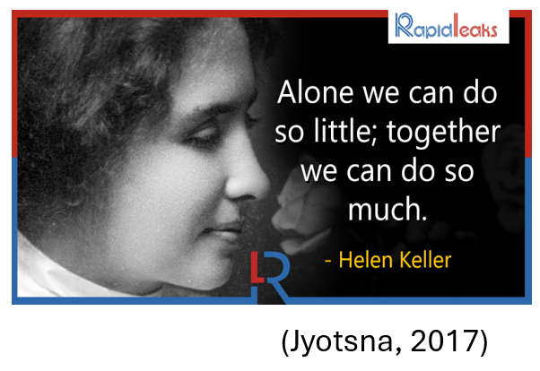
Hellen Keller said: “Alone we can do so little; together we can do so much” (Jyotsna, 2017). Inclusive Leadership is welcoming in an already formed group, different background, or culture individuals, treat them equally, forming and maintaining strong and positive work relationship (Shore & Chung, 2022). Studies argue that hospitality workforce is typically multicultural, with employees from diverse cultural, linguistic, and educational backgrounds (Boella & Goss-Turner, 2020). Inclusive Leadership helps bridge these differences by promoting fairness and respect (Manoharan & Singal, 2017). Research shows that inclusive leaders reduce interpersonal conflict, strengthen team cohesion, and improve communication, factors that directly influence service quality (Khassawneh & Mohammad, 2025).

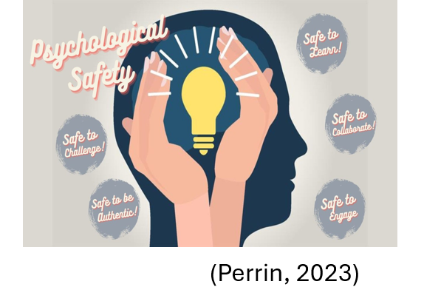
Also, a concept widely discussed in organisational behaviour literature is psychological safety, part of Inclusive Leadership. It enables employees to express ideas, participate in making decisions, raise concerns, with trust and confidence without fear of negative consequences (Perrin, 2023).
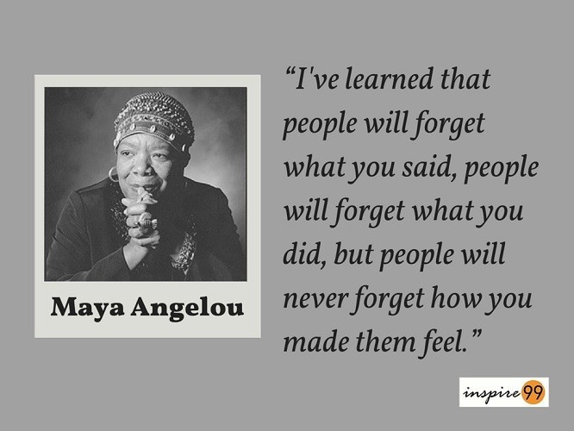
(Rittman, 2019)
As Maya Angelou said: “I’ve learned that people will forget what you said, people will forget what you did, but people will never forget how you make them feel.” (Rittman, 2019).
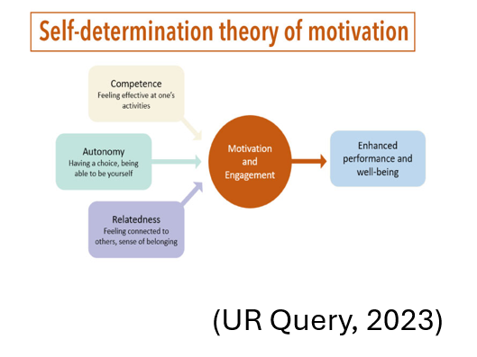
And according to the Self Determination Theory (Ryan, 2023), leaders who involve employees in making decision, offer constructive feedback, and acknowledge individual contribution help employee to feel more capable, confident, valued, and engaged in their work (Ryan & Deci, 2017).
In addition, research show that inclusive leaders reduce interpersonal conflicts, strengthen team solidarity, and improve communication, factors that directly influence performance and service quality (Bibi et al, 2025).
Despite its benefits, Inclusive Leadership faces the hierarchy of organisational structures barrier that limits the employee voice along with time pressure, inconsistent managerial capability and cultural norms that discourage open communication.

Identified Gaps in the Literature.
Although leadership research in hospitality has grown substantially, several important gaps remain, many of which became evident through this case study. These gaps explain why leadership challenges persist in hotel like Novotel Cardiff Centre and why further research is needed to deepen understanding of leadership, motivation dynamics in multicultural service environments. Examples are:
- lack of integrated models linking to leadership, motivation, and service quality
- inconsistent findings, due to the cultural and organisational differences
- insufficient assessment of barriers, which limits Inclusive Leadership
- limited case studies research that explores leadership behaviours in Novotel Hotels
- under-representation of Inclusive Leadership in hospitality research.
- Scarcity of case-based research in mid-scale branded hotels
These gaps are accounted for the need of a focused case study exploring how inclusive and transformational leadership influences employee motivation and service quality within a specific hotel environment.

Methods
This section of the case study outlines the research design, data collection strategy, analytical approach, and ethical considerations supporting this paper. The aim is to ensure methodological clearness and demonstrate how the chosen methods back up a rigorous examination of the influence of Inclusive and Transformational Leadership on employee service quality and motivation within hotel environments.


Research Design
Given the conceptual nature of leadership and motivation, and the existing scholarship in these areas, this case study adopts the first-hand author’s placement experience and secondary research design. First hand experience is based on what the author seen, heard of experienced during his working along the Novotel Cardiff Centre Hotel team. While secondary research is appropriate because of its richness in theoretical and empirical literature, that already exists, instead of primary data collection that may be constrained by practical, ethical, or organisational limitations (Saunders et al, 2023). In the context of hotel operations, gaining access to their information about internal performance, employee and management team, is challenging due to confidentiality, restrictions, laws, and commercial sensitivity.
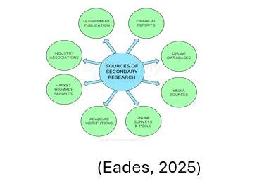
Therefore, a secondary research approach provides a feasible and academically method for exploring the case study theme without requiring fieldwork, extra time, and necessary ethical consent. Also, enables the researcher to identify, evaluate, and synthesise relevant academic resources. This approach supports development of rational understanding of how Inclusive and Transformational Leadership influence employee motivation and service delivery, while identifying gaps in the current evidence base.

Data Sources


Accessed through online database and digital libraries due the author student status, distance learner, the data for this study was collected exclusively from credible academic and industry sources. Such as:
- Academic books on leadership theory, motivation, and hotel and hospitality management.
- Governmental and professional publications related to labour markets, service standard, performance, and diversity.
- Peer-reviewed journal articles about hospitality management, leadership, and organisational psychology.
- Industry reports from hospitality organisations, tourism associations, and consultancy companies.
- Already existing case studies on the same theme or related to the information needed for the actual case study, and relevant to diverse workforces and leadership practices.
Data bases such us: Library UWTSD portal, ResearchGate, Emerald Insight, Science Direct, and Google Scholar were used to locate relevant academical sources.


Search Strategy
Only credible and up to date information were included to ensure feasibility. Searches were limited to the sources published within five to ten years to provide contemporary relevance, although original theoretical works were included where were necessary. The key words and combination included in research requirements were Transformational and Inclusive Leadership, hotel and hospitality management, diversity, inclusion, leadership behaviours, service quality, performance, employee motivation, and many more related to the case study.

Ethical Considerations

Being a secondary based research case study, this paper does not involve human participants. Collection of personal data, or interviews. Therefore, the ethical risk is reduced to minimal. All sources are referenced and cited accordingly to maintain academic integrity, and only accessible public materials were used.

Feasibility and Limitations

On account of the nature of this work, computer-based research, the feasibility is ensured within the time limit and word count of this project. However, potential limitations are possible gaps in literature, restricted to paid access journals, and the absence of more and accurate information from the primary data sources. These limitations were reduced by using multiple relevant databases, applying thematic comparison to strengthen reliability of findings and prioritising peer-reviewed journals.

Findings and Discussion

This chapter will summarise the findings of the study, organised around understanding how Inclusive Leadership influences employee motivation in hotel environments, examining the impact of Transformational Leadership on service quality, exploring the relationship between leadership behaviours and employee experiences within different hotel workforces and identifying the implications of these management strategies for hotel performance, with specific reference to Novotel Cardiff centre.

Findings

Influence of Inclusive Leadership on Employee Motivation

Fairness, Belonging, and Motivation

Particularly relevant in hotels, where the frontline employees experience emotional labour, customer pressure, and high workloads, is perceiving the leaders as fair and impartial. This kind of leadership creates a trustful environment and makes the employees to confident in the management team, feeling committed to the organisational goals, and invest significant effort in completing their tasks (Barling, 2023). Studies show that Inclusive Leadership helps reduce the feeling of favouritism or bias by communicating more open, sharing work fairly, and recognising everyone in a consistent way (Carroll et al, 2022). For a multicultural hotel such as Novotel Cardiff Centre, these behaviours help to create a well-integrated team environment where employees from diverse backgrounds, such as: Lit from Philippines, Gabriel from Portugal, Barbara from Poland, Anthony from England Sultana and Huzaifa from Arabia, the business manager Alfredo from Spain, feel equally valued.
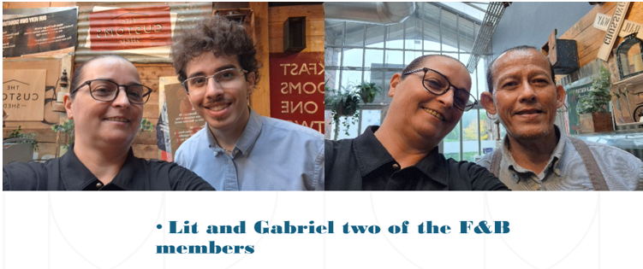
This sense of belonging increase motivation and reduce turnover intentions, a particularly important fact in hotel industry known for its high-rate staff turnover (Bratton et al, 2022). These feelings of fairness and belonging that the inclusive leaders are creating with their employee approaches are strongly linked to motivation. According to an Indeed employee review, the Novotel Cardiff Centre Team are feeling as part of a big family that work together to achieve the same goal (Indeed, 2021).
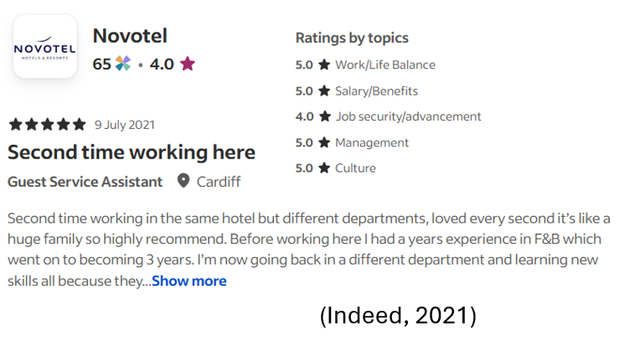

Psychological Safety and Employee Voice

One of the strongest findings across the reviewed literature is that the Inclusive Leadership makes the employee feel comfortable to express their own ideas, to be able to raise concerns and suggestions with confidence, without feeling fear of negative consequences (Jolly & Lee, 2021). This is psychological safety and studies show that is key predictor of employee motivation, especially in this effort and emotional demanding industry such as hotel industry (Umrani et al, 2024). The employees who feel free to speak have the tendency to engage in problem solving, bring new and innovative ideas (Wang et al, 2021) for service improvement, and display initiative-taking behaviour (Kelkay Eshete et al, 2025).


In the context of Novotel Cardiff Centre, where the workforce is highly diverse and includes employees from a wide range of ethnic and cultural backgrounds, psychological safety is essential. Research indicates that communication barriers, cultural misunderstandings, and unequal participation can emerge is such diverse teams. Applying Inclusive Leadership practices, the management team can mitigate these challenges by promoting fairness, respect, and openness. In this manner employee feel more valued when their leaders practice active listen, encourage participation, and acknowledge contributions (Younas et al, 2023).

Boosting Confidence and Independence
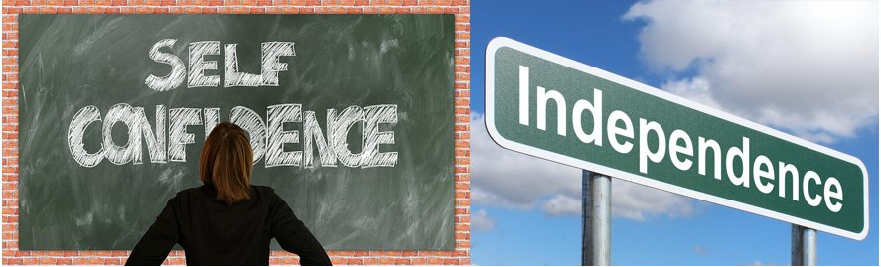
Drawing on Self Determination Theory (Rhyan, 2023), the literature reveals that Inclusive Leadership supports the employee’s basic needs to feel independent, capable, and connected to others (Zhao et al, 2024).
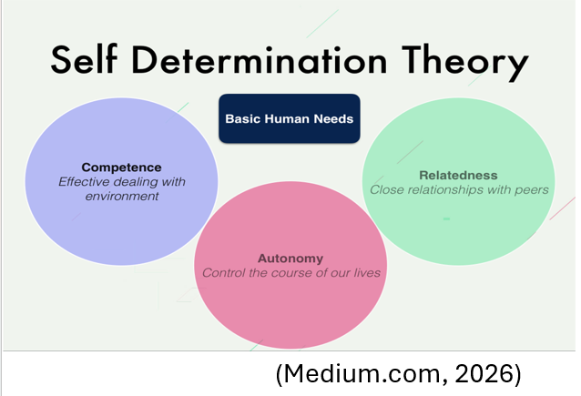
Being involved in decision making, receiving constructive feedback, and being recognised for its individual strengths, makes the employee to feel more efficient and engaged (Stanišić & Čerović, 2021). This is crucial in hospitality, especially in hotel roles that require initiative, adaptability, and emotional intelligence. In hotels, employees face unpredictable guest demands and must take a fast and correct decision to maintain service quality. Inclusive leaders give employees the confidence to take charge of their work, which boost their motivation (Huertas-Valdivia et al, 2019). Evidence supports that when employee feel trusted and supported, they are more likely to go beyond basic jobs requirements and deliver exceptional service (Wand & Yang, 2021).

Impact of Transformational Leadership on Service Quality


Intellectual Stimulation and Service Innovation
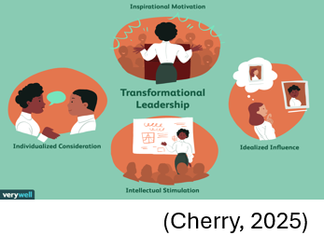
Another key finding is that Transformational Leadership encourage intellectual stimulation (Khan et al, 2025), encouraging employees to think creatively, challenge existing practices, and bring innovative solution to life (Helalat et al, 2023). This kind of behaviour in the hospitality industry, where the guest expectations are in continuous progress, is essential for maintaining competitiveness (Ding & Lin, 2021).
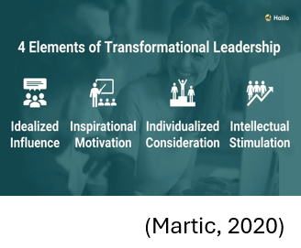
Studies show that Transformational Leadership is more likely to drive employees to bring and suggest improvements to service processes, to easily identify inefficiencies, and to contribute to service innovation (Al Shanqaiti & Farea, 2021). These practices enhance service quality by enabling hotels to adapt to changing customer needs and deliver personalised excellence experiences (El-Hage & Sidani, 2023).

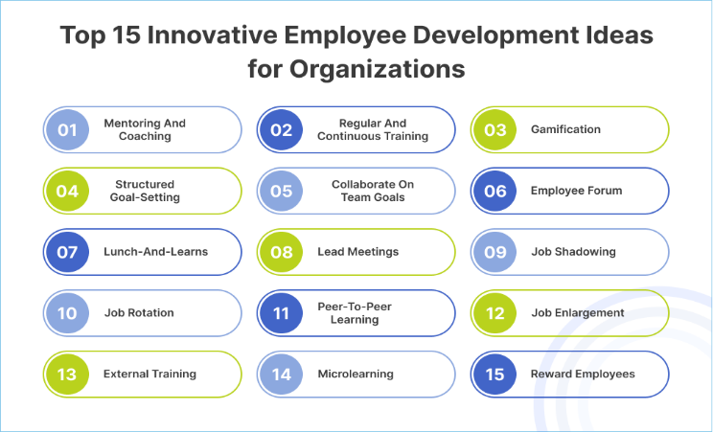
Individual Tailored Support and Employee Development
Transformational Leaders are well known for providing tailored individual support. This includes recognising individual unique strengths, offering customised help, and investing in training for their development (Malik, 2024). Research show that leaders are enhancing employee’s skills, confidence, and commitment to high quality service delivery (Ding & Lin, 2021).
In the context of Novotel Cardiff Centre, where the cultural and educational backgrounds are diverse, individual support and training is valuable. Employee who receives tailored coaching and development opportunities are able to oversee better complex situations, to communicate in an effective manner with the customers, and to provide positive service culture (Kisubu et al, 2025).

Inspirational Motivation and Service Climate

In the hotel environment where service quality is vital for the guest experience outcome, and for nurturing the brand reputation, inspirational motivation play a crucial role. The literature systematically demonstrates that the Transformational Leadership strongly influence the overall service atmosphere in a workplace. These leaders set a clear and inspiring vision for great service, motivate staff to aim for high standards, and constantly highlights how important customer satisfaction is.
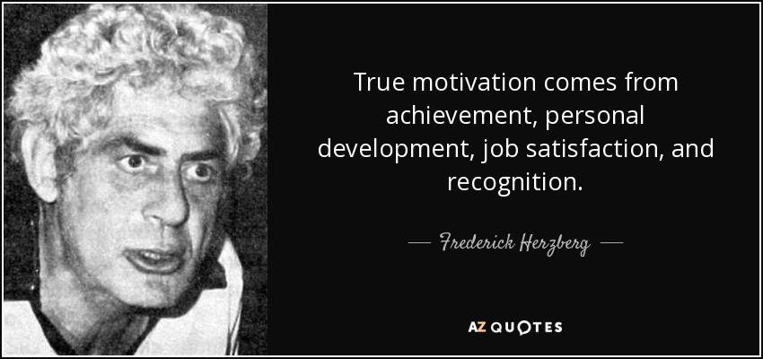
Frederick Herzberg said: “True motivation comes from achievements, personal development, job satisfaction, and recognition.” He means that people motivation come from feeling proud of their work and having a leader that is offering them a possibility of achievement, positive environment, and constant appreciation for individual and team results (‌Medcalf & Birchfield, 2005).
Employee who understands the organisation goals and feels inspired by their leaders are more willing to demonstrate enthusiasm attentiveness, and professionalism in guest interaction (Frank & linkedin.com, 2024).

Leadership Behaviours and Employee Experiences in Diverse Hotel Workforces
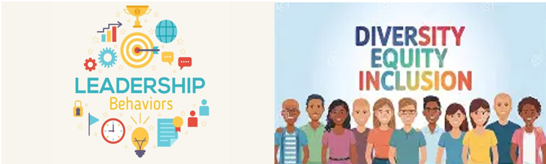

Diversity as a Strength and a Challenge
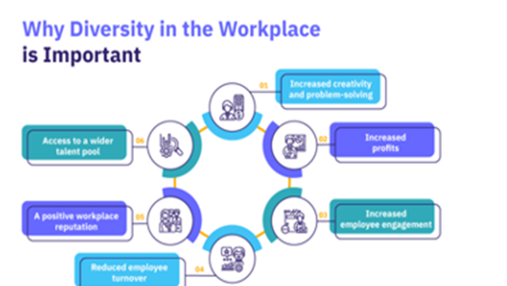
Literature highlights that diversity in hotel workforces can be both an asset and a challenge (Manoharan et al, 2021). Sundar Pichai said, “A diverse mix of voices leads to better discussion, decisions, and outcomes for everyone” (He, 2022). Having a diverse team means you have a great deal of viewpoints, cultural insights, and language abilities, which can really improve the experience for international guests. But if diversity is not managed well can create challenges like communication issues, cultural misunderstandings, or some feeling less involved than others (Moufakkir & Alnajem, 2017).

Inclusive and transformational leaders work well in diverse teams because they focus on fairness, respect, and teamwork. When leaders understand distinct cultures, encourage open conversation, and value each person contribution, it helps the whole team work together more effectively (Madera et al, 2023).
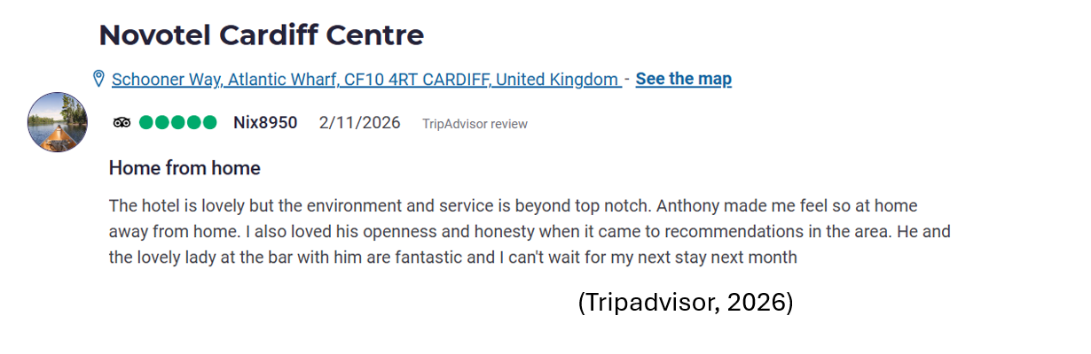
Novotel Cardiff Centre employs people from various ethnic backgrounds, making diversity a defining feature of its workforce. As this positive note of the many good Tripadvisor review and the first-hand placement experience reveal that this hotel leadership behaviours promote inclusion, empowerment, and cultural awareness, and have as a result maintaining motivation and service quality (Tripadvisor, 2026). Being from diverse culture the team members often look to their leaders for guidance on communication norms, conflict resolution, and team cohesion. The environment created due of the presence of inclusive and transformational leaders in the Novotel Cardiff Centre Hotel management team, is making the employee feel valued and confident to share their ideas and perspective.

The Joint Impact of Inclusive and Transformational Leadership

The literature shows that employee motivation is a mediating factor between leadership behaviours and service quality outcomes (Vakira & Shereni, 2025). By shaping employee motivation, engagement, and emotional commitment, leaders along with the whole team influence service quality (Jang, 2024). Motivated employees are more likely to deliver high quality service, respond effectively to the customer’s needs, and demonstrate increased empathy (Wihuda et al, 2017).
Also, a key finding in the literature is that Inclusive and Transformational Leadership styles complement each other. Inclusive strengthen emotional safety, belonging, and fairness while transformational enhance inspiration, development, and innovation. Together create a powerful mixture of employee motivation and service quality improvement (Northouse, 2022).
The hotels, including Novotel Cardiff Centre, which adopts the combination of these two important leadership practices have seen higher employee engagement, lower turnover, stronger service climate, improved guest satisfaction, enhanced organisational reputation, and positive workplace environment. These outcomes all together contribute to long term competitiveness and operational success.
Taken together, the findings show that Inclusive and Transformational Leadership play a crucial, jointly reinforcing role of shaping motivation, strengthening the performance of diverse teams, and enhancing overall service quality. in a multicultural setting like Novotel Cardiff Centre Hotel, these two styles work in tandem to empower employees, bridge differences, and translate into consistently strong service performance.

Discussions
This section critically analyses the research findings in relation to existing literature, addressing the research objective and exploring the implication for leadership, motivation, and service performance within the multicultural environment of Novotel Cardiff Centre. The analysis also acknowledges the study’s limitation and identifies areas of operational relevance for the placement hotel.

Interpreting Inclusive Leadership in Light of Existing Literature
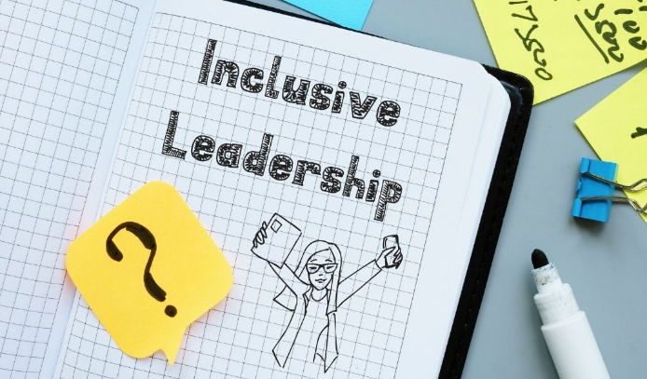
The findings of this study show that Inclusive Leadership significantly enhances employee motivation by fostering psychological safety, fairness, and sense of belonging. This aligns strongly with Caroll et al. (2022), who argue that inclusive leaders create environments where employees feel valued and able to express without fear of negative consequences. In the context of Novotel Cardiff Centre where the workforce is formed with highly multicultural individuals, this sense of safety is particularly essential. Employee may otherwise feel hesitant to speak up, share ideas, or question established practices.
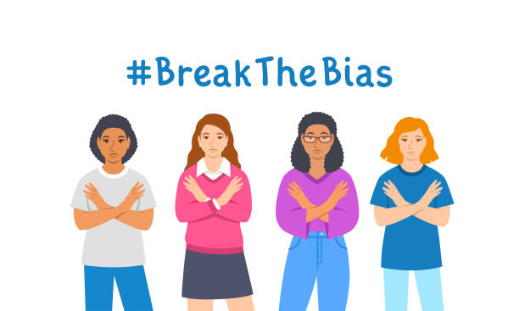
The research supports Kim et al. (2025) argument that inclusive leadership reduces perceived bias and increase perception of fairness. It says that when leaders listen actively, treat the employee fairly, and acknowledge individual needs, make them feel more motivated and more willing to contribute to service excellence. This reinforces the idea that inclusion is not just moral or ethical attitude but a practical leadership approach that directly influence the employee performance.


Limitation in Inclusive Leadership Practices Application
Inclusive Leadership brings many benefits, but there are various challenges that can make difficult to apply fully in the hotel environment and implicitly in Novotel Cardiff Centre Hotel. As example:

- High staff turnover disrupts relationship building. The hospitality is well known for its repeated staff changes. This is an inconvenience in building trust and long relationship that this kind of leadership is based on (Yasin et al, 2023). Making the new arrivals to feel comfortable in speaking and sharing current ideas and to trust the management and the hotel culture take time and lots of training (Li et al, 2025).
- Cultural and language differences. Novotel Cardiff Centre has a truly diverse workforce, which is a strength but also a challenge, due the creation of the communication barriers such as different communication styles or level of confidence (Meira et al, 2023).
- Dynamic workplace that leaves little time for inclusive practices. Constant guests demand, tight schedules, and uncertain situations are the words that describe the hotels environment. Managers have limited time to involve employees in decision, give personalised feedback, and hold open discussions (Lee, 2022).
- Inconsistent leadership skills across departments. Leaders have demonstrated that some can be more opened and supportive while others are more conventional, using top-down approaches (Junaid Aftab et al, 2023). This can lead to mixed experiences for employees and creates dissimilarities in Inclusive Leadership applications (Armstrong 2016).
- Pressure to meet performance targets. Under pressure, which arise from the hotel operations based on severe KPI’s like guest satisfaction scores, service times, occupancy rates, and cost controls, leaders may prioritise efficiency over inclusion, due the impression that involving and encouraging the staff may feel less urgent, even though it remains important.
- Limited employee participation. Inclusive Leadership presumes that workforce want to share ideas, take part in decisions making, and give feedback, fact that does not correspond with the real facts. Some people like clear instructions while others may feel uncomfortable speaking due low confidence levels, or cultural norms (Shein &Shein, 2017).
- Risk of “surface-level” inclusion. It is common for organisations to say their leadership is inclusive, but their day-to-day practices stay the same, without changing behaviours or systems. As a result, frustration and lose of trust is created and employee feel that are not genuine valued (Bharwani & Talib, 2017).

Transformational Leadership and Service Climate

The study found that Transformational Leadership firmly enhance service quality through development, inspiration, and innovation. This aligns with the work of Ding & Lin (2021) and them later Khan et al. (2025), which shows that transformational leaders shape a positive service climate by communicating a strong vision and encouraging employee to achieve higher level of performance.
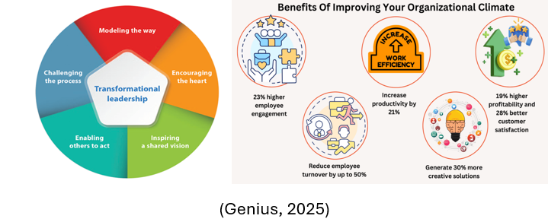
Existing literature highlights this kind of leadership a key driver of service excellence through its ability of motivate, inspire, and align employees around common goals (Yen et al, 2021), (Kim et al, 2023). The present study supports this view, showing that employees respond positively to leaders who clearly communicate the expectations, demonstrate enthusiasm for service quality, and encourage personal and professional development.
At Novotel Cardiff Centre, employees described transformational leaders as those who “set the tone,” “push for high standards,” and “make you want to do better” (Indeed, 2021). The findings support the argument that Transformational Leadership is successful and effective in hotel industry, where emotional labour, guest interaction, and adaptability are crucial practices for performance.

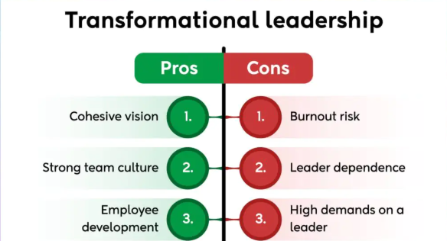
Limitation in Transformational Leadership Application
While Transformational Leadership is recognised for its positive influence on employee development, motivation and service climate, its application in hotel industry presents challenges and limitations, shaped by the intensive labour, multicultural workforce, changing guest expectations, diverse competitor threats, and fast-paced nature of work. This can make the sustainability of this practice difficult. Some of these limitations are:
- High operational pressure and limited time. The fluctuations of the guest demands, occupancy levels, and staff shortage create constant pressure on hotel operations. Transformational Leadership needs time for coaching, creating a long-time vision, mentoring, and training while some of the managers in a busy hotel environment struggle to prioritise these practices. during peak periods, leaders sometimes shift toward more controlling or task orientated methods to maintain workflow continuity. This limits this leadership consistency and depth in practice (Khattak et al, 2024).
- Employee overload and unrealistic expectations. The exceeding expectations and continuous improvement that Transformational leaders encourage to, can elevate service quality, but involuntarily may create pressure, especially where the work atmosphere is already heavy. Employee are feeling force “go over the limit” even when resources are limited, which can lead to burnout or fatigue. This pressure is accumulating quickly in a high demand hotel like Novotel Cardiff Centre (Pertiwi & Rachmawati, 2025).
- Cultural diversity and leadership evaluation. Typically, multicultural and with employee that evaluate the inspirational messages and empowerment different, hotel teams can receive this kind of leadership as nor universally effective. What some perceives as motivation, another may view as unclear and visionary. The rule to success is that leaders adapt their communication style to diverse culture expectations and use their people orientated skills, awareness, and ongoing effort (Yukl & Gardner, 2020).
- Influence of individual leadership characteristics. Not all managers naturally have the right attributes and not feel comfortable to adopt this inspirational leadership style. This creates inconsistency across departments and shift patterns. Inconsistent leadership, in an environment where the guest experience has to have the same high standard, leads to uneven morale a variable service delivery (Martins Abelha et al, 2018).
- Limited resources for training and development. Often the hotels are facing budget constraints, high turnover, and limited capacity. Transformational leaders may struggle to fulfil the developmental component of their role due the inconsistent or unavailable opportunities. This impacts on credibility and limits the effectiveness of their leadership approach (Choi et al, 2019).
- Emotional labour and service fatigue. Maintaining a customer driven attitude, when employees are engaging daily in prominent level of emotional labour, seems an exhausting task to complete. Transformational leadership encourage passion, emotional engagement, and enthusiasm. For the employee already emotionally distressed may be difficult to sustain this level of energy. Without support this leadership expectations feel unrealistic or draining (Hori & Chao, 2022).
- Misalignment with short term operational priorities. Transformational Leadership is a long-term, innovating, and focused on vision personal growth. Prioritising immediate problem solving, rapid decision making, and short-term performance metrics, is often the actual hotel operations. This limits the leaders to engage in transformational behaviours, especially during busy periods or when performance targets take precedence (Day et al, 2014).
- Challenges in measuring impact. The outcomes when applying this leadership style, motivation, empowerment, innovation, are often abstract and difficult to measure. Hotels rely on check-in times, cleanliness score, and guest review, real time metrics. Because of the Transformational Leadership outcomes that are not so visible, they may be undervalued or overlooked in favour of immediate operational measures (Ntalakos et al, 2025).
These limitations resonate strongly with the operational realities of a large, multicultural, city-centred hotel such as Novotel Cardiff Centre. Its busy environment, diverse workforce, shift based structures, and high service expectations create conditions where Transformational Leadership is beneficial but challenging to apply consistently. These limitations highlight the need of a balanced leadership approaches that combine inspiration with practical support, cultural sensitivity, and operational awareness.
Overall, the findings and discussion demonstrate that Inclusive and Transformational Leadership play a crucial role in shaping motivation, cohesion, and service performance within hotels. Together these styles help unlock the potential of multicultural teams, particularly in a dynamic operational setting. Such as Novotel Cardiff Centre. At the same time, the analysis of the limitations arised when these practices will and are put in practice. By recognising both strengths and weaknesses, this chapter provides a nuanced understanding of how leadership behaviours influence employee engagement and wellbeing, and service outcomes, creating a base for practical improvement and future research within hotel industry.

Conclusion
This report set out to explore how leadership behaviours influence motivation and service performance within multicultural environments of a modern hotel, using Novotel Cardiff Centre as a contextual anchor. Through the examination of Inclusive and Transformational Leadership, the dynamics of workforce diversity, and the processes that connect the leadership to employee outcomes, the study has provided a comprehensive understanding of how people focused leadership shapes both employee experience and operational effectiveness in hotel settings. The findings illustrate that leadership is not only a managerial function but essential driver of organisational climate, employee engagement, and service quality.
The research demonstrates that Inclusive Leadership plays an essential role in creating a supportive and equitable workplace culture. Promoting openness, respect, and emotional comfort, inclusive leaders assist the employees to feel valued and recognised, which strengthen their willingness to positively impact the guest experience. Particularly important in multicultural teams, where are diverse communication styles, expectations, and norms, this kind of leadership can easily lead to misunderstandings or feelings of exclusion. This study shows that when the leaders proactively listen, are fair, and support participation, employees demonstrate confidence, cooperation, and commitment to deliver high quality services. These results highlight the importance of relational leadership behaviours in workplaces where teamwork and interpersonal interaction are fundamental in daily organisational operations.
In addition, Transformational Leadership arise as a powerful engine for increasing service standards and sustaining constant improvement. Leaders who express a sense of purpose, exhibit enthusiasm, and invest in employee development promote a climate of people who are inspired to perform better. Also, supports innovation, adaptability, and a result orientated approach to gusts needs, qualities that are crucial in a sector defined by unpredictability and high customer expectation. The findings reinforce the idea that Transformational Leadership can stimulate teams and strengthen their commitment to organisational goals, contributing to a more dynamic and service orientated culture.
On the other hand, the study reveals that the application of Transformational Leadership has also challenges. The accelerating nature of hotel operations, combined with fluctuating workloads and emotional labour demands, can interfere, and make it challenging for leaders to maintain the inspirational and developmental aspect of this approach. Employee are appreciating the encouragement but also can feel overwhelmed when expectation rise without corresponding resources and support. This tension underscores the need for leaders to create stability in between ambition and realism, ensuring that the motivational effort does not unintentionally contribute to fatigue, stress, or mental health deterioration. The findings suggest that this leadership style is most effective when is applied in an understanding of operational limitations and when is paired with practical guidance and emotional support.
A key insight from the research is the significant role of motivation as an instrument through which leadership influences performance. When people feel respected, inspired, and empowered are more likely to engage with voluntary effort, demonstrate initiative, and maintain positive attitude toward management team, coworkers, and guests. Motivation is a connecting cord between leadership behaviours and service outcomes, consolidating the idea that employee experience is heavily connected with customer experience. this relationship is particularly relevant in hospitality, where service quality is the main target, and depends on the attitudes and behaviours of frontline staff.
As well, the study highlights the dual nature or workforce diversity. While diversity improves the organisation culture knowledge, language skills, and other perspectives, also brings complexity that requires thoughtful administration. Without intentional efforts to promote inclusion, diverse teams may struggle with communication barriers or uneven participation. The findings show that leadership styles that accentuate respect, empowerment, and collaboration are essential for using the strengths of multicultural workforce. This way, diversity becomes an asset only if is supported by leadership practices that bridges differences and cultivate unity.
For Novotel Cardiff Centre, the implications of these findings are particularly significant. As a hotel with a highly international team and a demanding operational environment, the organisation stands to benefit from leaderships approaches that concentrate on inclusion, clarity, and inspiration. The study suggests that strengthening leadership uniformity across shifts, investing in cultural awareness training, and supporting employee wellbeing would increase both staff experience and service delivery. The employees have a win with these improvements, and a service culture and a stronger guests satisfaction outcomes will arise.
Additionally, the research acknowledges several limitations, including the scope of data collection, the reliance on self-reported experiences, and the focus on a single hotel context. These limitations do not decrease the value of the findings but indicate that further research could explore leadership dynamics across different hotel types, cultural contexts, or organisational structures.
In conclusion, this report demonstrates that leadership is a decisive factor in shaping motivation, cohesion, and service performance within diverse hotel teams. Inclusive and Transformational Leadership, when applied thoughtfully and consistently, have the potential to create a work environment where employees feel supported, inspired, and capable of delivering excellence. At the same time, recognising operational realities, cultural differences, and emotional demands, when implementing these leadership styles has a significant importance for hotel industry. By integrating these insights into practice, hotels such as Novotel Cardiff Centre can strengthen their organisational culture, enhance employee wellbeing, and deliver a more consistent and a high-quality guest experience.

Recommendations
Based on the findings of this case study, several strategic recommendations can be made to improve the leadership practices, enhance employee motivation, and increase service performance within multicultural environment of Novotel Cardiff Centre. These are designed to be realistic, operationally relevant and aligned with the hotel culture. They are focused on leadership communication, diversity management, structural improvement, and employee wellbeing.

Strengthen Internal Communication Channels
Improved communication not only reduces operational errors but also supports inclusion by ensuring all employees feel informed and involved. Effective communication is essential in a diverse workforce environment to avoid misunderstandings and information gaps. Implementing multilingual communication tools where appropriate, using visual aids or simplified messages for key updates, standardising shift briefings, and encouraging two-way communication through feedback mechanisms are some of the strategies that can improve the internal communication channels.

Invest in Employee Wellbeing and Workload Management
Supporting wellbeing not only benefits employees but also enhance service consistency and guest satisfaction. The study shows that while Transformational Leadership can inspire high performance, it may also contribute to pressure or fatigue if not balanced with adequate support. To prevent burnout and maintain motivation, Novotel Cardiff Centre should prioritise employee’s wellbeing. This can be done through monitoring workload distribution, ensuring sufficient staffing levels during peak periods, offering wellbeing workshops or stress-management resources, recognising, and rewarding effort, and providing opportunities for rest and recovery.

Align Leadership Practices with Operational Realities
By aligning leadership behaviours with operational demands, the hotel can maintain motivation without overwhelming employees. This case study summarises the need for leadership approaches that are both aspirational and embedded in the hotel operations. Leaders should be encouraged to balance vision with practicality, ensuring that expectations remain achievable even in the peak periods, through adapted goals based on the staffing levels, clear guidance during peak hours, prioritised essential tasks, and leaders that remain visible and supportive on the floor all time.

Implement Systems for Recognising Employees Contributions
Regular recognition helps employees feel valued and reinforces the behaviours that contribute to service excellence. This is a key factor that influences motivation. the hotel should adopt systematic approach to acknowledging employee contributions through weekly, monthly, and yearly recognition awards, guests feedback shout-outs, team-based celebrations, and personalised appreciation messages from managers.

Enhance Opportunities for Employees Development
Employees feel more motivated when leaders actively support their development, but the challenging environment of the hotel operations can make this difficult. Creating simple, flexible development options, such as short training modules, peer learning, job shadowing, clear promotion pathways, and structured performance plans, helps employees grow even during busy periods and strengthens retention in a high turnover industry.

Leverage Workforce Diversity as a Strategic Asset
Diversity can significantly strengthen the hotel service delivery yet requires deliberate and thoughtful management to unlock its full potential. By implementing cultural awareness training, promoting cross-cultural learning, using multilingual abilities effectively, celebrating diverse cultural identities, and encouraging staff to share culturally informed insights, the hotel can transform diversity into strategic resource that strengthens team cohesion and elevates the guest’s experience.

Establish a Structured Leadership Development Programme
Increasing leadership capability is crucial for improving motivation and service delivery, yet the findings show that these behaviours are not applied consistently across diverse departments managers and shift patterns. Developing a structured leadership programme, focused on culturally aware communication, inclusive decision making, conflict resolution, coaching skills, emotional intelligence, and adaptable leadership styles, would help leaders guide different teams more effectively. Embedding these competencies into daily expectations would create a more unified leadership culture that supports staff engagement and enhance overall service delivery.

Promote Consistency Across Shifts Through Clear Leadership Standards
Inconsistent leadership across different shifts can disrupt team morale and weaken the overall service climate. Establishing clear leadership standards, supported by regular briefings, structured handovers, shared goals, checklists, and periodic reviews, would help ensure that employees experience stable expectations and coherent guidance regardless of who is on duty. This consistency would create a more reliable and supportive working environment for qualified employees.

Implement a Continuous Feedback and Reflection System
Finally, is the introduction of a continuous feedback and reflection system that give the employees and leaders the opportunity to evaluate workplace experiences, communication quality, and service challenges. While performance reviews are common in hospitality, they are often infrequent and focused on outcomes rather than ongoing development or team dynamics. A continuous feedback system would help bridge this gap by creating a more transparent and responsive organisational culture. This can include structured reflection moments, brief, anonymous pulse surveys, two-way feedback channels, regular leader self-reflection tools, and digital platforms, so the hotel can identify early the emerging problems, respond more effectively to staff needs, and strengthen trust between employees and leaders.

References
Adobe Stock, (2026), Leadership pictures, Available at: https://stock.adobe.com/uk/search?k=leadership%20symbols, [Accessed 05 February 2026].
ALL Accor.com, (2026), Novotel Cardiff Centre, Available at: https://all.accor.com/booking/en/novotel/hotel/5982?destination=cardiff-uk&compositions=1&dateIn=2026-02-08&dateOut=2026-02-09&nights=1&hideWDR=false&accessibleRoom=false, [Accessed 30 January 2026].
Al Shanqaiti, A.M.M. and Farea, Dr. M.M. (2021) “The Impact of Transformational Leadership Factors on Project Progress and which Factor has Significant Influence and Great Contribution towards Project Success,” WEB ology, 18(Special Issue 04), pp. 1389–1412. Available at: https://doi.org/10.14704/WEB/V18SI04/WEB18205. [Accessed 14 February 2026].
Armstrong, M. (2016) Armstrong’s handbook of management and leadership for HR: developing effective people skills for better leadership and management. Fourth edition. London; Kogan Page. Available at: https://www-vlebooks-com.uwtsd.idm.oclc.org/Product/Index/915260?page=0&startBookmarkId=-1, [Accessed 13 February 2026].
Asghar, M. et al. (2023) “The influence of inclusive leadership on hospitality employees’ green innovative service behaviour: A multilevel study,” Journal of hospitality and tourism management, 56, pp. 347–355. Available at: https://doi.org/10.1016/j.jhtm.2023.07.007. [Accessed 08 February 2026].
AZQuotes.com, (2026), Martin Luther King, Jr. (n.d.). Retrieved February 09, 2026, from AZQuotes.com Web site: Available at: https://www.azquotes.com/author/8044-Martin_Luther_King_Jr, [Accessed 01 February 2026].
Barling, J. (2023) Brave New Workplace: Designing Productive, Healthy, and Safe Organizations. 1st ed. New York: Oxford University Press. Available at: https://doi.org/10.1093/oso/9780190648107.001.0001. [Accessed 08 February 2026].
Baytok, A. et al. (2023) Leadership approaches in global hospitality and tourism. Edited by A. Baytok et al. Hershey, PA: Business Science Reference, an imprint of IGI Global. Available at: http://dx.doi.org/10.4018/978-1-6684-6713-8. [Accessed 31 January 2026].
Bharwani, S. and Talib, P. (2017) “Competencies of hotel general managers: a conceptual framework,” International journal of contemporary hospitality management, 29(1), pp. 393–418. Available at: https://doi.org/10.1108/IJCHM-09-2015-0448. [Accessed 14 February 2026].
Bibi, G. et al. (2025) “Perspective of the theory of planned behaviour and self-determination theory on sustainable hospitality: How green human resource management influences pro-environmental behaviour via employee perceptions and motivation,” Journal of environmental management, 396. Available at: https://doi.org/10.1016/j.jenvman.2025.127889. [Accessed 07 February 2026].
Boella, M.J. and Goss-Turner, S. (2020) Human resource management in the hospitality industry: a guide to best practice. 10th edition. Abingdon, Oxon; Routledge.
Bolden, R., Gosling, J., and Hawkins, B. (2023) Exploring leadership: individual, organizational, and societal perspectives. Second edition. Oxford; Oxford University Press.
Bratton, J. et al. (2022) Human resource management: a critical approach. Seventh edition / John Bratton and Jeff Gold with Andrew Bratton and Laura Steele. London: Bloomsbury Academic. Available at: https://app.kortext.com/borrow/1721410. [Accessed 09 February 2026].
Brownlee, D. and linkedin.com (2023) Driving Employee Engagement as a People Manager. Carpentaria, CA: linkedin.com. Available at: https://www.linkedin.com/learning/driving-employee-engagement-as-a-people-manager?u=77966930&auth=true. [Accessed 02 February 2026].
Calori, R., Baden-Fuller, C. and Hunt, B. (2000) “Managing Change at Novotel: Back to the Future,” Long range planning, 33(6), pp. 779–804. Available at: https://doi.org/10.1016/S0024-6301(00)00090-X. [Accessed 07 February 2026].
Carroll, B., Ford, J. and Taylor, S. (eds.) (2022) Leadership: contemporary critical perspectives. Third edition. Los Angeles: SAGE.
Cherry, K. (2025). How Transformational Leadership Can Inspire Others. Very well mind. Available at: https://www.verywellmind.com/what-is-transformational-leadership-2795313, [Accessed 15 February 2026].
Choi, H.-M. et al. (2019) “Hotel environmental management initiative (HEMI) scale development,” International journal of hospitality management, 77, pp. 562–572. Available at: https://doi.org/10.1016/j.ijhm.2018.08.020. [Accessed 16 February 2026].
Day, D.V., Griffin, M.A., and Louw, K.R. (2014) “The Climate and Culture of Leadership in Organizations,” in B. Schneider and K.M. Barbera (eds.) The Oxford Handbook of Organizational Climate and Culture. Oxford University Press. Available at: https://doi.org/10.1093/oxfordhb/9780199860715.013.0006. [Accessed 16 February 2026].
Depositphotos.com, (2026), Transformational leadership Stock Photos, Available at: https://depositphotos.com/photos/transformational-leadership.html, [Accessed 05 February 2026].
Dias, D. and Magalhães, C. (eds.) (2023) People management: highlighting futures. London: Intech Open.
Ding, H. and Lin, X. (2021) “Individual-focused transformational leadership and employee strengths use: the roles of positive affect and core self-evaluation,” Personnel review, 50(3), pp. 1022–1037. Available at: https://doi.org/10.1108/PR-10-2019-0541. [Accessed 14 February 2026].
DUAN, J. et al. (2017) “Transformational leadership and employee voice behaviour: A Pygmalion mechanism,” Journal of organizational behaviour, 38(5), pp. 650–670. Available at: https://doi.org/10.1002/job.2157. [Accessed 06 February 2026].
Eades, Lisa (2025). Secondary Market Research (AQA A Level Business): Revision Note. Savemyexams.com. Available at: https://www.savemyexams.com/a-level/business/aqa/23/revision-notes/3-marketing-management/3-2-understanding-markets-and-customers/secondary-marketing-research/, [Accessed 11 February 2026].
‌El-Hage Ursula and Sidani Dina (2023) “An exploration of the role of transformational leadership in times of institutionalization of change,” Tuning Journal for Higher Education, 11(1). Available at: https://doi.org/10.18543/tjhe.2130. [Accessed 15 February 2026].
Frank, M., (2023), The Inclusive Leadership Commitment Journey: Making Diversity and Inclusion Real in Your Organization, Available at: https://emberin.com/inclusive-leadership-commitment-journey/, [Accessed 05 February 2026).
Frank, Jaye T. and linkedin.com (2024) Meeting the Needs of Employees and Driving Business Results. Carpentaria, CA: linkedin.com. Available at: https://www.linkedin.com/learning/meeting-the-needs-of-employees-and-driving-business-results?u=77966930&auth=true. [Accessed 15 February 2026].
Genius. (2025). Organizational Climate: Meaning, Benefits, & Strategies. [online] Available at: https://joingenius.com/productivity/organizational-climate/. [Accessed 16 February 2026].
‌He, G. (2022). 70 Powerful Diversity and Inclusion Quotes for The Workplace. [online] teambuilding.com. Available at: https://teambuilding.com/en/articles/diversity-and-inclusion-quotes., [Accessed 16 February 2026].
‌Helalat, A. et al. (2023) “Revisiting the relationship between transformational leadership and employee psychological empowerment: A more holistic view using organisational culture,” Cogent business & management, 10(3), pp. 1–17. Available at: https://doi.org/10.1080/23311975.2023.2254023. [Accessed 15 February 2026].
Hori, N., and Chao, R.-F. (2022) “How emotional labour affects job performance in hospitality employees: The moderation of emotional intelligence,” International journal of research in business and social science, 11(3), pp. 151–160. Available at: https://doi.org/10.20525/ijrbs.v11i3.1733. [Accessed 16 February 2026].
Huertas-Valdivia, I., Gallego-Burín, A.R. and Lloréns-Montes, F.J. (2019) “Effects of different leadership styles on hospitality workers,” Tourism management (1982), 71, pp. 402–420. Available at: https://doi.org/10.1016/j.tourman.2018.10.027. [Accessed 11 February 2026].
Indeed, (2021), Working at Novotel in Cardiff: Employee Reviews | Indeed.com, Available at: https://uk.indeed.com/cmp/Novotel-3bf4c85e/reviews?fcountry=GB&floc=Cardiff, [Accessed 16 February 2026].
Jang, Y.J. (2024) “Charting a Course for Sustainable Hospitality by Exploring Leadership Theories and Their Implications,” Sustainability, 16(8), p. 3203. Available at: https://doi.org/10.3390/su16083203. [Accessed 16 February 2026[.
Jawaid, N. (2021). How to write feasibility study report? Feasability.com. Available at: https://www.feasibility.pro/write-feasibility-study-report/, [Accessed 11 February 2026].
‌Jolly, P.M., and Lee, L. (2021) “Silence is not Golden: Motivating Employee Voice through Inclusive Leadership,” Journal of hospitality & tourism research (Washington, D.C.), 45(6), pp. 1092–1113. Available at: https://doi.org/10.1177/1096348020963699. [Accessed 08 February 2026].
Junaid Aftab et al. (2023) “Do transformational leadership and work engagement matter for job performance in luxury hotels? Exploring the role of leaders’ managerial skills,” Journal of hospitality and tourism insights (Online), 6(5), pp. 1818–1839. Available at: https://doi.org/10.1108/JHTI-05-2022-0208. [Accessed 12 February 2026].
Jyotsna, A., (2017), “Helen Keller”: 15 Inspiring Quotes That Will Change Your Outlook On Life, Rapidleaks, Available at: https://rapidleaks.com/world/helen-keller-15-inspiring-quotes-that-will-change-your-outlook-on-life/, [Accessed 05 February 2026].
Katsaros, K.K. (2025) “Gen Z Tourism Employees’ Adaptive Performance During a Major Cultural Shift: The Impact of Leadership and Employee Voice Behaviour,” Behavioural sciences, 15(2), p. 171. Available at: https://doi.org/10.3390/bs15020171. [Accessed 06 February 2026].
Kandampully, J., Zhang, T. and Jaakkola, E. (2018) “Customer experience management in hospitality: A literature synthesis, new understanding and research agenda,” International journal of contemporary hospitality management, 30(1), pp. 21–56. Available at: https://doi.org/10.1108/IJCHM-10-2015-0549. [Accessed 04 February 2026].
Kelkay Eshete, S., Debela, K.L. and Amogne Kebede, T. (2025) “Inclusive Leadership and Employees’ Workplace Performance: The Case of Five Star Hotels in Addis Ababa, Ethiopia,” SAGE open, 15(4). Available at: https://doi.org/10.1177/21582440251376814. [Accessed 10 February 2026].
Khan, I.U., Amin, R.U. and Saif, N. (2025) “Individualized Consideration and Idealized influence of transformational Leadership: Mediating Role of Inspirational Motivation and Intellectual stimulation,” International journal of leadership in education, 28(6), pp. 1322–1332. Available at: https://doi.org/10.1080/13603124.2022.2076286. [Accessed 14 February 2026].
Khassawneh, O. and Mohammad, T. (2025) “The Influence of Workforce Diversity on Organizational Performance in the UAE Hospitality Sector: The Moderating Role of HR Practices,” SAGE open, 15(1). Available at: https://doi.org/10.1177/21582440241277859. [Accessed 06 February 2026].
Khattak, M.A., Rehman, Z.U. and Hashmi, S.H. (2024) “Role of empowering leadership in inducing employee green creative behavior in hotel and restaurant industry: a moderated-moderated mediation model,” Environment, development, and sustainability, 26(3), pp. 7547–7578. Available at: https://doi.org/10.1007/s10668-023-03021-6. [Accessed 16 February 2026].
Kim, J.-K., Yang, J.-J., and Lee, Y.-K. (2023) “The Impact of Transformational Leadership on Service Employees in the Hotel Industry,” Behavioural sciences, 13(9), p. 731. Available at: https://doi.org/10.3390/bs13090731. [Accessed 04 February 2026].
Kisubi, M.K., Mukyala, V. and Namono, R. (2025) “Ugandan hotel employee innovativeness: the role of transformational leadership and cultural intelligence,” Innovation & management review, 22(2), pp. 100–117. Available at: https://doi.org/10.1108/INMR-12-2022-0164. [Accessed 15 February 2026].
Lee, Y. (2022) “Dynamics of millennial employees’ communicative behaviours in the workplace: the role of inclusive leadership and symmetrical organizational communication,” Personnel review, 51(6), pp. 1629–1650. Available at: https://doi.org/10.1108/PR-09-2020-0676. [Accessed 13 February 2026].
Li, X., Ling, C.-D., and Zhu, J. (2025) “Implications of inclusive leadership for individual employee outcomes: A meta-analytic investigation of the mediating mechanisms and boundary conditions,” Asia Pacific journal of management, 42(4), pp. 2257–2294. Available at: https://doi.org/10.1007/s10490-024-09987-9. [Accessed 12 February 2026].
London Business School, (2025). Pictures, Next-Level Leadership, Available at: https://www.london.edu/executive-education/leadership/next-level-leadership, [Accessed 05 February 2026].
Madera, J.M. et al. (2023) “Diversity and inclusion in hospitality and tourism: bridging the gap between employee and customer perspectives,” International journal of contemporary hospitality management, 35(11), pp. 3972–3989. Available at: https://doi.org/10.1108/IJCHM-04-2023-0450. [Accessed 16 February 2026].
Malik, P. (2024) “Individual-focused transformational leadership and change-oriented organizational citizenship behaviour: mediating and moderating mechanisms of job crafting and employee resilience,” Journal of organizational effectiveness: people and performance, 11(1), pp. 90–113. Available at: https://doi.org/10.1108/JOEPP-05-2022-0120. [Accessed 15 February 2026].
Manoharan, A. and Singal, M. (2017) “A systematic literature review of research on diversity and diversity management in the hospitality literature,” International journal of hospitality management, 66, pp. 77–91. Available at: https://doi.org/10.1016/j.ijhm.2017.07.002. [Accessed 06 February 2026].
Manoharan, A., Gross, M.J. and Sardeshmukh, S.R. (2021) “Antecedents and Outcomes of a Culturally Diverse Workforce in Hotels,” Journal of hospitality & tourism research (Washington, D.C.), 45(8), pp. 1383–1416. Available at: https://doi.org/10.1177/1096348020986906. [Accessed 16 February 2026].
Martic, K. (2020). Transformational Leadership: The Secret to Organizational Success. [online] Haiilo. Available at: https://blog.haiilo.com/blog/transformational-leadership/, [Accessed 15 February 2026].
Martins Abelha, D., César da Costa Carneiro, P. and Cavazotte, F. (2018) “Transformational Leadership and Job Satisfaction: Assessing the Influence of Organizational Contextual Factors and Individual Characteristics,” Revista brasileira de gestão de negócios, 20(4), pp. 516–532. Available at: https://doi.org/10.7819/rbgn.v0i0.3949. [Accessed 16 February 2026].
Medcalf, G. and Birchfield, R. (2005) ‘Financial Times Handbook of Management’, New Zealand Management, 52(1), p. 25. Available at: https://research-ebsco-com.uwtsd.idm.oclc.org/linkprocessor/plink?id=b44104f2-5935-3a84-bc6a-0ce2867ee22, ,[Accessed: 15 February 2026].
Medium.com, (2026), Pictures, Available at: https://medium.com/gitcoin/building-a-platform-that-maximizes-freedom-1149968a7b05, [Accessed 10 February 2026].
Meira, J.V. de S. et al. (2023) “Human resources practices and employee motivation in the hospitality industry: Cross-cultural research,” Tourism and hospitality management, 29(2), pp. 157–167. Available at: https://doi.org/10.20867/thm.29.2.1. [Accessed 12 February 2026].
Moufakkir, O. and Alnajem, M.N. (2017) “Hostel front desk employees’ perception of customers: a comparative analysis based on cultural background,” Consumer Behaviour in Tourism and Hospitality, 11(3), pp. 355–371. Available at: https://doi.org/10.1108/IJCTHR-07-2016-0068. [Accessed 16 February 22026].
Mullins, L.J. and Dossor, P. (2013) Hospitality management and organisational behaviour. Fifth edition. Harlow, England: Pearson.
Northouse, P.G. (2022) Leadership: theory and practice. 9th edition. Thousand Oaks, California; SAGE.
Ntalakos, A. et al. (2025) “Examining the Validity of Organizational Behaviour Measurement Scales in the Greek Hospitality Industry,” International journal of hospitality & tourism systems, 18(1), pp. 1–16. Available at: https://doi.org/10.21863/ijhts/2025.18.1.001. [Accessed 16 February 2026].
Online Pictures, (2026), The journey of becoming a transformational leader, Pictures, Available at: https://fity.club/lists/suggestions/transformational-leadership/, [Accessed 05 February 2026].
Ortega, Drixel M. (2024) “Transformational leadership and job performance: the mediating role of corporate social responsibility in hotel industry in the Philippines,” Journal of the Academy of Business and Emerging Markets, 4(1), pp. 25–38. Available at: https://doi.org/10.5281/zenodo.10836798. [Accessed 04 February 2026].
Perrin, F., (2023), What is Psychological Safety? LinkedIn, Available at: https://www.linkedin.com/pulse/what-psychological-safety-fiona-perrin-cfiosh-ieng-mifiree, [Accessed 06 February 2026].
Pertiwi, A. and Rachmawati, R. (2025) “The Influence of Transformational Leadership and Role Overload on Public Sector Employee Burnout with the Moderation of Human Resources Management Practices”, Indonesian Interdisciplinary Journal of Sharia Economics (IIJSE), 8(2), pp. 3332-3348. Doi: https://doi.org/10.31538/iijse.v8i2.6053, [Accessed 16 February 2026].
Ponting, S.S.-A. (2020) “Organizational identity change: impacts on hotel leadership and employee wellbeing,” The Service industries journal, 40(1–2), pp. 6–26. Available at: https://doi.org/10.1080/02642069.2019.1579799. [Accessed 31 January 2026].
Pulido-Martos, M. et al. (2024) “Transformational leadership and emotional intelligence: allies in the development of organizational affective commitment from a multilevel perspective and time-lagged data,” Review of managerial science, 18(8), pp. 2229–2253. Available at: https://doi.org/10.1007/s11846-023-00684-3. [Accessed 06 February 2026].
Rittman, D.F., (2019), "I've learned that people will forget what you said . . .but people will never forget how you made them feel." Maya Angelou, LinkedIn, Available at: https://www.linkedin.com/pulse/ive-learned-people-forget-what-you-said-never-how-dede-faltot-rittman, [Accessed 07 February 2026].
Ryan, R.M. (ed.) (2023) The Oxford handbook of self-determination theory. New York: Oxford University Press. Available at: https://doi.org/10.1093/oxfordhb/9780197600047.001.0001. [Accessed 07 February 2026].
Ryan, RM, & Deci, EL, (2017), Self-Determination Theory: Basic Psychological Needs in Motivation, Development, and Wellness, Guilford Publications, New York. Available from: ProQuest eBook Central, https://ebookcentral.proquest.com/lib/trinity/detail.action?pq-origsite=primo&docID=4773318, [Accessed 07 February 2026].
Rumsey, M.G. (ed.) (2013) The Oxford handbook of leadership. New York; Oxford University Press. Oxford Handbooks Online Psychology, Available at: https://doi-org.uwtsd.idm.oclc.org/10.1093/oxfordhb/9780195398793.001.0001, [Accessed 01 February 2026].
Saunders, M.N.K., Lewis, P., and Thornhill, A. (2023) Research methods for business students. Ninth edition. Harlow, England: Pearson. Askew and Holts – Vle Books, available at: https://www-vlebooks-com.uwtsd.idm.oclc.org/Product/Index/3107562?page=0&startBookmarkId=-1, [Accessed 07 February 2026].
Schein, E.H. and Schein, P. (2017) Organizational culture and leadership. Fifth edition. Hoboken, N.J: Wiley & Sons, Incorporated, Newark. Available from: ProQuest eBook Central, Available at: https://ebookcentral.proquest.com/lib/trinity/detail.action?docID=4766585&pq-origsite=primo#, [Accessed 14 February 2026].
Shore, L.M. and Chung, B.G. (2022) “Inclusive Leadership: How Leaders Sustain or Discourage Work Group Inclusion,” Group & organization management, 47(4), pp. 723–754. Available at: https://doi.org/10.1177/1059601121999580., [Accessed 05 February 2026].
Stanišić, N. and Čerović, S. (2021) “Application of self-determination theory on the motivation structure of hotel management employees,” Serbian journal of management, 16(2), pp. 391–404. Available at: https://doi.org/10.5937/sjm16-31908. [Accessed 10 February 2026].
Szende, P., Dalton, A.N. and Yoo, M. (eds.) (2021) Operations management in the hospitality industry. Bingley, England: Emerald Publishing. ProQuest eBook Central. Available at: https://ebookcentral.proquest.com/lib/trinity/detail.action?docID=6633299&pq-origsite=primo, [Accessed 04 February 2026].
Tracey, J.B. and Hinkin, T.R. (1996) “How transformational leaders lead in the hospitality industry,” International journal of hospitality management, 15(2), pp. 165–176. Available at: https://doi.org/10.1016/0278-4319(95)00059-3. [Accessed 03 February 2026].
Tripadvisor, (2025), Novotel Cardiff Centre, 2025 reviews, photos and prices, Available at:https://www.tripadvisor.co.uk/Hotel_Review-g186460-d211571-Reviews-Novotel_Cardiff_Centre-Cardiff_South_Wales_Wales.html. [Accessed 30 January 2026].
Tripadvisor, (2026), Novotel Cardiff Centre customer reviews, Available at: https://www.tripadvisor.co.uk/Hotel_Review-g186460-d211571-Reviews-Novotel_Cardiff_Centre-Cardiff_South_Wales_Wales.html, [Accessed 16 February 2026].
Tschelisnig, G. and Westerlaken, R. (2022) “The impact of sustainability at the workplace on the employee’s motivation and satisfaction,” Research in hospitality management, 12(2), pp. 177–181. Available at: https://doi.org/10.1080/22243534.2022.2133179. [Accessed 07 February 2026].
Umrani, W.A. et al. (2024) “Inclusive leadership, employee performance and well-being: an empirical study,” Leadership & organization development journal, 45(2), pp. 231–250. Available at: https://doi.org/10.1108/LODJ-03-2023-0159. [Accessed 10 February 2026].
UR Query, (2023), Pictures, Self-Determination Theory of motivation, Available at: https://www.urquery.com/educations/self-determination-theory-of-motivation, [Accessed 07 February 2026].
Vakira, E. and Shereni, N.C. (2025) “Fostering environmental performance through green human resource management practices in hotels: the moderating role of green inclusive leadership,” Journal of human resources in hospitality & tourism, 24(3), pp. 495–516. Available at: https://doi.org/10.1080/15332845.2025.2484953. [Accessed 16 February 2026].
Wang, H., Chen, M., and Li, X. (2021) “Moderating Multiple Mediation Model of the Impact of Inclusive Leadership on Employee Innovative Behaviour,” Frontiers in psychology, 12, p. 666477. Available at: https://doi.org/10.3389/fpsyg.2021.666477. [Accessed 10 February 22026].
Wang, C.-J. and Yang, I.-H. (2021) “Why and How Does Empowering Leadership Promote Proactive Work Behaviour? An Examination with a Serial Mediation Model among Hotel Employees,” International journal of environmental research and public health, 18(5), p. 2386. Available at: https://doi.org/10.3390/ijerph18052386. [Accessed 11 February 2026].
Wihuda, F. et al. (2017) ‘Linking empowering leadership to employee service innovative behaviour: A study from the hotel industry’, Tourism (13327461), 65(3), pp. 294–313. Available at: https://research-ebsco-com.uwtsd.idm.oclc.org/linkprocessor/plink?id=9251c95d-8975-3440-882a-9a3a5d6aed15, [Accessed 16 February 2026].
Yasin, R. et al. (2023) “Inclusive leadership and turnover intention: the role of follower–leader goal congruence and organizational commitment,” Management decision, 61(3), pp. 589–609. Available at: https://doi.org/10.1108/MD-07-2021-0925. [Accessed 12 February 2026].
Yen, H.R., Hu, P.J.-H., and Liao, Y.-C. (2021) “Transforming the role of frontline service employees for cross-selling,” The Journal of services marketing, 35(4), pp. 428–441. Available at: https://doi.org/10.1108/JSM-02-2020-0071. [Accessed 16 February 2026].
Younas, A. et al. (2023) “Inclusive leadership and voice behaviour: The role of psychological empowerment,” The Journal of social psychology, 163(2), pp. 174–190. Available at: https://doi.org/10.1080/00224545.2022.2026283. [Accessed 10 February 2026].
Yukl, G.A. and Gardner, W.L. (2020) Leadership in organizations. Ninth edition. Harlow: Pearson Education Limited. Askew and Holts – VleBooks Available at: https://r3-vlebooks-com.uwtsd.idm.oclc.org/Reader?ean=9781292314426#, [Accessed 01 February 2026].
Zhao, H. et al. (2024) “Green inclusive leadership and hospitality employees’ green service innovative behaviour in the Chinese hospitality context: The roles of basic psychological needs and employee traditionality,” International journal of hospitality management, 123. Available at: https://doi.org/10.1016/j.ijhm.2024.103922. [Accessed 10 February 2026].
Zheng, J., Wu, G., and Xie, H. (2017) “Impacts of Leadership on Project-Based Organizational Innovation Performance: The Mediator of Knowledge Sharing and Moderator of Social Capital,” Sustainability, 9(10), p. 1893. Available at: https://doi.org/10.3390/su9101893. [Accessed 02 February 2026].
Zheng, Y. et al. (2020) “Service Leadership, Work Engagement, and Service Performance: The Moderating Role of Leader Skills,” Group & organization management, 45(1), pp. 43–74. Available at: https://doi.org/10.1177/1059601119851978. [Accessed 02 February 2026].

Appendices
Appendix 1

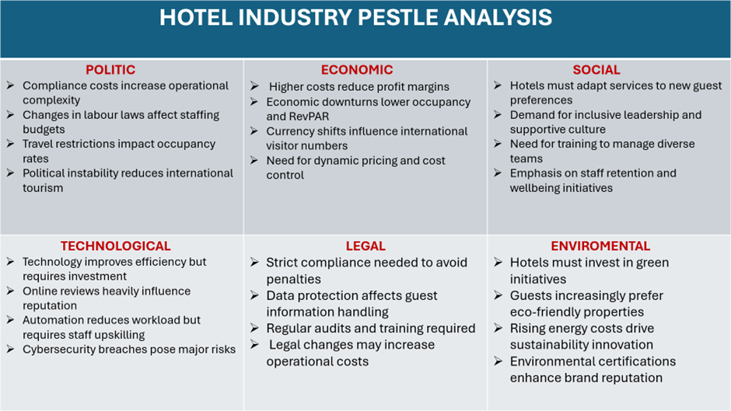

Appendix 2


