University of Wales “Trinity Saint David”

Problem Solving and Decision Making
Task 2: Report

Student Name: Gabriela-Paula Pirlica
Student Number: 2117958
Module: Problem Solving and Decision Making BMSW4004_BIRM
Lecturer: Zahra Mohammadnazari
Executive Summary
Problem-solving and decision-making are two major concepts that enable a business to mitigate its challenges or issues. The report has shed light on one of the major problems faced by Proper Care. Employee shortage is a significant problem faced by organisations in the UK healthcare sector. The report has discussed the scope and impact of the while; moreover, it has analysed the organisation and evaluated the problem. An alternative solution is determined for the company along with its implementation.
Table of Contents
1. Introduction 4
2. Defining the problem 4
3. Scope and impact of the problem 4
4. Analysing the organisation and its problem 6
4.1 PESTLE Analysis for analysing the organisation 6
4.2 Analysing the cause and effect of the problem through Fishbone Diagram 7
5. Proposing alternative solutions 9
6. Evaluation of solutions 9
7. Plan to implement the solution, monitor and review the process or system 11
7.1 Developing a plan to implement the determined solution 11
7.2 Identifying and discussing success criteria 12
8. Conclusion 13
9. References 14

1. Introduction
Problem-solving in the context of business generally refers to establishing processes that can eliminate obstacles currently affecting the strategic goals of the organisation. These obstacles are generally complex issues responsible for creating a gap between results and desired results. Another business concept that is related to problem-solving is decision-making. It can be defined as the process in which certain steps are taken by a business for determining the best course of action or option to meet its needs. Proper Care is a company in the UK healthcare industry that is facing a problem of staff shortage. The report will evaluate the organisation and its problem of staff shortage. Moreover, a relevant solution and its implementation will be discussed in this report.

2. Defining the problem
The Covid-19 outbreak has been a challenging situation for almost every business sector, especially the healthcare sector in the UK. One major challenge organisations face in this sector is staff shortage. According to a report by Reed (2022), the NHS is facing one of the worst staffing crises. England is facing a shortage of about 12,000 doctors and over 50,000 midwives as well as nurses. The problem of staff shortage is arising in the UK healthcare sector due to tight government budgets. Healthcare employees feel their efforts are undervalued and not paid enough for their jobs. Economic downturns are among the major reasons for the staff shortage problem faced by Proper Care and other organisations in the UK healthcare sector.

3. Scope and impact of the problem
Scope of the Problem
The staff shortage problem in Proper Care and other healthcare organisations in the UK is mainly due to the country’s economic downturn. According to Clark (2021), the UK government has spent approximately 219.4 billion British pounds on the healthcare sector in 2020-2021. Though the UK government has invested largely in the healthcare sector, it was not enough to deal with the pandemic problems faced by this industry. Staff shortage problem has the potential to have a long-term problem which can taint the reputation of these organisations. In terms of social issues, lack of employee satisfaction is one of the major reasons for staff shortage. Employees feel that they are not valued enough for their efforts. This is also creating operational problems due to the lack of proper management, as the workload on existing staff is increasing tremendously.
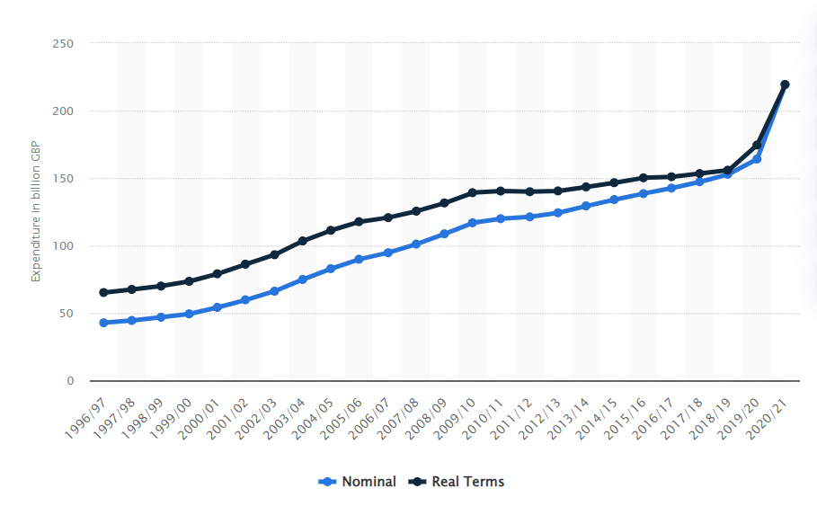
Figure 1: The UK government spending on the healthcare sector
(Source: Clark, 2021)
Impact of the problem
Staff shortage is a major problem for Proper Care and other healthcare organisations in the UK. The impact of this problem is severe as it may lead to major errors along with high morbidity as well as mortality rates. Additionally, burnout of hospital staff due to workload and dissatisfaction is significantly affecting the care quality provided by healthcare organisations (Hooiveld, 2022). This is, in turn, creating a hindrance to the long-term sustainability of Proper Care and other organisations in this sector.

4. Analysing the organisation and its problem

4.1 PESTLE Analysis for analysing the organisation
Factors | Discussion | Impact
Political | - The departure of the UK from the EU has led to staff shortages in the UK healthcare sector. According to Dalingwater (2019), about 5.6% of NHS employees were EU migrants, resulting in a shortage of qualified employees in the industry. | High
Economic | - The recession of 2008 in the UK had hit the country’s healthcare industry significantly, resulting in staff shortages. Many retired employees were recruited while many employees delayed their retirement (ANA-Illinois, 2022).  - As per the opinion of Montgomery et al. (2017), the central healthcare funding is failing to keep pace with the increasing funding demand in the industry. This is creating a staff shortage in healthcare organisations. | High
Social | - High expectations of patients regarding treatment provided by healthcare organisations are an increasing problem for healthcare providers. This increases the pressure on employees to perform better and failure to do so may lead to a failed reputation of the organisation. | Moderate
Technology | - With the implementation of new technology, the skill gaps of employees are increasing. The healthcare sector in the UK is slowly prioritising better education which requires relevant technology to reduce staff shortages (Warwick, 2022). | Moderate
Legal | - Following the employment act, minimum wage act, health and safety at workplace act, equality act, and other similar acts enable organisations in the UK healthcare sector to enhance employee operations (Cole, 2020). Ineffective implementation of these acts has led to staff shortage problems in Proper Care. | Moderate
Environmental | - CSR, especially environmental sustainability, is responsible for attracting employees. The positive reputation of organisations developed by promoting CSR activities tends to attract employees, reducing the problem of staff shortage. | Moderate
Table 1: PESTLE Analysis
(Source: Author)
The PESTLE analysis focused on various external factors that are influencing the staff shortage problem in the UK healthcare sector, including Proper Care.

4.2 Analysing the cause and effect of the problem through Fishbone Diagram
Determining the cause and effect of any problem helps in developing a better understanding of potential solutions (Lewis, 2022). The Fishbone diagram will help in identifying the cause and effect of the staff shortage problem in Proper Care.
Reduction in the blue-collar workforce: Proper Care lacks the number of blue-collar employees required for its effective operations. These employees are generally paid on an hourly basis and are involved in manual labour. Though Proper Care is focused on recruiting gold-collar employees and nurses, the lack of blue-collar employees is mainly due to the low revenue of the company.
Ageing employees: Employees of Proper Care are taking quick retirement due to the ageing workforce. There are very few young bloods in the workforce of the UK healthcare industry. The ageing workforce and their early retirement are leading to staff shortages in Proper Care.
High employee turnover: Employees in the healthcare sector are quitting their jobs. Probable reasons may be low growth, productivity, and employee dissatisfaction. This is resulting in a significant reduction in the workforce of Proper Care.
Weak workforce: Another major cause of staff shortage in Proper Care is lack of the operating organisational growth. This also indicates a weak labour force along with low employee training.
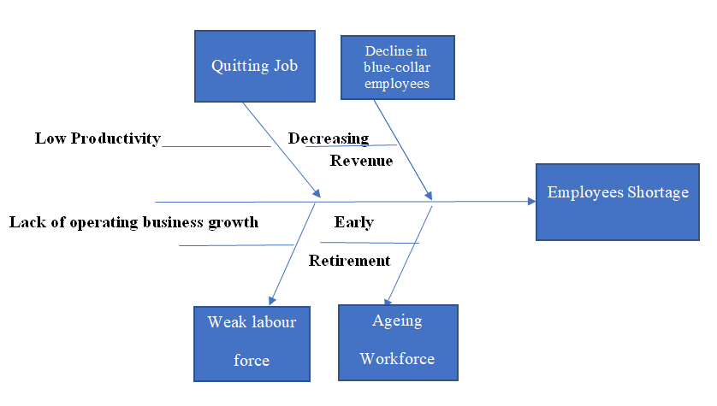
Figure 2: Fishbone Diagram
(Source: Author)

5. Proposing alternative solutions
There are three probable solutions for Proper Care that will enable the organisation to mitigate the problem of staff shortage.
Solution 1: Effective recruitment process
Proper Care is required to re-evaluate its recruitment process in order to manage as well as control employees from quitting their jobs. As per the opinion of McConnell (2021), various creating recruitment processes like social media integration will enable the company to attract more employees. Additionally, digital recruitment will allow Proper Care to increase the reach of its job advertisements.
Solution 2: Employee benefit programs
One of the major solutions to deal with the problem of staff shortage is enhancing employee benefit programs. Employees generally prefer working for organisations that focus on the growth and development of their workforce. Increasing salary, providing training programs, incentives, recognition programs, and other similar motivational elements will enable Proper Care to attract more employees and retain them as well.
Solution 3: Management style transformation
Since Proper Care is failing to attract employees and retain its current management style, the company can transform its management style. This will enable the company to increase its control over employee performance and organisational operations. For instance, adopting transformational management will enable the company to encourage employees and change according to the changing external environment, further motivating employees and reducing their turnover rate.

6. Evaluation of solutions
The PMI (plus, minus and interesting) framework will be used to select the most suitable solutions from the various identified solutions to effectively serve its purpose.
Solutions | Plus | Minus | Interesting | Total
1st | - Using social media platforms for recruitment will also decrease the time and effort of the recruiters in the recruitment process with the increased reach to job seekers numbers. (+3) | - Creative recruitment ideas planning and implementation involve high investments. (-3) | - Opportunity to attract higher people. (+2) | 3-3+2 = 2
2nd | - Perks like good recognition programmes, incentives and salaries increase the commitment and engagement of the employees leading to their higher productivity alongside enjoying the higher employee retention benefit. (+4) | - Increases competitiveness among employees. (-1) | - Provides career growth opportunities to employees. (+3) | 4-1+3 = 6
3rd | - Transforming the management style will help the organisations to increase their control over the staff management thereby decreasing their employees’ turnover rates. (+2) | - High investments are needed to train the staff for their proper performances in the changed environment. (-2) | - Higher control over staff will lead to a lower flow of creative ideas resulting in hindered creativity and innovations in the organisations. (-1) | 2-2-1 = -1
Table 2: PMI analysis of alternative solutions
(Source: Author)
The above analysis shows that the 2nd solution which is offering perks to employees will be the most suitable method to overcome the staff shortage problem in the UK’s healthcare sector.

7. Plan to implement the solution, monitor and review the process or system

7.1 Developing a plan to implement the determined solution
The most suitable solution to the staff shortage problem can be mitigated by the perks to the employee in the form of employee benefits programmes. These programmes can be planned and implemented by healthcare-based organisations using the following steps.
Identifying objectives: The most significant first step of employee benefits planning involves analysing its objectives. The objectives of this programme are to accurately attract and retain the talented workforce by offering different monetary benefits as well as career-growth scopes in the forms of appropriate salaries, incentives, bonuses, insurance schemes, promotions and more.
Forecasting budget: The next step involves proper estimation of costs in the employee benefit programmes by considering and evaluating the various suitable benefit programmes. This will enable the organisations to properly make a budget for constructing their programme plan efficiently.
Performing survey: The approach of conducting surveys among the employees will help the organisations to understand the needs of the employees in the organisations and also in the marketplace (Vantage Circle, 2021). This will enable them to include those benefit programmes in organisations to meet their objectives.
Selecting and implementing relevant benefit plans: Identification of the employees’ needs and preparing budget estimation will allow the organisations to accurately select and implement their benefit plans by conserving the legal terms.
Reviewing: The periodical evaluation process will help the organisations to understand the effectiveness of their planned benefit programmes which were implemented to attract and retain higher employees by overcoming the staff shortage issue (Qandle, 2021). This type of periodical reviewing will enable business organisations to bring effective and immediate changes in their benefits programmes depending on the transforming needs of their employees to meet their objectives constantly.

7.2 Identifying and discussing success criteria
The lack of in the UK’s healthcare sector is hindering the nation’s healthcare services. Implementation of the identified strategy of using employee benefits programmes will help the UK’s healthcare-based organisations to offer different reward packages to their employees as per their needs. The success of this strategy implementation can be interpreted from the gradual growth in the employment rates in the healthcare organisations of the UK besides looking at the employees’ satisfaction with their jobs. Moreover, the successful long-term retention of the organisations’ existing as well as new employees will also indicate the success of the employee benefits strategy through its high ancientness in the health service sector (Benjamin, 2020).

8. Conclusion
Problem-solving and decision-making is a planned business path initiative taken by a firm to solve any organisational problem. Proper Care is an organisation in the UK healthcare industry. One of the major problems currently faced by this company is staff shortage. This is affecting the company’s operations as well as its reputation. The company can minimise this problem by enhancing employee benefits perks such as increased salary, benefit programs, training programs, incentives, employee recognition, and other factors that can motivate employees.

9. References
Dalingwater, L., (2019) NHS staffing shortages and the Brexit effect. Observatoire de la société britannique, (24), pp.67-86.
Montgomery, H.E., Haines, A., Marlow, N., Pearson, G., Mythen, M.G., Grocott, M.P.W. and Swanton, C., (2017). The future of UK healthcare: problems and potential solutions to a system in crisis. Annals of Oncology, 28(8), pp.1751-1755.
ANA-Illinois, (2022). WHAT HAPPENS TO HEALTHCARE DURING A RECESSION? Available at:https://www.ana-illinois.org/news/what-happens-to-healthcare-during-a-recession/?utm_source=rss&utm_medium=rss&utm_campaign=what-happens-to-healthcare-during-a-recession [Accessed 26 July 2022].
Benjamin, J., (2020). How do you measure the success of employee benefits packages? Available at: https://reba.global/resource/how-do-you-measure-the-success-of-employee-benefits-packages.html [Accessed 26 July 2022].
Clark, D., (2021). Public sector expenditure on health in the United Kingdom (UK) from 1996/97 to 2020/21. Available at: https://www.statista.com/statistics/301992/health-spending-uk/ [Accessed 26 July 2022].
Cole, M.R., (2020). A Comprehensive List of Employment Legislation in the UK. Available at: https://croner.co.uk/resources/employment-law/legislation-list/#. [Accessed 26 July 2022].
Hooiveld, J., (2022). How staffing shortages affect patient safety. Available at: https://www.patientsafety.com/en/blog/staffing-shortages-affects-patient-safety [Accessed 26 July 2022].
Lewis, S., (2022). Fishbone diagram (Ishikawa cause and effect). Available at: https://www.techtarget.com/whatis/definition/fishbone-diagram [Accessed 26 July 2022].
McConnell, B., (2021). 15 recruitment strategies for hiring great employees. Available at: https://recruitee.com/articles/creative-recruitment-strategies [Accessed 26 July 2022].
Qandle, (2021). How to design the right employee benefits program for your employees? Available at: https://www.qandle.com/blog/how-to-design-the-right-employee-benefits-program-for-your-employees/ [Accessed 26 July 2022].
Reed, J., (2022). NHS in England facing worst staffing crisis in history, MPs warn. Available at: https://www.bbc.com/news/health-62267282 [Accessed 26 July 2022].
Vantage Circle, (2021). 5 Easy Steps To Creating An Employee Benefits Plan. Available at: https://blog.vantagecircle.com/employee-benefits-program/ [Accessed 26 July 2022].
Warwick, (2022). Learning Technologies in Healthcare Education. Available at: https://warwick.ac.uk/fac/sci/med/study/cpd/module_index/md969/ [Accessed 26 July 2022].

