STUDENT NAME | DIANA NANTEZA
STUDENT NUMBER | 1806519
MODULE NUMBER | BMSW5103_LON
TITLE | UNDERSTANDING AND ENGAGING IN THE CUSTOMER EXPERIENCE
LECTURER | DR KENNY TANG

CONTENTS

- INTRODUCTION
- CUSTOMER VALUE
- TESCO HISTORY
- 5 DIMENSIONS CUSTOMER VALUE
4.1 CONFORMANCE TO REQUIREMENTS
4.2 PRODUCT SELECTION
4.3 PRICE AND BRAND
4.4 VALUE-ADDED SERVICES
4.5 RELATIONSHIP AND EXPERIENCES
4.6 CONCLUTION
5. DIMENSIONS OF SERVICE QUALITY
5.1 RELIABILITY
5.2 ASSURANCE
5.3 TANGIBLES
5.4 EMPATHY
5.5 RESPONSIVENESS
5.6 CONCLUTION
6. GAPS IN SERVICE
6.1 EXPECTED SERVICE
6.2 PERCIEVED SERVICE
6.3 THE POLICY GAP
6.4 THE DELIVERY GAP
6.5 THE COMMUNICATION GAP
6.6 CONCLUTION
7. REPORT CONCLUSION
8. REFERENCES

1.INTRODUCTION

In this assay I will be critically evaluating the customers experience in Tesco. I will be analysing the quality process of the organisation and highlighting the benefits and challenges of maintaining good customer relationships. I will cover the 5 dimensions of customer value and see if they are effectively applied into the organisation.
By gaining understanding of quality process in this workplace, I will have a good idea on what this organisation can improve on.
Understanding the customer journey is very important as it gives the organisation clear vision in looking after their customer and focus on what the customer needs rather than what is convenient for the organisation.
It is important that the customer has some control of their customer experience, so I aim to show critical understanding of how this organisation can do that and instil quality systems.
With more and more people choosing to shop online, businesses have created easier and faster ways for customers to enjoy their customer experience.
According to Jessica Santos (2003) In the world of online shopping, service quality is recognised to be very effective in the electronic ecommerce. Things such as the online comparison feature has made it easier than the comparison through the traditional channels.

2.CUSTOMER VALUE
Customer value can be described as going above and beyond the ordinary to meet customer needs and wants. Professor Art Weinstein in his customer service theory spoke of what he calls “superior customer service”. This means delivering value in spectrum in terms of four components: service, quality, image, price. (Weinstein, 2012).

- Service: the intangible value offered to customers
- Quality: customers perception of how well a company's products and services meet expectations.
- Image: customers perception of the company or business they interact with.
- Price: the price you can command for your goods and services and your customers are willing to pay.
- Brand: how a company brands product to attract customers
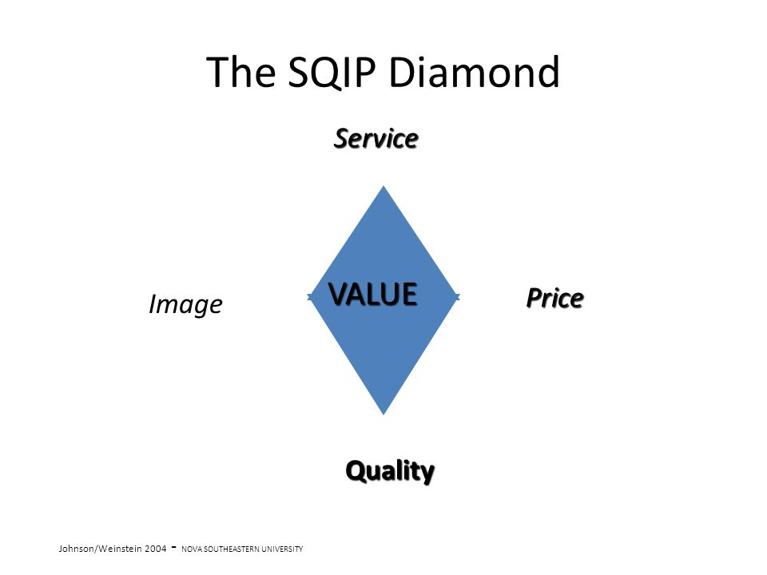
Weinstein (2012), and Johnson and Weinstein (2004) refer to this model as SQIP they see this as the best approach to customer value. Figure 1 above shows, service, quality, image, and price are what constitute customer value in terms of conferred benefits, meeting customer needs, wants and expectations.

3. TESCO HISTORY
Tesco is one of the leading supermarket/stores in Great Britain with an amazing market share that goes over 15 percent. With a list of 588 supermarkets that stretch between England, Scotland and Wales, Tesco also operates 32 stores in Europe.
The company was founded in 1932 by Cohen, the name was previously called Tesco Stores Limited and was then changed to Tesco. To support these stores and its new high-quality, service-oriented image, Tesco introduced its own branded products named Tesco Value. This exceeded their sales and created loyalty between the company and the customer.
In 1995 Tesco started their internet shopping service which is very popular now and remains one of the most popular retail websites in the retail online business. The company has since enhanced its range of services which include, insurance, travel agency, telecom, financial products and many other products.
The values of Tesco are their code of conduct, in which Tesco work and strive to do business on a whole. By understanding their customers and the needs of their customer, they also believe in innovation. The reflected Tesco customer values, in which they strive to bring passion and value services to the customers and employees. Tesco are also very proud of their working environment and make sure that their employees are well motivated so they can provide better services for their customers.
In this report I will be looking into Tesco's relationship with their consumers. Are they meeting their promises and expectations? I will also be comparing Tesco with Lidl to see how well they perform within the 5 dimensions of customer service.

4.FIVE Dimensions Customer Value
- Conformance of Requirements
- Product Selection
- Price and Brand
- Value-added Services
- Relationship and Experiences

The dimensions of customer value reflect the journey that the customer takes to buy a product, it is important that companies put these values in place in order to understand customer behaviour and customer relationship. All the 5 dimensions are as important as each other but for the to be effective all must be applied as part of the customer journey.
If a company is successful in applying these values, it will have more chances of maintaining customers and allowing the customer to enjoy their experience when buying items

4.1 Conformance to requirements
Being at the manufacturing level, conformance is subset of the overall quality meaning. All requirements include systems, specifications, product for the intended use of selling. Conformance is needed when manufacturing follows an unbroken sequence of operations from the start to end for a successful meeting what is needed. This process allows for the company to decide on whether products are right or not right to be distributed, in manufacturing if the products conform, they are shipped but if not, then that means that they would have failed the quality test.
Tesco can offer the customer wants and needs, costs associated with the market mediation that could happen when there are differences between supply and demand. Their ability to cater to their market with the supply and demand attitude has encouraged the company meet the demands that are expected in this type of supply chain. (Paul L, 2017)
Tesco | Ranking
Conformance Requirements | 8/10

4.2 Product Selection
Product selection is very important because products are the main reason customers will want to visit the business, the product’s performance would have to meet the obligations of what the customer is looking for.
For an automobile, performance would include things such as acceleration, handling, cruising speed and comfort. For a television set, performance means sound and picture clarity must meet requirements, colour and the ability to receive distant stations is a must. Every product sold will always have to meet the demand of the customer to meet customer satisfaction, this will add to a good customer experience. Organisations with larger variety of products would possibly face greater problems with managing supplies and predicting demand.
Tesco does not just focus on selling one product as it is a Mega-store, so it has many products to offer their customer to ensure variety.
Tesco does groceries, household products, insurance, Tesco mobile, clothing, points. Lidl does all that Tesco does apart from insurance, mobile, points.(lovemoneystaff, 2019).

STORE | Groceries | Household | Insurance | Mobile | Clothing | Points
TESCO | 8/10 | 7/10 | 6/10 | 8/10 | 7/10 | 9/10
LIDL | 6/10 | 8/10 | Non existent | Non existent | 6/10 | Non existent

4.3 Price and Brand
It very important for companies to be able to estimate the impact of price changes on sales and profits. This means that it is important to know how price change will impact customer experience, competitive response and volume. Many companies tend to think that a price increase is the most cost-effective revenue generating trick.
Branding plays a huge part in attracting customers to a product, good and attractive branding adds value to the product although quality is also as important. The image of the company, including the brand and the trust in the company or when the customer appreciates the values of the company help create sustainability. These are the things create overall great value for the customer. (My Supermarket, 2019).
Tesco has products that are cheaper than Lidl and the reason for this is because Tesco provide more deals/sales than Lidl, but because Lidl does not do a lot of deals, they have set permanent low prices on their products to make up for it.
Brand names such as Hovis and Fairy Liquid become and guarantee for quality so when looking for items such as those Lidl still proved to be cheaper than Tesco.
STORE | Hovis bread | Milk | Fairy Liquid | RANKING
TESCO | £1.10 | £1.35 | £1.80 | 6/10
LIDL | 99p | £1.09 | £1.59 | 8/10

4.4 Value-added Services
Value-added services are added benefits customers can get when they purchase a product or service. This can also be known as add-ons, they can go a very long way in helping build good will if free. They can also dramatically increase revenue if offered at a discounted price to consumers. When companies use these common value-added services, they can improve the benefits they offer their customer and get them grater deals when they purchase from their company.
When speaking about value-added services it is important to understand that this is a value that helps a company improve profits and definition from competition. The number one-way Tesco does this is to offer a rewarding system known as points system. (Tesco clubcard). (Lovemoney staff, 2019).
Tesco allows customers to collect points for every £1 spent, this in return creates value between the customer and Tesco therefore strengthening loyalty. Customers will more likely be loyal to Tesco and have an attachment to the company. (Lovemoney staff, 2019).
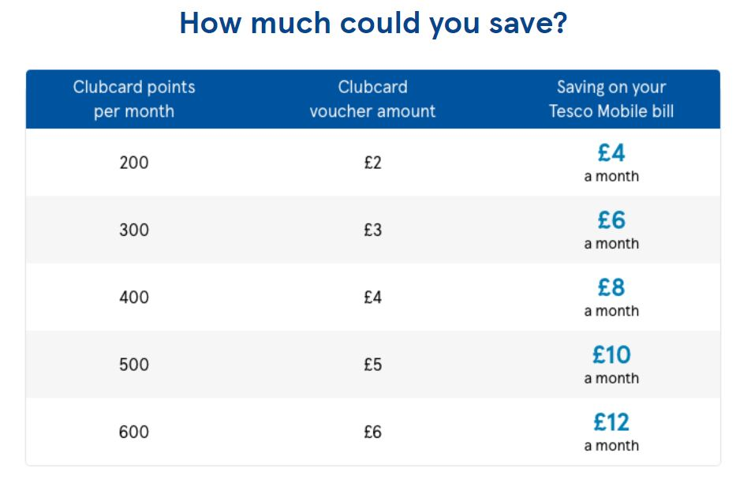

Tesco's competitor Lidl does not have a points system however they offer their customers low competitive prices with good quality and branded products. Lidl also offers their customers a month magazine that has different deals that customers can enjoy in store. Lidl also have an online shop option where they allow their customers to select their favourite items a discounted price. (Lidl.co.uk, 2019).
STORE | POINTS SYSTEM | RANKING
Tesco | Clubcard | 8/10
Lidl | Low prices/deals | 7/10

4.5 Relationship and Experiences
Creating good customer experiences takes focusing on every interaction being good especially the experience they have with the brand. Looking at ways that the company can improve customer relationship is very important. Leaders in companies should focus on gaining customer loyalty by enhancing their customers perceptions of service quality and increasing good customer service which will result in increasing customer value.
It is also important to address the importance of service quality, satisfaction, perceived value and image as it plays a huge part in the precise nature of the relationship that exists between the customer and company. Understanding of their effect on customer behaviour remains a key factor when creating good effective relationships. (Tesco.com, 2019).
Tesco has many ways to strengthen their relationship with their customers, because Tesco has an online store, they can offer their customers home delivery. This can sometimes even be same day delivery, providing this service means that Tesco is able to give their customers a more convenient option therefore strengthening the customers experience. (Tesco.com, 2019).
Tesco has also started to open isles that cater to different culture foods such as African and Asian options, such isles are called ‘International foods isle’. (Tesco.com, 2019).
Lidl however does not provide foods that cater to different cultures, the German company does have foods that cater for the European culture and satisfies their target market. Lidl also offers delivery options however they do not have a same day service, they have a very easy to access website that sells groceries, home items and clothes. (Lidl.co.uk, 2019).
 | Relationship | Ranking
TESCO | Caters to customers culture | 7/10
LIDL | Great deals easy to access | 6/10

4.6 CLONCLUTION
After considering the findings I have concluded that Tesco has higher marks in all the Customer Values in comparison to Lidl. The reason I think this has been the case is because Tesco offers their customers an opportunity to interact with the company by providing services such as Clubcard's and mobile contracts, these things add value and add to the relationship between the customer and Tesco. This I believe is something that Lidl could apply to their business model because in pleasing the customer and building a connection in relationship equals loyalty from the customer.
The great thing about Lidl is that they are consistent in their pricing, they are constantly beating their competitors in being the cheapest even when comparing big brand such as Hovis bread.

5.DIMENSIONS OF SERVICE QUALITY (Berry L, 1985)
When looking at a company, proving the best quality experience is vital so it is important to consider the dimensions of service quality and other vital qualities such as, responsiveness, tangibles, empathy, assurance, reliability. All these dimensions have an ability to have a great impact on customer satisfaction so in order to identify each factors potential, all dimensions must be exercised. Each dimension is as important as the other although for them to be affect they must all be applied. These qualities help better and stronger relationships between the customer and company. (Angelova B, 2003)

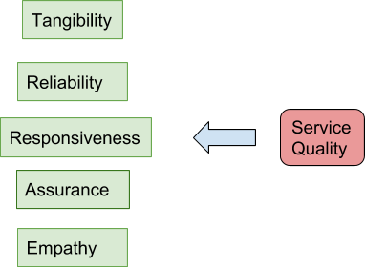

5.1 Reliability
Customers want a company they can rely on so means that companies should aim to perform a service correctly first time as first impressions are important in the word of reviews. However, research shows that companies work to achieve promises but don’t always meet customer requirements which may cause the customer to not be confident in the company. It is important that customers feel that they can expect the service that has been presented to them, reliability creates trust for the customer and insures repetitive business. (Kumbhar VM, 2012)

Tesco considers their customers in ensuring that there is a contact for encase customers have any concerns or complains. This means that if they have anything that they are not satisfied with they can contact Tesco. Tesco produces products that are needed in an everyday household so customers can rely on knowing that those products are always available. (Tesco.com 2019)
Lidl also has the same principles; it has a contact form where customers can complain about anything that they are concerned about. The store has many everyday products such as household items that the everyday person needs. (Lidl.co.uk, 2019)

STORE | RANKING
TESCO | 9/10
LIDL | 9/10

5.2 Assurance
Assurance is one of the highest within all the quality dimensions, assurance also means keeping customers in the know in the native language and being attentive to them regardless of the educational background, age, or nationality. Assurance also directs the attitudes of the workers and their behaviours, it also assures the employees ability to provide friendly, confidential, courteous and competent services. (Zeithaml V.A, 1994).
Tesco does not discriminate or make the customer feel like they cannot shop in their stores, all the marketing adverts are with different race models who are used. Their website shows all ages in the posters and banners. They have a wide selection of products that cater to any age and gender. Their staff members are also relatable as they are not limited to any gender, age or origin. (Tesco.com, 2019).
Lidl also make sure that their staff members are English speaking since their UK store is in an English-speaking country. They hire staff members of all ages and genders. (Lidl.co.uk 2019)
STORE | RANKING
Tesco | 7/10
Lidl | 6/10

5.3 Tangibles
Tangibles are associated with the physical systems used in the company. Things such as machines used in order to provide the services such as statements, cards machines, speed, and efficacy of transactions and websites. Tangibles have the same importance as empathy although it is important to consider tangibles as a distinct element, showing consistency across the ever growing fast paced world of technology. (Zeithaml V.A, 1994).
Tesco has a full functioning website that is easy to use, the features that the website has allows the customer to create their own account which will show their past shopping history. This can be very helpful when a customer wants to buy the same thing they bought before. Tesco also has club cards that are used to collect points whenever the customer buys something, this helps with customer loyalty and relationship. The Tesco website has a secure system which they use to take card payments, this is very important as customers must feel safe and secure when making payments. (Tesco.com, 2019).

Lidl has great features on their website, the website works effectively and easy to use. Customers can select the products they want without going into the store physically. Lidl website also sends a statement once payment is made so that the customer can have a receipt of their payment after ordering. (Lidl.co.uk 2019)

STORE | RANKING
TESCO | 9/10
LIDL | 9/10

5.4 Empathy
The importance of empathy in business is very vital, customers need to feel that they are a priority in the company. The heart of empathy must be reflected in the company by the employers, the feeling that the customer is important and special is what will create empathy. Employees must add care when handling customers, customer care also equates to empathy. (Zeithaml V.A, 1994).
Tesco offers a service both on the website and in store, the store hires over 5,000 staff in the UK and offers training to their staff members. Training includes customer service and online customer training that allows them to understand how to interact with different types of customers in store and online. This is a great business model and ads security and empathy to the company. (Tesco.com, 2019).

Lidl has a great level of staff members that cater to handling customer complaints and enquires. Lidl only provides one off training but does not extra customer service training. This can sometimes be bad for business as the staff need extra training in order to have empathy when dealing with customers, however this does not mean that Lidl does not have empathy when dealing with customers. (Lidl.co.uk 2019)
STORE | RANKING
TESCO | 8/10
LIDL | 7/10

5.5 Responsiveness
Responsiveness is basically communication, in short it means the willing of the organisation workers telling customers exactly when things will be done. As an example, we can look at letting customers know how long their items will take to deliver and answering emails in time. In doing so, employees must they give customers undivided attention especially on the shop floor. In promoting services and responding in accordance with their request's employees will build better relationship with their customers which will add to customer service. This value adds to good customer service in the company. (Zeithaml V.A, 1994).
Tesco has a contact for on their website where customers can contact them for any concerns or requirements. This means that Tesco must be very responsive in the timing they take to respond to these enquiries or complaints. This type of service would hell Tesco in being good at responding to their customers online or in store. (Tesco.com, 2019).
Lidl has staff members on the shop floor that offer help to their customers, they promote their services but mostly focus on having cheaper products in comparison to their competitors. This is something that Lidl can work on in future however Lidl has a customer service section that also helps in responsiveness. (Lidl.co.uk 2019)
STORE | RANKING
TESCO | 7/10
LIDL | 7/10

5.6 CONCLUTION
After reviewing my findings, I have concluded how important the relationship between the customer and the company is. Looking at the evidence, the company that has the best relationship in service quality is Tesco. Tesco has created a system that caters to the customers, Lidl on the other hand leans more towards having affordable, competitive prices. Their aim is not too focused on customer service or customer relationship.

6.GAPS IN SERVICE
In the generation that we are in customers increasingly ask for more, customers are demanding quality products and great customer service. Marketing is very vital when launching products so products such as cars, mobile phones and computers cannot be launched with no calculative planning. From a consumer's point of view, customer service is rated and considered part of the product. Customer service has become more and more important in a world where customers read reviews before purchasing a product. SERVQUAL (service quality gap model) is a gap method service quality measurement, this tool can be used by companies of all industries. (Zeithalm B 1985).

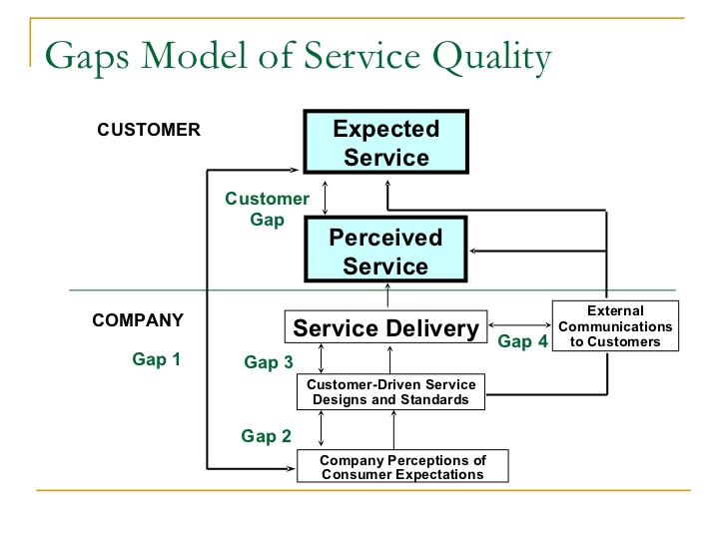

6.1Expected Services
There are crucial things that persuade a customer to purchase a product, the customer gap is the difference between customer expectations and customer perceptions. Customers may have a particular type of service that they have in mind and what influences that decision is their cultural background, family lifestyle, personality, demographics, advertising, experience with similar products available online. Customer perception is totally subjective and varies with each customer, it is also based on the customers interaction with the product or service. An example of that is how happy a customer is with a product. How the customer perceives the product is based on the customers satisfaction of the service and the quality of service delivery including the quality of the product. (Sage Journals 2017).

British customers have moved to ‘one stop’ and ‘bulk’ shopping because of variety of social changes, for that reason Tesco have increased the amount of non-food items available. There are demographic changes such as the aging population, a higher percentage of female workers and a decline in home meal preparation mean that UK retailers such as Tesco are also focusing on added value products and services. The variety of good and services demanded by consumers is a function of social conditioning and their consequent attitudes and beliefs. Tesco has adopted its product mix to accommodate an increased demand for organic products. Bennison and Guy, 1994; (Datamonitor Report, 2003).

STORE | RANKING
TESCO | 7/10

6.2Perceived Service
In customer-orientated business it is important to have a clear understanding of the customer's needs. The knowledge gap helps the company acknowledge the difference between the customers' expectations and the company's provision of the service and excellence. In this case, managers are not aware or have not correctly interpreted the customers expectation in relation to the company's services or products.
In order to identify the gap between the consumers expectations for service and, managements perception of service delivery there will need to be intensive market research done by the company. This research will allow the company of the right direction to take to meet customer expectations.

For Tesco to control and retain their customer base, they need to meet customers need by customizing service, ensure low prices, better choices and constant flow of in store promotions.
Operating in a mature flat market where growth is difficult with a lot of competitors in the market, Tesco has managed to dominate a large area of the market by catering to consumer's needs. Consumers are increasingly demanding and sophisticated, large chains as Tesco are accruing large amounts of consumer information that can be used to communicate with the consumer. (Ritz 2005

STORE | RANKING
TESCO | 6/10

6.3The Policy Gap
This gap reflects the company's incorrect translation of the service policy into the rules and rules for employees. There are problems that some businesses face such as going through difficulties translating consumer expectation into specific service quality delivery. The issue of that could occur or can include poor service design, failure to maintain and continue to update their provision of good customer service or simply maintain policy can be damaging to the business. Having such problems could result to consumers seeking similar products with better service in another company. (Ivory Research 2019)

Tesco has a great deal of marketing tactics that they use in order to gain their provision of good customer service. In creating the adverts that they do they make sure that they meet customer expectations in making sure that the deals and products are available in store. Things such as false advertising are to be avoided by Tesco.
In training their employees in customer service, Tesco can avoid disappointing their customers. (Tesco.com 2019)
STORE | RANKING
TESCO | 8/10

6.4The Delivery Gap
Businesses with delivery gap may state the service required give support to consumers but have subsequently failed to train their employees to put good systems and guidelines in action. This gap reveals the weakness in employee performance and lack of training, as a result employee are ill equipped to manage the customer's needs. (Ivory Research 2019)
These are the following problems that are faced if there is a delivery gap:
- Employees lack of product understanding and have difficulty managing customer enquiries and issues
- Companies have poor human resource
- Lack of teamwork and the inability to deliver

Tesco continues to invest in customer service, so the staff are motivated to learn and are encouraged to improve their approach to customers and service provision quality. Tesco aims to increase the number of training schemes and further develop its recruitment programmes, in order to pass on the customer benefits of well recruited, well trained staff. (Tesco.com 2019)
STORE | RANKING
TESCO | 9/10

6.5The Communication Gap
Communication raises customer expectations; most companies use means such as advertising on media platforms which heightens the level of expectation. In some cases, some promises that companies make are not met and at times when over-promising in advertising may not match the actual service this can be called false advertising. Lack of communication can in return means that there is a gap in the system or procedure. Consumers may end up disappointed because the promised service does not match the expected service and consequently may seek alternative product sources. (Ivory Research 2019)

Tesco has a wide range of ways to communicate with their customers which include, social media channels, newspapers, tv advertising and street banners. Tesco mostly advertises their ongoing deals and encourages customers to choose them over other retailers, they claim to have they have the best deals in comparison to their competitors.
Tesco must be careful and provide what they advertise for them to avoid customer disappointment. (Tesco.co.uk, 2019)

STORE | RANKING
TESCO | 8/10

6.6Conclusion
After looking at the findings, I have evaluated that Gaps in service are important because they allow the company to look deeper into their business model and fix the things that could potentially go wrong. Things such as making sure that companies deliver what has been promised to the customer will determine whether a customer is loyal or not.
Engaging with consumers through different systems and platforms allows the company to build stronger relationship with companies. This has been successful when looking into the systems Tesco has put in place, they have a very good online presence and they also cater to customers of different cultural backgrounds. They also make sure to hire staff that has been correctly trained and staff from different nationalities for them to relate to the customer.

7.REPORT CONCLUSION
The main purpose of this report was to identify key methods and strategies that are used for companies to understand the journey of a costumer. In conclusion I have evaluated that Tesco has used the methods needed to strengthen they customer service. Lidl has also been successful in putting systems in place that help make the customer journey simpler. They both have websites and advertise on national tv however, Tesco has more of a social media presence that Lidl.
Things such as club cards and loyalty cards have helped Tesco create loyalty among their customers but on the other had Lidl have achieved trust in presenting competitive prices to their consumers.
Both stores have been successful in achieving a share in a very competitive industry and they both have revolutionised their presence by belong based online and not just physical stores.

Basel, (2019) The Service Quality Service Dimensions. Available at: https://www.mdpi.com/2071-1050/11/4/1113/htm (Accessed 3rd Jan 2019).

Ivory Research (2005) Ivory Research Co Ltd. Available at:https://www.ivoryresearch.com/samples/economics-essay-example-strategic-management-of-tesco-supermarket-pestle-analysis-porter-5-forces-analysis-critical-success-factors-swot-analysis-value-chain-analysis-tesco-strategic-options-core-comp/ (Accessed 3rd Jan 2019).

Business Teacher (2019) Business Teachers. Available at:https://businessteacher.org.uk/swot/tesco.php (Accessed 3rd Jan 2019)

Lidl GB (2019) Lidl. Available at:https://www.lidl.co.uk/ (Accessed 3rd Jan 2019)

Tesco Groceries (2019) Tesco. Available at:https://www.tesco.com/groceries/?sc_cmp=ppc*GHS+-+Grocery+-+Repeat+&+DS*PX+%7C+Repeat+%7C+Tesco+Brand+%2B+Service+%7C+Drive+To+Store*New:+Service:+Delivery:+New+%7C+Tesco+Delivery*tesco+delivery*p&ds_rl=1116016&gclid=Cj0KCQiAxfzvBRCZARIsAGA7YMyA7eSKZ6BYwyZTanmMDVfQXWd9JlvpP5Clz7vLHK4qMzTSons1jI4aAkOLEALw_wcB&gclsrc=aw.ds (Accessed 3rd Jan 2019)

