Module Name: Strategic Management
Module Code: LCMB7003

Student Name: Thelma Dhussey
Student ID: 2516910

Table of Contents
Organisational Context and Overview 2
External and Internal Environment Analysis of Nestle 3
Critical Analysis of the Nestle CSR Strategy and its Alignment with Business Objectives 9
Comprehensive and Holistic view of Nestle using Balanced Scorecard Framework 11
Nestle’s Strategic Choices and Implementation 14
Strategic Evaluation and Recommendations for Nestlé 15
Personal Reflection Using Gibbs reflective cycle 18
References 21

List of Figures
Figure 1: Global sale of Nestle in 2025 (Source: Nestlé, 2026a). 3
Figure 2: PESTEL Framework (Kar, Das and Kar, 2025) 5
Figure 3 : VRIO Analysis of Nestle (Self-made) 8
Figure 4: Responsibly Sourcing of Nestle (Nestlé, 2026c). 11
Figure 5: Nescafe Plan 2020 Targets (Nestlé, 2021). 11
Figure 6: Regenerative Agriculture Practice in Nestle (Nestlé, 2026d). 12
Figure 7: Balanced Scorecard (Hamied and Elbagoury, 2025). 13
Figure 8: Gibbs Reflective Model (Source: Ahmadpour, Shariati, and Moghadam, 2025) 19

Selected Organisation: Nestle

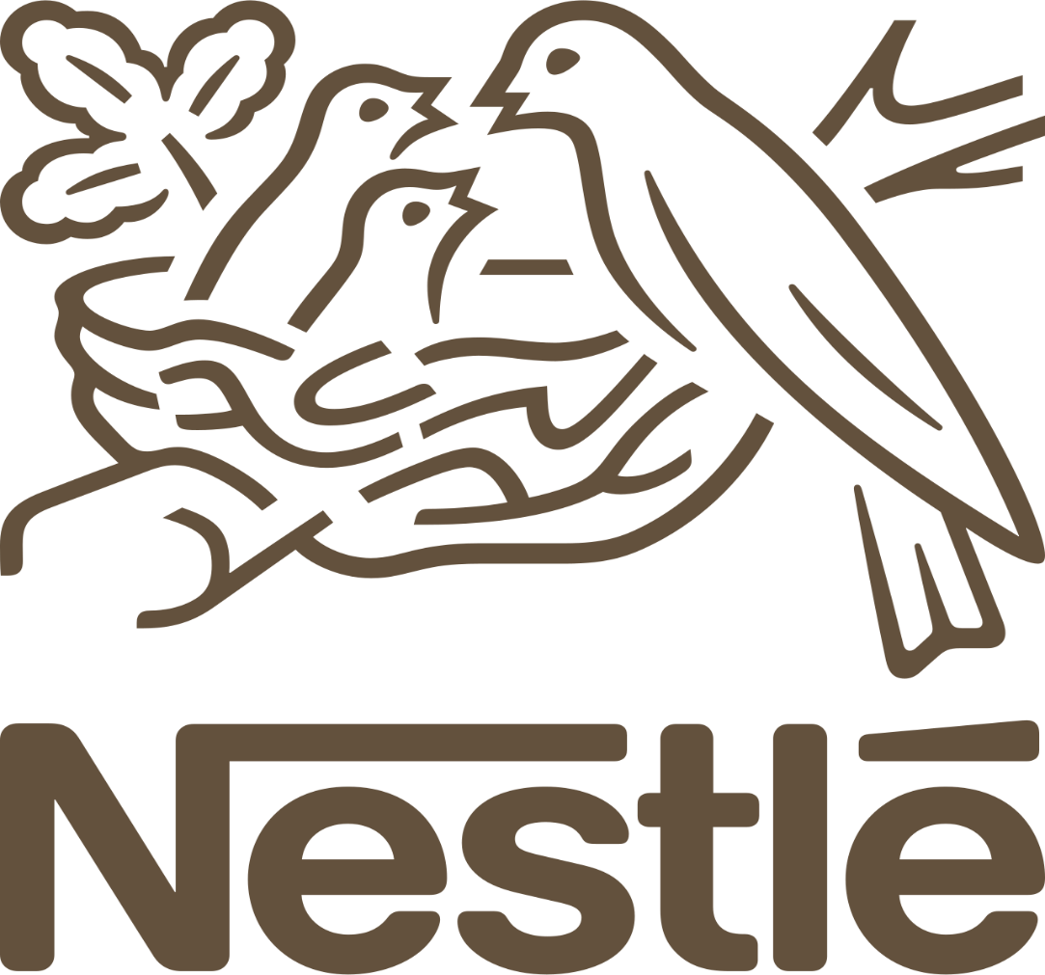

Section-1

Organisational Context and Overview
Nestle is a company that manufactures food and beverages in the world. Henri Nestle established the company in 1866 in Switzerland. It initially began by manufacturing infant cereal as a way of reducing the mortality of children. The company has increased its product over the years and has become a global leader in nutrition, health, and wellness products. Nestle now has operations in over 185 countries, and it has more than 271,000 employees worldwide (Nestlé, 2026). The company has a great presence in the international food market with a global sale of about CHF 89.6 billion in 2025.
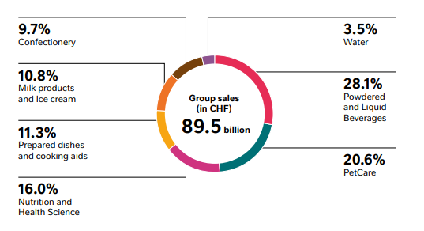
Figure 1: Global sale of Nestle in 2025 (Source: Nestlé, 2026a).
Nestle has the mission of Good Food, Good Life, which aims at offering good, safe, and healthy food that enhances the quality of life of people. The vision of the company is to be the best nutrition, health and wellness company in the world and get a healthier future. Sustainability is another area where Nestle focuses on, including cutting down carbon emission and responsible sourcing of raw materials. In its sustainability initiatives, the company is targeting to achieve net-zero greenhouse gas emissions by 2050 (Nestlé, 2026b).
Nestle adheres to diversified business model, which consists in manufacturing and retailing a broad product line of various food and beverage. Its brands include Nescafé, KitKat, Maggi and Nido which are well known brands (Johnson and Brechbühl, 2025). The firm makes revenue by manufacturing worldwide, effective branding, distribution, and constant product innovation.
Nestle is involved in the world food and beverage sector, which is very competitive and dynamic regarding changing customer preferences and health issues. The top competitors are Unilever, PepsiCo, The Coca-Cola Company, and Danone (Lubaba et al., 2025). The competition among these companies is based on innovation of products, pricing policies, and good distribution networks globally.
Regarding the market position, Nestle is generally considered as the largest packaged food company in the world. The company ensures that it has a competitive advantage through strong brand portfolio, global supply chain and research and development. With its expenditure of approximately CHF 1.7 billion each year in research and development, Nestle can come up with new products and address the changing consumer needs in the global markets (Nestlé, 2026).

External and Internal Environment Analysis of Nestle
Impact of External Factors on Nestle’s Strategic Decision Using PESTEL Framework
Nestle is a global organisation that is operating in a complex environment where external forces keep shaping strategic decisions. A PESTEL framework makes it apparent how political, economic, social, technological, environmental, and legal forces influence the long-term direction of Nestle.
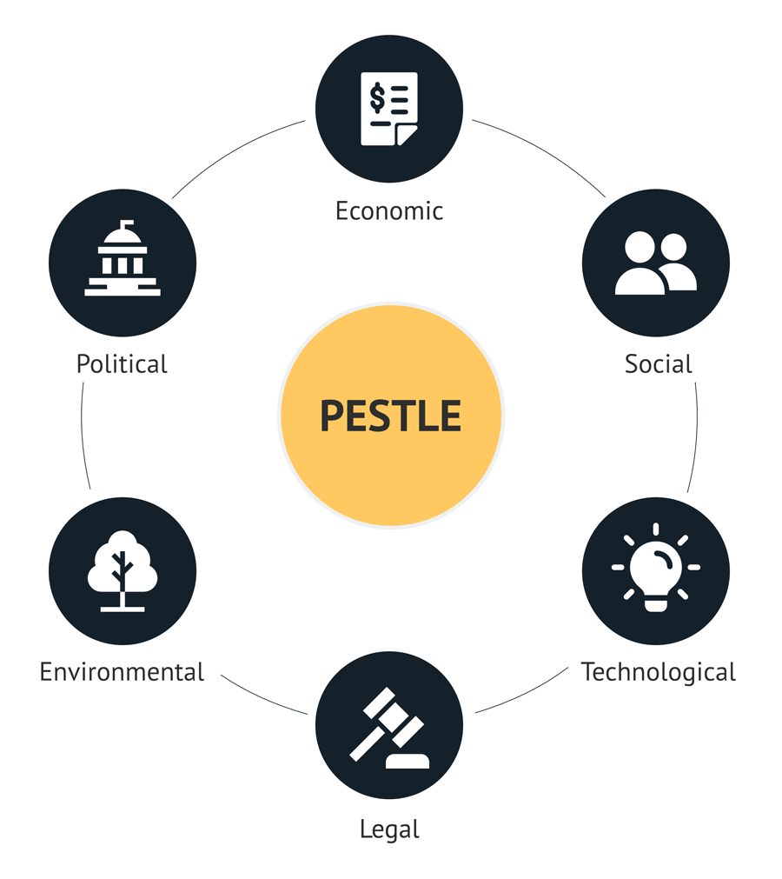
Figure 2: PESTEL Framework (Kar, Das and Kar, 2025)
Political Factors: The strategy of Nestle is highly influenced by political and regulatory pressures. Governments in Europe, North America and some parts of Asia are enacting more stringent laws on plastic use and food labelling. As an example, the Single-Use Plastics Directive in the European Union requires plastic packaging to be reduced and recycling to be increased (ESG News, 2024). As a reaction, Nestle announced its Nestle Packaging Roadmap, whereby by 2025, it will have 100 percent recyclable or reusable packaging and has already taken a step in this regard, by transitioning its YES! snack bars to paper packaging reducing plastic by as much as 97% (Packaging Gateway, 2025).
Economic Factors: Economic volatility, especially increasing inflation and disruption of supply chains, has had a significant impact on Nestle pricing, cost base, and organisational response. Inflation rates throughout the world in 2024 caused commodity prices to grow and Nestle has been forced to raise the prices of its products in certain markets (Asab, 2025). Nevertheless, the firm remained financially stable, with annual sales of CHF 91.4 billion and organic growth of 2.2, which demonstrated that its essentials were still in demand in times of economic downturns (Nestlé, 2025). Moreover, to defend its profitability under the unstable economic forecasts, Nestle declared a significant restructuring initiative involving cutting approximately 16,000 employees (Financial Times, 2025).
Social Factors: The changing consumer tastes are transforming corporate strategy across the world and Nestle is not an exception. The need to have healthy, sustainable products is more than ever. According to a NielsenIQ (2023) report, products sold as being planet-friendly increase 2.5 times more quickly than traditional products in most developed markets. To respond to this challenge, Nestle diversified its plants, such as plant-based Ready-Meals and Coffee Mate alternatives, among others, to adapt to evolving preferences (Le Monde, 2026). This change in consumer behaviour towards wellbeing and health is a direct response to the strategic focus that Nestle has placed on nutrition, health, and wellness.
Technological Factors: The key to competitive advantage is technological innovation. Nestle spends a lot of money in the research and development, about CHF 1.7 billion per year, to enhance food safety, product development and production (Nestlé, 2026). The digital transformation has grown with the utilisation of technologies such as AI-based demand forecasting and automated quality testing, which allows to be more responsive to market dynamics and supply issues. In addition to that, Nestle is cooperating with IBM Research on blockchain technology, which helps to advance the transparency of food supply chains, ensuring consumer confidence and efficiency (Towards Packaging, 2025).
Environmental Factors: One of the most significant external forces which influence the strategy of Nestle is environmental issues. The agricultural yields of such ingredients like coffee, cocoa, and dairy are at risk because of climate change. In response to this, Nestle has undertaken a commitment to achieve net-zero greenhouse gas emissions by 2050 and has already achieved 13.5% reduction in its 2018 level (Nestlé, 2026a). It also promotes regenerative agriculture initiatives and reforestation plans in the production areas like Cote d Ivory and Brazil to provide long term supply resilience and ecology protection (Reuters, 2025).
Legal Factors: Legal adherence affects the priorities of strategy, in terms of food safety and consumer protection. Health and labelling laws are strict in countries such as the United States and Japan. As an illustration, the FDA Nutrition Facts labelling reform has forced Nestle to reformulate and repackage its products to be accurate and transparent (Plevenn, 2025). Moreover, anti-trust laws in markets like India made Nestle change pricing schemes after local inspections, which forced it to be more strategic in its pricing and product placements.
The strategic decisions made by Nestle reflect high levels of adaptation to the external environmental forces. Instead of merely responding to forces of the world, Nestle is incorporating the variables of political, economic, social, technological, environmental, and legal into strategies.
Nestle Critical Success Factors and Strategic Challenges in External Environment.
The success of Nestle in the food and beverage market is determined by several external factors. Its intense priority on innovation and research is one of the significant success factors. It has an annual research and development expenditure of approximately CHF 1.7 billion which has allowed the firm to present healthier and more environmentally friendly products in accordance with the evolving consumer tastes (Nestle, 2026). Global brand portfolio and strength of supply chain are another success factor as the company can maintain stable demand. The organisation has more than 2000 brands and operation in 185 countries (Nestlé, n.d.). Nestle in 2025 recorded CHF 91.4 billion sales and 3.5 % organic growth, proving that even during economic uncertainty, people still needed the essential food products (Industrial Production Worldwide, 2025). Sustainability efforts also play a crucial role as more consumers now favour nature friendly brands.
Nestle has several strategic challenges in its external environment as well. According to Reuters (2025), climate change poses a threat to the availability of major raw materials like coffee and cocoa, which may change the cost, and availability of products. In addition, more stringent government controls regarding packaging and food labelling, including the European Union Single-Use Plastics Directive, raise compliance expenses and necessitate significant operational changes. The cost of production has also risen due to the global inflation and disruption of supply chains, which has necessitated the prices to increase in the market (European Commission, n.d.). These threats make Nestle keep changing its strategies to be competitive and sustainable in the international market.
Analysis of the Internal Environment of Nestle using the VRIO Framework
Nestle has a strong internal environment that helps it to develop competitive position in the global food and beverage market. Internal analysis concentrates on resources, capabilities and core competencies that the organisation possesses to give it sustainable competitive advantage. The VRIO Framework is one of the most popular strategic tools that can be used to assess these capabilities and determine whether organisational resources are Valuable, Rare, Inimitable and Organised to create value (Ariwibowo, Saputro and Haryanto, 2021).
Resource / Capability | Valuable | Rare | Inimitable | Organised | Competitive Outcome
Global Brand Portfolio (Nescafé, KitKat, Maggi; 2000+ brands) | ✓ | ✓ | ✓ | ✓ | Sustained advantage
Global Supply Chain (335 factories; operations in 185+ countries) | ✓ | ✓ | ✓ | ✓ | Strong advantage
R&D Capability (CHF 1.7 billion annual investment) | ✓ | ✓ | ✓ | ✓ | Sustained advantage
Industry Experience (150+ years since 1866) | ✓ | ✓ | ✓ | ✓ | Sustained advantage
Digital & AI Technologies | ✓ | ✗ | ✗ | ✓ | Temporary advantage

Figure 3 : VRIO Analysis of Nestle (Self-made)
Valuable Resources and Capabilities: The company has a strong global brand portfolio which is one of the most valuable internal resources of Nestle. It has over 2,000 brands, including famous products like Nescafé, KitKat, Maggi, and Nido. These are well known and trusted brands by consumers in most markets (Nestlé, n.d.). A good brand reputation will attract customer loyalty and enable Nestle to stay at constant demand even in cases of economic doubt. For example, in 2025, the company registered about CHF 91.4 billion in worldwide sales, which is an indication of the excellent market worth that its brand portfolio produced Industrial Production Worldwide, 2025).
Global supply chain and distribution network by Nestle are important resources of Nestle. The company has more than 185 countries of operation. Besides, it has 335 factories in 75 countries around the world (Nestle, 2026a). This large network enables Nestle to distribute its products effectively and ensure the same products are available in all markets across the world. The VRIO model indicates that this type of operational capabilities is value-creating since it enhances efficiency, minimizes distribution costs, and enables the company to cater to a vast and varied customer base.
Rare Resources: Nestle also has resources which are comparatively scarce relative to its many rivals. Its advanced research and development (R&D) capability is one such important resource. Each year Nestle invests around CHF 1.7 billion in R&D in terms of product innovation, nutrition science, and food safety (Nestle, 2026). The business has various research centres around the world which help in the invention of new products and enhance the existing one. This robust research capacity enables Nestle to launch new products like healthy snacks, plant-based products, and fortified food products that address the shifting consumer preferences.
Difficult to Imitate: The other factor of VRIO framework is the ability of rivals to imitate organisational resources easily. Competitors can hardly imitate Nestle because of its global brand name, long organisational history, and an established supply chain. Established in 1866, the company has over 150 years’ experience in the industry allowing it to establish good relations with its suppliers, distributors as well as retailers around the world. Such long-term relationship provides entry barriers to new market entrants (Ellitan and Rinata, 2024). Also, Nestle research and product development activities demand a significant number of financial resources and expertise. The Resource-Based View (RBV) theory suggests that these unique and hard-to-imitate resources assist firms in gaining a sustainable competitive advantage.
Organisational Support and Strategic Management: The final element of VRIO framework is how organisation is structured to maximises its resources. Nestle has also established strong organisational structures to ensure that the global business operations are handled effectively (Shen, 2022). The company has business units that are specialised like beverages, nutrition, dairy, and pet care and this enables the efficient management of its diverse product portfolio.
The Nestle also invests in digital technologies and sustainability projects continuously to enhance innovation. As an example, the company has launched AI-powered demand forecasting and digital supply chain technologies to enhance the efficiency of its operations and decision-making (Brain forge, no date). Such organisational capabilities help in ensuring that Nestle can be able to efficiently utilise its resources and be able to perform well in the global markets.
Contribution to competitive advantage
In general, Nestle has several internal strengths that can be considered to have a great impact on its competitive advantage. Its great global brands, effective supply chain, high research ability and industry experience create the strategic capabilities that the competitors may not be able to replicate (Ariwibowo, Saputro and Haryanto, 2021). Analysed in the context of the VRIO framework, these resources prove that Nestle has a few sustainable benefits that can help the company to grow and dominate the global food and beverage market in the long-term.

Critical Analysis of the Nestle CSR Strategy and its Alignment with Business Objectives
The Corporate Social Responsibility (CSR) strategy of Nestle is dedicated to the sustainable business practices, environmental protection, nutrition and health, and the support of the community. The company has also established specific objectives that support its long-term business strategies of growth, brand trust, and market leadership. Environmental sustainability, particularly the reduction of greenhouse gas emission, is one of the main CSR concerns. Nestle has set a goal of reaching net-zero greenhouse gas emissions by 2050 and minimised its emissions by 13.5% in comparison with the 2018 level (Nestle, 2026).
Responsible sourcing is another major CSR area of the company. In 2025, 49.8% of its ingredients was responsibly sourced (Nestlé, 2026c).
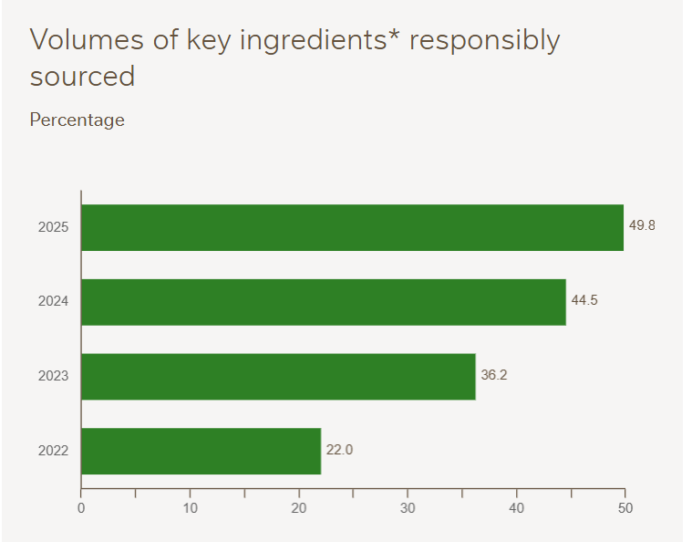
Figure 4: Responsibly Sourcing of Nestle (Nestlé, 2026c).
To have ethical supply chains, the firm invests in programs that support fair labour practices and sustainable agriculture. An example is the Nescafé Plan developed by Nestle that educates coffee farmers in sustainable farming practices and thus enhances yields and profits. This program contributes to the quality of long-term supply and assists rural communities (Nestlé, 2021).
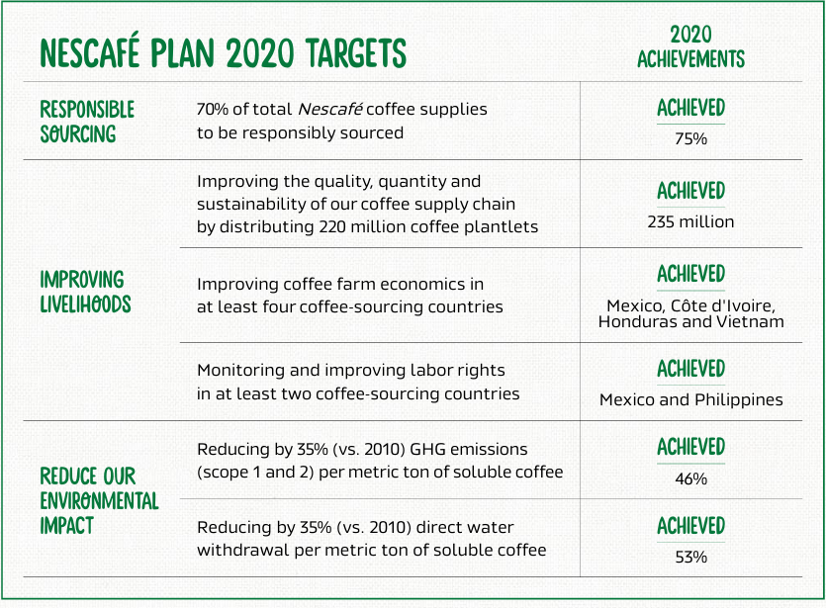
Figure 5: Nescafe Plan 2020 Targets (Nestlé, 2021).
Health and nutrition are also included in the CSR strategy of Nestle as it has a business goal to be the leader in nutrition, health and wellness. The company constantly reinvents products to contain less sugar, salt and unhealthy fats. Nestle also emphasizes on regenerative agriculture as its 27.6% key ingredients in 2025 were sourced from farmers who followed regenerative agriculture practices (Nestlé, 2026d).

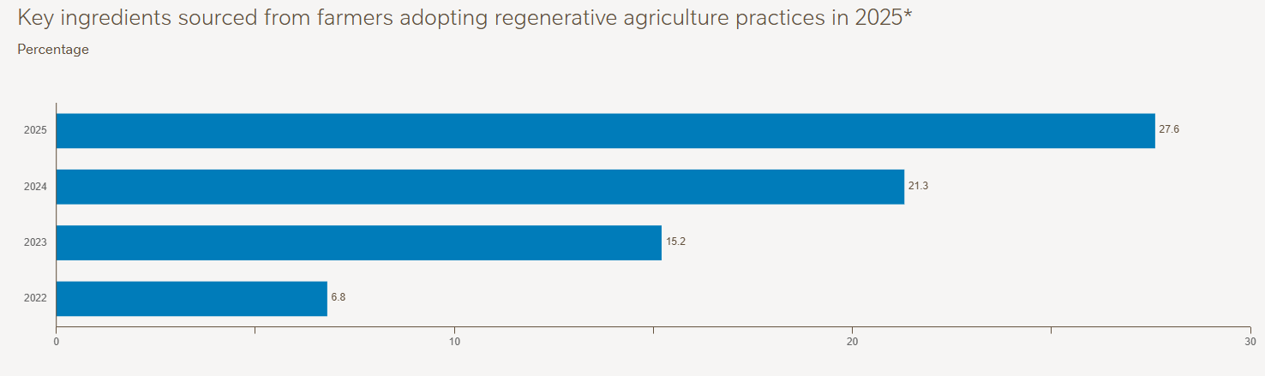
Figure 6: Regenerative Agriculture Practice in Nestle (Nestlé, 2026d).
Rahman and Hasan (2024) opined that Despite the ambitious nature of the CSR strategy at Nestle, critics state that some of its elements have been slow to improve, such as plastic reduction. Nevertheless, the current objectives and investments by the company indicate a strategic balance between CSR and business purposes: building brand value, achieving innovation and fuelling sustainable development.

Comprehensive and Holistic view of Nestle using Balanced Scorecard Framework
The Balanced Scorecard was the management model created by Robert Kaplan and David Norton in 1992 that measures organisational performance in four dimensions: financial, customer, internal business processes, and learning and growth (Aryani and Setiawan, 2020). This model assists organisations in making their strategy meet quantifiable goals and key performance indicators (KPIs). In the case of a global company such as Nestle, the balanced scorecard assists it to combine financial performance with sustainability, innovation, and customer value.
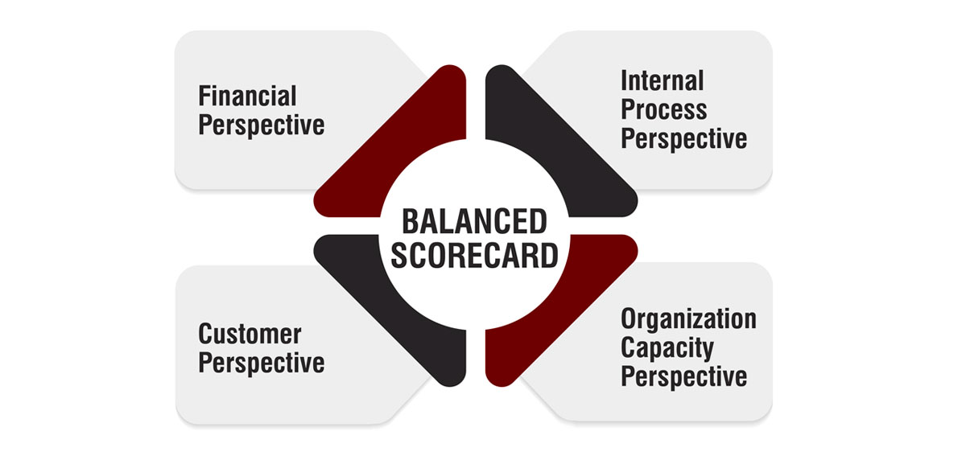
Figure 7: Balanced Scorecard (Hamied and Elbagoury, 2025).
Financial Perspective: The financial outlook is concerned with enhancing profitability, revenue growth and shareholder value. The primary goal of Nestle is to sustain the growth of sales at a sustainable level and remain efficient in its operations. Key KPIs will be organic sales growth, margin of profit operations, and cost savings. As an example, nestle has focused on the 2.2% organic growth and CHF 2.5 billion cost reduction by 2027 using efficiency programs and digital transformation (Nestlé, 2026).
The Nestle Continuous Excellence program is one such program that helps to achieve these targets by enhancing productivity and lowering operational costs. Automation and supply chain optimization can help Nestle boost its profit margins and maintain competitive prices on products (Büchel and Zintel 2024). Sustainability and innovation investments are also backed by financial performance in the long term.
Customer Perspective: Customer perspective is based on providing value to consumers and creating a good brand loyalty. The Nestle mission is to offer quality, nutritious, and safe food products to customers with customer satisfaction. The most important KPIs are the level of customer satisfaction, brand loyalty, product quality rating, and market share (Nagarathinam et al., 2021).
Nestle has a consumer base of over 180 countries and its products include Nescafé, Maggi, KitKat and Purina. Another objective of the company is to enhance nutrition by using fortified products. For example, Nestle distributed approximately 132 billion portions of fortified foods throughout the world, a move that aided in curbing nutritional deficiency in most nations (Nestle, 2026a).
As part of these objectives, nestle focuses on measures like product reformulation to minimise sugar, salt, and unhealthy fats, and advertising, which prioritize health and sustainability. Such programs enhance brand image and customer loyalty.
Internal Business Process Perspective: The internal business process approach is aimed at enhanced operational efficiency, product quality, and sustainable supply chains. The goals of Nestle are to enhance production methods, responsible sourcing and enhance product development innovation (Aryani and Setiawan, 2020).
Top KPIs are the percentage of sustainably sourced raw materials, the level of productivity, and efficiency of supply chain. As an example, Nestle has already sourced more than 93% of its key supply chains free of deforestation and has also used regenerative agriculture to make its production more environmentally friendly (Nestlé, 2026c).
Some of the initiatives in favour of this view are collaboration with growers, development of quality control technology, and investment in environmentally friendly production processes. Such enhancements guarantee a stable quality of goods and decrease risks on the environment.
Learning and Growth Perspective: The learning and growth approach is cantered on the development of employees, innovation, organisational culture. The goal of Nestle is to produce talented workers and promote life-long learning and innovation (Kumar et al., 2024). The main KPIs are hours of employee training, employee satisfaction, management diversity, and innovation performance.
For example, Nestle is dedicated to diversity and inclusion as approximately 47.4% of managerial roles are occupied by women. The company also promotes youth employment and through global efforts; the company has assisted more than 10 million young people to obtain training and employment opportunities (Nestlé, 2026e).
These initiatives enhance the skills and motivation of the employees thus culminating to innovation and improved organisational performance.

Nestle’s Strategic Choices and Implementation
As a global enterprise in the food and beverage industry, nestle engages in both business-level and corporate-level strategic decision-making to continue its growth, competitiveness, and sustainability (Nestlé, n.d.). These decisions dictate the competitive nature of the company in the markets as well as how it goes about managing its various product and operations.
Business-Level Strategic Decisions: At business level, Nestle mostly adheres to differentiation strategy. The company concentrates on the provision of high quality, nutritious and innovative products that satisfy consumer needs (Greckhamer and Gur, 2021). To illustrate, Nestle keeps recycling products by decreasing sugar, salt, and unhealthy fats in response to the health trends among consumers. Its focus on nutrition, health, and wellness enables it to set higher prices relative to competitors, and enjoy high brand loyalty (Nestlé, 2026a).
The most important evidence of this strategy is the Nescafé Plan that helps to sustain the farming and improve the quality of the products, forming the obvious difference in the coffee market (Nestlé, 2021). Moreover, Nestle invests in modern R&D systems across the globe, where it manufactures products, plant-based foods, fortified, and special nutrition products. This product differentiation does not only enhance customer satisfaction but also market leadership because Nestle is now located in more than 180 countries and offers more than 2,000 brands (Nestle, 2026).
Although cost leadership may equally be an option when dealing with emerging markets, the emphasis on quality and sustainability also makes sure that the principle of differentiation is more balanced with its international reputation and long-term goals.
Corporate-Level Strategic decisions: Nestle focuses on international expansion and internationalization in the corporate level. Expansion into foreign markets will enable it to venture into new markets, gain revenue, and decrease reliance on already developed markets such as Europe. As an example, Nestle has expanded rapidly in Asia and Africa and has taken over the emerging middle classes (Swissinfo, 2015).
The other strategic option is diversification. Nestle has a diverse portfolio, which consists of beverages, dairy, confectionery, pet care and health science products. By 2025, the company had been able to earn revenues in several segments, which eliminated the risk of being excessively dependent on one type of product. According to The Case Solutions (n.d.), the purchase of firms like The Bountiful Company in the U.S. to produce health and wellness products can serve as an example of the Nestle diversification strategy in the markets with high growth.
According to these alternatives, the strategic alternatives suggested to Nestle include staying with differentiation at the business level and international expansion with selective diversification at the corporate level. Differentiation increases brand equity and consumer confidence, and international expansion and diversification enhance resilience and profitability in the long-term.
Change and Implementation Management: Nestle has been exhibiting a high ability to manage change and this is essential in execution of its strategies. The firm has been able to respond to the evolving consumer tastes, digitalization and sustainability demands. As an example, Nestle launched a greener package, regenerative farming, and online marketing tools to access young buyers (Reza, 2020).
Nevertheless, there are still certain challenges. Critics suggest that the development of plastic and totally sustainable supply chains has been less rapid than scheduled. According to Sainger and Khan (2025), Nestle systematic initiatives such as Nestle Continuous Excellence demonstrate that change is integrated, and its systematic implementation enhances effectiveness, supply chain regulation, and involvement of employees.
The strategic decisions made by Nestle such as differentiation, internationalization, and diversification are in line with its mission of providing nutrition, health, and wellness with a sustainable growth.

Strategic Evaluation and Recommendations for Nestle
To critically analyse the current strategy of Nestle, this part includes the SWOT analysis and the Matrix created by Ansoff, which helps to understand the strengths, weaknesses, opportunities, and threats of the company, along with possible growth strategies.
SWOT analysis
SWOT | Details
Strengths | - Strong global brand (180+ countries and 2000 product portfolio)  - Multiple products (beverages, dairy, confectionery, health science)  - Nutrition, health and wellness leadership.  - High R&D and innovation capabilities (Tze et al., 2022).
Weaknesses | - Slow pace of reducing plastic waste  - Large and complex operations  - Increased cost  - Complex organisational structure
Opportunities | - Emerging market (Asia and Africa) growth potential.  - The increased demand of plant-based products, fortified nutrition, and sustainable products.  - Grasping digital growth opportunity  - Opportunity to reach younger consumers (Shen, 2022).
Threats | - High level competition from local and multinational food companies.  - Varying prices of raw materials and regulatory forces.  - Global warming and environmental threats.  - Shifting customer preferences

Ansoff’s Matrix
The development strategies of Nestle can be analysed using this strategic framework
Market Penetration: Nestle will be able to boost market share on current products within the mature markets by conducting promotions, loyalty programs, and reformulations of healthier products (Sin et al., 2022).
Market Development: Nestle can expand into new countries and regions, including the African and Southeast Asian markets, to access emerging consumer markets.
Product Development: Nestle is innovative and provides plant-based food, low-sugar options and functional drinks to suit the constantly evolving consumer preferences (Nestlé, 2026).
Diversification: Nestle acquires assets in health science, pet care and wellness segments to lessen its reliance on traditionally produced products and venture in high-growth markets
Recommendations
Nestle can also move towards practicing faster sustainability by targeting a reduction in plastic packaging and carbon footprint, using the practices of the circular economy. This is in line with the Porters shared value concept, which generates business value and social value. The company can also become more digitally transformed by investing in e-commerce platforms and data analytics that can better enable their understanding of customers, product personalization, and operational efficiency (McNeish and Neufeldt, 2023). Furthermore, Nestle should pay attention to new markets by adapting products to local preferences and prices. An example of this is establishing low-cost fortified products in African countries to enhance brand presence and social impact. Lastly, further innovation and investment in nutrition, plant-based and functional products will aid differentiation, ensuring Nestle stays ahead of competitors (Reza, 2020).

Section 2

Personal Reflection Using Gibbs reflective cycle
This reflection is a critical analysis of my learning and experience when performing the strategic assessment of Nestle. It shows my early struggles, development of knowledge and my study, critique and implementation of strategic models (Williams, Woolliams and Spiro, 2020). Strengths, limitations and lessons to enhance future assessment are also reflected on in the section. For writing this reflection Gibb’s reflective model is chosen.
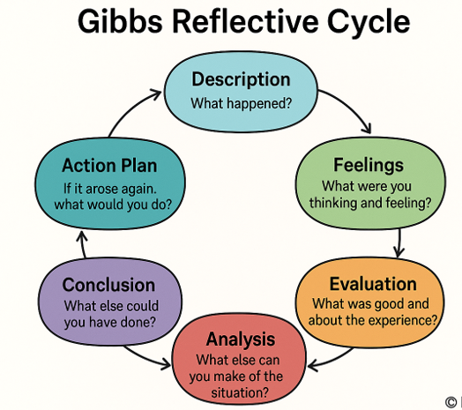
Figure 8: Gibbs Reflective Model (Source: Ahmadpour, Shariati, and Moghadam, 2025)
Description: To complete the above section of my assessment on Nestle, I had a systematic approach by researching, analysing and synthesizing information on various topics. The evaluation was done in six key areas, which included organisational context, external and internal environment analysis, CSR and sustainability, the balanced scorecard, strategic choices and strategic evaluation with recommendations. To understand the history, mission, vision, and operations of Nestle in detail, I started gathering data through the official site of the company, annual reports, sustainability reports, and reputable business journals. I also read secondary sources to discuss the industry environment, competitors, and market trends. Once the data were collected, I used strategic frameworks, including PESTEL, VRIO, Balanced Scorecard, SWOT, and Ansoff Matrix, to organize my analysis logically. Then every section was prepared meticulously, with theory connected to real-world examples like the Nestle Nescafé Plan, regenerative agriculture and strategies of international expansion.
Feelings: Initially, I felt overwhelmed by the fact that Nestle is a huge multinational corporation with a complicated structure, multiple products, and business in numerous countries. I was afraid of choosing appropriate information and not taking irrelevant details that might make the assessment too lengthy and confusing. Besides, I was also scared of getting appropriate data and examples relevant to this assessment. As I moved on, I started becoming more confident since such frameworks as PESTEL and VRIO offered structure and clarity. I also was inspired when I was allowed to associate practical efforts like sustainable sourcing and digital transformation with theoretic ones, making analysis more valuable and realistic.
Evaluation: There were positive and challenging moments in the research and writing process. One of my strongest points was that I was able to arrange much data into clear sections with the help of strategic frameworks. This assisted in coming up with a coherent analysis that linked internal strengths, external environment and strategic decisions. The other good thing was that recommendations related to theoretical models and therefore the work was scholarly sound. Nevertheless, one of the major difficulties was the handling of the flow of information. The global operations of Nestle and its sustainability initiatives result in large amounts of data, and I needed to select the most pertinent information and keep the word count at the appropriate level per section. Also, certain internal strategies are kept secret, which restricted the scope of analysis in some respects.
Analysis: The strategic analysis of Nestle through structured frameworks offered several indications. The PESTEL analysis made me see the extent to which political, economic, social, technological, environmental, and legal factors impact strategic decisions. The VRIO model helped to define the resources and capabilities that Nestle possesses to achieve its competitive advantage, including R&D expertise, brand equity, and sustainable supply chains. Application of the Balanced Scorecard revealed significance of tracking financial, customer, internal process, and learning and growth views. The use of SWOT and the Matrix of Ansoff also assisted in determining growth opportunities and strategic issues, making the recommendations realistic and evidence based. This helped to support my belief that a good strategy takes both critical assessment and alignment with business objectives.
Conclusion: Considering this process, I have come to understand that a high-quality strategic assessment requires systematic research, structured analysis and prudent synthesis. The frameworks are used to provide clarity, whereas the connection between the theory and the real-life examples adds to the understanding and academic validity. I also realized that time management, focusing on pertinent information, and providing concise data are important to abide by word limits.
Action Plan: In case I needed to repeat this process, I would begin with the research plan which clarifies what areas to be focused on and which sources to be used. I would be more systematic in following sources to be able to reference them correctly and not have outdated information. I would also incorporate visual aids such as charts and tables early into the process to systematise the data that needs to be analysed to make the analysis more comprehensible. For my future development, I will also focus on developing my time-management skills which will help me in the future for completing my assignment before the deadline. Lastly, I would spend more time on the critical reflection, where every recommendation would be proven by theory and practical evidence, which would enhance the overall assessment.
This reflective process provided me with useful information about strategic analysis and academic research. The use of structured frameworks enhanced my skills of interpreting complex organisational information and relating theory and practice. This experience has developed my analytical reasoning, the ability to organize research, and time management, which will help me make assessments more efficient and systematic in my further studies.

References
Ahmadpour, N., Shariati, A. and Moghadam, M.P. (2025) ‘Effect of narrative writing based on Gibbs’ reflective model on the empathy and communication skills of nursing students’, BMC Medical Education, 25(1), p. 10.
Ariwibowo, P., Saputro, F.B. and Haryanto, H., (2021). Analysis of strength & weakness, using the concept of resource-based view with the VRIO framework in sharia cooperatives. Jurnal Manajemen Strategi dan Aplikasi Bisnis, 4(1), pp.279-294.
Aryani, Y.A. and Setiawan, D. (2020) ‘Balanced scorecard: Is it beneficial enough? A literature review’, Asian Journal of Accounting Perspectives, 13(1), pp. 65–84.
Asab, N.A., (2025). Are supply shocks a key driver of global inflation? Evidence from CPI and GDP deflator analysis. Research in Globalization, 10, p.100279.
Brainforge (no date) How Nestle uses data analytics for market expansion. Available at: https://www.brainforge.ai/blog/how-nestle-uses-data-analytics-for-market-expansion (Accessed: 7 March 2026).
Büchel, B. and Zintel, C. (2024) ‘Nestlé Continuous Excellence: Lessons for driving performance improvement’, The European Financial Review, 1 September. Available at: https://www.europeanfinancialreview.com/nestle-continuous-excellence-lessons-for-driving-performance-improvement/ (Accessed: 15 March 2026).
Ellitan, L. and Rinata, Y.A.C., (2024). Building Competitive Advantage: Lesson Learned from “PT Nestlé Indonesia”.
ESG News (2024) Nestlé introduces 90% plastic reduction with new paper-based packaging innovations. Available at: https://esgnews.com/nestle-introduces-90-plastic-reduction-with-new-paper-based-packaging-innovations/ (Accessed: 10 March 2026).
European Commission (n.d.) Single-use plastics. Available at: https://environment.ec.europa.eu/topics/plastics/single-use-plastics_en (Accessed: 11 March 2026).
Financial Times (2025) Nestlé to axe 16,000 jobs as new boss intensifies cost-cutting push. Available at: https://www.ft.com/content/9bf755d8-5831-4bab-b1a1-6dc66f6cf252 (Accessed: 10 March 2026).
Greckhamer, T. and Gur, F.A. (2021) ‘Disentangling combinations and contingencies of generic strategies: A set-theoretic configurational approach’, Long Range Planning, 54(2), p. 101951.
Hamied, M.S.A. and Elbagoury, A., (2025). Balanced scorecards: proposed framework for application at the local system level insights from international experiences. Review of Economics and Political Science, 10(1), pp.34-51.
Industrial Production Worldwide (2025) Nestlé generates sales about CHF 89.5 billion in 2025. Available at: https://www.industrial-production-worldwide.com/news/nestle-generates-sales-about-chf-895-billion-2025 (Accessed: 11 March 2026)
Johnson, M.E. and Brechbühl, H., (2025). The CIO–CISO relationship in a globally networked business—An interview with Nestlé AG. Electronic Markets, 35(1), p.44.
Kar, S., Das, S. and Kar, B., (2025). PESTEL framework analysis: challenges, government support and performance in agricultural SMEs. SEDME (Small Enterprises Development, Management & Extension Journal), 52(2), pp.142–153.
Kumar, S., Lim, W.M., Sureka, R., Jabbour, C.J.C. and Bamel, U. (2024) ‘Balanced scorecard: trends, developments, and future directions’, Review of Managerial Science, 18(8), pp. 2397–2439.
Le Monde (2026) Nestlé exits ice cream market and partially withdraws from bottled water. Available at: https://www.lemonde.fr/en/economy/article/2026/02/19/nestle-exits-ice-cream-market-and-partially-withdraws-from-bottled-water_6750648_19.html (Accessed: 10 March 2026).
Lubaba, M., Hassan, S., Sultana, M., Morshed, S.M. and Bari, A.M., (2025). Assessment of the challenges to implementing green manufacturing in the food and beverage industry: an emerging economy perspective. Waste Management Bulletin, 3(3), p.100225.
McNeish, J.E. and Neufeldt, J. (2023) ‘Can Nestlé transform from a corporation that “talks about doing good” to “doing good” for the environment?’, in Dealing with socially responsible consumers: Studies in marketing, Springer Nature Singapore, Singapore, pp. 429–456.
Nagarathinam, V., Dhanvarshini, S., Ahamed, A.I., Ajith, S. and Yuvaraj, P. (2021) ‘A study on marketing mix of Nestlé product’.
Nestlé (2021) Our sustainable journey: Ten years of the NESCAFÉ Plan. Vevey: Nestlé. Available at: https://www.nestle.com/sites/default/files/2021-01/sustainable-journey-ten-years-nescafe-plan-2021-en.pdf (Accessed: 15 March 2026).
Nestlé (2025) Full-year results 2024. Vevey, Switzerland: Nestlé. Available at: https://www.nestle.com/media/pressreleases/allpressreleases/full-year-results-2024 (Accessed: 10 March 2026).
Nestlé (2026) At a glance: Key facts and figures. Available at: https://www.nestle.com/about/overview (Accessed: 10 March 2026).
Nestlé (2026b) Our purpose and values. Available at: https://www.nestle.com/about/how-we-do-business/purpose-values (Accessed: 10 March 2026).
Nestlé (2026c) Responsible sourcing. Available at: https://www.nestle.com/sustainability/responsible-sourcing (Accessed: 15 March 2026).
Nestlé (2026d) Sustainability. Available at: https://www.nestle.com/sustainability (Accessed: 15 March 2026).
Nestlé (2026e) Diversity, equity & inclusion. Available at: https://www.nestle.com/jobs/diversity-equity-inclusion (Accessed: 15 March 2026)
Nestlé (n.d.) Brands. Available at: https://www.nestle.com/brands (Accessed: 11 March 2026).
Nestlé (n.d.) Our strategy. Available at: https://www.nestle.com/about/strategy (Accessed: 15 March 2026).
Nestlé S.A. (2026a) Annual Review 2025. Vevey, Switzerland: Nestlé S.A. Available at: https://www.nestle.com/sites/default/files/2026-02/annual-review-2025-en.pdf (Accessed: 10 March 2026).
NielsenIQ (2023) Consumers care about sustainability – and back it up with their wallets. Available at: https://nielseniq.com/global/en/insights/report/2023/consumers-care-about-sustainability-and-back-it-up-with-their-wallets/ (Accessed: 10 March 2026).
Packaging Gateway (2025) Nestlé sets out five-pillar packaging plan of 2025 goal. Available at: https://www.packaging-gateway.com/news/nestle-sets-out-five-pillar-packaging-plan-ahead-of-2025-goal/ (Accessed: 10 March 2026).
Plevenn (2025) Global food labelling regulations you need to know about. Available at: https://www.plevenn.com/blogs/global-food-labelling-regulations-you-need-to-know-about (Accessed: 10 March 2026).
Rahman, K.S. and Hasan, M.D. (2024) Balancing ethics and profitability: Strategies for Nestlé to overcome ethical scandals and enhance reputation.
Reuters (2025) Nestle, Barry Callebaut, reagree to restore areas in Brazil’s cocoa, coffee regions. Available at: https://www.reuters.com/sustainability/climate-energy/nestle-barry-callebaut-regreen-restore-areas-brazils-cocoa-coffee-regions-2025-07-17/ (Accessed: 10 March 2026).
Reza, M.H. (2020) ‘Analysis of marketing strategy and quality policy of Nestlé’, International Journal of Scientific Research and Engineering Development, 3(2), pp. 1145–1152.
Reza, M.H. (2020) ‘Analysis of marketing strategy and quality policy of Nestlé’, International Journal of Scientific Research and Engineering Development, 3(2), pp. 1145–1152.
Reza, M.H., (2020). Analysis of marketing strategy and quality policy of Nestlé. International Journal of Scientific Research and Engineering Development, 3(2), pp.1145-1152.
Sainger, G. and Khan, W. (2025) ‘Nestlé’s new recipe for success: A CEO’s strategy amid inflation’, The CASE Journal, pp. 1–7.
Shen, Y. (2022) ‘SWOT analysis and strategy selection of Nestlé’, in Proceedings of the 7th International Conference on Social Sciences and Economic Development (ICSSED 2022), Atlantis Press, pp. 800–805.
Shen, Y., (2022), April. SWOT Analysis and Strategy Selection of Nestle. In 2022 7th International Conference on Social Sciences and Economic Development (ICSSED 2022) (pp. 800-805). Atlantis Press.
Sin, L.G., Rahim, N.F.A., Lin, J.L.J., Sharma, B., Gulati, C., Ghani, H.Z.B.H., Ming, G., Yinuo, G., Hassan, H.B.M., Triana, A.A.A. and Pawar, Y. (2022) ‘Fostering a culture of business ethics: A case study of Nestlé’, Society, 10(2), pp. 723–734.
Swissinfo (2015) Nestlé cuts Africa workforce as middle-class growth disappoints. Available at: https://www.swissinfo.ch/eng/business/nestl%C3%A9-cuts-africa-workforce-as-middle-class-growth-disappoints/41496210 (Accessed: 15 March 2026).
The Case Solutions (n.d.) Nestlé SA: Health & Wellness Strategy. Available at: https://www.thecasesolutions.com/nestle-continuous-excellence-lessons-for-driving-performance-improvement/ (Accessed: 15 March 2026).
Towards Packaging (2025) Nestlé and IBM collaborate to revolutionise sustainable packaging with AI. Available at: https://www.towardspackaging.com/news/nestle-ibm-ai-packaging-innovation (Accessed: 10 March 2026)
Tze, X.C., Zhe, X.C., Sin, C.C. and Shieh, H.C. (2022) ‘A study on marketing strategy of Nestlé in Asia’, Advances in Global Economics and Business Journal, 3(1), pp. 1–14.
Williams, K., Woolliams, M. and Spiro, J. (2020) Reflective writing. London: Bloomsbury Publishing.

