Module code: LCLM4004
Module name: Problem Solving and Decision Making
Assignment title: Component 2 Individual Report
Student name: Bianca Mariana Moise
Student ID: 2436545
Lecture`s name: Anita Nan

Contents
1.0 Introduction 3
2.0 Brief explanation of the business problem 3
3.0 Suggestion of two alternative solutions 5
3.1 Alternative solutions 5
3.2 Evaluation 6
4.0 Selection of one justified solution to the problem 7
5.0 Risk analysis of the selected solution 8
6.0 Plan to implement the decision 8
7.0 Ways to measure the effectiveness of the selected solution 9
8.0 Conclusion 9
Appendices 12
Appendix 1: Two alternative solutions 12
Appendix 2: Porter’s Five Forces 12
Appendix 3: Risk Matrix 13
Appendix 4: SMART Objectives 13
Appendix 5: Action Plan 13

1.0 Introduction
Problem-solving and decision-making are two essential business management skills to navigate challenges and achieve goals. Green Haven Florists has been experiencing a severe decline in in-store sales and rising operational costs. These have resulted in declining performance for the florist retailer in terms of remaining profitable and sustainable in the competitive marketplace. This report aims to profoundly analyse the business problem faced by Green Haven Florists and identify two alternative solutions. Overall, the study facilitates an effective decision-making process for the florist brand. By briefly analysing the problem and evaluating the most appropriate solution to encounter the challenges. This leads the report to showcase an approach to problem-solving for the company.

2.0 Brief explanation of the business problem
Green Haven Florists has been experiencing multiple business challenges for the last 12 months. It primarily happens due to shifting customer interest, inflationary crisis and intense competitive rivalry. The brand has experienced a 30% decline in its in-store sales. Shifting customer behaviour towards online purchase for availing smart features and convenience has resulted in a decline in in-store performance.
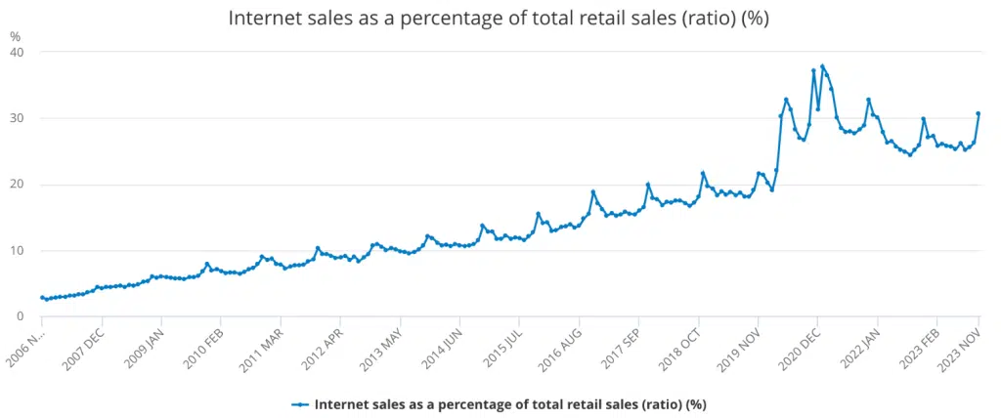
Figure 1: Share of online retail sales in the UK
Internet retail sales have been estimated to be 28.1% of all retail sales in the UK in October 2025 (Ons.gov.uk, 2025a). While the online sales rate of Green Haven Florists has slightly increased, the brand has failed to properly compensate for its decline in foot traffic. The emergence of the supply chain disruption and a high inflationary crisis has led to increased operational costs for the florist brand.

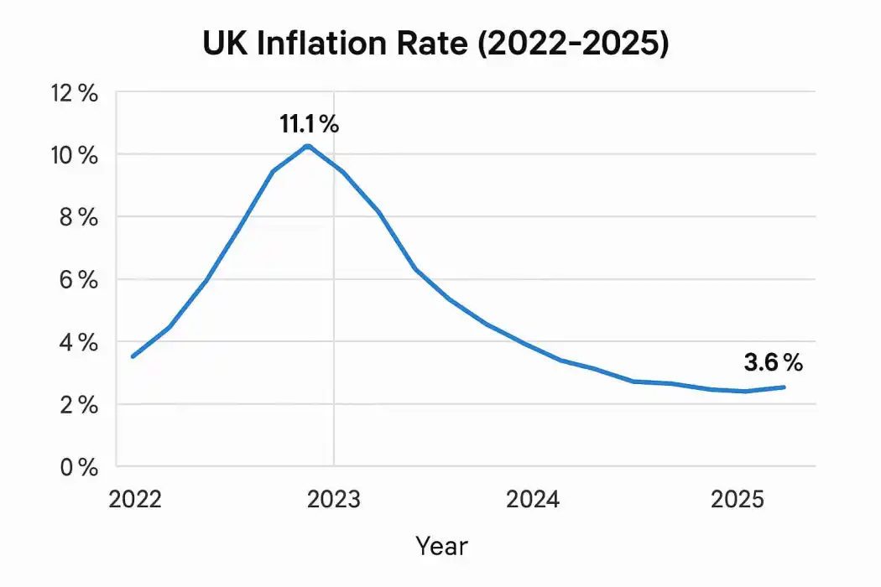
Figure 2: The UK inflation rate, 2022-2025
Currently, the UK inflation reached 3.6% as estimated in October 2025 (Commonslibrary.parliament.uk, 2025). Growing inflation has caused an increase in the Consumer Price Index (CPI) not only for customers but also for small businesses. The sourcing of biodegradable materials and locally sourced blooms has become more expensive for the florist retailer due to high CPI.
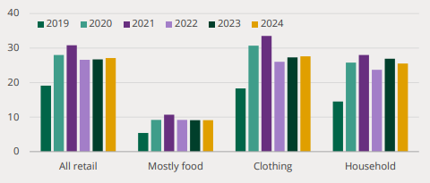
Figure 3: Online retail sales in Britain by categories
Online retail sales in the UK reached their peak in 2021 after the increasing focus on digital transition due to the impact of the COVID-19 pandemic (Researchbriefings.files.parliament.uk, 2025). However, customer feedback has highlighted an outdated website for Green Haven Florists. A website is crucial for driving online traffic and accelerating e-commerce sales revenue (Wackerbarth et al., 2021). A large number of long-term customers now prefer convenience and lower prices offered by the large online flower retailers. Such a scenario has made the market competition more intense for the brand. Additionally, the entry of two new competitors in the local market with trendy boutique services and aggressive pricing strategies has made the bargaining power of customers high for Green Haven Florists. Overall, the current crisis of the florist brand demonstrates a lack of business differentiation and modernisation.

3.0 Suggestion of two alternative solutions

3.1 Alternative solutions
Change management
Implementation of an adequate change management strategy will result in better corporate practices and profitability for Green Haven Florists. For instance, the brand can implement a customer-centric business model to drive equal improvement for physical stores and e-commerce channels [Refer to Appendix 1]. Change management can also help the company reconfigure its website to match the updated market insights to compete with the market rivals.
Business differentiation
The current issues faced by Green Haven have highlighted a significant gap in business differentiation in terms of standing out from the competition. Innovation is crucial for creating Unique Selling Points (USP) that help differentiate a business (Bataineh, Sánchez‐Sellero and Ayad, 2024). The company can develop new innovative services that cater to the shifting customer needs [Refer to Appendix 1]. For instance, the brand can expand to personalised subscription services to attain a new revenue generation stream.

3.2 Evaluation
The Plus Minus Interesting (PMI) model is an effective strategic tool for evaluating strategic alternatives. For instance, the plus point (advantage) of change management for Green Haven is increased organisational resilience to adapt to market changes.
Solution 1 : change management
Pluses ( advantages ) | Minuses (disadvantages) | Interesting points
- better omnichannel | - resistance to change | - elimination of outdated
- modernisation | - time consuming | - increased competitiveness

Solution 2 : business differentiation

Pluses ( advantages ) | Minuses (disadvantages) | Interesting points
- differentiated offering | - increased R&D budget | - unique selling points
- dynamic pricing | - operational complexity | - Increased customer retention

One key advantage that business differentiation can provide is increased control of the florist brand over dynamic pricing. However, this solution would require a high R&D budget from the brand to drive innovation for differentiation. The interesting points for implementing a change management strategy are the elimination of outdated services and increased competitiveness. For instance, this solution can be beneficial for updating its website.

4.0 Selection of one justified solution to the problem
The Porter’s Five Forces have denoted an overall high competitive rivalry for Green Haven. The low capital requirement and high growth potential in the florist retail market have made the threat of new market entrants high for Green Haven [Refer to Appendix 2]. In such a scenario, business differentiation would be the most appropriate strategic selection for the brand to enhance the competitiveness of its offerings by differentiating them. For instance, the brand can adopt lean principles as a differentiated approach to enhance competitiveness. Lean management is effective for minimising waste and maximising value for customers (Calderon et al., 2025). This will also help the brand better combat its high operational cost crisis due to supply chain disruption. Furthermore, focusing on business differentiation will help develop new innovative products. It will enhance the competitiveness of the firm to stand out from the competition with new market entrants. Differentiation is crucial for integrating new features in physical stores (Lee and Chau, 2022). For instance, Green Haven can integrate digital displays and a sustainable store design to attract customers and drive foot traffic.

5.0 Risk analysis of the selected solution
There are different risks associated with the selected alternative solution. Differentiation requires consistent R&D investment to generate innovative products and approaches (Buccella, Fanti and Gori, 2023). This may potentially lead to a high financial burden for the firm. Crowdfunding can be an effective strategy to prevent this potential risk [Refer to Appendix 3]. Differentiation would require the implementation of several changes and adjustments in the existing business strategy of Green Haven. This may be a potential cause of high employee resistance. Training and development programs would cater to the changing business requirements with employee skill development and ensure lower resistance. The company has experienced a significant downturn in revenue and foot traffic due to economic uncertainties, supply chain disruption and shifting customer needs. Differentiation will be effective for adopting lean management, customising physical stores in relation to customer preferences and offering innovative products. However, Green Haven may fail to adapt to the differentiation requirements. Adoption of a situational leadership style will enable the firm to enhance its resilience and adaptability by adjusting leadership behaviour based on the changing circumstances.

6.0 Plan to implement the decision
The implementation of this selected business decision to solve the emerging business problem at Green Haven Florists requires an adequate action plan. The action plan for this decision has specified the activities related to driving foot traffic in the physical stores of Green Haven. The brand will integrate sustainable infrastructure into its offline stores to showcase how it values environmental factors. In regard to the sustainable consumption behaviour of modern customers, this activity will create a likelihood of purchasing from the offline stores of Green Haven. Increasing the in-store traffic rate by 8% is considered a measurable goal of this decision [Refer to Appendix 4]. Overall retail sales in Great Britain are estimated to have fallen by 1.1% in October 2025 (Ons.gov.uk, 2025b). Consumers are more likely to show interest in sustainable retail products. In such a market dynamic, sustainable store infrastructure would be effective in increasing in-store sales.
The area of lean manufacturing as a differentiation strategy will require effective recycling for minimising waste and enhancing value for customers. Due to the failure of the UK government to close a loophole, around 600,000 tonnes of plastic waste are to be exported each year (Theguardian.com, 2025). The planned initiative of recycling would showcase the interest of Green Haven to protect the environment as a CSR strategy. This will drive value for sustainable community development and increase its competitiveness.

7.0 Ways to measure the effectiveness of the selected solution
The company will integrate multiple Key Performance Indicators (KPIs) to measure the progress of its planned initiative. Conversion rate is an effective KPI that can measure the number of customers who made a purchase (Chan et al., 2023). This will help the brand evaluate the progress of its new store infrastructure by calculating the number of store visitors who made a purchase. Overall Equipment Effectiveness (OEE) will be another KPI to measure the progress of lean manufacturing practices. This will combine availability, performance and quality in lean manufacturing. Green Haven will count the number of likes, comments and shares of its promotional advertisements of new product offerings to measure their likelihood among the target audience.

8.0 Conclusion
The report has positively evaluated the strategic solution of business differentiation for mitigating the current challenges of Green Haven Florists. The report has identified the current hurdles of the florist brand in terms of competing with market rivals. High operational costs and declining in-store performance have made the revenue generation process challenging for the firm. The report has acknowledged an effective consideration of differentiation in terms of developing innovative products and lean manufacturing. These will help the business create unique values for its customers and develop new revenue-generating streams.

Reference list:
-Bataineh, M.J., Sánchez‐Sellero, P. and Ayad, F., (2024). Green is the new black: How research and development and green innovation provide businesses a competitive edge. Business Strategy and the Environment, 33(2), pp.1004-1023
-https://www.researchgate.net/publication/390426247_Business_Process_Model_Re-Design_with_A_Data-Based_Green_Lean_Management_Approach_with_OEEM_A_Case_of_Plastic_Product_Manufacturing_Firm
-https://www.microbizmag.co.uk/ecommerce-statistics/ [Accessed 13 December 2025]
-https://cambridgecurrencies.com/current-uk-inflation-rate-july-2025/ [Accessed 13 December 2025]
-https://commonslibrary.parliament.uk/research-briefings/cdp-2025-0137/ [Accessed 13December 2025]

Appendices

Appendix 1: Two alternative solutions
Solution 1 |  | Solution 2
Solution | Description | Solution | Description
Change management | - Customer-centric business model  - Situational leadership style  - Restructuring the company website | Business differentiation | - R&D investment  - Development of differentiated products and services  - Expansion into new retail segments  - Innovation

Appendix 2: Porter’s Five Forces
Dimension | Insights | Force
Competitive rivalry | - The existing dominance of large-sized florist retailers  - Low capitalisation of Green Haven | High
Bargaining power of customers | - Wide variety of similar firms and services  - High availability of affordable prices | High
Bargaining power of suppliers | - Low availability of eco-friendly suppliers  - Low switching cost to replace suppliers | Moderate
Threat of new entrants | - High market potential for growth  - Low capital requirement | High
Threat of substitutes | - High availability of differentiated services | High

Appendix 3: Risk Matrix
Risk | Likelihood | Impact | Severity | Mitigation strategy
Resistance to change |  |  |  | Training and development
High R&D expenditure |  |  |  | Crowdfunding
Failure to adapt |  |  |  | Situational leadership style

Appendix 4: SMART Objectives
Specific (S) | Measurable (M) | Achievable (A) | Relevant (R) | Timebound (T)
To enhance in-store sales | To increase in-store traffic by 8% | To integrate smart and sustainable store infrastructure | To address customer pain points in relation to convenience | 4 months
To enhance competitiveness | To develop at least 2 innovative product offerings | To enhance R&D investment | To improve operational efficiency through lean manufacturing | 6 months

Appendix 5: Action Plan
Area | Activities | Resources | Time-frame
Website customisation | - Personalising contents  - Using dynamic content  - Use of Web Content Management System (WCMS) | - Digital website design platforms  - Data and customer lists | 3 months
Store infrastructure | - Installing sustainable store infrastructure  - Integrating digital monitors, screens and paying systems | - Financial capital  - Human capital | 4 months
Lean manufacturing | - Recycling waste  - Improving workflow | - Software solutions  - Tracking system | 6 months
Innovative product development | - Focusing on R&D  - Identifying market gaps | - Structured frameworks  - Diverse teams | 5 months

